SANCO/4802/2001-rev.2 final (May 2003)
 | EUROPEAN COMMISSION  HEALTH & CONSUMER PROTECTION DIRECTORATE-GENERAL  Directorate E - Food Safety: plant health, animal health and welfare, international questions  E1 - Plant health

focus SURFACE WATER SCENARIOS

IN THE EU EVALUATION PROCESS UNDER 91/414/EEC.

Report prepared by the FOCUS Working Group
on Surface Water Scenarios

Authors: J. Linders, P. Adriaanse, R. Allen, E. Capri, V. Gouy, J. Hollis, N. Jarvis, M. Klein, P. Lolos, W.-M. Maier, S. Maund, C. Pais, M. Russell, L. Smeets, J.-L. Teixeira, S. Vizantinopoulos, D. Yon

Acknowledgements
The authors would like to thank the many people who have assisted their work by kindly providing information, data and help in carrying out many test runs of the models. Without their contributions this work could not have been completed.

Working Group Membership

P. Adriaanse Alterra, NL
R. Allen Bayer CropScience, USA
E. Capri Universitá Cattolica del Sacro Cuore, I
V. Gouy Cemagref, F
J. Hollis, secretariat NSRI, Cranfield University UK
N. Jarvis SLU, S
M. Klein Fraunhofer-Institute for Molecular Biology & Applied Ecology, D
J. Linders, chairman RIVM, NL
P. Lolos (from June 2000) NAGREF, GR
W.-M. Maier (from September, 1988) European Commission, B
S. Maund Syngenta, UK
C. Pais (from March 2001) Instituto de Hidráulica, Engenharia Rural e Ambiente, P
M. Russell DuPont Crop Protection, USA
L. Smeets (To September, 1988) European Commission, B
J.-L. Teixeira (To March 2001) Instituto de Hidráulica, Engenharia Rural e Ambiente, P
S. Vizantinopoulos (To June 2000) National Agricultural Research Foundation, GR
D. Yon Dow Agrosciences, UK

Citation
Those wishing to cite this report are advised to use the following form for the citation:
FOCUS (2001). “FOCUS Surface Water Scenarios in the EU Evaluation Process under 91/414/EEC”. Report of the FOCUS Working Group on Surface Water Scenarios, EC Document Reference SANCO/4802/2001-rev.2. 245 pp.

FOREWORD

Introduction
This foreword is written on behalf of the FOCUS Steering Committee in support of the work of the FOCUS Working Group on Surface Water Scenarios. This work is reported here for use in the European review of active substances of plant protection products under Council Directive 91/414/EEC. FOCUS stands for FOrum for the Co-ordination of pesticide fate models and their USe.
The FOCUS forum was established as a joint initiative of the Commission and industry in order to develop guidance on the use of mathematical models in the review process under Council Directive 91/414/EEC of 15 July 1991 concerning the placing of plant protection products on the market and subsequent amendments. In their introductory report, the FOCUS Steering Committee mentions the need for guidance on the estimation of Predicted Environmental Concentrations (PECs) using mathematical models. To answer this need, three working groups were established and subsequently published guidance documents dealing with:
- Leaching Models and EU Registration (FOCUS, 1995);
- Soil Persistence Models and EU Registration (FOCUS, 1996)
- Surface Water Models and EU Registration of Plant Protection Products (FOCUS, 1997)
The guidance document on Surface Water Models included three important recommendations:
- In order to develop typical scenarios for surface water fate modelling including inputs from spray drift, drainage and run-off within the EU and to subsequently assess the distribution of ‘worst case scenarios’ following use of a plant protection product the development of appropriate EU databases of aquatic environments adjacent to agricultural land, soil types, topography, crops and climate is needed.
- Whilst standard scenarios are not available for the assessment of PECs in surface water and sediment, it is recommended that all model calculations make careful and reasoned consideration of the definition of the scenario(s). Justification for all selections must be made.
- Standard scenarios for the European Union should be developed.
Based on these recommendations, the Steering Committee established in 1996 the current FOCUS Working Group on Surface Water Scenarios and decided to develop a series of standard agriculturally relevant scenarios for the European Union that can be used with these models to fulfil the requirements for calculating PECs.
Remit to the Working Group
The Steering Group formulated the following remit to the group:
“ Objective
Develop scenarios that can be used as a reliable input for modelling in the EU registration process as proposed by the FOCUS Surface Water Working Group in the step by step approach proposed in their report.

Background
The registration procedure for plant protection products according to the Council Directive 91/414/EEC includes the possibility of using models for the calculation of Predicted Environmental Concentrations in surface water (PEC_{sw}). Depending on PEC_{sw}, further investigations, e.g. ecotoxicity tests, have to be conducted in order to demonstrate acceptable risk to aquatic organisms.
A step by step procedure for the calculation of PEC_{sw} has been described in the report of the FOCUS Surface Water Modelling Working Group. The procedure consists of four steps, whereby the first step represents a very simple approach using simple kinetics, and assuming a loading equivalent to a maximum annual application. The second step is the estimation of time-weighted concentrations taking into account a sequence of loadings, and the third step focuses on more detailed modelling taking into account realistic “worst case” amounts entering surface water via relevant routes (run-off, spray drift, drainage, atmospheric deposition). The last (4th) step considers substance loadings as foreseen in Step 3, but it also takes into account the range of possible uses. The uses are therefore related to the specific and realistic combinations of cropping, soil, weather, field topography and aquatic bodies adjacent to fields.
A critical component of any modelling procedure is the identification of relevant scenarios to characterise the environmental conditions determining model input parameters.
It would be ideal, when calculating PEC_{sw} for European registration purposes, if modellers could draw on a limited number of well-defined European scenarios. Such scenarios do not exist.
The entry routes of plant protection products into surface water will differ considerably from country to country within the EU. To identify the routes, region specific scenarios have to be defined considering the target crop, hydrological situation, surface water body, field topography, climatic, soil and management regime. To complete this task, another FOCUS Working Group is needed.
The existence of standard scenarios will make a uniform procedure for assessing the PEC_{sw} of plant protection products in surface water possible.”
The FOCUS Working Group on Surface Water Scenarios has now completed this work, which is represented in detail in this report and the associated computer files. It can be said that the objectives set by the Steering Committee have been met.
Use of the FOCUS Surface Water Scenarios and interpreting results
Although the approach developed by the FOCUS working group meets the objectives set, it is important to keep in mind some general rules when the models are used and their results are interpreted.
What the standard scenarios do and do not represent
The contamination of surface waters resulting from the use of an active substance is represented by ten realistic worst-case scenarios, which were selected on the basis of expert judgement. Collectively, these scenarios represent agriculture across Europe, for the purposes of Step 1 to 3 assessments at the EU level. However, being designed as “realistic worst case” scenarios, these scenarios do not mimic specific fields, and nor are they necessarily representative of the agriculture at the location or the Member State after which they are named. Also they do not represent national scenarios for the registration of plant protection products in the Member States. It may be possible for a Member State to use some of the scenarios defined also as a representative scenario to be used in national authorisations but the scenarios were not intended for that purpose and specific parameters, crops or situations have been adjusted with the intention of making the scenario more appropriate to represent a realistic worst case for a wider area.
The purpose of the standard scenarios is to assist in establishing relevant Predicted Environmental Concentrations (PECs) in surface water bodies which – in combination with the appropriate end points from ecotoxicology testing – can be used to assess whether there are safe uses for a given substance. The concept of the tiered approach to surface water exposure assessment is one of increasing realism with step 1 scenarios representing a very simple but unrealistic worst case calculation and step 3 scenarios presenting a set of realistic worst cases representative of a range of European agricultural environments and crops.
Selecting models and scenarios
There are many models available in the scientific literature that are able to estimate the fate of a substance in different environmental compartments after its application in agriculture. The FOCUS Working Group on Surface Water Scenarios has chosen a specific set of models to account for the different contamination routes of the surface waters under consideration. This choice has been made on pragmatic grounds and should not be considered final. The models chosen are MACRO for estimating the contribution of drainage, PRZM for the estimation of the contribution of runoff and TOXSWA for the estimation of the final PECs in surface waters. The user should define whether a drainage or a runoff scenario is appropriate for the situation under consideration. However, both may be relevant to determine a safe use of the substance. The notifier should carry out the PEC-calculation for the substance, for which listing on Annex I is requested and should present the input assumptions and model results in the dossier within the section reserved for the predicted environmental concentration in surface water (PEC_{sw}). The Rapporteur Member State may verify the calculations provided in the dossier. In all cases, the simulations at Step 3 by the notifier and rapporteur should be within the framework of the FOCUS scenarios, models and input guidance. It should therefore be clear from the documents that FOCUS-scenarios have been used to estimate the PECs for the compartment surface water and also the version of the models used should be mentioned. However, it is clear that the FOCUS SWS Working Group does not recommend the use of different models than the ones presented for the decision of Annex I inclusion. The use of such other models should be considered to be either a MS consideration or higher tier (i.e. Step 4) if such an approach was used by an applicant.
Proposal for interpretation of results
As the tiered approach for surface waters indicates, at each step a comparison should take place between the calculated PEC at the level under consideration and the relevant ecotoxicological data as available in the dossier. Generally, but there may be reasons to decide on a different approach, the lowest value of the acute toxicity data (L(E)C50) for aquatic organisms, algae, daphnia and fish is compared to the initial concentration in surface water and the Toxicity/Exposure Ratio (TER) is calculated. For the long-term assessment, the lowest no effect concentration (NOEC) for the same aquatic organisms or, if available another aquatic organism, is compared to the time-weighted average concentration over the appropriate time period. If the TER triggers set out in Annex VI to the Directive 91/414/EEC are met, it can be assumed that the given use of the active substance has no unacceptable impact on the aquatic environment and no further work for surface water is needed. If the TER-trigger is breached the risk evaluation is taken to Step 2. In practice this is very easy as Step 1 and 2 are combined in one tool. If the evaluation shows acceptable risk at Step 2 no further work is needed for surface water. If again the trigger is breached the process is taken forward to Step 3 and the required scenarios are calculated. From this Step 3 assessment there are several possible outcomes considering the initial, short term and long-term risk assessment considering the lowest value of the acute and chronic toxicity data of all the available taxa:
- The calculated TER derived from estimated PEC (initial, short-term or long-term) for a substance may exceed the TER-trigger value for all relevant scenarios
- The calculated TER derived from estimated PEC (initial, short-term or long-term) for a substance does not exceed the TER-trigger value for any relevant scenario
- The calculated TER derived from estimated PEC (initial, short-term or long-term) for a substance may exceed the TER-trigger value for some and does not exceed the TER-trigger value for other relevant scenarios.
The following actions are proposed to be taken in the different situations:
- If the calculated TER derived from the estimation of the PEC for a substance exceeds the TER-trigger value for all relevant scenarios, then Annex I inclusion would not be possible unless convincing higher tier data (e.g. higher tier ecotoxicology studies, monitoring data, more refined modelling) are made available to demonstrate an acceptable risk to aquatic organisms. It is also possible to use Step 4 considerations, including risk management options, like buffer zones, specific nozzles, etc.
- If the calculated TER derived from the estimation of the PEC for a substance does not exceed the TER-trigger values for any relevant scenario, there can be confidence that the substance can be used safely in the great majority of situations in the EU. This does not exclude the possibility of effects on very sensitive aquatic species in specific local situations within specific regions, but such situations should not be widespread and can be assessed at the Member State level.
- If the calculated TER derived from the estimation of the PEC for a substance may exceed the TER-trigger value for some and does not exceed the TER-trigger value for other relevant scenarios, then in principle the substance can be included on Annex I with respect to the assessment of its possible impact on surface water bodies. Each of the scenarios represents a major portion (estimated in the range of 15 to 30%) of agricultural land in the EU. In the Uniform Principles (B.2.5.1.3), concerning the possibility of pesticides contaminating surface water it is stated, that a suitable on the community level validated model should be used to estimate the concentration in surface water. At the moment the models proposed in FOCUS are not (yet) validated at a community level but they provide the current state-of-the-art. Therefore, while further validation work is going on it is recommended to use the current tools as if they were validated. Consequently, also “safe” uses are significant in terms of representing large agricultural areas of Europe. However, when making decisions in these cases, the full range of results should be evaluated with the aim to specify critical conditions of use as clearly as possible to assist Member States in their national decision making on the basis of refined, regional assessments after Annex I inclusion of the active substance.
As the FOCUS scenarios are used to determine safe use for Annex 1 listing, possible exceedence of the calculated TER derived from the estimation of the PEC for specific scenarios may be analysed further by MS and/or applicant using Step 4 considerations to seek registration in those situations.
Some uncertainty is associated with any modelling and sources of uncertainty are addressed in detail in the report. Overall, the selection of agricultural scenarios and modelling parameters was made with the goal to define a “realistic worst case” i.e. to provide estimates of the range of concentrations most likely to occur in small ditches, streams and ponds in vulnerable agricultural settings across Europe. We are confident that this goal has been achieved and that the scenarios are indeed protective.
It must always be kept in mind that the estimation of PECs for surface water bodies is not an isolated task. It is performed in close relation with the evaluation of ecotoxicological data on aquatic organisms and, therefore, re-iterations of the calculations will be necessary in many cases to allow for adjustments during the evaluation process.
Overall, it can be concluded that passing 1 (one) of the proposed surface water scenarios would be sufficient to achieve Annex I listing within the framework of 91/414/EEC. Passing a scenario means that the comparison between the calculated PEC using the scenarios developed by the FOCUS SWS Working Group and the relevant acute or chronic toxicity data for aquatic organisms (LC50, EC50 or NOEC) as determined using the Guidance Document on Aquatic Ecotoxicology (SANCO/3268/2001) revealing a Toxicity Exposure Ratio (TER) and using the appropriate trigger values (100 for acute and 10 for chronic) that a safe use is warranted.

Support
The FOCUS Steering Committee has set up a mechanism for the professional distribution, maintenance and ongoing support of the FOCUS scenarios and installed the FOCUS Working Group on Version Control, which is currently dealing with the ground water scenarios and related models. This includes access to the computer files via the Internet, and formal process for version control and updating of the files. It is intended to set up an analogous system for the models, scenarios and shells of the FOCUS Surface Water Scenarios. Training sessions are also being planned.
References
FOCUS (1995). Leaching Models and EU Registration. European Commission Document 4952/VI/95.
FOCUS (1996). Soil Persistence Models and EU Registration. European Commission Document 7617/VI/96.
FOCUS (1997). Surface Water Models and EU Registration of Plant Protection Products. European Commission Document 6476/VI/96.

Table of contents of report
Page

FOREWORD iii
Table of contents of report 1
EXECUTIVE SUMMARY 7
1. INTRODUCTION 13
1.1. General Approach to Risk Assessment 13
1.2. The tiered approach to Assessment of Surface Water Exposure 14
1.3 Overview of Scenario Development 16
1.3.1. Getting started 16
1.3.2 Input routes for surface water loadings 16
1.3.3 Relationship between Steps 1, 2 and 3 16
1.3.4 Development of tools to support the scenarios and PEC calculation 17
1.4 Selecting models for Step 3 and Step 4 assessments 17
1.5 Outline of the Report 18
1.6 References 19
2. Development of Step 1 and 2 Scenarios 20
2.1. Introduction 20
2.2 Standard assumptions common to both Steps 1 and 2 21
2.3 Step 1 Assumptions 22
2.3.1 Drift loadings. 22
2.3.2 Run-off/erosion/drainage loading. 24
2.3.3 Degradation in water and sediment compartments. 25
2.4 Step 2 Assumptions 25
2.4.1 Drift loadings. 25
2.4.2 Crop-interception 27
2.4.3 Run-off/erosion/drainage loading. 27
2.4.4 Degradation in water and sediment compartments. 28
3. IDENTIFICATION of Step 3 scenarios 30
3.1 Data Sources. 30
3.1.1 Climate 30
3.1.2 Landscape characteristics 31
3.1.3 Land use and cropping 31
3.2 Methods 31
Range mm 33
3.3 Outline characteristics of the scenarios. 38
3.4 Location of the scenarios 40
3.5 Relevance of the scenarios 57
3.6 Assessment of the amount of European agriculture ‘Protected” by each scenario. 65
3.7 References 67
4. CHARACTERISATION OF THE SCENARIOS 69
4.1 Weather 69
4.1.1 Description of the primary data source: the MARS data base 69
4.1.2 Identifying the relevant dataset 70
4.1.3 Creating the FOCUS weather files 73
4.1.4 Irrigation: The ISAREG model 74
4.2 Crop and Management parameters 81
4.2.1 Association of crops and scenarios 82
4.2.2 Proportion of EU crop production accounted for by scenarios 84
4.2.3 Spray Drift Input parameters 87
4.2.4 MACRO Input Parameters 88
4.2.5 PRZM Input parameters 88
4.2.6 Timing of pesticide application 89
4.3 Soil 91
4.3.1 Primary soil properties 91
4.3.2 Soil hydraulic characteristics 93
4.3.3 Catchment soil hydrological characteristics 93
4.3.4 Field drainage, runoff and soil loss characteristics 94
4.4 Water Bodies 95
4.4.1 Association of Water Bodies with Scenarios 96
4.4.2 ‘Reality check’ for the selection of water bodies for each scenario 96
4.4.3 Characteristics of the Water Bodies 98
4.5 Spray drift 108
4.6 Summary of realistic worst-case assumptions for the scenarios 108
4.6.1 Identifying realistic worst-case environmental combinations 108
4.6.2 Identifying realistic worst-case inputs from spray drift. 108
4.6.3 Identifying realistic worst-case inputs from runoff and drainage. 108
4.6.4 Identifying realistic worst-case inputs from the upstream catchments 109
4.6.5 Conclusions 109
4.7 References 110
5. USING STEP 3 SCENARIOS TO CALCULATE PEC_{SW} 111
5.1 Development of SWASH 111
5.2 Calculation of exposure in special cases 112
5.2.1. Multiple applications and peak exposure (mainly) caused by spray drift entries 112
5.2.2 Multiple applications covering both the early and the late growth stages and peak exposure (mainly) caused by spray drift entries 112
5.2.3. Two (identical) crops in season 113
5.2.4. Spraying grass or weeds between vines or tree crops 113
5.3 Calculation of exposure to metabolites 113
5.4 Calculation of inputs from Spray Drift 114
5.4.1 Source of Drift Data 114
5.4.2 Selecting Appropriate Drift Data for Multiple Applications 115
5.4.3 Definition of Percentile 116
5.4.4 Development of Regression Curves 116
5.4.5 Calculating the drift loading across the width of a water body 117
5.4.6 Drift loadings for TOXSWA 117
5.4.7 Aerial application 118
5.4.8 Data requirements for determining spray drift loadings into surface water 118
5.4.9 Crops, crop groupings and possible application methods 118
5.4.10 Refining drift values 119
5.5 Calculation of inputs from Drainage using MACRO 120
5.5.1 The MACRO model, version 4.3 120
5.5.2 Metabolites in MACRO 121
5.5.3 FOCUS Simulation procedure 121
5.6 Calculation of inputs from Runoff using PRZM 122
5.6.1 Modification of PRZM for use in FOCUS scenario shells 122
5.6.2 Simulation of metabolites by PRZM 122
5.6.3 Overview of the runoff and erosion routines in PRZM 123
5.6.4 Procedure used to select specific application dates 124
5.6.5 Procedure used to evaluate and select specific years for each scenario 124
5.6.6 Summary of scenario input parameters 125
5.7 Calculation of PEC_{sw} using TOXSWA 125
5.7.1 Features of TOXSWA 2.0 125
5.7.2 Handling metabolites in TOXSWA 127
5.7.2 Layout of the FOCUS water bodies in the scenarios 128
5.7.3 Exposure simulation by TOXSWA 129
5.8 References 129
6. TEST RUNS USING THE SCENARIOS AND TOOLS 131
6.1 Test Compounds Selected 131
6.2 Influence of environmental fate properties on drift, drainage & runoff using Test Compounds A to I 134
6.2.1 Drift 134
6.2.2 Drainage Inputs at Step 3 135
6.2.3 Runoff Inputs at Step 3 142
6.2.4 Comparison PEC_{sw} and PEC_{sed} with Steps 1,2 and 3 153
6.2.5 Overall comparison of distribution of PEC_{sw} and PEC_{sed} 159
6.3 Comparison of results from Steps 1, 2 and 3 using Test Compounds 1 to 7. 164
6.3.1 Comparison of Concentrations at Steps 1 and 2 165
6.3.2 Comparison of Risk Assessments at Steps 1 and 2 167
6.3.3 Calculation of exposure concentrations at Step 3. 172
6.3.4 Risk Assessments for test compounds 1 – 7 at Step 3. 178
6.3.5 Conclusions 184
6.4 Comparison of results with measured data on exposure 185
6.4.1 Field evidence for inputs from drainage 185
6.4.2 Field evidence for inputs from runoff 188
6.4.3 Field evidence for concentrations in edge of field water bodies 189
6.5 References 190
7. PESTICIDE INPUT PARAMETER GUIDANCE 193
7.1 Introduction 193
7.2 Application data 193
7.3 Physico-chemical parameters 196
7.4 General guidance on parameter selection 198
7.5 References 205
8. UNCERTAINTY ISSUES 208
8.1 Introduction 208
8.2 Uncertainties related to the choice of scenarios 208
8.3 Uncertainties related to scenario characteristics 209
8.3.1 Spatial variability of environmental characteristics. 209
8.3.2 Model parameterisation 210
8.4 Uncertainties related to spray drift deposition 210
8.5 Uncertainties related to drainage inputs calculated using MACRO 211
8.5.1 Model errors 212
8.5.2 Parameter errors 213
8.6 Uncertainties related to runoff inputs calculated using PRZM 214
8.6.1 Uncertainties related to temporal resolution of driving forces 214
8.6.2 Uncertainties related to use of edge-of-field runoff and erosion values 215
8.6.3 Uncertainties related to use of deterministic modelling 215
8.7 Uncertainties related to surface water fate calculated using TOXSWA 216
8.7.1 Processes modelled 216
8.7.2 Parameter estimation 216
8.7.3 Initial concentrations 217
8.7.4 FOCUS scenario assumptions 218
8.8 Summary of Uncertainties in Modelling Surface Water 224
8.9 Uncertainties relating to ecotoxicological evaluations 226
8.10 References 227
9. CONSIDERATIONS FOR Step 4 229
9.1 Introduction 229
9.2 Approaches to Step 4 Calculations 229
9.3 Refinement of the generic chemical input and fate parameters 230
9.4 Developing label mitigation measures and applying these to Step 3 scenarios. 230
9.5 Developing a new range of location- or region-specific landscape and/or scenario parameters. 231
9.6 References 233
10. Conclusions and recommendations 235
10.1 Conclusions 235
10.2 Recommendations 237

APPENDICES (* As separate documents)
- Existing National Scenarios A1 – A4
- Parameterisation of spray drift input B1 – B5
- Parameterisation of drainage input* C1 – C15
- Parameterisation of runoff input* D1 – D14
- Parameterisation of fate in surface water* E1 – E15
- Hydrological responses of the FOCUS surface water bodies
simulated by TOXSWA* F1 – F27
- Test Protocol and results for Steps 1, 2 & 3 comparisons* G1 – G53
- SWASH User Manual* H1 – H31
- STEPS 1-2 in FOCUS User Manual* I1 – I28
- MACRO in FOCUS User Manual* J1 – J15
- PRZM in FOCUS User Manual* K1 – K11
- TOXSWA in FOCUS User Manual* L1 – L56
- Parameterisation of Irrigation Requirements M1 – M8

EXECUTIVE SUMMARY
Main Characteristics of the FOCUS surface water scenarios
The estimation of the Predicted Environmental Concentration in surface water has been defined as a stepwise approach dealing with 4 steps. The resulting concentrations in a predefined aquatic environment are calculated for the relevant time points as required in the risk assessment process related to EU Guideline 91/414/EEC. The Step 1 accounts for an ‘all at once’ worst-case loading without specific additional characteristics. The Step 2 calculation accounts for a more realistic loading based on sequential application patterns, while no specific additional characteristics of the scenario are defined. Step 3 performs an estimation of the PECs using realistic worst case scenarios but taking into account agronomic, climatic conditions relevant to the crop and a selection of typical water bodies. Finally, Step 4 estimates the PECs based on specific local situations, which should be used on a case-by-case basis if Step 3 fails.
For Step 3, ten (10) realistic worst-case scenarios for the compartment surface water have been defined, which collectively represent agriculture in the EU (c. 33% of the area is covered by the scenarios), for the purposes of an assessment of the Predicted Environmental Concentration in surface water, at the EU level for the review of active substances under Directive 91/414/EEC. The representative weather stations are indicated in Figure ES-1.
Soil properties and weather data have been defined for all scenarios and are summarised in the table below (Table ES-1).
Table ES-1 Overview of the ten scenarios defined.
Name | Mean annual Temp. (°C) | Annual Rainfall (mm) | Topsoil | Organic carbon (%) | Slope (%) | Water bodies | Weather station
D1 | 6.1 | 556 | Silty clay | 2.0 | 0 – 0.5 | Ditch,  stream | Lanna
D2 | 9.7 | 642 | Clay | 3.3 | 0.5 – 2 | Ditch,  stream | Brimstone
D3 | 9.9 | 747 | Sand | 2.3 | 0 – 0.5 | Ditch | Vreedepeel
D4 | 8.2 | 659 | Loam | 1.4 | 0.5 – 2 | Pond, Stream | Skousbo
D5 | 11.8 | 651 | Loam | 2.1 | 2 – 4 | Pond, stream | La Jailliere
D6 | 16.7 | 683 | Clay loam | 1.2 | 0 – 0.5 | Ditch | Thiva
R1 | 10.0 | 744 | Silt loam | 1.2 | 3 | Pond, stream | Weiherbach
R2 | 14.8 | 1402 | Sandy loam | 4 | 20* | Stream | Porto
R3 | 13.6 | 682 | Clay loam | 1 | 10* | Stream | Bologna
R4 | 14.0 | 756 | Sandy clay loam | 0.6 | 5 | Stream | Roujan
* = terraced to 5%.

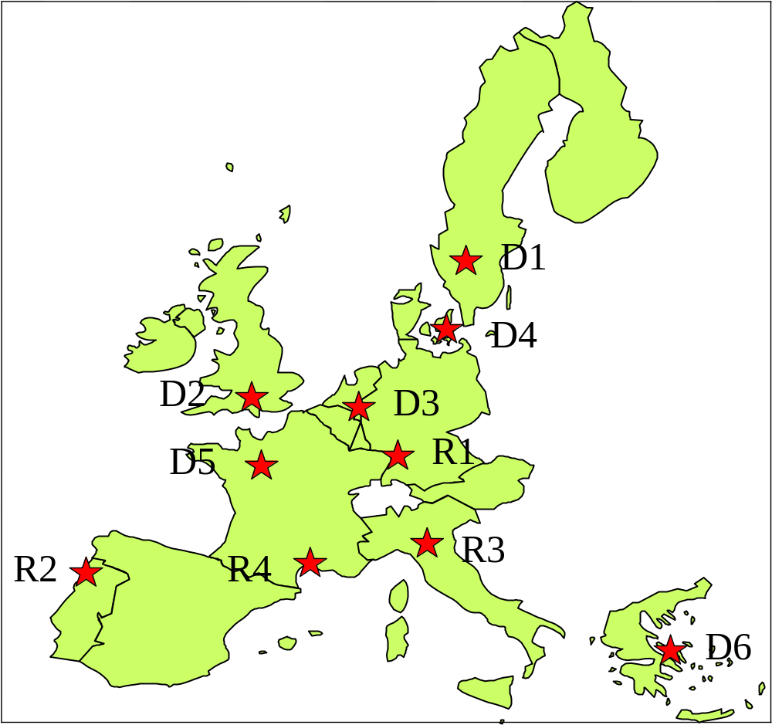Figure ES-1. Ten representative EU scenarios for surface water PEC calculations (D = drainage, R = run-off).
Crop information has also been defined for each scenario, including the likeliness of irrigation of the crop under consideration.
The basic data of the scenarios are taken from specific fields in the area, but they have been manipulated to assure a wider applicability. Now they represent a wide area of agriculture in the European Union and therefore should not be considered national scenarios. They mimic the characteristics of the whole area of the EU as indicated in the example figure ES-2.
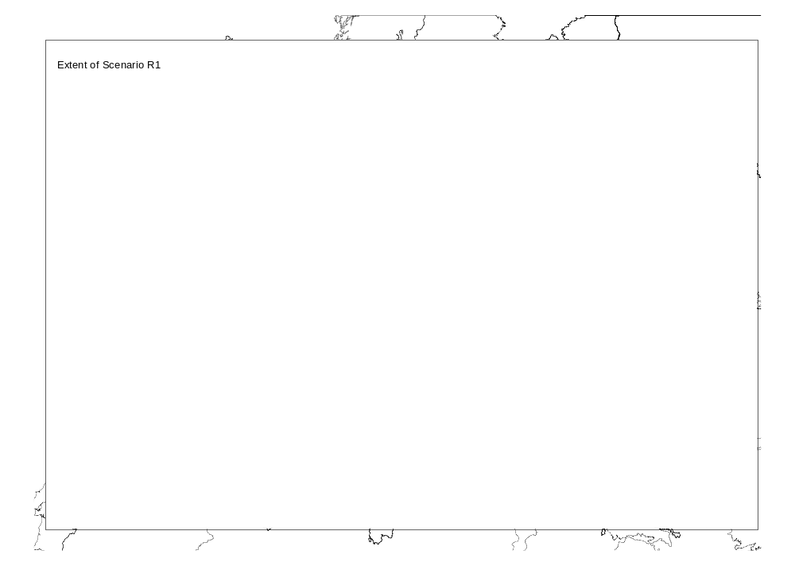
Figure ES-2. Example scenario for surface water PEC calculation.

Models involved in the PEC calculation
As for the groundwater scenarios, the scenario definitions in the surface water scenarios are simply lists of properties and characteristics, which exist independently of any simulation model. These scenario definitions have also been used to produce sets of model input files. Input files corresponding to all ten scenarios have been developed for use with the simulation models MACRO, PRZM, and TOXSWA. The models interact with each other in the sense that either MACRO or PRZM is always combined with the fate model TOXSWA depending on the scenario under consideration. If a drainage scenario is used, MACRO provides the input file for TOXSWA and if a run-off scenario is considered PRZM provides the input file for TOXSWA. In both cases an additional loading is defined as spray drift input. The weather data files developed for these models include irrigation for some of the crops in the different scenarios. An example of the procedure is given in Figure ES-3.
The calculation of the contribution of the spray drift is incorporated in the Graphical User Interface (GUI) developed for the surface water scenarios called SWASH (Surface WAter Scenarios Help).
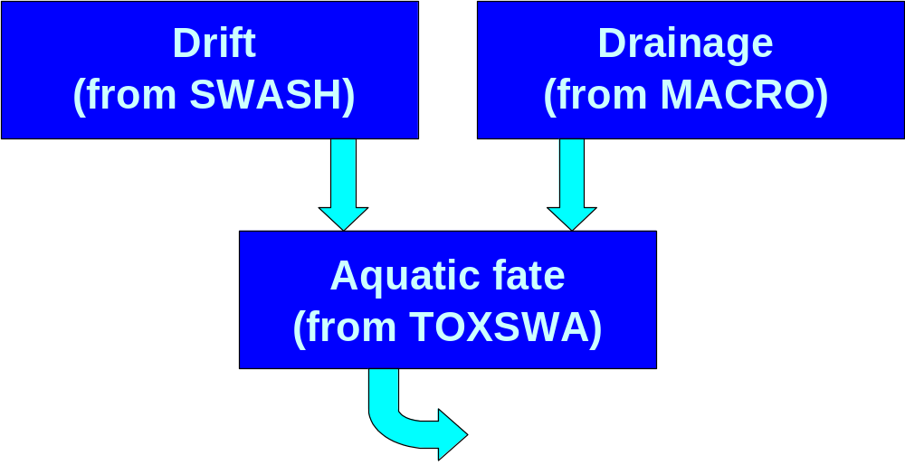
Figure ES-3 Example input loadings in TOXSWA
Use of surface water scenarios to assess PECs
Assessment of the surface water concentration after the application of plant protection products is not an end in itself but should always be considered in relation to the ecotoxicity data of the substance. Depending on the inherent toxicological properties of the substance, effects or risk may occur at different levels of the estimated concentration. Therefore, a stepwise approach has been developed so that more complicated calculations using the realistic worst-case Step 3 scenarios are only used to calculate a PEC if calculations at lower tiers give an unacceptable initial assessment. In addition to the scenario data defined in the standard scenarios, substance-specific data are needed. The combination of substance-specific data, scenario-specific data and crop-specific data result in the estimated PEC in surface water and related sediments that is used in the risk assessment process. Guidance on the selection of representative data from the data package accompanying the registration request is also needed. This involves in particular the physico-chemical data and the degradation and sorption data.
In order to minimise user influence and possible mistakes, a general model shell, SWASH, has been developed to ensure that the correct and relevant FOCUS scenarios are being defined to run the required calculations.
Benefits to the regulatory process
The FOCUS surface water scenarios offer a harmonised consensus approach for assessing the predicted environmental concentration in surface water and sediments across the EU. The process is based on the best available science.
The anticipated benefits include:
- Increased consistency. The primary purpose of defining standard scenarios is to increase the consistency with which industry and regulators assess the PECs in surface waters and sediments. The standard scenarios, the guidance on substance-specific input parameters, the overall shell, and the model shells will minimise user influence and possible mistakes.
- Speed and simplicity. Simulation models are complex and are difficult to use properly. Having standard scenarios means that the user has less input to specify, and the guidance document simplifies the selection of these inputs. The model shells also make the models easier to operate, whereas appropriate manuals are provided as well.
- Ease of review. Using standard scenarios means that the reviewer can focus on those relatively minor inputs, which are in the control of the user.
- Common, agreed basis for assessment. If and when the FOCUS scenarios are adopted for use in the regulatory process then Member States will have a common basis on which to discuss PEC assessment issues with substances at the EU level. Registrants will also have greater confidence that their assessments have been done on a basis, which the regulators will find acceptable. Debate can then focus on the substance-specific issues of greatest importance, rather than details of the weather data or soil properties, for example.
Differences among risk assessors
Definitions of the standard scenarios and the shells provided with the models are intended to minimise differences in assessments among different risk assessors although it is recognised that differences can never be completely excluded. However, it is anticipated that such differences will mainly be caused by the selection of substance-specific parameters available in the dossier. Some guidance on the selection of these parameters is included in this report and it is hoped that these will help to reduce differences in results between different risk assessors. In addition, the manuals provided with the models should also help to minimise such differences as those that could result from different assessors using a different timing of pesticide application.
Uncertainties in using the FOCUS surface water scenarios
Uncertainty will always be present to some degree in environmental risk assessment. As part of the EU registration process, the use of the FOCUS scenarios provides a mechanism for assessing the PECs in surface water and sediment with an acceptable degree of uncertainty.
The choice of the surface water scenarios, soil descriptions, weather data and parameterisation of simulation models has been made in the anticipation that these combinations should result in realistic worst cases for PEC assessments. It should be remembered, however, that the FOCUS surface water scenarios are virtual, in that each is a combination of data from various sources designed to be representative of a regional crop, climate and soil situation, although they have a real field basis. Adjustments of the data to make them useful in a much broader sense have been necessary. As such, none can be experimentally validated.
To further reduce uncertainty, independent quality checks of the scenario files and model shells were performed, and identified problems were removed. An additional check for the plausibility of the scenarios and models is provided by the test model runs made with dummy substances, which have widely differing properties.
Whilst there is still scope for further reductions in uncertainty through the provision of improved soils and weather data at the European level, the FOCUS Surface Water Scenarios Working Group is confident that the use of the standard scenarios provides a suitable method to assess the PECs in surface water and sediment at the first three Steps in the EU registration procedure.

INTRODUCTION

General Approach to Risk Assessment
Risk Assessments for potentially toxic substances such as pesticides are carried out according to a scheme as presented in Figure 1.1-1. Registrants are required to deliver a data set to the authorities accompanying the registration request. Part of these data, for example that relating to degradation half-life and sorption are used to evaluate the fate and behaviour of a substance in the environment and to undertake an Exposure Assessment. The remaining data, such as carcinogenicity and ecotoxicity, are used to assess the potential Hazard posed by the substance by quantifying its effects on non-target organisms such as humans, aquatic species, birds, earthworms, etc.
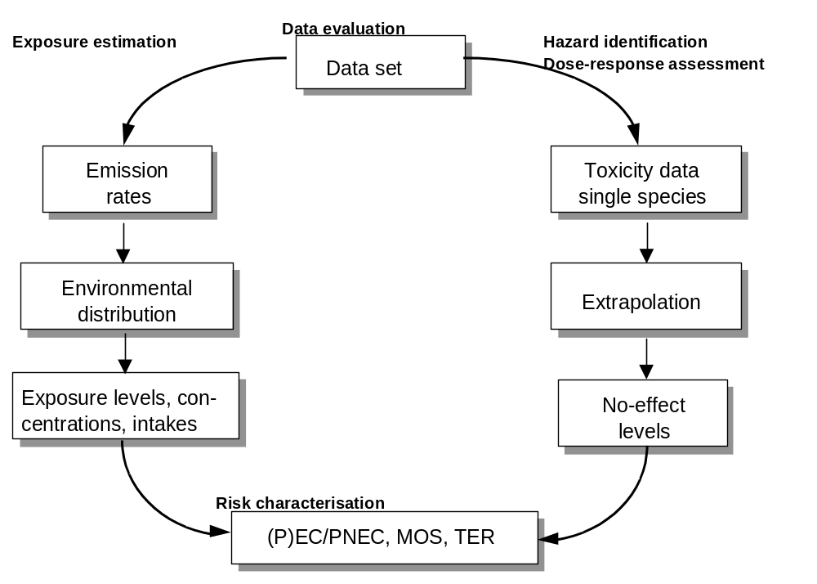
Figure 1.1-1 General Approach in Risk Assessment
The results of the exposure assessment and the hazard assessment are combined to produce an overall risk assessment. For the environment, risk assessment may be based on the ratio of the Predicted Environmental Concentration to the Predicted No-Effect Concentration (PEC/PNEC), or on the Toxicity Exposure Ratio (TER) or by applying a specified Margin of Safety (MOS) factor. Depending on the results of the initial risk assessment, more detailed data relating to environmental exposure or hazard may be required to clarify the environmental risk. Such data is generated from an increasingly comprehensive series of studies termed higher tier studies. At each tier a relevant comparison has to take place between the estimated exposure and the estimated hazard and there are thus separate tiers for both exposure and hazard estimation.
The methods and models presented in this Document apply only to the exposure estimation part of the risk assessment process (the left-hand side of figure 1.1-1). Methods for estimating the intrinsic hazard of a substance are dealt with in other Guidance Documents prepared for the Commission, such as those on Aquatic Ecotoxicology (Sanco/3268/2001) and Terrestrial Ecotoxicology (DOC. 2021/VI/98 rev.7)². For higher tier hazard evaluation, results of the HARAP (Campbell, et al, 1999) and CLASSIC (Giddings, et al, 2001) workshops may also be taken into account.
Of course, the entry of pesticides into surface waters via routes other than spray drift, runoff and drainage are possible, for example via dry deposition, colloid transport, groundwater, discharge of waste water, accidents and incidents of various nature. Some of these are considered to be of minor importance or are not Good Agricultural Practice. These routes were not considered to be part of the remit of the group and were therefore left outside the scope of the work performed.

The tiered approach to Assessment of Surface Water Exposure
As described in the report of the FOCUS Working Group on Surface Water Modelling (FOCUS, 1997) the surface water exposure estimation component of the risk assessment process takes place according to a stepwise or tiered approach as illustrated in Figure 1.2-1.
The first step in the tiered approach is to estimate surface water exposure based on an “extreme worst case loading” scenario. The estimated exposure may be compared to the relevant toxicity concentrations, the lethal or effect concentration, L(E)C50, or the No-effect concentration, NOEC, of the water organisms investigated. If, at this early stage, the use is considered safe no further surface water risk assessment is required. If however, the result indicates that use is not safe, it is necessary to proceed to a Step 2 exposure assessment. This step assumes surface water loading based on sequential application patterns taking into account the degradation of the substance between successive applications. Again the PECs are calculated and may be compared to the same and/or different toxicity levels for aquatic organisms. As with Step 1, if the use is considered safe at this stage, no further risk assessment is required whereas an ‘unsafe’ assessment necessitates further work using a Step 3 calculation. In Step 3, more sophisticated modelling estimations of exposure are undertaken using a set of 10 scenarios defined and characterised by the working group and representing ‘realistic worst-case’ situations for surface water within Europe. At this stage, the calculated PECs for each scenario are compared with relevant toxicity data and a decision made as to whether it is necessary to proceed to Step 4 exposure estimation. Risk assessments using Step 3 exposure estimation may incorporate higher-tier toxicity data generated from micro- or mesocosm studies.
The final step of the FOCUS process is Step 4. In principle, Step 4 can be regarded as a higher-tier exposure assessment step. This may include a variety of refinement options of different degrees of complexity covering risk mitigation measures, refinement of fate input parameters, or regional and landscape-level approaches. By its nature, Step 4 will be a 'case-by-case' process, depending on the properties of the compound, its use pattern, and the areas of potential concern identified in the lower tier assessments. As such, it is not appropriate to make specific recommendations for the Step 4 process. A Step 4 analysis is only considered necessary for those GAP applications that failed Step 3 and for which the applicant wants to continue the registration process. It may be considered appropriate to perform a Step 4 analysis for each use separately. Some guidance on the sorts of approaches that may be

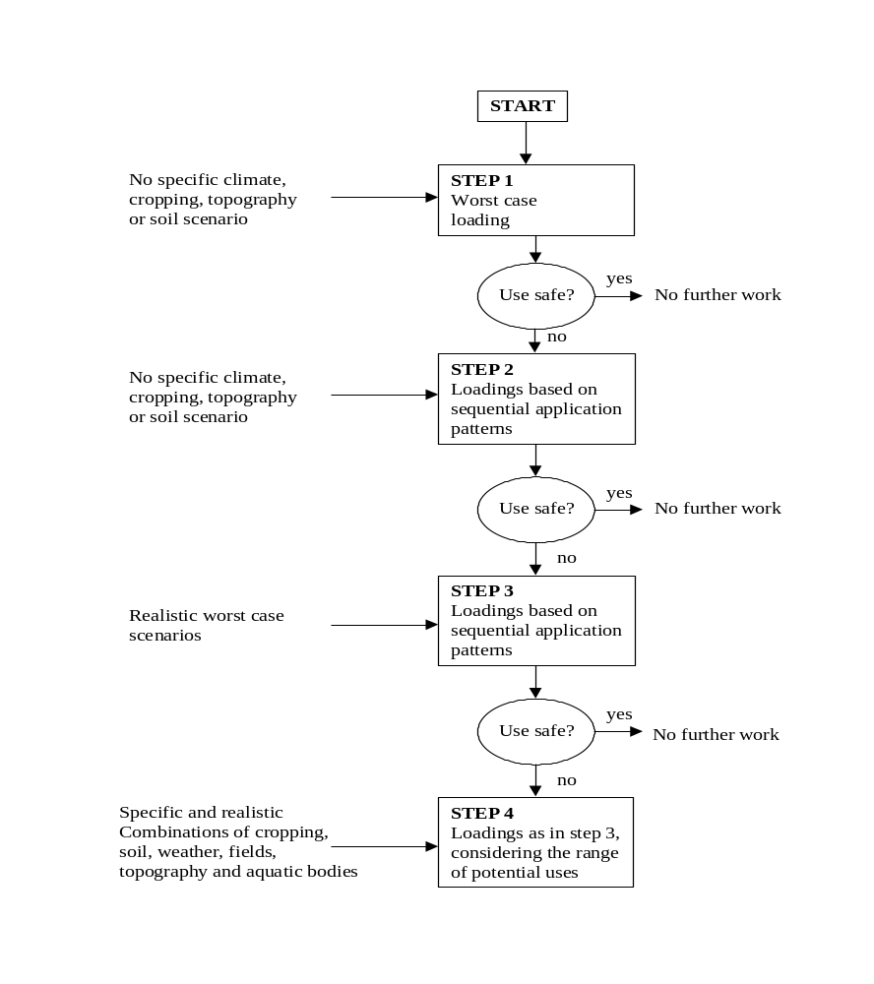Figure 1.2-1 The Tiered Approach in Exposure assessment of Plant Protection Products.
applied has been developed. It is conceivable that Step 4 approaches would be used both for Annex I listing and for national registration purposes. For example, for certain compounds it may be possible to identify a range of acceptable uses across the EU when appropriate mitigation measures (e.g., buffer zones) are applied. For certain specific uses, Step 4 approaches could also be useful for identifying safe uses at Member State level, for example if certain local or regional considerations mean that the lower-tier, EU level assessments were overly conservative.
In the next chapters, each step of the exposure assessment as proposed by the working group will be dealt with in more detail.

1.3 Overview of Scenario Development

1.3.1. Getting started
Many member states of the European Union have already developed some basic scenarios to assess potential pesticide exposure in surface waters. The Working group considered that these could provide a starting point for scenario development. In a letter from the European Commission to all Heads of Delegation of the working group ‘Plant Protection Products – Legislation’, dated 27 October 1997, all Member States were asked to send to the chairman of the FOCUS Working Group on Surface Water Scenarios information about methods used in the member state to calculate PECs in Surface Water, if available. An overview of the responses of the Member States is given in Appendix A. The different methods used by member states all clearly relate to the types of exposure assessment proposed for Steps 1 and 2 of the tiered approach (see fig. 1.2-1). They were thus used as a basis for developing the Step 1 and 2 scenarios described in chapter 2 of this report. However, none of the existing methods were considered suitable for developing Step 3 scenarios and associated exposure assessments and the initial work of the Group therefore focused on scenario development at this level. This work is described in chapter 3 of the report.

1.3.2 Input routes for surface water loadings
The remit of the Surface Water Scenarios Working Group included a request to consider all potential pesticide input routes to the surface water body, namely atmospheric deposition, spray drift, surface runoff and drainage. With respect to atmospheric deposition, it was concluded that the existing methods and/or models available were not developed enough for further consideration within the working group’s remit. Ongoing work to develop a risk assessment scheme for air by the Joint Environmental Risk Assessment Panel of the European and Mediterranean Plant Protection Organisation (EPPO) and the Council of Europe (CoE) is likely to change this situation. It is therefore suggested that the results and recommendations of this Panel be awaited before further work on the atmospheric deposition input route is carried out by a possible future FOCUS Working Group. As a result, none of the methods and tools developed and reported here take into account atmospheric deposition as a contributor to surface water loadings.

1.3.3 Relationship between Steps 1, 2 and 3
In developing the Step 1, 2 and 3 scenarios, the Group wanted to achieve a conceptual relationship between the PECs calculated at each step, as illustrated in figure 1.3-1.
This relationship clearly depends on the amount of surface water loading applied at Steps 1 and 2 and the simplicity of the associated water body and its simulated dissipation mechanisms. When developing the Step 1 and 2 scenarios therefore, this conceptual relationship was taken into account and the input loadings applied were carefully calibrated from the range of input loadings calculated using Step 3 models and scenarios. To ensure the reality of these relationships, a series of test runs were undertaken using the Step 3 scenarios and tools and it was confirmed that the predicted Step 3 surface water input loadings were similar to such measured field data as was available. Results of the Step 3 test runs are presented in chapter 6 and Appendix G of this report.

Figure 1.3-1. Conceptual relationship between the desired Predicted Environmental Concentrations at Steps 1, 2 and 3 and the Actual range of exposure.
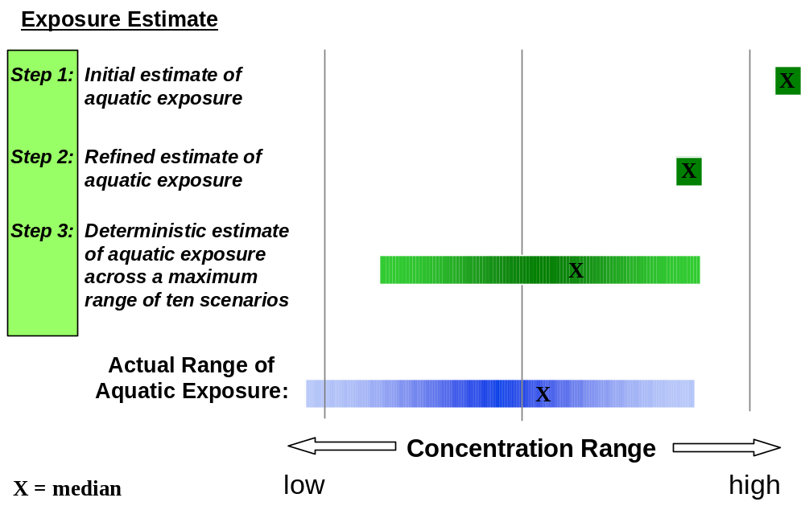

1.3.4 Development of tools to support the scenarios and PEC calculation
The Step 1, 2 and 3 scenarios and associated PEC calculation methods described in this report are more complex than any existing European methods for assessing surface water exposure. To facilitate their use and to ensure the consistency of their application by users, the Group has developed a set of software tools to support PEC_{sw} calculations at Steps 1, 2 and 3 of the tiered approach. The bases of these tools are described in chapters 2 and 5 of the report and User Manuals for the tools are provided in Appendices H to L.
It is anticipated that following release of this report, there may be some minor last-minute adjustments to the FOCUS surface water modelling tools before they are released for use. Because of this, users who repeat the Step 1, 2 & 3 comparison exercise described in chapter 6 are likely to find that the exact values of PEC_{sw} presented in the tables of that chapter and in Appendix F may be slightly different to those calculated using the ‘final release’ versions of the modelling tools.

1.4 Selecting models for Step 3 and Step 4 assessments
A wide range of models is available for calculating surface water exposure. These have been reviewed by a previous working group and a report published by the Commission (FOCUS, 1997). None of the models reviewed could be said to have been validated at the European level as required in Directive 91/414/EEC but the Working Group recommended a number as being suitable for use within Europe. In order to limit the amount of work undertaken by the Surface Water Scenarios Working Group, the test calculations and the software tools developed to perform and support Step 3 exposure assessments use only one of the models recommended for calculating loadings from the different input routes and for surface water fate. The models chosen are:
- MACRO (drainage)
- PRZM (runoff)
- TOXSWA (surface water fate).
Each of these models has been carefully parameterised for each scenario and a software tool developed to harmonise output data from the drainage and runoff models with input data requirements for the surface water fate model. In addition results from test runs of the Step 3 modelling tools have been used to calibrate the relationships between Steps 1, 2 and 3 exposure assessments as described in section 1.3.3 above. Because of this it is NOT recommended that any of the other models recommended in guidance document DOC. 6476/VI/96 (FOCUS, 1997) be used for Step 3 exposure assessments.
If higher tier exposure assessments at Step 4 become necessary however, then any of the following models recommended in report DOC. 6476/VI/96 can be used, providing the user is aware of their limitations and can justify their use with respect to specific scenarios:
Surface runoff: GLEAMS, PRZM, and PELMO.
Drainage: PESTLA/PEARL, MACRO, and CRACK-P.
Surface water fate: EXAMS, WASP, and TOXSWA.

1.5 Outline of the Report
Chapter 2 of this report describes the development of scenarios for Steps 1 and 2 of the tired approach and their associated calculation tool called STEPS 1&2 in FOCUS. In chapters 3 and 4 the development and characterisation of Step 3 scenarios is detailed, whereas chapter 5 describes how these scenarios are used to calculate exposure at Step 3 of the tiered approach. Chapter 6 gives details of the test runs carried out using the scenarios and tools developed by the Group and presents the results of the comparisons of Step 1, 2 and 3 calculations for a range of test compounds.
Selection of appropriate input data for pesticide parameters is a problematic area as all the models used are sensitive to these values and relatively small changes in them can significantly alter predicted concentrations. Advice on the selection of these input values is therefore given in chapter 7 of the report. Similarly, most of the models and methods presented and developed here are relatively new and have varying degrees of uncertainty attached to their use. Chapter 8 covers this topic area.
If a substance in the evaluation process has to be taken to Step 4, Chapter 9 gives additional information and guidance on what may be done at this level to perform the final assessment in the decision-making process. Strictly speaking, the Working Group considers this step to be outside its remit, but it was felt necessary to provide some guidance on this point to industry and regulatory bodies, especially on the role mathematical models may play at this stage.
Finally, in Chapter 10 the conclusions of the current work and recommendations for future work are indicated. At the end of the report, several appendices are included with technical information on the existing national scenarios considered at the start of the Group’s work, the specification of each scenario and parameterisation of the various models used. Also included in the appendices are the test protocol for comparing results from Steps 1, 2 and 3 and a set of manuals for the software tools developed by the group.

1.6 References
Campbell, P.J.; Arnold, D.J.S.; Brock, T.C.M.; Grandy, N.J.: Heger, W.; Heimbach, F.; Maund, S.J. & Streloke, M. (1999). Guidance Document on Higher-tier Aquatic Risk Assessment for Pesticides (HARAP). SETAC-Europe Publication, Brussels.
FOCUS (1997). Surface Water Models and EU Registration of Plant Protection Products. European Commission Document 6476/VI/96.
Giddings, J.; Heger, W.; Brock, T.C.M.; Heimbach, F.; Maund, S.J.; Norman, S.; Ratte, T.; Schäfers, C. & Streloke, M. (2001): Proceedings of the CLASSIC Workshop (Community Level Aquatic System Studies – Interpretation Criteria), SETAC-Europe Publication, Brussels; In press.

2. Development of Step 1 and 2 Scenarios

2.1. Introduction
As described in the remit of the Surface Water scenarios working group, Step 1 and 2 calculations should represent “worst-case loadings” and “loadings based on sequential application patterns” respectively but should not be specific to any climate, crop, topography or soil type. With this in mind the group developed two simple scenarios for calculating exposure in surface water and sediment. The assumptions at both Steps 1 and 2 are very conservative and are essentially based around drift values calculated from BBA (2000) and an estimation of the potential loading of pesticides to surface water via run-off, erosion and/or drainage. This “run-off” loading represents any entry of pesticide from the treated field to the associated water body at the edge of the field.
At Step 1 inputs of spray drift, run-off, erosion and/or drainage are evaluated as a single loading (sum of individual applications) to the water body and “worst-case” water and sediment concentrations are calculated. If inadequate safety margins are obtained (Toxicity Exposure Ratios < trigger values), the registrant proceeds to Step 2. At Step 2, loadings are refined as a series of individual applications, each resulting in drift to the water body, followed by a run-off/erosion/drainage event occurring four days after the last application and based upon the region of use (Northern or Southern Europe), season of application, and the crop interception. Again, if inadequate safety margins are obtained (Toxicity Exposure Ratios < trigger values), the registrant proceeds to Step 3. Step 3 requires the use of deterministic models such as PRZM, MACRO and TOXSWA.
Already at Step 1 and 2 concentrations can be calculated not only for the active compound but also for metabolites formed in the soil before runoff/drainage occurs. The user must define the properties of the metabolite, including the maximum occurrence of the respective metabolite in soil studies and the ratio of the molecular masses of parent and metabolite.
The fate of metabolites formed in the water body can also be taken into consideration at Step 1 and 2. The formation will be calculated in a similar way based on the maximum occurrence of the metabolite in water/sediment studies.
The purpose of formalising Step 1 and Step 2 calculations is to harmonise the methods of calculation and to avoid unnecessarily complex exposure assessments for plant protection products for which large safety margins exist even at the earliest steps of evaluation.
In order to facilitate the calculations for Step 1 & 2 scenarios, the Group has developed a stand-alone Surface water Tool for Exposure Predictions –Steps 1 & 2 (STEPS1-2 in FOCUS) for the derivation of PEC values in water and sediment based upon the chosen scenario. The tool, which is described in more detail in Appendix I, requires a minimum of input values (molecular weight, water solubility, DT50_{soil}, Koc, DT50_{sediment/water}, number of applications, application interval and application rate) and is designed to evaluate both active substances and metabolites. Some information on how to fill the necessary input parameters is already summarised in the program description (Appendix I). More detailed information is given in chapter 7 of the report. Appropriate eco-toxicity test end-points are also required for the conduct of Toxicity Exposure Ratio calculations.
This chapter outlines the assumptions made in the preparation of STEPS1-2 in FOCUS.

2.2 Standard assumptions common to both Steps 1 and 2
A set of assumptions for the water body dimensions common to Step 1 and 2 were compiled to derive the scenario. These are based upon a combination of existing concepts within the EU and Member States and measured datasets available to the Group, together with expert judgement. They are as follows:
A water depth of 30-cm overlying sediment of 5-cm depth was selected in order to comply with existing risk assessment approaches within the EU and existing ecotoxicity testing requirements for sediment-dwelling organisms.
The sediment properties were selected to represent a relatively vulnerable sediment layer with low organic carbon content for small surface waters in agricultural areas. Tables 2.2-1 and 2.2-2 present experimental data that were considered in defining the sediment properties for Step 1 and 2 calculations. Table 2.2-1 shows data from the experimental ditches of Alterra, two years after establishment (Adriaanse et al, in prep) and Table 2.2-2 refers to the situation seven years after establishment (Crum et al, 1998). The sediment in the ditches was taken from a mesotrophic lake and is a sandy loam in which well-developed macrophyte vegetation develops in summertime. The ditches are poor in nutrients. In Step 1 and 2 sediment layers of 5 cm are assumed. However for the distribution of the chemicals between water and sediment an effective sorption depth of only 1 cm is considered; Figure 2.2-1 shows the selected values for the organic carbon content and bulk density of the sediment layer.
Table 2.2-1 Sediment properties as a function of depth in the experimental ditches of Alterra, two years after construction (average of four ditches with a total of 16 sediment cores per ditch, taken in the course of the growing season)
Sediment layer (cm) | Organic carbon  (%) | Dry bulk density (kg/dm³) | Volume fraction of liquid phase
0 – 1 | 2.3 | 0.65 | 0.68
1 – 3 | 0.9 | 1.46 | 0.40
3 – 6 | 1.0 | 1.56 | 0.36
Below 6 | 1.1 | 1.54 | 0.36
Table 2.2-2 Sediment properties as a function of depth in the experimental ditches of Alterra, seven years after construction (average of two ditches with a total of 115 sediment cores per ditch, taken in the course of the growing season)
Sediment layer (cm) | Organic carbon  (%) | Dry bulk density (kg/dm³) | Volume fraction of liquid phase
0 – 1 | 15 | 0.1 | 0.9
1 – 2 | 11 | 0.2 | 0.8
2 – 4 | 3 | 0.7 | 0.7
4 – 10 | 1 | 1.6 | 0.4
The width of the water body is not necessary for the evaluation of drift loadings as plant protection product loadings are based upon a percentage of the application rate in the treated field. However, a fixed field: water body ratio (10:1) has been defined for run-off, erosion or drainage losses to reflect the proportion of a treated field from which pesticides are lost to surface water. This number was selected initially by expert judgement and was subsequently validated by model runs of PRZM, MACRO and TOXSWA. The standard assumptions common to both Step 1 & 2 scenarios are illustrated in figure 2.2-1.

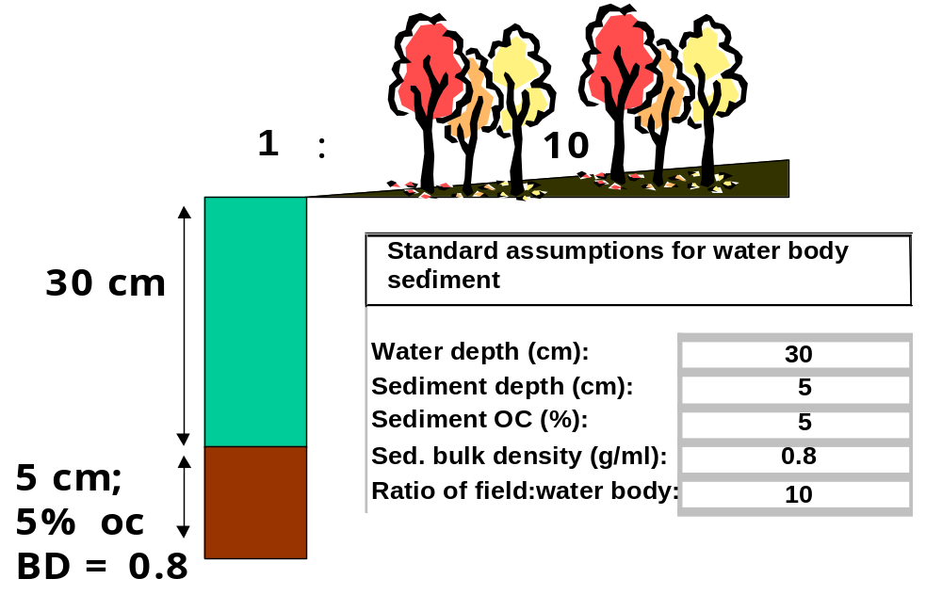
Figure 2.2-1. Standard assumptions used in Steps 1 and 2 scenarios

2.3 Step 1 Assumptions
At Step 1 inputs of spray drift, run-off, erosion and/or drainage are evaluated as a single loading to the water body and “worst-case” surface water and sediment concentrations are calculated. The loading to surface water is based upon the number of applications multiplied by the maximum single use rate unless 3 x DT50 in sediment/water systems (combined water + sediment) is less than the time between individual applications. In such a case the maximum individual application rate is used to derive the maximum PEC as there is no potential for accumulation in the sediment/water system. For first order kinetics the value of 3 * DT50 is comparable to the DT90 value.

2.3.1 Drift loadings.
Four crop groups (arable, vines, orchards and hops, representing different types of application), plus seed dressings and aerial applications have been selected as drift classes for evaluation at Step 1 and 2. Drift values have been calculated at the 90th percentile from BBA (2000) (see section 5.4). Values for a 1m “no spray zone” for arable crops and a 3m “no spray zone” for vines, orchards and hops have been selected in accordance with recommendations from the ECCO groups, because these represent the minimum default distance taking into account the ubiquitous presence of natural buffers. Seed and granular treatments will always have drift of 0% for all treatments and aerial drift loadings have been set to 33.2% for all applications. This latter value has been calculated using the AgDrift model (SDTF, 1999) and corresponds to a distance of 3 m from the edge of the treated field. As with all FOCUS scenarios, it assumes Good Agricultural Practice, which for aerial application means there is no overspray.
The selected values are shown in table 2.3.1-1.
Table 2.3.1-1 Step 1: drift input into surface water
Crop / technique | Distance crop-water  (m) | Drift  (% of application)
Cereals, spring | 1 | 2.8
Cereals, winter | 1 | 2.8
Citrus | 3 | 15.7
Cotton | 1 | 2.8
Field beans | 1 | 2.8
Grass / alfalfa | 1 | 2.8
Hops | 3 | 19.3
Legumes | 1 | 2.8
Maize | 1 | 2.8
Oil seed rape, spring | 1 | 2.8
Oil seed rape, winter | 1 | 2.8
Olives | 3 | 15.7
Pome / stone fruit, early applications * | 3 | 29.2
Pome / stone fruit, late applications * | 3 | 15.7
Potatoes | 1 | 2.8
Soybeans | 1 | 2.8
Sugar beet | 1 | 2.8
Sunflower | 1 | 2.8
Tobacco | 1 | 2.8
Vegetables, bulb | 1 | 2.8
Vegetables, fruiting | 1 | 2.8
Vegetables, leafy | 1 | 2.8
Vegetables, root | 1 | 2.8
Vines, early applications * | 3 | 2.7
Vines, late applications * | 3 | 8.0
Application, aerial | 3 | 33.2
Application, hand (crop < 50 cm) | 1 | 2.8
Application, hand (crop > 50 cm) | 3 | 8.0
No drift (incorporation, granular or seed treatment) | 1 | 0
* NOTE: for the distinction between early and late references is made to the BBCH–codes as mentioned in Table 2.4.2-1.
All inputs are assumed to occur at the same time but their initial distribution between the surface water and sediment compartments is dependent upon the route of entry and sorption coefficient (Koc) of the compound. Drift inputs are loaded into the water where they are subsequently distributed (after 1 day) between water and sediment according to the compound’s Koc. This assumption is refined at Step 2 (see section 2.4.1). Although the rate of distribution of drift events between water and sediment is reduced at Step 2 the assumption that the runoff event occurs simultaneously with drift at Step 1 always results in the most conservative assessment. The maximum PEC_{sw} value is always highest on the day of application (day 0). A warning message informs the user when PEC_{sw} exceeds the solubility limit for the compound as input by the user.

2.3.2 Run-off/erosion/drainage loading.
At Step 1 the run-off/erosion/drainage loading to the water body was set at 10% of the application for all scenarios. This is a very conservative estimate for a single loading and is based on maximum reported total losses of 8% to 9% for drainage (see section 6.4.1) and 3% to 4% for runoff (see section 6.4.2). The run-off/erosion/drainage entry is distributed instantaneously between water and sediment at the time of loading according to the Koc of the compound (see Fig 2.3.2-1). In this way compounds of high Koc are added directly to the sediment whereas compounds of low Koc are added to the water column in the ‘run-off/drainage’ water. The relationship between Koc and the distribution between water and sediment is calculated as follows:
Fraction of runoff in water = W ___
(W + (S_{eff}.oc.Koc))

where: W = mass of water (30g)
S_{eff} = mass of sediment available for partition (0.8g)
Oc = organic carbon content of sediment (0.05)
Koc = pesticide organic carbon partition coefficient (cm³.g⁻¹).
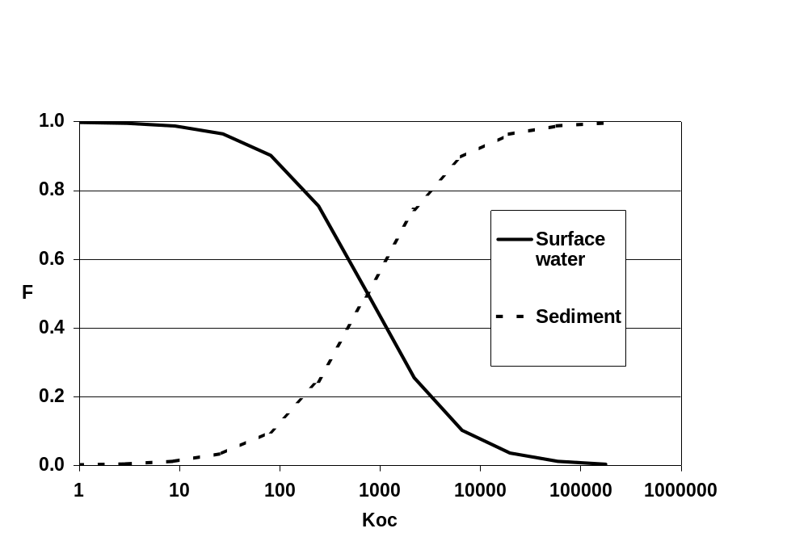
Figure 2.3.2-1 Influence of Koc on % of pesticide entering in water column and sediment

2.3.3 Degradation in water and sediment compartments.
At Step 1, degradation in the water and sediment compartments is dependent on the DT50_{sediment/water} (combined water + sediment value). Degradation in both compartments is assumed to follow simple first order kinetics. The program calculates and reports instantaneous concentrations and time weighted average concentrations in surface water and sediment at intervals of 1, 2, 4, 7, 14, 21, 28, 42, 50 and 100 days after application. At Step 1 the maximum PEC_{sw} and PEC_{sediment} concentrations are mostly found on the day of application (day 0).

2.4 Step 2 Assumptions
At Step 2 inputs of spray drift, run-off, erosion and/or drainage are evaluated as a series of individual loadings comprising drift events (number, interval between applications and rates of application as defined in Step 1) followed by a loading representing a run-off, erosion and/or drainage event four days after the final application. This assumption is similar to that developed by the United States EPA in their GENEEC model (Parker, 1995). Degradation is assumed to follow first-order kinetics in soil, surface water and sediment and the registrant also has the option of using different degradation rates in surface water and sediment.

2.4.1 Drift loadings.
The fraction of each application reaching the adjacent water is both a function of method and number of applications. The same criteria for “no spray zones” have been applied to the different types of application (arable, vines, orchards and hops, representing different types of application plus seed dressings and aerial applications) as were used in Step 1. The methods used to derive drift values for each type of application are presented in Section 5.4 In summary, percentage drift values have been calculated for up to 25 individual applications of a pesticide to arable, vines, orchard and hops such that the drift from the total number of applications represents the 90th percentile. The data have then been simplified as shown in table 2.4.1-1.
Thus, a single application to an arable crop results in a drift loading of 2.8 % of the applied amount (90th percentile drift for 1 m no spray zone) to the water body, whereas, four applications to an arable crop will each result in a drift loading of 1.9 % of the applied amount (total for four loadings is 90th percentile) or a total drift loading of 7.6 % of a single application. Depending on the compound's properties therefore, the resulting surface water concentrations may be lower for multiple applications than for the respective single application. For such situations, the user should also consider surface water concentrations calculated for the single drift event and consequently, a routine has been incorporated into the STEPS1-2 in FOCUS software to do this automatically.
Seed and granular treatments will always have drift of 0% for all treatments and aerial drift loadings have been set to 33.2% for all applications. This latter value corresponds to a distance of 3 m from the edge of the treated field and, as with all FOCUS scenarios, assumes Good Agricultural Practice, which for aerial application means there is no overspray. The aerial drift data are not adjusted for multiple applications because there are no distribution data reported in the AgDrift model (SDTF, 1999).
The Working Group considers that Step 2 calculations are an integral part of the sequential refining process for calculating PEC_{sw}, whereby exposure assessments proceed from ‘unrealistic worst-case’ to scenarios of increasing ‘reality’. Because of this, the Group considers that any mitigation measures based on increasing the distances for ‘no spray zones’ should only be used with the ‘realistic worst-case’ scenarios defined for Step 3 (see section 9.4).
Table 2.4.1-1 Step 2: drift input into surface water
Crop / technique | Distance to water | Number of application per season
 | (m) | 1 | 2 | 3 | 4 | 5 | 6 | 7 | >7
cereals, spring | 1 | 2.8 | 2.4 | 2.0 | 1.9 | 1.8 | 1.6 | 1.6 | 1.5
cereals, winter | 1 | 2.8 | 2.4 | 2.0 | 1.9 | 1.8 | 1.6 | 1.6 | 1.5
citrus | 3 | 15.7 | 12.1 | 11.0 | 10.1 | 9.7 | 9.2 | 9.1 | 8.7
cotton | 1 | 2.8 | 2.4 | 2.0 | 1.9 | 1.8 | 1.6 | 1.6 | 1.5
field beans | 1 | 2.8 | 2.4 | 2.0 | 1.9 | 1.8 | 1.6 | 1.6 | 1.5
grass / alfalfa | 1 | 2.8 | 2.4 | 2.0 | 1.9 | 1.8 | 1.6 | 1.6 | 1.5
hops | 3 | 19.3 | 17.7 | 15.9 | 15.4 | 15.1 | 14.9 | 14.6 | 13.5
legumes | 1 | 2.8 | 2.4 | 2.0 | 1.9 | 1.8 | 1.6 | 1.6 | 1.5
maize | 1 | 2.8 | 2.4 | 2.0 | 1.9 | 1.8 | 1.6 | 1.6 | 1.5
oil seed rape, spring | 1 | 2.8 | 2.4 | 2.0 | 1.9 | 1.8 | 1.6 | 1.6 | 1.5
oil seed rape, winter | 1 | 2.8 | 2.4 | 2.0 | 1.9 | 1.8 | 1.6 | 1.6 | 1.5
olives | 3 | 15.7 | 12.1 | 11.0 | 10.1 | 9.7 | 9.2 | 9.1 | 8.7
pome / stone fruit, (early) | 3 | 29.2 | 25.5 | 24.0 | 23.6 | 23.1 | 22.8 | 22.7 | 22.2
pome / stone fruit (late) | 3 | 15.7 | 12.1 | 11.0 | 10.1 | 9.7 | 9.2 | 9.1 | 8.7
potatoes | 1 | 2.8 | 2.4 | 2.0 | 1.9 | 1.8 | 1.6 | 1.6 | 1.5
soybeans | 1 | 2.8 | 2.4 | 2.0 | 1.9 | 1.8 | 1.6 | 1.6 | 1.5
sugar beet | 1 | 2.8 | 2.4 | 2.0 | 1.9 | 1.8 | 1.6 | 1.6 | 1.5
sunflower | 1 | 2.8 | 2.4 | 2.0 | 1.9 | 1.8 | 1.6 | 1.6 | 1.5
tobacco | 1 | 2.8 | 2.4 | 2.0 | 1.9 | 1.8 | 1.6 | 1.6 | 1.5
vegetables, bulb | 1 | 2.8 | 2.4 | 2.0 | 1.9 | 1.8 | 1.6 | 1.6 | 1.5
vegetables, fruiting | 1 | 2.8 | 2.4 | 2.0 | 1.9 | 1.8 | 1.6 | 1.6 | 1.5
vegetables, leafy | 1 | 2.8 | 2.4 | 2.0 | 1.9 | 1.8 | 1.6 | 1.6 | 1.5
vegetables, root | 1 | 2.8 | 2.4 | 2.0 | 1.9 | 1.8 | 1.6 | 1.6 | 1.5
vines, early applications | 3 | 2.7 | 2.5 | 2.5 | 2.5 | 2.4 | 2.3 | 2.3 | 2.3
vines, late applications | 3 | 8.0 | 7.1 | 6.9 | 6.6 | 6.6 | 6.4 | 6.2 | 6.2
application, aerial | 3 | 33.2 | 33.2 | 33.2 | 33.2 | 33.2 | 33.2 | 33.2 | 33.2
application, hand  (crop < 50 cm) | 1 | 2.8 | 2.4 | 2.0 | 1.9 | 1.8 | 1.6 | 1.6 | 1.5
application, hand  (crop > 50 cm) | 3 | 8.0 | 7.1 | 6.9 | 6.6 | 6.6 | 6.4 | 6.2 | 6.2
no drift (incorporation, granular or seed treatment) | 1 | 0 | 0 | 0 | 0 | 0 | 0 | 0 | 0
* NOTE: for the distinction between early and late references is made to the BBCH–codes as mentioned in Table 2.4.2-1.
In common with the Step 1 calculator, drift inputs are loaded into the water column where they are subsequently distributed between water and sediment according to the compound’s Koc. However the process of adsorption to sediment at Step 2 is assumed to take longer than 1 day (as assumed at Step 1). This is consistent with the rate of partitioning of pesticides between water and sediment observed in laboratory water sediment studies and outdoor microcosms. The calculator assumes that following a drift event, the pesticide is distributed in surface water into two theoretical compartments, “available” for sorption to sediment and “unavailable” for sorption to sediment.
Ma_{sw} = K • M_{sw}

Mu_{sw} = (1-K) • M_{sw}

where M_{sw} = total mass of pesticide in surface water,
Ma_{sw} = mass available for sorption,
Mu_{sw} = mass unavailable for sorption and
K = distribution coefficient.
A series of simulations were conducted with values for K of 1/3 to 1 and were compared to the results of laboratory sediment/water studies for weakly and strongly sorbing compounds. Based on the results of these tests together with comparisons of the predicted PEC_{sw} values for the test compounds described in Chapter 6 it was determined that a value for K of 2/3 should be used as a default value at Step 2.
As with Step 1, a warning message informs the user when PEC_{sw} exceeds the solubility limit for the compound.

2.4.2 Crop-interception
In contrast to Step 1, the amount of pesticide that enters the soil at Step 2 is corrected for crop interception. For each crop, 4 interception classes have been defined depending on the crop stage. Crop interception will decrease the amount of pesticide that reaches the soil surface and thus ultimately enters the surface water body via run-off/drainage.
The values used for crop interception at Step 2 are given in table 2.4.2-1. It should be noted that the interception percentages used by STEPS 1-2 in FOCUS are not the same as those listed in the FOCUS groundwater report (FOCUS, 2000) as more recent literature (Linders et al, 2000) has been used to compile the numbers and the Group wanted to apply a more conservative approach to interception at this early stage of the stepped approach to exposure calculation.

2.4.3 Run-off/erosion/drainage loading.
Four days after the final application, a run-off/erosion/drainage loading is added to the water body. This loading is a function of the residue remaining in soil after all of the treatments (g/ha) and the region and season of application. The different run-off/drainage percentages applied at Step 2 are listed in table 2.4.3-1. They have been calibrated against the results of Step 3-calculations as described in section 1.3.3 and in more detail in chapter 6.
The user selects from two regions (Northern EU and Southern EU according to the definitions given for crop residue zones in the SANCO Document 7525/VI/95-rev.7, SANCO, 2001) and three seasons (March to May, June to September and October to February).
In common with Step 1, the run-off/erosion/drainage entry is distributed between water and sediment at the time of loading according to the Koc of the compound. An effective sorption depth of 1 cm is used for the distribution between both phases. In this way compounds of high Koc are mostly added directly to the sediment whereas compounds of low Koc are mostly added to the water column in the ‘run-off/drainage’ water (see figure 2.3.2-1).
Table 2.4.2-1 Step 2: crop interception
crop | no interception | minimal  crop cover | intermediate  crop cover | full canopy
BBCH-code * | 00 – 09 | 10 – 19 | 20 – 39 | 40 – 89
Cereals, spring and winter | 0 | 0.25 | 0.5 | 0.7
Citrus | 0 | 0.7 | 0.7 | 0.7
Cotton | 0 | 0.3 | 0.6 | 0.75
Field beans | 0 | 0.25 | 0.4 | 0.7
Grass / alfalfa | 0 | 0.4 | 0.6 | 0.75
Hops | 0 | 0.2 | 0.5 | 0.7
Legumes | 0 | 0.25 | 0.5 | 0.7
Maize | 0 | 0.25 | 0.5 | 0.75
Oil seed rape, spring and winter | 0 | 0.4 | 0.7 | 0.75
Olives | 0 | 0.7 | 0.7 | 0.7
Pome / stone fruit, early and late | 0 | 0.2 | 0.4 | 0.7
Potatoes | 0 | 0.15 | 0.5 | 0.7
Soybeans | 0 | 0.2 | 0.5 | 0.75
Sugar beet | 0 | 0.2 | 0.7 | 0.75
Sunflower | 0 | 0.2 | 0.5 | 0.75
Tobacco | 0 | 0.2 | 0.7 | 0.75
Vegetables, bulb | 0 | 0.1 | 0.25 | 0.4
Vegetables, fruiting | 0 | 0.25 | 0.5 | 0.7
Vegetables, leafy | 0 | 0.25 | 0.4 | 0.7
Vegetables, root | 0 | 0.25 | 0.5 | 0.7
Vines, early and late | 0 | 0.4 | 0.5 | 0.7
Application, aerial | 0 | 0.2 | 0.5 | 0.7
Application, hand  (crop < 50 cm and > 50 cm) | 0 | 0.2 | 0.5 | 0.7
No drift (incorporation /seed treatment) | 0 | 0 | 0 | 0
* NOTE: indicative, adapted coding, the BBCH-codes mentioned do not exactly match (BBCH, 1994).
Table 2.4.3-1 Step 2: run-off/drainage input into surface water
Region/season | % of soil residue
North Europe, Oct. - Feb. | 5
North Europe, Mar. - May | 2
North Europe, June - Sep. | 2
South Europe, Oct. - Feb. | 4
South Europe, Mar. - May | 4
South Europe, June - Sep. | 3
No Run-off/drainage | 0

2.4.4 Degradation in water and sediment compartments.
At Step 2, degradation in the water and sediment compartments is dependent on the individual DT50_{water} and DT50_{sediment} from the laboratory water/sediment study although the combined water + sediment value can still be used in the absence of such data. Degradation in both compartments is assumed to follow simple first order kinetics. Residues in soil are accumulated and degraded with each subsequent application. Degradation is dependent on DT50_{soil}. Four days after the last application the percentage of the soil residue, as shown in table 2.4.3-1 is taken as the run-off/erosion/drainage loading into the water body.
The program calculates the daily concentrations in surface water and sediment and then calculates and reports the maximum time-weighted average concentrations for the specified time periods. It also reports the time of the maximum concentration in water and sediment and the actual concentrations 1, 2, 4, 7, 14, 21, 28, 42, 50 and 100 days after the maximum peak in each phase (water and sediment) as the default option. However, as an alternative option it is also possible to estimate the maximum TWA concentrations based on a moving time frame.
In addition to the above mentioned default times for the estimation of TWA concentrations the user can also select an individual time period.
If a product is used across both regions or two or more seasons then the Step 2 calculation should be repeated as appropriate. In this way, the Step 2 calculation can also be used to identify the worst-case (according to the loadings defined in a look-up table) or to determine which combination of uses require further evaluation at Step 3.
2.5 References.
Adriaanse, P.I., S.J.H. Crum and M. Leistra, in prep. Fate of the insecticide chlorpyrifos (applied as Dursban 4E) in the laboratory and in outdoor experimental ditches.
BBA (2000), Bekanntmachung über die Abtrifteckwerte, die bei der Prüfung und Zulassung von Pflanzenschutzmitteln herangezogen werden. (8. Mai 2000) in : Bundesanzeiger No.100, amtlicher Teil, vom 25. Mai 2000, S. 9879.
BBCH 1994. Compendium of growth stage indication keys for mono- and dicotyledonous plants - extended BBCH scale. Ed R Stauss. Published by BBA, BSA, IGZ, IVA, AgrEvo, BASF, Bayer & Ciba, ISBN 3-9520749-0-X, Ciba-Geigy AG, Postfach, CH-4002 Basel, Switzerland.
Crum, S.J.H., G.H. Aalderink and T.C.M. Brock. Fate of the herbicide linuron in outdoor experimental ditches, 1998. Chemosphere, 36, 10:2175-2190.
FOCUS (2000): “FOCUS groundwater scenarios in the EU plant protection product review process” Report of the FOCUS Groundwater Scenarios Workgroup, EC Document Reference Sanco/321/2000, 197pp).
Parker, R.D., H.P. Nelson and R.D. Jones (1995). “GENEEC: a screening model for pesticide environmental exposure assessment”, Proceedings of the International Symposium on Water Quality Modeling, Orlando, FL, ASAE.
Linders, J., H. Mensink, G.Stephenson, D.Wauchope and K.Racke (2000) Foliar Interception and Retention Values after Pesticide Application. A Proposal for Standardised Values for environmental Risk Assessment (Technical Report). Pure.ApplicationChem. Vol. 72, No. 11, pp 2199-2218.
Sanco (2001). European Union Guidance Document on Compatibility, Extrapolation, Group Tolerances and Data Requirements for Setting MRLs. Appendix. SANCO DOC. 7525/VI/95-rev.7, 12-3-2001, 31pp.
SDTF (1999). AgDrift, Spray Drift Task Force Spray Model, version 1.11.

3. IDENTIFICATION of Step 3 scenarios
In developing a set of scenarios for Step 3, the aim of the working group was to produce a limited number of “realistic worst-case” surface water scenarios which were broadly representative of agriculture as practised in the major production areas of the EU. These scenarios should take into account all relevant entry routes to a surface water body, as well as considering all appropriate target crops, surface water situations, topography, climate, soil type and agricultural management practices. The lack of comprehensive databases that characterise most of these agro-environmental parameters at a European level meant that it was not possible to select representative worst-case scenarios in a rigorous, statistically-based manner. The group therefore adopted a pragmatic approach to selection, using very basic data sources together with expert judgement. Additional factors that were taken into account when selecting scenarios were:
- There should not be more than one scenario per country within the EU but with a maximum of 10 scenarios in total. This was not achieved, as there are two scenarios for France reflecting Northern and Southern European characteristics.
- Scenarios should reflect realistic combinations of run-off and drainage, recognising that these processes dominate in different parts of Europe.
- Wherever possible, selected scenarios should be represented by specific field sites with monitoring data to allow subsequent validation of the scenario.
It was also decided that inputs to surface water bodies from spray-drift would be incorporated as an integral part of all of the scenarios. Data for this input route would come from tables based on the experimental data from Germany (BBA, 2000).

3.1 Data Sources.
Selection of representative realistic worst-case scenarios was based on a number of broad data sets that cover all areas of the European Community. The data sets are briefly described below, grouped according to the environmental characteristics they represent:

3.1.1 Climate
- Average annual precipitation.
This data was calculated from data collated by the Climatic Research Unit (CRU) at the University of East Anglia, UK as part of the Climatic Impacts LINK Project funded by the UK Department of the Environment. The data are held at a resolution of 0.5º longitude by 0.5º latitude and include long-term monthly averages of precipitation, temperature, wind speed, sunshine hours, cloud cover, vapour pressure, relative humidity and frost days based mainly on the period from 1961 to 1990 (Hulme et al., 1995). The database was derived from various sources and is based on daily data from between 957 and 3078 weather stations across Europe, depending on the specific variable.
- Daily maximum spring rainfall.
Values were calculated by combining data for ‘spring’ precipitation derived from the GISCO databases with daily rainfall data for the years 1977-1991 for a set of European stations available from the National Climatic Data Centre at Ashville in the USA (Knoche et al, 1998).
- Average spring (March, April, May) and autumn (Sept., Oct., Nov.) temperatures.
This data was calculated from the monthly temperature in the climatic dataset compiled by the Climatic Research Unit (CRU) at the University of East Anglia, in the UK as part of the Climatic Impacts LINK Project (see average annual precipitation section above).
- Average annual recharge.
Values for this parameter were calculated from a monthly soil-water-balance model using a uniform deep loamy soil as a standard. The data collated by CRU (see above) were used as sources for the model and the evapotranspiration input data was calculated according to the method of Thornthwaite (Thornthwaite, 1948; Thornthwaite & Mather, 1957).

3.1.2 Landscape characteristics
- Slope.
Data for slope were calculated from elevation data obtained from the USGS. This dataset has a resolution of 120 pixels per degree and was used to create average slope within a 5km x 5km resolution grid. (Knoche et al, 1998).
- Soil texture, drainage status and parent material
Information on general soil properties such as soil texture and parent material, together with those areas containing cropped soils with some type of field drainage system installed, were derived from the Soil Geographic Database for Europe (Le Bas et al., 1998).

3.1.3 Land use and cropping
- Land cover
Data relating to actual land use within Europe at a resolution of 1 km by 1 km was obtained from the United States Geological Service (USGS) EROS Data Centre as part of its Eurasia land cover characteristics database. It has been derived from the Normalised Difference Vegetation Index (NDVI) data from Advanced Very High Resolution Radiometer (AVHRR) satellite imagery spanning a twelve-month period from April 1992 through March 1993.
- Cropping
Data on the main ranges of crops grown in different parts of the European union were derived from the REGIO databases collated and administered through the Statistical Office of the European Communities; Eurostat. Relevant data are held in two main data sets; agri2landuse and agri2crops.

3.2 Methods
The pragmatic approach adopted to identify scenarios is illustrated in Figure 3.2-1. Initial scenario selection was based principally upon climate using temperature and recharge together with soil drainage status to identify broad drainage scenarios, and temperature and rainfall together with slope to identify broad run-off scenarios. The USGS land cover data was used to exclude non-cropped areas (pasture and forest) from consideration. Intersection of the data for land cover, slope, drainage status and climate showed that:
- Cropped land has a wide range of average autumn and spring temperature from less than 6.6ºC in the north to greater than 12.5ºC in the south.
- Cropped land occurs generally in areas with less than 1,000mm of average annual rainfall, but in marginal areas can have up to 1500mm.
- Cropped land with drainage occurs generally in areas with less than 250mm of average annual recharge, but in marginal areas can have up to 500mm.
- Cropped land does not occur in areas with average slopes greater than 15%.
- Cropped land with drainage occurs predominantly on areas with slopes of 4% or less.
Representative European Datasets
Classify agro-environmental characteristics according to their relative worst-case nature

Pragmatic choice of 10 realistic combinations in agricultural regions
Overlay datasets and identify realistic options
10 scenarios identified according to the worst-case nature of their inherent agro-environmental characteristics:

Climate Slope Soil

Figure 3.2-1. Pragmatic methodology for identifying realistic worst case surface water scenarios for Europe
Based on this analysis, sets of climatic and slope ranges were defined to differentiate drainage and run-off scenarios as shown in tables 3.2-1, 3.2-2 & 3.2-3.
Table 3.2-1 Climatic temperature classes for differentiating agricultural scenarios
Average Autumn & Spring temperature
Range °C | Assessment
<6.6 | Extreme worst-case
6.6 – 10 | Worst case
10 – 12.5 | Intermediate case
>12.5 | Best case
Table 3.2-2 Climatic classes for differentiating agricultural drainage and runoff scenarios
Average Annual Recharge (drainage) |  | Average Annual Rainfall (Run-off)
Range mm | Assessment | Range mm | Assessment
>300 | Extreme worst case | >1000 | Extreme worst case
200 – 300 | Worst case | 800 – 1000 | Worst case
100 – 200 | Intermediate case | 600 – 800 | Intermediate case
<100 | Best case | < 600 | Best case
Table 3.2-3 Slope classes for differentiating agricultural runoff scenarios
Slope (Run-off)
Range % | Assessment
>10 | Extreme worst case
4 – 10 | Worst case
2 – 4 | Intermediate case
<2 | Best case
The distribution of each of these climatic and slope ranges within the agricultural areas of Europe is shown in figures 3.2-2 and 3.2-3.
Appropriate soil types for either drainage or run-off scenarios were then identified using broad textural, structural and organic matter characteristics. Appropriate characteristics were considered to be those that represent a realistic worst-case for the identified input route, taking into account the models used to calculate inputs from that route. The soil characteristics used to classify relative worst cases for drainage and runoff are given in tables 3.2-4 and 3.2-5.
Table 3.2-4 Relative worst-case soil characteristics for Drainage
Soil Characteristics | Assessment
Coarsely structured ‘cracking clay’ soils with extreme by-pass flow on impermeable substrates | Extreme worst case
Clays and heavy loams with by-pass flow over shallow groundwater | Worst case
Sands with small organic matter content over shallow groundwater | Worst case
Light loams with small organic matter content and some by-pass flow on slowly permeable substrates | Intermediate case

Table 3.2-5 Relative worst-case soil characteristics for Runoff
Soil Characteristics | Assessment
Soil hydrologic group D (heavy clay soils) | Extreme worst case
Soil hydrologic group C ⁴ (silty or medium loamy soils with low organic matter content). | Worst case
Soil hydrologic group B ⁴ (light loamy soils with small clay and moderate organic matter content) | Intermediate case
By examining the combination of soil, climatic and slope characteristics across the European Union, 10 broad scenarios that integrate a realistic combination of inherent worst case characteristics for drainage and run-off were identified. Six of the scenarios characterise inputs from drainage and spray drift whilst four characterise inputs from runoff and spray drift. The inherent characteristics of each scenario are summarised in Table 3.2-6, whilst their inherent relative worst case nature is assessed in Tables 3.2-7 and 3.2-8. The selection process identified that scenarios combining extreme worst-case characteristics in every case do not occur in agricultural areas. This is because a combination of extreme environmental conditions means that most types of agriculture are not feasible. For example, a worst- or extreme worst-case soil for drainage scenarios precluded its combination with an extreme worst-case for recharge, because such extreme ‘wet’ climate and soil combinations restrict agriculture mainly to grassland.
Once the 10 broad scenarios had been selected, representative ‘field sites’ were identified for each one. In most cases these sites were chosen because extensive monitoring data was available to facilitate model parameterisation and possible future validation of PEC calculations. The field sites chosen to represent each scenario are:
D1 Lanna
D2 Brimstone
D3 Vredepeel
D4 Skousbo
D5 La Jailliere
D6 Váyia, Thiva
R1 Weiherbach
R2 Valadares, Porto
R3 Ozzano, Bologna
R4 Roujan
At this stage, representative “edge of field” surface water bodies were identified for each of the selected 10 scenarios. In the absence of data bases mapping the characteristics of surface water bodies over the whole of Europe, expert judgement was used to identify three categories of “edge of field” surface water body that are common in Europe. The three categories are ponds (static or slow moving), ditches (relatively slow moving) and first order streams (fast moving). The presence or absence of these three categories of water body at each site was then assessed from local knowledge and validated by examining detailed field-scale maps of the relevant areas (see section 4.4.2).
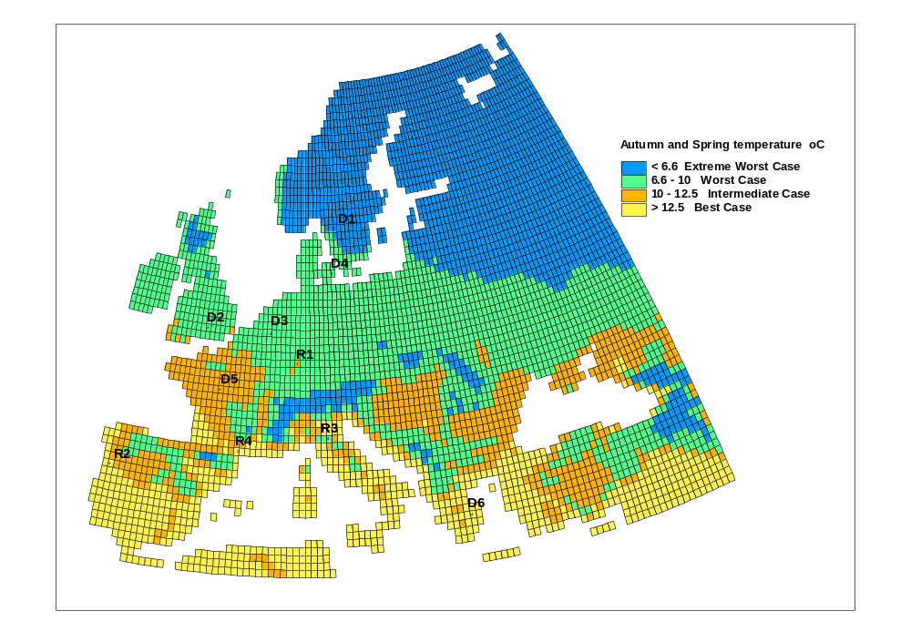
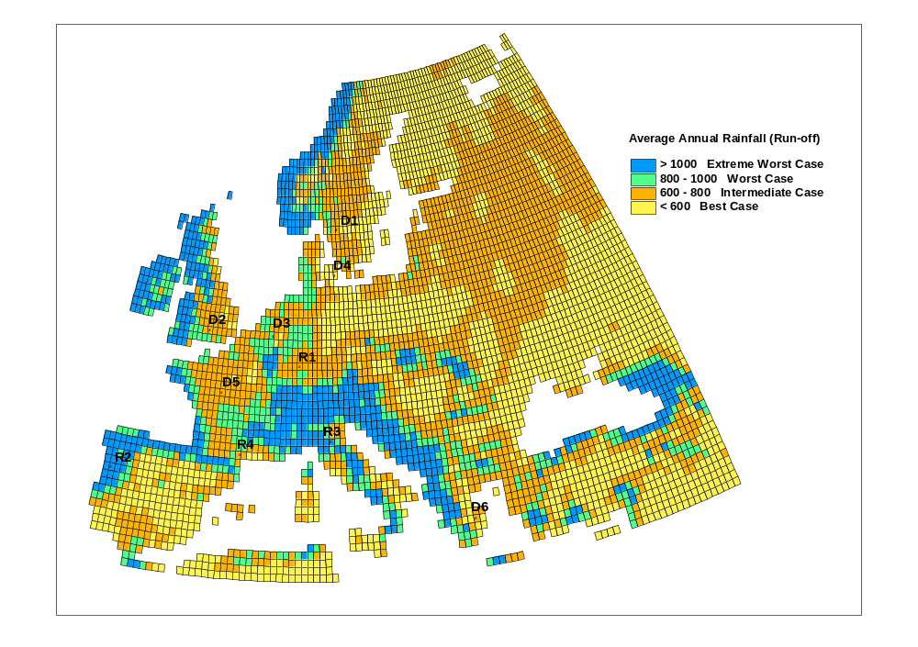
Fig. 3.2-2. Distribution of temperature and rainfall climatic ranges within the agricultural areas of Europe. The location of the meteorological stations used to characterise each scenario (see section 4.1.2) is also shown.
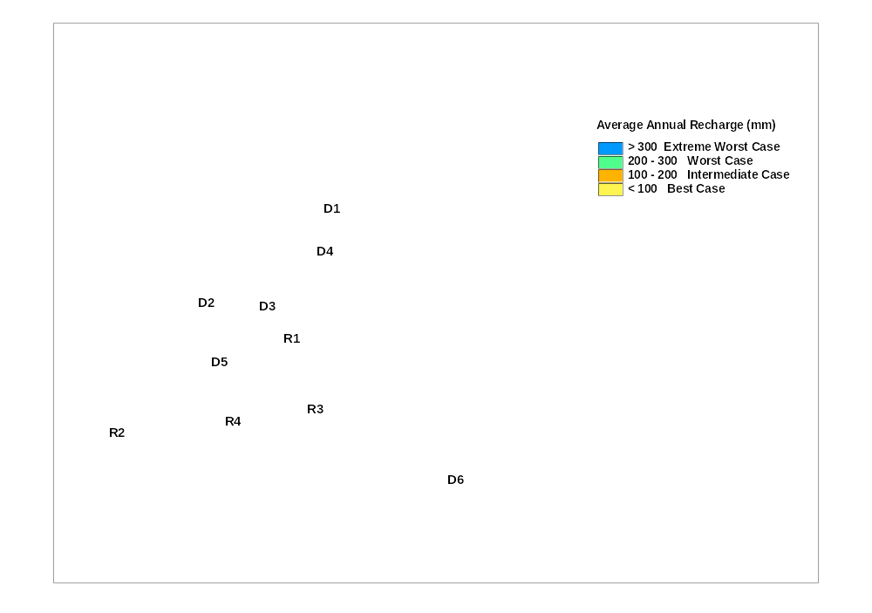
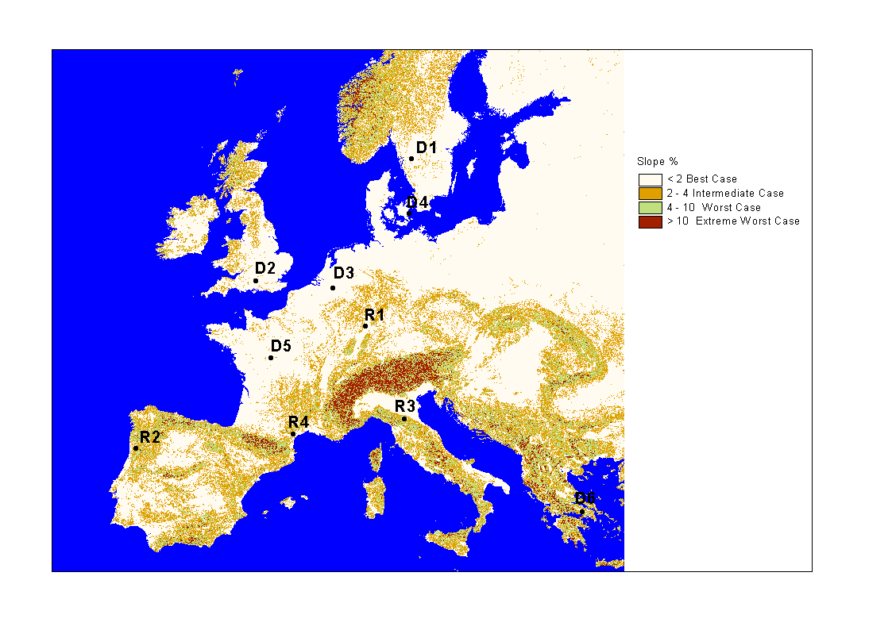
Fig. 3.2-3. Distribution of average annual recharge and slope ranges within the agricultural areas of Europe. The location of the meteorological stations used to characterise each scenario (see section 4.1.2) is also shown.
Table 3.2-6 Inherent Agro-environmental characteristics of the Surface water scenarios.
Scenario | Mean spring & autumn temp.(ºC) | Mean annual rainfall (mm) | Mean annual recharge (mm) | Slope (%) | Soil
D1 | <6.6 | 600 – 800 | 100 – 200 | 0 – 0.5 | Clay with shallow groundwater
D2 | 6.6 – 10 | 600 – 800 | 200 – 300 | 0.5 – 2 | Clay over impermeable substrate
D3 | 6.6 – 10 | 600 – 800 | 200 – 300 | 0 – 0.5 | Sand with shallow groundwater
D4 | 6.6 – 10 | 600 – 800 | 100 – 200 | 0.5 – 2 | Light loam over slowly permeable substrate
D5 | 10 – 12.5 | 600 – 800 | 100 – 200 | 2 – 4 | Medium loam with shallow groundwater
D6 | >12.5 | 600 – 800 | 200 – 300 | 0 – 0.5 | Heavy loam with shallow groundwater
R1 | 6.6 – 10 | 600 – 800 | 100 – 200 | 2 – 4 | Light silt with small organic matter
R2 | 10 – 12.5 | >1000 | >300 | 10 – 15 | Organic-rich light loam
R3 | 10 – 12.5 | 800 – 1000 | >300 | 4 – 10 | Heavy loam with small organic matter
R4 | >12.5 | 600 – 800 | 100 – 200 | 4 – 10 | Medium loam with small organic matter
Table 3.2-7. Relative inherent worst-case characteristics for non-irrigated drainage scenarios
Scenario | Temperature | Recharge | Soil
D1 | Extreme worst case | Intermediate case | Worst case
D2 | Worst case | Worst case | Extreme worst case
D3 | Worst case | Worst case | Worst case
D4 | Worst case | Intermediate case | Intermediate case
D5 | Intermediate case | Intermediate case | Worst case
D6 | Best case | Worst case | Worst case

Table 3.2-8 Relative inherent worst-case characteristics for non-irrigated run-off scenarios
Scenario | Temperature | Rainfall | Soil | Slope
R1 | Worst case | Intermediate case | Worst case | Intermediate case
R2 | Intermediate case | Extreme worst case | Intermediate case | Extreme worst case
R3 | Intermediate case | Worst case | Worst case | Worst case
R4 | Best case | Intermediate case | Worst case | Worst case
Finally, using local knowledge and the REGIO cropping databases, each of the 10 identified soil/climate scenarios were characterised in terms of the main range of crops they support (see section 3.3).

3.3 Outline characteristics of the scenarios.
D1
Climate: Cool with moderate precipitation.
Representative Field Site & Weather Station: Lanna, Sweden.
Soil type: Slowly permeable clay with field drains. Seasonally waterlogged by groundwater.
Surface water bodies: Field ditches and first order streams.
Landscape: Gently sloping to level land.
Crops: Grass, winter and spring cereals and spring oilseed rape.
D2
Climate: Temperate with moderate precipitation.
Representative Field Site & Weather Station: Brimstone, UK.
Soil type: Impermeable clay with field drains. Seasonally waterlogged by water perched over impermeable massive clay substrate.
Surface water bodies: Field ditches and first order streams.
Landscape: Gently sloping to level land.
Crops: Grass, winter cereals, winter oilseed rape, field beans.
D3
Climate: Temperate with moderate precipitation.
Representative Field Site & Weather Station: Vredepeel, Netherlands.
Soil type: Sands with small organic carbon content and field drains. Subsoil waterlogged by groundwater.
Surface water bodies: Field ditches.
Landscape: Level land
Crops: Grass, winter & spring cereals, winter and spring oilseed rape, potatoes, sugar beet, field beans, vegetables, legumes, maize, pome/stone fruit.
D4
Climate: Temperate with moderate precipitation.
Representative Field Site & Weather Station: Skousbo, Denmark.
Soil type: Light loam, slowly permeable at depth and with field drains. Slight seasonal water logging by water perched over the slowly permeable substrate.
Surface water bodies: First order streams and ponds.
Landscape: Gently sloping, undulating land.
Crops: Grass, winter & spring cereals, winter and spring oilseed rape, potatoes, sugar beet, field beans, vegetables, legumes, maize, pome/stone fruit.
D5
Climate: Warm temperate with moderate precipitation.
Representative Field Site & Weather Station: La Jaillière, France.
Soil type: Medium loam with field drains. Hard, impermeable rock at depth. Seasonally waterlogged by water perched over the impermeable substrate.
Surface water bodies: First order streams and ponds.
Landscape: Gently to moderately sloping, undulating land.
Crops: Grass, winter & spring cereals, winter and spring oilseed rape, legumes, maize, pome/stone fruit, sunflowers.
D6
Climate: Warm Mediterranean with moderate precipitation.
Representative Field Site & Weather Station: Thiva, Greece.
Soil type: Heavy loam over clay with field drains. Seasonally waterlogged by groundwater.
Surface water bodies: Field ditches.
Landscape: Level land.
Crops: Winter cereals, potatoes, field beans, vegetables, legumes, maize, vines, citrus, olives, cotton.
R1
Climate: Temperate with moderate precipitation.
Representative Field Site & Weather Station: Weiherbach, Germany.
Soil type: Free draining light silt with small organic matter content.
Surface water bodies: First order streams and ponds.
Landscape: Gently to moderately sloping, undulating land.
Crops: Winter cereals, winter & spring oilseed rape, sugar beet, potatoes, field beans, vegetables, legumes, maize, vines, pome/stone fruit, sunflowers, hops.
R2
Climate: Warm temperate with very high precipitation.
Representative Field Site & Weather Station: Porto, Portugal.
Soil type: Free draining light loam with relatively large organic matter content.
Surface water bodies: First order streams.
Landscape: Steeply sloping, terraced hills.
Crops: Grass, potatoes, field beans, vegetables, legumes, maize, vines, pome/stone fruit.
R3
Climate: Warm temperate with high precipitation.
Representative Field Site & Weather Station: Bologna, Italy.
Soil type: Free draining calcareous heavy loam.
Surface water bodies: First order streams.
Landscape: Moderately sloping hills with some terraces.
Crops: Grass, winter cereals, winter oilseed rape, sugar beet, potatoes, field beans, vegetables, legumes, maize, vines, pome/stone fruit, sunflower, soybean, tobacco.
R4
Climate: Warm Mediterranean with moderate precipitation.
Representative Field Site & Weather Station: Roujan, France.
Soil type: Free draining calcareous medium loam over loose calcareous sandy substrate.
Surface water bodies: First order streams.
Landscape: Moderately sloping hills with some terraces.
Crops: Winter & spring cereals, field beans, vegetables, legumes, maize, vines, pome/stone fruit, sunflower, soybean, citrus, olives.

In summary, based on the geographic distribution of agricultural soils, slopes and climatic conditions across Europe, a total of six unique drainage scenarios and four unique runoff scenarios were identified for use in FOCUS. However, it is important to note that the number of crop/scenario combinations associated with each type of scenario are essentially identical with a total of 57 crop/scenario combinations for drainage and 58 crop/scenario combinations for runoff (see table 4.2.1-1).

3.4 Location of the scenarios
The distribution of the 10 surface water scenarios within Europe was examined using the data sources identified in section 3.1. Maps of the climatic classes used to define each scenario are shown in figures 3.2-2 and 3.2-3. The general soil properties used to characterise each scenario (see tables 3.2-4 & 3.2-5) were used to identify relevant soil attributes that characterise Soil Typological Units (STUs) within the 1:1,000,000 scale Soil Geographic Database of Europe (Le Bas et al, 1998). These relationships are shown in Table 3.4-2.
Having identified the climatic and soil characteristics represented by each Scenario, the final stage in identifying areas represented by them was to ensure that each of the selected STUs in the 1:1,000,000 scale Soil Geographic Database of Europe is also associated with at least some of the crops that characterise each scenario. This was also done through the STU attribute database of the Soil Geographic Database of Europe. In this database, each STU is characterised by two land use classes defining its ‘dominant’ and ‘secondary’ land use. The land use classes included in the Soil Geographic Database of Europe are defined in Table 3.4-1 and those used to identify the associated STUs for each Scenario are shown in Table 3.4-3, together with the range of crops defined for each scenario (see section 3.3).
The distribution of each Scenario within Europe was then mapped using the ArcView GIS software. Initially, the soil types corresponding to each scenario were selected by identifying all map units in the 1:1,000,000 scale Soil Geographic Database of Europe that contained an
Table 3.4-1. Land Use classes included in the Soil Geographic Database of Europe
1.Pasture, grassland | 8. Garrigue | 15. Cotton
2. Poplars | 9. Bush, Macchia | 16. Vegetables
3. Arable land | 10. Moor | 17. Olive trees
4. Wasteland, scrub | 11. Halophile grassland | 18. Recreation
5. Forest, coppice | 12. Arboriculture, orchard | 19. Extensive pasture, rough grazing
6. Horticulture | 13. Industrial crops | 20. Dehesa (agriculture-pasture system in Spain)
7. Vineyards | 14. Rice | 21. Artificial soils for orchards in South East Spain
STU with attributes corresponding to those defined in Tables 3.4-2 and 3.4-3. Each of the resulting ten soil scenarios were then refined by intersecting them with the relevant climatic zones for each scenario defined in Table 3.2-1, using the CRU 0.5º longitude by 0.5º latitude grid dataset. The resulting maps (Figs. 3.4-1 to 3.4-10) show the distribution of areas within Europe that are relevant to each of the ten Scenarios. The maps do not mean that the scenarios are relevant to 100% of the areas highlighted. Rather they indicate that in any of the areas highlighted, some part of the agricultural landscape corresponds to the soil, climate and at least one of the cropping characteristics of the specified scenario.
Finally, the complete extent of all drainage scenarios, all runoff scenarios and all 10 surface water scenarios are shown in figures 3.4-11, to 3.4-13.

Table 3.4-2. General soil properties of the FOCUS surface water scenarios and their corresponding STU attributes in the Soil Geographic Database of Europe.
Scenario | General | Corresponding STU attributes
location | soil properties | Soil | Texture class | Parent material | Water management | Water regime
D1 | Clay soil with groundwater at shallow depth | All | 4 | All | WM1: 1  WM2: 1, 4, 5  WM3: 2, 3, 4 | 2, 3, 4
D2 | Clay soil over a soft impermeable clay substrate | All | 4 | 310, 312, 313, 314 | WM1: 1  WM2: 1, 4, 5  WM3: 2, 3, 4 | 2, 3, 4
D3 | Sandy soil with groundwater at shallow depth | Arenosol or Podzol | 1 | All | WM1: 1  WM2: 1, 4, 5  WM3: 2, 3, 4 | 2, 3, 4
D4 | Medium loam with a slowly permeable substrate. | All | 2 | All | WM1: 1  WM2: 1, 4, 5  WM3: 2, 3, 4 | 2, 3, 4
D5 | Medium loam with a perched seasonal water table at shallow depth | All | 2 | All | WM1: 1  WM2: 1, 4, 5  WM3: 2, 3, 4 | 2, 3, 4
D6 | Heavy loam soil with groundwater at shallow depth | All | 2 | All | WM1: 1  WM2: 1, 4, 5  WM3: 2, 3, 4 | 2, 3, 4
R1 | Deep, free draining silty soil | All | 3 | All | WM1: 1  WM2: 2, 4  WM3: 8, 9 | 1
R2 | Deep, free draining, organic-rich light loamy soil | All | 2 | All | WM1: 1  WM2: 2, 4  WM3: 8, 9 | 1
R3 | Deep, free draining medium loam soil | All | 2 | All | WM1: 1  WM2: 2, 4  WM3: 8, 9 | 1
R4 | Deep, free draining medium loam soil | All | 2 | All | WM1: 1  WM2: 2, 4  WM3: 8, 9 | 1
Texture class: 1: Coarse. >65% sand and <18%clay. 2: Medium. 15 to 65% sand and <18%clay, OR >18 to 35% clay and >15% sand. 3: Medium fine. <15% sand and <35% clay. 4. Fine 35% to 50% clay
Parent material: 310, 312, 313, 314: Old clayey sedimentary deposits; Secondary, Tertiary or Pleistocene clay.
Water Management: WM1: 1. Agricultural land normally has a water management system.
WM2: 1. To alleviate water logging.
2. To alleviate drought stress.
4. To alleviate both water logging and drought stress.
5. To alleviate both water logging and salinity.
WM3: 2. Ditches.
3. Pipe under drainage (network of drain pipes).
4. Mole drainage.
8. Overhead sprinkler (system of irrigation by sprinkling).
9. Trickle irrigation.
Water regime: 1: Not wet within 80 cm depth for over 3 months, nor wet within 40 cm for over 1 month.
2: Wet within 80 cm depth for 3 to 6 months, but not wet within 40 cm for over 1 month.
3: Wet within 80 cm depth for over 6 months, but not wet within 40 cm for over 11 months.
4: Wet within 40 cm depth for over 11 months.
Table 3.4-3. Specified crops and associated Soil Typological Unit (STU) land use classes for each surface water scenario.
Scenario | Specified crops | STU land use classes ¹
D1 | Grass (+ alfalfa); winter cereals; spring cereals; spring oil seed rape | 3; 6
D2 | Grass (+ alfalfa); winter cereals; winter oil seed rape; beans (field). | 3; 6
D3 | Grass (+ alfalfa); winter cereals; winter oil seed rape; spring cereals; spring oil seed rape; sugar beet; potatoes; beans (field); cabbage; carrots; onions; peas (animals); maize; apples. | 3; 6; 12; 13; 16
D4 | Grass (+ alfalfa); winter cereals; winter oil seed rape; spring cereals; spring oil seed rape; spring cereals; peas (animals); maize; apples. | 3; 6; 12; 13; 16
D5 | Grass (+ alfalfa); winter cereals; winter oil seed rape; spring cereals; spring oil seed rape; spring cereals; sugar beet; potatoes; beans (field); cabbage; onions; peas (animals); maize; apples; sunflower. | 3; 6; 12; 13; 16
D6 | Winter cereals; potatoes; beans (field); cabbage; carrots; onions; peas (animals); tomatoes; maize; vines; citrus; olive; cotton. | 3; 6; 7; 13; 15; 16; 21
R1 | Winter cereals; winter oil seed rape; spring cereals; spring oil seed rape; sugar beet; potatoes; beans (field); cabbage; carrots; onions; peas (animals); maize; vines; apples; sunflower; hops. | 3; 6; 7; 12; 13; 16
R2 | Grass (+ alfalfa); potatoes; beans (field); cabbage; carrots; onions; peas (animals); tomatoes; maize; vines; apples. | 3; 6; 7; 12; 13; 16; 21
R3 | Grass (+ alfalfa); winter cereals; winter oil seed rape; sugar beet; potatoes; beans (field); cabbage; carrots; onions; peas (animals); tomatoes; maize; vines; apples; sunflower; soybean; tobacco. | 3; 6; 7; 12; 13; 16; 21
R4 | Winter cereals; spring cereals; beans (field); cabbage; carrots; onions; peas (animals); tomatoes; maize; vines; apples; sunflower; soybean; citrus; olive. | 3; 6; 7; 12; 13; 16; 17; 21
¹ STU land use classes refer to the dominant or secondary land use class identified as being typical of each STU in the Soil Geographic database of Europe (see section 3.4). The definition numbers of each land use class code is given in table 3.4-1.

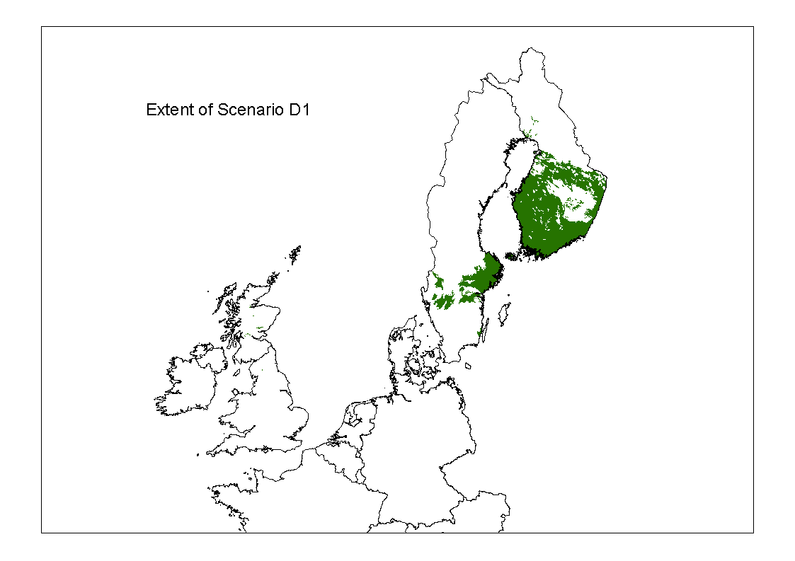 Figure 3.4-1 Distribution of Scenario D1 within Europe
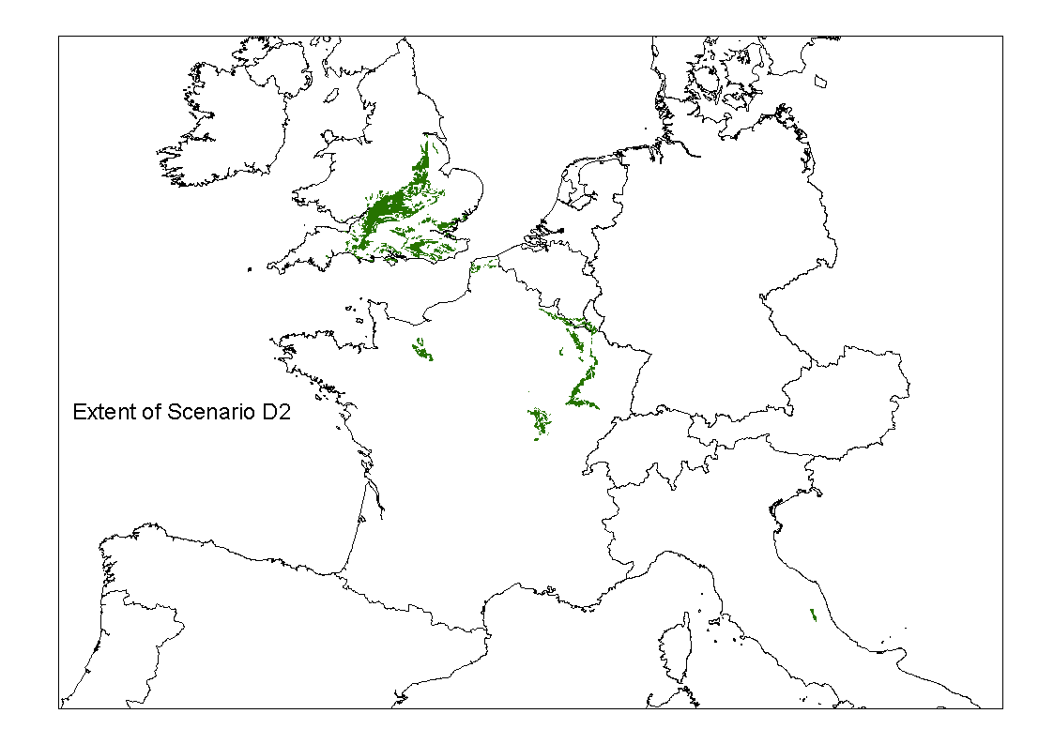 Fig. 3.4-2. Distribution of Scenario D2 within Europe

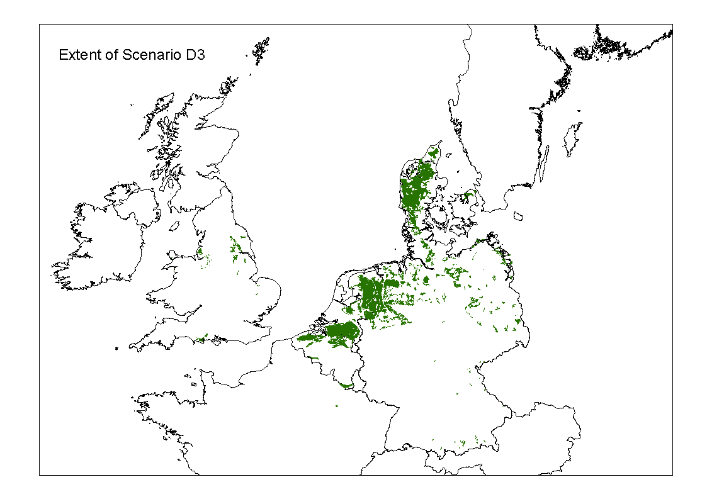 Figure 3.4-3 Distribution of Scenario D3 within Europe
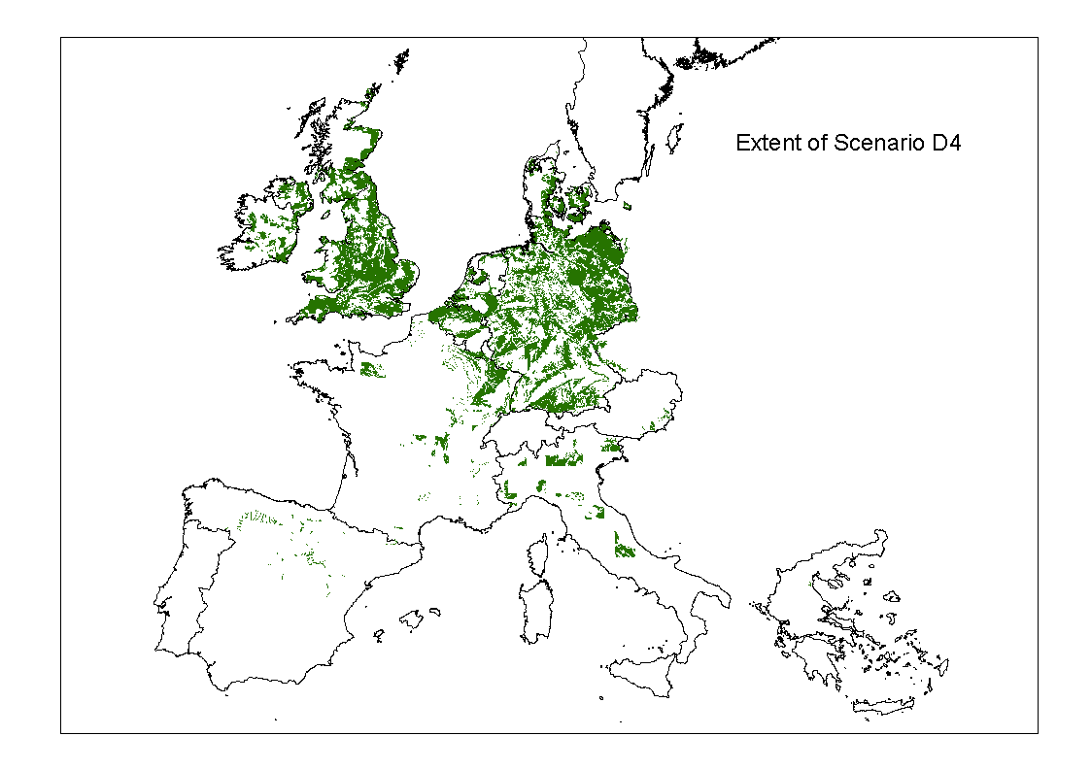 Figure 3.4-4 Distribution of Scenario D4 within Europe
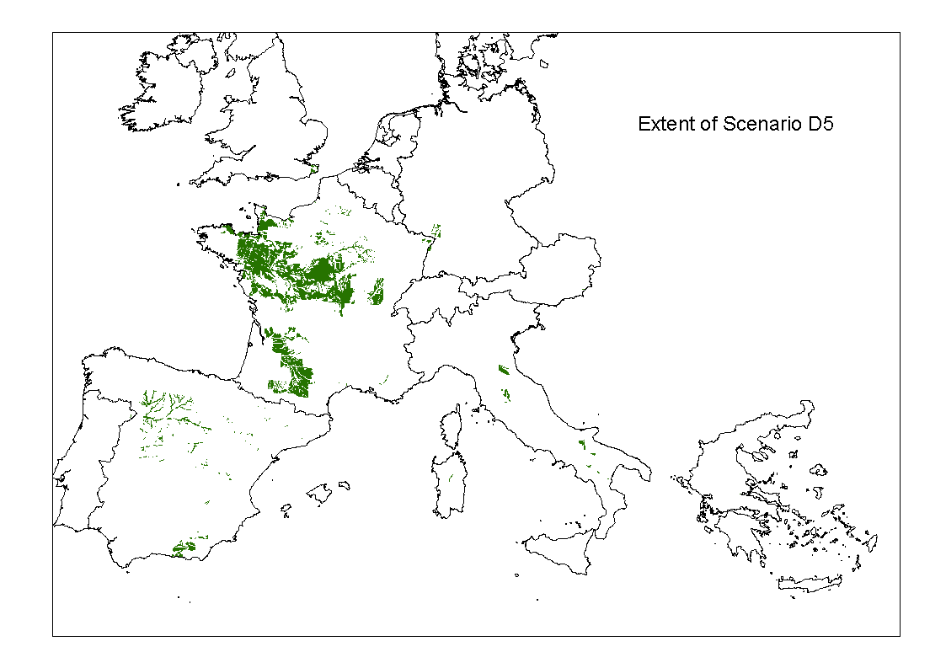 Figure 3.4-5 Distribution of Scenario D5 within Europe
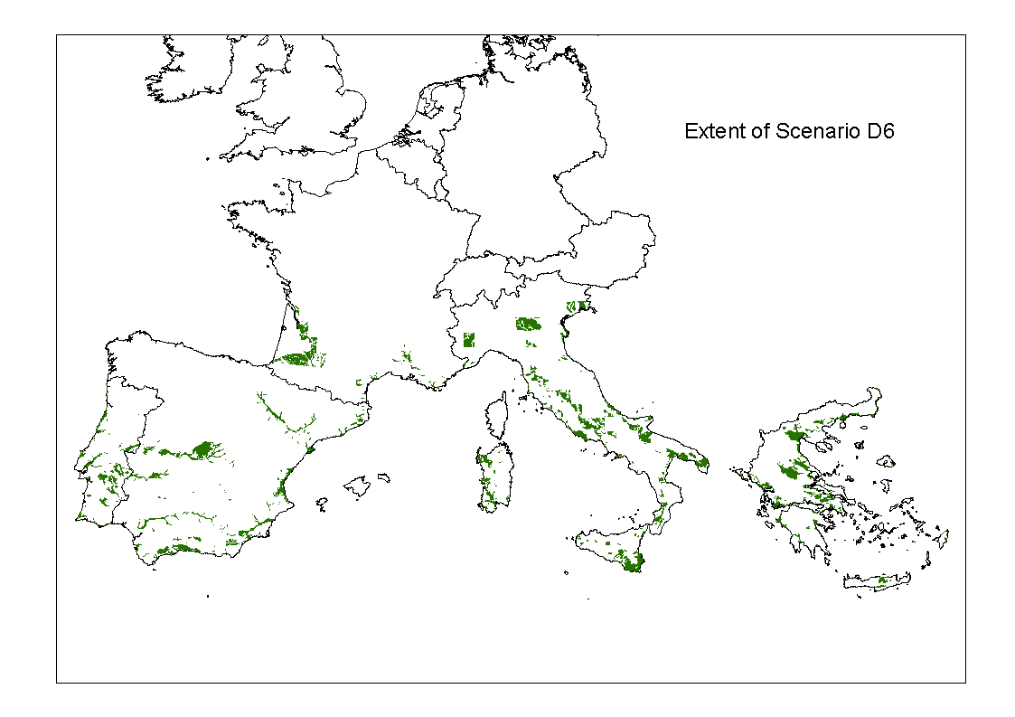 Figure 3.4-6 Distribution of Scenario D6 within Europe
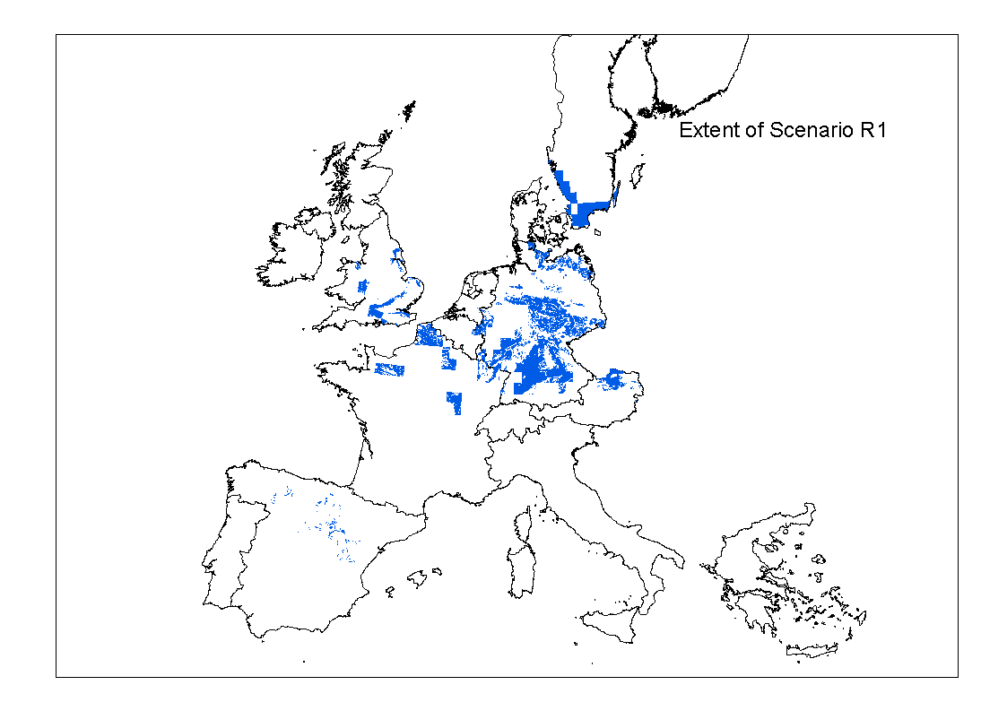 Figure 3.4-7 Distribution of Scenario R1 within Europe
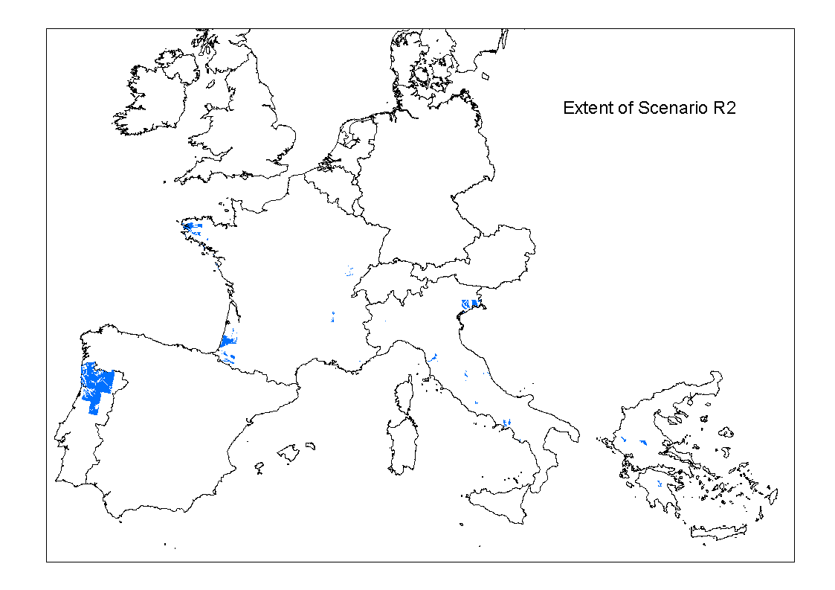 Figure 3.4-8 Distribution of Scenario R2 within Europe
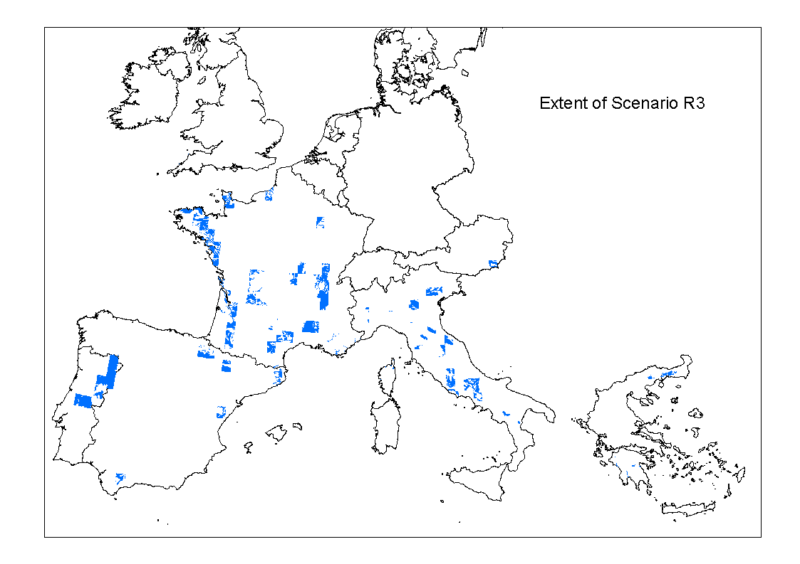 Figure 3.4-9 Distribution of Scenario R3 within Europe
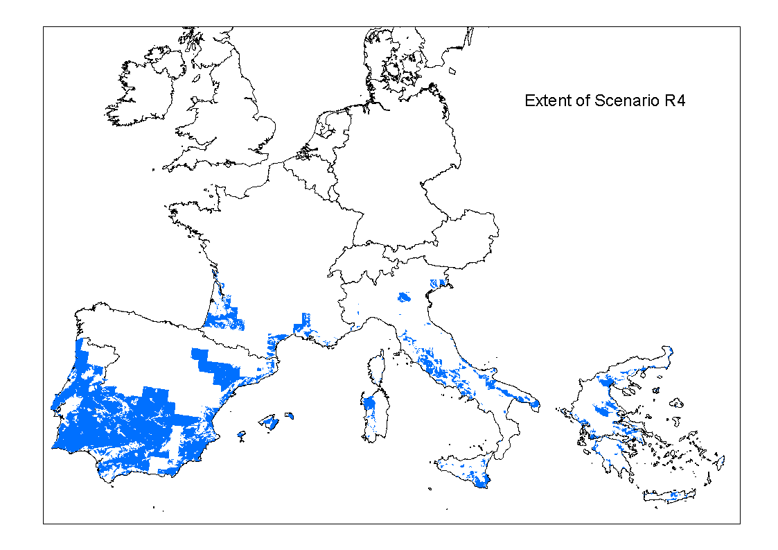 Figure 3.4-10. Distribution of Scenario R4 within Europe
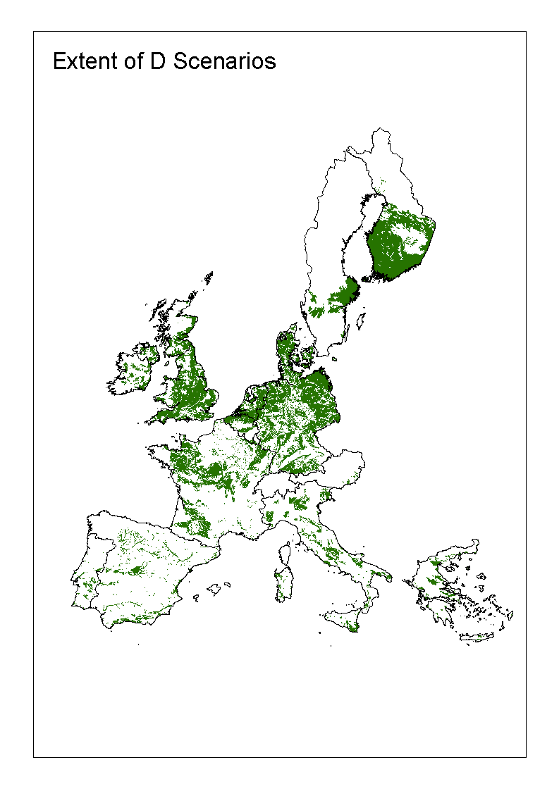 Figure 3.4-11 Distribution of Drainage Scenarios within Europe
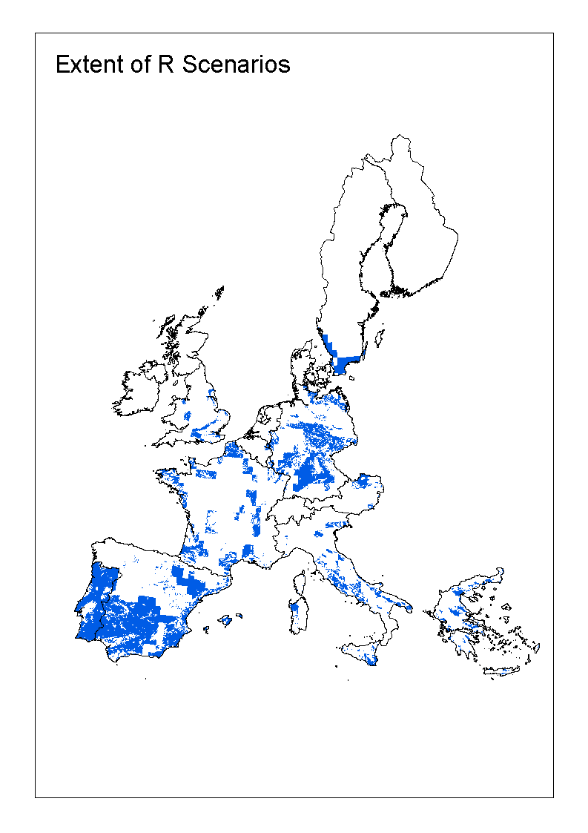Figure 3.4-12 Distribution of Runoff Scenarios within Europe
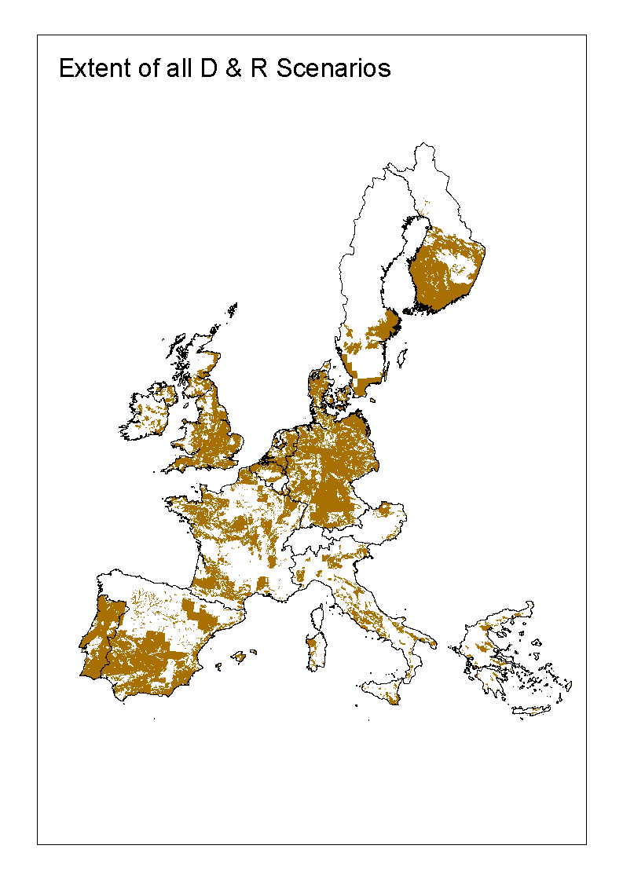 Figure 3.4-13 Distribution of all Surface Water Scenarios within Europe

3.5 Relevance of the scenarios
Statistical data on the extent of each scenario is presented in table 3.5-1. This data relates to each soil and climate combination representative of the scenario. However, it is more specific than the maps shown in figures 3.4-1 to 3.4-10 in that only data for the scenario-specific STU is used, rather than data relating to the soil map unit (SMU) polygons of which the identified STU is a component.
Table 3.5-1 Extent of the ten surface water scenarios within the European Union.
Scenario | Area (km²) | Percentage of total agricultural land
D1 | 15703 | 1.5
D2 | 8459 | 0.8
D3 | 8855 | 0.9
D4 | 44204 | 4.2
D5 | 15999 | 1.5
D6 | 36531 | 3.5
R1 | 75631 | 7.7
R2 | 6779 | 0.7
R3 | 22912 | 2.3
R4 | 95716 | 9.7
Table 3.5-1 shows that the 10 surface water scenarios cover 32.9% of all the agricultural land in the European Union. However, in the regulatory context it is important to know how representative the scenarios are in terms of a worst case for pesticide movement to surface waters. As indicated at the start of this chapter, the lack of comprehensive databases that characterise the environmental characteristics across the European Union mean that it is not possible to undertake a worst-case assessment in a rigorous, statistically-based manner. Instead, the data sources described in section 3.1 were used to examine the extent of land with characteristics that are ‘worse than’ those of the identified scenarios, from the point of view of pesticide movement to surface water.
There are problems when attempting to quantify the overall environmental worst-case nature of each scenario within European agricultural areas. It is not possible to scale the factors of soil, slope, rainfall / recharge and temperature in terms of their relative contribution to an overall worst-case environmental combination. Any one of the factors may be the most important depending on how each set of pesticide-specific application and physico-chemical characteristics interacts with the rainfall patterns and volumes, soil and slope characteristics of each scenario.
In order to simplify the worst-case assessments therefore, they were initially carried out only within each of the four relative worse case temperature ranges defined in section 3.2. The temperature ranges were used to sub-divide the European Union area because they form relatively coherent regions along approximate ‘north – south’ latitudinal lines (see Figure 3.2-2).
Firstly, the ArcMap GIS was used to identify and estimate the extent of all agricultural land in the European Union that is subject to field drainage or significant surface runoff. Such land was identified using the characteristics associated with Soil Typological Units (STUs) in the European Soil Database as shown in table 3.5-2. The distribution of this land is shown in Figures 3.5-1 and 3.5-2. Next, the drained and runoff agricultural land was subdivided according to the four relative worse case temperature ranges and the percentage of each was computed (Table 3.5-3).
Table 3.5-2 Characteristics of Soil Typological Units used to identify ‘Drained’ and ‘Runoff’ agricultural land within the European Union.
Category | PARENT MATERIAL | SOIL | WATER MANAGEMENT & REGIME
Drained land | Any | Any | WM2 =1, 3, 4, 5,  OR  WM1 = 1, AND WR = 2, 3, 4
Runoff land | NOT  100, 110, 111, 112, 113, 120, 130, 131, 420, 430, 520, 521, 523, 910 | NOT  G**, Bg*, Bv*, Dg*, Lg*, Pg*, V*, W*, J*, O* | Any
Parent material:
100, 110, 111, 112, 113, 120: River, estuarine and marine alluvium
130, 131: Glaciofluvial deposits and glacial till
420, 430, 520, 521, 523 Alluvial, glaciofluvial or wind-blown sands, wind-blown loess
910. Organic materials
SOIL
G**, Bg*, Dg*, Lg*, Pg*: All Gleysols; Gleyic Cambisols, Gleyic Podzoluvisols, Gleyic Luvisols and Gleyic Podzols. These are soils affected by a ground water table.
V*, Bv*:. All Vertisols and Vertic Cambisols. These are ‘cracking-clay soils usually formed in level or gently sloping sites.
W*: All Planosols. These are soils with strongly contrasting textural profiles usually formed in basin sites.
J*, O*: All Fluvisols and Histosols. These are recent alluvial soils and peat soils formed in basin sites
Water Management:
WM1: 1. Agricultural land normally has a water management system
WM2: 1. To alleviate water logging.
3. To alleviate salinity.
4. To alleviate both water logging and drought stress.
5. To alleviate both water logging and salinity.
Water regime:
WR: 2: Wet within 80 cm depth for 3 to 6 months, but not wet within 40 cm for over 1 month.
3: Wet within 80 cm depth for over 6 months, but not wet within 40 cm for over 11 months.
4: Wet within 40 cm depth for over 11 months.
Table 3.5-3 Percentage of agricultural drained and runoff land within relative worse case temperature ranges
Relative worse case temperature range | Percentage of drained land | Percentage of runoff land
Extreme Worst Case (< 6.6 ºC) | 17 | 5
Worst Case (6.6 – 10.0 ºC) | 59 | 35.5
Intermediate Case (10.1 – 12.5 ºC) | 13 | 34.5
Best Case (> 12.5 ºC) | 11 | 25

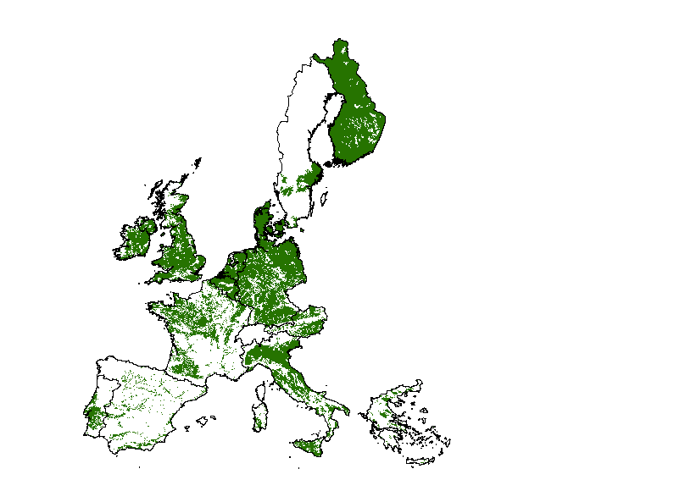
Figure 3.5-1. The distribution of all agricultural ‘drained soils’ in the European Union.

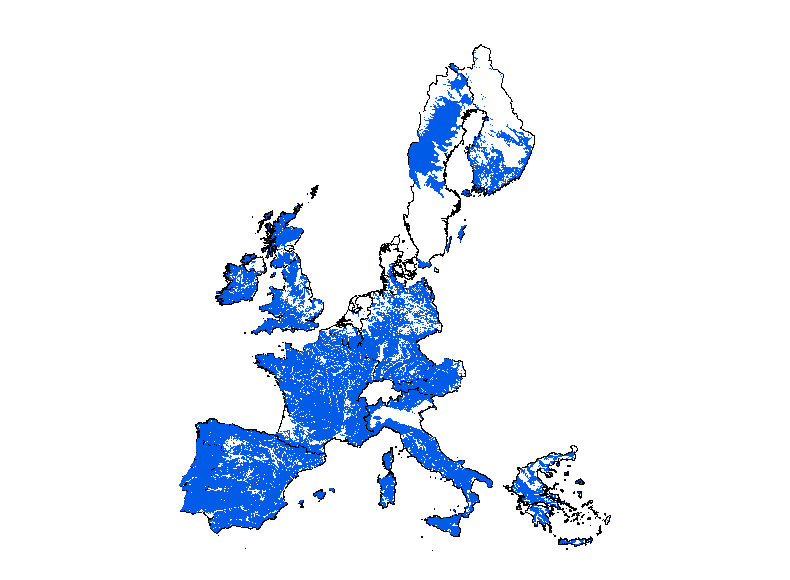
Figure 3.5-2. The distribution of all agricultural ‘runoff soils’ in the European Union.
The percentage of drained or runoff land within each temperature range that had characteristics ‘worse than’ those of each defined scenario was then computed and, using these percentages an overall assessment was made of the percentage worst case represented by each scenario within its relevant temperature range. These assessments and the characteristics used to derive them are shown in tables 3.5-4 and 3.5-5. In defining climatic characteristics worse than those defined for each scenario, average Spring and Autumn temperature, average annual recharge (for drainage scenarios) and average annual precipitation (for runoff scenarios) were used. Those areas with significantly ‘worse’ climatic characteristics than those of each scenario were defined as follows:
- Spring & Autumn temperature at least 0.5 ºC less than that of the scenario as defined from the climatic grid (see section 3.2, above) within which its representative weather dataset falls (see section 4.1, below).
- Average annual recharge at least 10 mm larger than that of the scenario as defined from the climatic grid (see section 3.2, above) within which its representative weather dataset falls (see section 4.1, below).
- Average annual precipitation at least 25 mm larger than that of the scenario as defined from the climatic grid (see section 3.2, above) within which its representative weather dataset falls (see section 4.1, below).

Table 3.5-4 Worst case assessment of the Drainage Scenarios
Temperature range | Scenario | Scenario Characteristics | Characteristics ‘Worse than’ the scenario | % of land worse than the scenario | Worst case assessment
Extreme Worst | D1 | - Clay soil (worst case)  - S & A temp. 6.1 ºC  - Recharge 150 mm | - Heavy clay soil (extreme worst case)  - S & A temp < 5.6 ºC.  - Recharge > 160 mm | - None present  - 17.6% | D1 represents an 82.4 % ile worst case within the ‘Extreme worst’ temperature range
Worst | D2 | - Heavy clay soil (extreme worst case)  - S & A temp.  - Recharge 227 mm | - No soils worse than this.  - S & A temp. covered by D1  - Recharge > 237 mm | - None present  - Covered by D1  - 1.2% | D2 represents a 98 8 % ile worst case within the ‘Worst’ temperature range
Worst | D3 | - Sandy soil (worst case)  - S & A temp  - Recharge 264 mm | - Heavy clay soils  - S & A temp. covered by D1  - Recharge > 274 mm | - Covered by D2  - Covered by D1  - 0.75% | Worse than D2: 4.1%  Extent of D2: 3.7%  Worse than D3: 0.75%.  D3 represents a 91.5 % ile worst case within the ‘Worst’ temperature range
Worst | D4 | - Loamy soil (Intermediate case).  - S & A temp.  - Recharge 150 mm | - Heavy clay, clay and sandy soils  - S & A temp. covered by D1  - Recharge > 160 mm | - Heavy clay & sandy soils covered by D2.  Clay soils 35.6 %  - Covered by D1  - 35.6 % | Worse than D2: 4.1%  Extent of D2: 3.7%  Worse than D3: 0.75%.  Extent of D3: 3.7%  Worse than D4: 35.6 %  D4 represents a 38 % ile worst case within the ‘Worst’ temperature range
Intermediate | D5 | - Heavy loam soil (worst case)  - S & A temp. 11  - Recharge 182 mm | - Heavy clay soils  - S & A temp. < 10.5  - Recharge > 192 mm | - 1%  - 18.5 % | D5 represents an 80 5 % ile worst case within the ‘Intermediate’ temperature range.
Best | D6 | - Heavy loam soil (worst case)  - S & A temp.  - Recharge 280 mm | - Heavy clay soils  - S & A temp covered by D1  - Recharge > 290 mm | - 9%  - Covered by D1  - 12.7 % | D6 represents a 78.3 % ile worst case within the ‘Best’ temperature range
Table 3.5-5 Worst case assessments of the Runoff Scenarios
Temperature range | Scenario | Scenario Characteristics | Characteristics ‘Worse than’ the scenario | % of land worse than the scenario | Worst case assessment
Extreme Worst & Worst | R1 | - Class C soil (worst case)  - S & A temp.  - Slope (Intermediate case)  - Rainfall 744 mm | - Class D soil (Extreme worst case)  - Extreme worst case  - Worst and Extreme Worst case  - Rainfall > 769 mm | - 5.6%  - 12.4%  - 5.0%  - 4.8 % | R1 represents a 72.6 %ile worst case within the ‘Extreme worst’ & ‘Worst’ temperature range
Intermediate | R2 | - Class B soil (intermediate case)  - S & A temp.  - Slope (Extreme worst case  - Rainfall 1402 mm | - Class C & D soils  - Covered by R1  - None worse than this  - Rainfall > 1427 mm | - 1%  - Covered by R1  - None worse  - 0.9% | R2 represents a 98.1 %ile worst case within the ‘Intermediate’ temperature range
Intermediate | R3 | - Class C soil (Worst case)  - S & A temp.  - Slope (Worst case)  - Rainfall 846 mm | - Class D soil  - Covered by R1  - Covered by R2  - Rainfall >> 871 mm | - 4.3%  - Covered by R1  - Covered by R2  - 7.2% | Worse than R2: 1.9%  Extent of R2: 3.5%  Worse than R3: 11.5%.  R3 represents an 83.1 %ile worst case within the ‘Intermediate’ temperature range
Best | R4 | - Class C soil (Worst case)  - S & A temp.  - Slope (Worst case)  - Rainfall 756 mm | - Class D soil  - Covered by R1, R2n & R3  - Covered by R2  - Rainfall > 781 mm | - 4.5%  - Covered by R1, R2 & R3  - Covered by R2  - 18.3% | R4 represents a 77.2 %ile worst case within the ‘Intermediate’ temperature range

The results in tables 3.5-4 and 3.5-5 show that drainage scenarios represent between a 78th percentile and 97th percentile worst case for each of the four temperature ranges. Within the extreme worst and worst case temperature ranges scenarios D1 and D2 represent an 82nd percentile and 96th percentile worst case respectively. Runoff scenarios represent between a 73rd and 99th percentile worst case for each of the four temperature ranges. Within the extreme worst and worst case temperature range, R1 represents a 72nd percentile worst case, whereas within the intermediate temperature range R2 represents a 98th percentile worst case. The data is summarised in Figure 3.5-3.
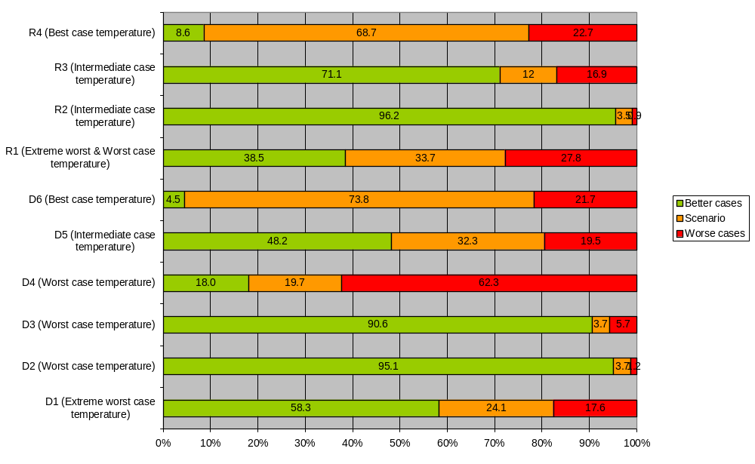
Figure 3.5-3. Worst case assessment of the ten Surface Water Scenarios within their relative worst-case temperature ranges.
Based on these assessments and the combination of relative worse case characteristics for each scenario given in tables 3.2-7 and 3.2-8, the following overall worst-case assessments were made:
DRAINAGE
Scenario D2 combines an extreme worst-case soil with a worst case recharge and represents a 98.8 percentile worst case for drainage within the worst case temperature range. The extreme worst case temperature range contains no extreme worst case soils, nor does it contain any agricultural land with significantly larger recharge values than D2. The only drained land ‘worse than D2 is thus the 1.2% of areas within the worst-case temperature range that have significantly larger recharge (see table 3.5-4). These areas represent 0.7% of all drained land (1.2% of worst case temperature drained agricultural land, which is 59% of all drained land). D2 thus represents a 99.3 percentile worst case for all drained agricultural land.
RUNOFF
Scenario R2 combines an extreme worst-case slope with an extreme worst-case rainfall and it represents a 98.1 percentile worst case for runoff within the intermediate case temperature range. There are no worse slopes under agriculture within all the runoff agricultural land in Europe. The only significantly worse areas of rainfall within all the agricultural runoff land occur in the intermediate temperature range where they represent 0.9 % of the agricultural runoff land. Worse-case runoff soils (hydrologic classes C & D) occur within the worst and extreme worst case temperature land but areas with more than 1402 mm of rainfall occupy only 1.3% of the total agricultural runoff land. The only agricultural runoff land ‘worse than’ R2 is thus this 1.3% of agricultural runoff land and the 0.9% of areas within the intermediate-case temperature range that have significantly larger rainfall plus the 1% of areas within the intermediate-case temperature range with class C or D soils (see table 3.5-5). These areas represent 2.0% of all runoff land (1.3 % plus 1.9% of intermediate case temperature agricultural runoff land, which is 34.5% of all agricultural runoff land). R2 thus represents a 98 percentile worst case for all agricultural runoff land.
These overall worse case assessments of scenario environmental characteristics are summarised in Figure 3.5-4. It is important to emphasise that these assessments apply only to the combination of general environmental characteristics that were used to identify the 10 surface water scenarios. In order to understand how these worst-case assessments compare with other realistic worse-case assumptions used to characterise the scenarios for model parameterisation, the reader should refer to section 4.6.

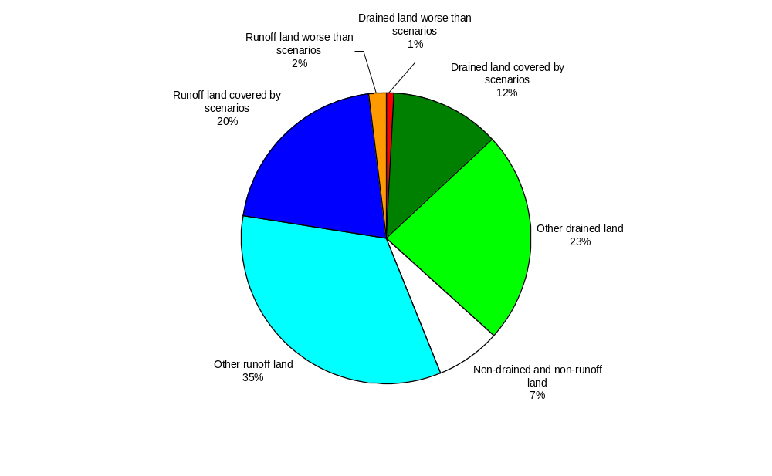
Figure 3.5-4. Overall assessment of the relevance of the ten Surface Water Scenarios to European Union agriculture.

3.6 Assessment of the amount of European agriculture ‘Protected” by each scenario.
The following principles were used in estimating the percentage of agricultural land ‘protected’ by each scenario.
- Drainage scenarios do not protect runoff scenarios and vice versa.
- Land not subject to drainage or runoff (7 % of EU agriculture, see figure 3.5-3) is not relevant for surface water risk assessment and is thus not taken into account in the estimations.
- Each of the environmental characteristics that were used to define the scenario (temperature, recharge or rainfall, soil and slope), is given equal weight.
This is because, depending on the characteristics of the compound under evaluation, any of the environmental characteristics considered could be the most important factor determining environmental fate. Thus, some compounds may be more sensitive to variations in temperature than to variations in soil, rainfall or slope properties whereas others may be most sensitive to soil properties, etc.

Using these principles, the amount of land that is protected by each scenario was calculated and expressed as a percentage of the total amount of agricultural drained and runoff land. When deriving assessments of the amount of land with worse environmental characteristics than those of each scenario, the temperature value was always calculated first. Subsequent assessments for soil, recharge or rainfall and slope were then only carried out on land which had the same or ‘better’ (i.e. higher) temperature than that of the scenario under consideration. This avoided ‘double-counting’ of land already classed as having a worse temperature than that of the scenario under consideration. However this procedure places a strong emphasis on temperature as an environmental driver of pesticide fate and means that scenarios in the ‘best-case’ (i.e. warmest) temperature range (D6 & R4) are always estimated to protect the smallest amount of total agricultural drained and runoff land (see tables 3.6-1 & 3.6-2). Because of this and because the range of crop / irrigation combinations associated with scenarios D1, D2, D3, D4, D5 and R1 are essentially relevant to Northern European agriculture, whereas the crop / irrigation combinations associated with scenarios D6, R2, R3 and R4 are essentially relevant to Southern European agriculture, an additional regionalized assessment was made of the amount of ‘relevant’ European agricultural land protected by each scenario. This adjustment was made by using all agricultural land in the extreme worst- and worst-case temperature ranges as representing ‘Northern’ European agriculture and all agricultural land in the intermediate- and best-case temperature ranges as representing ‘Southern’ European agriculture. On this basis, Northern European agriculture represents 54% of all agricultural drained and runoff land in the EU whereas Southern European agriculture represents 46% of all such land.
Tables 3.6-1 and 3.6-2 show the results of these assessments. Each gives details of the amount of land that has ‘worse’ environmental characteristics than those of each individual scenario, together with the amount of land that is either drained or subject to runoff (see figure 3.5-3). These values are then added to give the amount of land that is ‘not protected’ by each scenario and hence, the total drained and runoff land in the EU that is ‘protected’. Finally the value for the total protected land is adjusted to provide a Regionalized assessment value for either Southern or Northern European crops
When interpreting the tables, it is important to remember that the values are simply estimates based on the methods described in section 3.5 and the derived values given in tables 3.5-1, 3.5-3 and 3.5-4 and figure 3.5-3. They are not based on robust statistical data for individual environmental characteristics, as such data is not yet available at a harmonised European level. They are therefore subject to uncertainty such that differences of a few percent should not be used as a reliable indicator of significant differences between scenarios.
In summary, the tables show that a combination of any single drainage scenario and any single runoff scenario protects at least 15% of all agricultural drained and runoff land in the EU and at least one-third (33%) of all relevant agricultural land when regionalized cropping is taken into account.

Based on these results it is estimated that a favourable risk assessment for any single drainage scenario or any single runoff scenario should protect a significant area (at least >5 %) of relevant European agriculture and thus should be adequate for achieving Annex 1 listing.

Table 3.6-1. Assessment of the amount of European agricultural land ‘protected’ by each Drainage scenario.
Drainage Scenario | D1 | D2 | D3 | D4 | D5 | D6
Area of drained land with a ‘worse’ Temperature expressed as a % of all drained and runoff land | 1.2 | 6.6 | 6.6 | 6.6 | 29.6 | 34.7
Area of drained land with a ‘worse’ Soil expressed as a % of all drained and runoff land | 0.9 | 0 | 1.3 | 17.9 | 0.4 | 0.4
Area of drained land with a ‘worse’ Recharge expressed as a % of all drained and runoff land | 8.3 | 1.4 | 1.2 | 9.3 | 1.8 | 0.5
TOTAL area of drained land with ‘worse’ characteristics expressed as a % of all drained and runoff land | 10.4 | 8.0 | 9.1 | 33.8 | 31.8 | 35.6
Total Runoff Land expressed as a % of all drained and runoff land | 59 | 59 | 59 | 59 | 59 | 59
Total area of land ‘unprotected’ expressed as a % of all runoff and drained land | 69.4 | 67 | 68.1 | 92.8 | 90.8 | 94.6
Total area of land ‘protected’ expressed as a % of all runoff and drained land | 30.6 | 33 | 31.9 | 7.2 | 9.2 | 5.4
Total area of land ‘protected’ expressed as a % of all runoff and drained land in Northern European agriculture | 55.0 | 61.0 | 59.1 | 13.3 | 16.9 | n.a.
Total area of land ‘protected’ expressed as a % of all runoff and drained land in Southern European agriculture | n.a. | n.a. | n.a. | n.a. | n.a. | 11.7

Table 3.6-2. Assessment of the amount of European agricultural land ‘protected’ by each Runoff scenario.
Runoff Scenario | R1 | R2 | R3 | R4
Area of runoff land with a ‘worse’ Temperature expressed as a % of all drained and runoff land | 13.1 | 24.7 | 24.7 | 45.8
Area of runoff land with a ‘worse’ Soil expressed as a % of all drained and runoff land | 3.0 | 14.5 | 3.0 | 0.7
Area of runoff land with a ‘worse’ Rainfall expressed as a % of all drained and runoff land | 6.6 | 0.4 | 4.1 | 2.8
TOTAL area of runoff land with ‘worse’ characteristics expressed as a % of all drained and runoff land | 22.2 | 39.6 | 32.4 | 50.9
Total Drained Land expressed as a % of all drained and runoff land | 39 | 39 | 39 | 39
Total area of land ‘unprotected’ expressed as a % of all runoff and drained land | 61.2 | 78.6 | 71.4 | 89.9
Total area of land ‘protected’ expressed as a % of all runoff and drained land | 38.8 | 21.4 | 28.6 | 10.1
Total area of land ‘protected’ expressed as a % of all runoff and drained land in Northern European agriculture | 71.9 | n.a. | n.a. | n.a.
Total area of land ‘protected’ expressed as a % of all runoff and drained land in Southern European agriculture | n.a. | 46.6 | 62.1 | 21.9

3.7 References
BBA (2000), Bekanntmachung über die Abtrifteckwerte, die bei der Prüfung und Zulassung von Pflanzenschutzmitteln herangezogen werden. (8. Mai 2000) in : Bundesanzeiger No.100, amtlicher Teil, vom 25. Mai 2000, S. 9879.
Carsel, R.F., J.C. Imhoff, P.R. Hummel, J.M. Cheplick & A.S. Donigian, Jr, 1995. PRZM-3. A Model for Predicting Pesticide and Nitrogen Fate in the Crop Root and Unsaturated Soil Zones. Users Manual for Release 3.0. National Exposure Research Laboratory, U.S. Environmental Protection Agency, Athens, GA, USA.
Hulme, M., Conway, D., Jones, P.D., Jiang, T., Zhou, X., Barrow, E.M. & Turney, C. (1995). A 1961-90 Gridded Surface Climatology for Europe, Version 1.0, June 1995. A report Accompanying the Datasets Available through the Climate Impacts LINK project. Climate Research Unit, School of Environmental Sciences, University of East Anglia, Norwich, UK. 50 pp.
Knoche, Klein & Lepper (1998). Development of criteria and methods for comparison and applicability of regional environmental conditions within the EU member states. Report of the German environmental agency, No. 126 05 113, Berlin.
Le Bas, C., King, D., Jamagne, M. & Daroussin, J. (1998). The European Soil Information System. In: Land Information Systems: Developments for planning the sustainable use of land resources. H.J. Heineke, W. Ecklemann, A.J. Thomasson, R.J.A. Jones, L. Montanarella & B. Buckley (Eds.). European Soil Bureau Research Report No. 4, EUR 17729 EN, 33-42. Office for Official Publications of the European Communities, Luxembourg.
Thornthwaite, C.W. (1948) An approach towards a rational classification of climate. Geogr. Rev. 38:55-94
Thornthwaite, C.W. and Mather, J.R. (1957) Instructions and tables for computing potential evapotranspiration and the water balance. Drexel Institute of Technology, Laboratory of Climatology, Volume X, Number 3, Centerton, New Jersey.

4. CHARACTERISATION OF THE SCENARIOS
Having identified the outline characteristics of the ten Step 3 ‘realistic worst-case’ surface water scenarios and mapped their distribution within Europe, the next stage is to derive relevant weather, crop, soil, surface water and spray drift datasets specific to each one. This was achieved mainly using data from the representative ‘field sites’ identified for each scenario during the first phase of scenario development (see section 3.1.2, p. 36).

4.1 Weather
All those models recommended in the report of the FOCUS Surface Water Modelling Working Group (EC 1996) require daily weather data as input, with variables relating mostly to precipitation, temperature and evapotranspiration. Long time series are also required to ensure that a representative range of weather conditions is taken into account.

4.1.1 Description of the primary data source: the MARS data base
The Space Applications Institute of the Joint Research Centre (JRC) at Ispra, Italy, hold long-term weather data, compiled as part of the Monitoring Agriculture by Remote Sensing (MARS) project (Vossen and Meyer-Roux, 1995). The data were derived using a method developed by the DLO-Staring Centre for Agricultural Research in the Netherlands (van der Voet, et al., 1994). The MARS meteorological database contains daily meteorological data spatially interpolated on 50 x 50 km² grid cells. The original weather observations data set originate from 1500 meteorological stations across Europe, Maghreb countries and Turkey, and are based on daily data for the period 1971 to 1998 (Terres, 1998). They were compiled from data purchased from various national meteorological services, either directly or via the Global Telecommunication System. Some of the data were obtained from the national meteorological services under special copyright and agreements for MARS internal use only. The original station data are thus not generally available and only interpolated daily meteorological data are provided to characterise the scenarios.
In the MARS database, the basis for interpolation is the selection of a suitable combination of meteorological stations for determining the representative meteorological conditions for a grid cell. The selection procedure relies on the similarity of the station and the grid centre. This similarity is expressed as the results of a scoring algorithm that takes the following characteristics into account:
- Distance
- Difference in altitude
- Difference in distance to coast
- Climatic barrier separation
The following weather parameters are available:
- Date
- Minimum air temperature
- Maximum air temperature
- Precipitation
- Wind speed
- Vapour pressure deficit
- Calculated potential evaporation (Penman equation)
- Calculated global radiation following Ångströms formula (sunshine hours based), Supit formula (cloudiness and temperature based) and Hargreaves (temperature based).
The MARS dataset was found to be the most appropriate source for establishing the weather files for the FOCUS surface water scenarios. Daily weather data for the selected scenarios for a period of 20 years were transferred to the working group, after negotiating the intellectual property rights and data use with the data provider.

4.1.2 Identifying the relevant dataset
Using the representative field sites identified for each scenario, the most relevant 50 km x 50 km grid cell was identified and the corresponding long-term weather dataset selected for use. The names of the weather datasets for each scenario are given in table 4.1.2-1 below and their locations are shown in figures 3.2-2 and 3.2-3 in relation to the climatic ranges used to derive the outline scenarios.
Table 4.1.2-1. Weather datasets used to characterise each scenario
Scenario | Selected weather dataset: | Latitude | Longitude
D1 | Lanna (S) | 58 20 N | 13 03 E
D2 | Brimstone (UK) | 51 39 N | 01 38 W
D3 | Vredepeel (NL) | 51 32 N | 05 52 E
D4 | Skousbo (DK) | 55 37 N | 12 05 E
D5 | La Jailliere (F) | 47 27 N | 00 58 E
D6 | Thiva (GR) | 38 23 N | 23 06 E
R1 | Weiherbach (D) | 49 00 N | 08 40 E
R2 | Porto (P) | 41 11 N | 11 24 W
R3 | Bologna (I) | 44 30 N | 11 24 E
R4 | Roujan (F) | 43 30 N | 03 19 E
Figures 4.1.2-1 to -2 illustrate the climatic differences between each scenario, with respect to average annual temperature, precipitation and potential evapotranspiration.
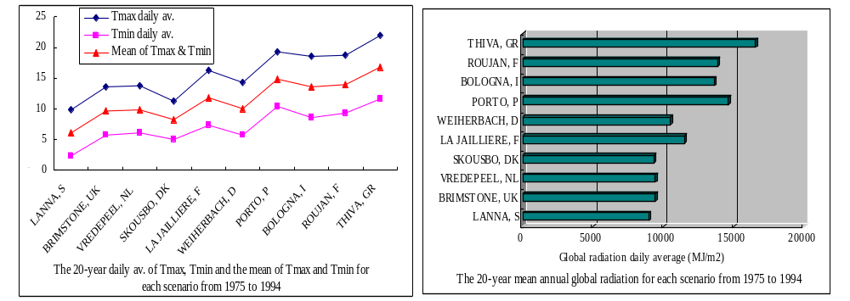
Figure 4.1.2-1 Temperature and Global Radiation for the ten Surface Water Scenarios

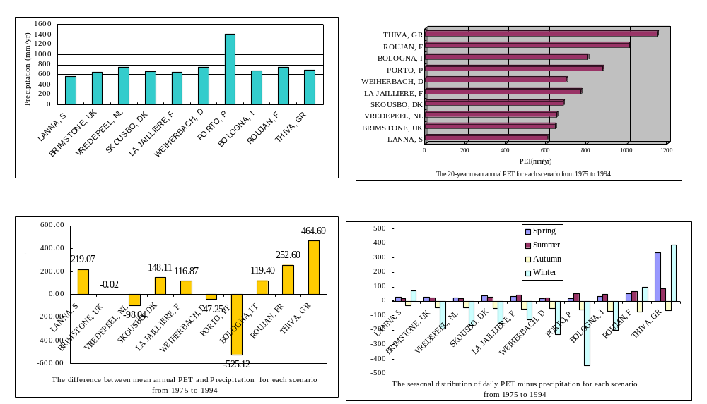
Figure 4.1.2-2 Rainfall and Potential Evapotranspiration for the ten Surface Water Scenarios
Some of the selected models, particularly MACRO and TOXSWA, take significant time to undertake their computations for long-term simulations. In order to limit such ‘run-time’ problems, it was decided to undertake PEC calculations for a single ‘representative’ year only. Further, because the scenarios defined already include some realistic worst case characteristics in terms of their climate (see tables 3.2-2 and 3.2-3), it was decided that the selected year for simulation should be on the basis of a ‘50th percentile’ year.
For drainage, the 50th percentile year for each scenario was originally selected according to annual rainfall totals. The MACRO model was then run using the site-specific long-term weather series data sets to check that the water balance for the selected year adequately represents the 50th percentile simulated water balance for the long-term time series. All simulations were run assuming a winter cereal crop because this is the only crop that is grown at all six scenarios. It should be noted however, that the water balances for other crops will be different. Simulations were run according to the FOCUS procedure described in section 5.5.3 (i.e. a six year warm-up period followed by the sixteen month assessment period), and compared to continuous simulations run for a much longer period (20 years in four scenarios, but only 14 years at Lanna and 18 years at Thiva). The results are given in table 4.1.2-2.
They show that the drainage predicted by MACRO varies between 115 mm/year at D4 to 264 mm/year at D3. In four cases, the simulated drainage in FOCUS is within 5% of the simulated long-term average value. For D2, the drainage is 8% smaller than the long-term average, while for D4, the drainage is 17% larger than the 20-year average. These results must be considered as an acceptable approximation to the 50th percentile hydrological year. As parameterised in MACRO, deep percolation to groundwater varies from zero for both D3 and D5 to 34 mm/year for D4. Evapotranspiration for continuous winter wheat varies from c. 400 mm/year for the clayey scenarios of D1, D2 and D6 to slightly more than 500 mm/year in the loamy soil of scenario D4.
Table 4.1.2-2 Water balances predicted by MACRO for the drainage scenarios for winter wheat. All figures are in millimetres, for the last 12 months of the 16-month simulation (1/5 to 30/4). Figures in parentheses represent the 50th percentile water balance components predicted by the model for 20 year simulations (1975-1994; except for D1, 14 years between 1980 and 1993, and D6, 18 years between 1977 and 1994).
Scenario | Selected weather year | Precipitation | Drainage | Percolation | Evapo-transpiration | Runoff
D1 | 1982 | 538 (556) | 136 (130) | 19 (18) | 366 (400) | 0 (0)
D2 | 1986 | 623 (642) | 212 (230) | 15 (15) | 402 (393) | 0 (0)
D3 | 1992 | 693 (747) | 264 (274) | 0 (0) | 484 (460) | 0 (0)
D4 | 1985 | 692 (659) | 115 (98) | 35 (34) | 564 (517) | 0 (3)
D5 | 1978 | 627 (651) | 182 (177) | 0 (0) | 443 (468) | 3 (4)
D6 | 1986 | 733 (683) | 259 (263) | 21 (17) | 475 (398) | 0 (4)

For runoff scenarios, hydrological flows vary greatly according to season. It was therefore necessary to identify a 50th percentile hydrological year for each season during which application events occurred. Each runoff scenario thus has three different selected weather years depending upon the date of the first application event. In addition, runoff fluxes are much more dependent on the magnitude of individual daily events than is the case with drainage fluxes. Representative 50th percentile weather years were therefore chosen by running PRZM using the site-specific long-term weather series and selecting a year according to a combination of factors including daily, cumulative seasonal and cumulative annual runoff and erosion values. The identified representative 50th percentile years for each scenario are given in table 4.1.2-3.
Table 4.1.2-3. Representative 50th percentile weather years for runoff (based on analysis of data for a representative irrigated crop, maize)
Scenario | Selected Year for Each Application Season
Scenario | Spring  (Mar to May Application) | Summer  (Jun to Sep Application) | Autumn  (Oct to Feb Application)
R1 | 1984 | 1978 | 1978
R2 | 1977 | 1989 | 1977
R3 | 1980 | 1975 | 1980
R4 | 1984 | 1985 | 1979
As for the drainage scenarios, the runoff model PRZM was run using the site-specific long-term weather series data sets to check that the water balance for the selected year and season adequately represents the 50th percentile simulated water balance for the long-term time series. All simulations were run assuming a representative maize crop because this is the only crop that is grown at all four scenarios. As for the equivalent drainage simulations however, the water balances for other crops will be different. Simulations were run according to the FOCUS procedure described in section 5.6.3 (i.e. a 12-month assessment period related to a specific season of application), and compared to continuous simulations run for the full 20 year period represented by the full weather dataset. The results are given in table 4.1.2-4 and show a very good agreement between the selected ‘50th percentile hydrological runoff year’ and the median runoff values.
Table 4.1.2-4 Runoff statistics for selected weather years versus median weather years for a representative irrigated crop (maize)
Runoff  Scenario | Weather  Year | Seasonal Runoff (mm) |  |  | Annual Runoff (mm)
Runoff  Scenario | Weather  Year | Max daily | Total |  | Max daily | Total
Spring
R1 | Selected year (1984) | 3.9 | 7.5 |  | 14.5 | 68.5
 | Median year | 3.7 | 10.6 |  | 13.7 | 66.4
R2 | Selected year (1977) | 11.1 | 47.5 |  | 24.0 | 316.0
 | Median year | 10.5 | 54.7 |  | 19.8 | 301.5
R3 | Selected year (1980) | 9.1 | 23.7 |  | 26.3 | 140.5
 | Median year | 13.3 | 23.4 |  | 24.5 | 124.7
R4 | Selected year (1984) | 13.5 | 31.0 |  | 41.3 | 246.0
 | Median year | 14.1 | 33.0 |  | 41.7 | 283.0
Summer
R1 | Selected year (1978) | 9.6 | 17.3 |  | 14.0 | 14.0
 | Median year | 9.1 | 17.2 |  | 13.7 | 13.7
R2 | Selected year (1989) | 6.8 | 12.0 |  | 24.5 | 307.0
 | Median year | 11.2 | 10.5 |  | 37.9 | 338.0
R3 | Selected year (1975) | 8.0 | 47.3 |  | 25.8 | 143.0
 | Median year | 6.4 | 47.7 |  | 29.0 | 137.0
R4 | Selected year (1985) | 14.7 | 52.8 |  | 41.3 | 260.0
 | Median year | 8.7 | 47.0 |  | 29.6 | 269.0
Autumn
R1 | Selected year (1978) | 10.7 | 43.5 |  | 13.6 | 71.0
 | Median year | 13.7 | 49.6 |  | 13.7 | 70.7
R2 | Selected year (1977) | 21.0 | 230.1 |  | 23.6 | 309.1
 | Median year | 19.8 | 230.1 |  | 42.9 | 309.1
R3 | Selected year (1980) | 20.9 | 68.6 |  | 27.1 | 136.0
 | Median year | 20.9 | 50.0 |  | 31.3 | 136.0
R4 | Selected year (1979) | 40.9 | 167.0 |  | 40.9 | 257.0
 | Median year | 38.6 | 171.0 |  | 38.6 | 257.0

4.1.3 Creating the FOCUS weather files
The procedure used to create the MARS database means that actual meteorological data for a selected representative weather station may deviate from that recorded in the MARS data file. Such deviations can be significant for precipitation data, which remain difficult to interpolate in time and space. As such, generated data from the MARS records do not always correspond to the pre-defined targets. After selecting the representative year for each scenario therefore, the corresponding precipitation datasets were checked against the actual meteorological site data for their consistency and accuracy. Most of the selected MARS weather datasets were sufficiently accurate but the following adjustments were considered necessary for 3 scenarios:
Precipitation data for Lanna and Skousbo derived from the MARS database appeared too low. The MARS-derived precipitation data for Lanna and Skousbo were therefore scaled up to match the average annual precipitation observed for each site. The scaling factors used were 1.431 for Lanna and 1.246 for Skousbo and each resulting ‘scaled-up’ weather dataset still gave an approximate 50th percentile drainage flux.
MARS-derived precipitation data for Bologna also appeared somewhat low compared with the actual site data. This is most likely the result of difficulties in interpolating precipitation data in areas where there is a rapid change in altitude over relatively short distances. The Bologna weather dataset characterises a runoff scenario and thus requires analysis on a seasonal basis (see table 4.1.2-3 above). The Group decided that it was not feasible to undertake an ‘upscaling’ approach for the selected MARS-derived Bologna weather dataset because of considerable uncertainty attached to this process for short, within-season periods in relatively steeply sloping areas. The original MARS-derived weather dataset for Bologna was therefore used to characterise the R3 scenario.

4.1.4 Irrigation: The ISAREG model
Many of the defined scenario/crop combinations represent management systems that normally use irrigation to supplement rainfall. Scenario/crop combinations that are irrigated are shown in table 4.2.1-1. In order to include realistic use of irrigation in the step 3 scenarios, a daily irrigation-scheduling model - ISAREG - was used to calculate amounts and dates for irrigation to be added to the selected rainfall files for the appropriate scenario/crop combinations.
The ISAREG model is different to that chosen to calculate irrigation inputs for the FOCUS Groundwater Scenarios (FOCUS, 2000). This is because, unlike the IRSIS model (Raes, et al, 1988) used with the Groundwater Scenarios, the ISAREG model has been developed and validated for Southern European conditions. It was therefore considered to be particularly appropriate for the runoff scenarios where careful irrigation scheduling is important to avoid excessive runoff. Another factor considered was that ISAREG has been developed by one of the Group members who was thus able to ensure its correct application to each scenario.
The ISAREG model (Teixeira and Pereira, 1992) aims at the computation of dates and volumes of irrigation for a given crop or at the evaluation of a selected irrigation schedule. It incorporates several programs related to crop, soil and meteorological data and is based on a soil water balance calculation that considers a multi-layered soil. The model includes options for taking into account ground water contributions to the water balance, for evaluating different irrigation objectives and for considering water supply restrictions. Six different irrigation objectives are possible:
Option 1. to schedule irrigations aiming at maximum yields, i.e., when actual evapotranspiration, Eta, equals the maximum evapotranspiration, Etm. The available soil water reaches a minimum, Rmin, which corresponds to the lower limit of the easily available soil water (EAW) defined by a selected soil water depletion fraction, p;
Option 2. to select irrigation thresholds like the Eta/Etm ratio, a percentage of the available soil water, a percentage of total soil water (expressed in weight or in volume), or an allowable increase of the (optimal) fraction p;
Option 3. concerns irrigations at fixed dates, with computation of variable irrigation depths, or considering selected irrigation depths;
Option 4. Searches for an optimal irrigation scheduling under conditions of limited water supply, with constant or variable irrigation depths;
Option 5. Executes the water balance without irrigation;
Option 6. Computes the net water requirements for irrigation.
Water supply restrictions can be considered for options 1 and 2, either relative to fixed minimum intervals between irrigations or concerning limited available water supply volumes during one or more time periods to be indicated by the users. In option 2, 3 and 4 the groundwater contribution can be computed.
A simplified flow chart of ISAREG is given in Figure 4.1.4-1.
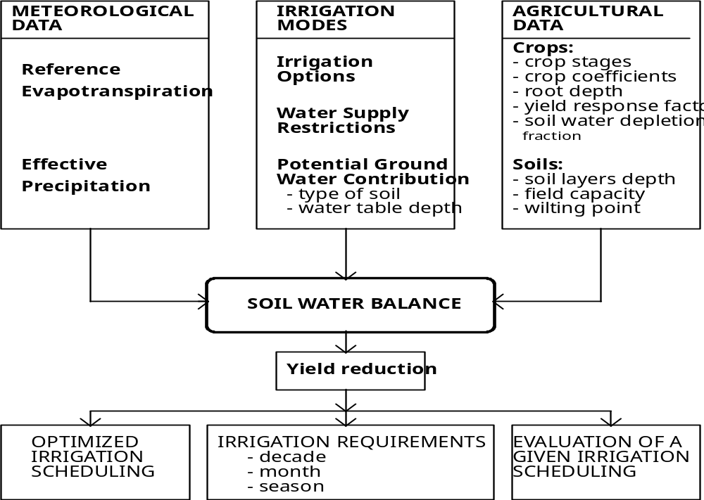
Figure 4.1.4-1 Simplified flow-chart of ISAREG.

Soil water balance
The water stored in the soil profile is considered to be divided into three zones (Figure 4.1.4-2): (i) the excess water zone, corresponding to gravitational water, not immediately available for plants; (ii) the optimal yield zone, where water is readily available in an amount favourable to obtain the maximum yield of a given crop; (iii) the water stress zone, where available water is not enough to attain the maximum evapotranspiration, therefore inducing crop water stress and yield reduction.
The water storage zones vary as a function of the crop development stage as shown in Figure 4.1.4-2. The upper boundary for the excess water zone is constant and corresponds to the soil moisture at saturation considering the maximum soil depth. The upper limit of the optimal yield zone corresponds to the maximal available soil water (mm), Rmax. The lower limit of the optimal yield zone corresponds to the minimal available soil water Rmin (mm) and is related to Rmax through the soil water depletion fraction, p(%), as follows:
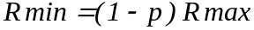

- - - - - - - | Saturation line
⎯⎯⎯⎯ | Maximum available soil water (Rmax)
⎯⎯⎯⎯ | Minimum readily available soil water (Rmin)
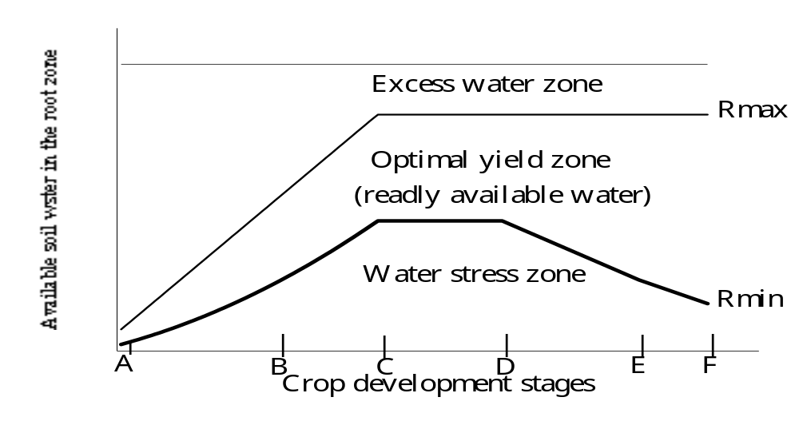
Available soil water in the root zone
Figure 4.1.4-2 Water in the soil profile in relation to crop development.

Then, the soil water balance equation can be written
Where ΔR is the soil water variation (mm) during the time interval Δt (days); The water entering the system during the same period Δt is: Pe = effective precipitation (mm); Vz = the water stored (mm) in the deeper layer of thickness z' which starts to be exploited by the roots after equivalent root growth during this time period; Ir = irrigation depth (mm); Gc = groundwater contribution (mm). The water leaving the system, for the same period is: ETa = actual evapotranspiration (mm); and Dr = deep percolation losses (mm).
Gc (mm/day) is computed from the potential for capillary rise G (mm/day) as follows:
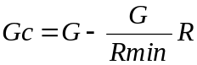
In the optimal yield zone Dr=0 (no gravity water exists), Gc=0 (in general) and ETa=ETm. For this case, the water balance equation, after integration, simplifies to:
This expresses a linear decrease of available soil water R with the time t, for intervals between irrigations.
In the water stress zone, R is below Rmin and accordingly ETa is lower than ETm and is calculated by:
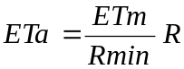
Once ETa < ETm there is a reduction (%) in yield, Qy, which can be computed by the Stewart model S-1:
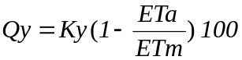
Where Ky is the yield response factor.
Crop water requirements calculated for the Focus Scenarios
A set of files concerning meteorological, agricultural and irrigation data were defined for each surface water scenario/crop combination.
From the selected weather data set, daily effective precipitation, Pe, and reference evapotranspiration, Eto, calculated by Penman-Monteith were integrated on separate files.
For each crop, at each development stage (see section 4.2), it was necessary to define the root depth, d; the soil water depletion fraction, p; the yield response factor, Ky; and the crop coefficients, Kc. This was done using the scenario soil parameter data described in section 4.3 and defined in Appendices C & D.
No contribution from groundwater table was considered and the selected irrigation options were:
- Beginning of irrigation at the optimal yield threshold and 30-mm of irrigation depth for each application. The method for irrigation is assumed to be a sprinkler system with a ‘standard’ agricultural layout for all scenario/crop combinations;
- Initial soil water content is assumed to be field capacity. After the first year water balance, soil water content at the beginning of each irrigation season is defined by a non-irrigated water balance.
- No water supply restrictions were defined, and so, no yield reduction occurs.
For the considered years, daily simulation of the water balance was performed for each scenario/crop combination. This resulted in a set of irrigation dates with specified amounts of irrigation. The irrigation volumes were then added to the rainfall volumes on each specified date and a final ‘weather plus irrigation’ data file created.
As a result of this procedure, any scenario that includes crops that are irrigated has a number of crop-specific weather datasets attached to it:
For the drainage scenarios, additional irrigation amounts were added to selected crops in D3 (93-268mm), D4 (150-175mm) and D6 (125-620mm) as shown in Table 4.1.4-1.
For the runoff scenarios, additional irrigation amounts were added to selected crops in R1 (30-131mm), R3 (39-305mm) and R4 (108-492mm) as shown in Table 4.1.4-2.
During computation of irrigation of Hops at scenario R1 (Weiherbach), it became clear that this crop is actually only grown in climatically wetter areas and is thus not normally irrigated. To cater for this exception, it was agreed that the weather dataset used for the R1 hops scenario should be based on the MARS-derived rainfall data for Weiherbach for the relevant seasons that produce a 70th percentile runoff hydrological flux.
Table 4.1.4-1 Average irrigation amounts for drainage scenarios
Scenario | D3 ¹ | D4 ¹ | D6 ¹
Annual precipitation (mm) | 693 | 692 | 733
Annual average irrigation (mm)
Winter cereals | 93
Spring cereals | 110
Winter oilseed rape | 0 |  | 0
Spring oilseed rape | 0
Sugar beets | 138 | 165
Potatoes | 157 | 155 | 620
Field beans | 95 |  | 477
Root vegetables | 138 |  | 125
Leafy vegetables | 160 | 160 | 257
Bulb vegetables | 130 | 175 | 160
Legumes | 121 | 150 | 232
Fruiting vegetables |  |  | 462
Maize | 144 |  | 565
Vines |  |  | 0
Pome/stone fruit | 123 | 0
Grass/alfalfa | 268 | 0
Sunflower
Hops
Soybeans
Citrus |  |  | 495
Olive |  |  | 0
Tobacco
Cotton |  |  | 572
Average crop irrigation (mm) | 140 | 141 | 397
¹ A 0 (zero) value indicates the crop is present but not irrigated;
A shaded box indicates that the crop is not present in the scenario (see table 4.2.1-1).

Table 4.1.4-2 Average irrigation amounts for runoff scenarios
Scenario | R1 ¹ | R2 ¹ | R3 ¹ | R4 ¹
Annual average precipitation (mm) | 744 | 1402 | 682 | 756
Annual average irrigation (mm)
Winter cereals | 0 |  | 0 | 0
Spring cereals |  |  |  | 0
Winter oilseed rape | 0 |  | 0
Summer oilseed rape | 0
Sugar beets | 60 |  | 284
Potatoes | 87 | 0 | 276
Field beans | 0 | 0 | 47 | 108
Root vegetables | 111 | 0 | 39 | 128
Leafy vegetables | 131 | 0 | 305 | 492 *
Bulb vegetables | 104 | 0 | 54 | 125
Legumes | 78 | 0 | 305 | 186
Fruiting vegetables |  | 0 | 233 | 222
Maize | 47 | 0 | 258 | 398
Vines | 0 | 0 | 0 | 0
Pome/stone fruit | 0 | 0 | 0 | 317
Grass + alfalfa |  | 0 | 0
Sunflower | 30 |  | 176 | 266
Hops | 0
Soybeans |  |  | 282 | 159
Citrus |  |  |  | 113
Olive |  |  |  | 0
Tobacco |  |  | 293
Cotton
Average crop irrigation (mm) | 81 | 0 | 212 | 228
¹ A 0 (zero) value indicates the crop is present but not irrigated;
A shaded box indicates that the crop is not present in the scenario (see table 4.2.1-1).
* This is based on irrigation for two crops per year
MODEL VALIDATION
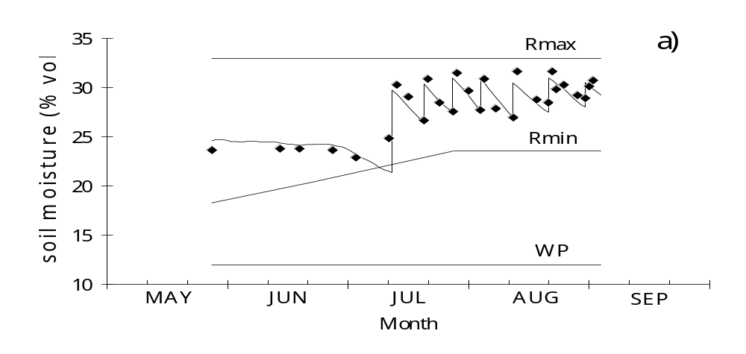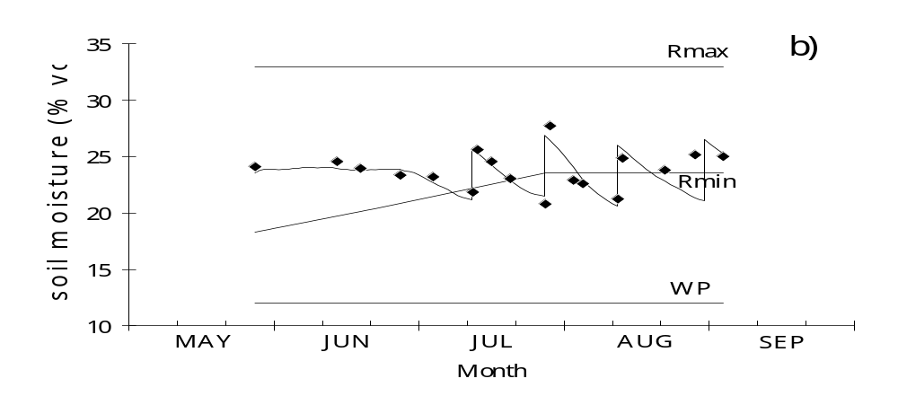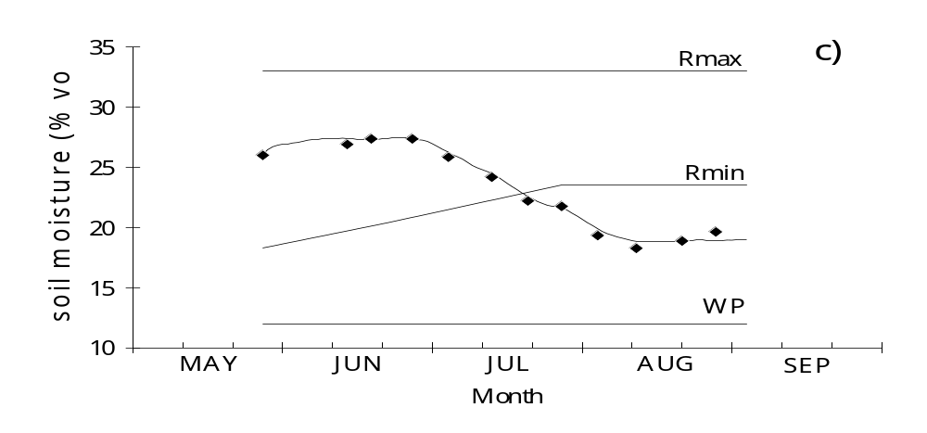
Figure 4.1.4-3 Comparison of simulated (---) and observed (♦ ♦) soil moisture values for corn in a loamy soil at Coruche: (a) irrigated weekly; (b) irrigated with 15 days interval; (c) non irrigated with shallow water table.

Concerning model validation, the results from experiments located at Coruche - Portugal, with corn grown in both a sandy soil and a loamy soil, with and without groundwater contribution, have been utilised. Results of these experiments are shown in Figures 4.1.4-3 for a loamy soil and 4.1.4-4 for a sandy soil.
Complementing this information, other printed and graphical outputs are available (Teixeira and Pereira, 1992).

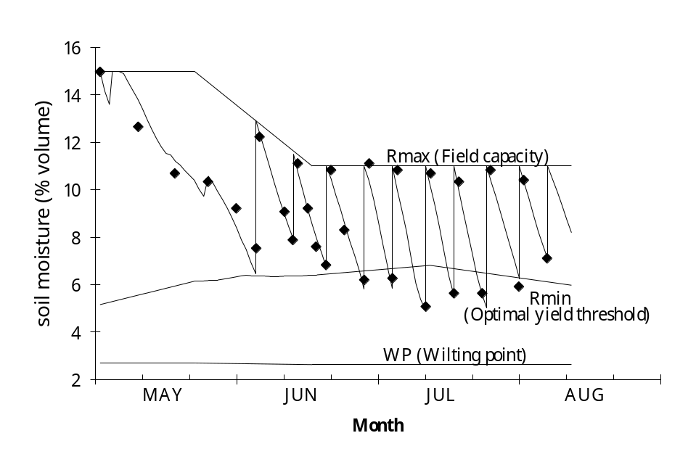
Figure 4.1.4-4 Comparison of simulated (- - -) and observed (♦ ♦) soil moisture values for irrigated corn at Coruche in a sandy soil with weekly irrigation.

4.2 Crop and Management parameters
The crop grown at each scenario and the practices used to manage the soil structure, especially the soil water balance contribute to the potential exposure of plant protection products to surface water bodies. In the simplest terms the potential for drift is a function of the crop type and method of application. The size of the crop canopy influences the amount of plant protection products reaching the soil and the depth and distribution of root systems together with soil management practices affect the soil water balance and therefore indirectly the amount of runoff and drain flow. The selection of crop and management factors is therefore an essential component of the derivation of input parameters required for each of the standard scenarios.
Before parameter selection was considered, the ten soil and climate scenarios were reviewed with regard to their suitability for production of specific crops or crop groupings. Crop and soil management parameters were then selected in order to achieve as much commonality as possible between surface water and the groundwater scenarios defined by the equivalent FOCUS group. However this was not an overriding factor due to differences in the location and type of scenarios as well as crop groupings. When necessary, parameter selection for each scenario was based on local information supplemented by expert judgement. The parameters presented here for each crop satisfy the input requirements of PRZM and MACRO. They will also satisfy many of the parameters required by other models but the remainder would require determination or estimation and justification by the notifier.

4.2.1 Association of crops and scenarios
Each scenario was considered as to its suitability for particular crop groupings based upon the climate, soil type and topography of each scenario. The crops or crop groupings considered were similar to those of the groundwater scenario group. Table 4.2.1-1 lists each crop or crop grouping associated with the 10 scenarios and also identifies those scenarios that should be considered for Step 3 calculations following application of the compound to a specific crop or crop group.
Table 4.2.1-1. Association of crops and scenarios
Scenario | D1 | D2 | D3 | D4 | D5 | D6 | R1 | R2 | R3 | R4
Weather: | Lanna | Brimstone | Vredepeel | Skousbo | La Jallière | Thiva | Weiherbach | Porto | Bologna | Roujan
Crop:
Cereals, winter | X | X | X i | X | X | X | X |  | X | X
Cereals, spring | X |  | X i | X | X |  |  |  |  | X
Oil seed rape, winter |  | X | X | X | X |  | X |  | X
Oil seed rape, spring | X |  | X | X | X |  | X
Sugar beets |  |  | X i | X i |  |  | X i |  | X i
Potatoes |  |  | X i | X i |  | X i | X i | X | X i
Field beans |  | X | X i | X |  | X i | X | X | X i | X i
Vegetables, root ª |  |  | X i |  |  | X i | X i | X | X i | X i
Vegetables, leafy ^{b} |  |  | X i | X i |  | X i | X i | X | X i | X i
Vegetables, bulb ^{c} |  |  | X i | X i |  | X i | X i | X | X i | X i
Legumes^{d} |  |  | X i | X i | X | X i | X i | X | X i | X i
Vegetables, fruiting ^{e} |  |  |  |  |  | X i |  | X | X i | X i
Maize |  |  | X i | X | X | X i | X i | X | X i | X i
Vines |  |  |  |  |  | X | X | X | X | X
Pome/stone fruit^{f} |  |  | X i | X | X |  | X | X | X | X i
Grass / alfalfa | X | X | X i | X | X |  |  | X | X
Sunflowers |  |  |  |  | X |  | X i |  | X i | X i
Hops |  |  |  |  |  |  | X ^{g}
Soybeans |  |  |  |  |  |  |  |  | X i | X i
Citrus |  |  |  |  |  | X i |  |  |  | X i
Olives |  |  |  |  |  | X |  |  |  | X
Tobacco |  |  |  |  |  |  |  |  | X i
Cotton |  |  |  |  |  | X i
ª Carrot chosen as representative ^{b} Cabbage chosen as representative
^{c} Onion chosen as representative ^{d} Peas chosen as representative
^{e} Tomatoes chosen as representative ^{f} Apple chosen as representative
^{g} 70th percentile wettest weather data used (see 4.1.4, p. 66) i Irrigation used
Most of the groupings in Table 4.2.1-1 are self-evident but the following descriptions explain the rationale for the association of crops with each scenario.
Scenario D1
This scenario represents a Northern European/Scandinavian situation. The major crops for this region and soil type are winter and spring sown cereals and spring sown oilseed rape. The prevailing climatic conditions and chosen soil type preclude significant production of other arable crops, tree fruits and vegetables.
Scenario D2
This scenario represents a tile-drained heavy clay in Western Europe dominated by a maritime climate. Under such conditions, only winter sown cereals and oilseed rape together with field beans and grassland are grown in significant quantities. The soil type is unsuitable for production of root crops.
Scenario D3
The combination of soil type, topography and prevailing climatic conditions are suitable for a wide range on Northern European crop types: winter and spring-sown small grain cereals, oilseed rape, root crops, vegetables, maize and pome fruit. Many of these crops require irrigation during summer months to optimise growth during periods of water deficit.
Scenario D4
The crop groupings associated with this scenario are similar to those identified for scenario D3, except that the soil type is not considered suitable for root vegetables.
Scenario D5
The crop groupings associated with this scenario are winter and spring sown cereals and oilseed rape, legumes, maize, pome/ stone fruit and grass leys. Also included is sunflower based on the more southerly location of the site. As for scenario D2 the soil type / climate combination is not considered suitable for the production of root crops.
Scenario D6
This scenario is typical of a soil discharging water to surface water via field drains in Southern Europe. It is suitable for a wide range of crops including small grain cereals, vegetables, pome/stone fruit and other tree crops, maize and cotton. Many of these crops are irrigated at times of water deficit.
Scenario R1
This extensive runoff scenario is suitable for a wide range of crop types including hops.
Scenario R2
This Southern European scenario is parameterised for terraced crop production in relatively steep sloping locations with high rainfall. It is therefore suitable for intensive crops such as potatoes, vegetables and maize, as well as vines, pome/stone fruits and grass or alfalfa.
Scenario R3
This scenario is typical of gently to moderately sloping Southern European locations and is suitable for production of a wide range of arable crops, including soybean, tobacco and sunflower as well as vines and pome/stone fruit. Many of these crops are irrigated at times of water deficit.
Scenario R4
This extensive Southern European scenario is characterised by hot dry summers and is suitable mainly for vegetables, tree crops (pome/stone fruits, citrus and olives), vines, maize, soybeans and sunflower. Many of these crops are irrigated at times of water deficit.

4.2.2 Proportion of EU crop production accounted for by scenarios
It is not possible to readily quantify the proportion of EU crop production represented by the combinations of scenarios. The scenarios were selected as realistic worst-case with respect to their potential to generate run-off or discharge via drains to surface waters. However an attempt was made to compare crop production values of Member States for each of the crop groupings therefore confirming the association between crops and scenarios at least from the perspective of geographical locations.
For each crop or crop grouping, the area of production in the Member States where the scenarios are located was summed and is represented by the area in the following pie charts labelled “Scenario Locations”. Production in Member States considered to have similar agroclimatic conditions to one or more of the scenario locations was also aggregated and is represented in the pie charts as “Equivalent Member States”. The production in Member States of significantly different agroclimatic conditions from those of the scenario locations was also calculated and is represented as the area labelled “Non Equivalent Member States”. The total area of each pie chart represents total EU production for that crop. The data for this evaluation was obtained from available EUROSTAT production statistics for each member state for the period 1995 to 1998.
Figure 4.2-1 Crop production in EU Member States (for explanation, see text of 4.2.2)
Crop: Cereals | Crop: Oilseed Rape
Scenarios: D1; D2; D3; D4; D5; D6; R1; R3; R4 | Scenarios: D1; D2; D3; D4; D5; R1; R3
Member States: SE; UK; NL; DK; FR; GR; DE; IT | Member States: SE; UK; NL; DK; FR; DE; IT
Equivalent MS: AT; BE; ES; FI; IR; LU; PT | Equivalent MS: AT; BE; ES; FI; IR; LU
Non-equivalent MS: | Non-equivalent MS: GR; PT
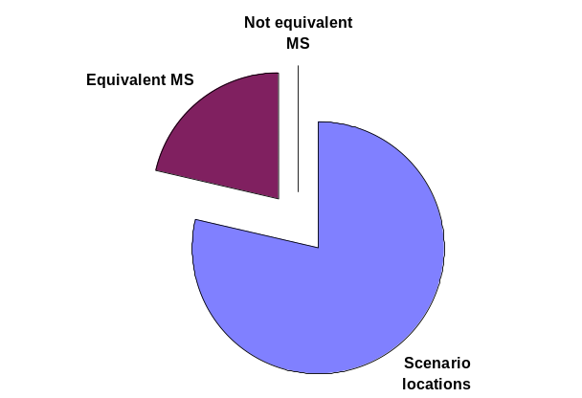 | 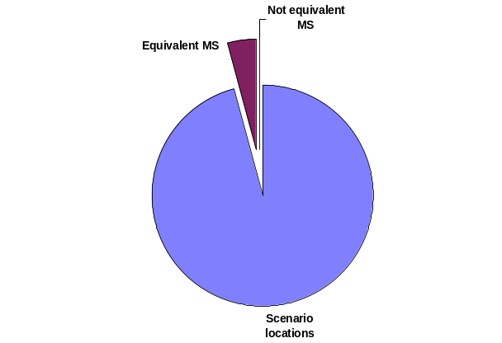
Crop: Sugar Beet | Crop: Potatoes
Scenarios: D3; D4; R1; R3 | Scenarios: D3; D4; D6; R1; R2; R3
Member States: NL; DK; DE; IT | Member States: NL; DK; GR; DE; PT; IT
Equivalent MS: AT; BE; FI; FR; LU; SE; UK | Equivalent MS: AT; BE; ES; FR; IR; LU; UK
Non-equivalent MS: ES; GR; IR; PT; | Non-equivalent MS: FI; SE
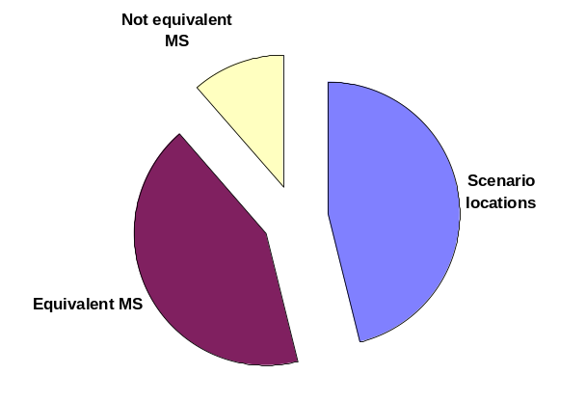 | 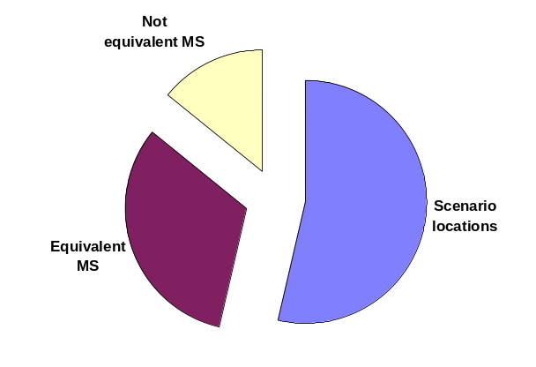
Crop: Vegetables |  | Crop: Maize
Scenarios: D3; D4; D5; D6; R1; R2; R3; R4 |  | Scenarios: D3; D4; D5; D6; R1; R2; R3; R4
Member States: NL; DK; FR; GR; DE; PT; IT; FR |  | Member States: NL; DK; FR; GR; DE; PT; IT; FR
Equivalent MS: AT; BE; ES; LU; UK; |  | Equivalent MS: AT; BE; ES; LU; UK;
Non-equivalent MS: FI; IR; SE |  | Non-equivalent MS: FI; IR; SE
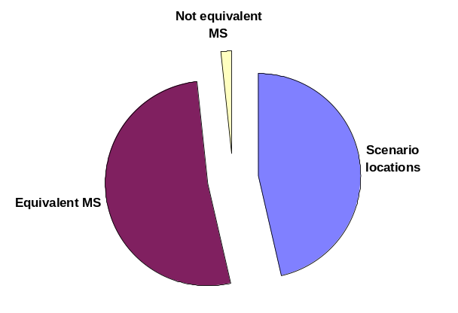 |  | 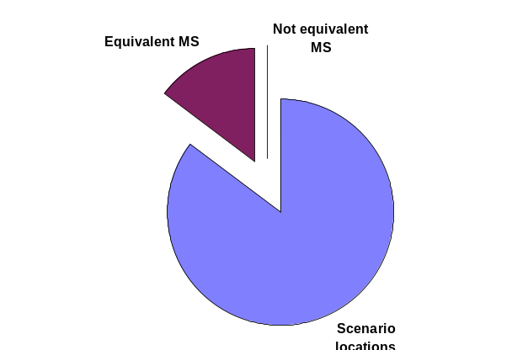
Crop: Vines |  | Crop: Pome/ Stone fruit
Scenarios: D6; R1; R2; R3; R4 |  | Scenarios: D3; D4; D5; R1; R2; R3; R4
Member States: GR; DE; PT; IT; FR |  | Member States: NL; DK; FR; DE; PT; IT; FR
Equivalent MS: AT; ES |  | Equivalent MS: AT; BE; LU; UK;
Non-equivalent MS: BE; DK; FI; IR; LU; NL; SE; UK |  | Non-equivalent MS: FI; IR; SE; GR
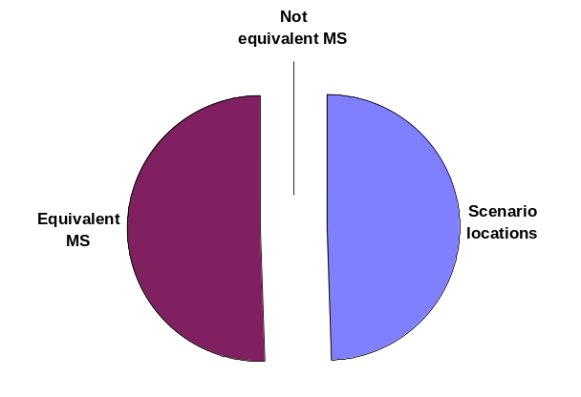 |  | 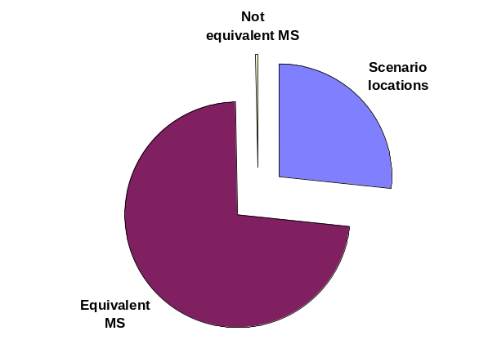
Crop: Sunflowers |  | Crop: Hops
Scenarios: D6; R1; R3; R4 |  | Scenarios: R1
Member States: GR; DE; IT; FR |  | Member States: DE
Equivalent MS: ES; PT; AT; |  | Equivalent MS: AT; IT
Non-equivalent MS: BE; DK; FI; IR; LU; NL; SE; UK |  | Non-equivalent MS: : BE; DK; ES; FI; FR; GR; IR; LU; NL; PT; SE; UK
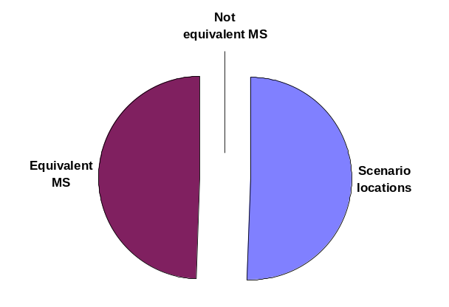 |  | 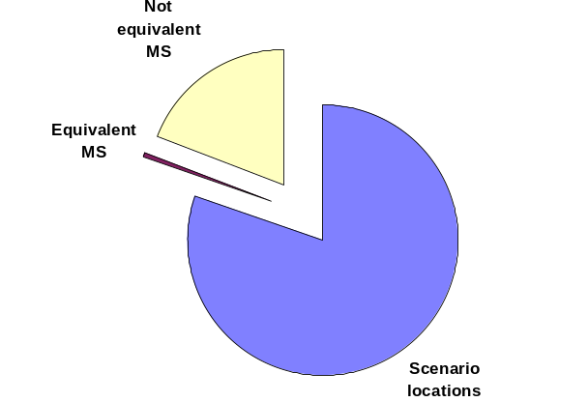
Crop: Soybeans |  | Crop: Citrus
Scenarios: R3; R4 |  | Scenarios: D6; R4
Member States: IT; FR |  | Member States: GR; FR
Equivalent MS: ES; PT; GR |  | Equivalent MS: ES; IT; PT
Non-equivalent MS: : BE; DE; DK; FI; FR; IR; LU; NL; SE; UK |  | Non-equivalent MS: : BE; DE; DK; FI; FR; IR; LU; NL; SE; UK
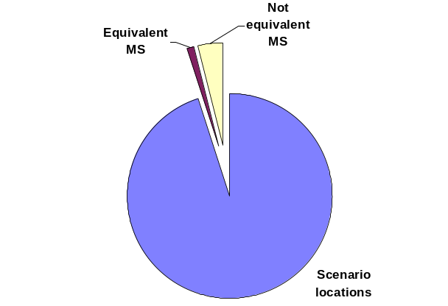 |  | 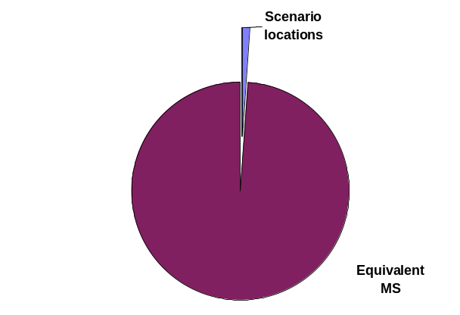
Crop: Olives |  | Crop: Tobacco
Scenarios: D6; R4 |  | Scenarios: R3
Member States: GR; FR |  | Member States: IT
Equivalent MS: IT; ES; PT |  | Equivalent MS: GR; ES; PT
Non-equivalent MS: AT; BE; DE; DK; FI; IR; LU; NL; SE; UK |  | Non-equivalent MS: AT; BE; DE; DK; FI; FR; IR; LU; NL; SE; UK
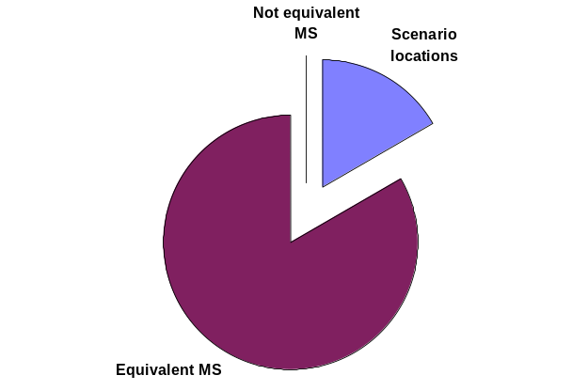 |  | 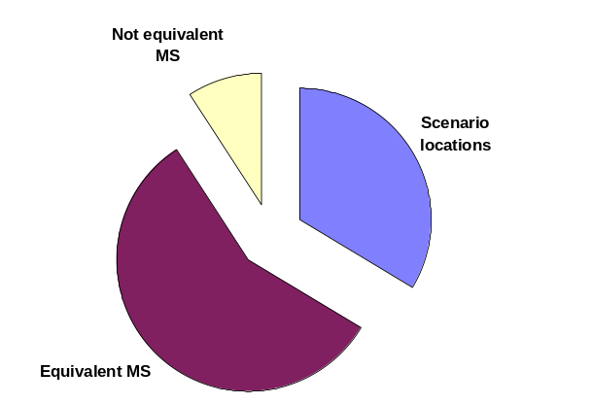

4.2.3 Spray Drift Input parameters
At step 3, the spray-drift input parameters are derived from the distance from the edge of the treated field to the water body (ditch, stream and pond). The crops were put into five groups that reflect the distance between rows in the field. Narrow-row crops such as cereals and oilseed rape are more likely to be sown closer to the edge of the field than row crops such as sugar beet, or tree crops. For each class a default distance from the edge of the treated field to the top of the bank of the water body was defined. This also included default distances for hand-held and aerial applications, which are independent of crop type. Distances range from 0.5 m to 3 m for ground applications and 5 m for aerial applications. The horizontal distance from the top of the bank to the water body is specific to each type and was defined as 0.5 m for ditches, 1.0 m for streams and 3.0 m for ponds.
The default distances defined by the FOCUS group that are used in all standard calculations for drift inputs at Step 3 are given in table 4.2.3-1. In addition, in Figure 4.2.3-1 the different distances that are taken into account are elucidated.

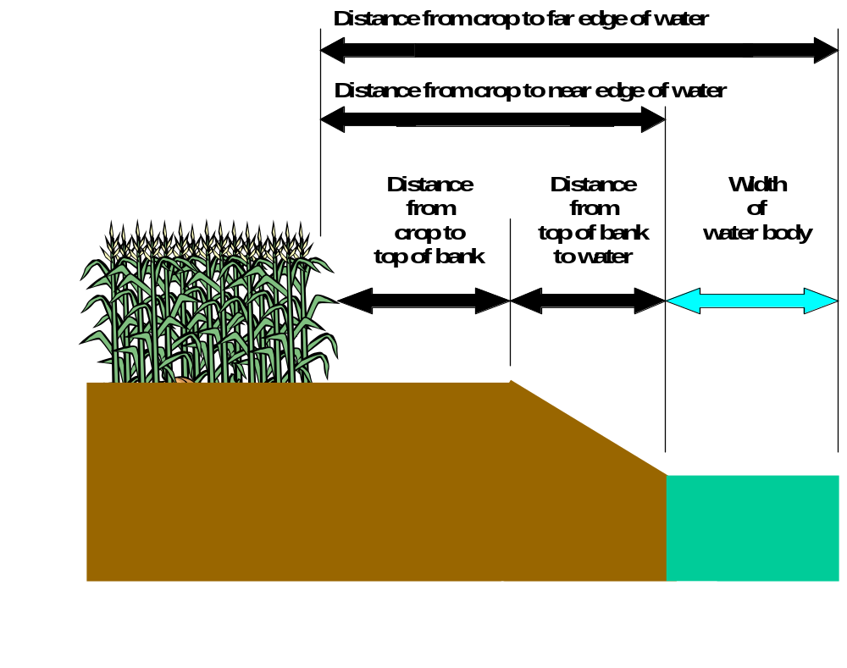
Figure 4.2.3-1. Definition of distances between crops, top of bank and water bodies.

Table 4.2.3-1. Crop-specific parameters for Calculating Spray Drift Inputs at Step 3
Crop grouping or Application Method | Distance from edge of field to top of bank (m) | Water Body Type | Distance from top of bank to edge of water body (m) | Total Distance From Edge of Field to Water Body (m)
cereals, spring | 0.5 | Ditch | 0.5 | 1.0
cereals, winter
grass / alfalfa
oil seed rape, spring
oil seed rape, winter | 0.5 | Stream | 1.0 | 1.5
vegetables, bulb
vegetables, fruiting | 0.5 | Pond | 3.0 | 3.5
vegetables, leafy
vegetables, root
application, hand (crop < 50 cm)
potatoes | 0.8 | Ditch | 0.5 | 1.3
soybeans
sugar beet | 0.8 | Stream | 1.0 | 1.8
sunflower
cotton
field beans
legumes | 0.8 | Pond | 3.0 | 3.8
maize
tobacco | 1.0 | Ditch | 0.5 | 1.5
tobacco | 1.0 | Stream | 1.0 | 2.0
tobacco | 1.0 | Pond | 3.0 | 4.0
citrus | 3.0 | Ditch | 0.5 | 3.5
hops
olives | 3.0 | Stream | 1.0 | 4.0
pome/stone fruit, early applications
vines, late applications | 3.0 | Pond | 3.0 | 6.0
application, hand (crop > 50 cm)
application, aerial | 5.0 | Ditch | 0.5 | 5.5
application, aerial | 5.0 | Stream | 1.0 | 6.0
application, aerial | 5.0 | Pond | 3.0 | 8.0

4.2.4 MACRO Input Parameters
Crop and management input parameters were selected for the MACRO model for each crop or crop grouping for the drainage scenarios D1 to D6. Five crop parameters (root depth, emergence date, date for intermediate crop development, date of maximum leaf area development and date of harvest) are specific to each scenario and are summarised in Appendix C. The remaining parameters were either constant for each crop across all scenarios or were constant for all crops. All the parameters are listed in Appendix C.

4.2.5 PRZM Input parameters
Crop and management input parameters were selected for the PRZM model for each crop or crop grouping for the runoff scenarios R1 to R4. Again, five crop parameters (maximum rooting depth, sowing date, emergence date, maturation date and harvest date) are specific to each scenario and are summarised in Appendix D. The remaining parameters were constant for each crop across all scenarios. All the parameters are listed in Appendix D.

4.2.6 Timing of pesticide application
Pesticide losses in both surface runoff and subsurface drainage flow are ‘event-driven’ and therefore very strongly dependent on the weather conditions immediately following application, in particular the rainfall pattern (see sections 6.4.1 & 6.4.2).
It was therefore considered necessary to develop a procedure which would help to minimise the influence of the user choice of application date on the results of FOCUS surface water scenario calculations, at the same time as retaining some degree of flexibility in simulated application timings to allow realistic use patterns for widely different compounds. A Pesticide Application Timing calculator (PAT) was developed to achieve this dual purpose. PAT is incorporated in the shell programs for both MACRO and PRZM, and is also available as a stand-alone program.
The PAT calculator eliminates a significant number of potential application dates due to the requirement that at least 10 mm of precipitation be received within ten days following application. This criteria in the PAT calculator results in selection of application dates which are the 60th to 70th percentile wettest days for non-irrigated crops and the 50th to 60th percentile wettest days for irrigated crops (based on analysis of maize met files). The slightly lower percentile values for irrigated crops are due to the additional number of wet days created by irrigation events for these crops.
Principles of the method
PAT automatically determines pesticide application dates which satisfy pre-set criteria, based on the daily rainfall file for the simulation period (16 months for drainage using MACRO and 12 months for runoff using PRZM), together with the following user-defined information:
- An application ’window’ (defined by a first possible day of application and a last possible day of application) (See 7.2.4. for the estimation of the application window).
- The number of applications (up to a maximum of five).
- The minimum interval between applications (for multiple applications).
Initially, the pre-set criteria state that there should be at least 10 mm of rainfall in the ten days following application and at the same time, there should be less than 2 mm of rain each day in a five day period, starting two days before application, extending to two days following the day of application. PAT then steps through the ’application window’ to find the first day which satisfy these requirements. For multiple applications, the procedure is carried out for each application, respecting the minimum interval specified between applications.
Depending on the rainfall pattern in the application window defined by the user, it is quite possible that no application day exists which satisfies the two basic criteria defined above. In this case, the criteria are relaxed and the procedure repeated until a solution is found, as follows:
- The five-day period around the day of application is reduced first to a three day period (one day either side of the application day), and then if there is still no solution, to just the day of application. Relaxing these criteria makes the resulting leaching estimates potentially more conservative.
- If PAT still fails to find a solution, then the second criteria is relaxed, such that 10 mm of rain is required to fall in a 15 day period following application, rather than 10 days. Relaxing these criteria makes the leaching estimates less conservative.
- If a solution is still not forthcoming (for example, for dry periods, such that the total rainfall during the entire application window is less than 10 mm), then the minimum rainfall requirement is reduced 1 mm at a time, to zero.
- If PAT still fails to find a solution (this will be the case if the application window is very wet, with more than 2 mm of rain every day), then the amount of rain allowed on the day of application is increased 1 mm at a time, until a solution is found.
- NOTE: If multiple applications occur within the application window, it is important to make the window as large as possible (but still in agreement with the GAP) in order to prevent PAT from unnecessarily relaxing the precipitation rules.
Following this procedure, the program always finds a solution. An illustration of a PAT output figure is given in Figure 4.2.6-1.
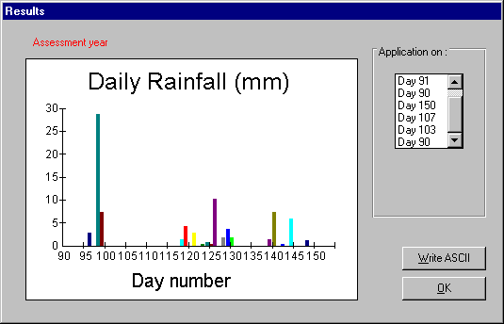
Figure 4.2.6-1. Example output from the PAT calculator in MACROinFOCUS.

4.3 Soil
Soil characteristics for Surface Water scenarios only contribute indirectly to exposure calculations in that they influence runoff and drainage input fluxes, both through specific organic matter content, pH and hydraulic properties and through the way their general soil water storage and permeability characteristics affect base flow hydrology of the upstream catchment (see section 4.4.3). As described in chapter 3, the soil types that represent each of the 10 outline scenarios were identified on the basis of their inherent relative ‘worst-case’ characteristics with respect to drainage or runoff. The general soil properties for each scenario are described in table 3.4-2 and the relevant characteristics for each one have been derived from soil profile descriptions and analytical data taken from the ‘representative’ field site identified for each scenario (see section 3.2). Full details of the soil parameters for each scenario are given in Appendices C & D.

4.3.1 Primary soil properties
The primary topsoil properties of each scenario are given in table 4.3.1-1, whereas the distribution of organic carbon and clay with depth is illustrated in figure 4.3.1-1.
The properties clearly reflect the desired worst-case characteristics of each soil type. Thus large clay contents for scenario D2 reflect its extreme ‘by-pass’ flow characteristics, whereas those for D1 and D6 are slightly less extreme. In contrast the large sand contents for scenario D3 reflect its ‘worst-case’ nature for leaching, whereas the extremely silty soil at scenario R1 and the medium loamy soils at scenarios R3 and R4 characterise their worst-case nature for runoff. Small organic carbon contents characterise all runoff scenarios except for R2. This scenario has the largest organic carbon content which is the result of its extremely wet climatic regime (see table 3.2.3) and its ‘man made’ nature (it is a terraced soil on a steep slope).
For nearly all the scenarios, some data derivation was necessary and the details of this are described in the footnotes to the tables given in Appendices C & D.
Table 4.3.1-1. Topsoil primary properties for the 10 Step 3 scenarios
Scenario | Representative field site | Organic carbon % | Texture class | Clay ¹ % | Silt ¹ % | Sand ¹ % | pH | Bulk density  g cm⁻³
D1 | Lanna | 2.0 | Silty clay | 47 | 46 | 7 | 7.2 | 1.35
D2 | Brimstone | 3.3 | Clay | 54 | 39 | 7 | 7.0 | 1.20
D3 | Vredepeel | 2.3 | Sand | 3 | 6 | 91 | 5.3 | 1.35
D4 | Skousbo | 1.4 | Loam | 12 | 37 | 51 | 6.9 | 1.48
D5 | La Jailliere | 2.1 | Loam | 19 | 39 | 42 | 6.5 | 1.55
D6 | Váyia, Thiva | 1.2 | Clay loam | 30 | 34 | 36 | 7.5 | 1.43
R1 | Weiherbach | 1.2 | Silt loam | 13 | 82 | 5 | 7.3 | 1.35
R2 | Valadares, Porto | 4.0 | Sandy loam | 14 | 19 | 67 | 4.5 | 1.15
R3 | Ozzano, Bologna | 1.0 | Clay loam | 34 | 43 | 23 | 7.9 | 1.46
R4 | Roujan | 0.6 | Sandy clay loam | 25 | 22 | 53 | 8.4 | 1.52
¹ Clay size fraction <0.002 mm; Silt size fraction 0.002 – 0.05 mm; Sand size fraction 0.05 to 2 mm.
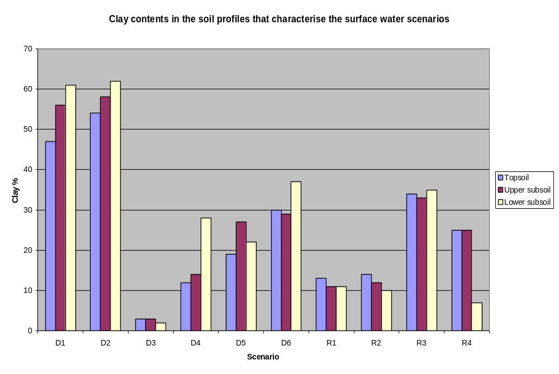
Figure 4.3.1-1. Clay contents of soils characterising the 10 surface water scenarios

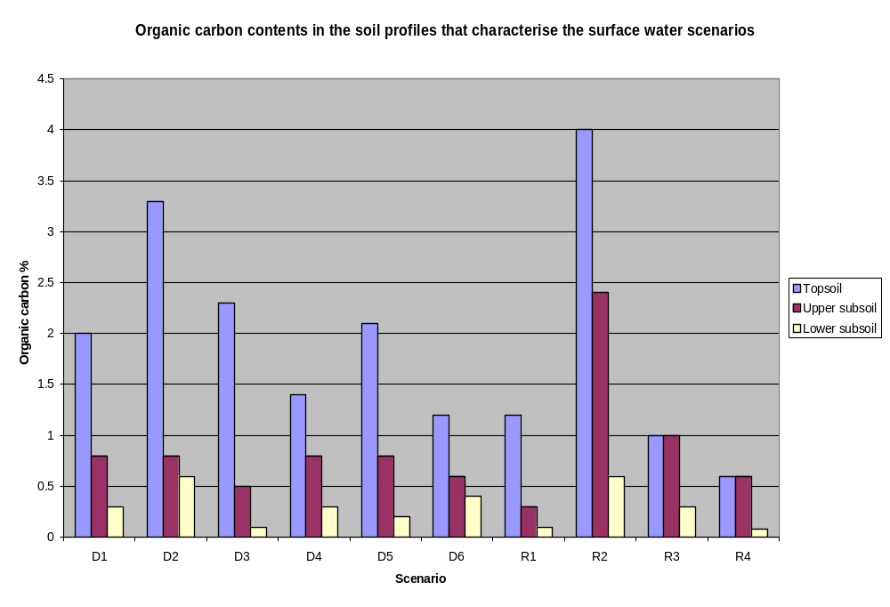
Figure 4.3.1-2. Organic carbon contents of soils characterising the 10 surface water scenarios

4.3.2 Soil hydraulic characteristics
Both MACRO and PRZM require scenario-specific input data that characterise the hydraulic characteristics of each soil layer.
MACRO is a physically-based model that uses the Richard’s equation and the convection-dispersion equation to model water flow and solute transport. The hydraulic characteristics of each soil layer are described using the Brooks Corey / Mualem model (Brooks & Corey, 1964; Mualem, 1976) and for each drainage scenario the hydraulic parameters were either directly measured, derived from measured values, derived from the primary property data using specific ‘pedo-transfer functions’ or derived by representative site-specific calibration. In each case, the method of derivation is indicated in the footnotes to the relevant tables given in Appendix C. MACRO also requires scenario-specific parameter data to describe the water content, water tension and hydraulic conductivity at the macro/micropore boundary. These values are very difficult to measure and for most scenarios were either derived from representative site-specific calibration or based on an assumed or default value. Again the method of derivation is specified in the data tables in Appendix C. Finally, MACRO also requires soil parameters that define the dispersivity, mixing depth, shrinkage characteristics, fraction of sorption sites in macropores, excluded pore volume and initial soil temperature and pesticide concentration in the soil including the lower boundary. Default values were used for all of these parameters and were kept constant for all 6 drainage scenarios.
PRZM uses a simpler ‘capacity’ approach to water transport and only requires data for water content at ‘field capacity’ and ‘wilting point’. For all runoff scenarios, these values were calculated using established ‘pedo-transfer functions’, in most cases developed specifically to derive such input data for the PRZM model (Rawls. et al., 1982). The method of deriving these hydraulic characteristics is indicated in the footnotes to the relevant tables given in Appendix D.

4.3.3 Catchment soil hydrological characteristics
In order to derive a base-flow component to the hydrological flows feeding the surface water bodies at each scenario (see section 4.4.3 below), parameters quantifying the catchment ‘base flow index’ (BFI) and ‘mean annual minimum 7-day flow’ (MAM7) were needed. BFI quantifies the fraction of long-term total flow in a catchment that is represented by base flow, whereas MAM7 represents the annual average minimum daily flow within any 7-day period. These parameters were derived from the estimated soil hydrological class at each scenario-representative field site as defined in the Hydrology Of Soil Types (HOST) study (Boorman, et al., 1995). Each HOST class has an associated set of empirically derived coefficients describing stream flow characteristics, including BFI and MAM7. The estimated HOST classes for each scenario, together with their associated BFI and MAM7 values are given in table 4.3.3-1.
Base flow was then calculated for each scenario with the aid of the long-term recharge and the MAM7 values (Table 4.3.3-2). Long-term recharge was determined on the basis of the average precipitation excess, (precipitation –evaporation), of October to March for the entire 20 years weather set for the scenario concerned.
Table 4.3.3-1. Soil hydrological characteristics for the surface water scenarios
Scenario | HOST class | MAM7 (% of total flow) | BFI
D1 | 21 | 12.4 | 0.34
D2 | 25 | 0.1 | 0.17
D3 | 10 | 1.4 | 0.52
D4 | 18 | 19.6 | 0.52
D5 | 14 | 12.4 | 0.38
D6 | 8 | 21.4 | 0.56
R1 | 6 | 30.4 | 0.64
R2 | 17 | 12.4 | 0.32
R3 | 19 | 12.4 | 0.47
R4 | 4 | 27.5 | 0.79
Table 4.3.3-2. Calculation of base flow for the Surface Water Scenarios
Scenario | MAM7  (% of total flow) | Precipitation excess (mm/y) | Base flow (m3/d, ha)
D1 | 12.4 | 97.0 | 0.330
D2 | 0.1 | 218.6 | 0.00599
D3 | 1.4 | 274.3 | 0.105
D4 | 19.6 | 197.9 | 1.063
D5 | 12.4 | 218.3 | 0.742
D6 | 21.4 | 316.1 | 1.853
R1 | 30.4 | 230.3 | 1.918
R2 | 12.4 | 825.2 | 2.803
R3 | 12.4 | 224.4 | 0.762
R4 | 27.5 | 255.7 | 1.927

4.3.4 Field drainage, runoff and soil loss characteristics
In order to calculate hydrological and associated pesticide solute fluxes from field drainage, MACRO requires data on the depth and spacing of field drainage systems present and also on the hydraulic transmission coefficient of the lower boundary of the soil. Site specific data from the representative field sites identified for each drainage scenario were used to define the field drainage characteristics of each scenario and these are shown in table 4.3.4-1.
Table 4.3.4-1. Field drainage characteristics of the Step 3 Drainage Scenarios
Scenario | Representative field site | Drain depth (m) | Drain spacing (m)
D1 | Lanna | 1.0 | 13.5
D2 | Brimstone | 0.55 (mole drains) | 2 (mole drains)
D3 | Vredepeel | 1.75 | 76
D4 | Skousbo | 1.2 | 10
D5 | La Jailliere | 0.9 | 9
D6 | Váyia, Thiva | 1.0 | 8
The lower boundary hydraulic transmission coefficient governs the rate at which water is ‘lost’ as recharge from the base of the soil. Scenario-specific values for this were derived from the estimated soil HOST class (see section 4.3.3) at each site and are defined in the data tables given in Appendix C.
PRZM uses a modification of the Soil Conservation Service Runoff Curve Number (RCN) approach to compute runoff volumes and the Modified Universal Soil Loss Equation (MUSLE) to calculate erosion. These approaches require various scenario-specific soil and site parameters such as soil hydrologic group, soil erodability, Manning’s coefficient, slope, length-slope factor, area of field for erosion and others. The parameters are fully defined in the soil data tables given in Appendix D and were derived either from other scenario-specific characteristics described in this section, from routines given in the PRZM manual (Carsel et al, 1995; Williams, 1975), or, in the case of Manning’s coefficient, as a ‘standard’ value for all runoff scenarios.

4.4 Water Bodies
At present, aquatic risk assessments for European pesticide registration are based on the assumption that spray drift will enter a static water body (commonly referred to as a ditch) of 30 cm depth. The Group agreed that this was an appropriate worst-case assumption for preliminary risk characterisation, and therefore retained the 30 cm deep static ditch as the conservative water-body of concern for Steps 1 and 2. With the development of Step 3 scenarios, which were designed to take more account of the regional differences that exist across Europe, the Group decided that it would be appropriate to further define the types of water bodies that would be associated with the particular scenarios. It was agreed that this should particularly take into account the derivation of the scenario as either a ‘drainage’ or ‘runoff’ scenario (in addition to inputs from spray drift), and also include climatic and topographic considerations. Furthermore, the inclusion of drainage and runoff inputs demanded that flowing water bodies should also be considered. The Group therefore decided that dynamic hydrology should be included at Step 3.
Across large biogeographical regions such as the agricultural soil-climate scenarios selected for Step 3, there will be a continuum of sizes and types of water bodies, ranging from the smallest temporary pond or spring, through moderate sized ponds, ditches and streams, to the largest rivers and lakes. Which of these water bodies are most common to a particular region will be determined by the underlying geology, topography and climate. In selecting the water bodies associated with the scenarios, the Group settled on two main criteria. Firstly, the water body should be permanent. This criterion was used to match the existing risk assessment assumptions and also recognising that for certain surface water organisms, especially fish, temporary waters are not a relevant habitat. Secondly, the water body should be of an appropriate size for an ‘edge-of-field’ risk assessment. Thus it was decided that the water bodies selected should be of a moderate size – large enough to be able to reasonably contain water throughout the season, and to accept water inputs from runoff and drainage without being completely flooded; small enough that edge-of-field inputs would be of some ecotoxicological relevance (i.e. not large lakes or rivers). Consequently, it was decided that the scenario water bodies should include moderate sized ditches, streams and ponds.
The Group also decided that each scenario need not necessarily have every water body (i.e. stream, ditch and pond) associated with it, both for reasons of logic and pragmatism (constraining the number of modelling runs at Step 3 to a reasonable level). In selecting the water bodies to be associated with each scenario, the Group took a rational approach: undrained soils were considered unlikely to contain drainage ditches; steep slopes were considered more likely to support streams; warm climates were considered less likely to support permanent ponds. The selection of water bodies was then ‘empirically’ checked by referring to a topographic map (1:10-1:20 000 scale) for the area around the scenario representative sites. The map was examined to determine whether the sorts of water bodies associated with the scenario were present. Further details are provided below.

4.4.1 Association of Water Bodies with Scenarios
For each scenario, the principal water bodies associated with that scenario for use in exposure modelling were defined (Table 4.4.1-1), using the pragmatic approaches described above.
Table 4.4.1-1 Water bodies associated with scenarios
Scenario | Inputs | Slope (%) | Soil type | Water body type(s)
D1 | Drainage and drift | 0 – 2 | Clay | Ditch, stream
D2 | Drainage and drift | 0 – 2 | Clay | Ditch, stream
D3 | Drainage and drift | 0 | Sand | Ditch
D4 | Drainage and drift | 0 – 2 | Light loam | Pond, stream
D5 | Drainage and drift | 2 – 6 | Medium loam | Pond, stream
D6 | Drainage and drift | 0 – 4 | Heavy loam | Ditch
R1 | Runoff and drift | 2 – 4 | Light silt | Pond, stream
R2 | Runoff and drift | 10 – 30 | Light loam | Stream
R3 | Runoff and drift | 0 – 155 | Heavy loam | Stream
R4 | Runoff and drift | 2 – 10 | Medium loam | Stream

4.4.2 ‘Reality check’ for the selection of water bodies for each scenario
In order to perform a preliminary ‘reality check’ on the association of water bodies with the various scenarios, topographic maps (generally 1:25 000 [1 cm = 250 m] or less) were examined to identify the types of water bodies associated with the scenario area. At this scale, small ponds, ditches and streams are clearly identifiable on the maps. Since the selected scenarios are broadly representative of broad soil-climate regions, this approach should be viewed as a crude check, rather than a rigorous validation. However, the Group considered that such an exercise would at least provide initial corroboration of the selections of water body type. A narrative description of the analysis of the topographic maps is displayed in Table 4.4.2-1.
Comparing the water bodies selected for the scenarios to those found on the topographic maps indicated that the types of water bodies selected for the scenarios were quite reasonable.
Table 4.4.2-1 Description of water bodies found in the locale of the scenario weather station site.
Scenario | Water body type(s) | Map  reference | Scale/area | Description of water bodies
D1 | Ditch, stream | Gula kartan Saleby 8C:48 | 1: 20 000  150 km² | Extensive network of drainage ditches throughout arable land, collecting into natural streams. Streams generally un-channelised and surrounded by woodland. No natural ponds within arable land, and generally very few ponds (< 1 /10km²). Those present generally occur in woodland.
D2 | Ditch, stream | Ordnance Survey Pathfinder 1135 Faringdon | 1: 25 000  200 km² | Upper headwaters of the River Thames and River Cole. Extensive network of drainage ditches connected to brooks and streams. Low numbers of ponds (approx. 1/5 km²) and many of these were in villages, rather than on arable land. A number of large (ornamental) lakes.
D3 | Ditch | Topografische Kaart van Nederland Blad 52A Milheeze | 1: 25 000  125 km2 | Most fields surrounded by ditches draining into extensively channelised larger drainage canals. No apparent un-channelised flowing waters. No ponds apparent on arable land. Some ponds, but only in woodland or recreational areas.
D4 | Pond, stream | Kort & Matrikelstyrelsen 1513 Havdrup | 1: 25 000  approx. 150 km² | High density of ponds (on average approx. 3 ponds/1 km). Moderate network of natural streams.
D5 | Stream, pond | Serie Blue 1422 O Varades | 1: 25 000  260 km² | Area intersected by the River Loire. Many intermittent streams connecting into permanent waters, draining into the Loire. As would be expected, many ponds in the flood plain of the river, however on the slopes relevant to the scenario (2-6%) relatively low numbers of ponds. No ditches.
D6 | Ditch | Helenic Military Geographical Service location Váyia 1988 | 1 : 50 000  approx. 570 km² | Agricultural areas dominated by flat drained land area heavily intersected by ditches (indicated as intermittent). No ponds. Intermittent streams on slopes.
R1 | Pond, stream | Topographische Karte 6818 Kraichtal | 1: 25 000  approx. 125 km² | Relatively steep terrain dominated by small valleys containing streams. Some ponds but generally at a low density (less than 1/km²). No ditches.
R2 | Stream | Carta Militar de Portugal No 133 Valadares | 1: 25 000  approx. 110 km² | Area intersected by the Rio Douro. Hydrology dominated by small streams feeding into the larger rivers. No ponds or ditches.
R3 | Stream | Carta Tecnica Regionale Sezione No 221140 | 1: 10 000  approx. 36km² | Hydrology dominated by small streams in relatively steep valleys. No ditches and very low numbers of ponds (<< 1/km²)
R4 | Stream | Serie Blue 2644 O Varades | 1: 25 000  260 km² | Generally little permanent surface water. Mostly small streams. A small number of ponds, but from their topography, these appear to be reservoirs. No ditches.

4.4.3 Characteristics of the Water Bodies
In order to run the TOXSWA in FOCUS model, a set range of characteristics relating to the dimensions, sediment and organic components and hydrology of each water body are required to parameterise each scenario. Of these characteristics, the water body dimensions and sediment and organic components were fixed for each water body type irrespective of the scenario. These ‘fixed’ properties were agreed upon based on the experience of the participants and limited to the edge-of-field scale that was the scope of discussions outlined in the Group’s remit. They are defined in the first two sections below. Such a ‘fixed’ characterisation was not possible with respect to water body temperature which, because it depends on ambient conditions, is of necessity specific to the weather data used to characterise each scenario. The linkage of water body temperatures to scenario weather data is described in the third section below.
‘Fixed’ characterisation is also not possible for the hydrology where a realistic description of the dynamics in flow and water depth is essential if realistic exposure concentrations are to be calculated. Further, it is impossible to realistically describe such flow dynamics by considering only the hydrology of the neighbouring field. It was thus necessary to expand the strict ‘edge-of-field’ approach to include realistic hydrological inputs from a small upstream catchment with a hydrological cycle that reflects the soil, substrate and slope characteristics identified for each scenario. As a result of this approach, it then became necessary to consider whether the upstream catchment would deliver pesticide and, where there was a runoff scenario, sediment to the water body. These scenario-specific characteristics are defined in the final two sections below and the conceptual outline of each ditch, pond and stream scenario for Step 3 calculations is illustrated in figure 4.4.3-1.
dimensions:
A summary of the fixed dimensions for each water-body type is described in Table 4.4.3-1 below. All three water bodies, pond, ditch and stream, have a rectangular internal cross-section (vertical side slope).
Table 4.4.3-1 Water body parameters
Type of water body | Width (m) | Total length (m) | Distance from top of bank to water (m)
Ditch | 1 | 100 | 0.5
Pond | 30 | 30 | 3.0
Stream | 1 | 100 | 1.0
organic and sediment components
The characteristics of the sediment and organic components of all the water bodies are fixed and defined in table 4.4.3-2.
Because none of the water bodies are defined as containing macrophytes the calculated exposure concentrations for Step 3 are considered to be conservative, as macrophytes tend to adsorb pesticides. The sediment layer is assumed to be identical to the sediment of Step1 and 2, which implies that its properties are constant with depth. The sediment layer represents a relatively vulnerable sediment layer in agricultural areas and its properties are based on experimental data (see section 2.2).

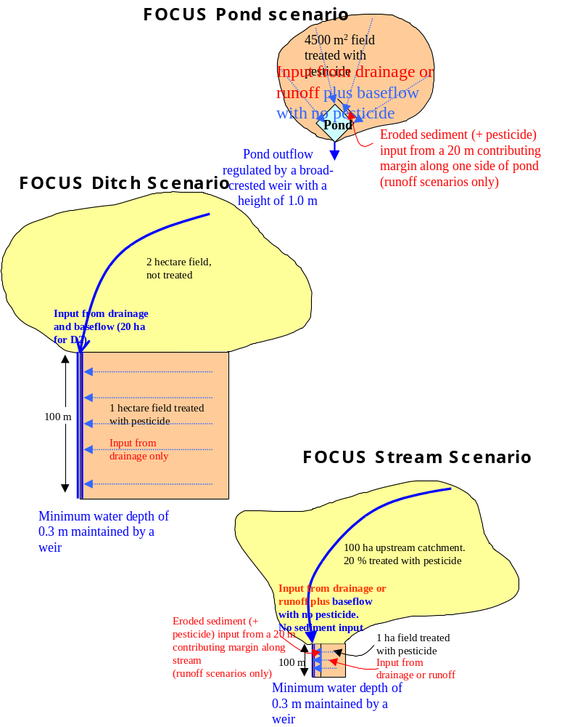

Figure 4.4.3-1. Conceptual outline of the FOCUS surface water bodies

Table 4.4.3-2 Sediment and suspended solid characteristics of all FOCUS water bodies
Characteristic | Value
Concentration of suspended solids in water column (mg.L⁻¹) | 15
Sediment layer depth (cm) | 5
Organic carbon content (%) | 5 (approx. 9% organic matter)
Dry bulk density (kg.m⁻³) | 800
Porosity (%) | 60
TEMPERATURE
Volatilisation and transformation are the two processes that are most sensitive to the ambient temperature. The temperature in the water bodies of the FOCUS surface water scenarios has been represented by means of monthly averaged, scenario-specific values. They have been calculated on the basis of the daily minimum and maximum air temperature of the data set of the scenario concerned for the twenty years’ period. For this purpose, daily average temperatures below 4 ºC have been corrected to 4 ºC, this being the temperature with the maximum density for non-frozen water.
HYDROLOGY
In order to achieve a realistic worst-case scenario for surface water exposure, the working group specified a set of desired residence times and water depths for each type of water body (see table 4.4.3-3).
Table 4.4.3-3. Desired average residence times and water depths for each type of surface water body
Surface water body | Average water depth (m) | Average residence time (days)
Pond | 1.0 | 50
Ditch | 0.3 | 5
Stream | 0.3 to 0.5 | 0.1
However, in reality flows within any water body are dynamic, reflecting the various base flow, runoff and drainage responses to rainfall events in the water body catchment. To characterise such flow dynamics in the FOCUS surface water bodies the Work group used the concept of ‘Hydraulic residence time’ with the following definition:
τ = V/Q
where:
τ = hydraulic residence time (d)
V = volume of water body considered (m³)
Q = discharge flowing out of water body (m³/d)
Because both discharge and water depth (and thus, volume) are a function of time, the hydraulic residence time is also a function of time. Runoff and drainage through macropores are dynamic processes, which have been expressed on an hourly basis in FOCUS. This implies that hydraulic residence times may fluctuate considerably from hour to hour and from day to day. In order to compare the various scenarios and water body types in an easy and manageable way the Work group introduced monthly averaged residence times, i.e. time-weighted average residence times over a period of a month.
In order to achieve the desired depths and residence times given in table 4.4.3-3, the hydrology of each water body in each scenario was characterised using a combination of either the MACRO or PRZM models to derive weather-related drainage or runoff inputs, the soil HOST-related catchment characteristics to derive base flow and, for runoff scenarios, recession flows (the reduction in flows over time from the event-induced peak flow) and the TOXSWA model to derive water fluxes and depths within the water body.
Inputs to each surface water body comprise a base flow component based on the characteristics of the upstream catchment (see section 4.3.3) together with either a drainage or a runoff component calculated for both the upstream catchment and the adjacent field. Base flow is the ‘background’ flow in any water body that represents the contribution to total flows made by the catchment groundwater store. It usually represents only a very minor fraction of the total flow in a FOCUS surface water body, as soon as drainage or runoff occurs. Drainage inputs are derived from the calculated fluxes for the year that represents the mean rainfall value of the long-term weather dataset for each drainage scenario. It was shown that this year also produces drainage fluxes that approximate to the 50th percentile drainage fluxes of the long-term weather data (see Table 4.1.2-2). Runoff inputs are derived from the calculated fluxes for the weather year that represents the 50th percentile seasonal runoff generated during the three main application seasons (October-February; March-May; June-September). In this way, for each water body in each scenario, inputs always represent a 50th percentile occurrence from either drainage or runoff combined with a 90th percentile occurrence from spray drift deposition. This combination, together with the target residence times and the rainfall specification imposed by PAT (see section 4.2.6) provides a realistic worst-case for estimating PEC_{sw}.
Ditches occur in four drainage scenarios. They have a length of 100 m and a width of 1 m and are fed by water fluxes from an upstream catchment of 2 ha and lateral water fluxes from a 1 ha neighbouring field. Scenario D2 is an exception to this where the base flow component originates from a 20 ha upstream catchment in order to maintain a minimum flow in summer. The more rapid drain flow component originates from the 2 ha catchment. A minimum water depth of 0.3 m is maintained in the ditch by means of a weir at its outflow end.
The parameterised discharges, water depths and monthly residence times for each ditch scenario are summarised in table 4.4.3-4, whilst the monthly variance of residence times is shown in table 4.4.3-5. Detailed descriptions and illustrations of the hydrological characteristics of the four ditch scenarios are given in Appendix F.
Scenarios D1, D2 and D6 all show considerable variation in discharge, depth and residence time, reflecting their relatively fast response to rainfall events. The D3 scenario shows a much more even response reflecting its significant base flow component and the ability to absorb and attenuate rainfall. The D2 scenario, which has the most rapid response to rainfall (see the drainage fluxes in the upper graph of D2 hydrology in Appendix F), has the largest variation in residence times (less than 1 h to 250 d), while the D3 scenario, responding most slowly to rainfall, has the lowest variation in residence times (0.7 to 4.4 d).

Table 4.4.3-4. Main characteristics of the drainage scenario ditches. All values are for the example crop of winter wheat for the 16-month simulation period
Scenario | Upstream catchment (ha) | Length* width (m²) | Min /max  discharge (l/s) | Min /max  water depth (m) | Min/max monthly residence time (d)
D1 | 2 | 100 * 1 | 0.008 – 3.88 | 0.30 – 0.32 | 0.4 – 45.5
D2 | 2 (20 for base flow) | 100 * 1 | 0.001 – 11.5 | 0.30 – 0.35 | 0.65 – 250
D3 | 2 | 100 * 1 | 0.08 – 0.71 | 0.30 – 0.31 | 0.70 – 4.4
D6 | 2 | 100 * 1 | 0.04 – 12.8 | 0.30 – 0.36 | 0.24 – 8.1
Table 4.4.3-5. Monthly averaged residence times (d) in the ditch exposure scenarios at D1, D2, D3 and D6 for 1982-83, 1986-87, 1992-93 and 1986-87, respectively. Example crop for which MACRO calculated drainage fluxes was winter wheat
Month | D1 | D2 | D3 | D6
January | 39.5 | 0.65 | 0.7 | 1.98
February | 2.9 | 4.8 | 0.92 | 0.24
March | 0.47 | 2.08 | 1.19 | 2.27
April | 1.23 | 1.29 | 1.31 | 7.31
May | 26.8 | 2.38 | 1.71 | 8.13
June | 45.5 | 250 | 2.03 | 8.13
July | 45.5 | 250 | 3.23 | 8.13
August | 45.5 | 7.18 | 4.44 | 8.13
September | 45.4 | 13 | 3.22 | 8.13
October | 45.5 | 3.18 | 2.71 | 8.13
November | 1.34 | 0.80 | 1.18 | 7.63
December | 0.56 | 0.78 | 1.12 | 0.41
January | 2.29 | 3.79 | 0.98 | 0.41
February | 6.52 | 1.69 | 1.02 | 0.66
March | 2.6 | 1.34 | 1.24 | 0.97
April | 3.07 | 1.2 | 1.78 | 3.31

It is important to note that, in terms of the desired residence times for ditches, scenarios D3 and D6 have residence times close to 5 days during the spring, summer and autumn periods but during winter they are shorter. In contrast, the ditches in scenarios D1 and D2 have residence times of about the desired 5 days only in winter and spring, but in summer and autumn they are significantly longer.
Ponds are present in two drainage scenarios and one runoff scenario. They have an area of 30 x 30 m², and a contributing area for drainage or runoff of 4500 m². The base flow, continuously feeding the pond, originates from a 3 ha catchment. In order to achieve the desired residence times of approximately 50 days, the ponds are fed by a small constant base flow of 0.025 to 0.1 L.s⁻¹. The outflow is composed of the base flow plus the drainage or runoff fluxes from the 4500 m² contributing area. Outflow occurs across a weir with a crest width of 0.5 m. The parameterised hydrological characteristics of each pond scenario are summarised in tables 4.4.3-6 and 4.4.3-7 and illustrated in detail in Appendix F.
Table 4.4.3-6. Main characteristics of the drainage scenario ponds. All values refer to the example crop of winter wheat for the 16-month simulation period
Scenario | Length x width (m²) | Min /max discharge (L/s) | Min/max water depth (m) | Min/max monthly residence time (d)
D4 | 30 * 30 | 0.025 – 0.40 | 1.00 – 1.01 | 87.7 – 283
D5 | 30 * 30 | 0.026 – 0.90 | 1.00 – 1.01 | 46.8 – 405
Table 4.4.3-7. Main characteristics of the runoff scenario ponds. All values refer to the non-irrigated crop of vines for the three 12-month simulation period, selected for each application season (spring: Mar-May, summer: Jun-Sep, autumn: Oct-Feb)
Scenario | Length x width (m) | Application season | Min /max discharge (L/s) | Min/max water depth (m) | Min/max monthly residence time (d)
R1 | 30 * 30 | Spring | 0.1 – 1.4 | 1.00 – 1.01 | 108 – 157
R1 | 30 * 30 | Summer | 0.1 – 1.6 | 1.00 – 1.01 | 85 – 157
R1 | 30 * 30 | Autumn | 0.1 – 1.6 | 1.00 – 1.01 | 85 – 157
The monthly variance of pond residence times is shown in tables 4.4.3-8 and 4.4.3-9. In most cases the residence times are about 2 to 3 times longer than the residence time of 50 d, which was the original aim of the Workgroup. This implies that the pond scenarios should produce a conservative estimate of concentrations with respect to (semi) chronic exposure.
Pond outflow has a maximum flux of 0.40 to 1.6 L.s⁻¹. The desired water depth of 1 m in the ponds hardly varies throughout the simulation period. This is because the storage capacity of the ponds is large with respect to the fluxes into it. Input fluxes are greatest from the R1 runoff scenario; however as they occur during short periods only, minimum monthly average residence times occur in at the drainage scenario D5.
Table 4.4.3-8. Monthly averaged residence times (d) in the pond exposure scenarios at D4 and D5 for 1985-86 and 1978-79, respectively. Example crop for which MACRO calculated drainage fluxes was winter wheat
Month | D4 | D5
January | 157 | 63.5
February | 123 | 82.2
March | 152 | 174
April | 153 | 218
May | 217 | 387
June | 279 | 405
July | 283 | 405
August | 283 | 405
September | 283 | 405
October | 283 | 405
November | 283 | 405
December | 61.7 | 405
January | 103 | 161
February | 177 | 46.8
March | 233 | 135
April | 230 | 164
Table 4.4.3-9. Monthly averaged residence times (d) in the pond exposure scenarios at R1. Figures refer to 1984-1985 (spring application) and 1978-79 (summer and autumn application). Example crop for which PRZM3 calculated runoff fluxes was the non-irrigated vines.
 | R1
Month | Application season
 | spring | summer | Autumn
March | 156 | - | -
April | 133 | - | -
May | 124 | - | -
June | 139 | 137 | -
July | 147 | 108 | -
August | 157 | 157 | -
September | 134 | 157 | -
October | 148 | 155 | 155
November | 108 | 139 | 139
December | 130 | 85 | 85
January | 116 | 144 | 144
February | 122 | 97 | 97
March | - | 123 | 123
April | - | 136 | 136
May | - | 154 | 154
June | - | - | 157
July | - | - | 157
August | - | - | 154
September | - | - | 157
Streams are present at four of the six drainage scenarios and all four runoff scenarios. They have a length of 100 m, a width of 1 m and their inflow is composed of a constant base flow plus variable fluxes of drainage or runoff water from a 100 ha upstream catchment. The 1 ha field adjacent to each stream also delivers lateral fluxes of drainage and runoff water into it. As with the ditch scenarios, a minimum water depth of 0.3 m is maintained in the stream by means of a weir at its outflow end.
The parameterised hydrological characteristics of each stream scenario are summarised in tables 4.4.3-10 and 4.4.3-11 and illustrated in detail in Appendix F.
Table 4.4.3-10. Main characteristics of the drainage scenario streams. All values refer to the example crop of winter wheat for the 16-month simulation period
Scenario | Length x width (m²) | Min /max  discharge (l/s) | Min /max water depth (m) | Min/max monthly residence time (d)
D1 | 100 * 1 | 0.38 – 131 | 0.31 – 0.82 | 0.017 – 0.93
D2 | 100 * 1 | 0.007 – 388 | 0.30 – 1.40 | 0.022- – 50.2
D4 | 100 * 1 | 1.23 – 85.2 | 0.31 – 0.68 | 0.017 – 0.29
D5 | 100 * 1 | 0.86 – 218 | 0.29 – 0.92 | 0.012- – 0.39
Table 4.4.3-11. Main characteristics of the runoff scenario streams. All values refer to the non-irrigated crop of vines for the three 12-month simulation period, selected for each application season (spring: Mar-May, summer: Jun-Sep, autumn: Oct-Feb)
Scenario | Length x width (m) | Application season | Min /max discharge (L/s) | Min/max water depth (m) | Min/max monthly residence time (d)
R1 | 100 x 1 | Spring | 2.22 – 399 | 0.41 – 1.32 | 0.06 – 0.21
R1 | 100 x 1 | Summer | 2.22 – 356 | 0.41 – 1.25 | 0.03 - 0.21
R1 | 100 x 1 | Autumn | 2.22 – 356 | 0.41 – 1.25 | 0.03 – 0.21
R2 | 100 x 1 | Spring | 3.24 – 350 | 0.31 – 1.17 | 0.01 – 0.10
R2 | 100 x 1 | Summer | 3.24 – 367 | 0.31 – 1.20 | 0.01 – 0.11
R2 | 100 x 1 | Autumn | 3.24 – 350 | 0.31 – 1.17 | 0.01 – 0.11
R3 | 100 x 1 | Spring | 0.88 – 330 | 0.29 - 1.13 | 0.02 - 0.38
R3 | 100 x 1 | Summer | 0.88 – 341 | 0.29 – 1.15 | 0.02 – 0.38
R3 | 100 x 1 | Autumn | 0.88 – 330 | 0.29 – 1.13 | 0.02 – 0.38
R4 | 100 x 1 | Spring | 2.23 – 491 | 0.41 – 1.46 | 0.01 – 0.21
R4 | 100 x 1 | Summer | 2.23 – 503 | 0.41 – 1.51 | 0.02 – 0.21
R4 | 100 x 1 | Autumn | 2.23 – 459 | 0.41 – 1.42 | 0.01 – 0.21
Water depth varies from 0.29 to 1.51 m and the minimum discharge varies from 0.38 to 3.24 L.s-1 for all scenarios, except for the D2 scenario with the heavy clay soils, where it is 0.007 L.s-1. The maximum discharge varies from 85 to 218 L.s-1 for D1, D4 and D5, while it varies from 330 to 503 L.s-1 for D2 and the four runoff scenarios. Apparently the heavy clay soils of D2 show rapid responses to rainfall events, comparable to those occurring in the runoff scenarios. Monthly residence times vary from 0.01 d to 0.93 d, except for D2 where the maximum monthly residence time is 50.2 d.
Table 4.4.3-12 summarises the monthly averaged residence times of the four streams in the drainage scenarios for the 16 month simulation period, while table 4.4.3-13 presents the residence times for the four streams of the runoff scenarios for the three application seasons and the 12 month simulation period. Again winter and spring months generally show lower average residence times than summer and autumn months. Except the June and July months of D2, the residence times approximate the aimed residence time of 0.1 d (section 5.7.2), within a factor of 10. In summer and autumn they often exceed the desired residence time, implying that in those periods the scenarios are more conservative with respect to long-term exposure than the Workgroup initially aimed for.
Table 4.4.3-12. Monthly averaged residence times (d) in the stream in the drainage scenarios at D1, D2, D4 and D5 for 1982-83, 1986-87, 1985-86 and 1978-79, respectively. Example crop for which MACRO calculated drainage fluxes was winter wheat.
Month | D1 | D2 | D4 | D5
January | 0.829 | 0.022 | 0.052 | 0.015
February | 0.080 | 0.132 | 0.036 | 0.019
March | 0.017 | 0.059 | 0.049 | 0.045
April | 0.037 | 0.039 | 0.050 | 0.064
May | 0.600 | 0.066 | 0.103 | 0.306
June | 0.927 | 50.2 | 0.270 | 0.391
July | 0.927 | 50.2 | 0.294 | 0.391
August | 0.927 | 0.192 | 0.294 | 0.391
September | 0.924 | 0.35 | 0.294 | 0.391
October | 0.927 | 0.086 | 0.294 | 0.391
November | 0.039 | 0.025 | 0.294 | 0.391
December | 0.020 | 0.025 | 0.017 | 0.391
January | 0.065 | 0.105 | 0.029 | 0.040
February | 0.169 | 0.049 | 0.065 | 0.012
March | 0.072 | 0.040 | 0.126 | 0.032
April | 0.084 | 0.036 | 0.120 | 0.042
Table 4.4.3-13. Monthly averaged residence times (d) in the stream exposure scenarios at R1 (1984-85, spring application and 1978-79, summer & autumn application); R2, (1977-78, spring application, 1989-90, summer application and 1977-78, autumn application); R3 (1980-81, spring & autumn application And 1975-76, summer application) and R4 (1984-85, spring application, 1985-86, summer application and 1979-80, autumn application). Example crop for which PRZM3 calculated runoff fluxes was non-irrigated vines
 | R1 |  |  | R2 |  |  | R3 |  |  | R4
Month | Sp | Su | Au | Sp | Su | Au | Sp | Su | Au | Sp | Su | Au
March | 0.207 | - | - | 0.032 | - | - | 0.067 | - | - | 0.150 | - | -
April | 0.099 | - | - | 0.035 | - | - | 0.099 | - | - | 0.201 | - | -
May | 0.080 | - | - | 0.080 | - | - | 0.126 | - | - | 0.046 | - | -
June | 0.116 | 0.111 | - | 0.045 | 0.065 | - | 0.381 | 0.089 | - | 0.212 | 0.212 | -
July | 0.147 | 0.057 | - | 0.085 | 0.109 | - | 0.302 | 0.381 | - | 0.212 | 0.212 | -
August | 0.213 | 0.213 | - | 0.099 | 0.109 | - | 0.374 | 0.090 | - | 0.042 | 0.101 | -
September | 0.101 | 0.211 | - | 0.072 | 0.109 | - | 0.350 | 0.135 | - | 0.189 | 0.212 | -
October | 0.153 | 0.200 | 0.200 | 0.029 | 0.035 | 0.029 | 0.143 | 0.018 | 0.143 | 0.212 | 0.039 | 0.010
November | 0.056 | 0.118 | 0.118 | 0.037 | 0.011 | 0.037 | 0.018 | 0.069 | 0.018 | 0.013 | 0.136 | 0.201
December | 0.093 | 0.035 | 0.035 | 0.013 | 0.010 | 0.013 | 0.072 | 0.093 | 0.072 | 0.020 | 0.026 | 0.071
January | 0.066 | 0.139 | 0.139 | 0.020 | 0.013 | 0.020 | 0.308 | 0.280 | 0.308 | 0.212 | 0.021 | 0.130
February | 0.076 | 0.045 | 0.045 | 0.011 | 0.034 | 0.011 | 0.324 | 0.027 | 0.324 | 0.130 | 0.024 | 0.203
March | - | 0.078 | 0.078 | - | 0.109 | 0.021 | - | 0.149 | 0.134 | - | 0.114 | 0.105
April | - | 0.108 | 0.108 | - | 0.049 | 0.034 | - | 0.381 | 0.381 | - | 0.046 | 0.056
May | - | 0.189 | 0.189 | - | 0.109 | 0.044 | - | 0.381 | 0.210 | - | 0.212 | 0.174
June | - | - | 0.213 | - | - | 0.095 | - | - | 0.058 | - | - | 0.212
July | - | - | 0.213 | - | - | 0.109 | - | - | 0.379 | - | - | 0.212
August | - | - | 0.195 | - | - | 0.109 | - | - | 0.112 | - | - | 0.119
September | - | - | 0.213 | - | - | 0.109 | - | - | 0.049 | - | - | 0.212
PESTICIDE INPUTS FROM THE UPSTREAM CATCHMENT AND ADJACENT FIELD
All three defined water bodies, the Pond, Ditch and Stream have an adjacent field that contributes drainage or runoff fluxes to the water body. In addition, the Ditch and Stream scenarios have an upstream catchment that also contributes drainage or runoff fluxes to the water body. In order to make this scenario as realistic as possible, but maintain consistency between scenarios, the fraction of the upstream catchment and adjacent field that has been treated with pesticide and the fraction that contributes an input of eroded sediment have been defined for each water body type (table 4.4.3-14).
Table 4.4.3-14 Pesticide inputs (dissolved and adsorbed) to the different water bodies
Water Body | Drainage or runoff with associated pesticide fluxes contributed from: | Pesticide fluxes associated with eroded sediment contributed from:
Pond | All the contributing catchment. | A 20 m ‘corridor’ adjacent to the pond.
Ditch | The adjacent 1 ha field only. | No runoff scenarios
Stream | The adjacent 1 ha field plus 20 ha of the upstream catchment. | A 20 m ‘corridor’ adjacent to the stream. (None from the upstream catchment)
Pond scenarios represent the simplest arrangement. Each 30 m x 30 m pond receives drainage or runoff waters with associated pesticide in solution from a 4500 m² contributing catchment. No pesticide is present in the base flow that enters the pond. For runoff scenarios, the pond also receives eroded sediment and associated pesticide from a 20 m ‘corridor’ adjacent to the pond. Eroded sediment is not contributed from the whole of the 4500 m² catchment because of its tendency to re-deposit when transported over extended distances.
Ditch scenarios are only associated with drainage inputs. They receive drainage fluxes from a 1ha field adjacent to the ditch and from a 2ha upstream catchment. Pesticide solute is only present in drainage waters from the 1 ha field adjacent to the Ditch. No pesticide is present in drainage waters from the upstream catchment. This represents a situation where 33% of the area considered in this scenario is treated with the pesticide. As for the pond, no pesticide solute is present in the base flow fluxes that contribute water to the ditch.
Stream scenarios are the most complex. They receive drainage or runoff fluxes from a 1ha field adjacent to the ditch and from a 100 ha upstream catchment. It is assumed that, in addition to the adjacent 1 ha field, pesticide will be applied on the same day to 20% of the area of the upstream catchment. The stream thus receives pesticide solute in the drainage or runoff waters from all of the 1 ha adjacent field and 20 ha of the upstream catchment. However, in order to adopt an extremely conservative approach to the exposure calculation, it is assumed that all pesticide solute deriving from the treated area of the upstream catchment impacts upon the surface water body at exactly the same time as that deriving from the treated field adjacent to it.
Again no pesticide solute is present in the base flow fluxes that contribute water to the stream. For runoff scenarios, as with the pond, it is assumed that the stream only receives eroded soil and associated pesticide from a 20 m ‘corridor’ in the field adjacent to it. No eroded soil or associated pesticide is received from the upstream catchment as all such soil is assumed to be incorporated within the upstream water body.

4.5 Spray drift
In order to conform with the desired ‘realistic worst-case’ nature of Step 3 scenarios, input to the water bodies from spray drift was assumed to be the cumulative 90th percentile value for all applications during the season. The spray drift data were obtained from the BBA (2000) data and were calculated based on a single application rate, the number of applications and default distances between various types of crops and adjacent surface water. In addition, the drift loadings were integrated across the width of the water body to provide a mean drift loading for a specific type of water body. For the Pond and Ditch scenarios, the calculated spray drift inputs are received only from the ‘treated’ field adjacent to the water bodies. For the stream scenarios however, where 20% of the upstream catchment is also assumed to be treated (see section 4.4.3 above), calculated drift inputs are received from both the adjacent field and 20 ha of the upstream catchment. The assumption made is that the upstream catchment was sprayed some time before the neighbouring field. This earlier spray event resulted in a 20% spray drift deposition in the stream water flowing into the water body from the upstream catchment. This in-flowing water with its 20% spray drift load passes through the simulated stretch of stream at the same time as the 100 % spray drift deposition from the adjacent field falls on its surface (see also section 5.7.3).

4.6 Summary of realistic worst-case assumptions for the scenarios
At various stages in the identification and characterisation of the 10 Surface Water Scenarios, calculations and assumptions have been made of their worst case nature. These assumptions and assessments can be summarised under three broad headings:

4.6.1 Identifying realistic worst-case environmental combinations
Assessments of the worst case nature of the Scenarios with respect to their environmental characteristics were described in section 3.5. They show that, taken as a whole, the chosen Scenarios represent between a 98th percentile worst case for all agricultural runoff land and a 99th percentile worst case for all drained agricultural land in the European Union.

4.6.2 Identifying realistic worst-case inputs from spray drift.
The spray drift inputs at Step 3 use calculations based on the 90th percentile worst-case values taken from measured data (BBA, 2000, see section 4.5 above). In addition to this, a worst case assumption is made that spray events always occur when the wind is blowing towards the scenario water body. For stream scenarios, the stipulation that inputs from spray drift occurring in the upstream catchment always coincide with spray drift inputs from the adjacent treated field (see section 4.5) provides an additional worst-case situation.

4.6.3 Identifying realistic worst-case inputs from runoff and drainage.
Unlike leaching to groundwater, pesticide inputs from runoff and drainage are mainly dependent on pesticide residues in the soil in relation to the timing and pattern of rainfall events following application and not on annual or seasonal volumes of runoff or drainage. This is particularly the case with respect to peak concentrations within the water body which are entirely dependent on the amount of pesticide residue in the upper parts of the soil and the timing and magnitude of the first significant rainfall event after application.
To ensure a realistic worse case for soil residues, the foliar wash-off coefficient in both MACRO and PRZM were set to a value of 0.5 cm⁻¹ (see section 7.4.10).
In order to impose a worst-case for rainfall in relation to pesticide application, the PAT calculator eliminates a significant number of potential application dates due to the requirement that at least 10 mm of precipitation be received within ten days following application (see section 4.2.6). This requirement results in the selection of application dates which ensure the 60th to 70th percentile wettest days for non-irrigated crops and the 50th to 60th percentile wettest days for irrigated crops (based on analysis of maize met files). The slightly lower percentile values for irrigated crops are due to the additional number of wet days created by irrigation events for these crops.

4.6.4 Identifying realistic worst-case inputs from the upstream catchments
Only two of the scenario water body types, the ditch and stream, receive surface water from an upstream catchment, although all three types receive a small base-flow input. The following assumptions have been made:
- The small base-flow input to each water body does not contain any pesticide residue.
- The surface water drainage input from the 2 hectare field that forms the upstream catchment of ditch scenarios does not contain any pesticide residues. It is assumed that this field is not treated with pesticide at the same time as the field adjacent to the scenario water body resulting in one third of the area considered in the ditch scenarios is treated with pesticide.
- For stream scenarios, it is assumed that 20% of the upstream catchment is treated with pesticide at roughly the same time as the field adjacent to the stream. Some of the fields in the catchment will be treated slightly before the field next to the water body, other areas will be treated slightly afterwards. The upstream water body will thus receive pesticide inputs from spray drift and rainfall event-driven drainage and runoff from these treated areas but, depending on the location of the treated fields and the time of treatment, the resulting pesticide fluxes will impact on different stretches of the upstream catchment and at different times. Realistically therefore, event-driven pesticide fluxes from different parts of the treated upstream catchment will arrive at the scenario water body inflow point at different times and are not likely to coincide with pesticide inputs from the adjacent field. However, because only 20% of the upstream catchment is treated, a worst-case assumption is made that the pesticide fluxes from treated areas of the upstream catchment arrive at the stream scenario water body at the same time as the pesticide input fluxes from the treated field adjacent to it.

4.6.5 Conclusions
The various assumptions and ‘worst-case’ assessments summarised above show that, for many of the scenario factors that determine the magnitude and duration of pesticide residues in water bodies, a 90th+ percentile worst-case has been adopted. In order not to create scenarios where worst-case conditions are unrealistically combined, other scenario factors are less severe and represent 50th to 70th percentile worst cases. The FOCUS Surface Water Scenarios Group does not consider it statistically valid to attempt to integrate the various worst-case assessments into a single value. However, it considers that the 10 Step 3 scenarios that have been created and characterised as described in the previous two chapters will provide a realistic range of PEC_{sw} estimates that represent significant agricultural areas within Europe. The highest PEC_{sw} estimates from the ten scenarios are likely to represent at least a 90th percentile worst-case for surface water exposures resulting from agricultural pesticide use within the European Union.

4.7 References
BBA (2000), Bekanntmachung über die Abtrifteckwerte, die bei der Prüfung und Zulassung von Pflanzenschutzmitteln herangezogen werden. (8. Mai 2000) in : Bundesanzeiger No.100, amtlicher Teil, vom 25. Mai 2000, S. 9879.
Boorman, D.B., Hollis, J.M. & Lilly, A. (1995). Hydrology of Soil Types: A hydrologically-based classification of the soils or the United Kingdom. Institute of Hydrology Report No. 126, Wallingford, UK. 137 pp.
Brooks, R.H. & Corey, A.T. (1964). Hydraulic properties of porous media. Hydrology paper No. 3, Colorado State University, Fort Collins, CO, USA.
Carsel, R.F., J.C. Imhoff, P.R. Hummel, J.M. Cheplick & A.S. Donigian, Jr, (1995). PRZM-3. A Model for Predicting Pesticide and Nitrogen Fate in the Crop Root and Unsaturated Soil Zones. Users Manual for Release 3.0. National Exposure Research Laboratory, U.S. Environmental Protection Agency, Athens, GA, USA.
FOCUS (2000) “FOCUS groundwater scenarios in the EU plant protection product review process” Report of the FOCUS Groundwater Scenarios Workgroup, EC Document Reference Sanco/321/2000, 197pp.
Mualem, Y. (1976). A new model for predicting hydraulic conductivity of unsaturated porous media. Water Resources Research 12, 513 – 522.
Raes, D., Lemmens, H., van Aelst, P., van den Bulcke, M. & Smith, M. (1988). IRSIS, Irrigation scheduling information system. Laboratory of Land Management. Katholieke Universiteit Leuven, Belgium. 119pp.
Rawls, W.J, D.L. Brakensiek and K.E. Saxton, 1982. Estimation of Soil Water Properties. Transactions ASAE Paper No. 81-2510, pp. 1316-1320.
Teixeira J.L. and Pereira L.S. (1992). ISAREG, an irrigation scheduling simulation model. ICID Bulletin, 41(2): 29-48.
Terres, J.M. (1998). MARS meteorological database – Technical description. Report of Agricultural Information Systems Unit, Space Applications Institute, Joint Research Centre, Ispra, Italy. 14pp.
Van der Voet, P., Van Diepen, C.A. & Oude Voshaar, J. (1994). Spatial interpolation of meteorological data. A knowledge-based procedure for the region of the European Communities. SC-DLO report 533, DLO Winand Staring centre, Wageningen, the Netherlands.
Vossen, P. & Mayer-Roux, J. (1995). Crop Monitoring and Yield Forecasting Activities of the MARS Project. In: European Land Information Systems for Agro-Environmental Monitoring. D. King, R.J.A. Jones & A.J. Thomasson (Eds.). EUR 16232 EN, 11-30. Office for the Official Publications of the European Communities, Luxembourg.
Williams, J.R., (1975). Sediment Yield Prediction with Universe Equation Using Runoff Energy Factor. In: Present and Prospective Technology for Predicting Sediment Yields and Sources. U.ES. Dept. of Agriculture, Washington, DC. ARS-S-40.

5. USING STEP 3 SCENARIOS TO CALCULATE PEC_{SW}

5.1 Development of SWASH
To facilitate the calculation of exposure concentrations at step 3 level a software tool has been developed: SWASH, acronym for Surface WAter Scenarios Help. It is an overall user-friendly shell, encompassing a number of individual tools and models involved in Step 3 calculations. The main functions of SWASH are:
- Maintenance of a central pesticide properties database,
- Provision of an overview of all Step 3 FOCUS runs required for use of a specific pesticide on a specific crop,
- Calculation of spray drift deposition onto various receiving water bodies and
- Preparation of input for the MACRO, PRZM and TOXSWA models.
In addition, SWASH provides information on the FOCUS Surface Water Scenarios.
After completing a SWASH session, the user must manually perform simulations with the individual models: PRZM, MACRO and TOXSWA. SWASH does not execute model runs, but provides guidance and helps the user determine which runs need to be performed for pesticide applications to various crops.
The PRZM and MACRO models calculate the water and substance fluxes that enter the water body via runoff/erosion and drainage, respectively. TOXSWA simulates the fate of the pesticide in the water body following loading resulting from spray drift deposition and either runoff/erosion or drainage. The concentrations calculated by TOXSWA include actual and time-weighted average PEC values in the water layer and the sediment, which are needed for subsequent aquatic risk assessments.
The central pesticide database stores information on physico-chemical properties as well as the use patterns of the compound. Data can be entered directly by the user using the SWASH shell or data can be uploaded from the chemical property databases of MACRO or PRZM. After exiting SWASH (or choosing to update the database during a SWASH session), the information in the central database is written back into the databases of MACRO or in sets of input files for PRZM or TOXSWA. In this way SWASH ensures that identical or consistent information on pesticide properties and use is introduced into the consecutive model runs.
SWASH has two wizards: the standard FOCUS wizard and a user-defined wizard. These tools help the user to determine which runs need to be done to obtain exposure concentrations in the relevant FOCUS surface water scenarios. With the standard FOCUS wizard, the user selects a crop on which a specific compound is used and the wizard provides an overview of all the combinations of EU scenarios and water body types that exist as FOCUS Surface Water Scenarios for the selected crop. The user-defined wizard provides an overview of a specific, user-defined combination of compound, crop, EU scenario and water body type. Both wizards can be used to prepare part of the inputs required to run PRZM, MACRO and TOXSWA. With both wizards, drift deposition is automatically calculated and written into appropriate input files for use by TOXSWA. The generated overview of the needed runs may be viewed and edited before being printed for use in guiding the user in performing the listed simulation runs.
Part of the SWASH software tool presents information on the FOCUS Surface Water Scenarios and the tools and models used for simulating drift, runoff/erosion, drainage and aquatic fate. Summaries of the range of crops and water body types in each of the ten FOCUS surface water scenarios is summarised together with a classification of the scenario type (i.e. drainage or runoff). FOCUS scenarios represent sites with a range of characteristics (e.g. precipitation, temperature, soil type and slope). As a result, they are intended to represent a broad range of environmental settings across Europe and not specific locations. Maps are included in SWASH to show the geographic extent of each of the FOCUS scenarios across the EU.
A manual version of the FOCUS drift calculator is incorporated in SWASH to help the user gain an improved understanding of how the drift deposition is calculated by the wizards. The manual drift calculator can also be used to calculate customised drift loadings for more refined modelling evaluations in later steps. Drift deposition is calculated as a function of application rate, number of applications, crop type and water body type. Section 5.4 below gives more details on these calculations.
SWASH has a help function to guide the user in correctly defining the required simulation runs. Finally, it indicates the versions of all included or coupled calculation tools: the drift calculator, the MACRO, PRZM and TOXSWA models as well as SWASH's own version number.

5.2 Calculation of exposure in special cases
Generally speaking the SWASH tool guides the user in performing the needed scenario runs for a selected compound-crop combination. However, there are some special cases that need additional attention and they have been described below.

5.2.1. Multiple applications and peak exposure (mainly) caused by spray drift entries
The FOCUS Surface Water Scenarios Working Group has based its drift deposition on the concept that the cumulative drift deposition for the entire application season represents the 90th percentile of drift probabilities. This implies that the drift deposition of a single event is lower in case of multiple applications during the season than in case of one single application in the entire application season (refer also to section 5.4.2). This means that if the peak PEC is entirely or mainly caused by spray drift deposition and not by the drainage or runoff entry (i.e. the peak occurs immediately after application), the peak PEC is calculated to be lower for multiple applications than for one application!
Theoretically this could lead to the situation that a compound may be eligible for Annex 1 listing based on multiple use during the application season, but may be rejected on the basis of a single use! To avoid such bizarre situations the user should repeat the exposure calculation procedure for one application and select the highest PEC calculated to perform the aquatic risk assessment.
So, in case of multiple applications of a compound with the maximum PEC occurring at a day of application, the exposure calculation with SWASH should be repeated for a single application and the maximum PEC, so the worst case, should be selected for the aquatic risk assessment.

5.2.2 Multiple applications covering both the early and the late growth stages and peak exposure (mainly) caused by spray drift entries
In SWASH the user needs to select the crop on which the compound is intended to be used. As spray drift deposition varies considerably for fruit trees and vines, a distinction has been made between their early and late crop growth stage, representing respectively a growth stage with no or few leaves and a growth stage in which the leaves are well developed (see BBCH Crop Growth Codes as mentioned in Table 2.4.1-1).
In case the maximum PECs are caused by the spray drift deposition (i.e. peak at day of application) and the application window covers both crop growth stages, the user should evaluate exposure in both crop growth stages. This means that in SWASH the user should select once the crop category of e.g. pome/stone fruit, early and next pome/stone fruit, late. The maximum PEC, so the worst case, should be selected for the aquatic risk assessment.

5.2.3. Two (identical) crops in season
In some scenarios it is possible to cultivate two times the crop within the growing season, e.g. field beans in D6, or leafy vegetables in the four R scenarios. In those cases SWASH automatically prepares two runs for this crop (each with their own runid), one for the first crop and one for the second crop in the season. The user should perform the MACRO/PRZM and TOXSWA runs twice, i.e. for both crops and next select the highest PECs, so again the worst case, for the aquatic risk assessment. Please note that this procedure differs from the calculation procedure for the FOCUS Groundwater Scenarios. In the FOCUS groundwater scenarios only one run needs to be done, because in one run the first as well as the second crop in the season are assumed to be treated with the selected compound, while in the (more event-driven) FOCUS Surface Water Scenarios treatment of either the first or the second has been considered.

5.2.4. Spraying grass or weeds between vines or tree crops
For a selected compound and crop SWASH determines all runs to be done, and prepares the input for the MACRO, PRZM and TOXSWA models. E.g. for atrazine on maize SWASH composes a project with 11 runs, one for each scenario plus water body where maize is cultivated. Input for the models is prepared based on the characteristics of the maize crop, e.g. spray drift deposition, crop interception, crop rooting and transpiration.
A problem arises when one wants to evaluate the risks of treating e.g. grass or weeds between vines or tree crops. Exposure concentrations need to be obtained in the water bodies of the scenarios, where the vines or tree crops are cultivated, but the grass or weeds between the vines or tree crops are treated and not the vines or tree crops themselves. The FOCUS Surface Water Scenarios Working Group considers these cases are not a standard step 3 assessment anymore and so, not all model input is being prepared by the SWASH tool. The user will need to edit or change some input himself.
In the cited example of grass or weeds between vines or tree crops the user is advised to determine the needed runs (and runids) by composing a project for the compound with the vines or tree crop and next consider critically all input prepared for the three models. Changes will be needed in a.o. the interception values for the MACRO and PRZM model (e.g. by adapting the application method or the CAM value) and the spray drift deposition in the TOXSWA input file. The models may need to be run without their standard step 3 Graphical User Interface or with the aid of a bat file in MS DOS (refer to the user manuals of the models).

5.3 Calculation of exposure to metabolites
Exposure to metabolites in the FOCUS Surface Water Scenarios is calculated in the following way.
It has been assumed that no metabolites are formed in the air and so, only the parent compound and no metabolites enter the surface water via the spray drift deposition entry route. This implies that in the FOCUS Surface Water Scenarios metabolites can only enter the water bodies via the drainage or runoff entry routes.
Part of the application is deposited onto the plant canopy, where it degrades. However, it has been assumed that only the parent compound is washed off the plant onto the soil surface, from where it can be drained or run off into surface water. So, no metabolites wash off the plant foliage onto the soil surface.
The applied compound is deposited onto the soil surface and penetrates into the soil. Next, it will degrade, form metabolites and be drained or run off into the FOCUS water body.
The MACRO model can deal with one parent compound and one metabolite in one, single simulation sequence. If more than one metabolite are being formed another simulation sequence should be performed, for the same parent compound, but the other metabolite. It prepares an output file, listing the metabolite drainage fluxes as a function of time that TOXSWA reads in. (See also section 5.5.2 Metabolites in MACRO).
The PRZM model can handle two metabolites simultaneously. Either two metabolites are formed from the parent compound, or the first metabolite degrades into a second metabolite. (Refer also to section 5.6.2 Simulation of metabolites by PRZM.) In both cases PRZM prepares two separate output files, that list the metabolite run off fluxes as a function of time. The TOXSWA model can read these files and thus account for the fate of the metabolite in the water body.
A parent compound that is deposited on the surface area of the FOCUS water body dissolves into the water and metabolites are formed. Additionally, metabolites may enter the water body via various entry routes.
The TOXSWA model is not able to simulate the formation of metabolites in water or in sediment. So, at present TOXSWA only simulates the fate of a metabolite that entered the water body via drainage or run off. Section 5.7.2 Handling metabolites with TOXSWA presents an approach to estimate exposure concentrations of metabolites that have been formed in the FOCUS water body.

5.4 Calculation of inputs from Spray Drift
A drift calculator has been developed by the FOCUS Surface Water Scenario group to provide aquatic drift loadings for Step 3 assessments of PEC_{sw} and PEC_{sediment}. This calculator is incorporated into the FOCUS SWASH (Surface Water Scenarios Help) shell and will also be available as a stand-alone spreadsheet tool for use in estimating drift loadings in refined Step 4 assessments.
Inputs to the calculator include the application rate, number of applications, type of crop and type of water body. The calculated drift loadings are intended for use in either TOXSWA or EXAMS.

5.4.1 Source of Drift Data
The basis of the drift calculator is the recently published data from the BBA [BBA, 2000] for ground applications and the Tier 1 regressions from the AgDrift model [SDTF, 1999] of the Spray Drift Task Force for aerial applications. In the BBA data, crops have been divided in five groups (arable crops, fruit crops (orchards), grapevines, hops and vegetables/ornamentals/small fruit) with additional distinction made between the early and late growth stages for fruit crops and grapevines and a crop height distinction for vegetables/ornamentals/small fruit. A category of drift resulting from aerial application has also been added to provide an initial estimate of spray drift resulting from this mode of application.
For each crop and growth stage combination, experimental spray drift deposition data have been compiled as a function of distance from the edge of the treated field. The data at each distance have been analysed to determine the probabilities of observing various amounts of drift. If the 90th percentile drift values are calculated for each distance, this experimental data set can be used to determine a 90th percentile regression curve for the crop/growth stage combination being considered. In a similar fashion, a 70th percentile drift regression curve can be developed by fitting the 70th percentile drift values at each distance from the treated field. Additional details on the regression methodology used are in Section 5.4.3.

5.4.2 Selecting Appropriate Drift Data for Multiple Applications
The FOCUS Surface Water Working Group has recommended that a 90th percentile cumulative drift probability be used for all drift applications made during a single cropping season. This concept has recently been endorsed by the BBA in their new drift tables (BBA, 2000).
The basic concept of this approach is to select appropriate drift values so that the cumulative drift for the entire application season is the 90th percentile of drift probabilities. It is assumed that the drift amounts for a single event are normally distributed with a mean μ and a standard deviation σ. For a series of n applications, the mean of all the experimental observations is μ and the standard deviation is σ/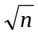.

For a single application, the cumulative 90th percentile drift amount has a value of μ + 1.282 σ in a normal distribution which is equivalent to stating that 90% of the values in the distribution lie below the value which is 1.282 standard deviations above the mean. For a series of six applications, the cumulative 90th percentile drift amount has a value of μ + 1.282 σ / 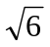 or μ + 0.523 σ. The cumulative percentile which corresponds to a value 0.523 standard deviations above the mean in a normal distribution is the 70th percentile. Therefore, a series of six individual spray drift events, each with a 70th percentile probability, has an overall 90th percentile probability for the entire season of applications.

In the general case, the drift amount, which if repeated n times, would result in a total drift amount which would be exceeded in 1 year in 10 (i.e. an annual 90th percentile), is equal to the xth percentile of the BBA drift data, where x is the percentile corresponding to a point 1.282/ standard deviations above the mean. The single event percentiles for various numbers of applications per season are tabulated in Table 5.4.2-1.
Table 5.4.2-1. Percentile of individual spray drift events for n applications which are equivalent to cumulative 90th percentile spray drift for the season
Number of  applications | Drift percentile of a single Event | Cumulative drift Percentile for the Season
1 | 90 | 90
2 | 82 | 90
3 | 77 | 90
4 | 74 | 90
5 | 72 | 90
6 | 70 | 90
7 | 69 | 90
8 | 67 | 90
>8 | 67 (assumed) | 90+

5.4.3 Definition of Percentile
The most common method of determining percentiles for environmental data is the use of the Weibull ranking function which assigns a probability of 1/(n+1) to each data point and then rank orders the data to determine cumulative probability. The cumulative probability of event I is then i/(n+1). This probability ranking method was used to analyse the BBA drift data and to calculate the crop drift values at each distance from the edge of the treated field.

5.4.4 Development of Regression Curves
Individual regression curves were developed for each crop grouping as well as for each number of applications, based on fitting the various percentile drift results as a function of distance from the edge of the treated area. Regression curves have been determined for up to eight applications for each crop grouping. The regression values for eight applications are also used for more than eight applications (see Table 5.4.2-1).
Each data set was described using a simple power function in order to obtain two regression parameters:
Percent drift = A * z^{B} Equation 1
where Percent drift = percentile drift value (percent of application) at distance z (m) from the edge of the treated field
A = regression factor (constant)
B = regression factor (exponent).
This function worked well for the data sets for arable crops, vegetables (< 50 cm), vegetables (> 50 cm) and grapes (both early and late). However, a single power function with only two regression parameters was inadequate to describe the data sets for hops and fruit crops (early and late) as well as aerial applications. To represent the drift data for these cases, a regression function was developed using two sequential power functions splined together at a distance H:
Percent drift = A * z^{B} (for z = 0 to H)
= C * z^{D} (for z > H) Equation 2
where Percent drift = percentage drift value (percent of application) at distance z from the edge of the treated field
A = constant regression factor for distance 0 to H
B = exponential regression factor for distance 0 to H
C = constant regression factor for distance H and higher
D = exponential regression factor for distance H and higher
H = distance limit for each part of the regression (m), also called a hinge point.
This regression curve uses the regression parameters A and B to calculate drift for distances between 0 and H; regression parameters C and D are used for drift calculations for distances for H and higher. Using this approach, all of the drift data sets could be simply and accurately described by using either two parameters (arable crops, vegetables, grapes) or four parameters (hops, fruit crops and aerial application).
Example regression curves are provided in Appendix B for arable crops (described by two parameters) and hops (described by four parameters). Appendix B also shows all of the regression parameters for all of the drift data sets, together with the hinge points (H) where applicable and shows examples of the fit of the modelled data to the original data sets.

5.4.5 Calculating the drift loading across the width of a water body
Equations 1 and 2 can be used to calculate the drift deposition expected at a specific distance from a treated field. In order to calculate the total drift loading on a receiving water body, these equations must be integrated over the width of the receiving water body since the drift is higher on the edge nearest to the field and lower on the edge farthest from the field. Use of the drift loading just at the water body edge closest to the field provides an unrealistic estimate of the total drift loading across the entire water body. For relatively wide water bodies (e.g. ponds), the integration of drift is an important refinement that provides more realistic drift loadings. For relatively narrow water bodies (e.g. ditches and streams), the integration of drift provides a minor correction to edge-of-field drift loadings.
The mean (integrated) drift deposition into surface water bodies can be calculated from the following equation, which has been derived from Equation 2 above:
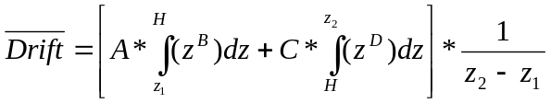 Equation 3
where 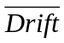 = mean percent drift loading across a water body that extends from a distance of z1 to z2 from the edge of the treated field
A, B, C, D = previously defined regression parameters
z₁ = distance from edge of treated field to closest edge of water body (m)
z₂ = distance from edge of treated field to farthest edge of water body (m)
H = distance limit for each regression (m), also called hinge point.
The integrated form of this equation is as follows:
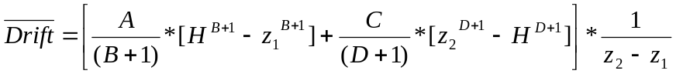 Equation 4
Equation 4 can be simplified if the furthest edge of the water body (z₂) is less than the hinge distance, H, or if only one regression curve is necessary:
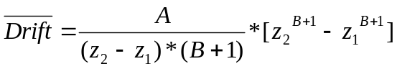 Equation 5

5.4.6 Drift loadings for TOXSWA
To calculate the drift loading into surface water for use in TOXSWA, the mean drift loading is multiplied by the application rate as follows:
Drift/area = App rate/10 */100 Equation 6
where Drift/area = drift loading into a receiving water body (units: mg/m²)
App rate = application rate of chemical in treated field (g as/ha)
= mean percent drift loading across a receiving water body.

5.4.7 Aerial application
The spray drift estimates for aerial application were taken from data developed by the Spray Drift Task Force and presented in the model Agdrift (SDTF, 1999). Since the data from this work cannot be cited without compensation, a regression curve was developed which closely resembles the Tier 1 regression curve for a single application in the Agdrift model. This curve is assumed to represent a 90th percentile drift curve for aerial application and FOCUS regression parameters are only provided for a single application.
It is not anticipated that this drift option would be used significantly within the EU registration process. If the resulting values prove to be unacceptable, the registrant will need to use the data of the Spray Drift Task Force to provide a more definitive assessment of the actual situation.

5.4.8 Data requirements for determining spray drift loadings into surface water
Based on the approach described above, the data that are needed to obtain a Step 3 calculation of spray drift loading into an adjacent surface water body are as follows:
- Application rate, g as/ha
- Number of applications (to determine the correct spray drift percentile per event)
- Crop type (to determine the correct default distance between crop and water body)
- Water body type (to determine the correct default width of water body)
Once these four parameters are defined, the calculator determines the appropriate spray drift percentiles, defines the default distance between the crop and the water body, determines the default dimensions of the water body and calculates the drift loading received by the adjacent water body.
The results of the calculation are expressed in units of mg as/m² of the water body and the drift result is transferred to TOXSWA to be combined with drainage and/or runoff/erosion loadings.

5.4.9 Crops, crop groupings and possible application methods
The FOCUS Surface Water Scenarios Working Group has classified the crops into the BBA (2000) crop groupings to be able to calculate the drift deposition according to crop type (Table 5.4.9-1). Drift deposition also depends on the application method and the following applications methods have been defined: (i) ground spray, (ii) air blast, (iii) soil incorporated, (iv) granular and (v) aerial application. The FOCUS SWASH tool (Surface WAter Scenarios Help) allows the user to couple all crops to the application methods soil incorporated, granular or aerial, but crops can only be coupled to either the ground spray or the air blast application method. Table 5.4.9-1 presents to which of the two last-mentioned methods each crop has been coupled.
Table 5.4.9-1. Overview of the classification of crops according to crop grouping and the default application method of each crop.

Crop | BBA  Crop grouping | Default application method in SWASH
Cereals, spring | Arable crops | Ground spray
Cereals, winter | Arable crops | Ground spray
Citrus | Fruit crops, late | Air blast
Cotton | Arable crops | Ground spray
Field beans | Arable crops | Ground spray
Grass/alfalfa | Arable crops | Ground spray
Hops | Hops | Air blast
Legumes | Arable crops | Ground spray
Maize | Arable crops | Ground spray
Oil seed rape, spring | Arable crops | Ground spray
Oil seed rape, winter | Arable crops | Ground spray
Olives | Fruit crops, late | Air blast
Pome/stone fruit, early applications | Fruit crops, early | Air blast
Pome/stone fruit, late applications | Fruit crops, late | Air blast
Potatoes | Arable crops | Ground spray
Soybeans | Arable crops | Ground spray
Sugar beets | Arable crops | Ground spray
Sunflowers | Arable crops | Ground spray
Tobacco | Arable crops | Ground spray
Vegetables, bulb | Arable crops | Ground spray
Vegetables, fruiting | Arable crops | Ground spray
Vegetables, leafy | Arable crops | Ground spray
Vegetables, root | Arable crops | Ground spray
Vines, early applications | Vines, early | Ground spray
Vines, late applications | Vines, late | Ground spray

5.4.10 Refining drift values
The drift loadings that are calculated using this Step 3 tool incorporate the following assumptions:
- Cumulative drift loadings are 90th percentile values based on BBA (2000) data
- Default distances have been established between treated crops and the top of the bank of the adjacent water body based on the type of crop. Specified distances range between 0.5m for cereals to 5.0m for aerial applications.
- Default distances have been established between the top of the bank and the edge of the water body based on the type of water body. Specified distances are 0.5m for ditches, 1m for streams and 3m for ponds.
- Default water body widths are as follows: ditches – 1m; streams – 1m, ponds – 30m.
- The direction of wind is always directly from treated field to the receiving water body.
- The Tier 1 regression values from the AgDrift model are assumed to be equivalent to the 90th percentile aerial drift curve for a single application.
In some cases, it may be necessary to further refine the Step 3 drift values obtained by considering additional factors, which affect drift in “real world settings” such as:
- actual distances between the treated crop and the surface water bodies
- evaluation of the drift-reducing effects of cover crops or weeds in the non-treated zone between the edge of the field and adjacent surface water
- consideration of the density of treated fields in a landscape and the range of distances between treated areas and receiving water, typically based on GIS analyses
- evaluation of the effects of variable wind speed and direction on drift loadings
- evaluation of the effects of drift-reducing nozzles or shielded spray equipment
To facilitate use of the drift calculator in SWASH for Step 4 assessments, it is possible to manually adjust the distance between the treated crop and water body and to evaluate the resultant drift loadings. In addition, an Excel spreadsheet version of the drift calculator is also available to permit more detailed modifications of the drift calculations. Any changes made to the drift calculations should be clearly labelled as Step 4 refinements in subsequent reporting.

5.5 Calculation of inputs from Drainage using MACRO
The model MACRO was chosen to calculate drainage inputs to surface water bodies for the step 3 simulation examples presented in this chapter. This is because of the model’s ability to simulate pesticide losses through both macropore flow and bulk matrix flow and thus its applicability to the wide range of soil types included in the 6 scenarios where drainage is a significant input. To put this selection in context and to provide a ‘reality-check’ for the results of the drainage calculations presented in section 7.5, a brief summary of the available pesticide monitoring data for tile-drained field sites is presented in this section. The model (MACRO v.4.2) which has been parameterised for the FOCUS drainage scenarios is then described, followed by a discussion of uncertainties in both model process descriptions and parameter selection.

5.5.1 The MACRO model, version 4.3
MACRO (version 3.2) was described in detail in the report of the FOCUS surface water models group (Adriaanse, et al., 1995). However, although the model structure is fundamentally the same, some aspects of the process descriptions have changed since this earlier report was published, and some new processes have been introduced since the release of version 3.2. The most important of these for the FOCUS scenarios are:
- Freundlich sorption instead of a linear isotherm
- treatment of snowpack
- improved description of crop leaf area development and calculation of crop surface resistance
- Drainage flows originating also from below drain depth
- ability to simulate a pesticide metabolite
- new bottom boundary condition for saturated conditions
MACRO is a general purpose leaching model that includes the effects of macropores (Jarvis, 1994a; Jarvis, 2001). It explicitly considers macroporosity as a separate flow domain assuming gravity flow of water and a simple power law function for the conductivity. This is equivalent to a numerical kinematic wave (Germann, 1985). Solute movement in the macropores is assumed to be dominated by mass flow, while the concentration of solutes in water entering the macropores at the soil surface is calculated using the ‘mixing depth’ concept, whereby the incoming rain perfectly mixes with the soil solution in a given depth of soil. MACRO describes the movement of water through the soil matrix using Richards’ equation and solute transport with the convection-dispersion equation. Mass exchange between the flow domains is calculated using approximate first-order expressions based on an effective diffusion path length. Sorption is described with a Freundlich isotherm, with the sorption sites partitioned between the two domains. Degradation is calculated using first-order kinetics.
Drainage from saturated soil layers is given as a sink term to the vertical one-dimensional flow equation using seepage potential theory (Leeds-Harrison et al., 1986) for saturated layers above drain depth and the second term of the Hooghoudt equation for layers below drain depth. Perched water tables are also considered. The bottom boundary condition utilised for the FOCUS surface water scenarios is a vertical seepage rate calculated as an empirical linear function of the height of the water table in the soil profile, first introduced in version 4.2 of MACRO. Pesticide movement to the drains is calculated assuming perfect mixing in the lateral dimensions in each saturated soil layer.

5.5.2 Metabolites in MACRO
MACROinFOCUS can deal with one parent compound and one metabolite in one single simulation sequence (additional metabolites can be dealt with in additional simulations). The user must define the properties of the metabolite, including the proportion of the degraded mass of parent compound that is transformed into the metabolite. No account is taken internally of the different molecular weights of parent compound and metabolite, so this should be factored in to the calculation. Two output files are then created by MACROinFOCUS, one for the parent and one for the metabolite and TOXSWA input files can be created from both.

5.5.3 FOCUS Simulation procedure
A sixteen-month assessment period is used for simulation of drainage inputs to surface waters. The weather data for the first 12 months of the assessment period were chosen to represent the 50th percentile year with respect to annual rainfall (the remaining 4 months are simply selected as the period following the selected 12-month period). It should be noted that actual loadings to surface waters are controlled more by the rainfall pattern soon after application than by the annual rainfall climate when losses are event-driven i.e. dominated by macropore flow. The worst-case nature of the weather data in the period following application is controlled by the PAT calculator (see section 4.2.6) and is between the 50 and 70th percentile, depending on whether irrigation is used. In preliminary model runs with MACRO, it was noted that, especially for persistent compounds, the travel time of the pesticide to the drains was significantly longer than sixteen months, such that concentrations in drain outflow were still increasing at the end of the simulation. It was therefore decided to employ a six-year warm-up period, in the same way as in the FOCUS groundwater scenarios (FOCUS, 2000). Pesticide applications are made each year, using the Pesticide Application Timer (PAT, see section 4.2.6) to calculate the application day(s) in each year. Depending on the application day(s) calculated by PAT, a fraction of the dose specified by the user is calculated as being intercepted by the crop canopy. This is given as a function of the method of application, a maximum interception reached at the maximum leaf area, and the leaf area index at the time of application. One of five different application methods is selected by the user: ground spray, air-blast, granular, incorporated and aerial. Interception is assumed zero for both granular and incorporated applications, the only difference between the two methods being that the solute mixing depth (ZMIX, see Appendix C) is set to zero for incorporated pesticides. For air-blast applications and for ground and aerial sprays to perennial crops, the interception is assumed to always equal the maximum interception fraction (see Appendix B for the crop-specific values assumed). For annual crops, the interception for ground and aerial sprays is given as the ratio of the current leaf area to the maximum leaf area, multiplied by the maximum interception fraction.
Hourly values of water discharges through drains, and the pesticide loads in the discharge during the assessment period are saved to an output file, which is then used as input to the surface water fate model TOXSWA (see section 5.7). A shell program (MACRO in FOCUS) has been developed to help facilitate the calculations of drainage inputs to surface waters using MACRO, and the data links to TOXSWA.

5.6 Calculation of inputs from Runoff using PRZM
The Pesticide Root Zone Model (PRZM) was selected to calculate runoff and erosion loadings into surface water bodies for four of the Step 3 FOCUS surface water scenarios. PRZM is a one-dimensional, dynamic, compartmental model that can be used to simulate chemical movement in unsaturated soil systems within and immediately below the root zone. It has two major components – hydrology and chemical transport. The hydrologic component for calculating runoff and erosion is based on the USDA Soil Conservation Service curve number methodology and a watershed-scale variation of the Universal Soil Loss Equation. Evapotranspiration is composed of evaporation from crop interception, evaporation from soil and transpiration from the crop. Water movement is simulated by the use of generalised soil parameters, including field capacity, wilting point and saturation water content (Carsel et al, 1995).

5.6.1 Modification of PRZM for use in FOCUS scenario shells
The version of PRZM that has been adapted for use in the FOCUS surface water scenarios is PRZM, version 3.22. To facilitate data entry, parameterisation of the required input files and analysis of the simulation results, a Windows-based shell has been developed for use with this model (PRZM in FOCUS, version 1.1.3). The shell also provides a convenient interface with the overall shell SWASH and the aquatic fate model TOXSWA.
The key features that have been added to PRZM to improve its use for surface water calculations include:
- option of using a Freundlich sorption isotherm or a standard linear isotherm
- option of simulating aged sorption (sorption increasing with time)
- option of simulating degradation as a function of temperature and moisture (following FOCUS recommendations)
- option of simulating a parent and up to two metabolites using degradation rates, molar conversion factors and molecular weights of each species
- the creation of tables and graphs to view the output from PRZM in FOCUS
- the automatic creation of PRZM to TOXSWA (*.P2T) output files for use by TOXSWA
The core model, PRZM 3.22, is the same model used for performing FOCUS groundwater calculations.

5.6.2 Simulation of metabolites by PRZM
In PRZM, the degradation of the parent compound occurs on the plant canopy as well as in the soil profile. On plant foliage, degradation/dissipation of the parent chemical is simulated but the fate of the degradation products is not tracked. As a result, the soil receives some direction application of parent chemical as well as periodic amounts of parent chemical that washes off of the foliage onto the soil. Within the soil profile, the parent and up to two metabolites can be simultaneously simulated by PRZM. When metabolites are simulated by PRZM, separate P2T (PRZM to TOXSWA) files are generated for each chemical species.
If it is necessary to simulate more than two metabolites, it is possible to calculate the runoff and erosion of any number of metabolites by simulating them as separate applications, correcting for differences in molecular weight and the maximum amount formed in soil in experimental studies. If metabolites are simulated as “equivalent parent applications”, it may be necessary to adjust the depth of incorporation and possibly the timing of the applications to reflect the fact that metabolites are generated within the soil profile and not at the soil surface. For example, if the metabolite concentration peak occurs 40 days after application of parent and the parent peak has moved to a depth of 30 cm during this time, it is appropriate to use an incorporation depth of 30 cm and to shift the metabolite application window 40 days after that of the parent compound. When metabolites are kinetically generated by the model, no depth or application date corrections are necessary.

5.6.3 Overview of the runoff and erosion routines in PRZM
Hydrologic and hydraulic computations in PRZM are performed on a daily time step even though finer temporal resolution could provide greater accuracy and realism for some of the processes involved (e.g. evapotranspiration, runoff and erosion). PRZM retains its daily time step primarily because of the relative availability of daily meteorological data versus shorter time step data. To help address this issue, the PRZM provides enhanced parameter guidance and incorporates algorithms, which consider critical aspects of the runoff hydrographs such as peak flow and typical duration. To help couple the runoff and erosion results simulated by PRZM with the transient hydrology incorporated in TOXSWA, the daily runoff and erosion time series output files (*.ZTS) are automatically post-processed into a series of hourly runoff and erosion values by assuming a peak runoff rate of 2 mm/hr in output files designated as *.P2T (for PRZM to TOXSWA). Thus, an 18 mm daily precipitation event is entered into TOXSWA as a nine hour runoff loading of 2 mm/hr. The erosion loadings and chemical fluxes in runoff and erosion have been handled in a similar manner. The temporal distribution of the daily runoff and erosion loadings facilitates efficient mathematical solutions of the aquatic concentrations in TOXSWA.
The curve numbers used in PRZM are a function of soil type, soil drainage properties, crop type and management practice. For the four FOCUS runoff/erosion scenarios, appropriate curve numbers for each crop in each scenario have been selected and entered into a database within the PRZM in FOCUS shell. During a simulation, the curve number is modified daily based on the soil water status in the upper soil layers using algorithms developed by Haith & Loehr (1979). The daily curve number is used to determine a watershed retention parameter, which in turn determines the daily runoff as follows:
S = 1000/RCN – 10

where S = daily watershed retention parameter
RCN = runoff curve number (dimensionless, adjusted daily depending upon antecedent moisture)

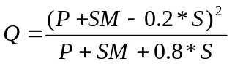

where Q = daily runoff (mm)
P = daily precipitation (mm)
SM = daily snow melt (mm)
S = daily watershed retention parameter.

Values of the crop-specific curve numbers for each scenario are provided in Appendix D.
The current version of PRZM contains three methods to estimate soil erosion: the Modified Universal Soil Loss Equation (MUSLE), developed by Williams (1975); and two recent modifications, MUST and MUSS.
MUSS is specifically designed for small watersheds and was selected for use in FOCUS:
MUSS:
where Xe = the event soil loss (metric tonnes day⁻¹)
Q = volume of daily runoff event (mm)
q_{p} = peak storm runoff (mm/h), determined from generic storm hydrograph
A = field size (ha)
K = soil erodability factor (dimensionless)
LS = length-slope factor (dimensionless)
C = soil cover factor (dimensionless)
P = conservation practice factor (dimensionless).
This expression depends primarily upon daily runoff volumes and rates as well as the conventional USLE factors K, LS, C and P. It is very weakly dependent on the size of the field.

5.6.4 Procedure used to select specific application dates
To help standardise runoff assessments, the actual dates of application are determined by the Pesticide Application Tool (PAT) contained in the PRZM in FOCUS shell. The user is asked to enter four application parameters: first possible date of application (with respect to emergence), the number of days in the application window, the number of applications and the minimum interval between applications. PAT then attempts to select appropriate application dates that meet two criteria:
- No more than 2 mm/day of precipitation should occur on any day within two days before or after an application
- At least 10 mm of precipitation (cumulative) should occur within 10 days of an application
If no dates are found in the meteorological files that meet these criteria, the precipitation targets and timing in the two rules are progressively relaxed until acceptable application dates are found. PRZM creates a file called PAT.TXT that summarises the final rules used to select application dates.

5.6.5 Procedure used to evaluate and select specific years for each scenario
Based on an evaluation of the temperature and precipitation patterns for each runoff/ erosion scenario, these scenarios represent the 73rd to 98th percentile of potential European settings (see section 3.5 for more detail). Each of the surface water scenarios developed by FOCUS has 20 years of meteorological data. The PRZM in FOCUS shell runs all 20 years of data and creates a time series output file containing all of the daily runoff data (*.ZTS). Due in part to the computational requirements of TOXSWA, the FOCUS surface water group have selected one representative 12-month period for each use pattern being evaluated in Step 3. Since the first few runoff events following application generally result in most of the chemical transport via runoff/erosion, the selected 12-month period is based upon an analysis of daily, cumulative seasonal and cumulative annual runoff and erosion values for the entire 20-year sequence of results.
The representative years selected for creation of PRZM output files for use by TOXSWA are given in table 5.6.3-1. For example, an application to maize, which occurs in June would result in selection of the following 12-month period for Scenario R3: June 1975 to September 1976. Determination of the selected year and all necessary post-processing to create an hourly PRZM to TOXSWA (*.P2T) file are handled automatically within the PRZM in FOCUS shell.
Table 5.6.3-1. Selected years for creation of PRZM to TOXSWA (*.P2T) files
Scenario | Date of First Application
Scenario | March to  May | June to September | October to February
R1 | 1984 | 1978 | 1978
R2 | 1977 | 1989 | 1977
R3 | 1980 | 1975 | 1980
R4 | 1984 | 1985 | 1979

5.6.6 Summary of scenario input parameters
Two detailed sources of information on the PRZM in FOCUS shell are provided in this report. A complete listing of the parameter values selected for use in each FOCUS runoff/erosion scenario (R1 to R4) is provided in Appendix D. A line-by-line description of the input files (*.inp) created by the PRZM in FOCUS shell is provided in Appendix K. In order to ensure that the calculations performed by the PRZM in FOCUS shell use the correct input values for soil, climate and agronomy, the user should not edit the PRZM input files (*.inp) created for Step 3 calculations.

5.7 Calculation of PEC_{sw} using TOXSWA
The TOXSWA model (Adriaanse, 1997; Beltman and Adriaanse, 1999) was selected to calculate fate in surface water bodies for the step 3 simulation examples of this chapter. Although the USA EPA model EXAMS is another good candidate, the FOCUS Surface Water Scenarios Working Group preferred the TOXSWA model for the following reasons:
- User friendliness, including post-processing functions
- Current use in the registration procedure of one EU member state (the Netherlands), and
- Possibility of developing customised version for the FOCUS surface water scenarios. For FOCUS, the TOXSWA code was extended with options to simulate transient flow resulting from surface runoff and drainage.
In this section, the principles of TOXSWA 2.0 will be briefly presented and we will describe how TOXSWA 2.0 has been applied for the FOCUS Surface Water Scenarios.

5.7.1 Features of TOXSWA 2.0
The TOXSWA model describes the behaviour of pesticides in a water body at the edge-of-field scale, i.e. a ditch, pond or stream adjacent to a single field. It calculates pesticide concentrations in the both the water and sediment layers. In the water layer, the pesticide concentration varies in the horizontal direction (varying in sequential compartments), but is assumed to be uniform throughout the depth of each compartment. In the sediment layer, the pesticide concentration is a function of both horizontal and vertical directions.
TOXSWA considers four processes: (i) Transport, (ii) Transformation, (iii) Sorption and (iv) Volatilisation. In the water layer, pesticides are transported by advection and dispersion, while in the sediment, diffusion is included as well. The transformation rate covers the combined effects of hydrolysis, photolysis (in cases where this is accounted for in the experimental set-up used to derive this parameter value) and biodegradation and it is a function of temperature. Metabolites are not directly considered but can be represented by performing separate runs and adjusting parent application rates for maximum percent formed and molecular weight changes. Sorption to suspended solids and to sediment is described by the Freundlich equation. Sorption to macrophytes is described by a linear sorption isotherm but this feature is not used in the TOXSWA in FOCUS model used for the FOCUS surface water scenarios. Pesticides are transported across the water-sediment interface by advection (upward or downward seepage) and by diffusion. In the FOCUS surface water scenarios, transport across the water-sediment interface takes place by diffusion only.
The mass balance equations for the water and sediment layers are solved with the aid of a generalised finite-difference method. For the numerical solution, the water layer is divided into a number of nodes in the horizontal direction. Below each water layer node, an array of nodes is defined for the sediment layer. Distances between the nodes in the water and sediment layers are in the order of magnitude of metres and millimetres, respectively.
TOXSWA 2.0 handles transient hydrology and pesticide fluxes resulting from surface runoff, erosion and drainage as well as instantaneous entries via spray drift deposition. In order to simulate the flow dynamics in an edge-of-field water body in a realistic way, the field-scale system is defined as the downstream part of a small catchment basin.
The water body system in TOXSWA 2.0 has been described with the aid of a water balance that accounts for all incoming and outgoing water fluxes. The incoming fluxes include the discharge from the upstream catchment basin (base flow component plus runoff or drainage component), the runoff or drainage fluxes from the neighbouring field, and, as appropriate, the precipitation and upward seepage through the sediment. The outgoing fluxes are composed of the outgoing discharge of the water body and, if desired, a downward seepage through the sediment. The water fluxes in the modelled system vary in time as well as in space, i.e. with distance in the water body. The water level in the water body varies in time, but it is assumed to be constant over the length of the water body.
The TOXSWA model does not simulate the drainage or runoff/erosion processes itself, but uses the fluxes calculated by other models as entries into the water body system of TOXSWA. For this purpose the PRZM in FOCUS model for runoff/erosion (see section 5.6) and the MACRO in FOCUS model for drainage (see section 5.5) create output files that list the water and mass fluxes as a function of time on an hourly basis. TOXSWA uses these output files as input to calculate the hydrologic and pesticide behaviour in the appropriate water body systems.
The variation of the water level in time has been calculated in two ways. For a pond, outflow is assumed to occur across a weir and the water level in the pond is derived with the aid of a classical Q(h) relation for a broad-crested weir (Ministère de la Coopération, 1984). In the case of a watercourse, the following approach has been taken: the watercourse is part of a channel (‘representative channel’), representing the average conditions in the catchment considered with respect to channel width, bottom slope and bottom roughness. Responding to the discharge coming out of the upstream catchment basin, the water level in the representative channel is calculated by either assuming uniform flow conditions for which the Chézy-Manning equation can be applied, or by assuming a backwater curve in front of a weir of which the water level at a certain distance represents the water level in the TOXSWA watercourse (Chow, 1959).

5.7.2 Handling metabolites in TOXSWA
TOXSWA in FOCUS does not simulate the formation of metabolites in water or in sediment. However it is possible to calculate or at least estimate the concentration of the metabolite in water and sediment. The following cases can be distinguished.

- Metabolite is only formed in soil metabolite study.
MACRO and PRZM calculate loadings of the metabolite into the surface water. TOXSWA needs to make a separate run for the metabolite with its specific substance properties using the metabolite m2t or p2t file for drainage or runoff loading; there is no spray drift deposition in this metabolite TOXSWA run.

- Metabolite is only formed in the water-sediment studies.
Compare the time needed for formation of the maximum metabolite mass (t_{form}) to the monthly averaged hydraulic residence time of the FOCUS surface water bodies (τ). The monthly averaged residence time is approximately 0.1, 5 and 150 d for a stream, ditch and pond, respectively. (For more details, refer to section 4.4.3.)
If t_{fomp} > τ:
Formation of metabolites in the FOCUS surface water body is negligible, (nearly all substance has flowed out before a considerable metabolite mass has been formed)
If t_{fomp} < τ:

- Metabolite is mainly formed in water phase:
Determine the time of the global maximum concentration for the parent and enter at t_{global max} + t_{form} the maximum percentage of formed metabolite, expressed in g/m² water surface area. Enter this mass as an (artificial) spray drift loading into TOXSWA. Change the m2t or p2t loadings file of the parent into a file delivering water fluxes only by setting all pesticide fluxes in these files to 0 and couple it to TOXSWA. Next, run TOXSWA for the metabolite. You now obtain an approximate metabolite exposure concentration based on a correct hydrology.
The approximations consist of
- formation of metabolites happens during a certain period of time, while the maximum percentage has been added in one time in the water,
- stream only: formation of metabolites in upstream catchment has not been taken into account.
- Metabolite is mainly formed in sediment phase:
Enter the maximum percentage of formed metabolite, expressed as g/m³ sediment for the upper sediment layer (i.e. 5-cm for FOCUS SWS), as an initial concentration. Change the m2t or p2t loadings file of the parent into a file delivering water fluxes only by setting all pesticide fluxes in these files to 0 and couple it to TOXSWA. Next, run TOXSWA for the metabolite. You now obtain an approximate metabolite exposure concentration in the sediment based on a correct hydrology.
The approximations consist of
- formation of metabolites happens during a certain period of time, while the maximum percentage has been added in one time to the sediment at the beginning of the simulation.

- The same metabolite is formed in the soil metabolite study as well as in the water-sediment studies.
Combine the approaches described under 1 and 2.

5.7.2 Layout of the FOCUS water bodies in the scenarios
The three FOCUS surface water bodies and their position in the landscape are described below.
The FOCUS pond occurs in both FOCUS drainage scenarios as well as in FOCUS runoff scenarios. It is assumed to be 30 m x 30 m and to have an average depth of about 1 m. It is fed by a constant base flow not containing any pesticides that originates from an area of 3 ha. In addition to the base flow, drainage or runoff fluxes are delivered into the pond from a catchment area of 4500 m² (0.45 ha). Therefore, the FOCUS Step 3 pond scenario has a ratio of land: water of 5:1, similar to the ratio used in the Step 1 and 2 calculations. The entire adjoining area of 4500 m² is treated with pesticides, but the eroded soil fluxes containing pesticides sorbed onto eroded sediment originate from 600 m² only, corresponding to an effective erosion length of 20 m along one side of the pond. The outflow of the pond is across a broad-crested weir with a width of 0.5 m.
The FOCUS ditch only occurs in FOCUS drainage scenarios where the land is relatively flat and relatively slowly drained. The ditch is assumed to be 100 m long and 1 m wide, with a rectangular cross-section. Its minimum depth is 0.3 m, implying that in all ditches a outflow weir maintains this minimum water level even during periods of very low discharge. The ditch is fed by the discharge of an upstream catchment basin of 2 ha that delivers its constant base flow plus variable drainage water fluxes to the upstream end of the ditch. On one side of the ditch a field of 100m x 100 m is located that drains into the ditch. This field may be treated with pesticides, so drainage water as well as pesticide fluxes from this 1 ha field enter the ditch. The upstream catchment basin is assumed to be not treated with pesticides. As a result, the pesticide concentration in the incoming drain water from the adjoining fields is diluted by approximately a factor of 3 compared to the effluent concentration of the drainage tiles.
The FOCUS stream occurs in the FOCUS drainage scenarios as well as the FOCUS runoff scenarios. Similar to the FOCUS ditch, the stream is assumed to be 100 m long and 1 m wide, with a rectangular cross-section. Its minimum depth is 0.3 m, implying that also in all streams a weir is located that maintains the 0.3 m water level even during periods of very low discharge. The stream is fed by the discharge of an upstream catchment basin of 100 ha which delivers its constant base flow plus variable drainage or runoff water fluxes to the stream. On one side of the stream a field of 100m x 100 m (1 ha) is located that delivers its drainage or runoff fluxes into the stream. This field is assumed to be treated with pesticides, so water as well as dissolved pesticide fluxes from this 1 ha field enter the stream. Again the eroded soil fluxes with pesticide sorbed onto the soil originate from a 20 m wide margin only, comparable to the situation for the pond. A surface area of 20% of the upstream catchment basin is assumed to be treated with pesticides. Consequently, this catchment configuration results in the dilution of edge-of-field drainage or runoff concentrations by an approximate factor of 5 before it enters the stream.
The main hydrological characteristics of the FOCUS water bodies have already been described in section 3.2.4. Minimum and maximum water levels and discharges, and hydraulic residence times have been presented there.

5.7.3 Exposure simulation by TOXSWA
In addition to inputs via drainage or runoff/erosion, pesticide enters the water body by spray drift deposition. Section 4.2 explains how the spray drift deposition is calculated as a function of crop, water body type and number of applications in the scenarios. Note that in the stream scenarios the spray drift deposition is multiplied by a factor of 1.2. The assumption made is that the upstream catchment was sprayed some time before the neighbouring field. This earlier spray event resulted in a 20% spray drift deposition in the stream water flowing into the water body from the upstream catchment. This inflowing water with its 20% spray drift load passes through the simulated stretch of stream at the same time as the 100 % spray drift deposition from the adjacent field falls on its surface. The two inputs are thus added together to create the multiplication factor of 1.2.
Exposure of aquatic organisms to pesticides results from various routes. In TOXSWA 2.0, inputs via spray drift deposition and either drainage or runoff/erosion are taken into account. In the FOCUS pond scenarios, the exposure concentrations selected for regulatory comparisons with ecotoxicological endpoints occur at the outflow from the pond, which is numerically identical with the bulk concentration in the pond, since it is simulated as an ideally mixed reservoir. In a watercourse, the concentrations selected are calculated at the downstream end of the 100-m long stretch of water that is simulated by the model. In this way, time-weighted average concentrations reflect a realistic worst case situation.
TOXSWA provides both acute and chronic exposure concentrations for the water layer as well as the sediment. It specifies the global maximum concentration of the simulated period plus the concentration 1, 2, 4, 7, 14, 21, 28, 42, 50 and 100 d thereafter in water and sediment. It also specifies the maximum time-weighted average concentrations of the simulated period, calculated with the aid of a moving time-frame and for periods of 1, 2, 4, 7, 14, 21, 28, 42, 50 and 100 d. These concentrations are needed in the registration procedure to perform appropriate aquatic risk assessments.

5.8 References
Adriaanse, P.I., 1997. Exposure assessment of pesticides in field ditches: the TOXSWA model. Pestic. Sci., 49, 210-212.
Adriaanse, P., Allen, R., Gouy, V., Hollis, J., Hosang, J., Jarvis, N., Jarvis, T., Klein, M., Layton, R., Linders, J., Schäfer, H., Smeets, L. & Yon, D. 1997. Surface water models and EU registration of plant protection products. Report 6476-VI-96 (EU Commission), Regulatory Modelling Group, FOCUS, 218 pp.
BBA, 2000: Bekanntmachung des Verzeichnisses risikomindernder Anwendungsbedingungen für Nichtzielorganismen. Bundesanzeiger Nr. 100, 9879-9880, Germany, May 26, 2000.
Beltman, W.H.J.,& P.I. Adriaanse (1999). User’s manual TOXSWA 1.2. Simulation of pesticide fate in small surface waters. SC-DLO Technical Document 54, Wageningen, the Netherlands.
Carsel, R.F., J.C. Imhoff, P.R. Hummel, J.M. Cheplick & A.S. Donigian, Jr, 1995. PRZM-3. A Model for Predicting Pesticide and Nitrogen Fate in the Crop Root and Unsaturated Soil Zones. Users Manual for Release 3.0. National Exposure Research Laboratory, U.S. Environmental Protection Agency, Athens, GA, USA.
Chow, Ven Te, 1959. Open-channel hydraulics. McGraw-Hill, 680 pp.
FOCUS (2000) “FOCUS groundwater scenarios in the EU plant protection product review process” Report of the FOCUS Groundwater Scenarios Workgroup, EC Document Reference Sanco/321/2000, 197.
Germann, P. 1985. Kinematic wave approach to infiltration and drainage into and from soil macropores. Transactions of the ASAE, 28, 745-749.
Haith, D.A. and R.C. Loehr, 1979. Editors, Effectiveness of Soil and Water Conservation Practices for Pollution Control. USEPA, Athens, GA. EPA-6003-79-106.
Jarvis, N.J. 1994a. The MACRO model (Version 3.1). Technical Description and sample simulations. Reports and Dissertations, 19, Department of Soil Sciences, Swedish University of Agricultural Sciences, Uppsala, Sweden, 51 pp.
Jarvis, N.J. 2001. The MACRO model (version 4.3). Technical description. http://www.mv.slu.se/bgf/macrohtm/macro.htm
Leeds-Harrison, P.B., Shipway, C.J.P., Jarvis, N.J. & Youngs, E.G. 1986. The influence of soil macroporosity on water retention, transmission and drainage in a clay soil. Soil Use and Management 2, 47-50.
Ministère des Relations Extérieures, Coopération et Développement, 1984. Mémento de l’agronome. République Française. 1604 pp.
Rautmann, D; Streloke, M., Winkler, R. (2001) New basic drift values in the authorisation procedure for plant protection products. In Forster, R.; Streloke, M. Workshop on Risk Assessment and Risk Mitigation Measures in the Context of the Authorization of Plant Protection Products (WORMM). Mitt. Biol. Bundesanst. Land-Forstwirtsch. Berlin-Dahlem, Heft 381.
SDTF (1999). AgDrift, Spray Drift Task Force Spray Model, version 1.11.
Williams, J.R., 1975. Sediment Yield Prediction with Universe Equation Using Runoff Energy Factor. In: Present and Prospective Technology for Predicting Sediment Yields and Sources. U.ES. Dept. of Agriculture, Washington, DC. ARS-S-40.

TEST RUNS USING THE SCENARIOS AND TOOLS
PLEASE NOTE
The following chapter and the results presented in Appendix G represent model runs conducted with the Step 3 models in order to test the Step 1, 2 and 3 scenarios and also to provide example output for a series of "real" compounds in order that the pass/fail rate of these compounds could be assessed through the Step 1, 2 and 3 process and compared with current methodology. The modelling was conducted between November 2001 and June 2002 using development versions of the PRZM, MACRO and TOXSWA modelling tools. As all of these tools have subsequently been modified in response to the beta testing programme, and the SWASH tool has become fully commissioned, it is no longer possible for modellers to exactly reproduce the results found in these sections and they should be regarded as examples only. Therefore, for modellers looking for a test data set to reproduce as part of training/familiarisation, it is recommended that the test dataset released with the modelling tools on the JRC website at ISPRA be used.

6.1 Test Compounds Selected
Two inter-related objectives have been defined in order to test the step 1, 2 and 3 scenarios and tools and these objectives required the definition of a number of real (compounds 1 – 7) and imaginary (compounds A – I) test compounds. The two data sets were created because of the different requirements of the two objectives of the testing.

The first objective was to define the fraction of applied chemical or residue remaining in the soil that is lost via run-off or drainage to an adjacent water body at step 1 and 2. These values were set initially using expert judgement but were then refined based on the results of step 3 calculations. This process of refinement also involved some modifications to the algorithms initially developed with the Step 1 and 2 Calculator. The results presented her are comparisons of PEC values generated with the current versions of the calculator and Step 3 models (PRZM, MACRO and TOXSWA) available at the time of the calculations.

This test was conducted with a series of hypothetical parameters to evaluate the impact of environmental fate properties on the magnitude of run-off and drainage losses and subsequent PEC values in surface water and sediment. These were not real compounds but cover the typical range of key parameters influencing losses via runoff and drainage and fate in surface water. Koc values were increased logarithmically to 10, 100 and 1000 ml/g. DT50_{soil} values were set to 3, 30 and 300 days. All other pesticide parameters were set the same. They are summarised in Table 6.1-1.

The second objective of the testing was to make quantitative comparisons of PEC values with relevant ecotoxicological endpoints at each step using a number of test compounds in order to demonstrate the stepwise approach and to compare with existing risk assessment principles. The data set used for this purpose comprised a series of real compounds compiled from a set of EPPO compounds created for a risk assessment workshop and from recently completed EU reviews leading to the inclusion of the compounds on Annex I. A total of seven compounds were included. The properties of these compounds are included in Table 6.1-2.

A copy of the full test protocol used for this evaluation is included in Appendix G. This document also includes details of the scenarios modelled, the crops, application timings, numbers and rates of applications etc. that were conducted during the evaluation.
Table 6.1-1 Properties of the test compounds A to I
 | Example Compound:
 | A | B | C | D | E | F | G | H | I
Molar mass  (g/mol) | 300 for all compounds
Vapour pressure  (Pa @ 20°C) | 1.0 x 10⁻⁷ for all compounds
Water solubility (mg/L @ 20°C) | 1.0 for all compounds
Log Kow | 0.2 | 2.1 | 4.1 | 0.2 | 2.1 | 4.1 | 0.2 | 2.1 | 4.1
Application rate (kg/ha) | 0.1 | 0.1 | 0.1 | 0.1 | 0.1 | 0.1 | 0.1 | 0.1 | 0.1
Soil half-life (days) | 3 | 3 | 3 | 30 | 30 | 30 | 300 | 300 | 300
Koc (cm³. g⁻¹) | 10 | 100 | 1000 | 10 | 100 | 1000 | 10 | 100 | 1000
Freundlich 1/n | 1
Surface water half-life (days) | 1 | 1 | 1 | 10 | 10 | 10 | 100 | 100 | 100
Sediment half-life (days) | 3 | 3 | 3 | 30 | 30 | 30 | 300 | 300 | 300
Total system half-life (days) | 1 | 1 | 2 | 10 | 12 | 22 | 102 | 126 | 219
Table 6.1-2 Properties of the test compounds 1 to 7
 | Test Compound
Parameter | 1  (I) | 2  (H) | 3  (H) | 4  (I) | 5  (F) | 6  (H) | 6 *  (metab) | 7  (F)
Molar mass (g/mol) | 190.3 | 215.7 | 221.0 | 505.2 | 376.0 | 255.0 | 197.0 | 286.1
Vapour pressure (Pa @ 20°C) | 0.017 | 3.85 x 10⁻⁵ | <1 x 10⁻⁵ | 1.24 x 10⁻⁸@ 25°C | 6.4 x 10⁻⁹ | 3.78 x 10⁻⁹ | Assumed low (<1E-9 Pa) | 1.3 x 10⁻⁴
Water solubility (mg/L @ 20°C) | 6000 @ 25°C | 30 | 620 @ 25°C | 0.0002 @25°C | 1.15 | 91 @ pH 7 | Assumed same as parent | 2.6 @ pH 7
Log Kow | 1.6 | 2.5 | 2.8 | 4.6 | 3.2 | 2.0 | N/A | 3.0
Soil half-life (days) | 6 | 43 | 4 | 26 | 250 | 28 | 58 ª | 50
Koc | 15 | 91 | 1 | 1024000 | 860 | 66 | 580 | 500
Freundlich 1/n | 1.0 | 0.88 | 1.0 | 0.93 | 1.0 | 1.0 | 1.0 | 1.0
Surface water half-life (days) | 6 | 26 | 1.5 | 0.7 | 6 | 24 | 33 | 2.5
Sediment half-life (days) | 6 | 26 | 1.5 | 76 | 118 | 24 | 33 ^{b} | 28
Fish acute LC50 (mg/L) | 0.115 | 11 | 18 | 0.00026 | 1.9 | 14.3 | 39 | >18
Aquatic Invertebrate EC50 (mg/L) | 0.41 | 87 | <100 | 0.00025 | >5 | >100 | >49 | 4
Algae EC50 (mg/L) | 1.4 | 0.043 | 9.8 | >9.1 | 0.014 | 49.8 | >45 | >1.02
Lemna EC50 (mg/L) | -- | 0.020 | 12.3 | -- | 1.4 | 12.3 | -- | --
Fish chronic NOEC (mg/L) | -- | 0.25 | 0.2 | 0.000032 | 0.3 | 0.2 | -- | 0.05
Aquatic invertebrate chronic NOEC (mg/L) | 0.11 | 0.040 | 0.1 | 0.0000041 | 0.648 | 0.1 | -- | 1.95
Method of application | Pre-plant soil inc | pre-em ground app | post-em ground app | orchard air-blast | Air-blast in vines | Post-em ground app | N/A | Air-blast in vines
Crop | Potatoes | maize | winter wheat | Apples | Vines | Cereals | N/A | Vines
Application rate (kg/ha) | 3 | 1 | 1 | 0.0125 | 0.075 | 0.4 (NZ)  0.2 (SZ) | N/A | 0.75
Number of applications | 1 | 1 | 1 | 3 | 5 | 1 | N/A | 4
Timing | minus 1day before planting | First possible app 1 day after sowing | First possible app day after 1 March | First possible app day after 15 April. min 14 day interval between remaining apps. | First possible app day after 1 April. Min 10 days between remaining apps. | First possible app day after 1 March | First possible app day after 1 April. Min 14 days between remain-ing apps
Soil inc = soil incorporation, pre-em = pre-emergence, ground app = ground application, NZ = Northern zone, SZ = Southern zone, App = applications. ª Maximum occurrence in soil = 11%, ^{b} Maximum occurrence in sediment = 35%.
* the fraction of formation of the metabolite of substance H is 0.77 (i.e 100% conversion with molar ratio of 197/255.

6.2 Influence of environmental fate properties on drift, drainage & runoff using Test Compounds A to I
A series of test runs were made with compounds A to I with the following objectives:
- to evaluate the influence of environmental fate properties (half-lives in soil and water and adsorption coefficients) on entry of pesticides via drift, drainage and runoff at steps 1, 2 and 3.

- to make intra-scenario comparisons at step 3, i.e. establish how the runoff and drainage losses, as well as the PECs are influenced by compound properties.

- to define the fraction of applied chemical or residue remaining in the soil that is lost via run-off or drainage to an adjacent water body at step 1 and 2, based on the results of step 3 calculations.

6.2.1 Drift
With respect to the first of the three objectives described above, the FOCUS surface water scenarios assume that the entry of plant protection products into adjacent water from drift is not influenced by environmental fate properties. However the loading of plant protection products to water bodies is dependent upon the evaluation step. The different assumptions at steps 1, 2 and 3 are fully described in Sections 2.3.1, 2.4.1 and 4.2.3 respectively.
The loading to surface water bodies and corresponding exposure concentrations at each of the three steps for compounds A to I applied to a winter wheat crop by ground are presented in Table 6.2.1-1. At Step 1 and 2 the drift loading is taken from Tables 2.3.1-1 and 2.4.1-1 respectively. At Step 3 the drift loading is a function of the distance to the respective water body and its width. At Step 3 the total distance from the edge of the field to the edge of the water is 1.0 m for ditches, 1.5 m for streams and 3.5 m for ponds (see Table 4.2.3-1). At step 3 the mean deposition to each water body following drift from ground applications, calculated using the FOCUS drift calculator (Section 5.4), ranges from 0.219% of the application rate for the pond, 1.19% for streams and 1.53% for ditches. PEC_{sw} values at step 3 cannot be calculated in a generic way because the depth of each water body varies with time depending upon inputs of water from runoff and drainage.
Table 6.2.1-1 Loading to Surface Water Body and Corresponding Exposure Concentrations at Steps 1, 2 and 3 for Compounds A to I via drift.

 | Step 1 | Step 2 | Step 3
 | Step 1 | Step 2 | Stream | Ditch | Pond
Drift loading (% of application rate) | 2.77 | 2.77 | 1.19 | 1.53 | 0.219
Loading to adjacent water body (mg/m²) | 0.28 | 0.28 | 0.12 | 0.15 | 0.022
Corresponding PEC_{sw} (µg/L) | 0.92 | 0.92 | N/A | N/A | N/A
N/A Not applicable as depth of water bodies varies with time

6.2.2 Drainage Inputs at Step 3
All six drainage scenarios include winter wheat as a relevant crop. Therefore each test compound was evaluated through each scenario assuming three different times of application according to the procedures outlined in the test protocol (Appendix G). The hydrologic balance for the final 12 months of the 16-month evaluation period for each scenario D1 through D6 was the same regardless of test compound or application date.
Table 6.2.2-1 presents the water balances predicted by MACRO for the six drainage scenarios. Drainage predicted by MACRO varies between 145 mm/year at Scenario D4 (Skousbo weather) to 319 mm/year at Scenario D3 (Vredepeel weather). Drain flows (expressed in mm/day) for the six scenarios are shown in Figure 6.2.2-1 to Figure 6.2.2-6. Similar figures (in mm/hr) are included in Appendix F that presents the hydrological responses of the surface water bodies simulated by TOXSWA.
In Scenarios D1, D4, D5 and D6 the pattern of drain flow for the selected assessment years is similar, with little or no drainflow through the summer months. At Scenario D2 the pattern of drain flow comprises of short pulses of drainage characteristic of the significant preferential flow occurring in this soil type. At scenario D3 there was a continual low flux of water (ca 0.5 to 2 mm/day) from the drains.

Table 6.2.2-1 Water balances predicted by MACRO for the drainage scenarios for winter wheat. All figures are in mm, for the last 12 months of the 16-month simulation (1/5 to 30/4).
Scenario | Weather Station | Precipitation | Drainage | Percolation | Evapo-transpiration | Run-off | Change in storage
D1 | Lanna | 534 | 159 | 20 | 344 | 0 | 11
D2 | Brimstone | 623 | 260 | 15 | 354 | 0 | -6
D3 | Vredepeel | 818 | 319 | 0 | 523 | 0 | -49
D4 | Skousbo | 706 | 145 | 39 | 521 | 12 | -11
D5 | La Jailliere | 626 | 199 | 0 | 429 | 3 | -5
D6 | Thiva | 733 | 300 | 22 | 433 | 0 | -22
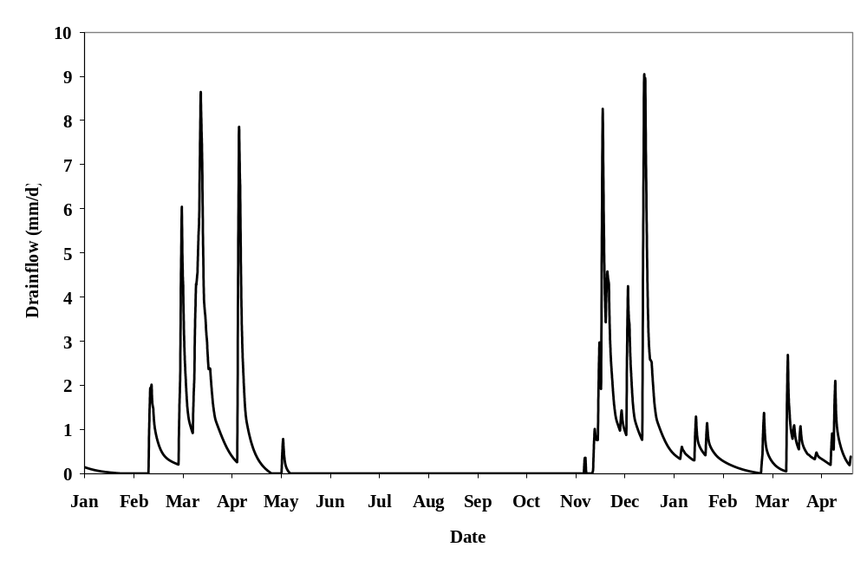
Figure 6.2.2-1 Simulated drainflow for scenario D1 (Lanna weather January 1982 to April 1983) under a winter wheat.
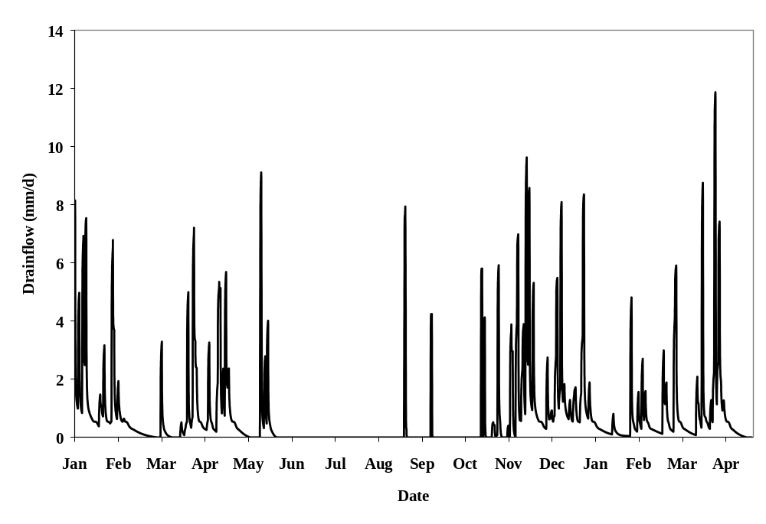
Figure 6.2.2-2 Simulated drainflow for scenario D2 (Brimstone weather January 1986 to April 1987) under a winter wheat crop.

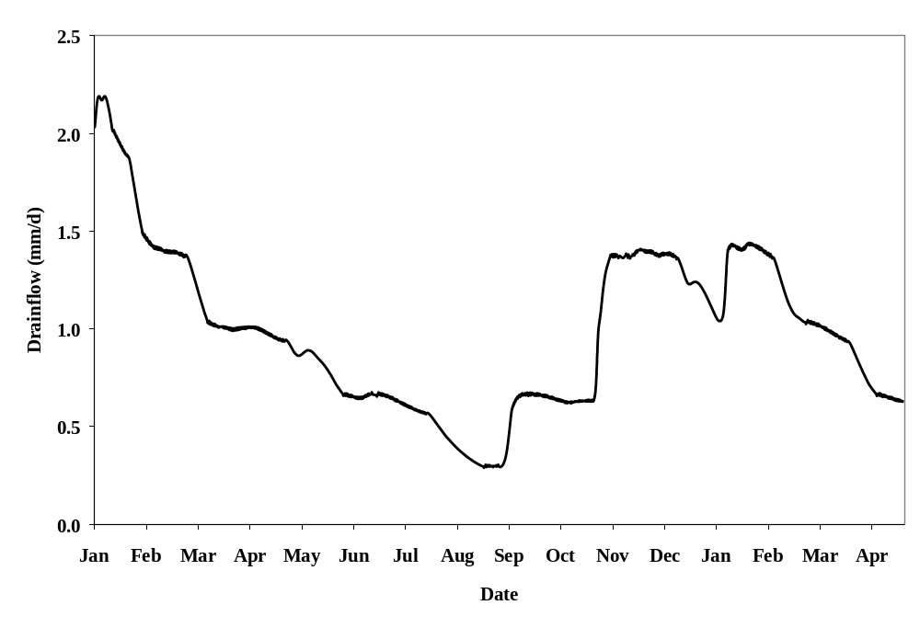
Figure 6.2.2-3 Simulated drainflow for scenario D3 (Vredepeel weather January 1992 to April 1993) under a winter wheat crop.

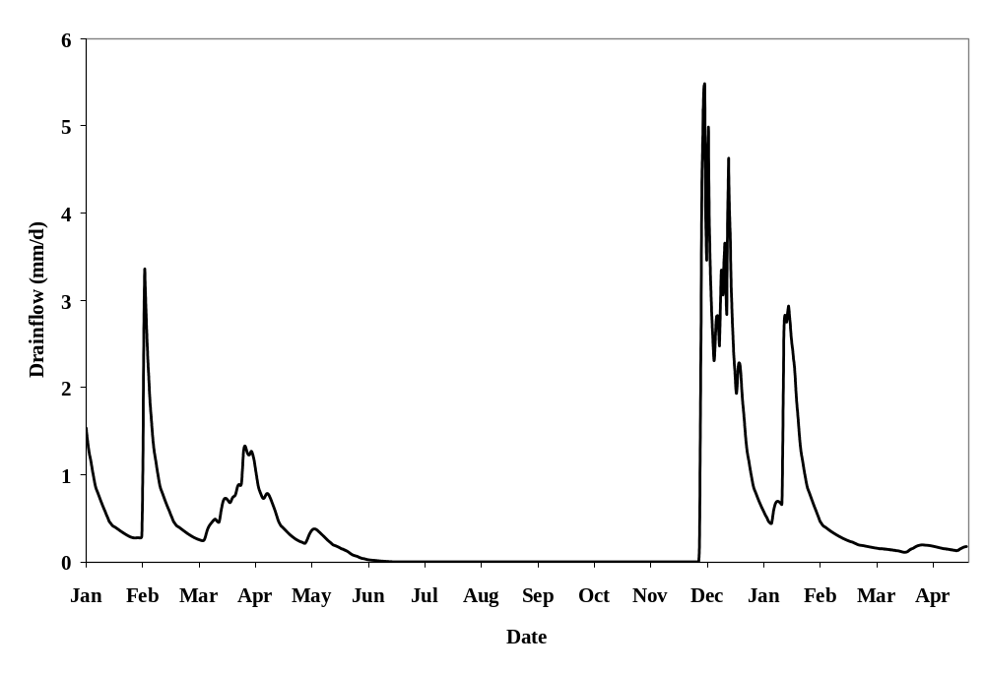
Figure 6.2.2-4 Simulated drainflow for scenario D4 (Skousbo weather January 1992 to April 1993) under a winter wheat crop.

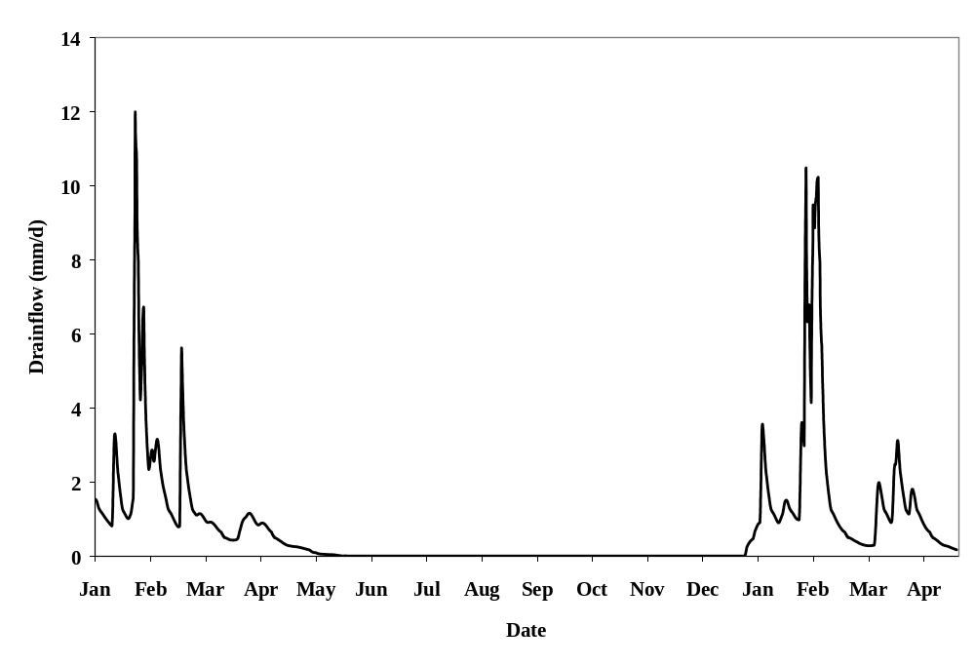
Figure 6.2.2-5 Simulated drainflow for scenario D5 (La Jaillière weather January 1978 to April 1979) under a winter wheat crop.
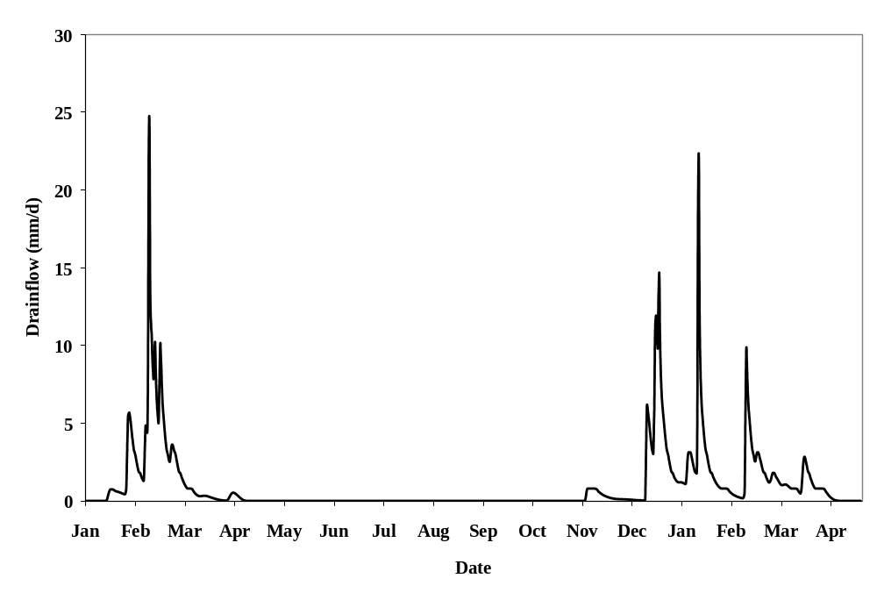
Figure 6.2.2-6 Simulated drainflow for scenario D6 (Thiva weather January 1986 to April 1987) under a winter wheat crop.
MACRO to TOXSWA transfer files (known as .m2t files) were evaluated using an Excel spreadsheet that calculated the following results from each simulation:
- Maximum hourly flux of pesticide from the treated field.
- Maximum daily flux of pesticide from the treated field.
- Total amount of pesticide lost via drains from the time of application to the end of the simulation.
Appendix G contains a series of tables (Table G.2-1 to Table G.2-9) that provide the results for each of the 6 drainage scenarios for each application season. Each table also includes the losses to surface water via drainage calculated at step 2 (see Table 2.4.3-1).
Maximum hourly losses in northern Europe ranged from <0.001% - 0.65% of applied for autumn applications, <0.001% - 0.55% for spring applications and <0.001% - 0.049% for summer applications. Maximum daily losses for the three application seasons ranged from <0.01% - 3.84%, <0.01% - 2.80% and <0.01% - 4.41% respectively. This was considered to be the most appropriate parameter to compare with the step 2 losses as the step 2 calculator utilises a daily time step.
Figures 6.2.2-7 to Figure 6.2.2-9 present the maximum daily flux via drainflow following applications of five of the compounds in autumn, spring and summer for the six drainage scenarios. These five compounds allow for comparisons of losses as a function of adsorption coefficient (Koc) and degradation half-life. Compounds D, E and F all have a half-life of 30 days in soil but range in Koc from 10 to 1000. Compounds A and D both have a Koc of 10 but half-lives of 3 days and 30 days respectively and Compounds F and I both have Koc values of 1000 and respective half-lives of 30 days and 300 days.
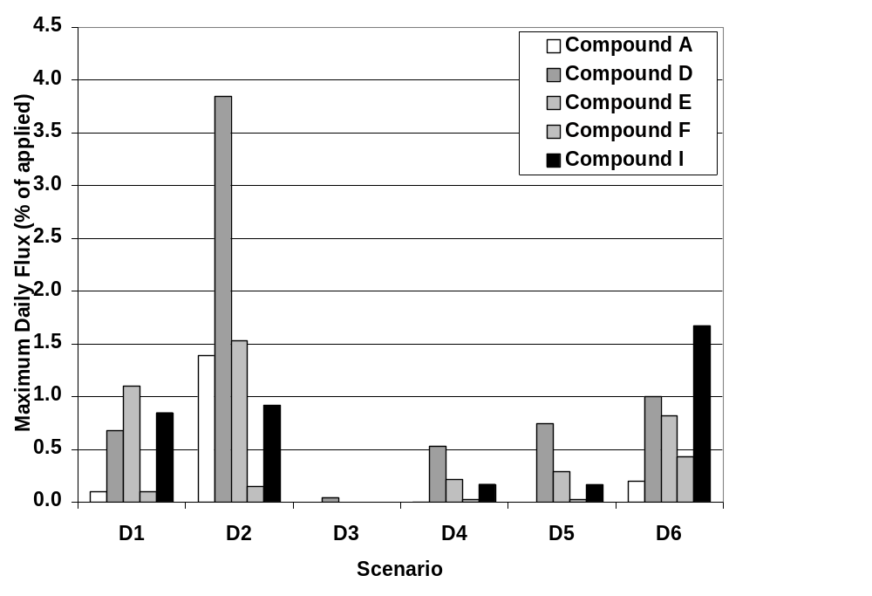
Figure 6.2.2-7 Comparison of the losses calculated in drainage scenarios D1 to D6 for test compounds A, D, E, and F and I following application in Autumn to a Winter Wheat crop.
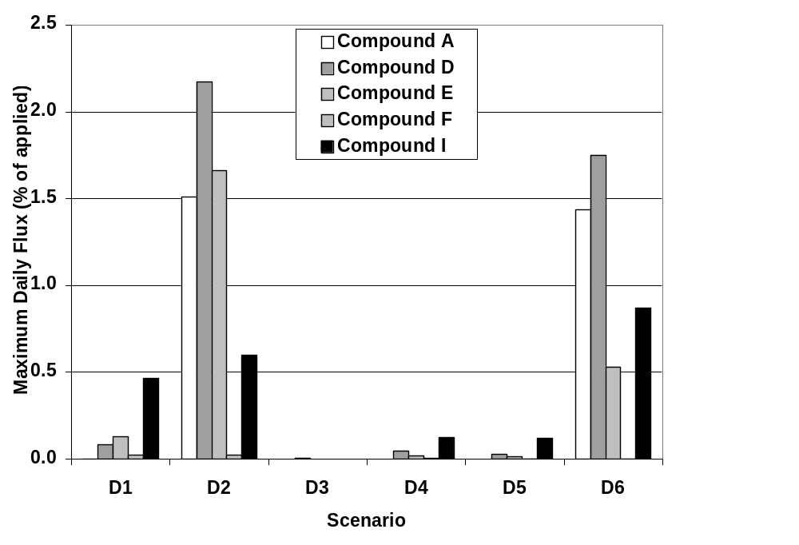
Figure 6.2.2-8 Comparison of the losses calculated in drainage scenarios D1 to D6 for test compounds A, D, E, and F and I following application in Spring to a Winter Wheat crop.
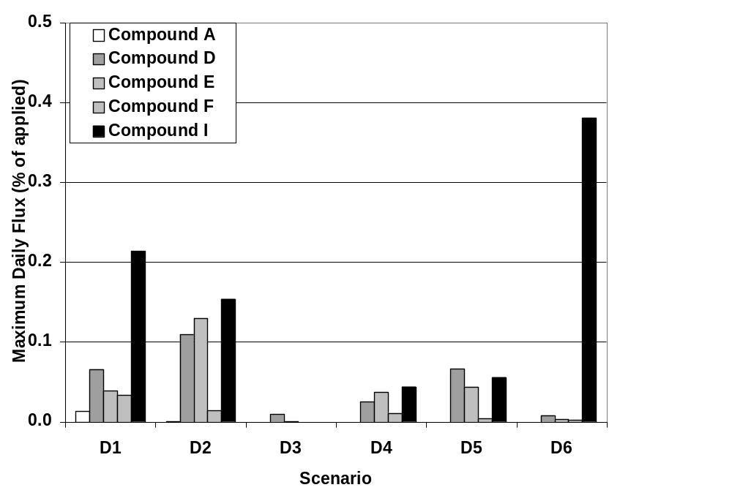
Figure 6.2.2-9 Comparison of the losses calculated in drainage scenarios D1 to D6 for test compounds A, D, E, and F and I following application in Summer to a Winter Wheat crop.
With respect to the first objective in Section 6.2 the expected trends between environmental fate properties on drainage losses were observed in almost all cases. For compounds with soil degradation half-lives of 30 days, daily maximum loads declined with increasing adsorption except for Scenario D1 following autumn application, where losses of Compound E (Koc = 100) were greater than Compound D (Koc = 10). This result may be of consequence of the greater mobility of Compound D removes the compound from the soil surface and therefore becomes less exposed to macropore flow. In general a 100-fold increase in Koc from 10 to 1000 results in a reduction in drainage losses by a factor of approximately 10.
Similarly the influence of degradation rate on drainage losses followed expected trends with increased drainage losses with increasing half-life. In general a 10-fold increase in half-life results in an increase in drainage losses by a factor of approximately 3.
The relative vulnerability of the drainage scenarios reflects the respective soil properties and drainage systems and the contribution of preferential flow to the movement of water to drainage systems. Scenario D2 (a clay soil) results in the largest drainage losses followed by D1 and D6. Scenarios D4 and D5 are less vulnerable and finally Scenario D3 (a sand soil) is the least vulnerable.
In all cases the timing of application has a significant impact on predicted losses. In general losses were greater with autumn applications, slightly less in spring and lowest in with summer applications, which is consistent with field observations. One exception was scenario D6 where spring losses were often greater than autumn losses. However this appears to be a consequence of the defined timing of the spring application for scenario D6 in the test protocol (February) when drainflow was predicted to be at a maximum for the simulation period.
For compounds A, B and C (half-life = 3 days) no or minimal losses were predicted for applications in the summer months whereas for more persistent compounds (G, H and I) the amount lost via drains was not affected by application timing to the same extent. For example the maximum amount predicted to be lost via drains in scenario D2 varied by a factor of about 8 (0.5% to 4.1%) from autumn to summer applications for compound G (half-life = 300 days and Koc = 10). Whereas for compound D (half-life = 30 days, Koc = 10) the corresponding values ranged by a factor of 38 (0.1% to 3.8%).

6.2.3 Runoff Inputs at Step 3
Three of the four runoff scenarios include winter wheat as a relevant crop whereas R2 does not. Therefore maize was used as the target crop for this scenario. Again each test compound was evaluated through each scenario assuming three different times of application according to the procedures outlined in the test protocol (Appendix G). The hydrologic balance for the 12-month period selected for each scenario R1 to R4 and season of application is given in Table 6.2.3-1. Runoff predicted by PRZM varied between 39 mm/year at Scenario R1 (1984 weather) to 453 mm/year at Scenario R2 (1977 weather). Predicted runoff and erosion for the four scenarios are shown in Figures 6.2.3-1 to 6.2.3-8.
Table 6.2.3-1. Water balances predicted by PRZM for the runoff scenarios. All figures are in mm, for the selected 12-month simulation.
Scenario | Weather Station | Season and year | Precipitation | Percolation | Evapo-  transpiration | Runoff | Change in  storage
R1 | Weiher-bach | Autumn – 1978 | 909 | 325 | 422 | 131 | 31
R1 | Weiher-bach | Spring – 1984 | 817 | 246 | 436 | 39 | 96
R1 | Weiher-bach | Summer – 1978 | 909 | 325 | 422 | 131 | 31
R2 | Porto | Autumn – 1977 | 1906 | 932 | 474 | 453 | 47
R2 | Porto | Spring – 1977 | 1906 | 932 | 474 | 453 | 47
R2 | Porto | Summer – 1989 | 1369 | 495 | 526 | 315 | 33
R3 | Bologna | Autumn – 1980 | 970 | 335 | 455 | 121 | 59
R3 | Bologna | Spring – 1980 | 724 | 198 | 388 | 74 | 64
R3 | Bologna | Summer – 1980 ª | 724 | 198 | 455 | 121 | -50
R4 | Roujan | Autumn – 1979 | 816 | 280 | 355 | 170 | 11
R4 | Roujan | Spring – 1984 | 812 | 134 | 435 | 179 | 64
R4 | Roujan | Summer – 1984 ^{b} | 812 | 134 | 435 | 179 | 64

ª Compounds were applied in May therefore utilised the “Spring” year. Summer applications for Bologna use 1975 weather
^{b} Compounds were applied in May therefore utilised the “Spring” year. Summer applications for Roujan use 1985 weather
In general runoff only occurs at times of high rainfall. Therefore environmental fate properties are less important in influencing runoff and erosion losses than the magnitude of the first run-off event and the time between application and the event.
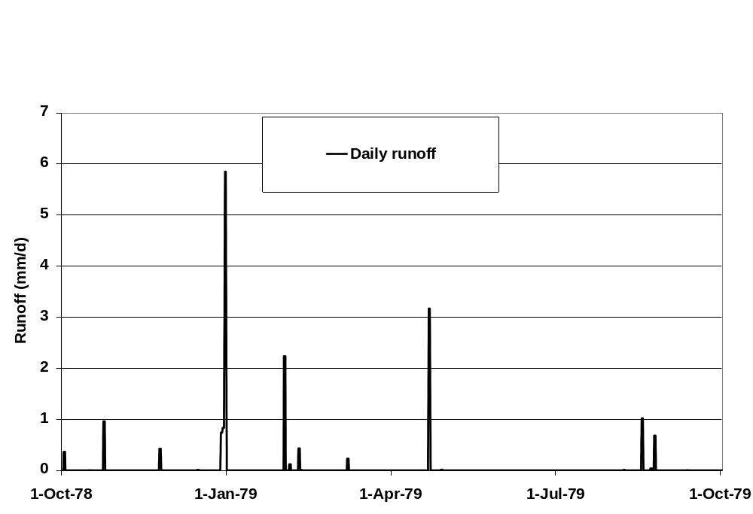

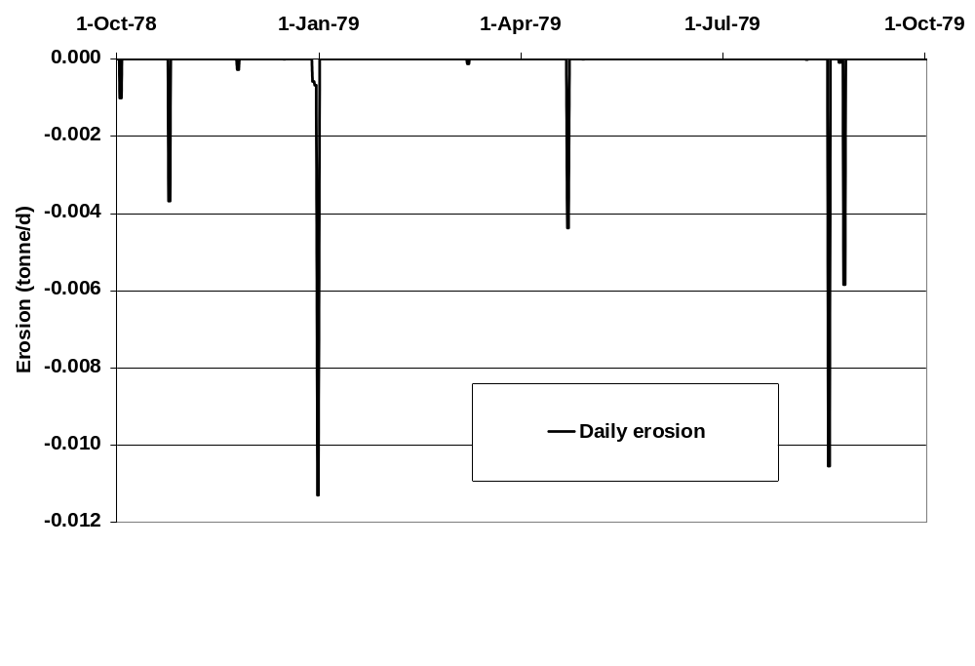
Figure 6.2.3-1 Simulated runoff and erosion for scenario R1 (Autumn) (Weiherbach weather 1978) under a winter wheat crop
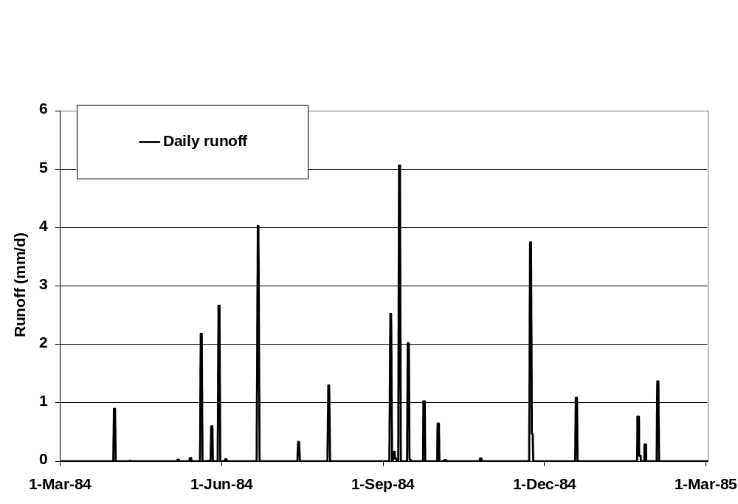
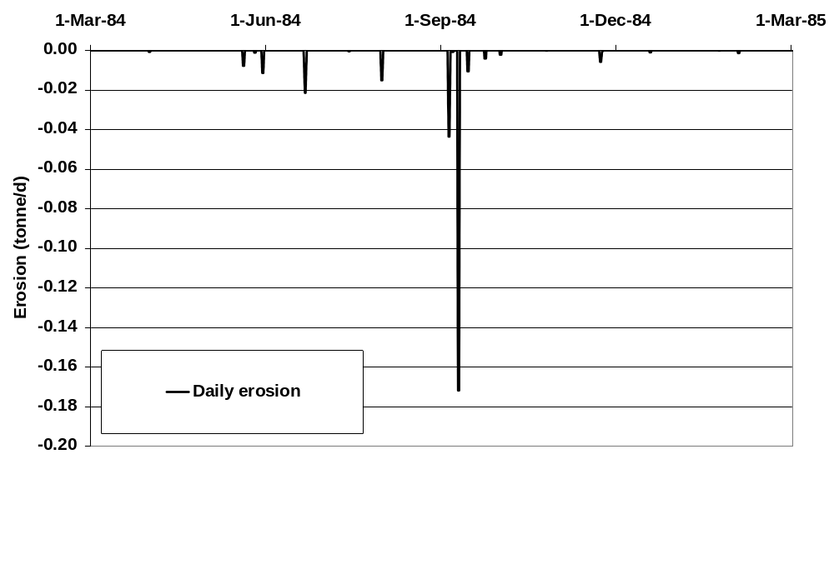
Figure 6.2.3-2 Simulated runoff and erosion for scenario R1 (Spring) (Weiherbach weather 1984) under a winter wheat crop.
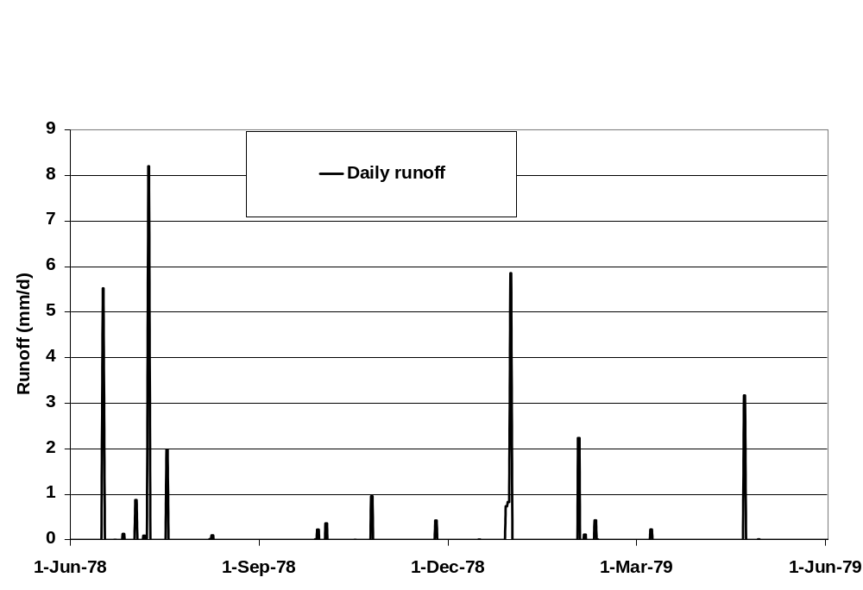
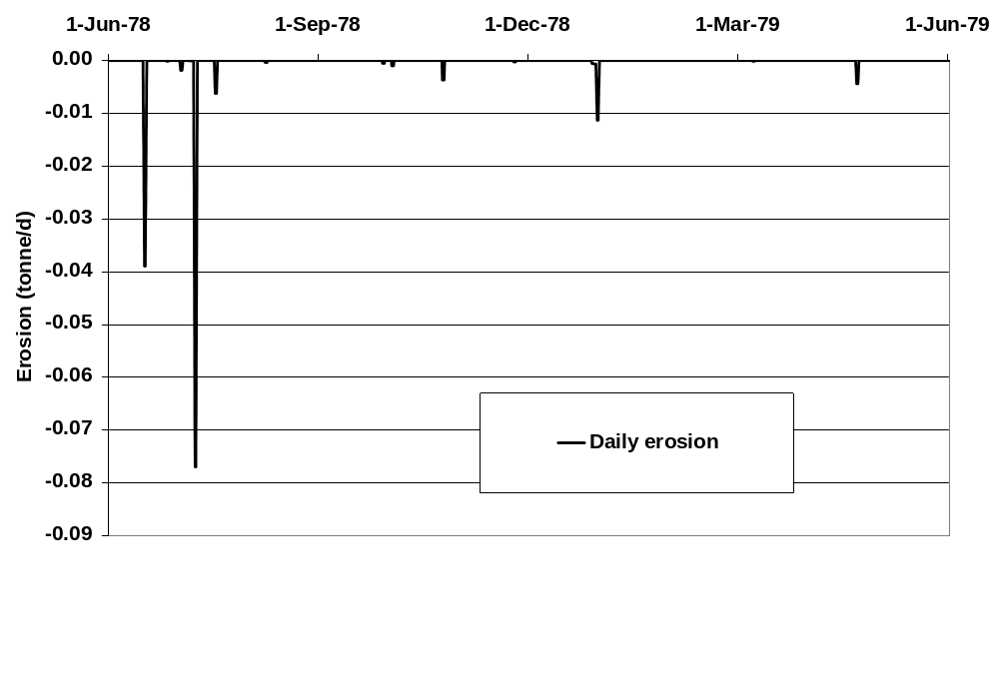
Figure 6.2.3-3 Simulated runoff and erosion for scenario R1 (Summer) (Weiherbach weather 1978) under a winter wheat crop.
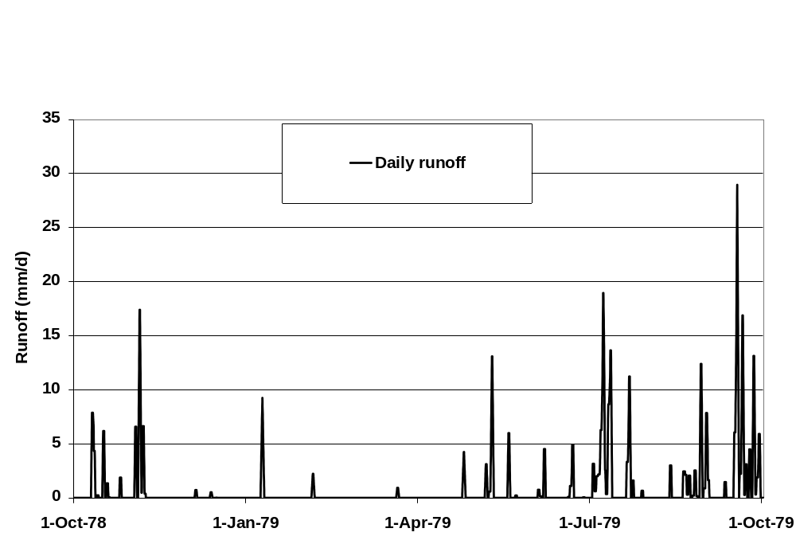
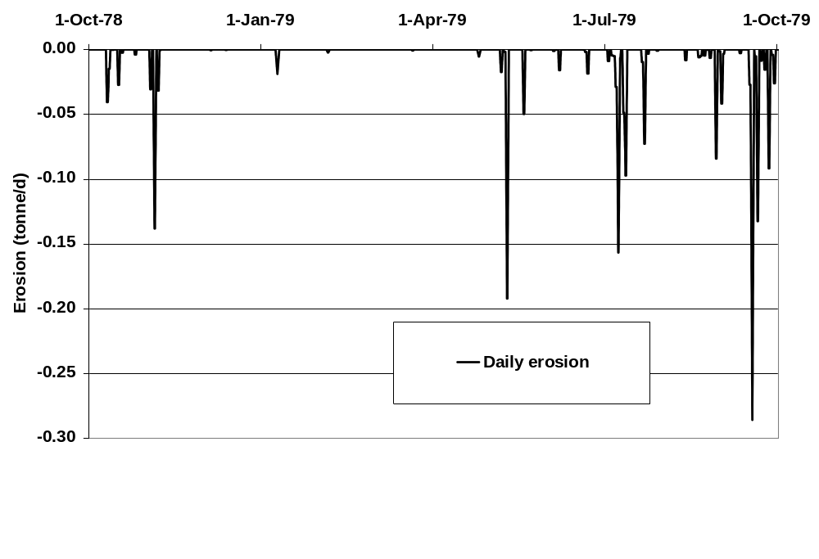
ª Spring scenario was used for a pre-emergence application and early post-emergence application to maize (winter wheat not grown at this scenario)

Figure 6.2.3-4 Simulated runoff and erosion for scenario R2 (Spring ª) (Porto weather 1978) under a maize crop.

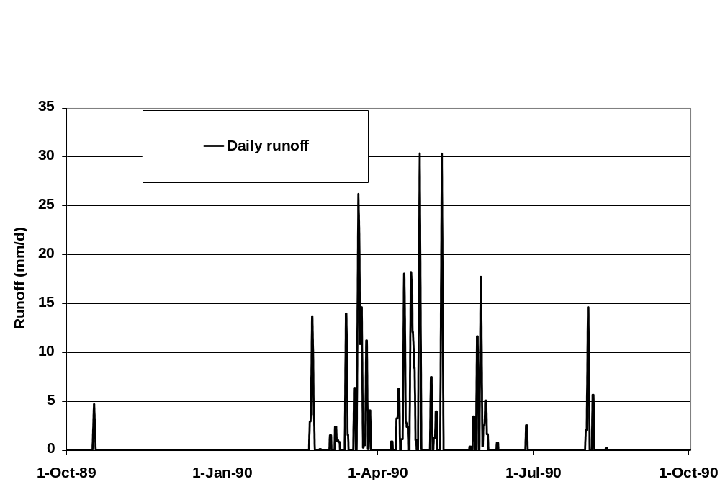
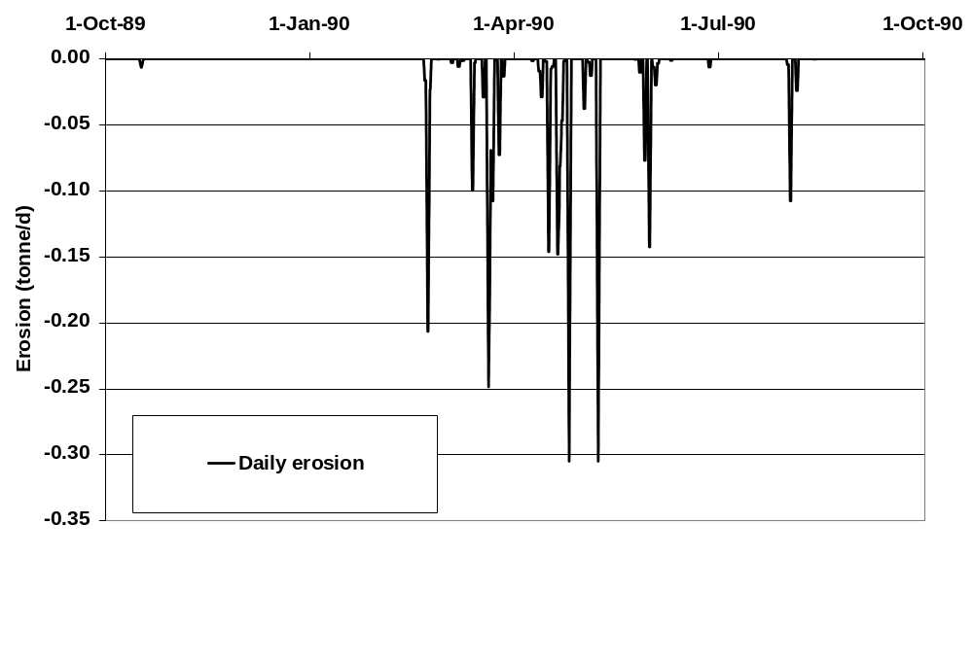
Figure 6.2.3-5 Simulated runoff and erosion for scenario R2 (Summer) (Porto weather 1989) under a maize crop.

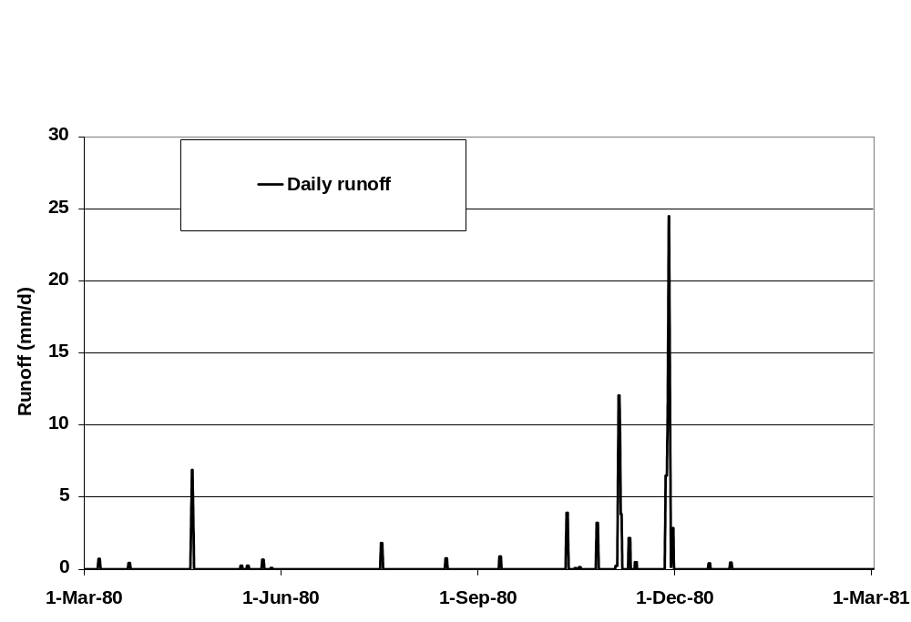
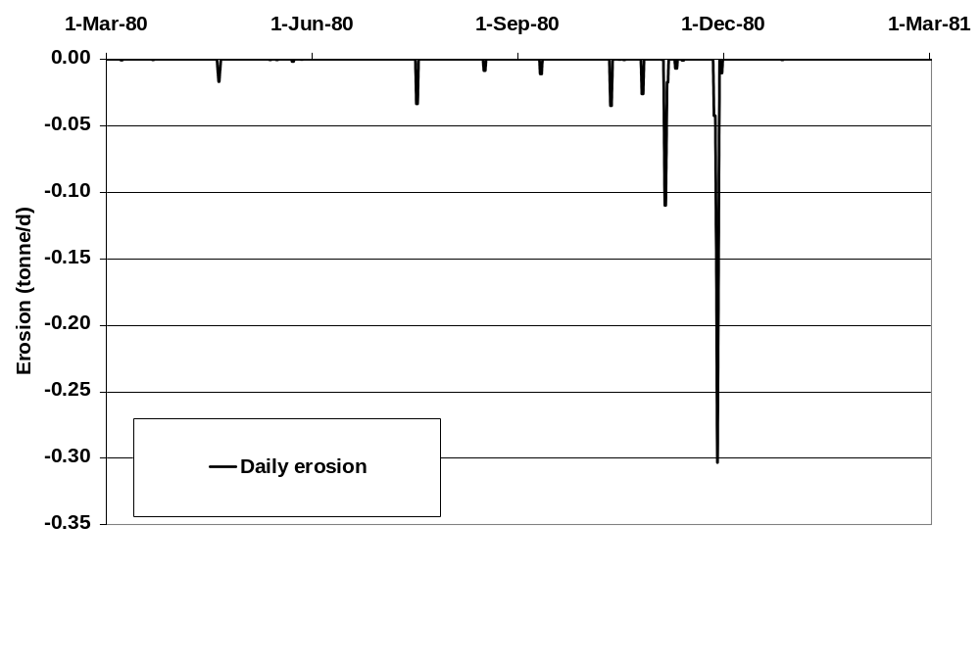
Summer applications were in May therefore utilised the “Spring” year. Summer applications for Bologna use 1975 weather

Figure 6.2.3-6 Simulated runoff and erosion for scenario R3 (Autumn, Spring and Summer) (Bologna weather 1980) under a winter wheat crop.

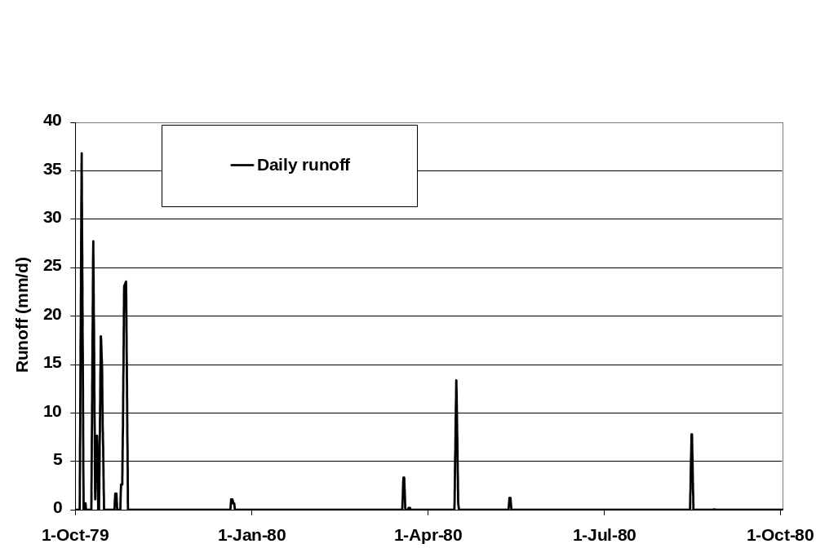
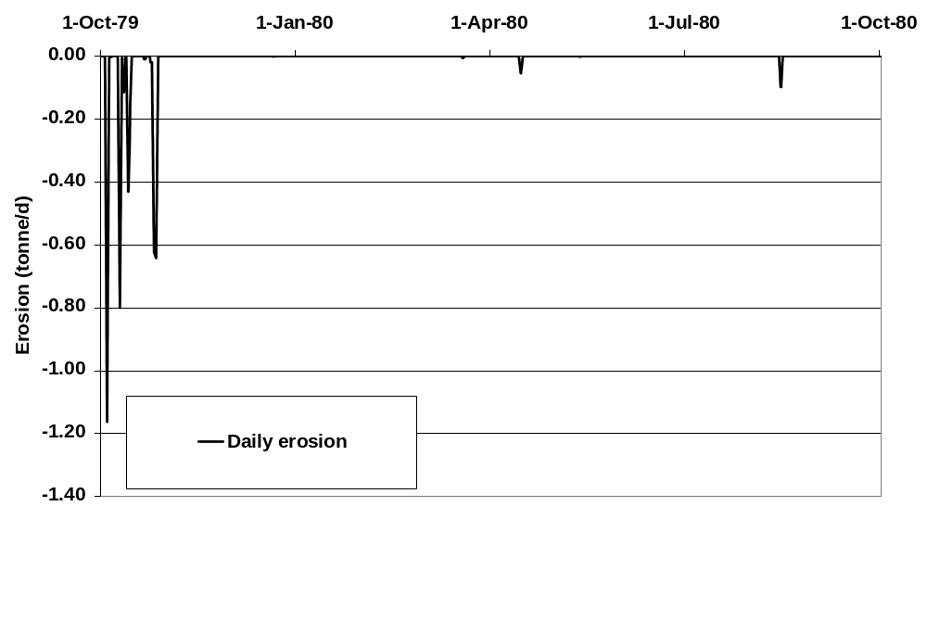
Figure 6.2.3-7 Simulated runoff and erosion for scenario R4 (Autumn) (Roujan weather 1979) under a winter wheat crop.
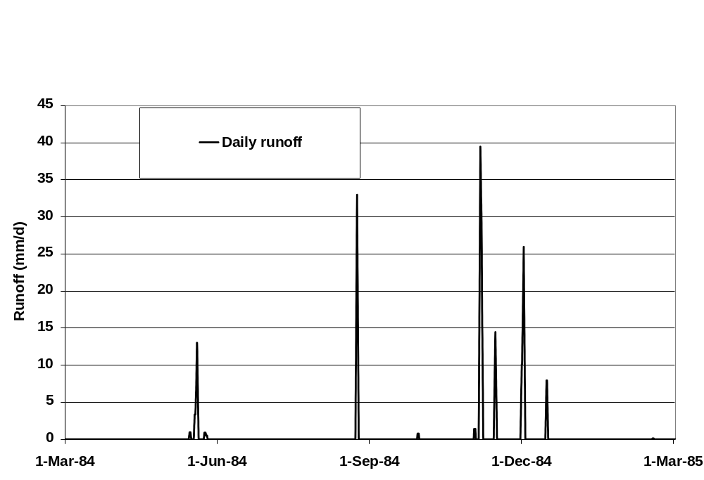
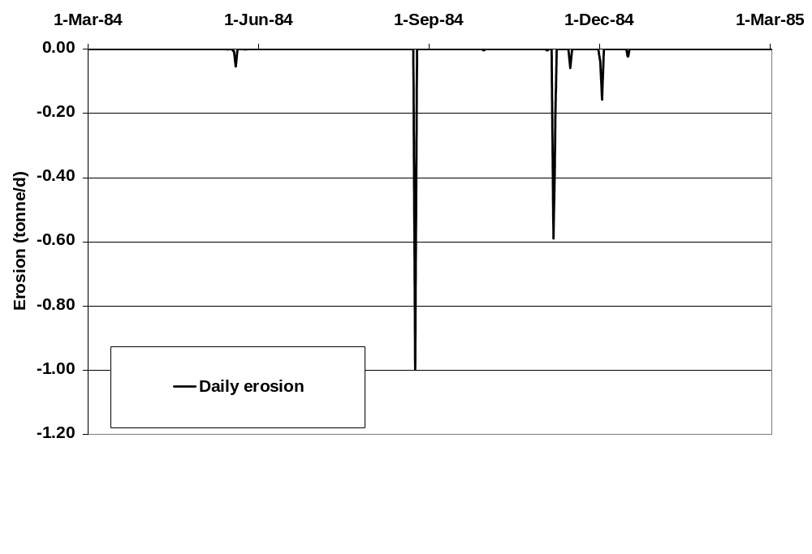
Applications were in May therefore utilised the “Spring” year. Summer applications for Roujan use 1985 weather

Figure 6.2.3-8 Simulated runoff and erosion for scenario R4 (Spring and Summer) (Roujan weather 1984) under a winter wheat crop.

Figures 6.3.2-9 to 6.2.3-11 present the maximum daily flux via runoff following applications in autumn, spring and summer for the same five compounds evaluated in section 6.2.2 for the four runoff scenarios. Obviously rapidly degrading compounds (e.g. compound A) were predicted to be less prone to runoff than more persistent compounds because the period during which residues remain in the soil and are available for runoff is relatively short. Also Compounds of low Koc are not always the most prone to runoff because residues are more mobile and move down the soil profile making them unavailable for runoff. For example, in Scenario R3, simulated daily losses via runoff for Compound E (Koc = 100) were approximately four times greater than Compound D (Koc = 10) following application in the autumn (Figure 6.2.3-9).
In general erosion losses were very small, with less than 0.1% lost via this route over 12-month periods for all uses.
Overall the most vulnerable scenario in these tests for autumn applications was R3. For spring applications scenario R2 appeared to be the most vulnerable (Figure 6.2.3-10) whereas in the summer the most vulnerable was scenario R1 (Figure 6.2.3-10). Losses of chemicals at R4 were predicted to be relatively small in the autumn when compared with the runoff of water (Figure 6.2.3-7). However the selected application date in the protocol (4 November) occurred after a period of significant runoff in the previous month. This again demonstrates the importance of application timing in relation to runoff events in determining the extent of losses of pesticides from treated fields to receiving water bodies. However in all cases tested the maximum amount of runoff predicted was less than 1% of applied.

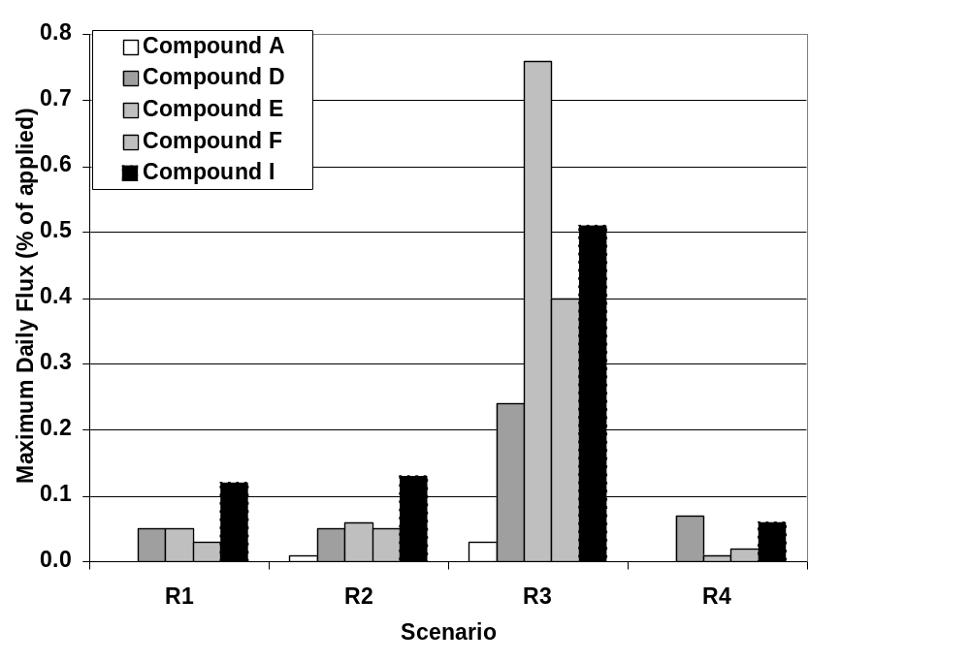
Figure 6.2.3-9 Comparison of the losses calculated in runoff scenarios R1 to R4 for test compounds A, D, E, F and I following application in Autumn to a Winter Wheat crop (R1, R3 and R4) or pre-emergence application to Maize (R2).
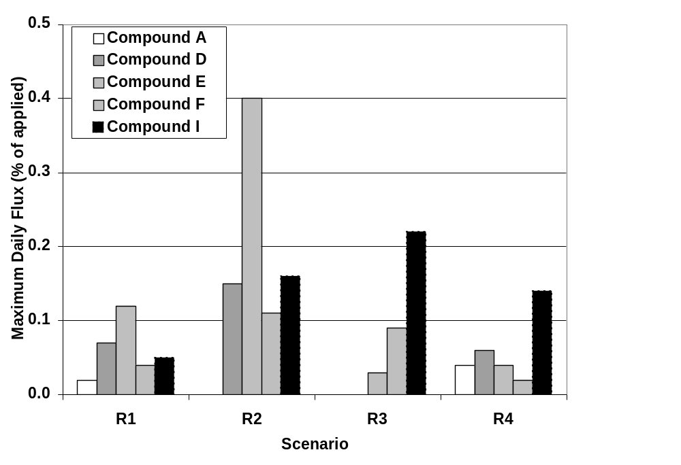
Figure 6.2.3-10 Comparison of the losses calculated in runoff scenarios R1 to R4 for test compounds A, D, E, F and I following application in Spring to a Winter Wheat crop (R1, R3 and R4) or Maize (R2).
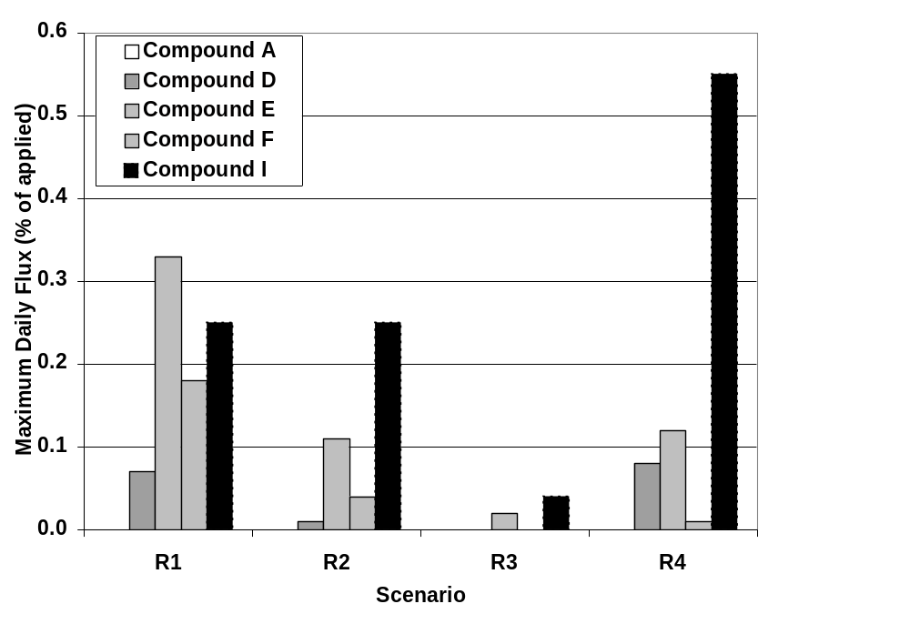
Fig. 6.2.3-11 Comparison of the losses calculated in runoff scenarios R1 to R4 for test compounds A, D, E, F and I following application in Summer to a Winter Wheat crop (R1, R3 and R4) org Maize (R2).

6.2.4 Comparison PEC_{sw} and PEC_{sed} with Steps 1,2 and 3
Figures 6.2.4-1 to Figures 6.2.4-6 present the results of calculations at steps 1, 2 and 3 for test compounds A, D, E, F, H and I using the Steps1-2 in FOCUS calculator and the Step 3 Scenarios with MACRO or PRZM plus TOXSWA.

a) Maximum PEC_{sw} | b) 28d TWAC_{sw}
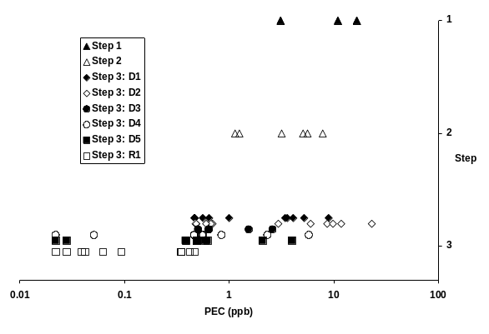 | 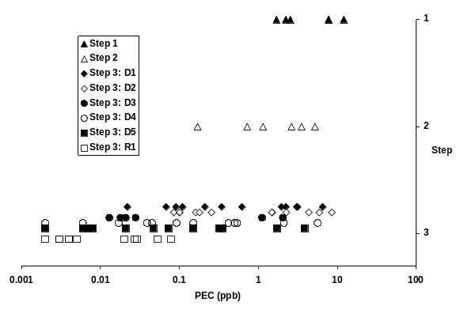
c) Maximum PEC_{sed} | d) 28d TWAC_{sed}
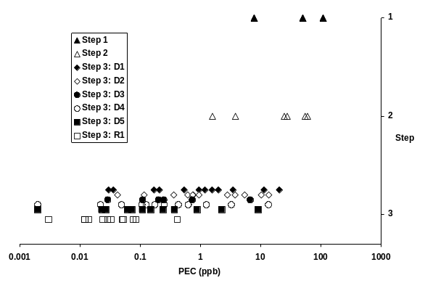 | 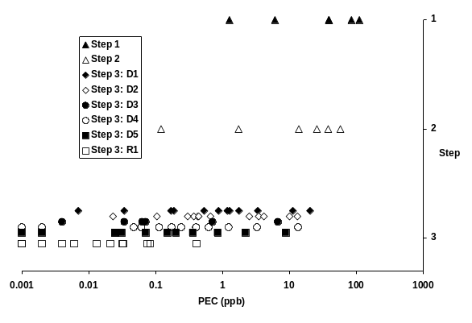
Figure 6.2.4-1 Comparison of Predicted Environmental Concentrations calculated at steps 1, 2 and 3 for Northern European Scenarios following application of test compounds A, D, E, F, H and I to a winter wheat crop in autumn.
Northern Europe: Autumn
At step 2 it is assumed that 5% of the pesticide residue remaining in soil four days after the last application is transported from the field to the receiving water body. The maximum PEC_{sw} for the six compounds at step 2 range from 6.59 to 15.69 μg/L with a mean of 11.03 μg/L. At step 3 maximum values for a total of 66 simulations (six compounds and eleven scenarios) ranged from 0.02 mg/L to 22.95 mg/L with a mean of 1.91 mg/L. Six of the 66 values exceed the maximum value calculated at step 2 and are associated with ditches at scenario D1 (one) and D2 (four). Only one value (compound D, scenario D2 – ditch) exceeded the corresponding step 1 value. All five were a consequence of drainage events (out of the 66 maxima, 25 were a consequence of drainage events, four from runoff events and the remainder from spray drift). Scenario D2 is considered an extremely vulnerable scenario for drainage losses especially for autumn applications of pesticides. Comparison of 28-day time weighted average concentrations in surface water showed a similar trend, with four step 3 values exceeding the maximum step 2 value. All predicted sediment concentrations at step 3 were greater than the corresponding step 2 values. Overall as greater than 90% of the values at step 3 were lower than those calculated at step 2, it is considered the assumptions made at step 2 for autumn applications in Northern Europe are appropriate.

a) Maximum PEC_{sw} | b) 28d TWAC_{sw}
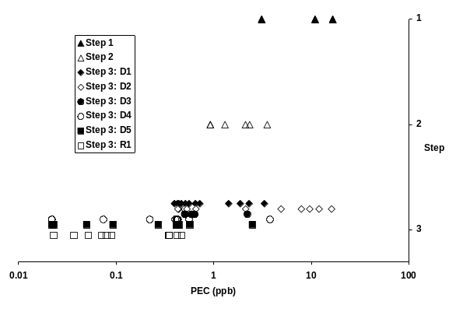 | 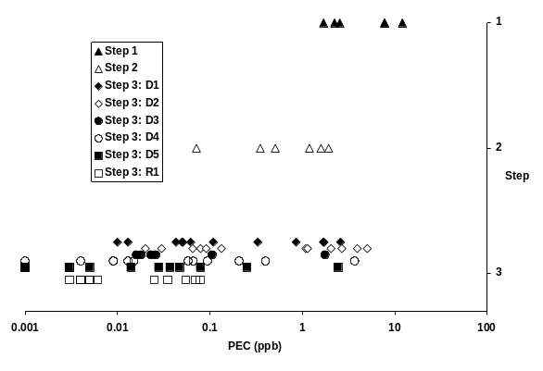
c) Maximum PEC_{sed} | d) 28d TWAC_{sed}
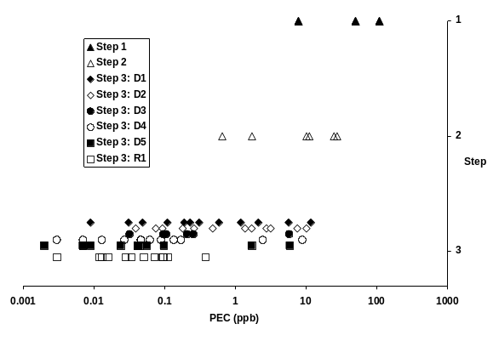 | 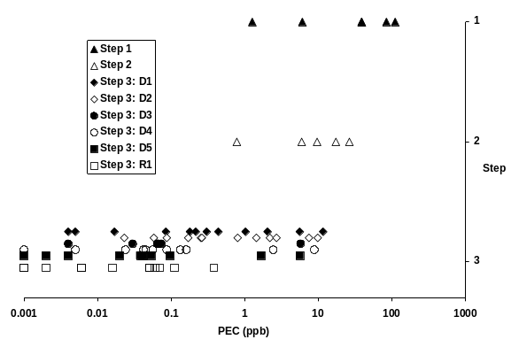
Figure 6.2.4-2 Comparison of Predicted Environmental Concentrations calculated at steps 1, 2 and 3 for Northern European Scenarios following application of test compounds A to I to a winter wheat crop in spring.
Northern Europe: Spring
At step 2 it is assumed that 2% of the pesticide residue remaining in soil four days after the last application is transported from the field to the receiving water body. The maximum PEC_{sw} for the six compounds at step 2 range from 2.02 to 5.19 mg/L with a mean of 3.67 μg/L. At step 3 maximum values for a total of 66 simulations (six compounds and eleven scenarios) ranged from 0.02 mg/L to 16.06 mg/L with a mean of 1.35 mg/L. Five of the 66 values exceed the maximum value calculated at step 2 and are associated with ditches at scenario D2 (five) and D4 (one). No values exceeded the corresponding step 1 value. All six were a consequence of drainage events (out of the 66 maxima, 20 were a consequence of drainage events, one from a runoff event and the remainder from spray drift). Comparison of 28-day time weighted average concentrations in surface water showed a similar trend, with seven step 3 values exceeding the maximum step 2 value. All predicted sediment concentrations at step 3 were greater than the corresponding step 2 values. Again, as greater than 90% of the values at step 3 were lower than those calculated at step 2 it is considered that the assumptions made at step 2 for spring applications in Northern Europe are appropriate.
a) Maximum PEC_{sw} | b) 28d TWAC_{sw}
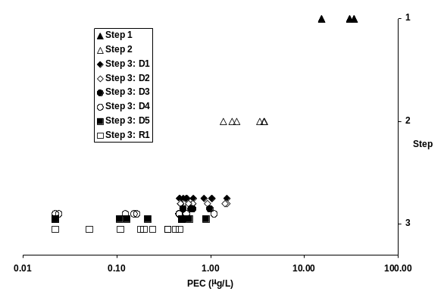 | 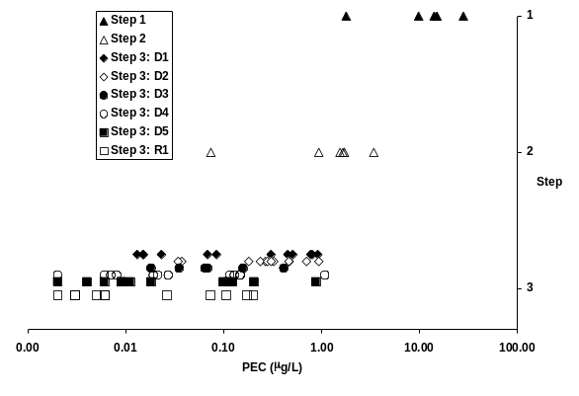
c) Maximum PEC_{sed} | d) 28d TWAC_{sed}
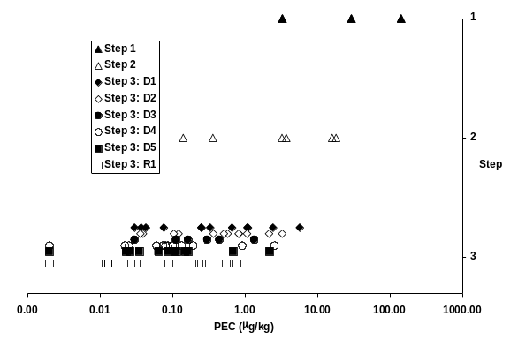 | 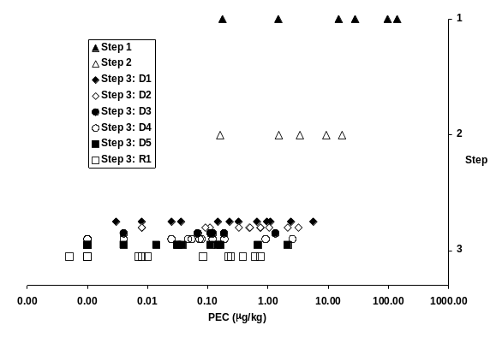
Figure 6.2.4-3 Comparison of Predicted Environmental Concentrations calculated at steps 1, 2 and 3 for Northern European Scenarios following application of test compounds A to I to a winter wheat crop in summer.
Northern Europe: Summer
At step 2 it is assumed that 2% of the pesticide residue remaining in soil four days after the last application is transported from the field to the receiving water body. The maximum PEC_{sw} for the six compounds at step 2 range from 1.36 to 3.74 μg/L with a mean of 2.62 μg/L. At step 3 maximum values for a total of 66 simulations (six compounds and eleven scenarios) ranged from 0.02 mg/L to 1.49 mg/L with a mean of 0.50 mg/L. None of the 66 values exceed the maximum value calculated at step 2. Of the 66 maxima, 16 were a consequence of drainage events, five from runoff events and the remainder from spray drift. The 28-day time weighted average concentrations in surface water and sediment concentrations at step 3 were all greater than the corresponding step 2 values. The assumption of a maximum of 2% loss via drainflow and/or runoff following applications of pesticides in summer months at step 2 is therefore appropriately conservative.

a) Maximum PEC_{sw} | b) 28d TWAC_{sw}
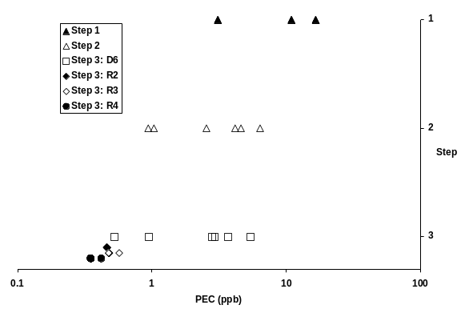 | 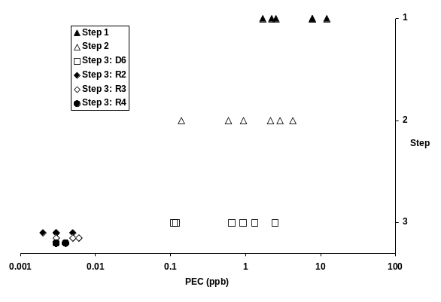
c) Maximum PEC_{sed} | d) 28d TWAC_{sed}
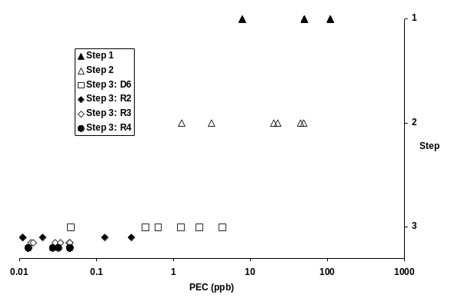 | 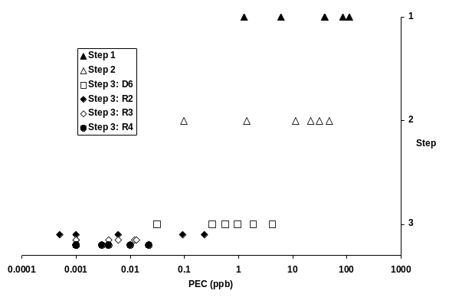
Figure 6.2.4-4 Comparison of Predicted Environmental Concentrations calculated at steps 1, 2 and 3 for Southern European Scenarios following application of test compounds A to I to a winter wheat crop in autumn.
Southern Europe: Autumn
At step 2 it is assumed that 4% of the pesticide residue remaining in soil four days after the last application is transported from the field to the receiving water body. The maximum PEC_{sw} for the six compounds at step 2 range from 5.28 to 12.69 μg/L with a mean of 8.93 μg/L. At step 3 maximum values for a total of 24 simulations (six compounds and four scenarios) ranged from 0.35 mg/L to 5.40 mg/L with a mean of 1.03 mg/L. None of the values exceed the maximum value calculated at step 2. Of the 24 maxima, five were a consequence of drainage events, one from a runoff event and the remainder from spray drift. The 28-day time weighted average concentrations in surface water and sediment concentrations at step 3 were all less than the corresponding step 2 values. The assumption of a maximum of 4% loss via drainflow and/or runoff following applications of pesticides in autumn months at step 2 is therefore appropriately conservative.

a) Maximum PEC_{sw} | b) 28d TWAC_{sw}
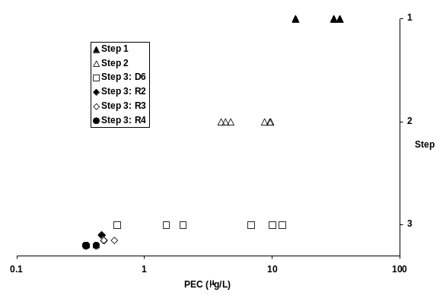 | 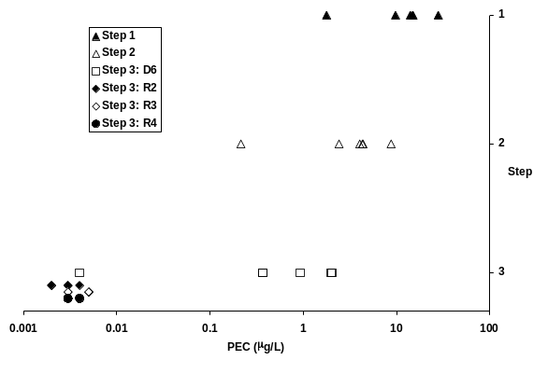
c) Maximum PEC_{sed} | d) 28d TWAC_{sed}
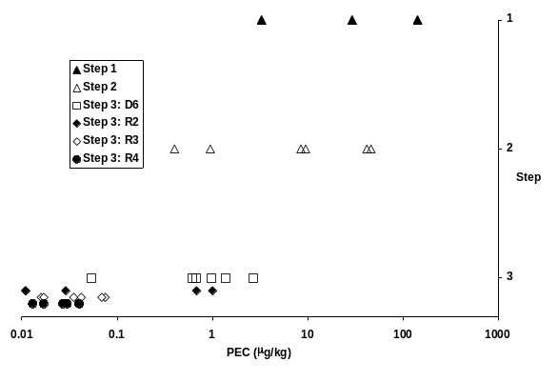 | 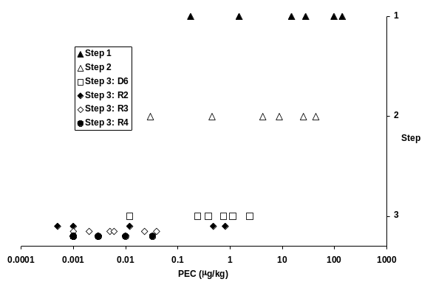
Figure 6.2.4-5 Comparison of Predicted Environmental Concentrations calculated at steps 1,2 and 3 for Southern European Scenarios following application of test compounds A to I to a winter wheat crop in spring.
Southern Europe: Spring
At step 2 it is assumed that 4% of the pesticide residue remaining in soil four days after the last application is transported from the field to the receiving water body. The maximum PEC_{sw} for the six compounds at step 2 range from 3.97 to 9.69 μg/L with a mean of 6.82 μg/L. At step 3 maximum values for a total of 24 simulations (six compounds and four scenarios) ranged from 0.35 mg/L to 11.97 μg/L with a mean of 1.70 μg/L. Two out of 24 step 3 values exceeded the maximum value calculated at step 2. All were associated with scenario D6 and weakly adsorbed compounds. In these simulations the compounds were applied in February during a period of significant drainflow (Figure 6.2.2-6). It is expected that losses following applications at the end of February or early March would result in predictions of significantly smaller losses. Of the 24 maxima, five were a consequence of drainage events, one from a runoff event and the remainder from spray drift. The 28-day time weighted average concentrations in surface water and all sediment concentrations at step 3 were all less than the corresponding step 2 values. As greater than 90% of the values at step 3 were lower than those calculated at step 2 it is considered that the assumptions made at step 2 for spring applications in Southern Europe are appropriate.

a) Maximum PEC_{sw} | b) 28d TWAC_{sw}
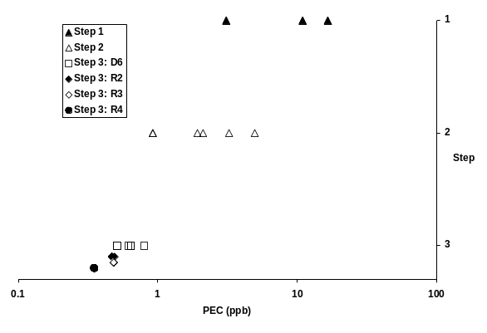 | 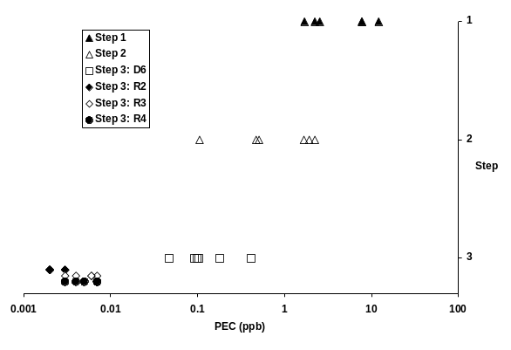
c) Maximum PEC_{sed} | d) 28d TWAC_{sed}
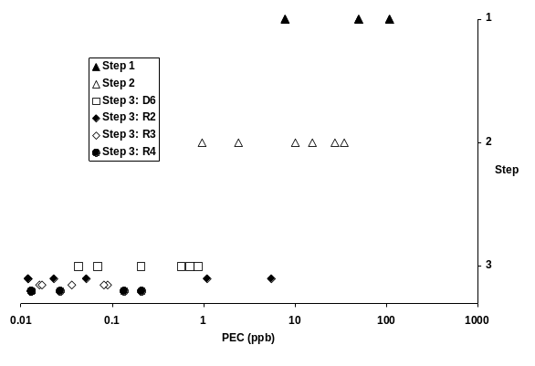 | 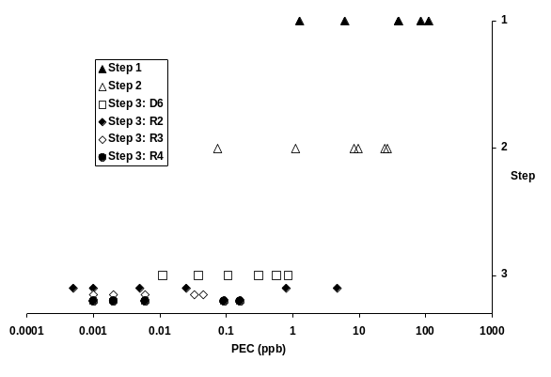
Fig. 6.2.4-6 Comparison of Predicted Environmental Concentrations calculated at steps 1,2 and 3 for Southern European Scenarios following application of test compounds A to I to a winter wheat crop in summer.
Southern Europe: Summer
At step 2 it is assumed that 3% of the pesticide residue remaining in soil four days after the last application is transported from the field to the receiving water body. The maximum PEC_{sw} for the six compounds at step 2 range from 2.02 to 5.19 μg/L with a mean of 3.67 μg/L. At step 3 maximum values for a total of 24 simulations (six compounds and four scenarios) ranged from 0.35 mg/L to 0.80 mg/L with a mean of 0.49 mg/L. None of the step 3 values exceeded those at step 2. Of the 24 maxima, two were a consequence of drainage events, one from a runoff event and the remainder from spray drift. Similarly, the 28-day time weighted average concentrations in surface water and all sediment concentrations at step 3 were all less than the corresponding step 2 values. The assumption of a maximum of 3% loss via drain flow and/or runoff following applications of pesticides in summer months at step 2 is therefore appropriately conservative.
Conclusions
Based on the Step 3 simulation results for compounds A to I, the peak concentrations in the various surface water bodies are attributable to spray drift loadings approximately half of the time. In the remaining cases, a drainage or runoff event is responsible for the peak concentration. This result agrees reasonably well with the conventional wisdom of the significance of spray drift compared to the alternative loading mechanisms of tile drainage, runoff and erosion. However, by including multiple loading mechanisms, the Step 3 simulations proposed by FOCUS provide a more complete assessment of potential surface water concentrations and permit a more balanced assessment of the exposure of aquatic systems to pesticides.

6.2.5 Overall comparison of distribution of PEC_{sw} and PEC_{sed}
In addition to the comparison of losses across individual scenarios and steps described above, a further analysis was carried out to examine the overall distributions of PECs at Steps 1, 2, and 3 using Compounds A, D, E, F, H and I. The Group considered it important to conduct such an analysis to gain a broader impression of the relationship between steps over a range of pesticide fate properties than could be gained for the analysis of one compound.
As discussed above, due to their range of adsorption and degradation properties, Compounds A, D, E, F, H and I are a reasonable representation of the ‘universe’ of pesticide fate properties that will most influence run-off/drainage inputs (at least for compounds which were considered by the Group to be likely to receive an approval under 91/414). That is to say, the range of concentrations estimated for Compounds A, D, E, F, H and I is likely to encompass the range of concentrations for all pesticides (assuming of course that the use pattern is the same). Consequently, comparisons of the distribution of PECs for Steps 1, 2 and 3 for compounds A to I will give a reasonably robust indication of the overall relationship between the steps. Considering that the exposure scenario selected for Compounds A to I was arable uses, it was considered that this assessment would also be a reasonably conservative comparison since the influences of run-off and drainage input will be relatively great for arable uses (since spray drift inputs are much lower than for other crop types).
To recap, the rationale that the Group developed as the basis for the relationship between the steps was as follows. Step 3 (the surface water scenarios) was conceived as representing the 'realistic worst-case distribution' of surface water PECs across the EU (see Introduction). Working back from this, Steps 1 and 2 should then be viewed as screening tools that enable an efficient identification of compounds that present negligible risks to surface water organisms. Step 1 should cover the extreme worst-case, and Step 2 was conceived as a less extreme worst-case, but with a limited distribution of PECs, whose highest PECs should be of the order of the 90th percentile value of the realistic worst-case distributions. Consequently, Step 1 PECs for a particular compound should always exceed Step 3 PECs. However, since the highest Step 2 concentrations should be similar to the 90th percentile value of the Step 3 distribution, there may be occasions when a limited number of Step 3 PECs exceed the Step 2 values (i.e. a limited number of Step 3 values which are more worst-case than the 90th percentile). Since a broader range of scenarios are covered at Step 3 which are both more and less extreme than Step 2, the distribution of concentrations at the upper and lower end are also broader. The group considered that such a relationship between Steps 2 and 3 was logical and acceptable.
Distributions of PECs for across geographical scenarios and seasons:
In order to summarise and compare the exposure concentrations across the two different geographical scenarios (north and south EU) and three different seasons (autumn, spring or summer uses) for the ‘globality’ of pesticide properties (i.e. represented by Compounds A, D, E, F, H and I), PEC data were summarised on cumulative frequency distributions. PEC data for Compounds A, D, E, F, H and I at each step were ranked according to concentration, converted to a cumulative frequency (using the rank divided by the total number of observation plus one) and plotted on a logarithmic scale of the X axis and a probability scale on the Y axis. Using this approach it was possible to compare the distributions of PECs for the universe of pesticide properties at each of the Steps. So, for example, the median concentration at each step can be compared. The distributions for global maximum and 28 d time-weighted average water and sediment concentrations are shown in Figure 6.2.5.1-6.2.5.8.
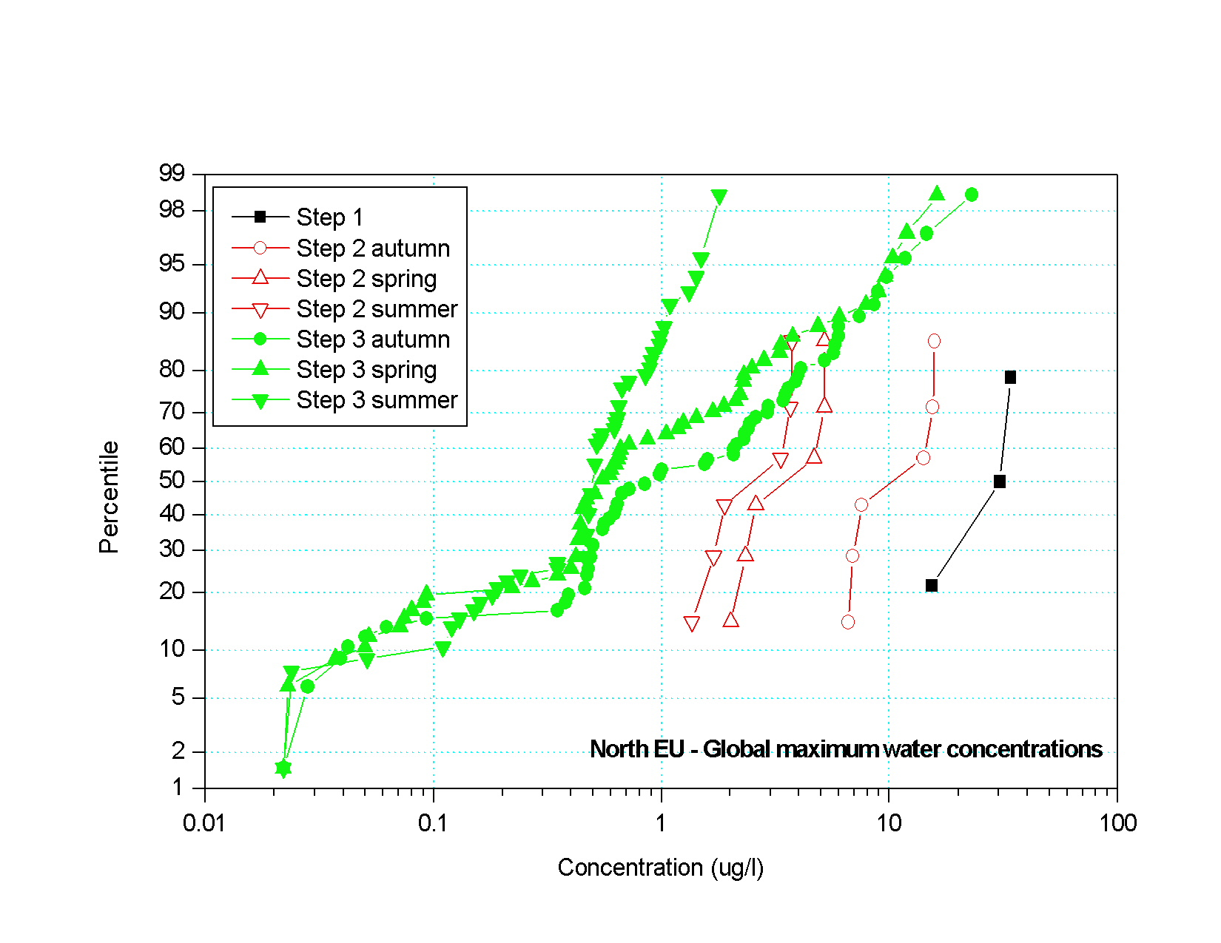
Figure 6.2.5.1 Distributions of global maximum water concentrations for example Compounds A, D, E, F, H and I for North EU uses
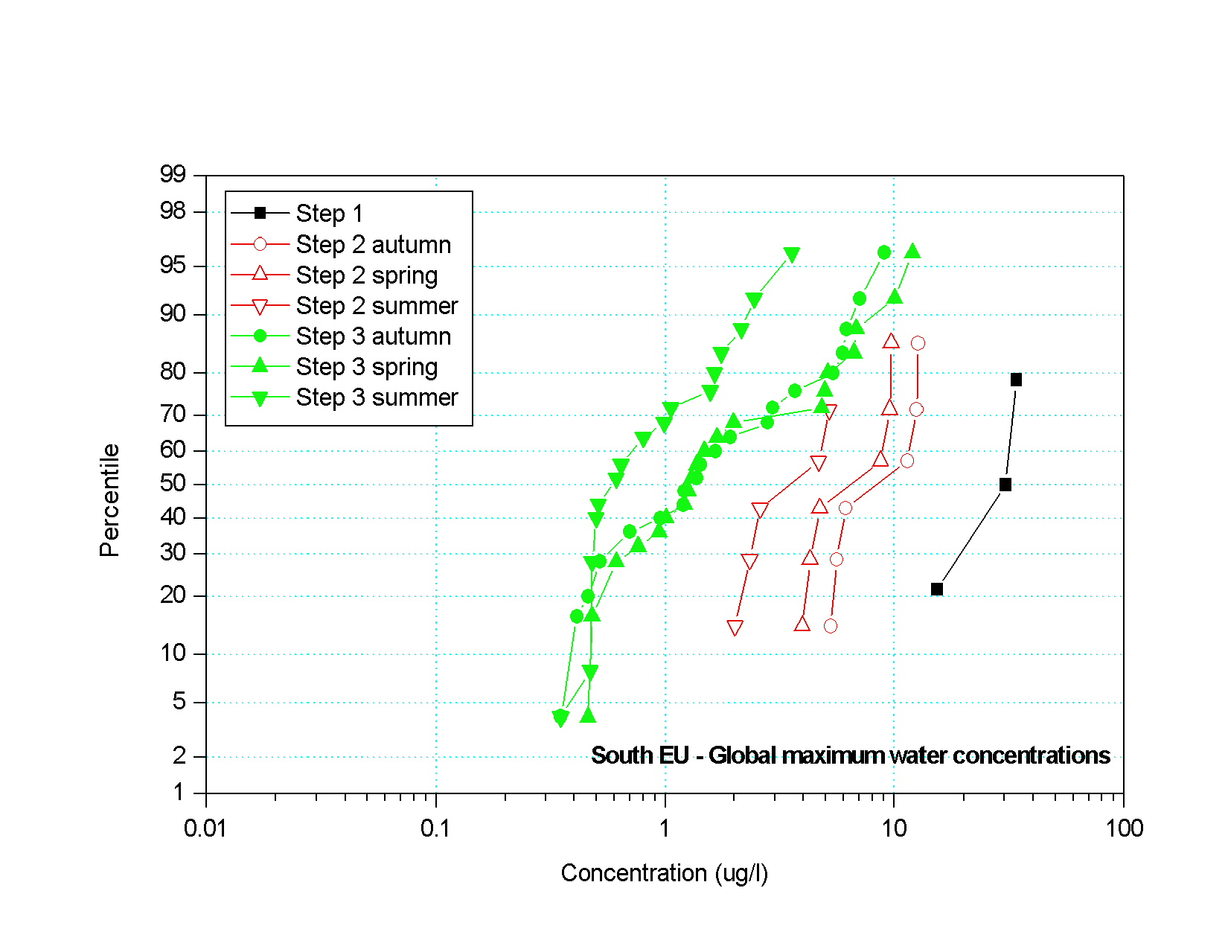
Figure 6.2.5.2 Distributions of global maximum water concentrations for example Compounds A, D, E, F, H and I for South EU uses
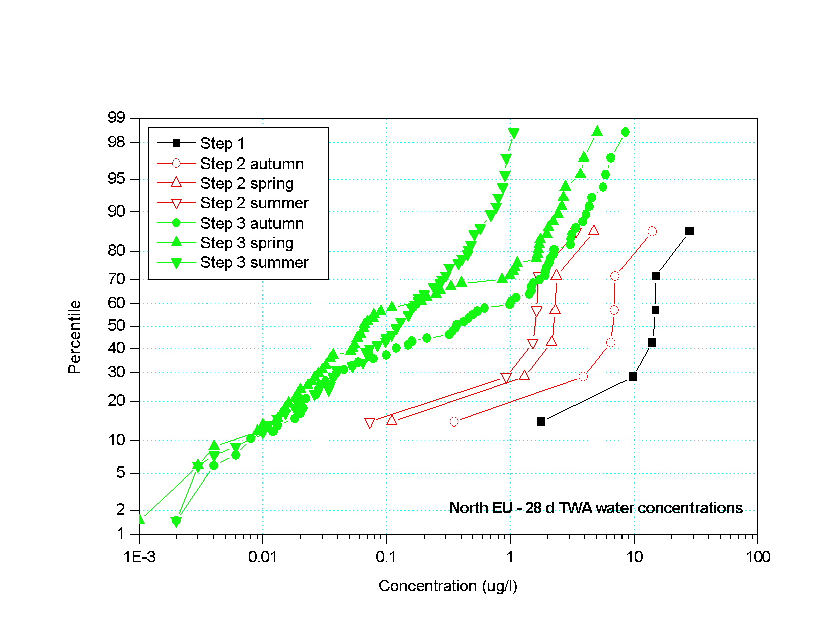
Figure 6.2.5.3 Distributions of 28d time-weighted average water concentrations for example Compounds A, D, E, F, H and I for North EU uses

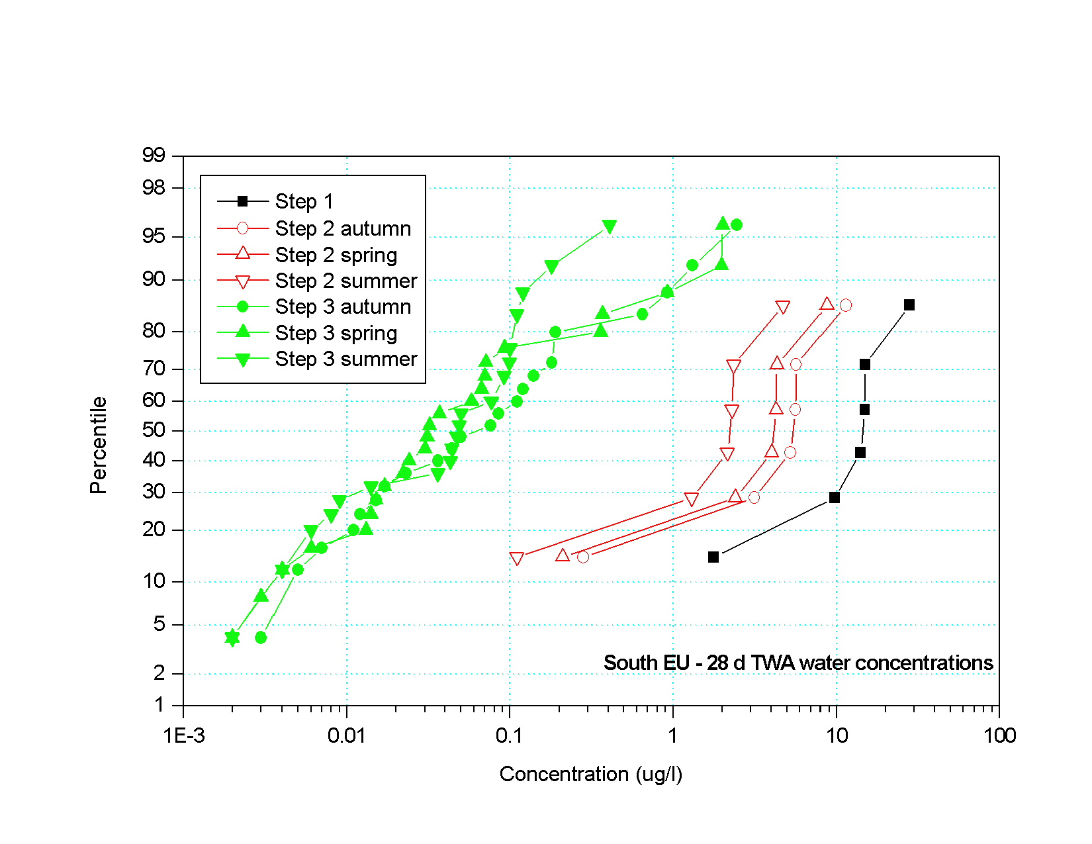
Figure 6.2.5.4 Distributions of 28d time-weighted average water concentrations for example Compounds A, D, E, F, H and I for South EU uses
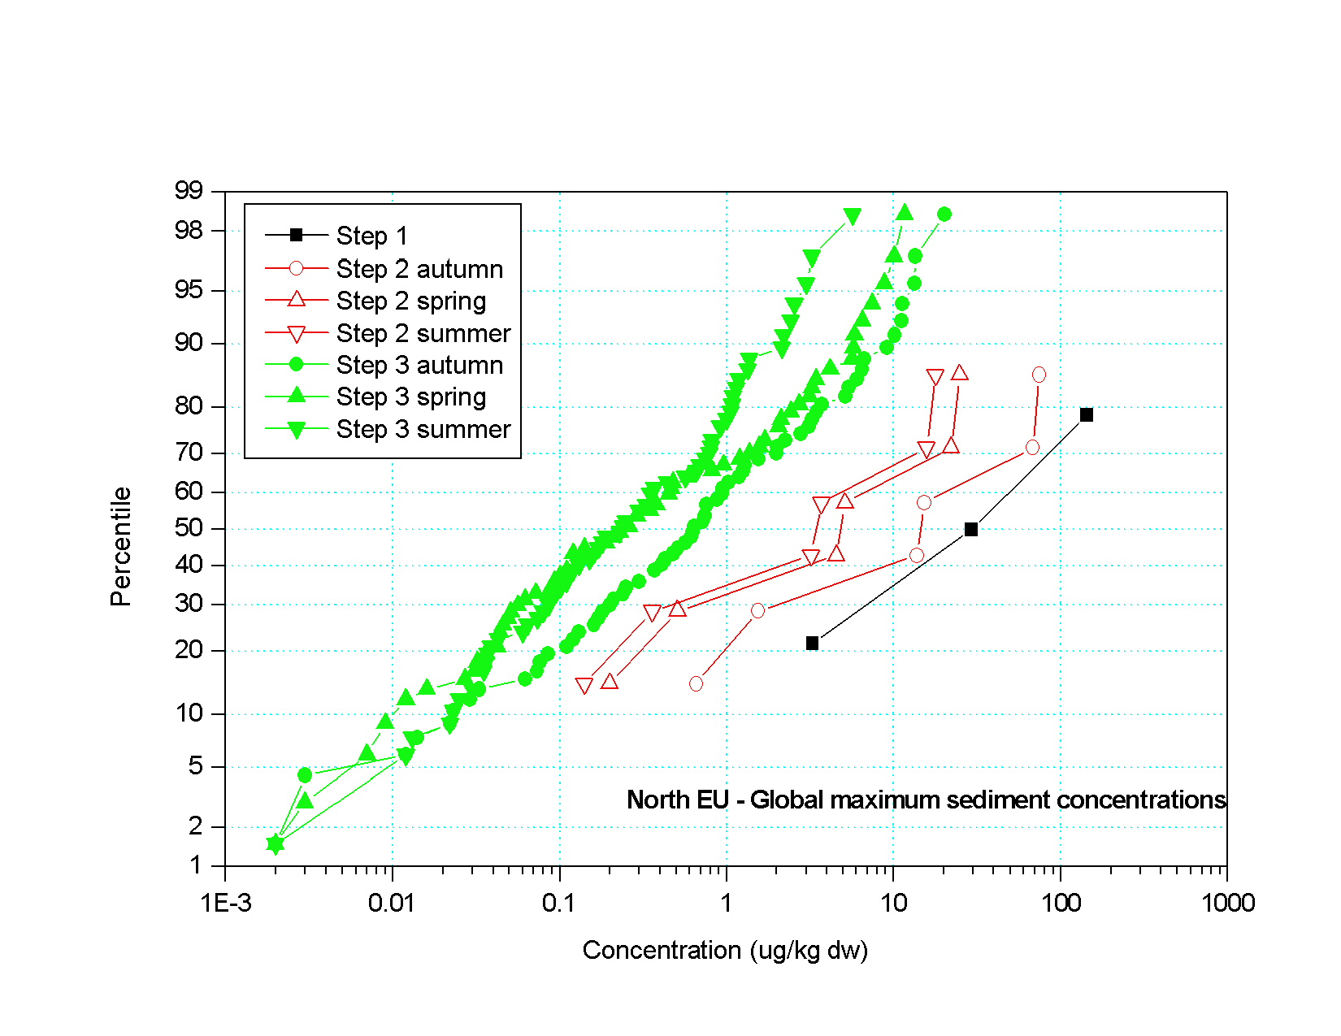
Figure 6.2.5.5 Distributions of global maximum sediment concentrations for example Compounds A, D, E, F, H and I for North EU uses
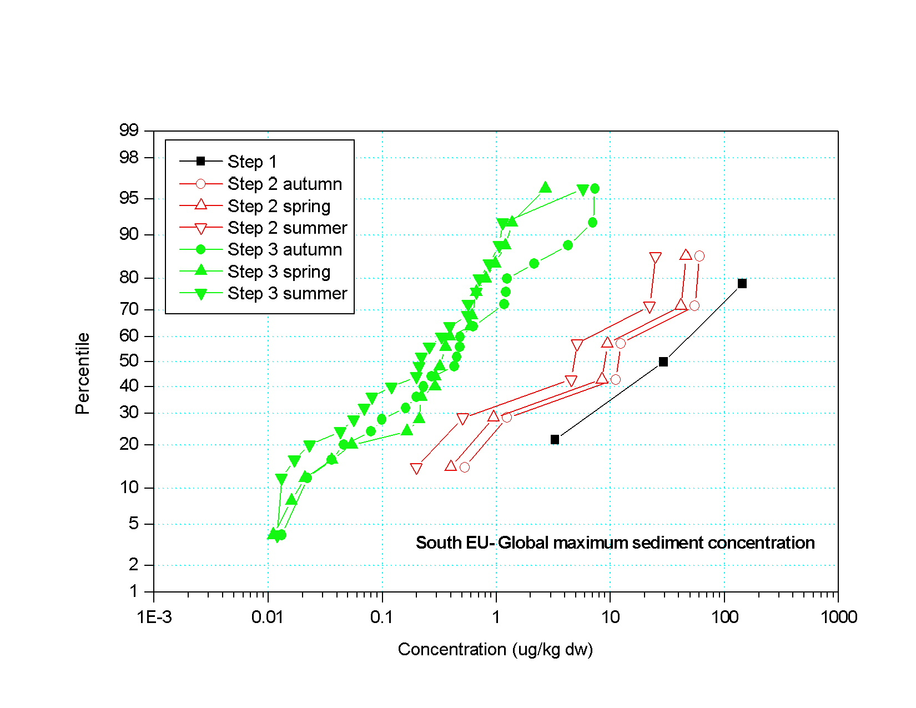
Figure 6.2.5.6 Distributions of global maximum sediment concentrations for example Compounds A, D, E, F, H and I for South EU uses
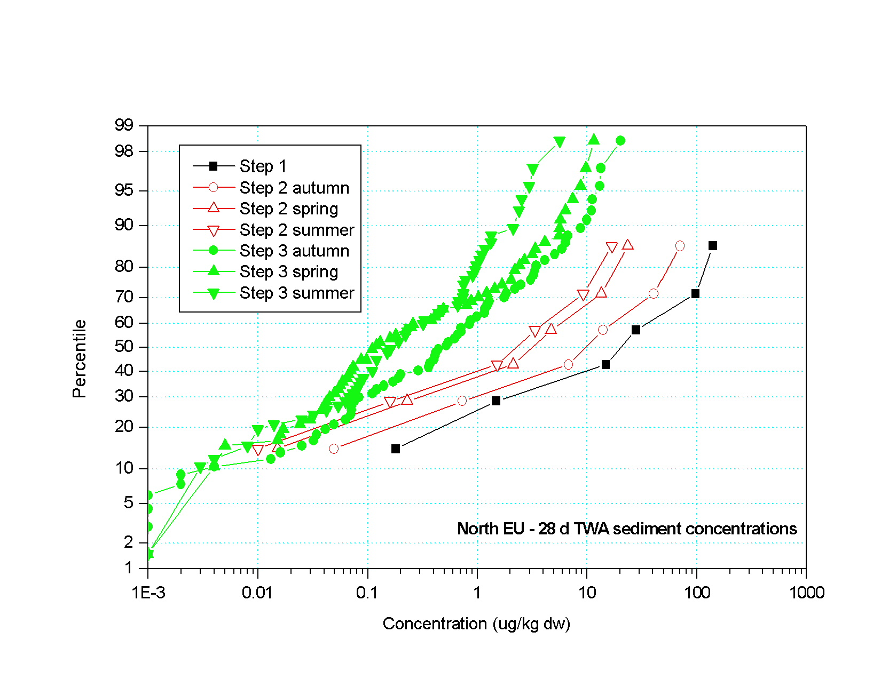
Figure 6.2.5.7 Distributions of 28 d time-weighted average sediment concentrations for example Compounds A, D, E, F, H and I for North EU uses

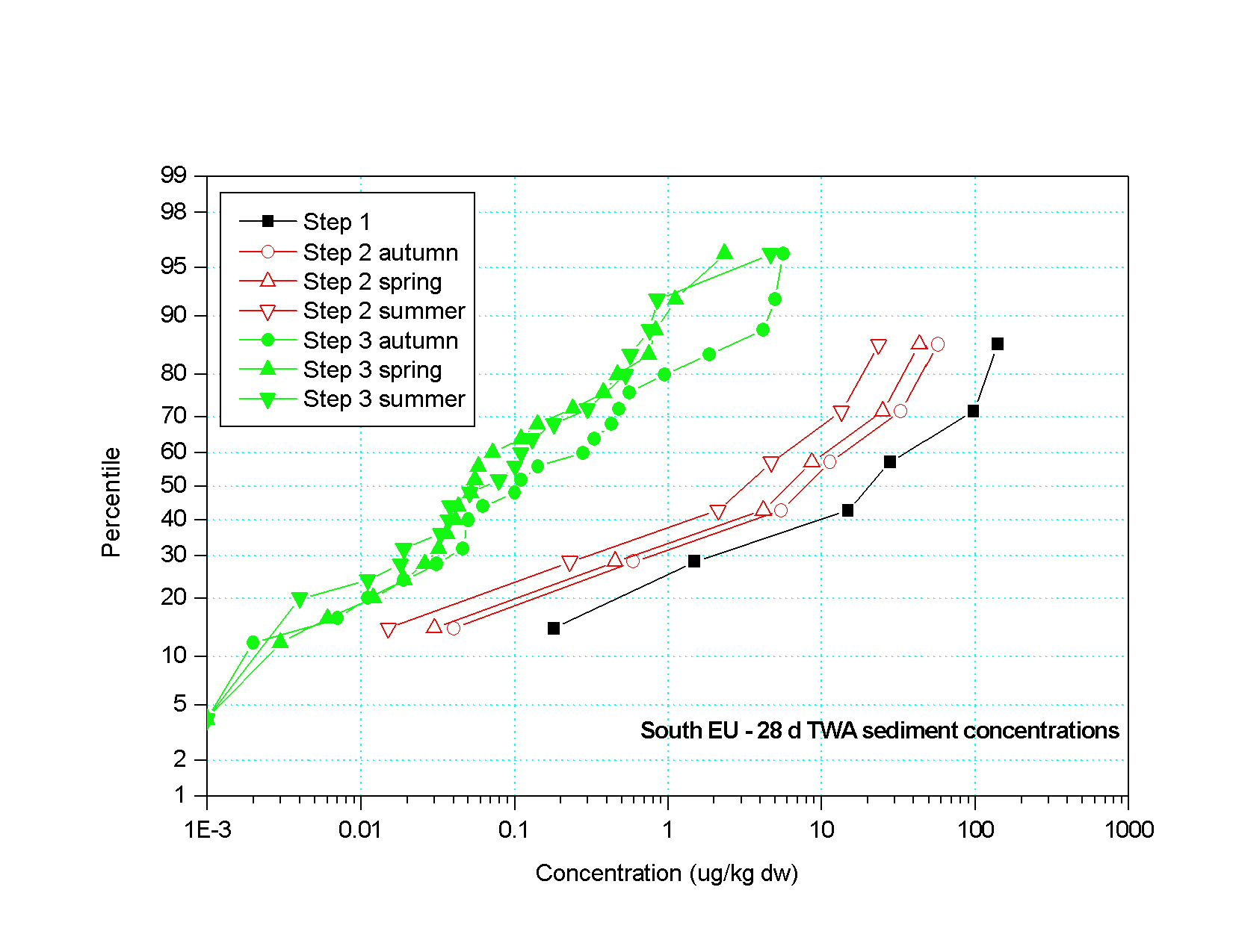
Figure 6.2.5.8 Distributions of 28 d time-weighted average sediment concentrations for example Compounds A, D, E, F, H and I for North EU uses
Comparing these distributions is initially somewhat difficult conceptually because the PECs are derived from compounds with a range of properties. However, if it is borne in mind that these distributions represent the ‘universe’ of potential PECs for an arable use rate at 100 g ai/ha, then certain patterns begin to emerge. In general, a consistent relationship between the Steps would be reflected by a gradual shift of the curve towards the Y-axis, ideally with no intersection of the curves. More specific comparisons between the distributions can be made by selecting a certain percentile on the distribution and reading across the concentrations at the different Steps. N.B. Each graph also has curves for different seasons. Like seasons should only be compared with like for the purposes of checking consistency between the steps.

Generally, distributions of PECs for water and sediment peak and time-weighted average concentrations produced similar patterns. In all cases, there was a consistent relationship between the median values, with decreasing median (50th percentile) water and sediment concentrations with increasing realism of the Step.

In all cases, there was no overlap between the distributions of concentrations at Step 1, and the distributions at Steps 2 and 3 (i.e., for a given percentile, the Step 1 concentration was always higher than the Step 2 and 3 concentrations). This demonstrates that across the ‘universe’ of pesticide fate properties, Step 1 should always constitute the worst case, and that its relationship to Steps 2 and 3 is logical and consistent.

In the vast majority of cases, there was also no overlap between distributions for the same season for Step 2 and Step 3. The cases where there was an indication of overlap was for the global maximum peak water concentration where North and South EU spring scenarios where 90th percentile concentrations for Step 2 and 3 were similar and appeared to be converging. However, this convergence only occurred at the extremes of the distributions, indicating that such overlap is only likely to occur for extreme scenarios with compounds with relatively extreme properties. That this convergence only occurs at or above the 90th percentile was also consistent with the philosophy developed by the group for the relationships between the steps.

Along with the additional analyses described above, these data demonstrate that there is a logical and consistent relationship between the steps.

6.3 Comparison of results from Steps 1, 2 and 3 using Test Compounds 1 to 7.
A series of test runs were made with test compounds 1 to 7 with the following objectives:
- To make a quantitative comparison of PEC values with relevant ecotoxicological endpoints at each step, in order to illustrate the proposed stepwise approach and to compare resulting risk assessment outcomes to those from current procedures.
- To make inter-scenario comparisons at Step 3 (relative vulnerability).
The group of test compounds were selected because relevant environmental fate and eco-toxicology data have been collated to allow evaluation of the compounds through an exposure assessment using the Step 1 , 2 and 3 surface water models followed by an effects assessment using current risk assessment procedures. The group includes test compounds used as examples at recent risk assessment workshops, plus examples of compounds which have recently been granted Annex I listing.
The properties, classes and use patterns of the six compounds plus one metabolite are presented in Table 6.2.1. The group includes three herbicides (including triazine and auxin classes), two insecticides (a carbamate and a pyrethroid) and two fungicides (a triazole and an oxazolidinedione). The application rates ranged from 3 kg/ha (as a single application) to 12.5 g/ha (three applications). Unlike test compounds A to I, the loading of test compounds 1 to 7 to surface water bodies and corresponding exposure concentrations that arise from drift are related to application rate and crop type and vary for each of the three steps. The test compounds were applied to a range of crops (potatoes, winter cereals, vines, maize and apples) which are in different drift categories and, therefore, have different loss rates. All of the compounds were spring applied and a number of the compounds also had multiple application regimes (test compounds 4, 5 and 7). The crop types were well represented among the six drainage and four run-off scenarios at Step 3. Test compound 1 is a soil incorporated pre-emergence application and, therefore, has no associated drift losses and the metabolite of test compound 6 is formed in soil and also has no drift losses.

6.3.1 Comparison of Concentrations at Steps 1 and 2
To compare the performance of the new Step 1 and 2 calculations, a series of predicted environmental concentration (PEC) calculations were conducted according to the methods recommended in the EU Guidance Document on Aquatic Ecotoxicology. Concentrations in a 30 cm deep water body resulting from drift from treated crops according to the drift tables of Ganzelmeier (1995) were calculated and compared to the results of the Step 1 and 2 calculations for compounds 1 – 7. The 95th percentile drift values were used, reflecting the approach recommended in the EU Aquatic Guidance Document prior to its current revision (currently 90th percentile values are recommended). This exposure calculation method used only drift inputs, with no consideration of losses to water bodies from either run-off or drain flow.
Arable crops, vines and orchard uses were represented by compounds 1 – 7 and the 95th percentile drift losses for these compounds at the minimum buffer distance were 4% (for winter wheat, maize and potatoes at 1m distance), 7.5% (vines at late growth stage at 3m distance, worst case assumption) and 29.6% (orchard trees at early growth stage at 3m distance, worst case assumption). Water body concentrations for test compounds 1 to 7 for Steps 1 and 2 were calculated using the ‘Step 1 _2 in FOCUS’ calculator. Drift rates were set automatically depending on crop type and crop interception was set to “no interception” for all single application compounds (test compound 1, 2, 3 and 6) and set to “minimum crop cover” for all multiple application compounds (test compound 4, 5 and 7). At Step 1, the total season application rate was applied as a single dose. At Step 2, calculations were carried out for spring use in Northern and Southern Europe with 2% and 4% losses from run-off/drainage respectively. The results of the Ganzelmeier 95th percentile and Step 1 and 2 calculations are summarised in Table 6.3.1-1. The maximum surface water concentration (PEC_{sw} max) and a selection of time weighted average (TWA) concentrations for use in the risk assessment (see section 6.3.2) are presented.
Table 6.3.1-1 Concentrations in Water Body at Steps 1 and 2 for Test Compounds 1 to 7
Compound/crop | PEC value | Surface water concentrations (μg/L)
 |  | Ganzelmeier | Step 1 | Step 2
 |  | (95th centile) |  | N Europe | S Europe
Test compound 1/ | PEC_{sw} max | 40.00 | 980.39 | 61.76 | 123.52
Potatoesª | 14d TWA | 19.82 | 485.97 | 30.64 | 61.29
 | 21d TWA | 15.03 | 368.45 | 23.23 | 46.47
 | 28d TWA | 11.88 | 291.19 | 18.36 | 36.72
Test compound 2/ | PEC_{sw} max | 13.33 | 306.50 | 35.55 | 63.42
Maize | 14d TWA | 11.13 | 255.00 | 29.45 | 52.71
 | 21d TWA | 10.21 | 233.96 | 27.02 | 48.36
 | 28d TWA | 9.39 | 215.27 | 24.86 | 44.50
Test compound 3/ | PEC_{sw} max | 13.33 | 342.12 | 18.09 | 34.74
Winter wheat | 14d TWA | 2.06 | 53.15 | 2.84 | 5.46
 | 21d TWA | 1.37 | 35.48 | 1.90 | 3.64
 | 28d TWA | 1.03 | 26.61 | 1.42 | 2.73
Test compound 4/ | PEC_{sw} max | 3.70 | 3.65 | 1.00 | 1.00
Apples^{b} | 14d TWA | 0.27 | 0.13 | 0.05 | 0.05
 | 21d TWA | 0.18 | 0.09 | 0.03 | 0.03
 | 28d TWA | 0.13 | 0.07 | 0.02 | 0.02
Test compound 5/ | PEC_{sw} max | 9.38 | 61.60 | -- | 6.80
Vines^{c} | 14d TWA | 4.65 | 57.47 | -- | 4.44
 | 21d TWA | 3.52 | 56.30 | -- | 3.77
 | 28d TWA | 2.78 | 55.17 | -- | 3.24
Test compound 6/ | PEC_{sw} max | 5.33/2.67e | 126.2/63.1e | 11.10 | 11.10e
Winter wheat | 14d TWA | 4.39/2.20e | 103.6/51.8e | 9.13 | 9.13e
 | 21d TWA | 4.00/2.00e | 94.4/47.2e | 8.32 | 8.32e
 | 28d TWA | 3.66/1.83e | 86.4/43.2e | 7.61 | 7.61e
Test compound 6- | PEC_{sw} max | NC | 6.07/3.04e | 0.58 | 0.58e
metab/Winter | 14d TWA | NC | 5.25/2.63e | 0.50 | 0.50e
wheat | 21d TWA | NC | 4.90/2.45e | 0.47 | 0.47e
 | 28d TWA | NC | 4.59/2.30e | 0.44 | 0.44e
Test compound 7/ | PEC_{sw} max | 75.00 | 626.99 | -- | 54.05
Vines^{d} | 14d TWA | 18.92 | 521.14 | -- | 18.83
 | 21d TWA | 12.84 | 480.78 | -- | 13.45
 | 28d TWA | 9.66 | 444.68 | -- | 10.29
-- Scenario not relevant for chosen crop type. NC = Not calculated.
ª Pre-emergence application.
^{b} 3 Applications per season (15 Apr – 30 Jun), assumed early season. Air blast application.
^{c} 5 Applications per season (1 Apr – 30 Jun), assume early season.
^{d} 4 Applications per season (1 Apr – 30 Jun), assume early season.
^{e} S European application rate = 200 g/ha.
The resulting initial PEC_{sw} values are compared in Figure 6.3.1-1. Similar trends were observed for time weighted average concentrations but these are not shown here.
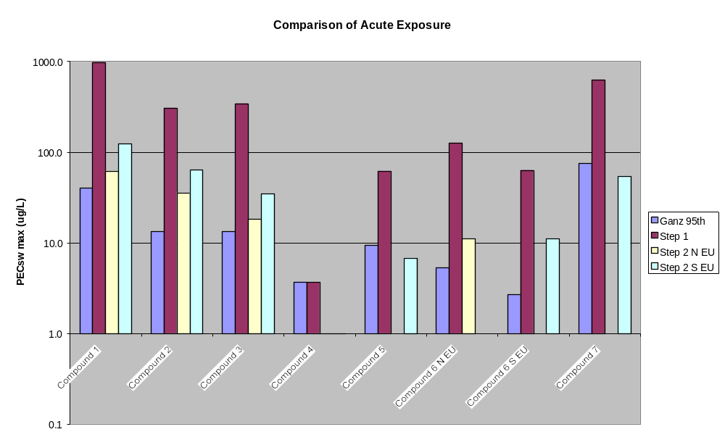
Figure 6.3.1-1 Initial PEC_{sw} concentrations for Compounds 1 to 7 using the previous EU approach and the Step 1 and 2 approach
The graph shows the concentration calculated using the previous EU methodology compared with the Step 1 and Step 2 (N and S zones) results. The data demonstrate that the Step 1 initial PEC_{sw} results were all greater than those generated using the previous EU methods. The difference was minimal for compound 4 but was significant in all other cases indicating that the Step 1 calculation is much more conservative than the previous EU methods because it includes the seasonal use rate and a run-off/drainage component. The reason the PECs for compound 4 are similar is that this compound is used in orchards which have the high spray drift rates that significantly exceed the input at Step 1 from run-off/drainage.
The further refinements introduced at Step 2 (simulation of individual applications rather than seasonal use rate, drift loadings resulting in an overall 90th percentile loading, plus variable run-off/drainage losses depending on location and season of use) generates PECs of a similar magnitude to the previous EU methods. NB. The Step 2 results for compound 4 were both 1 μg/L (the y-axis is logarithmic, so graph looks as if there is no surface water exposure).

6.3.2 Comparison of Risk Assessments at Steps 1 and 2
Table 6.1-2 presents the properties for test compounds 1 – 7 and includes information on ecotoxicity endpoints for use in risk assessments. Data are included for fish and invertebrate acute toxicity (LC/EC50), toxicity to algae and Lemna (EC50), and fish and invertebrate chronic toxicity (NOEC). Potential risks of the compounds were assessed using the toxicity exposure ratio, calculated as follows:

According the criteria established under 91/414/EEC, safe uses have been identified in the preliminary risk assessment when the TER exceeds a value of 10 (fish and aquatic invertebrate chronic, algae and Lemna endpoints) or 100 (fish and aquatic invertebrate acute endpoints).
TER values were calculated using PECs from the previous EU method and Step 1 and 2. Both acute risk assessments (using initial PEC_{sw} values) and chronic risk assessments (using 14, 21 and 28 time weighted average concentrations) were conducted for all compounds regardless of whether chronic assessments were required for the compounds in question. The results of the comparisons are presented in Figures 6.3.2-1 – 6.3.2-6. In these graphs, the TERs for the Step 1 are shown as pink squares, Step 2 TERs are shown as blue triangles, and TERs from the previous EU method are presented as green diamonds. The diagonal line represents a TER of 10 or 100 as appropriate. Points falling above the line fail the trigger, points on or below the line pass the trigger. Data for the same compound are arranged in a vertical line.
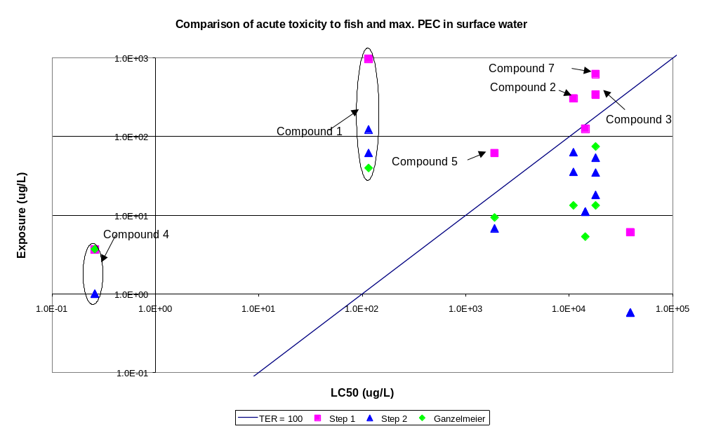
Figure 6.3.2-1 Acute Fish Risk assessments for test compounds 1 – 7.

Acute Risk assessments FOR Fish.
Figure 6.3.2-1 shows the comparison of the acute fish risk assessment using the previous EU method and Steps 1 and 2. Using the previous EU method, all but two of the compounds pass, the exceptions being compounds 2 and 4, which are both insecticides. The results of the Step 1 calculation show that six of the compounds [1 (I), 2 (H), 3 (H), 4 (I), 5 (F) and 7 (F)] fail, demonstrating that the Step 1 calculation is much more conservative than the previous method. The outcome of the Step 2 calculations is the same as for the previous EU method, with all compounds passing except compounds 1 and 4.

Acute Risk Assessments for Aquatic Invertebrates.
Figure 6.3.2-2 shows the comparison of the acute risk assessment for aquatic invertebrates.
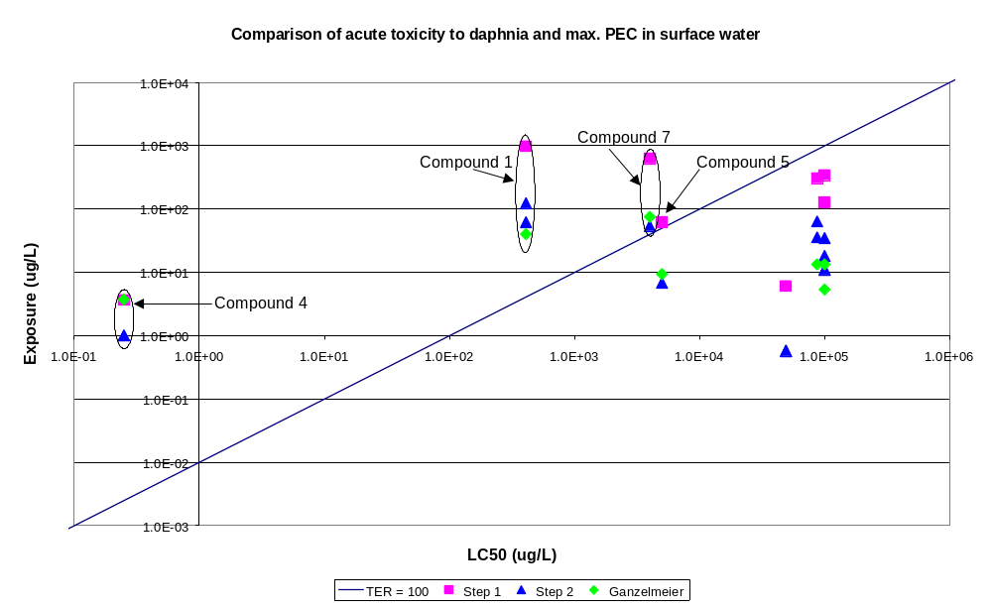
Figure 6.3.2-2 Acute assessments for Aquatic Invertebrates for test compounds 1 – 7.
Using the previous EU method, three of the compounds fail the risk assessment. These compounds are the two insecticides and one of the fungicides. The results of the Step 1 evaluation show that the same three compounds fail and the second fungicide (compound 5) also fails. The results of the Step 2 calculations are the same as for the previous EU method, with three compounds failing.
Risk Assessments for Algae.
Figure 6.3.2-3 shows the comparison of the risk assessment for algae. The results of the previous EU method show that two of the compounds fail the risk assessment (one insecticide and one herbicide). The results of the Step 1 calculations show that the same two compounds fail, plus compounds 1 (I, insecticide) and 7 (F, fungicide). The results of the Step 2 calculations are the same as for the previous EU method.

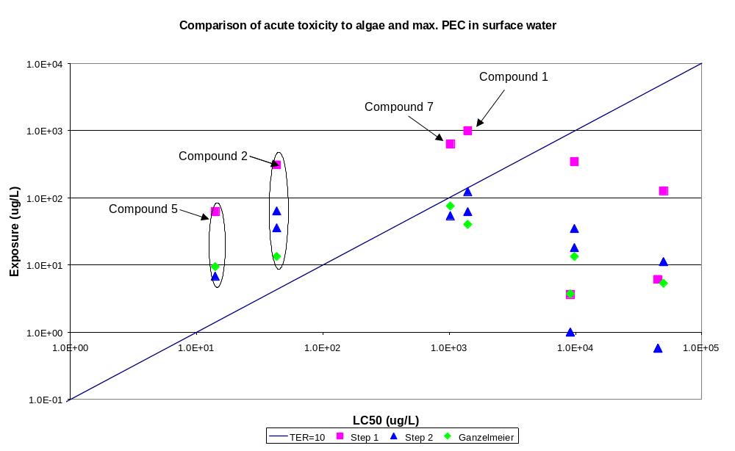
Figure 6.3.2-3 Risk assessments for Algae for test compounds 1 – 7.
Chronic Risk Assessments for Fish.
Figure 6.3.2-4 shows the comparison of the chronic risk assessment for fish.
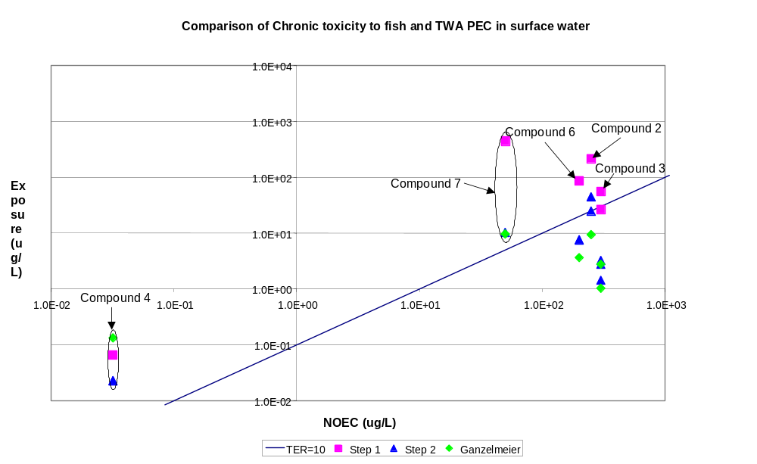
Figure 6.3.2-4: Chronic assessments for Fish for test compounds 1 – 7.
The results of the previous EU method show that compounds 4 (I) and 7 (F) fail the risk assessment. The results of the Step 1 calculations show that three further compounds, 6 (H), 2 (H) and 3 (H), also fail the risk assessment. The results of the Step 2 calculations are the same as for the previous EU method, but also show that compound 2 (H) also fails.
Chronic Risk Assessments for Aquatic Invertebrates.
Figure 6.3.2-5 shows the comparison of the chronic risk assessment for aquatic invertebrates. Data was available for all compounds except the metabolite of compound 6.
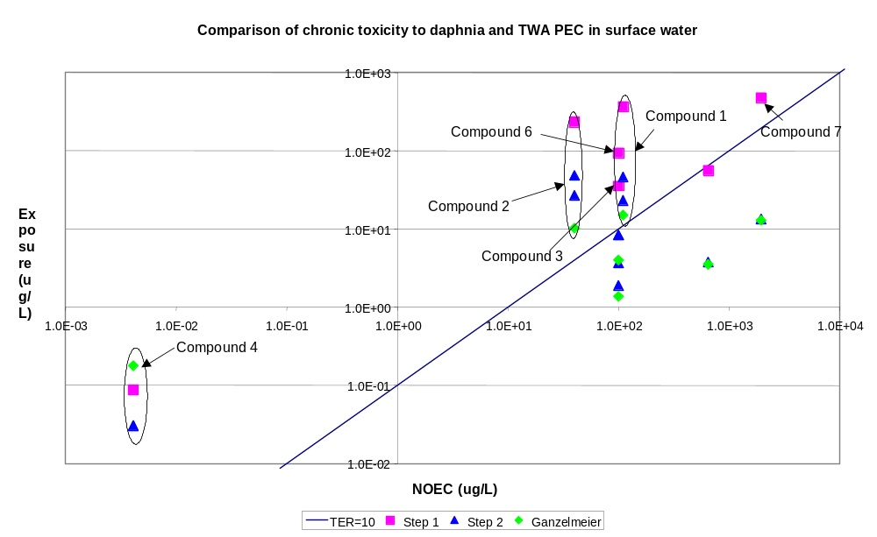
Figure 6.3.2-5 Chronic assessments for Aquatic invertebrates for test compounds 1 – 7.
The results of the previous EU method show that compounds 1 (I), 2 (H) and 4 (I) fail the risk assessment. The results of the Step 1 calculations show that three further compounds, 6 (H), 3 (H) and 7 (F), also fail the risk assessment. The results of the Step 2 calculations are the same as for the previous EU method.
Risk Assessments for Lemna.
Figure 6.3.2-6 shows the comparison of the risk assessment for the aquatic plant, Lemna. Data on Lemna are generally only required for herbicides, so data were only available for four of the compounds (2, 3, 5 and 6). The results for all of the calculations (previous EU method and steps 1 and 2) show that compound 2 (H) fails the risk assessment and the other three pass.

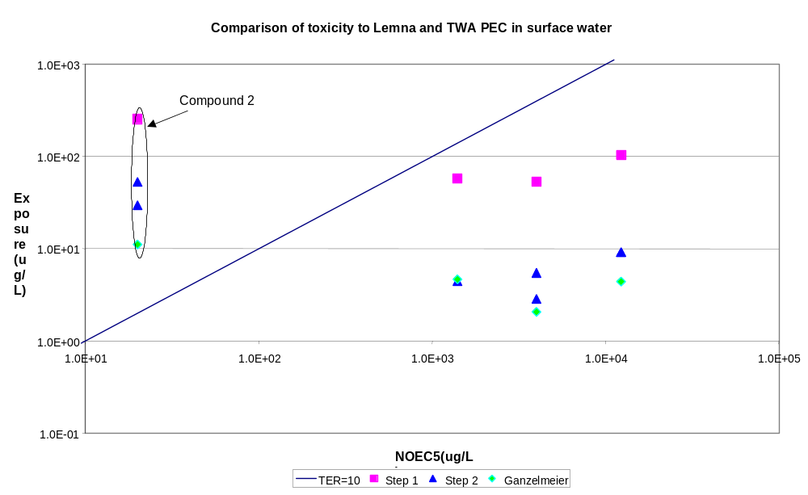
Figure 6.3.2-6: Risk assessments for Lemna for test compounds 1 – 7.

6.3.3 Calculation of exposure concentrations at Step 3.
For Step 3 calculations, drift losses were calculated using the drift calculator in SWASH. The mean areic drift rate for the relevant surface area was used as input to TOXSWA. This value was calculated at appropriate percentiles reflecting the crop type and number of applications and was entered into the TOXSWA model as separate events for multiple applications. The drift loadings at Step 3 were lower than those at Step 2 because the drift was integrated over the width of the water bodies which vary from 1 to 30 m, and also reflect the different distances between the crop and top of the water body (these range from 0.5m – 3.0 m depending on crop type).
Drainage loadings to the water bodies at Step 3 are calculated using the MACRO model for the six FOCUS drainage scenarios, and run-off loadings are calculated using the PRZM model for the four FOCUS run-off scenarios. Appropriate M2T (MACRO) or P2T (PRZM) output files were read as direct input to the TOXSWA model. Summarised output from the MACRO and PRZM simulations are presented in Appendix G Parts 5 and 6. The results for simulations with the TOXSWA surface water fate model for test compounds 1 – 7 are presented in Appendix G, Parts G-7 and G-8.
Ponds are well represented among the drainage scenarios and for test compounds 1 – 7 these are associated with D4, D5 and D6. Ponds are only associated with run-off scenario R1. Streams are well represented among the drainage scenarios and for test compounds 1 – 7 these are associated with D1, D2, D4 and D5. Streams are also well represented among the run-off scenarios and are associated with all scenarios (R1, R2, R3 and R4). Ditches are well represented among the drainage scenarios and for test compounds 1 – 7 these are associated with D1, D2, D3 and D6, but ditches are not associated with any of the run-off scenarios.
The results of the Step 3 PEC initial calculations for each compound are compared graphically with the results from the Steps 1 and 2 calculations in Figures 6.3.3-1 to 6.3.3-8. These are also generally representative of the time weighted average exposure values calculated for the compounds, although, in the latter calculations there is more buffering of extreme values.
The graphs show that in all cases the results for Step 1 are more extreme than those for Steps 2 and 3. This is to be expected given the very conservative nature of the assumptions made at Step 1 and indicates that if the risk assessments for a compound can be passed at Step 1 there is a high degree of safety in the results.
The graphs also show that for a number of the test compounds (compounds 1 (I), 3 (H), 6 (H) and 6-metabolite), a number of the Step 3 calculations give rise to concentrations that are greater than those predicted at Step 2. Conceptually this can occur as the Step 3 calculations represent a range of possibilities in the real world, some of which are more extreme than Step 2 which represents a realistic worst case. It has been shown that the drainage scenario D2 represents such an extreme (see graphs for compound 3 and 6). The results also show that for this group of spring applied compounds, scenario D1 and run-off scenarios R1 and R3 can also give extreme values if the day of application occurs before a heavy storm event that generates significant run-off or drain flow. The high run-off losses calculated at Step 3 were for compound 1, which is a soil incorporated compound. It is important to comment that the default parameterisation for the run-off scenarios (CAM = 1, DEPI = 4 cm) is not optimised for soil incorporated compounds and the use of these default parameters may have contributed to the high run-off concentrations.
The maximum Step 3 initial concentrations for the test compounds are summarised in Table 6.3.3-1.
Table 6.3.3-1 Maximum Initial Concentrations in Water Body at Step 3 for Test Compounds 1 to 7.
Compound | Scenario | Maximum PEC_{sw} initial (μg/L)
1 | R1/stream | 374.1
2 | R1/stream | 82.0
3 | D2/ditch | 176.5
4 | R3/stream,  D5/stream | 0.37
5 | R4/stream | 6.3
6 | D2/ditch | 43.5
6-met | D1/ditch | 21.1
7 | D6/ditch | 3.85

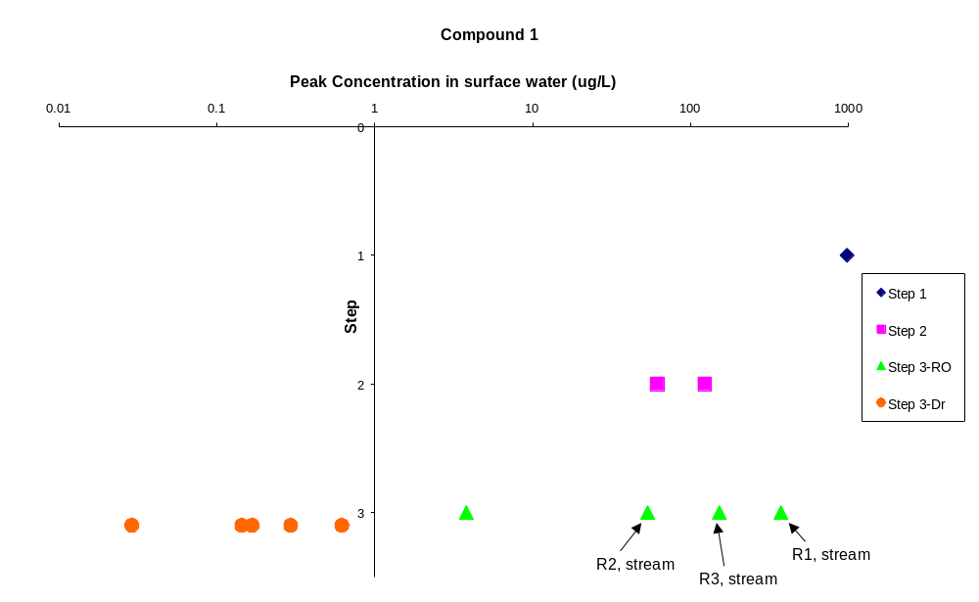
Figure 6.3.3-1 PEC_{sw} initial for test compound 1 at steps 1, 2 and 3.

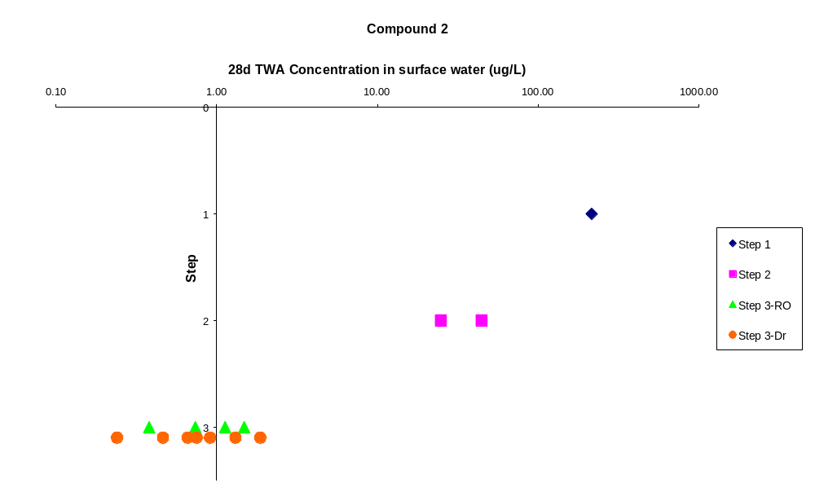
Figure 6.3.3-2 PEC_{sw} initial for test compound 2 at steps 1, 2 and 3.

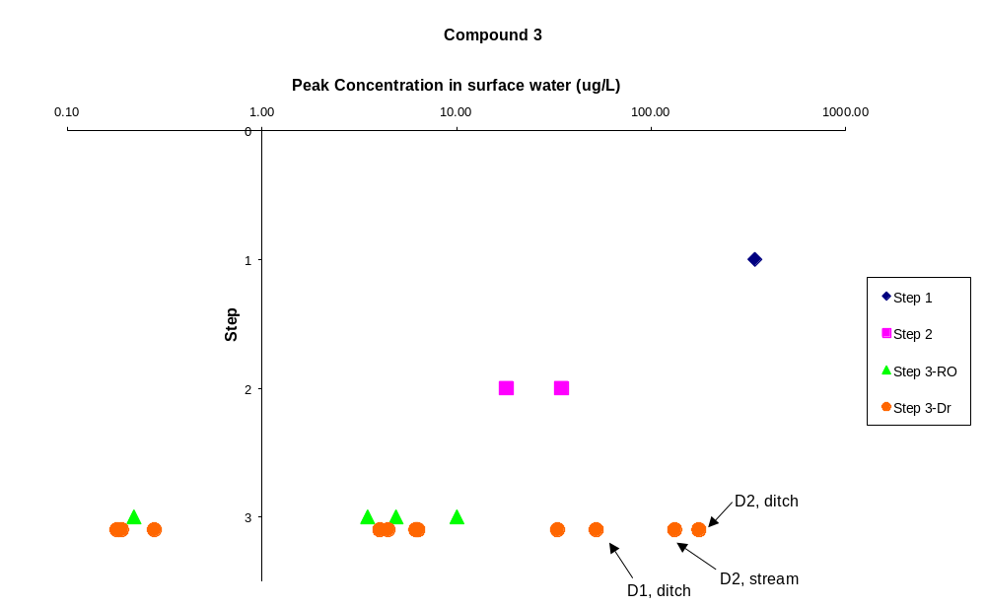
Figure 6.3.3-3 PEC_{sw} initial for test compound 3 at steps 1, 2 and 3.

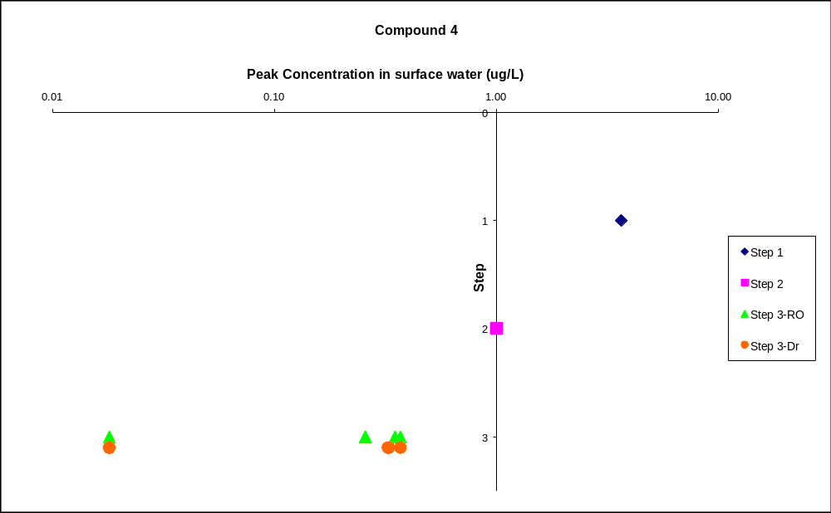
Figure 6.3.3-4 PEC_{sw} initial for test compound 4 at steps 1, 2 and 3.

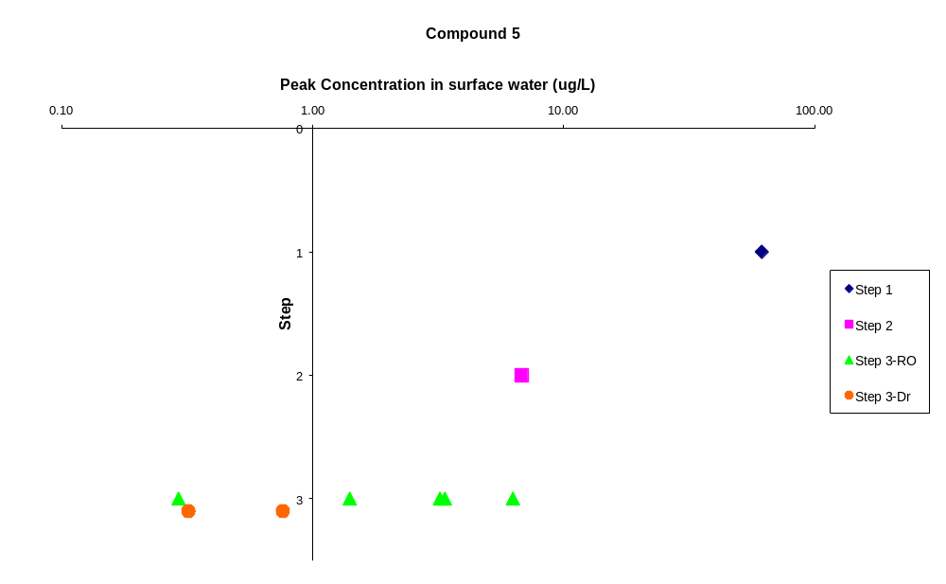
Figure 6.3.3-5 PEC_{sw} initial for test compound 5 at steps 1, 2 and 3.

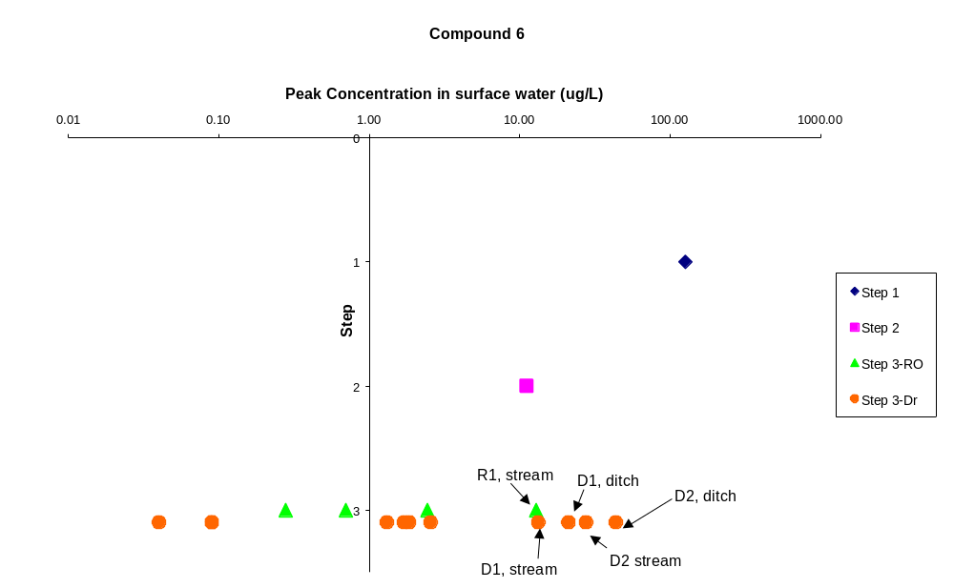
Figure 6.3.3-6 PEC_{sw} initial for test compound 6 at steps 1, 2 and 3.

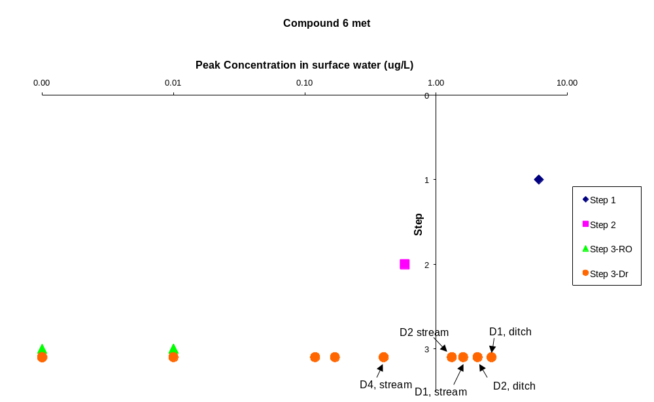
Figure 6.3.3-7 PEC_{sw} initial for test compound 6-metabolite at steps 1, 2 and 3.

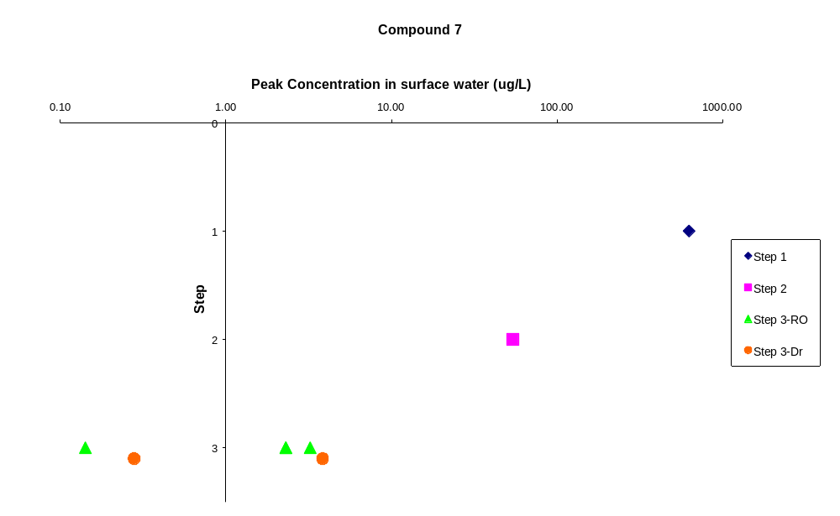
Figure 6.3.3-8 PEC_{sw} initial for test compound 7 at steps 1, 2 and 3.

6.3.4 Risk Assessments for test compounds 1 – 7 at Step 3.
Risk assessments have been carried out for compounds 1 – 7 at Step 3 using the same methodology described in section 6.3.2.
Acute risk assessments have been carried out using the PEC_{sw} max values presented in Tables G.7-2 and G.8-2 in the Appendix. These were compared with the fish and aquatic invertebrate acute endpoints. Chronic risk assessments have been carried out using appropriate TWA concentration values which are also presented in Tables G.7-2 and G.8-2. The 28-d values were used for the chronic fish assessment, the 21-d values for the chronic aquatic invertebrates’ assessment, and the 96 h and 14 d values were used for evaluating Lemna and algal toxicity respectively. These were compared with the appropriate chronic toxicity endpoints.
The results of the risk assessments are presented graphically in Figures 6.3.4-1 to 6.3.4 –6.
Acute Fish Risk assessments.
Figure 6.3.4-1 shows the results of the risk assessments at Step 3 for compounds 1 – 7. The same graphical display is used as was first presented in section 6.3.2, with compounds that pass the TER trigger falling below and to the right of the diagonal line across the graphs. The results for the drainage scenarios are presented as blue squares and the results for the run-off scenarios are presented as pink triangles.

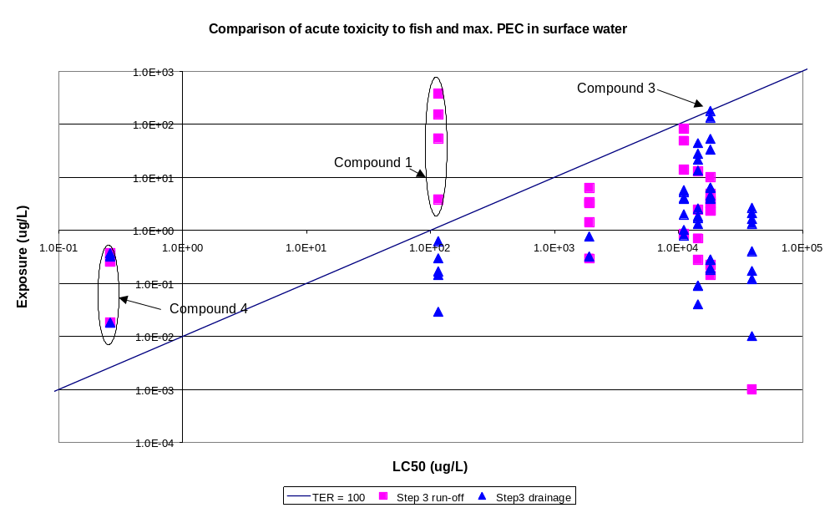
Figure 6.3.4-1 Acute Fish Risk assessments for test compounds 1 – 7.
The results show that compound 4 (I) fails all of the Step 3 scenarios whilst compound 1 (I) fails four of the run-off scenarios. Compound 3 (H) has one value that is very close to the trigger. All other compounds pass the scenarios with a reasonable margin.

From section 6.3.2-1 it can be seen that compounds 1 (I) and 4 (I) also failed the acute fish toxicity risk assessment at steps 1 and 2. Compounds 2, 3, 5 and 7 also failed at Step 1 but passed at Step 2. The results are summarised in Table 6.3.4-1. Although the sample size used in this evaluation is small, the results clearly show that the number of compounds passing the risk assessments increases at each step of the assessment which is consistent with the logic of a tiered approach.
Table 6.3.4-1 Pass/Fail rates for acute toxicity to fish for test compounds 1 - 7.
 |  | Pass/Fail at each step
Compound | Step 1 | Step 2 | Step 3
1 | F | F | 0/9
2 | F | P | 11/11
3 | F | P | 15/15
4 | F | F | 0/10
5 | F | P | 7/7
6 | P | P | 15/15
6-met | P | P | 15/15
7 | F | P | 7/7
Overall pass rate | 25% | 75% | 79%
P = pass, F = fail, x/y = passes / total number of simulations for compound.
Acute Risk Assessments for Aquatic Invertebrates.
Figure 6.3.4-2 shows the results of the risk assessments at Step 3 for compounds 1 – 7. The results show that compound 4 (I) fails all of the Step 3 scenarios whilst compound 1 (I) fails three of the four run-off scenarios. All other compounds pass the scenarios by a reasonable margin. From section 6.3.2-2 it can be seen that compounds 1 (I), 4 (I) and 7 (F) also failed the acute toxicity risk assessment for aquatic invertebrates at steps 1 and 2 and compound 5 also failed at Step 1 but passed at step 2. The results are summarised in Table 6.3.4-2.
Table 6.3.4-2 Pass/Fail rates for acute toxicity to aquatic invertebrates for test compounds 1 - 7.
 |  | Pass/Fail at each step
Compound | Step 1 | Step 2 | Step 3
1 | F | F | 6/9
2 | P | P | 11/11
3 | P | P | 15/15
4 | F | F | 0/10
5 | F | P | 7/7
6 | P | P | 15/15
6-met | P | P | 15/15
7 | F | F | 7/7
Overall pass rate | 50% | 63% | 85%
P = pass, F = fail, x/y = passes / total number of simulations for compound.

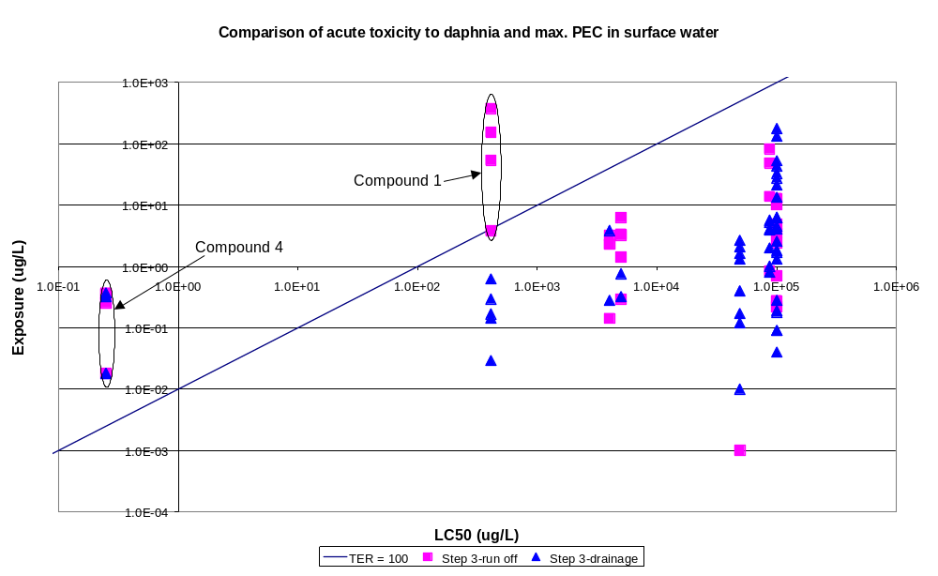
Figure 6.3.4-2 Acute Risk assessments for Aquatic Invertebrates for test compounds 1 – 7.

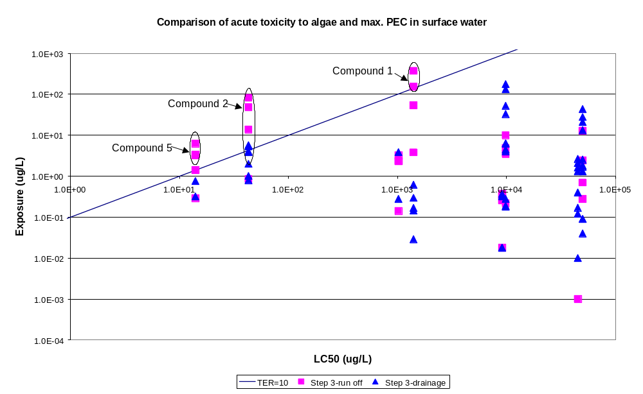
Figure 6.3.4-3 Acute risk assessments for Algae for test compounds 1 – 7.

Risk Assessments for Algae.
Figure 6.3.4-3 shows the results of the risk assessments at Step 3 for compounds 1 – 7. The results show that compound 1 (I), 2(H) and 5 (F) fail some of the Step 3 scenarios (mostly run-off scenarios). All other compounds pass the scenarios by a reasonable margin. From section 6.3.2-3 it can be seen that compounds 2 (H) and 5 (F) failed the risk assessment for algae at Steps 1 and 2, and compounds 1 (I) and 7 (F) also failed at Step 1 but passed at Step 2. The results are summarised in Table 6.3.4-3.
Table 6.3.4-3 Pass/Fail rates for toxicity to algae for test compounds 1 - 7.
 |  | Pass/Fail at each step
Compound | Step 1 | Step 2 | Step 3
1 | F | P | 7/9
2 | F | F | 6/11
3 | P | P | 15/15
4 | P | P | 10/10
5 | F | F | 4/7
6 | P | P | 15/15
6-met | P | P | 15/15
7 | F | P | 7/7
Overall pass rate | 50% | 75% | 89%
P = pass, F = fail, x/y = passes / total number of simulations for compound.
Chronic Risk Assessments for Fish.
Figure 6.3.4-4 shows the results of the risk assessments at Step 3 for compounds 1 – 7. No eco-toxicity data were available for compounds 1 and the metabolite of compound 6 so these were not included in the assessment.
The results show that compound 3(H) and 4 (I) fail some of the Step 3 scenarios. All other compounds pass the scenarios by a reasonable margin. From section 6.3.2-4 it can be seen that compounds 4 (I) and 7 (F) failed the chronic toxicity risk assessment for fish at steps 1 and 2 and compounds 2 (H), 3 (H) and 6 (H) also failed at Step 1 but passed at step 2. The results are summarised in Table 6.3.4-4.
Table 6.3.4-4 Pass/Fail rates for chronic toxicity to fish for test compounds 1 - 7.
 |  | Pass/Fail at each step
Compound | Step 1 | Step 2 | Step 3
2 | F | P | 11/11
3 | F | P | 13/15
4 | F | F | 7/10
5 | P | P | 7/7
6 | F | P | 15/15
7 | F | F | 7/7
Overall pass rate | 17% | 67% | 92%
P = pass, F = fail, x/y = passes / total number of simulations for compound.

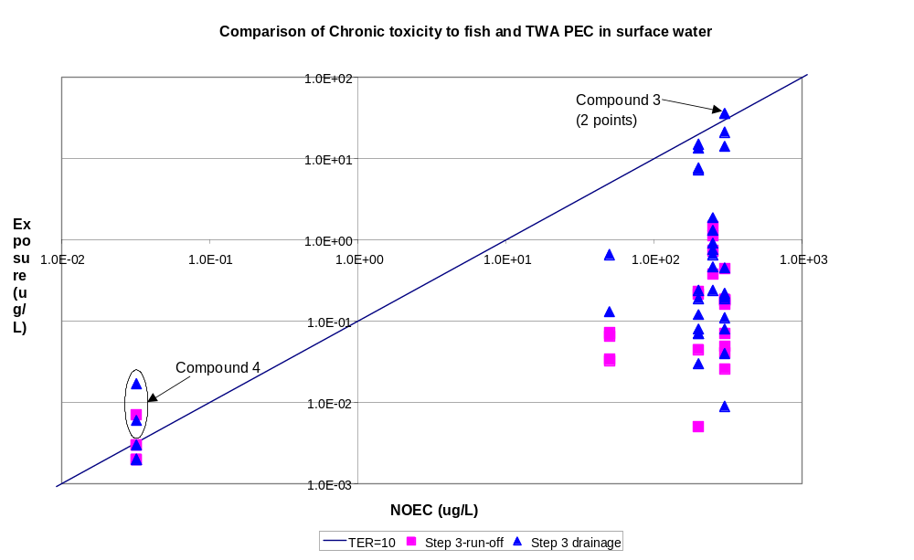
Figure 6.3.4-4 Chronic Risk assessments for Fish for test compounds 1 – 7.
Chronic Risk Assessments for Aquatic Invertebrates.
Figure 6.3.4-5 shows the results of the risk assessments at Step 3 for compounds 1 – 7. No ecotoxicity data were available for the metabolite of compound 6 so this compound was not included in the assessment.
The results show that compound 4 (I) fails all of the Step 3 scenarios and compounds 3 and 6 fail some of the drainage scenarios.. All other compounds pass the scenarios by a reasonable margin. From section 6.3.2-5 it can be seen that compounds 1 (I), 2 (H) and 4 (I) failed the chronic toxicity risk assessment for aquatic invertebrates at Steps 1 and 2 and compounds 3 (H), 6 (H) and 7 (F) also failed at Step 1 but passed at Step 2. The results are summarised in Table 6.3.4-5.

Table 6.3.4-5 Pass/Fail rates for chronic toxicity to aquatic invertebrates for test compounds 1 - 7.
 |  | Pass/Fail at each step
Compound | Step 1 | Step 2 | Step 3
1 | F | F | 9/9
2 | F | F | 11/11
3 | F | P | 11/15
4 | F | F | 0/10
5 | P | P | 7/7
6 | F | P | 13/15
7 | F | P | 7/7
Overall pass rate | 14% | 57% | 78%
P = pass, F = fail, x/y = passes / total number of simulations for compound

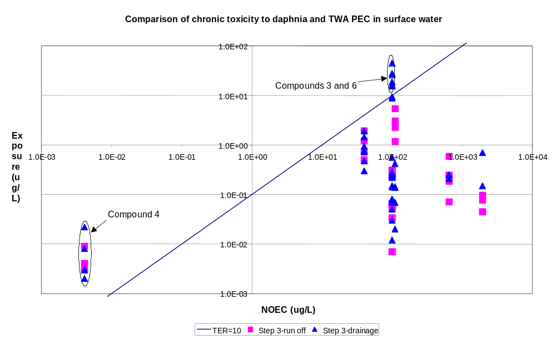
Figure 6.3.4-5 Chronic Risk assessments for Aquatic Invertebrates for test compounds 1 – 7.
Risk Assessments for Lemna.
Figure 6.3.4-6 shows the results of the risk assessments at Step 3 for compounds 1 – 7. No toxicity data were available for compounds 1, 4, 7 and the metabolite of compound 6 so these compounds were not included in the assessment. The remaining compounds included three herbicides and one fungicide.
The results show that compound 2 (H) failed one of the Step 3 run-off scenarios and the other three compounds pass the scenarios by a reasonable margin. From section 6.3.2-6 it can be seen that compound 2 (H) also failed the risk assessment for Lemna at Steps 1 and 2 while the other compounds all passed at Step 2. The results are summarised in Table 6.3.4-6.
Table 6.3.4-6 Pass/Fail rates for toxicity to Lemna for test compounds 1 - 7.
 |  | Pass/Fail at each step
Compound | Step 1 | Step 2 | Step 3
2 | F | F | 10/11
3 | P | P | 15/15
5 | P | P | 7/7
6 | P | P | 15/15
Overall pass rate | 75% | 75% | 98%
P = pass, F = fail, x/y = passes / total number of simulations for compound.

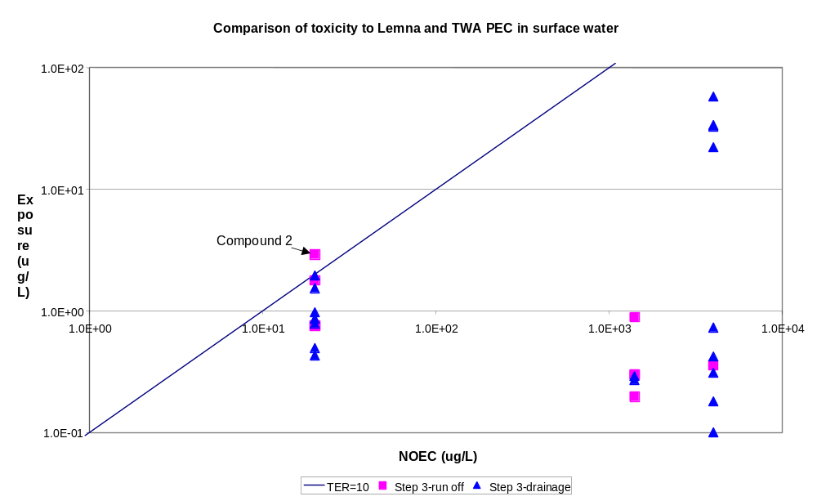
Figure 6.3.4-6: Risk assessments for Lemna for test compounds 1 – 7.

6.3.5 Conclusions
The performance of the FOCUS Step 1, 2 and 3 exposure assessments has been evaluated and compared using data from a number of real compounds. PECs were compared to the previous EU exposure calculation method. TERs were also calculated using the risk assessment methodology established under 91/414/EEC.
The compounds examined included the following range of properties:
- Variety of compound classes (herbicides, insecticides, fungicides and one metabolite)
- Application rates ranging from 12.5 g/ha up to 3 kg/ha
- Soil incorporated and foliar spray uses
- Crop types with different drift characteristics (cereals, potatoes, vines and orchards)
- Single and multiple applications
- A broad range of DT50 (4d to 250d) and Koc (1 to 1.02 x 10⁶) values in soil
- A broad range of acute and chronic toxicity values to aquatic organisms
One limitation to the evaluation was that all of these compounds were used in spring, so no autumn uses were evaluated. Autumn uses might be especially vulnerable for the drainage scenarios.
The results of the evaluation show that the Step 1 calculations, which consider both spray drift and run-off/drainage losses, are more conservative than previous methods of assessment that focused on spray drift losses only (using 95th percentile values). The Step 2 calculations which include such refinements as individual applications, total drift loading at the 90th percentile and run-off/drainage loading four days after the last application, give results that are generally comparable with previous methods.
The results of the Step 1 (extreme worst case) calculations are always more conservative than those of the Step 2 (realistic worst case) calculations, but on occasions some Step 3 calculations give rise to greater concentrations than step 2. This is because Step 3 reflects a broader distribution of all possibilities in the “real world” and this can include some situations that are more extreme than Step 2.
The results of risk assessments for fish, aquatic invertebrates and plants have also been evaluated and discussed and the pass/fail rates for the test compounds have been assessed for each species and are summarised in Table 6.3.5-1.
Table 6.3.5-1 Pass/Fail rates for aquatic risk assessments for test compounds 1 - 7.
 | Pass/Fail at each step
Risk assessment | Step 1 | Step 2 | Step 3
Acute ª | 42% | 71% | 84%
Chronic ^{b} | 16% | 62% | 85%
Lemna | 75% | 75% | 98%
ª Average values for acute risk assessments to fish and aquatic invertebrates, and risks to algae.
^{b} Average values for chronic risk assessments for fish and aquatic invertebrates.
The summary shows that there is the anticipated gradation in the pass rate for compounds, with fewest compounds passing at Step 1 (most conservative step) to > 80% of compounds passing at Step 3 (most realistic step). The pass rate for these compounds is probably as high as it is since most of the compounds have recent registrations or re-registrations.

6.4 Comparison of results with measured data on exposure

6.4.1 Field evidence for inputs from drainage
Flury (1996) reviewed the available published experimental evidence concerning pesticide losses to field drainage systems. In a comprehensive literature search of studies published prior to 1996, he found only c. 21 studies, dealing with 14 compounds (plus several metabolites). Of these, Flury reports the mass loss of 13 compounds in 12 studies. He noted that most studies had been carried out on loamy or clayey soils (similar to FOCUS scenarios D1, D2, D4 to D6), since these are commonly under-drained for agricultural production. In these soils, leaching was ‘event-driven’ with preferential flow apparently responsible for most of the movement to the drainage systems. Mass losses in the studies reviewed ranged from < 0.001% of the applied amount for strongly sorbed compounds (pendimethalin, trifluralin) up to 2 to 3% of the dose for more mobile compounds (e.g. atrazine, carbofuran, metribuzin, isoproturon). It should be noted that, in some of these studies, the estimates may underestimate the true loss, because sampling was only carried out for a limited time following pesticide application. It can also been noted that preferential movement of pesticide to drainage systems is highly transient and therefore may be difficult to adequately capture with sampling schemes characterised by a low temporal resolution. Furthermore, in soils prone to preferential flow, leaching may be highly variable from year to year (Beulke, et al., 1999), such that a single extreme event can dominate long-term leaching (Jarvis, 1994).
Total mass loss is perhaps not the most relevant measure in the context of FOCUS. This is because the maximum concentration attained is more critical for acute ecotoxicological end-points. Flury (1996) did not report maximum concentrations in the studies he reviewed, so some examples are briefly mentioned here. In a silty clay soil in Indiana, Bottcher et al. (1981) reported maximum drain flow concentrations of c. 200 μg l⁻¹ for carbofuran and c. 50 μg l⁻¹ for alachlor, 5 days following pesticide application. From limited measurements made in only one year, Gentry et al. (2000) reported maximum concentrations of atrazine and metolachlor of c. 30 μg l⁻¹ draining from a silty clay loam soil in Illinois. Gaynor, et al. (1995) reported maximum concentrations in tile drainage water of 200 to 300 μg l⁻¹ for the same two compounds following spring application to a clay loam soil in Ontario, Canada. During a four year period, mass losses ranged from 0.1% to 3.6% of the applied dose for both compounds, with the largest mass losses recorded in one of the four years, characterised by significant tile drainage flows following application, in response to heavy spring rainfall. Buhler, et al. (1993) reported small mass losses (< 0.1%) of atrazine and alachlor following continuous spring application to a tile-drained clay loam in Minnesota, with mean concentrations of only c. 1 μg l⁻¹. They noted that on no occasion during the six-year study did heavy rainfall soon after the spring pesticide applications, thus giving sufficient time for degradation to take place prior to the recommencement of drain flows in autumn.
At Brimstone (scenario D2), Harris et al. (1994) reported typical winter drain flow concentrations of 10 to 50 μg l⁻¹ for isoproturon. In limited spring drain flow, they noted concentrations of more than 600 μg l⁻¹ for the same compound. Beulke, et al. (1999) report maximum yearly drain flow concentrations of isoproturon in English heavy soils (two clays and a clay loam: Brimstone, Wytham, Cockle Park) of 465, 290 and 4 μg l⁻¹ respectively. Compound E has very similar properties to isoproturon (half-life = 30 days, Koc =100). When applied at an application rate of 100 g a.s./ha the simulated peak drainflow concentrations for scenario D2 were 28, 20 and 2 μg l⁻¹ following applications in autumn, spring and summer, respectively. Isoproturon is applied at rates of between 1 and 2 kg a.s./ha. Therefore when adjusted for the difference in application rates (a factor of 10 to 20) these simulated concentrations are of a similar magnitude to those observed in field studies at this scenario.
Three studies have been carried out on pesticide movement to tile drains at scenario D1. Bergström, et al. (1990) reported concentrations of fluroxypyr in drainage water following spring application. Only four weekly samples were obtained in the dry summer and autumn period between 25th May and 9th November in the study year, and of these samples, only one showed a concentration (2 μg l⁻¹ in the double dose treatment) above the detection limit. These results do not compare well with the simulation of compound 6 (which is similar in properties to fluroxypyr) in scenario D1 where a peak concentration in drainflow of > 60 μg l⁻¹ was simulated. However this may be a conseuqence of the dry conditions at the time of the field experiment. Similar results were obtained for clopyralid which was applied at the same time as fluroxypyr, with single detections in summer drain flow of 0.5 and 6 μg l⁻¹ in normal and double dose treatments respectively (Bergström, et al., 1991). Larsson & Jarvis (1999) applied the weakly sorbed herbicide bentazone to Lanna in mid-October 1994 and continuously recorded drainage concentrations during the following year. Maximum concentrations of 200 μg l⁻¹ were measured 20 days following application in the first significant drain flow, although it should be noted that they applied c.3 times the recommended dose. However, this initial breakthrough due to preferential flow was overshadowed by slow convective-dispersive leaching of bentazone to the drains during the subsequent winter period. In total, 8% of the applied amount was recovered in tile drain flow during the one-year period, with concentrations as large as 50 μg l⁻¹ recorded in autumn drain flow more than one year after application. These losses are comparable to similar compounds evaluated assuming autumn applications in scenario D1. Bentazon is similar in properties to compounds D and E. Simulations of autumn applications of these two compounds calcualte annual losses of 8.9% to 11.1% (Table G.2-4). Vicari, et al. (1999) reported mass losses in tile drain flow for four compounds (metolachlor, atrazine, prosulfuron and triasulfuron) from a Carpi clay soil in the Po Valley in northern Italy ranging from less than 0.1% (triasulfuron) to 8.6% (prosulfuron) of the applied amount.
Preferential flow also strongly affects pesticide losses in drain flow from loamy soils, although mass losses seem to be somewhat smaller than from the finer-textured clay soils discussed above. For example, in a comprehensive study, Kumar et al. (1998) found peak concentrations of atrazine of 10 to 12 μg l⁻¹ and an upper limit for the total mass loss of c. 0.6% of that applied from a loamy soil in Iowa. Kladivko, et al. (1991) reported losses of carbofuran amounting to 0.94% of the applied amount and maximum concentrations of 160 μg l⁻¹ soon after application. Although atrazine, cyanazine and alachlor were also detected in the drain flow, losses of these compounds were less than 0.06% of the applied amount. Traub-Eberhard et al. (1995) found maximum concentrations of 62 μg l⁻¹ and 0.7 μg l⁻¹ for isoproturon and pendimethalin respectively, following autumn application to a silt loam soil in northern Germany. The peak concentrations detected following spring application of a range of different compounds were much smaller (< 0.01 μg l⁻¹ for pendimethalin, for example). Vicari, et al (1999) found 3 to 10 smaller tile drainage loads from a sandy loam soil compared to a clay soil in northern Italy, for three out of four compounds studied. At La Jailliere (scenario D5) in north-west France, ISMAP (1997) reported mass losses of up to 0.9% for isoproturon and 0.25% for atrazine in tile drainage from this loamy soil. These losses also compare reasonably well with the results presented in Appendix G. For scenario D5, a total mass loss equivalent to 1.6% was simulated for compound E with autumn application (Table G.2.3; equivalent to the isoproturon study) and 0.4% for compound 2 with spring application (Appendix G, Part 5; equivalent to the atrazine study).
Few studies of leaching to drainage systems have been carried out on sandy soils influenced by shallow groundwater similar to the D3 (Vredepeel) FOCUS scenario. Leaching of bentazone and ethoprophos has been monitored at Vredepeel itself, but only with the core sampling technique (Boesten & van der Pas, 2000), so that fluxes are difficult to estimate. Nevertheless, the measurements indicated that a significant fraction of the mobile compound bentazone leached past 1 m depth, while ethoprophos was essentially sorbed and degraded in the upper topsoil. In tile drain flow from a sandy soil in Georgia, Leonard et al. (1988) reported maximum concentrations of 22 μg l⁻¹ for EDB, 24 μg l⁻¹ for aldicarb, 0.5 μg l⁻¹ for atrazine and 30 μg l⁻¹ for butylate. Another compound applied to the field (fenamiphos) was not detected in the tile drain outflow. In a sandy soil in Germany, Traub-Eberhard, et al. (1995) found smaller peak concentrations of isoproturon and pendimethalin in tile drainage water from a sandy soil (1.4 μg l⁻¹ and non-detectable respectively) than from a structured silt loam soil prone to preferential flow (62 μg l⁻¹ and 0.7 μg l⁻¹).
In summary therefore, the following general conclusions can be drawn from a survey of the available literature on pesticide losses to field drainage systems:
- macropore flow is a widespread and dominant mechanism controlling pesticide transport to drains, occurring in both fine-textured clayey and loamy soils. In such situations, pesticide leaching to drains is ’event-driven’, and may be highly variable from year to year depending on prevailing weather conditions. This is especially true for spring applications, where losses are highly dependent on application timing with respect to rainfall and drain flow.
- mass losses seem to be largest in well-structured clayey soils, and somewhat less from loamy soils. Sands with shallow groundwater are less well investigated, but seem to pose a smaller risk than soils exhibiting macropore flow. Mass losses clearly depend on compound properties even in the presence of macropore flow. For mobile compounds, typically up to 2 to 4 % of the applied amount may leach to drains, with two extreme values of 8-9% reported for weakly sorbed compounds applied on well-structured clay soils (one in autumn in Sweden, one in spring in Italy). Simulations for compounds with half-lives ranging from 3 to 30 days and Koc from 10 to 100 (more typical of mobile pesticides actually used in agriculture) indicate annual losses in the range of <0.1% to 3.1% for compounds A and B (both with a half-life of 3 days) and <0.1% to 19.3% for compounds D and E (both with a half-life of 30 days) (Table G.2.3). Although annual losses are greater than those observed in field studies the range of maximum daily losses are more comparable (Table G.2.2) to field observations. Maximum concentrations depend on both the compound properties and dose rate, but for weakly to moderately sorbed compounds, concentrations from tens to several hundred μg l⁻¹ are commonly reported and were of similar magnitude to the residues in drainflow simulated in the more vulnerable scenarios such as D1, D2 and D6.

6.4.2 Field evidence for inputs from runoff
A number of validation and comparison studies have been published for PRZM. In the USA, FIFRA Exposure Model Validation Task Force recently completed a validation exercise for PRZM that included comparison of simulated edge-of-field runoff and erosion with the results of field-scale experiments (FEMVTF, 2000). Model predictions for individual runoff events typically matched field data within a factor of 2-3X. Cumulative values (e.g. runoff summed over the study period) typically agreed within a factor of 3X and many model runs resulted in concentrations that matched field data within a factor of 1-2X. The accuracy of runoff and erosion predictions corresponded with the magnitude of the runoff events with much greater accuracy being found for medium-to-large runoff events. A detailed description of the other results from PRZM validation modelling is available in the FEMVTF report (FEMVTF, 2000).
A number of European studies of runoff and erosion have been published and were consulted during the parameterisation of PRZM (Lennartz, et al., 1997; Louchart, et al., 2001; Voltz, et al., 1997; Sanchez-Camazano, et al., 1995; Vicari, et al., 1999, Miao, et al., 2001, Rossi Pisa, et al., 1992). In the hilly area at Ozzano Emilia (Bologna, Italy), plots with a 15% slope on a loamy soil were used to study the effect of two tillage systems, conventional tillage (CT) and minimum tillage (MT), on runoff losses of several herbicides. In the year 1996-97 the fate of metolachlor, atrazine and its metabolites (desethylatrazine: DEA; desisopropylatrazine: DIA), and two sulfonylureas, prosulfuron and triasulfuron, applied to a winter wheat-maize biennial rotation was monitored. Runoff losses ranged between 0.1 to 2% of precipitation. As a consequence of the rainfall pattern, losses of herbicides amounted to a maximum of 0.24, 0.25, 0.05 and 0.003% of the amount applied, for atrazine, metolachlor, prosulfuron and triasulfuron, respectively and the minimum tillage reduced metolachlor and atrazine losses with respect to conventional tillage (Vicari et al., 1999). The FOCUS runoff scenario corresponding to Bologna is R3. PRZM calculations for atrazine in R3 resulted in annual losses of 0.10% and 0.001% for triasulfuron, indicating reasonable general agreement with this single year of experimental data.
A similar experiment was also carried out near Bologna during 1991-92 using the herbicides atrazine, metolachlor and terbuthylazine. In this study, runoff corresponded to 0.5 and 3.5% of precipitation for normal and minimum tillage respectively. A maximum of 1.6, 1.1 and 0.07 % of the applied amount of metolachlor, atrazine and terbuthylazine, respectively, was lost via runoff. The FOCUS scenario corresponding to Bologna is R3. The annual pesticide losses simulated by PRZM for these chemicals in R3 were 2.0, 1.3 and 0.3% for metolachlor, atrazine and terbuthylazine, respectively, again indicating reasonable agreement between this scenario and the available experimental data.
In a series of studies describing runoff from no-till and tilled fields in a wine-growing catchment in southern France, detailed measurements were reported for seasonal runoff, seasonal pesticide losses and the concentrations in individual edge-of-field runoff events for normal agronomic applications of diuron and simazine (Lennartz, et al., 1997; Louchart, et al., 2001). The FOCUS scenario corresponding to southern France is R4. Comparisons between the experimental data for 1995 and 1997 and the results of PRZM simulations for scenario R4 are as shown in Table 6.4.2-1.
Table 6.4.2-1 Comparison of experimental and simulated values for Scenario R4
Parameter  being compared | Values from  Field Experiments | Values from  PRZM, Scenario R4
Annual runoff  (% of annual precipitation) | 19 – 22 % | 24 %
Annual diuron loss  (% of applied) | 0.7 – 0.9 (tilled) | 0.7
Annual simazine loss  (% of applied) | 0.5 – 0.8 (tilled) | 0.4
Runoff concentrations of diuron (ug/L, from first four events) | 1 – 57 (0.5 kg ai/ha)  2 – 100 (2.0 kg ai/ha) | 4 – 82 (0.5 kg ai/ha)  11 – 344 (2.0 kg ai/ha)
Runoff concentrations of simazine (ug/L, from first four events) | 0.3 – 57 (0.28 kg ai/ha)  0.2 – 45 (1.0 kg ai/ha) | 0.8 – 57 (0.28 kg ai/ha)  2 – 204 (1.0 kg ai/ha)

The results obtained from Scenario R4 using PRZM show good general agreement with the two years of experimental data for diuron and simazine with similar annual losses as well as similar ranges of runoff concentrations.
These PRZM simulation results indicate that the model is capable of providing reasonable estimates of the runoff coefficient (fraction of precipitation resulting in runoff) as well as reasonable estimates of cumulative runoff flux. It should be emphasised the FOCUS runoff scenarios provide sound general estimates of runoff and erosion behaviour likely to occur given the soil, agronomic and weather data selected for use in each scenario. More detailed, site-specific comparisons of PRZM with experimental runoff events require the use of local soil, agronomic and weather data.

6.4.3 Field evidence for concentrations in edge of field water bodies
No comparison of the revised model (TOXSWA 2.0) has been made with field measurements to date. However, several datasets are available for future evaluation of the model in the coming years. These datasets describe the aquatic fate of pesticides in a well-defined water body as well as the environmental setting being studied.
A recent compilation of runoff studies has been published by the USGS, covering an extremely wide range of scales (from bench top to major watersheds), physical locations (primarily USA and Europe) and chemicals (Capel, et al, 2001). Analysis of this data set indicates that the mean runoff losses reported for all scales of European study sites was 0.8% of the applied chemical. For small watersheds similar to those used in the FOCUS scenarios (0.1 to 100 ha), the mean runoff was 0.7% of the applied indicating that runoff losses are essentially independent of the size of the watershed. This result supports the use of FOCUS runoff scenarios as representative of larger land areas that are intensively cropped and treated.
Catchment runoff losses will be lower than the edge-of-field losses in proportion to the fraction of the catchment that is treated as well as the distance of the treated fields from water bodies. The authors of the experimental work in southern France noted that the losses of diuron and simazine were 0.9% and 0.5%, respectively, for edge-of-field losses to surface water. When these same sites were evaluated on a catchment scale (catchment size = 91 ha), the losses of diuron and simazine were 0.52% and 0.24%, respectively. These loss reduction figures agree reasonably well with the fraction of the catchment treated which was estimated to be 52% for diuron (approximately equivalent to the ratio of catchment loss/edge-of field loss: 0.52/0.9=0.57) and 34% for simazine (with has a loss ratio of 0.24/0.5=0.48). The FOCUS scenarios incorporate the assumption of 100% of the drainage/runoff area (catchment area) treated for ponds, 33% for ditches and 20% for streams. These values provide a wide range of catchment cropping densities in combination with the differing hydraulic regimes of the three types of receiving water bodies and are intended to be representative of the broad range of aquatic concentrations that are likely to be observed in ditches, ponds and streams across Europe.

6.5 References
Bergström, L., McGibbon, A.S., Day, S.R. & Snel, M. 1990. Leaching potential and decomposition of fluroxypyr in Swedish soils under field conditions. Pesticide Science, 29, 405-417.
Bergström, L., McGibbon, A.S., Day, S.R. & Snel, M. 1991. Leaching potential and decomposition of clopyralid in Swedish soils under field conditions. Environmental Toxicology and Chemistry, 10, 563-571.
Beulke, S., Brown, C.D. & Jarvis, N.J. 1999. MACRO: A preferential flow model to simulate pesticide leaching and movement to drains. In: Proc. of the ARW workshop ‘Modeling of environmental chemical exposure and risk’, Sofia, Bulgaria (October 1999), NATO publication series, in press.
Boesten, J.J.T.I. & van der Pas, L.J.T. 2000. Movement of water, bromide ion and the pesticides ethoprophos and bentazone in a sandy soil: description of the Vredepeel dataset. Agricultural Water Management, in press
Bottcher, A.B., Monke, E.J. & Huggins, L.F. 1981. Nutrient and sediment loadings from a subsurface drainage system. Transactions of the ASAE, 24,1221-1226.
Buhler, D.D., Randall, G.W., Koskinen, W.C. & Wyse, D.L. 1993. Atrazine and alachlor losses from subsurface tile drainage of a clay loam soil. Journal of Environmental Quality, 22, 583-588.
Capel, Paul D, Thomas A Winterstein & Steven J. Larson, 2001. Selected data from field studies of pesticide runoff to surface waters. National Water Quality Assessment Program, USGS Water Resources Investigations Report 00-4284, Sacramento, CA.
FEMVTF, 2000. Russell L. Jones and Mark H. Russell, Eds., "FIFRA Environmental Model Validation Task Force: Final Report, April 27, 2001",USEPA MRID 45433201.
Flury, M. 1996. Experimental evidence of transport of pesticides through field soils – a review. Journal of Environmental Quality, 25, 25-45.
Gaynor, J.D., MacTavish, D.C. & Findlay, W.I. 1995. Atrazine and Metolachlor loss in surface and subsurface runoff from three tillage treatments in corn. Journal of Environmental Quality, 24, 246-256.
Gentry, L.E.,David, M.B., Smith-Starks, K.M. & Kovacic, D.A. 2000. Nitrogen fertilizer and herbicide transport from tile-drained fields. Journal of Environmental Quality, 29, 232-240.
Harris, G.L., Nicholls, P.H., Bailey, S.W., Howse, K.R. & Mason, D.J. 1994. Factors influencing the loss of pesticides in drainage from a cracking clay soil. Journal of Hydrology, 159, 235-253.
ISMAP. 1997. Site de la Jailliere. Final report, project EUREKA EU 479 Phase du Développement. 55 pp.
Jarvis, N.J. 1994. The implications of preferential flow for the use of simulation models in the registration process. In : Proceedings of the 5th International Workshop `Environmental behaviour of pesticides and regulatory aspects (COST)' (eds. A. Copin, G. Houins, L. Pussemier, J.F. Salembier), Brussels, April 1994, 464-469.
Kladivko, E.J., van Scoyoc, G.E., Monke, E.J.,Oates, K.M. & Pask, W. 1991. Pesticide and nutrient movement into subsurface tile drains on a silt loam soil in Indiana. Journal of Environmental Quality, 20, 264-270.
Kumar, A., Kanwar, R.S. & Ahuja, L.R. 1998. Evaluation of preferential flow component of RZWQM in simulating water and atrazine transport to subsurface drains. Transactions of the ASAE, 41, 627-637.
Larsson, M.H. & Jarvis, N.J. 1999. Evaluation of a dual-porosity model to predict field-scale solute transport in a macroporous soil. Journal of Hydrology, 215, 153-171.
Lennartz, B., X. Louchart, M. Voltz, P. Andrieux, 1997. Diuron and simazine losses to runoff water in Mediterranean vineyards. J.Env.Qual., Volume 26, No. 6,Nov-Dec.
Leonard, R.A., Shironhammadi, A., Johnson, A.W. & Marti, L.R. 1988. Pesticide transport in shallow groundwater. Transactions of the ASAE, 31, 776-788.
Louchart, X., M. Voltz, P. Andrieux, R. Moussa, 2001. Herbicide transport to surface waters at field and watershed scales in a Mediterranean vineyard area. J.Env.Qual., in press.
Miao Z., Vicari A., Catizone P., Capri E. (2001). Predicting pesticide runoff and erosion from agricultural fields under different soil management. In preparation.
Rossi Pisa P., Catione P., Vicari A. (1992). Runoff and watershed studies at the agricultural farm “Terreni di Ozzano” of the University of Bologna. Department of Agronomy, University of Bologna.
Sanchez-Camazano, M, M.J. Sanchez-Martin and T. Crisanto, 1995. Occurrence of atrazine in surface and ground waters in the province of Salamanca (Spain). Toxicol. Environ. Chem., 47:203-211.
Traub-Eberhard, U., Henschel, K-P., Kördel, W. & Klein, W. 1995. Influence of different field sites on pesticide movement into subsurface drains. Pesticide Science, 43, 121-129.
Vicari A., Rossi Pisa P., Catione P. (1999). Tillage effects on runoff losses of atrazine, metolachlor, prosulfuron and triasulfuron. 11th EWRS Symposium, Basel, Switzerland, 28 June- 1 July 1999.
Voltz, M., B. Lennartz, P. Andrieux, X. Louchart, L. Roger, M. Luttringer, 1997. Transfert de produits phytosanitaires dans un bassin versant cultive mediterraneen: analyse experimentale et implications pour la modelisation. INRA technical report, Laboratoire de Science du Sol, Montpellier.

7. PESTICIDE INPUT PARAMETER GUIDANCE

7.1 Introduction
Registrants are required to prepare a dossier with a wide range of relevant environmental fate data to support the registration of pesticide in the European Union. These data are substance specific and include physico-chemical data, like solubility, vapour pressure, octanol-water partition coefficient, etc, as well as degradation and sorption data, which are critical for performing environmental exposure assessments of the substance under consideration. A range of ecotoxicological data are also included in EU dossiers and, when combined with appropriate exposure assessments, permit the conduct of regulatory risk assessments. It is vitally important that environmental fate and ecotoxicological data be of sufficient quality to enable valid risk assessments. Poor quality input data used in exposure models can result in misleading output results and can lead to inaccurate risk assessments. The information in this chapter is intended to provide guidance in the selection of appropriate, high quality data for use in the FOCUS surface water models to help ensure valid exposure results for use in aquatic risk assessments.
In a previous publication, a detailed chapter has been provided by FOCUS Groundwater Work Group addressing the selection of input parameters for use in the modelling of leaching (FOCUS, 2000). Much of the parameter guidance provided in the groundwater report is also valid for surface water modelling. Therefore a significant portion of the groundwater parameter guidance has been duplicated in this report to provide a convenient and consistent source of guidance in selection of input parameters for Step 3 modelling of surface water. The Step 3 FOCUS surface water models include MACRO (Jarvis & Larsson, 1998), PRZM (Carsel, et al., 1998) and TOXSWA (Adriaanse & Beltman, in prep.).
As pointed out in previous chapters a normal FOCUS SWS run is using the shell SWASH as a guiding tool. It will be made possible in future to run the three different models MACRO in FOCUS, PRZM in FOCUS and TOXSWA in FOCUS, separately. Care should be taken to enter the correct input data in all cases. To run the different models guidance is given in the respective manuals for the operation of the model and to choose certain parameters, if this information is available. The guidance in this chapter, however, is mainly limited to those data that are supposed to be present in the registration dossier. The data requirements may be found in the Annexes II and III to the EU Directive 91/414/EEC (95/36/EC). It is explicitly mentioned which item is part of the dossier and which is not.

7.2 Application data

Name of the substance or metabolite
The names of the active substance or metabolite(s) to be evaluated are known from the registration dossier of the applicant. Depending on the metabolisation scheme presented by the notifier in the dossier and whether or not adapted in the monograph of the substance a selection should be made, which substances are to be covered by the risk assessment in the FOCUS Surface Water Scenarios. For PRZM it is possible to select 2 metabolites in consecutive order or as parallel reactions. In MACRO, only one metabolite at a time may be identified to be included in the calculation. TOXSWA requires a separate run for each substance, active ingredient or metabolite. It is obvious that the name of active substance and relevant metabolites are given in the registration dossier.

Application rate
The application rate as mentioned or intended to be mentioned on the label for a single application according to Good Agricultural Practice (GAP) should be used as input value. Note that the unit of the dose is g/ha in Steps 1 and 2 in FOCUS, MACRO in FOCUS and in SWASH. In PRZM in FOCUS the unit is kg/ha.
For Steps 1 and 2 in FOCUS, SWASH, PRZM and MACRO, the full application rate should be entered in the model. The model Steps 1 and 2 in FOCUS will automatically adjust the dose that reaches the soil by the interception defined by the user because of the selection of the growth stage at which the substance is applied. Both models, MACRO and PRZM incorporate a canopy interception model based on the growth stage of the crop and will calculate the fraction of the applied chemical that is intercepted by the canopy. The application rate is contained in the dossier.

Number and interval of applications
The number and interval of applications should follow the proposed label instructions according to Good Agricultural Practice (GAP) for the product. It is not possible to differentiate in the time between applications for the Steps 1 and 2 in FOCUS. The other models are using the Pesticide Application Timer (PAT), which governs the timing of the applications. See also 7.2.4. The recommended number and interval of the application is part of the registration dossier.

Dates of application
Both MACRO and PRZM use an algorithm to select the exact application dates for each scenario and for each year. Using the application data listed on the GAP, the user should enter the first possible application date, the number of applications, the minimum time between applications and the width of the window for all applications. The Pesticide Application Tool (PAT) algorithm will then determine the specific application dates to help ensure that application dates do not occur within 2 days of significant rainfall events as well as ensuring that a reasonable amount of rainfall occurs within 10 days after the application date (see 5.5.2 and 5.6.2 for more details). The date of application is not mentioned in the registration dossier, as it is dependent on local situations, e.g. before or after emergence.
The Julian day is the day of the year if counted to 365. So, 1 February is day 32.
The following formula should be used to determine the application window for PAT:
Window = 30 + (number of applications-1) * interval
For large numbers of applications, it is important to provide a wide enough window to permit PAT to select application dates without having to relax the two selection rules to any significant extent. In general, the use of the full width of application window as specified by the GAP is recommended. For pesticides with very broad application windows, it is advisable to separately evaluate both early and late applications in order to evaluate the contributions of canopy interception, dissipation and washoff on the calculated results. This can be done by making two sets of model runs, one with an appropriate early application window and a second set with a later window.

Interception by the crop
In both MACRO and PRZM, the amount of the dose intercepted by the crop is determined by the date of application relative to the extent of crop canopy simulated by the models at the time of application. In Chapter 2, fixed crop interception values for Step 1 and 2 in FOCUS are given based on generalised descriptions of crop canopies during application (e.g. minimal, average, full). In Step 3, crop canopies develop with time from the date of emergence to the date of maturity with maximum interception values that have been harmonised for use in both the ground water and surface water scenarios. For completeness, the table of maximum interception values is given below (Table 7.2.5-1). These values are used automatically if the crop is selected together with an appropriate foliar application method. Data on the extent of foliar interception of individual applications is not available from the registration dossier.
Table 7.2.5-1 Maximum interception data at Step 3, harmonised for surface water and groundwater for different crops and treatment methods.
Crop | Full canopy | Crop | Full canopy
cereals, spring | 90 | pome / stone fruit | 80
cereals, winter | 90 | potatoes | 80
citrus | 70 | soybeans | 85
cotton | 90 | sugar beet | 90
field beans | 80 | sunflower | 90
grass / alfalfa | 90 | tobacco | 90
hops | 90 | vegetables, bulb | 60
legumes | 85 | vegetables, fruiting | 80
maize | 90 | vegetables, leafy | 90
oil seed rape, spring | 90 | vegetables, root | 80
oil seed rape, winter | 90 | vines | 85
olives | 80
Treatment
application, aerial | 70
application, hand (crop < 50 cm) | 70
application, hand (crop > 50 cm) | 70
no drift (incorporation/ seed treatment) | 0

Crops or crop type
One of the main drivers in the surface water scenarios, three steps, are the crops or crop types. The active substance under evaluation is intended to be used on a specific crop or several crops. These are known from the registration dossier. Therefore, the crop is selected from the main screen of STEPS 1 and 2 in FOCUS and again in SWASH, and if run separately also in MACRO in FOCUS and PRZM in FOCUS. The crop to be selected should be taken from the label of the substance according to GAP. If a crop is not in the listing of table 7.2.5-1 then the user should select a crop resembling the intended crop based on expert judgement. The selected crops determine, which scenarios have to be calculated by the models. The governing table is Table 4.2.1-1, where exactly is indicated which crops are grown in which scenario and whether or not the crop is irrigated. As an active substance is intended for specific crop(s), this information is available in the registration dossier. If the intended crop is not listed in the FOCUS list of crops the most similar crop should be selected.

Regional and seasonal application
The item Regional and seasonal application is only selectable from the STEPS 1 and 2 in FOCUS model’s main screen. It is intended for a distinction between North and South Europe. The region selected determines the amount of active substance entering the watercourse by the combined input of the contribution of drainage and erosion/run-off. The values presented in Table 2.4.3-1 are used. Also a possibility is created to examine a situation where no run-off or drainage takes place. In using the EU Guidance Document 7525/VI/95-rev.7 the assessor should be able to determine the European area under consideration from the data in the registration dossier.

Drift
To determine which drift values to use in the drift calculator for early and late applications in pome / stone fruit or in vines the user is referred to the description of the in Chapter 2 concerning the BBCH-codes in Table 2.4.2-1.

7.3 Physico-chemical parameters

Molecular weight
The molecular weight of the active substance and, if relevant, the metabolite(s) are directly taken from the registration dossier. The molecular weight can be used to estimate the Henry’s law constant if required. For metabolites, the molecular weight is needed to correct the concentrations of metabolites calculated by the models (or alternatively, to determine the equivalent application rates of metabolites). This is done in all models, including the STEPS 1 and 2 in FOCUS.

Maximum occurrence observed for the metabolite
The maximum amount of the metabolite formed in soil and water/sediment degradation studies is reported in the registration dossier and finally in the list of endpoints. If the metabolite is considered relevant the data should be used in the evaluation of exposure and therefore in the FOCUS surface water scenarios. It is recommended to use the maximum value at any time point during the degradation study.

Solubility in water
The solubility of the active substance or the relevant metabolite(s) is also directly taken from the registration dossier as well as the temperature at which the solubility has been determined. Preferable, the value at 20 ˚C is used. If the solubility was given at another temperature the models in Step 3 automatically recalculate the value at a standard temperature of 20 ˚C using the molar enthalpy of dissolution, which has been given a default value of 27000 J/mol. See also 7.3.7.
The solubility in water is used to calculate the Henry’s law constant (this is only appropriate for non-ionised compounds) or for the estimation of a sorption constant in the absence of these data, whilst in STEPS 1 and 2 in FOCUS an exceedence of the solubility is signalled to inform the user to be careful.

Vapour pressure
The vapour pressure of the active substance or the relevant metabolite(s) is also directly taken from the registration dossier as well as the temperature at which the vapour pressure has been determined. Preferable, the value at 20 ˚C is used. If the vapour pressure was given at another temperature the models automatically recalculate the value at a standard temperature of 20 ˚C using the molar enthalpy of vaporisation, which has been given a default value of 95000 J/mol. See also 7.3.8.
The vapour pressure is required to calculate Henry’s law constant, which is used to estimate the volatilisation of the substance or relevant metabolite(s).

Diffusion coefficient in water
The diffusion coefficient is not available in the registration dossier, but should be provided by the registrant if the default value has been changed. The suggested default value is 4.3 x 10⁻⁵ m²/day (Jury, 1983; TOXSWA units) which is equivalent to 5.0 x 10⁻¹⁰ m²/sec (MACRO units). This is generally valid for molecules with a molecular mass of 200-250. If necessary, a more accurate estimate can be based on the molecular structure of the molecule using methods as described by Reid & Sherwood (1966).

Gas diffusion coefficient
The gas diffusion coefficient is not available in the registration dossier, but should be provided by the registrant if the default value has been changed. The suggested default value is 0.43 m²/day (Jury, 1983) which is equivalent to 4300 cm²/day (PRZM units). This is generally valid for molecules with a molecular mass of 200-250. If necessary, a more accurate estimate can be based on the molecular structure of the molecule using methods as described by Reid & Sherwood (1966). TOXSWA needs exchange coefficients in air and water for use in the Liss and Slater equation (Liss & Slater, 1974).

Molecular enthalpy of dissolution
The molecular enthalpy of dissolution is not available in the registration dossier, but should be provided by the registrant if the default value has been changed. This parameter is required for TOXSWA to adjust the solubility to the actual temperature. The suggested default value is 27 kJ/mol. It is not recommended to change the default value unless justified by the user or registrant. In Bowman & Sans (1985) a range is mentioned from - 17 to 156 kJ/mol.

Molecular enthalpy of vaporisation
The molecular enthalpy of vaporisation is not available in the registration dossier, but should be provided by the registrant if the default value has been changed. This is required for TOXSWA and optional for PRZM to estimate the volatilisation at the actual temperatures. The suggested value is 95 kJ/mol (TOXSWA) which is equivalent to 22.7 kCal/mol (PRZM). It is not recommended to change the default value unless justified by the user or registrant. In Smit, et al. (1997) a range is mentioned from 58 to 146 kJ/mol based on data for 16 pesticides.

Temperature
The temperature at which the study for a specific requirement has been carried out should be listed in the relevant report of the registration dossier and in the summary of the study in the monograph. It is recommended to include this value in the list of endpoints as well. The temperatures are used by the different models to adjust the values to the actually needed temperature in the models, e.g. to follow the annual variation.

7.4 General guidance on parameter selection

Degradation rate or half-life in top soil
The soil degradation rates used in Step 2 of STEPS 1 and 2 in FOCUS, MACRO in FOCUS and PRZM in FOCUS should be derived from analysis of laboratory or field soil studies assuming lumped first-order degradation. It is important to clearly distinguish between degradation rates/half-lives at reference conditions (laboratory) and those under field conditions. Either approach (laboratory degradation or field degradation/dissipation rates) may be defensible depending on the circumstances, but in all cases the modeller must justify the approach taken (an example of how the use of field data might be justified is given by CTB, 1999). In addition, the modeller should take into account the effect of this decision on the parameterisation of the model.
It is also essential to assess whether the method used to determine degradation rates from the experimental data is compatible with the method assumed by the models (usually simple first order kinetics, MACRO and PRZM use first order kinetics). Degradation rates for both laboratory and field experiments can be calculated using various different methods (detailed guidance on how to calculate degradation parameters will be provided by the FOCUS Working Group on Degradation Kinetics. Until this working group has finalised its report it is recommended to use advice as provided in DOC 9188/VI/97). Where methods are not compatible, consideration should be given on a case-by-case basis to the most suitable approach. In some cases, this could include re-fitting the experimental data using first-order kinetics, but only if this still provides an acceptable (though inferior) fit.
As the models used in the FOCUS Surface Water Scenarios themselves operate with simple first order kinetics it is not justified to use a more advanced methodology like e.g. Modelmaker, Model Manager (1998), Topfit, etc. to determine a different order of kinetics just by optimising the correlation coefficient. The highest correlation coefficient does not provide the risk assessor with the most optimal or reliable figure. It is only justified to deviate from first order kinetics if there is a physico-chemical reason to do so. If that is not the case simple first order kinetics are sufficient to describe the degradation process.
The real value of these different methods will be subject to further analysis by the FOCUS Working Group on Degradation Kinetics. Until this working group has finalised its report it is recommended to use only first order kinetics.
For the degradation in soil generally 3 useful and reliable DT50 values are required. Sometimes there is a fourth value available from the degradation pathway study as mentioned in Annex II to the Directive 91/414/EEC, separately adopted under 95/36/EC. The useful and reliable DT50 values should come from good quality studies that fulfil certain criteria, like e.g. different soils, with well described parameters like type, pH, CEC, % organic matter and moisture content. There should be at least 5 data points in the period of 100 days after the application of the substance to the sample. If a lag phase may be present the existence should be demonstrated by at least 3 sequential time points in addition to the 5 already mentioned. If r² < 0.7, the regressions are generally not regarded as valid. More quality criteria may be found in Mensink, et al. (1995).
The at least three values of the DT50 of a substance should be averaged and the mean value is recommended to use in the further risk assessment process. This is done because it is assumed that the actual measurements of the DT50 are taken from a normal distribution of possible values and the mean is the best estimator of the real DT50. It is not recommended to use the highest value of the available DT50-values because it would stack worst cases. In the philosophy and logic of FOCUS the realistic worst case situation is assumed to occur in the scenarios and not in the input data.
Several possibilities occur in the degradation process of a substance:
- Degradation of the substance takes place in two phases, the first phase being very quick, say less than 1 or 2 day and the other slower. Probably the second phase describes the degradation whilst the first denotes the sorption of the substance to the soil organic matter. In such a case it is recommended to use only the second phase for the determination of the DT50.
- Degradation of the substance occurs very quickly, less than 1 or 2 days and a metabolite is formed to large amounts, e.g. up to 80 – 95%. Probably the substance is hydrolysed very fast into the metabolite, which in fact should be considered as the active substance. It is recommended to use the metabolite as the most important substance, for which the risk assessment should be carried out.
- Degradation of the substance takes place in two phases and the second phase starts after e.g. 40 – 50 days or more but less than 100 days. Probably the biological activity of the soil has been depleted by the substance or by the fact that the soil had only a minor biological activity. The ‘hockey’-stick model could be applied as described by Brouwer, et al. (1994). The model should only be applied if the ‘hockey’-stick fit is significantly different from the normal first order fit. If there is no significance at the P=0.05 level the first order fit is recommended.

Reference temperature
Where laboratory data have been obtained in line with current EU guidelines (95/36/EC), the reference temperature will be 20°C. It is recommended to list the actual temperature of the degradation study explicitly in the list of endpoint to the monograph of the active substance. If the actual temperature deviates from the reference temperature of 20°C, the DT50 values should be recalculated to the reference temperature using the Arrhenius equation or the appropriate Q10-value. See also 7.4.4.

Reference soil moisture (gravimetric; volumetric; pressure head)
Current EU guidelines for laboratory degradation studies require that the establishment of soil moisture content of 40-50% of the maximum water holding capacity (SETAC, 1995). Additional data provided in study reports may include the actual moisture content of the soil during the study expressed either volumetrically (% volume/volume), or gravimetrically (% mass/mass). Other studies may define the reference soil moisture in terms of percent of field capacity (FC), or using matric potential values such as pF, kPa or Bar. A usual value for e.g. the pF-value is between 2 and 3. The parameter should be listed in the list of endpoints to the monograph and therefore be documented in the appropriate study of the registration dossier. A reference value of pF=2 is recommended to use in FOCUS scenarios. See also 7.4.5.

Parameters relating degradation rate to soil temperature
The various models require different factors to relate degradation rate to soil temperature but the algorithms are all related. The user should ensure that equivalent values are used if any comparison of model outputs is undertaken (γ = α = (ln Q₁₀)/10).
The Q10 factor is required for PRZM (version 3.22) with the recommended default value being 2.2 (FOCUS, 1996). This same thermal sensitivity is used in MACRO but is now expressed in terms of an alpha factor (a) with the recommended default value is 0.079
K⁻¹. Both of these factors can be derived from the Arrhenius activation energy of 54,000 J mol⁻¹ (FOCUS 1996) which is the factor used in TOXSWA. Therefore, it is assumed that this factor is the same for water and sediment as for soil.
Laboratory data should be corrected for temperature differences but field degradation data generally already include this effect and further correction is not generally warranted. It is not recommended to change the default values, unless scientifically justified.

Parameter relating degradation rate to soil moisture
The B value is used in both PRZM and MACRO and is derived from the Walker equation (f = (θ/θREF)^{B}, Walker, 1974). The recommended default value is 0.7, which is the geometric mean of a number of values found in the literature (Gottesbüren, 1991). This correction factor is appropriate for laboratory data but is generally not needed for degradation data obtained from field studies. It is not recommended to change the default values, unless scientifically justified.

Parameter relating degradation rate to soil depth
Both PRZM and MACRO assume that the rate of pesticide degradation decreases with depth in the soil profile, following the same rate of decline assumed in the development of the FOCUS groundwater scenarios. The following default values are used in the MACRO and PRZM models:

Table 7.4.6-1 Factors for adjustment of degradation rate with soil depth
Soil depth | Degradation rate factor
0 – 30 cm | 1.0
30 – 60 cm | 0.5
60 – 100 cm | 0.3
> 100 cm | 0.0

Koc-/Kom-value or Kf-values in different depths
TOXSWA, PRZM and MACRO all use the Freundlich adsorption coefficient (K_{f}). The Freundlich adsorption coefficient is defined as x= K_{f} c_{ref} (c/c_{ref})^{1/n} where x is the concentration of sorbed substance (mg/kg) and c is the concentration in the liquid phase (mg/l). C_{ref} is the reference concentration, which is usually 1 mg/l.
In PRZM the sorption coefficient (K_{d} or K_{f}) can be set for each layer down the profile or a single K_{foc} (the Freundlich sorption constant normalised for organic carbon content) value can be given and the model will automatically correct the sorption with depth based on organic carbon content. TOXSWA has the same options, but uses organic matter rather than organic carbon for input (%OC = %OM / 1.724; Koc = 1.724 * Kom). MACROinFOCUS requires the user to supply Koc and 1/n values for the compound, and Kf values are then calculated internally based on the organic carbon contents of the different soil layers.
As PRZM and MACRO are models that describe processes in soil the Koc or Kom may be used and are directly valid from the dossier data on sorption. Annex II to the Directive, 95/36/EC, requires four Kom or Koc relevant, useful and reliable values. It is recommended to use the mean value of all the acceptable data as the appropriate input value in the models. Using the lowest value would of course result in lower sorption and therefore a higher input in surface waters. As reasoned before the realistic worst case situation is accounted for by the definition of the scenario and not by the choice of substance dependent input values.
Although the model TOXSWA needs sorption data to sediment organic matter, which information is generally not available in the dossier because it is not considered a specific data requirement. It is assumed that the sorption data for soil can also be used for sediment, as the process of sorption to organic matter is the same. Therefore, it is recommended to use the soil Koc or Kom also as the sorption input parameter for TOXSWA.

Exponent of the Freundlich isotherm
Information on the mechanism of sorption should generally be available from the dossier used to establish the monograph of the substance. If the kinetics of sorption follow the Freundlich adsorption kinetics model one of the regression coefficients available will be the 1/n –value. For models, which require the Freundlich adsorption coefficient, the exponent of the isotherm (1/n) is also required and values of this parameter are typically determined in each sorption experiment. If a number of 1/n have been determined (e.g. for a number of soils), the average value of 1/n should also be used (note that 1/n is sometimes also referred to as N). A default value of 0.9 is assumed if no information on the 1/n value is present. If a linear relation for sorption has been determined the value may be set to 1.

Incorporation depth
The majority of applications in agriculture are likely to be made either to foliage or directly to the soil surface. However some compounds may be incorporated during application and in such cases the label recommendation for incorporation depth (usually ca. 20 cm) should be used as input.
PRZM 3.22 works by specifying CAM values (Chemical Application Method) and associated values such as depth of incorporation. This approach provides the possibility of creating a wide range of initial soil distributions to represent a variety of application methods. For direct application to soil (CAM 1) and foliar application (CAM 2), a default incorporation depth of 4-cm is automatically selected to account for surface roughness and to provide appropriate chemical concentrations in runoff and erosion.
For applications which are incorporated, the user should specify the appropriate application method (e.g. granular or incorporated), the anticipated incorporation profile (e.g. uniform with depth, increasing with depth, decreasing with depth or totally placed at one depth) and the depth of incorporation. For PRZM runs, it is not recommended to specify an incorporation depth shallower than 4-cm in order to ensure simulation of appropriate concentrations in runoff and erosion.

Foliar dissipation half-life
The foliar dissipation half-life is defined as the overall rate of degradation and/or volatilisation from plant surfaces for foliar applied compounds. The foliar dissipation half-life is not a generally available data requirement for active substances of plant protection products according to Annex II to the Directive 95/36/EC.
For a wide range of rapidly dissipating insecticides, this half-life ranges between 1 to 5 days. More slowly dissipating compounds typically have half-lives between 8 and 35 days (Knisel, 1980). A recent EU guidance document on bird and mammal risk assessment (SANCO/4145/2000, 2002) recommends that a default value of 10 days be used as a reasonable default value for foliar half-life. To maintain harmonisation between guidelines, a default foliar half-life value of 10 days is also recommended for use in FOCUS surface water modelling. If appropriate experimental data is available to support a significantly different foliar dissipation rate, this value can be substituted for the default value.

Foliar wash off coefficient
Washoff from plant surfaces is modelled using a relationship based on foliar mass of pesticide, a foliar washoff coefficient and rainfall amount. The foliar washoff coefficient is an exponential term describing the removal of pesticide from foliage by individual rainfall events, expressed as follows:
M = M0 * exp(-FEXTRC*R)
where:
M = mass of pesticide on foliage after the rainfall event
M0 = mass of pesticide on foliage before the rainfall event
FEXTRC = foliar extraction coefficient (MACRO: mm⁻¹; PRZM: cm⁻¹)
R = amount of rainfall per event (MACRO: mm; PRZM: cm)
A summary of available washoff data is provided in the database of the Root Zone Water Quality Model (RZWQM) and a generic set of washoff values have been proposed as a function of pesticide solubility (Wauchope, et al., 1997). To facilitate use of this relationship, the following regression equation has been developed for use in FOCUS surface water modelling:
FEXTRC = 0.0160 * (SOL)^0.3832 r2 = 0.999
where:
FEXTRC = foliar extraction coefficient (cm⁻¹)
SOL = pesticide aqueous solubility (mg/L)
The foliar washoff coefficient is not a generally available data requirement for active substances of plant protection products, according to Annex II to the Directive 95/36/EC. A default value of 0.5 cm⁻¹ (PRZM) and 0.05 mm⁻¹ (MACRO) is recommended for use in FOCUS.
Based on the regression provided above, the default FEXTRC value of 0.5 cm⁻¹ corresponds to a pesticide solubility of approximately 8,000 mg/L. Thus, the default value is appropriate for moderately to highly soluble pesticides. If the pesticide being modelled has an aqueous solubility, which is significantly different than 8,000 mg/L, a corrected value of FEXTRC should be calculated using the regression equation and used for the compound being modelled. Note that the foliar washoff coefficient for MACRO is a factor of 10 lower than the value used in PRZM due to the use of mm rather than cm.

Parameters from water/sediment studies
Accurate determination of the rate of pesticide degradation in water/sediment systems is critically important for evaluating fate in aquatic systems. Guidance for the conduct of water/sediment studies has been published by several groups (BBA, 1990; MAFF PSD, 1992; Agriculture Canada, 1987; US-EPA, 1982; SETAC-Europe, 1995) and a consensus summary of this guidance has been compiled in a recent OECD guideline 308 (OECD, 2001). A water/sediment study performed according OECD Guideline 308 should be considered appropriate for use in Step 3 model scenario calculations. In addition, Mensink, et al. (1995) offers quality criteria for summarising and evaluating the results of water/sediment studies. Detailed guidance on how to calculate degradation parameters for water-sediment systems will be provided by the FOCUS Working Group on Degradation Kinetics.
Key elements that are important for the conduct and analysis of a water/sediment study are presented in Table 7.5-1.
Table 7.5-1 Key experimental elements and required analyses of test results for water/sediment studies (based in part on draft OECD Guideline 308)
Key experimental elements
1. Use of appropriate sediments, water/sediment ratios and sediment depths
2. Use of both aerobic and anaerobic sediment layers
3. Application of a single, environmentally relevant pesticide concentration
4. Use of radio-labelled test substance to allow determination of degradation pathways as well as mass balance
5. Duration of test should normally not exceed 100 days and should continue until 90% of the test substance has been transformed
6. A minimum of five to six data points (including zero time) should be collected
Required analyses of test results
1. To support aquatic fate modelling, first-order degradation rates (i.e. half-life values) should be determined for parent and major metabolites using appropriate regression methods (e.g. Heinzel, et al, 1993; Model Manager, 1998)
2. Specific kinetic endpoints that should be calculated from the water/sediment data include:
- DT₅₀,_{wa} = degradation half-life in water phase
- DT₅₀,_{sed} = degradation half-life in sediment phase
- DT₅₀,_{sys} = degradation half-life in the overall water/sediment system
In addition to a number of critical experimental elements (such as selection of sediments, water: sediment ratios, test conditions, analytical methods, etc.), it is of vital important that the results of this study be analysed in a way that provides compartmental degradation rates that can be used in aquatic fate models such as TOXSWA and EXAMS.
For water/sediment systems a distinction is made between the DT₅₀ value for the pesticide in the aqueous phase (DT_{50,wat}), the DT₅₀ value in the sediment phase (DT_{50,sed}), and the DT₅₀ value for the whole water/sediment system (DT_{50,sys}). The latter is required as input for STEP1. STEP2 allows the user to specify separate values for the individual compartments. TOXSWA requires degradation rates in water and sediment. For modelling purposes, the first two parameters, DT_{50,wat} and DT_{50,sed}, should represent only the transformation processes in the respective phases and not the mass transfer processes such as sorption and/or volatilisation. The observed decline in pesticide concentration in the water phase with time includes both the effects of degradation as well as loss of the test substance due to sorption into the sediment phase and loss into the headspace via volatilisation. Appropriate kinetic modelling should be performed to provide separate values for the rate of transformation (i.e. degradation) and the rate of transfer between compartments (Carlton & Allen, 1994; Adriaanse, et al., 2000). It is important that the assumptions of the kinetic model used are in line with those included in STEP1, STEP2 and TOXSWA.
The following steps will help ensure the calculation of reliable DT₅₀ from water/sediment studies:
1. Studies should be conducted for a period of up to 100 days or until 90% of the parent compound has been transformed. Extension of the study beyond 100 days is generally not recommended due to potential reductions in the biological activity of the test system.
2. At least five time points including the value at time zero should be collected over a period of up to 100 days to enable adequate regression analysis.
3. For the whole system, only data showing mole fractions of ≥10% should be included in mathematical kinetic analyses. At low fractions, losses due to diffusion may influence the calculated transformation rates.
4. At least three sequential time points (in addition to those of point 2 above) are needed to demonstrate the existence of a lag phase. The lag phase should not be included in the calculation of the DT₅₀. As a consequence, if it is obvious that a lag phase is present, additional time points should be available in the part of the study where degradation takes place to fulfil criterion 2.
5. The data from a water/sediment study should initially be fitted using conventional first-order kinetics, including the formation and decline of all significant metabolites (i.e. molar fractions > 10%). If a first-order fit does not provide a reasonable fit for all of the experimental data, it is appropriate to also fit the data using a series of two successive first-order processes, resulting in a ‘hockey stick’ regression. All available time points should be used for this case, including those outside the first 100 days with molar fractions ≥10%. In the case of a 'hockey stick' curve, a period with a higher transformation rate is followed by a period with a lower transformation rate, resulting in a hinge point in the transformation curve. An appropriate statistical analysis should be performed to demonstrate that the 'hockey-stick' model provides a better fit than the conventional first-order model. If a significant hinge point (p ≤ 0.05), which means that the ‘hockey’-stick fit differs significantly from the first-order fit, exists between 50 to 100 days after application of the substance, only the time points up to the hinge point should be used for the calculation of the DT₅₀. If the hinge point occurs before 50 days, or in case the hinge point is after 100 days and the % residues are high (molar fraction > 50%) after 100 days, both periods should be mentioned (hinge point and slopes), and expert judgement is required to establish the DT₅₀. This method should therefore only be used if there is a justifiable reason for it, e.g. depletion of the microbial activity of the system.
6. The DT₅₀ value can be calculated using either linear (i.e. log-transformed concentrations) or non-linear (i.e. untransformed concentrations) first order kinetics using all selected time points, provided that first-order kinetics appear to be valid. If the metabolite concentrations are significantly less than those of the parent, it is generally recommended that the regressions of the parent and metabolites be performed sequentially rather than simultaneously. If r² < 0.7, the regressions are generally not regarded as valid.
7. Finally, if mathematical analysis is problematic, DT_{50,sys} can be estimated graphically. However, this approach cannot readily be used to provide appropriate values of DT_{50,wat} and DT_{50,sed} for use in aquatic fate modelling.
Additional quality criteria are given in Mensink, et al. (1995). Most of the water/sediment studies carried out up to now are not performed according the new OECD Guideline 308, but use methods described by a draft OECD Guideline or guidelines presented by national authorities like EPA, BBA and CTB (BBA, 1990; MAFF PSD, 1992; Agriculture Canada, 1987; US-EPA, 1982; SETAC-Europe, 1995). Using one of these guidelines it may show impossible to derive the specific DT50-values for the individual phases, water and sediment. In that case the DT50 for the whole system is recommended to be used in the exposure evaluation of the surface water scenarios. Generally, information on two different water/sediment systems is available in the dossier. It is recommended to calculate the average of these two values and to use this value in the models STEPS 1 and 2 in FOCUS and TOXSWA in FOCUS.
It is not recommended to use other than first-order kinetics to calculate the DT50-values, as the model currently used, TOXSWA, also uses first-order kinetics internally. In this way at least the methods deriving the DT50s and the models using the DT50s are the same.
Based on the available data for the DT50 in the whole system or the separate phases, water and sediment, the mean DT50 has to be determined by averaging the reliable data, which value should be used in the further calculations using the scenarios. The same approach should be used as for the degradation in soil described in section 7.4.1, although generally less than 3 data will be available.
A FOCUS Working Group on Degradation Kinetics has started its work in early 2002. It is anticipated that this group will develop more detailed recommendations for the determination of degradation kinetics from water/sediment studies. For the time being it is recommended to use the guidance mentioned in this chapter.

7.5 References
91/414/EEC. The Authorisation Directive. Anon. (1991) Official Journal of the European Communities No L 230, 19.8.1991, p1.
95/36/EC. Fate and Behaviour sections of Annex II/III of 91/414/EEC. Anon. (1995) Official Journal of the European Communities No L 172, 22.7.1995, p8.
Adriaanse, P.I. & W.H.J. Beltman (in prep.). Behaviour of pesticides in small surface waters. The TOXSWA simulation model, version 2.
Adriaanse, P.I., W.W.M. Brouwer, M. Leistra, J.B.H.J. Linders, J.W. Tas & J.P.M. Vink (draft feb 2000). Estimating transformation rates of pesticides, to be used in the TOXSWA model, from standardized water-sediment studies. Alterra report 23.
Agriculture Canada (1987). Environmental chemistry and fate. Guidelines for registration of pesticides in Canada. Aquatic (Laboratory) - Anaerobic and aerobic. Canada. pp 35-37.
BBA (1990). Guidelines for the examination of plant protectors in the registration process. Part IV, Section 5-1: Degradability and fate of plant protectors in the water/sediment system. Germany.
Bowman, B.T.,& W.W. Sans (1985). Effetc of Temperatue on the Water Solubility of Insecticides. J.Environ.Sci.Health B20. P.625-631.
Brouwer, W.W.M., Boesten, J.J.T.I., Linders, J.B.H.J. & Linden, A.M.A. van der (1994). The Behaviour of Pesticides in Soil: Dutch Guidelines for Laboratory Studies and their Evaluation. Pesticide Outlook, Vol 5 no 5, October 1994, p. 23-28.
Carsel, R.F., Imhoff, J.C., Hummel, P.R., Cheplick, J.M. and Donigian, A.S. (1998). PRZM-3, A Model for Predicting Pesticide and Nitrogen Fate in the Crop Root and Unsaturated Soil Zones: Users Manual for Release 3.0. National Exposure Research Laboratory, Office of Research and Development, U.S. Environmental Protection Agency, Athens, GA 30605-2720
Carlton, R.R. & Allen, R. (1994). The use of a compartment model for evaluating the fate of pesticides in sediment/water systems. Brighton Crop Protection Conference – Pest and Diseases, pp 1349-1354.
CTB (1999) Checklist for assessing whether a field study on pesticide persistence in soil can be used to estimate transformation rates in soil. In: Handleiding voor de Toelating van Bestrijdingsmiddelen Versie 0.1. Chapter B.4 Risico voor het milieu, II Gewasbeschermingsmiddelen, b) Uitspoeling naar het grondwater, Bijlage 3, p. 19. Document at www.agralin.nl/ctb.
DOC 9188/VI/97 rev.3. (1998) Guidance Document on Persistence in Soil. Draft Working Document. Directorate General for Agriculture, European Commission
FOCUS Groundwater Scenarios (2000). FOCUS groundwater scenarios in the EU pesticide registration process, Report of the FOCUS Groundwater Scenarios Workgroup, EC Document Reference SANCO/321/2000, 195 pp.
FOCUS Leaching Group (1995). Leaching Models and EU registration. European Commission Document 4952/VI/95
FOCUS Soil Group (1996). Soil Persistence Models and EU Registration. European Commission Document 7617/VI/96
Gottesbüren, B. (1991) Doctoral thesis. Konzeption, Entwicklung und Validierung des wissenbasierten Herbizid-Beratungssystems HERBASYS.
Heinzel, G., Woloszczak, R. and Thomann, P. (1993). TopFit 2.0: Pharmacokinetics and Pharmacodynamic Data Analysis System for the PC. GustavFischer Verlag, Stuttgart, ISBN 3-437-11486-7.
Jarvis, N. and Larsson, M. (1998). The Macro Model (Version 4.1): Technical Description. http://www.mv.slu.se/macro/doc/
Jury, W.A., Spencer, W.F. and Farmer, W.F. (1983) J. Environ. Qual. 12, 558-564
Knisel, W.G. Ed., (1980). CREAMS: A Field-Scale Model for Chemicals, Runoff and Erosion from Agricultural Management Systems. USDA, Conservation Research Report No. 26.
Liss, P.S. & P.G. Slater (1974) Flux of gases across the air-sea interface. Nature, 24, p.181-184.
MAFF PSD, (1992). Pesticides Safety Directorate. Preliminary guideline for the conduct of biodegradability tests on pesticides in natural sediment/water systems. Ref No SC 9046. United-Kingdom.
Mensink, B.J.W.G., Montforts, M, Wijkhuizen-Maslankiewicz, L., Tibosch, H., Linders, J.B.H.J. (1995) Manual for Summarizing and Evaluating the Environmental Aspects of Pesticides. RIVM-report 679101022, Bilthoven, The Netherlands, 117pp.
Model Manager, (1998). Version 1.1, Cherwell Scientific Limited, (software recently acquired by Family Genetix), Oxford, UK
OECD (2001). Aerobic and Anaerobic Degradation in Water / Sediment Systems. OECD Test Guideline 308 (Adopted 21 April 2002).
Reid, R.S. and Sherwood, T.K. (1966). The Properties of gases and liquids. p550. McGraw-Hill, London, 646 pp.
SETAC (1995) Procedures for Assessing the Environmental Fate and Ecotoxicity of Pesticides. Society of Environmental Toxicology and Chemistry. ISBN 90-5607-002-9. Brussels, Belgium pp1-54.
Smit, A.A.M.F.R., F. van den Berg and M. Leistra (1997) Estimation method for the Volatilisation of Pesticides from Fallow Soil. DLO Winand Staring Centre, Environmental Planning Bureau Series 2, Wageningen, The Netherlands.
Smith, C.N. and R.F. Carsel, (1984). Foliar Washoff of Pesticide (FWOP) Model: Development and Evaluation. Journal of Env. Sci. and Health. B(19)3.
US-EPA (1982). Pesticide assessment guidelines, Subdivision N. Chemistry: Environmental fate. Section 162-3, Anaerobic aquatic metabolism.
Walker, A., (1974) A simulation model for prediction of herbicide persistence. J. Environ. Qual. 3 p396-401.
Wauchope, R. Don, Ralph G. Nash, Laj R. Ahuja, Kenneth W. Rojas, Guye H. Willis, Leslie L. McDowell, Thomas B. Moorman and Qing-Li Ma (1997) RZWQM Technical Documentation, Chapter 6: Pesticide Dissipation Processes.

8. UNCERTAINTY ISSUES

8.1 Introduction
As with any modelling procedure, there are a range of uncertainties associated with the methodology for calculating PEC_{sw} described in this report. This chapter discusses those uncertainties, both with respect to the selection and characterisation of the scenarios and with respect to the models themselves, some of which are relatively new.
Although this chapter focuses on uncertainty, it should be emphasised that the Working Group considers the scenarios and modelling strategies presented in this report to be highly appropriate for assessing the potential concentrations of pesticides in surface water and sediment at the European level. In particular, the calibration and model validation exercises described in chapter 6 demonstrate the consistency of the relationships between PEC_{sw} calculated at Steps 1, 2 and 3 and demonstrate that, at least with respect to inputs from spray drift, drainage and runoff, the Step 3 models predict concentrations that are consistent with values measured in the field.

8.2 Uncertainties related to the choice of scenarios
The stepped procedure to surface water exposure assessment described in section 1.2 is based on a progressive sequence of modelling procedures that utilise increasingly realistic scenarios.
Steps 1 and 2 do not attempt to incorporate any realistic environmental characteristics other than those related to the pattern of application and simple conservative degradation mechanisms within a simplified water body. Therefore, the PEC_{sw} values calculated using these scenarios do not imply that such concentrations are likely to occur if the compound is used within Europe. Instead, it simply means that, if risk assessments based on these PECs indicate a ‘safe usage’, then use of the compound in Europe is unlikely to give surface water concentrations in excess of the calculated PEC_{sw} in any part (Step 1) or most (Step 2) of the proposed usage area.
At Step 3, an attempt has been made to identify a set of realistic worst-case environmental scenarios based on the range of climatic, topographic, soil, cropping and surface water characteristics that occur within European agriculture. The characteristics chosen to identify such ‘worst-case’ scenarios were those that are most sensitive with respect to specific model outputs. Thus the climatic characteristics used to identify scenarios are based on seasonal values for temperature (which influences degradation rate), average annual recharge (for drainage scenarios) and seasonal rainfall (for runoff scenarios). Similarly, soil characteristics used to identify scenarios are based mainly on the susceptibility to preferential flow (for drainage scenarios) or on the soil hydrologic group (for runoff scenarios). When identifying appropriate and realistic combinations of such characteristics, the lack of consistent, comprehensive and detailed European-level databases necessitated the use of expert judgement in combination with such European-wide datasets as were available (see section 3.1). Because of this, it was not possible to undertake a proper statistical analysis to quantify the percentile worst-case represented by each scenario. Instead, a classification of the ‘worst-case’ nature of each characteristic used to identify Step 3 scenarios has been made on the basis of expert judgement and each scenario characterised accordingly. This gives the user some idea of the relative worst case nature of each scenario.
With a limited number of scenarios, it is not possible to represent all possible agronomic situations that result in the transport of agricultural chemicals to surface water bodies. In order to make the scenarios as broadly applicable as possible, maps of geographic locations that are reasonably similar to the specific situation being modelled were developed (see section 3.4). In this way, a significant fraction of the arable land within Europe that is subject to drainage or runoff and erosion is represented by one of the ten scenarios.
If the exposure values created by Tier 3 modelling of runoff and erosion result in significant levels of risk to aquatic organisms, it may be appropriate to perform more refined, higher tier modelling which incorporates a wider range of chemical properties, a broader range of environmental settings and/or the effects of year-to-year variations using probabilistic modelling.

8.3 Uncertainties related to scenario characteristics
Step 1 and 2 scenarios are simple ‘unrealistic worst-cases based on a static water body with fixed dimensions and sediment characteristics. Clearly a different set of fixed water body dimensions and characteristics would give different PEC values and the derivation of these parameters thus gives rise to some uncertainty. The fixed water body parameters were chosen by reviewing those used in existing national scenarios and using expert judgement to select or refine what were considered to be the most appropriate values. This process was considered to give the best compromise between existing practice and the Groups knowledge of factors that affect surface water fate.
At Step 3, each of the ten scenarios has been characterised according to data available from a representative field site (see chapter 4). These data related to local weather, crop growth, slope and soil characteristics and water body hydrology. These characteristics were then used to parameterise the models as described in Appendices B to E. Two sources of uncertainty arise from this process.

8.3.1 Spatial variability of environmental characteristics.
All environmental characteristics vary spatially and thus there is a certain amount of uncertainty associated with the values selected to represent any one property. In most cases, the values selected were based on measurements taken from the representative sites and a check made that they conformed to the characteristics required for the specific scenario. The values chosen thus represent an ‘average’ field value but local spatial variability, together with analytical uncertainty means that if this process were to be repeated, slightly different values would almost certainly be derived. Minor changes to properties are unlikely to significantly change model predictions but some ‘model-sensitive’ ones such as slope, soil organic matter content and hydraulic conductivity and water sediment characteristics can vary significantly within a field or a small surface water catchment. Further refinement of the Step 3 scenarios could thus be undertaken if data is available to quantify the variability of model-sensitive environmental properties within the general range of characteristics used to define a specific scenario (see section 3.3). To date, such data has not been available at a European level, but as European-wide databases improve, this may become an option for higher tier modelling to examine how such spatial variability impacts on the range of PEC_{sw} for specific scenarios.
The weather data used to characterise each scenario represents a special case of uncertainty because of the way it was derived (see section 4.1). It would be possible to select a weather data set from another area that is encompassed by the identified distribution of the scenario characteristics (see section 3.4) and this would undoubtedly give very different values if the same ‘representative year’ was selected for model simulation. Because of this, if a different weather dataset is used to drive model simulations for a specific scenario, it is important to repeat the process of selecting the 50th percentile hydrological year for both drainage and runoff and then applying the pesticide application timing model, PAT (see section 4.2.6) and the irrigation model, ISAREG (see section 4.1.4) to the data year. This process is not recommended by the Working Group however, and if users wish to examine the uncertainty associated with weather datasets, it is best done as a higher tier modelling study using probabilistic approaches encompassing a number of representative long-term weather datasets to put the existing Step 3 scenario results into a properly quantified context.

8.3.2 Model parameterisation
All the models used to calculate PEC_{sw} required some input parameters which were either not measured at the representative sites or are very difficult or impossible to measure. These input parameters were therefore derived using predictive algorithms, rule-based estimation or expert judgement. The methods used to derive each one are described in general in chapter 4 and specifically identified in Appendices B to E. Uncertainties associated with some specific model parameterisation are discussed in the sections below and others are covered in sections 6.3 and 6.4 of the Report on FOCUS Groundwater Scenarios (FOCUS, 2000). However, all the estimation routines impart uncertainty to model predictions and the best way to understand such uncertainty is to undertake a model sensitivity analysis to identify those parameters that are most likely to affect predictions because of the uncertainty in their derivation.

8.4 Uncertainties related to spray drift deposition
Spray drift deposition is dependent on a variety of environmental, crop and application factors. Increased wind speed (Kaul, et al., 2001) and driving speed (Arvidsson, 1997) can lead to higher drift rates. Increasing spray boom height and different nozzle types may also have a significant effect (e.g. Elliot & Wilson, 1983). A variety of techniques are also available to reduce drift, for example using coarser nozzles, modifying the spray angle, spray pressure and driving speed, or using air-assisted techniques. Such approaches can reduce spray drift by more than 50% (e.g. Taylor, et al., 1989). Clearly then, selection of an appropriate spray drift data set is very much dependent on a matter of judgement and applicability, but this also leads to a degree of uncertainty.
For the current FOCUS approach, spray drift deposition was based on the German drift database (Rautmann, 2000; Ganzelmeier, et al., 1995). These data were generated from a series of studies (at a number of locations and with a variety of crops) whose objective was to determine the absolute level of drift in practice under a variety of conditions. However, even this extended data base partly reflects environmental, crop and application factors prevailing in Germany as may become clear from the comparison with another database.
The Dutch IMAG institute performed spray drift deposition measurements for several crops at various sites in the Netherlands. Van de Zande, et al. (2001) recently compared the 90th percentile values derived from Ganzelmeier, et al. (1995) and Rautmann (2000) with 90th percentiles obtained from this Dutch database. They found good correspondence between the German and Dutch 90th percentiles for spray drift deposition in orchards. However, for four arable crops Van de Zande, et al. (2001) found that 90th percentiles as estimated from the Dutch database were typically five times larger than the 90th percentile from the German database as is shown by Figure 8.4-1.
A preliminary analysis suggests that the difference may be mainly caused by differences in nozzle types (less or more advanced) and in crop height, related to spray boom height (J.C. Van de Zande, personal communication 2001, D. Rautmann, personal communication 2001). This comparison illustrates that further refinement of drift estimates may be useful, when more specific situations need to be assessed.
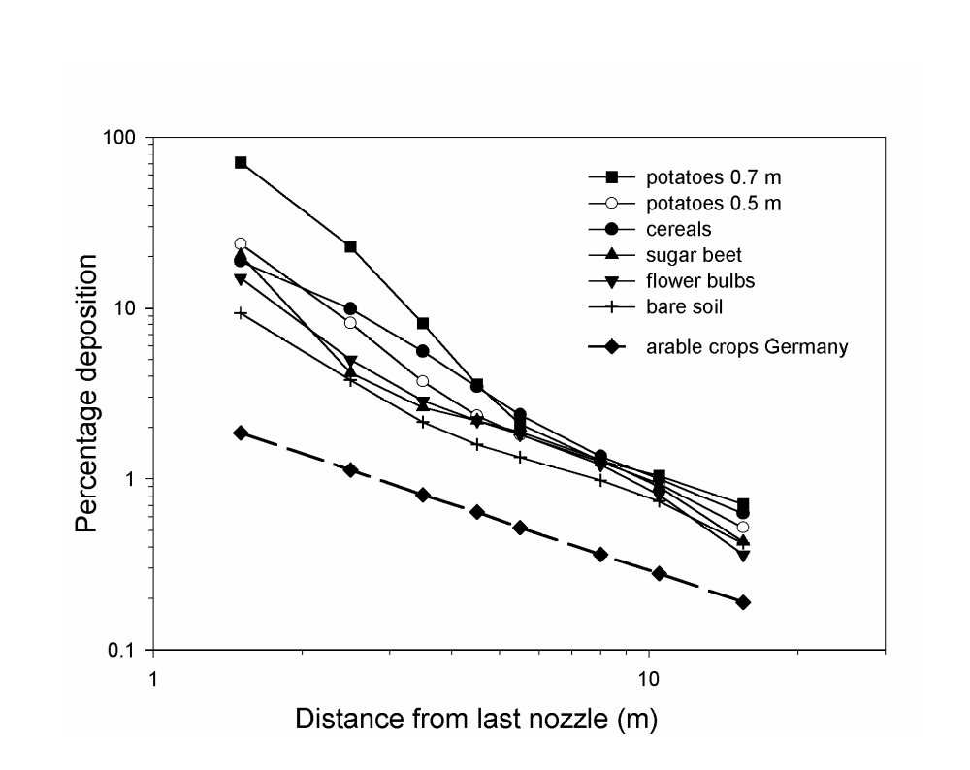
The FOCUS Surface Water Scenarios Working Group selected the German drift data for FOCUS Step 3 assessments, because this database was the most comprehensive, widely available data set at the time the group’s work was in progress. The use of this database also has significant precedent in the EU evaluation process. To come to a harmonised approach in the future, an ISO working group (ISO, 2001) has been established to attempt to standardise methods for measuring drift deposition and drift reduction. As a result, the drift inputs used in FOCUS may need to be modified in the future if new recommendations are developed by this group.
Figure 8.4-1. Spray drift deposition as a function of distance from last nozzle as derived from German and Dutch data. Each line represents 90th percentile values derived from populations of 40 to 110 measurements. The solid lines are based on Dutch measurements for different crops and bare soil from van der Zande, et al. (2001) and the dashed line is the relationship used by FOCUS based on German measurements from Ganzelmeier, et al (1995) and Rautmann (2000). The 0.7 m and 0.5 m indicated for potatoes are different spray boom heights.

8.5 Uncertainties related to drainage inputs calculated using MACRO
Errors in model simulations arise from two sources: model error and parameter error (Loague & Green, 1991). Model errors are caused either by incorrect or oversimplified descriptions of processes in the model, or simply by neglecting significant processes. Both types of errors are assessed below in relation to the Step 3 drainage input calculations using MACRO.

8.5.1 Model errors
Models are by definition simplifications of reality, so that some degree of model error is inevitable. In principle, these errors should be minimised in detailed mechanistic models, which include as many of the relevant processes as possible.
Two processes are not included in MACRO, which may lead to overestimated leaching in some circumstances:
- Volatilisation. Clearly, the model should not be used to estimate leaching of highly volatile substances. However, a simple correction of the applied dose may be sufficiently accurate in some cases.
- Long-term increases in sorption. MACRO assumes instantaneous reversible sorption. This may result in overestimates of drain flow concentrations at long times (and therefore chronic exposure), although maximum concentrations should be very little affected. This is especially true for the five FOCUS drainage scenarios, which are dominated by macropore flow (i.e. excluding D3).
Loss of pesticide in lateral saturated flow in shallow groundwater is included in the MACRO model as a simple sink term based on a residence time concept, but this is not activated for the FOCUS scenarios. Thus, the drainage system is assumed to constitute the main outlet for pesticide loss from the field (although small percolation losses are also simulated in 4 of the 6 scenarios). This assumption may somewhat overestimate the importance of drainage systems for loss to surface waters compared to the field situation. For example, Larsson & Jarvis (1999) made comprehensive mass balance measurements for an autumn application of bentazone at Lanna (scenario D1) during a one-year period, including measurements in the soil to 90 cm depth, groundwater concentrations at 2 m depth, and concentrations in tile drain outflow at a high time resolution. Around 24% of the bentazone was not recovered, and some of this was thought to be lost as lateral shallow groundwater flow. Harris et al. (1994) found four times larger concentrations of IPU in shallow surface layer lateral flow at Brimstone (scenario D2) compared to concentrations in drainage water, although the amount of shallow lateral water flow was considered small compared to drain flow on an annual basis.
Swelling/shrinkage is included in the MACRO model, but it is not activated in the FOCUS scenarios, even though at least one of the soils (Brimstone, D2) is dominated by expansive clay minerals and is known to show swell/shrink behaviour. The extent to which the seasonal development of cracking affects pesticide leaching is not known, but preliminary simulations using MACRO with the swell/shrink option activated suggested that it has little significance for the model predictions. Another process which is not included in MACRO and which may impact significantly on pesticide leaching is the effect of tillage on soil structure and subsequent changes in the soil surface condition due to sealing and crusting.
With respect to model simplifications, the assumption of only two flow domains, and the approximate first-order treatment of mass exchange between them, may introduce some errors (Larsson, 1999). However, although more complex models of preferential flow do exist, these are much more difficult to parameterise (Jarvis, 1998). The numerical resolution at the soil surface is also a potential problem in MACRO. A thin surface layer is required for an accurate prediction of the routing of pesticide into macropores at the soil surface. In theory, the model can be run with as thin layers as the user desires, but in practice this results in extremely long run times (the time step required for numerical stability depends on the square of the layer thickness). A thick surface layer may result in overestimated movement of pesticide into the macropores at long times, although again, peak concentrations occurring in the first rainfall events after application should not be as sensitive to the numerical discretisation.
In summary, a consideration of the process descriptions in MACRO, and the way in which the model has been implemented for the FOCUS scenarios, suggests that it may, in some cases, result in overestimates of total leaching losses to drainage systems, although predictions of the maximum concentration of most interest for ecotoxicological assessments should be more reliable, or at least unbiased.

8.5.2 Parameter errors
MACRO has been applied in a deterministic manner to the FOCUS scenarios. As also noted in section 8.6.3. for runoff modelling with PRZM, a probabilistic or stochastic approach may be conceptually, at least, more reasonable approach to take, given the considerable uncertainty and variability (both spatial and temporal) in many model input parameters. Unfortunately, such an approach is not (yet) practical, nor especially reliable, since the parameter distributions and especially the correlations between parameters, are not well known.
Bearing in mind the need to minimise parameter uncertainty, the locations of the FOCUS drainage scenarios were selected, as far as possible, at previously well investigated sites (see Section 3.1). Thus, wherever possible, the scenarios have been parameterised from a combination of direct measurements and model calibration already performed at the site, complemented by model default settings and the pedotransfer functions in MACRO_DB (Jarvis, et al., 1997) to fill in the remaining data gaps. Four of the six scenarios have, to a greater or lesser extent, been pre-calibrated (D1 Lanna, D2 Brimstone, D3 Vredepeel and D4 Skousbo), while the remaining two scenarios currently represent ’blind simulations’ (D5 La Jailliere and D6 Thiva). However, scenario D5 (La Jailliere) is a well-instrumented research site with historical records of pesticide movement to drains (ISMAP, 1997), so this scenario could also be validated with relatively little effort in the future. With respect to the experiments and model simulations that have previously been carried out at the field sites represented in the FOCUS drainage scenarios, it should be noted that even in the best cases, the scenarios have only been calibrated (with MACRO) for a non-reactive tracer and one pesticide compound per site and for only one crop. The methods used to determine individual soil parameters for each of the scenarios are summarised in Appendix C. In the following sections, some additional comments of a more general nature are made concerning the level of predictive uncertainty that might result from parameter errors.
Parameters controlling macropore flow
Parameter errors are potentially serious for a model such as MACRO which deals with non-equilibrium water flow and pesticide fluxes in soil macropores. This is because, even though the pesticide sorption and degradation parameters are still the most discriminating and sensitive parameters (Brown et al., 1999), the model outcome (leaching to drains) can also be rather sensitive to the parameters defining the macropore region, especially the effective diffusion path length, the fraction of sorption sites in the macropore region and the saturated hydraulic conductivity of the matrix. The first two of these parameters are impossible to measure, and the third is difficult, especially in more inaccessible subsoil horizons. This means that parameterisation has to rely either on model calibration or on the use of pedotransfer functions (estimation algorithms). Both approaches have been adopted in parameterising the FOCUS drainage scenarios. Methods to estimate model parameters from more easily available soils data have been developed for MACRO (e.g. the pedotransfer functions in MACRO_DB, Jarvis, et al., 1997) but these have not yet been widely tested. Beulke, et al. (1999) tested MACRO_DB against experimental data from lysimeters and tile-drained field plots in the U.K. and concluded that leaching was generally underestimated. The main reason is thought to be an overestimate of the parameter describing the fraction of sorption sites in the macropore region, which in MACRO_DB is estimated from the ratio of macroporosity to total soil porosity. This function has, therefore, not been used in FOCUS. Instead, the fraction of sorption sites in the macropore region was set to the default value (= 0.02) in MACRO (after v4.0). Experience from applications of the model to an increasing number of field experiments suggests that this is a reasonable average value (Jarvis, 1998).
Crop parameters and water balance
Water balances have been calibrated and/or tested in four of the FOCUS drainage scenarios (D1 to D4), but only for one or two crops in each case (spring cereals and spring rape at D1, winter cereals at D2 and D3, and spring cereals at D4). Therefore, for all remaining crop/scenario combinations, the water balances calculated by MACRO are purely predictive. However, a qualitative validation of the water balance has been carried out for some of the Mediterranean crops (e.g. olive, citrus) grown at Thiva (scenario D6), since the members of the group had little prior experience of model applications for such climate/crop combinations. Crop parameters (e.g. stomatal resistance, leaf area index) were obtained from a literature search and the predicted water balances were compared with literature information on typical seasonal evapotranspiration losess (e.g. Martin-Aranda, et al., 1975; Castel, et al., 1987; Michelakis, et al., 1994; Villalobos, et al., 1995; Fernandez, et al., 1997).
Even though the overall long-term water balance predicted by MACRO (and other models) is usually reliable, small errors in drain flow estimates during critical periods, especially in spring, can have large impacts on estimated pesticide losses to drainage systems in the first events following application (Besien, et al., 1997). In these situations, discharges may be small, but concentrations can be large.

8.6 Uncertainties related to runoff inputs calculated using PRZM
There are a number of factors, which create uncertainty in the simulation of runoff and erosion in the FOCUS scenarios. Specific sources of uncertainty include:
- Limited calibration/comparison of modelling results to field data. This aspect has been discussed in section 6.4.2.
- Temporal resolution of precipitation, runoff and erosion
- Use of edge-of-field runoff and erosion values
- Use of deterministic modelling
- Conceptual description of runoff scenarios

8.6.1 Uncertainties related to temporal resolution of driving forces
Precipitation events, which create the driving forces for transport of chemicals via runoff and erosion, normally occur with highly variable durations and intensities and in patterns can vary seasonally as well as regionally. Meteorological data used for environmental fate modelling generally consists of daily values for precipitation, temperature and evapotranspiration. The daily resolution of weather data is used primarily because of daily data is easier to obtain than data with finer temporal resolution.
For environmental processes such as leaching, which occur over time scales of weeks to years, daily weather data provides adequate resolution to describe the driving force of infiltration with a reasonable degree of accuracy. For more transient processes such as runoff and erosion, which have time scales of minutes to days, the use of daily weather creates significant uncertainties due to the lack of information on the storm hydrograph of each runoff event, which can dramatically influence the simulated chemical losses.
To compensate for the use of daily weather data, a number of approaches have been developed to help create more accurate simulation results:
- Some storm events can last for more than one day. The weather files for PRZM record these events as series of sequential daily precipitation events. The runoff curve number methodology in PRZM adjusts the curve number daily based on antecedent moisture conditions which adjusts simulated runoff based on current climatic and soil conditions.
- PRZM incorporates a generalised description of seasonal rainfall distribution as well as the concept of hydraulic length (maximum flow path) to alter the time of peak flow during storm events.
- Snowmelt is simulated in PRZM through the use of a simple function, which results in melting of 2 mm/day/ºC. This value, which is slightly lower than the normal default value of 3-5 mm/day /ºC, was selected to prevent high runoff rates during snowmelt which could cause hydrologic computational problems in TOXSWA. The selection of the lower snowmelt rate effectively distributes snowmelt over a longer time period.
- PRZM creates a continuous series of daily runoff and erosion values as one of its output files. In a post processing step, the PRZM in FOCUS shell distributes these daily values over a number of hours using a maximum runoff rate of 2 mm/hr (see section 5.6). This step transforms the simulated aquatic loadings into a simplified storm hydrograph rather than a unit impulse function. This step creates a more reasonable delivery rate for runoff and erosion and results in more realistic aquatic concentrations. More refined approaches for creation of storm hydrographs are available but have not been included in this effort.

8.6.2 Uncertainties related to use of edge-of-field runoff and erosion values
PRZM produces runoff and erosion values that represent volumes and concentrations that are likely to be observed at the immediate edge of treated agricultural fields. The current version of the model does not include the effects of landscape features which normally provide some degree of mitigation of runoff and/or erosion such as non-treated vegetated zones, brush or trees or non-uniform slopes which create localised ponding and increased infiltration.
If data is available to demonstrate reductions in runoff and/or erosion during transport through non-treated zones adjacent to fields, a simple post-processing tool has been provided in the PRZM in FOCUS shell to permit a quick evaluation of the potential effects of this type of mitigation.

8.6.3 Uncertainties related to use of deterministic modelling
Due to the potential complexity of detailed runoff modelling as well as the current amount of computational time required to perform the modelling, the FOCUS Surface Water Work Group developed a modelling approach which uses a single set of selected application dates (selected by the Pesticide Application Tool, PAT) and a single runoff simulation year (selected by the PRZM in FOCUS shell) for each runoff scenario. The sequence of selected application events are established based on the following specific rules intended to minimise application during rain events as well as during extended periods of drought (see section 4.2.6). The selected years generate seasonal and annual runoff amounts that closely approximate those of the 20 year weather sequences provided with the PRZM model for each scenario and crop combinations.
A more detailed evaluation of runoff and erosion could consider a number of factors which are known to vary spatially including chemical properties, soil characteristics, crop attributes and land descriptions as well as temporal factors such as the timing of applications with respect to rainfall events and probabilistic evaluation of runoff/erosion over an extended number of years.

8.7 Uncertainties related to surface water fate calculated using TOXSWA

8.7.1 Processes modelled
With respect to the processes modelled, the main limitations of the TOXSWA model are:
- Sedimentation and re-suspension are not considered; the water body has a constant concentration of suspended solids only. TOXSWA distributes pesticide mass sorbed onto incoming eroded soil over a certain depth of the upper sediment.
- Bioturbation in the sediment is not included, so mixing of the upper sediment layer does not take place.
- Time-dependant sorption to suspended solids or the sediment matrix is not incorporated; at present sorption is instantaneous and described with the aid of a Freundlich isotherm.
- The description of the hydrology is based on a base flow component and a fast-responding drainage or runoff flow component. No intermediate type of flow component, like interflow, is taken into account. This results in rather ‘peaky’ hydrographs for the watercourse.
- The water and pesticide fluxes coming out of the upstream catchment basin and entering the water body system are modelled in a simplified way: all water and pesticide mass leaving the soil column, enter TOXSWA’s water body in the same instant of time, i.e. runoff or drainage fluxes, calculated to represent the behaviour at field scale, are applied at (small) catchment scale. So, no attenuation of fluxes because of a distribution in time and space of driving forces in the catchment area, is taken into account.

8.7.2 Parameter estimation
With respect to parameter estimation, the following limitations exist:
- One of the most important parameters for the exposure concentration, the transformation rate in the water layer (Westein, et al., 1998), has to be derived indirectly from so-called water-sediment studies. Often reports on these studies only present transformation rates for the entire system, water plus sediment, and disappearance rates for the water and for the sediment layer, which includes sorption/desorption from the sediment. In such cases the TOXSWA user should apply a suitable parameter estimation method to determine the individual transformation rates for the water and the sediment layer. This method should differentiate between the various processes, such as transformation in the water phase, sorption and desorption from the sediment and transformation in the sediment. It should also take the system properties, such as size of the water-sediment interface, into account.
- The temperature of the water body is characterised by monthly average values only, so no variation from day to day or variation within the day (e.g. sinusoidal course) can be entered into the model. The temperature is an important factor determining the transformation and volatilisation rate of the pesticide.
- The sorption coefficient describing linear sorption to macrophytes is unknown in general, as it is not required for the registration dossiers. A method to estimate coefficients for sorption onto macrophytes has been presented in Crum, et al. (1999). The FOCUS Surface Water Scenarios assume that macrophytes are not present in the water bodies.

8.7.3 Initial concentrations
The current calculation of exposure concentrations is based on a 12 or 16 months simulation of the compound’s behaviour in the water body, assuming initially the water body is free of pesticides. However, especially in less dynamic water systems the sediment and even the water layer may contain pesticide residues of foregoing application periods. Figure 8.7.3-1 demonstrates this phenomenon for the D4 pond surrounded by winter cereals on which an autumn application of test compound H has been done. The figure shows that the concentration profiles for the water layer are considerably different, when the initial concentration is 0.0 compared to when it is equal to the concentration at the end of the first run. However, the maximum exposure concentration hardly changes. For the sediment it takes longer before equilibrium is reached and the maximum exposure concentration is about 20% higher then in case of an initial concentration of 0.0.
So, for situations in which compounds are expected to accumulate over the course of several years it may be necessary to perform several years of initialisation calculations. Figure 8.7.3-1 shows that for the water concentrations about one year suffices to reach equilibrium, while for the sediment layer about three years of initialisation would be needed. For these initialisation calculations equilibrated runoff or drainage entries would be needed. As it was impossible to change the entire Step 3 calculation procedure at the stage this initialisation phenomenon was brought into the FOCUS Working Group it was agreed that Step 3 calculations would assume that the water and sediment layers are free of pesticides and that in case exposure concentrations in the sediment become critical a Step 4 calculation would be needed, e.g. according to the procedure used to produce Figure 8.7.3-1.
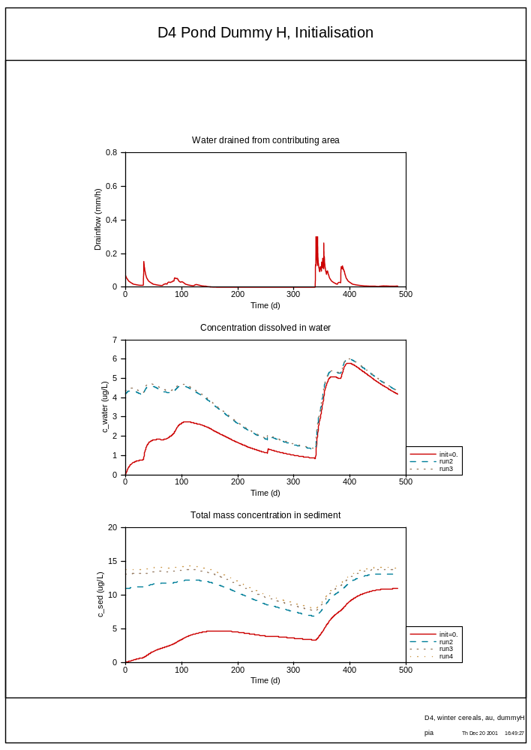
Figure 8.7.3-1 Concentration profiles in water and sediment for consecutive simulation runs, of which the first run has initial concentrations of 0.0 and the next ones start each with the concentrations reached at the end of the foregoing simulations. All runs have been performed for the D4 pond with an autumn application (day 253) of 100 g a.i./ha on winter cereals.

8.7.4 FOCUS scenario assumptions
The process of defining a scenario implies specification of many system parameters in a consistent way that are representative for the scenario to be developed.
Below an overview is presented in which the influence of main scenario assumptions on the calculated maximum exposure concentration in the surface water has been estimated by varying key parameter values into likely other values. So, no rigorous uncertainty analysis, based on the realistic range and distribution of the most important input parameters that determine the model output, has been executed, but a mere illustration of the possible size of variation of exposure concentration. Note that the PEC_{max} may be due to either spray drift deposition or due to input via drainage or run-off. Comparing the application date with the date of occurrence of the PEC_{max} shows which entry route contributes most to the global maximum predicted environmental concentration in the surface water, i.e. the PEC_{max}.

PEC_{max} due to spray drift deposition
Table 8.7.4-1 presents the influence of main FOCUS scenario assumptions on the global maximum exposure concentration, PEC_{max}, in case the PEC_{max} is due to the spray drift entry. Please note that the influence of the assumptions is estimated on the basis of the BBA drift database. This implies that the uncertainty in spray drift deposition estimation related to the use of a different database (See section 8.4) has not been considered in deriving the values presented in Table 8.7.4-1. The table is explained below.
Table 8.7.4-1 Overview of the influence of main scenario assumptions on the global maximum instantaneous exposure concentration, PEC_{max}, as calculated by TOXSWA for the FOCUS Surface Water Scenarios. PEC_{max} is due to spray drift deposition only

Scenario assumption
System parameter |  | FOCUS value (FV) | Changed value (CV) | PEC_{max,CV} /PEC_{max,FV}
Size of water body
Cereals, winter
Width (m) | Ditch | 1 | 2 | 0.80
Width (m) | Stream | 1 | 2 | 0.85
Length * width (m) | Pond | 30 * 30 | 15 * 15 | 2.9
Pome / stone fruit (early applications)
Width (m) | Ditch | 1 | 2 | 0.92
Width (m) | Stream | 1 | 2 | 0.93
Length * width (m) | Pond | 30 * 30 | 15 * 15 | 2.9
All crops
Water depth (m) | Ditch | 0.30 – 0.36 | 0.15 – more | <2
Water depth (m) | Stream | 0.29 – 1.51 | 0.15 – more | <2
Water depth (m) | Pond | 1.00 – 1.01 | 0.50 – 0.51 | ~2
Distance edge of field – edge of water surface
Cereals, winter
Distance (m) | Ditch | 1.0 | 0.5 | 1.6
 | Stream | 1.5 | 0.75 | 1.4
 | Pond | 3.5 | 1.75 | 4
Pome/stone fruit (early applications)
Distance (m) | Ditch | 3.5 | 1.75 | 1.6
 | Stream | 4.0 | 2.0 | 1.6
 | Pond | 6.0 | 3.0 | 1.5
Ratio of treated area and water surface area
All crops, all FOCUS water bodies |  |  |  | 1
Percentage treatment of upstream catchment
Catchment (2 ha) | Ditch | 0 % | 100 % | 3
Catchment (100 ha) | Stream | 20 % | 50 % | 1.25
Catchment (3 ha, base flow only) | Pond | 0 % | - | -
Size of upstream catchment
Catchment (ha) | Ditch | 2 | 4 | 0.5 – 1
Catchment (ha) | Stream | 100 | 200 | 0.5 – 1
Catchment (ha, base flow only) | Pond | 3 | 6 | 1
Timing of application versus rainfall event
 | All | PAT determined | Other rules in PAT | ~1

Size of the water body
The width of the ditch or stream is of importance for the size of the spray drift deposition that decreases exponentially when the distance to the crop increases. For winter cereals in the Step 3 scenarios, the deposition resulting from spray drift amounts to1.93% and 23.60% for a ‘ditch’ type water body and to 1.43% and 21.58% for a ‘stream’ type water body (winter cereals and pome/stone fruit, early applications, respectively). If the width of the water body increases by a factor 2, the resulting deposition decreases to 1.53% and 21.76% for the ditch and 1.19% and 20.06% for the stream (winter cereals and pome/stone fruit, early applications, respectively, see Drift Calculator in SWASH). So, if the global maximum exposure concentration is caused by spray drift the width-averaged deposition will be lower by a factor of 0.79 for the ditch and 0.83 for the stream (winter cereals) and by a factor of 0.92 for the ditch and 0.93 for the stream (pome/stone fruit, early applications).
The dimensions of the pond influence the PEC_{max,} in an analogous way as the width of the ditch or stream do. For the standard FOCUS pond drift deposition is 0.22% for winter cereals and 4.73% for pome/stone fruit, early applications. For a halved pond width, the average spray drift deposition is about 0.63% and 13.5% (winter cereals and pome/stone fruit, respectively). So, when the pond width is halved the spray drift deposition increases with a factor 2.9 for both winter cereals and pome/stone fruit, early applications and so will the PEC_{max}.
If the water depth of the receiving water body is halved the spray drift deposition results in a PEC_{max} that is twice as large as the one for the original water depth.

Distance edge of field – edge of water surface
The distance from the edge of field, or more exactly from the last nozzle of the spray boom, to the edge of the water surface determines the size of the spray drift deposition on top of the water surface area. Table 8.7-2 presents for a set crops with minimum (winter cereals) and maximum (pome/stone fruit) distances the effect on the PEC_{max} by halving these distances. The data have been derived with the aid of the FOCUS Drift Calculator in SWASH.

Ratio of treated area and water surface area
This ratio does not influence PEC_{max} values caused by spray drift deposition, because the spray drift entry is not changed by a changed ratio.

Percentage treatment of upstream catchment
The FOCUS ditch has an ‘upstream catchment’ of 2 ha, which is assumed to be not treated with any pesticide. In case the upstream 2 ha would be treated however, spray drift entries would be multiplied by a factor 3 (analogously to the factor 1.2 for the FOCUS stream) and so, the PEC_{max} would be tripled. The assumption behind is that the spray drift deposited in the ditch in the upstream catchment passes the neighbouring field at the same moment that this 1 ha neighbouring field is treated.
The FOCUS stream has an upstream catchment of 100 ha, of which 20% is treated. This treatment took place some time before the treatment of the neighbouring field. At the time the neighbouring field is treated the 20% deposition from the upstream catchment passes the neighbouring field and so, this is added on top of it. So, the spray drift deposition into the FOCUS stream is multiplied by a factor 1.2. If 50% of the upstream catchment would be treated and all other assumptions would be maintained the total drift deposition would be 150% instead of 120%, and so the PEC_{max} would be a factor 150/120 = 1.25 higher.
The FOCUS pond has no upstream catchment from which variable pesticide or water fluxes enter, so the PEC_{max} is not affected by a changed percentage treatment of the catchment. The base flow is assumed to be free of pesticides.
Size of upstream catchment
The size of the upstream catchment determines the dynamics of flow in the watercourse. The water depth is of importance for the PEC_{max}, caused by spray drift.
If the catchment size of the ditch increases from 2 to 4 ha the PEC_{max} caused by spray drift may be lower, because the water depth may have increased; the PEC_{max} can maximally decrease by a factor of about 2.
For the FOCUS stream with an upstream catchment of 200 ha the water depth will be higher than for a catchment of 100 ha and so, PEC_{max} values caused by spray drift entries may decrease maximally by a factor of 2.
The FOCUS pond has a catchment of 3 ha that delivers a small, constant base flow into the pond. The base flow would become twice as large when the catchment size would be doubled, but this would not affect the water depth in the FOCUS pond, and so the PEC_{max} values due to spray drift deposition onto the pond would remain unchanged.

Timing of application versus rainfall event
The timing of the pesticide application relative to the rainfall events does not influence spray drift deposition directly. The PEC_{max} values may only change for other timings, if the water depth has changed for the alternative timing.

PEC_{max} due to drainage or run-off entries
Table 8.7.4-2 presents the influence of main FOCUS scenario assumptions on the global maximum exposure concentration, PEC_{max}, in case the PEC_{max} is due to drainage or run-off entries. The table is explained below.

Size water body
When increasing the width of a ‘ditch’ or ‘stream’ type water system by a factor 2, the water volume of the receiving water body is twice as large. So, the incoming water and pesticide fluxes are mixed into a two times larger water body and therefore the global maximum exposure concentration resulting from input via drainage or runoff can be maximally 2 times lower.
For a pond system with halved width and length, drainage or runoff fluxes will be mixed in a water volume 4 times lower, and as incoming water volumes are small with respect to the total pond volume the PEC_{max} will be 4 times higher.
In the FOCUS ditch and stream scenarios a minimum water depth of 0.30 m is maintained with the aid of a weir located somewhere downstream in the watercourse. If this minimum water depth would be 0.15 m incoming water and pesticide fluxes would be mixed into a water body with a 2 times smaller volume and so, PEC_{max} values would maximally be a factor 2 higher.
In the FOCUS pond a rather constant water depth of 1 m is maintained by a weir at the outflow. If the maintained water depth would be lowered to 0.50 m the PEC_{max} caused by drainage or runoff entries would be 2 times higher.

Distance edge of field- edge water surface
PEC_{max} values caused by drainage or runoff entries will not be influenced by halving the distance edge of field to edge of water surface area in the FOCUS scenarios.

Ratio of treated area and water surface area
This ratio influences only PEC_{max} values caused by drainage or runoff entries; the spray drift entry is not changed by a changed ratio. Halving the contributing length for the stream and the ditch changes the ratio of the incoming fluxes per unit length of watercourse and the receiving water volume in the watercourse. However, it does not change the pesticide concentration of the incoming fluxes. So, the maximum effect on the PEC_{max}
Table 8.7.4-2 Overview of the influence of main scenario assumptions on the global maximum instantaneous exposure concentration, PEC_{max}, as calculated by TOXSWA for the FOCUS Surface Water Scenarios. PEC_{max} is due to drainage or runoff entries only

Scenario assumption
System parameter |  | FOCUS value (FV) | Changed value (CV) | PEC_{max,CV} /PEC_{max,FV}
Size water body
All crops
Width (m) | Ditch | 1 | 2 | 0.5 – 1
Width (m) | Stream | 1 | 2 | 0.5 – 1
Length * width (m) | Pond | 30 * 30 | 15 * 15 | 4
All crops
Water depth (m) | Ditch | 0.30 – 0.36 | 0.15 – more | <2
Water depth (m) | Stream | 0.29 – 1.51 | 0.15 – more | <2
Water depth (m) | Pond | 1.00 – 1.01 | 0.50 – 0.51 | 2
Distance edge of field – edge of water surface
All crops, all FOCUS water bodies |  |  |  | 1
Ratio of treated area and water surface area
Contributing length : water | Ditch | 100:1 | 50:1 | 0.5 – 1
Contributing length : water | Stream | 100:1 | 50:1 | 0.5 – 1
Contributing area : water | Pond | 5:1 | 10:1 | 2
Percentage treatment of upstream catchment
Catchment (2 ha) | Ditch | 0 % | 100 % | 3
Catchment (100 ha) | Stream | 20 % | 50 % | 2.5
Catchment (3 ha, base flow only) | Pond | 0 % | - | -
Size of upstream catchment
Catchment (ha) | Ditch | 2 | 4 | 0.6
Catchment (ha) | Stream | 100 | 200 | ~1
Catchment (ha, base flow only) | Pond | 3 | 6 | 1
Timing of application versus rainfall event
 | All | PAT determined | Other rules in PAT | Up to 10
is that the PEC_{max} may be halved. Probably it will be less than halved, because water flows out of the watercourse, while the drainage or runoff water fluxes from the neighbouring field as well as the upstream catchment flow into the watercourse.

For the pond doubling the contributing area results in a PEC_{max} that is nearly twice as high as the original value, as the incoming water volumes are negligible small compared to the water volume of the pond itself.

Percentage treatment of upstream catchment
The FOCUS ditch has an ‘upstream catchment’ of 2 ha, which is assumed to be not treated with any pesticide. The water from the catchment mixes with the lateral fluxes from the 1 ha neighbouring field. In case the upstream 2 ha would be treated however, water from the upstream catchment would no longer be free of pesticides and so the concentration dilution of the lateral fluxes by a factor of 3 would no longer occur. So, in case the 2 ha are treated PEC_{max} values would be 3 times higher. The factor 3 represents the ratio of 2 ha upstream+1 ha neighbouring field versus the 1 ha neighbouring field. At the time of pesticide entries, the lateral fluxes largely dominate the (pesticide-free) base flow (see Appendix F) and therefore the factor 3 is a good approximation of the dilution factor in case the upstream catchment has not been treated.
The FOCUS stream has an upstream catchment of 100 ha, of which 20% is assumed to be treated. So, water fluxes of 100 ha and pesticide fluxes from 20 ha enter the FOCUS stream of 100 m via its upstream end and they mix with the lateral fluxes from the 1 ha neighbouring field. As the size of the catchment is 100 times larger than the size of the neighbouring field, the fluxes coming out of the catchment dominate those from the neighbouring field. If 50% of the upstream catchment would be treated pesticide fluxes from 50 ha would enter the FOCUS stream. This implies that in this case the PEC_{max} in the FOCUS stream would maximally be a factor 50% / 20% = 2.5 times higher.
The FOCUS pond is fed by a small constant base flow on top of which water fluxes from the surrounding contributing area are added. So, it has no upstream catchment, from which drainage or runoff fluxes enter.

Size of upstream catchment
The size of the upstream catchment determines the dynamics of flow in the watercourse. The size of the discharge is of importance for the PEC_{max}, caused by drainage or runoff entries, because its determines the dilution rate with the lateral fluxes.
If the catchment size of the ditch increases from 2 to 4 ha (still not treated) the lateral incoming drainage or runoff entries are diluted by a factor of 5 instead of 3 (4 ha upstream+1 ha neighbouring field versus 2 ha upstream+1 ha neighbouring field) and so the PEC_{max} decreases with a factor of 3/5 = 0.6.
For the FOCUS stream the catchment size is so large compared to the neighbouring field that it dominates the water and pesticide input from the neighbouring field. So, if the size of the catchment would be increased to 200 ha, but the treatment ratio of 20% maintained the PEC_{max} values due to drainage or runoff entries would hardly change.
The FOCUS pond has a catchment of 3 ha that delivers a small, constant base flow into the pond. The base flow would become twice as large when the catchment size would be doubled, but still be so small compared to the total water volume in the pond that this would not affect the PEC_{max} values due to drainage or runoff entries.

Timing of application versus rainfall event
The timing of the application relative to rainfall events is very important for the event-driven processes of macropore drainage and surface run-off. This implies that other rules for timing the application with respect to rainfall within the Pesticide Application Timer (PAT, see section 4.2.6) may change considerably incoming drainage or runoff entries. Therefore PEC_{max} values due to drainage or run-off may change significantly, e.g. by an order of magnitude.

8.8 Summary of Uncertainties in Modelling Surface Water
As previously discussed, there are many sources of uncertainty in simulating the environmental concentrations of pesticides in aquatic systems. These effects can generally be regarded as either conceptual uncertainties (e.g. scenario selection; configuration of fields, tile drainage networks, water bodies and watersheds; selection of representative weather years) or uncertainties associated with the use of the various models (e.g. effects of values selected for individual parameters, limitations in the capabilities of various algorithms imbedded in the models and temporal/spatial limitations in the models).

In the preceding sections, a number of specific uncertainties in individual Step3 models have been identified:

Model Major sources of uncertainty
SWASH Selection of soil type, weather data, crop parameters, application dates, drift amounts, types of receiving water bodies
MACRO: volatilisation, sorption changes with time, soil shrink/swell, parameterisation of macropores, crops and hydrology
PRZM: temporal resolution issues, use of edge-of-field values, use of deterministic modelling for a single year
TOXSWA: watershed assumptions, limitations in parameter estimation (e.g. determination of degradation rate in water layer and use of instantaneous sorption), hydrologic description (base flow plus fast responding flows from drainage or runoff)

Surface water concentrations calculated using the Step 3 FOCUS models include the integrated effects of the various individual sources of uncertainty, with some sources biasing the calculations toward higher concentrations (e.g. use of edge-of-field runoff) and some biasing the calculations lower (e.g. use of untreated watersheds for some surface water scenarios).

The environmental concentrations that are calculated using the Step 3 FOCUS surface water models are intended to provide conservative (e.g. relatively high) estimates of the potential concentrations of agricultural chemicals that could occur in small ditches, streams and ponds in vulnerable use settings across Europe. As illustrated in Figure 1.3-1, the intent of the Step 3 FOCUS surface water modelling is to provide exposure estimates that represent the upper half of the distribution of actual aquatic exposures, with exposures varying as a function of location, crop, type of water body and time with individual daily concentrations ranging in probability between ~50% and ~100%. If the Step 1, 2 or 3 FOCUS PEC_{sw} values result in acceptable TER values for surface water, the potential aquatic impacts of the pesticide are likely to be acceptably low in magnitude, duration and/or frequency of occurrence.

Based on limited comparisons of Step 3 simulations with published monitoring data (see Section 6.4), the predicted pesticide concentrations and cumulative losses appear to fit reasonably well with the upper end of the available monitoring data (i.e. very little experimental data exceeds the simulation results). The uncertainty in the FOCUS surface water calculations is likely to be of the same magnitude as the uncertainty associated with experimental monitoring data. Surface water calculations and experimental monitoring results are both subject to numerous sources of uncertainty including temporal and spatial variation. As illustrated in Section 7, the range of concentrations predicted across the defined scenarios (crops, locations and types of water bodies) typically varies by 2 to 4 orders of magnitude and reflects the relative vulnerability of each type of environmental setting.

While it is not possible to provide an exact value for the accuracy of an individual Step 3 calculation (i.e. one chemical in one scenario), it is likely that the predicted concentrations are within an order of magnitude of the actual concentrations likely to occur in that setting. To help place the results of FOCUS surface water modelling and its associated uncertainties into better context, it would be useful to compare aquatic monitoring results for several chemicals in multiple types of water bodies at multiple locations and times of year with the range of predicted concentrations. Unfortunately, aquatic monitoring data is both difficult and expensive to obtain and very few chemicals have adequate monitoring data for the whole of Europe for comparison with the results of FOCUS modelling.

It is likely that relative differences between scenarios are more significant than absolute values determined for a single scenario. As a result, it is appropriate to compare the results for various types of water bodies and/or regions of Europe in order to identify the locations and types of water bodies where aquatic safety is most likely to occur. Locations and/or water body types, which result in clearly unacceptable TER_{sw} values at Step 3 may require further modelling refinement, mitigation or monitoring in order to demonstrate aquatic safety.

8.9 Uncertainties relating to ecotoxicological evaluations
In order to determine the overall 'margin of safety' provided by the aquatic risk assessment evaluation, one has to consider not only the exposure uncertainties but also the effects uncertainties. Furthermore, the degree of uncertainty will depend on which combinations of 'tiers' are being used for the assessment. For example, a higher-tier effects assessment could be used alongside Step 2 calculations, or the basic ecotoxicity data package could be used with Step 3 PECs. Nonetheless it is possible to make some general comments on this.
In the EU aquatic risk assessment scheme there are many inherent conservatisms that mean that the assessment will be protective of potential effects under field conditions. From the effects side, this includes i.a.:
- sensitive species from a range of taxonomic groups are tested – an uncertainty factor of 100 is applied to acute fauna data, and 10 is applied to chronic fauna data and plant studies to account for potential differences in species sensitivity. However, the species tested are generally known to be among the more sensitive (hence their selection as standard species).
- neonate/juvenile organisms are used which are generally the more sensitive life stages.
- effects data are usually generated under maintained exposure concentrations whilst in the field, dissipation will often decrease exposure with time.
- large-scale ecological processes of recovery/recolonisation are generally not included in assessment (except in micro/mesocosm studies where for some taxa a conservative assessment of recovery potential can be made).
From the exposure side, the assumptions (and their uncertainties) that have been included in the generation of the scenarios and their worst-casedness has been reviewed in the report. Overall, the aim of the group was to aim for a realistic worst-case approach at Step 3 (c. 90th percentile). So under most circumstances, the exposure concentrations in the real world will be less (perhaps substantially so) than those modelled. Added to that, there are some further inherent conservatisms in the approach adopted, e.g.:
- it is assumed that a water body always occurs close to the point of application.
- it is assumed that for every application, the wind is blowing at 3-5 m/s in the direction of the water body.
- no riparian or aquatic vegetation is included in the scenarios, and these can provide significant mitigation of exposure in the real world.
Taking these factors into account, it seems likely that the assessments conducted will be protective of the real world, when other mitigating factors are taken into account. However, a more precise estimate of the 'margin of safety' is not possible at this time, given the multivariate nature of the uncertainties associated with the assessment. Given these considerations, passing one of the scenarios will provide confidence that a major agricultural use of the product will not result in unacceptable effects, and thus Annex I approval should be granted. More detailed evaluation of the potential risk by crop and use area can then be performed by the Member States for local uses.

8.10 References
Arvidsson, T., 1997. Spray drift as influenced by meteorological and technical factors. A methodological study. Swedish University of Agricultural Sciences, Acta Universitatis Agriculturae Sueciae, Agraria 71. 1997. 144pp.
Besien, T.J., Jarvis, N.J., Williams, R.J. 1997. Simulation of water movement and isoproturon behaviour in a heavy clay soil using the MACRO model. Hydrology and Earth System Sciences, 1, 835-844.
Beulke, S., Brown, C.D. & Jarvis, N.J. 1999. MACRO: A preferential flow model to simulate pesticide leaching and movement to drains. In: Proc. of the ARW workshop ‘Modeling of environmental chemical exposure and risk’, Sofia, Bulgaria (October 1999), NATO publication series, in press.
Brown, C.D., Beulke, S. & Dubus, I. 1999. Simulating pesticide transport via preferential flow: a current perspective. In: Proc. XI Symposium on Pesticide Chemistry, Human and Environmental exposure to xenobiotics (eds. A.A.M. del Re, Brown, C., Capri, E., Errera, G., Evans, S.P. & Trevisan, M.), September 1999, Cremona, Italy, 73-82.
Castel, J.R., Bautista, I., Ramos, C. & Cruz, G. 1987. Evapotranspiration and irrigation efficiency of mature orange orchards in Valencia (Spain). Irrigation & Drainage Systems Int. J. 1, 205-217.
Crum, S.J.H., A.M.M. van Kammen-Polman & M. Leistra (1999): Sorption of nine pesticides to three aquatic macrophytes. Arch. Environ. Contam. Toxicol. 37: 310-316.
Elliott, J.G. & B.J. Wilson, 1983. The influence of weather on the efficiency and safety of pesticide application. The drift of herbicides. BCPC Occasional Publication No. 3, British Crop Protection Council, Croydon, UK. 135 pp.
Fernandez, J.E., Moreno, F., Giron, I.F. & Blazquez, O.M. 1997. Stomatal control of water use in olive tree leaves. Plant and Soil, 190, 179-192.
FOCUS (2000) “FOCUS groundwater scenarios in the EU plant protection product review process” Report of the FOCUS Groundwater Scenarios Workgroup, EC Document Reference Sanco/321/2000, 197pp.
Ganzelmeier, H.; Rautmann, D.; Spangenberg, R.; Streloke, M.; Herrmann, M.; Wenzelburger H.-J.; Walter, H.-F. (1995): Untersuchungen zur Abtrift von Pflanzenschutzmitteln. Mitteilungen aus der Biologischen Bundesanstalt für Land- und Forstwirtschaft Berlin-Dahlem, 304.
Harris, G.L., Nicholls, P.H., Bailey, S.W., Howse, K.R. & Mason, D.J. 1994. Factors influencing the loss of pesticides in drainage from a cracking clay soil. Journal of Hydrology, 159, 235-253.
ISMAP. 1997. Site de la Jailliere. Final report, project EUREKA EU 479 Phase du Développement. 55 pp.
ISO, 2001. Draft standards on spray drift measuring protocol and spray drift classification. International Standardisation Organisation, TC23/SC6/WG4&WG7.
Jarvis, N.J. 1998. Modelling the impact of preferential flow on non-point source pollution. In Physical non-equilibrium in soils: modeling and application, (ed. H.H. Selim & L. Ma), Ann Arbor Press, 195-221.
Jarvis, N.J., Hollis, J.M., Nicholls, P.H., Mayr, T. & Evans, S.P. 1997. MACRO_DB: a decision-support tool to assess the fate and mobility of pesticides in soils. Environmental Modelling & Software, 12, 251-265.
Kaul, P., E. Moll, S. Gebauer & R. Neukampf, 2001. Modelling of direct drift of plant protection products in field crops. Nachrichtenblatt der Deutschen Pflanzenschutsdienst, 53(2001)2: 25-34 (in German with English summary).
Larsson, M.H. 1999. Quantifying macropore flow effects on nitrate and pesticide leaching in a structured clay soil. Agraria 164, Acta Universitatis Agriculturae Sueciae, 34 pp.
Larsson, M.H. & Jarvis, N.J. 1999. Evaluation of a dual-porosity model to predict field-scale solute transport in a macroporous soil. Journal of Hydrology, 215, 153-171.
Loague, K.M. and Green, R.E. 1991. Statistical and graphical methods for evaluating solute transport models: overview and application. Journal of Contaminant Hydrology, 7, 51-73.
Martin-Aranda, J., Arrue-Ugarte, J.L. & Muriel-Fernandez, J.L. 1975. Evapotranspiration regime and water economy physical data in olive grove soils in southwestern Spain. Agrochimica, 19, 82-87.
Michelakis, N.I.C., Vouyoucalou, E. & Clapaki, G. 1994. Soil moisture depletion, evapotranspiration and crop coefficients for olive trees cv. Kalamon, for different levels of soil water potential and methods of irrigation. Acta Horticulturae, 356, 162-167.
Rautmann, D., 2000. New basic drift values in the authorisation procedure for plant protection products. Paper for the FOCUS-Surface Water Group, 2000. 9p.
Taylor, W.A., P.G. Andersen & S. Cooper, 1989. The use of air assistance in a field crop sprayer to reduce drift and modify drop trajectories. Brighton Crop Protection Conference Weeds 1989 BCPC, Farnham, 631-639.
Van de Zande, J.C., M.M.W.B. Hendriks, J.F.M. Huijsmans, 2001. Spray drift when applying agrochemicals in the Netherlands. IMAG Report, Wageningen, the Netherlands. (in preparation).
Villalobos, F.J., Orgaz, F., Mateos, L. 1995. Non-destructive measurement of leaf area in olive (Olea europaea L.) trees using a gap inversion method. Agricultural and Forest Meteorology, 73, 29-42.
Westein, E., M.J.W. Jansen, P.I. Adriaanse and W.H.J. Beltman, 1998. Sensitivity analysis of the TOXSWA model simulating fate of pesticides in surface waters. SC-DLO Report 154, Wageningen, the Netherlands.

9. CONSIDERATIONS FOR Step 4

9.1 Introduction
Within the remit of the current FOCUS surface water group, the approach that was proposed for Step 4 was to examine more specific and realistic combinations of cropping, soil, weather, fields, topography and aquatic bodies than those used at Step 3, considering the potential range of uses of the plant protection product (see DOC. 6476/VI/96). During discussions, the Surface Waters Group considered that the precise definition of scenarios for Step 4 was beyond its current remit, and that in general, these would have to be generated on a case-by-case basis (depending on the proposed uses, the areas of concern triggered by the risk assessment at Step 3, and the pesticide properties). Whilst the Group did think that it was feasible to generate specific scenarios, it was agreed that it would be useful to provide some general guidance on the sort approaches that might be considered for Step 4. The following chapter contains some suggestions for approaches, which may be appropriate when generating Step 4 exposure estimates. Potential approaches to Step 4 calculations will be developed further by a new FOCUS group on Landscape and Mitigation Measures in Ecological Risk Assessment, which will begin in mid 2002.

9.2 Approaches to Step 4 Calculations
Step 4 exposure calculations are triggered by failing any of Step 3 scenarios. As discussed above, there are a number of inherent ‘conservatisms’ associated with Step 3, and, as with the development of the other steps, a move from Step 3 to Step 4 implies an increase in realism, and a decrease in conservatism and uncertainty. There are a number of potential approaches that would be suitable for Step 4 calculations, and these are discussed in more detail below.
A very specific type of step 4 calculation concerns the situation that more flexible application patterns are needed than the ones standardly proposed in Step 3 calculations. An example is treatment of weeds or grass in vines: the standard step 3 assessment has an automatic coupling between vines and spray drift deposition calculated on the basis of a vine-specific curve. However, for weed treatment between the vine rows this curve does not well represent reality and so, the user would like to edit the standard Step 3 scenario characteristics to represent better the reality. The manual of the SWASH tool gives details of how to compose such type of Step 4 calculations.
At Steps 1 to 3, because of the nature of the scenarios that have been developed, it is not possible to ‘mitigate’ exposure concentrations at any of these steps. If any of the preceding steps is failed, the notifier is triggered to perform a higher-tier exposure calculation, followed by an appropriate risk assessment using the standard aquatic ecotoxicology endpoints (fish and Daphnia acute L(E)C50, algal EC50, Daphnia chronic NOEC and fish chronic NOEC, and if appropriate an EC50 for sediment-dwelling Chironomus riparius). The reason for this is that the first two steps should be regarded very much as screening tools that allow the identification of compounds that pose negligible risks to the aquatic environment. Thus, since the approach is conservative, exposure concentrations can be considered to be very much a worst-case estimate of environmental concentrations. Step 3 is considered to be a reasonable worst-case which is broadly representative of agriculture across the EU, and thus if potential risks are identified at this step, it may be appropriate to consider mitigation measures, as well as further steps to also refining the risk assessment. Thus Step 4 calculations could in principle cover both refined risk exposure calculations and/or exposure calculations based on mitigation measures.
Options for conducting a Step 4 analysis can be categorised into three general areas:
- further refinement of the generic chemical input and fate parameters used at Step 3.
- developing label mitigation measures and applying these to Step 3 scenarios.
- developing a new range of landscape and/or scenario input parameters that are location or region specific.
Each of these options will be discussed in more detail below. It should also be noted however that when developing Step 4 exposure and hence risk assessments, it is also critical to consider refinement of the ecotoxicological endpoints which are generating concerns at Step 3 (see for example Solomon, et al., 2001; Giddings, et al., 2001; Hendley, et al., 2001; Maund, et al., 2001). In some circumstances, further refinements of these endpoints may in themselves dispense with the need for further modelling at Step 4 because of the inherent conservatism of standard laboratory toxicity data. Further details about suitable approaches to the higher-tier aquatic ecotoxicological approaches can be found in the HARAP guidance document (Campbell, et al., 1999). Consequently before embarking on a Step 4 exposure assessment, the notifier should consider all of the options for effects and exposure refinement along with mitigation options in order to select the most appropriate path for further risk refinement at Step 4.

9.3 Refinement of the generic chemical input and fate parameters
The laboratory environmental fate parameters which are used in Steps 1 to 3 are derived from standard regulatory guideline studies. These studies, by design, focus on only one or a few processes individually within the study. For example, photolysis studies are generally carried out in pure water (no potential for photolytic potentiation), hydrolysis studies are conducted under sterile conditions (no degradation), water-sediment studies are conducted in the dark, with no macro-organisms present (no photolysis, limited bioturbation of the sediment). Furthermore, certain processes such as adsorption to or degradation by plants are not even included in standard studies or scenarios, even though these can be important dissipation mechanisms in natural water bodies (Crum, et al., 1999; Hand, et al., 2001)
When Step 3 scenarios are failed, the fate profile of the chemical should be carefully reviewed in order to establish whether further studies could help estimate more realistic dissipation rates under field conditions. In these cases, it is the responsibility of the notifier in discussion with the regulator to establish an appropriate programme of studies in which more realistic estimates of fate input parameters could be established.
Under these circumstances, an appropriate approach to Step 4 calculations would be to re-run those scenarios, which failed the Step 3 analysis, to establish whether with refined fate data, the use still poses unacceptable risks.
Other approaches, which could be explored at Step 4, are to evaluate the range of values of the fate input parameters used in the model (e.g. five soils are commonly tested to establish aerobic degradation rates). Rather than using the mean value, it may be appropriate to conduct a Monte Carlo analysis to establish the likely range of outcomes depending on the value of the input parameter. This would then give an indication of the likely range of outcomes depending on the input value selected.

9.4 Developing label mitigation measures and applying these to Step 3 scenarios.
Steps 1 to 3 assume minimum mitigation of use patterns, in that the minimum distance between crops and water bodies are assumed, applications rates and frequencies are assumed to be the maximum specified on the label, basic application equipment is used, and that no other agronomic practices have been included to reduce exposure. One option for Step 4 calculation is to include some form of label mitigation (directions on a pesticide label that will restrict uses to a certain set of agronomic circumstances) so that exposures are reduced. Under these circumstances, it would be appropriate to re-run the Step 3 calculations for the scenarios, which failed but include the influence of the mitigation measures proposed in a modified scenario.
The degree to which use patterns can be mitigated is usually somewhat limited because of potential compromises to pest, weed or disease control efficacy. The most common way that mitigation has been applied in the past is to include some sort of no-spray buffer zone, depending on the toxicity of the compound concerned (e.g. the UK PSD LERAP scheme). Similarly elsewhere in the EU, the implied reductions in drift with increasing distance from the crop in the BBA spray drift data (BBA, 2000) have been used as a simple estimate of the distance that is required between crop and water body to reduce spray drift to such a level that exposure concentrations no longer cause concerns. Whilst this may be a simple way of restricting uses, it is often not agronomically practical. Also, the assumption that spray drift as measured in the BBA data (with essentially 2-D off crop areas with no tall vegetation) would be the same as in an unsprayed area of agriculture is somewhat precarious. For example, comparing the median drift values measured by Ganzelmeier, et al. (1995) at a specified distance from an arable crop (without any intervening crop) with the drift values measured by de Snoo (2001) with a buffer containing potatoes reveals that there can be at least an order of magnitude reduction in drift when intervening crop (and by implication other vegetation of similar height and canopy density) are present. However, very little data are currently available which allow the influence of crop or non-crop vegetation on spray drift to be estimated. It is recommended that research into approaches for the management of crop margins leading to quantifiable reductions in drift would be extremely beneficial for the development of appropriate drift mitigation measures for the future. Other recent developments, which offer promise for reducing drift inputs, include the use of low-drift nozzles or spray equipment.
For runoff and drainage inputs, since these have historically not been included in risk assessment in the EU, mitigation options are relatively unexplored. However, there may be physical means of decreasing exposure through drains (e.g. with drain ‘risers’ which intercept sediment, or with filtration materials) or from runoff (by managing tillage, including vegetative filter strips).
In general, the options for risk mitigation are poorly developed in the EU, and although some preliminary discussions have taken place about potential approaches (Forster & Streloke, 2001), it is clear that further work in this area will be required in the future.

9.5 Developing a new range of location- or region-specific landscape
and/or scenario parameters.
Step 3 risk assessments will identify particular scenarios, which may raise concerns for certain uses. The Step 3 scenarios were developed in such a way as to be reasonably worst-case and broadly representative of EU agriculture. Therefore, from one perspective, in addition to identifying safe uses, Step 3 scenarios could be viewed as a mechanism for identifying under what sorts of agricultural conditions a particular pesticide may present unacceptable risks to aquatic ecosystems. If particular scenarios are identified as being of concern, then it should be possible to more precisely define the extent of such risks. This could be done either by looking at a broader range of scenario parameters that may be associated with the use, or by evaluating risks at a broader scale than at Step 3 (i.e., moving away from the edge-of-field to the landscape level and developing risk assessments that are location or region specific).
Essentially this approach requires a much wider examination of the range of crop, climate, soil, slope, water body, etc., characteristics for agricultural areas represented by Step 3 scenarios (where potential issues are identified). Since the extent of representation of the scenarios has been defined (see Section 3.4), this information could be used as a starting point for determining the location and extent of any further work at Step 4. For example, if a Step 3 analysis identifies that drainage scenario 2 may pose potential risks to aquatic organisms, then it may be appropriate to:
- establish the extent of coverage of scenario D2 in regions across the EU
- select suitable regions for further analysis
- develop databases of appropriate input parameters for a regional risk assessment.
To provide an indication of the potential flexibility of approaches, the following list identifies a number of assumptions in the Step 3 scenarios, which may be appropriate for refinement at Step 4:
Drift inputs:
- Application rate (many labels contain a range of use rates which may vary in time)
- Numbers/timings of applications (may vary depending on pest pressure, use of other compounds)
- Application equipment (can influence drift rate, for example shielded sprayers, air-assist sprayers)
- Nozzle selection (droplet size can influence drift and low drift nozzles are also available)
- Distribution of wind speeds at time of application (data used in the spray drift calculator assume a wind speed of 4-5 m/s for every application)
- Relative wind direction at application (data used in the spray drift calculator assume that spray drift strikes the water body perpendicular to the field)
- Distance of the crop from the water body (assumptions at Step 3 are that crop is always relatively close to the water see Table 4.2.3-1)
- Presence and nature of intervening vegetation (Step 3 scenarios assume that there is no intervening vegetation or crop that will intercept spray drift)
Runoff/Drainage Entry:
- Likelihood of runoff entry co-occurring with drift (Step 3 scenarios assume relatively close co-occurrence of drift and runoff inputs)
- Filtering capacity of any vegetative filter strips (the presence of a margin around the water body my reduce inputs from runoff
- Likelihood of rill/sheet erosion (these are often managed by local good agronomic practices)
- Variations in slope/topography at water body margins (assumptions at Step 3 are for a fixed slope across the watershed. In practice there will be local variations in slope)
- Climatic data (clearly there will be large variations in meteorological conditions)
- Variation in soil properties or texture resulting in differences in adsorption/desorption, degradation rate, etc.
- Tillage practices, presence of crop trash (these can both influence drainage or runoff input)
Characteristics of the receiving waters:
- Depth/width/cross sectional area, flow and replacement time, water mixing during/after entry (these clearly influence the degree of dilution)
- Presence, quantity and surface area/architecture of riparian and aquatic plants (for certain compounds these may have an important influence on dissipation)
- Trophic status and water quality e.g., suspended solids, DOM, ions (may influence fate of compounds)
- Nature of sediment (can be very variable and may have an influence on bioavailability of sediment-sorbed compounds)
- Proportion of water body potentially exposed (i.e. areas of no/low exposure may occur)
In addition to these exposure considerations, as mentioned above a Step 4 risk assessment will, by its nature, also have to take into account ecological and ecotoxicological issues. In relation to determining whether a particular use will or will not cause unacceptable risks, it is also important to consider the biological nature of the ecosystems potentially exposed. For example, consistent with the Step 4 philosophy of regional or local risk assessment, biological considerations could include:
- Presence of sensitive organisms (are there organisms present in these system which are sensitive to the pesticide of concern (e.g. temporary water bodies are unlikely to contain significant fish populations, acidic waters are unlikely to contain Crustacea, oligotrophic systems may not include certain phytoplankton species)
- Presence of refugia or nearby unaffected sources of re-colonisation, intrinsic rate of increase of organism, dispersal ability, abundance of organism and seasonal variations thereof (in order to establish whether the effects observed are likely to be long- or short-lived)
- Temporal co-occurrence of exposures with sensitive life stages (sometimes applications can occur at times when there are no sensitive life-stages present e.g. when larval insects have emerged as adults and are essentially terrestrial)
- Return times of chemical disturbances in relation to recovery potential of organisms
- Presence of alternative and /or additive stressors
The use of such approaches at Step 4 requires the development of landscape-level data on a number of parameters, combined with other higher tier data. Generally speaking, unlike the USA where many such databases are freely available, in Europe such data tends to be hard to locate, in many disparate institutions, and fraught with intellectual property issues so that it can be difficult or extremely costly to conduct such analyses at present.

9.6 References
BBA (2000), Bekanntmachung über die Abtrifteckwerte, die bei der Prüfung und Zulassung von Pflanzenschutzmitteln herangezogen werden. (8. Mai 2000) in : Bundesanzeiger No.100, amtlicher Teil, vom 25. Mai 2000, S. 9879.
Campbell, P.J.; Arnold, D.J.S.; Brock, T.C.M.; Grandy, N.J.: Heger, W.; Heimbach, F.;Maund, S.J. & Streloke, M. (1999). Guidance Document on Higher-tier Aquatic Risk Assessment for Pesticides (HARAP). SETAC-Europe Publication, Brussels.
Crum SJH, van Kammen-Polman AMM, Leistra M. (1999). Sorption of nine pesticides to three aquatic macrophytes. Archives of Environmental Contamination and Toxicology, 37, 310-316.
De Snoo GR. (2001). Drift reduction by vegetation and application technique. In: Workshop on Risk Assessment and Risk Mitigation Measures in the Context of the Authorization of Plant Protection Products (WORMM) 27-29 September 1999. Eds R Forster & M Streloke, Mitt. Aus der BBA, Heft 383, Berlin, pp 94-98.
Forster R. & Streloke, M. Eds. (2001). Workshop on Risk Assessment and Risk Mitigation Measures in the Context of the Authorization of Plant Protection Products (WORMM) 27-29 September 1999. Mitt. Aus der BBA, Heft 383, Berlin.
Ganzelmeier, H.; Rautmann, D.; Spangenberg, R.; Streloke, M.; Herrmann, M.; Wenzelburger H.-J.; Walter, H.-F. (1995): Untersuchungen zur Abtrift von Pflanzenschutzmitteln. Mitteilungen aus der Biologischen Bundesanstalt für Land- und Forstwirtschaft Berlin-Dahlem, 304.
Giddings JM, Solomon KR & Maund SJ. (2001). Probabilistic risk assessment of cotton pyrethroids in aquatic ecosystems: 2. Aquatic mesocosm and field studies: observed effects and their ecological significance. Environmental Toxicology and Chemistry, 20, 660-668.
Hand LH, Kuet SF, Lane MCG, Maund SJ & Hill IR. (2001). Influences of aquatic plants on the fate of the pyrethroid insecticide lambda-cyhalothrin in aquatic environments. Environmental Toxicology and Chemistry, 20, 1740-1745.
Hendley P, Holmes C, Kay S, Maund SJ, Travis KZ & Zhang M. (2001). Probabilistic risk assessment of cotton pyrethroids in aquatic ecosystems: 3. A spatial analysis of the Mississippi cotton landscape. Environmental Toxicology and Chemistry, 669-678.
Maund SJ, Travis KZ, Hendley P, Giddings JM & Solomon KR. (2001). Probabilistic risk assessment of cotton pyrethroids in aquatic ecosystems: 5. Combing exposure and effects distributions to estimate risks. Environmental Toxicology and Chemistry, 20, 687-692.
Solomon KR, Giddings JM & Maund SJ. (2001). Probabilistic risk assessment of cotton pyrethroids in aquatic ecosystems: 1. Distributional analyses of laboratory aquatic toxicity data. Environmental Toxicology and Chemistry, 20, 652-659.

10. Conclusions and recommendations

10.1 Conclusions
The work of the FOCUS Working Group on Surface Water Scenarios presented here in this report reveals the following conclusions:
- A tiered approach has been developed for the establishment of surface water concentration calculations based on loadings from spray drift together with drainage or runoff. At Step 1, a very simplistic method uses an unrealistic worst case situation based on a single lumped loading. At Step 2 a more realistic loading is applied according to the label recommendations, but no climate, cropping, topography or soil characteristics are taken into account. At Step 3 realistic worst-case situations are considered with a regional differentiation across the European Union using ten (10) different scenarios.
- The Step 1, 2 and 3 scenarios have been carefully calibrated to ensure consistency of the PEC_{sw} calculated at each step. Thus, compound-specific exposure calculations using the Step 1 scenario will always give higher PEC_{sw} than those calculated using the any of the ten Step 3 scenarios. The relationship between exposure calculations using Step 2 and Step 3 scenarios is more complex and for a few compounds, one or two of the more extreme worst-case Step 3 scenarios may give a PEC_{sw} that is slightly larger than that calculated using the Step 2 scenario. For the majority of the Step 3 scenarios however, compound-specific PEC_{sw} will be less than that calculated using the Step 2 scenario.
- The Step 3 scenarios have been developed to be used on the European Union level intended for the calculation of Predicted Environmental Concentrations (PECs). These PECs will be use in the framework of EU Directive 91/414/EEC to decide whether an active substance may be put on Annex I of this Directive.
- There are six (6) scenarios developed for the situation that fields are drained, which means a relatively flat area with often an excess of water that has to be removed from the field and four (4) runoff scenarios, taking into account some sloping of the fields. With respect to the crops grown, agricultural practice may include irrigation in both cases.
- The scenarios developed cover a wide range of areas in all countries of the European Union. However, in some countries the coverage is more extensive than in others. It was not possible to reach a higher coverage of the EU given the limited amount of scenarios to be developed.
- The scenarios are identified by overlaying several distributions of relevant data such as annual and spring temperature, annual average rainfall including average annual recharge, soil characteristics and slopes. In the representative area a field site was chosen because of extensively available monitoring data to aid in the model parameterisation and future model validation possibilities. A nearby weather station was chosen to identify the meteorological conditions of the example locations.
- At all the sites representing specific scenarios, existing water bodies were identified in order to be as close to reality as possible. In addition crops grown in the chosen areas were identified and crop management was introduced on expert judgement basis considering differences in irrigation, sowing and harvest and successive cropping.
- Several tools have been developed to actually carry out the calculations of the PECs at the different tiers. For Step 1 and 2 a stand-alone Visual Basic tool, called ‘STEPS1&2 in FOCUS’ calculates the preliminary estimations before deciding the more sophisticated modelling tool using the 10 scenarios is needed. This tool generally combines the current methods of estimating PECs in surface waters in the European Union for the preparation of monographs for Annex I listing.
- The mathematical models used in Step 3 are the following:
- the drift calculator, to estimate the drift input into surface water depending on the application method and the crop involved,
- the pesticide application timer (PAT, which is already incorporated into the MACRO & PRZM shells), to determine the right application date taking into account the actual rainfall pattern of the scenario under consideration,
- the MACRO model, to determine the contribution of drainage to the loading of the surface water
- the Pesticide Root Zone Model (PRZM), to estimate the contribution of runoff to the surface water, and
- the model TOXSWA, to estimate the final fate of the substance in the surface water.
- The Graphical User Interface SWASH (Surface WAter Scenarios Help) was developed to provide an overview of Step 3 scenarios and Step 3 FOCUS runs that are required for use of a specific pesticide on a specific crop. It contains a central pesticide database to enhance consistency between simulation runs executed with the various models. Moreover it performs the spray drift calculations and prepares part of the input for the MACRO, PRZM and TOXSWA models evaluated.
- The scenarios and tools developed by the FOCUS Working Group on Surface Water Scenarios are considered useful for the estimations of PECs in the process of deciding to place an active substance of a plant protection product on Annex I of Directive 91/414/EEC. Industry and governmental agencies may use the tools and models in the risk assessment process.
- It should be stressed, however, that the scenarios developed and presented here are not intended as national scenarios. Nevertheless, they do represent a realistic range of worst-case environmental situations representative of European agriculture. For the crops considered in this report, it is anticipated that the FOCUS scenarios will enable a reasonable assessment of the risk to aquatic organisms when the exposure results are compared to appropriate ecotoxicological endpoints. However, it is recognised that not all crops have been included in the FOCUS effort and some unique local environmental settings may require additional exposure evaluation at the member state level.
- Given the limited time and resources available the Working Group was not able to solve and anticipate all possible situations in the risk assessment process to determine PECs. However, it is the opinion of the group that in most cases a sufficient reliable estimation of the PECs is reached to back a decision for a substance under consideration.
- Most models used are not (yet) validated in a sufficient manner. This lack of validation was already mentioned in the earlier report of the FOCUS Working Group on Surface Water Modelling (DOC. 6476/VI/96) and did not change during the development of the scenarios. However, the choice of the scenarios does make validation of models and scenarios possible providing sufficient input is available from the financial and manpower point of view.
- The scenarios and models are based on current scientific knowledge. It is recognised that science is developing very rapidly and therefore constant adjustment and updating of models and scenarios is needed.

10.2 Recommendations
Based on the work carried out by the FOCUS Working Group on Surface Water Scenarios the following recommendations may be considered for future work:
- As the current proposals are based on the combination of different tools and models facilitated by use of the SWASH interface, it may still be appropriate to develop an integrated tool for the estimation of the PECs in surface water. The Group estimates that this would be a large and complex task and recommends that a scoping study be undertaken to assess the feasibility of developing such an integrated modelling tool.
- The models and scenarios used and developed here may require additional validation, as the validation status is still quite low. Further validation may result in an increasing confidence in using models for decision making by the national authorities and industry. A proper validation is, however, a time and money consuming effort.
- The uncertainty chapter of this report is indicating many areas where data and science are still inherently uncertain. Every data in the report may be subject to some uncertainty. The area of drift deposition has been identified with a lot of uncertainty. Additional research carried out to decrease the uncertainty is still needed. Industry and governmental agencies need data as reliable as possible, although 100% certainty is an illusion to reach.
- As new developments in data availability and model improvements become evident in corporation into the models and scenarios should be carried through according to the process developed already by the FOCUS Working Group on Version Control. The procedures for keeping track of the groundwater models and scenarios seem to work very well.
- Efforts have to taken in the near future to explain and communicate the FOCUS surface water scenarios to governmental agencies and industry in order to achieve a smooth introduction of the approach proposed and taken. This may involve workshops and training sessions, centralised in Brussels or decentralised if required.
- Although, the analysis of the scenarios currently proposed already indicate some applicability for candidate Member States a more close investigation of the scenarios to this purpose may be needed.
- The quality of the data used in the models to calculate the PECs need to be high in order to achieve results as reliable as possible. Therefore, especially the substance specific input data, like solubility, vapour pressure, sorption and degradation need to be given special attention from the quality of data point of view.
- The development of national scenarios – if justified by agroclimatic and pedological differences between FOCUS Surface Water Scenarios and national conditions – should follow the same principles for scenario development as used by FOCUS.
- The difference between the current standings of the estimation of the PEC and the proposals of the FOCUS SWS Working Group are quite substantial. In addition, in some cases the calculations of Step 3 may give higher results compared to Step 2. Therefore, it is suggested that, in order to build up confidence in the results of Step 3 to perform additional calculations with test runs by registration authorities and during training sessions.

For community level (mesocosm) studies other TER values may be appropriate – see available guidance on aquatic ecotoxicology.
When the term ‘substance’ is used in this report it means either the active substance of a plant protection product for which an assessment has to be carried out, or a relevant metabolite of that active substance.
Current versions of the guidance documents can be found on the web server of the European Commission under: http://europa.eu.int/comm/food/fs/ph_ps/pro/wrkdoc/index_en.htm
Note that the model PESTLA is no longer supported.
Descriptions of soil hydrologic groups are according to the PRZM manual (Carsel et al, 1995)
This is not to say that temporary waters are not an important aquatic habitat. Indeed such water bodies may be very important from a biodiversity perspective. However, it recognises that the current EU scheme does not specifically consider temporary waters and appropriate risk assessment procedures (e.g. selection of appropriate taxa, exposure scenarios, effect and recovery considerations) have not yet been developed. Their inclusion at this stage would therefore be premature.

