CAL POLY MASTER PLAN ~ Volume II RESPONSE TO COMMENTS

This section of the Final EIR (FEIR) presents the responses to public comments made on the Cal Poly Master Plan and Draft EIR (DEIR). Each letter commenting on the Plan and DEIR has been assigned a number, from 1 to 59. Within each letter, comments have been numbered in ascending order. A unique number that consists of the number assigned to the comment letter, followed by the comment number, identifies comments and responses. For example, the comment and responses identified as 1-1 represents the first comment in the first letter. Subsequent comment from that letter would be identified as 1-2, 1-3, etc. The second comment letter would commence with 2-1, 2-2, etc. The person making the comment is the “commenter,” and is identified before the response. Some comments do not pertain to physical environmental issues, but responses are included to provide additional information for use by decision-makers. Many of the comments spoke directly to issues with the Master Plan. Responses to these are included here. Also included in the FEIR are staff-initiated text changes and errata.

List of Persons Commenting on the Cal Poly Master Plan and DEIR

1 | Terry Roberts | State Clearing House | 5-Dec
2 | Allen Settle | SLO City Mayor | 13-Dec
3 | John Mandeville/Arnold Jonas | SLO City Council | 7-Dec
4 | John Moss | Utilities Director | 5-Dec
5 | Michael McCluskey | SLO City-Director of Public Works | 12-Dec
6 | Barry Lajoie | Air Pollution Control District | 7-Dec
7 | Roger W. Briggs | CA Reg. Water Quality Cont. Bd. | 16-Nov
8 | Larry Newland | CA Dept. of Transportation | 8-Dec
9 | Ron DeCarli | SLOCOG | 7-Dec
10 | Harvey Greenwald | Academic Senate | 29-Nov
11 | Jasmine Watts | Student | 4-Dec
12 | Ali Schlageter | Student | 4-Dec
13 | Andre von Muhlen | Student | 1-Dec
14 | Bob Ladd |  | 4-Dec
15 | Anonymous | Student | 4-Dec
16 | Brianna Holan | Student | 4-Dec
17 | Brooke Saavedra | Student | 4-Dec
18 | Chad Gifford | Student | 4-Dec
19 | Chad Gifford | Student | 5-Dec
20 | Anonymous |  | 4-Dec
21 | Dale Sutliff | LAC/College of Architecture | 18-Nov
22 | Doug Piirto | Professor-NRM (CAGRLUC) | 5-Dec
23 | Dr. Richard Kranzdorf | Professor-Pol Sci. Dept. | 5-Dec
24 | Eugene Jud | Professor- CE | 8-Dec
25 | Glen Lawson | Student (Senior Project) | 6-Dec
26 | James Vilkitis | Professor-NRM | 6-Dec
27 | Anonymous |  | 4-Dec
28 | Jenny Wong | Student | 4-Dec
29 | Ken Scotto | CAGR Land Use Committee | 8-Dec
30 | Ken Solomon | Bio-Resource/Ag. Engineering | 15-Nov
31 | Mark Shelton | College of Agriculture | 26-Oct
32 | Norm Pillsbury | NRM Dept. Head | 5-Dec
33 | Obadiah Bartholomy | Student - ME (via Paul Zingg) | 4-Dec
34 | Phil Ashley | Bio. Science Dept. | 8-Dec
35 | Rick Johnson | ASI | 6-Dec
36 | Rob Rutherford | Animal Sciences | 29-Nov
37 | Roger Gambs | Biological Science | 20-Sep
38 | Sarah Brown | Student | 4-Dec
39 | Scott Cooke | Resident (& Staff at Cal Poly) | 30-Nov
40 | Scott Steinmaus | Crop Sciences | 21-Nov
41 | Simon Robertshaw | Student | 22-Nov
42 | Stephen Kaminaka | Professor-Bio Res/Ag. Eng. | 6-Dec
43 | Steven Marx | English Dept., Resident | 26-Nov
44 | Tyson Carroll | Student (Landscape Arch.) | 5-Dec
45 | V.L. Holland | Chair-Biological Sciences | 6-Dec
46 | Yasman Okano | Student | 4-Dec
47 | Anonymous |  | 4-Dec
48 | Carlyn Christianson | Action for Healthy Communities | 16-Nov
49 | Donna Duerk | Foundation Board Member | 8-Dec
50 | Frank Mumford | Foundation Director | 14-Dec
51 | John Beccia | Life on Planet Earth | 6-Dec
52 | Neighbors | Bishops Peak Neighbor Assoc. | 8-Dec
53 | Pamela M. Heatherington | ECOSLO | 7-Dec
54 | Patricia Wilmore | Chamber of Commerce | 7-Dec
55 | Terry Elfrink | Resident | 8-Dec
56 | Ben Fine
57 | Shredder | New Times
58 |  | RQN
59 | Margot MacDonald
60 | Paul Zingg, Chair | University Planning And Budget Advisory Committee | 25-Oct
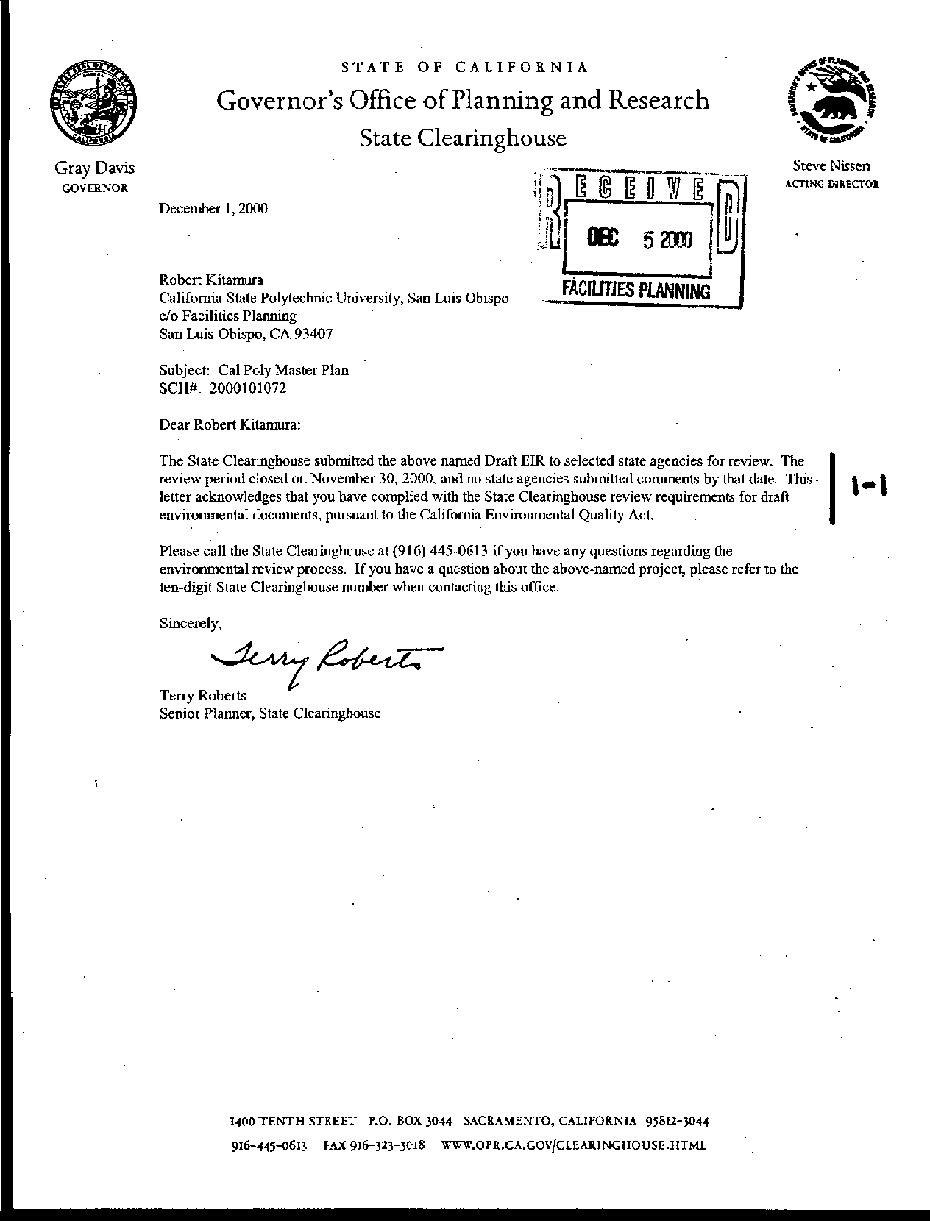
Letter 1
Letter 1
Mr. Terry Roberts
State Clearinghouse

December 5, 2000

1-1 No comments were received from the agencies receiving the EIR via the State Clearinghouse.

Response Other, local agencies have responded to the EIR and their comments follow. No response required

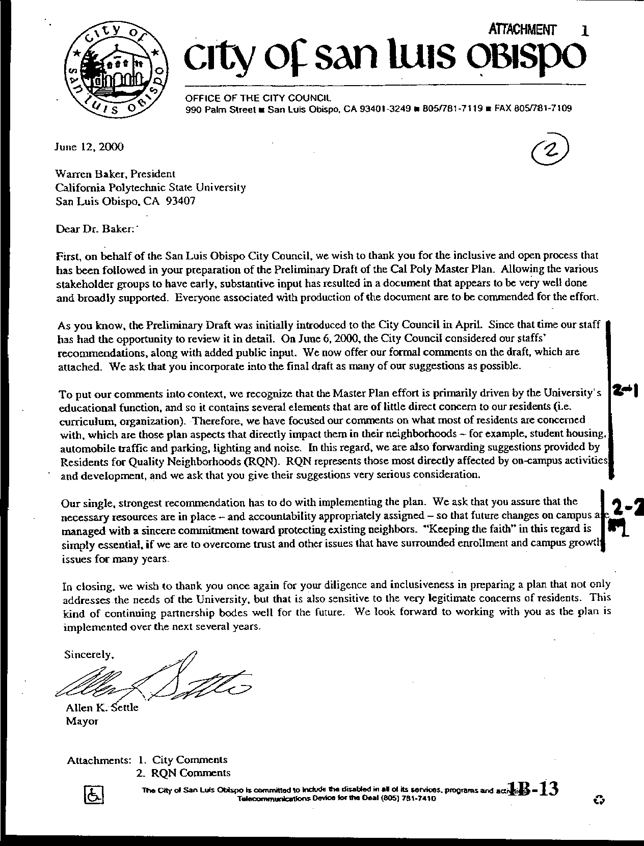
Letter 2
Letter 2
Mayor Allen Settle
City of San Luis Obispo

December 6, 2000

2-1 The Mayor suggests that while most of the City’s comments from the last draft were incorporated, a few remain. Further, many comments from RQN were not addressed in the draft.

Response See responses to letter number 58, Residents for Quality Neighborhoods. The remaining City responses are set forth in responses to letter number 3, below.

2-2 The mayor recommends that realistic and sincere implementation of the plan is important.

Response The comment is noted. Please refer to the revised text in Chapter 7 on implementation of the Master Plan. Following adoption of the Master Plan, Cal Poly will engage in a series of implementation studies (specified in Chapter 7). As projects are planned and built, they will be reviewed and monitored for compliance with the environmental analysis as well as with meeting plan expectations to reinforce the academic quality of the University. The Campus Planning Committee will review the Master Plan annually so as to determine whether conditions have changed sufficiently to warrant a major update.

One of the responsibilities of the Campus Planning Committee (CPC) is to monitor the implementation of the Master Plan. The CPC sees project proposals as part of the five-year capital improvement program, submitted annually to the California State University (CSU). When a specific building or landscape project is being designed, the CPC assesses its consistency with the Master Plan and sees the environmental assessment. If the proposal differs from the Master Plan, the campus, with CPC approval, may forward a request for amendment to the CSU Board of Trustees. As the CSU is most concerned with enrollment capacity and physical construction, the system requires campus review of enrollment levels and facilities annually.

The Campus Planning Committee will add responsibility for an annual review of the assumptions underlying the master plan and its policies, so as to identify when a major update may be required. This annual review will include an update on compliance with the Master Plan mitigation monitoring program. The Academic Senate has urged that the University assess the impacts of enrollment growth on academic quality for each phase of Master Plan implementation. This analysis should occur as part of Cal Poly’s assessment and accountability efforts, including academic program review.

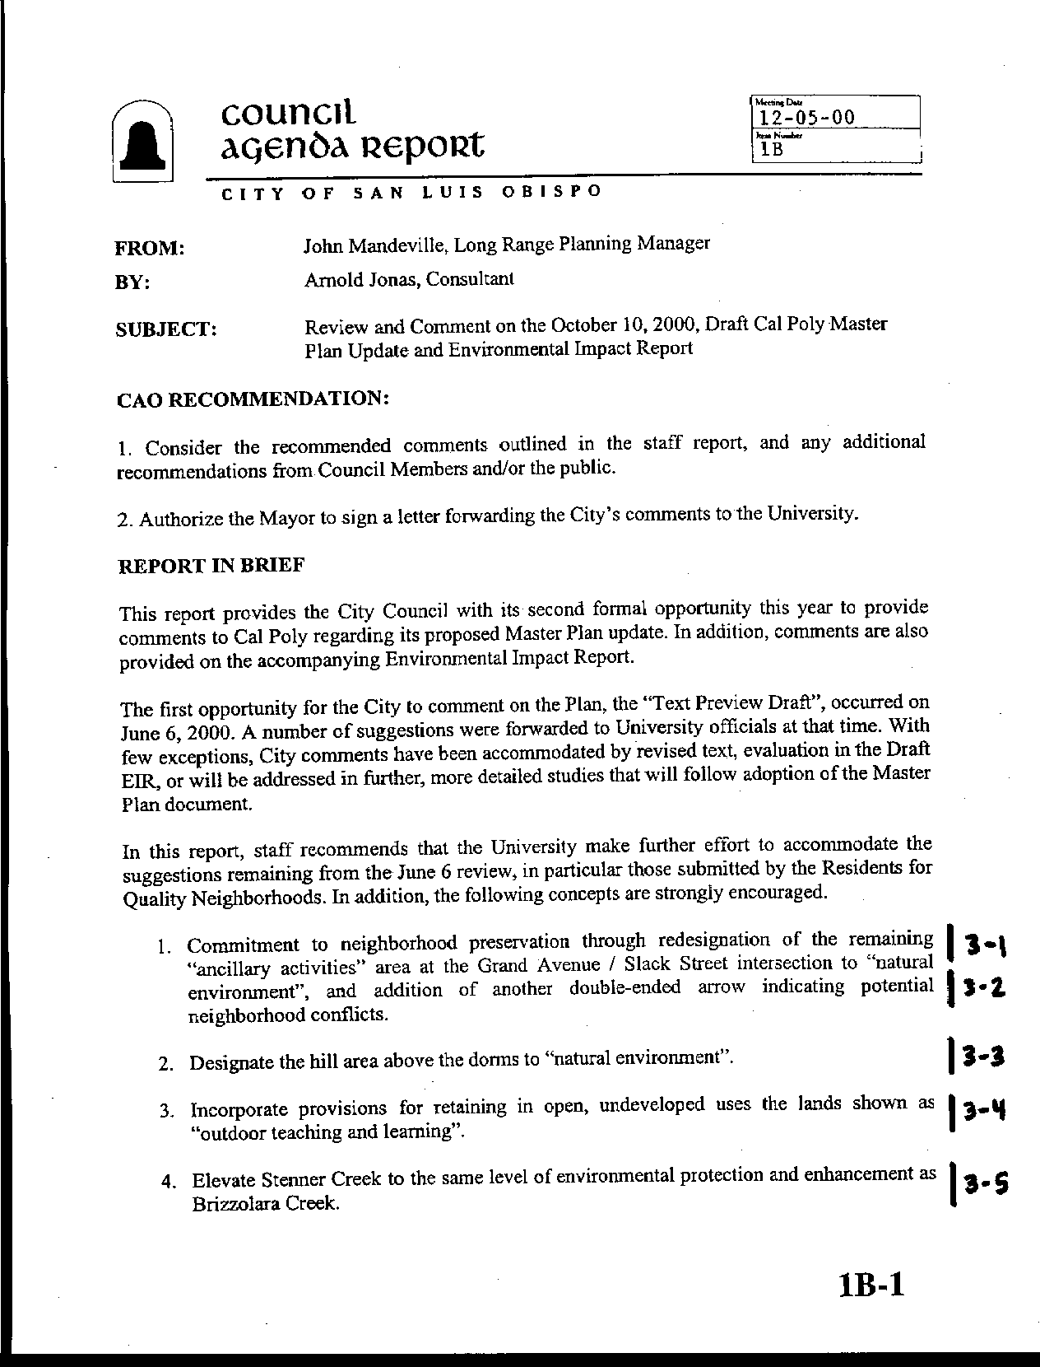
Letter 3
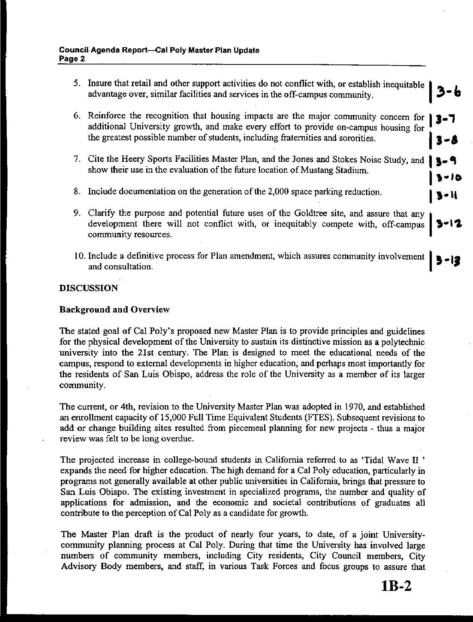
Letter 3
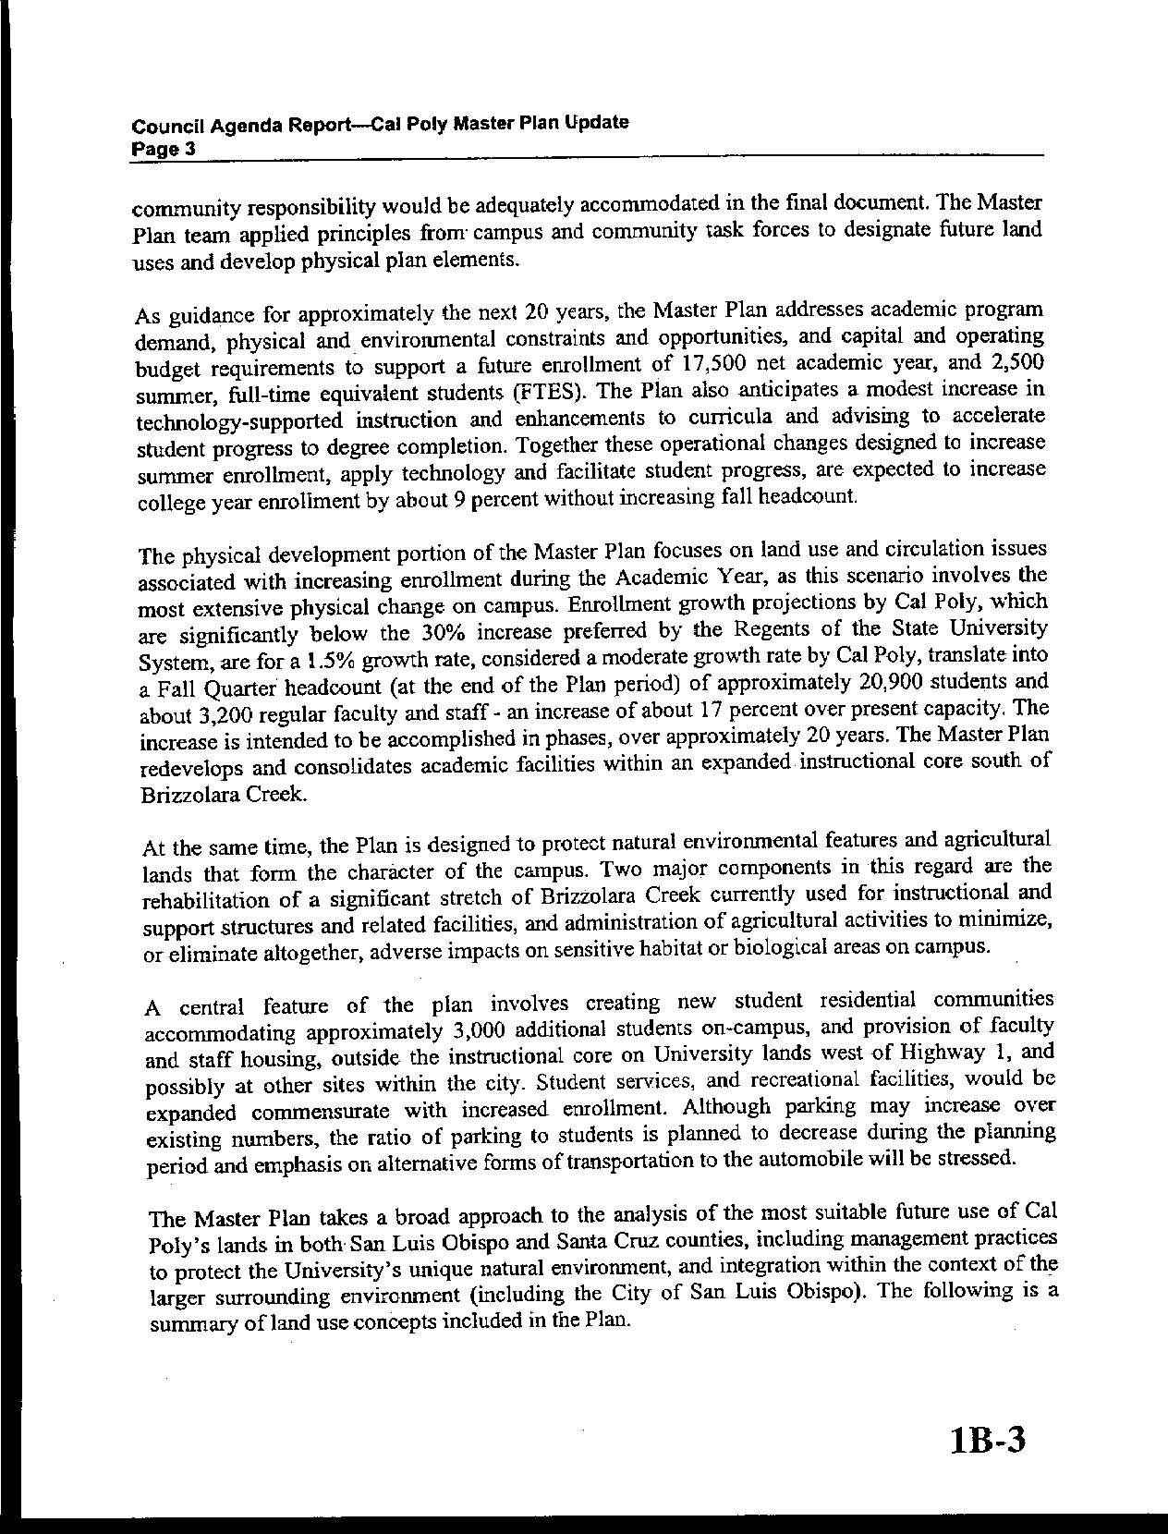
Letter 3
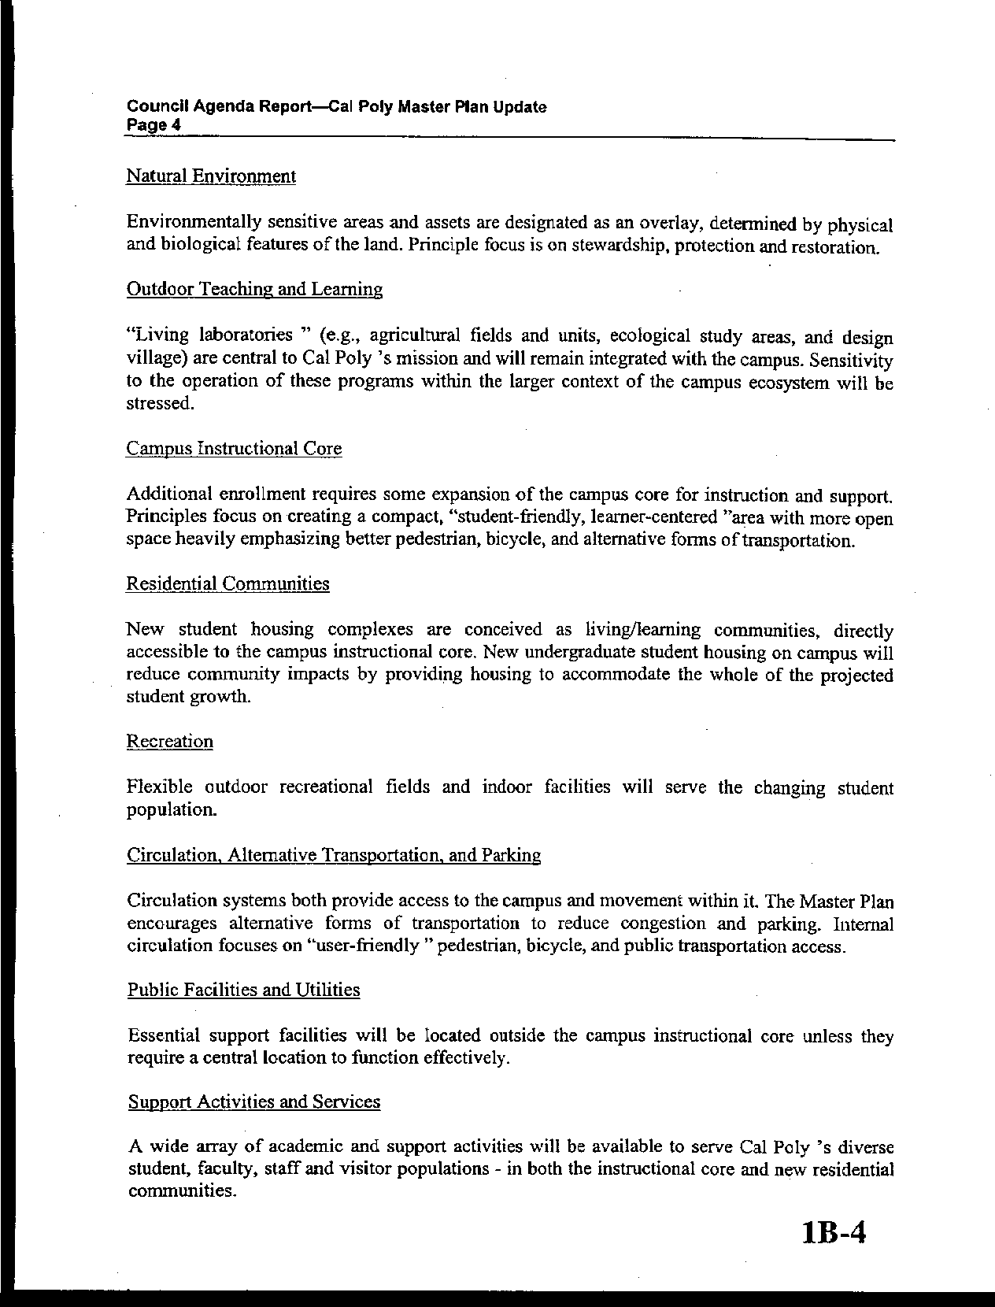
Letter 3
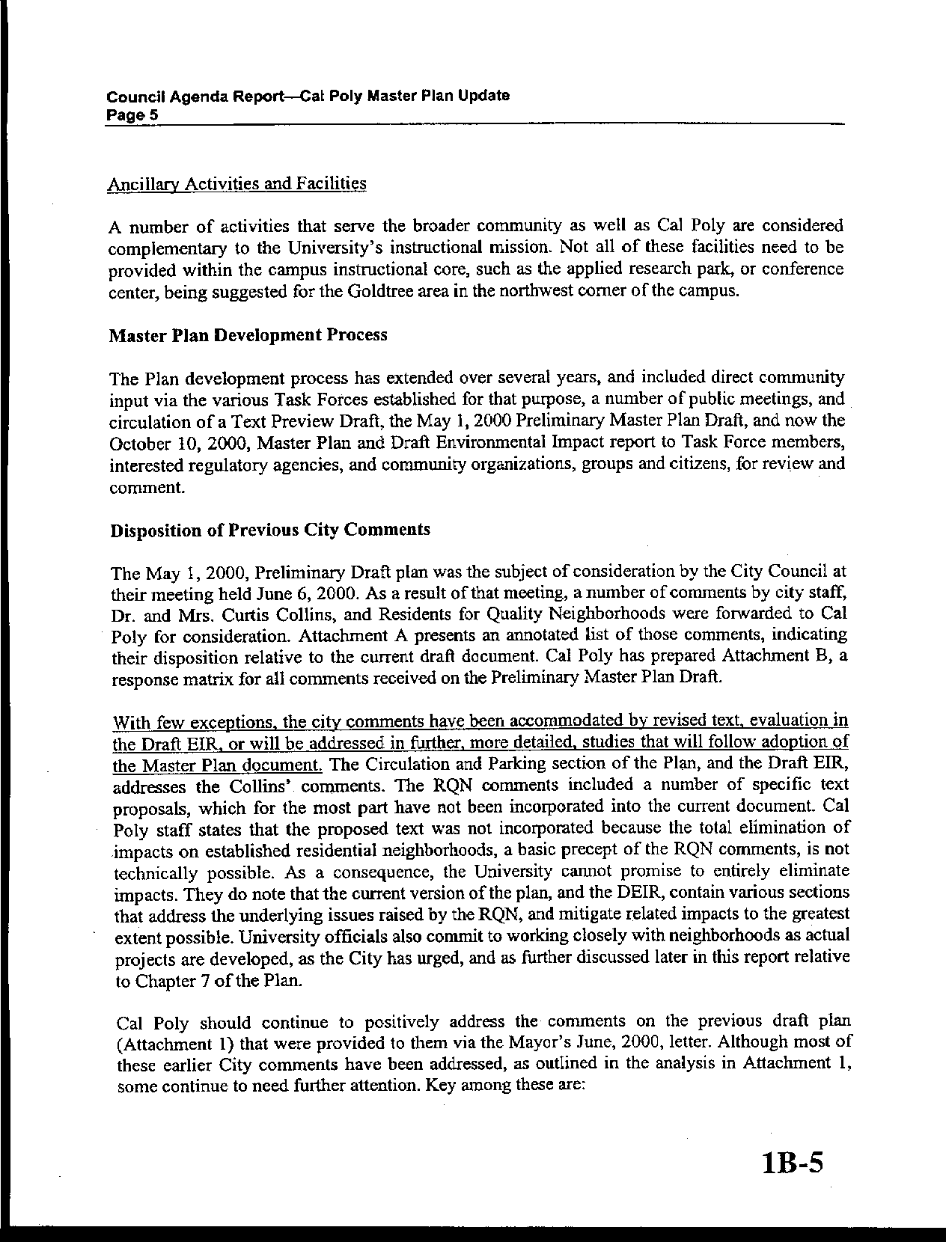
Letter 3
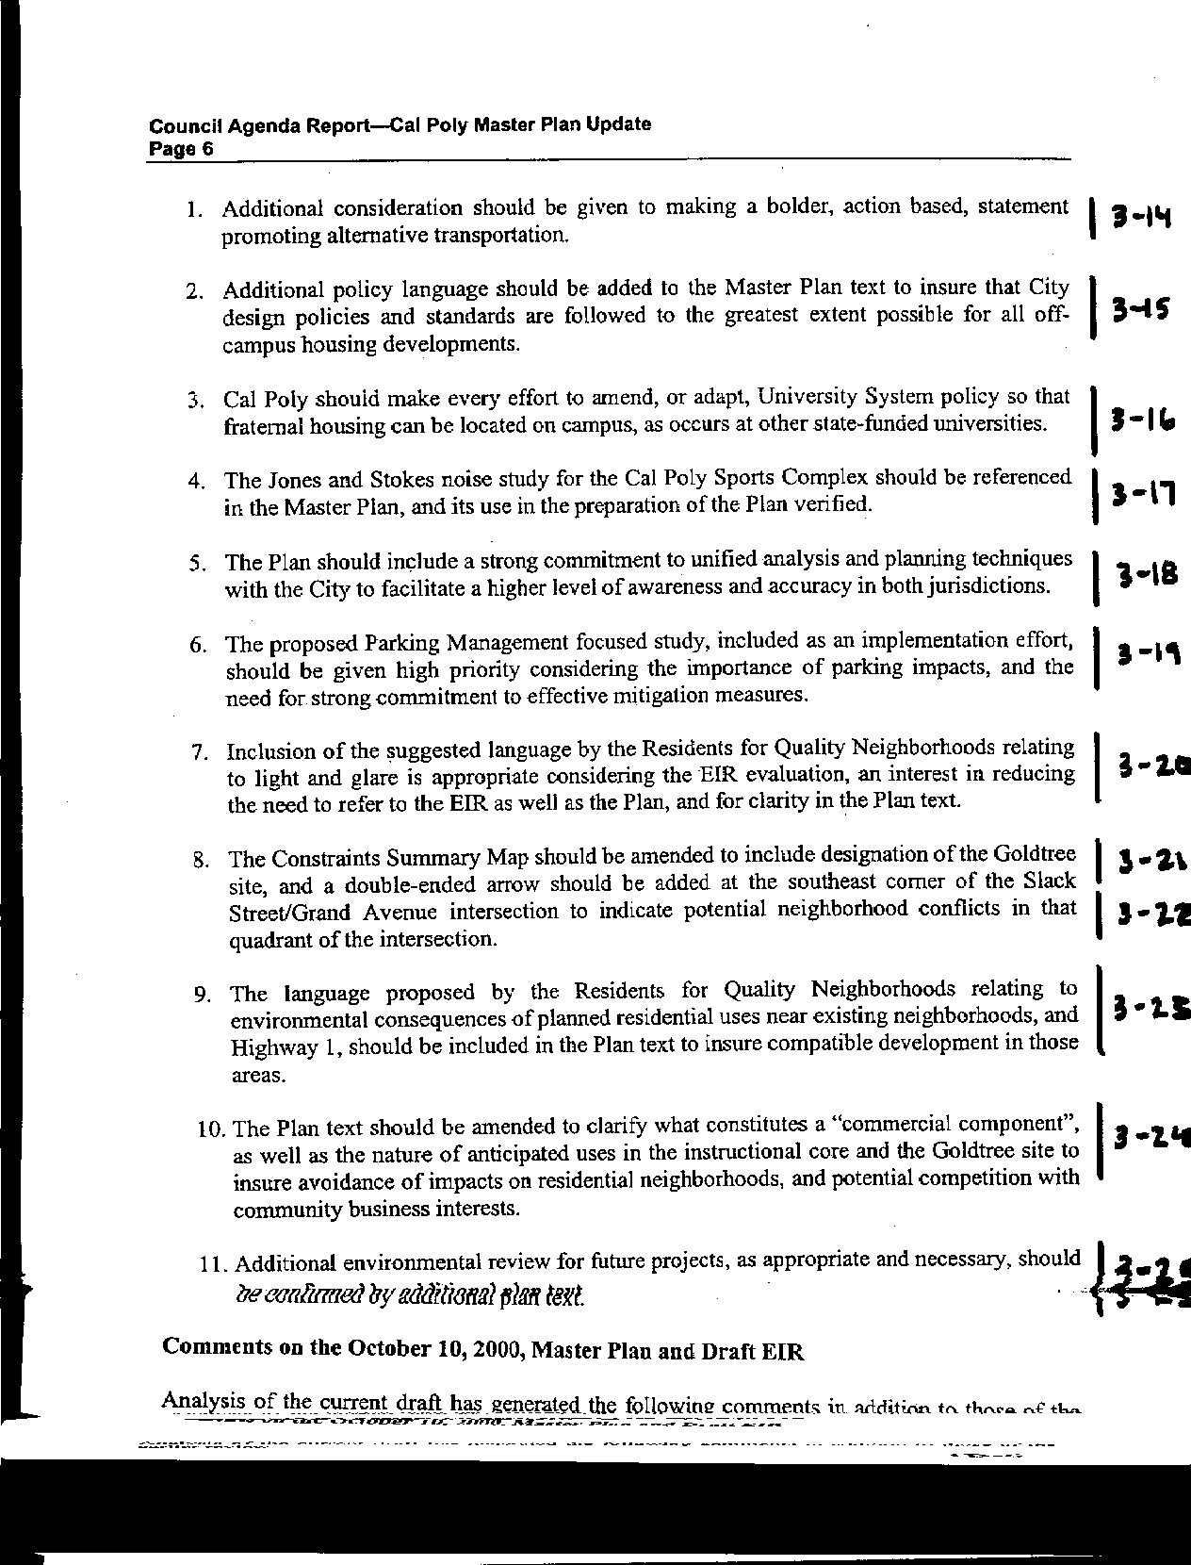
Letter 3
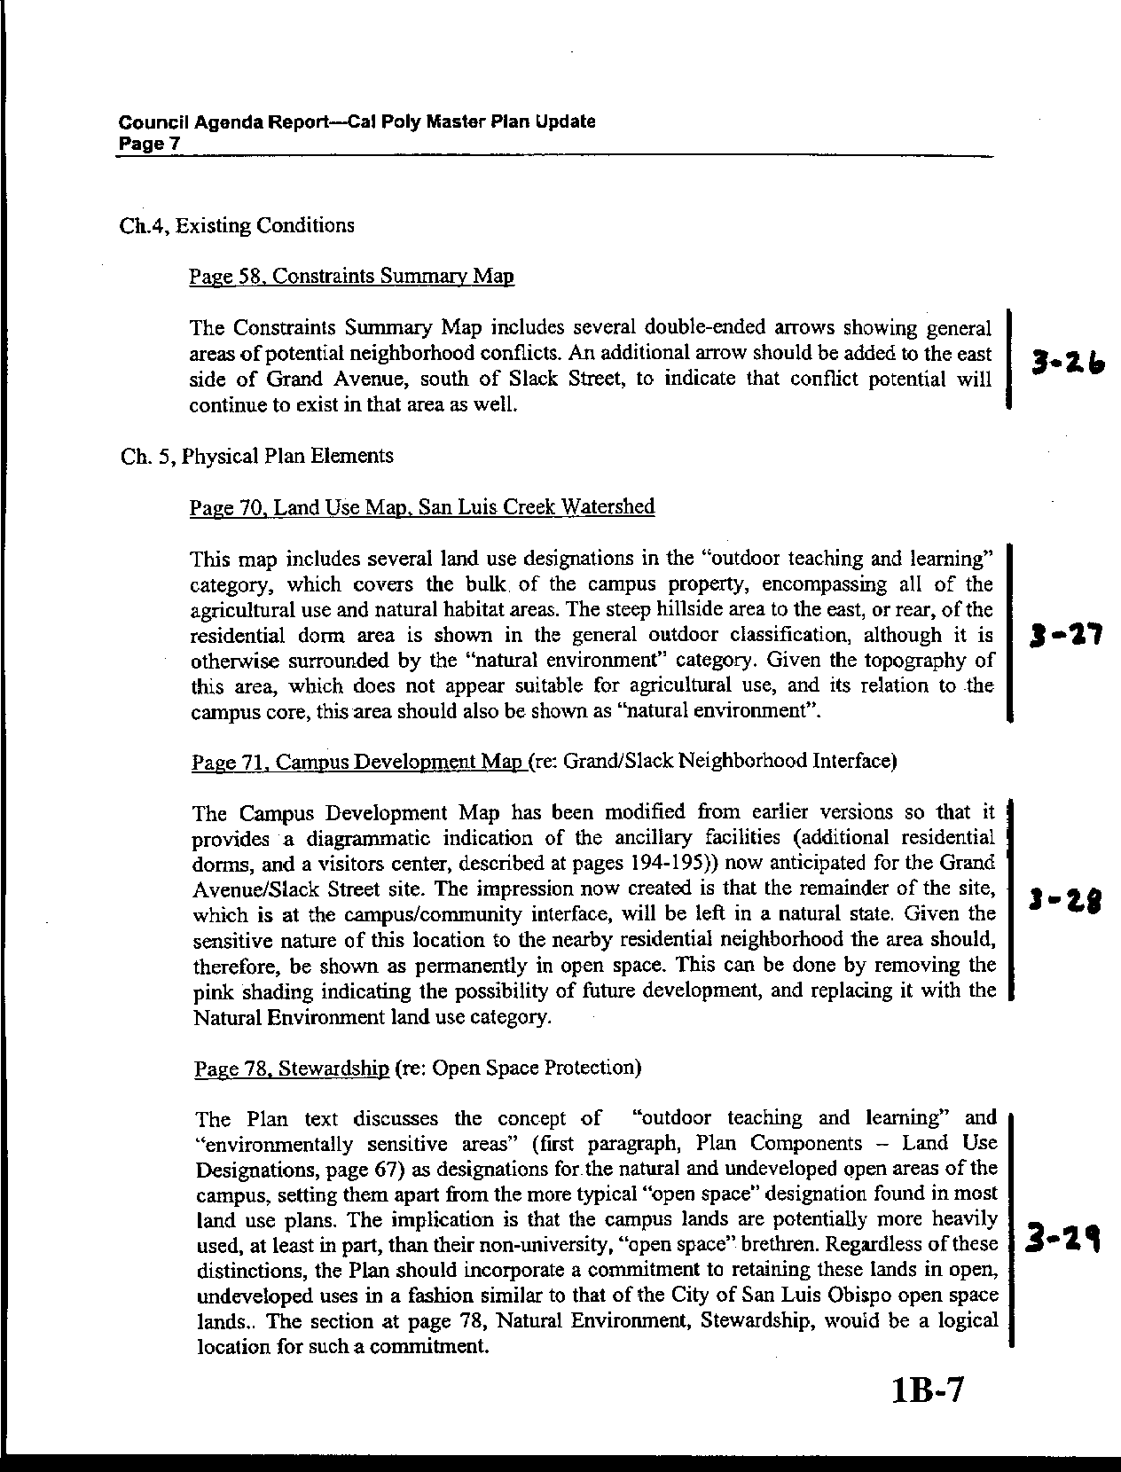
Letter 3
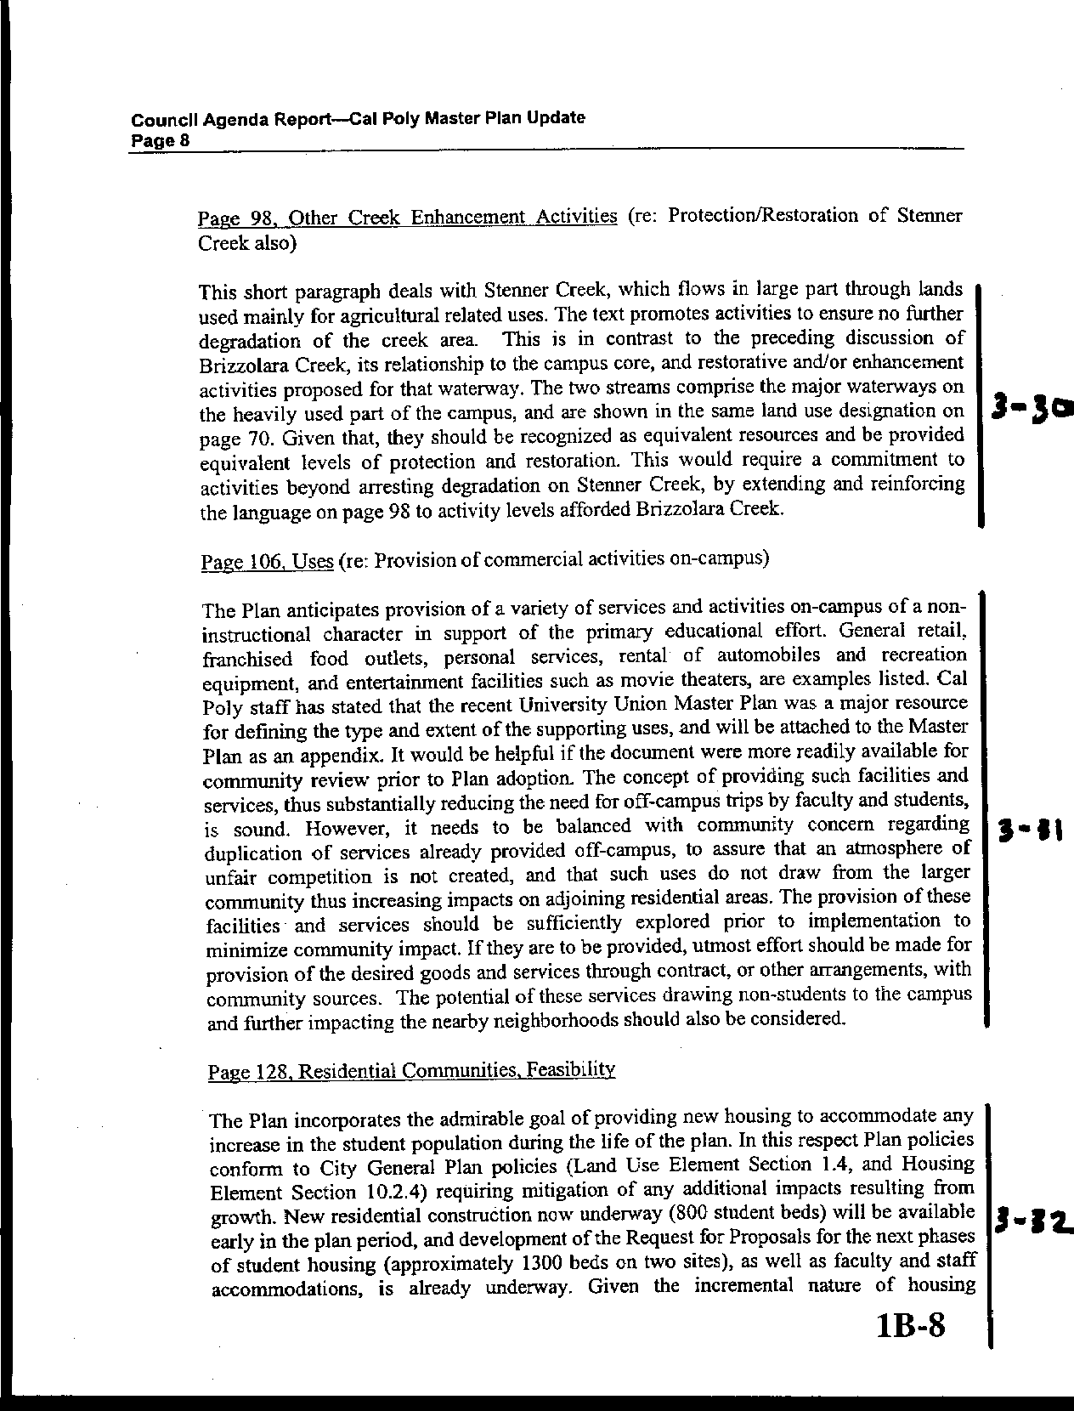
Letter 3
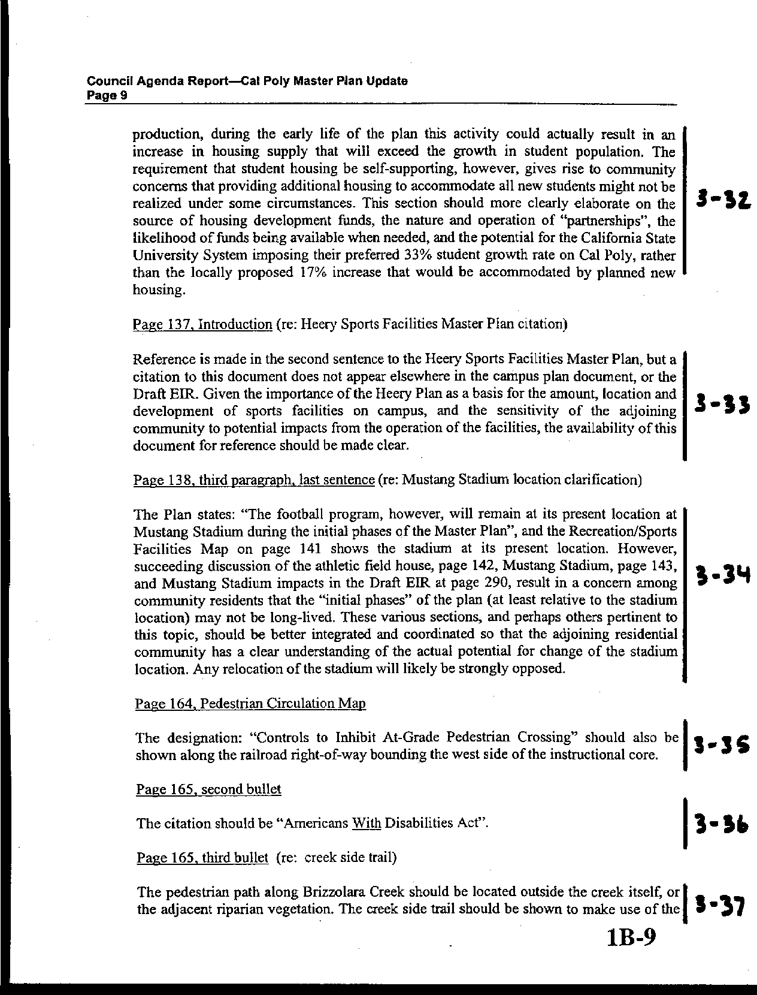
Letter 3
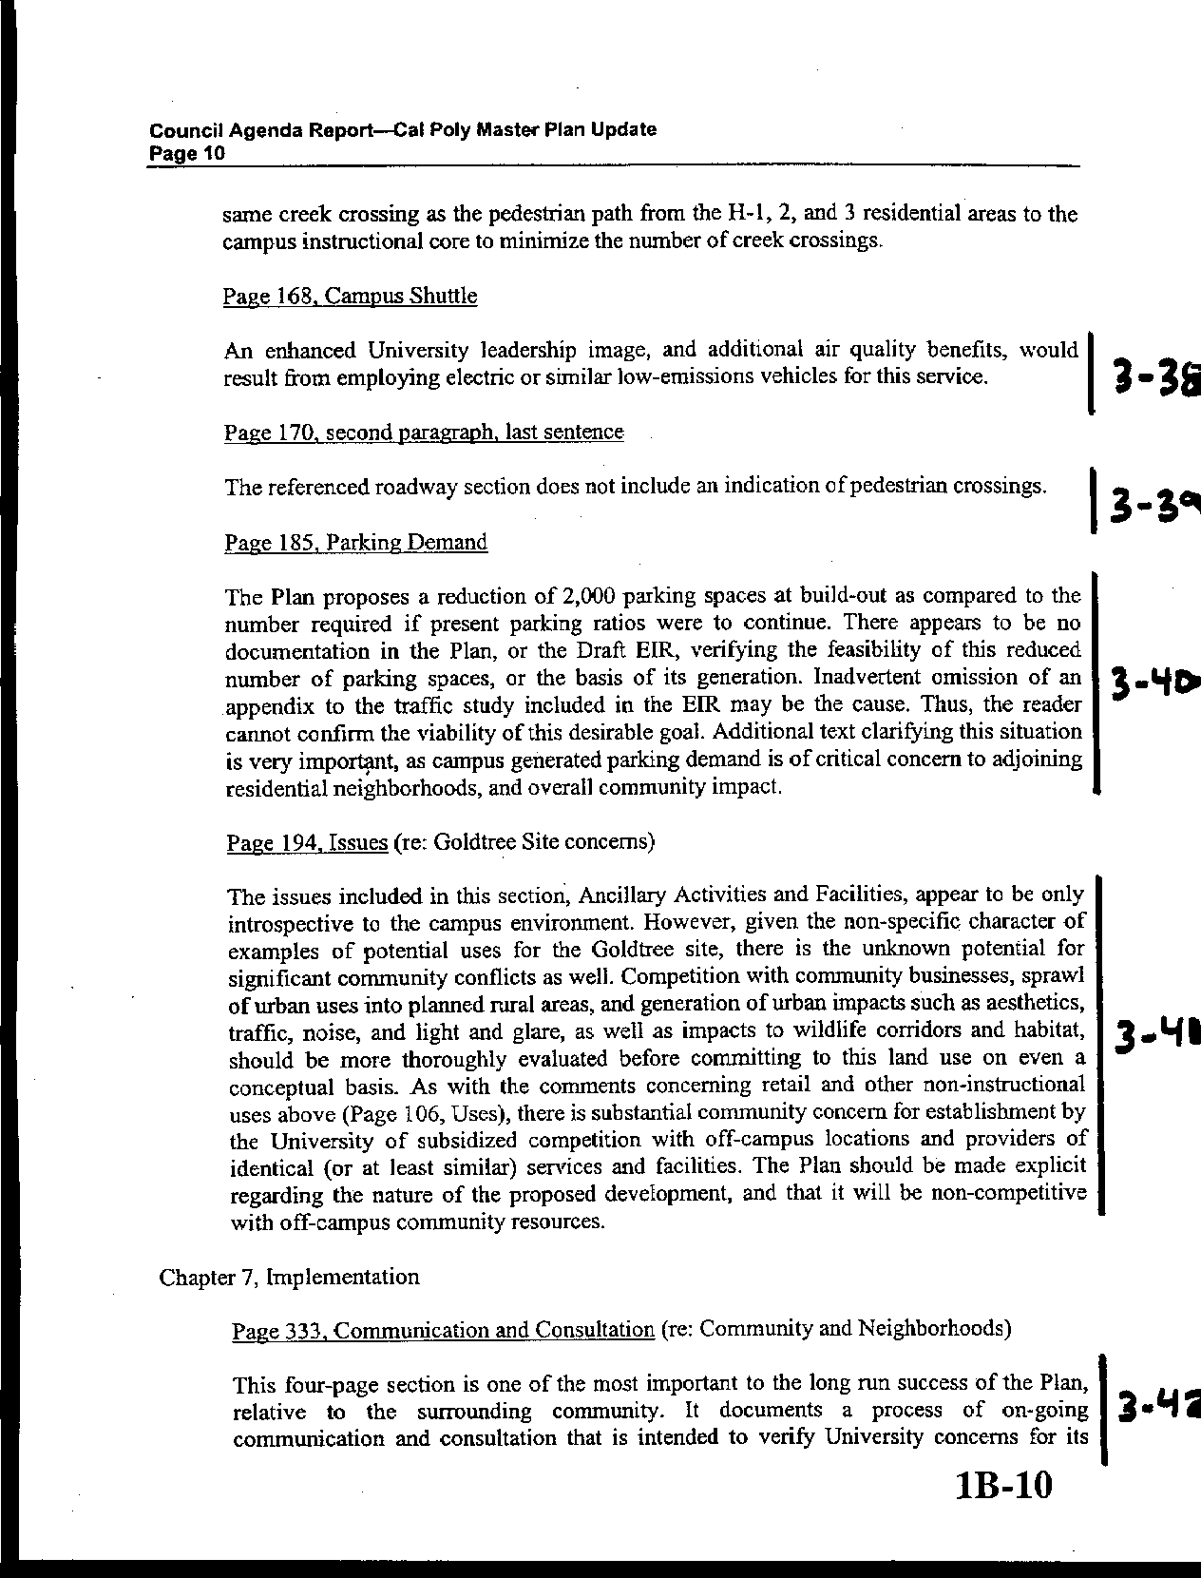
Letter 3
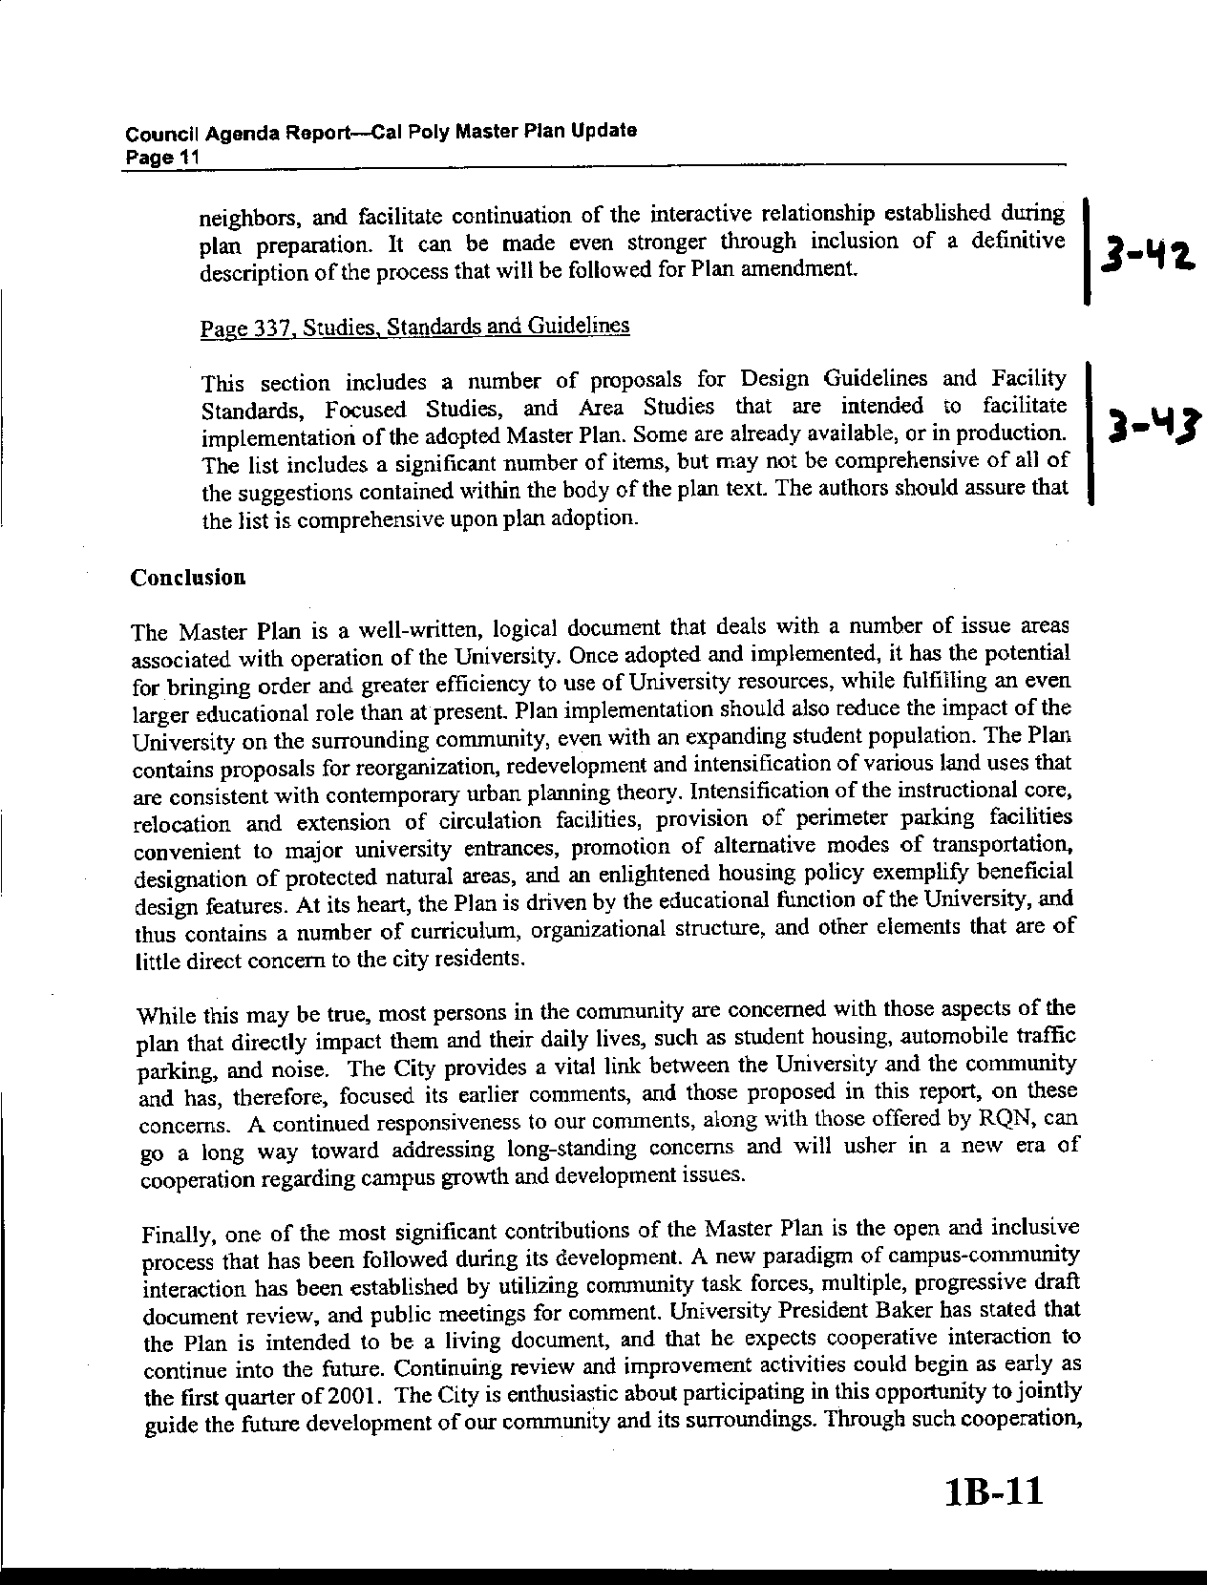
Letter 3
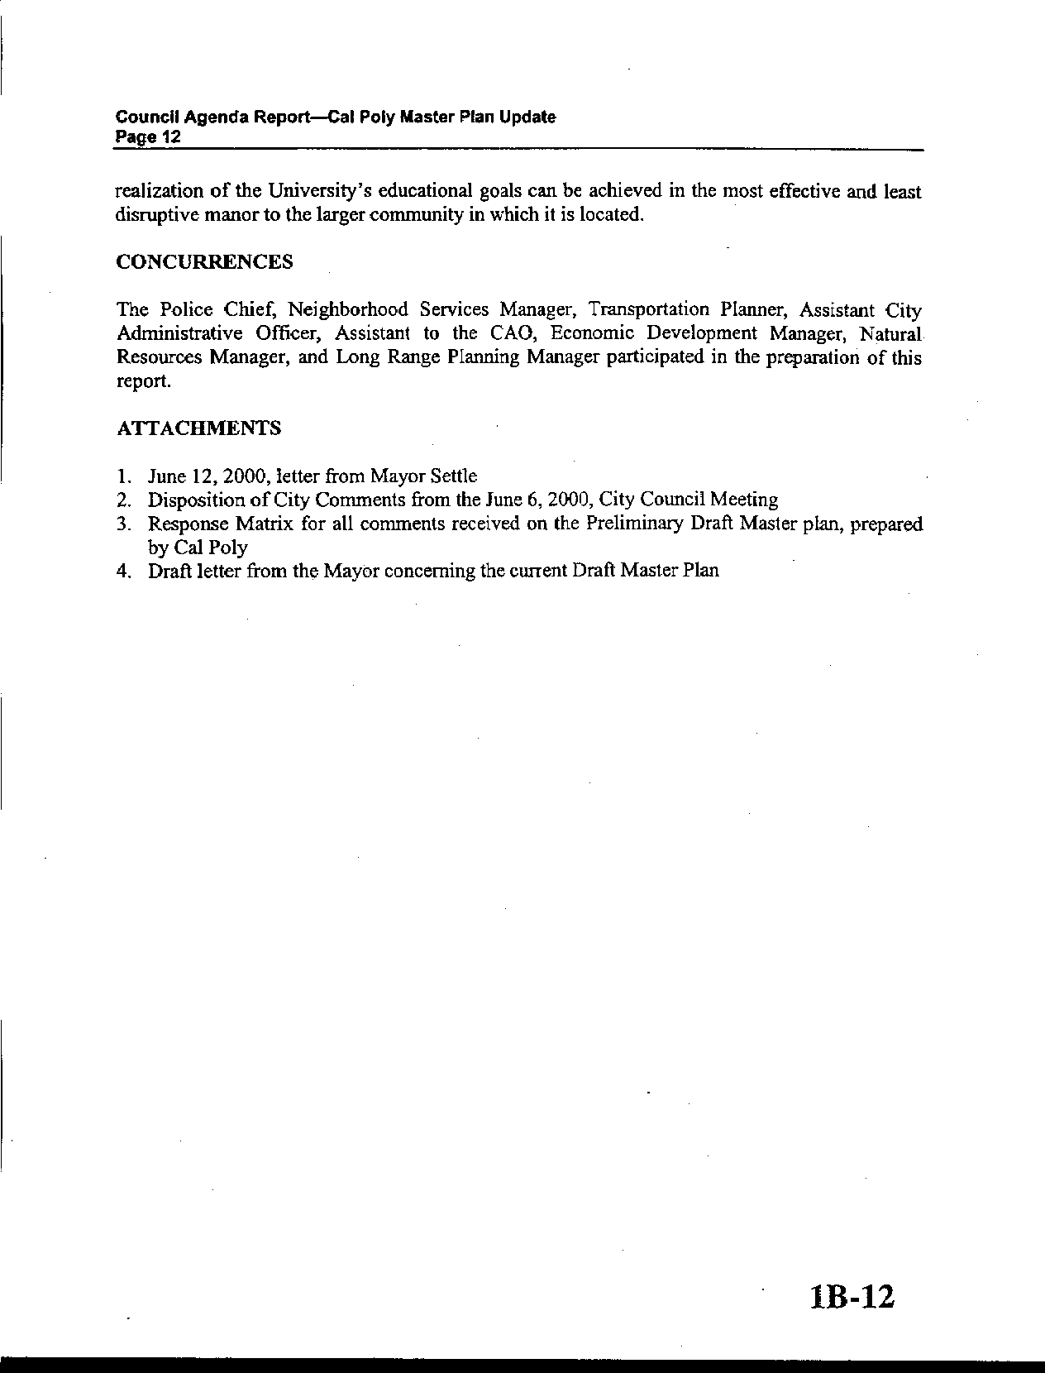
Letter 3
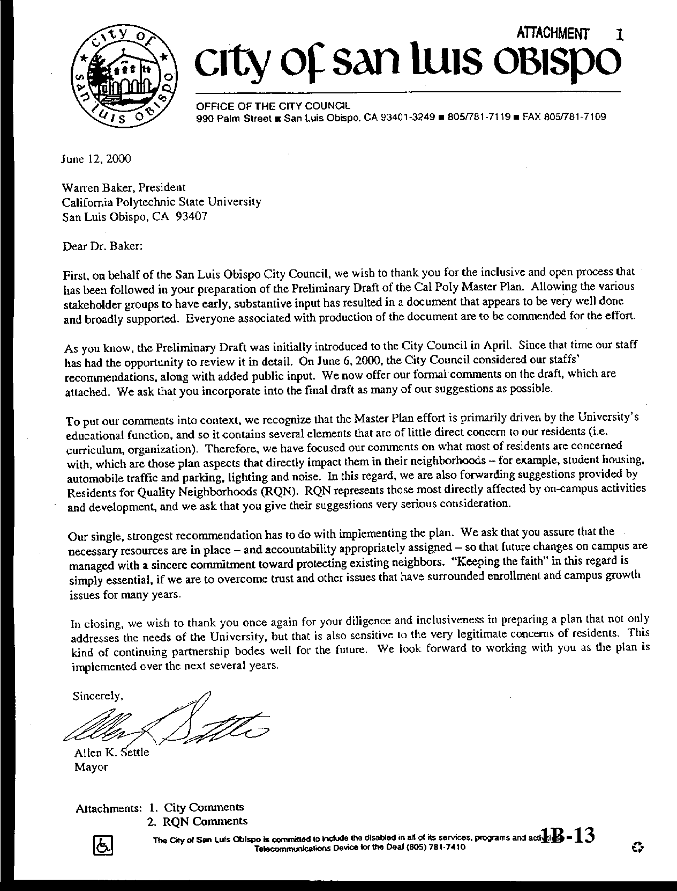
Letter 3
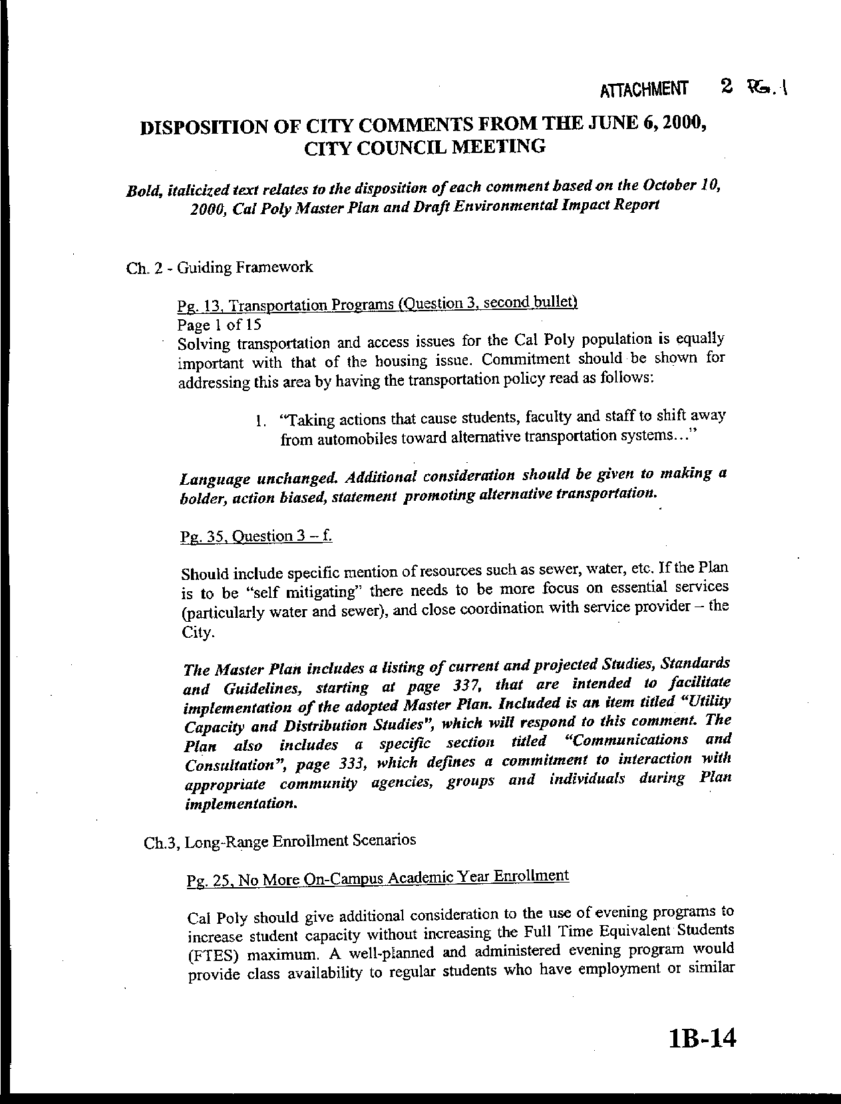
Letter 3
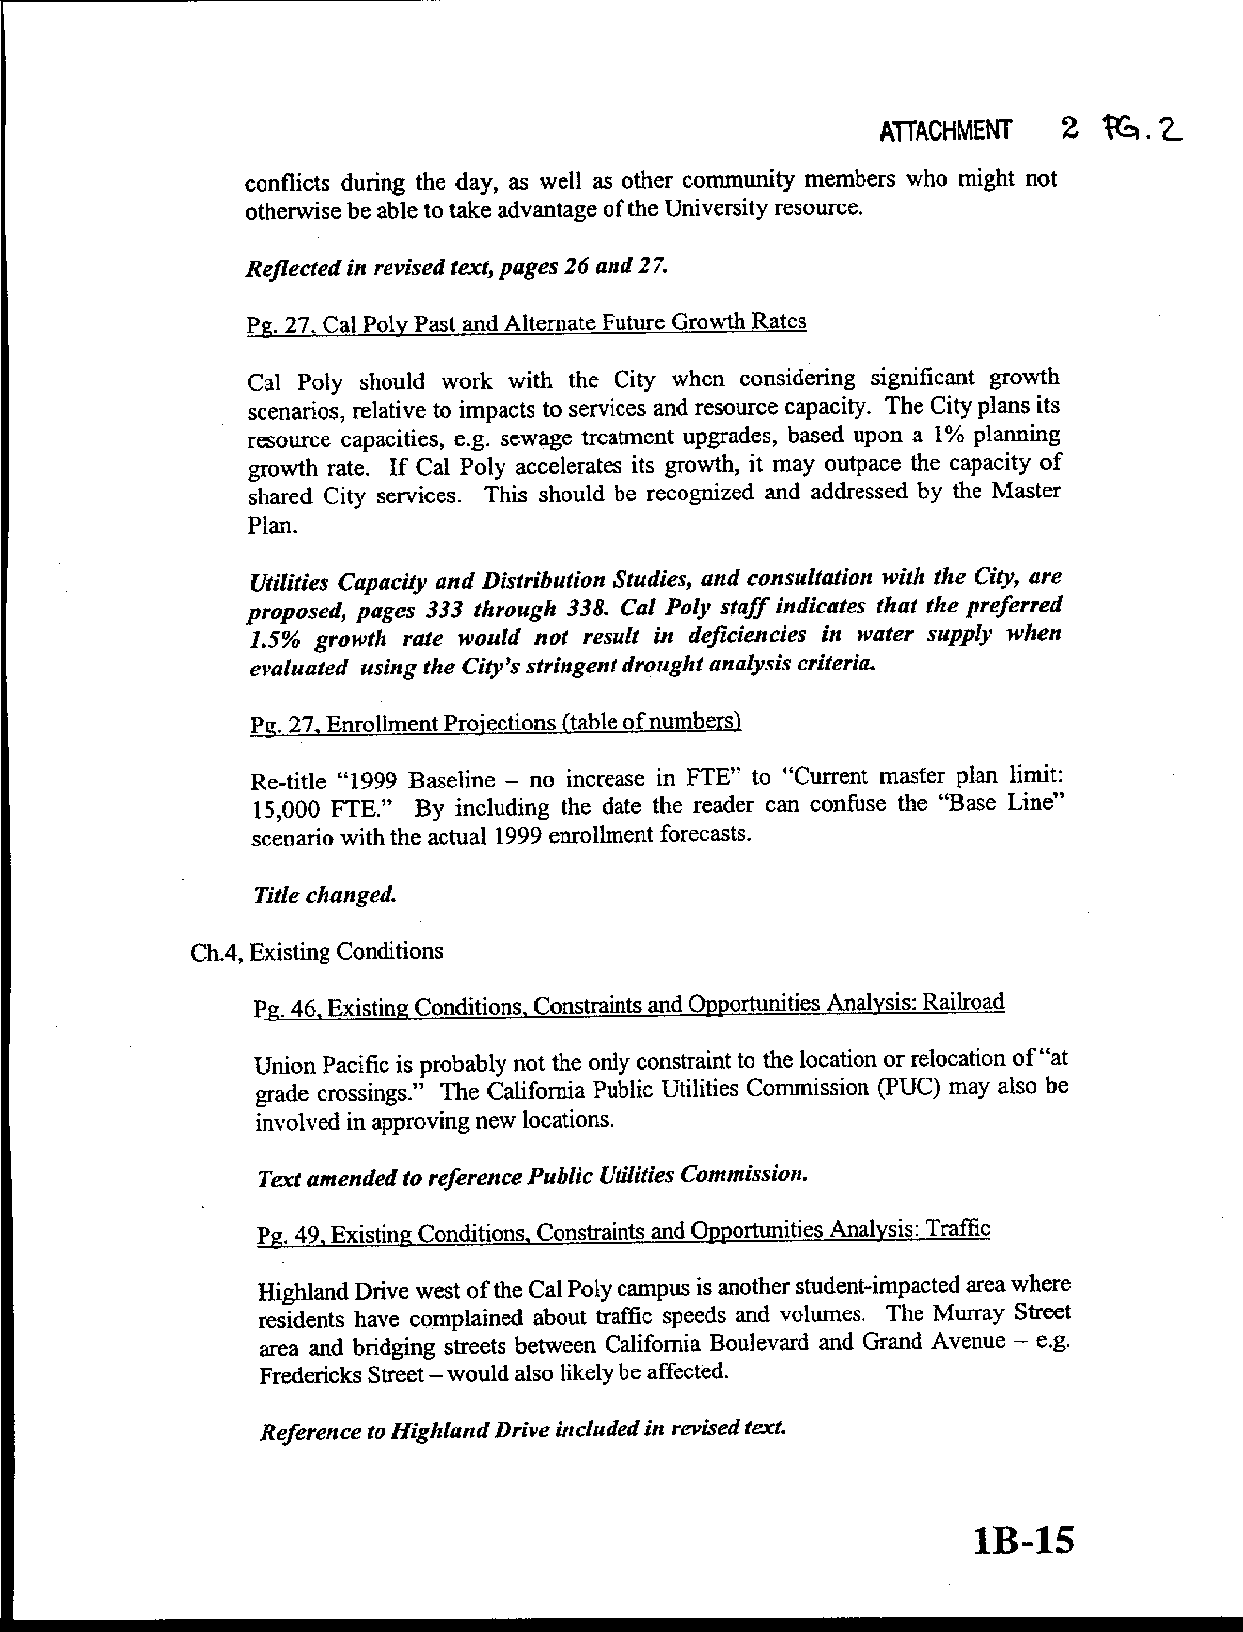
Letter 3
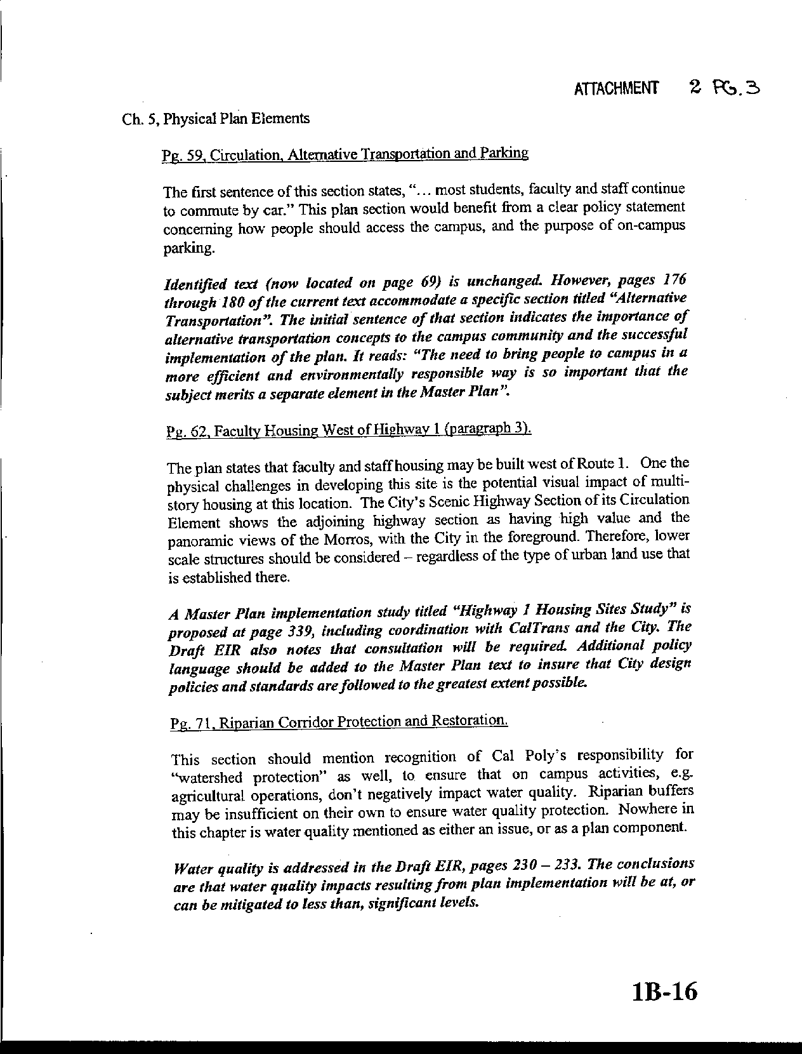
Letter 3
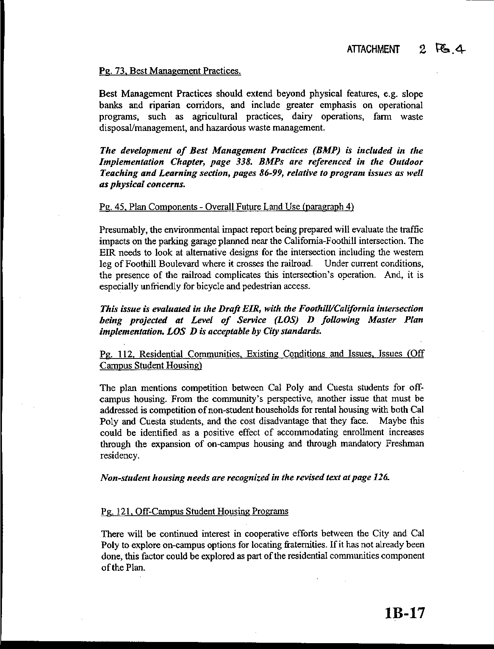
Letter 3
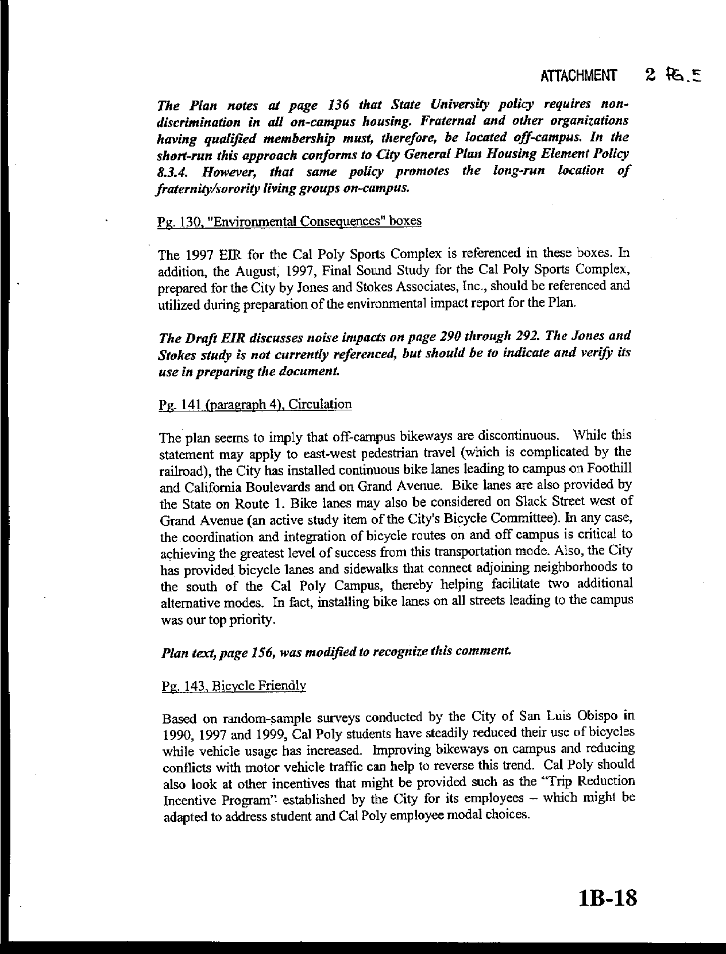
Letter 3
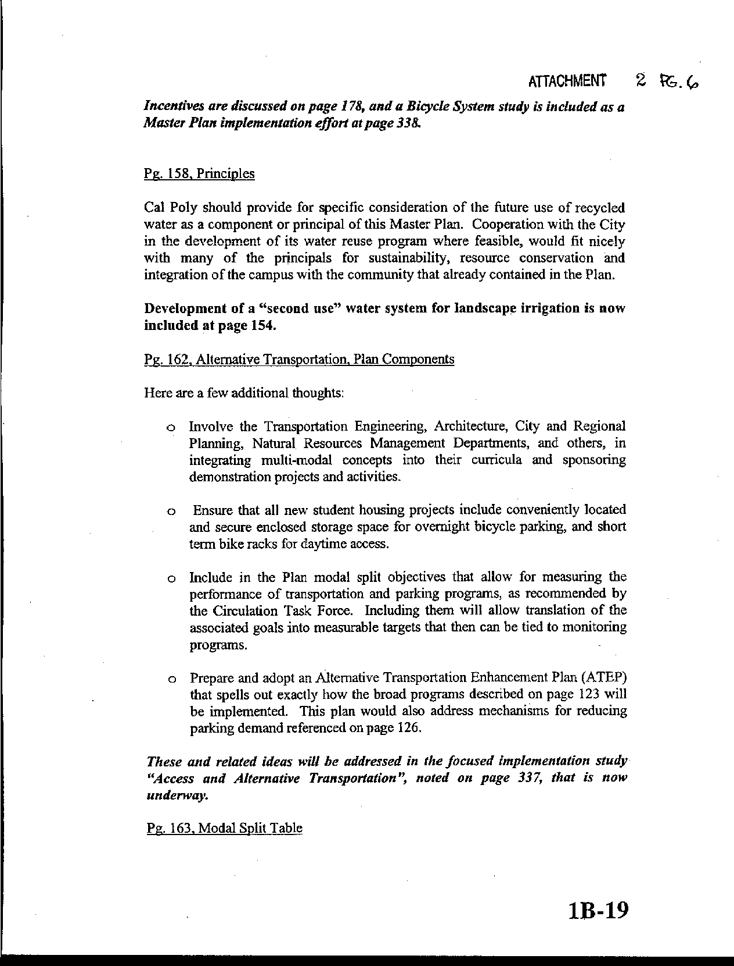
Letter 3
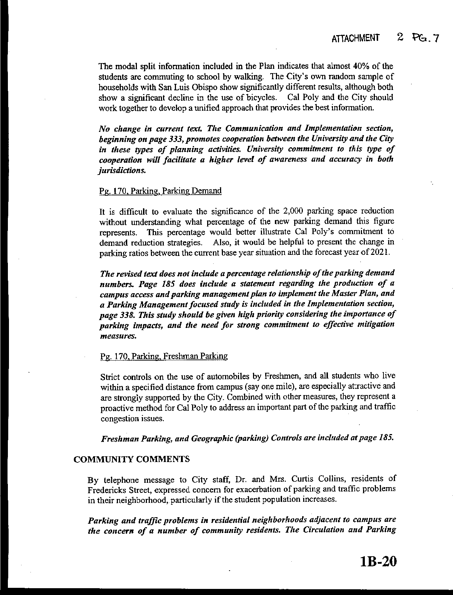
Letter 3
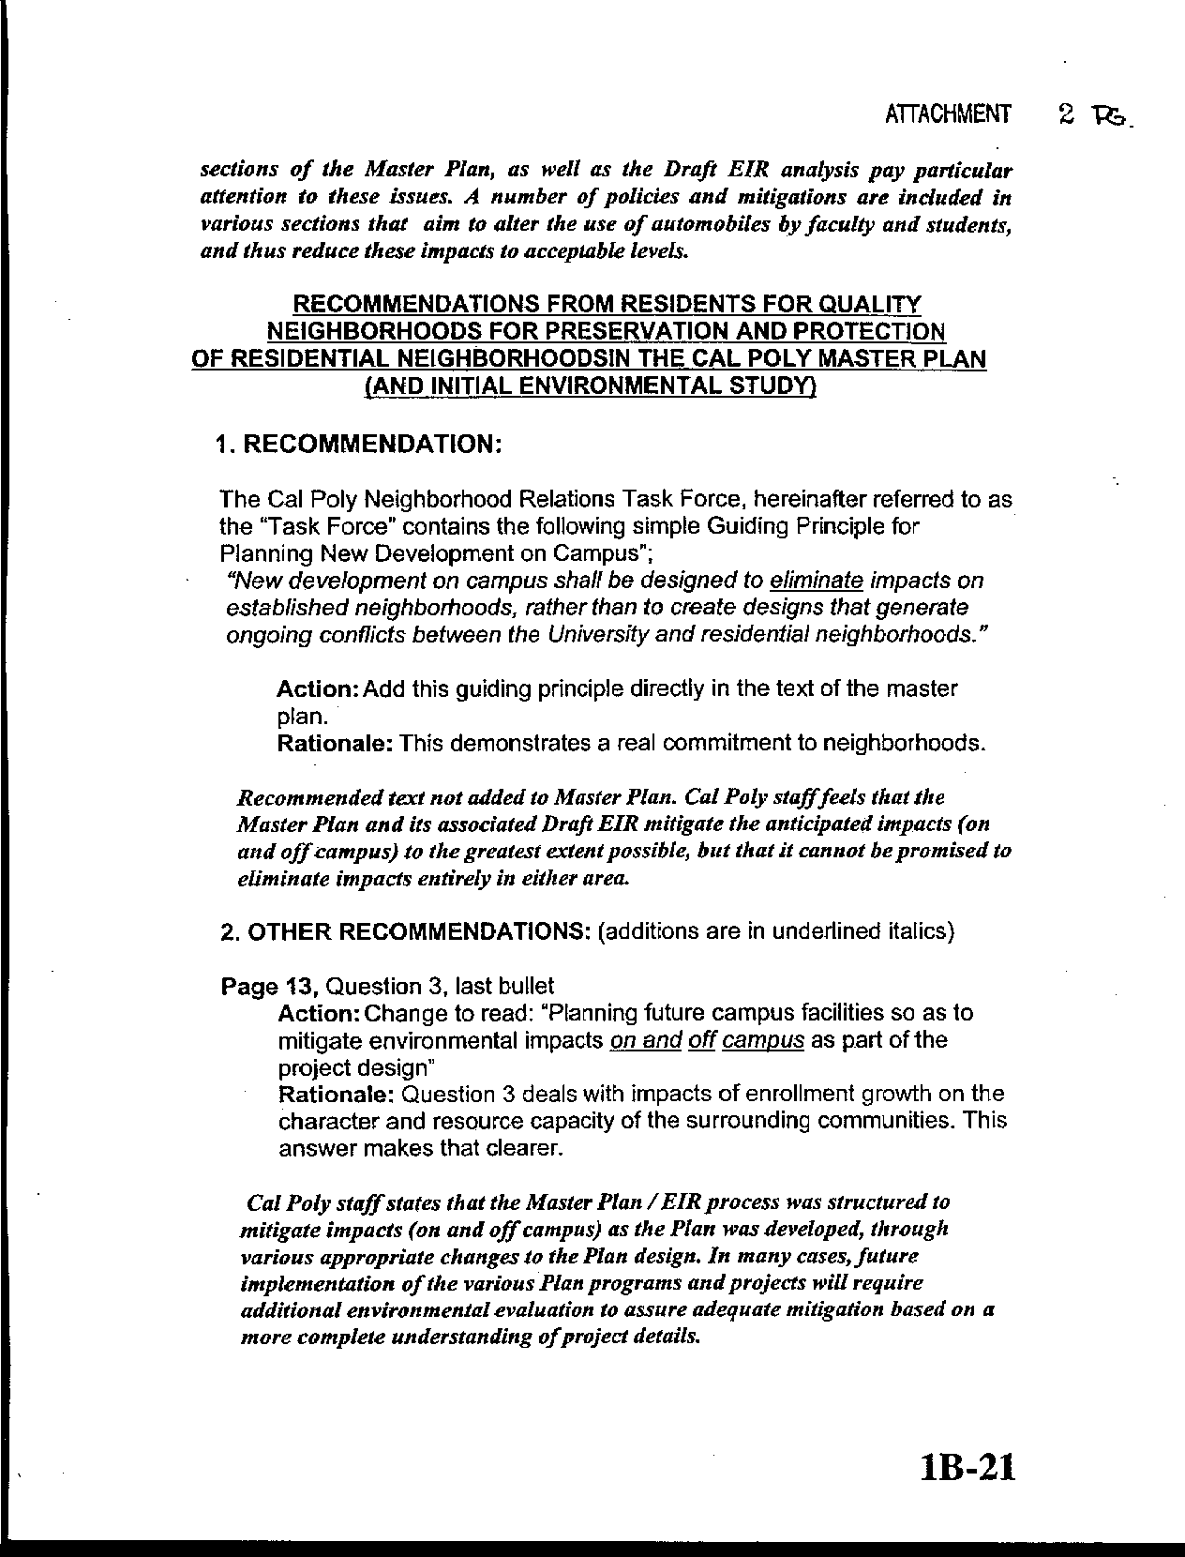
Letter 3
58.2
58-3
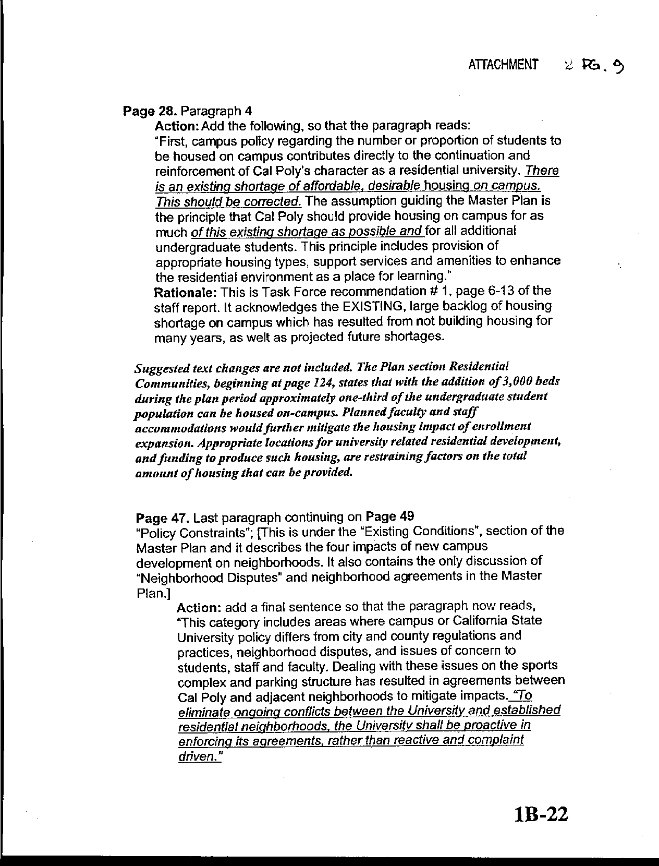
Letter 3
58-4

58-5
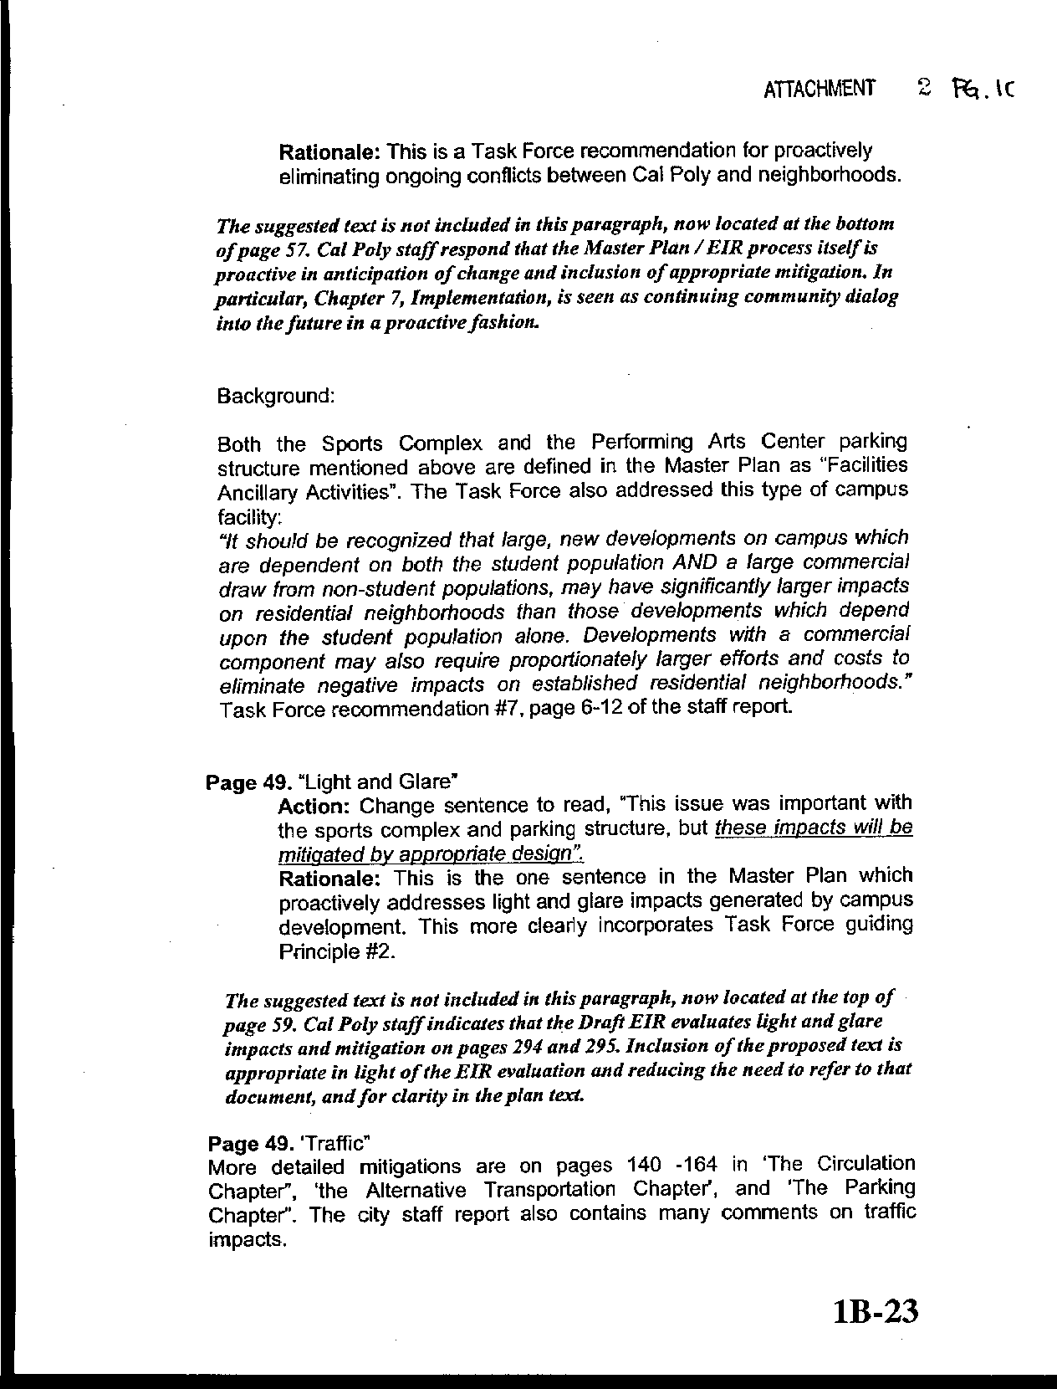
Letter 3
58.6
59-7
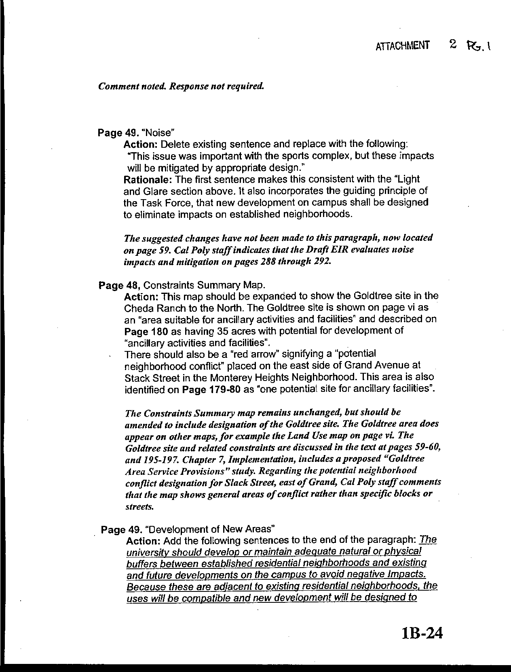
Letter 3
58-5
58-9
58-10
58-11
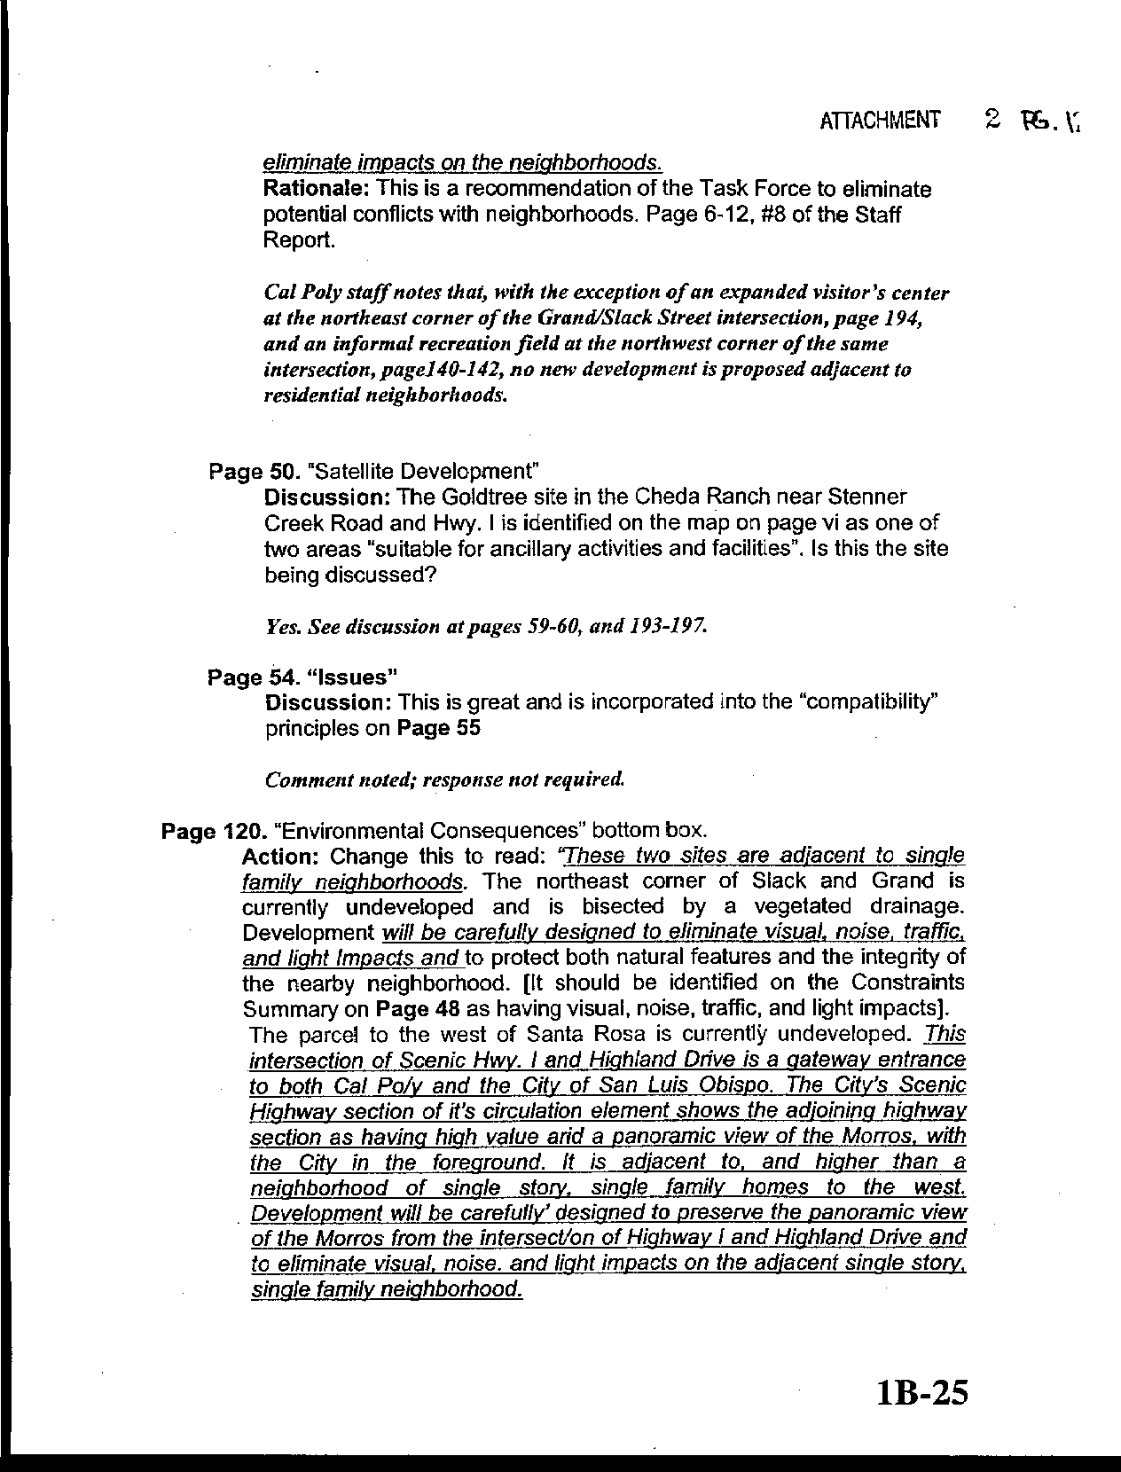
Letter 3
58-11
58-12
58-13
58-14
58-15
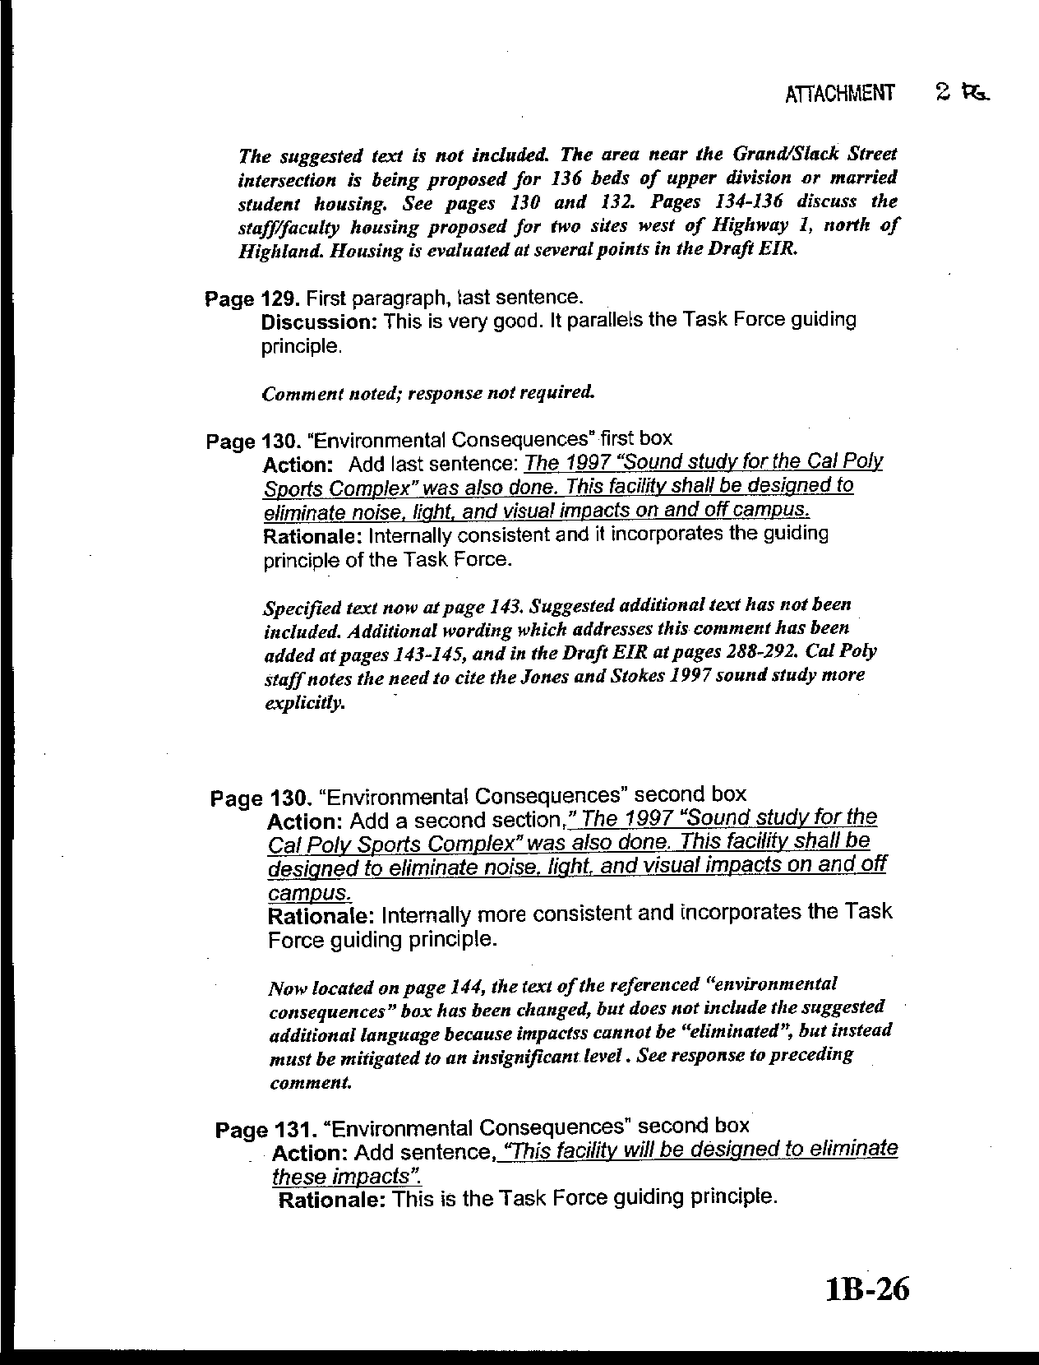
Letter 3
58-16
58-17
58-18
58-19
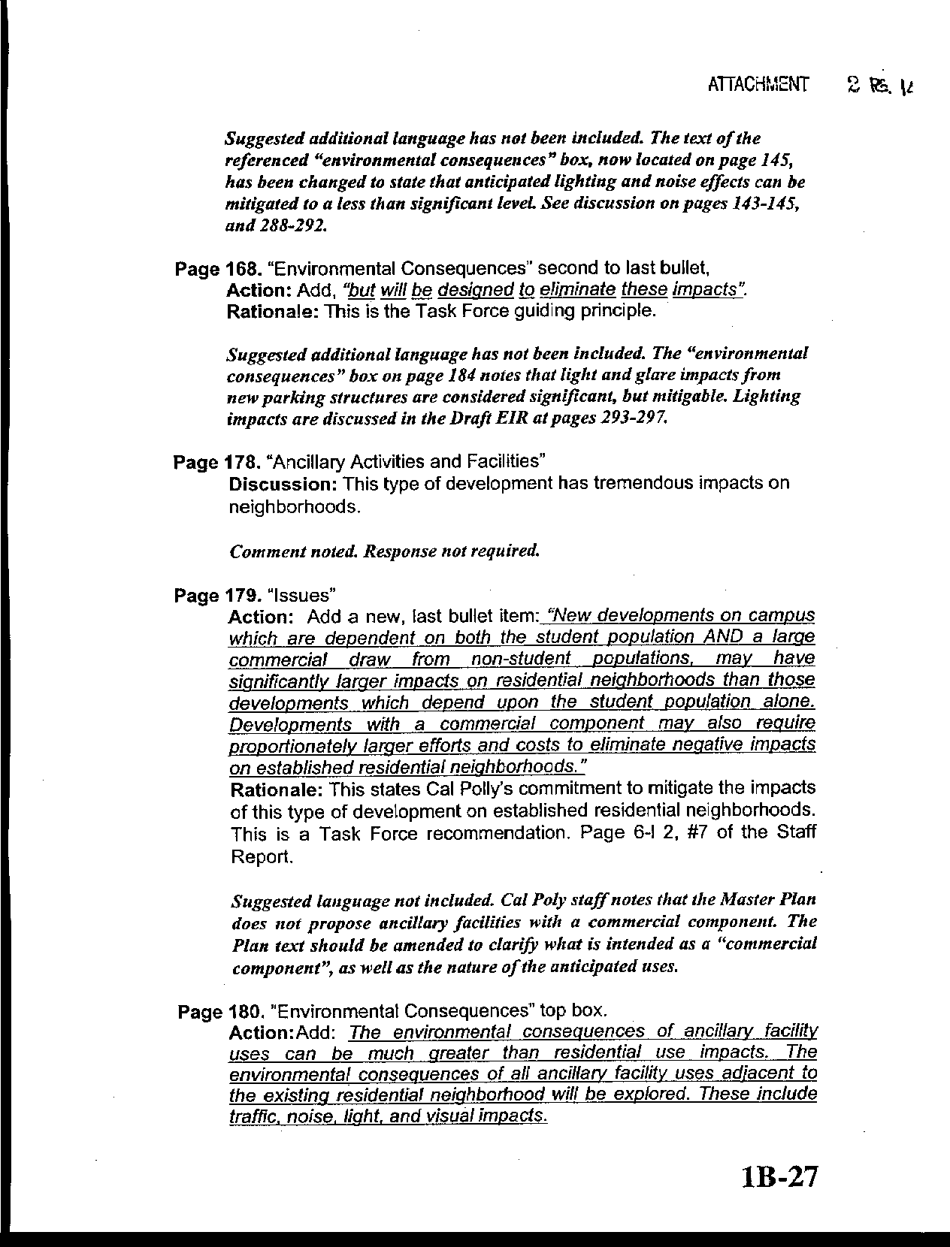
Letter 3
58-20
58-21
58-22
58-23
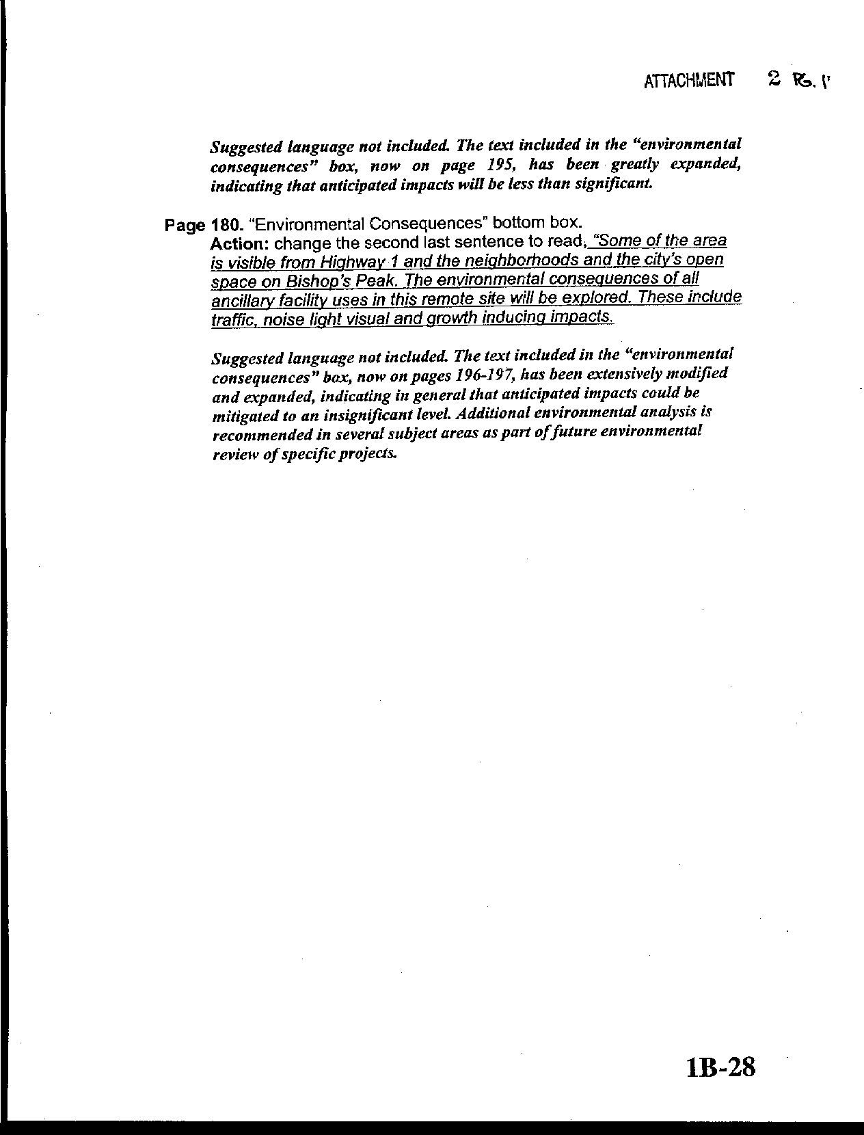
Letter 3
58-24
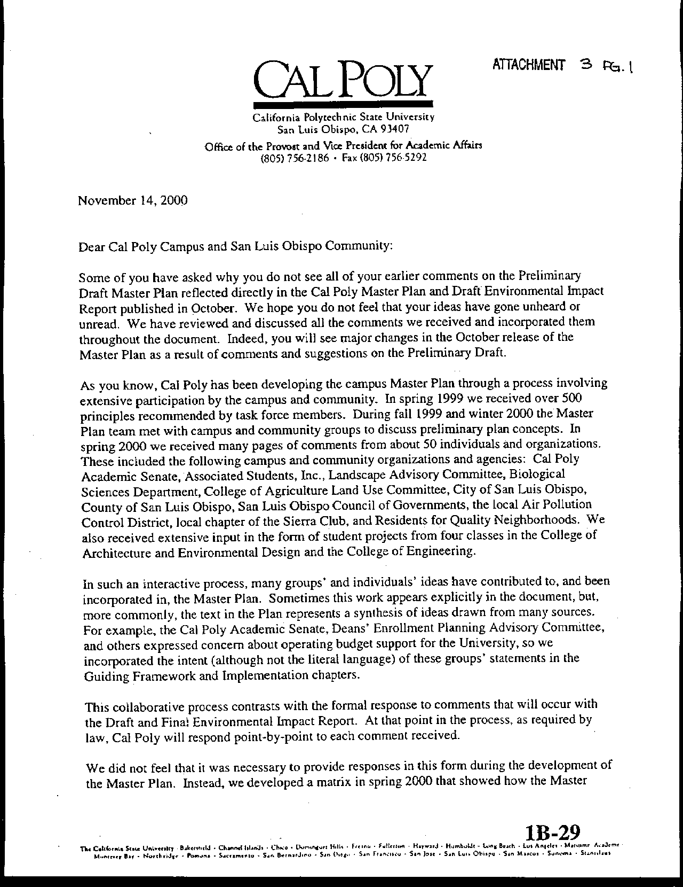
Letter 3
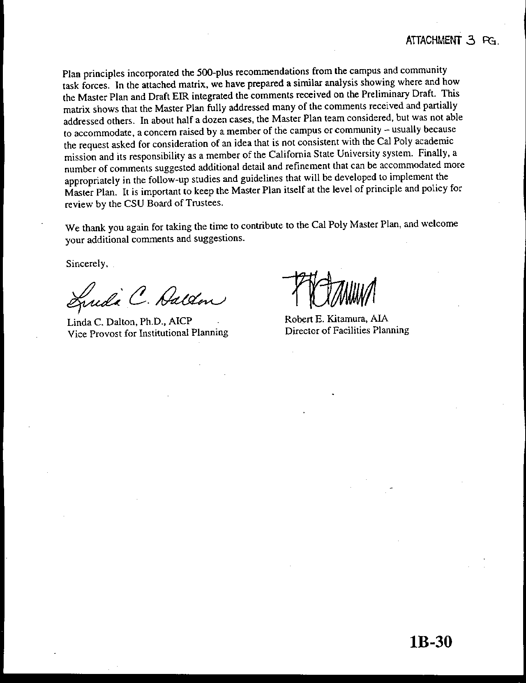
Letter 3
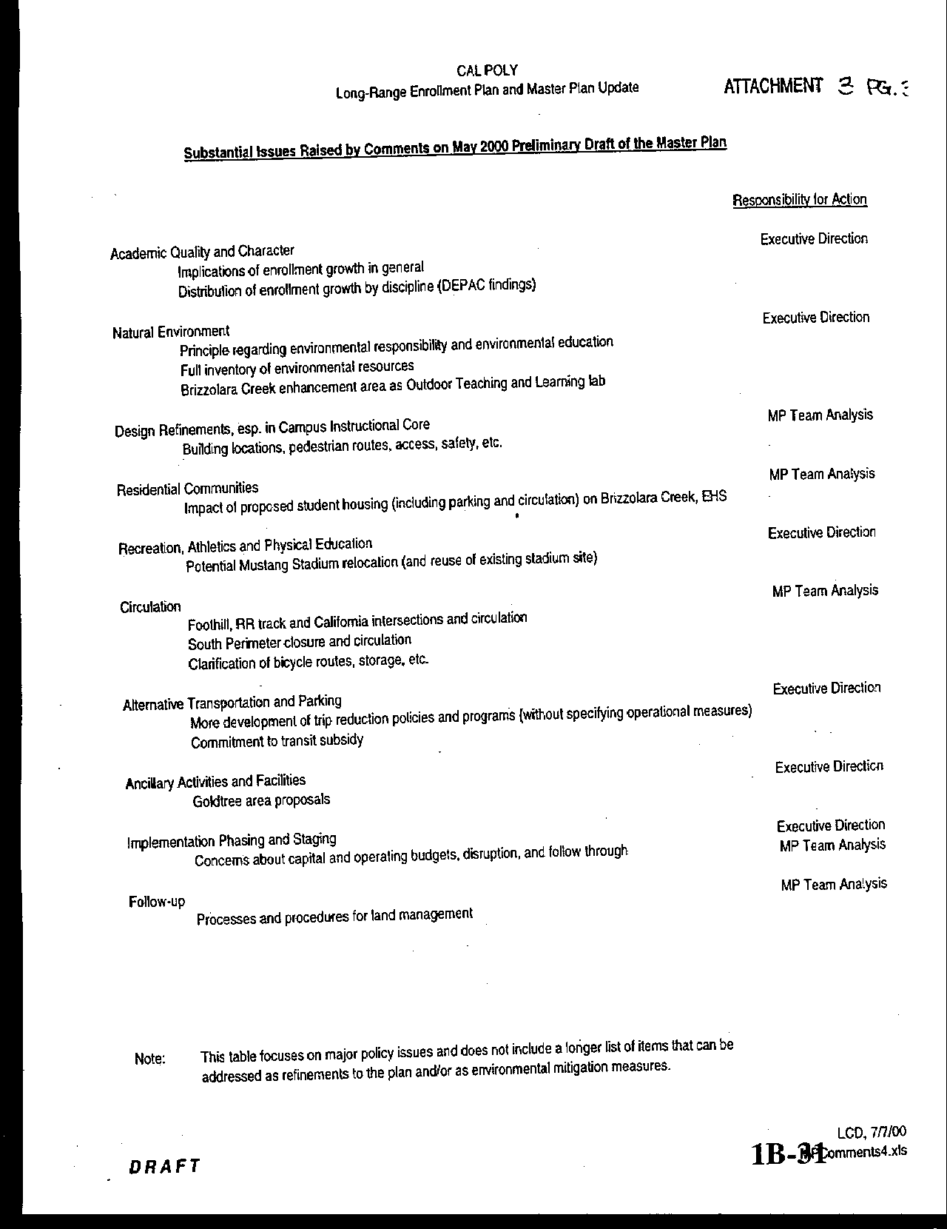
Letter 3
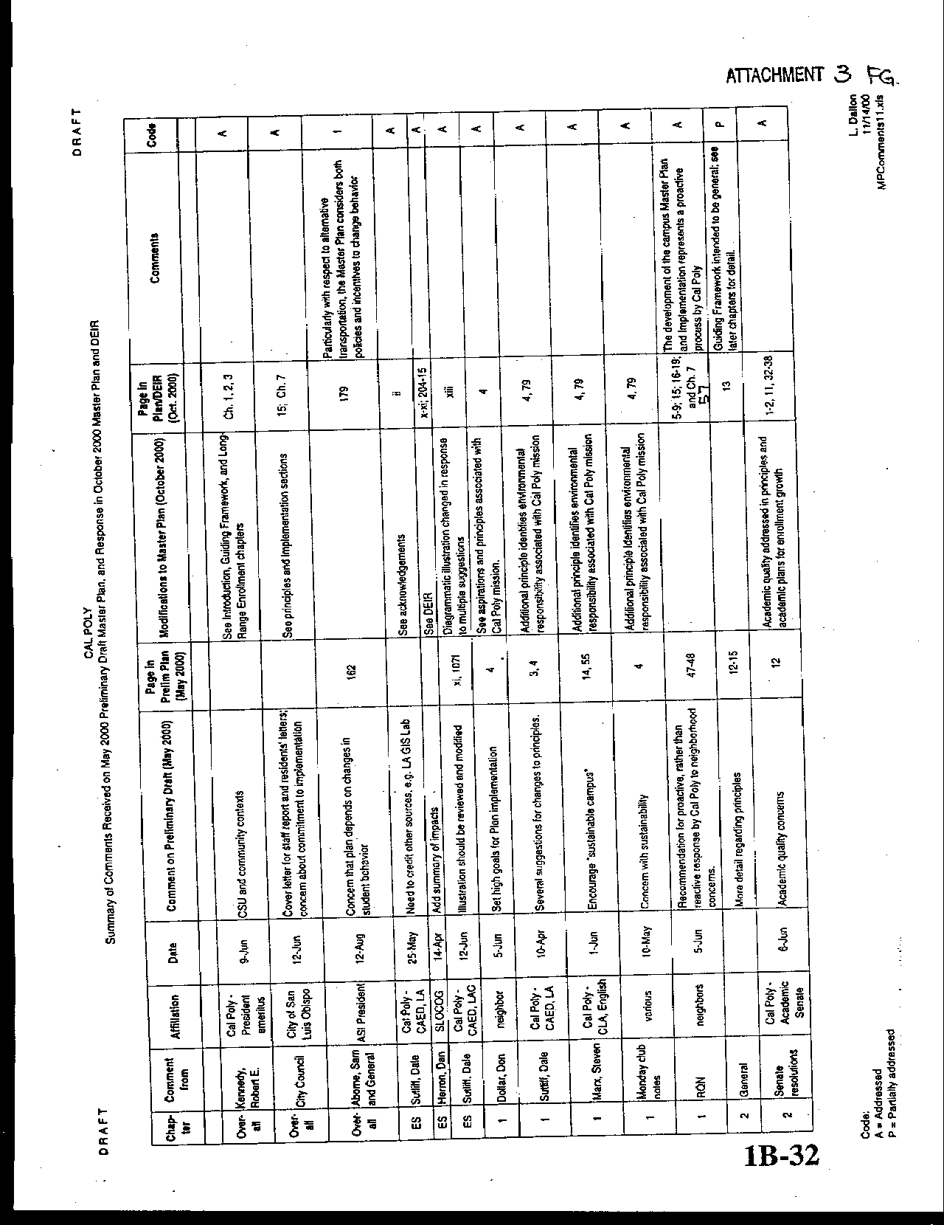
Letter 3
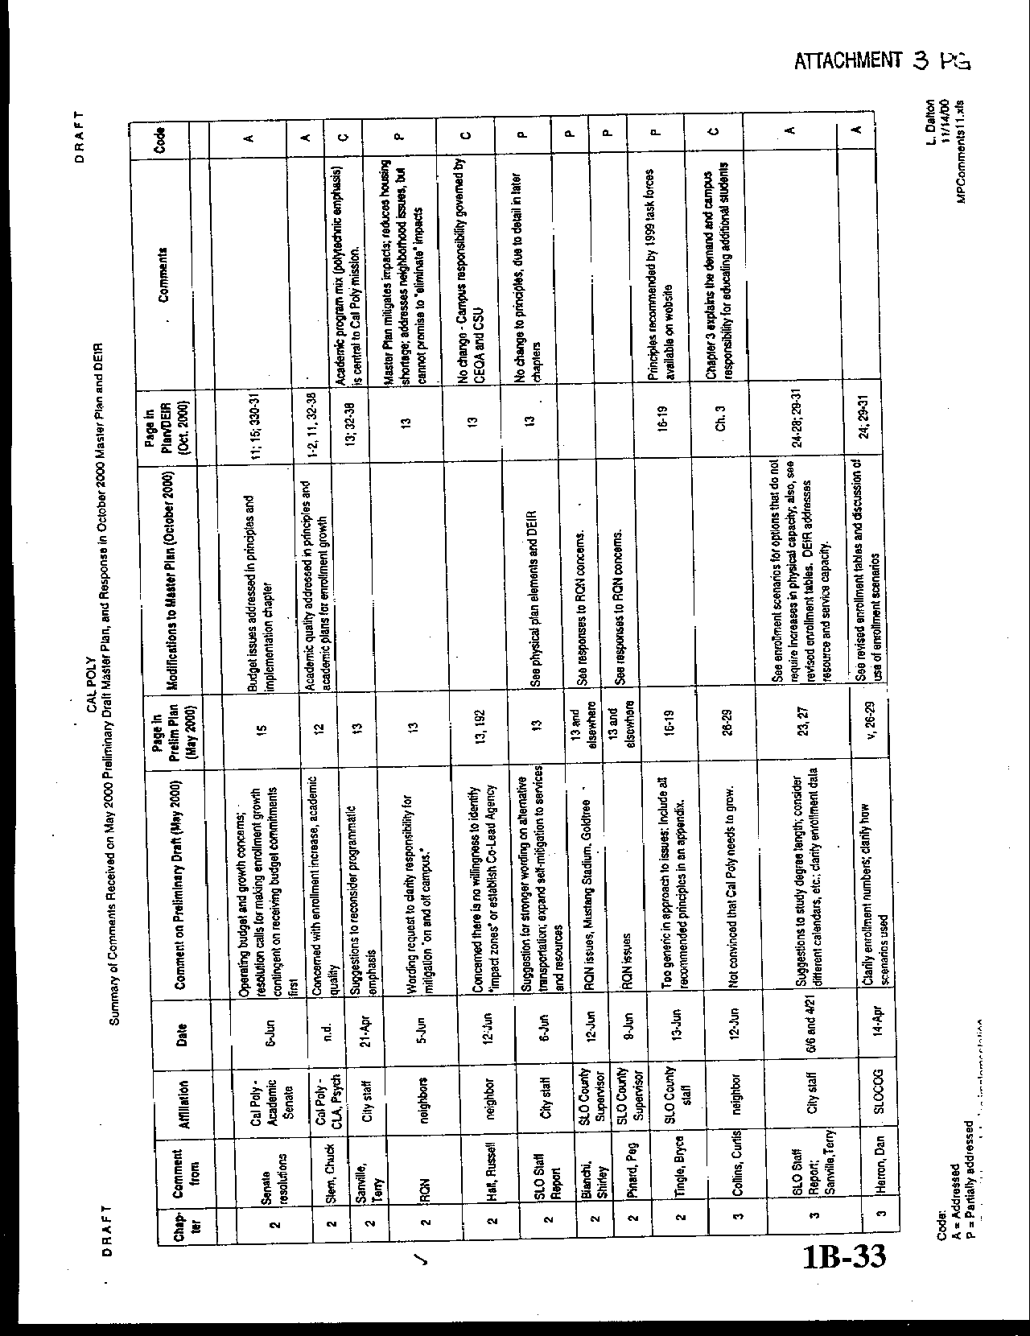
Letter 3
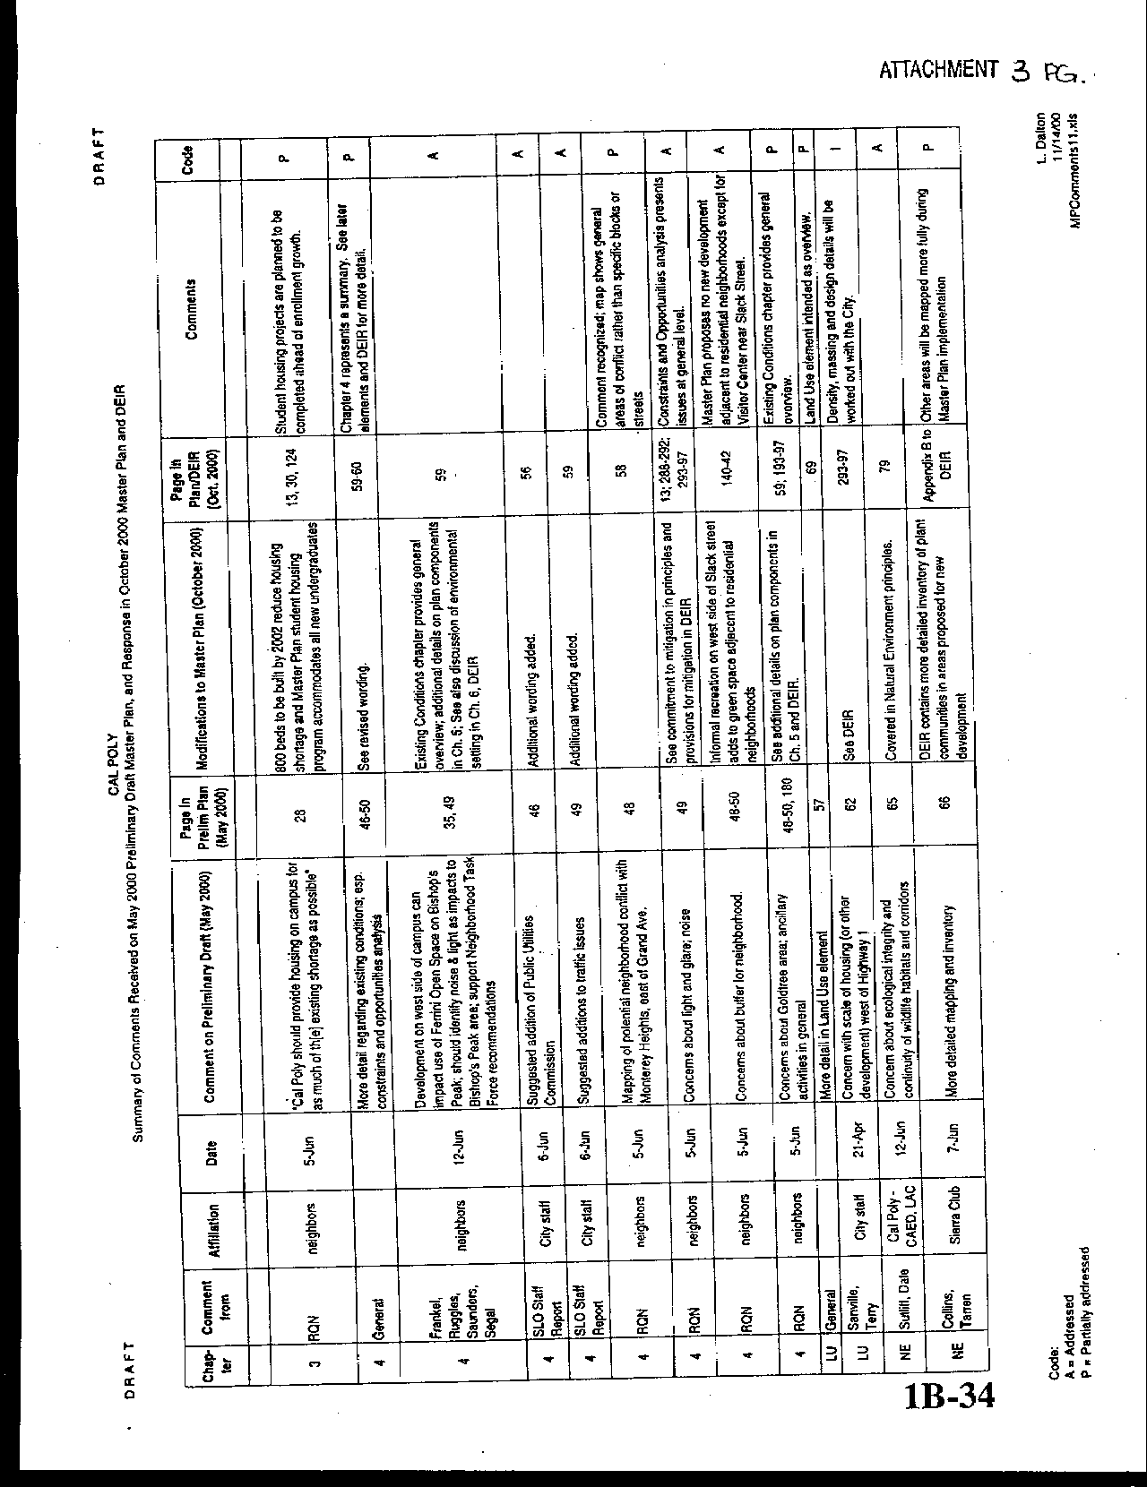
Letter 3
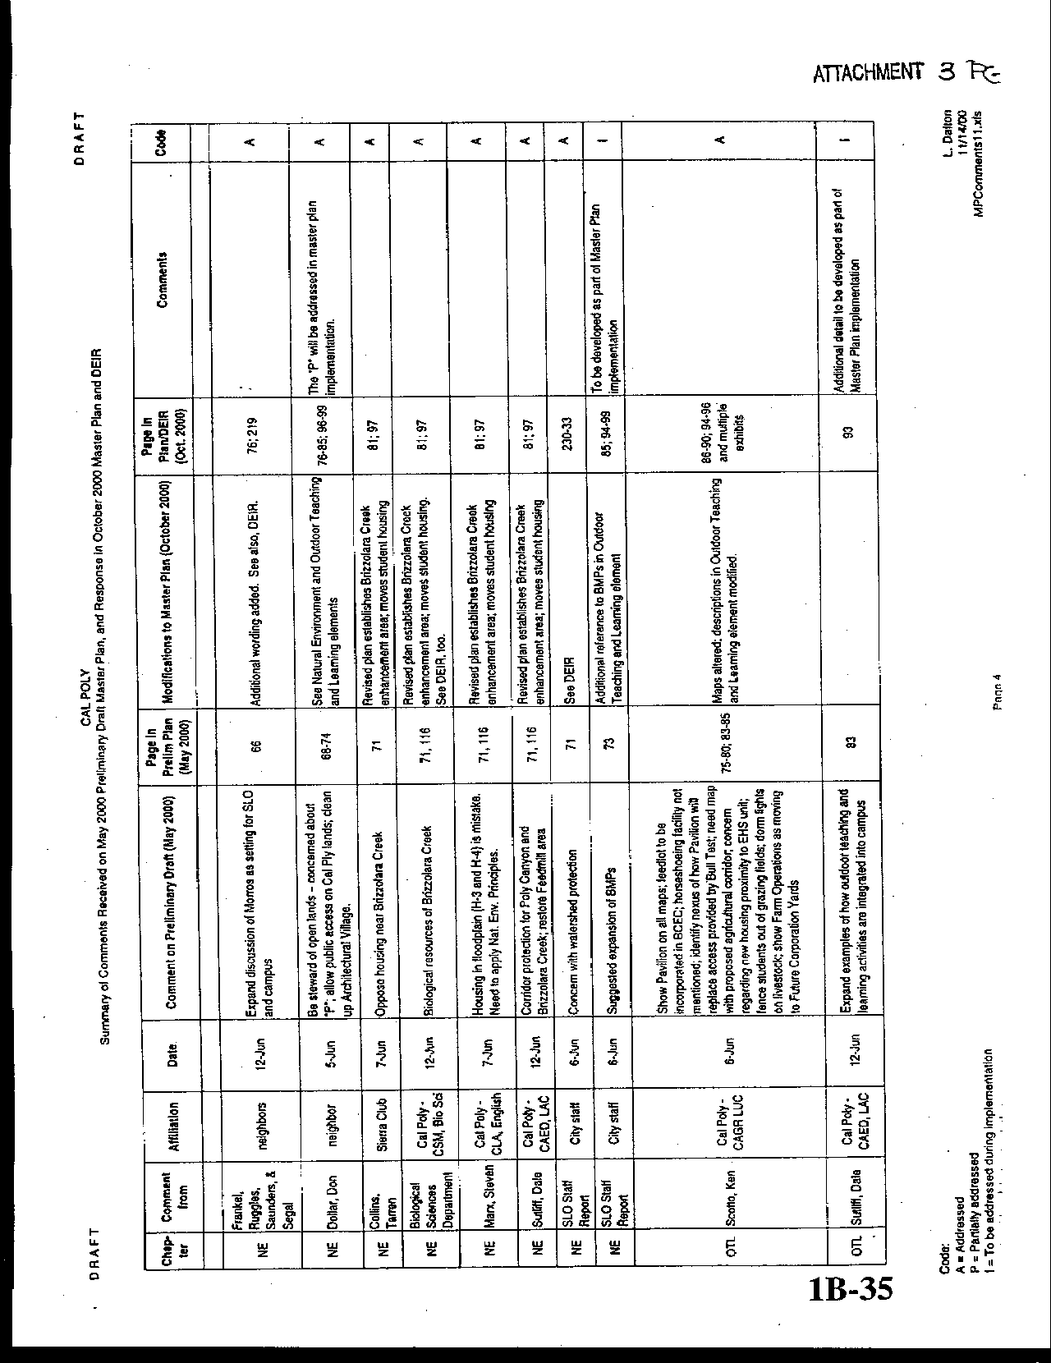
Letter 3
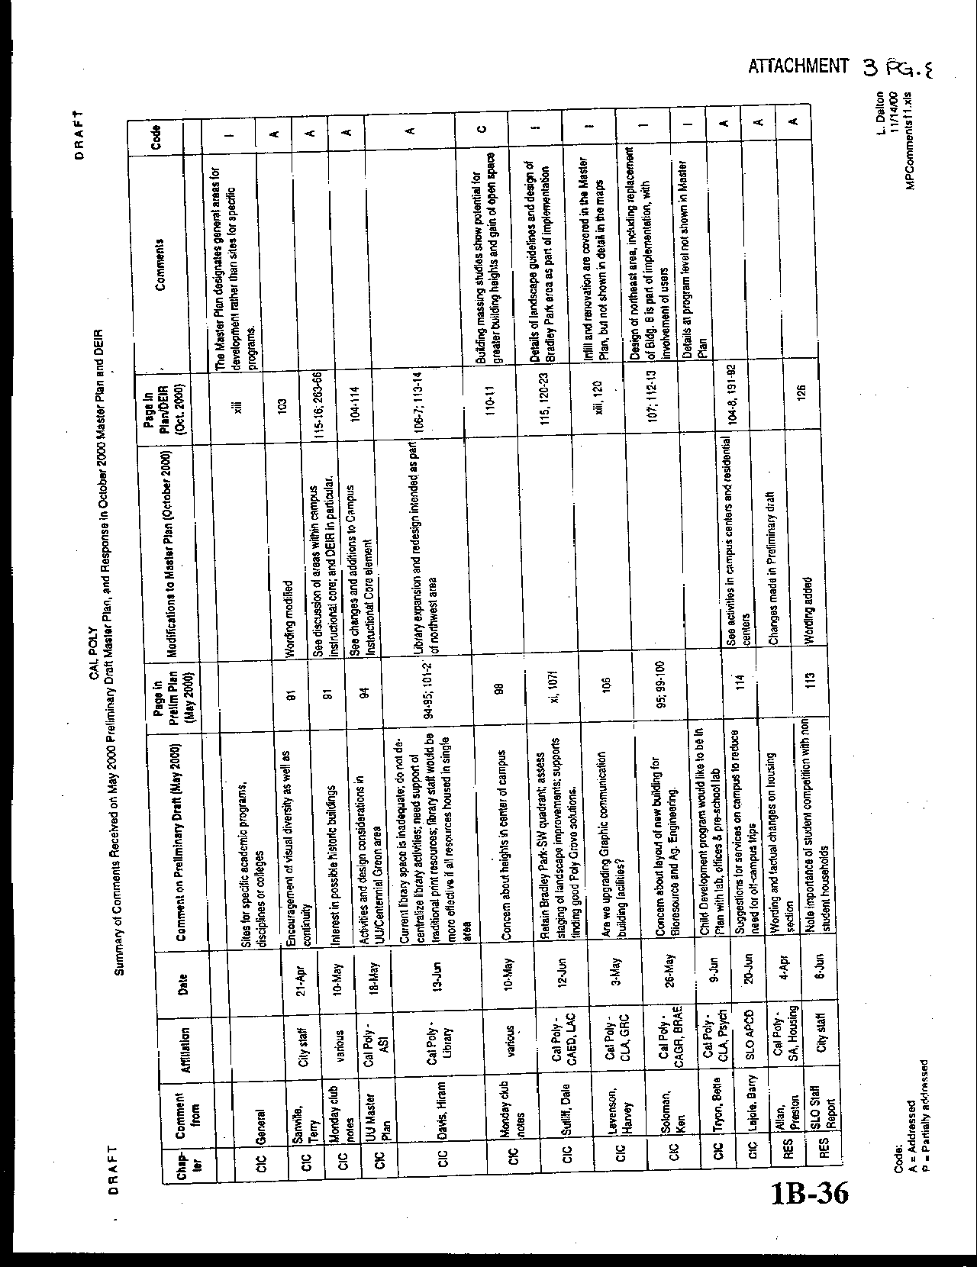
Letter 3
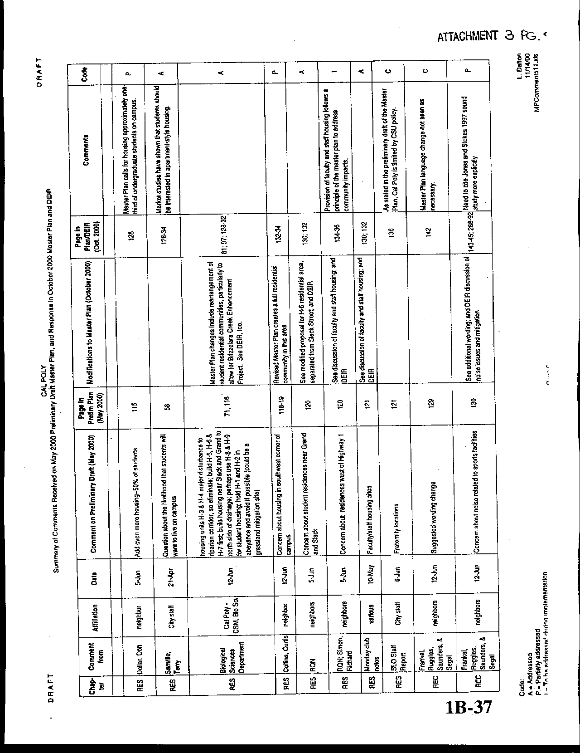
Letter 3
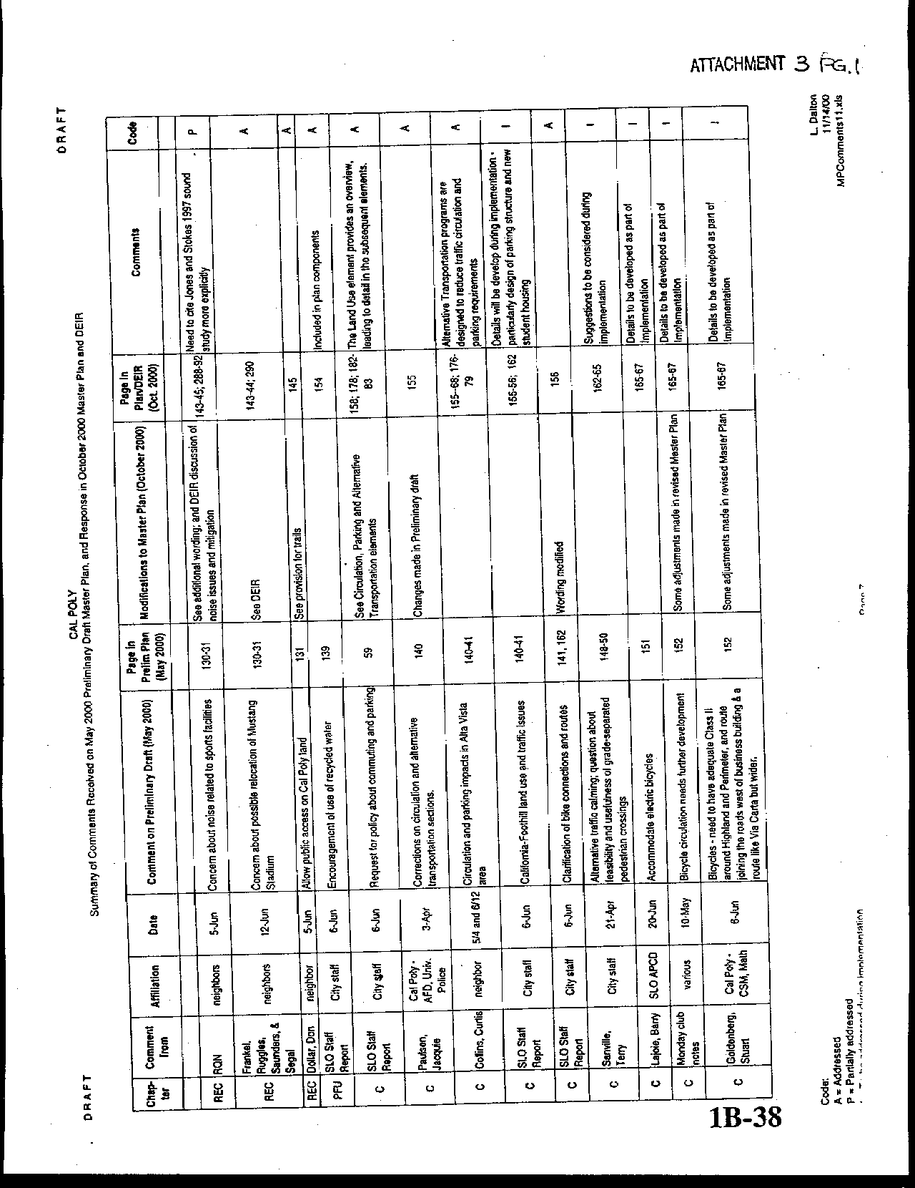
Letter 3
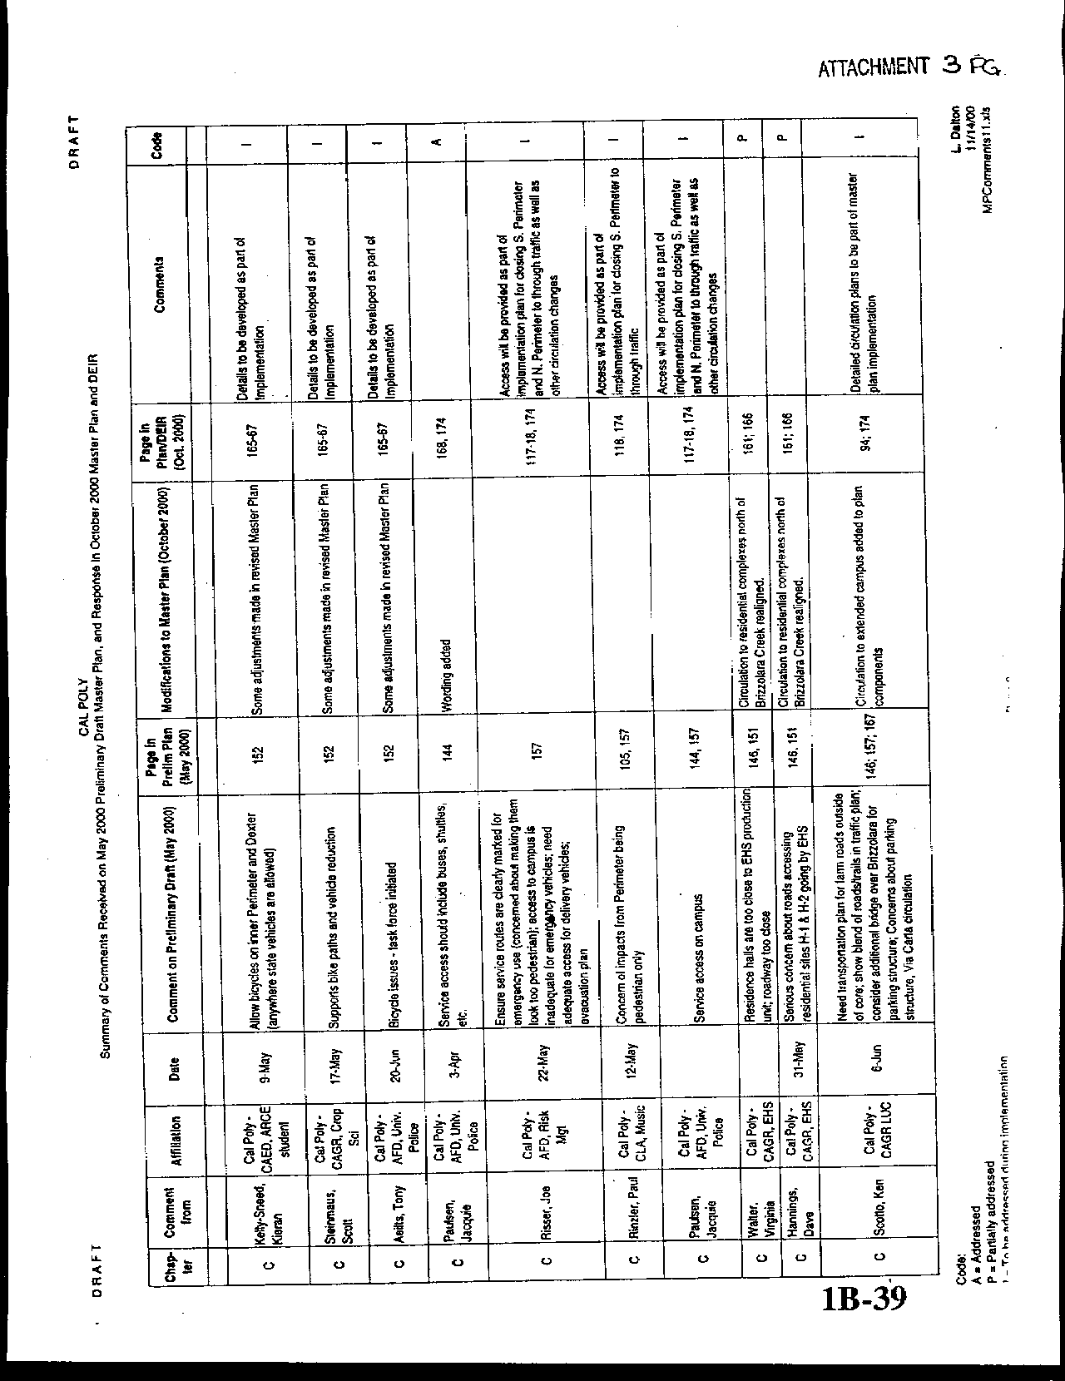
Letter 3
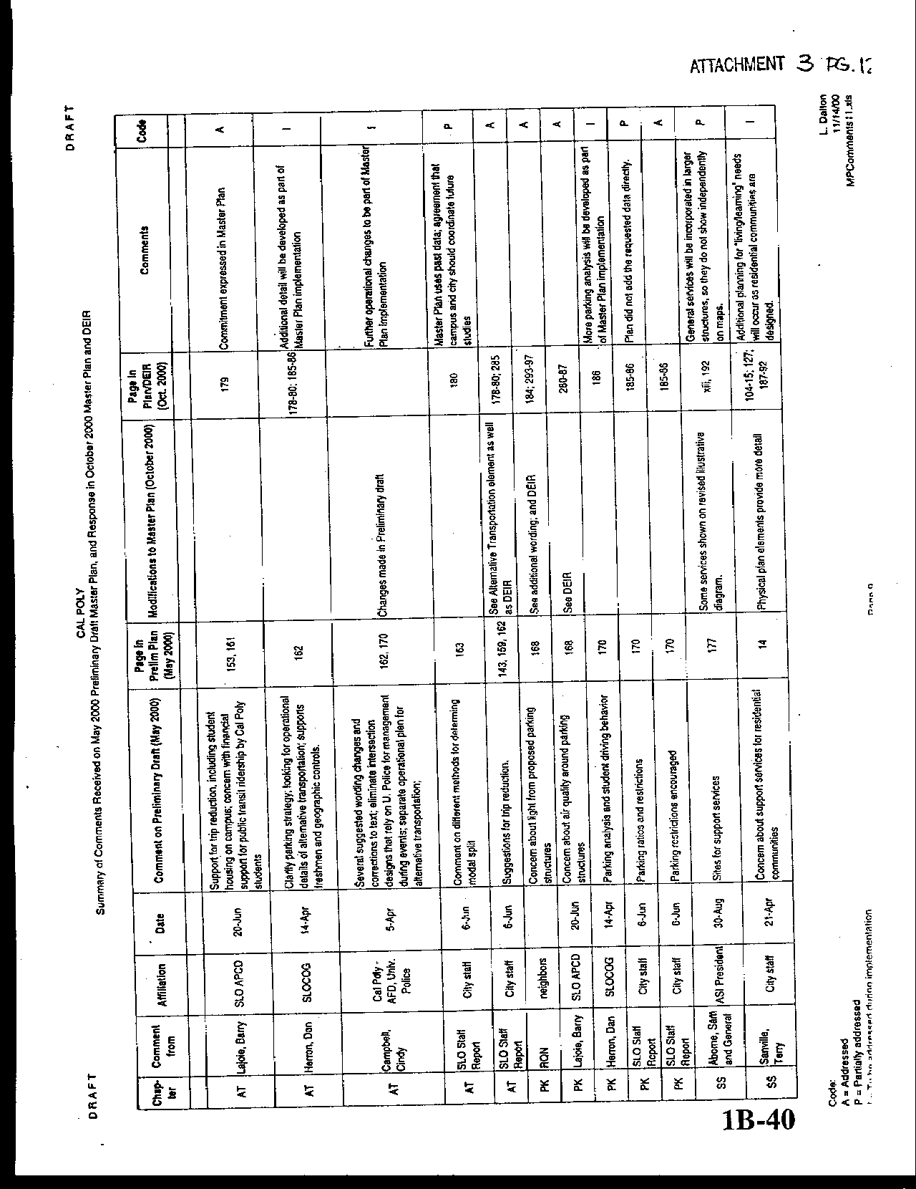
Letter 3
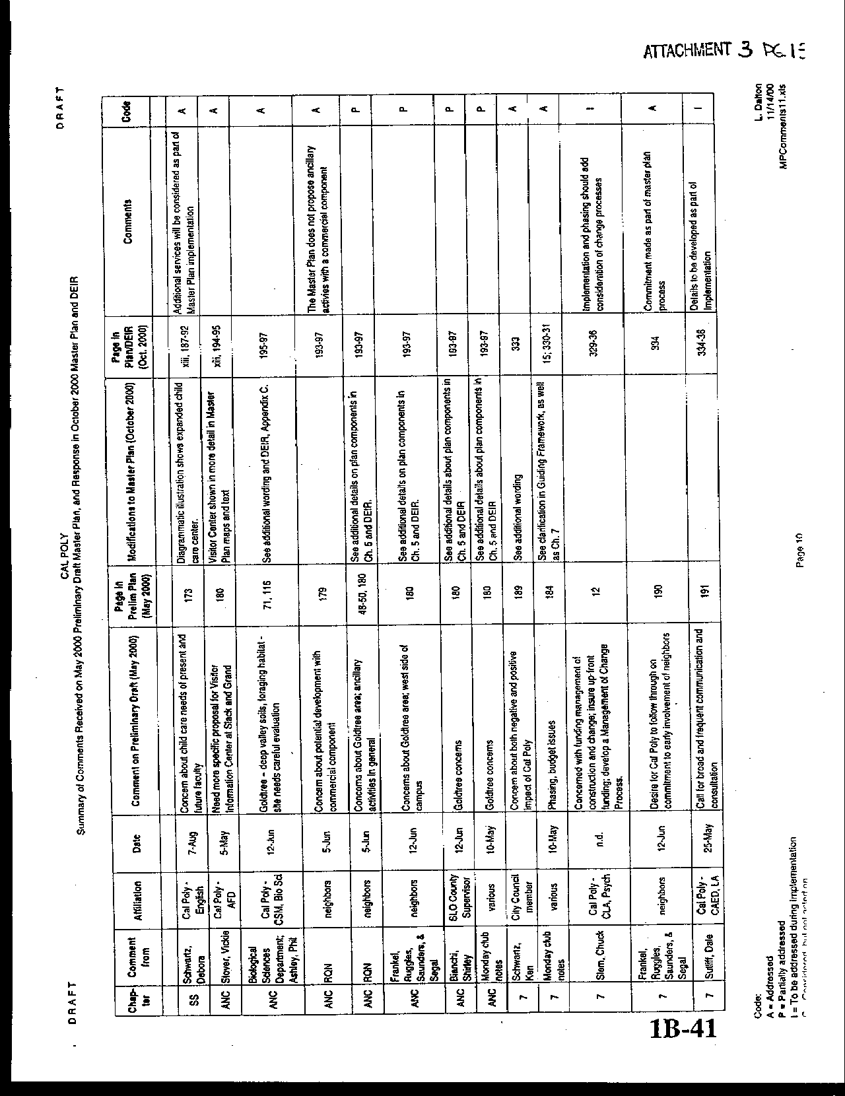
Letter 3
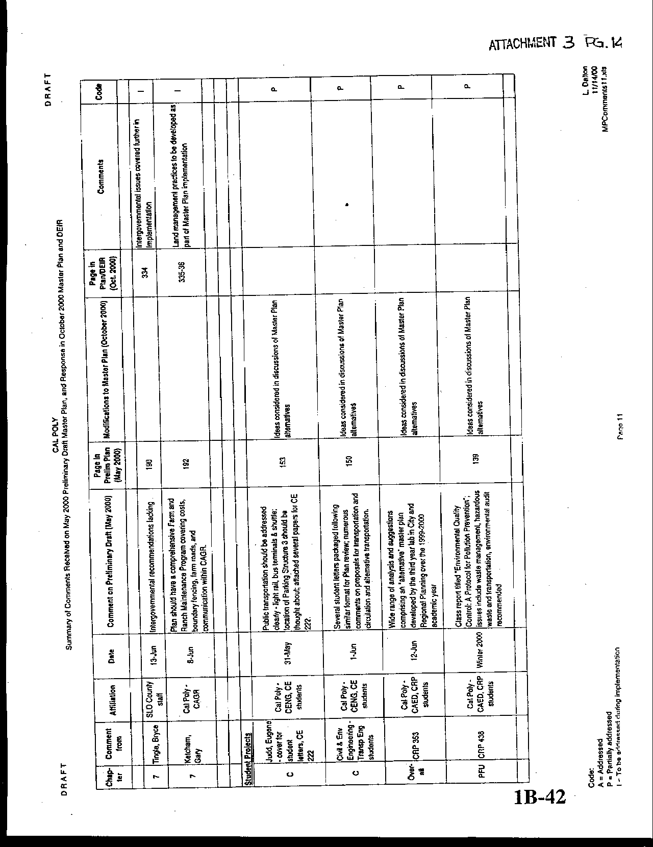
Letter 3
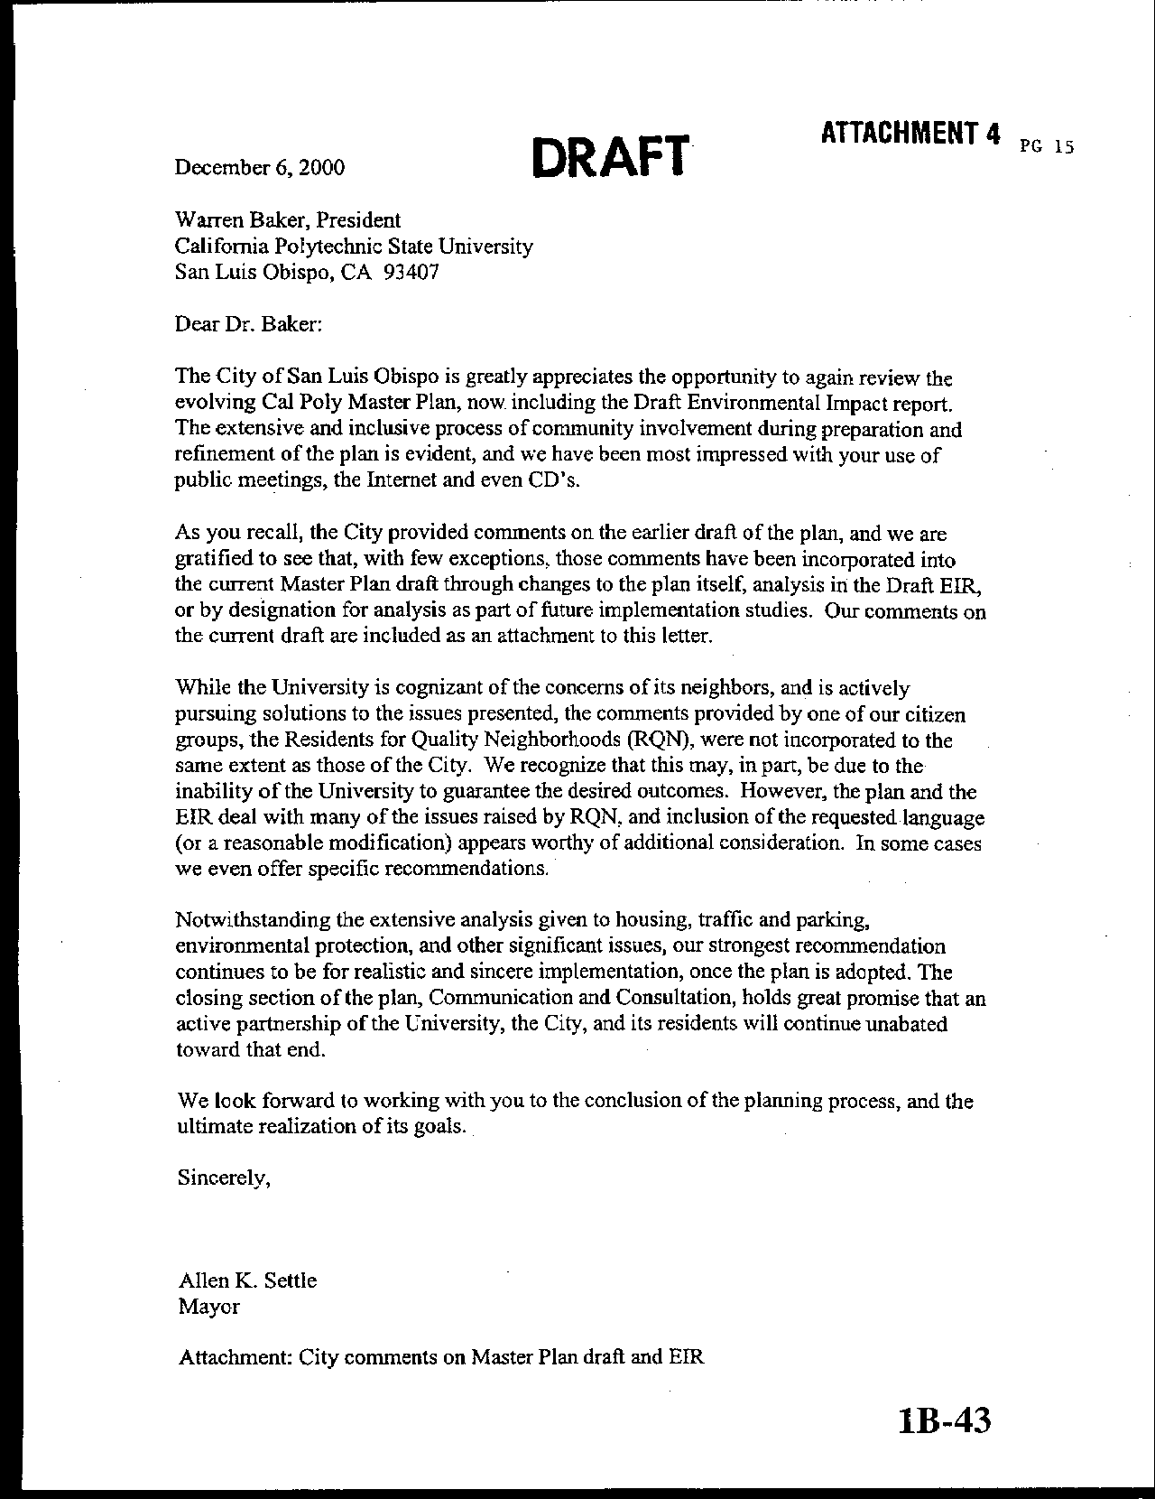
Letter 3
Letter 3
Mr. John Mandeville
City of San Luis Obispo

December 5, 2000

[Note: The letter from the City contained several lists of points. For reference purposes, we have coded the first set as General, 1 through 12; the second set as Previous, 1 through 11; and then added the remaining comments.]

3-1 General 1. A. Commenter suggests reducing the size of ancillary activity area at Grand and Slack.

Response Exhibit I on page vi shows more limited area and adds a buffer at Slack and Grand.

3-2 General 1. B. Commenter suggests recognizing potential neighborhood conflicts at Grand and Slack.

Response A double arrow has been moved on Exhibit 4.10 to the east of Grand Avenue to indicate potential neighborhood conflicts.

3-3 General 2. Commenter suggests designating the hill above residence halls to Natural Environment.

Response This area is currently used for grazing, which explains the Outdoor Teaching and Learning designation. This is consistent with other designations throughout the Cal Poly campus.

3-4 General 3. Commenter suggests retaining Outdoor Teaching and Learning lands in open, undeveloped use.

Response See text addition page 98-99, clarifying future status of Outdoor Teaching and Learning lands. A fundamental concept to understand with regard to the lands of Cal Poly is that it is not appropriate to think of them as “open space.” Such a designation may work in a municipality, but university property cannot be viewed this way. The lands of Cal Poly must support its academic mission. They must possess academic “assets” or, in the most severe situation, they may be viewed as “surplus.” Much of Cal Poly’s 6,000 acres in San Luis Obispo County is in an open and natural state, and will remain this way. It remains thus because it offers grazing for campus livestock, or biological study areas, or watershed management projects or any number of other academic activities. Understanding and appreciating this concept will assist the City with its goal of preserving a natural green belt around its borders.

3-5 General 4. The commenter suggests protecting Stenner as well as Brizzolara creek.

Response The following text has been added at page 103: “Guiding Principles and Goals for the Cal Poly Creek Management and Enhancement Plan” are located in Appendix F. The principles and goals will apply to all creeks on Cal Poly lands, including Stenner Creek. In addition, Cal Poly has partnered with the Land Conservancy of San Luis Obispo County. The Land Conservancy has undertaken several projects on Stenner Creek to reduce erosion and improve fisheries habitat, especially for the endangered steelhead. This enhancement work will continue with other reaches of the creek.

3-6 General 5. Concern about conflict/competition between on and off campus retail.

Response The vision of the Master Plan calls for a primary campus activity center near the University Union that is focused on students. The range of retail businesses and other activities would remain specialized and not constitute a full urban commercial center – and thus not compete directly with San Luis Obispo’s downtown. Cal Poly understands that there is a delicate balance in determining how much of what services will be sufficient to support the campus community and manage commuting. Effective alternative transportation will allow students, faculty, and staff – as well as members of the broader community – to take advantage of the range of services and facilities both on and off campus without adding to traffic congestion. The Cal Poly Foundation is presently the exclusive provider of certain services – e.g., food service, vending machines and bookstore. Other services compete for campus outlets – e.g., travel service, ATMs. As planning for an increased range and volume of services occurs, the campus will need to determine which it should offer directly and which might be provided through franchise or “privatization.”

3-7 General 6. The commenter suggests affirming student-housing impacts as major community concern.

Response Text has been added under the new heading “Background and Issues” on page 129 to clarify the existing shortage and address the major impact which student housing could have on the community. In addition, the following has been added in a section entitled, Commitment to Student Housing on Campus: “The Master Plan takes the local housing situation into account and proposes measures that will help alleviate a portion of it. The Guiding Framework of the Master Plan calls for adding student housing to accommodate all new enrollment growth. The campus will be breaking ground in Spring 2001 to build apartment-style housing for 800 students. This facility is scheduled to be ready for occupancy in Fall 2002. The next phase calls for housing from 1150 to 1300 additional students by 2004 or 2005. In sum, Cal Poly expects to add 1950 to 2100 student beds in the next five years, but only about 1250 additional students during that same time period. Over the next two decades Cal Poly will increase the proportion of students who live on campus from about 17 percent today to over 30 percent in the future” (p. 136).

“Further, Cal Poly will monitor the local market closely, and, if continuing students are not able to find suitable housing, the campus will develop a strategy to house a larger proportion of the University’s students in the future. Strategies may involve working with off-campus partners to identify suitable housing locations and provide financing. Cal Poly and Cuesta College are also exploring ways to cooperate in assuring appropriate housing for their students. Finally, Cal Poly will participate with non-profit organizations in seeking broader solutions to community housing needs” (p. 136).

3-8 General 7. The commenter suggests making every effort to develop on-campus housing.

Response The Plan is exhaustive in its attempts to house all new enrollment on campus, as well as provide off-campus housing for faculty and staff. Fraternities and sororities cannot be provided for on campus because state law and California State University policy prohibits the funding of group housing with exclusive membership.

3-9 General 8. The commenter suggests citing Jones and Stokes sound study.

Response The DEIR and the Master Plan have been amended to cite and incorporate the Jones and Stokes sound study completed for the Sports Complex.

3-10 General 9. The commenter suggests citing the Heery Sports Facilities Master Plan.

Response The Heery Sports Facilities Master Plan has been cited in the Master Plan and DEIR. Note that the Heery plan was developed by a consulting team to suggest the approach to all campus athletic facilities. The plan is not “adopted,” it is only advisory. The Master Plan team used the Heery plan as background information, incorporating some of its suggestions, but not all. For example, the football stadium design in the Heery Plan will not be followed.

3-11 General 10. Document parking space reduction.

Response The following table has been used for estimating where savings would occur in parking demand. The Master Plan policy is to reduce parking demand by 2,000 spaces.

Estimated Parking Demand Reductions

Approach | Savings | Relative  Cost | Safety Valve*
Freshmen restrictions | 1,000~1,500 | L | some no.
Geographic controls | 500 | L | appeal
Car/vanpools | 300 | M
Lottery | As determined | L | appeal
Parking Fees | minor | L | appeal
On-campus transit | moderate | H
City transit | minor | H
Bike/ped enhancmt | moderate | H
Area mgt | minor | L
Fac/Staff incentives | minor | M
Entertainment | moderate | H
Enrollment scenarios | moderate | M
Note: alternative transportation savings will be lower for Cal Poly because many of these programs are in existence and functioning well.

*Absolute controls will require provisions (safety valve) for hardships.

The University, as stated policy in the Master Plan, will reduce demand by 2,000 spaces. This reduction can be achieved through a number of measures. Over time, the feasibility and success of various measures will vary. For this reason, it is impractical to commit, at a Master Plan level, to absolutes. For example, an important idea is having an on campus and near campus shuttle. But this needs to be subjected to feasibility studies and trial programs, which the University will do.

To meet the parking reduction proposal of 2,000 spaces, Cal Poly intends to institute as a first, and most effective measure, that freshmen be required to live on campus and that they not be allowed to maintain cars on campus (with exceptions made for hardship and job-related requirements). We believe that the inelasticity of demand Cal Poly will prevent this policy from having a detrimental effect on the dormitory market. This restriction exists at other universities, including UC Santa Cruz.

It is estimated that there will be about 4,000 new undergraduate students each Fall (about 3,000 freshmen) at Cal Poly under the full growth anticipated with the Master Plan. Currently, we house approximately 80% ~ 90% of our freshmen on campus, and the campus provides 1,530 parking spaces for residents (R1 & R2). At present ratios, approximately 1,800 spaces would be needed under the Master Plan for freshmen. Allowing for some hardship requirements for freshmen, it is anticipated that approximately 1,500 or more spaces could be reduced with this policy alone.

This policy will do more than just reduce cars on campus. It will change the culture of the campus, infusing a higher regard for the environment and a reduced reliance on the automobile. As students advance through the University, they will do so with the ability to use alternative modes of transportation.

3-12 General 11. The commenter suggests clarifying future uses in Goldtree area; concern with compatibility with off-campus resources.

Response At Goldtree an applied research park would be developed in partnership with the local community. Thus, local businesses would have an opportunity to be considered as vendors and service providers as well as occupants of the applied research park. The facility has been sited in a location that has relatively low-value grazing land, low visibility from Highway 1, is adjacent to the City’s wastewater treatment plant, and near the California Men’s Colony. Additional environmental work will be undertaken when a project for the site has been developed.

3-13 General 12. The commenter suggests including the plan amendment process with provision for community notification, involvement and consultation.

Response A section on plan monitoring, review and revision has been added to Chapter 7.

The Land Use and Project Review Procedures to be established to implement the Master Plan will include the following considerations.
- Establishment of a project development team that represents all affected University interests;
- Identification of responsibility for liaison with elected officials and local and regional agencies, as appropriate to the nature of the project;
- Identification of the appropriate neighborhood areas that may be affected by the project so that meetings may be held early in project planning and design regarding ways to relieve possible impacts.

3-14 Previous 1. The commenter suggests a bolder commitment to alternative transportation.

Response Text on page 188 (Principles, subheading Support) has been amended from “Cal Poly should continue to work with city and regional agencies to make alternative transportation increasingly convenient, including scheduling, access and quality of service” to say the following: “Cal Poly will continue to provide financial support for public transportation. Further, the campus should explore how the University can balance the allocation of resources toward trip reduction programs rather than toward the cost of providing more parking on campus.”

Cal Poly currently has the most successful alternative transportation program of any organization in the county.

3-15 Previous 2. The commenter suggests following City policies and standards for off-campus housing.

Response See text in Environmental Consequences discussion. Cal Poly reviewed City and County policies for the development of the Master Plan. To the extent that doing so does not interfere with the academic mission of the school, Cal Poly will strive to meet the spirit of the policies developed by its neighboring jurisdictions. The environmental review of the off-campus housing will include a discussion of consistency with City policies.

3-16 Previous 3. The commenter suggests seeking CSU policy change to allow fraternity housing on campus.

Response CSU policy does not permit campuses to provide housing for organizations with selective membership. Cal Poly will monitor this policy for any system-wide changes.

3-17 Previous 4. The commenter suggests citing and confirming the use of Jones and Stokes noise study.

Response The DEIR and the Master Plan have been amended to cite the Jones and Stokes sound study done for the Sports Complex. The study has been incorporated into the analysis of the FEIR at Chapter 6, Noise.

3-18 Previous 5. The commenter suggests making a commitment to unified analysis and planning with City.

Response As part of the Communication and Consultation section of Chapter 7, the Master Plan includes provision for consultation with elected officials and local and regional agencies.

3-19 Previous 6. The commenter suggests giving high priority to parking studies and mitigation.

Response Comment noted. The Master Plan specifies this plan as part of its implementation studies.

3-20 Previous 7. The commenter suggests clarifying language in EIR regarding light and glare.

Response Language regarding light and glare and the mitigation of impacts has been added to pertinent sections of the EIR.

3-21 Previous 8. A. The commenter suggests amending constraints summary to include Goldtree area.

Response Further discussion and a map has been added to the constraints summary to show the Goldtree area (pp. 64-65).

3-22 Previous 8. B. The commenter suggests amending constraints summary to include potential neighborhood conflicts near Slack and Grant.

Response A double arrow has been relocated on Exhibit 4.10east of Grand Avenue to indicate the potential for neighborhood conflicts. It was the original intention of the constraints analysis to include this area, but the exhibit is not at a scale to identify this level of detail.

3-23 Previous 9. The commenter suggests including RQN language regarding environmental consequences on nearby residential neighborhoods.

Response Text on page 15 has been amended (Question 3, f, third bullet) from “Planning future campus facilities so as to mitigate environmental impacts as part of project design” to “Planning future campus facilities and support services so as to minimize and mitigate environmental impacts on and off campus to the full extent feasible as part of project design.”

3-24 Previous 10. The commenter suggests clarifying "commercial component" in campus core and Goldtree area.

Response The range of retail businesses and other activities in the campus core would remain specialized and not constitute a full urban commercial center. At Goldtree an applied research park would be developed in partnership with the local community. Thus, local businesses would have an opportunity to be considered as vendors and service providers as well as occupants of the applied research park.

3-25 Previous 11. The commenter suggests providing for additional environmental review for future projects.

Response Chapter 7 describes how future projects will be reviewed within the context of the program EIR for the Master Plan.

Following adoption of the Master Plan, Cal Poly will engage in a series of implementation studies (specified in Chapter 7). As projects are planned and built, they will be reviewed and monitored for compliance with the environmental analysis as well as with meeting plan expectations to reinforce the academic quality of the University. Many projects will require additional environmental review in the form of Negative Declarations or focused EIRs. The Campus Planning Committee will review the Master Plan annually so as to determine whether conditions have changed sufficiently to warrant a major update.

3-26 The commenter requests recognition of neighborhood impact at Grand Ave. and Slack Street.

Response A double arrow has been relocated on Exhibit 4.10 east of Grand Avenue to indicate the potential for neighborhood conflicts.

3-27 The commenter suggests designating hill above residence halls to Natural Environment.

Response This area is currently used for grazing, which explains the Outdoor Teaching and Learning designation.

3-28 The commenter suggests clarifying Visitor Center site and conference facility expectations at Grand and Slack.

Response Map change shows more limited area and adds a buffer; see also text changes on p. 206. A visitor center would provide a facility to welcome guests to the campus. It could include a station where visitors could obtain parking permits, campus maps, and directions to their destinations. The visitor center could serve as the starting point for campus tours conducted by Poly Reps. It could also include a small exhibit covering Cal Poly’s history and accomplishments.

No detailed program has been suggested for a conference center, yet the idea has been studied several times and continues to arise. Presently, Cal Poly’s Conference Services use regular campus facilities during times that they are not scheduled for instruction, and house attendees in some of the residence halls during the summer. The Master Plan calls for an expansion of alumni services near the present Alumni House, which may include small conference or retreat facilities. In addition, the area near Grand Avenue and Slack Street has been suggested for potential conference facilities. Cal Poly will continue to use its residence halls during the off-season to support conferences.

3-29 The commenter suggests adding specific language to retain environmentally sensitive areas in open, undeveloped use.

Response Text has been added on page 82, under “Stewardship” as follows: “The principle of stewardship includes permanent protection of environmentally sensitive areas as open, undeveloped lands. As noted by the commenter, the University’s approach to land use differs from that of the City and the County. There is no “Open Space” designation. With the update of the Master Plan, Cal Poly has designated all of its lands to a particular use. The areas designated Outdoor Teaching and Learning are, for most of the acreage involved, agricultural, and most of that is grazing. Some of the agricultural land may see improvements in the future that include accessory farm structures or teaching quarters. Specific “Ancillary” activity areas have been designated on the land use map (Exhibit i).

It is important to understand the fundamental premises in land use designations for Cal Poly, and how these differ from other jurisdictions. No development that is inconsistent with the land use designations will be allowed without a Master Plan amendment granted by the CSU Board of Trustees. Such changes would require CEQA compliance and public comment. Also, it is important to understand that all the land of the University must, in some sense, forward the academic mission of Cal Poly. Approaching areas of campus as “open space” would raise the question with CSU as to whether the land is necessary and should be surplused. That would be counter productive to any City strategy of protecting open space in its green belt.

3-30 The commenter suggests giving equivalent attention to Stenner Creek.

Response The following text has been added on page 103: “Guiding Principles and Goals for the Cal Ply Creek Management and Enhancement Plan” are located in Appendix F. The principles and goals will apply to all creeks on Cal Poly lands, including Stenner Creek. In addition, Cal Poly has partnered with the Land Conservancy of San Luis Obispo County. The Land Conservancy has undertaken several projects on Stenner Creek to reduce erosion and improve fisheries habitat, especially for the endangered steelhead. This enhancement work will continue with other reaches of the creek.”

3-31 The commenter notes trade-offs between providing commercial services for students, faculty and staff on and off campus.

Response The range of retail businesses and other activities would remain specialized and not constitute a full urban commercial center – and thus not compete directly with San Luis Obispo’s downtown.

3-32 The commenter suggests expanding commitment to student housing, timing and financial feasibility.

Response Additional sections have been added to the Residential Communities element to address these issues; please refer to pages 129 to 136.

3-33 The commenter suggests clarifying references to Heery Sports Facilities Master Plan, especially with respect to possible relocation of Mustang Stadium.

Response The Heery Sports Facilities Master Plan has been cited in the Master Plan and DEIR. Note that the Heery plan was developed by a consulting team to suggest the approach to all campus athletic facilities. The plan is not “adopted,” it is only advisory. The Master Plan team used the Heery plan as background information, incorporating some of its suggestions, but not all. Refer to the marginal note added on page 145 for clarification.

3-34 The commenter suggests clarifying the status of Mustang Stadium, including potential for remodeling rather than relocation.

Response Refer to page 146, text (formerly on p. 138) referring to Mustang Stadium has been deleted. Note that the Master Plan does not propose relocating Mustang Stadium. It does suggest that if it needs to be moved, the preferred location would be as suggested in the Heery plan, on the lower fields of the Sports Complex. Mustang Stadium can be remodeled, which was also suggested in the Heery plan. Nevertheless, any relocation of Mustang Stadium will require careful design in order to minimize impacts to adjacent neighborhoods, especially with regard to lighting and noise, as well as additional environmental review. See p. 151 for discussion of renovation of Mustang Stadium as the preferred option.

3-35 The commenter suggests adding "controls to inhibit at-grade pedestrian crossing" along railroad right of way.

Response The map (Exhibit 5.13) has been amended to show this change.

3-36 The commenter notes correction for "Americans with Disabilities Act".

Response This text correction has been made in the Circulation Element, page 174.

3-37 The commenter suggests siting a pedestrian path along Brizzolara Creek outside riparian corridor; minimize creek crossings.

Response Text on page 174, second to last bullet, has been changed from “ Develop a new pedestrian path along Brizzolara Creek from the California/Highland intersection to the new residential housing village at the Poly Canyon entrance. The path should be sensitively sited to support restoration of this natural creek corridor” to read “Develop a new pedestrian path along Brizzolara Creek from the California/Highland intersection to the new residential housing community at the Poly Canyon entrance. The path should be sensitively sited to support restoration of this natural creek corridor. This path will be designed as part of the Brizzolara Creek Enhancement Project to ensure that it is located outside the riparian corridor. Creek crossings will be consolidated and minimized.”

3-38 Commenter offers supports for electric or low-emissions vehicles for shuttle service.

Response The following bullet has been added to page 177: “Use state-of-the-art technologies to add to the convenience and efficiency of transit use.”

3-39 Commenter notes roadway section does not show pedestrian crossings.

Response Text on page 179 has been corrected.

3-40 The commenter suggests confirming feasibility of reduction in parking demand.

Response Please see Response 3-11, above.

3-41 Commenter raises concern that development of ancillary activities in the Goldtree area may create community conflicts and compete with off-campus activities and generate impacts.

Response At Goldtree an applied research park would be developed in partnership with the local community. Thus, local businesses would have an opportunity to be considered as vendors and service providers as well as occupants of the applied research park. Ancillary activities would not create significant peak traffic demand. They would also be contained within facilities so concerns about aesthetics, light and glare would need to be addressed during site and building design and development.

3-42 The commenter suggests the need to strengthen discussion of process, particularly for plan amendment.

Response A section on plan monitoring, review and revision has been added to Chapter 7.

3-43 The commenter suggests reviewing the list of implementation guidelines, standards, and studies for completeness.

Response Chapter 7 has been revised to include a more comprehensive list of implementation studies.

3-44 Comment incorporates letter dated December 3, 2000 from Bishop's Peak neighborhood residents to SLO City Council.

Response See December 8, 2000 correspondence from Bishop's Peak neighborhood residents (Letter 52).

3-45 Comment incorporates letter from RQN dated December 4, 2000 to SLO City Council.

Response See RQN correspondence from December 4 and June 6, 2000 (Letter 58).

3-46 Comment incorporates e-mail message from Richard Kranzdorf dated 12/5/00 to SLO City Council.

Response See Kranzdorf correspondence of December 5, 2000 (Letter 23).

3-47 Comment incorporates testimony and correspondence from Naoma Wright to SLO City Council, 12/5/00 and 12/600 -- request for Cal Poly and Cuesta to provide more student housing.

Response See additional sections added to Residential Communities element (p. 136).
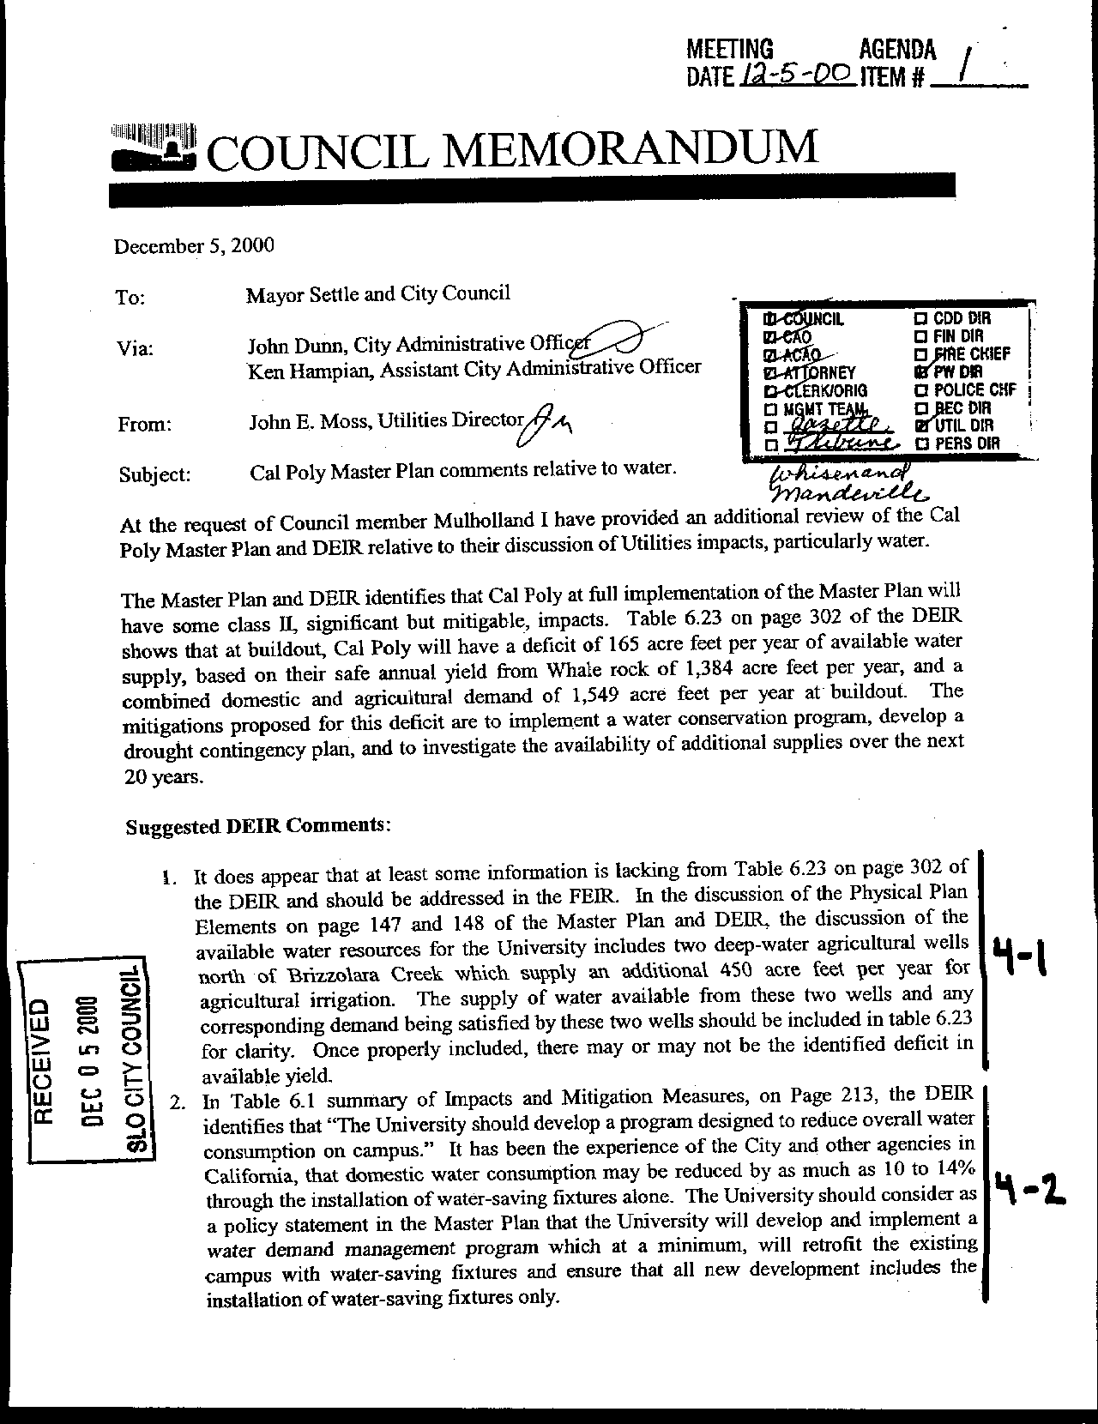
Letter 4
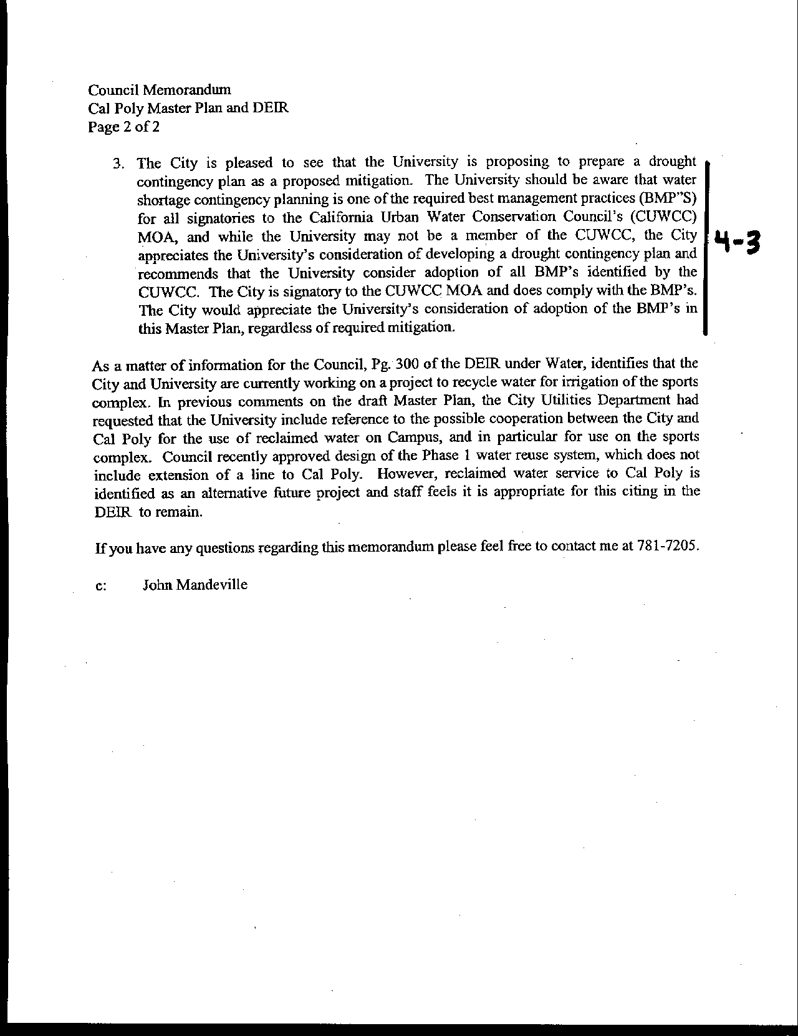
Letter 4
Letter 4
Mr. John Moss
City of San Luis Obispo

December 5, 2000

4-1 Regarding a lack of sufficient water supplies for the Master Plan, the commenter notes the University should incorporate agricultural irrigation wells as part of the supply.

Response Comment noted. The actual yield of agricultural wells is uncertain; the University has five wells, two of which draw from shallow, creek-fed water tables. The other three are located on Chorro Ranch and their capacity is also unknown. The text has been changed to reflect the uncertainty of agricultural well supplies. The University continues to have a long-term potential for deficiency.

4-2 Consider a policy to implement a water demand management program that, at a minimum, will retrofit existing fixtures.

Response Comment noted. The mitigation includes incorporation of water-saving fixtures into all new development, retrofit of older facilities over time, and modification of landscaping irrigation requirements. This effort is part of the Master Plan implementation program set forth in Chapter 7.

4-3 Consider adopting the California Urban Water Conservation Council’s best management practices as part of the University’s drought contingency plan.

Response Comment noted. The University is currently working with the Regional Water Quality Control Board to develop its comprehensive Water Quality Management Plan in order to adopt BMP’s as standard practice.

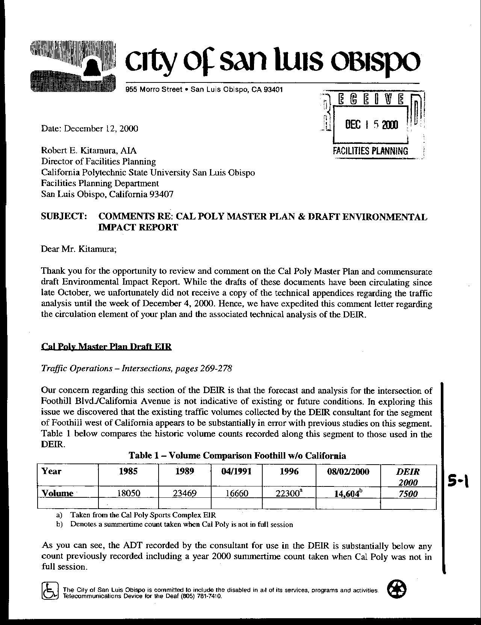
Letter 5
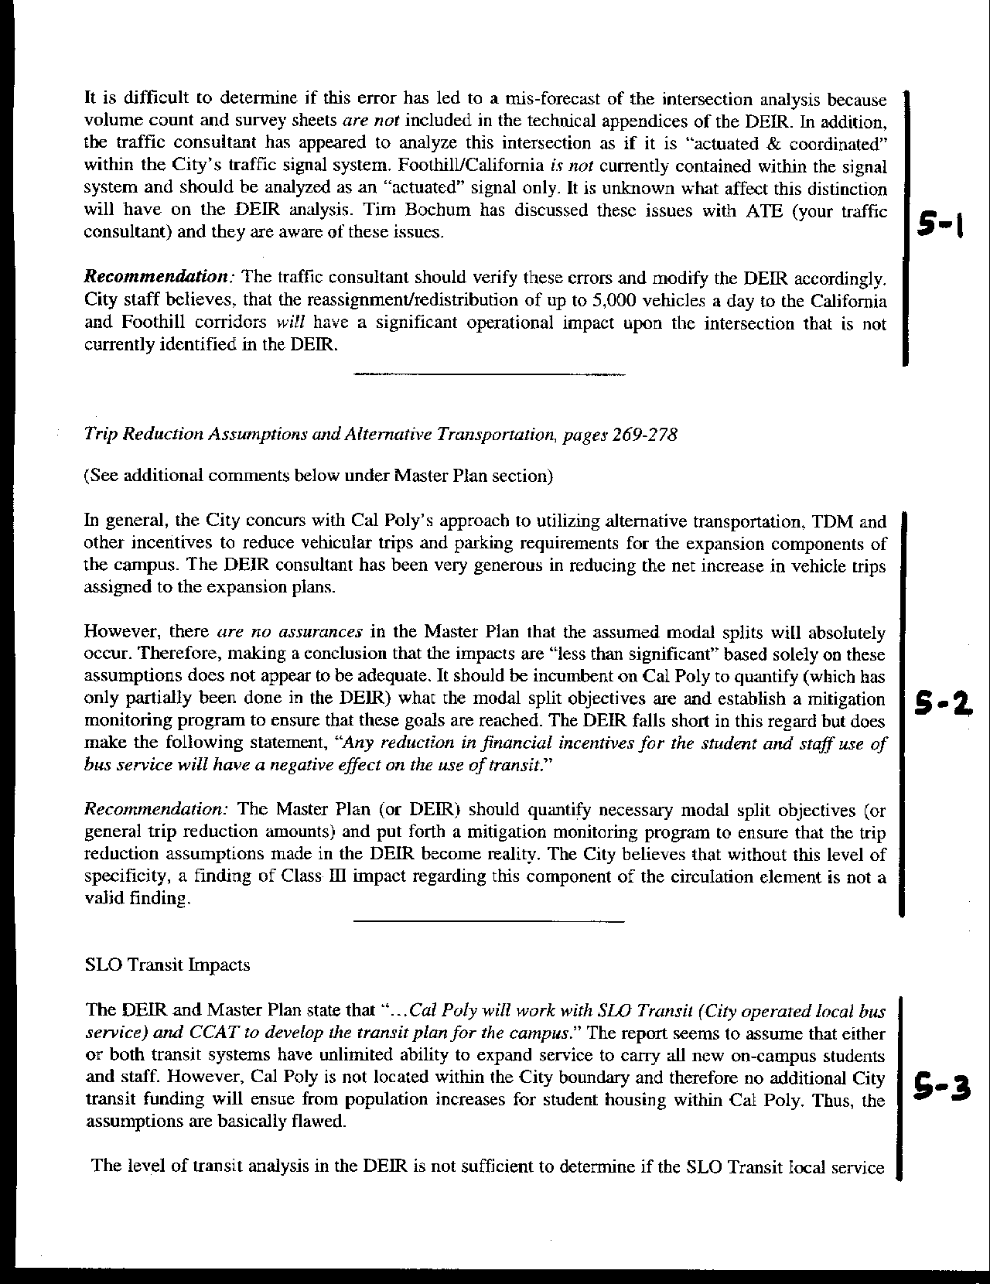
Letter 5
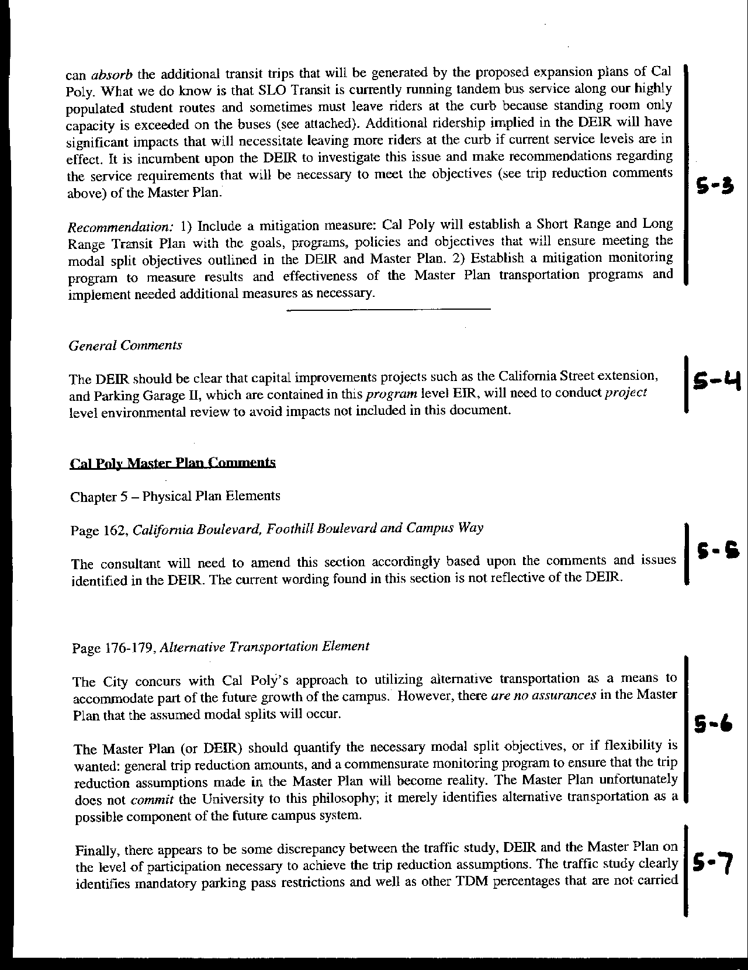
Letter 5
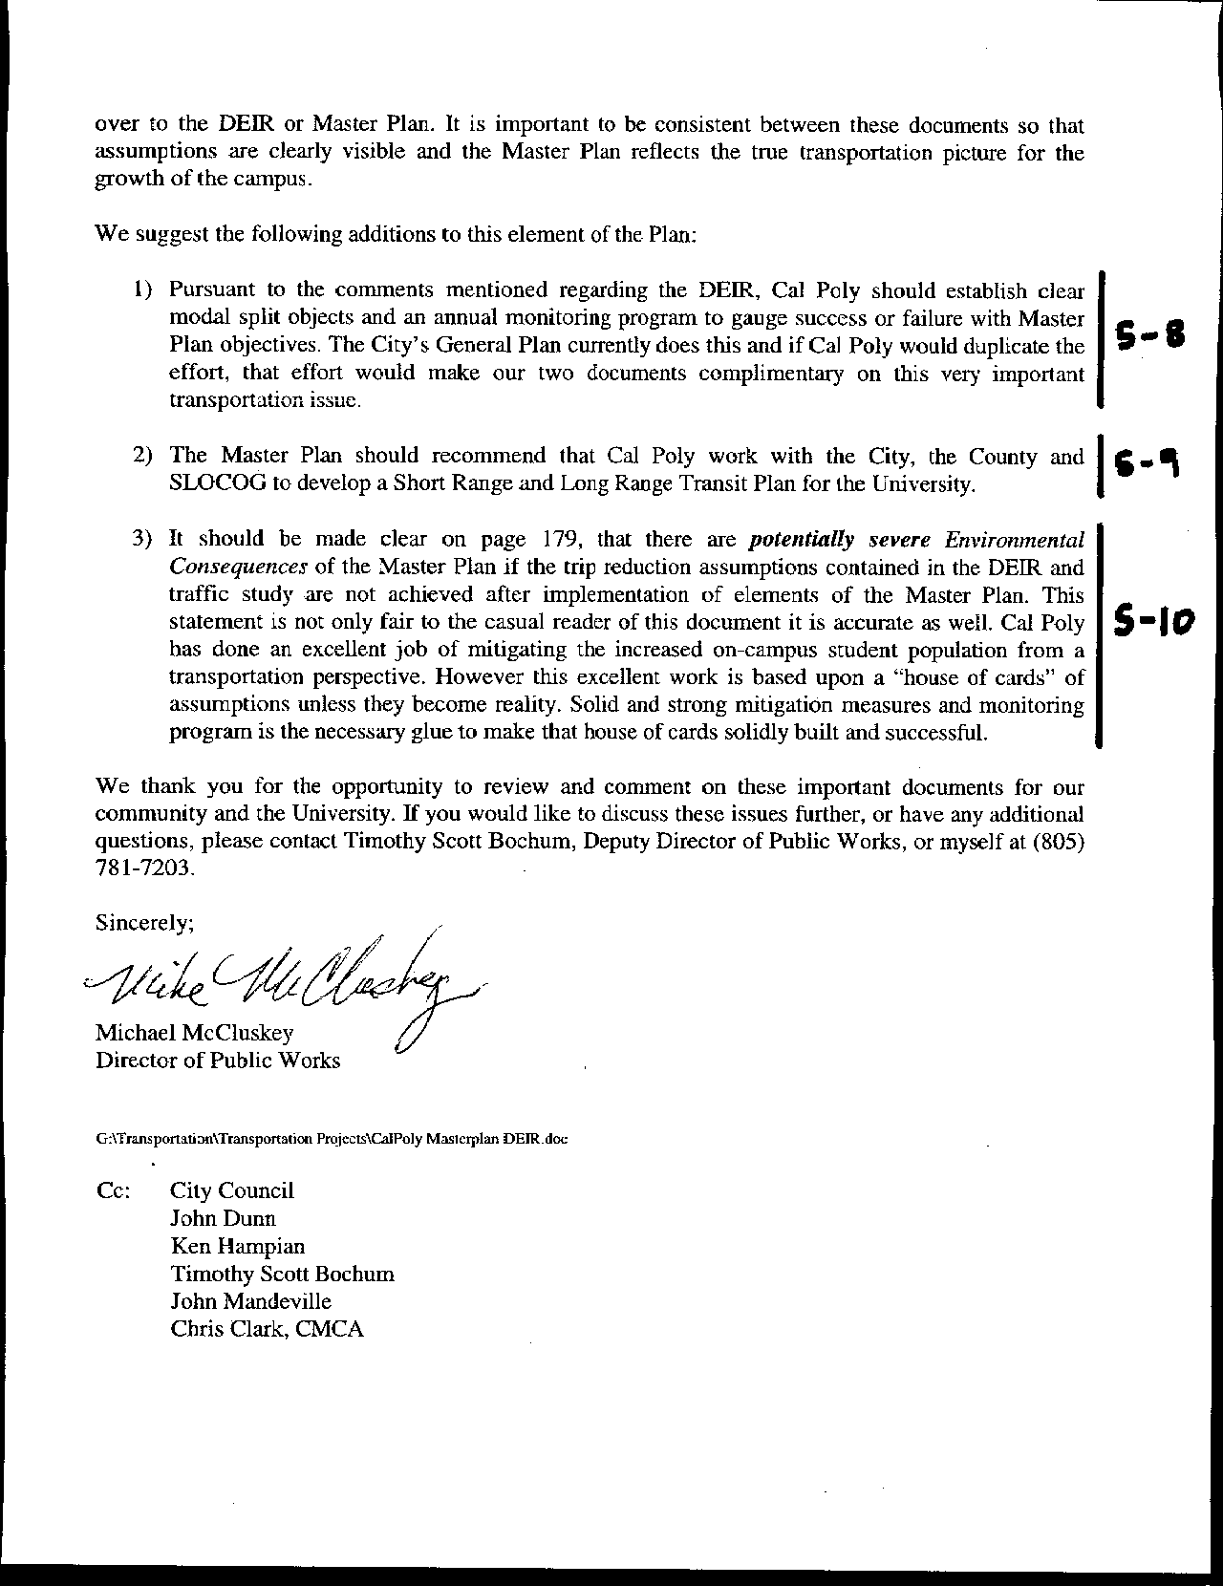
Letter 5
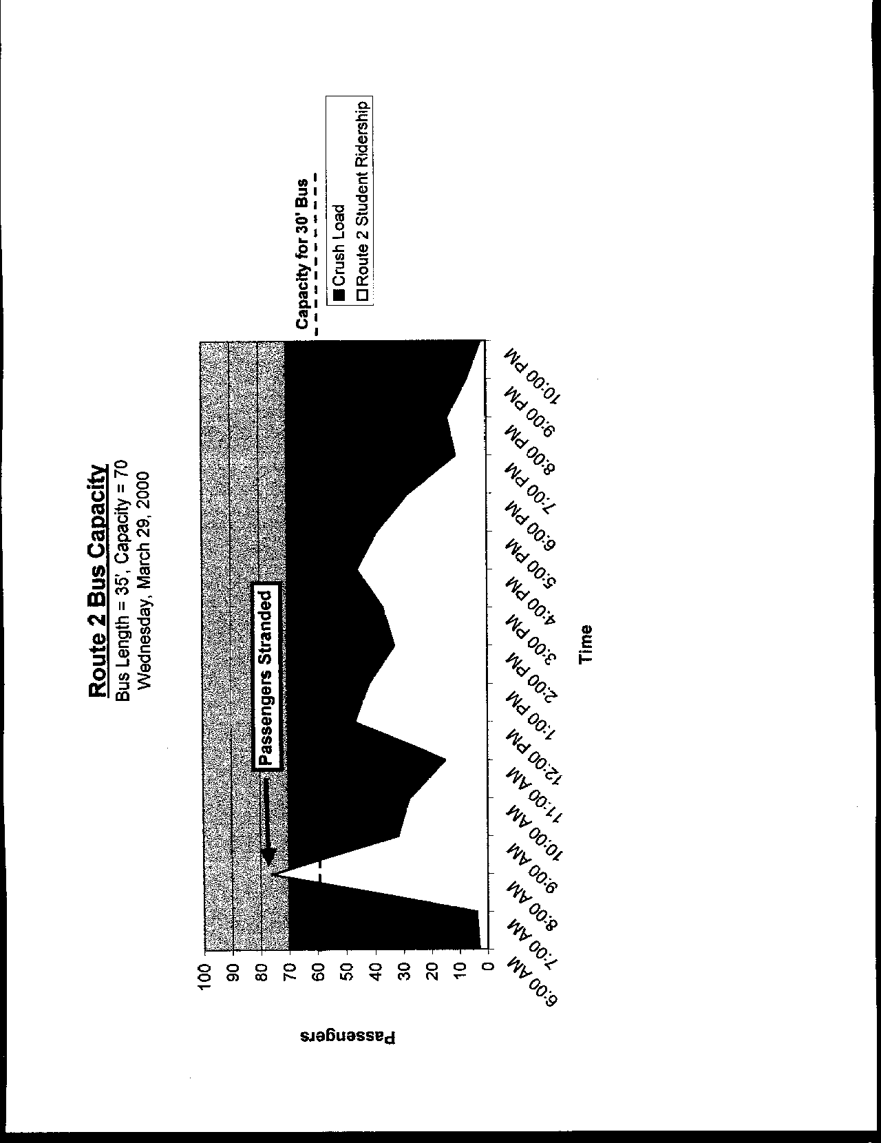
Letter 5
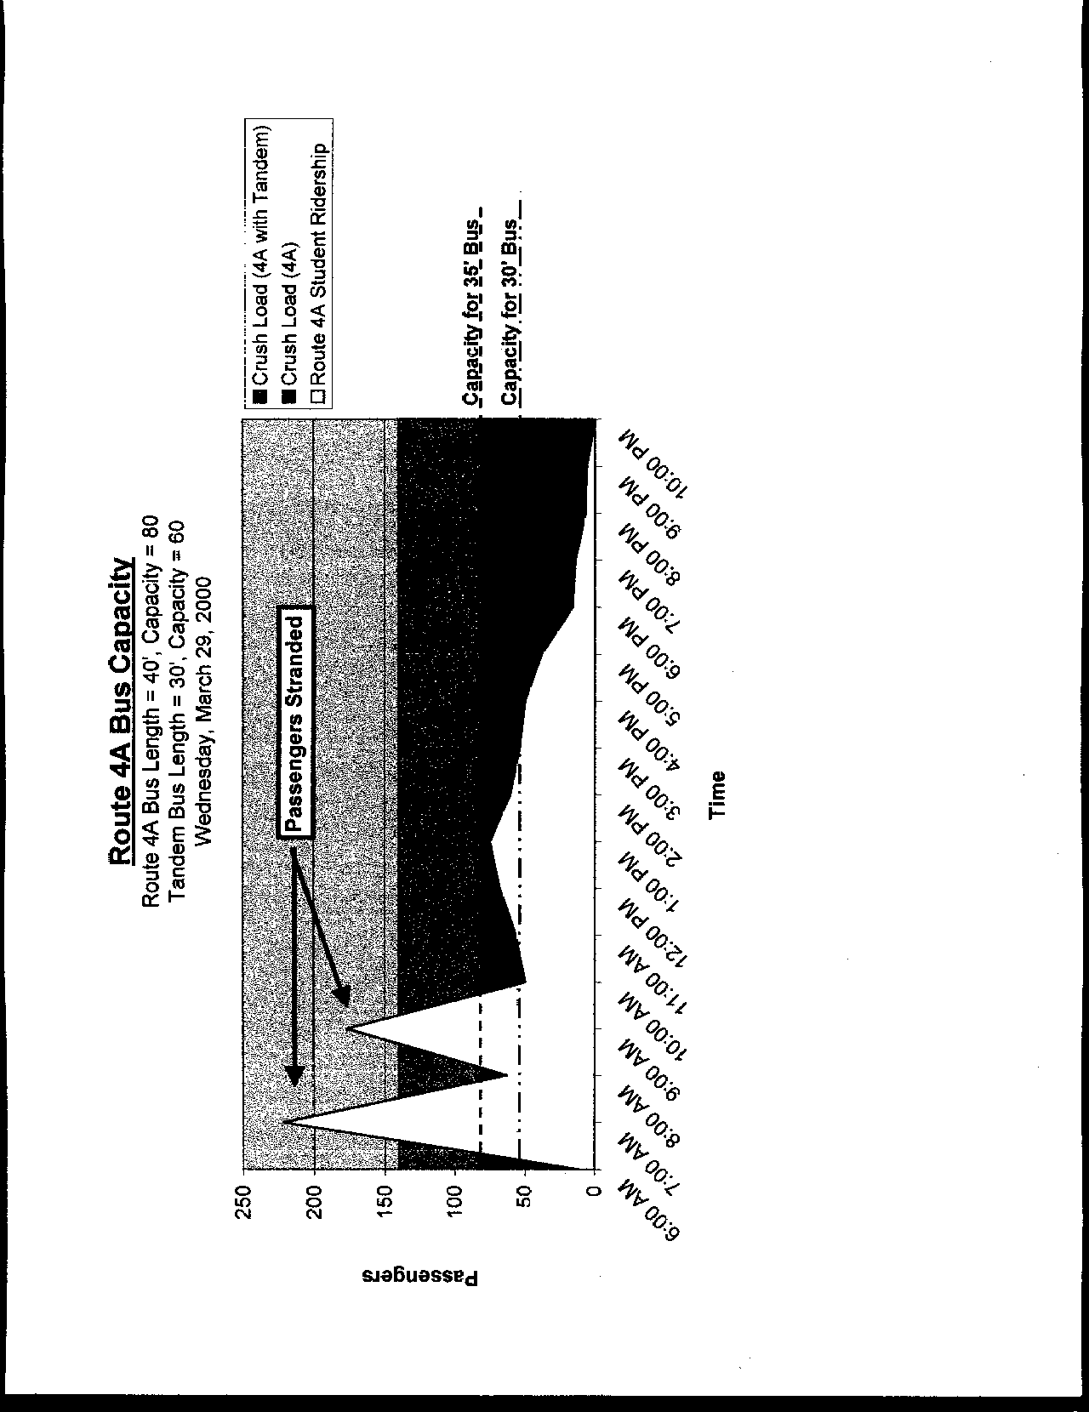
Letter 5
Letter 5
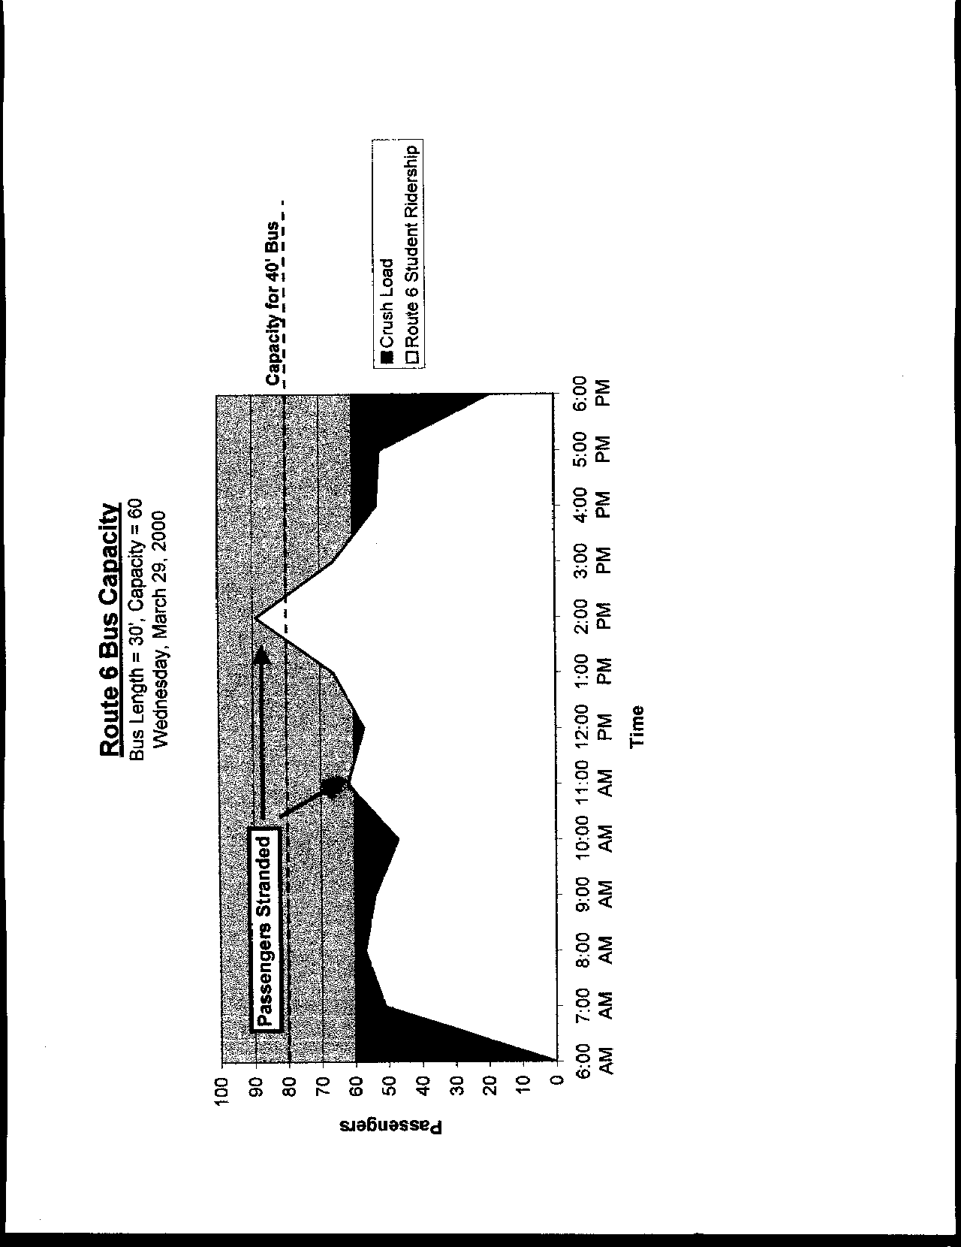
Letter 5
Letter 5
Mr. Michael McCloskey
City of San Luis Obispo, Public Works

December 12, 2000

5-1 Commenter suggests that traffic volumes reported for the Foothill Boulevard/California Avenue segments of the circulation system appear to be in error. This could substantially change the impact analysis for the intersection at Foothill and California.

Response The traffic volumes (ADT) were reported in error. These figures have been corrected in the text of the Final EIR. However, the intersection volumes were taken separately from the roadway ADT count and are correct. The level of service (LOS) for the Foothill/California intersection was calculated assuming actuated signal control (rather than actuated-coordinated as reported in the study). The resulting LOS are shown below in Table A.
Table A
Foothill/California Levels of Service

Scenario | A.M. Peak Hour | P.M. Peak Hour
Existing | 12.2 Sec / LOS B | 21.7 sec / LOS C
Baseline | 13.8 Sec / LOS B | 25.5 Sec / LOS C
Baseline + Project | 14.3 Sec / LOS B | 30.4 Sec / LOS C
Cumulative | 16.3 Sec / LOS B | 36.1 Sec / LOS D
Cumulative + Project | 16.8 Sec / LOS B | 42.7 Sec / LOS D

5-2 Commenter suggests an inadequacy in the environmental analysis of the impacts to circulation because the plan does not mandate trip reductions through alternative transportation and other means. The plan should quantify necessary modal split objectives.

Response The plan does mandate trip reductions. The fundamental trip reduction mechanism is housing all new enrollment on campus. This would be the functional equivalent of the City adding a new residence for every new job created within San Luis Obispo. Furthermore, the campus will institute a policy of restricting freshmen from having automobiles on campus. The Master Plan states as policy that the demand for 2,000 parking spaces will be eliminated. The following table has been used for estimating where savings would occur in parking demand.

Estimated Parking Demand Reductions

Approach | Savings | Relative  Cost | Safety Valve*
Freshmen restrictions | 1,000~1,500 | L | some no.
Geographic controls | 500 | L | appeal
Car/vanpools | 300 | M
Lottery | As determined | L | appeal
Parking Fees | minor | L | appeal
On-campus transit | moderate | H
City transit | minor | H
Bike/ped enhancmt | moderate | H
Area mgt | minor | L
Fac/Staff incentives | minor | M
Entertainment | moderate | H
Enrollment scenarios | moderate | M
Note: alternative transportation savings will be lower for Cal Poly because many of these programs are in existence and functioning well.

*Absolute controls will require provisions (safety valve) for hardships.

The University, as stated policy in the Master Plan, would reduce demand by 2,000 spaces. This reduction can be achieved through a number of measures. Over time, the feasibility and success of various measures will vary. For this reason, it is impractical to commit, at a Master Plan level, to absolutes. For example, an important idea is having an on campus and near campus shuttle. But this needs to be subjected to feasibility studies and trial programs, which the University will do.

To meet the parking reduction proposal of 2,000 spaces, Cal Poly intends to institute as a first, and most effective measure, that freshmen be required to live on campus and that they not be allowed to maintain cars on campus (with exceptions made for hardship and job-related requirements). We believe that the inelasticity of demand Cal Poly will prevent this policy from having a detrimental effect on the dormitory market. This restriction exists at other universities, including UC Santa Cruz.

It is estimated that there will be about 4,000 new undergraduate students each Fall (about 3,000 freshmen) at Cal Poly under the full growth anticipated with the Master Plan. Currently, we house approximately 80% ~ 90% of our freshmen on campus, and the campus provides 1,530 parking spaces for residents (R1 & R2). At present ratios, approximately 1,800 spaces would be needed under the Master Plan for freshmen. Allowing for some hardship requirements for freshmen, it is anticipated that approximately 1,500 or more spaces could be reduced with this policy alone.

This policy will do more than just reduce cars on campus. It will change the culture of the campus, infusing a higher regard for the environment and a reduced reliance on the automobile. As students advance through the University, they will do so with the ability to use alternative modes of transportation.

5-3 Commenter suggests transit impacts are not adequately quantified in the DEIR. The capacity of the transit system to absorb the necessary increase in ridership has not been established. Further suggests that mitigation and monitoring be added to reinforce transit objectives.

Response The enrollment increases will take place over the next twenty years. During this time, Cal Poly will work with the transit providers to enable the increase in capacity necessitated by this and other growth. The City will also increase, both in residences and jobs (especially the latter) and will also require additional transportation alternatives. Cal Poly will work with the City to monitor the use of transit services. In addition, Cal Poly will begin a feasibility study, as part of the implementation of the Master Plan, for a near campus shuttle system, which could reduce the impacts on the local transit providers.

5-4 Commenter suggests that the DEIR be clarified regarding the need for project level environmental review for capital projects such as California Boulevard extension and Parking Structure II.

Response Comment noted. Individual projects will be subjected to additional environmental review. Chapter 7 describes how future projects will be reviewed within the context of the program EIR for the Master Plan.

The Land Use and Project Review Procedures to be established to implement the Master Plan will include the following considerations.

- Establishment of a project development team that represents all affected University interests;
- Identification of responsibility for liaison with elected officials and local and regional agencies, as appropriate to the nature of the project;
- Identification of the appropriate neighborhood areas that may be affected by the project so that meetings may be held early in project planning and design regarding ways to relieve possible impacts.

5-5 Commenter notes that page 162 of the plan (new page 171) will require modification consistent with comment number 5-1.

Response The text has been modified.

5-6 Commenter offers concern that the modal split objectives have no assurance that they will be achieved. He further suggests that further mitigation (see 5-9 below) and monitoring be instituted.

Response The Master Plan proposes housing all new enrollment on campus. All of these on-campus residents will use a mode of transportation that is an alternative to vehicular use, namely, walking. In addition, freshmen will be restricted from using automobiles.

5-7 Commenter notes discrepancies between DEIR, plan, and traffic study as to required level of participation necessary to achieve trip reduction assumptions.

Response The Master Plan has been clarified to identify how trip reduction would be achieved, providing a commitment to funding the bus subsidy at least at current amounts (see p. 189).

5-8 Commenter suggests adding clear modal split objectives and an annual monitoring program.

Response Please see Response 5-2, above.

5-9 Commenter suggests Cal Poly work with the City, County, and SLOCOG to develop a Short Range and Long Range Transit Plan for the University.

Response Text which read “City Transit Improvements - Continue to work with transit providers to improve local transit to campus to meet future needs” has been changed to read “Integrated Transit Plan – Work with SLOCOG, City and County to develop both short and long term transit plans” (p. 189).

5-10 Commenter suggests the “potentially severe environmental consequences” will result if the trip reduction assumptions in the plan are not achieved.

Response Many commenters, including the City of San Luis Obispo, Caltrans, SLOCOG, and others have stated strong concerns with Cal Poly’s alternative transportation approach in the Master Plan. Michael McCloskey, Director of Public Works for the City of San Luis Obispo, observes that Cal Poly’s vehicle trip reduction program is “based upon a ‘house of cards’ of assumptions” which will collapse unless recommended mitigation measures are made reality. This description is apt.

The Cal Poly Master Plan was initiated in part by the California State University’s proclamation that it would endeavor to educate the growing ranks of students referred to as Tidal Wave II, the children of the baby boom. Cal Poly would take its reasonable share of those students. At the outset of the Master Plan process President Baker declared, as a matter of policy, that all new enrollment would be housed on campus. The University would not exacerbate an extremely tight housing market in the community by asking it to accept and find homes for an additional 3,000 students.

This on-campus housing requirement presented the Master Plan team with its greatest challenge. Although Cal Poly maintains 6,000 acres of campus in San Luis Obispo County, only a small portion of that fit the profile of appropriate housing sites. A student residence must be built at the intersection of low environmental/educational sensitivity, and proximity to the instructional core of campus. And more than just being within walking distance to classes, it needed to configure a community that would foster academics and citizenship.

An important component of the proposed student housing is the fact that under present conditions six of ten freshmen and eight of ten upper class students will want to bring cars to campus. In order to meet the anticipated demand, Cal Poly would need to develop approximately two additional parking structures beyond the two currently proposed. Realizing that having five parking structures on campus was difficult to accept, the Master Plan team sought alternatives.

The result was a three-pronged strategy to manage this demand:

- Policy-driven reduction of parking spaces. A reduction in the projected number of parking spaces that would be required under the Master Plan if the campus were to continue to provide parking in accordance with current ratios.

- Improved transit and other alternative transportation approaches. These are listed below.

- Moderation of impacts to neighborhoods. Any reduction in parking availability will immediately increase the pressure on local neighborhoods for parking. The city and university have previously cooperated on residential parking restrictions. As mitigation for the reduction, this program will be reviewed and expanded.

The University, as stated policy in the Master Plan, would reduce demand by 2,000 spaces. This reduction would be achieved through a number of measures. Over time, the feasibility and success of various measures will vary. For this reason, it is impractical to commit, at a Master Plan level, to absolutes. For example, an important idea is having an on campus and near campus shuttle. But this needs to be subjected to feasibility studies and trial programs, which the University will do.

To meet the parking reduction proposal of 2,000 spaces, Cal Poly intends to institute as a first, and most effective measure, that freshmen be required to live on campus and that they not be allowed to maintain cars on campus (with exceptions made for hardship and job-related requirements). We believe that the inelasticity of demand Cal Poly will prevent this policy from having a detrimental effect on the dormitory market. This restriction exists at other universities, including UC Santa Cruz.

It is estimated that there will be about 4,000 new undergraduate students each Fall (about 3,000 freshmen) at Cal Poly under the full growth anticipated with the Master Plan. Currently, we house approximately 80% ~ 90% of our freshmen on campus, and the campus provides 1,530 parking spaces for residents (R1 & R2). At present ratios, approximately 1,800 spaces would be needed under the Master Plan for freshmen. Allowing for some hardship requirements for freshmen, it is anticipated that approximately 1,500 or more spaces could be reduced with this policy alone.

This policy will do more than just reduce cars on campus. It will change the culture of the campus, infusing a higher regard for the environment and a reduced reliance on the automobile. As students advance through the University, they will do so with the ability to use alternative modes of transportation.

Additional measures to further reduce demand will be instituted. The following table presents a list of actions the university will explore and implement if feasible. Note that some of these measures will be more successful than others. For example, restricting students who live close to campus from getting parking permits will be difficult to enforce, but other campuses have found workable ways to do so. For example, UC Santa Barbara issues no campus parking permits to students living within two miles of campus. In addition, Cal Poly already has one of the most successful alternative transportation programs in the region. This means that the return on additional investment in some of these programs will be relatively marginal.

Proposals for Managing Parking and vehicle trips on Campus

- Freshmen restrictions | - Bike/pedestrian enhancement
- Geographic controls | - Continued bus subsidy
- Car/vanpools | - Faculty/Staff incentives
- Parking Fees | - Entertainment/services on campus
- On-campus shuttle | - Enrollment scenarios
- City transit improvements | - Remote parking

Many comments on the Master Plan have raised concerns about the continuation of the fully subsidized bus passes for Cal Poly students and employees. The current bus subsidy is an element of a negotiated arrangement between Cal Poly and the City of San Luis Obispo. The current agreement is for four years and ends on June 30, 2001. The negotiations are complex and are influenced by ever increasing costs. In addition, Cal Poly’s current funding (through parking fines) has been and continues to be relatively stable, meaning it has not been increasing commensurate with increased transit costs. Because the subsidy is the result of two party negotiations, it is not possible for the University to predict that it will always be able to reach an agreement with the city. Nevertheless, Cal Poly is committed to maintaining the funding for the bus at least at the currently designated level, and is exploring funding sources, such as an increase in parking fees, to fully cover the subsidy.

To conclude this discussion, it is important to review the pieces of the puzzle. In lieu of building two additional structures of steel and concrete, Cal Poly has chosen to erect a “house of cards” dependent on an interlocking set of incentives and policies. The “house of cards” for alternative transportation and parking demand management will be held together by the following important elements.

Cal Poly will:

- house all new enrollment on campus, eliminating the majority of new vehicle trips that would otherwise occur with off campus residences. Cal Poly is also undertaking faculty and student housing projects that will further reduce demand;
- institute restrictions on freshmen parking;
- maintain, at least at current levels, the bus subsidy;
- study the feasibility, and if appropriate, institute a campus shuttle system;
- study the feasibility, and if appropriate, institute geographic restrictions on parking permits;
- not build the two structures that otherwise would have been required to meet parking demand;
- work with the City to manage any resulting impacts to neighborhoods; and
- continue its aggressive and successful alternative transportation program.

Without this structure, the campus will not function in accord with the Master Plan. Air quality and transportation impacts will be significant. Community concerns will be heightened and the quality of the university experience will be diminished.
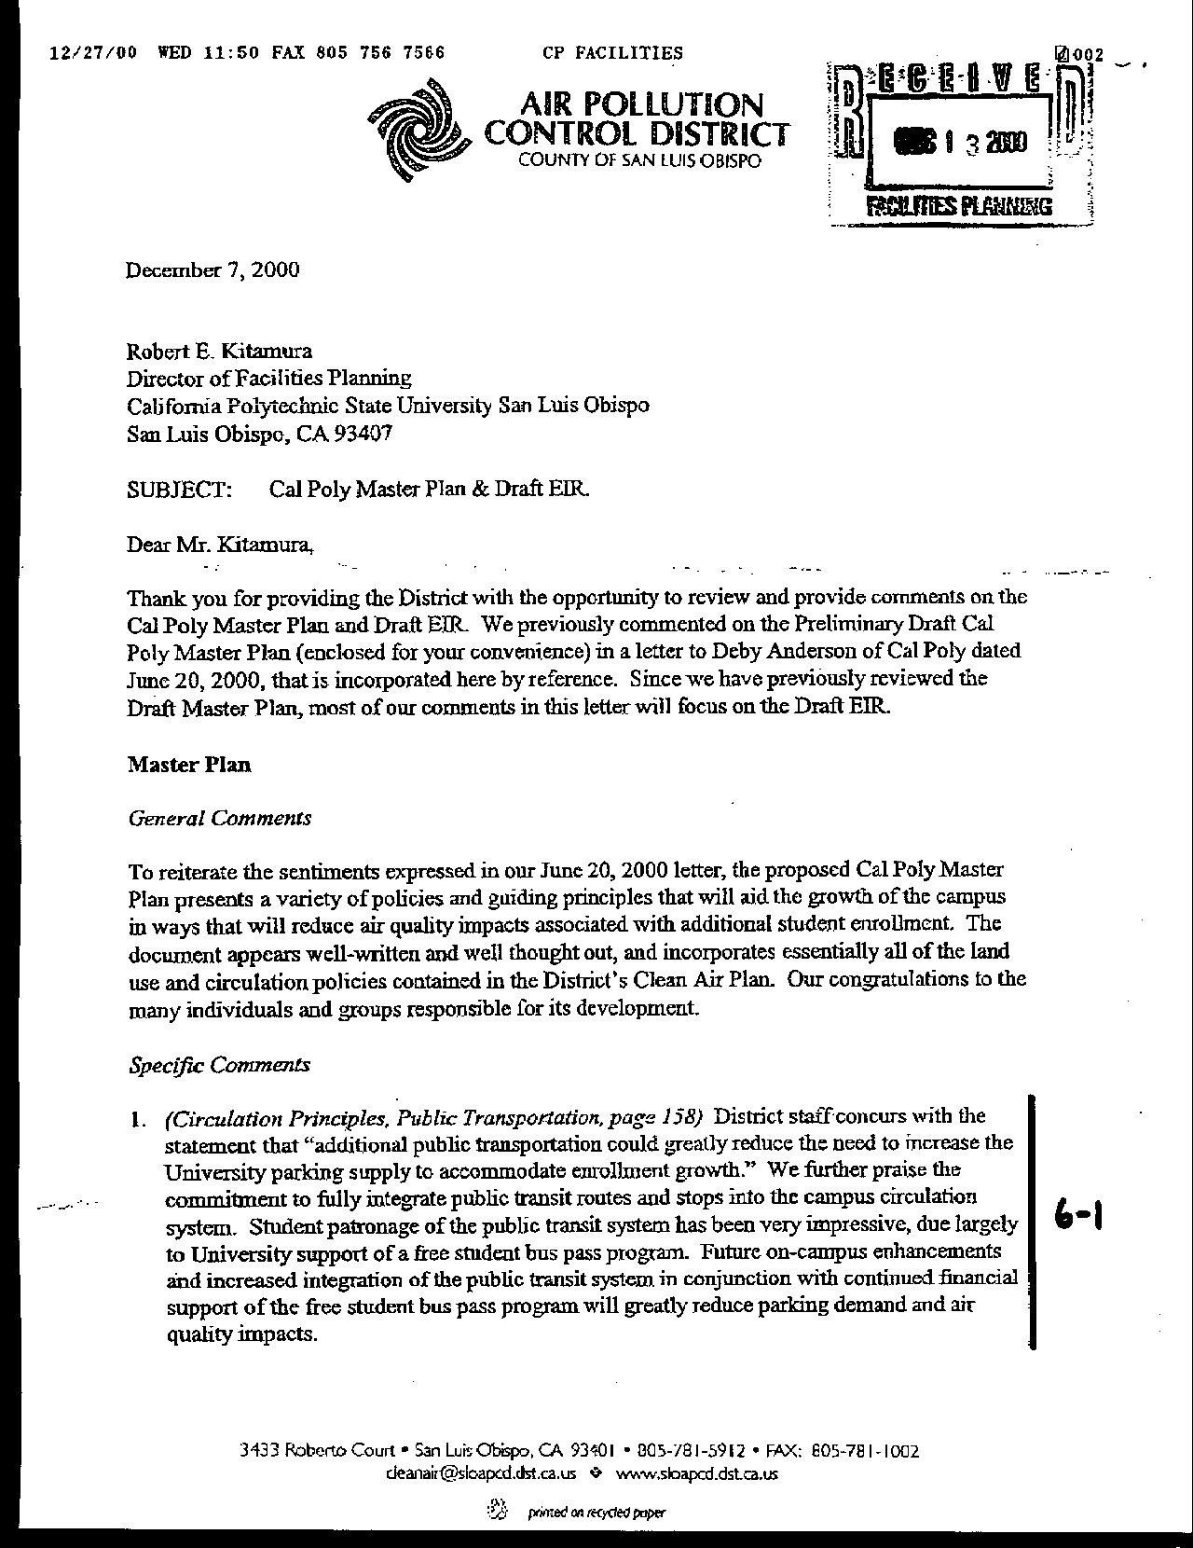
Letter 6
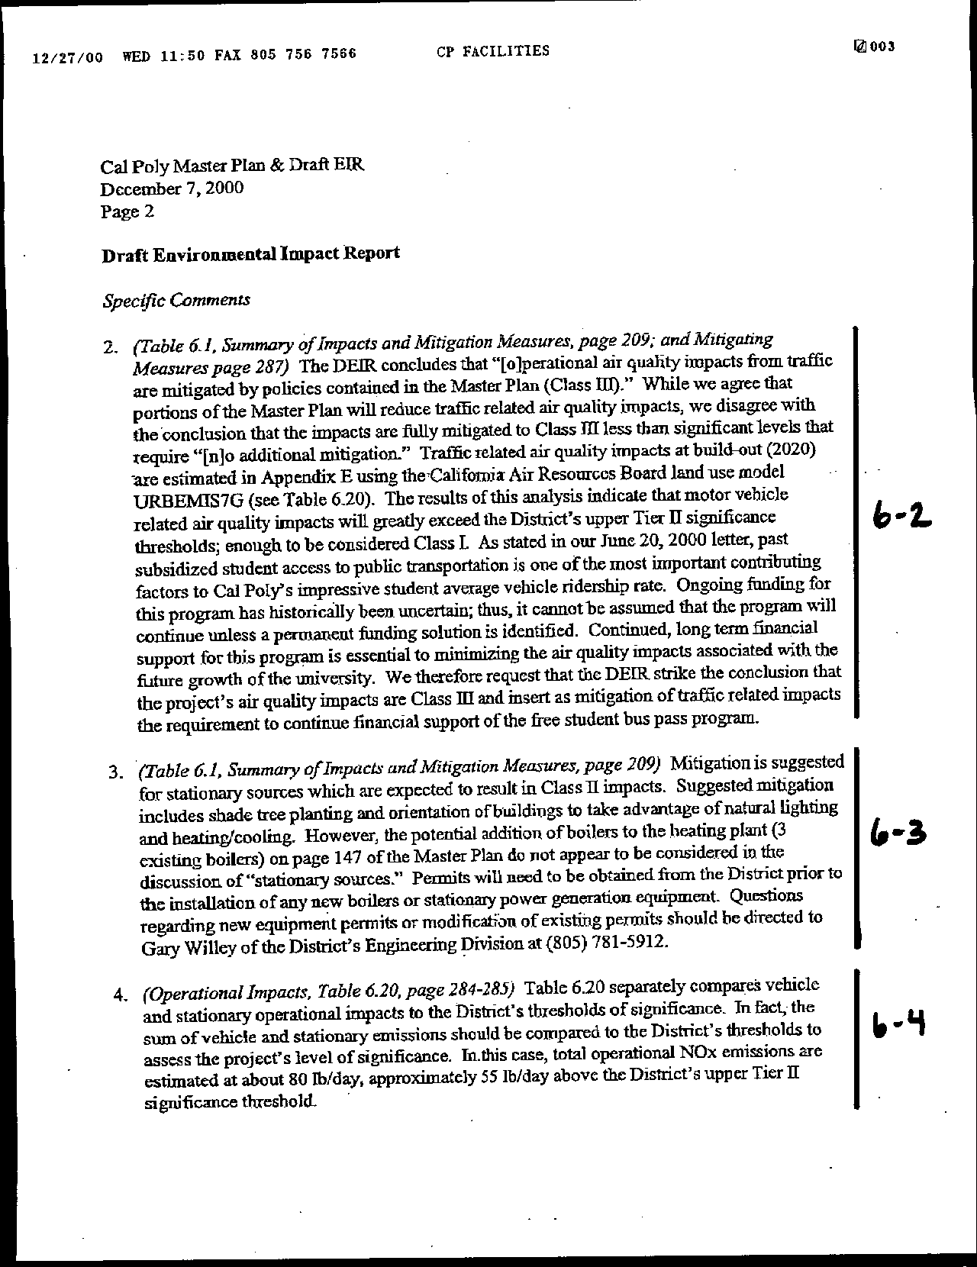
Letter 6
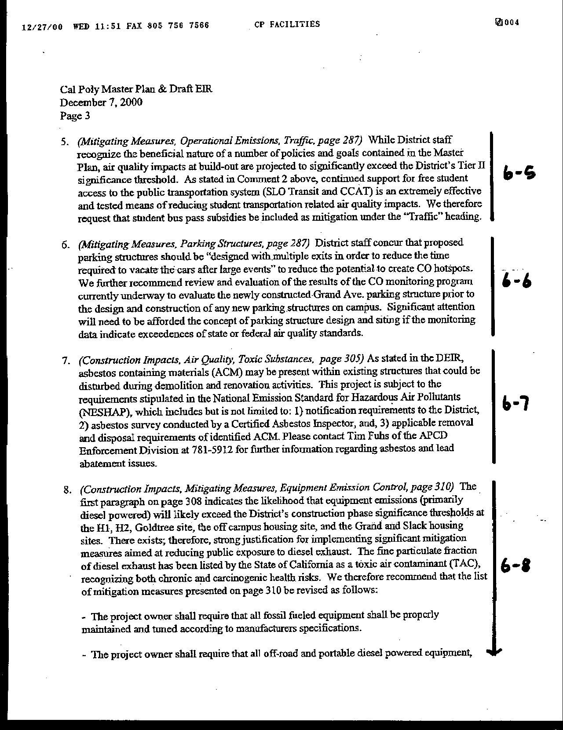
Letter 6
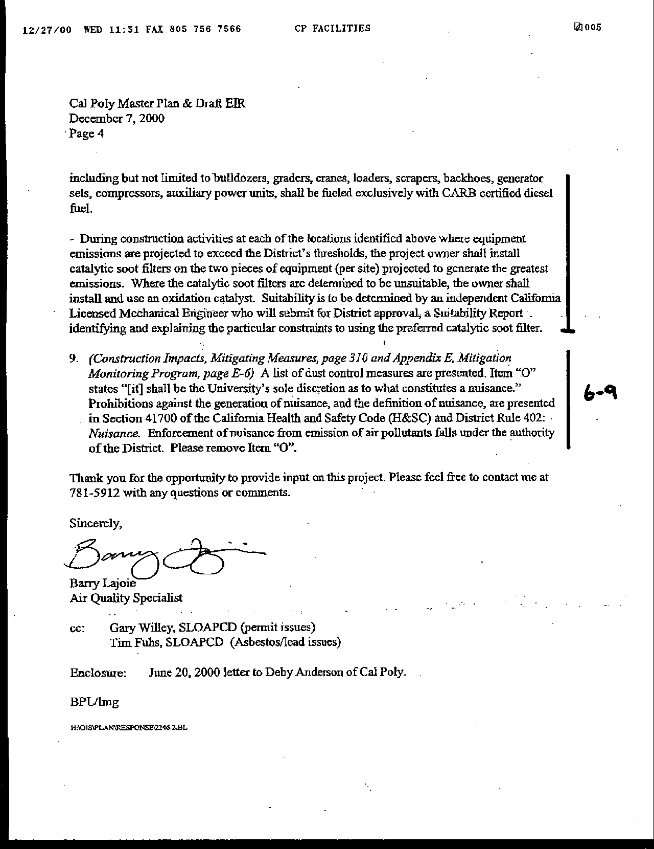
Letter 6
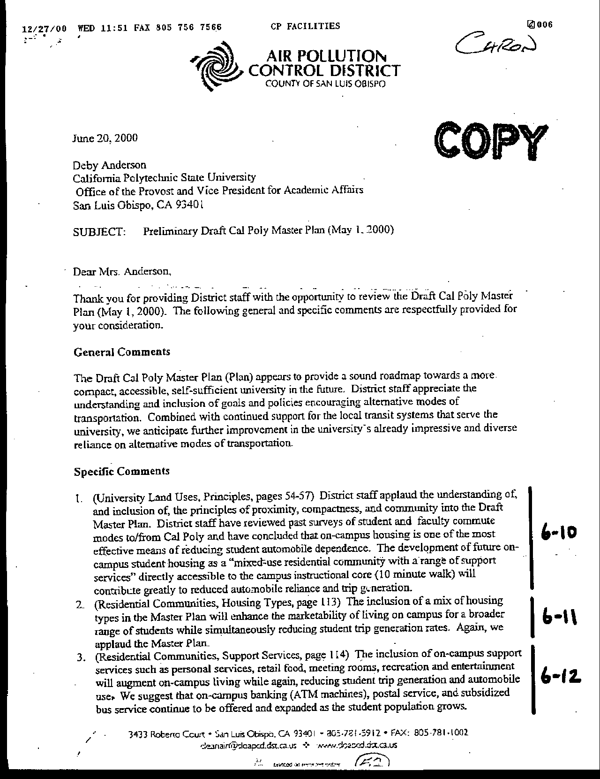
Letter 6
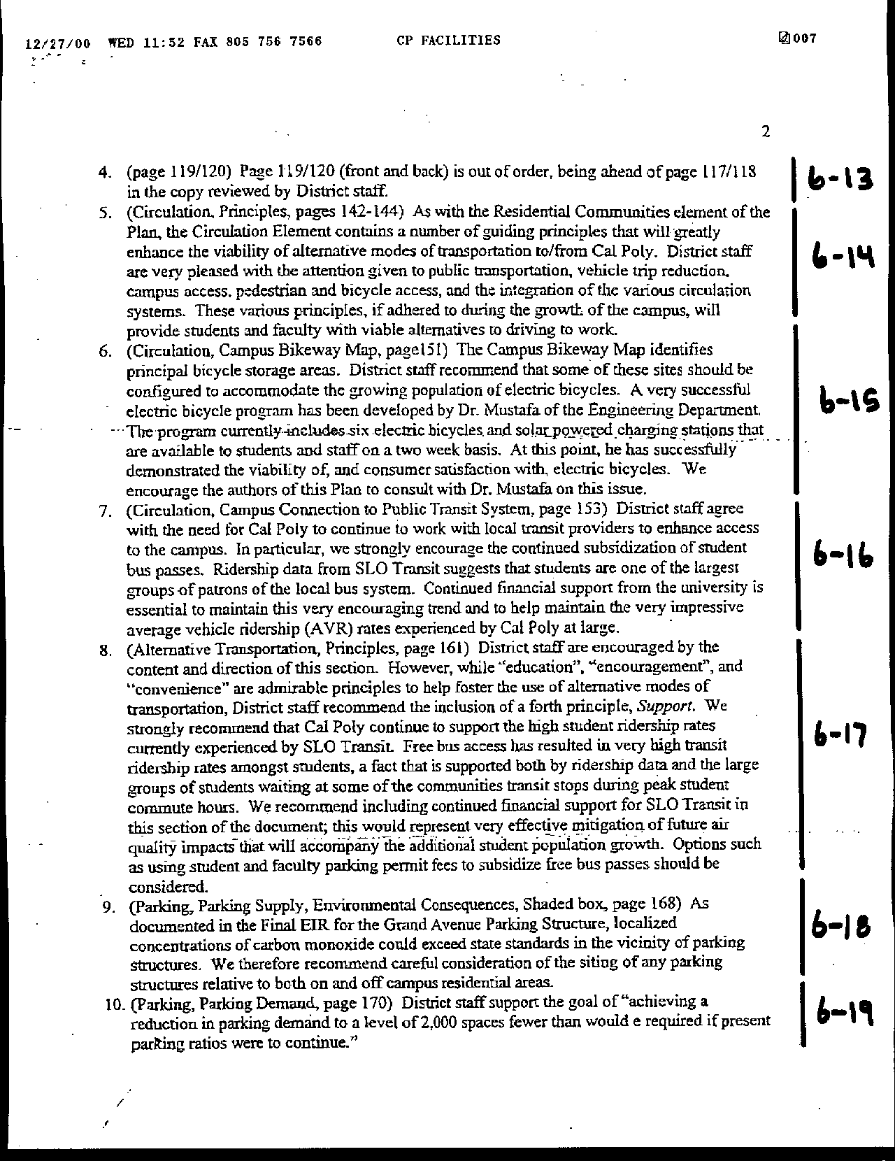
Letter 6

Letter 6
Letter 6
Mr. Barry Lajoie
Air Pollution Control District

December 5, 2000

6-1 The commenter concurs with the air quality benefits of integrating transit with the future development of the Cal Poly campus.

Response No additional response is necessary.

  - The commenter expresses the desire to make mitigation of traffic impacts contingent on public transit subsidy.

Response Many comments on the Master Plan have raised concerns about the continuation of the fully subsidized bus passes for Cal Poly students and employees. The current bus subsidy is an element of a negotiated arrangement between Cal Poly and the City of San Luis Obispo. The current agreement is for four years and ends on June 30, 2001. The negotiations are complex and are influenced by ever increasing costs. In addition, Cal Poly’s current funding (through parking fines) has been and continues to be relatively stable, meaning it has not been increasing commensurate with increased transit costs. Because the subsidy is the result of two party negotiations, it is not possible for the University to predict that it will always be able to reach an agreement with the city. Nevertheless, Cal Poly is committed to maintaining the funding for the bus at least at the currently designated level, and is exploring funding sources, such as an increase in parking fees, to fully cover the subsidy.

6-3 The comment questions the conclusion that emissions associated with operational motor vehicles will be less than significant when compared with the Air Pollution Control District’s thresholds for significance and the need to make mitigation of traffic impacts contingent on public transit subsidy.

Response Table 6.20 provides a summary of estimated unmitigated emissions associated with buildout of the university in accordance with the various uses and transportation strategies included in the Master Plan. The emissions were calculated based on the net traffic generation associated with the campus as described in Appendix C of the Draft EIR (Parking and Traffic Study, Associated Transportation Engineers, 2000) and assumes incorporation and implementation of transportation control measures and other aspects of the Master Plan that reduce overall trip generation. When compared with the District’s thresholds, the resulting unmitigated emissions exceed the Tier 2 threshold for Nox by about 55 pounds per day but are less than the Tier 3 threshold of 25 tons per year. According to the District’s CEQA Guidelines, when a project is expected to exceed the Tier 2 threshold, an EIR should be prepared and all feasible “standard” and “discretionary” mitigation measures should be implemented. The commenter refers to ongoing funding for subsidized student access to public transit as a feasible mitigation whose implementation is uncertain under the present wording of the Master Plan.

6-4 The comment refers to the District permit requirements for boilers that can be a source of stationary emissions.

Response This comment is noted and the permitting requirements will be forwarded to the Director of Facilities Planning.

  - The comment notes that the correct characterization of emissions associated with the project should combine stationary and mobile source estimates.

Response The resulting total is about 55 lbs/day above the District’s Tier 2 threshold, as described in response No. 6-2, above.

6-6 Commenter notes need to make mitigation of traffic impacts contingent on public transit subsidy.

Response Many comments on the Master Plan have raised concerns about the continuation of the fully subsidized bus passes for Cal Poly students and employees. The current bus subsidy is an element of a negotiated arrangement between Cal Poly and the City of San Luis Obispo. The current agreement is for four years and ends on June 30, 2001. The negotiations are complex and are influenced by ever increasing costs. In addition, Cal Poly’s current funding (through parking fines) has been and continues to be relatively stable, meaning it has not been increasing commensurate with increased transit costs. Because the subsidy is the result of two party negotiations, it is not possible for the University to predict that it will always be able to reach an agreement with the city. Nevertheless, Cal Poly is committed to maintaining the funding for the bus at least at the currently designated level, and is exploring funding sources, such as an increase in parking fees, to fully cover the subsidy.

  - The comment recommends incorporating the information gained from currently ongoing carbon monoxide monitoring of the recently-completed parking structure to help shape the design of future structures in a manner that minimizes CO exposure.

Response This comment is noted and will be forwarded to the Director of Facilities Planning. The monitoring of the parking structure has been going on since October 2000. To date, the highest level of CO has been less than 3 parts per million, considerably below the state and federal thresholds. This monitoring will continue until September 2001. The only significant concern with the new parking structure has been the exit time, sometimes exceeding thirty minutes. This is because, pursuant to an agreement with the Alta Vista Neighborhood Association, there is only one regularly operated exit. The new structures will be designed, to the extent feasible, with multiple exits.

6-8 The comment notes that the project will be subject to the requirements contained in the National Emissions Standard for Hazardous Air Pollutants with regard to asbestos abatement and removal.

Response This comment is noted and will be forwarded to the Director of Facilities Planning. The University has undergone extensive asbestos removal in building renovation and demolition. The University will comply with asbestos and related regulations.

6-9 The comment recommends additional mitigation measures to address diesel emissions associated with construction activities at off-campus housing sites.

Response The following items have been added to the list of Equipment Emissions Control in the EIR at page 326:

The project shall require that all fossil-fueled equipment shall be properly maintained and tuned according to manufacturers specifications.

The project proponent shall require that all off-road and portable diesel-powered equipment including but not limited to bulldozers, graders, cranes, loaders, scrapers, backhoes, generator sets, compressors, auxiliary power units, shall be fueled exclusively with CARB certified diesel fuel.

During construction activities at each of the locations identified above where equipment emissions are projected to exceed the District’s thresholds, the project proponent shall install catalytic soot filters on the two pieces of equipment (per site) projected to generate the greatest emissions. Where the catalytic soot filters are determined to be unsuitable, the project proponent shall install and use an oxidation catalyst. Suitability is to be determined by an independent California Licensed Mechanical Engineer who will submit for District approval, a Suitability Report identifying and explaining the particular constraints to using the preferred catalytic soot filter.

6-10 The comment refers to the regulation of, and definition of, a “nuisance” provided in the Health and Safety Code that will determine the University’s exercise of discretion with regard to the abatement of nuisances associated with construction-related dust. The comment states that the abatement of a nuisance associated with air pollutants (such as dust) falls under the discretion of the Air Pollution Control District.

Response This comment is noted and will be forwarded to the Director of Facilities Planning.

6-11 The comment provides support for Land Use principles.

Response No response required.

6-12 The comment provides support for mix of housing types.

Response No response required.

6-13 The comment provides support for expanding services for students living on campus.

Response No response required.

6-14 The comment notes pages are out of sequence in review copy.

Response Noted - October 10 and January 23 plan pagination is sequential.

6-15 The comment provides support for Circulation principles.

Response No response required.

6-16 The comment suggests the University consider electric bicycle use and storage.

Response Ed Johnson, Facilities Planning, has received a grant to test the feasibility of using electric bicycles on campus. The first bike arrived on campus at the end of last year.

6-17 The comment provides strong support for coordination with local transit providers and continued bus subsidy.

Response No response required. See Response 6-2, above.

6-18 The comment suggests adding Support as a principle for alternative transportation.

Response Text on page 189 has been added to read that “Cal Poly is committed to maintaining the funding for the bus at least at the currently designated level.”

6-19 The comment notes concern with air quality associated with parking structures.

Response Please refer to comment 6-6 above. The new structure, even during event conditions, has operated well below state and federal requirements.

6-20 The comment provides support for reduction in parking demand.

Response The following table has been used for estimating where savings would occur in parking demand. The Master Plan policy is to reduce parking demand by 2,000 spaces.

Estimated Parking Demand Reductions

Approach | Savings | Relative  Cost | Safety Valve*
Freshmen restrictions | 1,000~1,500 | L | some no.
Geographic controls | 500 | L | appeal
Car/vanpools | 300 | M
Lottery | As determined | L | appeal
Parking Fees | minor | L | appeal
On-campus transit | moderate | H
City transit | minor | H
Bike/ped enhancmt | moderate | H
Area mgt | minor | L
Fac/Staff incentives | minor | M
Entertainment | moderate | H
Enrollment scenarios | moderate | M
Note: alternative transportation savings will be lower for Cal Poly because many of these programs are in existence and functioning well.

*Absolute controls will require provisions (safety valve) for hardships.

To meet the parking reduction proposal of 2,000 spaces, Cal Poly intends to institute as a first, and most effective measure, that freshmen be required to live on campus and that they not be allowed to maintain cars on campus (with exceptions made for hardship and job-related requirements). We believe that the inelasticity of demand Cal Poly will prevent this policy from having a detrimental effect on the dormitory market. This restriction exists at other universities, including UC Santa Cruz.

It is estimated that there will be about 4,000 new undergraduate students each Fall (about 3,000 freshmen) at Cal Poly under the full growth anticipated with the Master Plan. Currently, we house approximately 80% ~ 90% of our freshmen on campus, and the campus provides 1,530 parking spaces for residents (R1 & R2). At present ratios, approximately 1,800 spaces would be needed under the Master Plan for freshmen. Allowing for some hardship requirements for freshmen, it is anticipated that approximately 1,500 or more spaces could be reduced with this policy alone.

This policy will do more than just reduce cars on campus. It will change the culture of the campus, infusing a higher regard for the environment and a reduced reliance on the automobile. As students advance through the University, they will do so with the ability to use alternative modes of transportation.

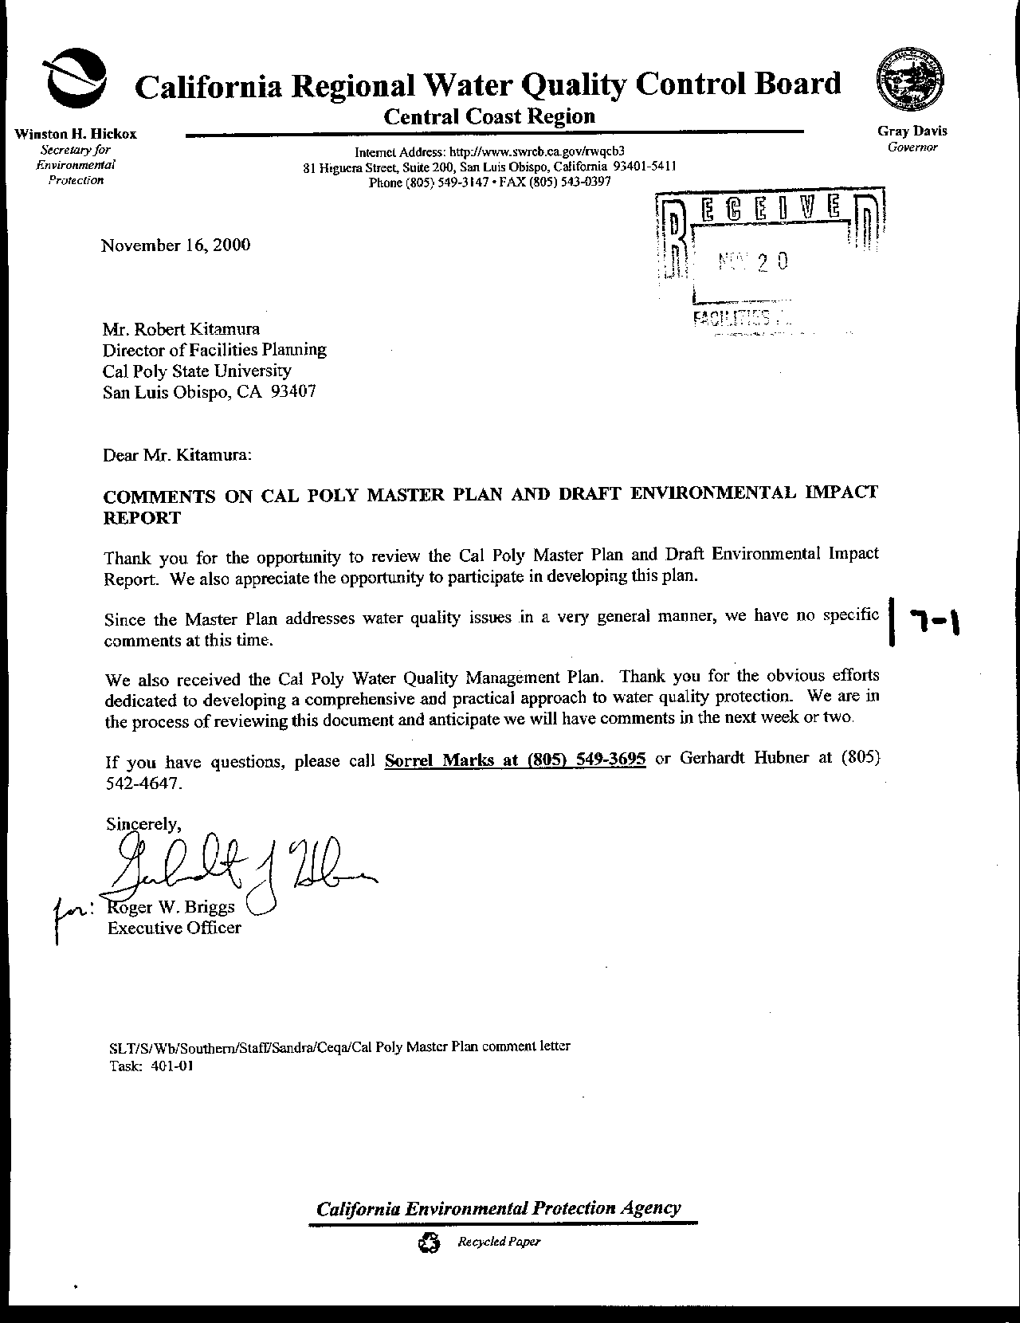
Letter 7
Letter 7
Mr. Roger Briggs
Regional Water Quality Control Board

December 5, 2000

7-1 No specific comments were received from the Regional Water Quality Control Board.

Response None required.

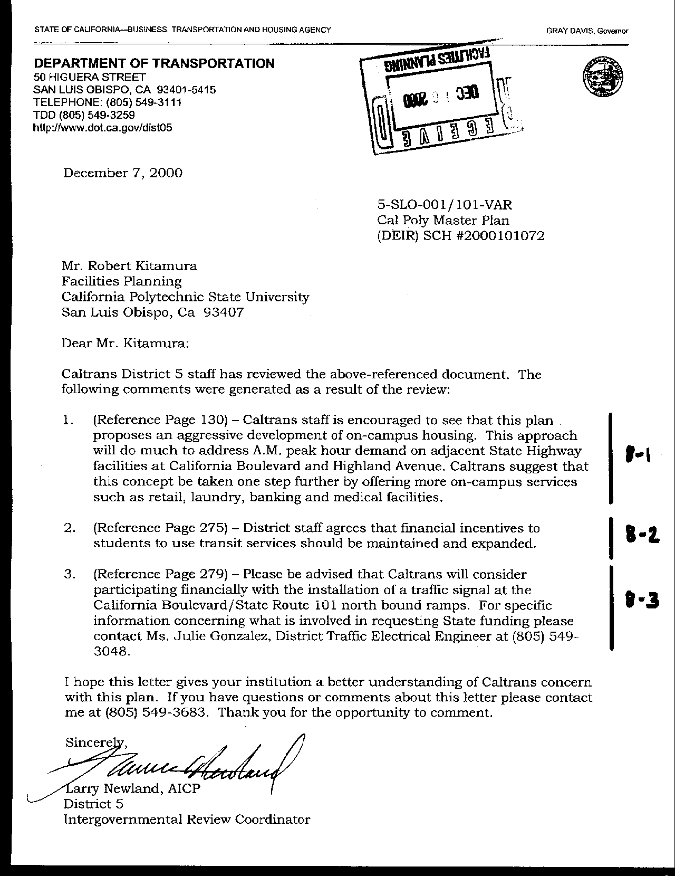
Letter 8
Letter 8

Mr. Larry Newland
Department of Transportation

December 7, 2000

8-1 Caltrans commends the development of on-campus housing and encourages more on-campus services to further reduce trips.

Response The Master Plan proposes several activities and services that will be attractive to students and reduce the number of trips to downtown and other locations. These are detailed in the University Union Plan and in the Campus Instructional Core section of chapter 5 of the Master Plan. See pp. 16, 133, 189, and 202.

8-2 Caltrans agrees that financial incentives should be maintained and expanded for transit.

Response Cal Poly recognizes the importance of maintaining the subsidy for free bus ridership with the local transit providers. A healthy ridership on local buses will continue to be an important component in reducing area traffic and air pollution. Cal Poly will continue to provide incentives for transit and other alternative transportation.

An important question is whether Cal Poly will be able to subsidize 100% of the transit use into the foreseeable future. That question depends on a number of factors that cannot be determined at this time. It is important to understand the background of the transit subsidy in order to understand why this is so. Every several years, the transit contract between the University and the City is renegotiated. Factors used to determine costs include the number of students using the system, the overall cost, and projections of use into the future.

See also text additions to p. 188-199.

8-3 Caltrans is considering participating financially in the development of a signal at the California Boulevard/State Route 101 northbound ramps.

Response With the extension of California Boulevard to Highland Avenue, approximately 5,000 additional vehicle trips per day could be redirected onto this roadway. The northbound off ramp at California Boulevard is an attractive alternative to Grand Avenue. Drivers exit onto their own westbound lane of California Boulevard as opposed to the required crossing of Grand Avenue without benefit of traffic controls. A signal at California and Highway 101 should improve traffic conditions at that intersection, especially as traffic increases on that road segment.

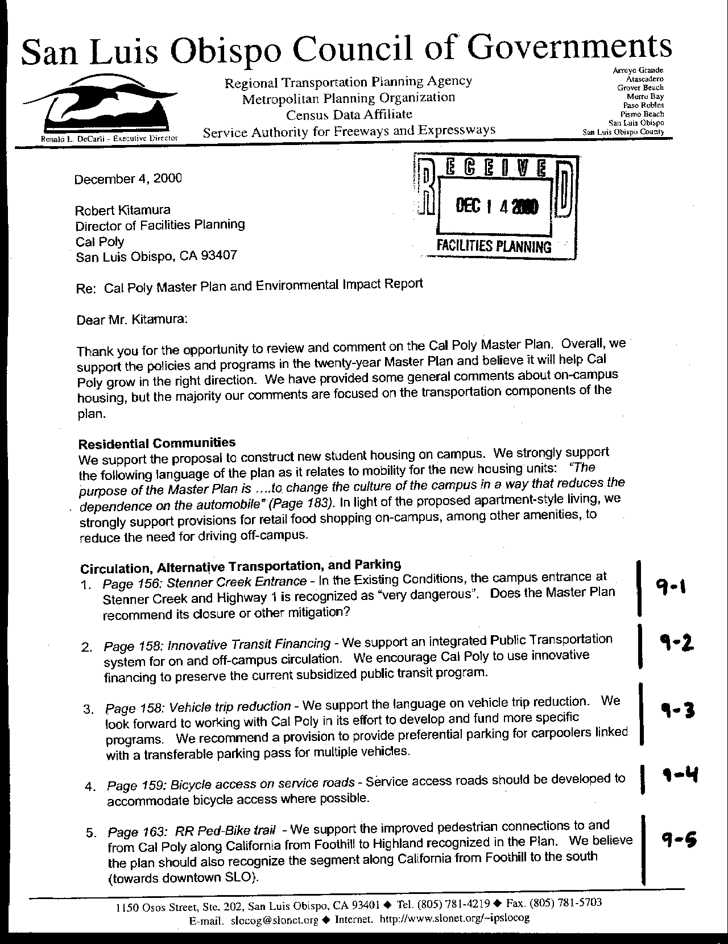
Letter 9
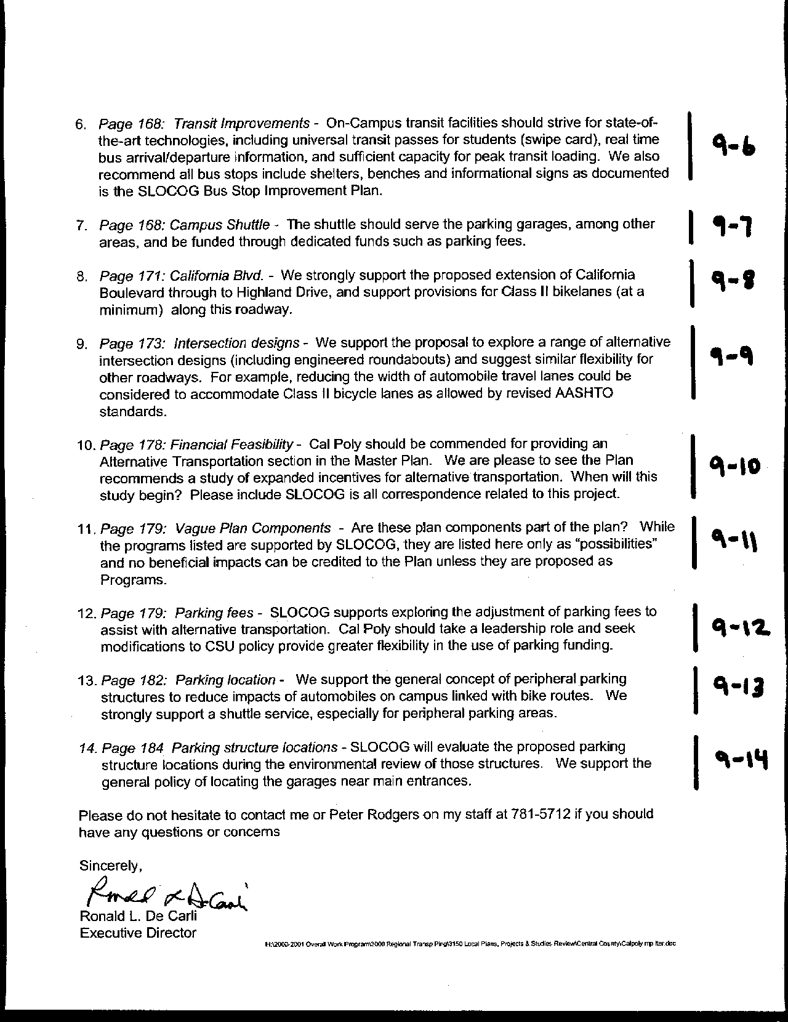
Letter 9
Letter 9

Mr. Ron DeCarli
SLOCOG

December 7, 2000

9-1 Does the Master Plan recommend closure or other mitigation at Stenner Creek and Highway 1?

Response Cal Poly is currently in discussions with Caltrans to seek improvements along the Highway 1 corridor to improve safety and access to the University’s many properties and activities along that route. Ideally, there would be a consolidation of access points along that segment of Highway 1.

9-2 SLOCOG supports innovative transit financing.

Response Cal Poly will continue to look for funding mechanisms such as grants and partnerships, as well as modifications to parking fees, to support student, staff and faculty access to local transit systems. In order to accomplish the parking demand reduction goal of 2,000 spaces, the university must support a robust alternative transportation program. See also page 189.

9-3 SLOCOG supports the Master Plan language on trip reduction and recommends preferential parking for carpooling linked with a transferable pass for multiple vehicles.

Response Cal Poly supports this recommendation. The trip reduction program, its operation and administration, will be part of the more detailed implementation measures developed subsequent to the adoption of the Master Plan. See also page 189.

9-4 Bicycle access should be accommodated on service roads.

Response Services roads on campus will be primarily for pedestrian use. A bicycle access plan is on exhibit 5.14 of the Master Plan that includes most of the major routes to and on campus. Text on page 167 under “Bicycle Friendly” has been amended to include the following sentence: “Where appropriate bicycle routes may follow service access roads.”

9-5 SLOCOG supports improved pedestrian connections along California and would like that expanded to include the segment south of Foothill.

Response Cal Poly will work with the City of San Luis Obispo in coordinating pedestrian and bicycle access routes. See text addition, p. 171.

9-6 Transit improvements should strive for state-of-the-art technologies.

Response Cal Poly will seek funding for research and implementation of innovative alternative transportation systems such as those described in the comment. See text additions, pp. 177 and 189.

9-7 Campus shuttle should serve parking garages and be supported by dedicated fees.

Response The campus shuttle would serve nearby residential areas and the parking structures. This program, its operation and administration, will be part of the more detailed implementation measures developed subsequent to the adoption of the Master Plan. The following paragraph (with amended text in italics) now appears on page 178: “In order to encourage alternative transportation and to provide access to and from nearby student residential complexes, parking lots and outdoor teaching and learning facilities, Cal Poly should undertake a financial feasibility analysis to institute a campus shuttle service with dedicated funding. Routes should be designed to serve regular locations on a frequent schedule. In addition, the shuttle service feasibility study should include an analysis of the ability to provide ad hoc access for student field trips and other activities in the Extended Campus away from the instructional core. The shuttle should have regular loading and unloading points at key buildings, parking lots and structures. Consideration should be given to using electric or similar low-emission vehicles for the shuttle service.”

9-8 SLOCOG supports extending California through to Highland and including Class II bikelanes.

Response The extension of California Boulevard is the first priority for major circulation improvements at Cal Poly. The current design of the extension has Class II bicycle lanes included.

9-9 SLOCOG supports innovative intersection designs and decreased roadway widths to accommodate bicycles.

Response Intersection design will begin with the development of detailed plans to push Highland Avenue around to connect with Grand Avenue. The intersection at Highland and Via Carta will be challenging. It must accommodate increased automobile traffic with the continuation of the road, and increased pedestrian activity with the construction of student apartments north of Brizzolara Creek. Engineered round-abouts are preferred because they maintain a steady flow of traffic, however, they are inconvenient in proximity to pedestrian crossings (you cannot stop in or near a round about). The following text has been added to the paragraph that discusses Key Intersection Designs: “…Intersection redesign needs to accommodate pedestrians and bicycles as well as motorized vehicles” (p. 183).

9-10 SLOCOG supports expanded incentives for alternative transportation and asks when planning will begin.

Response This program, its operation and administration, will be part of the more detailed implementation measures developed subsequent to the adoption of the Master Plan

9-11 SLOCOG notes that the plan components for alternative transportation are “vague” and should be proposed as “programs.”

Response The Master Plan has been revised to clarify its intention of providing alternative transportation incentives and components. It is the intention of the Master Plan that some or all of these proposals be put in place. There are in fact necessitated by the stated policy of reducing parking demand by 2,000 spaces. Without improved alternative transportation, the campus will face severe parking inadequacies in the future. These programs, their operation and administration, will be part of the more detailed implementation measures developed subsequent to the adoption of the Master Plan.

9-12 SLOCOG supports adjusting parking fees.

Response Parking fees for faculty and staff are controlled, in part, by collective bargaining. The campus controls student fees, subject to provisions of California State University fee policies. This program, its operation and administration, will be part of the more detailed implementation measures developed subsequent to the adoption of the Master Plan

9-13 SLOCOG supports peripheral parking structures, better bicycle access, and shuttle service.

Response The parking structure locations were part of the Walker 1988 Parking Master Plan. This plan examined the parking needs of the entire campus and proposed a comprehensive program for improving parking and access for the campus

9-14 SLOCOG generally supports the proposed location of the parking structures and will evaluate them closer during environmental review.

Response Each of the structures will be designed and reviewed in much greater detail during their development phase. Each will have at least a Mitigated Negative Declaration prepared pursuant to CEQA, which will give SLOCOG and others an opportunity to comment further.
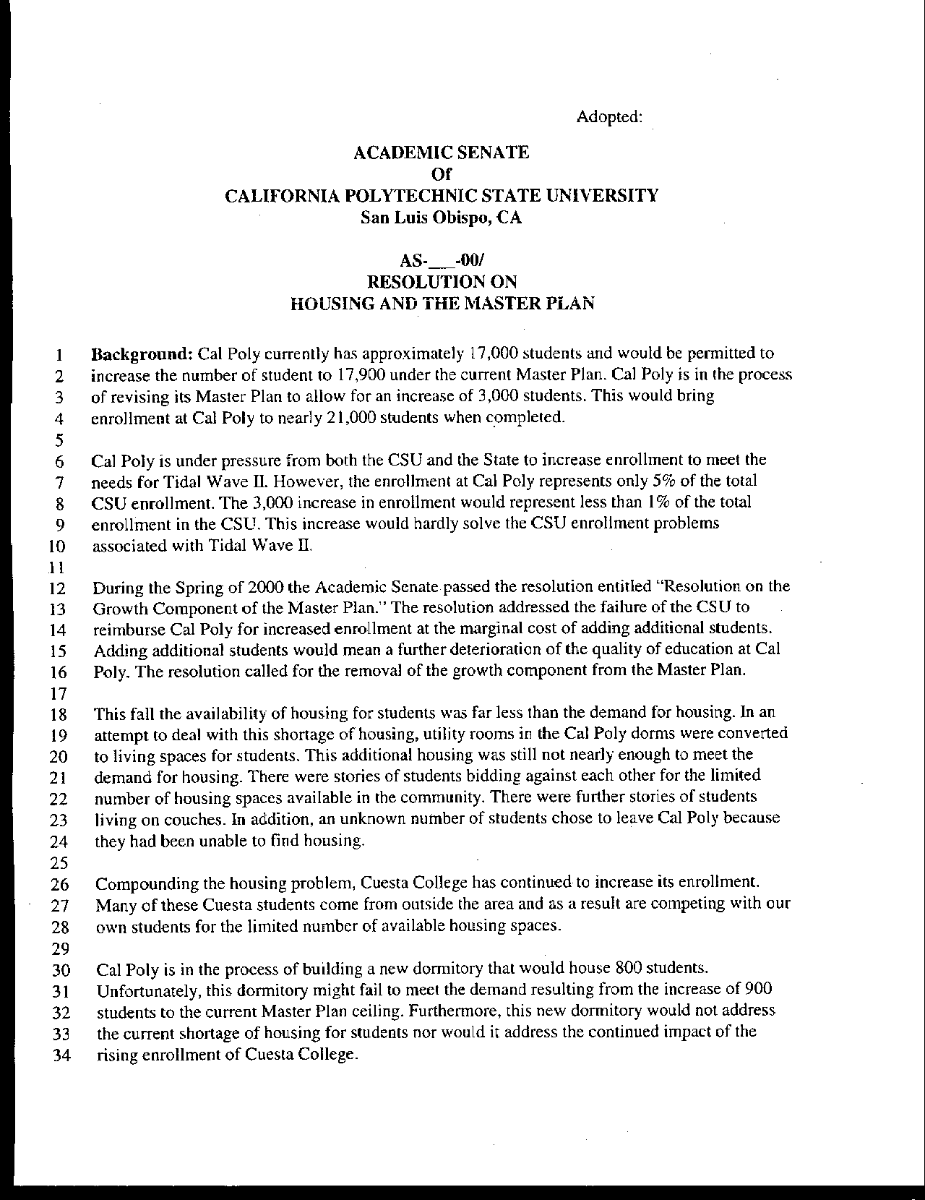
Letter 10
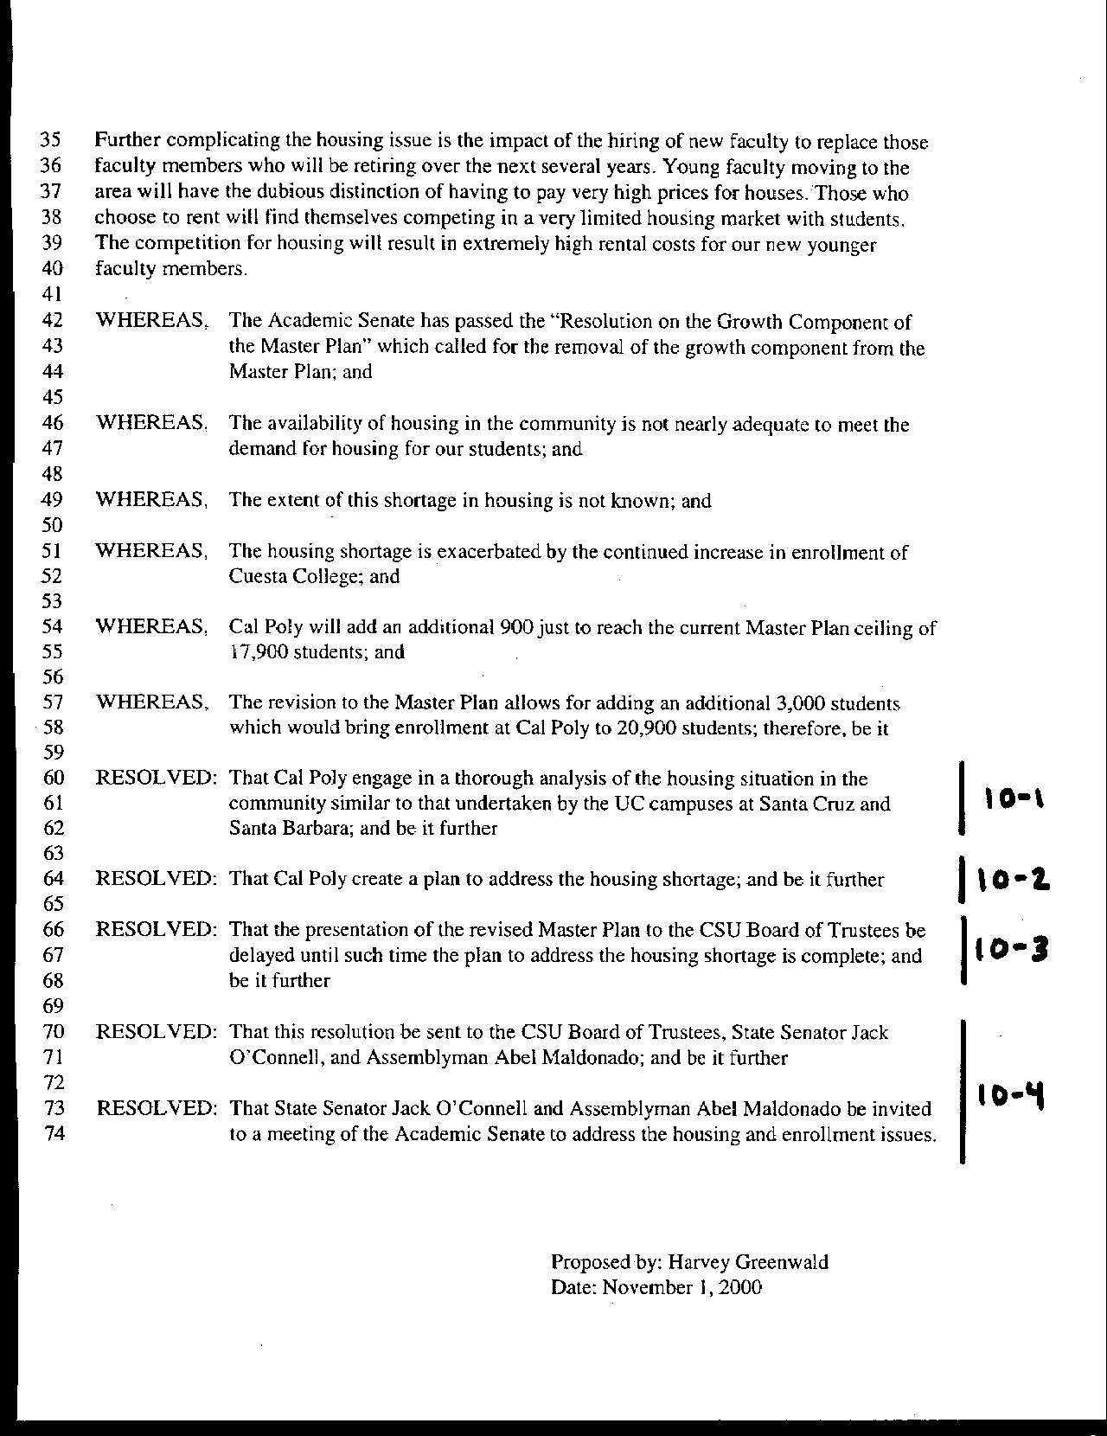
Letter 10
Letter 10

Dr. Harvey Greenwald

Academic Senate

November 1, 2000

10-1 Dr. Greenwald submitted a “Resolution on Housing and the Master Plan” to the Academic Senate Executive Committee on November 1, 2,000. While this resolution was not forwarded to the full Senate, it raised a number of issues of importance to the Master Plan. The resolution recommends Cal Poly prepare a study on the housing shortage on campus and in the community.

Response A discussion of the Market Analysis prepared prior to the Master Plan has been incorporated into the Residential Communities Element in pages 129-130. The analysis provides information on current deficiencies in the San Luis Obispo housing market, and the feasibility of providing housing on-campus.

10-2 The resolution further suggests that Cal Poly develop a plan to address that housing shortage.

Response The Residential Communities element has been reorganized and now includes a more substantial discussion of existing deficiencies and plans to reduce the impacts of this shortage on students and faculty, as well as the larger community. See pp. 136-137, where the following language has been added.

Cal Poly has sponsored two recent studies of the housing market as it affects students, faculty and staff. In 1998, the Division of Student Affairs retained Gordon Chong and Partners and the Sedway Group to analyze the student housing market and explore the potential for new student housing on campus. The findings from this study contributed to the University’s decision to build apartment-style units to house an additional 800 students on campus. The Cal Poly Foundation contracted with Anderson Strickler, LLC, to investigate the need and potential for University-sponsored housing for faculty and staff. Their 2000 Employee Housing Study found that housing cost is a significant factor in faculty recruitment and retention. Their report is guiding the development of faculty and staff housing on two sites west of Highway 1, as identified in the Master Plan.

Cal Poly will review and revise these market studies to inform each phase of Master Plan housing development and enrollment growth. Relevant comparative data includes vacancy rates, rents, land available for housing, financing options, and the nature and importance of amenities. Studies will also address student housing preferences and challenges in locating suitable off-campus housing.

10-3 The proposed resolution calls for Cal Poly to delay submittal of the Master Plan to the Board of Trustees pending completion of the housing plan.

Response Cal Poly will submit the Master Plan to the Board of Trustees for its March 2001 meeting. This date has been in the plan development program for three years. As stated in the plan, increased enrollment will follow the development of additional student housing. Thus, the Master Plan enrollment increases will not exacerbate the housing shortage. In addition, an 800 bed residential facility will begin construction this year. Plans for the development of faculty housing are underway.

10-4 Commenter suggests that state legislators as well as Board of Trustees be engaged in helping address housing and enrollment issues.

Response Please refer to the discussion in Chapter 3 reflecting enrollment pressures associated with demand for Cal Poly's programs.
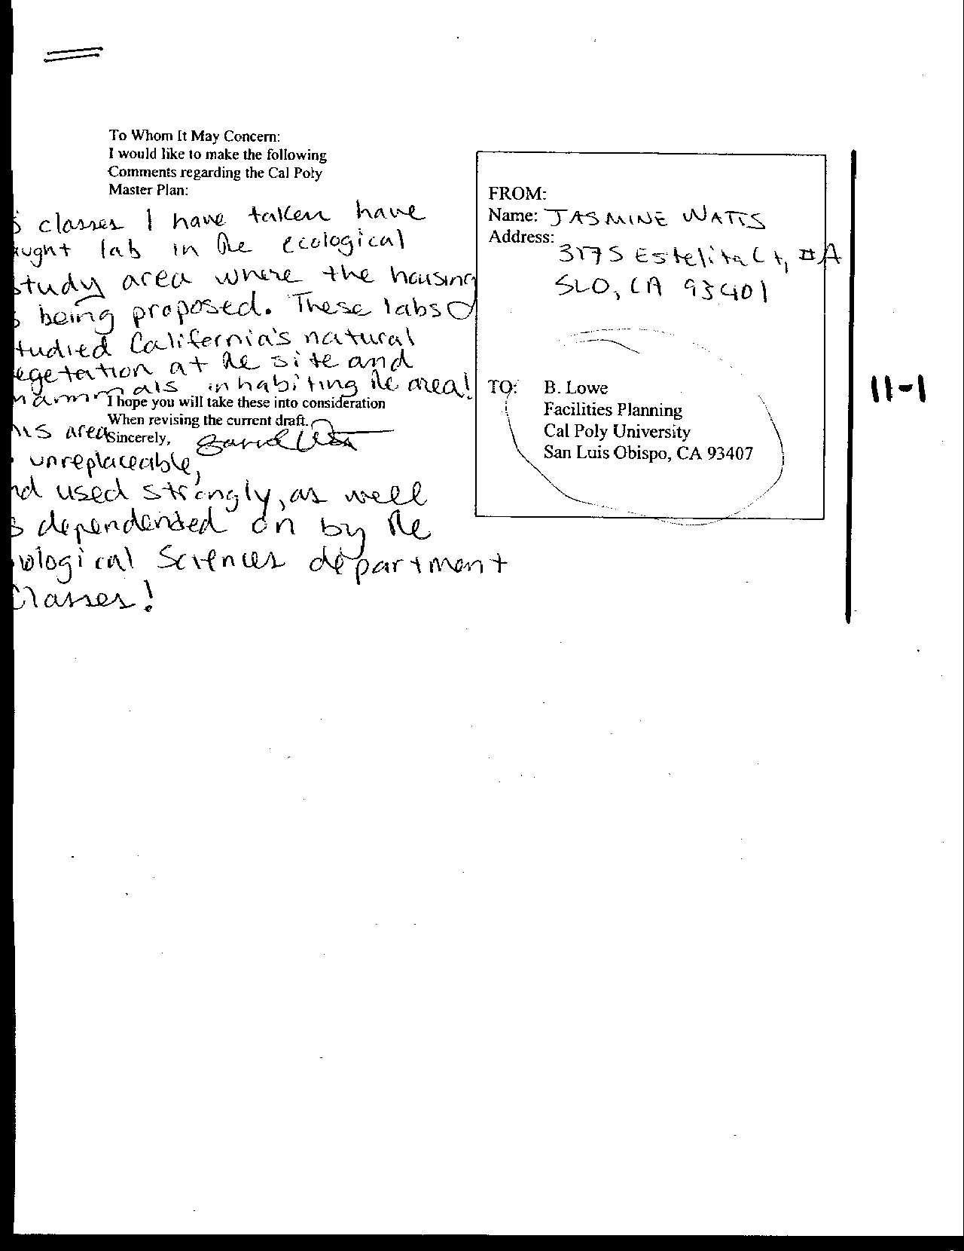
Letter 11
Letter 11

Ms. Jasmine Watts

December, 2000

11-1 Commenter is concerned about effects on biota from the housing near the Ecological Study Area.

Response The housing proposed at H-2 is adjacent to one of the campus’ Ecological Study Areas at the mouth of Poly Canyon (see Exhibit 5.9). This facility will be designed to stay southwest of the ecological study area. The area will be enhanced in the future with native grasses and the introduction of Cambria Morning Glory, a plant listed by the California Native Plant Society. The DEIR addressed impacts associated with the housing development.

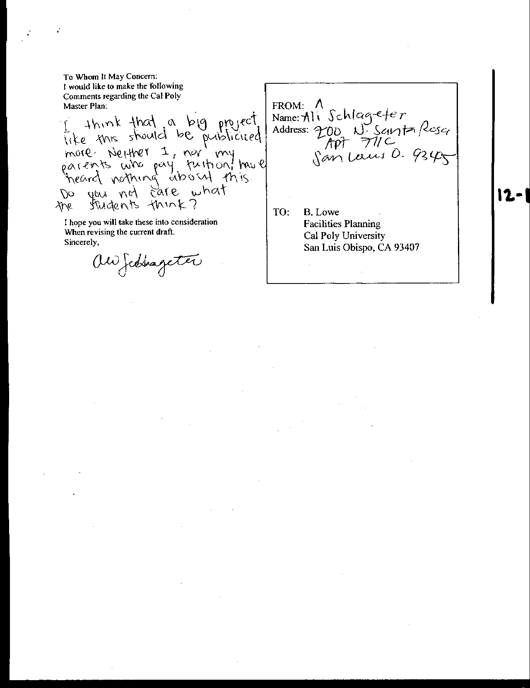
Letter 12
Letter 12

Mr. Ali Schlageter

December, 2000

12-1 Commenter suggests the Master Plan was inadequately publicized.

Response Cal Poly’s Master Plan team has been preparing the Master Plan for the past three years. Following a series of meetings during the Fall and Winter quarters of the 1998-1999 academic year, over one hundred members of the campus and community participated in task forces during Spring 1999 to develop the guiding principles for the plan. The plan was first presented in draft form to the public in the Spring of 2000. Numerous press releases and public meetings accompanied the release of this early version of the plan. The formal plan and Draft EIR were presented to the community in the Fall of 2000. The March date for the Board of Trustees presentation has been presented to the public for over three years. See discussion of process in Introduction and Task Forces in Chapter 2.
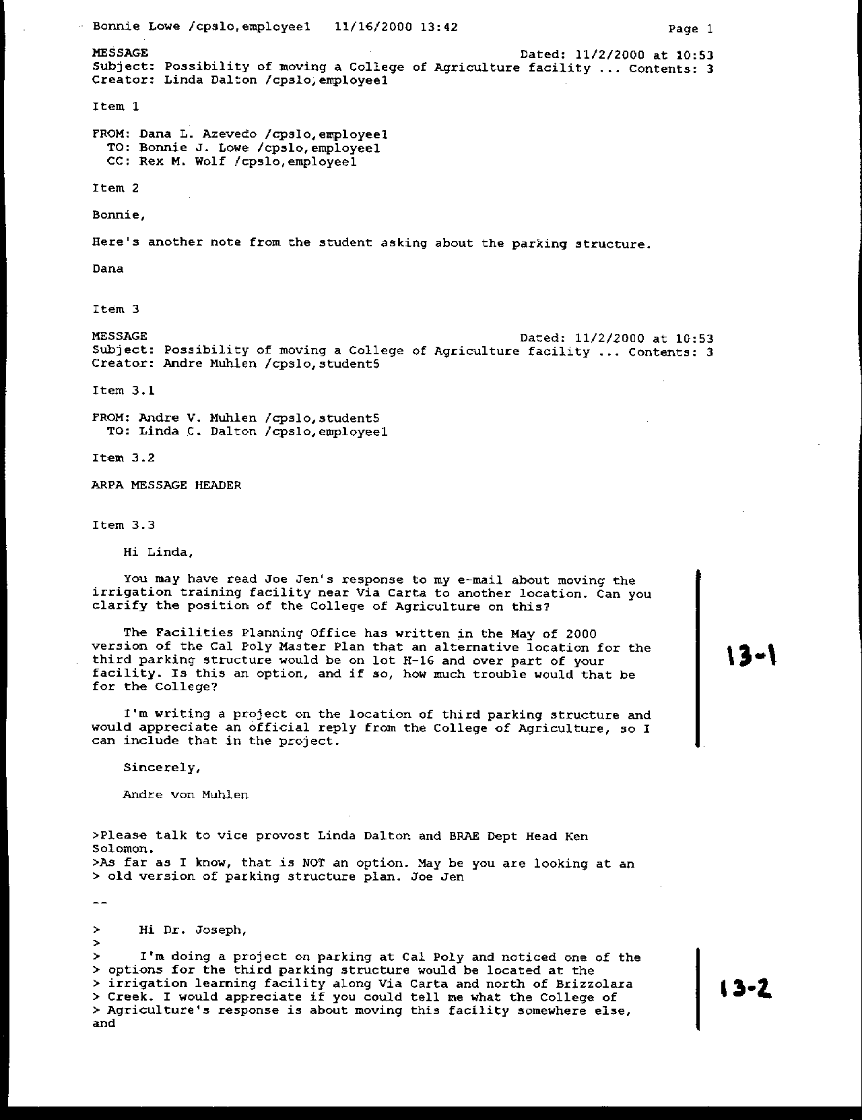
Letter 13

Letter 13
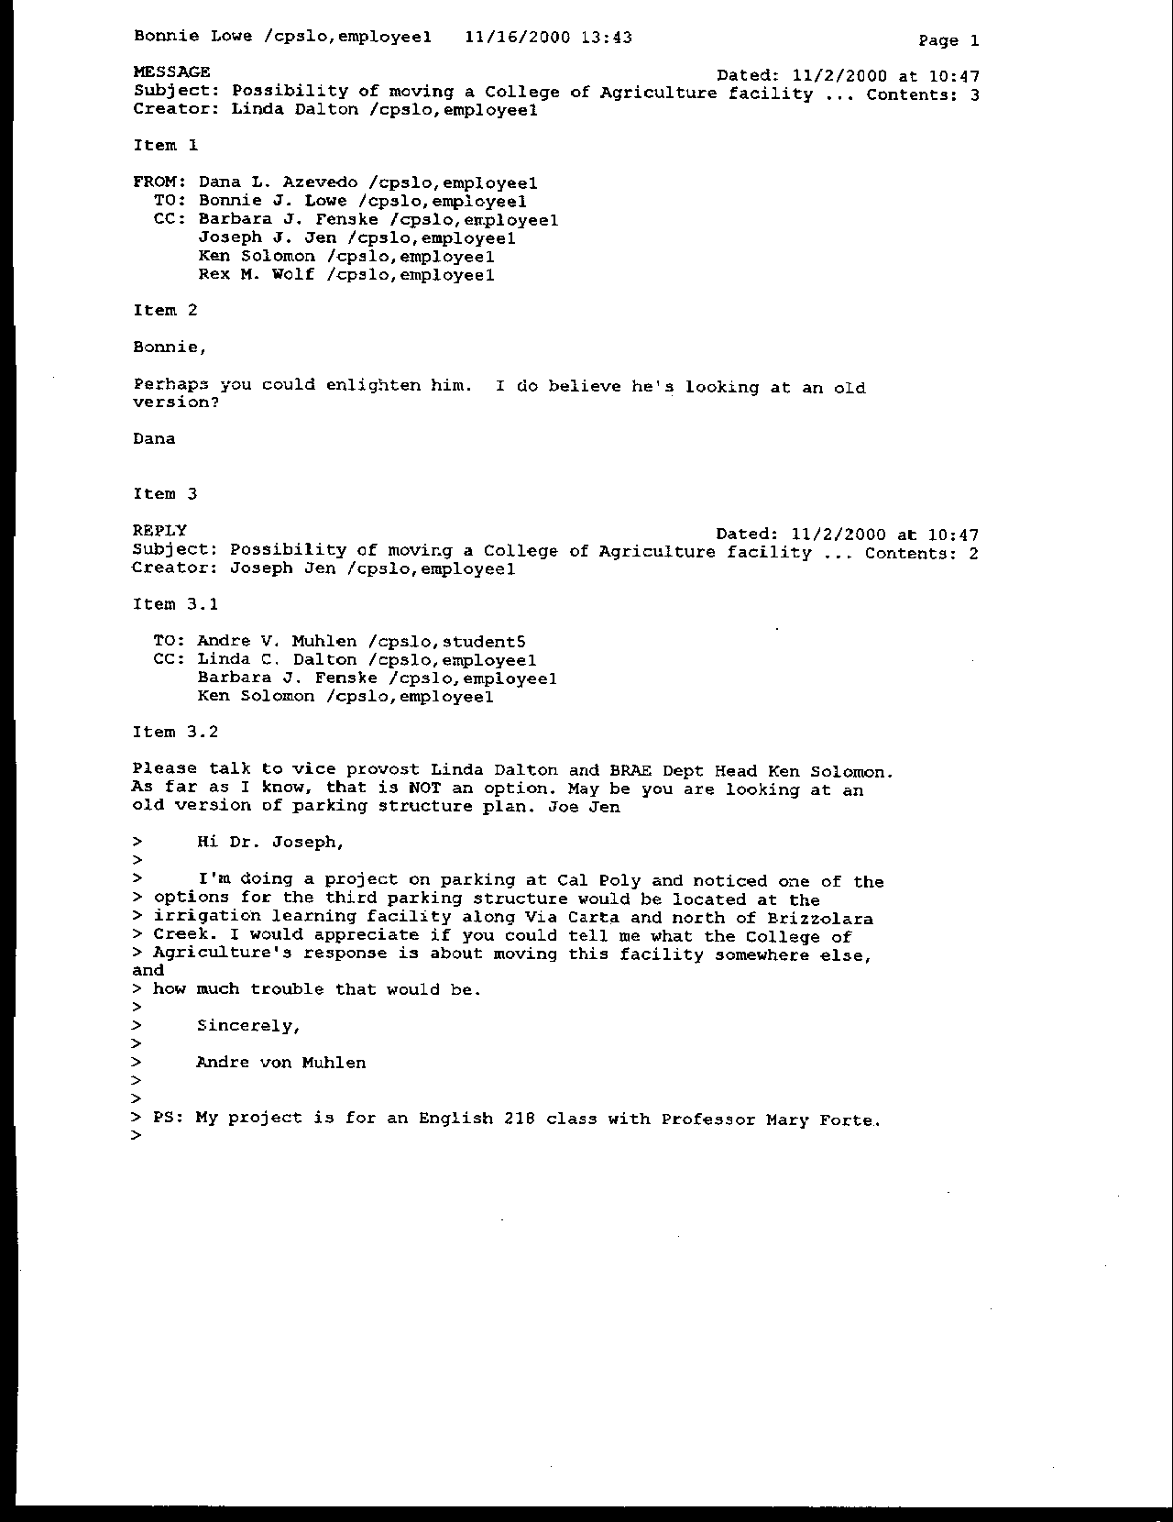
Letter 13
Letter 13

Mr. Andre von Muhlen

November 2, 2000

13-1 The commenter seeks clarification on the location of Parking Structure III, and whether it would impact the irrigation training facility.

Response An early version of some planning studies showed the structure using part of the land now occupied by the irrigation training facility. Subsequent discussions with the College of Agriculture Land Use Committee informed the Master Plan team that this location would not be appropriate. The proposed location in the Master Plan is on parking lot H-12 at the northwest corner of the intersection of Via Carta and Highland.
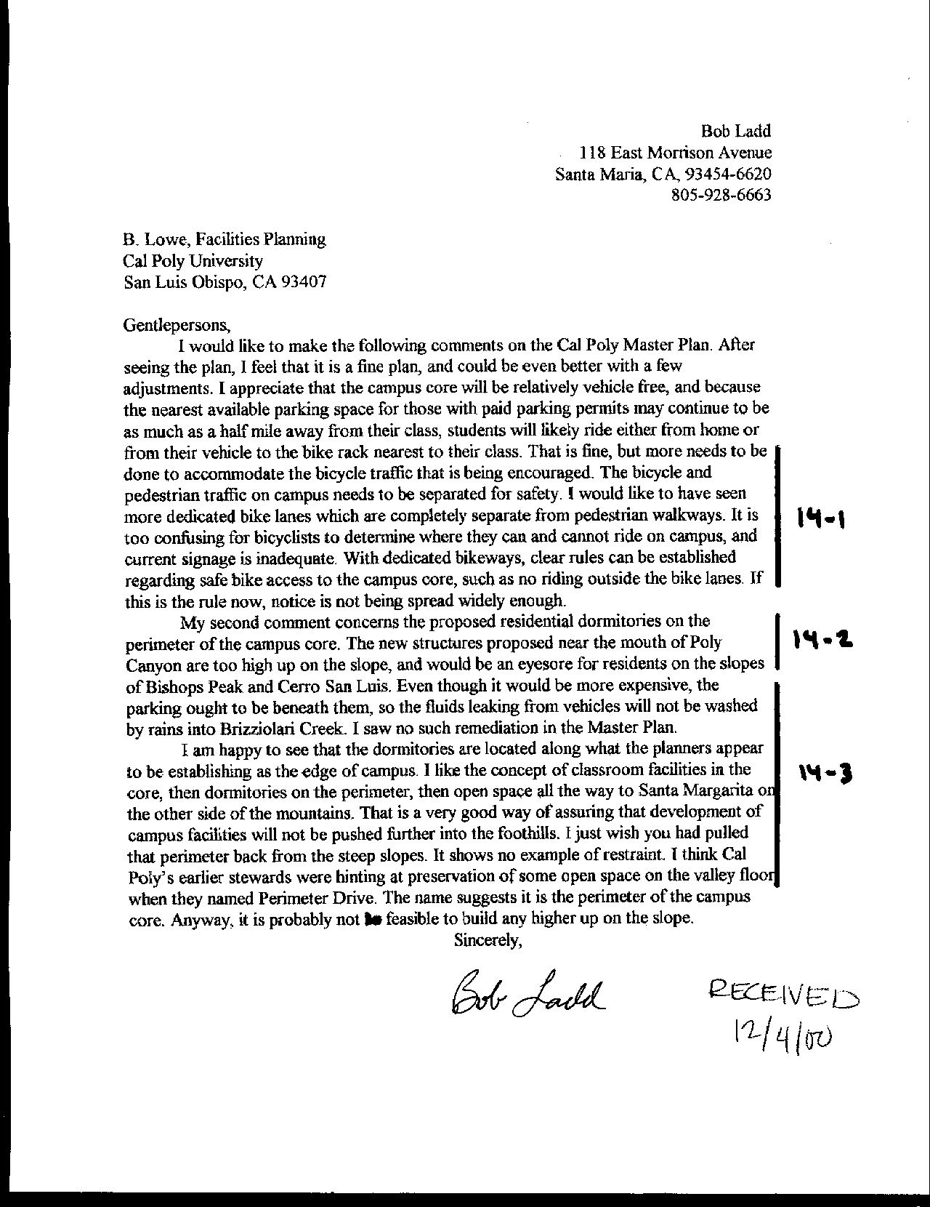
Letter 14
Letter 14

Mr. Bob Ladd

December 4, 2000

14-1 The commenter suggests that more needs to be done to accommodate the bicycle traffic on campus, including greater separation between pedestrians and bicycles for safety.

Response A detailed bicycle planning will be included in the implementation plans.

14-2 The commenter is concerned that the student housing is to be developed too high up the slope of the hills on the eastern edge of the campus instructional core. This could negatively impact the views from residences on the slopes of Bishops Peak and Cerro San Luis.

Response As part of the constraints analysis undertaken at the outset of the Master Plan process, the team identified steep slopes on campus (Exhibit 4.6) that would be inappropriate for development. Further, the team established a limit for construction line on slopes (see text on p. 59). This limit was designed to be consistent with policies in adjoining jurisdictions, the City of San Luis Obispo and the County of San Luis Obispo. Some of the new housing will be visible to established housing across the valley and elsewhere. Because of the distance of these residences from the proposed housing, the impact to visual resources is not significant.

14-3 Parking should be beneath the housing to reduce the possibility of water quality impacts.

Response All campus parking will be designed with drainage facilities that prevent the deterioration of water quality from automobile-related pollutants, whether they are within a structure, or a surface parking lot. A Water Quality Management Plan is under development that will provide best management practices for all development, including parking, on campus. See text addition on p. 195, which indicates that the Plan calls for us to “integrate parking into other structures at ground level or below as feasible.”
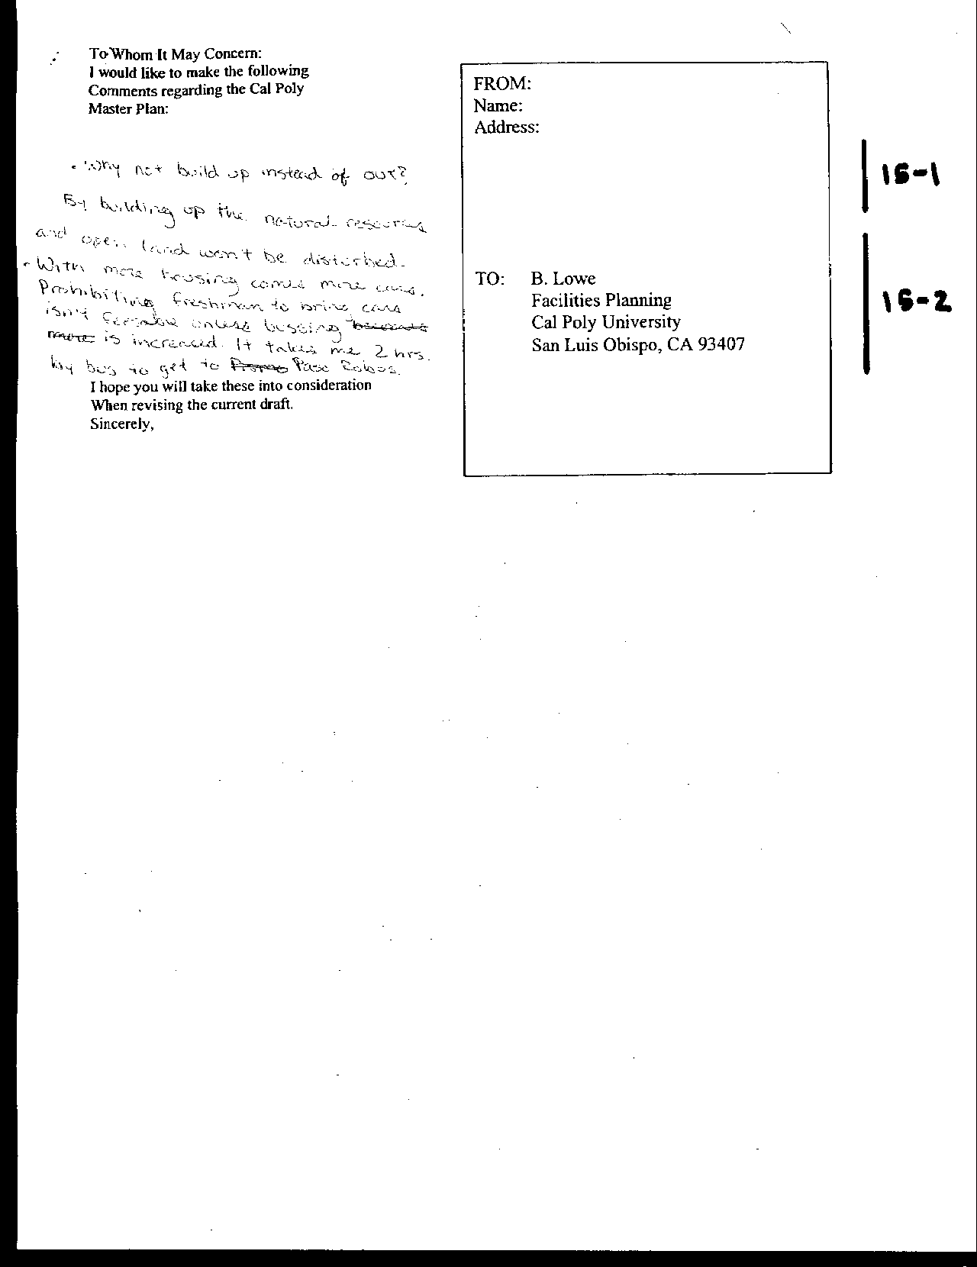
Letter 15
Letter 15

Anonymous

December , 2000

15-1 Commenter suggests “building up instead of out,” thereby preserving natural resources and open land.

Response Several commenters have suggested the University develop housing in a more compact form to save land, especially through the use of taller buildings – “up not out.” Housing on campus was designed to meet several parameters. One was to avoid the development of high-rises. Student housing is effective when it provides an atmosphere of community. This requires air and open recreation space, as well as a connection to everyday living patterns. Taller structures create a disconnection between the student and the student community. In addition, taller structures increase the risk of catastrophe from fire or seismic events. Nevertheless, the proposals are compact, at a density equal to or greater than that elsewhere on campus. Furthermore, a constraints analysis undertaken at the outset of the Master Plan process identified areas appropriate for housing development. The housing proposals are consistent with that analysis. See Constraints and Opportunities analysis in Chapter 4.

15-2 Commenter notes that housing will bring more cars. Transit services must be improved if measures like freshmen restrictions are implemented.

Response Comment noted. Cal Poly will continue to provide financial support for public transportation. Further, the campus will explore many ways in which to balance the allocation of resources toward trip reduction programs rather than toward the cost of providing more parking on campus.

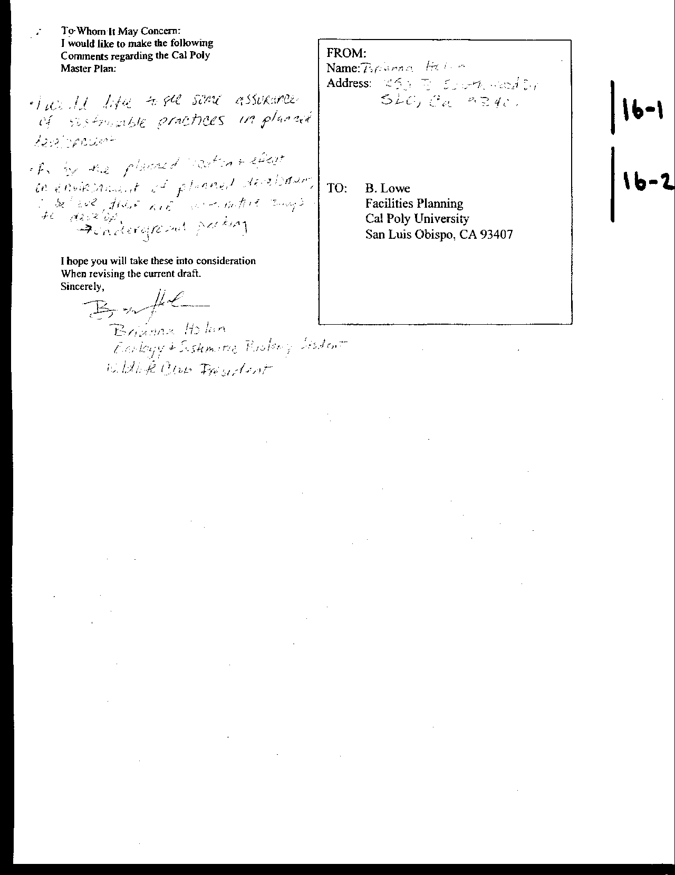
Letter 16
Letter 16

Ms. Brianna Holan

December , 2000

16-1 Commenter requests assurances of sustainable practices in planned development.

Response The following has been added to the Master Plan (pp. 162-163):

Site selection, site planning and building design should account for solar exposure, prevailing wind direction, and patterns of light and shade to minimize energy requirements and enhance the quality of outdoor space. Design guidelines and processes for implementing the Master Plan should encourage energy efficient building design and resource conservation. The campus landscape plan should consider the impact of vegetation and water use on the resource efficiency of facilities and the creation of comfortable and functional outdoor space.

Design for renovation of existing buildings and new construction should consider ways to maximize energy efficiency and take advantage of the mild climate in San Luis Obispo. Alternative, renewable energy sources should be used to the greatest extent possible to offset growth in demand. As costs escalate for traditional energy sources, other options to consider include integrated photovoltaic and solar generation for electricity, passive and low energy cooling strategies for buildings (including materials, solar control, natural ventilation, thermal mass), passive solar space and water heating, and effective use of day lighting. New buildings should be well ventilated using natural ventilation, and existing buildings should be retrofitted where feasible to make them usable and livable during the summer without requiring air conditioning.

Consistent with Cal Poly’s mission, the campus should explore an integrated approach to sustainable, or “green” design for research, education and operational applications in new and renovated buildings and in the campus landscape treatment. In addition to the energy conservation measures noted above, these efforts should address water conservation and reclamation, re-use of materials and products, and life-cycle costing in general. Several opportunities for resource recovery projects with educational and research potential as well as operational value include water supply and waste treatment for animal facilities, enhancement of Brizzolara Creek and the construction of new student residential communities.

16-2 As to the location and effect on environment from planned development, commenter suggests that there are alternatives, such as underground parking.

Response Several commenters have suggested the University develop housing in a more compact form to save land, especially through the use of taller buildings – “up not out.” Housing on campus was designed to meet several parameters. One was to avoid the development of high-rises. Student housing is effective when it provides an atmosphere of community. This requires air and open recreation space, as well as a connection to everyday living patterns. Taller structures create a disconnection from the student to the student community. In addition, taller structures increase the risk of catastrophe from fire or seismic events. Nevertheless, the proposals are compact, at a density equal to or greater than that elsewhere on campus. Furthermore, a constraints analysis undertaken at the outset of the Master Plan process identified areas appropriate for housing development. The housing proposals are consistent with that analysis. See Constraints and Opportunities analysis. Where feasible, the Master Plan calls for “integration of parking into structures at ground level or below” (page 195).

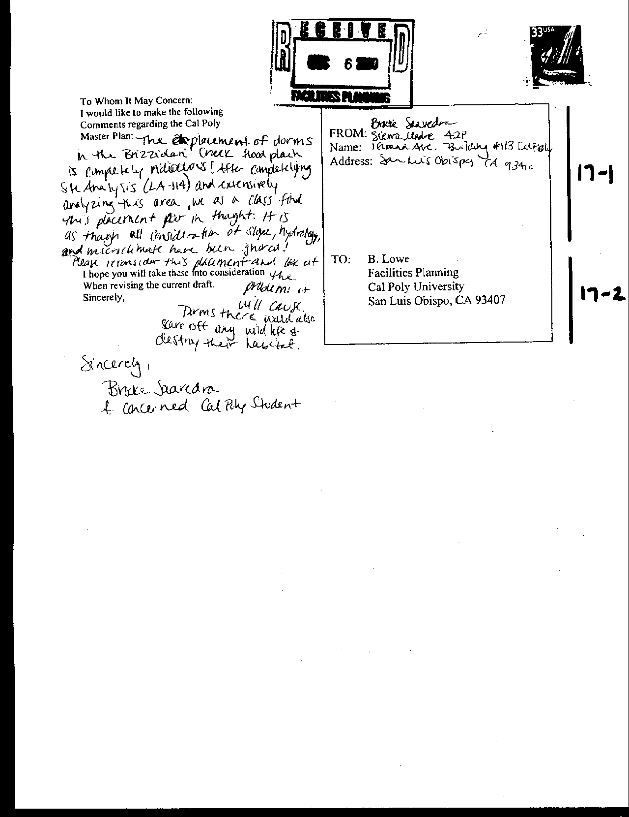
Letter 17
Letter 17

Ms. Brooke Saavedra

December , 2000

17-1 Commenter questions wisdom of placing student housing in the Brizzolara Creek floodway.

Response Student housing was proposed near Brizzolara Creek in the Spring 2000 draft of the Master Plan. This housing was relocated to accommodate the Brizzolara Creek Enhancement Project. No housing will be located in the floodway. See Exhibit 5.9. See Constraints and Opportunities analysis in Chapter 4, as well.

17-2 Housing will impact wildlife and habitat.

Response Please refer to Exhibit 5.9. Housing has been located only on previously utilized land (for example the Bull Test area –H-1 and H-2, or the parking lot behind the North Mountain dorms—H-5), with the exception of the small area to the south of Yosemite Hall (H6). The DEIR addresses impacts from the housing proposals.

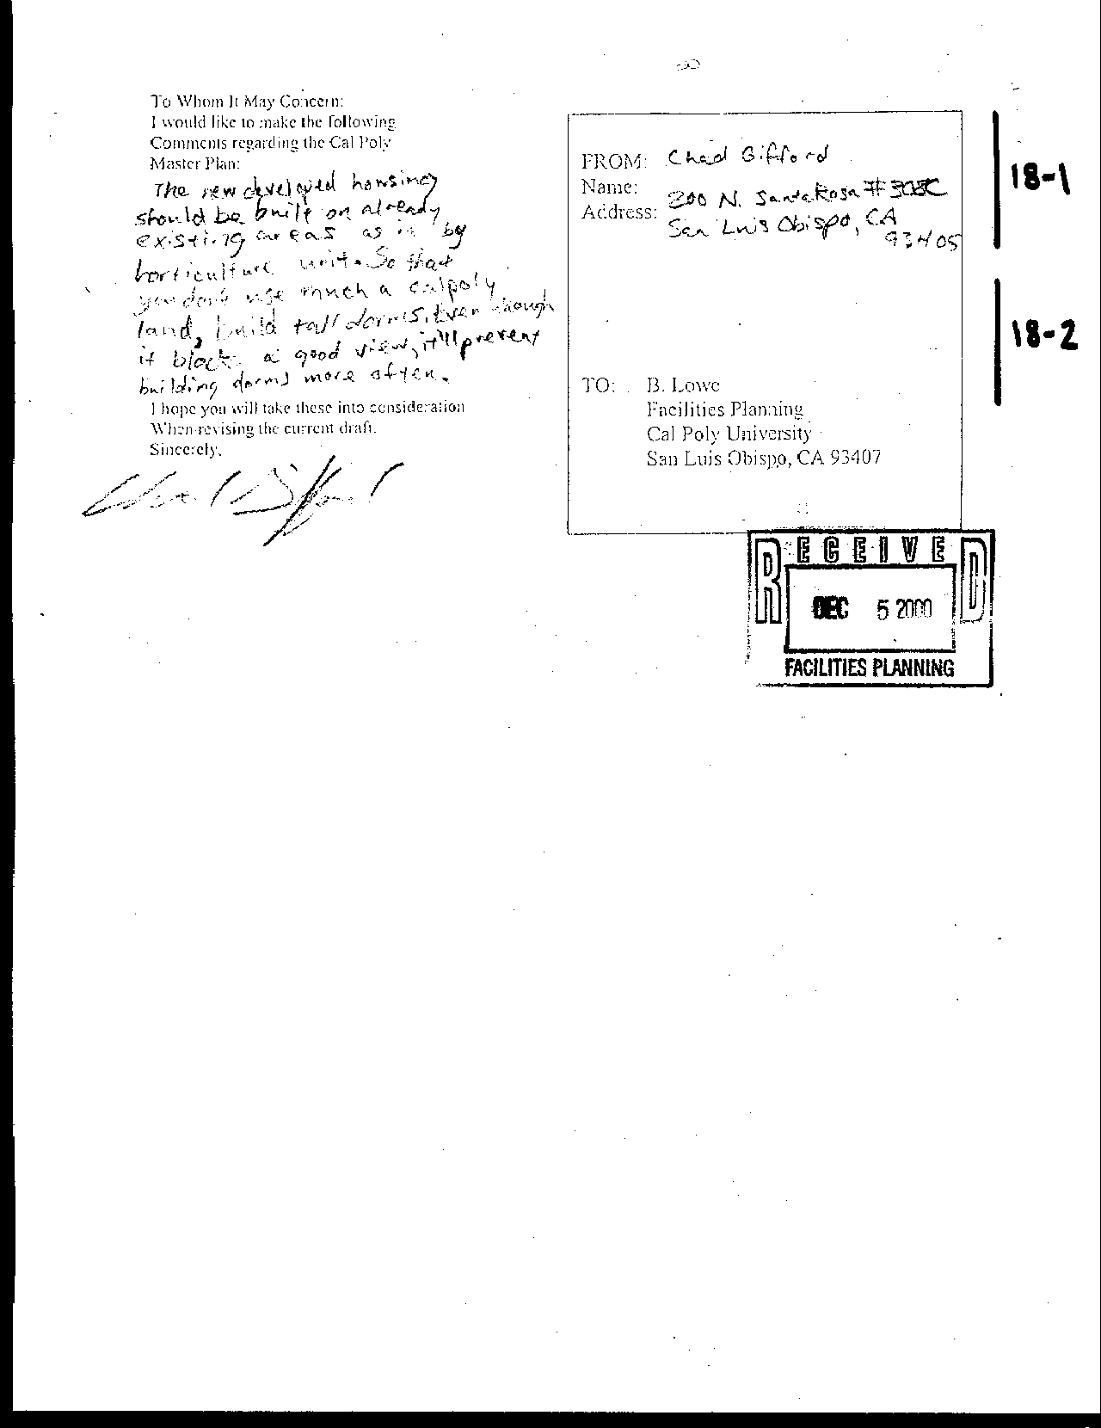
Letter 18
Letter 18

Mr. Chad Gifford

December , 2000

18-1 Commenter suggests new housing should be developed on previously developed areas.

Response Please refer to Exhibit 5.9. Housing has been located only on previously utilized land (for example the Bull Test area –H-1 and H-2, or the parking lot behind the North Mountain dorms—H-5), with the exception of the small area to the south of Yosemite Hall (H6). See Constraints and Opportunities analysis in Chapter 4.

18-2 Commenter suggests building taller structures to save land.

Response The proposed housing will range from two to four stories, although the University prefers not exceeding three stories. The reasons for not developing taller structures have to do with safety and community. The taller the structure, the greater the fire and seismic hazards. Furthermore, taller structures are not conducive to creating an atmosphere of community. See Constraints and Opportunities analysis in Chapter 4. Where feasible, parking may be incorporated into structures at or below ground level to allow for more compact development (refer to page 195).

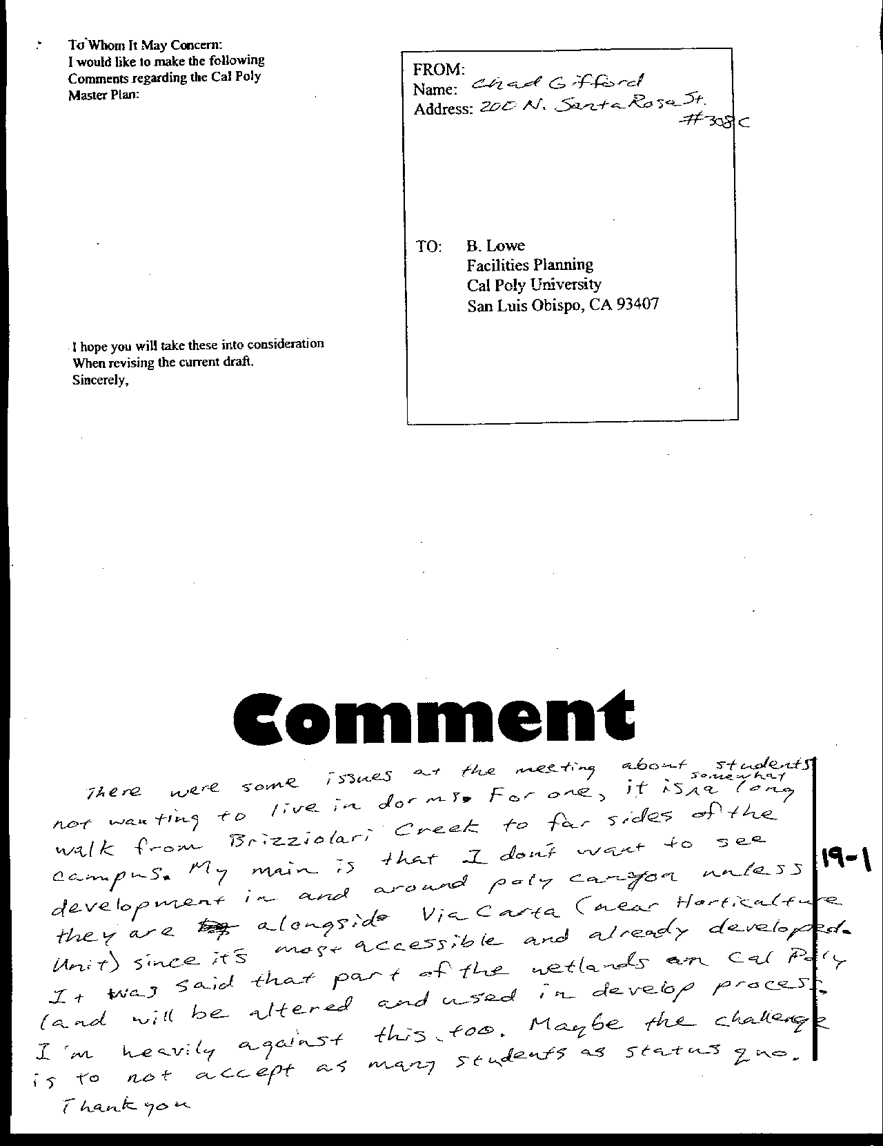
Letter 19
Letter 19

Mr. Chad Gifford

December , 2000

19-1 Commenter reiterates previous comments and adds that housing near Brizzolara Creek will be too far from the far side of campus.

Response The so-called “10-minute rule,” was used to define the campus instructional core, and guide the placement of housing. The rule intones that a student should be able to traverse campus, from one class to the following, within 10 minutes. The housing at H-1 and H-2 will be the furthest residences from classes in the College of Business, for example, and some students may need to allow more than ten minutes to cover this distance. However, once within the campus core, students should be able to move from class to class within ten minutes.

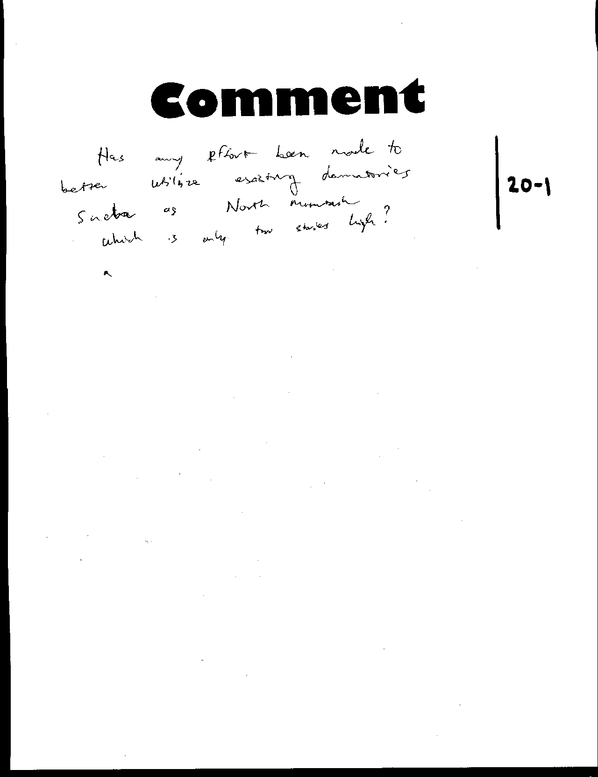
Letter 20
Letter 20

Anonymous

December , 2000

20-1 Commenter asks if any effort has been made to better utilize existing dormitories, such as North Mountain, which are only two stories.

Response Yes. The redevelopment of North Mountain dormitories is shown on Exhibit 5.9 as proposed housing H-4. See Residential Communities element.
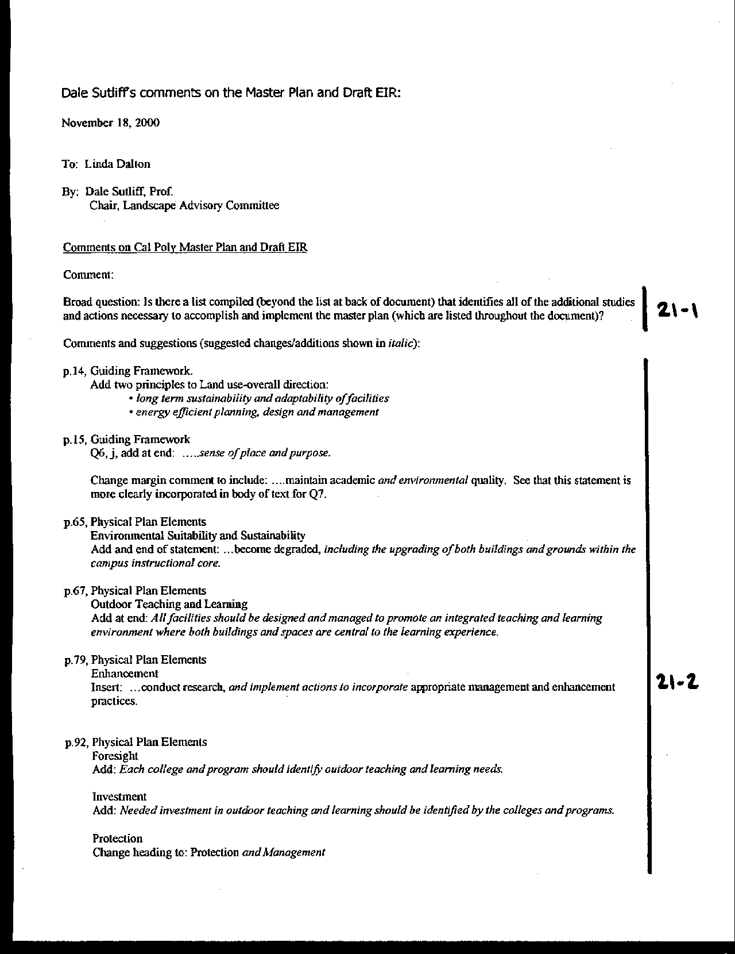
Letter 21
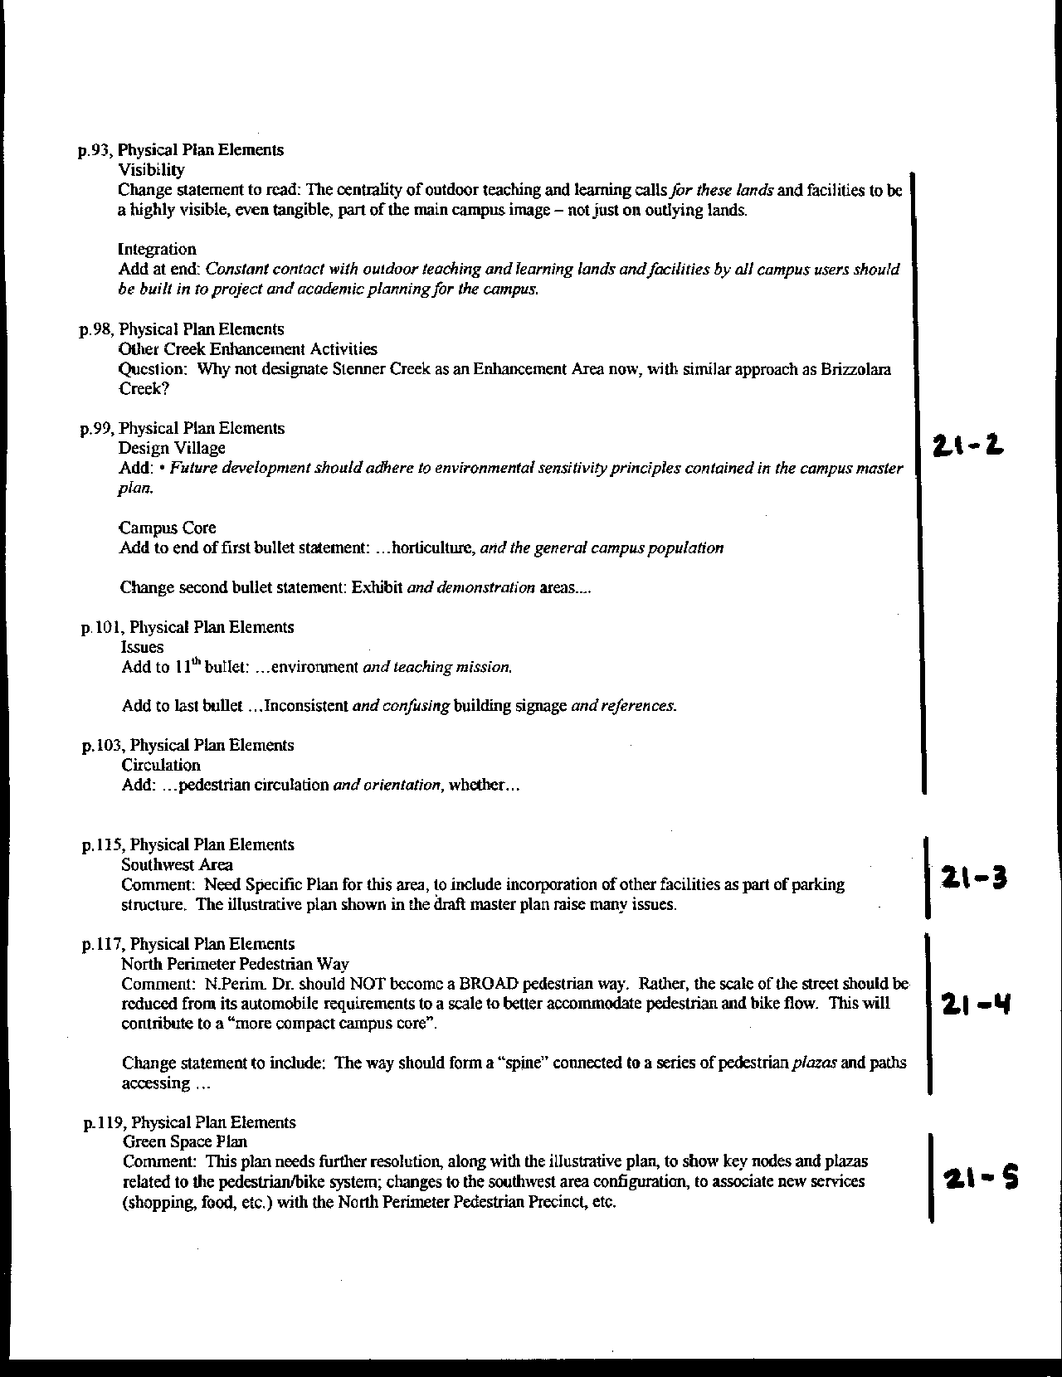
Letter 21
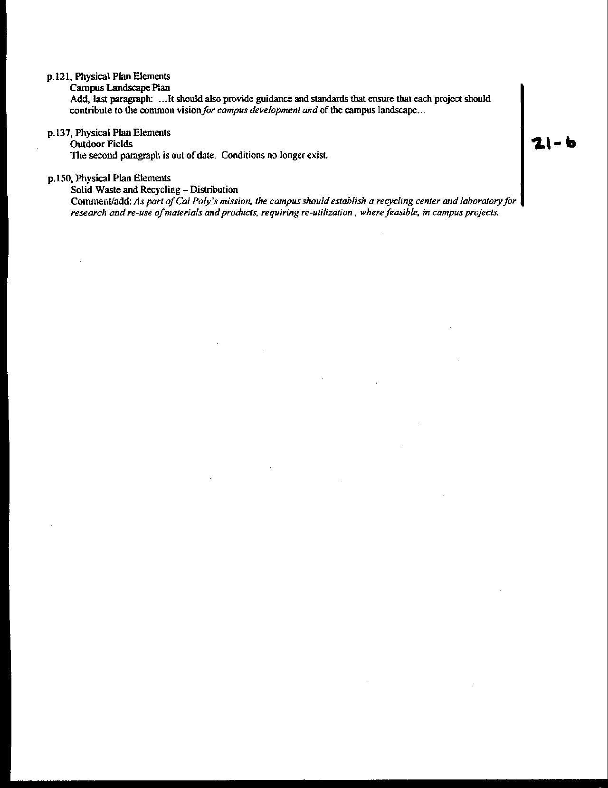
Letter 21
Letter 21

Mr. Dale Sutliff

Chair, Landscape Advisory Committee

November 18, 2000

21-1 Commenter asks if a complete list of implementation actions are included in the plan.

Response The current version of the Master Plan has been modified to include a list of all suggested implementation measures for the Master Plan. See Chapter Seven, Implementation Activities. See Chapter 7, updated.

21-2 Commenter suggests a number of text changes to the Master Plan, specifically on pages 14, 15, 65, 67, 79, 92, 93, 99, 101, 103, 121 and 150 (pages per the October 10, 2000 Plan).

Response Most changes were made consistent with the intent of this suggestion. Text changes can be found on pages 16, 17, 69, 71, 84, 96, 97, 98, 103, 106, 108, 127. The alteration suggested for recycling (draft plan page 150) was not incorporated into the plan at this location. Instead, a new section on Sustainable Campus Planning and Design was added at the end of the Public Facilities and Utilities element. This section includes the following language: “… these efforts should address water conservation and reclamation, re-use of materials and products, and life-cycle costing in general” (pp. 162-163).

21-3 Commenter suggests the need for a more specific plan of the southwest area of campus.

Response Chapter 7 identifies the Southwest Area for one of several implementation studies.

21-4 Commenter suggests North Perimeter should not become a “broad pedestrian way.”

Response The text has been changed to reflect this comment; “North Perimeter Drive should become a human-scale pedestrian way …” (p. 122).

21-5 Commenter suggests that the green space plan needs further refinement, showing key pedestrian nodes and plazas and other features.

Response Chapter 7 identifies pedestrian systems as one of several implementation studies.

21-6 Commenter suggests a number of text changes to the Master Plan, specifically on pages 121, 137, and 150.

Response Environmental quality is addressed in question 2.

21-7 Designate Stenner Creek as an Enhancement Area now.

Response The following has been added to the Master Plan (p. 103): “Guiding Principles and Goals for the Cal Poly Creek Management and Enhancement Plan” are located in Appendix F. The principles and goals will apply to all creeks on Cal Poly lands, including Stenner Creek. In addition, Cal Poly has partnered with the Land Conservancy of San Luis Obispo County. The Land Conservancy has undertaken several projects on Stenner Creek to reduce erosion and improve fisheries habitat, especially for the endangered steelhead. This enhancement work will continue with other reaches of the creek.”

21-8 The discussion in the Recreation, Athletics and Physical Education element entitled “Outdoor Fields” is out of date.

Response With the completion of the Sports Complex, the discussion in the Master Plan has been modified to reflect current conditions (p. 145).

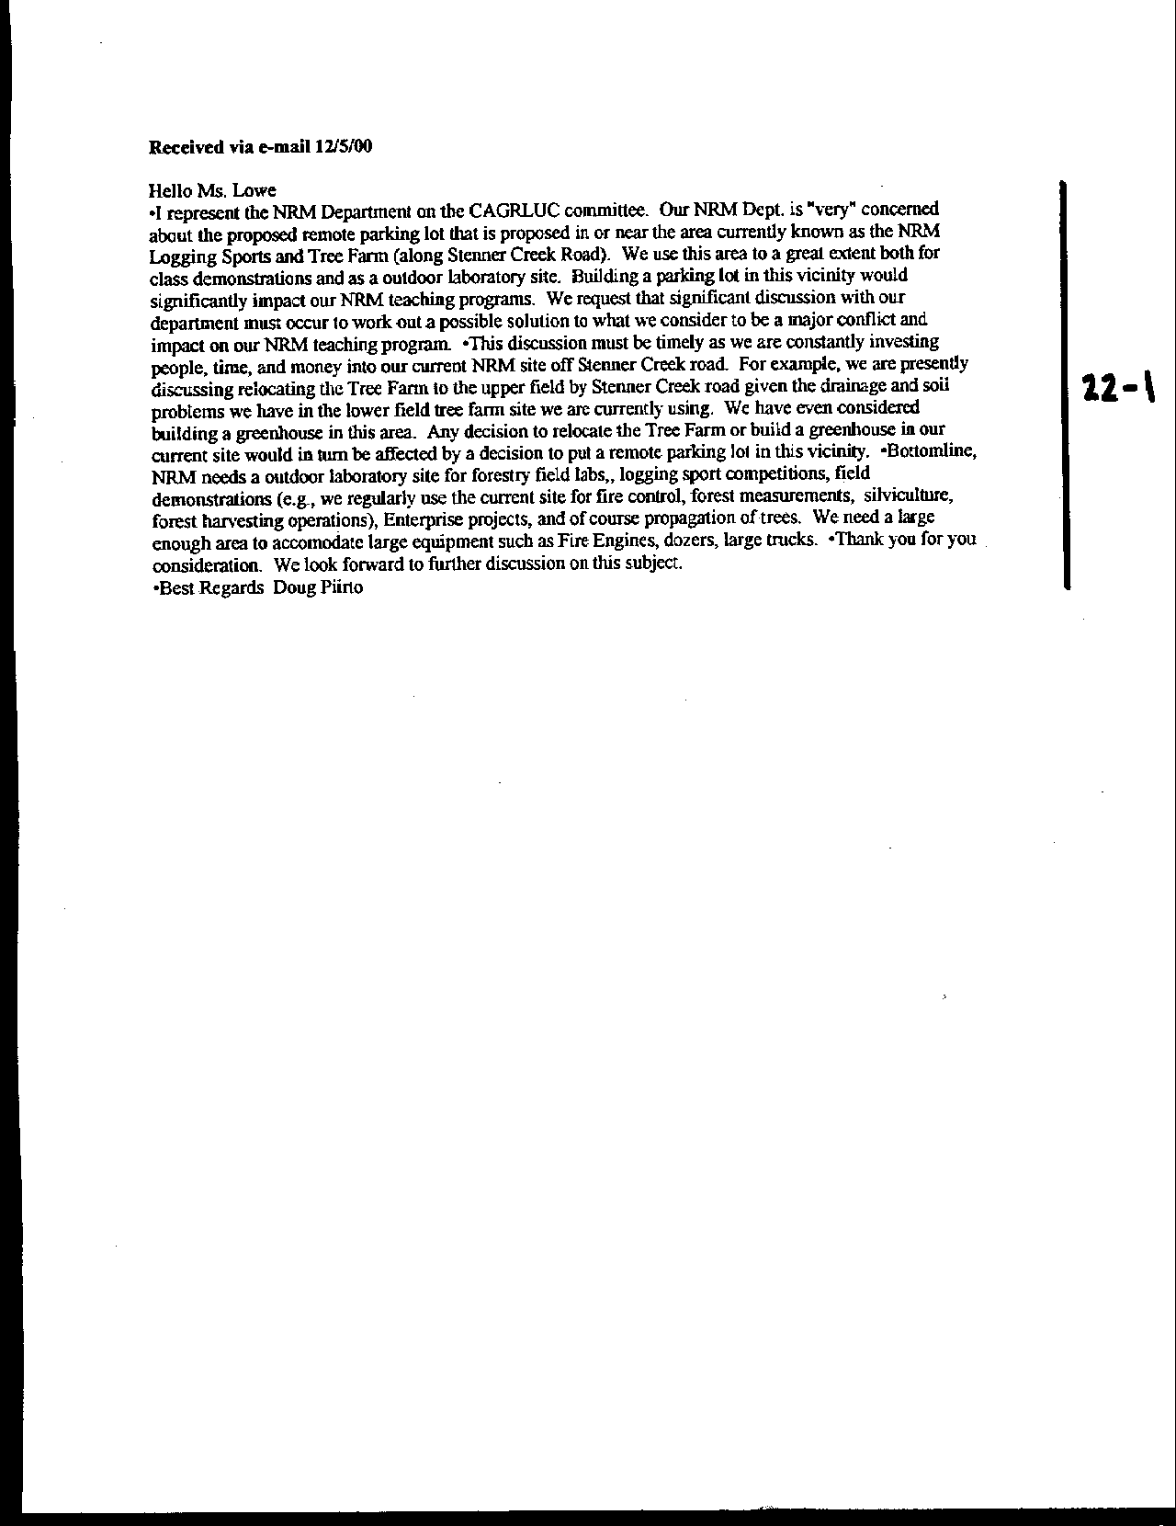
Letter 22
Letter 22

Dr. Doug Piirto

CAGRLUC

December 5, 2000

22-1 Commenter, on behalf of the NRM Department and CAGRLUC, raises concerns about the proposed locations for remote parking. Commenter notes that the proposed lot is on or near the area of their Forestry Demonstration Area and Christmas Tree Farm.

Response The Master Plan Land Use map (Exhibit i) identified two general locations where a remote parking lot could be developed. The locations will be refined as discussed in new text on p. 195: “Planning for development of a remote parking site that would involve moving any Outdoor Teaching and Learning activities, such as the forestry demonstration area or sheep grazing, would follow the principle that a new site for their operations would need to be identified and developed first, so as to minimize disruption.” It is important to note that the development of remote parking is a contingency predicated on the inability to reduce parking demand through restrictions described in the Alternative Transportation element of the Master Plan.

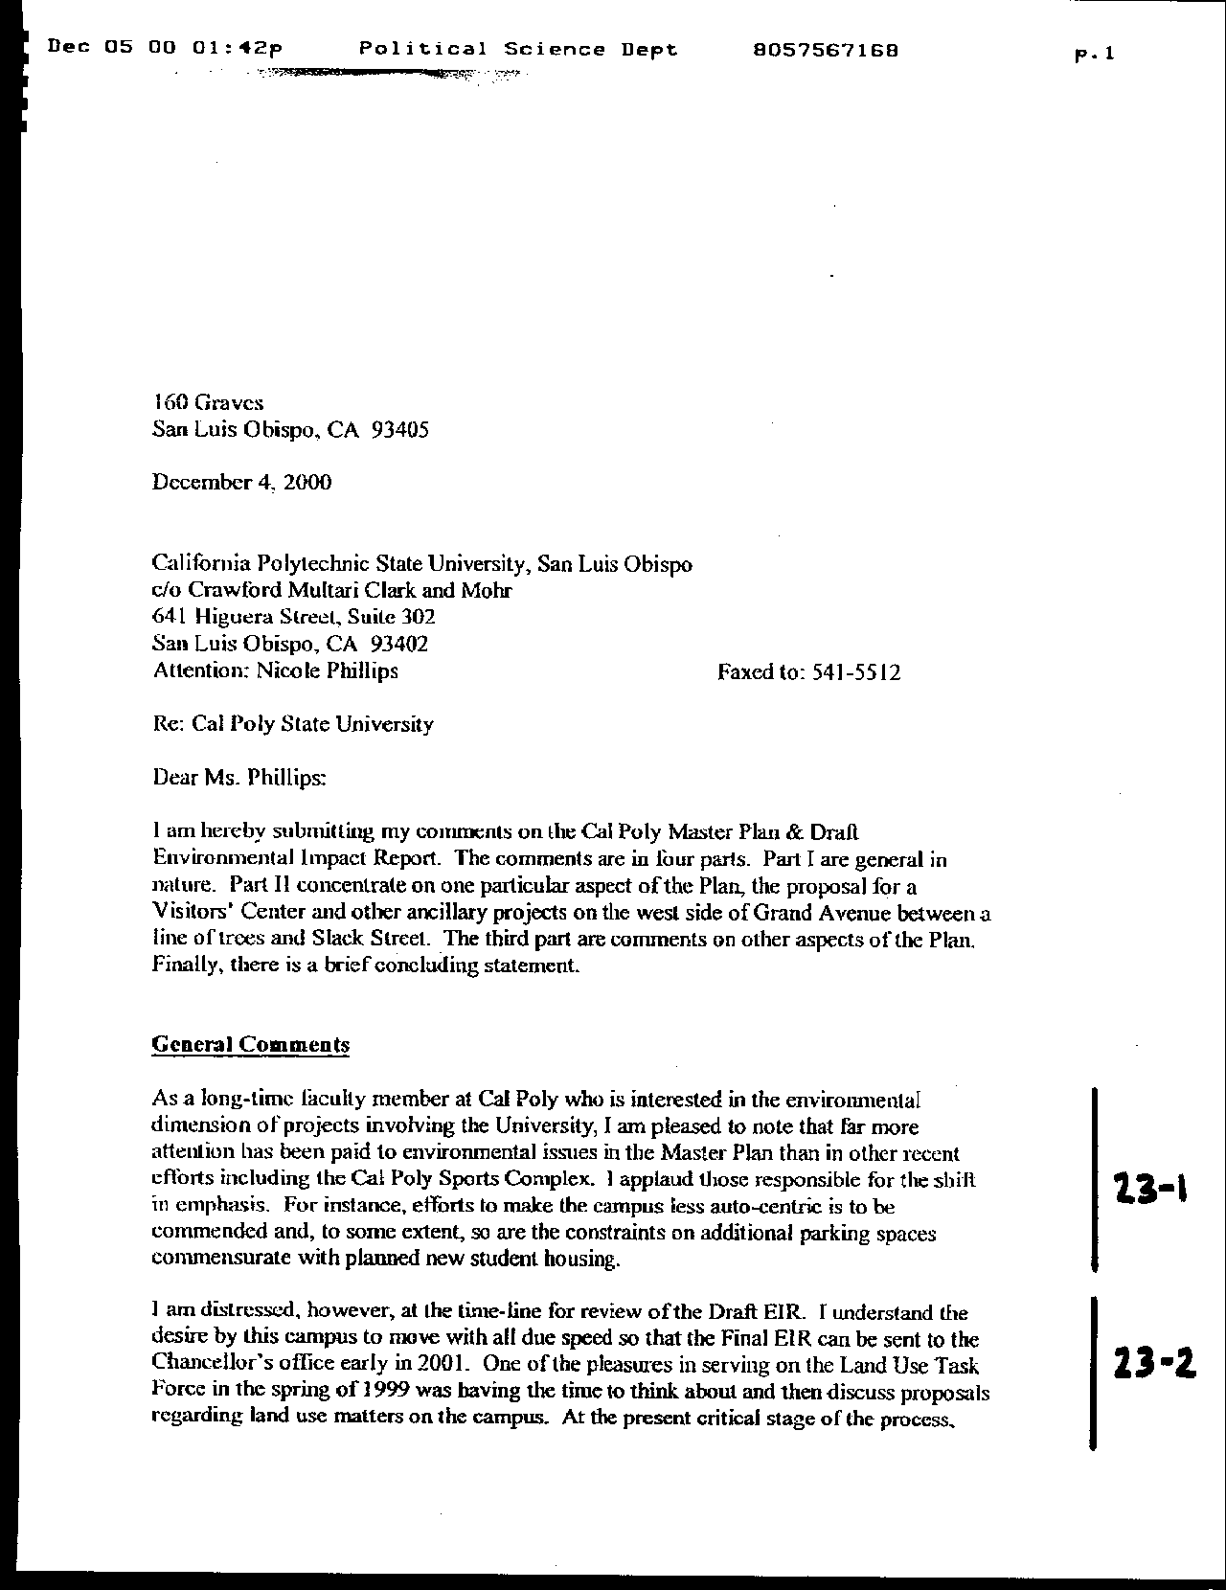
Letter 23
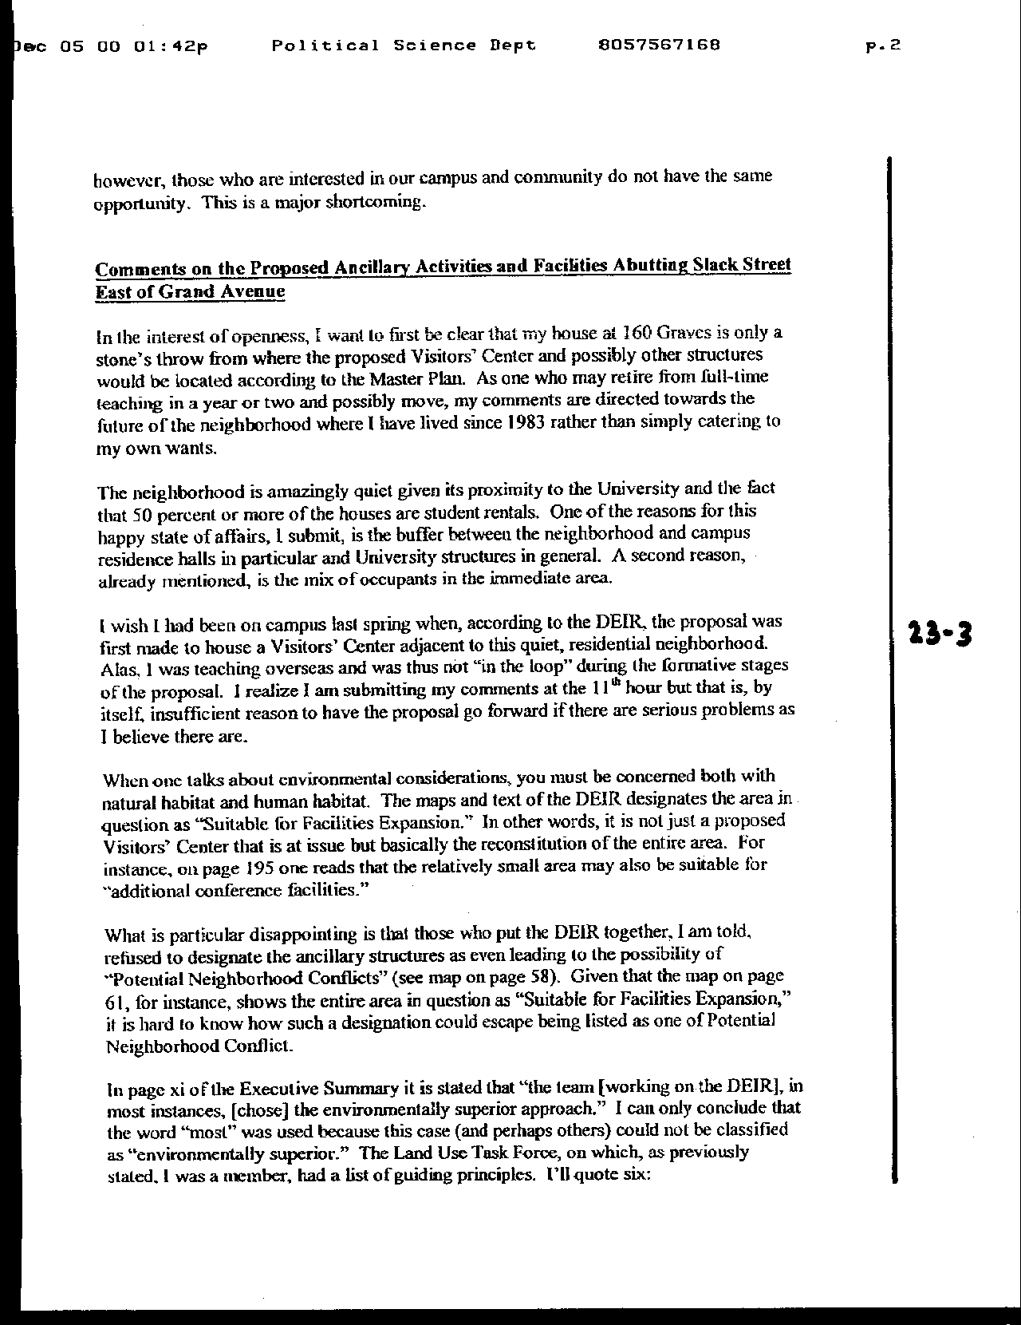
Letter 23
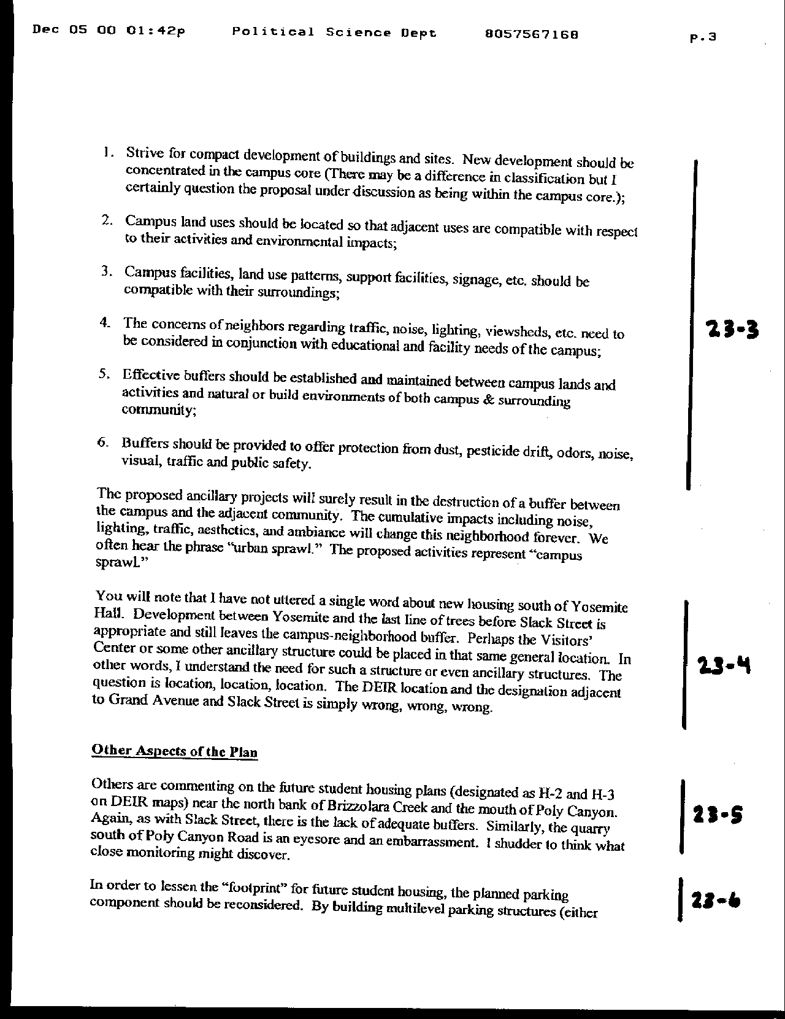
Letter 23
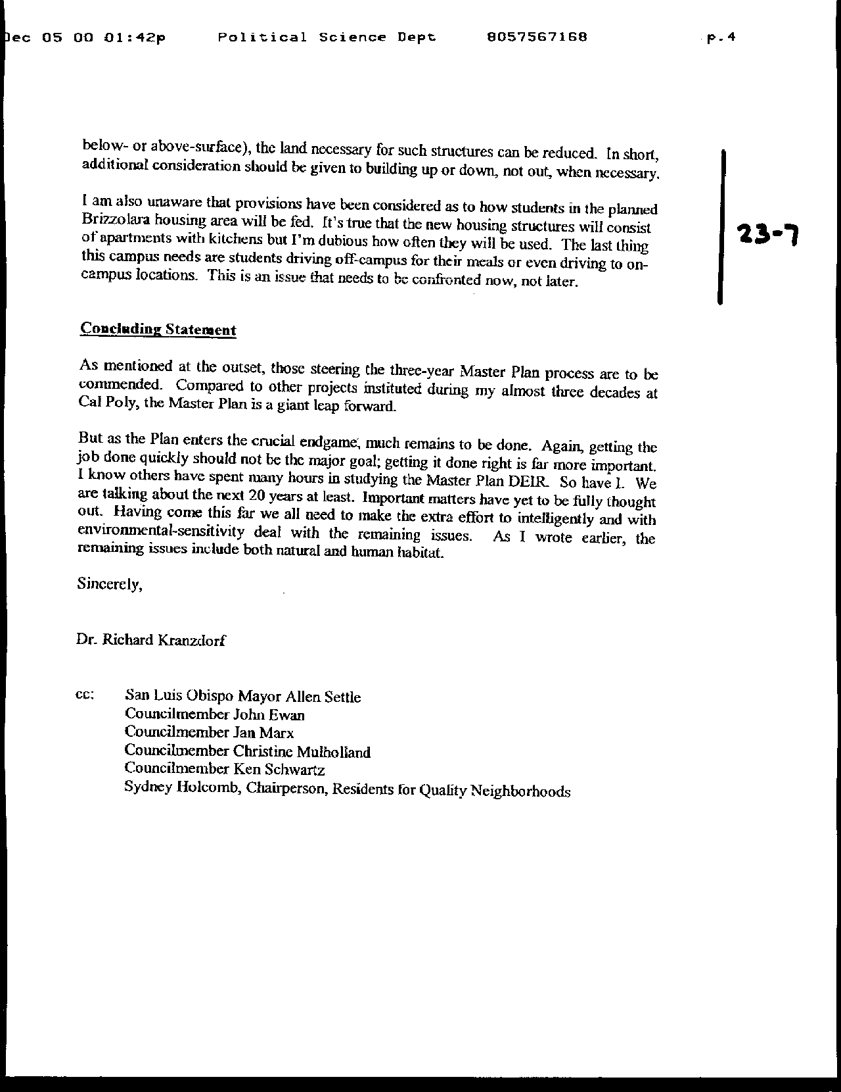
Letter 23
Letter 23

Dr. Richard Kranzdorf

December 4, 2000

23-1 Commenter lauds efforts to reduce reliance on the automobile.

Response Comment noted for the benefit of the decision makers. No response required.

23-2 Commenter concerned about the short time frame for review of the Master Plan.

Response Cal Poly’s Master Plan team has been preparing the Master Plan for the past three years. Following public meetings during the Fall and Winter quarters of the 1998-1999 academic year, over one hundred members of the campus and community participated in task forces during Spring 1999 to develop the guiding principles for the plan. The plan was first presented in draft form to the public in the Spring of 2000. Numerous press releases and public meetings accompanied the release of this early version of the plan. The formal plan and Draft EIR were presented to the community in the Fall of 2000. The March date for the Board of Trustees presentation has been presented to the public for over three years. See discussion of process in Introduction and Task Forces in Chapter 2.

23-3 Commenter is concerned about development proposed at the northeast corner of the intersection of Slack Street and Grand Avenue and that it is not a “Potential Neighborhood Conflict.”

Response The map has been modified to show a more limited area of development, and a buffer has been added. The Constraints Summary (Exhibit 4.10) has been modified to more specifically identify potential neighborhood conflicts on the east side of Grand Avenue. Shifting this arrow in no way implies that the west side of Grand is now in a changed condition relative to neighborhood impacts.

23-4 Commenter notes that he has no objection to development located immediately south of the Yosemite Hall dormitory buildings.

Response This area is still several hundred feet from the residential development and is buffered by vegetation located in a drainage swale.

23-5 Commenter echoes concerns raised by others regarding development near Brizzolara Creek and Poly Canyon.

Response Concerns are noted. The Master Plan team made extensive efforts to relocate the H-1 and H-2 housing units at a suitable distance from the creek corridor that resulted in the creation of the Brizzolara Creek Enhancement Project and the re-adsorption of units initially proposed for location along the creek (namely H-3). The additional beds were the result of partial absorption of the H-4 housing unit which could not be relocated in its entirety elsewhere on campus. The EIR addresses the impacts of the proposed housing project.

23-6 Commenter suggests additional structured parking to reduce the need for development of more land.

Response See Constraints and Opportunities analysis. Text has been added to the Plan to include parking under structures where feasible (p. 195).

23-7 Commenter raises concerns about students living north of Brizzolara Creek and their need to drive off campus for food.

Response The proposed new residences will be apartment style dwellings. Each will contain a kitchen. The Master Plan proposes additional markets on campus to support student needs. See Support Services element, p. 199, 202-203. Nevertheless, students will need to leave campus for some shopping. These trips are included in the traffic analysis.

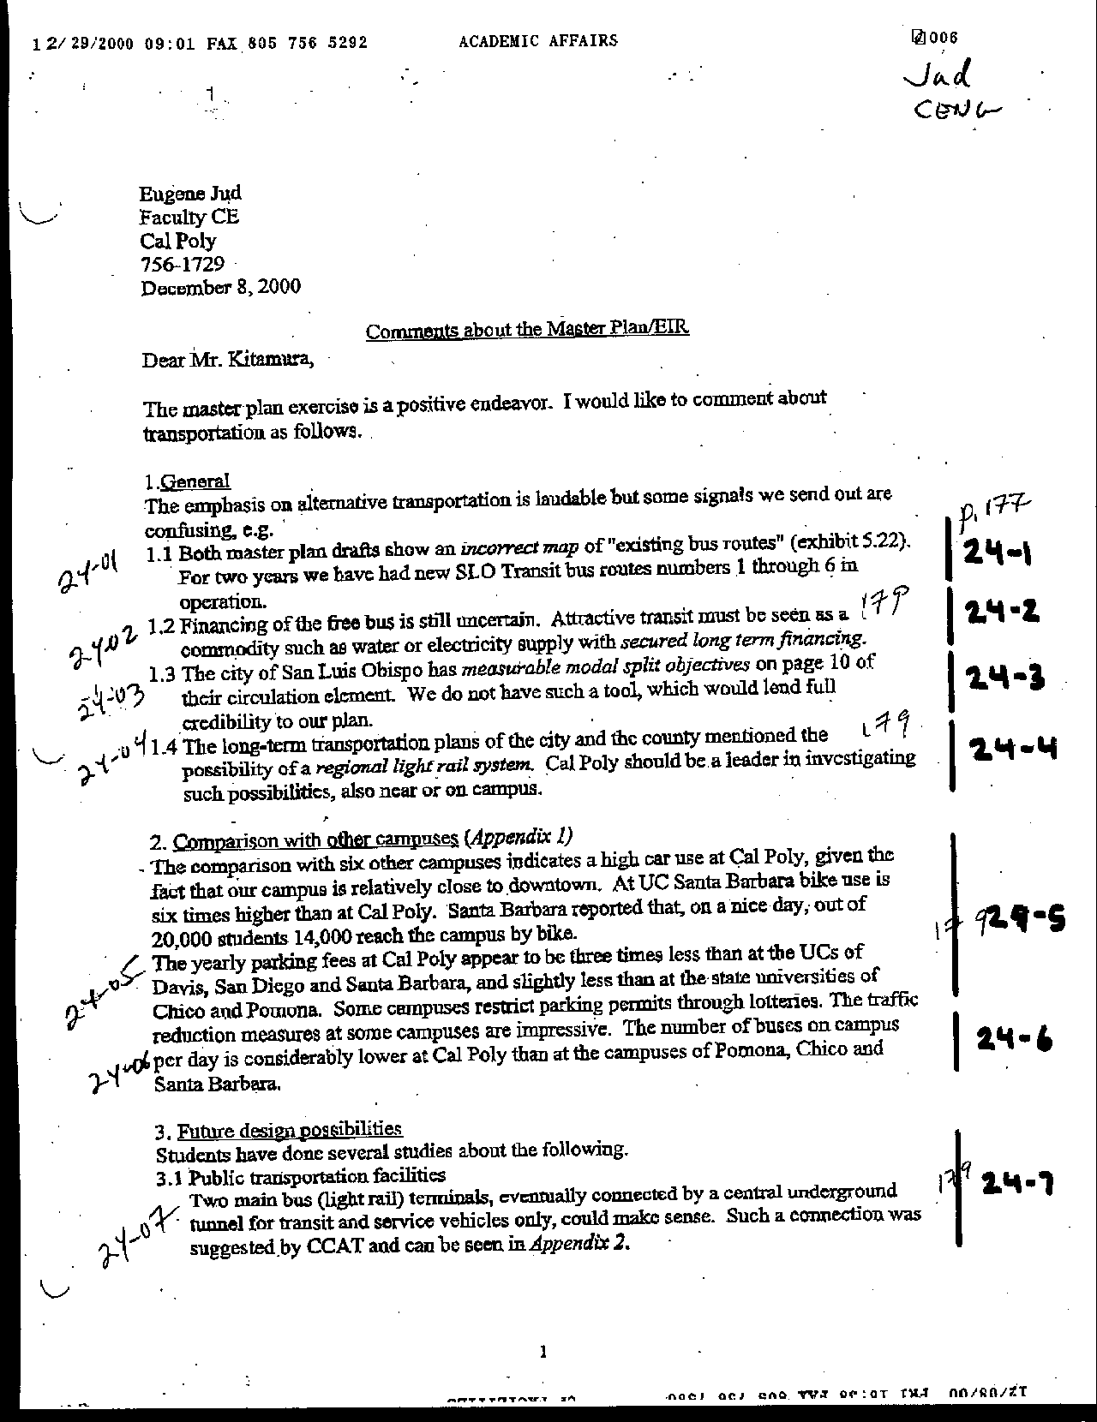
Letter 24
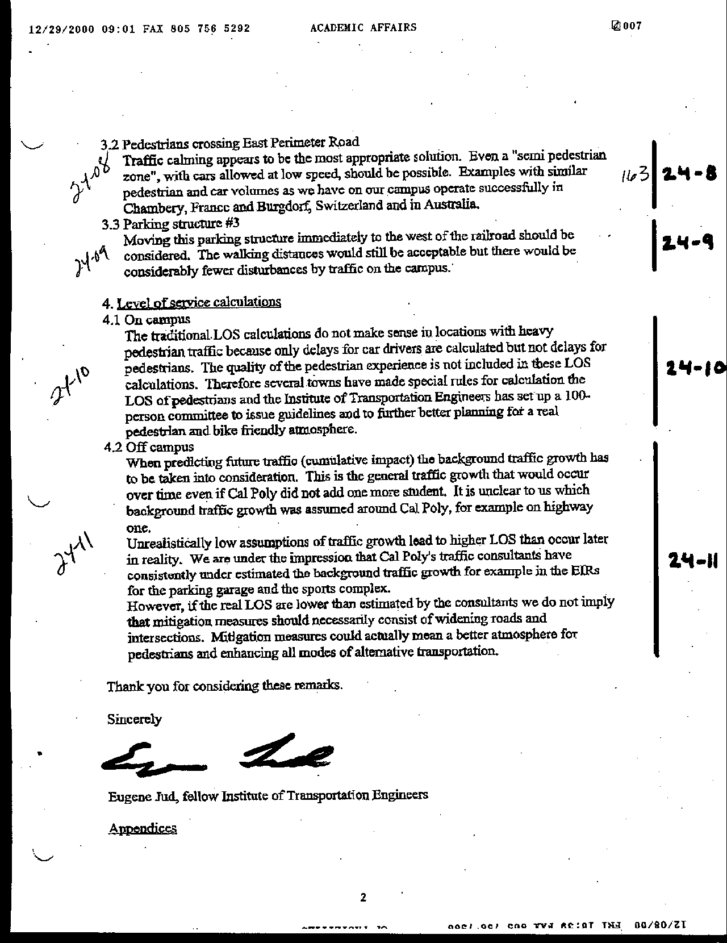
Letter 24
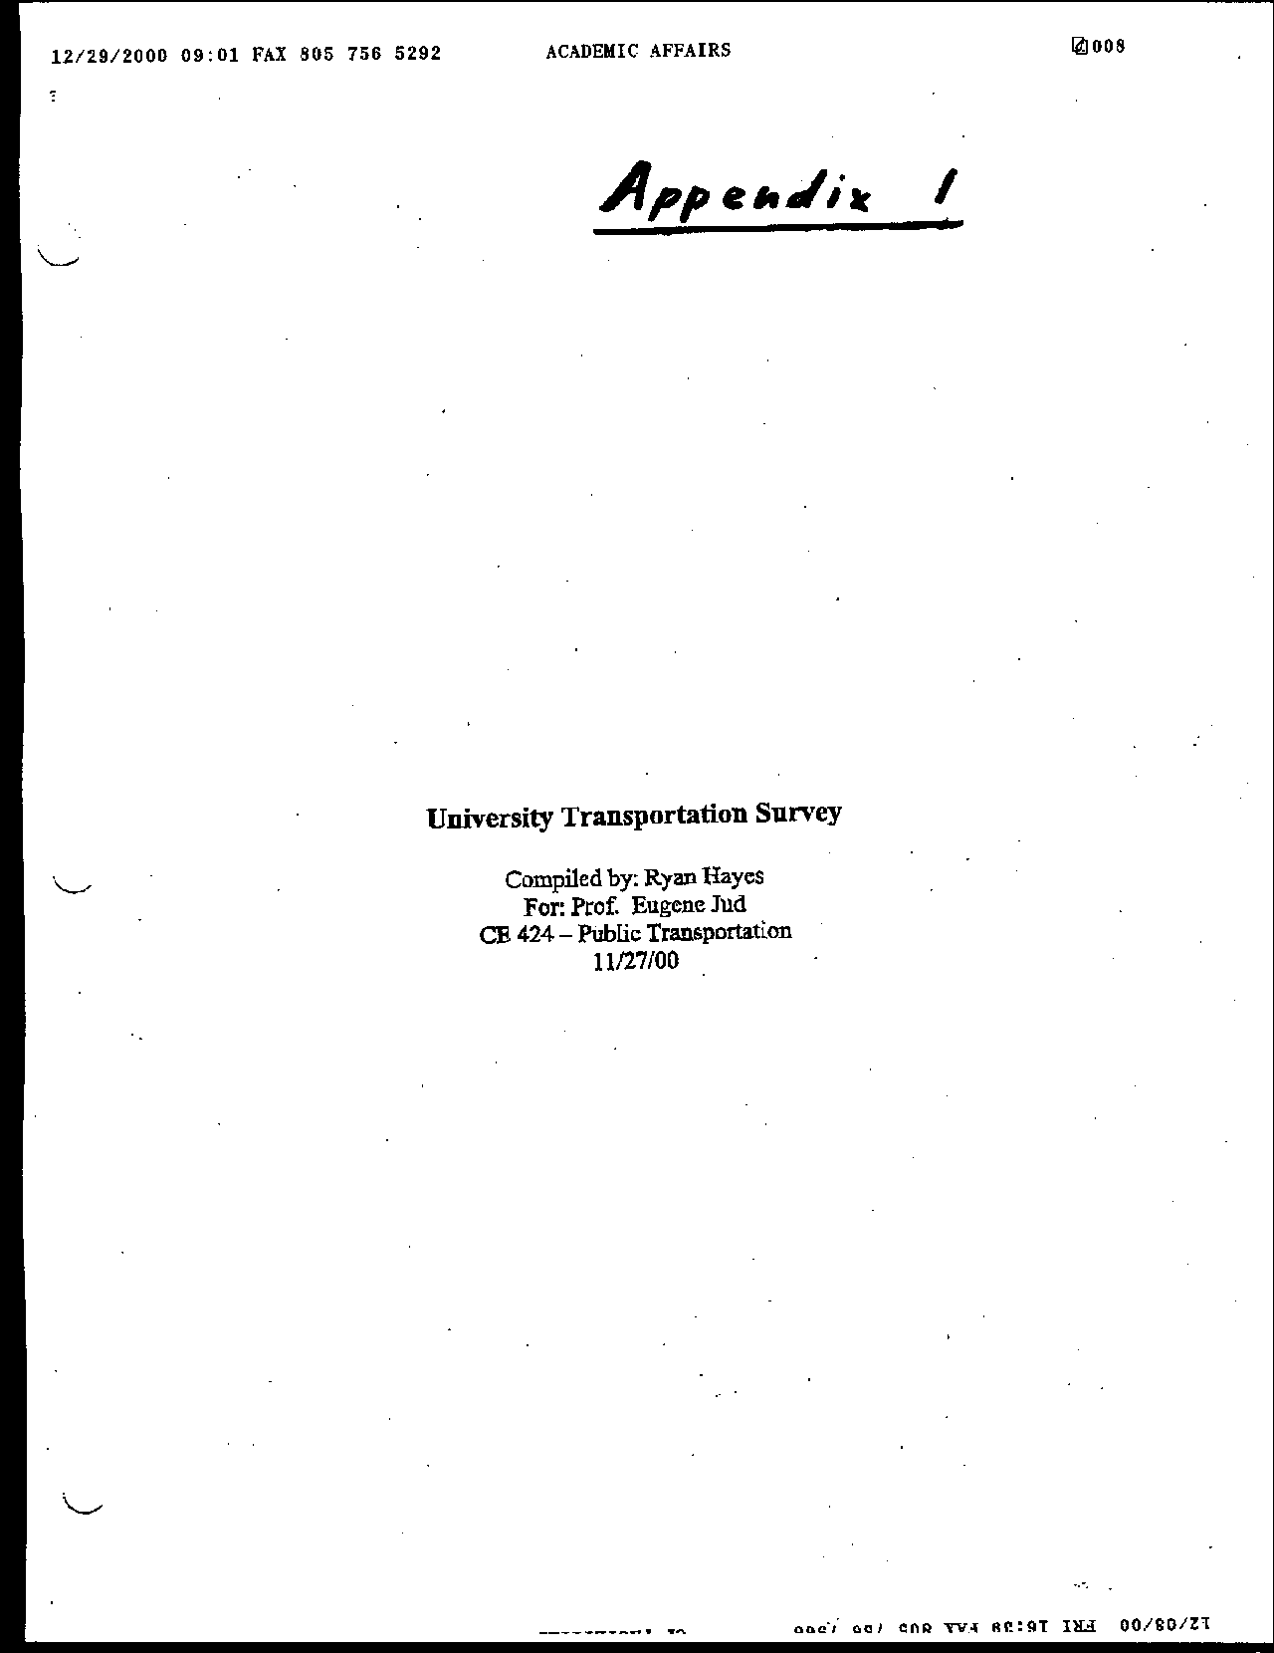
Letter 24
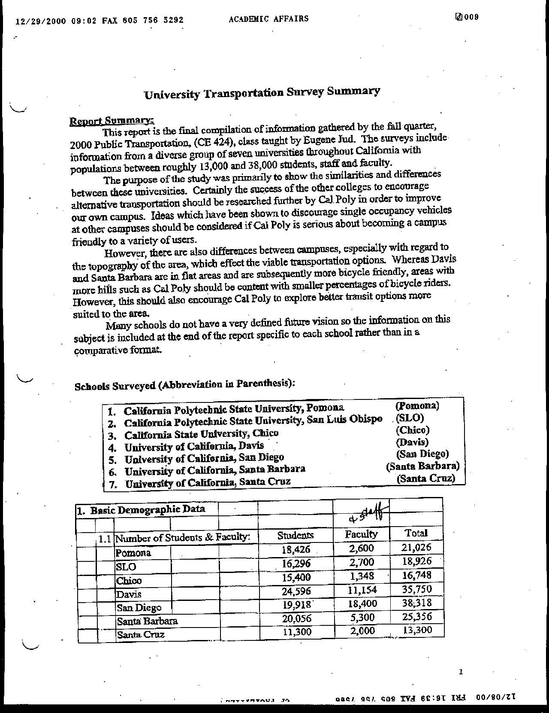
Letter 24
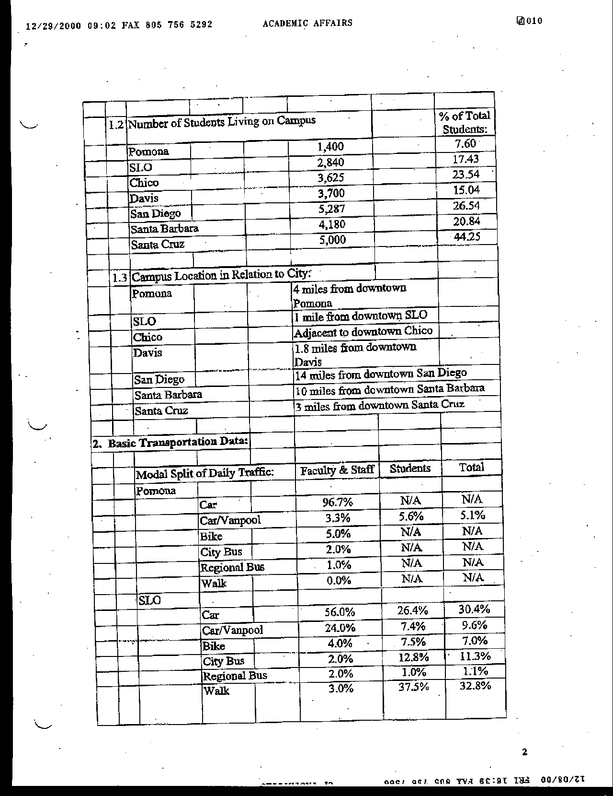
Letter 24
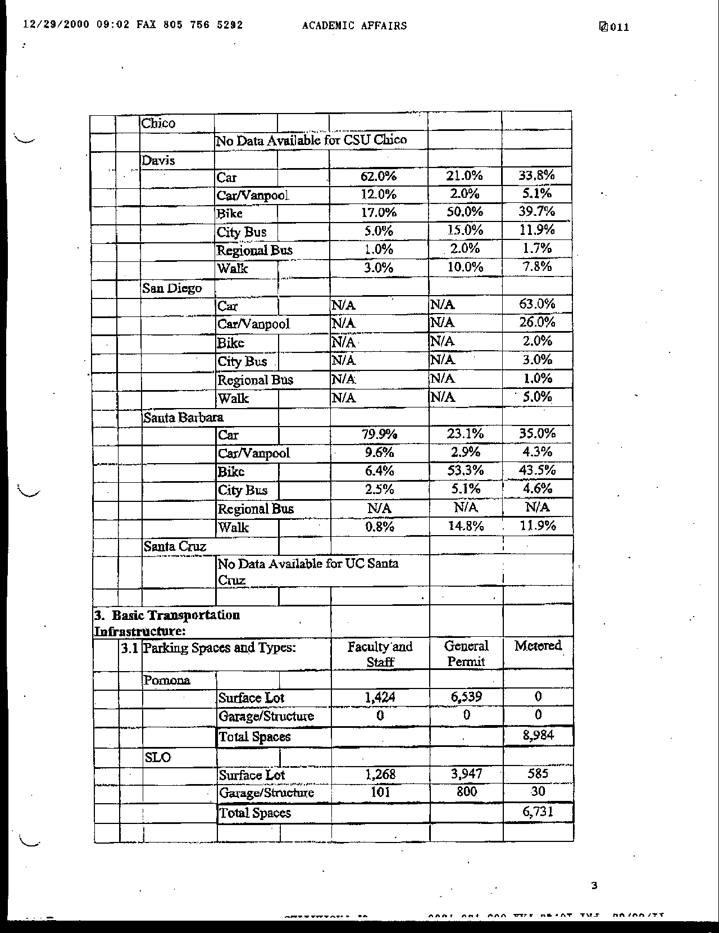
Letter 24
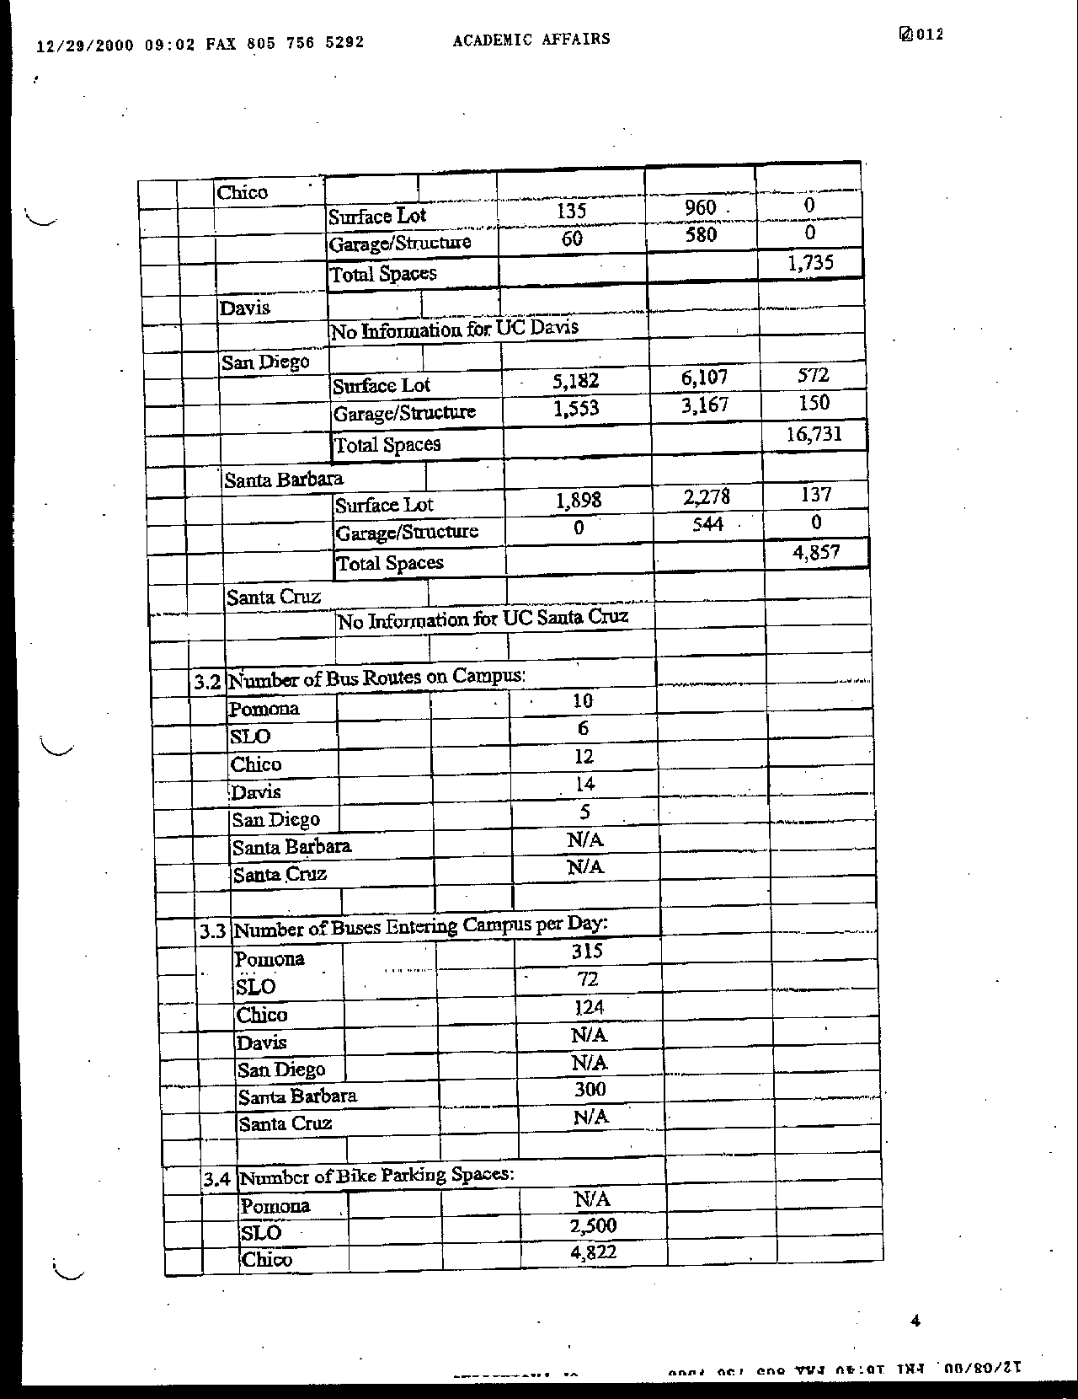
Letter 24
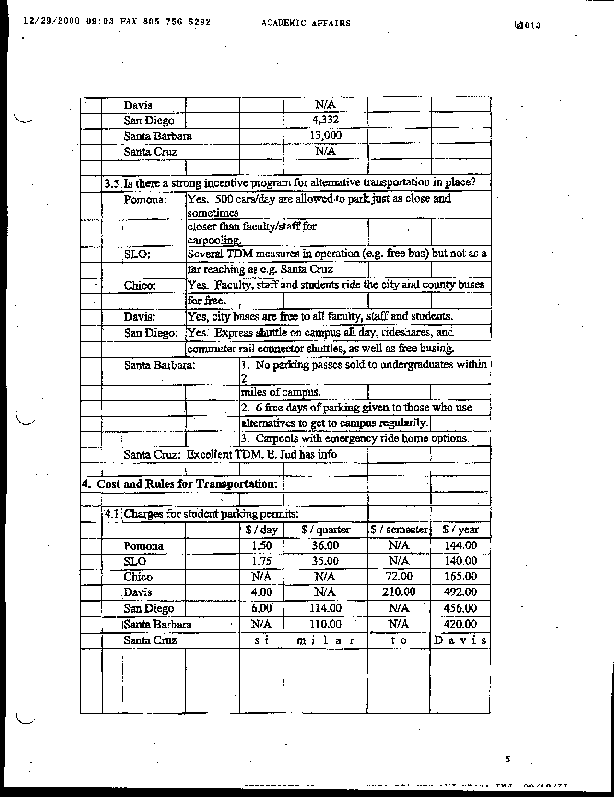
Letter 24
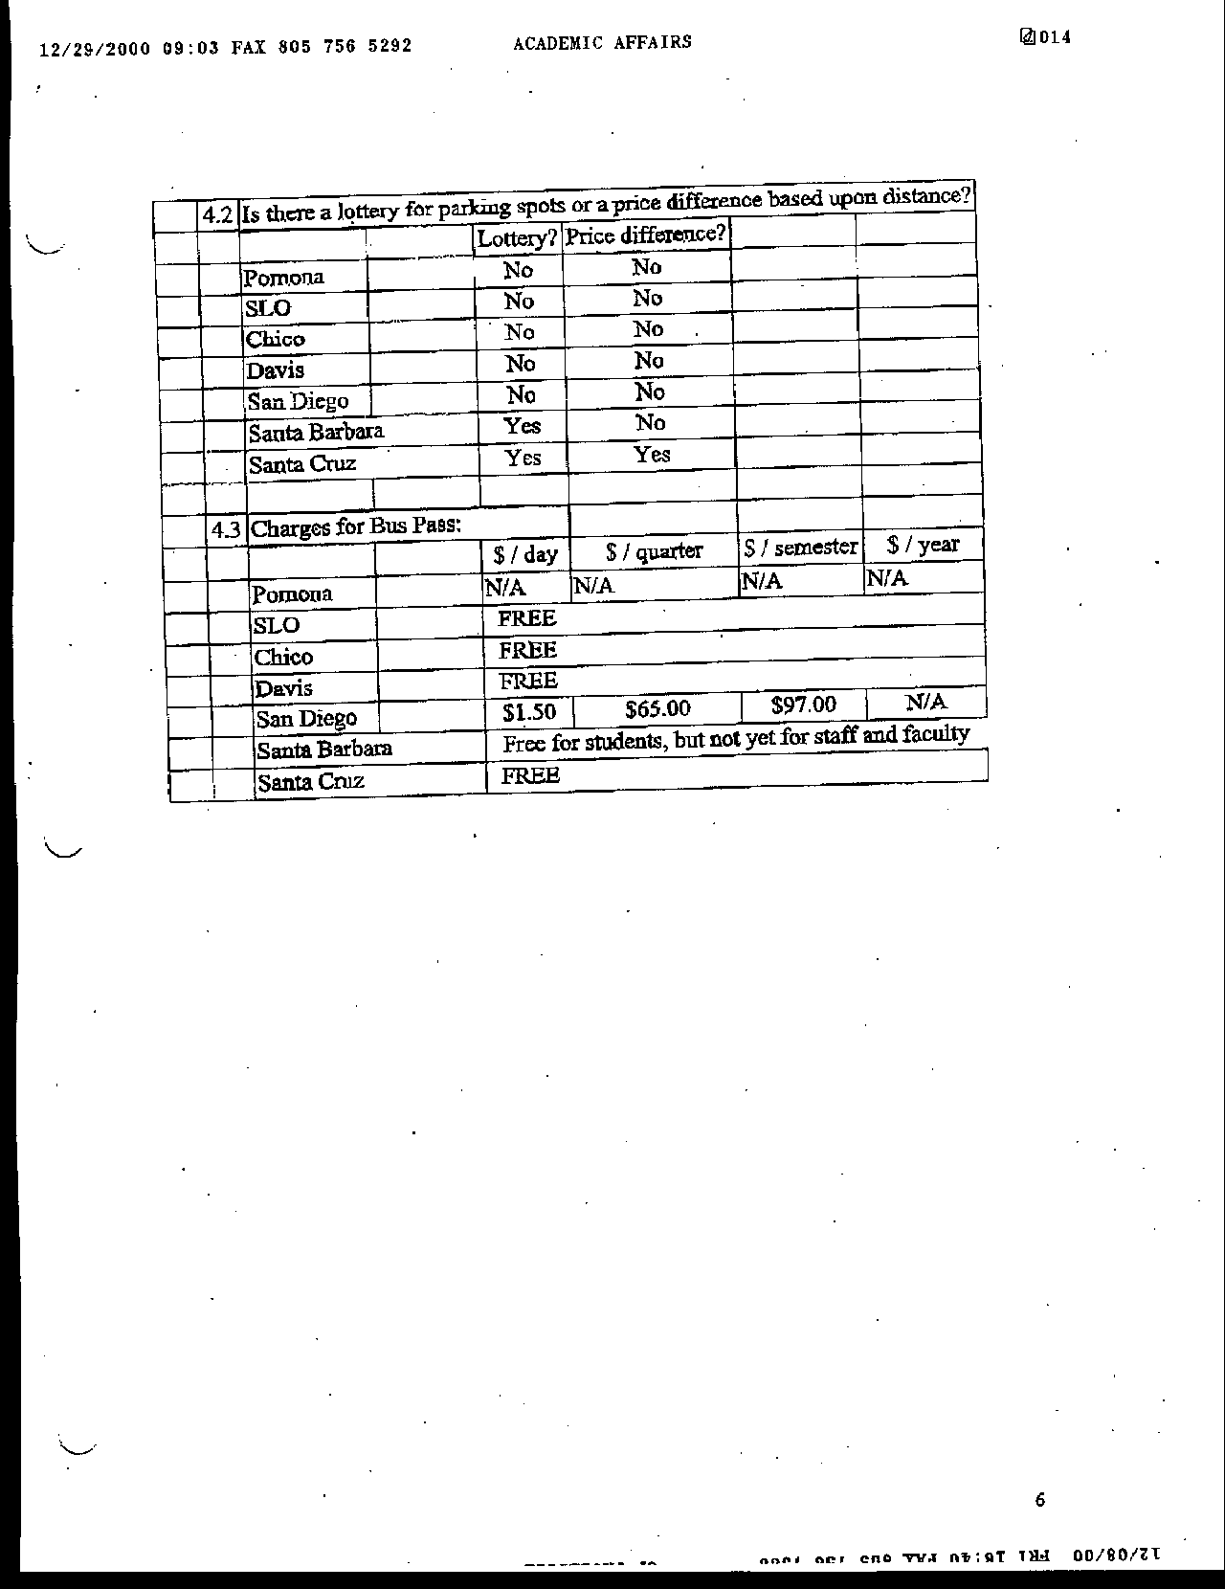
Letter 24
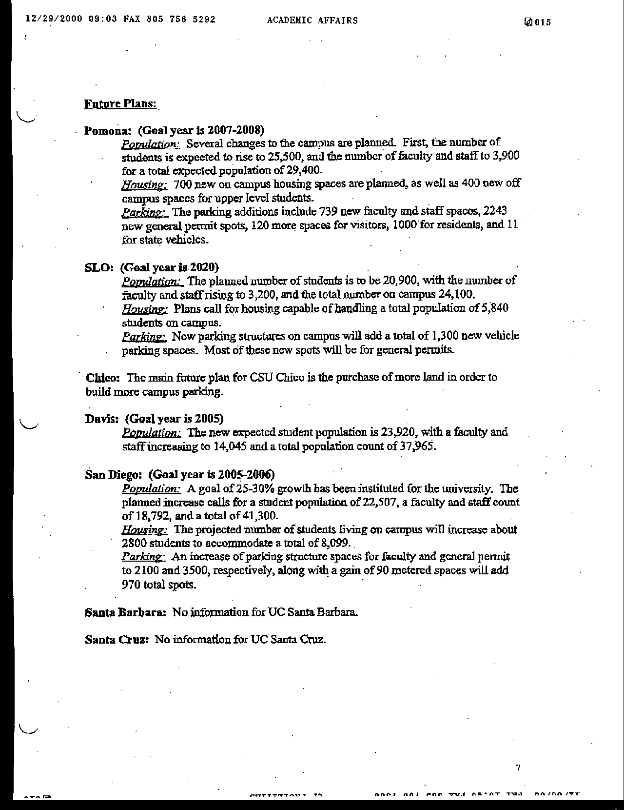
Letter 24
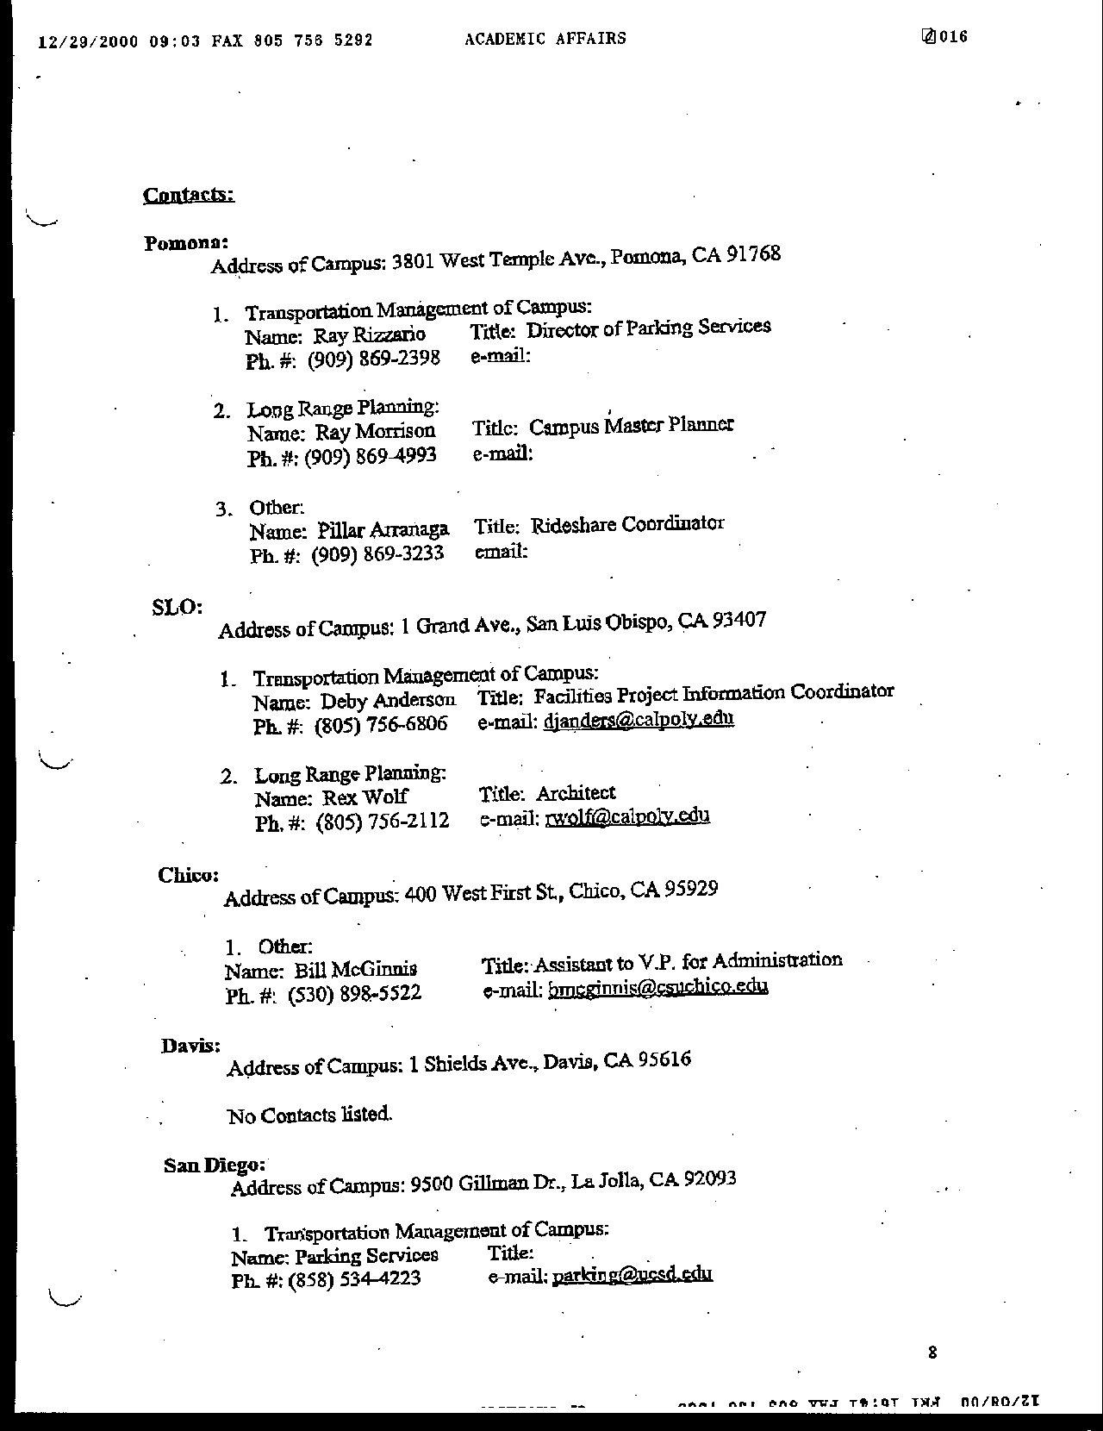
Letter 24
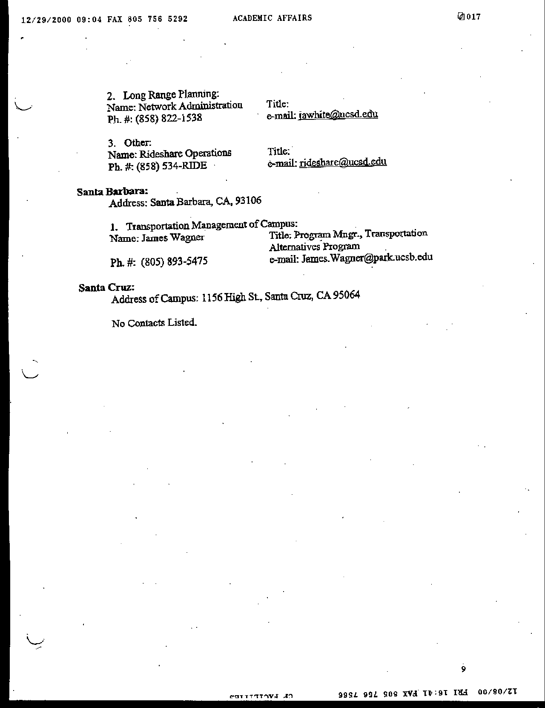
Letter 24
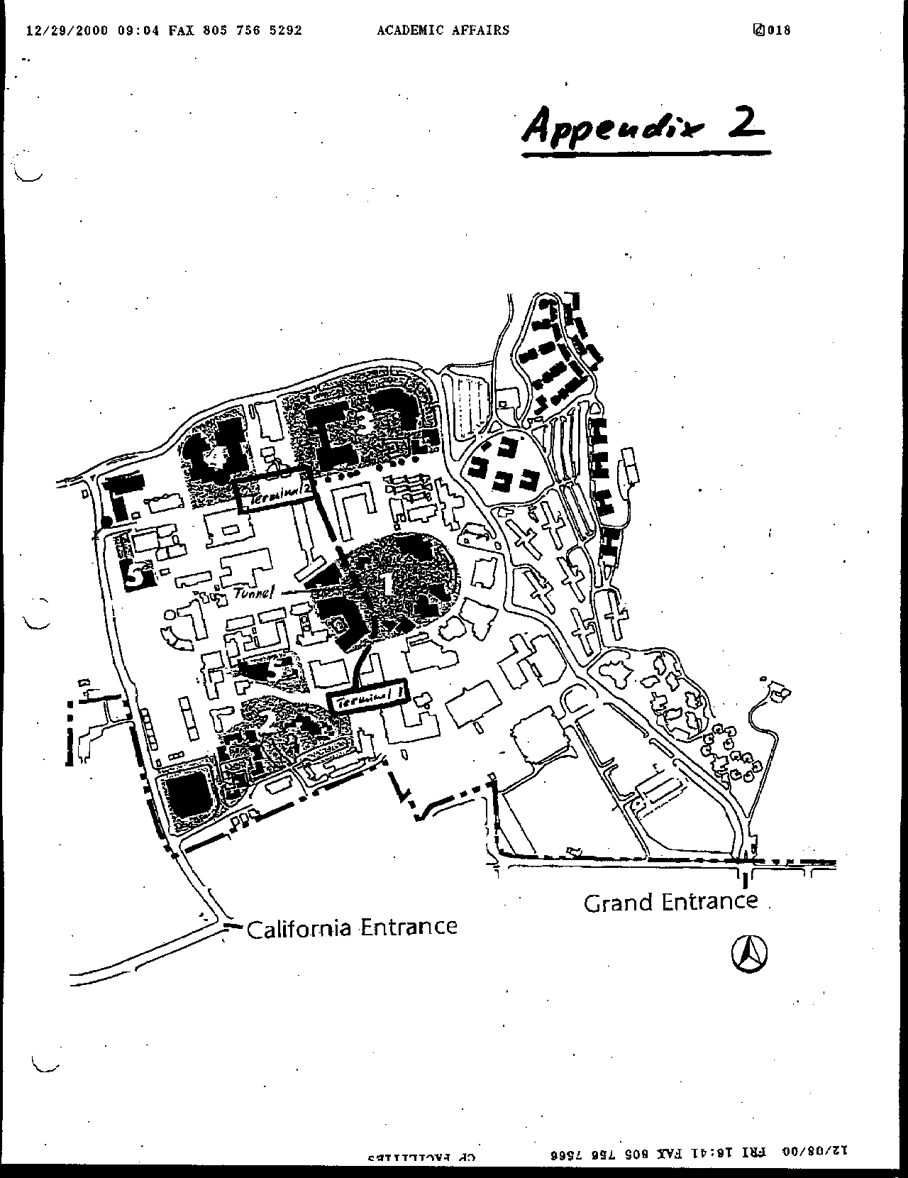
Letter 24
Letter 24

Mr. Eugene Jud

December 8, 2000

24-1 Commenter notes the need to correct bus routes on Exhibit 5.22

Response Exhibit 5.22 has been modified to show the correct bus routes.

24-2 Commenter notes the need secure funding for local bus service.

Response Many comments on the Master Plan have raised concerns about the continuation of the fully subsidized bus passes for Cal Poly students and employees. The current bus subsidy is an element of a negotiated arrangement between Cal Poly and the City of San Luis Obispo. The current agreement is for four years and ends on June 30, 2001. The negotiations are complex and are influenced by ever increasing costs. In addition, Cal Poly’s current funding (through parking fines) has been and continues to be relatively stable, meaning it has not been increasing commensurate with increased transit costs. Because the subsidy is the result of two party negotiations, it is not possible for the University to predict that it will always be able to reach an agreement with the city. Nevertheless, Cal Poly is committed to maintaining the funding for the bus at least at the currently designated level, and is exploring funding sources, such as an increase in parking fees, to fully cover the subsidy.

24-3 Commenter notes the need measurable modal split objectives.

Response The following table has been used for estimating where improved alternative transportation and savings in parking demand would occur. The Master Plan policy is to reduce parking demand by 2,000 spaces.

Estimated Parking Demand Reductions

Approach | Savings | Relative  Cost | Safety Valve*
Freshmen restrictions | 1,000~1,500 | L | some no.
Geographic controls | 500 | L | appeal
Car/vanpools | 300 | M
Lottery | As determined | L | appeal
Parking Fees | minor | L | appeal
On-campus transit | moderate | H
City transit | minor | H
Bike/ped enhancement | moderate | H
Area mgt | minor | L
Fac/Staff incentives | minor | M
Entertainment | moderate | H
Enrollment scenarios | moderate | M
Note: alternative transportation savings will be lower for Cal Poly because many of these programs are in existence and functioning well.
*Absolute controls will require provisions (safety valve) for hardships.

The University, as stated policy in the Master Plan, would reduce demand by 2,000 spaces. This reduction would be achieved through a number of measures. Over time, the feasibility and success of various measures will vary. For this reason, it is impractical to commit, at a Master Plan level, to absolutes. For example, an important idea is having an on campus and near campus shuttle. But this needs to be subjected to feasibility studies and trial programs, which the University will do.

To meet the parking reduction proposal of 2,000 spaces, Cal Poly intends to institute as a first, and most effective measure, that freshmen be required to live on campus and that they not be allowed to maintain cars on campus (with exceptions made for hardship and job-related requirements). We believe that the inelasticity of demand Cal Poly will prevent this policy from having a detrimental effect on the dormitory market. This restriction exists at other universities, including U.C. Santa Cruz.

It is estimated that there will be about 4,000 new undergraduate students each Fall (about 3,000 freshmen) at Cal Poly under the full growth anticipated with the Master Plan. Currently, we house approximately 80% ~ 90% of our freshmen on campus, and the campus provides 1,530 parking spaces for residents (R1 & R2). At present ratios, approximately 1,800 spaces would be needed under the Master Plan for freshmen. Allowing for some hardship requirements for freshmen, it is anticipated that approximately 1,500 or more spaces could be reduced with this policy alone.

This policy will do more than just reduce cars on campus. It will change the culture of the campus, infusing a higher regard for the environment and a reduced reliance on the automobile. As students advance through the University, they will do so with the ability to use alternative modes of transportation.

24-4 Commenter suggests the potential for Cal Poly leadership in regional light rail.

Response The following text addition has been made on page 189: “Energy Technology – Collaborate with SLOCOG and public transportation providers in exploring alternative technologies, including vehicles not dependent on fossil fuels, “real time” arrival/departure information, flexible as well as fixed routing, etc.” Refer also to page 177.

24-5 Commenter suggests considering higher parking fees; permit restrictions.

Response Comment is noted and appreciated. Parking fees at Cal Poly are much lower than many comparable schools around the state. Cal Poly proposes a robust program of parking demand reduction, including restrictions on freshman parking and geographic controls. Please refer to the alternative transportation section.

24-6 Commenter suggests increasing public transit access.

Response See Alternative Transportation element. Text has been changed to place increased emphasis on public transit.

24-7 Commenter suggests considering light rail terminals at Cal Poly.

Response Refer to comment 24-4 above.

24-8 Commenter suggests considering traffic calming on east Perimeter.

Response See text addition, page 172, which reads “Explore “traffic calming” alternatives to reduce vehicle/pedestrian conflicts.” See also, page 168.

24-9 Commenter suggests moving parking structure #3 west of railroad.

Response Moving parking structure three west of the railroad would require the use of prime agricultural farmland, which is contrary to Master Plan policies.

24-10 Commenter suggests reviewing LOS discussion with respect to pedestrians.

Response Comment noted. The pedestrian movements at California Boulevard decrease the efficiency of the roadway. Prior to the development of Parking Structure II, a detailed plan of that segment of the road will be undertaken to improve both automobile and pedestrian flow.

24-11 Review LOS calculations with respect to increases in background traffic.

Response Text has been added to the EIR to clarify background traffic used in the analysis. An error occurred with regard to the Foothill segment near California. This has been corrected.

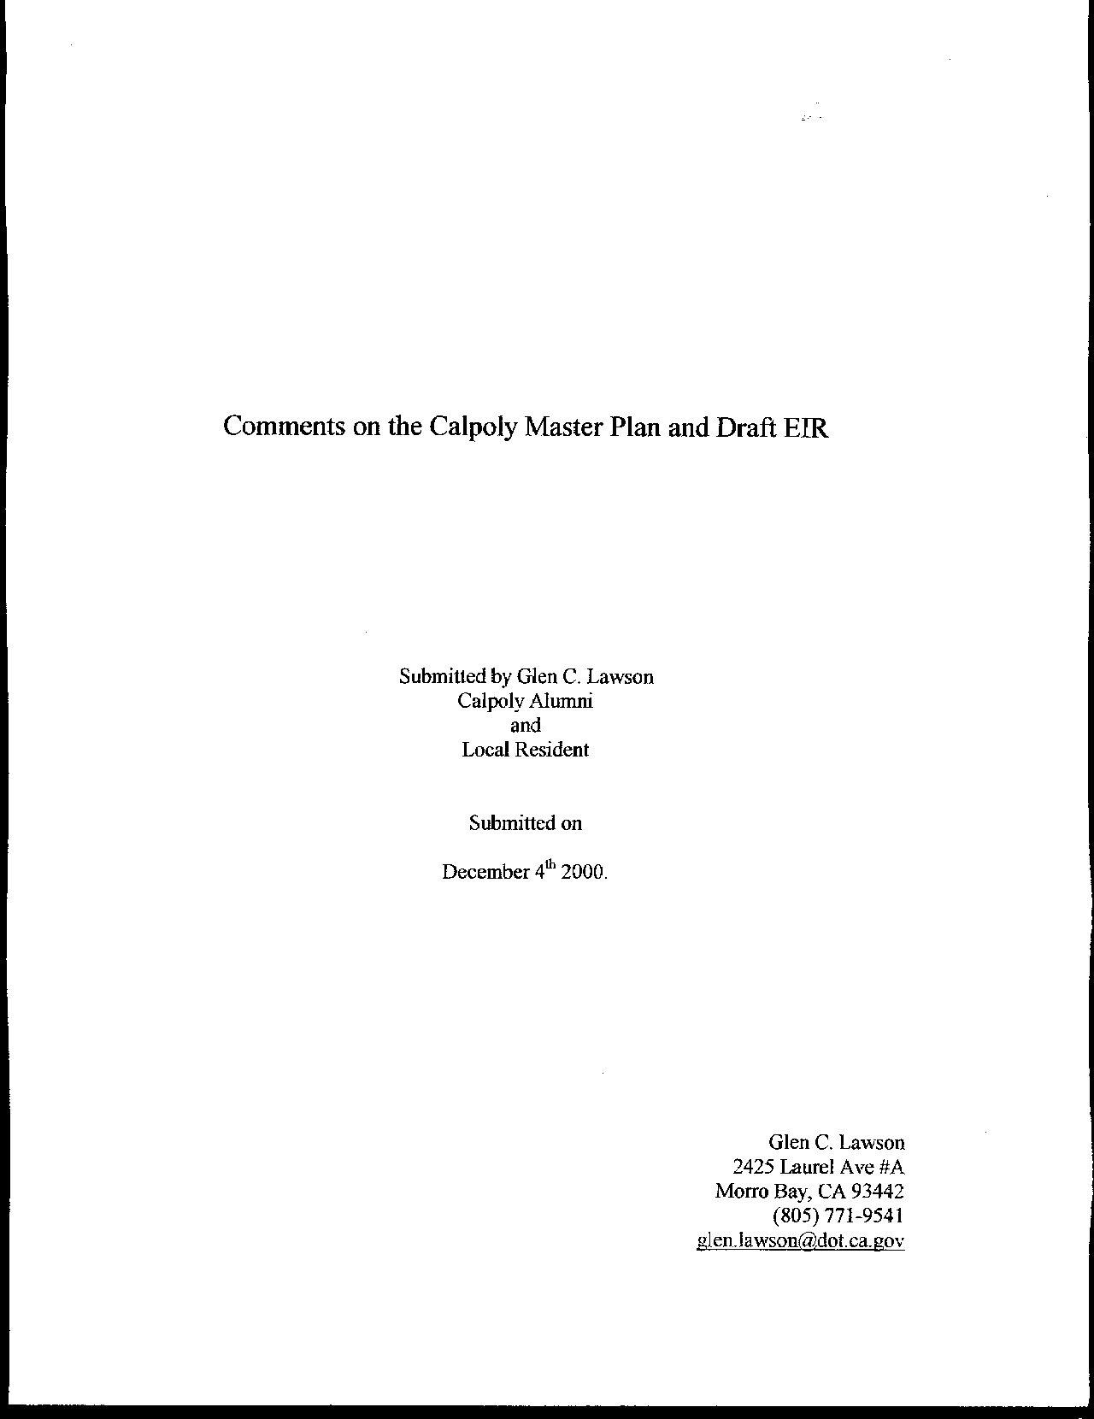
Letter 25
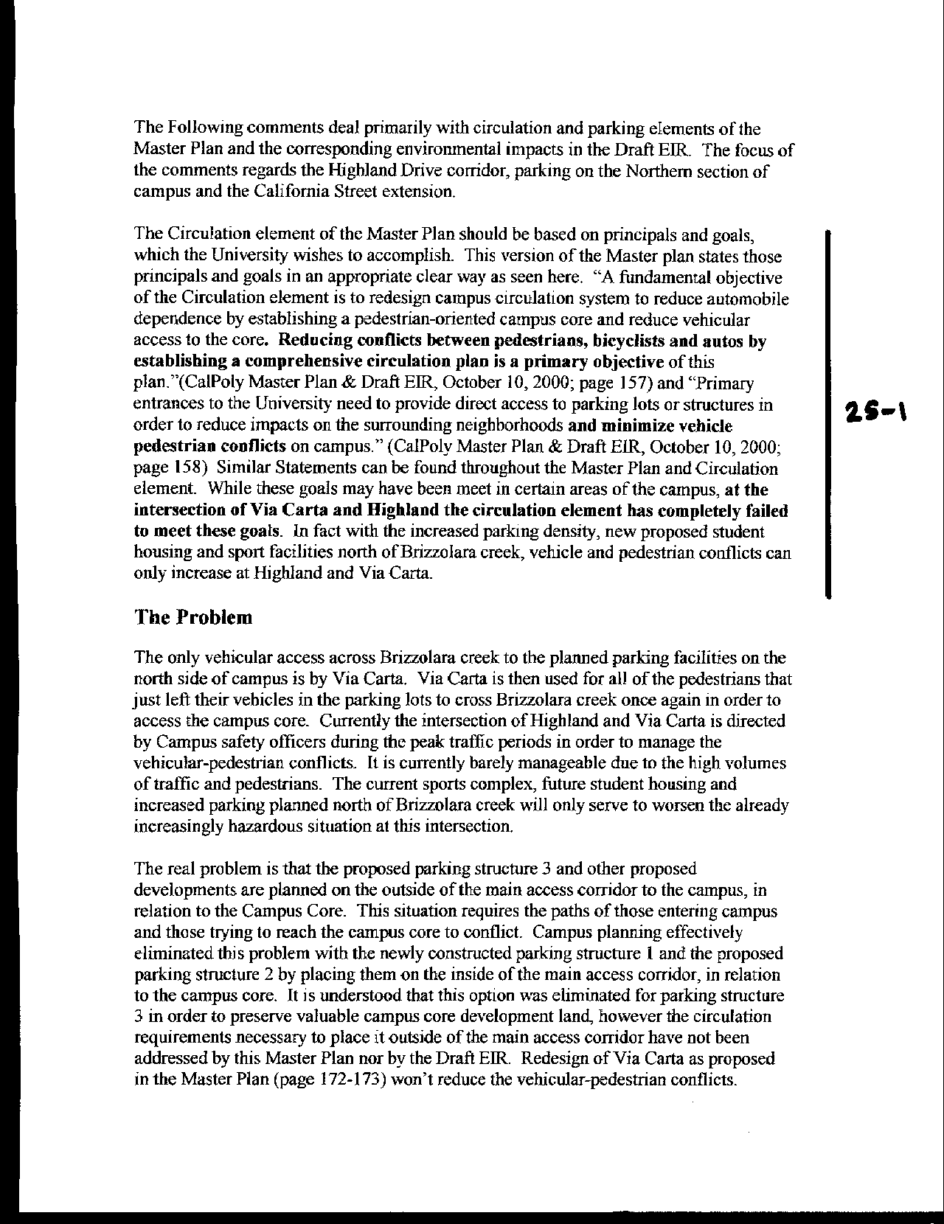
Letter 25
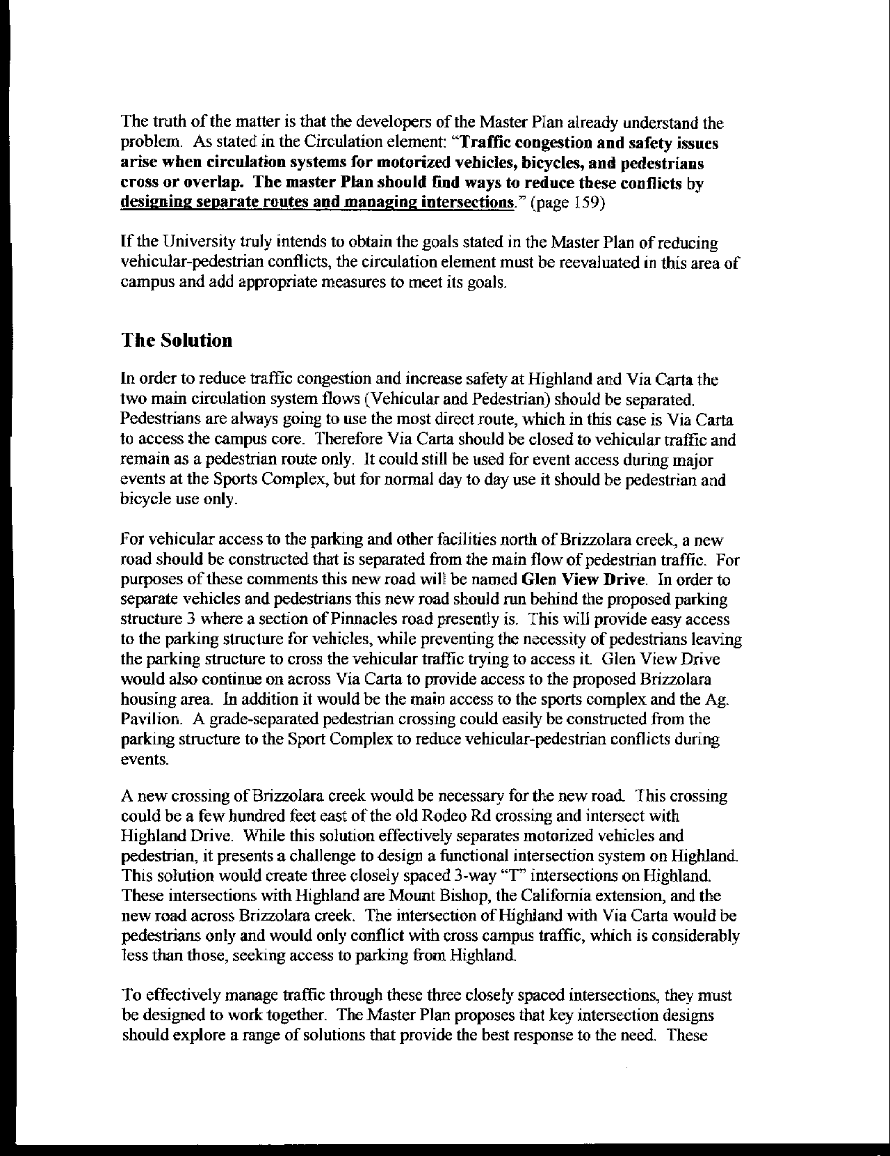
Letter 25
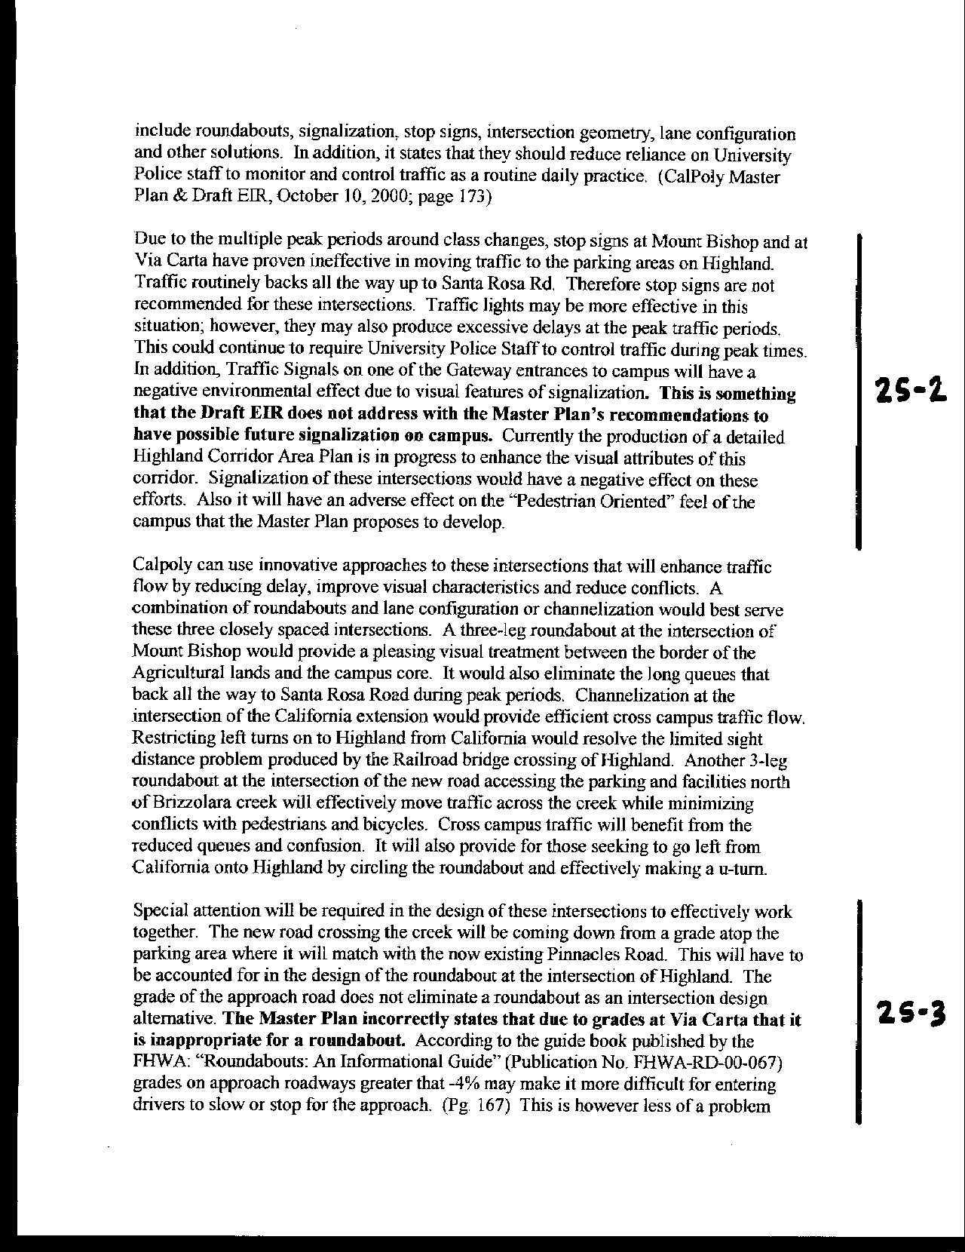
Letter 25
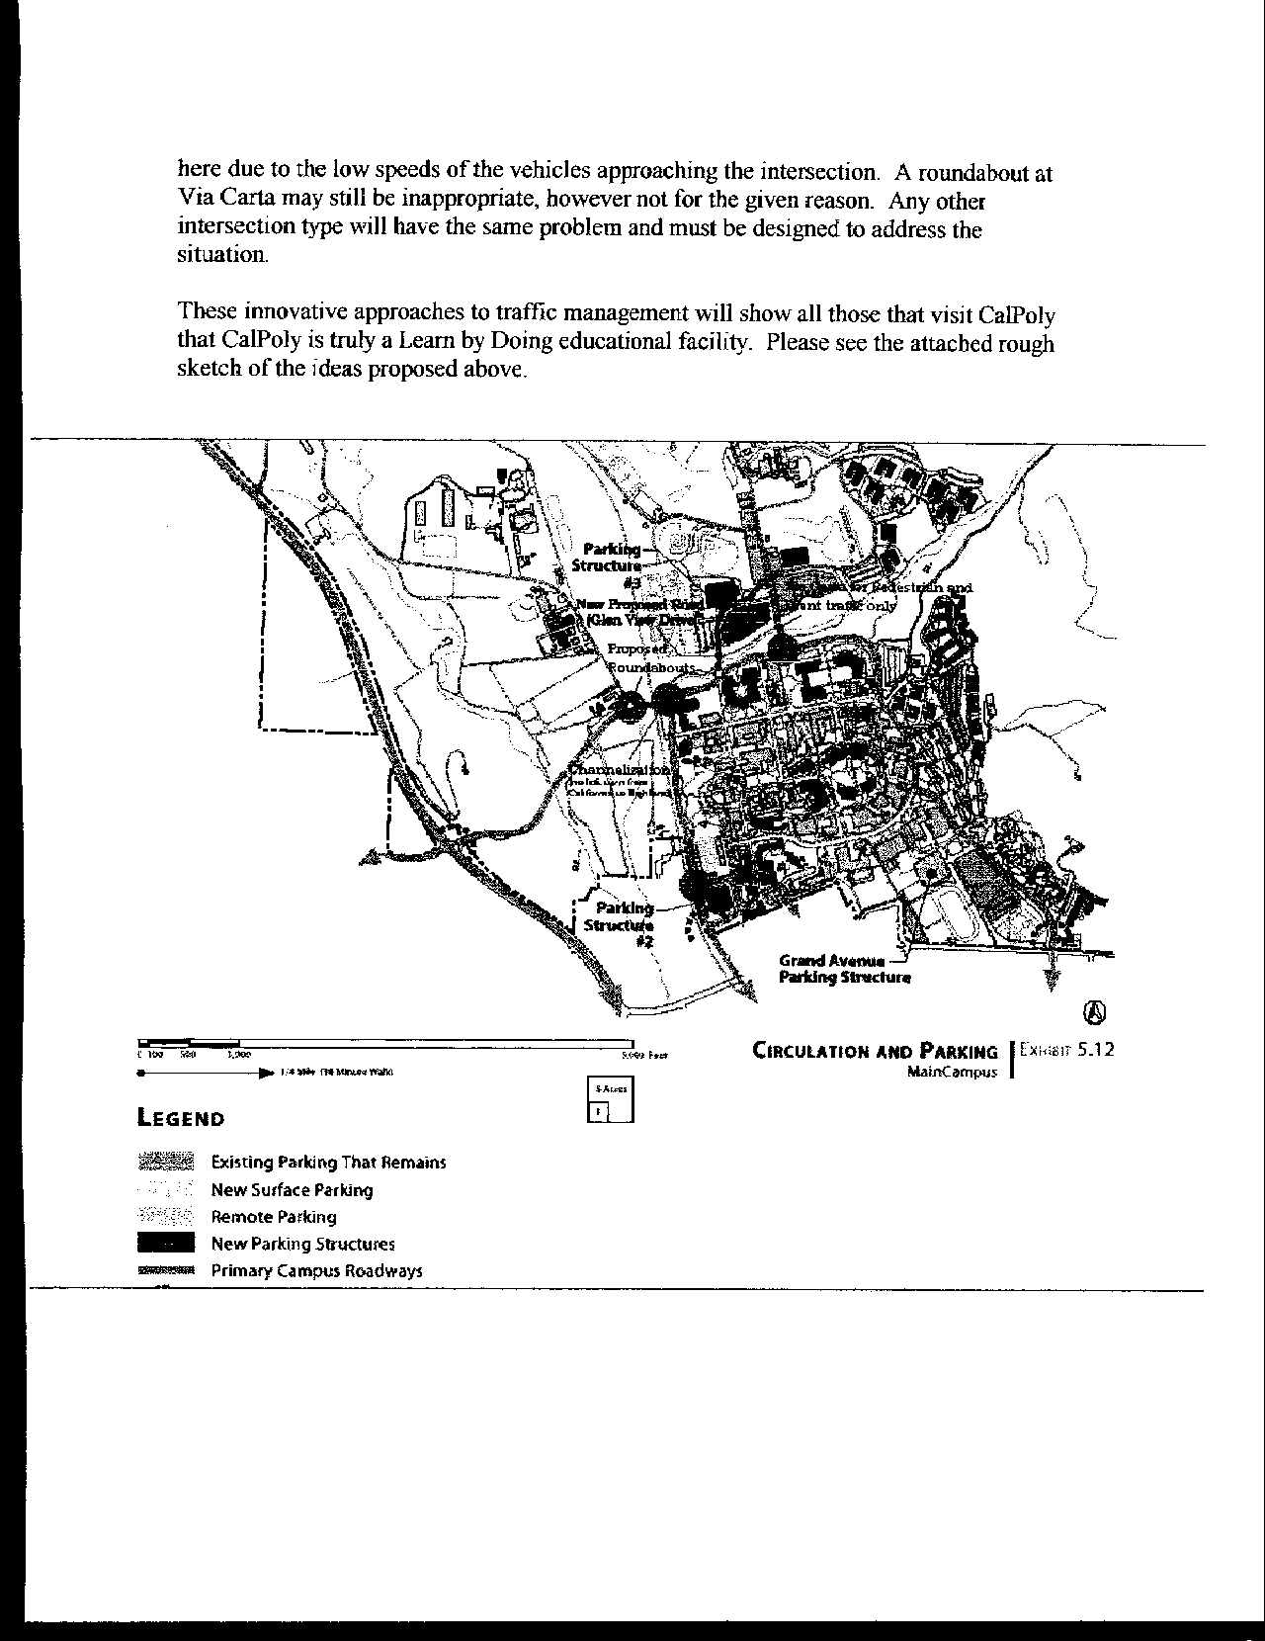
Letter 25
Letter 25

Mr. Glen Lawson

December 4, 2000

25-1 The commenter expresses concern about vehicle-pedestrian conflicts on Via Carta at and north of Highland Drive

Response These comments are noted and have been forwarded to Facilities Planning. When Parking Structure III is designed, a detailed study will be undertaken to optimize the circulation in the vicinity of Via Carta, and to reduce conflicts with pedestrians.

25-2 The commenter proposes an additional road crossing Brizzolara Creek

Response A crossing of Brizzolara Creek will be considered during the implementation of the Master Plan. Such a crossing will require permit authority from the California Department of Fish and Game and the U. S. Army Corps of Engineers.

25-3 The commenter suggests intersection redesign options.

Response The DEIR suggested that a roundabout at Via Carta and Highland may not be feasible due to the steep grade on Via Carta. The intersection design will be studied for the most appropriate geometric configuration during implementation of the plan.

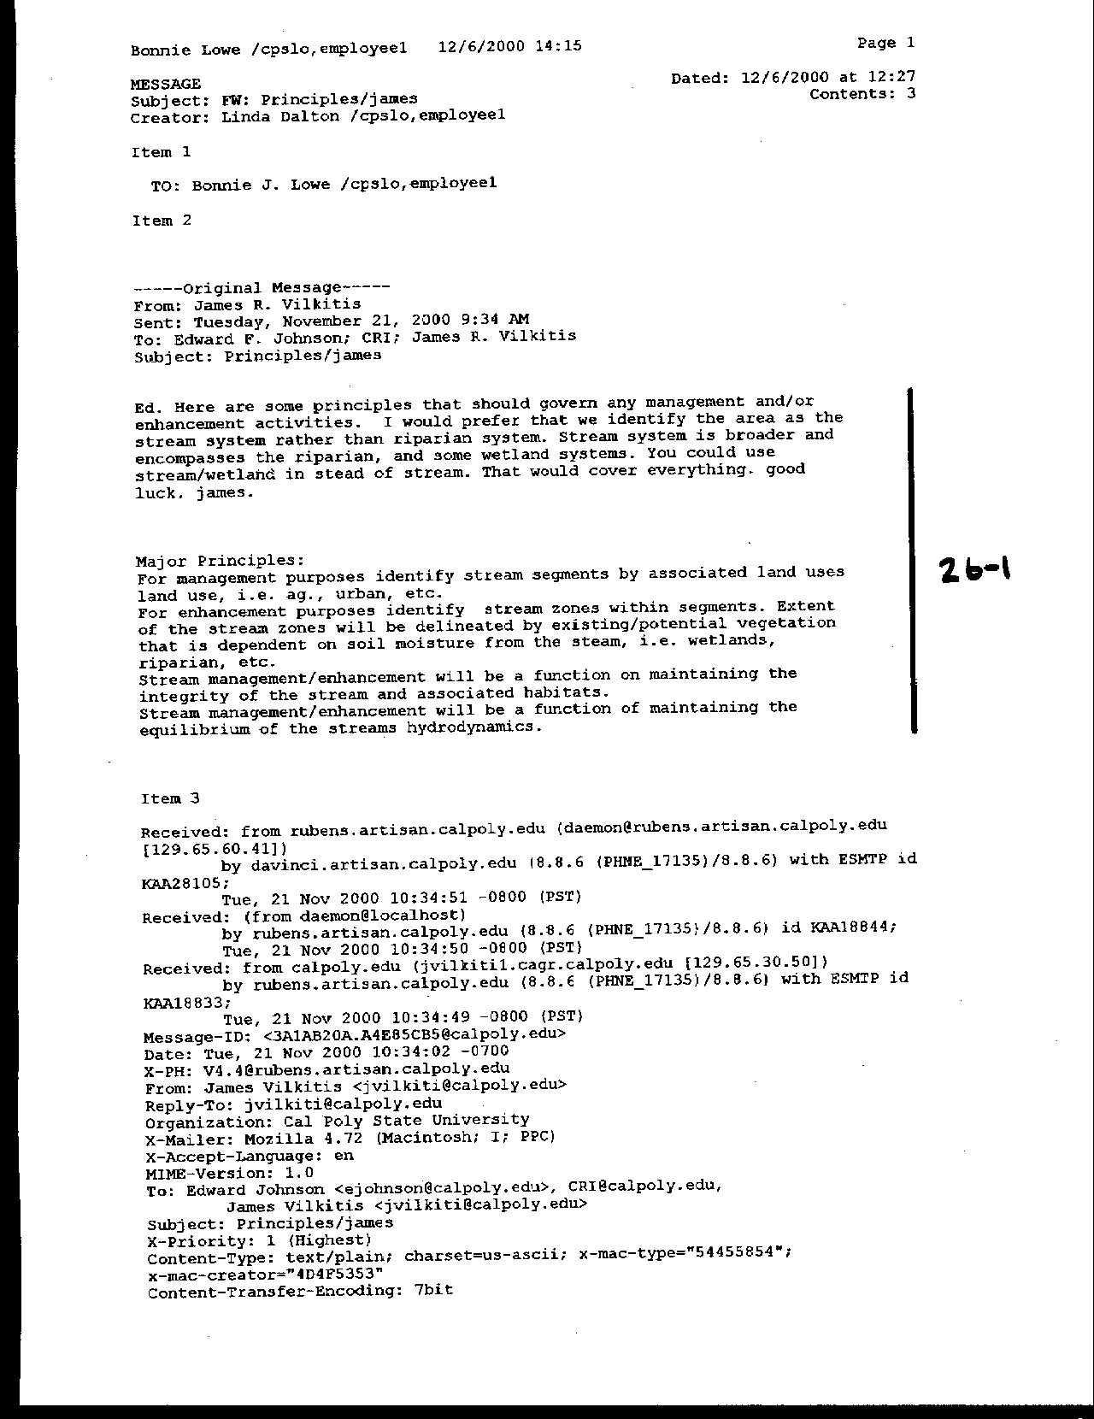
Letter 26
Letter 26

Dr. James Vilkitis

Natural Resources Management Department

December 6, 2000

26-1 Commenter suggests a number of vocabulary modifications to the Master Plan, including identifying “stream” systems, rather than riparian systems.

Response The comment is noted and the text has been modified to reflect this suggestion (p. 85).

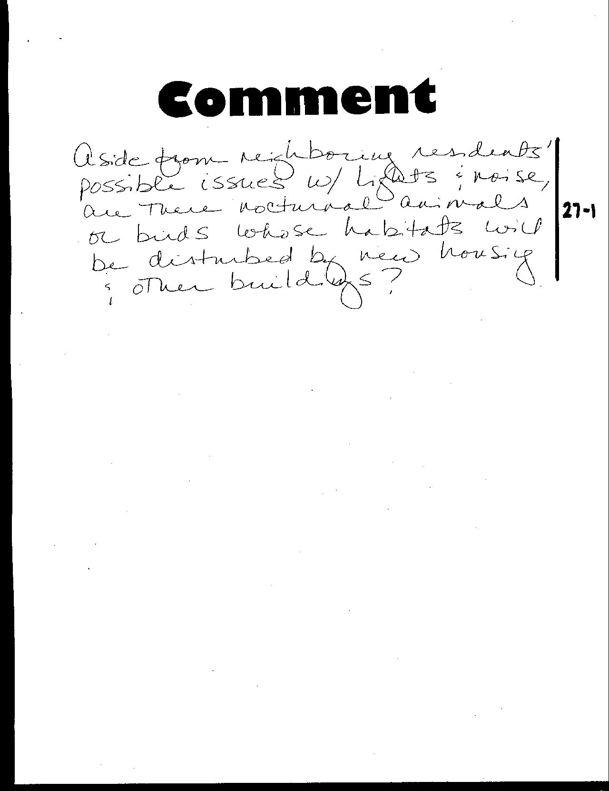
Letter 27
Letter 27
Anonymous

December , 2000

27-1 Commenter asks if lighting and noise will disturb neighboring residents and nocturnal animals.

Response New development, especially located on the edge of the campus instructional core, will have impacts on wildlife and neighboring residences. This issue is discussed in the sections of the Draft EIR on Noise and Aesthetics. Mitigation measures have been recommended to reduce these impacts to a less than significant level. The DEIR addressed these impacts.

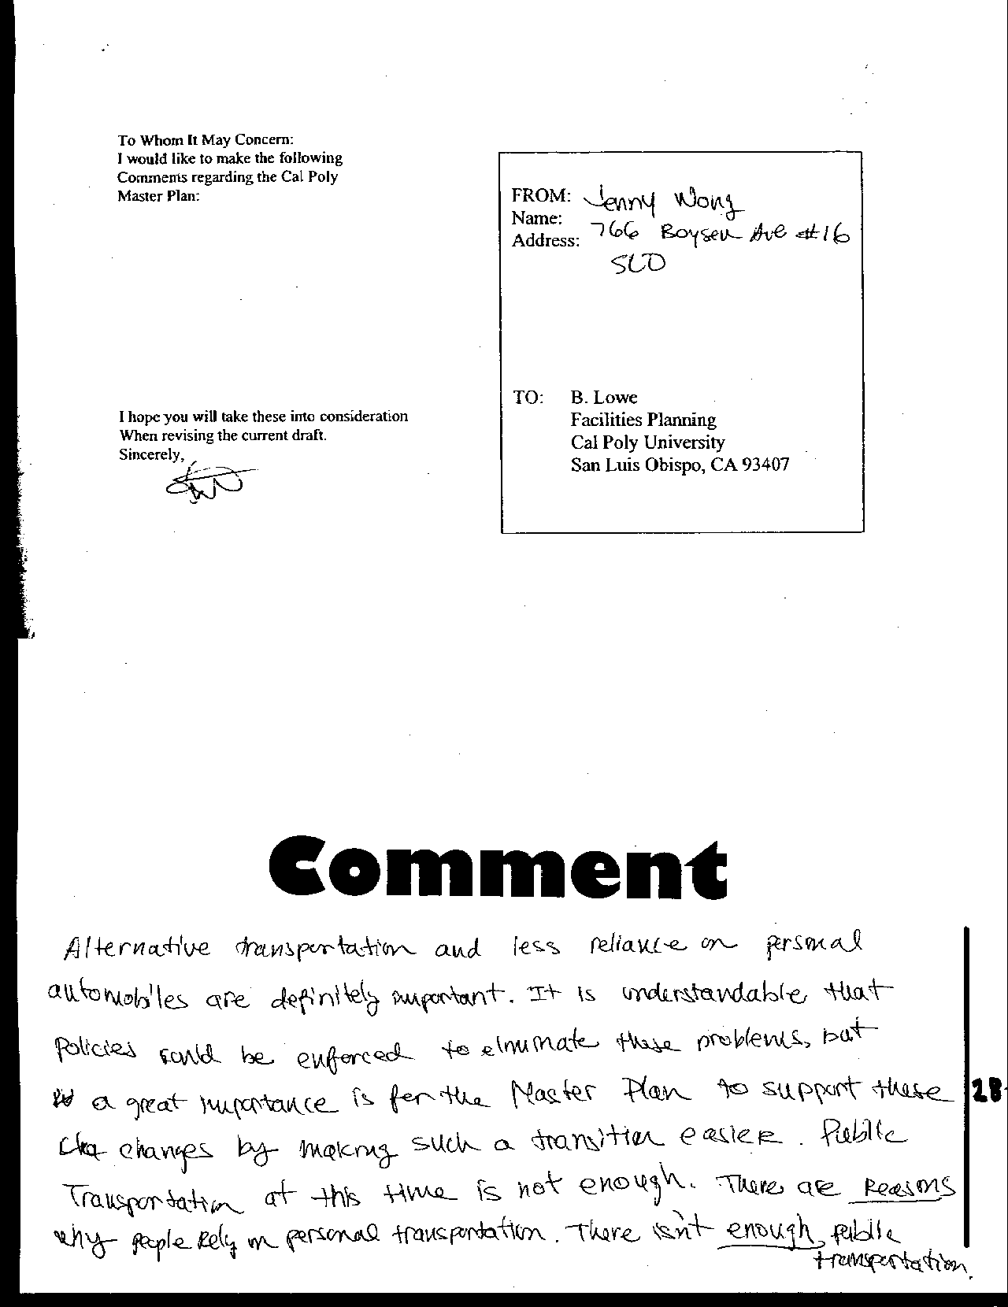
Letter 28
Letter 28

Ms. Jenny Lang

December , 2000

28-1 Commenter reinforces the need for a strong alternative transportation system on campus and suggests the present system is inadequate.

Response These comments are noted and forwarded for the benefit of the decision makers. The Alternative Transportation section of the Master Plan details proposals for improvement of the alternative transportation system. See Alternative Transportation chapter.

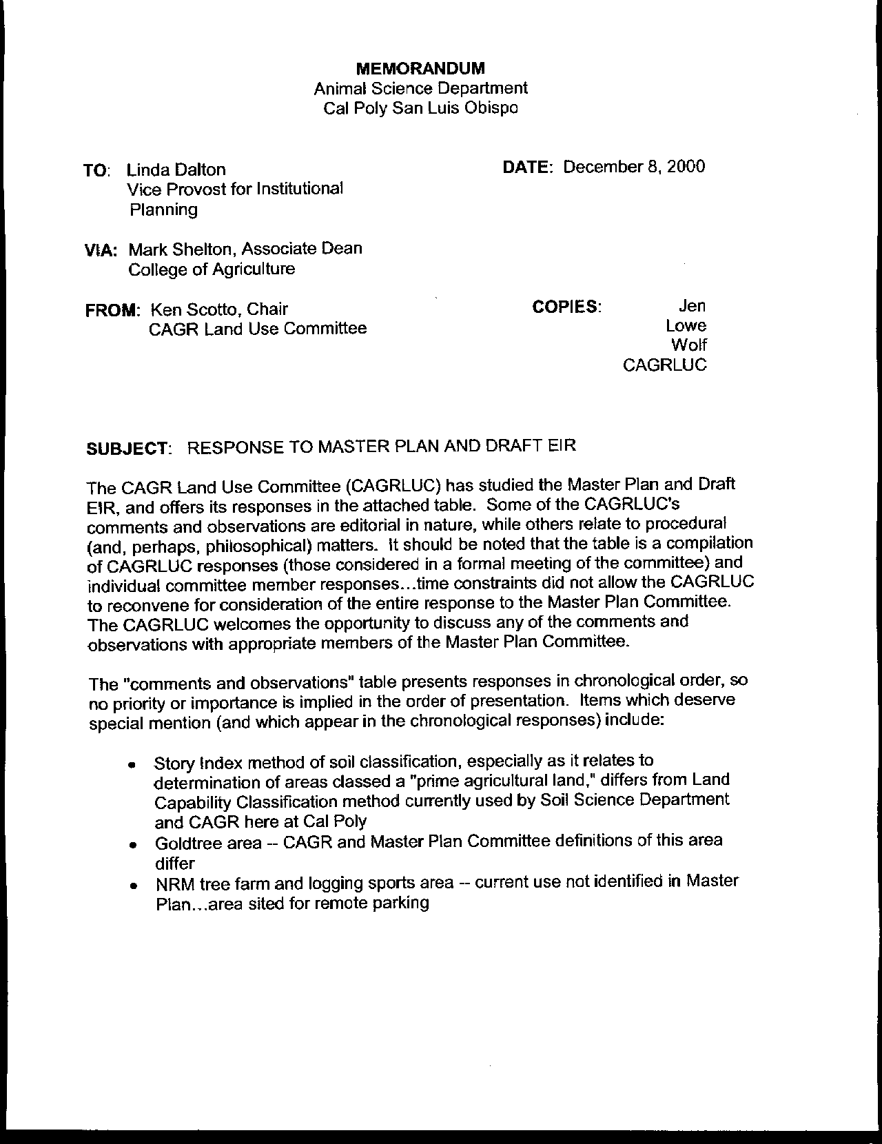
Letter 29
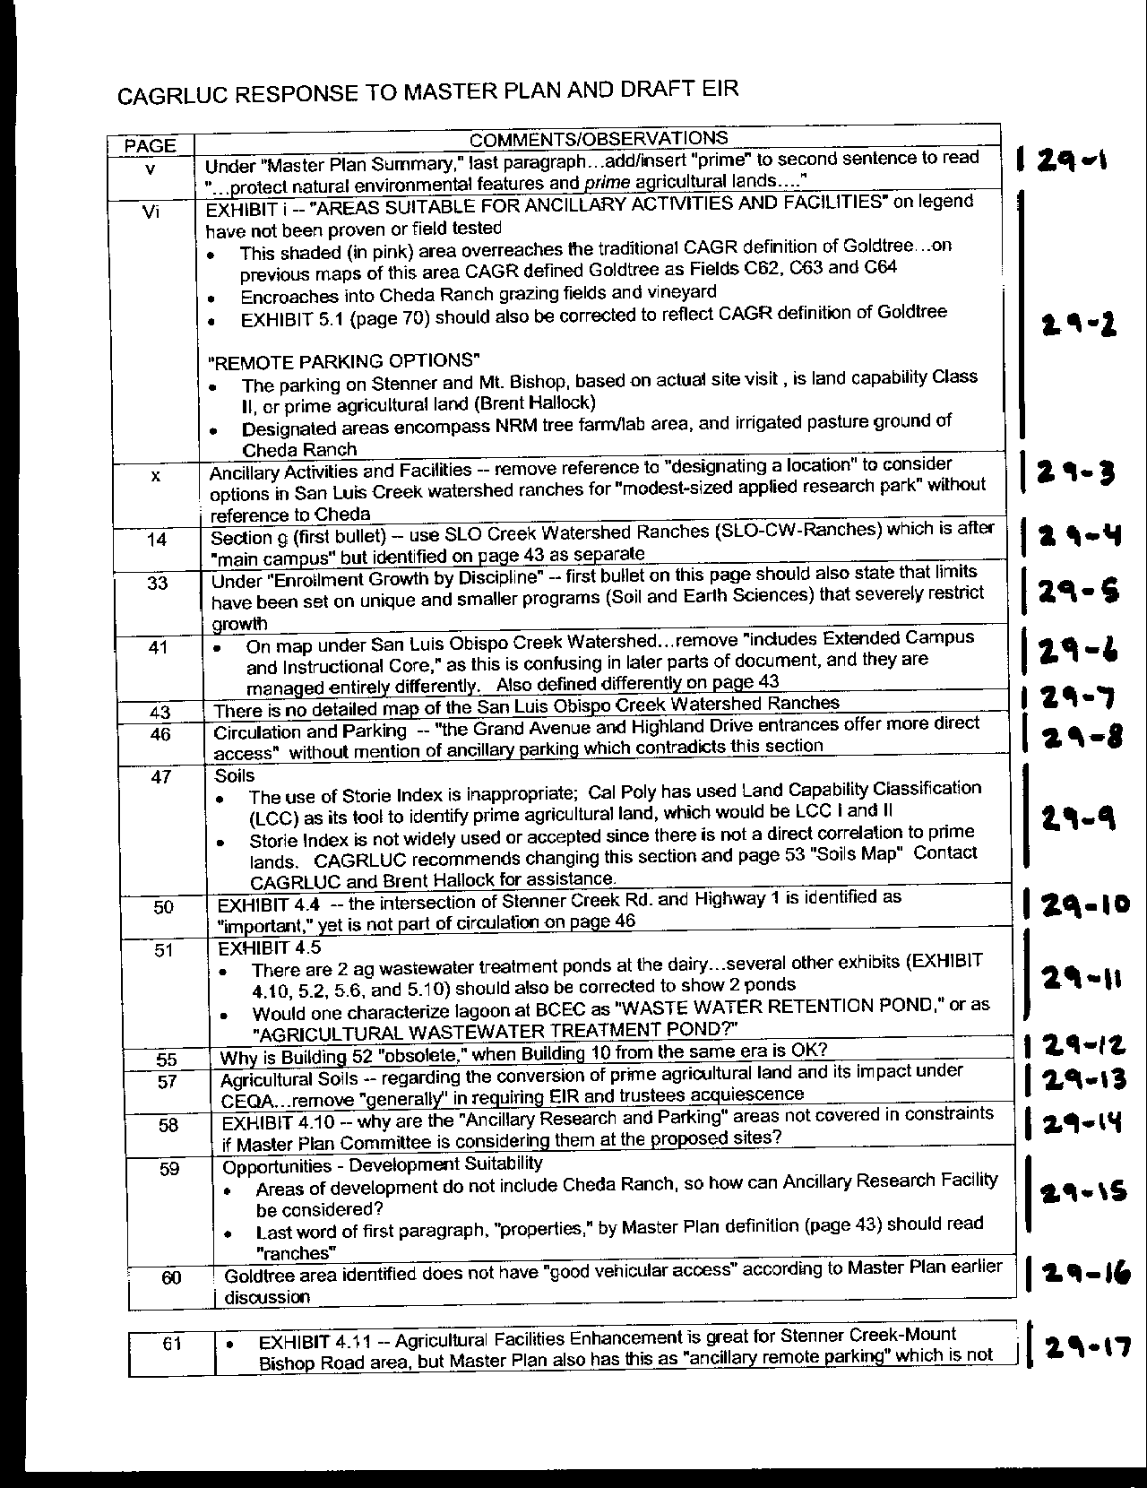
Letter 29
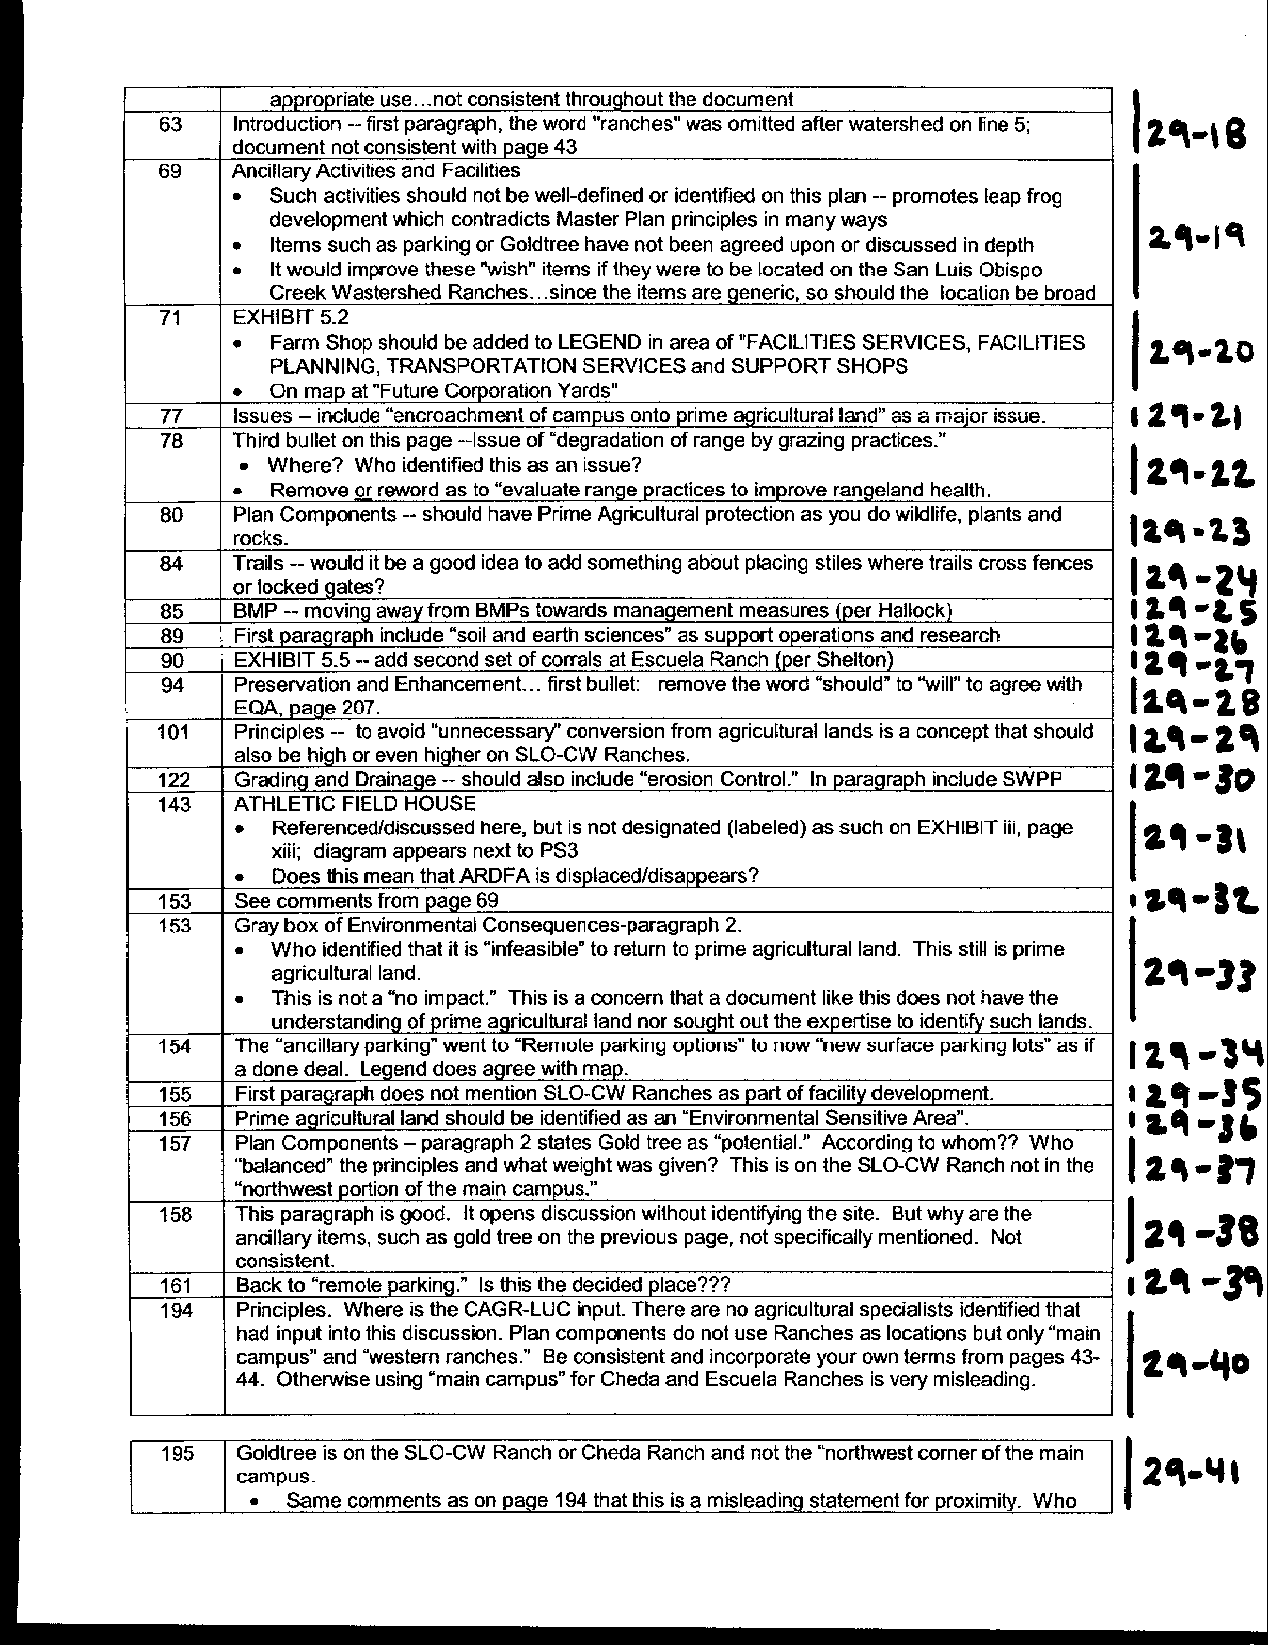
Letter 29
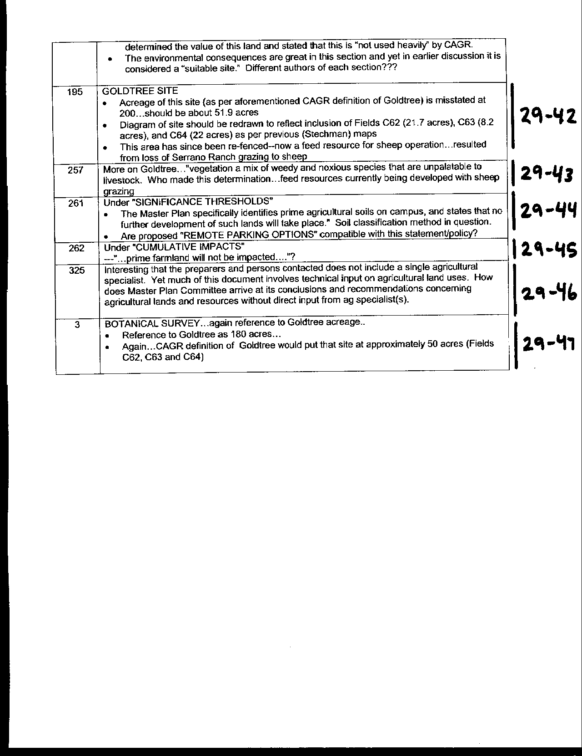
Letter 29
Letter 29

Dr. Ken Scotto

December 8, 2000

29-1 Comment requests that "prime" be added to the agricultural land designation.

Response The text has been modified to reflect this recommendation (refer to page viii).

29-2 Commenter raises concerns about the depiction of the Goldtree area.

Response The graphic depicting Goldtree has been amended to incorporate suggested changes and refine the location. The location will not impinge upon existing vineyards. Remote parking will not take place on prime agricultural lands nor will it displace current or future NRM facilities.

29-3 Commenter questions designation of applied research park site.

Response Text has been clarified; refer to pages xi, 64, and 206; Nevertheless, the University feels that it is important to continue to identify the Goldtree area of Cheda.ranch as a possible site for an applied research park.

29-4 Commenter suggests clarifying San Luis Obispo Creek watershed.

Response The following text has been added: “…Such designations will be used for all lands on the main campus, San Luis Obispo Creek Watershed ranches and Chorro Creek Watershed ranches in San Luis Obispo County.” (page 16).

29-5 Commenter notes limits on size of smaller, unique programs.

Response See text addition under discussion of Critical Mass (p. 37). The following text has been added: “In some instances the campus chooses to limit the size of unique programs despite demand, due to the specialized faculty, facilities and equipment or higher costs associated with such programs.”

29-6 Commenter suggests change in map legend.

Response The map on page 43 has been changed accordingly.

29-7 Commenter criticizes lack of detailed map of SLO Creek watershed ranches.

Response Maps of Cheda, Peterson and Serrano ranches have been added on page 45.

29-8 Commenter expresses concern about an apparent contradiction about access from Grand and Highland in Chapter 4.

Response Chapter 4 discusses Existing Conditions only. The commenter’s concern is focused on access to future uses, which are addressed later in the Master Plan. For example, see page 195 for a discussion of possible remote parking sites.

29-9 Commenter questions soil classification and analysis.

Response The soil study has been modified to use the Natural Resources Conservation Service soil capability class system, consistent with other jurisdictions.

29-10 Stenner Creek Road intersection (identified on p. 50) should be discussed on page 46.

Response This is discussed later in Circulation element. See page 165.

29-11 Commenter indicates that maps are missing some reservoirs and lagoons.

Response The base map has been changed to include additional reservoirs and lagoons.

29-12 Commenter has questions about dates and obsolescence for buildings 10 and 52.

Response Obsolescence is defined by several criteria, including functionality, not just age.

29-13 Commenter asks for clarification that an EIR would be required for conversion of prime agricultural lands.

Response Text has been clarified, refer to page 59.

29-14 Commenter asks why areas suggested for ancillary activities aren't covered on the constraints map?

Response The base map focuses on the Main Campus. The Constraints analysis has been modified, with the addition of another map and text about Cheda Ranch on page 64.

29-15 Commenter seeks clarification of reference to San Luis Obispo Creek watershed ranches.

Response The text has been clarified accordingly; refer to page 60.

29-16 Commenter is concerned with the suitability of Goldtree/Cheda Ranch area for development.

Response The Constraints analysis now contains a more detailed analysis of Cheda Ranch on page 64.

29-17 Commenter points out inconsistent designation of development suitability in area near Stenner Creek Road.

Response The remote parking sites are not expanded agricultural facilities. These were added after the constraints map was developed. There has been a clarification in the text to reflect this and changes in Exhibit 4.11. Please refer also to the discussion of potential remote parking sites on page 195.

29-18 Commenter suggests that the word “ranches” should be added to the second sentence at the beginning of the Land Use element.

Response This is a general paragraph not requiring the word change proposed.

29-19 Commenter calls for less specificity in designating ancillary activities.

Response The Master Plan team feels that a specific designation should remain, but with text clarification; refer to page 64.

29-20 Commenter seeks clarification of map legend to include reference to the Farm Shop.

Response The legend in Exhibit 5.2 has been changed to add this clarification. Exhibit iii has been modified as well.

29-21 Commenter is concerned that references to remote parking are not consistent throughout the Master Plan, and that the remote parking designation on the map does not match the legend on Exhibit 5.2.

Response The legend in Exhibit 5.2 has been changed to distinguish remote parking options from planned surface lots closer to the campus instructional core.

29-22 Commenter indicates that SLO Creek Watershed ranches are not included as part of facility development.

Response The SLO Creek Watershed ranches and Chorro Creek Watershed ranches are discussed in a separate section on page 77, which has been modified to indicate some potential for development on Cheda Ranch.

29-23 Commenter suggests identifying prime agricultural land as environmentally sensitive.

Response The Master Plan recognizes the environmental value of prime agricultural land in text, but designates it as Outdoor Teaching and Learning on land use maps. The Master Plan now explicitly refers to prime agricultural lands as meriting conservation and protection (see pp. 83 and 96).

29-24 Commenter questions Goldtree development potential as discussed in the Land Use element.

Response The Master Plan includes a general discussion in this section, so the text required only minor modification here. The development potential on Cheda Ranch is discussed in more detail in Chapter 4, Existing Conditions (see p. 64).

29-25 Commenter prefers the general level of discussion about possible remote parking sites in contrast to the more detailed references to the Goldtree area.

Response Comment noted. Discussions of Cheda Ranch in general, the Goldtree area and remote parking options have been expanded in several sections of the Master Plan. See pp. 64, 195 and 206.

29-26 Commenter suggest adding “encroachment of campus onto prime agricultural land” as a major issue.

Response See text addition on page 95 where more appropriate under Issues in Outdoor Teaching and Learning element. The first Issue now reads “pressure to expand instructional core, sports and recreation activities and student housing into agricultural lands.”

29-27 Commenter expresses concern about criticism of grazing practices.

Response This issue was removed from the list. Grazing management is discussed elsewhere in the Natural Environment and Outdoor Teaching and Learning elements (see pp. 88, 89 and 99.

29-28 Commenter calls for adding protection for prime agricultural lands in Natural Environment element.

Response Protection for class I agricultural lands is now covered more explicitly in Principles in both Natural Environment and Outdoor Teaching and Learning elements. (see revised text on pp. 83 and 96).

29-29 Commenter suggests adding to trails discussion regarding security.

Response The following text has been added: “Trail standards need to be designed to address security as well as environmental issues – for example, stiles can provide access where appropriate over fences or near locked gates.” (See p. 88.)

29-30 Commenter suggests using "management measures" rather than "best management practices".

Response The text has been clarified accordingly (see p. 89).

29-31 Comment asks that the discussion of the Campus Farm reflect research regarding soils and earth sciences.

Response References to soils research have been added to the text (see p. 93).

29-32 Commenter indicates that Exhibit 5.5 should show a second set of corrals at Escuela Ranch.

Response Exhibit 5.5 has been changed to show a set of corrals where the Walter’s Ranch western boundary intersects the Escuela Ranch.

29-33 Commenter asks for language change from "should" to "will" to strengthen protection of agricultural lands.

Response Text now reads “Prime agricultural soils (class I) will be retained in agricultural use” (p. 99).

29-34 Comment calls for adding principles regarding avoidance of conversion of agricultural lands.

Response This concern is addressed elsewhere in the Land Use, Natural Environment and Outdoor Teaching and Learning elements (see pp. 69, 83 and 96).

29-35 Commenter asks that erosion control be included as part of Landscape Design guidelines.

Response This is already addressed as "minimizing erosion" under the Grading and Drainage section (p. 127).

29-36 Commenter suggests that the illustrative diagram designate the proposed field house with a letter and on legend, and asks if ARDFA will be displaced.

Response Exhibit iii has been changed to show the proposed athletic field house at some future date. When that occurs, ARDFA will be displaced and other arrangements will be made for the research activities that currently take place in that facility.

  - Commenter critiques the environmental analysis of the move of the Corporation Yards to Old Poultry Unit area asking for an explanation of why it would not be feasible to return this site to productive agriculture.

Response The environmental consequence discussion at page 161 has been rewritten to note that reconversion of this site to agriculture would be impractical, given the capital investment in buildings and site alterations. The notion that there are no impacts to agriculture refers to the additional development not exacerbating the previous conversion of prime soils.

29-38 Exhibit 5.12 generated additional questions regarding "remote parking" options.

Response Maps and legends have been made consistent throughout the Master Plan. Additional text on p. 195 explains that “If parking demand should require Cal Poly to consider using any of these locations, additional site analysis will be undertaken to determine the amount of land needed, the most appropriate site or sites, how access will be provided, the effect on circulation, how the parking area(s) would be secured, and how existing uses can be relocated.”

29-39 Commenter reminds us to be consistent in use of terms for Main Campus and ranches as we have defined them in the Existing Conditions chapter (4).

Response The text has been clarified in the Ancillary Activities and Facilities element (p. 205) as well as elsewhere in the document.

29-40 Commenter asks for further clarification of the description of the Goldtree area, particularly in the context of the potential for an applied research park.

Response Additional analysis has been added on p. 64 (discussed above), and this is reflected in wording changes in the Ancillary Activities and Facilities element (p. 208).

29-41 The Master Plan should recognize and discuss sheep operations in the Goldtree area.

Response Text has been added on p. 93, as follows: “The sheep unit and sheep operations occupy approximately 144 acres, or about one-third of Cheda Ranch, including some of the area known as Goldtree.”

29-42 Commenter criticized some of the terminology used in the environmental analysis of the Goldtree area.

Response The determination was made by V.L. Holland of the Biological Sciences Department who performed site botanical studies. Text has been amended to remove this characterization. (See p. 208).

29-43 Commenter raises questions regarding soil analysis and significance.

Response Remote parking options will not be located in areas currently used for prime agriculture or with prime agricultural soils. Prime agricultural soils were based on criteria used by the Natural Resources Conservation Service and local agencies such as the County of San Luis Obispo.

29-44 Commenter questions cumulative impact analysis.

Response It is the objective of the Master Plan not to further impact prime agricultural soils on campus lands.

29-45 Commenter critiques lack of involvement of agricultural specialists in analysis.

Response Comment noted. Determination of soils was based on accepted criteria of the NRCS. The Master Plan team consulted numerous times with the College of Agriculture Land Use Committee and other representatives of the College of Agriculture throughout the development of the Master Plan.

29-46 Commenter seeks clarification of description of Goldtree area in appendices to EIR.

Response Reference to Goldtree in this context is to the area surveyed by the biologists; refer also to page 64 for clarification.

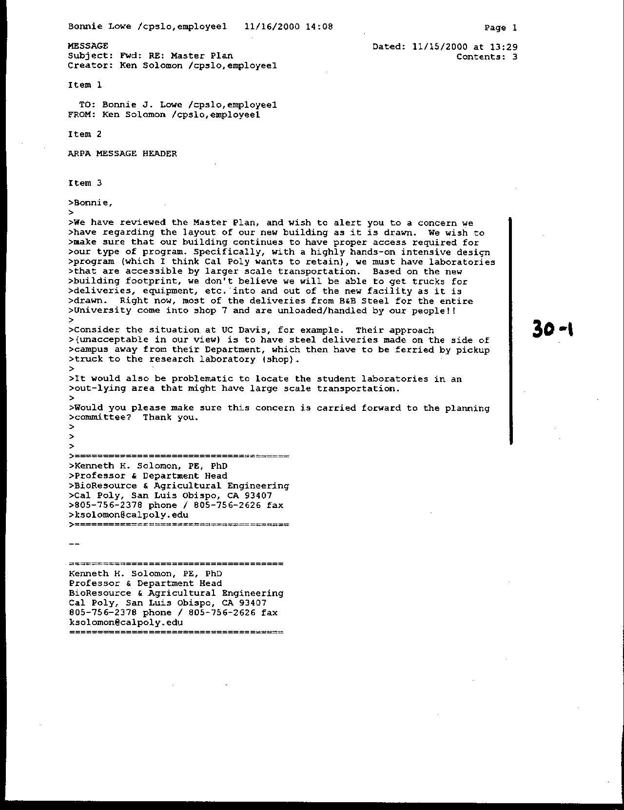
Letter 30
Letter 30

Dr. Ken Solomon
Agriculture Engineering

November 15, 2000

30-1 Commenter expresses concern about the proposed configuration of future BRAE building, and specifically the need to accommodate delivery of large goods.

Response Following adoption of the Master Plan, Cal Poly will engage in a series of implementation studies (specified in Chapter 7). As projects are planned and built, they will be reviewed and monitored for compliance with the environmental mitigation requirements as well as with meeting plan expectations to reinforce the academic quality of the University. The Campus Planning Committee will review the Master Plan annually so as to advise the campus whether conditions have changed sufficiently to warrant a major update. New text in the Master Plan recognizes service delivery requirements, as follows: “Site design for new agricultural facilities will accommodate delivery of materials and equipment for student labs, including access by large trucks” (p. 117).

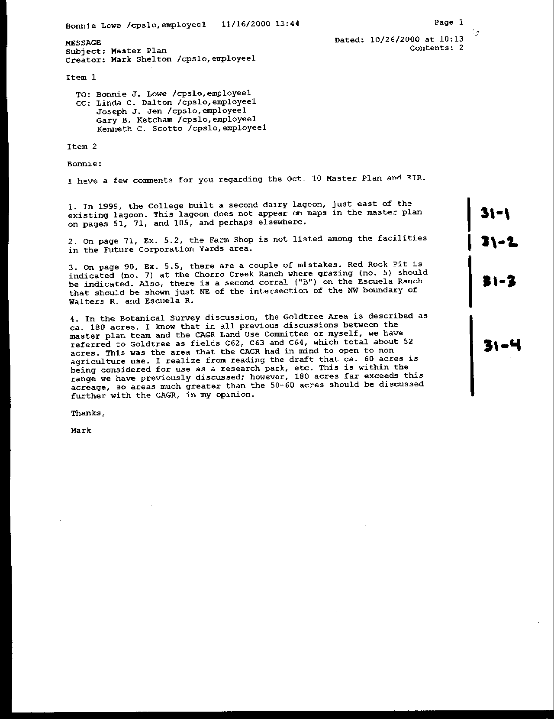
Letter 31
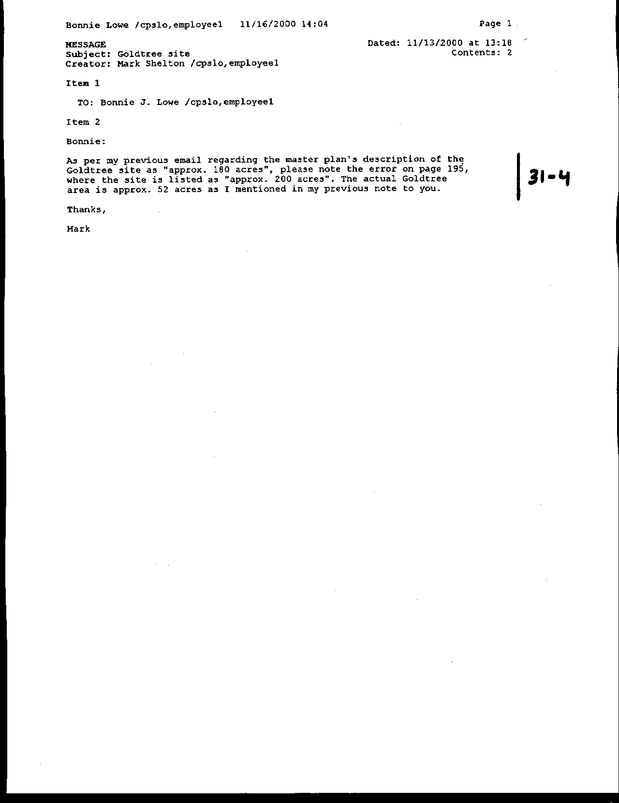
Letter 31
Letter 31

Dr. Mark Shelton
Assistant Dean, College of Agriculture

October 26, 2000

31-1 Commenter notes the omission of the second Dairy Lagoon.

Response Maps have been modified to show lagoon.

31-2 Commenter notes that the Farm Shop was not listed for the future Corporation Yards.

Response Exhibit 5.2 has been modified to list the Farm Shop.

31-3 Commenter notes errors on Exhibit 5.5 regarding red rock pit and corrals omitted.

Response Exhibit 5.5 has been modified accordingly.

31-4 Commenter notes a concern with the Master Plan’s description of the so-called Goldtree Area.

Response The northwest corner of Cheda Ranch includes an area known as Goldtree. Traditionally, this area has consisted of three fields (C62, C63, C64), totaling about 52 acres. In conducting feasibility studies for ancillary activities at a satellite location, the Master Plan team examined a slightly larger area (including fields C65 and part of C,61, but excluding C64 as too steep) to determine which land might be more suitable, considering environmental, regulatory, cost and policy constraints. Based on soil type, slope, and current condition, the 60-acre area shown on the detailed map was identified as most suitable for potential development, and became known as the Goldtree project area or site. It is close to the Union Pacific Railroad and has access to water, sewage treatment and electricity. Access could be provided from Highway 1 (perhaps from an improved intersection near the site or at Stenner Creek Road) and/or internally from Mount Bishop Road (pp. 64-65). Reference to Goldtree in the Appendix to the EIR is to the area surveyed by the biologists, not the area proposed for development.

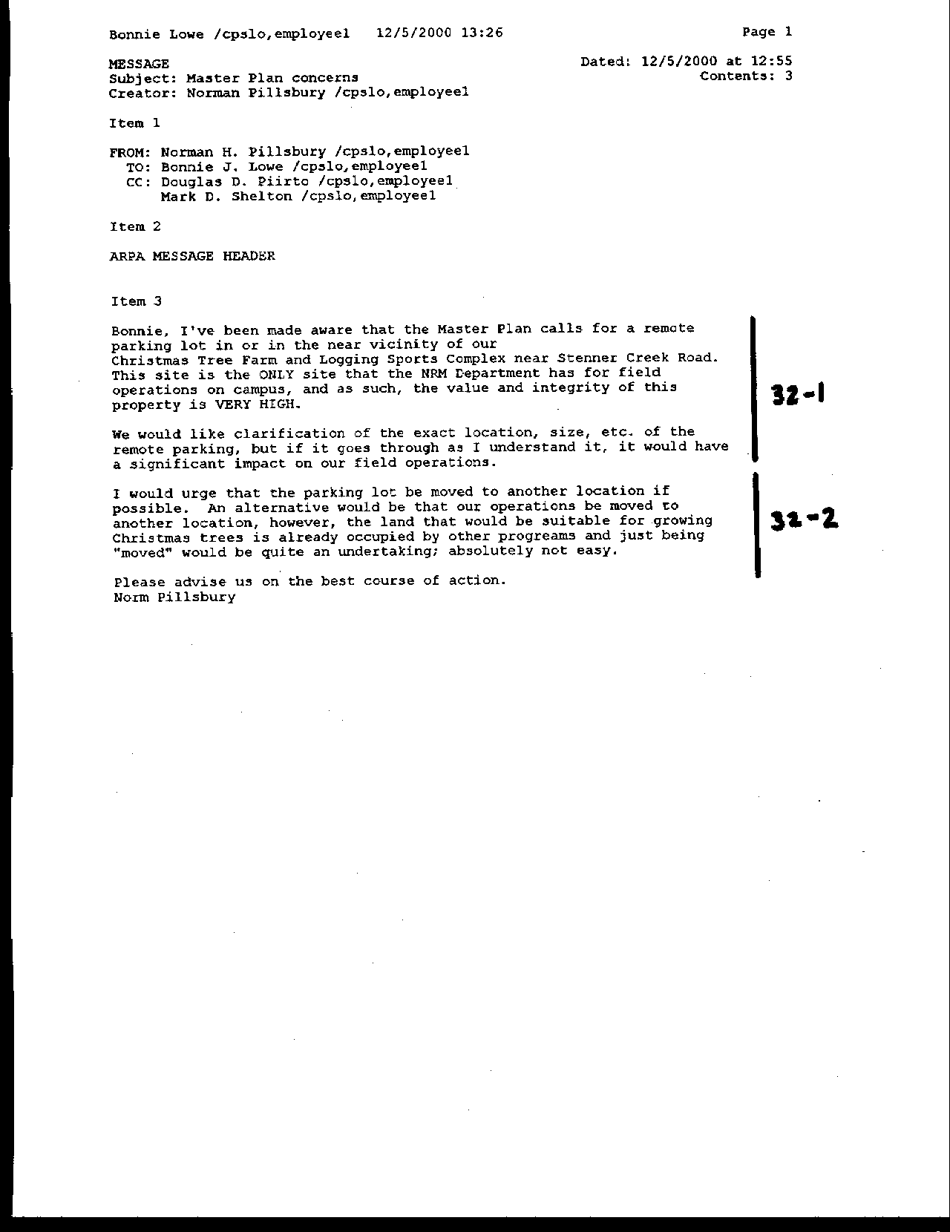
Letter 32
Letter 32

Dr. Norman Pillsbury

Chair, Natural Resources Management

December 5, 2000

32-1 Commenter raises concern about the location of the remote parking lot relative to the Tree Farm and Logging Sports Complex near Stenner Creek Road. He further requests the exact location of the remote parking be described and moved away from NRM facilities.

Response The Master Plan Land Use map (Exhibit i] identified two general locations where a remote parking lot could be developed. The locations will be refined as discussed in new text on p. 195: “Planning for development of a remote parking site that would involve moving any Outdoor Teaching and Learning activities, such as the forestry demonstration area or sheep grazing, would follow the principle that a new site for their operations would need to be identified and developed first, so as to minimize disruption.” It is important to note that the development of remote parking is a contingency predicated on the inability to reduce parking demand through restrictions described in the Alternative Transportation element of the Master Plan.

32-2 Commenter suggests that the NRM Christmas Tree Farm be relocated to better soils.

Response NRM, at a meeting on January 3, identified land with the potential for relocating the tree farm. Consideration of remote parking locations will not impede this move.

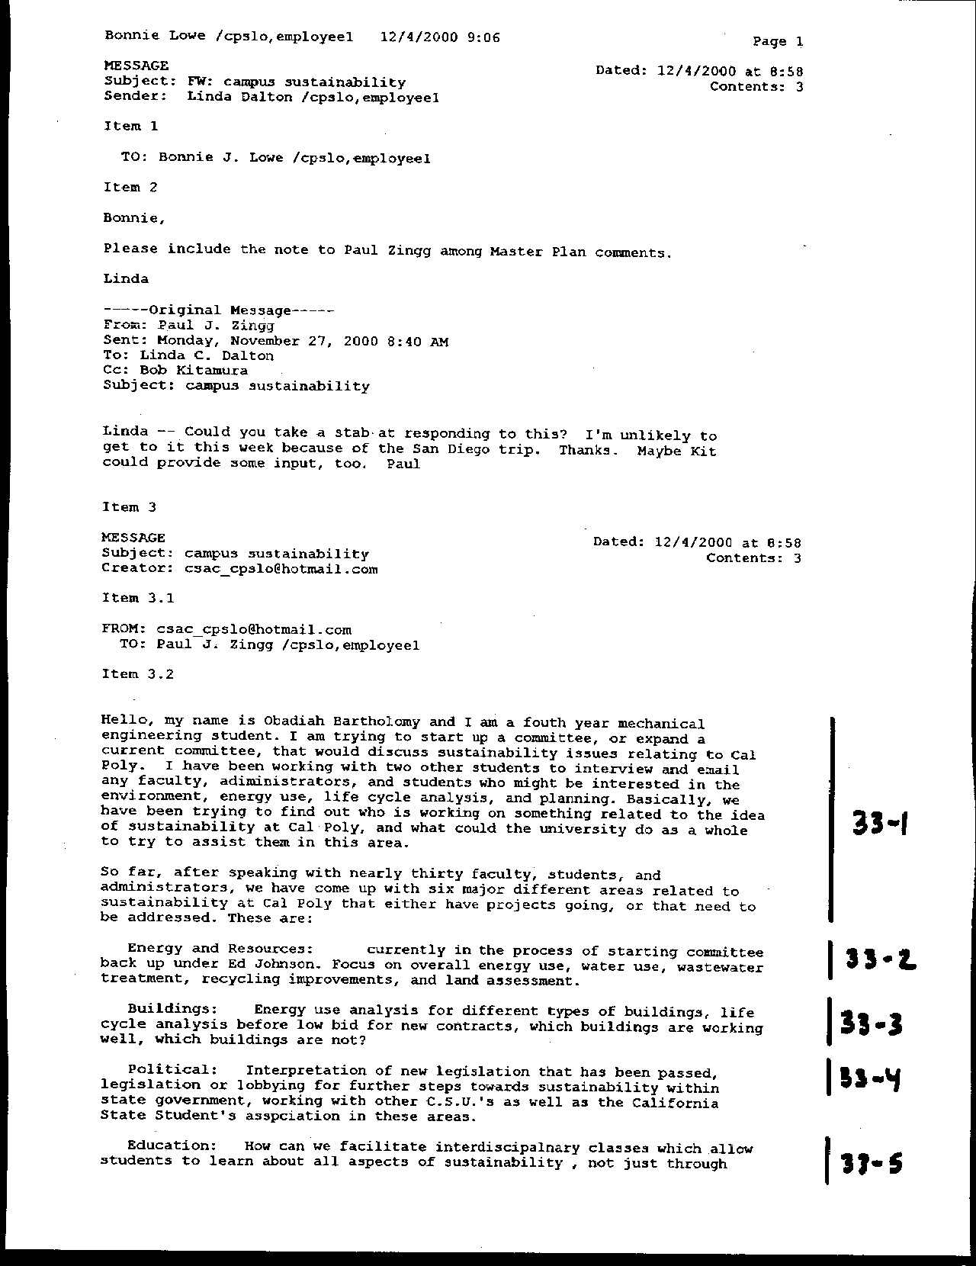
Letter 33
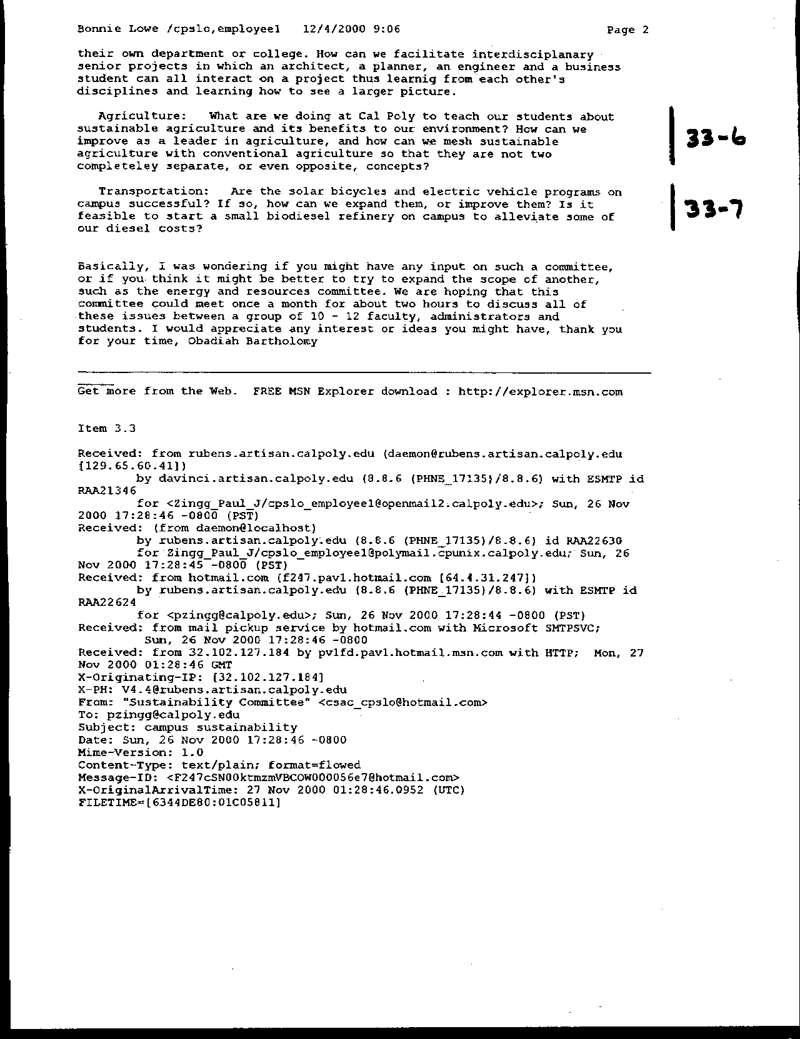
Letter 33
Letter 33

Mr. Obadiah Bartholomy

December 4, 2000

33-1 Commenter notes that he is attempting to set up a campus committee on sustainability issues to promote projects dealing with areas such as energy and resource, buildings, political issues, education, agriculture, and transportation.

Response See new integrated discussion at end of Land Use and Public Facilities and Utilities elements (pp. 79 and 162-163).

33-2 Commenter expresses concern with energy and resource use.

Response See new integrated discussion at end of Public Facilities and Utilities element (pp. 162-163).

33-3 Commenter expresses concern with life cycle analysis for buildings.

Response See new integrated discussion at end of Land Use and Public Facilities and Utilities elements (pp. 162-163).

33-4 Commenter expresses interest in political and legislative support for sustainable practices.

Response Such support will contribute to Cal Poly's ability to address such issues in implementing the Master Plan as it raises public awareness and may provide resources as well.

33-5 Commenter expresses interest in interdisciplinary courses and student projects addressing environmental sustainability.

Response Introductory chapter enables and supports curricular attention to sustainability.

33-6 Commenter expresses interest in sustainable agriculture.

Response See Outdoor Teaching and Learning element.

33-7 Commenter suggests expanding bicycle use, including solar and electric energy.

Response Bicycle use will be made more convenient under the Master Plan. Cal Poly has already initiated several programs to deal with solar and electric powered vehicles. The first electric bicycles have already arrived on campus for a beta testing program under Ed Johnson of Facilities Planning.

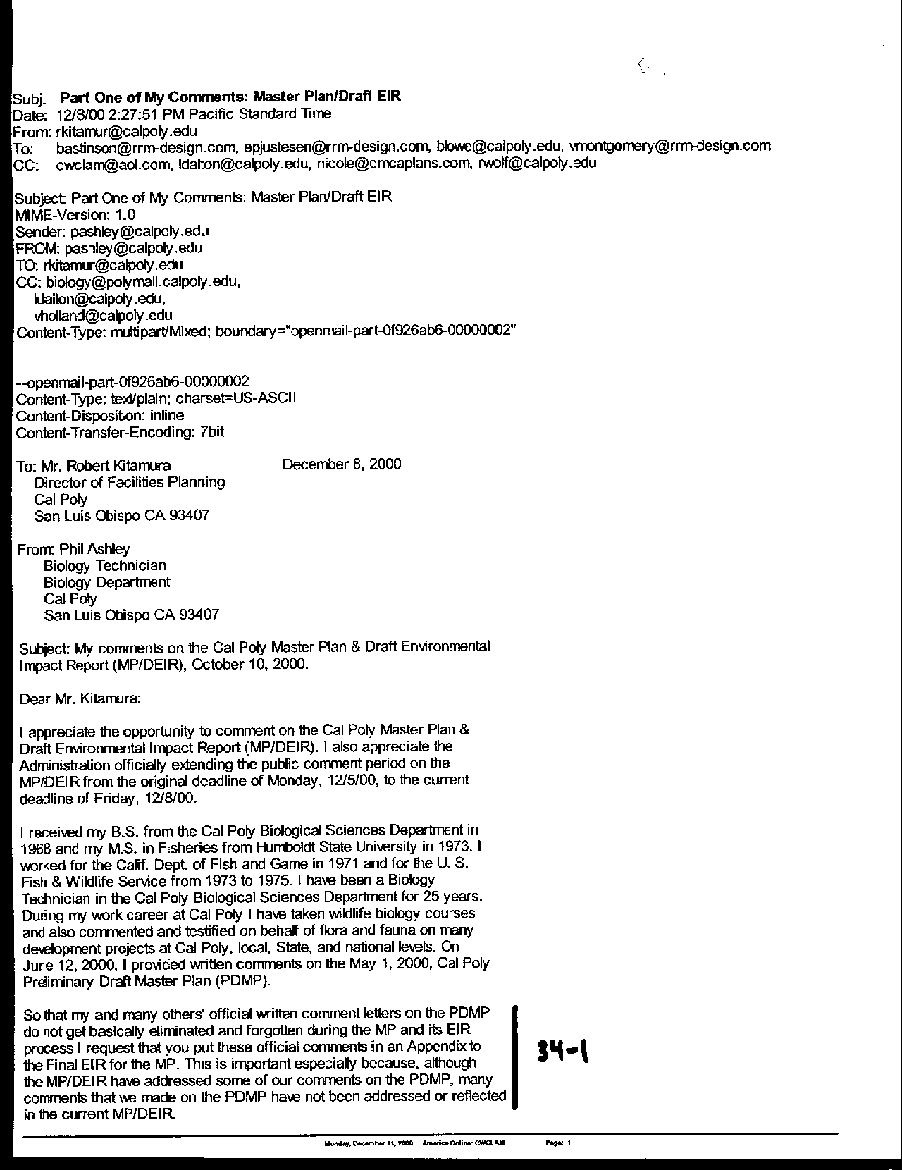
Letter 34
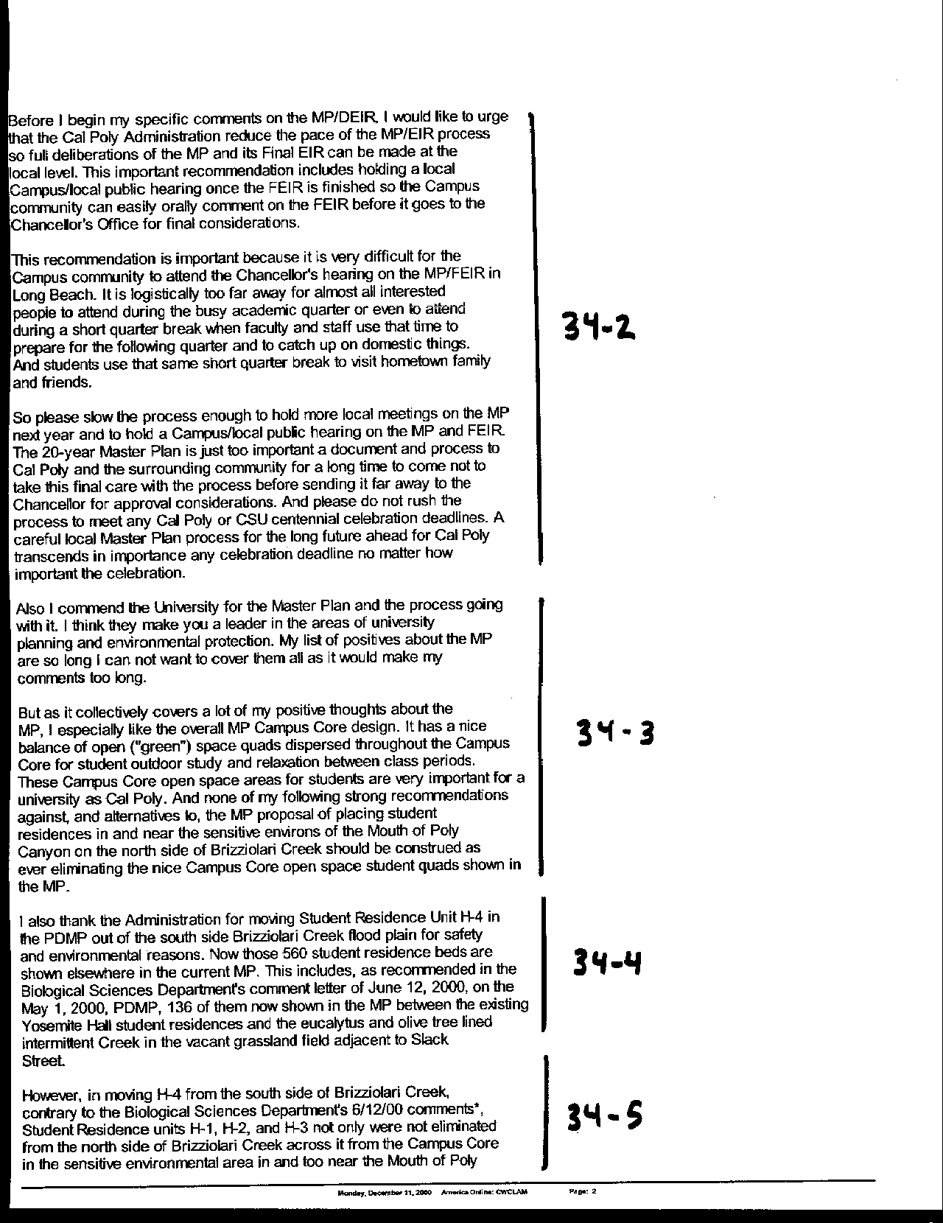
Letter 34
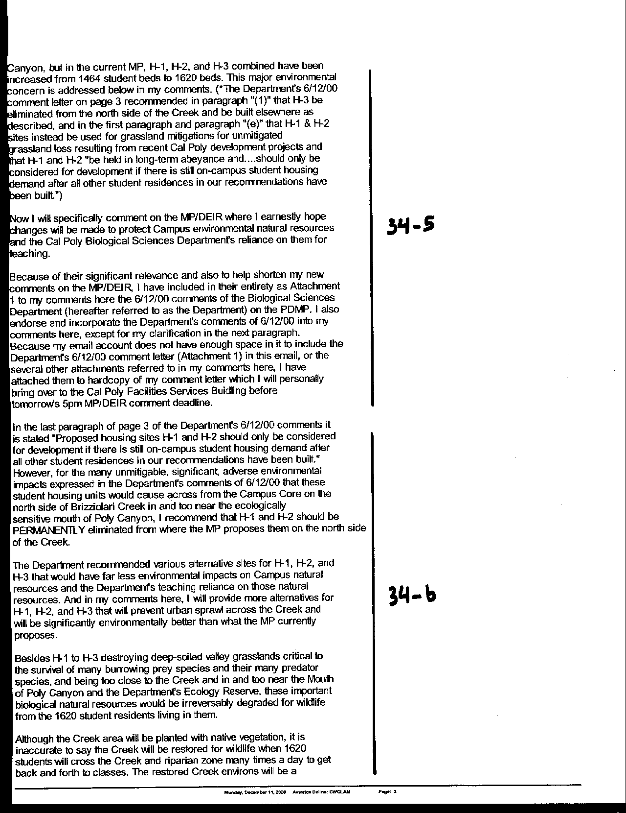
Letter 34
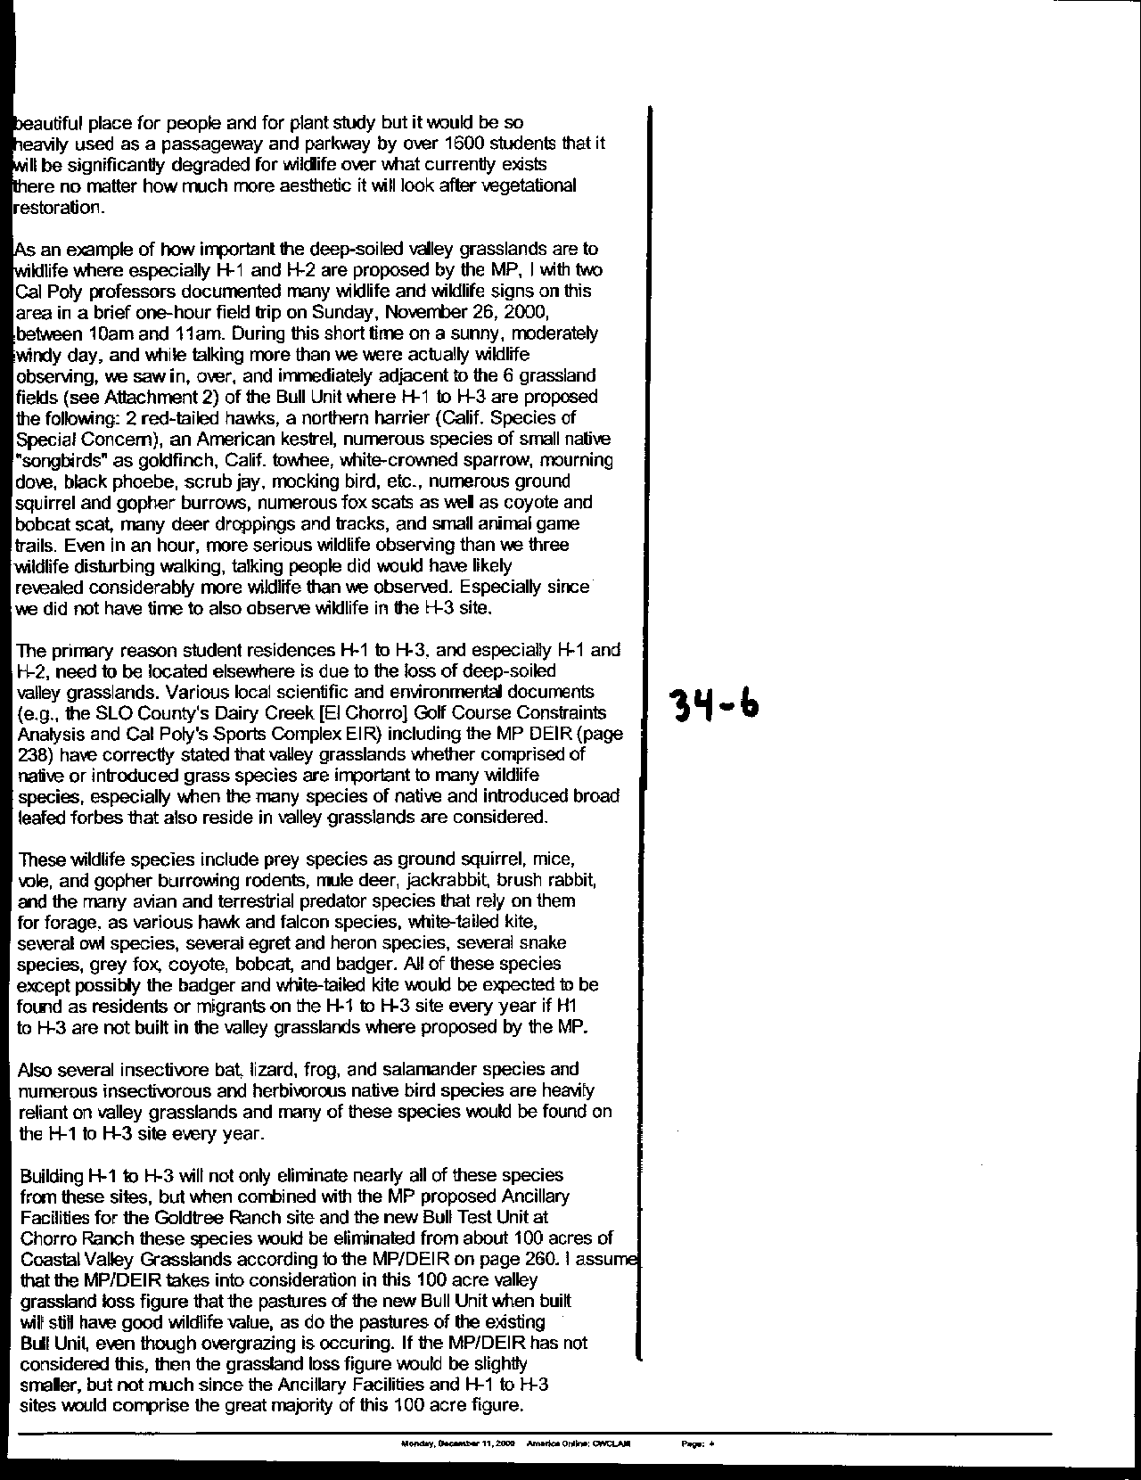
Letter 34
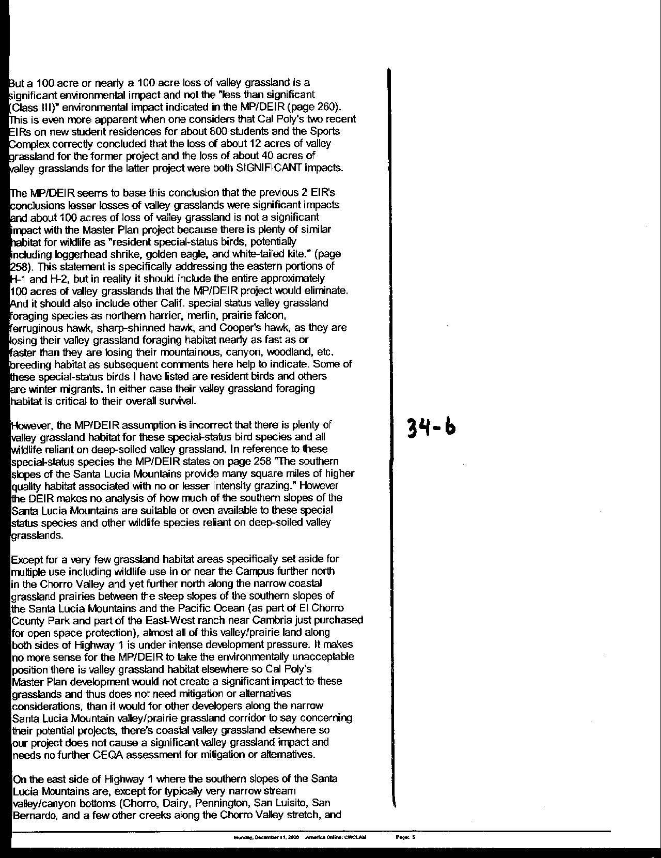
Letter 34
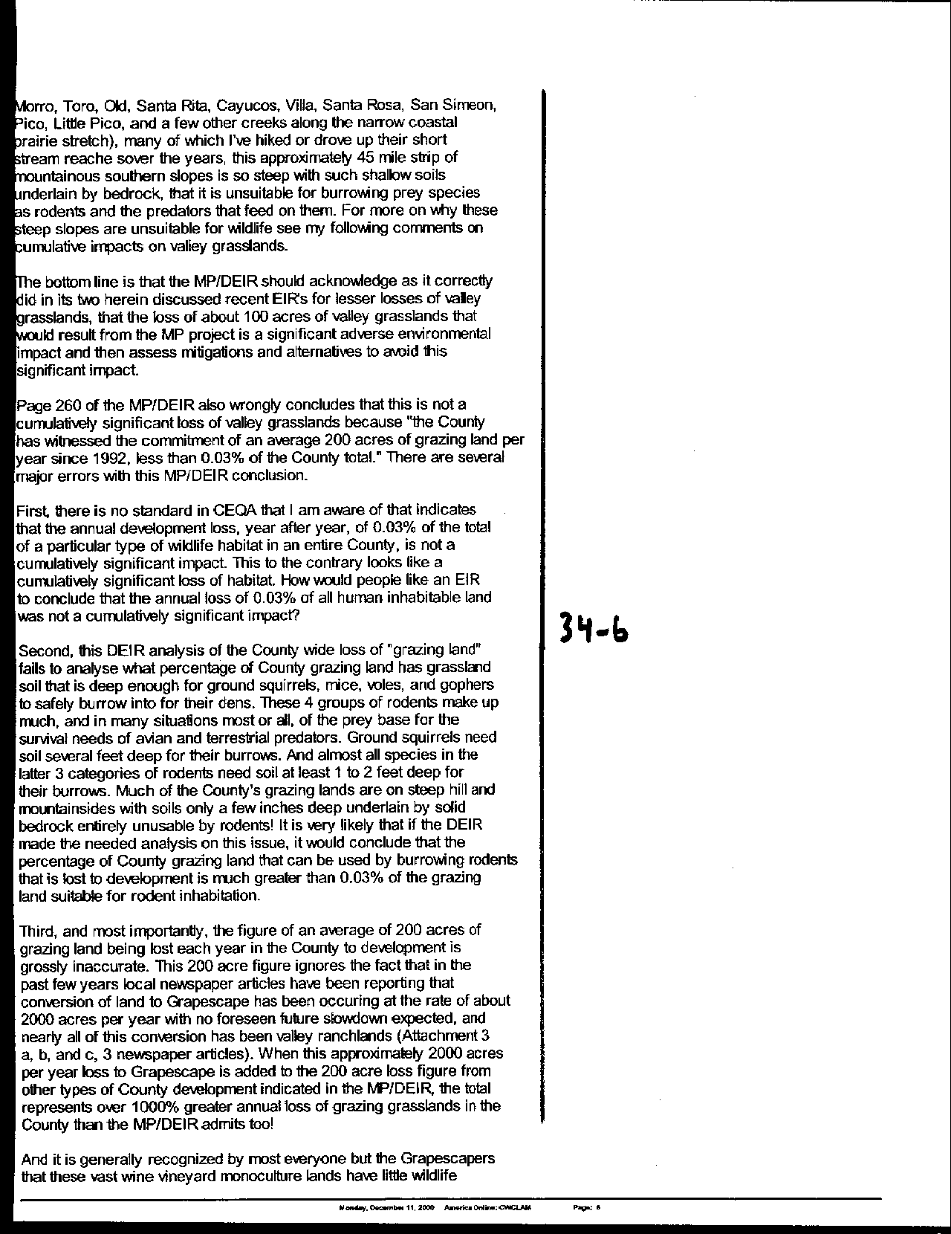
Letter 34
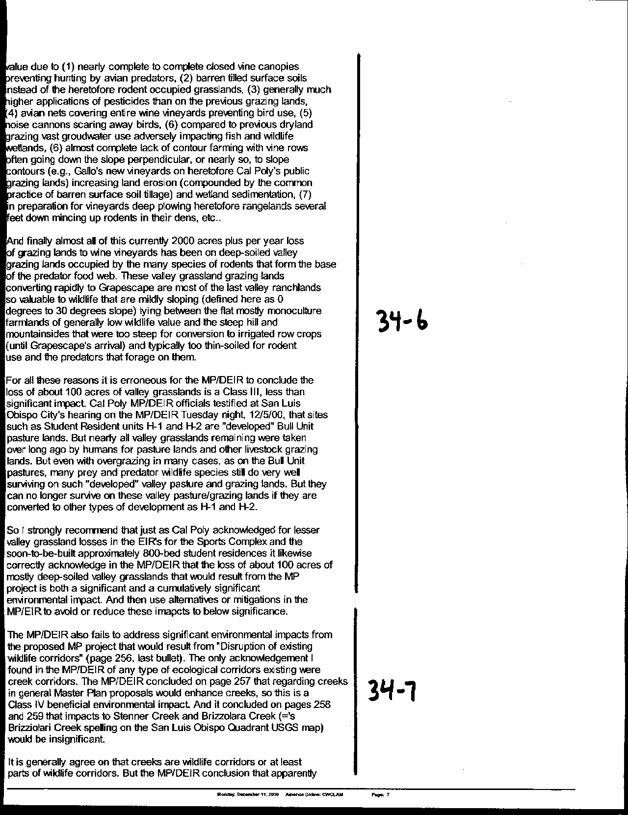
Letter 34
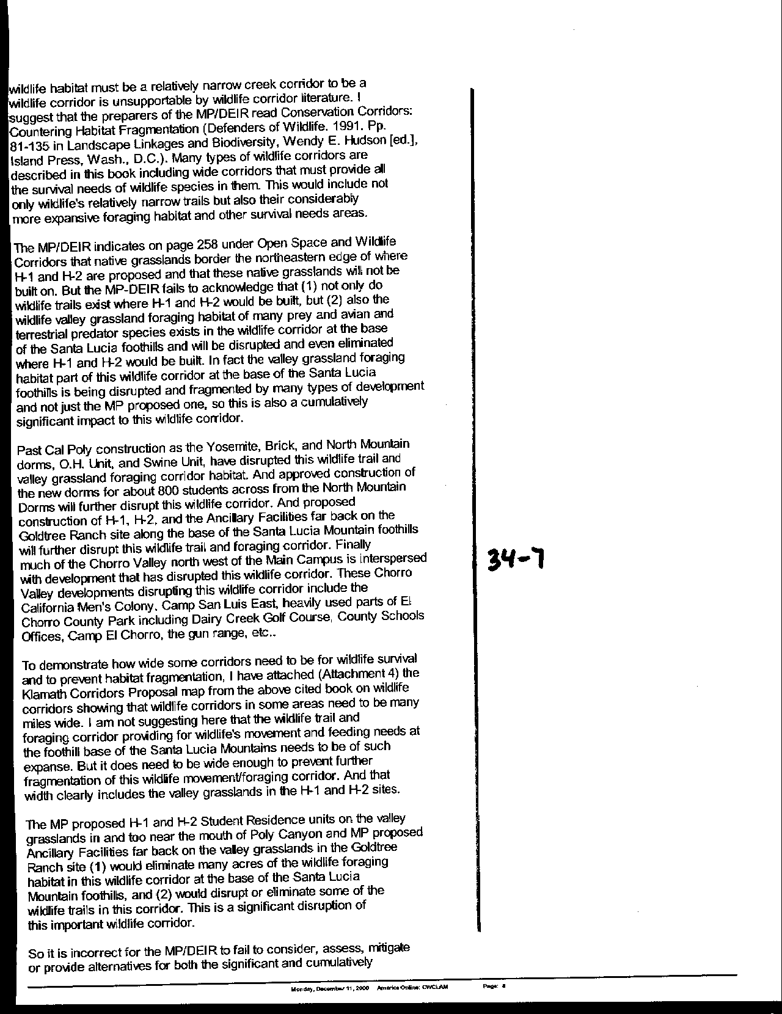
Letter 34
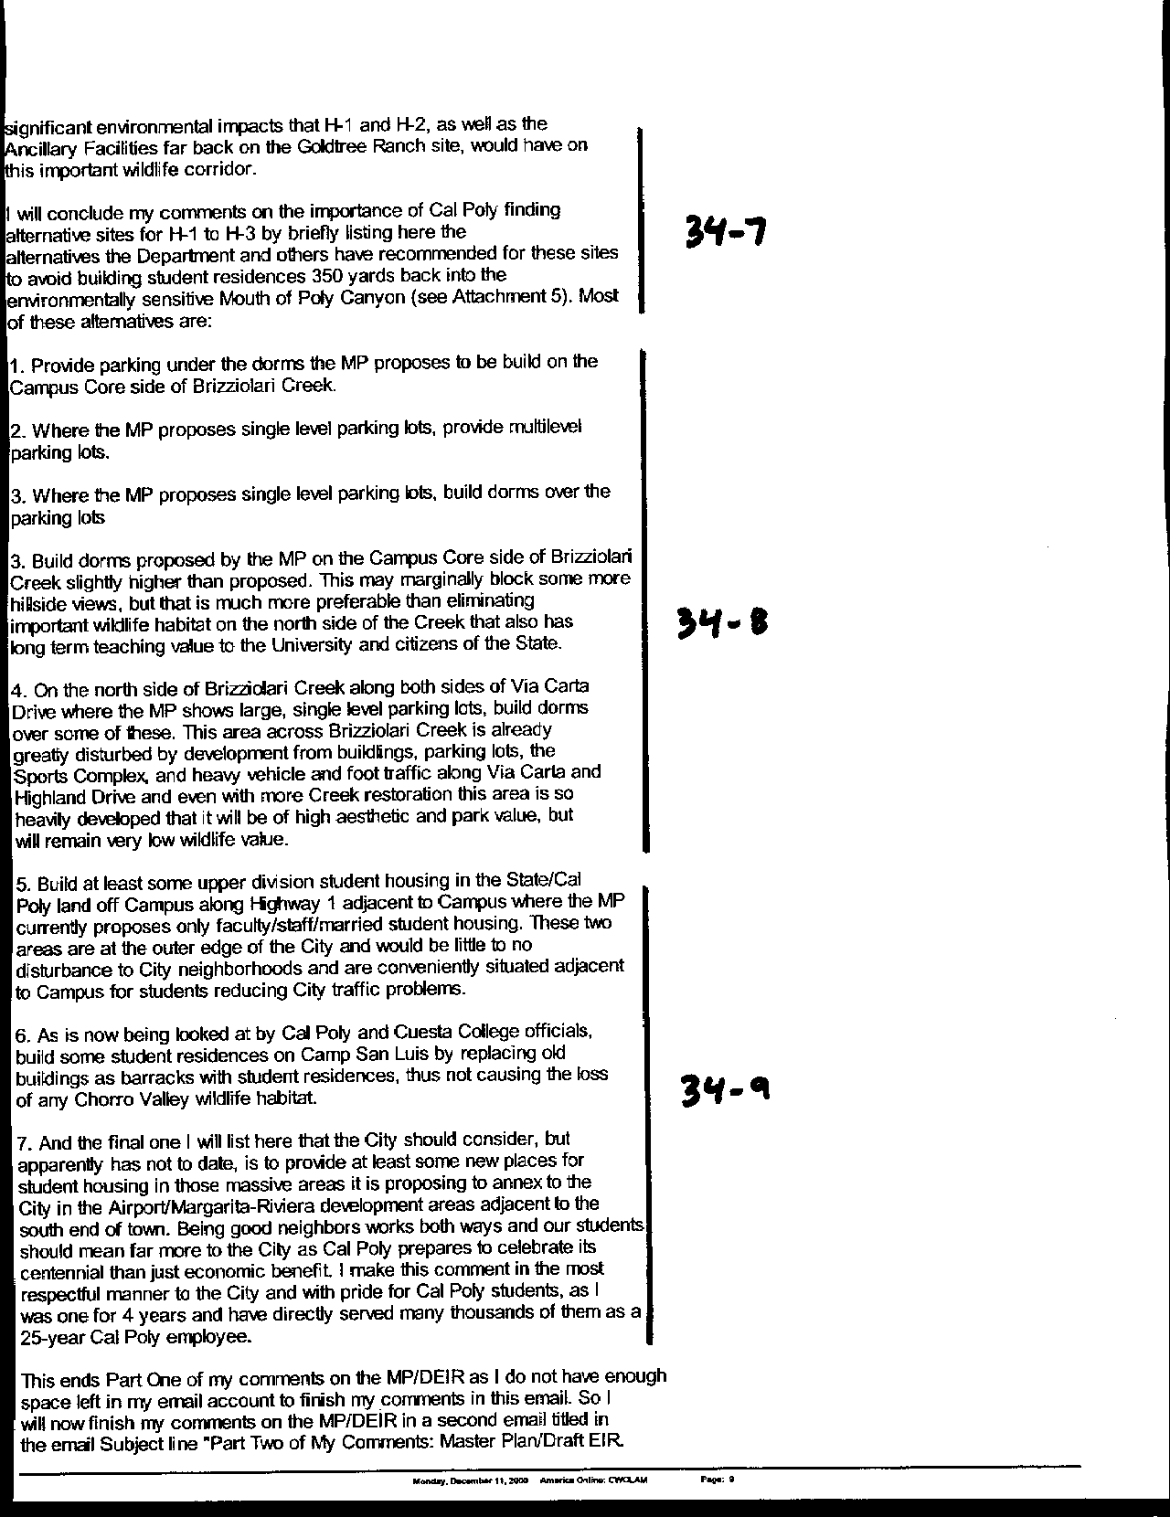
Letter 34
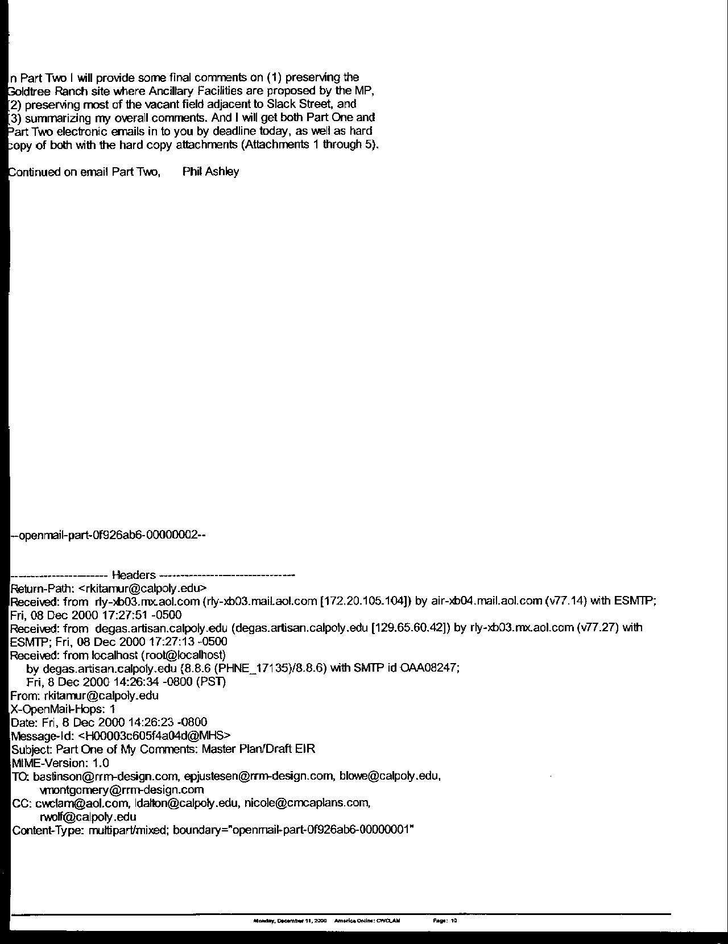
Letter 34
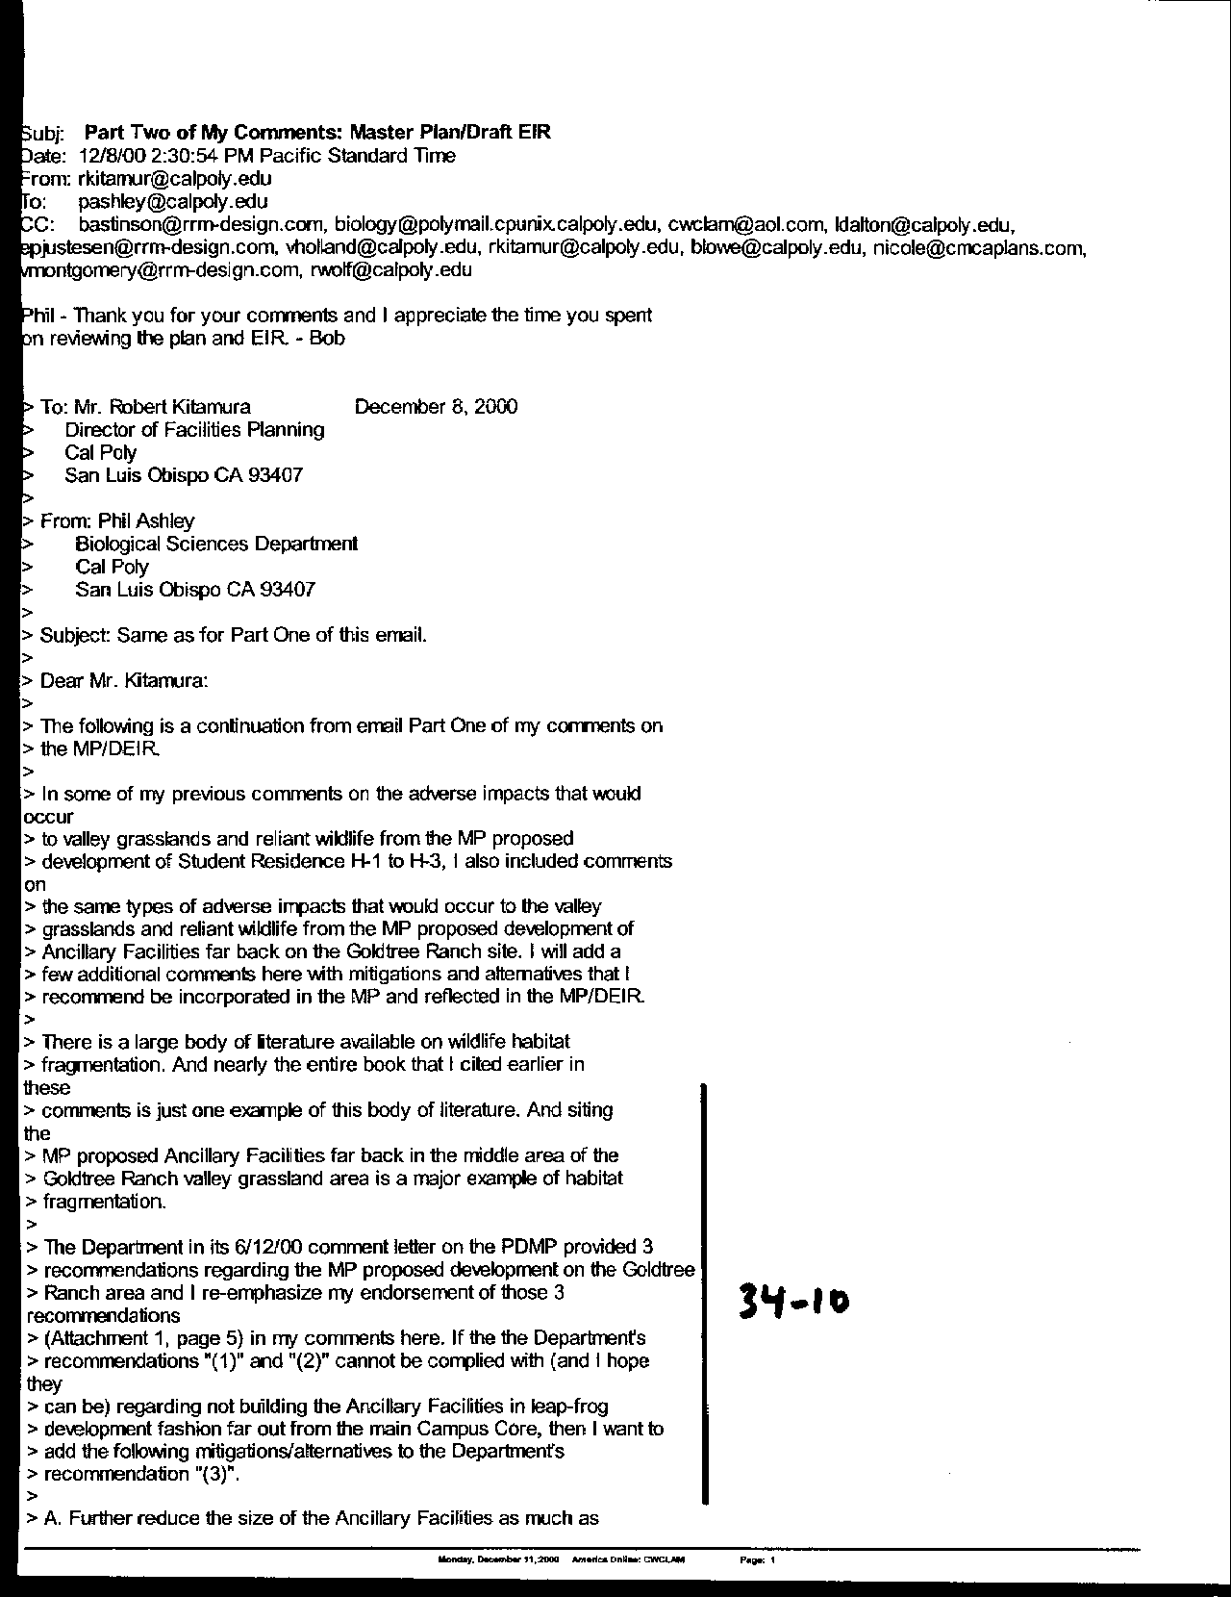
Letter 34
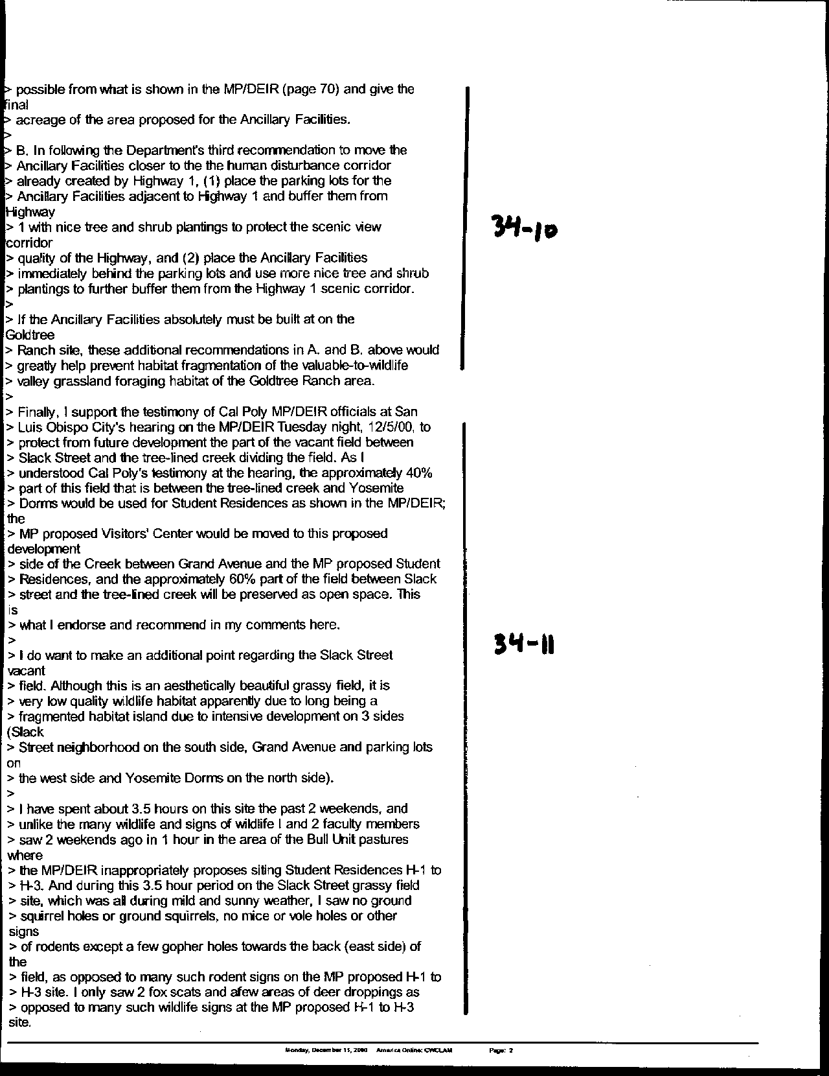
Letter 34
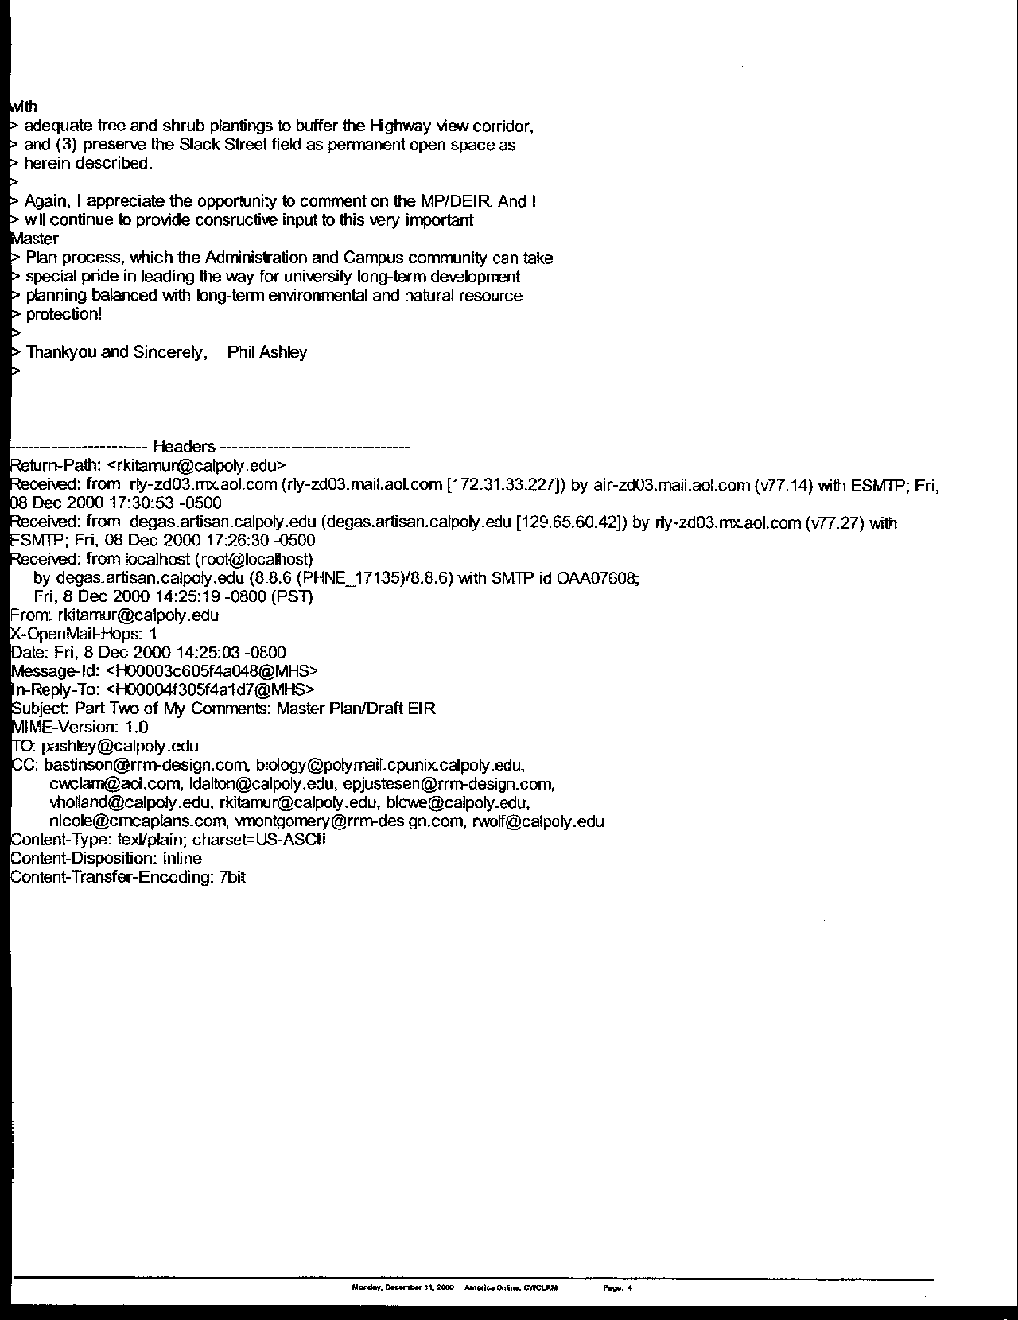
Letter 34
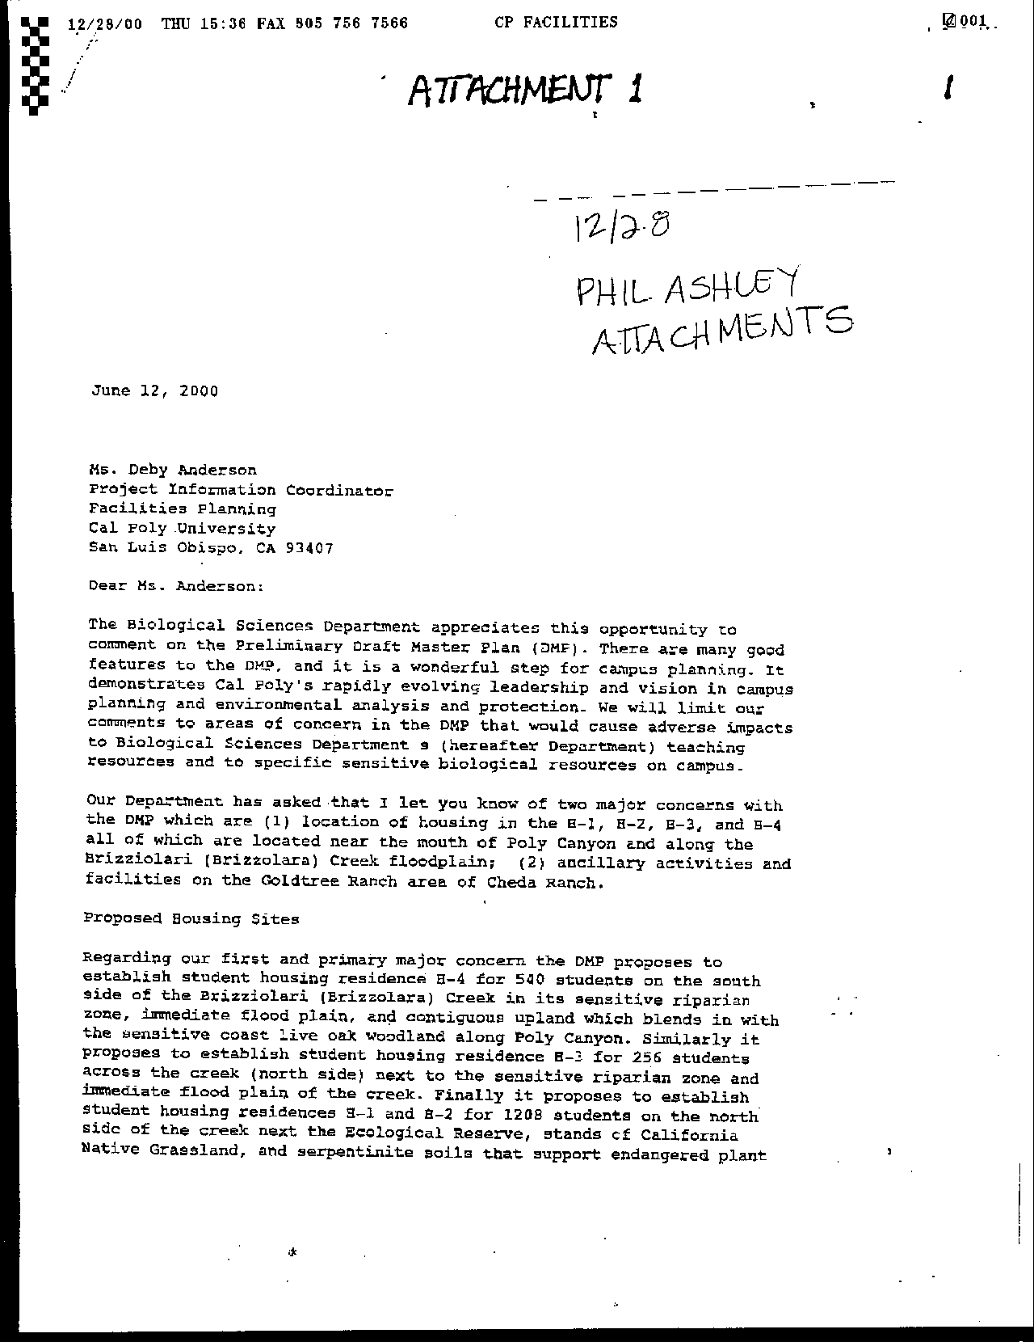
Letter 34
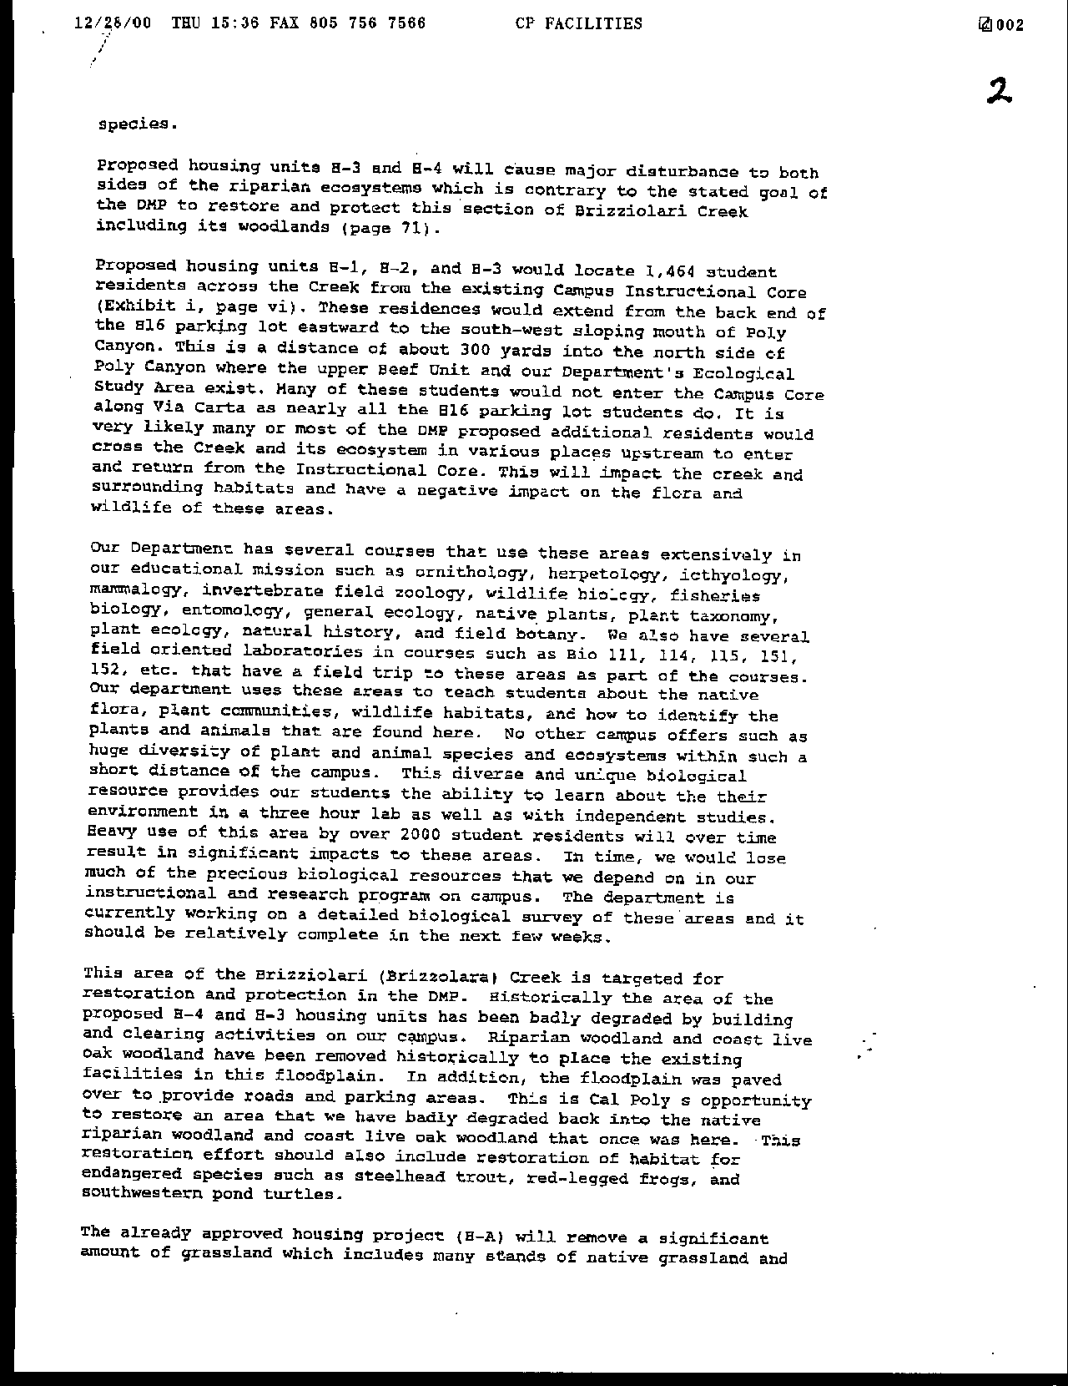
Letter 34
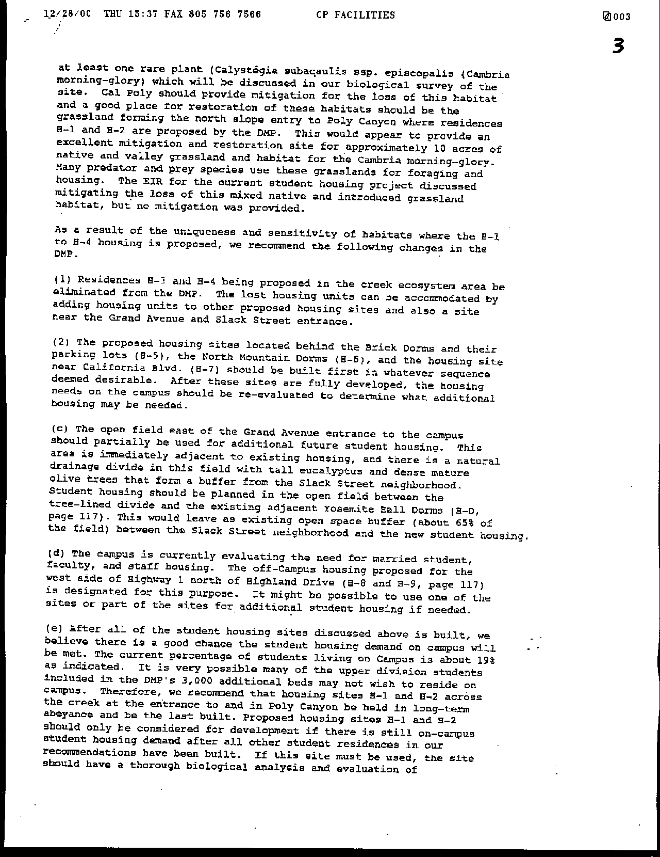
Letter 34
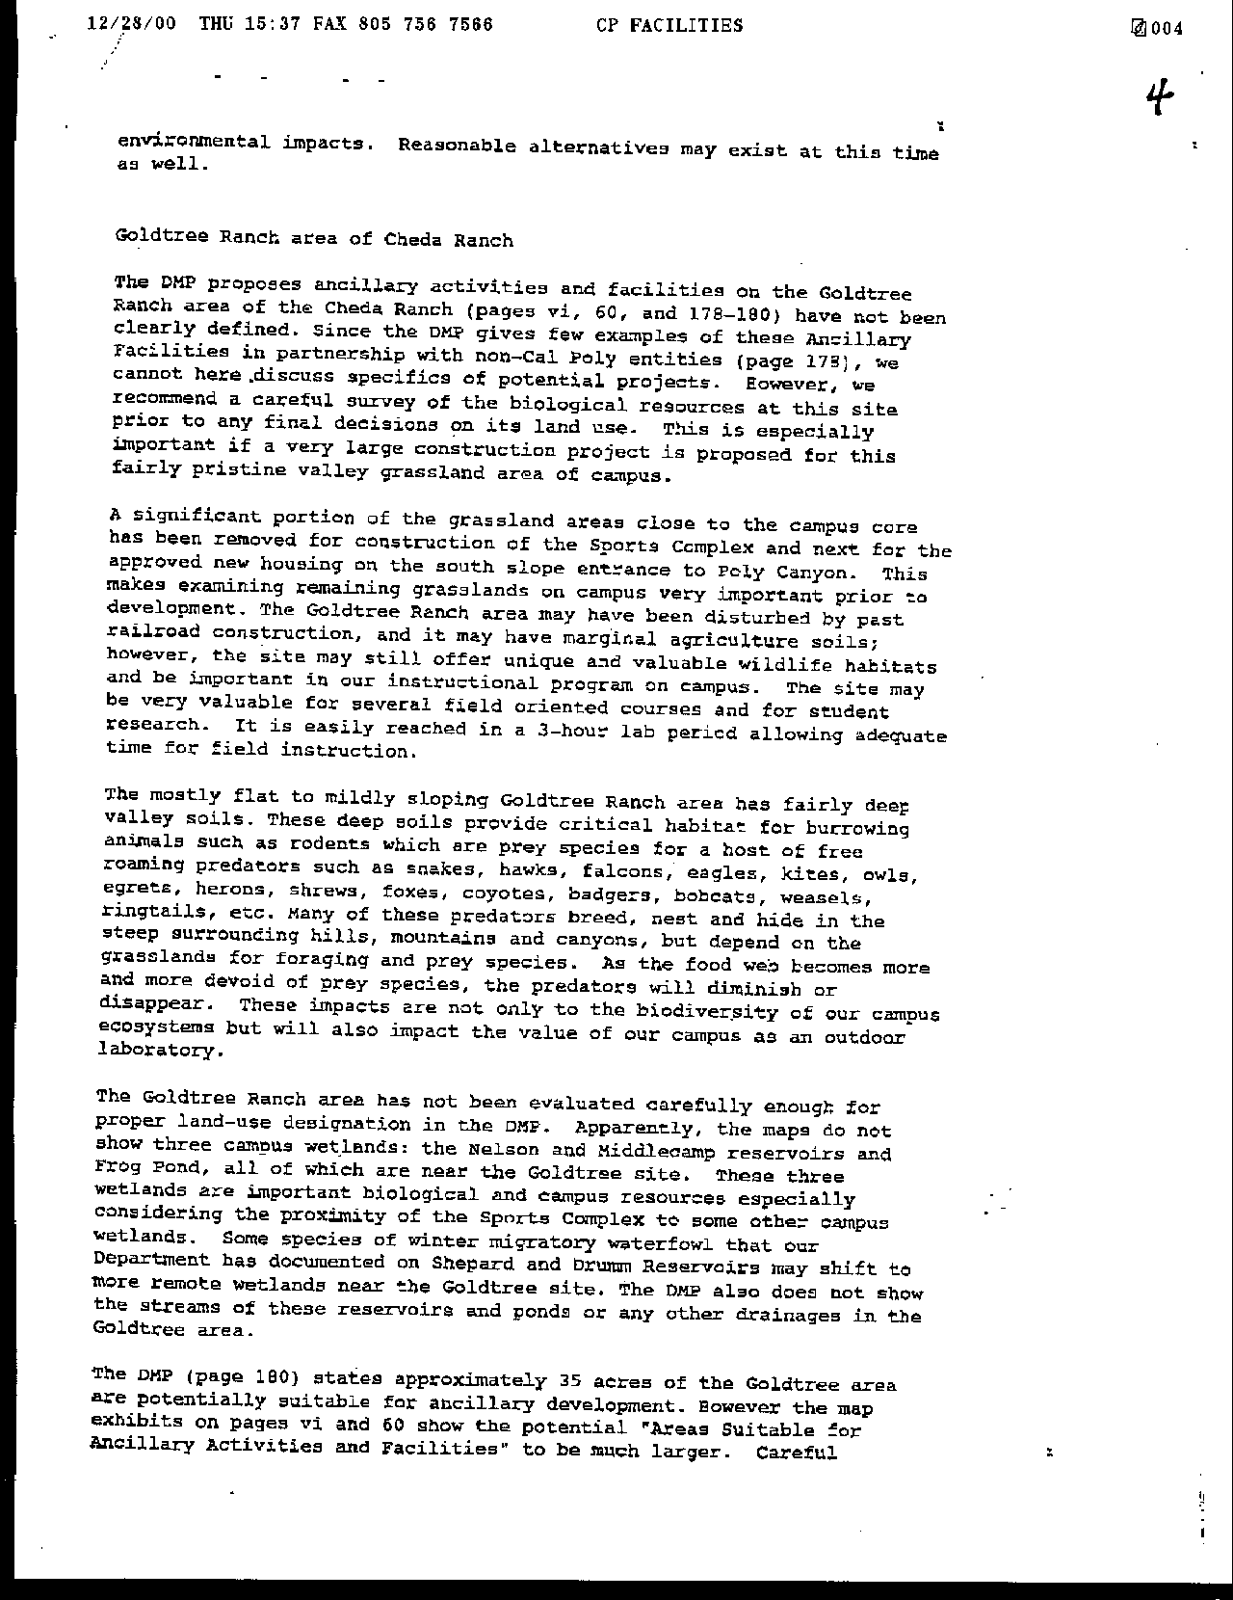
Letter 34
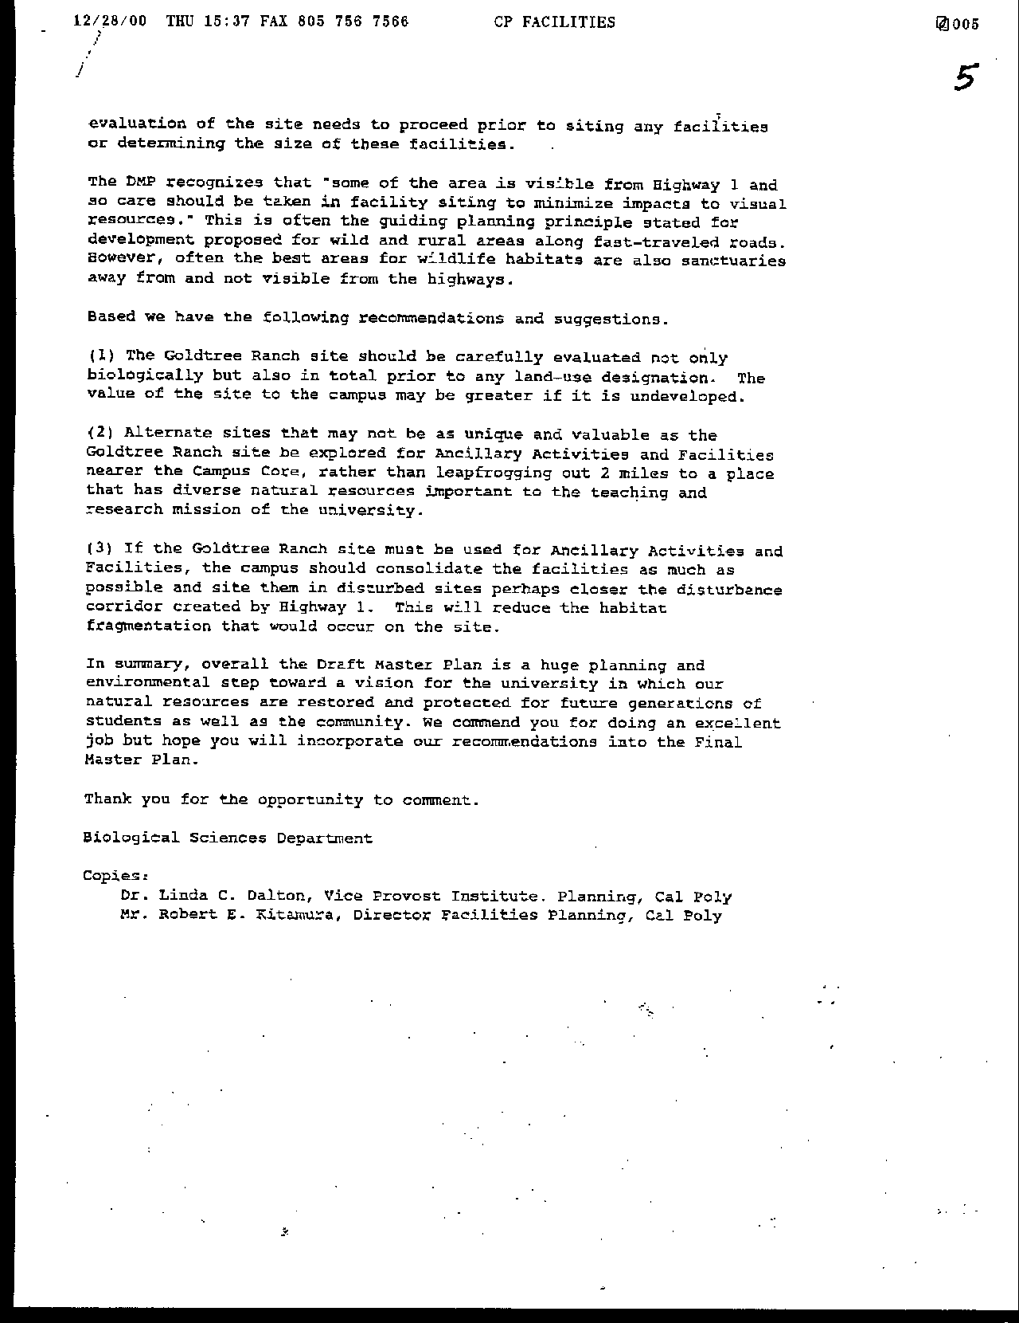
Letter 34
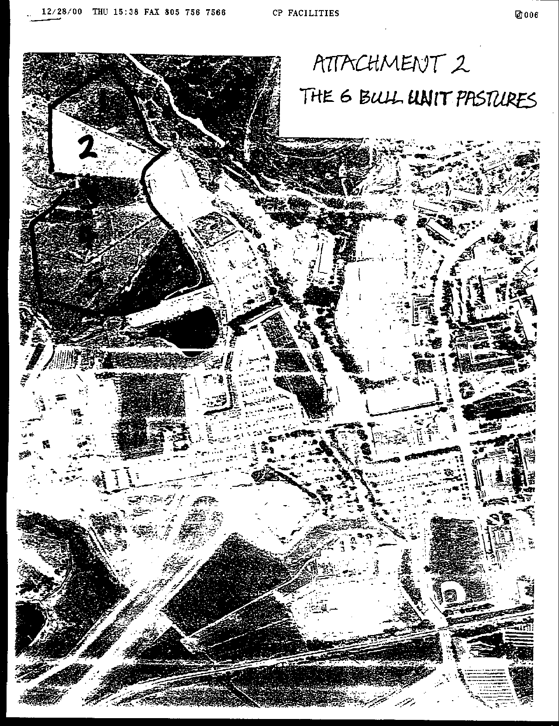
Letter 34
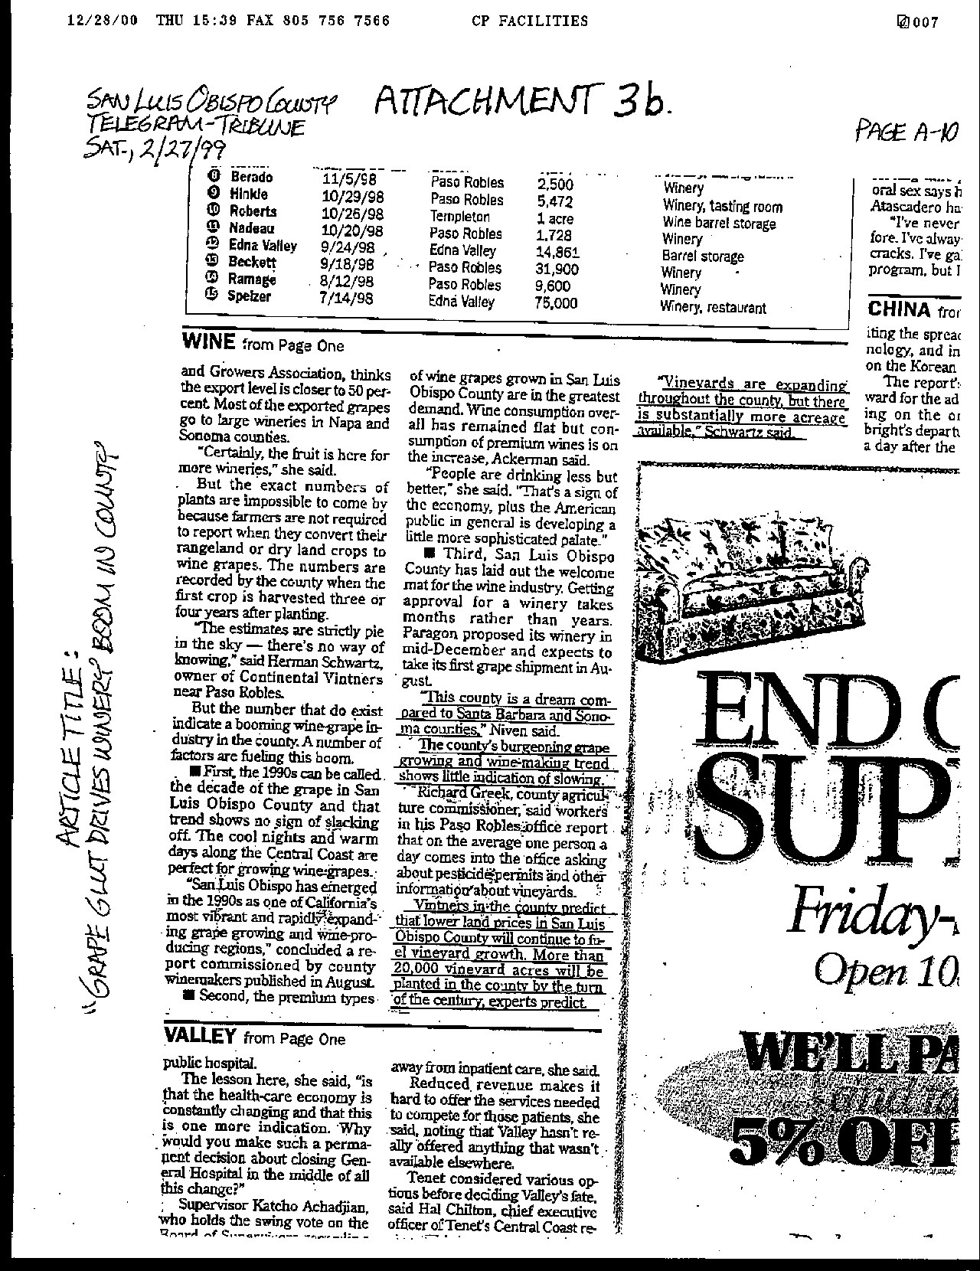
Letter 34
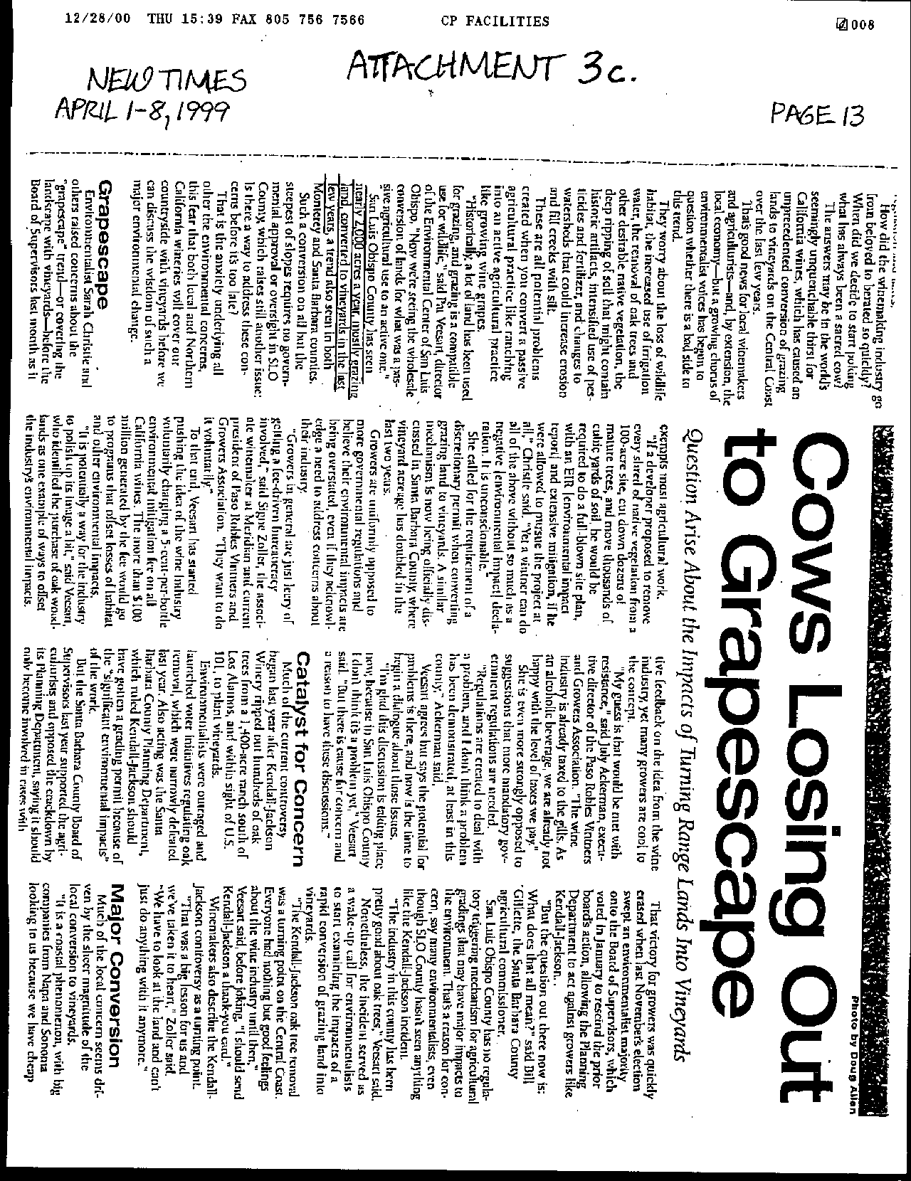
Letter 34
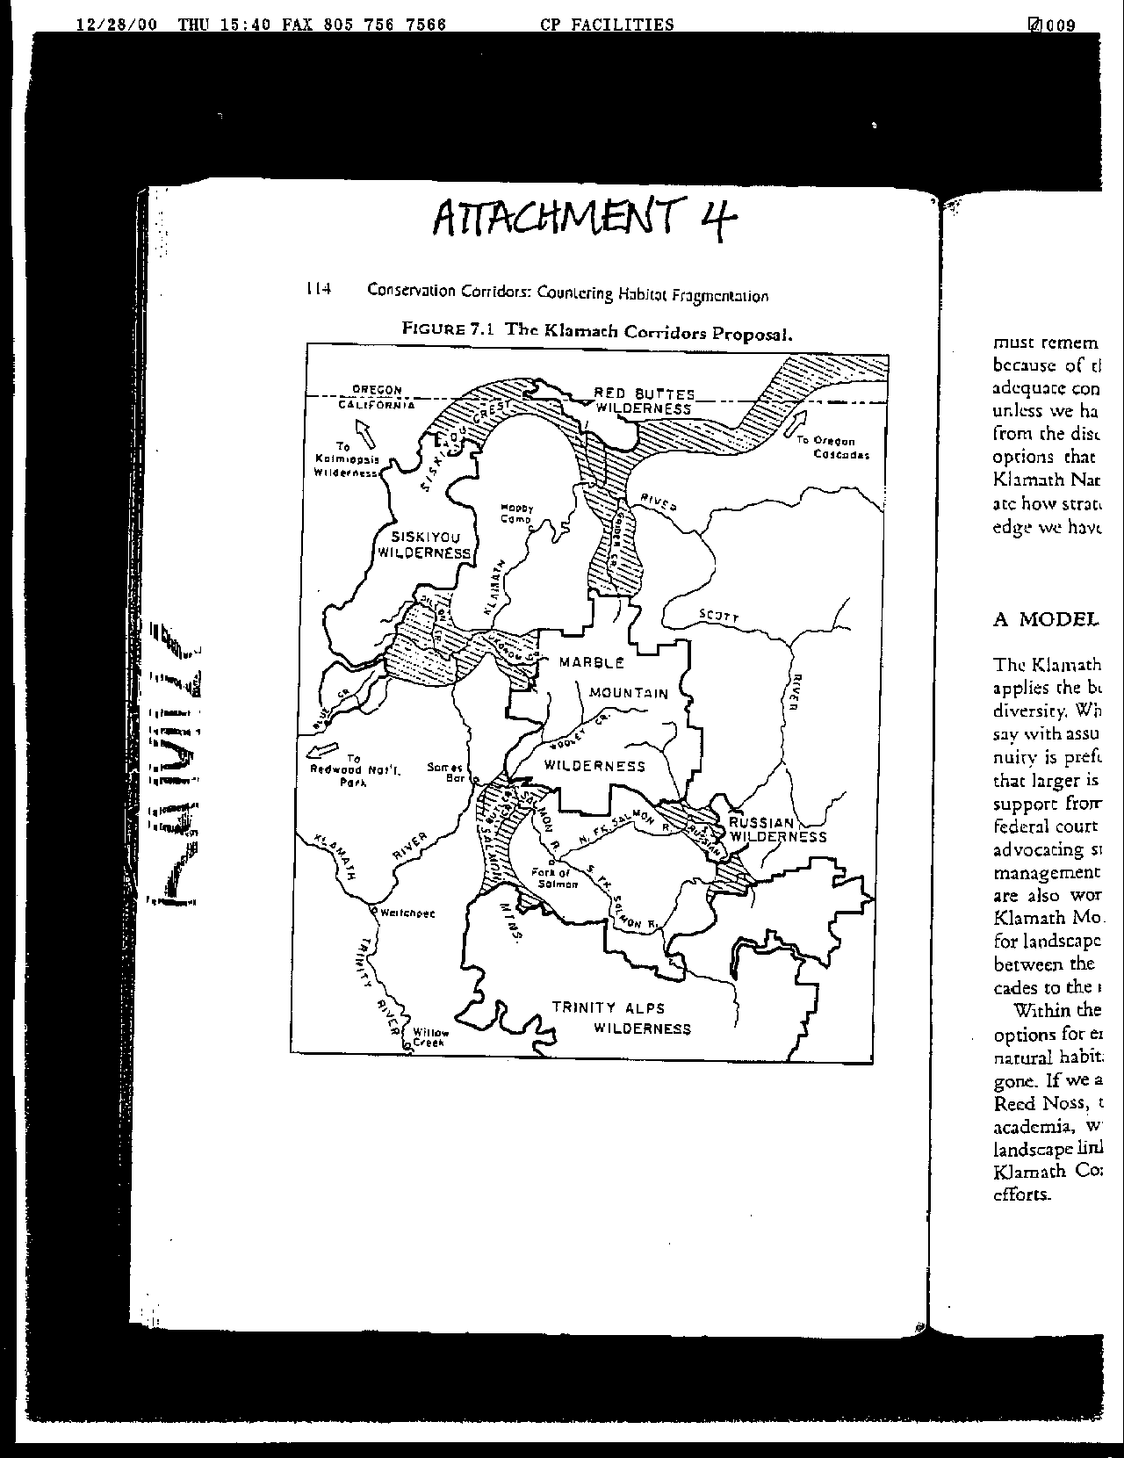
Letter 34
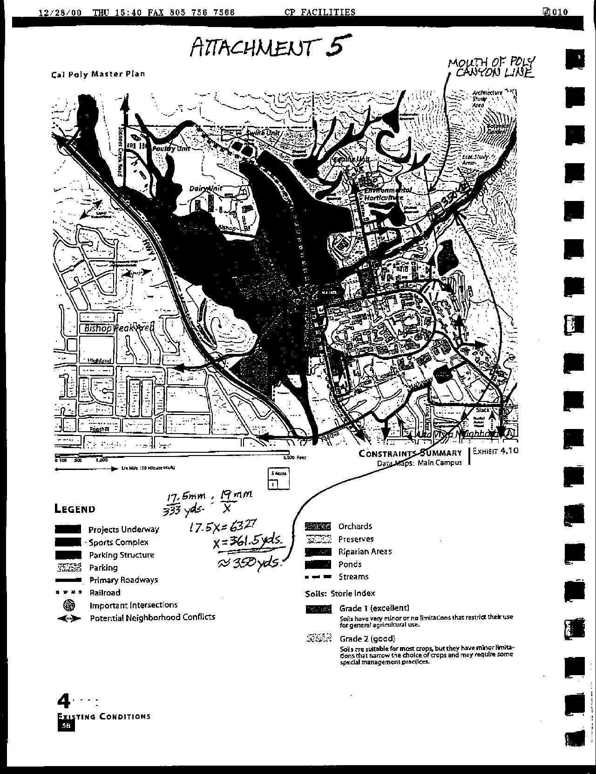
Letter 34
Letter 34

Mr. Phil Ashley

Department of Biology

December 8, 2000

34-1 Commenter suggests putting comments and responses in appendix to Final EIR.

Response Comments have been placed in the body of the Final EIR. The Master Plan and FEIR will include all comments on the October 10 publication, plus a matrix showing changes from both the May 1 and October 10 publications.

34-2 Commenter has suggested reducing the pace of the review of the Master Plan.

Response Comment noted. Review periods for the Master Plan and EIR were extended beyond required timeframes to allow for more comment, and the Preliminary draft and its preparation involved the input of the public and many campus advisory groups.

34-3 Commenter expresses appreciation for components of the Master Plan such as design of the campus core.

Response Comments are noted.

  - Commenter expresses appreciation for the moving of the H-4 unit since the Preliminary draft.

Response Comments are noted.

34-5 Commenter expresses concerns with current location of H-1, H-2 and H-3 housing units.

Response Concerns are noted. The Master Plan team made extensive efforts to relocate the H-1 and H-2 housing units at a suitable distance from the creek corridor that resulted in the creation of the Brizzolara Creek Enhancement Project and the re-adsorption of units initially proposed for location along the creek (namely H-3). The additional beds were the result of partial absorption of the H-4 housing unit that could not be relocated in its entirety elsewhere on campus.

34-6 Commenter suggests that H-1 and H-2 be permanently eliminated from the Master Plan for several reasons, the first being the loss of deep-soiled valley grasslands, and the second the degradation of the creek corridor due to traffic.

Response Grasslands. The grasslands the commenter refers to are currently used for grazing and foraging of animal species. Valley grasslands consisting of species typical of pasture vegetation are not considered a sensitive plant community at the state or federal level, nor are they considered sensitive by CNPS. Therefore, the loss of this vegetative community is not considered a significant impact. In order to consider the loss of foraging habitat a significant impact under CEQA, the consultant would have to find that the proposed development would “have a substantial adverse effect [through habitat modification]” on sensitive species as defined in the EIR. The consultant maintains that there is adequate foraging habitat on surrounding Cal Poly lands for sensitive bird species, and that development of the site would not result in loss of nesting or other habitat for such species.

Creek Degradation. The Master Plan and EIR make a priority of the enhancement of the Brizzolara Creek corridor through the designation of a special project. Mitigation for the H-1 and 3 housing units specifically states (pg. 206) that “Plans for the H-1 and H-2 housing units will include pedestrian systems which are sensitive to the Brizzolara Creek corridor.” The commenter is reminded that the design shown in the Plan is conceptual; mitigation in the EIR requires that the creek be protected from pedestrian traffic. Implementation of this mitigation will be part of the long-range implementation of the Master Plan; the project will be further reviewed at such time it is planned to be built.

34-7 Commenter suggests Draft EIR and Master Plan fail to address the disruption of existing wildlife corridors.

Response The consultant believes that the site provides marginal “corridor” values due to existing development on three sides, and maintains that the major wildlife corridor in the area consists mainly of Brizzolara Creek. As mentioned above, the project provides a hard edge to the campus and provides protection for wildlife corridors along the hillsides and through Poly Canyon.

34-8 Commenter suggests several alternative locations and approaches to the housing development at H-1, H-2, and H-3.

Response The commenter is referred to the housing alternatives analysis prepared in the EIR which directs housing siting and design. The goals of the Master Plan are to locate housing within proximity to the campus instructional core and create a community for student living without compromising the function.

34-9 Commenter suggests Master Plan will result in wildlife habitat fragmentation.

Response Comment noted. Development has been concentrated near existing campus development so that fragmentation of wildlife habitat is minimized. The commenter’s specific reference to ancillary facilities at Goldtree is noted. These facilities are located where other site constraints (slopes, wetlands) will not be adversely affected. See additional sections added to Residential Communities element.

34-10 Commenter suggests location of H-1 and H-2 at the Grand Avenue and Slack Street location.

Response The University faces significant constraints in this area associated with the surrounding residential neighborhoods (specifically light and noise) that make development of this site with significant housing units difficult. The Environmental Suitability and Sustainability principle in the Land Use element (p. 65) calls for "limiting future development to those areas least affected by regulatory and/or high cost environmental constraints."

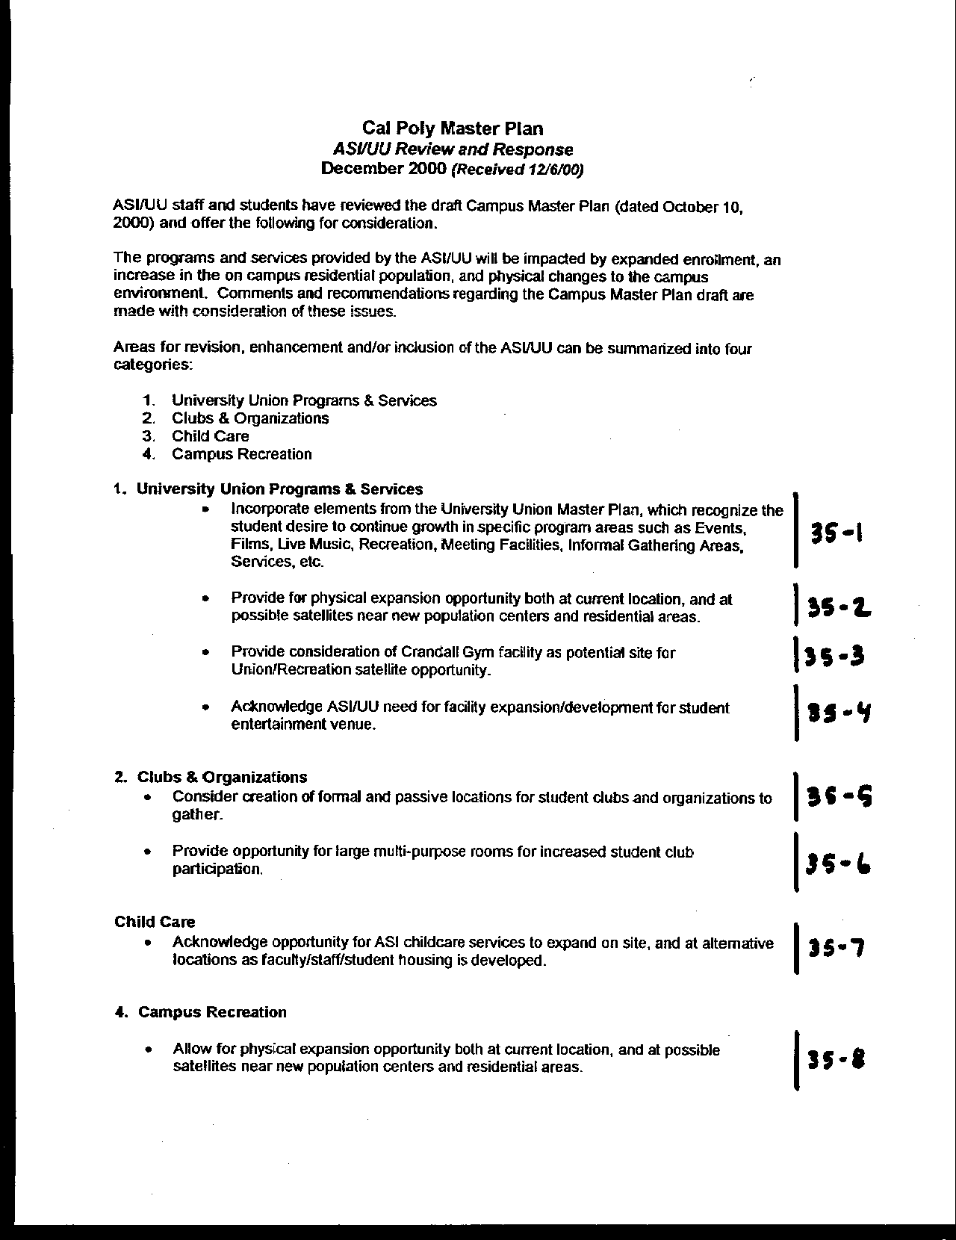
Letter 35

Letter 35
Letter 35

Dr. Rick Johnson

Cal Poly ASI/UU

December 6, 2000

35-1 Commenter asks that the Master Plan incorporate UU program areas for expansion.

Response Text has been added to the Campus Instructional Core element on p. 111: “The UU planning process identified the need for expanded facilities and programs, both in the current location and elsewhere on campus.” In addition, the list of area studies in Chapter 7 refers to the “University Union and Student Services Plan.”

35-2 Commenter ask for flexibility for UU expansion at present and possible satellite locations.

Response Language added to Campus Instructional Core (above) reflects this request. In addition, Integration and Social Environment principles in this element recognize the need for dispersed activities (refer to p. 109).

35-3 Commenter asks for consideration of potential reuse of Crandall Gym for Union and/or Recreation activities.

Response A plan component has been added to the discussion of the Southwest area of the campus: “Renovation of Crandall Gym for possible additional instructional space and/or recreation and support activities.” See p. 122.

35-4 Commenter seeks acknowledgement of student entertainment facility needs.

Response These are addressed in the list of uses for primary campus activity center. (Refer to p. 111.)

35-5 Commenter reminds us that clubs and organizations need formal and informal space.

Response Text regarding this need now reads “space in student residential communities can accommodate formal and informal functions of student organizations closer to where students live” (p. 202).

35-6 Commenter also reminds us that clubs and organizations need multipurpose rooms.

Response Text under the principle of Flexibility for Support Activities and Services has been added to read: “This should include multi purpose rooms for student clubs and organizations” (p. 200).

35-7 Commenter asks that the Master Plan acknowledge the need to expand childcare and provide alternative child care locations.

Response Discussion of childcare in the Support Activities and Services element has been modified to read: “The revised diagrammatic illustration shows a site for expanding the Child Care Center at its present location. ASI may also explore additional child care facilities on campus and/or within or near married student housing and/or faculty and staff housing” (p. 202).

35-8 Commenter suggests that the Master Plan allow for expansion of recreation at its current location and near new residential areas.

Response The Recreation element addresses this need as part of the Proximity principle (p. 147) and in discussions of the potential reuse of Mott Gym (p. 152).

35-9 Commenter asks for consideration of potential reuse of Crandall Gym for Union and/or Recreation activities. (repeated comment).

Response Text has been added on p. 122 as noted above.

35-10 Commenter reminds us that the Sports Complex Operating Agreement calls for replacement of recreation fields with any consolidation of athletic facilities at the Sports Complex.

Response This issue is addressed by the Continuity principle (refer to p. 147).

35-11 Commenter encourages an explicit ASI role in the development and management of recreation sites to ensure that the planning process addresses operational considerations.

Response Text has been added, as follows: “As the organization responsible for managing student recreation programs, ASI should be involved in the design of new outdoor and indoor recreation facilities” (p. 153).

35-12 Commenter suggests that the Master Plan allow for expansion of recreation at its current location and near new residential areas (repeat comment).

Response As noted above, the Recreation element addresses this need as part of the Proximity principle (p. 147).

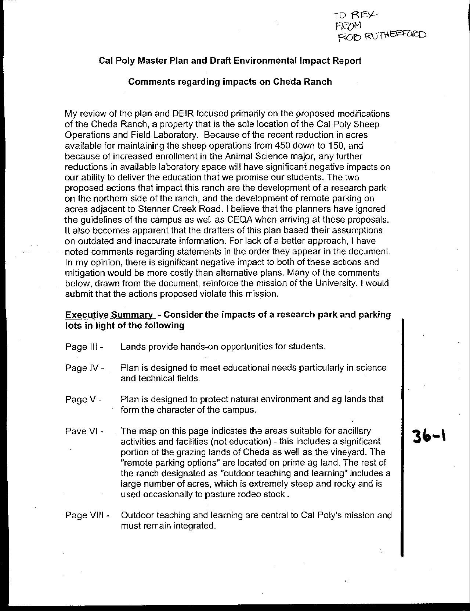
Letter 36
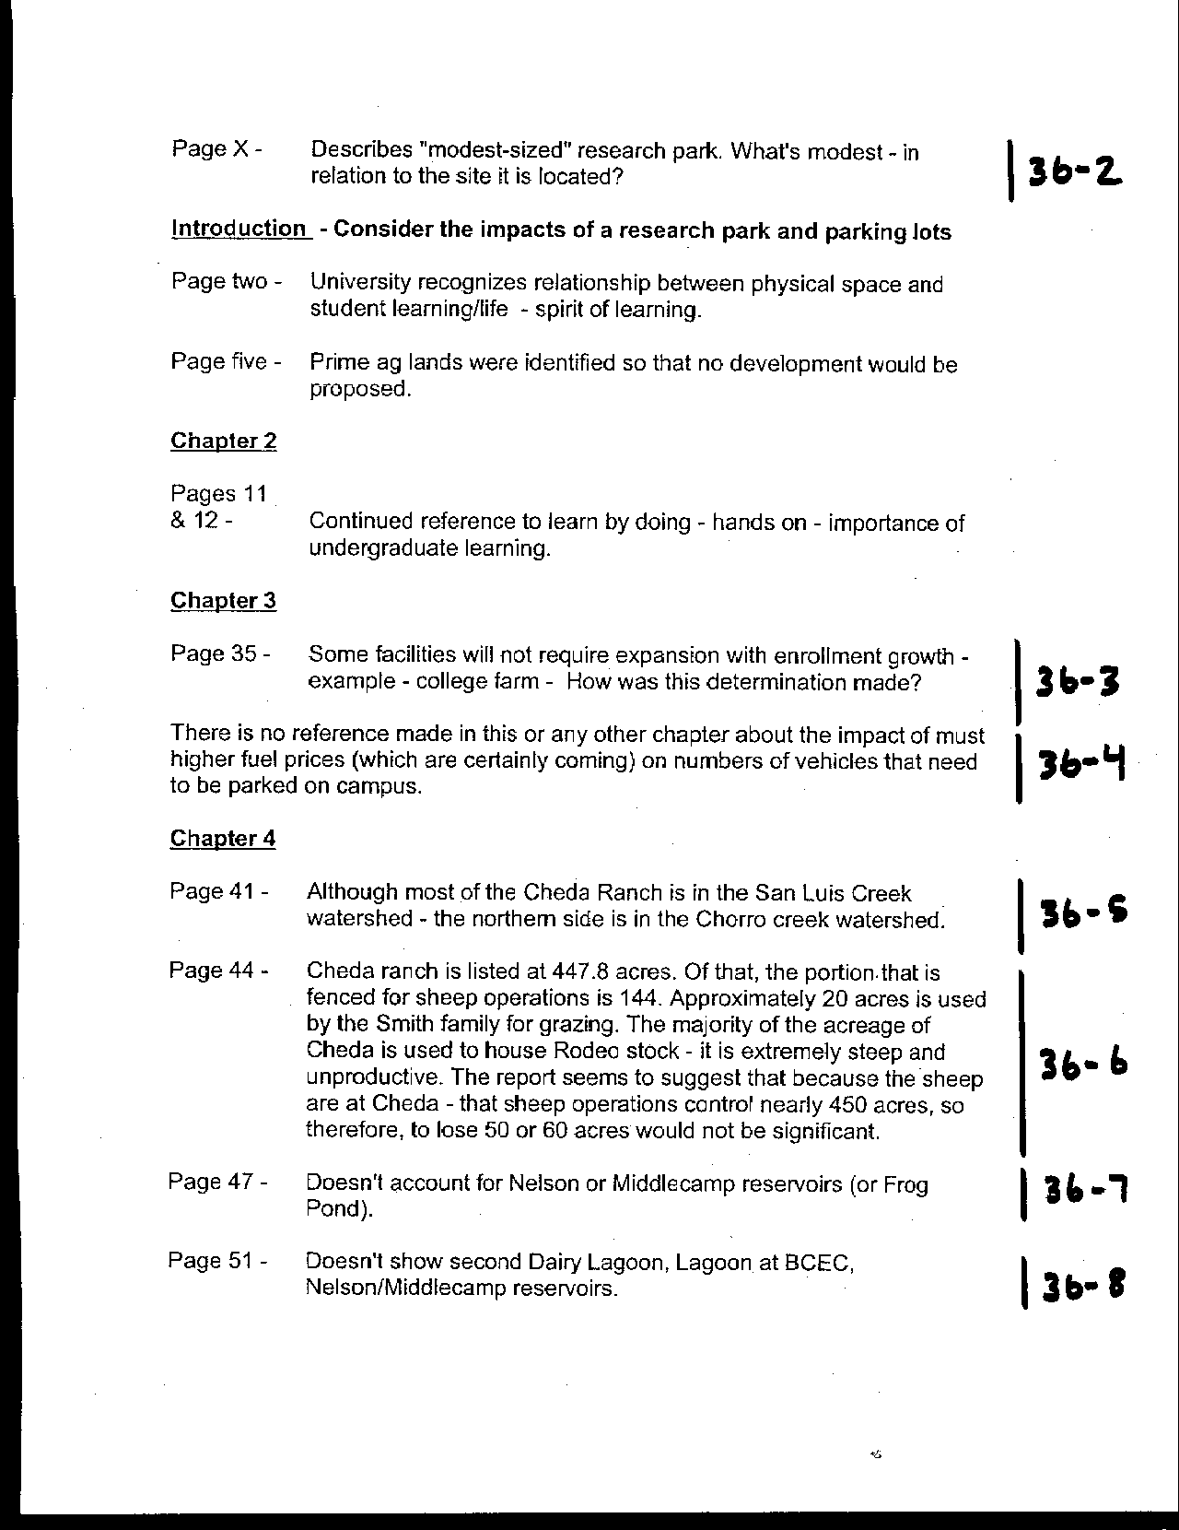
Letter 36
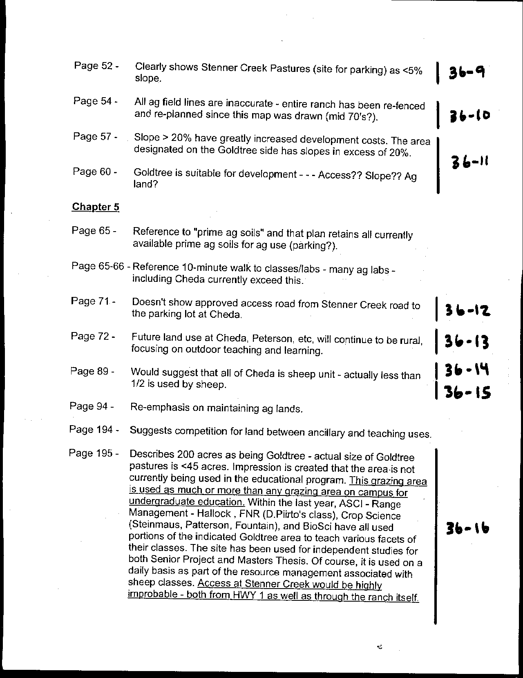
Letter 36
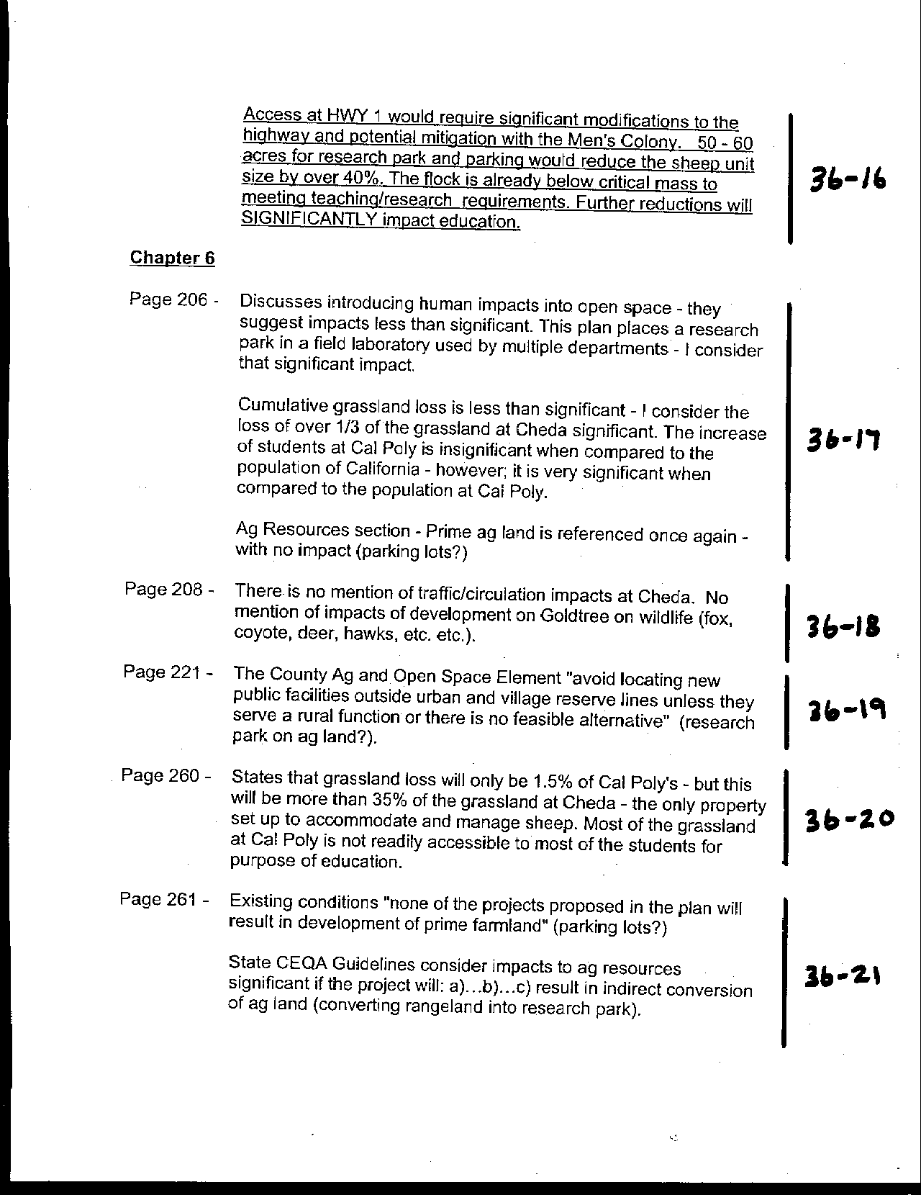
Letter 36
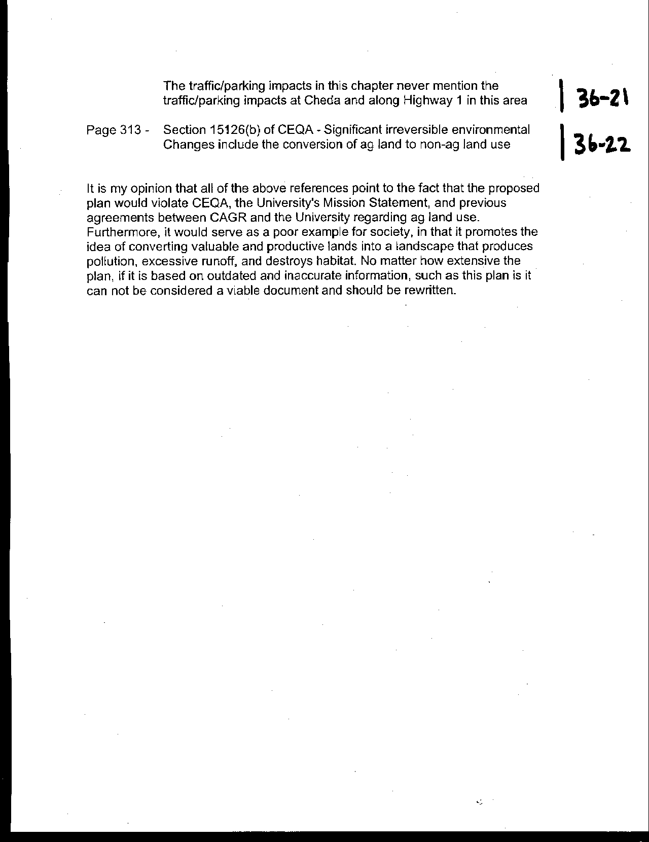
Letter 36

Letter 36

Dr. Robert Rutherford

College of Agriculture, Animal Science

December, 2000

36-1 Commenter raises concern about suitability of Cheda Ranch area for ancillary activities and/or remote parking.

Response The commenter has raised several concerns regarding the appropriateness of developing ancillary activities in the Cheda Ranch area. As the head of the Sheep Unit, Dr. Rutherford is expressly concerned about the viability of the sheep operations. The Sheep Unit has been impacted by a number of changes on campus. The most significant was the recent moving of the entire unit from the location now occupied by the Sports Complex to the Cheda Ranch buildings, the former location of the Dairy Unit. In addition, sheep grazing pasture area has been reduced by the Sports Complex and expansion of the Horse Unit grazing requirements.

36-2 Commenter asks what does "modest-sized" research park mean?

Response Analysis for the DEIR considered a possible development of about 400,000 square feet of building plus parking. The comparison would be to like facilities developed at universities elsewhere.

36-3 Commenter asks how was the determination made that campus farm would not require expansion to serve more enrollment?

Response The College of Agriculture leadership has indicated that the college has facility capacity.

36-4 Commenter notes lack of reference to impact of fuel prices on number of automobiles.

Response See text addition regarding dependence on fossil fuels as a principle related to Alternative Transportation: “Less reliance on vehicles using internal combustion engines can also contribute to improving air quality and diminishing the use of fossil fuels” (p. 167). A new section on Sustainable Campus Planning and Design also notes “Alternative, renewable energy sources should be used to the greatest extent possible to offset growth in demand” (p. 163).

36-5 Commenter notes that Cheda Ranch is partially in Chorro Creek watershed.

Response See text change, p. 45. The clarification is appreciated.

36-6 Commenter notes misleading data on use of Cheda Ranch for sheep and rodeo stock.

Response The text has been modified to reflect the actual use by the Sheep unit, as follows: “The sheep unit and sheep operations occupy approximately 144 acres, or about one-third of Cheda Ranch, including some of the area known as Goldtree.” See text change, p. 93.

36-7 The commenter notes that reservoirs (Nelson and Middlecamp) are missing from the discussion.

Response The text in the Existing Conditions chapter has been made more general, referring to “multiple reservoirs and ponds” (p. 49). Elsewhere, the base map has been changed to add missing reservoirs and ponds.

36-8 Commenter notes certain reservoirs and ponds missing from map

Response The base map for Exhibit 4.5 and others has been modified to show additional water bodies.

36-9 Commenter notes on slope in areas shown for potential remote parking is less than 5%.

Response Comment is noted.

36-10 Commenter notes that new fencing patterns have rendered Exhibit 4.8 out of date.

Response It is recognized that the description of these facilities is in need of updating.

36-11 Commenter questions suitability of Goldtree area for development.

Response Text to clarify the analysis of the Goldtree area has been added to the discussion of constraints and opportunities (pp. 64-65). “The northwest corner of Cheda Ranch includes an area known as Goldtree. Traditionally, this area has consisted of three fields (C62, C63, C64), totaling about 52 acres. In conducting feasibility studies for ancillary activities at a satellite location, the Master Plan team examined a slightly larger area (including fields C65 and part of C61, but excluding C64 as too steep) to determine which land might be more suitable, considering environmental, regulatory, cost and policy constraints. Based on soil type, slope, and current condition, the approximately 60-acre area shown on the detailed map was identified as most suitable for potential development, and became known as the Goldtree project area or site. It is close to the Union Pacific Railroad and has access to water, sewage treatment and electricity. Access could be provided from Highway 1 (perhaps from an improved intersection near the site or at Stenner Creek Road) and/or internally from Mount Bishop Road.”

36-12 Commenter suggests showing access from Stenner Creek Road to Cheda Ranch.

Response Area is outside the base mapping. Detailed mapping needs to be extended to the rest of the campus area.

36-13 Commenter suggests clarifying future use of Cheda Ranch, in view of Goldtree discussions.

Response The following text has been added to the discussion of Ancillary Activities and Facilities (p. 206). “The City and County of San Luis Obispo have supported a research partnership with Cal Poly through the California Central Coast Research Park (C3RP) task force. While a number of sites both on and off campus have been suggested over the years, the Master Plan explores the potential of an applied research park on campus. One possible site is in the Goldtree area. It is important to note that an applied research park on Cal Poly lands would focus on applied research and advanced development activity in support of the University’s academic mission, including applied research partnerships, “incubator” support for new technology, and business development. It is likely to be heavily involved in and dependent on technology – information technology, telecommunications, biotechnology, geographic information systems, visual imaging, etc. An applied research park would provide opportunities for faculty professional development, internships for students, and employment for partners and spouses of faculty and staff. It could include business services (e.g., photocopying equipment, meeting rooms, and food service). However, it would not include activities often associated with business or industrial parks, such as professional offices or manufacturing (assembly) except as incidental to applied research and development.”

36-14 Commenter requests that the plan clarify use of Cheda Ranch by sheep operations.

Response As noted above, additional text has been provided in the Outdoor Teaching and Learning element (p. 93).

36-15 Commenter notes competition between ancillary activities and teaching.

Response Comment noted.

36-16 Commenter questions the suitability of Goldtree area for development given the extent of its current use.

Response As noted above, the text in Chapter 4, under the discussion of Constraints and Opportunities, has been added to analyze development potential at Cheda Ranch including the Goldtree area (p. 64).

36-17 Commenter questions determination of less than significant impact, regarding human use, loss of grassland, and prime agricultural land.

Response Valley grasslands consisting of species typical of pasture vegetation are not considered a sensitive plant community at the state or federal level, nor are they considered sensitive by CNPS. Therefore, the loss of this vegetative community is not considered a significant impact. This grassland is not supported by prime agricultural soils or other important farmland soils and its loss therefore does not constitute a significant impact under the significance thresholds given. However, the University can make a determination, outside of the realm of CEQA, as to the best use of these lands. Discussions are ongoing with CAGRLUC regarding this area.

36-18 Commenter requests that the plan add traffic and wildlife analysis for Cheda/Goldtree.

Response The eventual type of development at Goldtree and feasible access routes are not yet well understood. This information will be required to determine traffic impacts. Future environmental review and consultation with agencies such as CalTrans will determine impact significance.

Significant impacts to wildlife are limited to sensitive species; the loss of this grassland is not considered to pose a significant threat to the fecundity of sensitive species in the area; similar foraging habitat exists elsewhere on Cal Poly property and in surrounding areas.

36-19 Commenter questions the research park location, analysis.

Response Important in the policy cited is the condition “unless…there is no feasible alternative.” Goldtree has been chosen because of the importance of having campus facilities near the core, and the lack of available, unconstrained space, including areas that do not overlie prime soils. A facility of that type is not essential to the function of the University and is too large to locate on campus.

36-20 Commenter expresses concern about grassland loss.

Response The College of Agriculture is currently pursuing opportunities to expand grazing in areas off-campus. The Master Plan’s commitment is to not develop new facilities without adequately replacing any that may be displaced. See the principle of Continuity in the Outdoor Teaching and Learning element (p. 97).

36-21 Commenter expresses concern about conversion of agricultural lands

Response Parking lots will not be located on prime agricultural land. Further, additional text on p. 195 explains that “If parking demand should require Cal Poly to consider using any of these locations, additional site analysis will be undertaken to determine the amount of land needed, the most appropriate site or sites, how access will be provided, the effect on circulation, how the parking area(s) would be secured, and how existing uses can be relocated.”

36-22 Commenter expresses concern about conversion of agricultural lands

Response The Master Plan policy is to not convert any Prime agricultural lands. There are some designated fields used by the College of Agriculture, which have been identified for development of housing, parking and other ancillary activities. None of these fields contain prime soils.

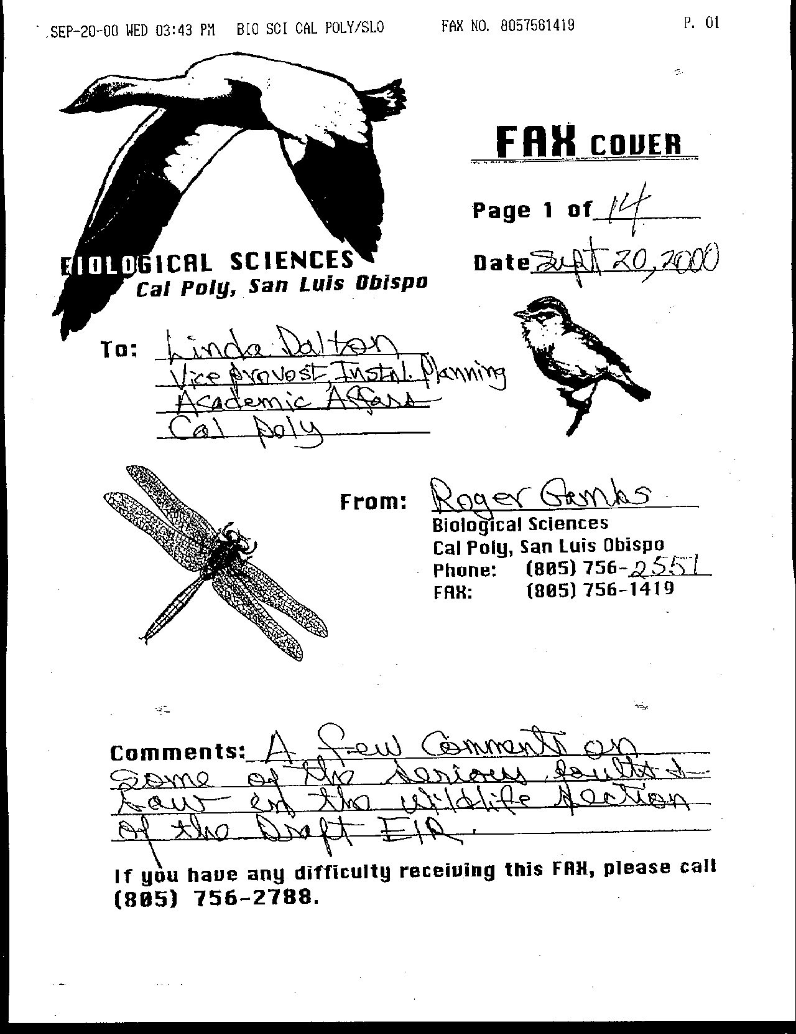
Letter 37
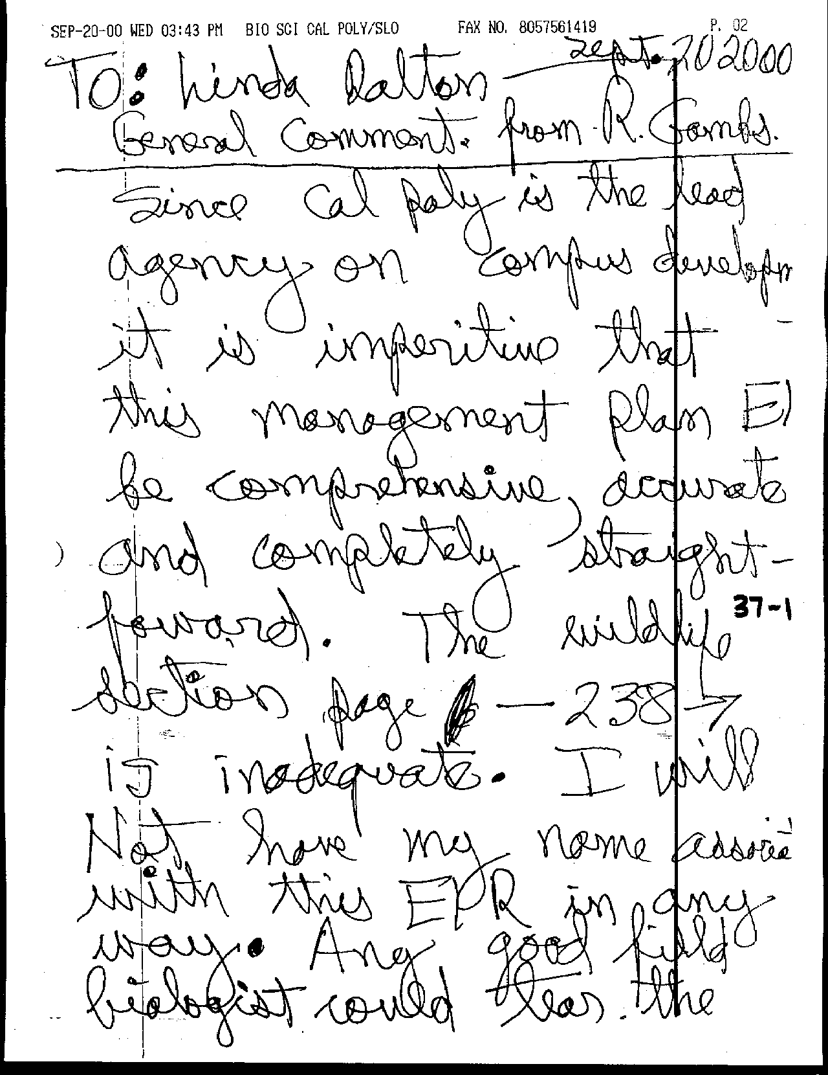
Letter 37
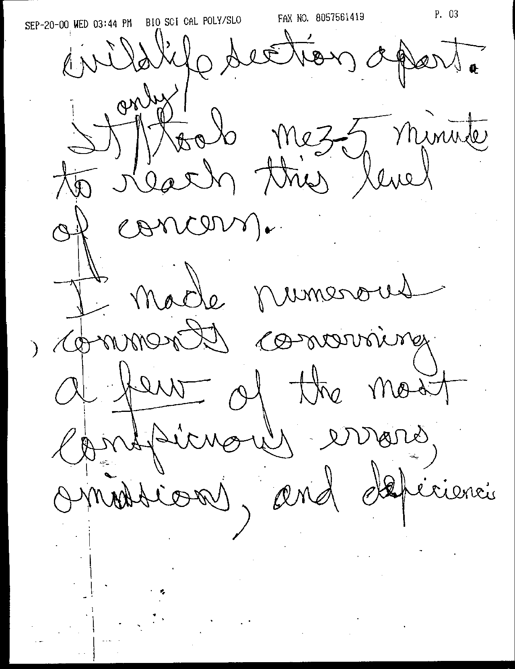
Letter 37
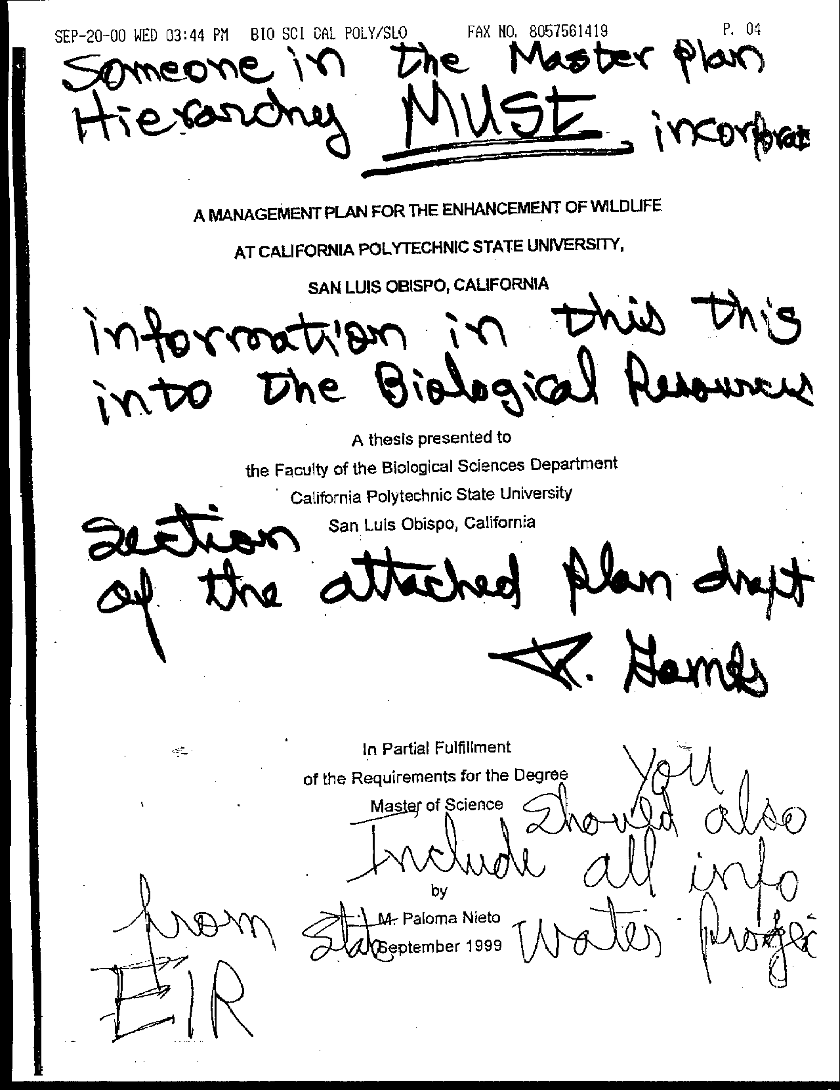
Letter 37
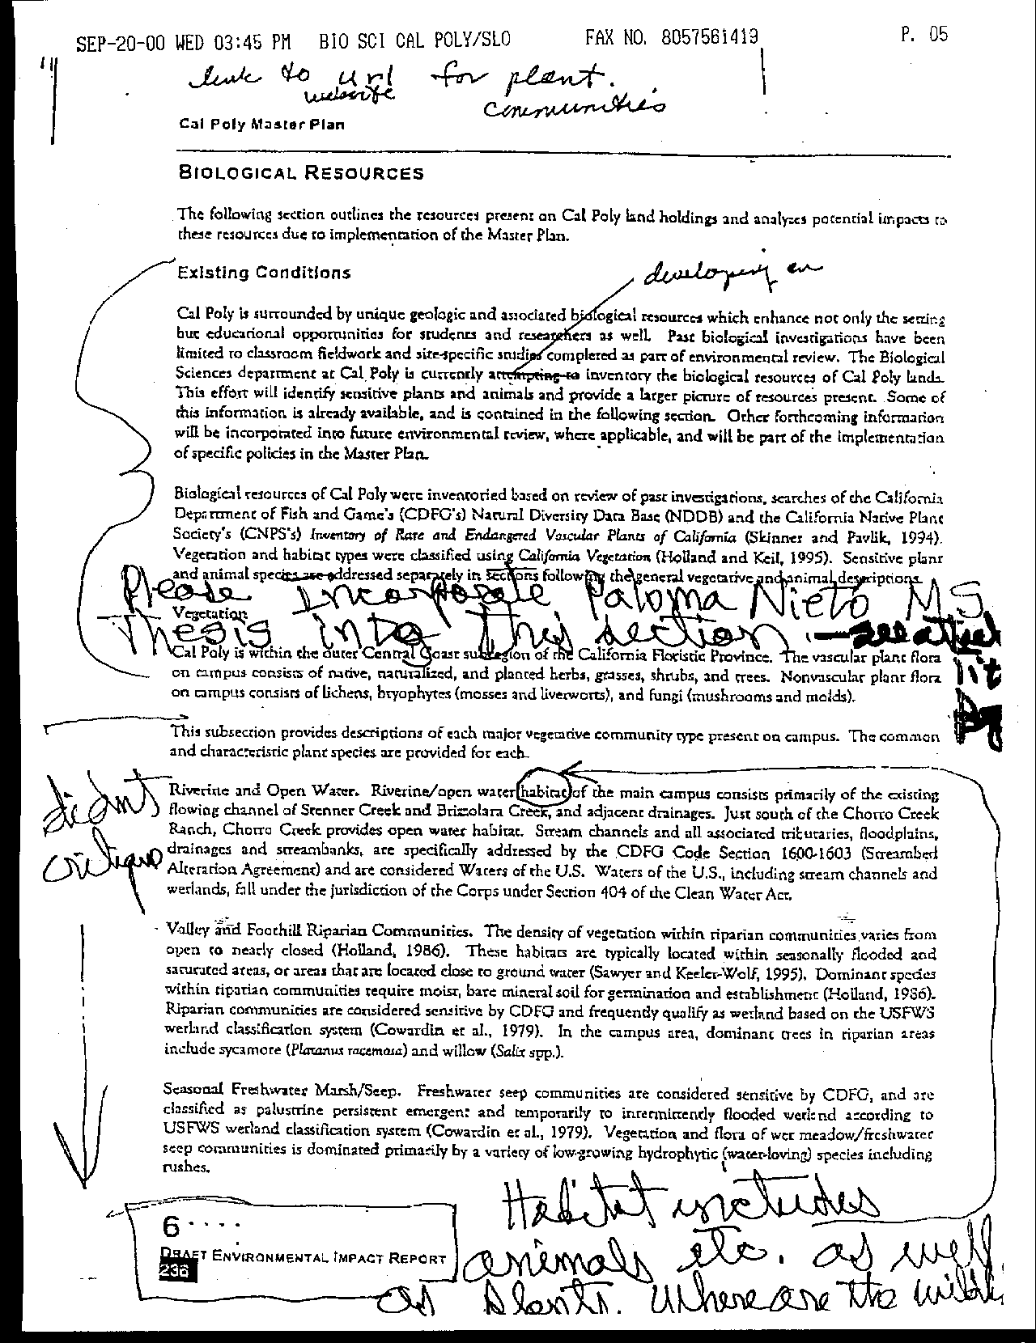
Letter 37
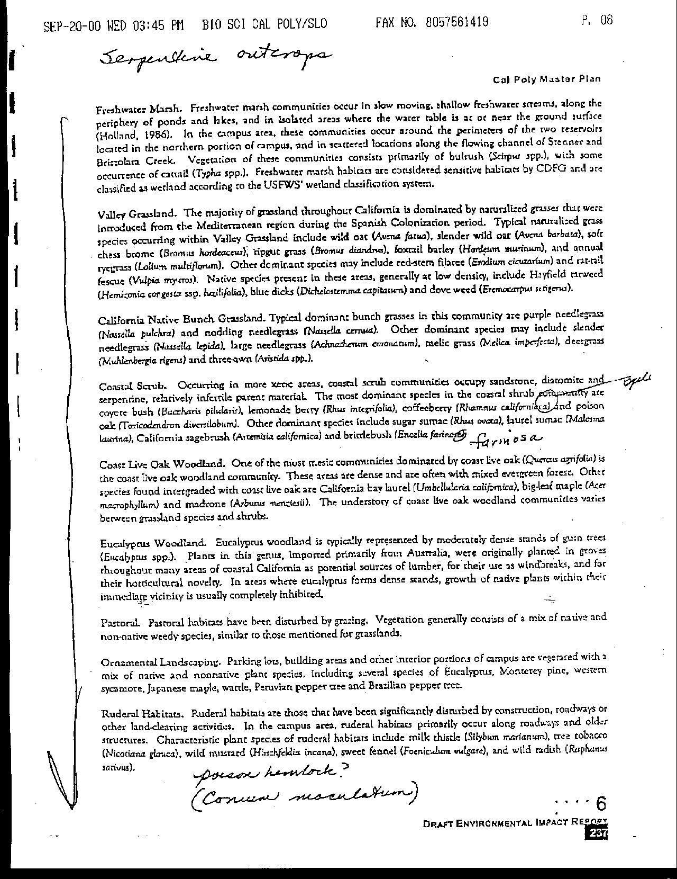
Letter 37
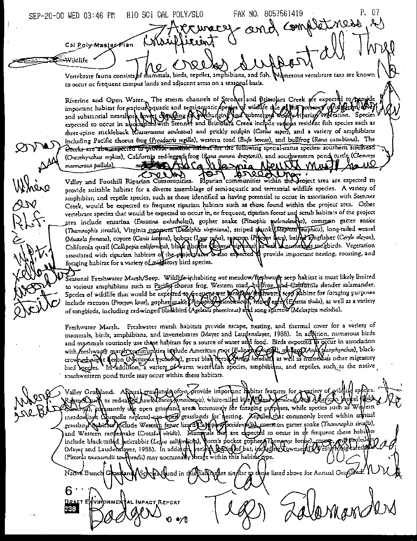
Letter 37
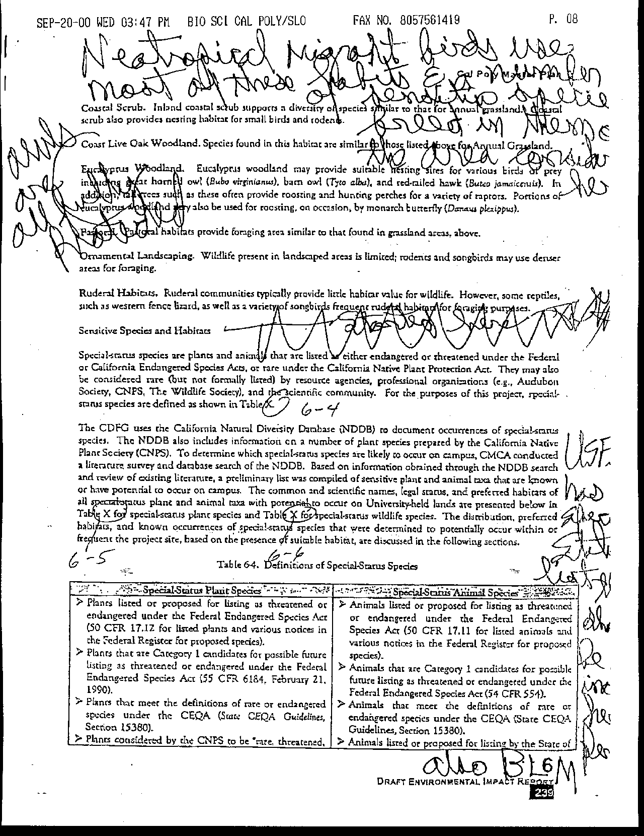
Letter 37
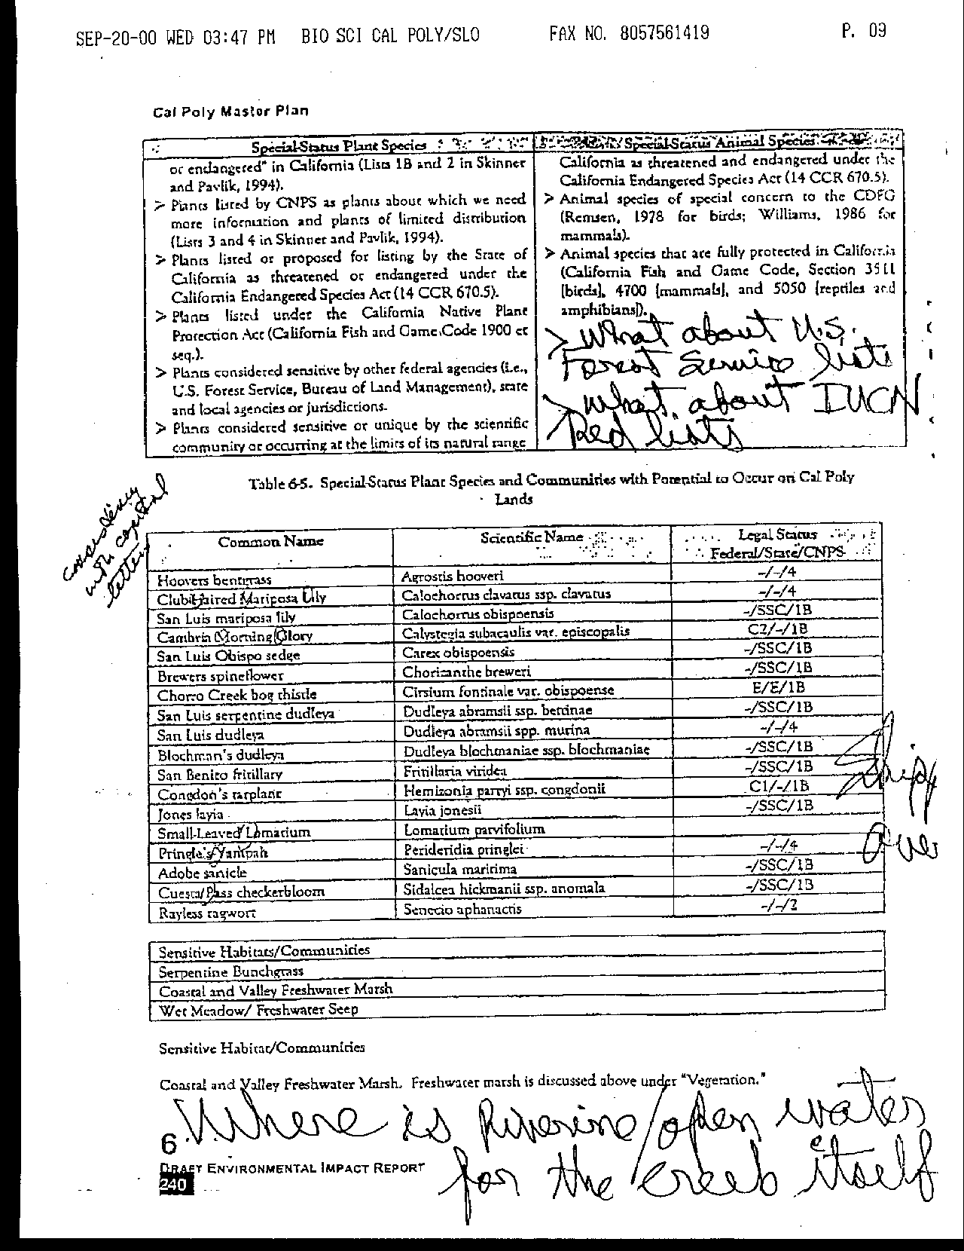
Letter 37
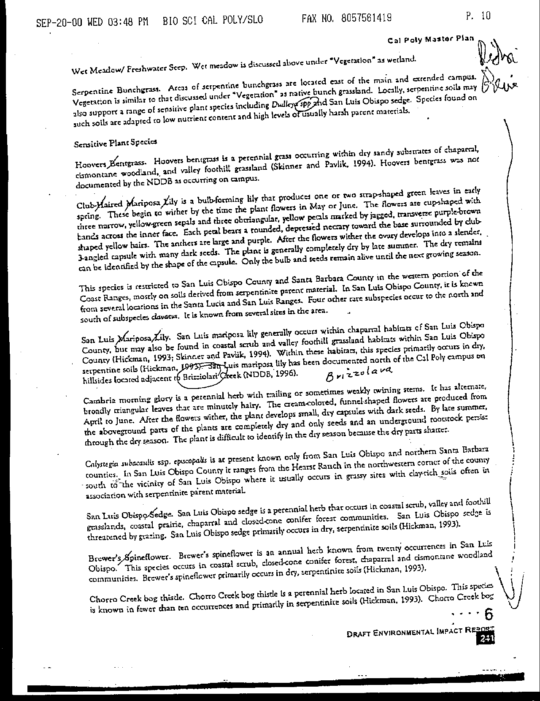
Letter 37
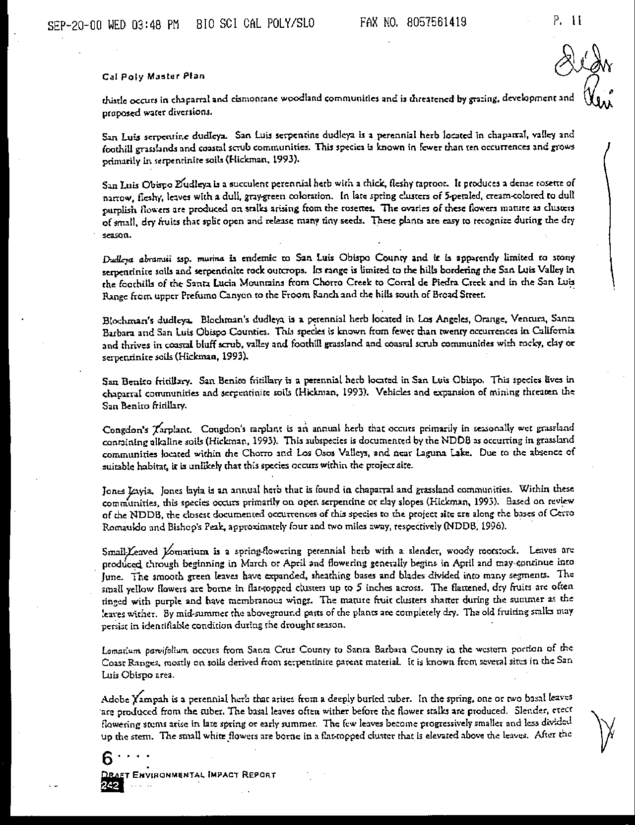
Letter 37
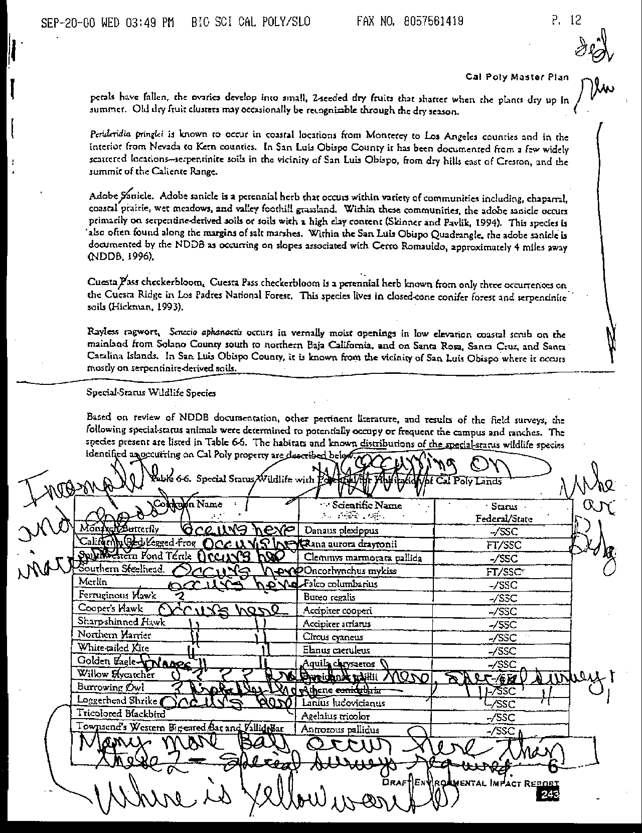
Letter 37
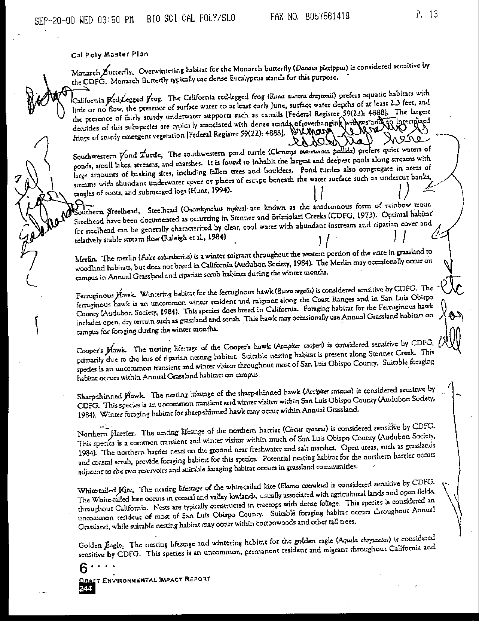
Letter 37
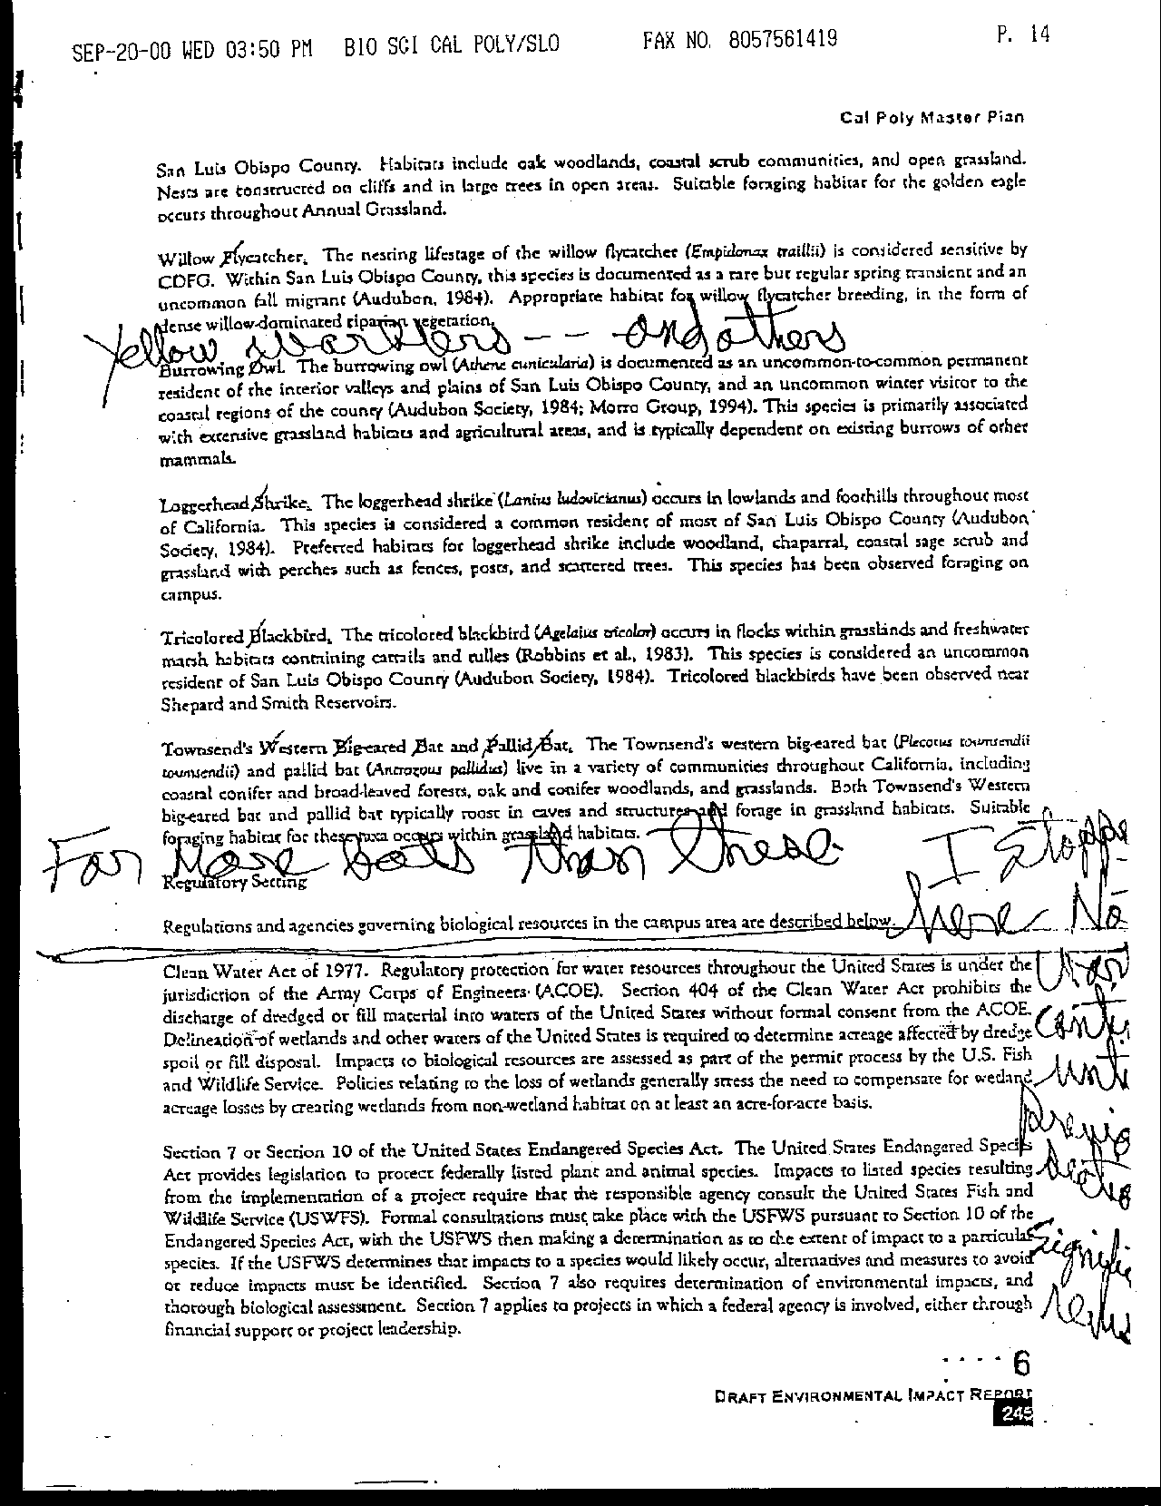
Letter 37
Letter 37

Dr. Roger Gambs

Biology Department

December , 2000

37-1 Dr Gambs was requested to comment on the wildlife portion of the administrative draft of the EIR. He identified several important omissions and errors in this early version of the document.

Response Corrections were made to the EIR to incorporate many if not all of Dr. Gambs comments. These were included in the public review Draft EIR and therefore need not be elaborated here.

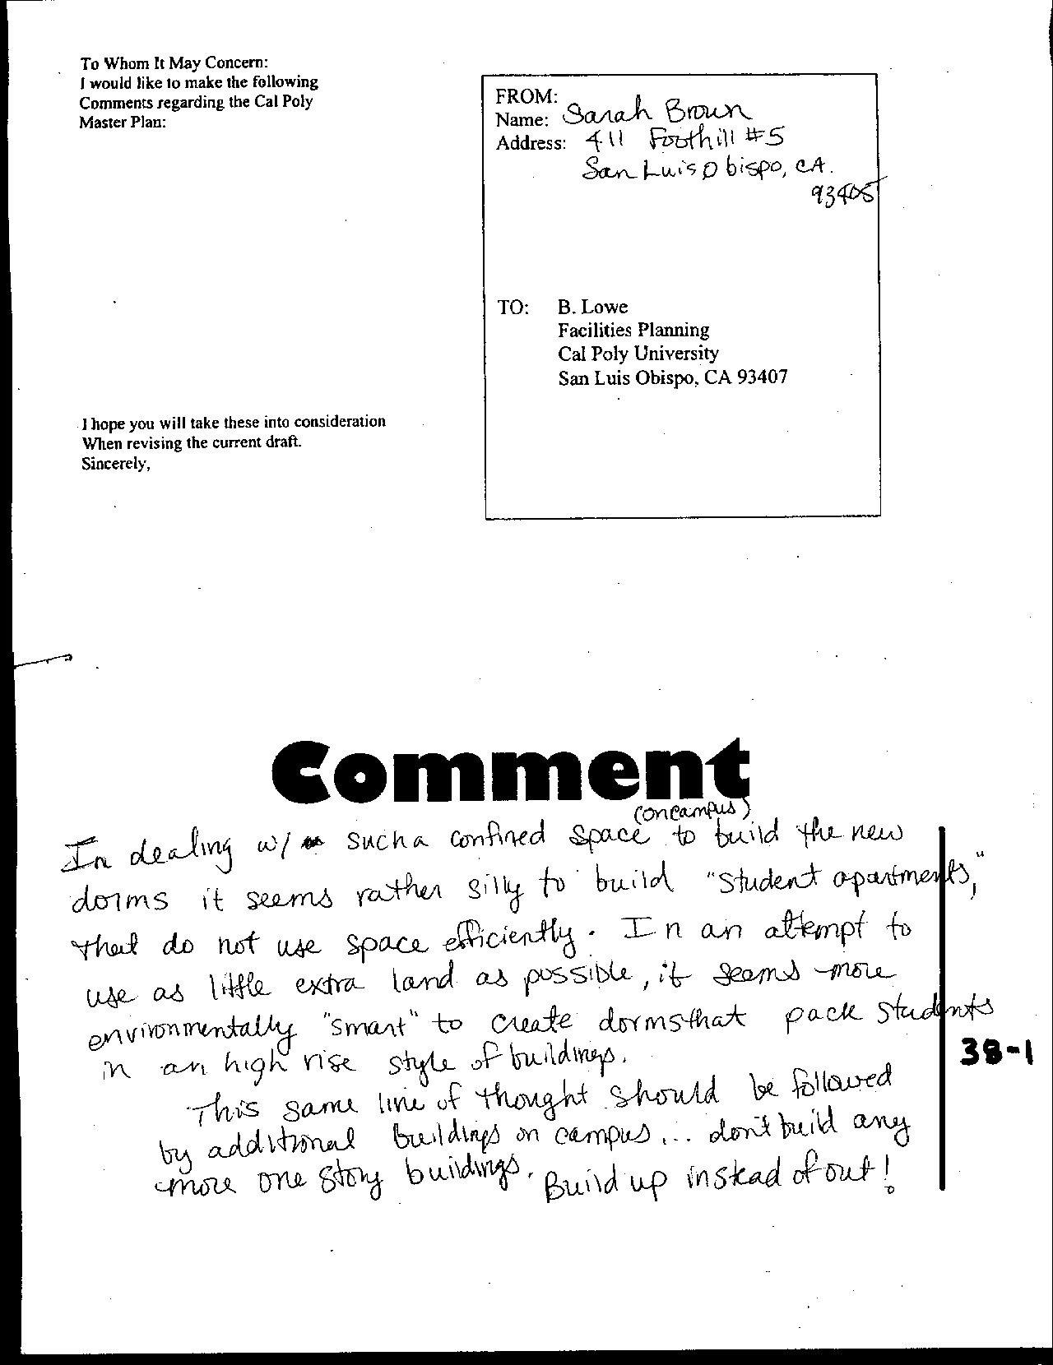
Letter 38

Letter 38

Ms. Sarah Brown

December 4, 2000

38-1 Commenter suggests development on campus should go “up and not out” utilizing taller buildings instead of greater land area.

Response The Master Plan has been designed to maintain a compact instructional core to reduce the need to “sprawl” into undeveloped areas of campus, or into Outdoor Teaching and Learning areas. See specific policies and discussion in the Outdoor Teaching and Learning chapter. See Constraints and Opportunities analysis.

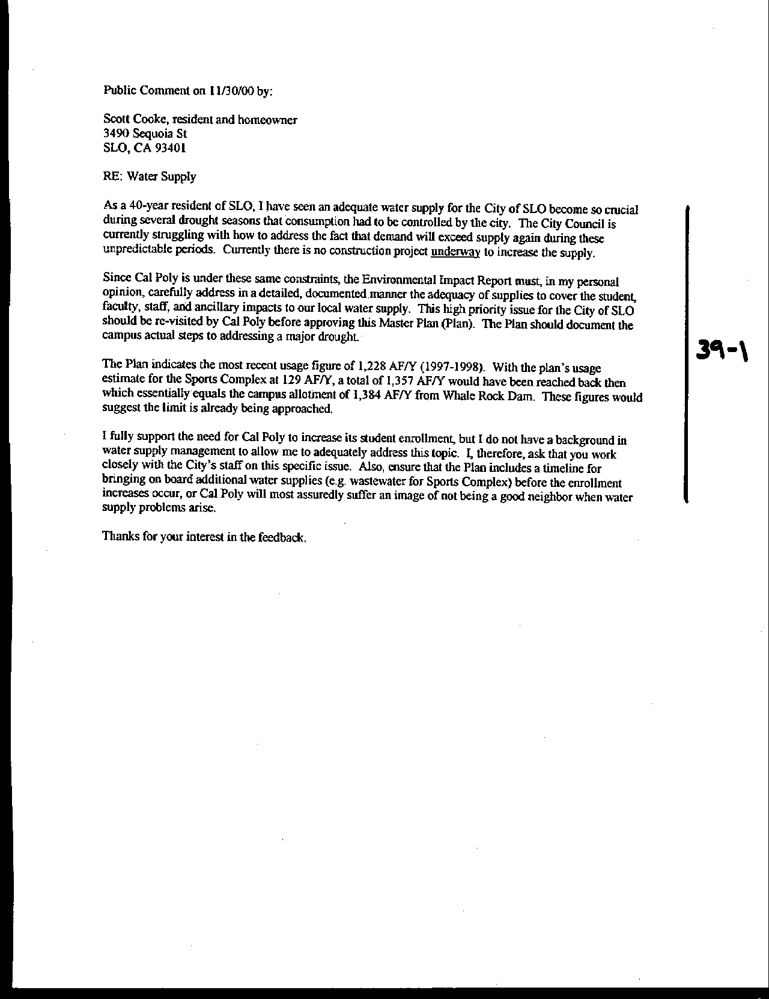
Letter 39
Letter 39

Scott Cooke

November 30, 2000

39-1 Commenter describes in detail concerns regarding Cal Poly’s water supply especially during drought and vis-à-vis the City’s water supply.

Response Cal Poly derives its water from groundwater sources and through surface water entitlements. For domestic (non-agricultural) use, the University owns entitlement to 33% of the water in Whale Rock Reservoir or approximately 13,707 acre-feet. This amount is not available for continuous consumption because a certain level of water must be maintained in the reservoir to avoid a deficit.

The City of San Luis Obispo, which shares the reservoir with Cal Poly, has developed a computer model that assigns allowable yearly withdrawals based on worst-case weather cycle conditions. The model shows that during the 27-year cycle from 1942-1969, approximately 1,384 acre-feet per year (AF/Y) would have been available to the University, and would have drained Cal Poly’s allocation during that 27-year period. This allocation does not account for losses due to sedimentation of the reservoir over time; however, this loss of capacity is relatively minor (estimated 2 AF/Y) and has not been documented. This remains a very conservative lower limit on consumption. The City of San Luis Obispo’s water use from Whale Rock regularly exceeds their worst-case allocation.

Water from Whale Rock reservoir is treated at the Stenner Canyon water treatment facility owned and operated by the City of San Luis Obispo. A portion of the entitlement is diverted prior to treatment for use in landscape and turf irrigation. Peak treatment capacity has been recently expanded to 16 million gallons per day (mgd). Since water is conveyed to the University through the City’s treatment plant and distribution system, the actual source of drinking water arriving at the campus may be either Whale Rock Reservoir or Salinas Reservoir. No matter the source, Cal Poly’s allotment is still based upon its Whale Rock share.

Agricultural operations on campus derive their water from a number of sources, depending on location. Untreated Whale Rock water is supplied to the Sports Complex, and all agricultural operations east of Mount Bishop Road, via the reservoir system on campus. Agricultural operations west of Mount Bishop Road are supplied by groundwater, namely two shallow wells fed by Stenner Creek. Agricultural operations on the Chorro Creek watershed ranches are supplied by three groundwater wells. The University’s understanding and documentation of their water supply is limited to their allocation from Whale Rock; none of the groundwater supplies have been documented.

The Sports Complex EIR placed total agricultural allocations at 900 AF/Y because it assumed 449 AF.Y of Whale Rock water was allocated specifically for irrigation and 450 AF/Y was available from other sources. Cal Poly does not currently allocate Whale Rock water in this fashion. Therefore, domestic and agricultural water users compete equally for Whale Rock water. Other sources, as mentioned above, have not been documented, although the well have never run dry or hampered agricultural operations. For the purposes of this EIR, analysis is limited to impacts on the Whale Rock supply, as it is the only known quantity. It is strongly suggested that Cal Poly study their total agricultural water supply prior to expansion or intensification of irrigated agricultural operations.

In recent years, use of Whale Rock water has been split almost equally between agricultural and domestic users. The following table illustrates this division.

Table 24. Use of Water From Whale Rock

Year | Total AF | Percentage/AF Domestic | Percentage/AF Agricultural
1999-2000 | 1,130 | 52%/587 | 48%/544
1998-1999 | 918 | 57%/525 | 43%/393
1997-1998 | 824 | 63%/552 | 37%/272
Source: Ed Johnson, Cal Poly Facilities Planning

Current (2000) domestic water use by the University (for non-agricultural purposes) is 587 AF/Y, and agricultural use is currently 544 AF/Y, including the sports complex. The housing project will add 56 AF/Y, for a total of 1,187 AF/Y. Water demand varies considerably; records have shown total consumption as high as 1,130 AF/Y (1999-2000), and as low as 792 AF/Y (1992-1993). The year 1999-2000 is considered the worst-case scenario for the purposes of this analysis.

Cal Poly and the City of San Luis Obispo are currently working on a project to recycle wastewater for irrigation of the Sports Complex. The development of this system would reduce demands on the domestic system, which is currently irrigating the Complex at a rate of approximately 73 AF/Y.

The Master Plan is expected to result in an additional 3,000 student residents and 465 additional faculty and staff. The Plan will also result in approximately eleven acres of additional recreational fields, and approximately nine acres of green space (non-athletic turf). Water demand factors from apartment-style housing facilities at the University of California Santa Barbara campus were used to project water demand in the residence halls. City and County water demand factors were used to calculate staff (office) demand. Water demand for landscape irrigation was based on current per acre usage at the University. Total projected demand, compared with existing use and the University’s total domestic Whale Rock water allocation is summarized in Table 6.25 below.

Table 6.25: Master Plan (Current + Future) Estimated Whale Rock Water Demand

Use | Number | Water Demand Factor | Total Water Usage (AF/Y)
Current Usage (Agricultural, Domestic, and Sports Complex) | 1,130
Student Housing Project | 56
Projected Usage under the Master Plan
Future Resident Students (Apartments, Landscaping + Laundry) | 3,000 persons | 0.09 AF/Y | 263
Future Staff/Faculty | 465 persons | 20 gpd | 10.4
Future Recreation Fields | 11 acres | 1.4 AF/yr/acre | 15.4
Future Greenspace (Lawns) | 9 acres | 1.4 AF/yr/acre | 12.6
Future Facilities (Off campus –estimate) |  |  | 70
Total Master Plan Demand | 1,557
Total (Worst-case) Supply | 1,384
Remaining Water Entitlement (Deficit) | (173)
Source: Ed Johnson, Utilities Coordinator, Cal Poly, 2000 and City of San Luis Obispo Water Demand Factors

City of San Luis water supply models show that during worst-case weather cycle conditions, Cal Poly demand would exceed supply. During normal rain years, it is likely that considerably more water would be available to Cal Poly

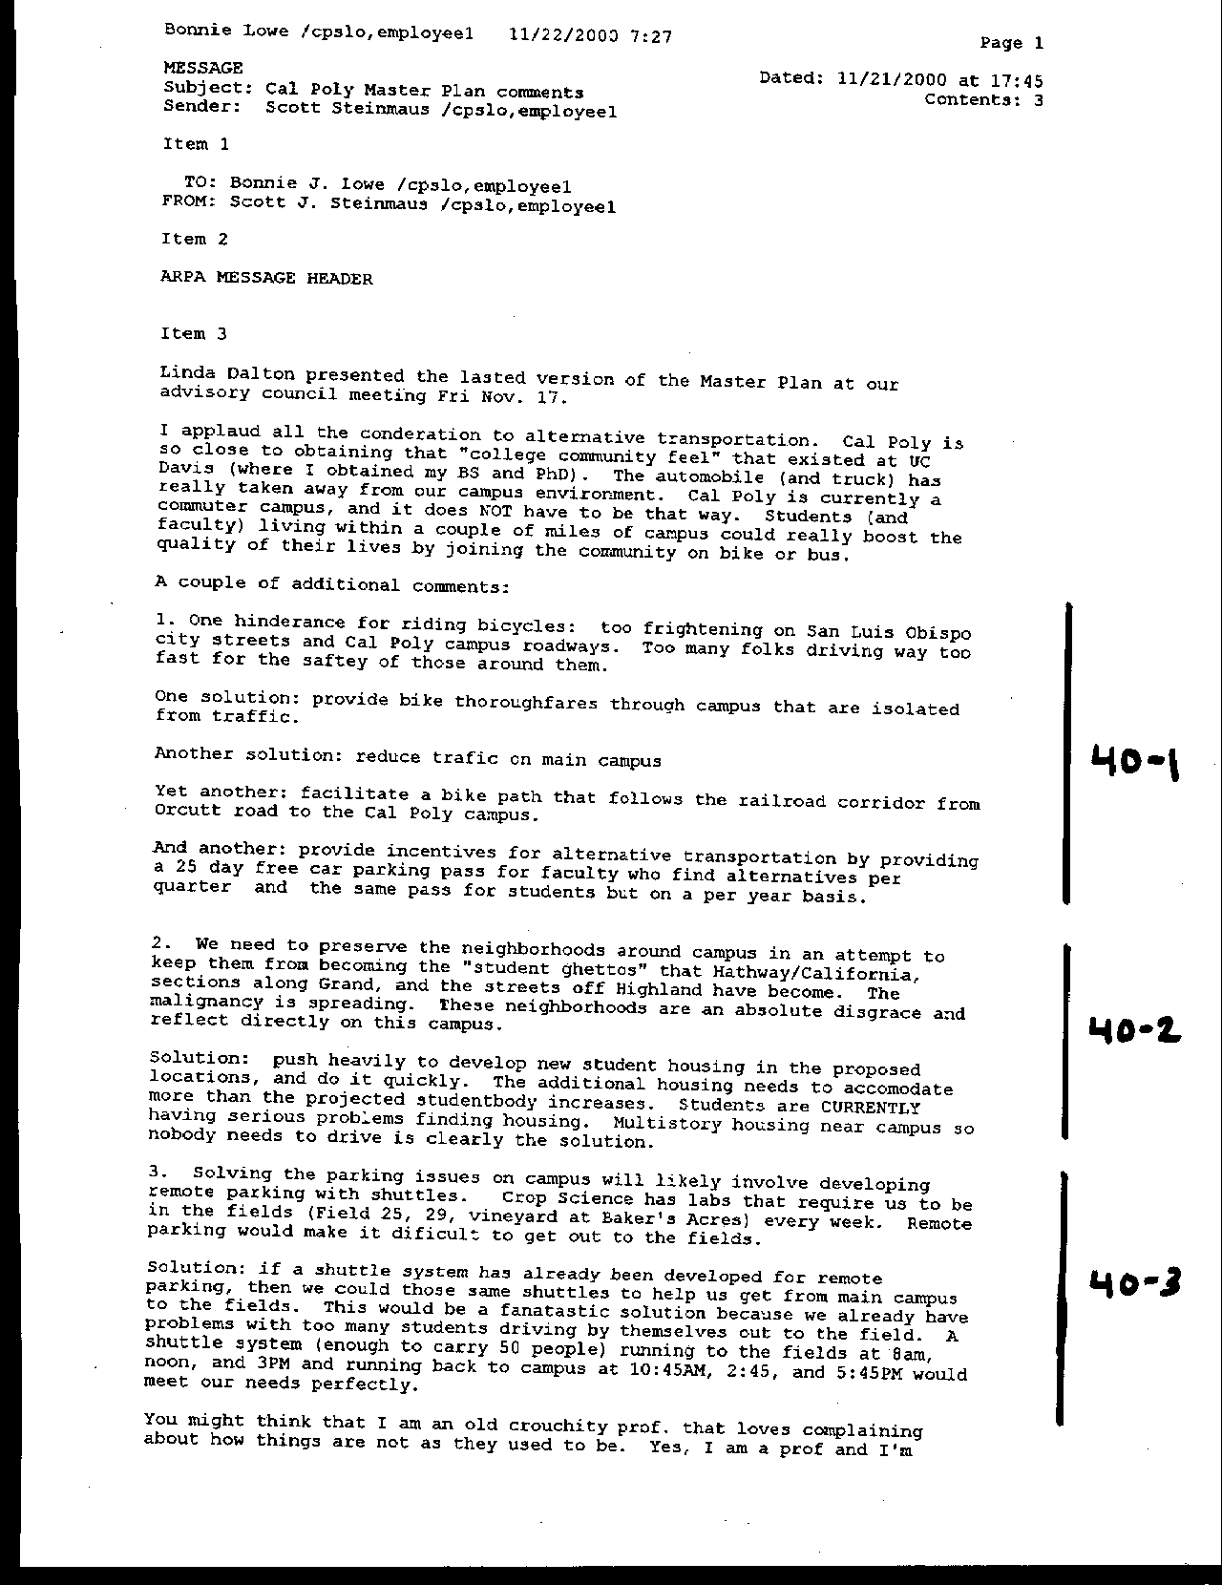
Letter 40

Letter 40
Letter 40

Dr. Robert Steinmaus

Crop Sciences

November 21, 2000

40-1 Commenter raises concerns for the ability to commute via bicycle to campus. He notes specifically that city streets and campus ways are unsafe for bicycles. He suggests bike thoroughfares on campus, reducing traffic on campus, a bike path along the railroad corridor, and alternative transportation incentives.

Response Detailed bicycle planning will be included in the implementation programs of the Master Plan.

40-2 Commenter suggests the need to prevent “student ghettos” near campus and offers that additional housing on campus is the solution.

Response Cal Poly is currently developing 800 new beds on campus for current demand. Cal Poly will develop an additional 3,000 beds on campus to house all new enrollment. Cal Poly is in planning for the development of approximately 200-250 faculty and staff housing units to be located on Highway 1 just off campus.

40-3 Commenter suggests the utility of campus shuttles extending to aid Crop Science students accessing relatively remote labs.

Response A shuttle program has been recognized by the College of Agriculture as a positive step towards improving the efficiency and convenience of their course offerings.

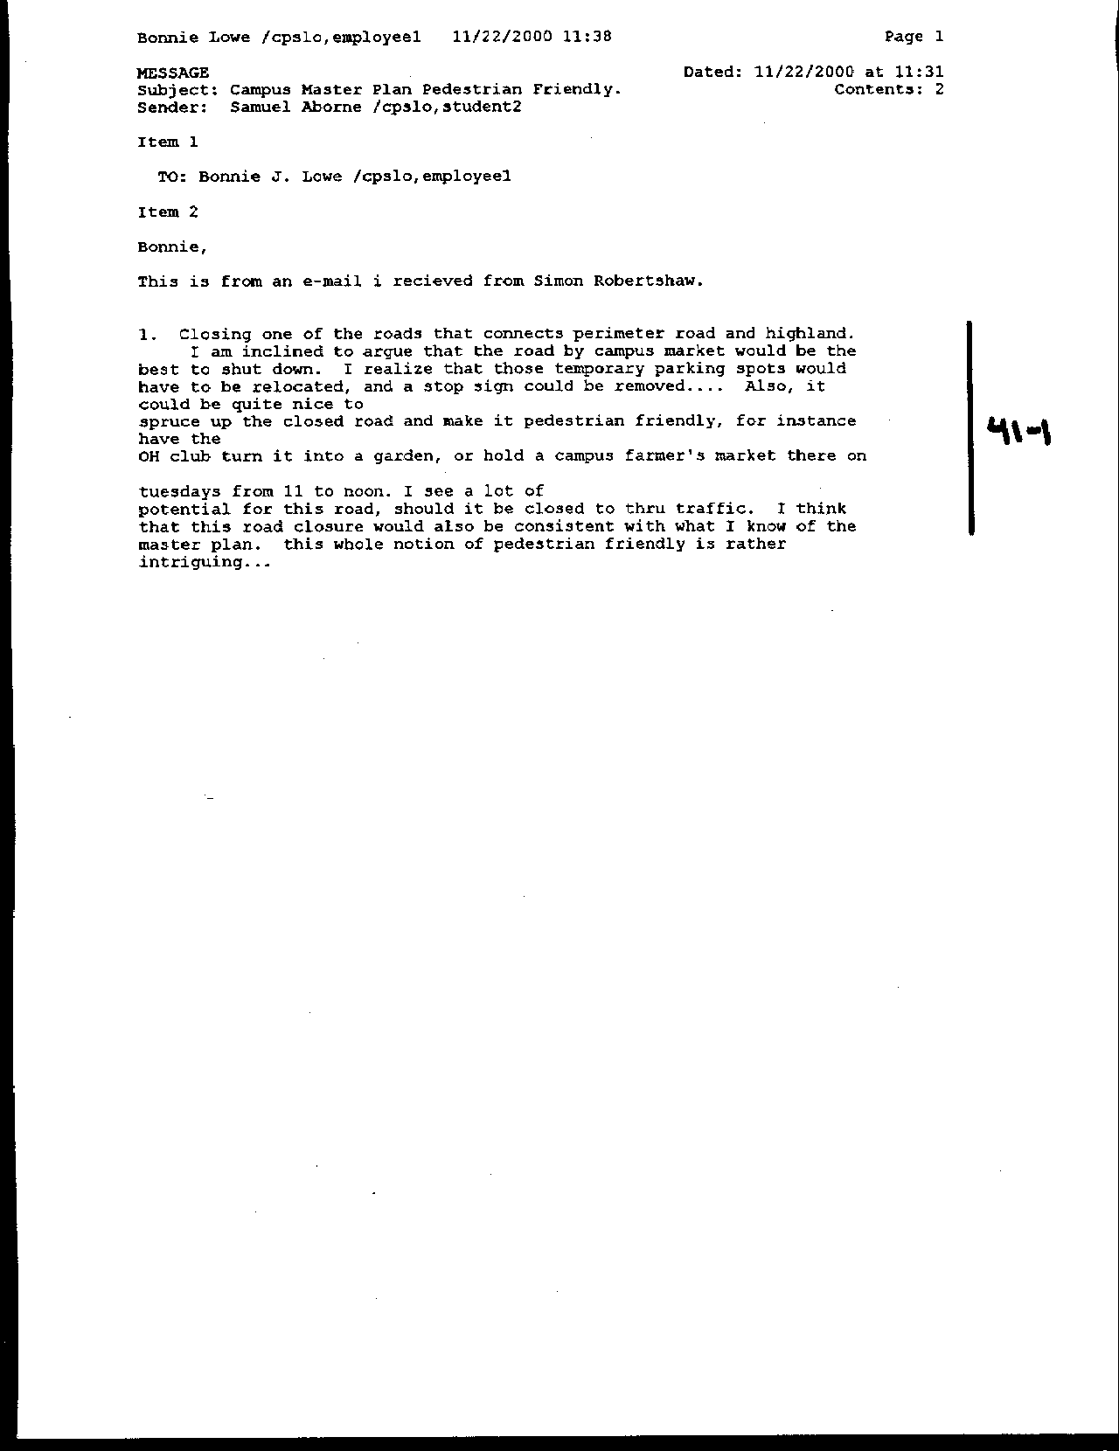
Letter 41
Letter 41

Simon Robertshaw

November 22, 2000

41-1 Commenter suggests that Via Carta from Highland to North Perimeter should be closed to all but pedestrians. He further suggests that the area be made into a garden and hold a Farmer’s Market. Commenter is intrigued by the notion of “pedestrian friendly.”

Response The Master Plan (see Campus Pedestrian System in the Circulation section of chapter five) recommends just such a treatment of Via Carta from the Rec Center to Highland Drive. The specifics of the design of this pedestrian promenade will be part of the implementation phase of the Master Plan. See text addition on p. 182.

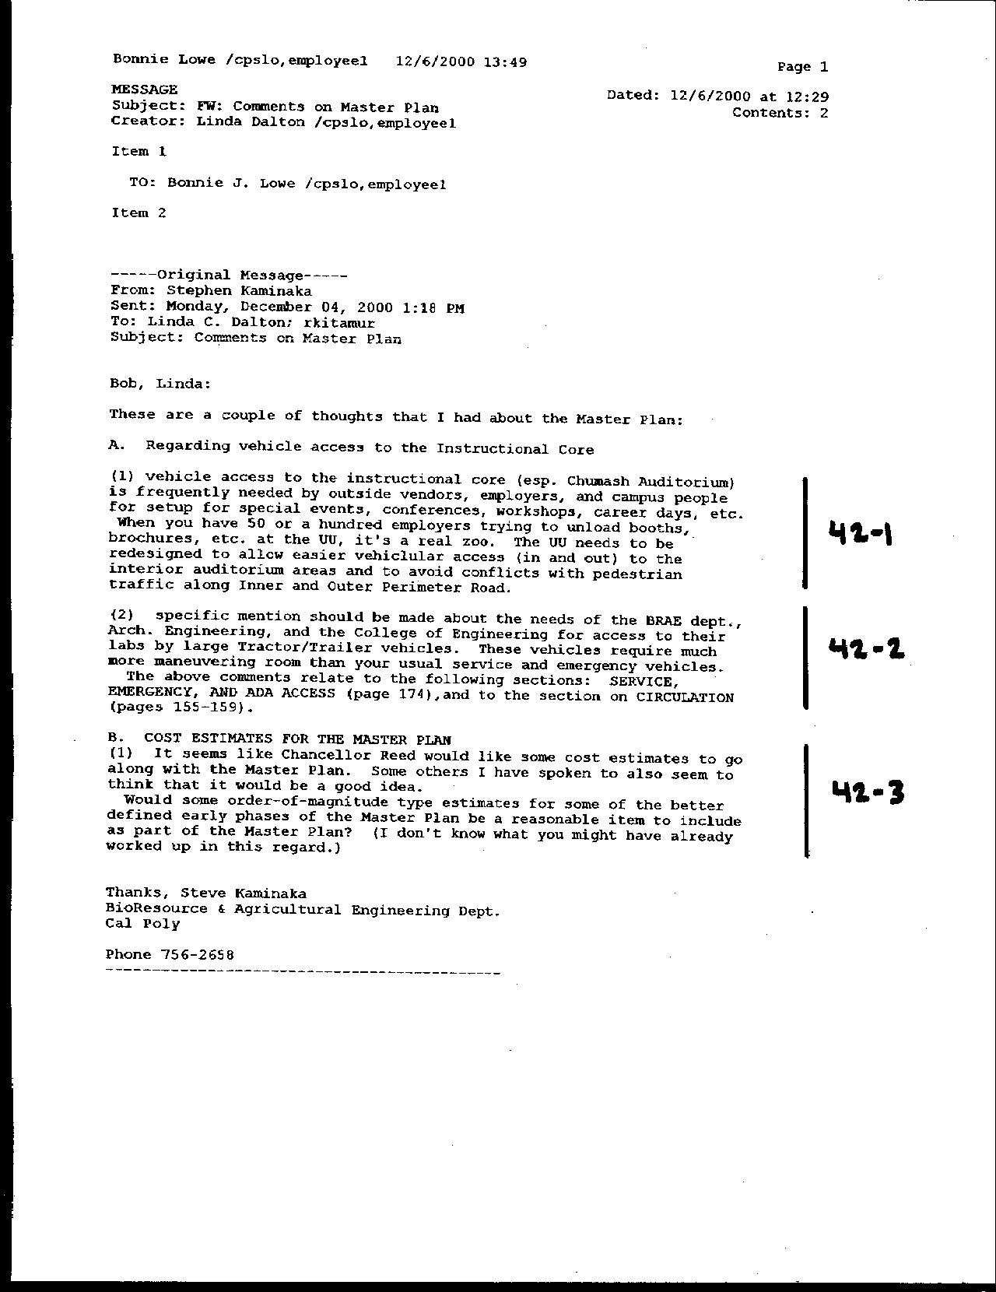
Letter 42
Letter 42

Dr. Stephen Kaminaka

Biological Resources/Agriculture Engineering

December, 2000

42-1 Commenter suggests the need for improved vehicle access to the campus core for the purpose of deliveries and special events, especially at the University Union.

Response While the Master Plan proposes the closing of Perimeter to standard automobile traffic, all interior ways will be designed to facilitate delivery and safety vehicles.

42-2 Commenter notes the need for special access consideration for BRAE, Architecture and Engineering for large vehicle.

Response An addition to the text has been made to clarify these access considerations. The design of the access will occur during the implementation phase (p. 117).

43-3 Commenter suggests the need for cost estimates to be included in the Master Plan for its recommended components.

Response Cost estimates are normally developed as part of the campus capital improvement program. This is considered an aspect of Master Plan implementation.

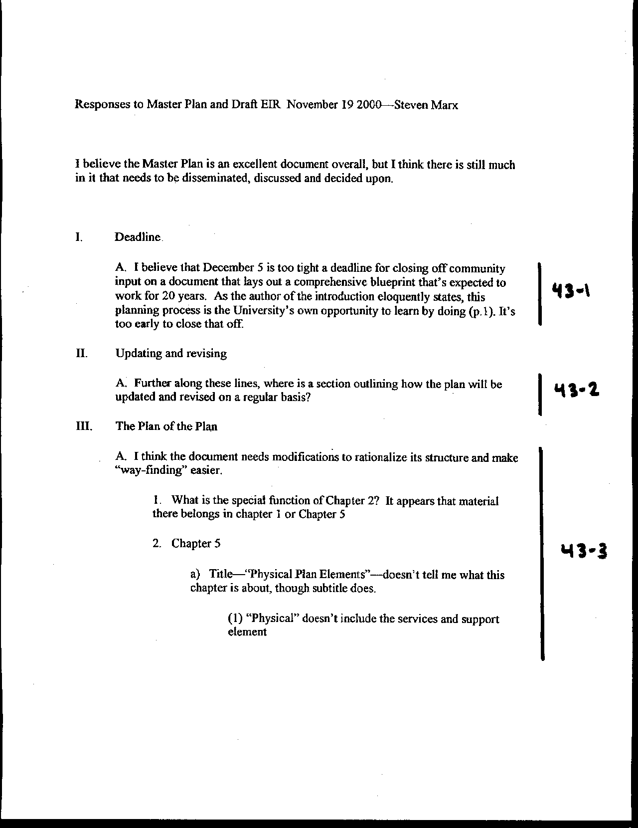
Letter 43
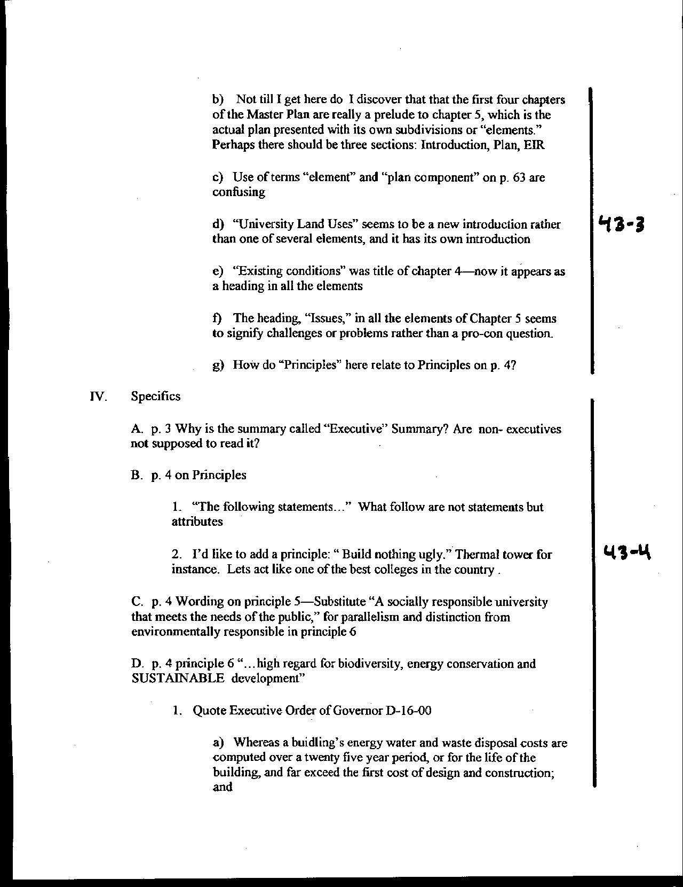
Letter 43
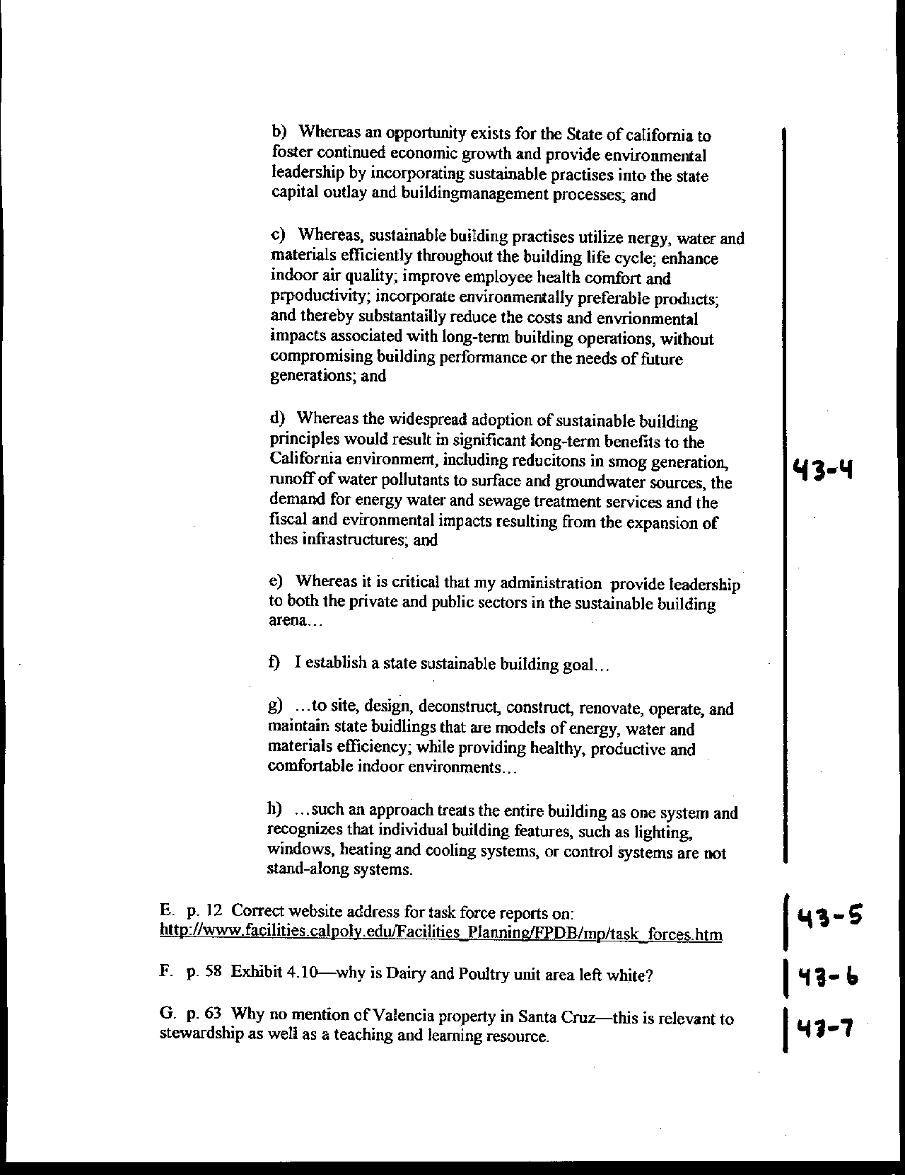
Letter 43
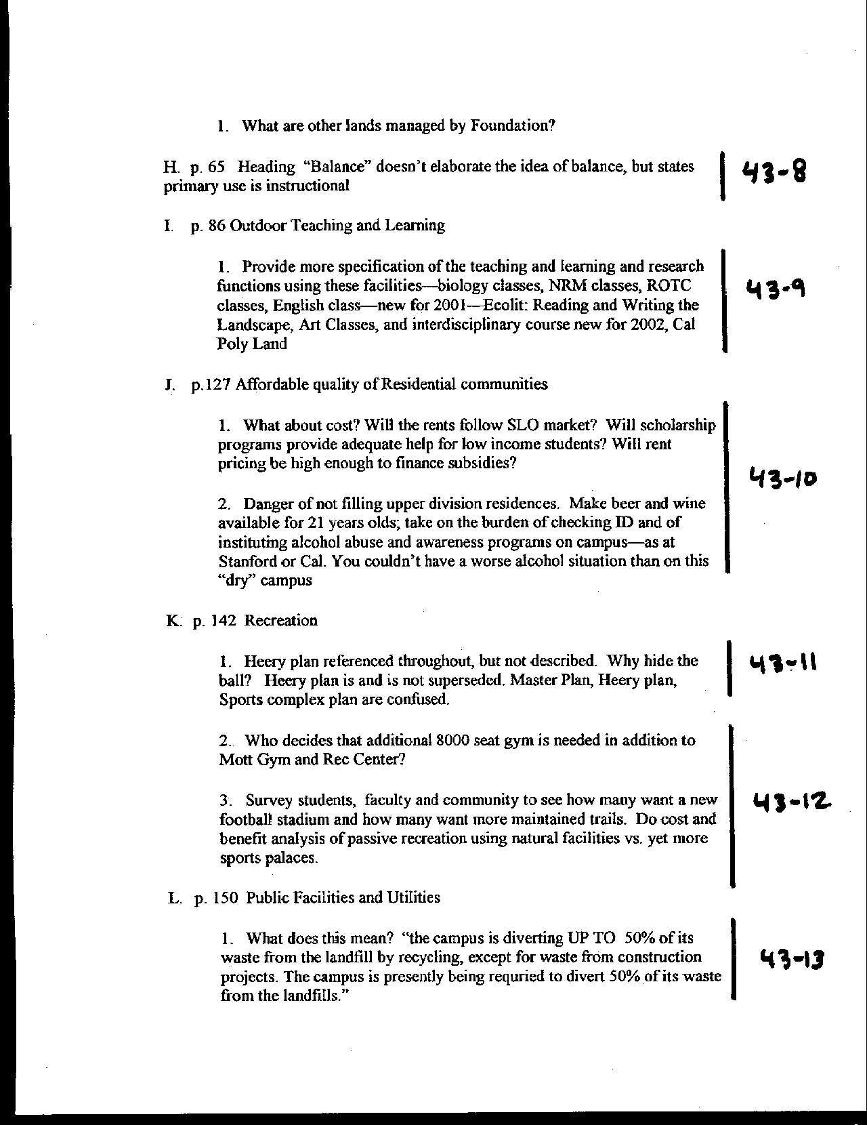
Letter 43
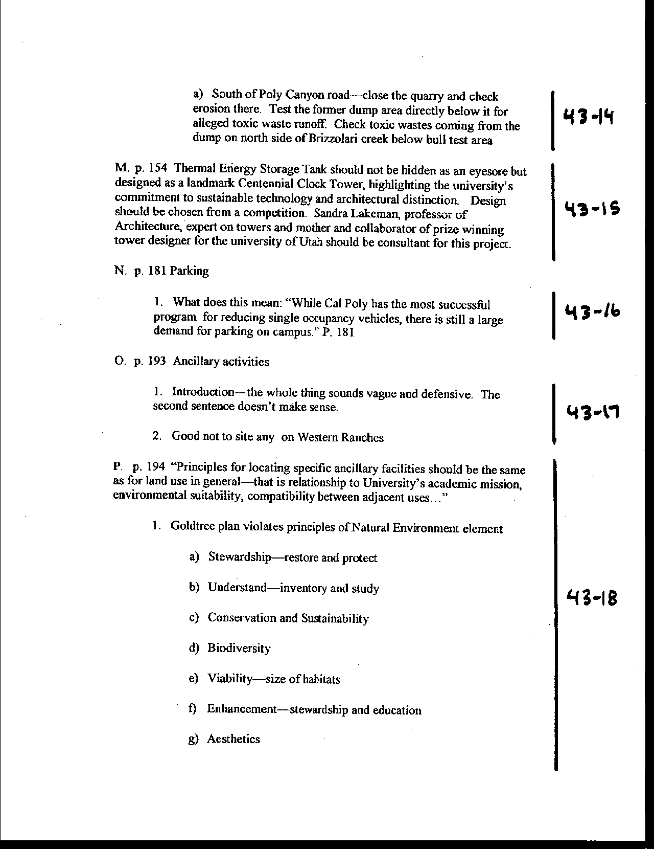
Letter 43
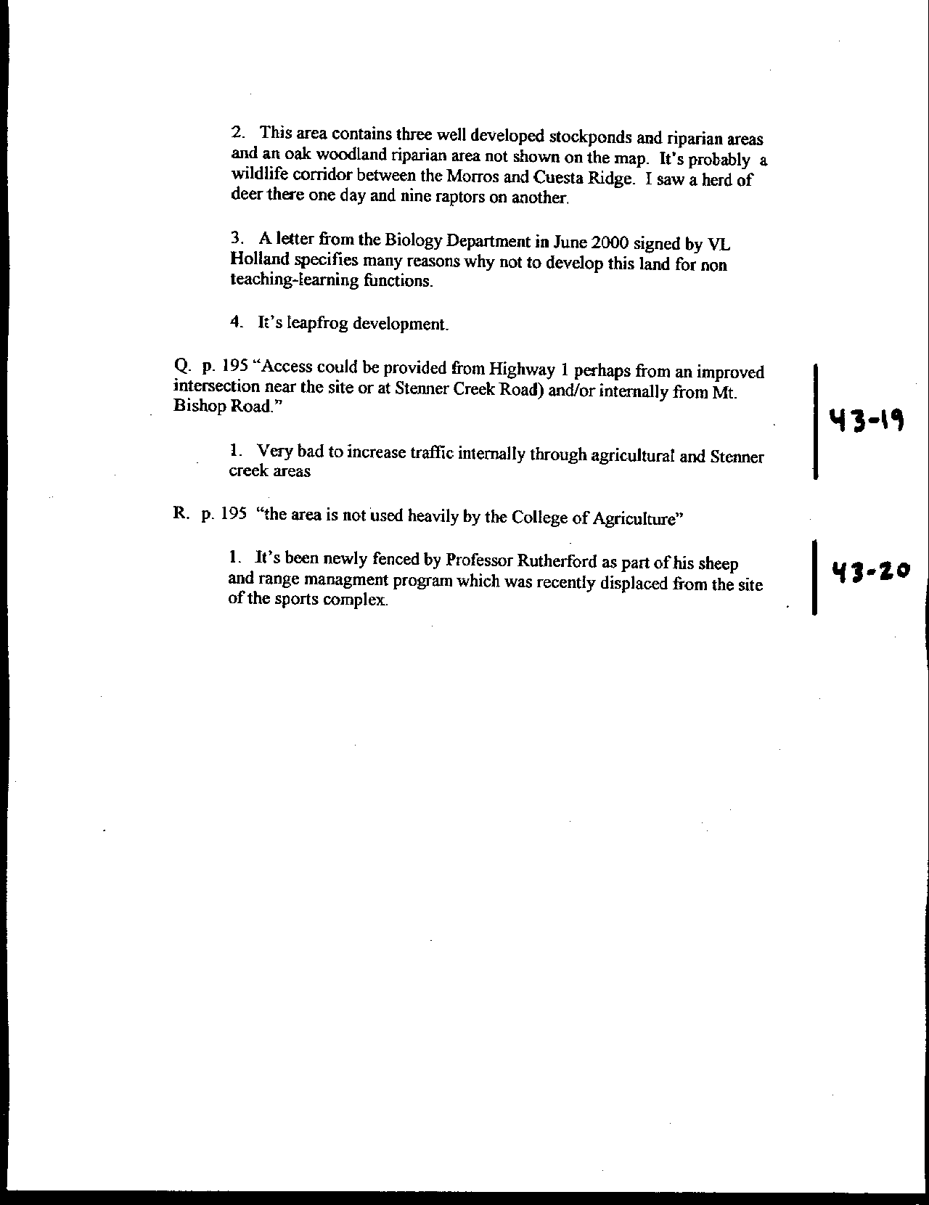
Letter 43
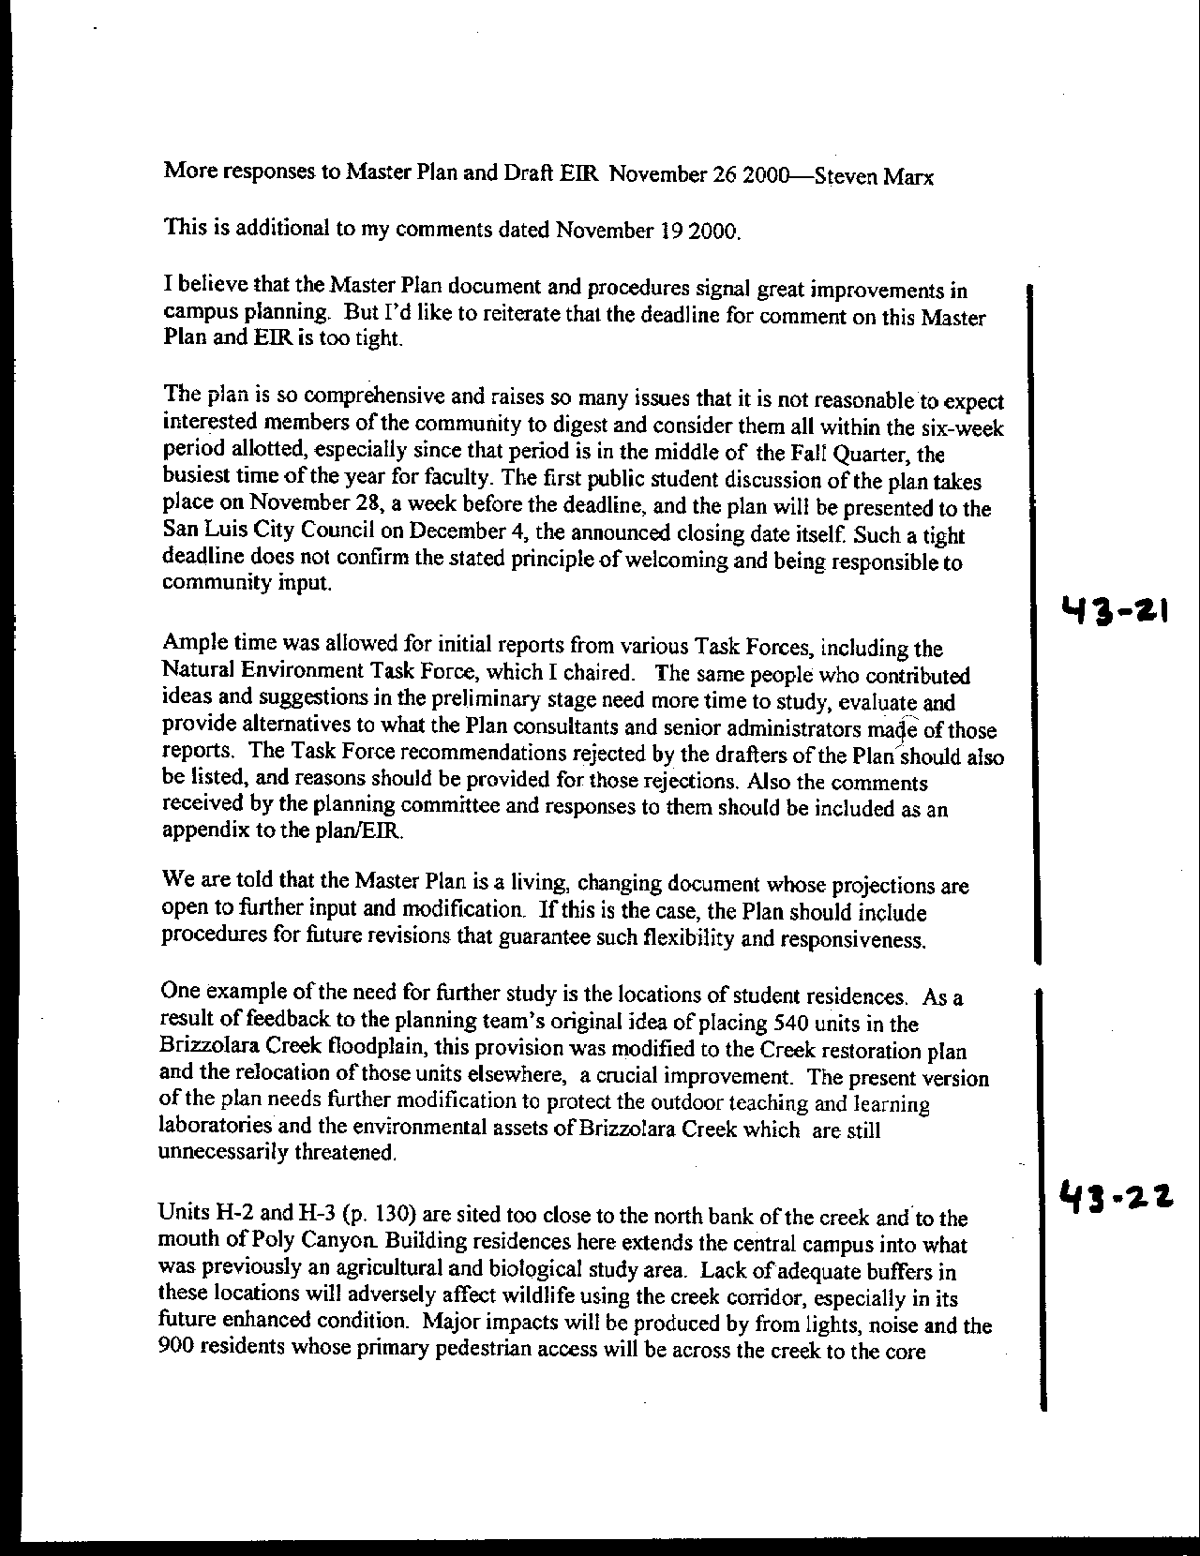
Letter 43
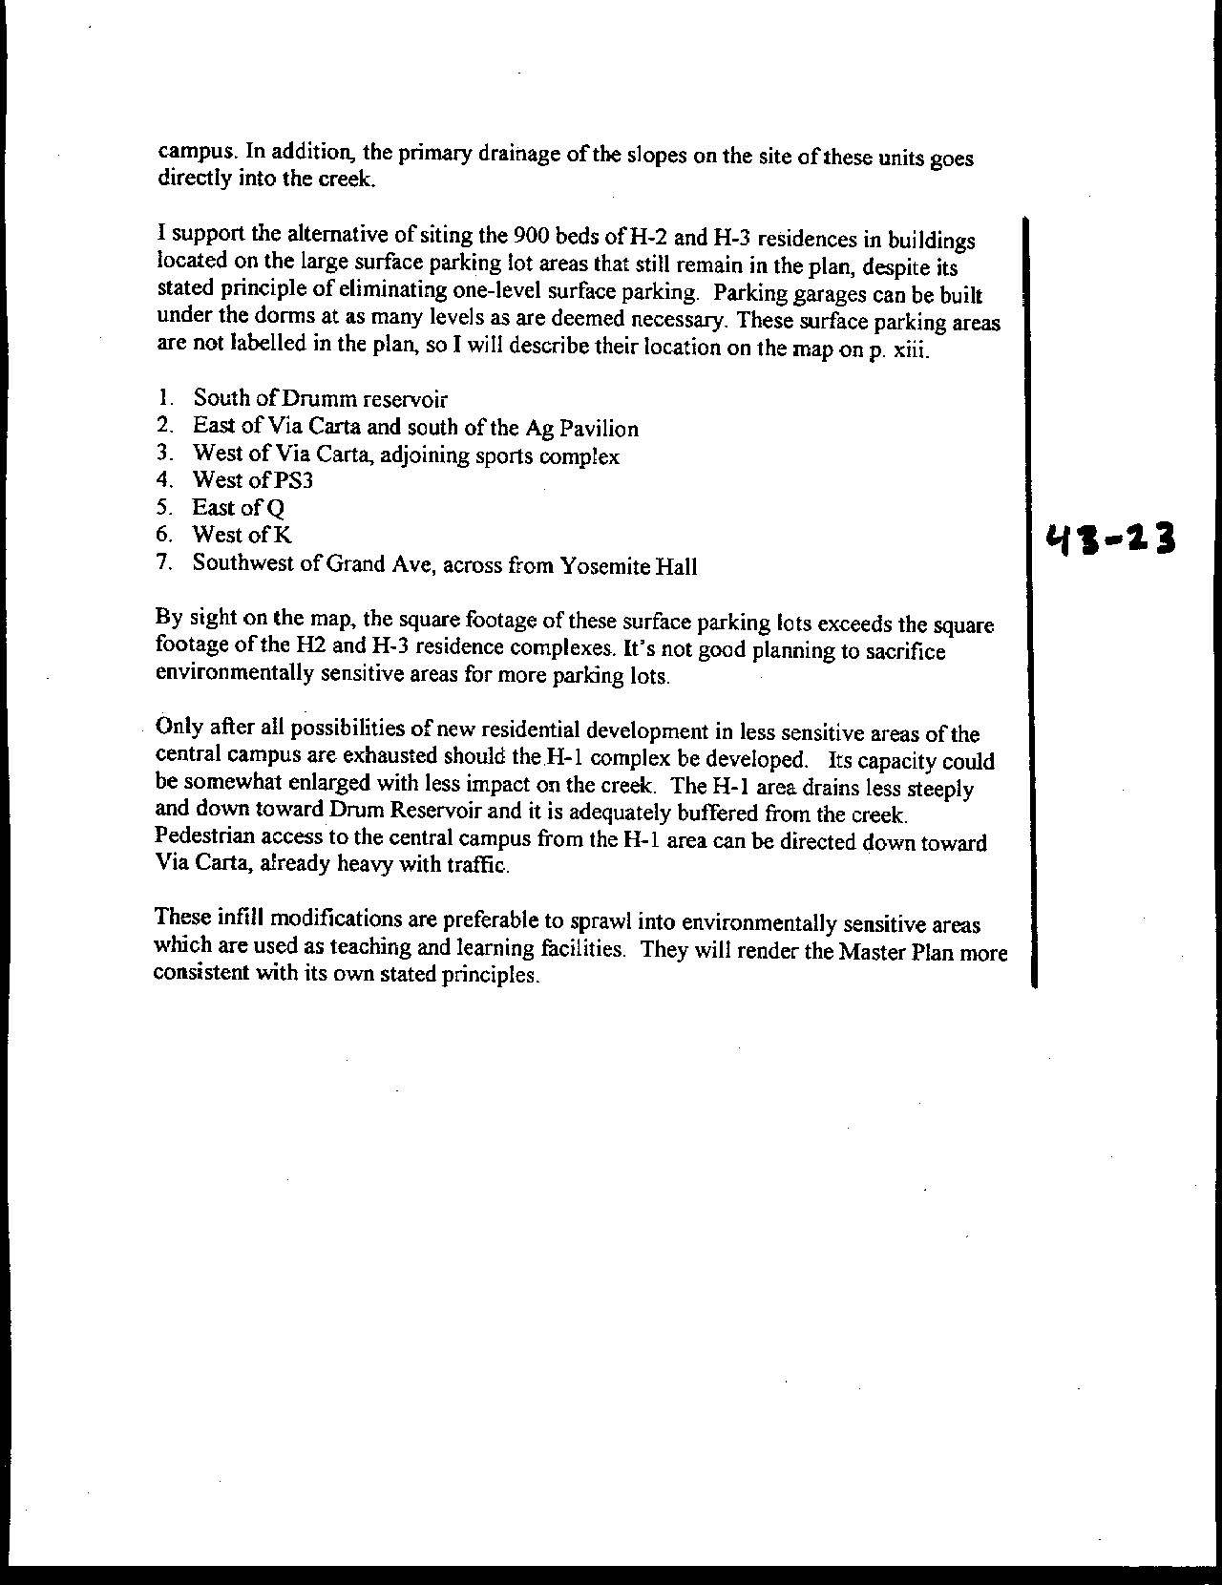
Letter 43
Letter 43

Dr. Steven Marx

November 19 and November 26, 2000

43-1 Commenter requests more time for deliberation on the Master Plan.

Response Cal Poly’s Master Plan team has been preparing the Master Plan for the past three years. After public meetings during the Fall and Winter quarters of the 1998-1999 academic year, over one hundred members of the campus and community participated in task forces during Spring 1999 to develop the guiding principles for the plan. The plan was first presented in draft form to the public in the Spring of 2000. Numerous press releases and public meetings accompanied the release of this early version of the plan. The formal plan and Draft EIR were presented to the community in the Fall of 2000. The March date for the Board of Trustees presentation has been presented to the public for over three years. For further information, please see discussion of process in Introduction and Task Forces in Chapter 2.

43-2 Commenter suggests need for a section on how plan will be updated.

Response A section on plan monitoring, review and revision has been added to Chapter 7 explaining the role of the Campus Planning Committee and California State University system (p. 351).

43-3 Commenter raises questions and suggestions about organization and chapter titles.

Response Organization retained, but text clarified. Key changes include the following: Addition of a section in Chapter 1 explaining the organization of the document; also within each element, the section labeled "Existing Conditions" and Issues has been relabeled as "Background and Issues" to avoid confusion with Chapter 4, Existing Conditions.

43-4 Commenter suggests editing of principles in the Introduction.

Response Text changes - statements now identified as Values to distinguish master plan principles in subsequent chapters.

43-5 Commenter indicates need to correct website address.

Response Text correction has been made (p. 14).

43-6 Commenter seeks explanation of white space around Dairy and Poultry units on Exhibit 4.10.

Response Map has been relabeled as “Selected Constraints Summary.” Many white areas are simply not constrained by the environmental features shown on this exhibit.

43-7 Commenter asks for reference to Valencia Creek property in Santa Cruz County.

Response As the Valencia Creek properties are not used for direct support of instruction, they are noted in the footnote at the beginning of the University Land Uses element (p. 67).

43-8 Commenter requests clarification of use of the term "Balance."

Response The text has been clarified as follows: “This principle recognizes that all uses of Cal Poly’s lands must be balanced in support of the University’s academic mission …” (p. 65).

43-9 Commenter seeks elaboration on outdoor teaching and learning activities.

Response Additional text provides broad language defining outdoor teaching and learning in the introduction to this element: “Specific courses in these and other colleges, including Liberal Arts, are frequently designed to focus on different aspects of campus lands” (p. 90). As the course numbers and titles for specific course applications change over time, a list at that level of detail would not be appropriate in the Master Plan.

43-10 Commenter expresses concerns about the affordability and marketability of student residences.

Response See new discussion of Market Analysis added to Residential Communities element. “Cal Poly will review and revise these market studies to inform each phase of Master Plan housing development and enrollment growth” (p. 136).

43-11 Commenter asks Cal poly to clarify references to Heery Sports Facilities Master Plan.

Response A new note at the beginning of the Recreation element explains: “The Heery Sports Facilities Master Plan was prepared in 1996 as the basis for the development of the Sports Complex north of Brizzolara Creek. The Heery Plan included a range of recommendations. Cal Poly did not adopt the entire plan, but rather used it as the basis for the Sports Complex. The campus Master Plan also referred to the Heery analysis but supercedes the Heery Plan” (p. 145).

43-12 Commenter questions need for additional sports facilities; calls for more analysis.

Response New text has been added explaining that, “As the Master Plan is implemented, the campus, and ASI in particular, will review and refine the kinds of recreational facilities needed to serve students, faculty and staff” (p. 150).

43-13 Commenter seeks clarification of discussion of recycling

Response Confusing language has been deleted (p. 158).

43-14 Commenter calls for a discussion of environmental condition of quarry area.

Response The red rock quarry is not proposed to be modified under the Master Plan. Nevertheless, the campus will continue to work with the Regional Water Quality Control Board on this and other sites on campus.

43-15 Commenter suggests making TES a landmark.

Response Addition to Invisibility principle in Public Facilities and Utilities element allows for "environmental aesthetic that balances beauty and function" (p. 161).

43-16 Commenter asks for clarification of statement about vehicle trip reduction.

Response Cal Poly does have the most successful vehicle reduction program among CSU campuses; however, demand for parking continues. Text has been clarified to this effect (p. 191).

43-17 Commenter finds discussion of Ancillary Activities “vague and defensive.”

Response The introduction to this element has been simplified. Then, the Plan Components section contains an amplified discussion of likely ancillary facilities (pp. 204-206).

43-18 Commenter claims that proposed facilities near Goldtree violate environmental suitability location principles.

Response The Environmental Suitability and Sustainability principle in the Land Use element (p. 69) calls for "limiting future development to those areas least affected by regulatory and/or high cost environmental constraints." Compared with other areas on the Main Campus and ranches in the San Luis Obispo Creek and Chorro Creek watersheds, the Goldtree area is relatively well-suited as a satellite location. (See the discussion in Chapter 4 regarding Constraints and Opportunities as well.)

43-19 Commenter expresses concerns about access to Goldtree area.

Response At such a time as detailed proposals are developed, site planning and feasibility analysis will provide more detailed evaluation of access options.

43-20 Commenter indicates use of Goldtree area by sheep operations.

Response See text addition in Outdoor Teaching and Learning element (p. 93).

43-21 Commenter suggests that comments on Preliminary Draft and responses be appended.

Response The Master Plan and FEIR will include all comments on the October 10 publication, plus a matrix showing changes from both the May 1 and October 10 publications.

43-22 Commenter expresses continuing concerns about student housing north of Brizzolara Creek

Response The DEIR addresses impacts. Housing units are conceptual, but in general are located 150 feet or more from the channel, a greater distance than existing feedlots. Drainage mitigation is required; pedestrian and light control is required; refer to the text for additional mitigation and analysis.

  - Commenter asks for consideration of more intense student housing, including use of existing parking lots (specific sites listed).

Response See responses to Ashley (letter 34). The commenter is referred to the housing alternatives analysis prepared in the EIR that directs housing siting and design. The goals of the Master Plan are to locate housing within proximity to the campus instructional core and create a community for student living without compromising the function.

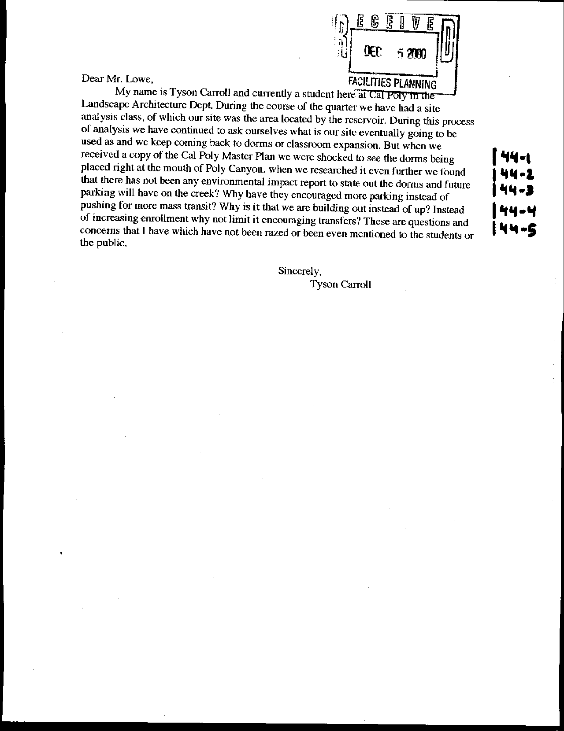
Letter 44
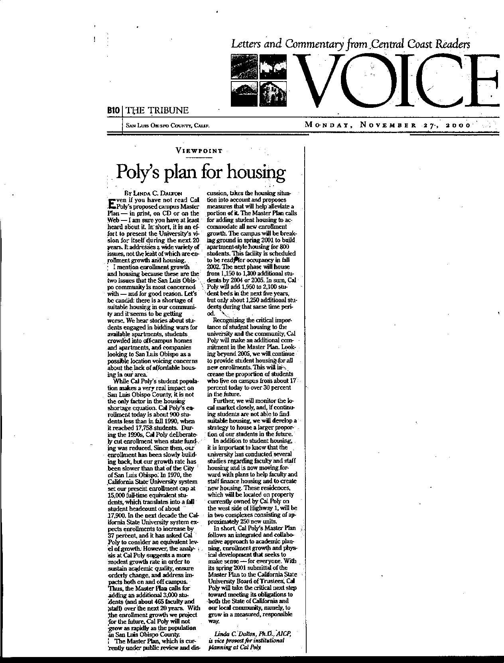
Letter 44
Letter 44

Tyson Carroll

December , 2000

44-1 Commenter is concerned about placement of housing at the “mouth” of Poly Canyon.

Response The housing proposed near Poly Canyon has been situated to avoid the sensitive resources in that area. The Ecological Study Area and Botanical Preserve will be protected. Housing will be designed to encourage students to move towards campus, rather than up the canyon. Numerous measures will be instituted to protect the sensitive resources of the canyon. DEIR addresses impacts

44-2 Commenter states there is no analysis of impacts to the creeks from housing in the EIR.

Response The EIR identifies numerous policies, design elements, and mitigation measures – including the University’s Water Quality Management Plan – that will reduce impacts to the Brizzolara Creek and other natural resources on campus.

44-3 Commenter asks why the Master Plan encourages more parking instead of promoting mass transit.

Response The Master Plan is promoting many measures to reduce the demand for parking and increase alternative transportation. Specifically, the plan calls for a reduction in demand of 2,000 parking spaces. This is to be achieved through many measures identified in the Alternative Transportation section of the Master Plan. See Alternative Transportation element. and plans for reduction in parking demand.

44-4 Commenter asks why the Master Plan encourages building “out instead of up.”

Response The Master Plan has been designed to maximize the land use of the campus instructional core, rather than spreading into the Natural Environment or Outdoor Teaching and Learning areas. See Constraints and Opportunities analysis

44-5 Commenter suggests the Master Plan should encourage transfer students instead of increasing enrollment.

Response The reader is referred to Chapter 3 of the Master Plan entitled “Long-Range Enrollment Scenarios” for a detailed explanation of Cal Poly’s approach to growth and its response to California’s need for higher education. See Chapter 3.

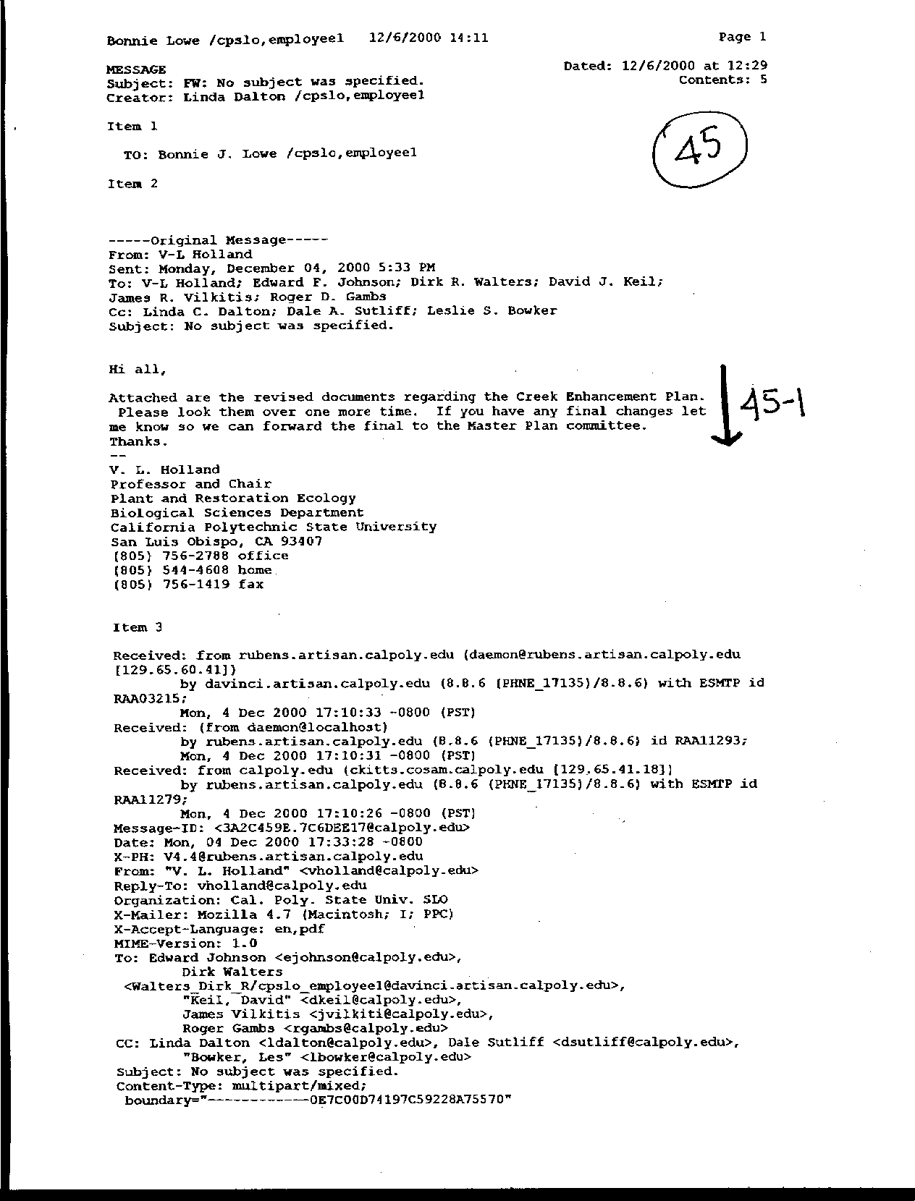
Letter 45
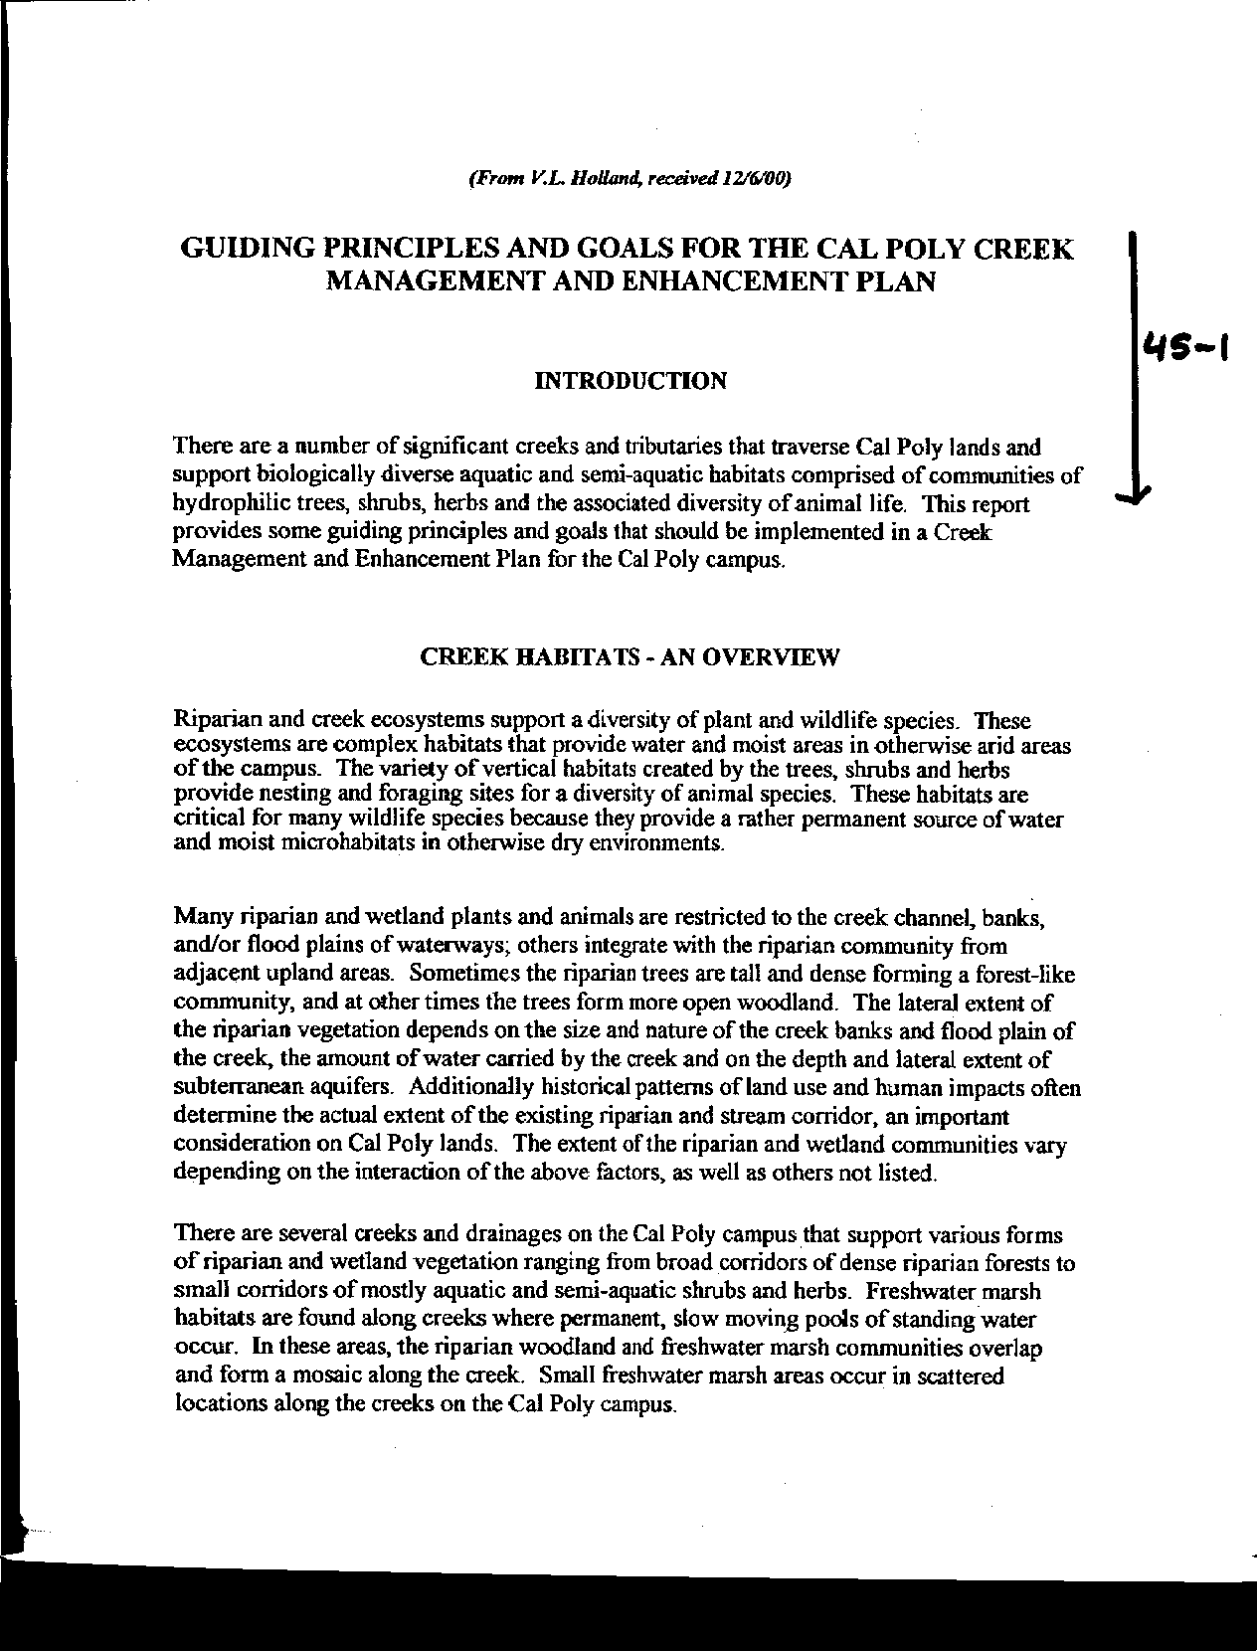
Letter 45
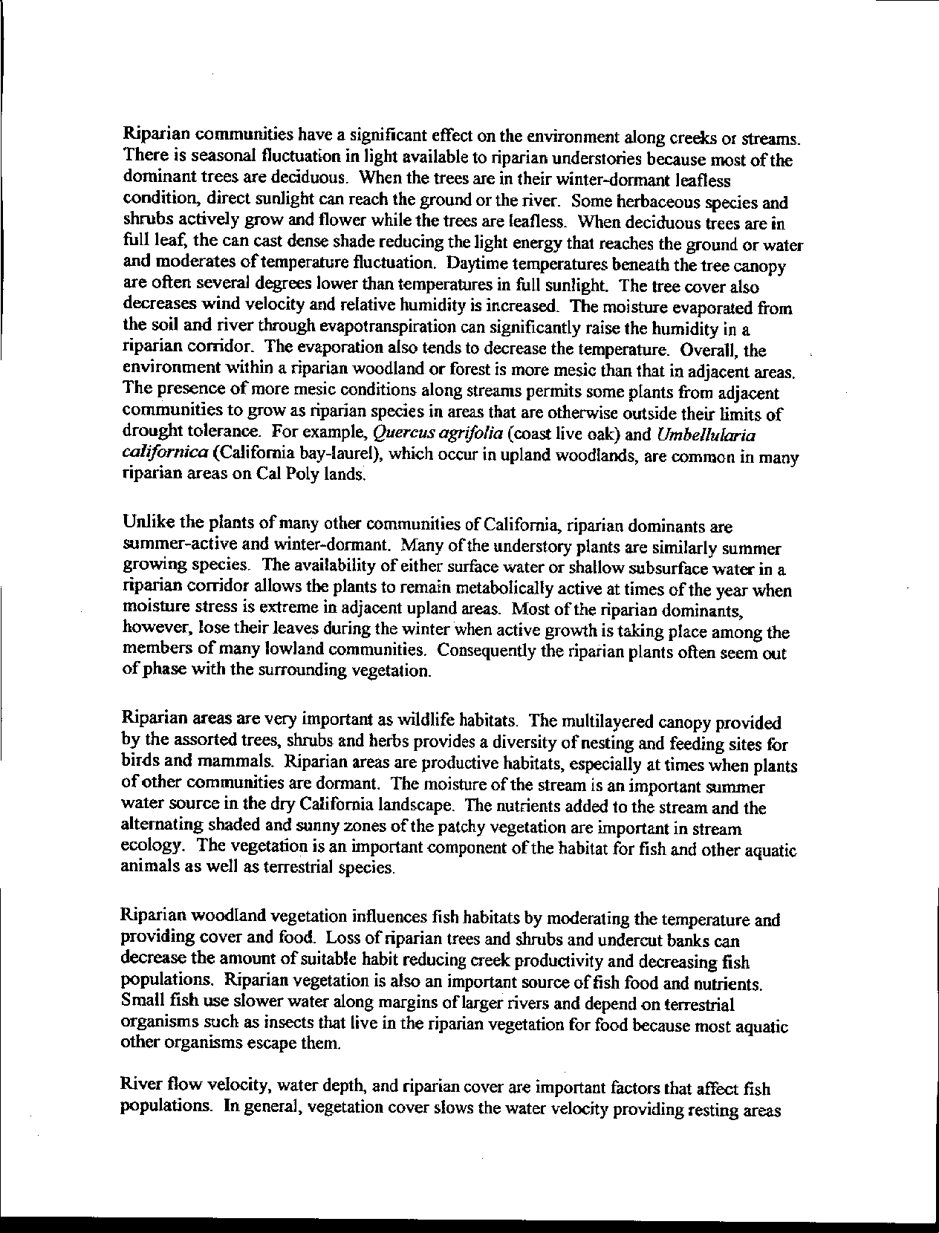
Letter 45
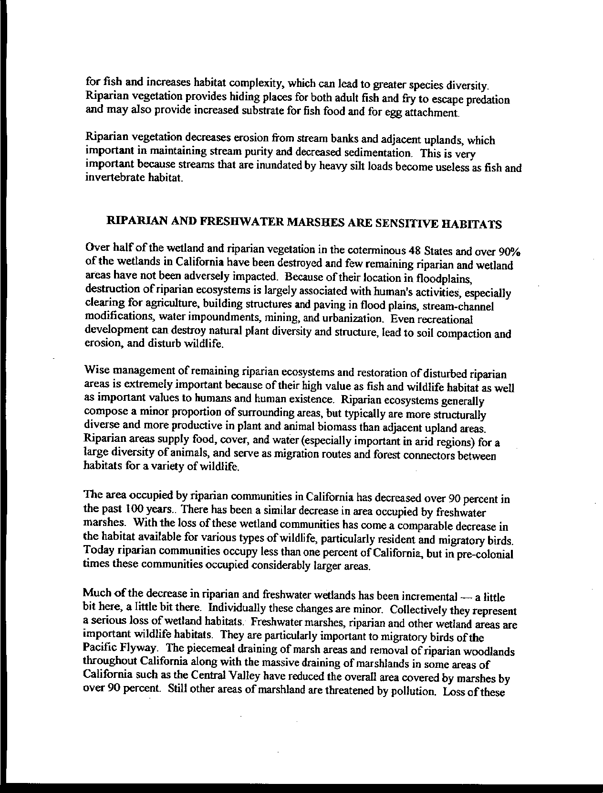
Letter 45
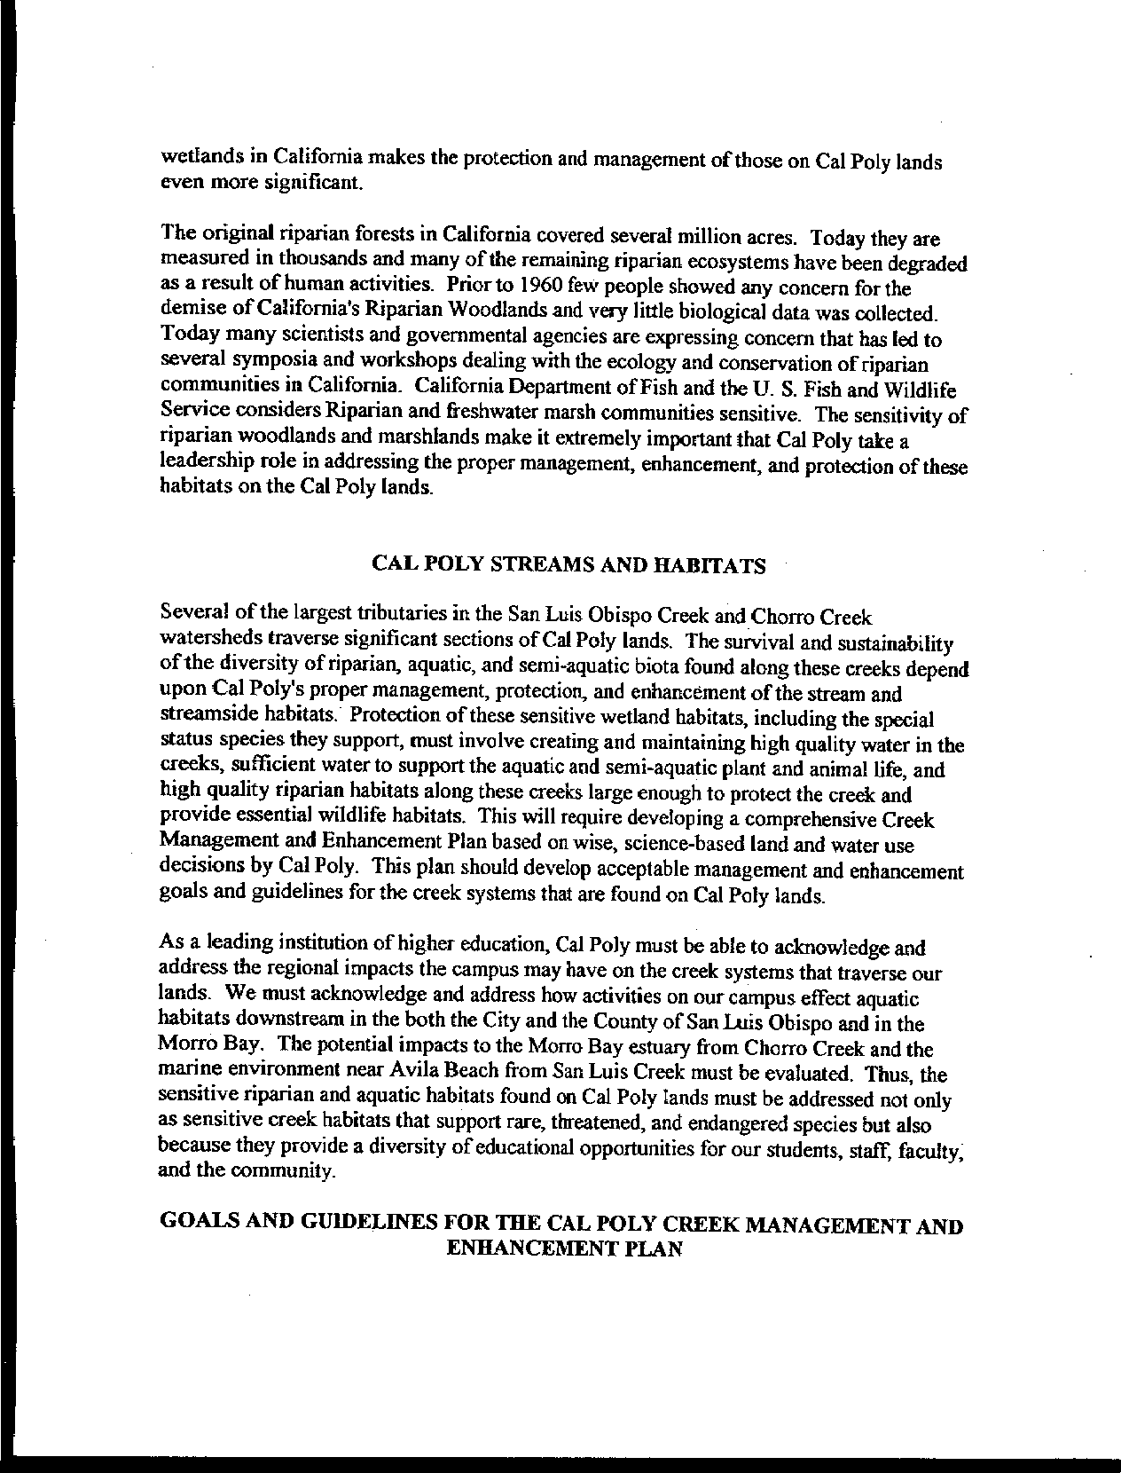
Letter 45
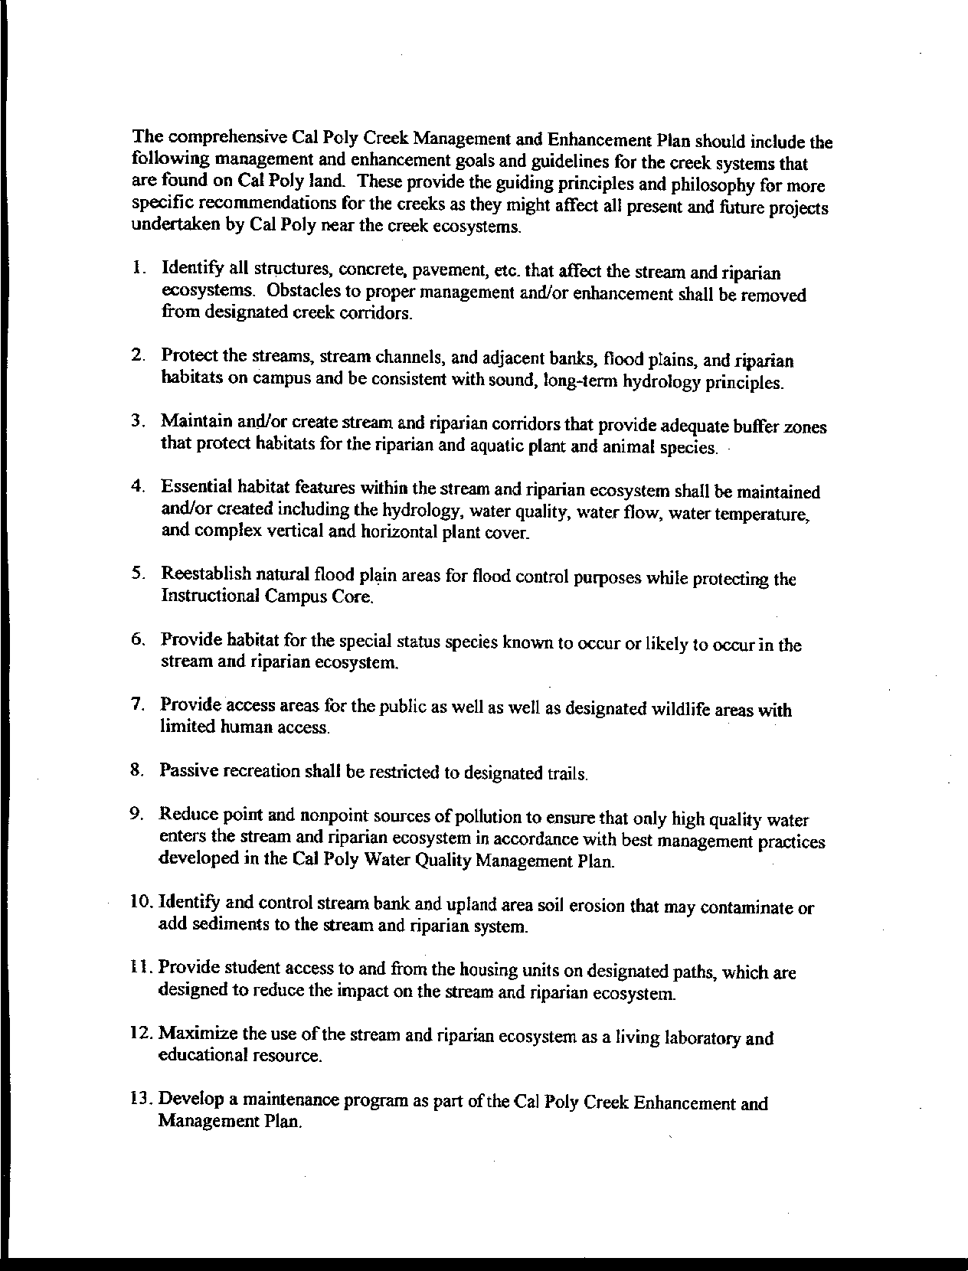
Letter 45
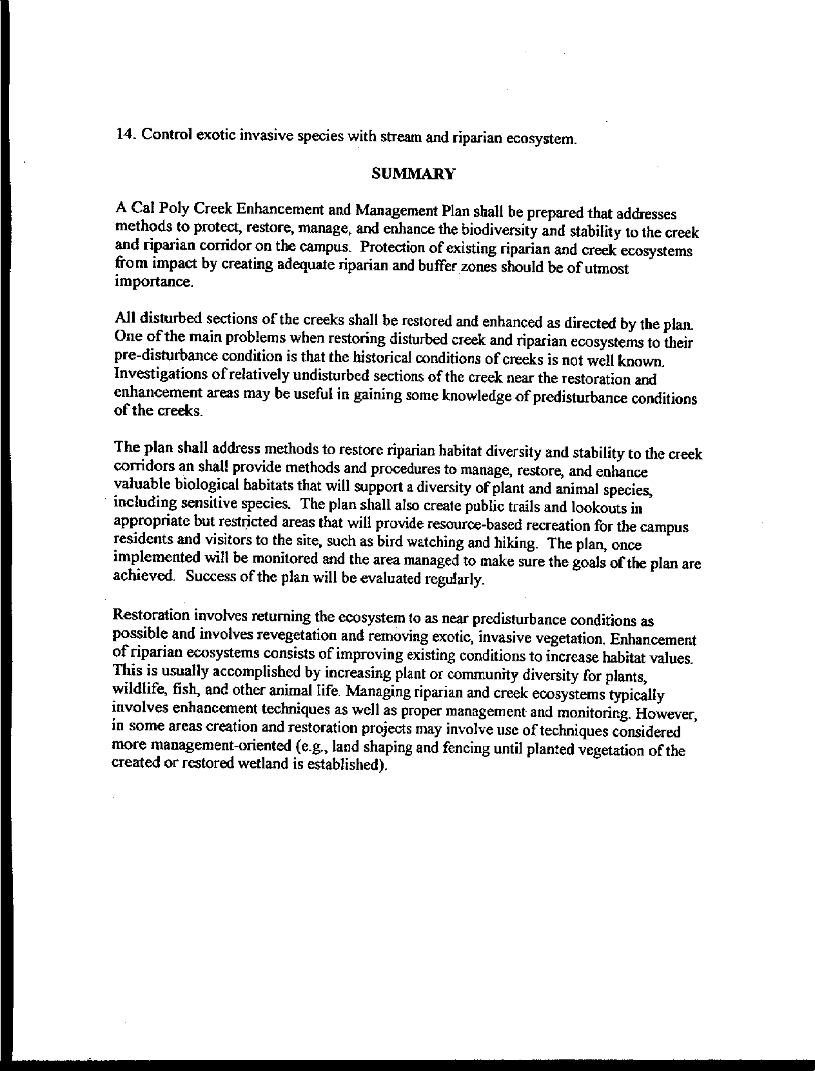
Letter 45
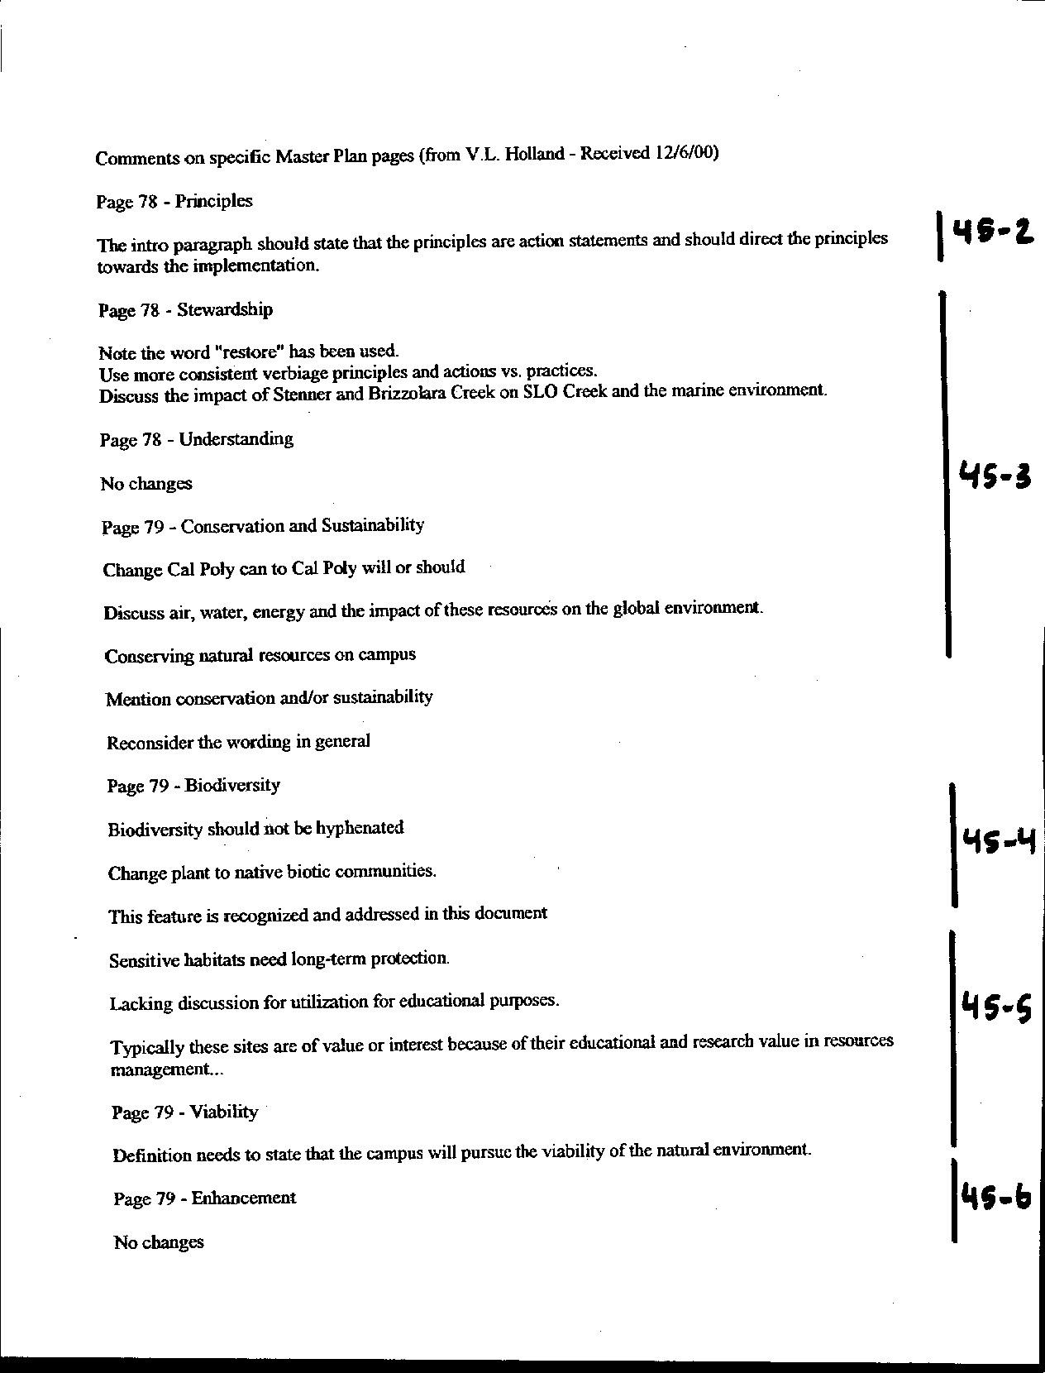
Letter 45

Letter 45
Letter 45

Dr. V. L. Holland

Chair, Department of Biology

December 6, 2000

45-1 Dr. Holland has prepared a report entitled “Guiding Principles and Goals for the Cal Poly Creek Management and Enhancement Plan.”

Response The report is part of the implementation of the Brizzolara Enhancement Project, and applies as well to other riparian areas of Cal Poly. It is incorporated into the Master Plan as an implementing report as Appendix F. See text addition.

45-2 Commenter wants paragraph to state "action" statements.

Response See text addition page 82, indicating “Implementation of the Master Plan provides Cal Poly with a unique opportunity to maintain and improve its leadership role as a steward of the land.”

45-3 Commenter suggests more consistent use of verbiage; Change Cal Poly “can” to Cal Poly “will” or “should”; Discuss global air, water and energy impacts.

Response Text clarification on p. 83. Global effects of the plan are difficult to quantify and are dependent upon too many factors and variables to be considered in the EIR. CEQA requires analysis of “reasonably foreseeable impacts;” global effects of the plan are not considered to fall under this designation. Regional air and water issues are discussed; energy usage is reduced by policies in the plan, which provide conservation options for buildings.

45-4 Change plant to native biotic communities; Biodiversity should not be hyphenated.

Response The text has been corrected at page 83.

45-5 Commenter suggests expanding Biodiversity discussion.

Response See text addition page 83.

45-6 Commenter suggests rewording the definition of Viability.

Response See text addition page 83.

45-7 Commenter suggests that “Feedmill” is one word.

Response Dictionaries differ regarding spelling.

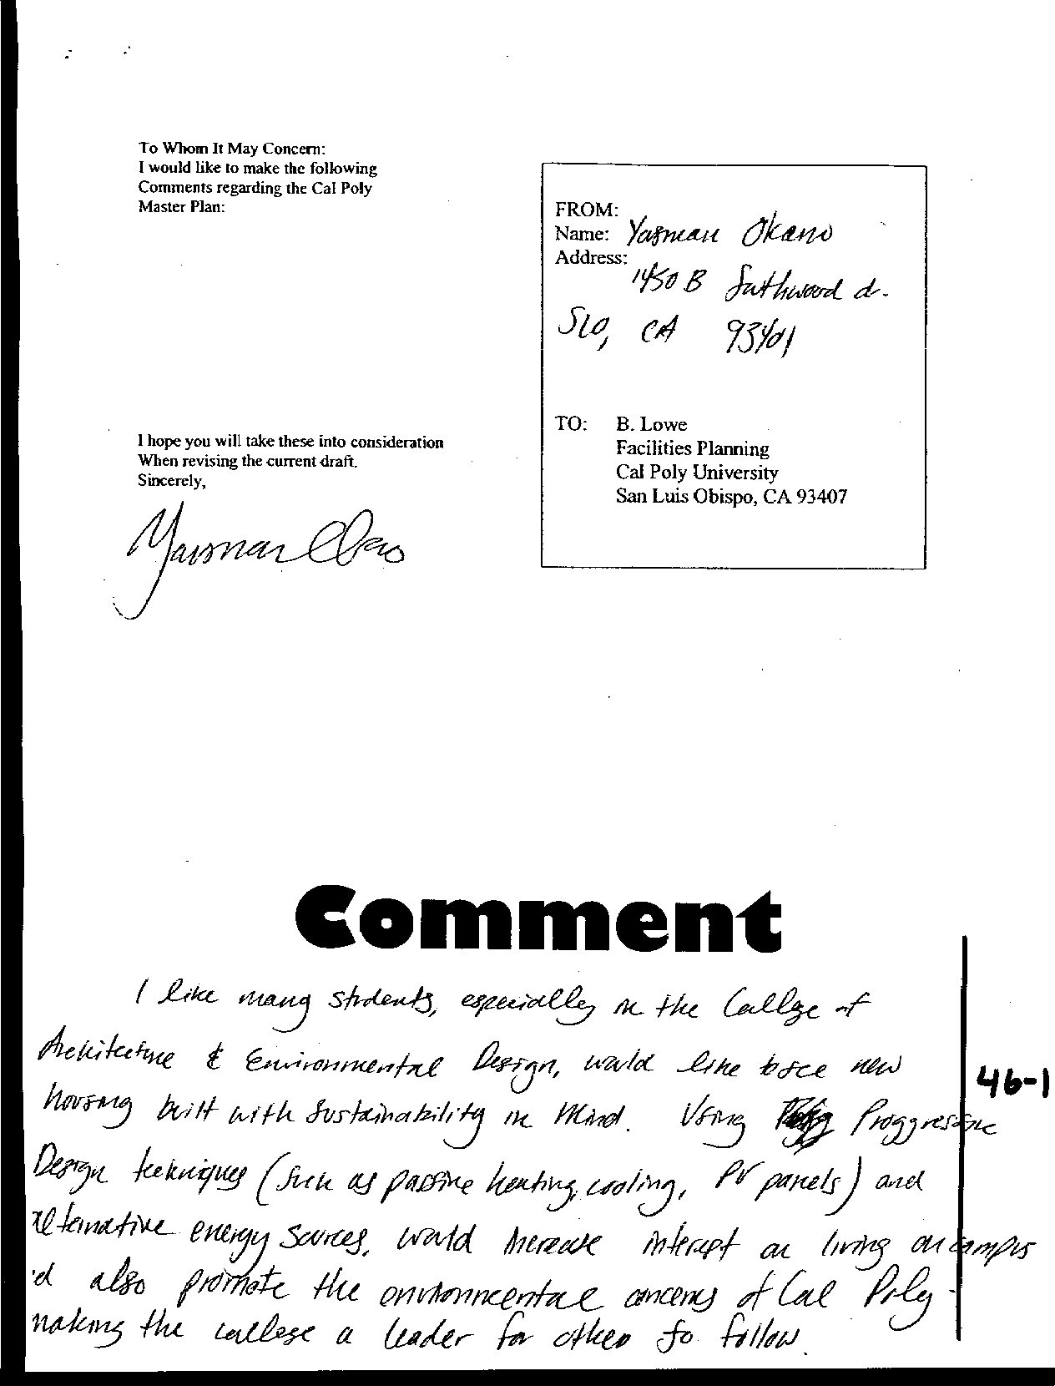
Letter 46
Letter 46

Yasman Okano

December , 2000

46-1 Commenter suggests Cal Poly’s new housing be built using principles of sustainability.

Response The following has been added to the Master Plan (pp. 162-163): Site selection, site planning and building design should account for solar exposure, prevailing wind direction, and patterns of light and shade to minimize energy requirements and enhance the quality of outdoor space. Design guidelines and processes for implementing the Master Plan should encourage energy efficient building design and resource conservation. The campus landscape plan should consider the impact of vegetation and water use on the resource efficiency of facilities and the creation of comfortable and functional outdoor space.

Design for renovation of existing buildings and new construction should consider ways to maximize energy efficiency and take advantage of the mild climate in San Luis Obispo. Alternative, renewable energy sources should be used to the greatest extent possible to offset growth in demand. As costs escalate for traditional energy sources, other options to consider include integrated photovoltaics and solar generation for electricity, passive and low energy cooling strategies for buildings (including materials, solar control, natural ventilation, thermal mass), passive solar space and water heating, and effective use of day lighting. New buildings should be well ventilated using natural ventilation, and existing buildings should be retrofitted where feasible to make them usable and livable during the summer without requiring air conditioning.

Consistent with Cal Poly’s mission, the campus should explore an integrated approach to sustainable, or “green” design for research, education and operational applications in new and renovated buildings and in the campus landscape treatment. In addition to the energy conservation measures noted above, these efforts should address water conservation and reclamation, re-use of materials and products, and life cycle costing in general. Several opportunities for resource recovery projects with educational and research potential as well as operational value include water supply and waste treatment for animal facilities, enhancement of Brizzolara Creek and the construction of new student residential communities.

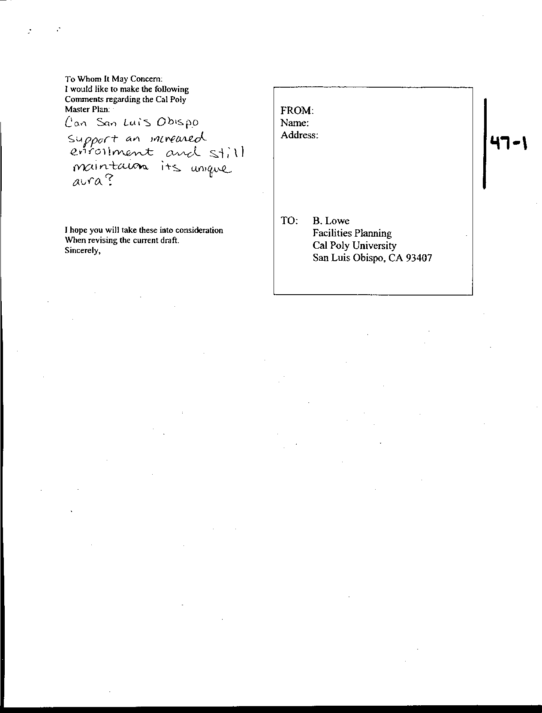
Letter 47
Letter 47

Anonymous

December , 2000

47-1 Commenter asks if San Luis Obispo can support increased enrollment and still maintain its unique aura.

Response With careful planning, elegant execution, and a sensitive handling of the details of Master Plan implementation, we believe it can. See Chapter 3. DEIR addresses impacts.

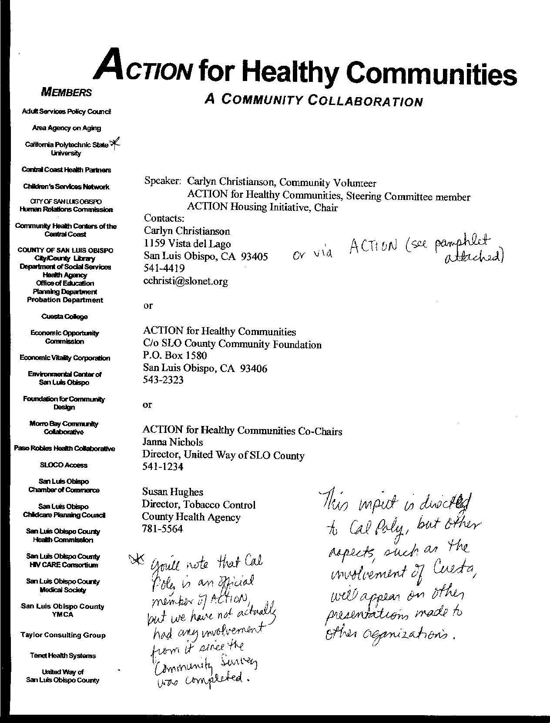
Letter 48
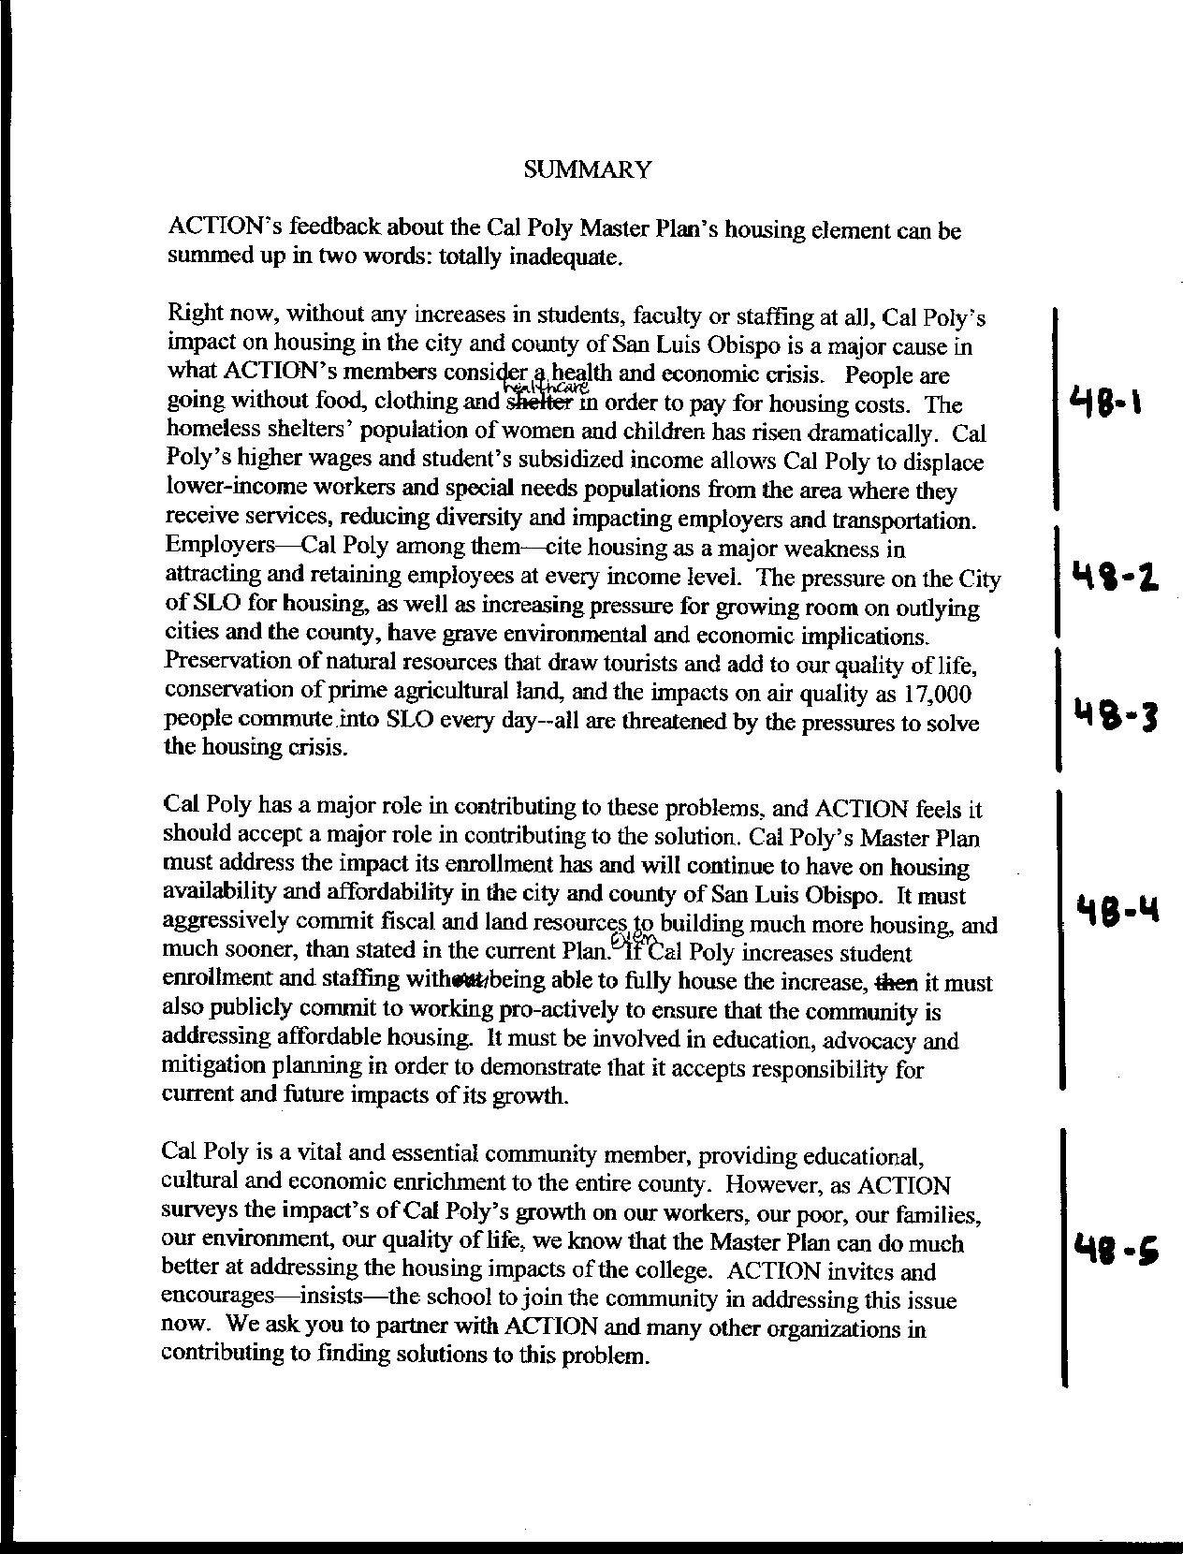
Letter 48
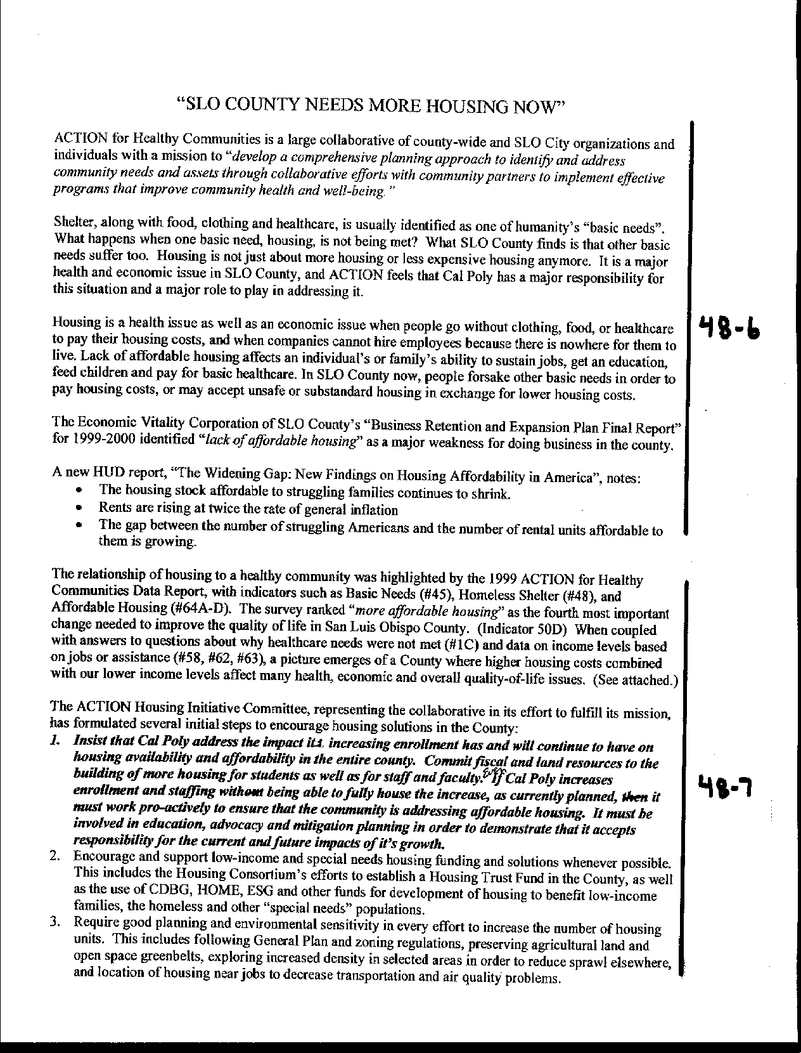
Letter 48

Letter 48
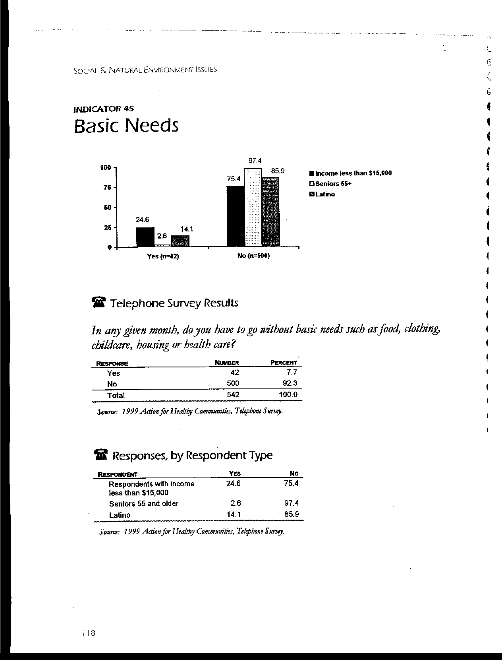
Letter 48
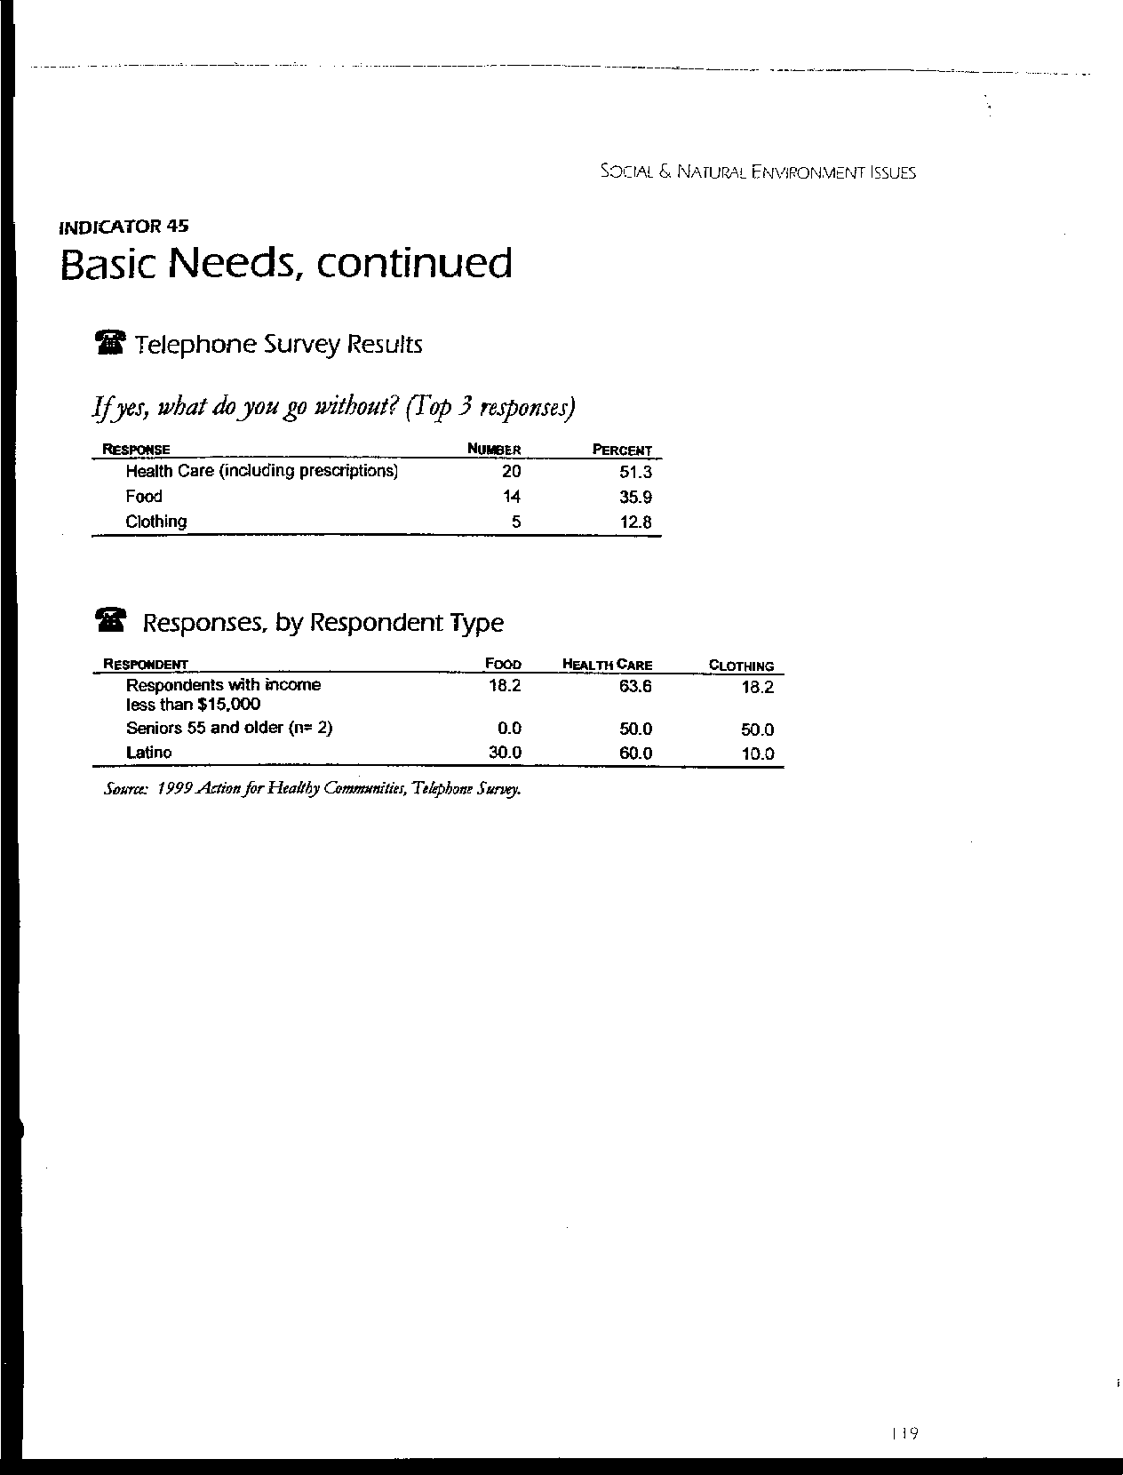
Letter 48
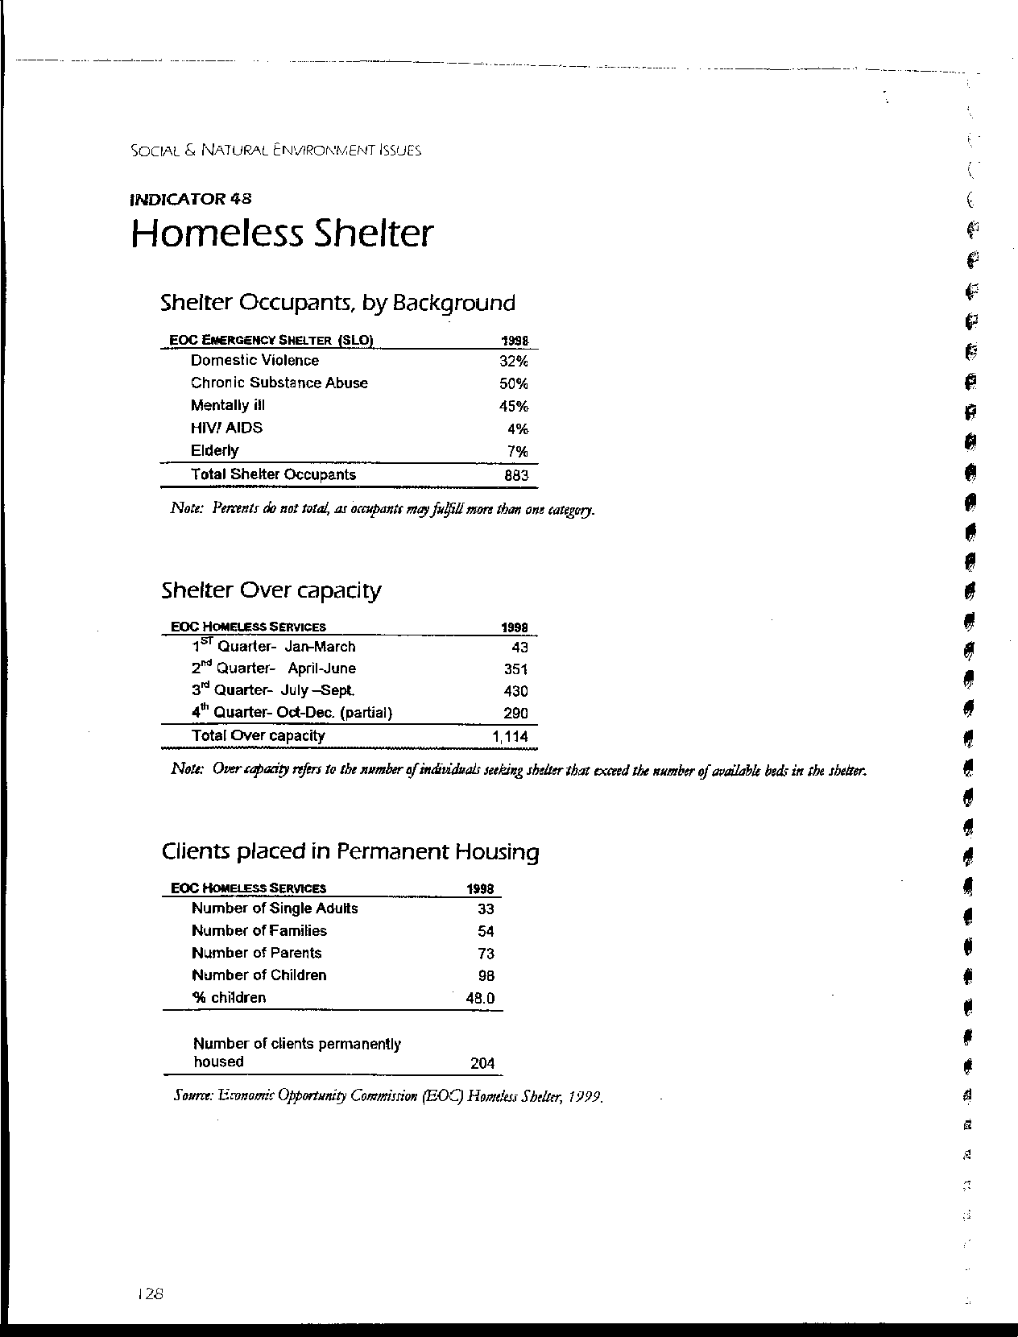
Letter 48
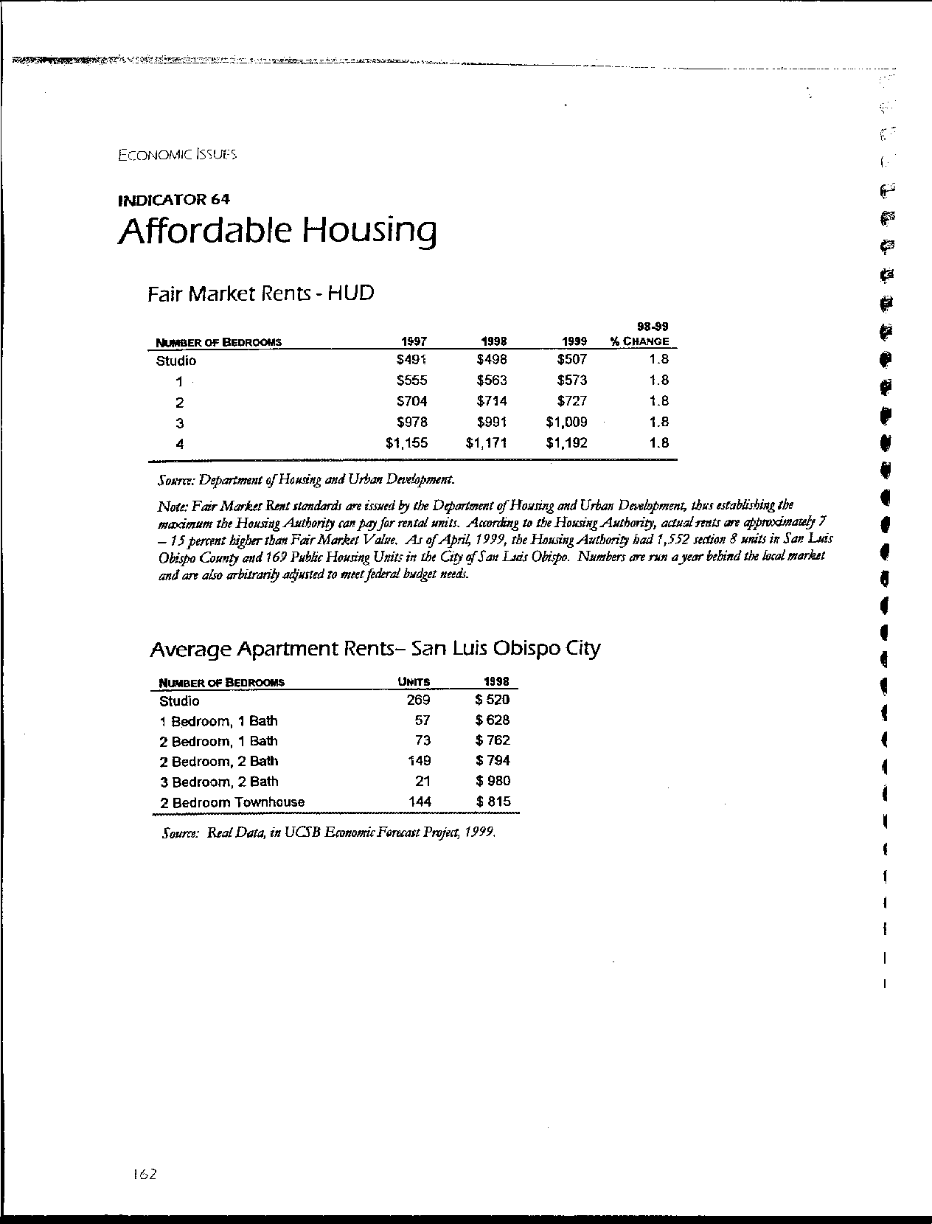
Letter 48
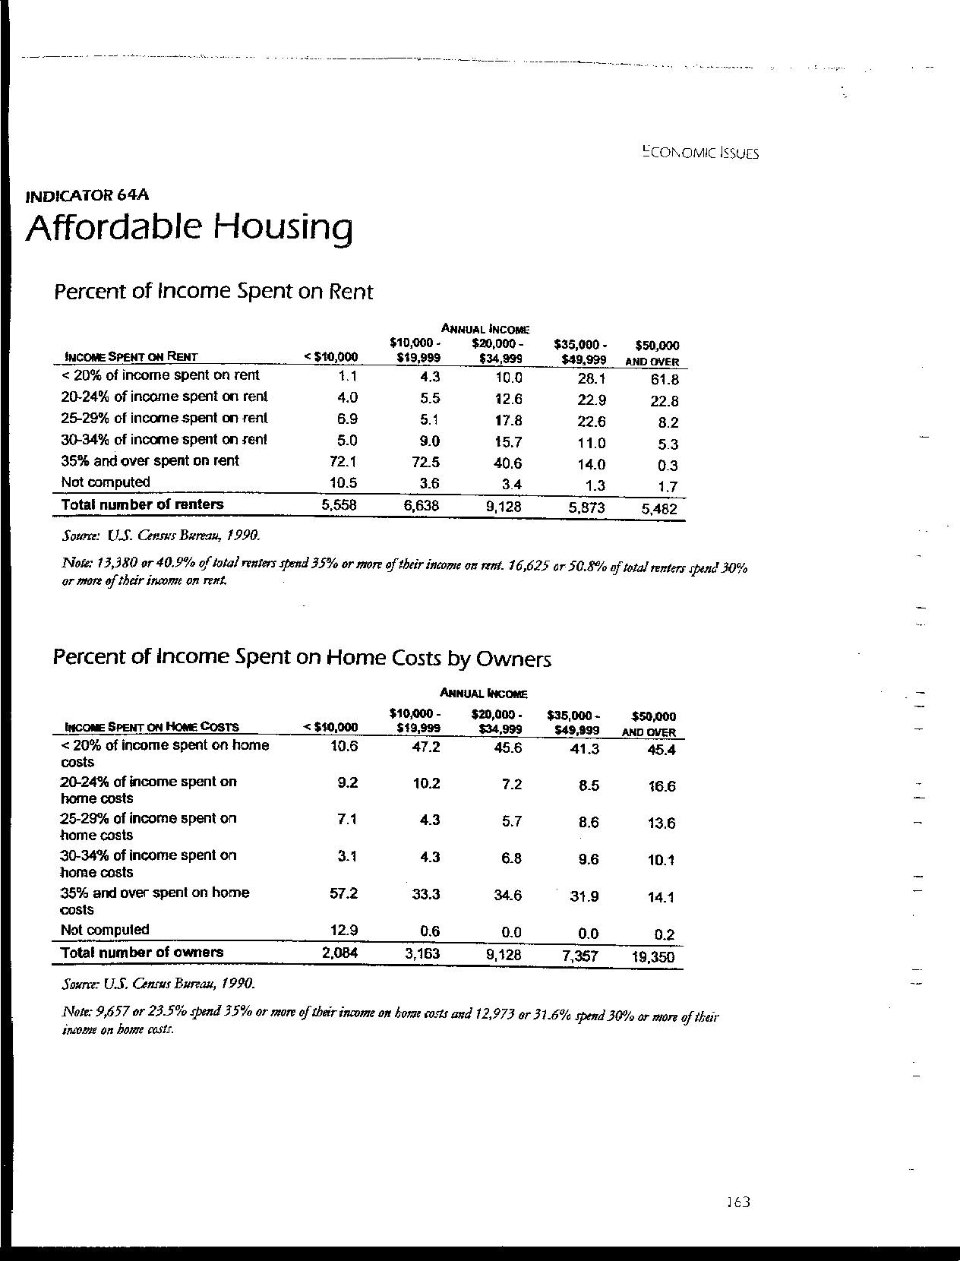
Letter 48
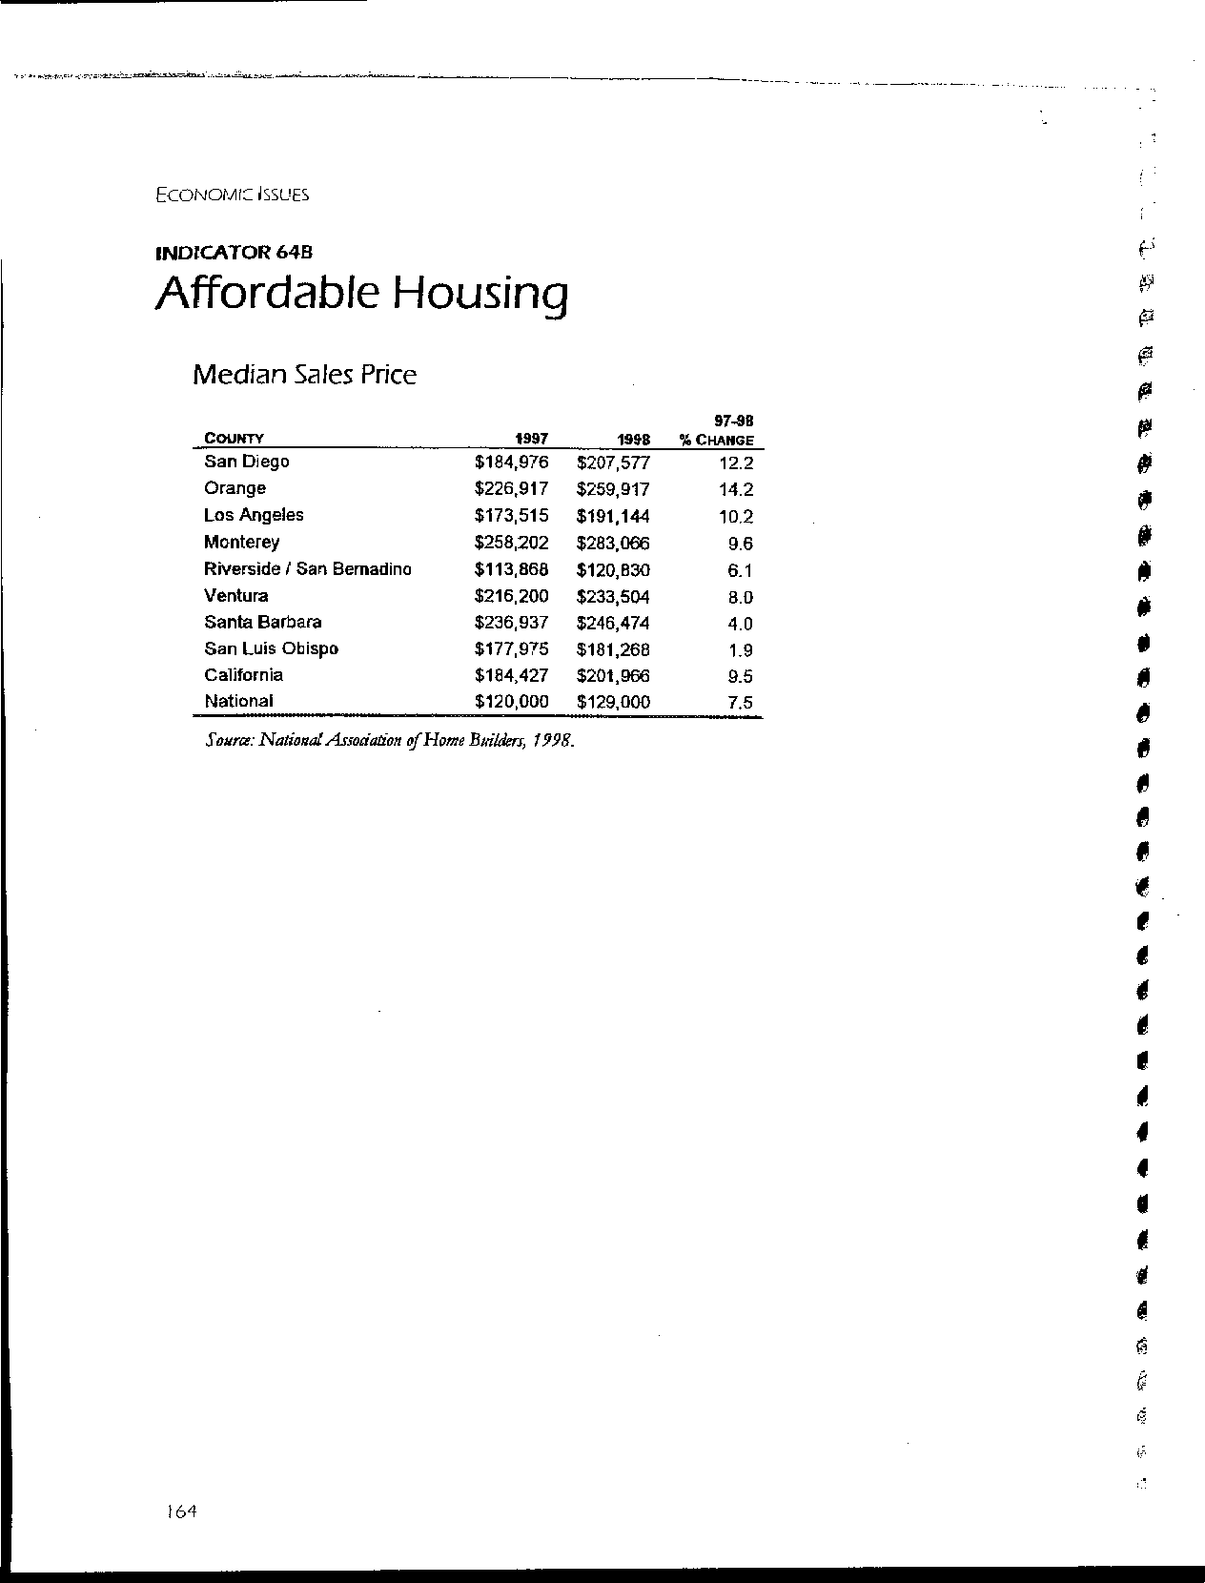
Letter 48
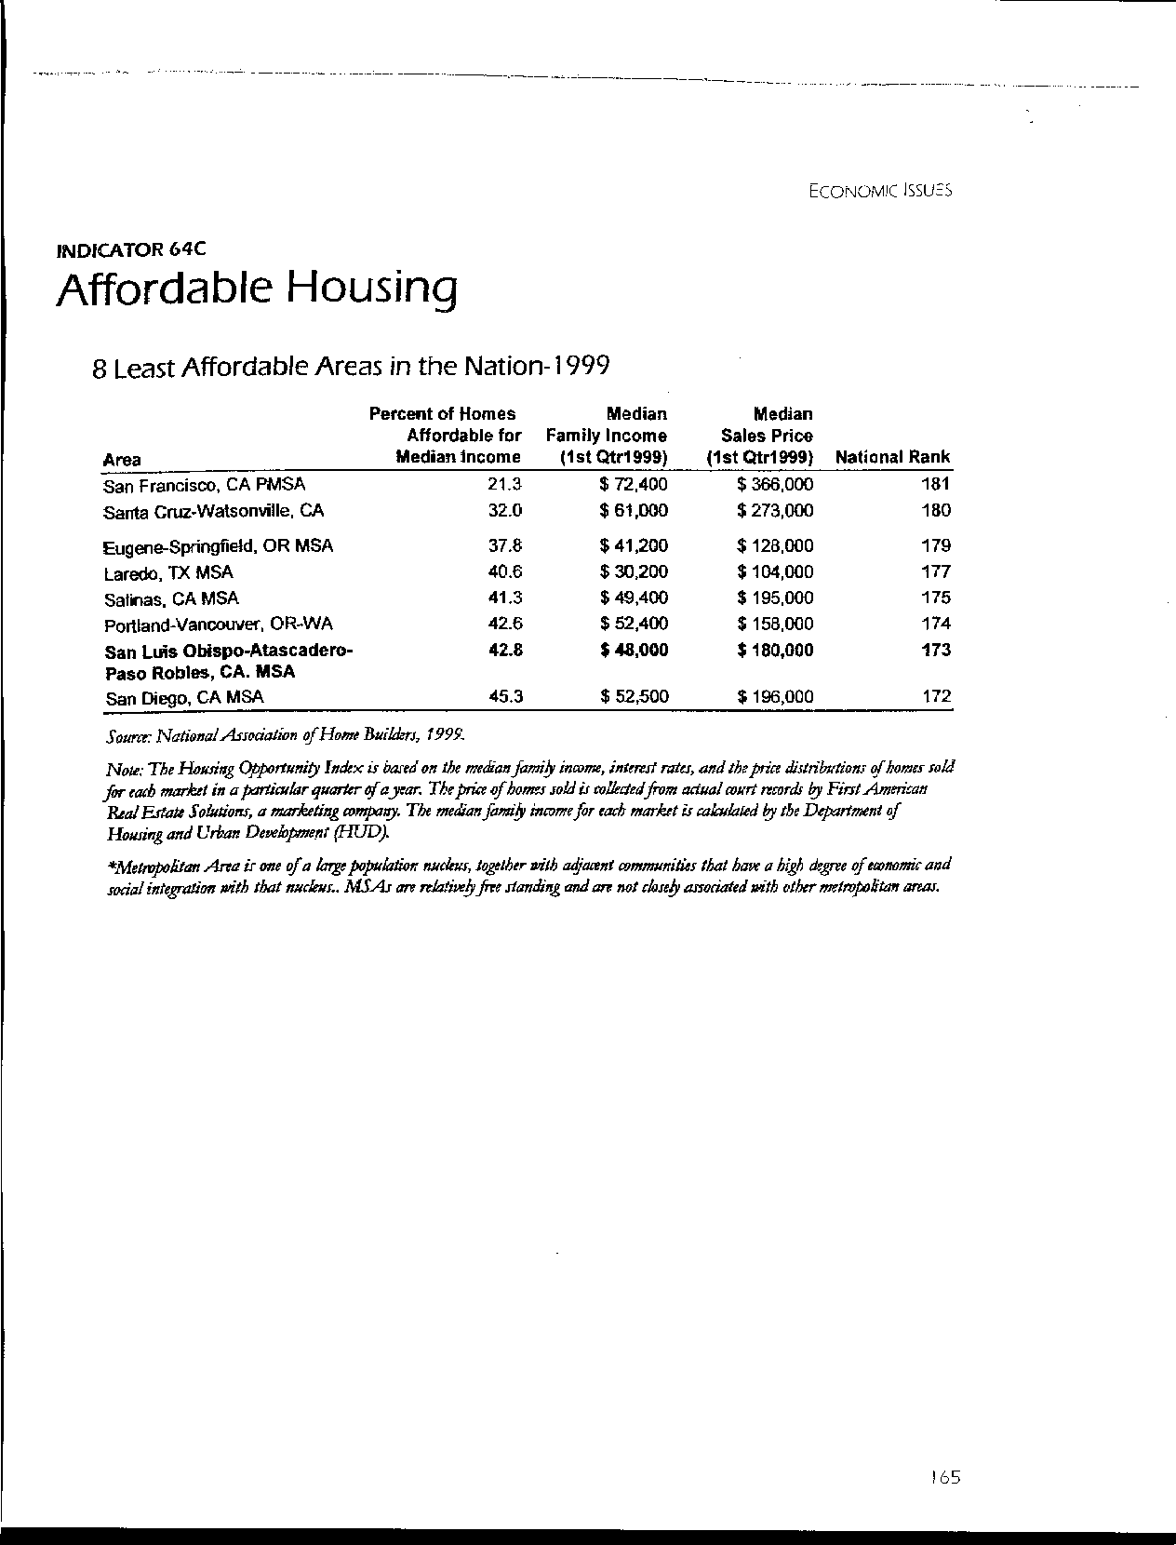
Letter 48
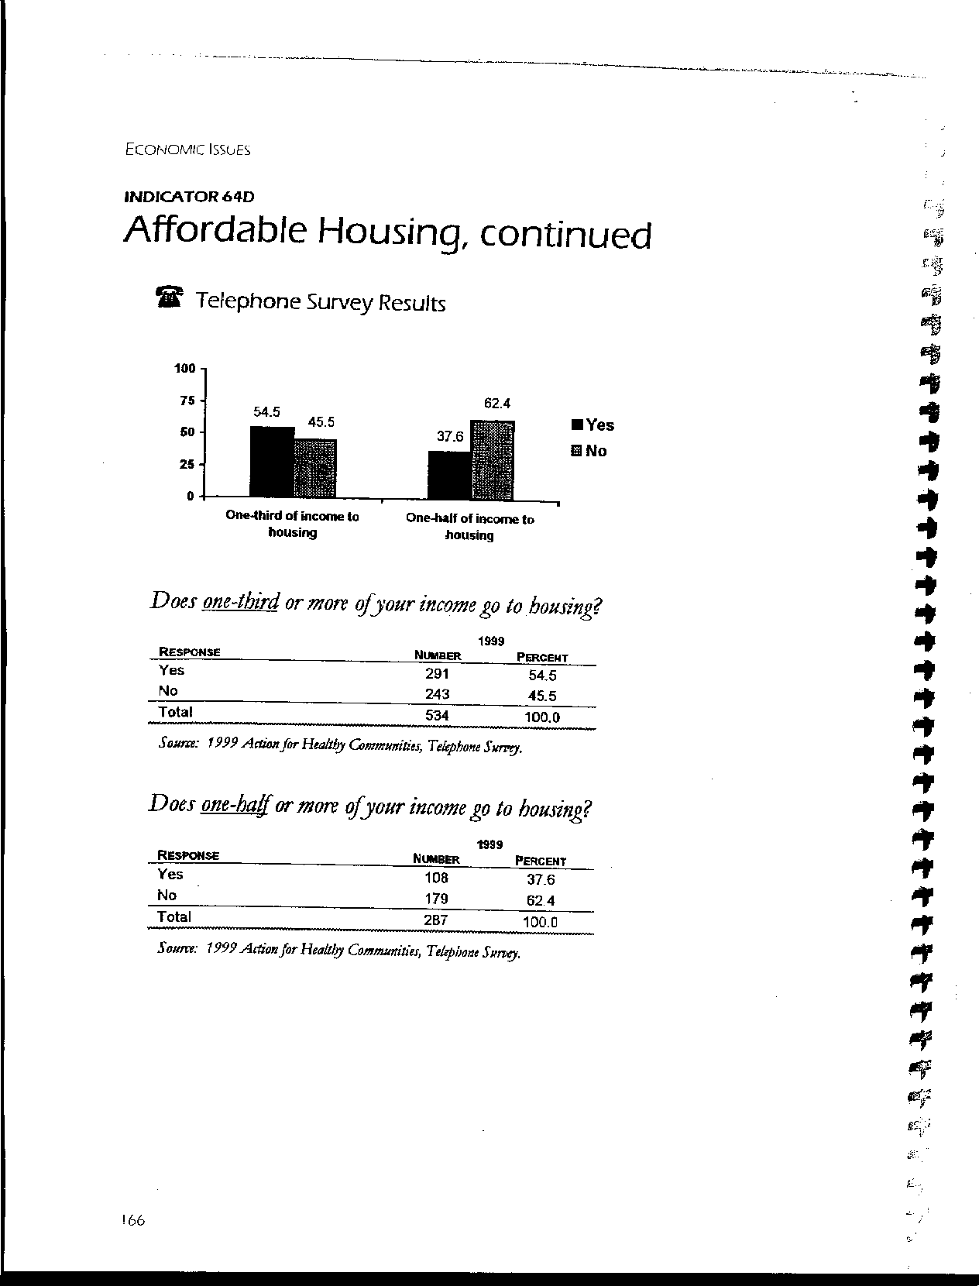
Letter 48
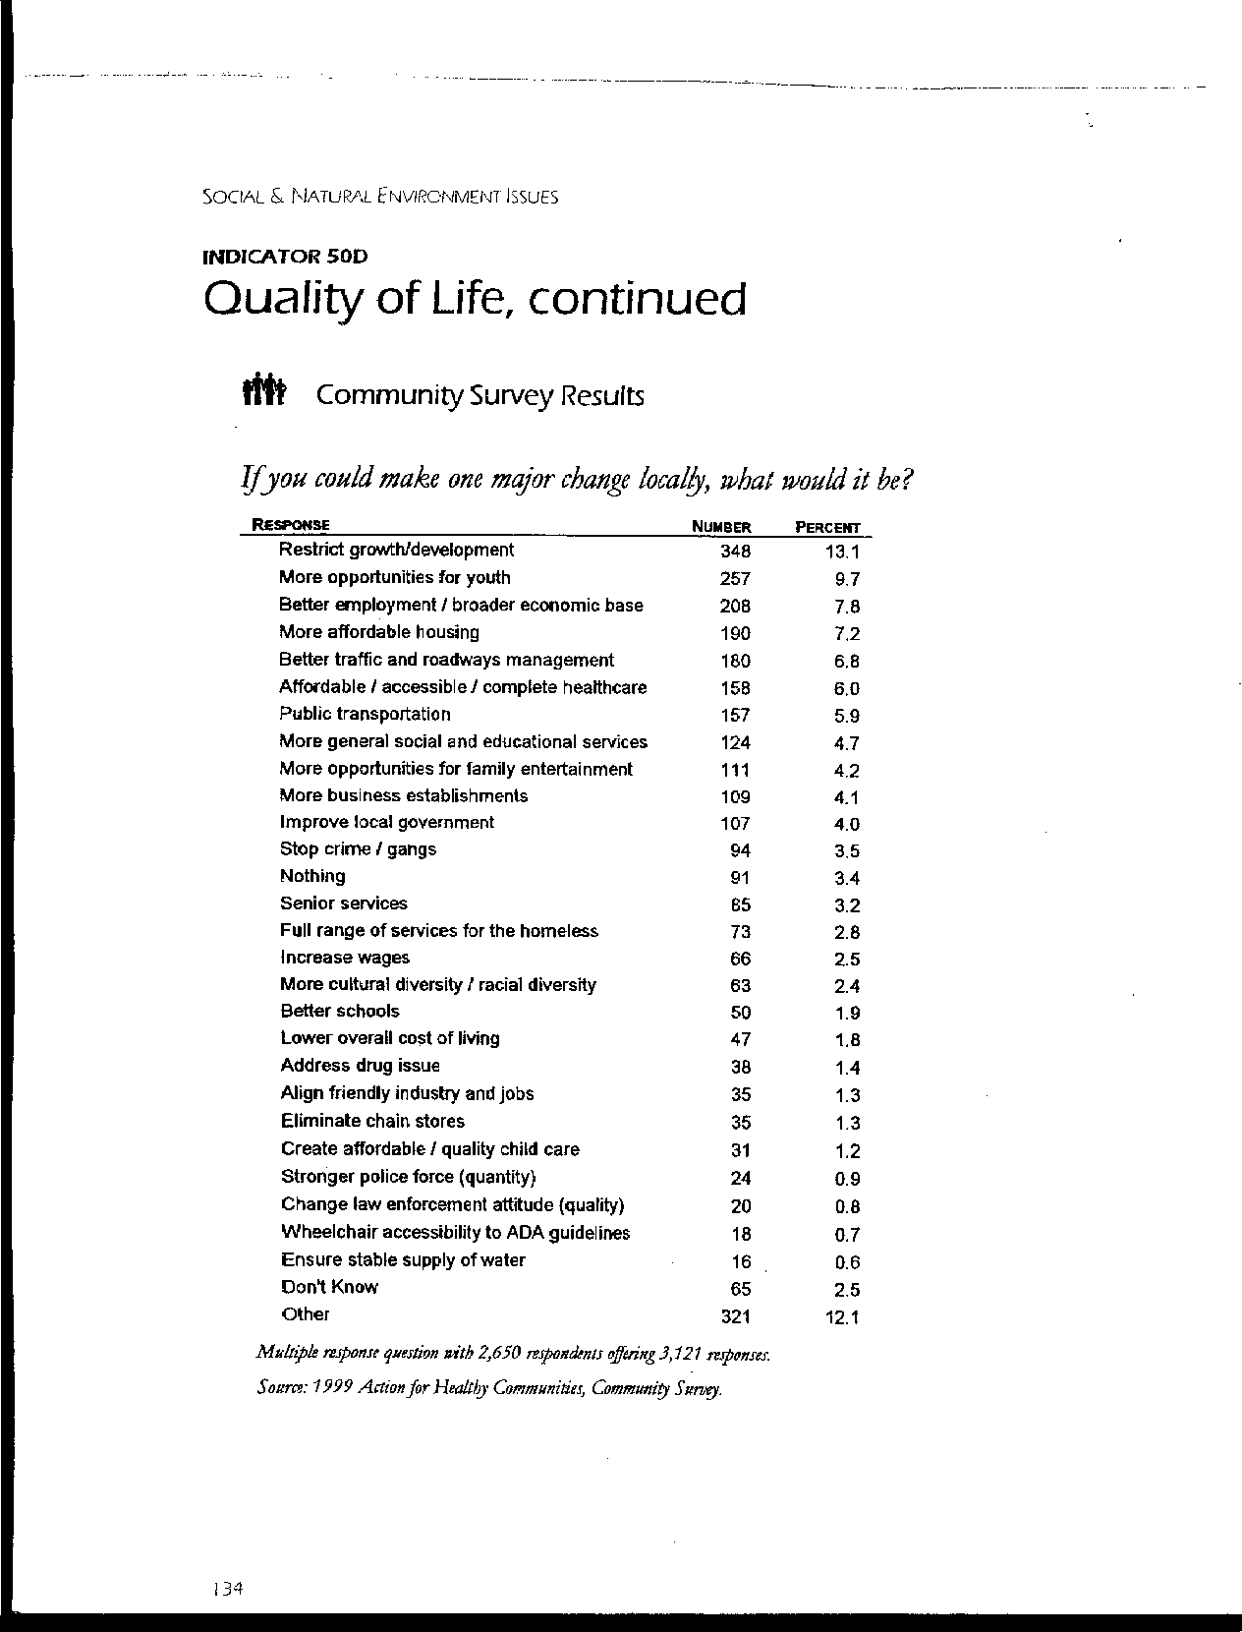
Letter 48
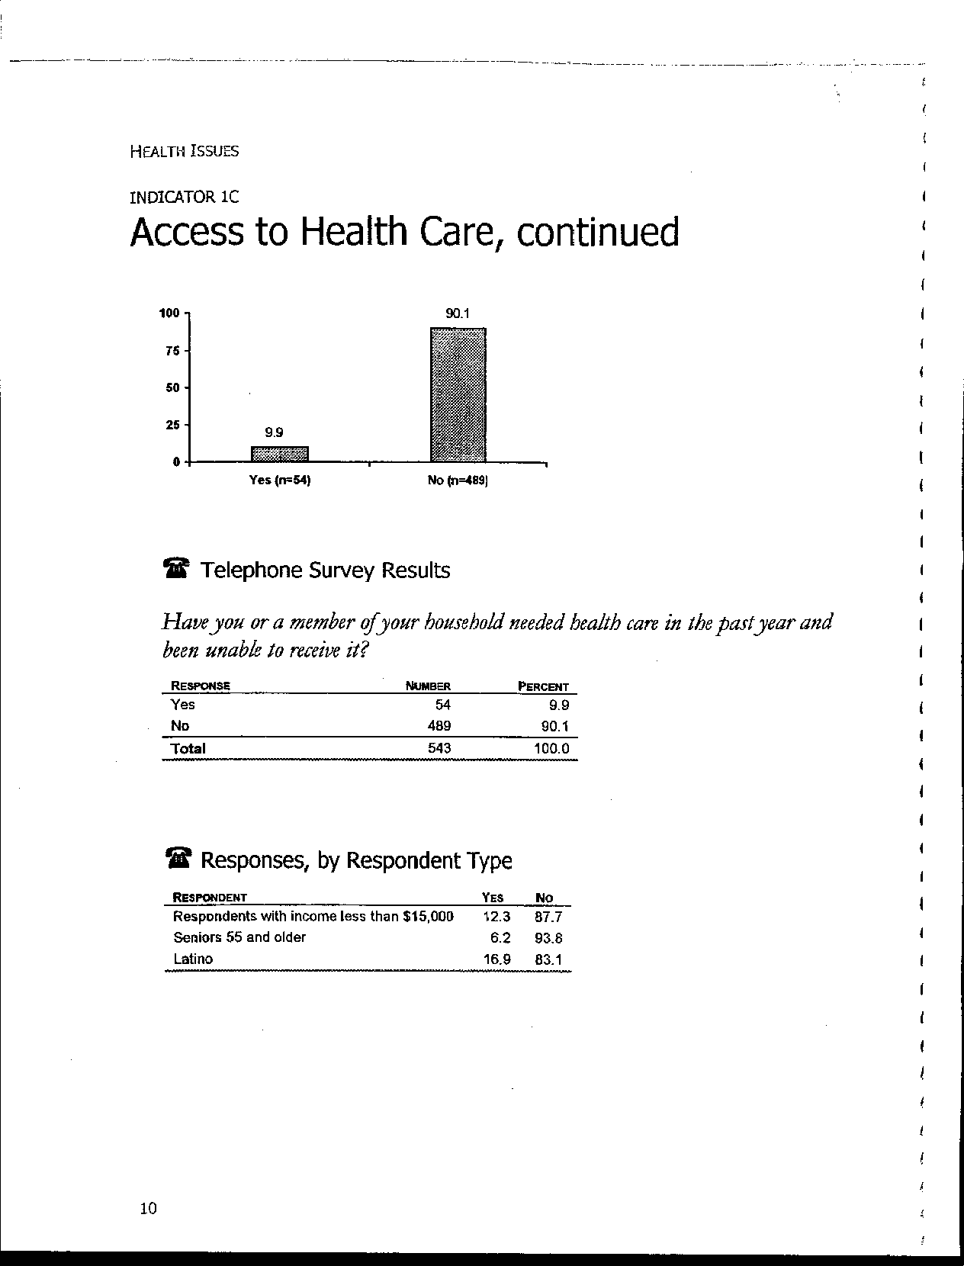
Letter 48
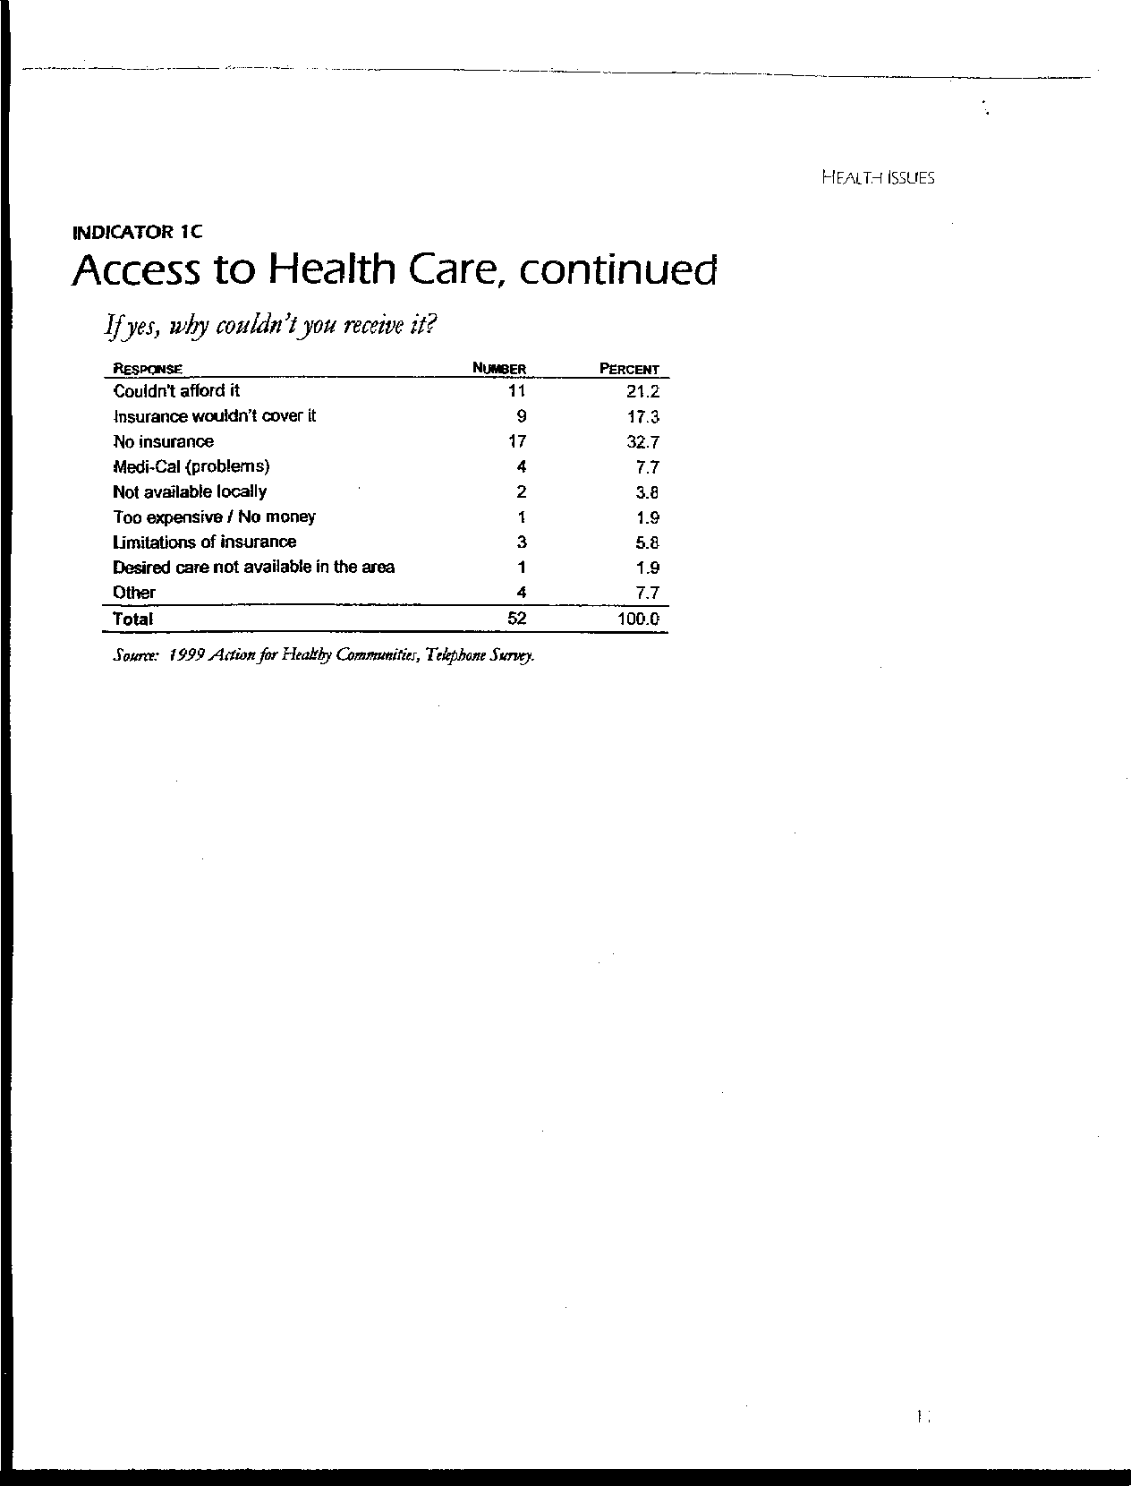
Letter 48
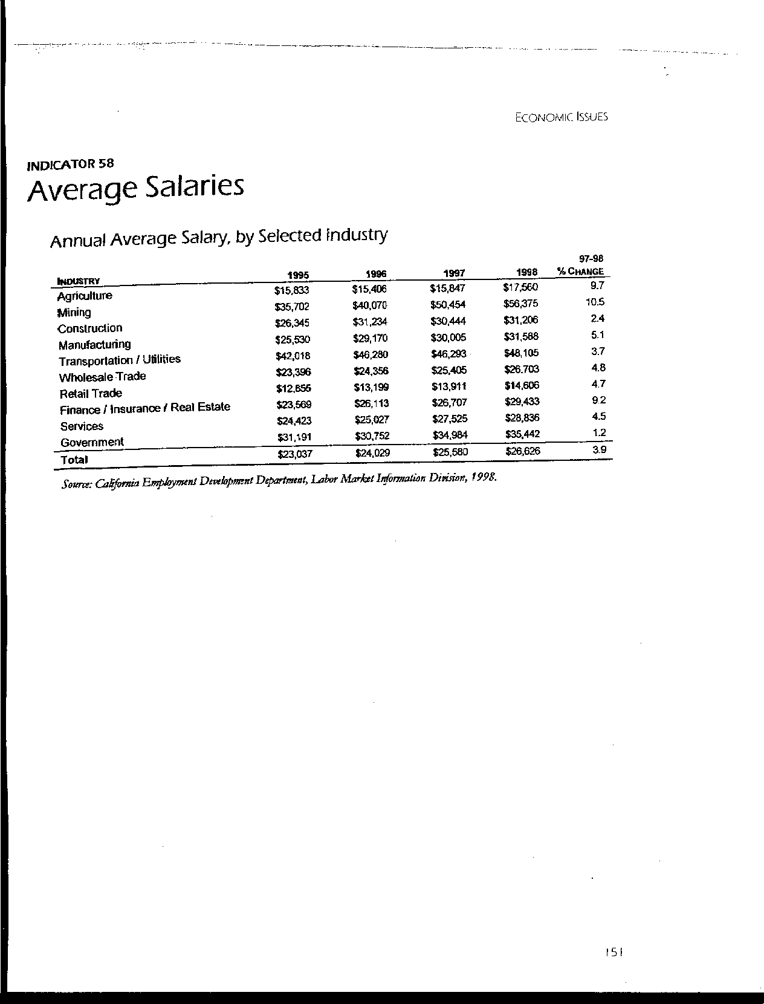
Letter 48
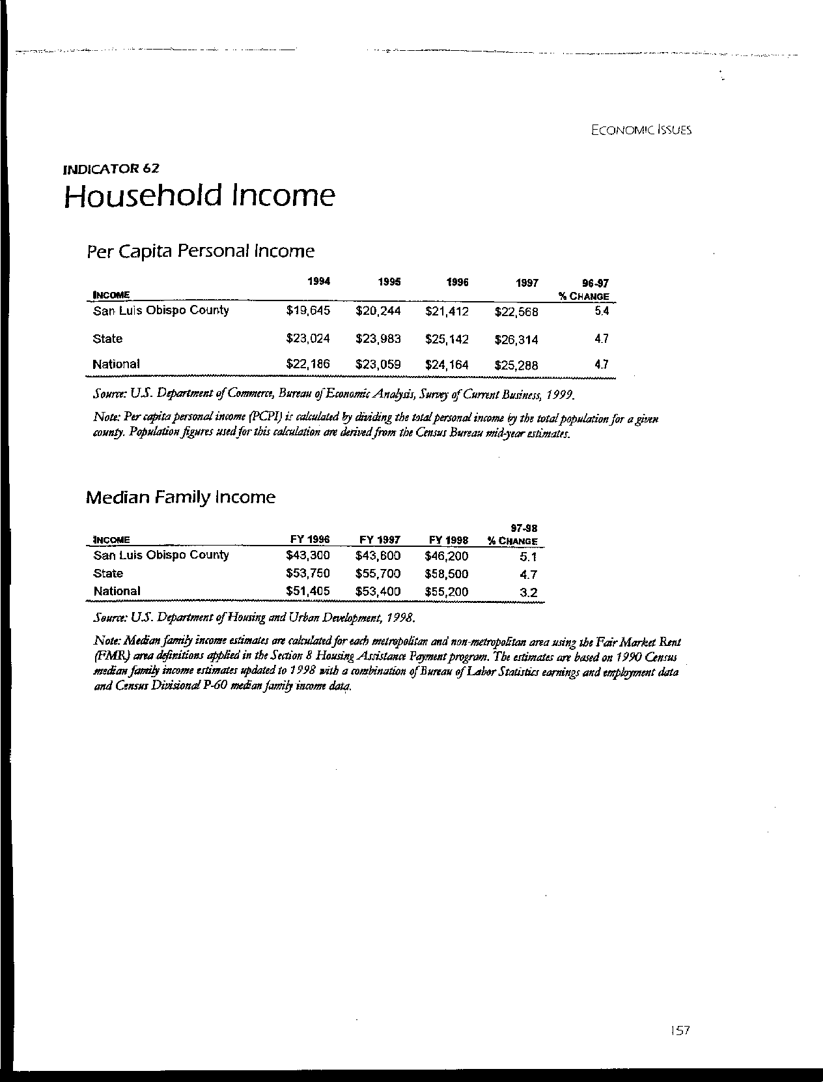
Letter 48
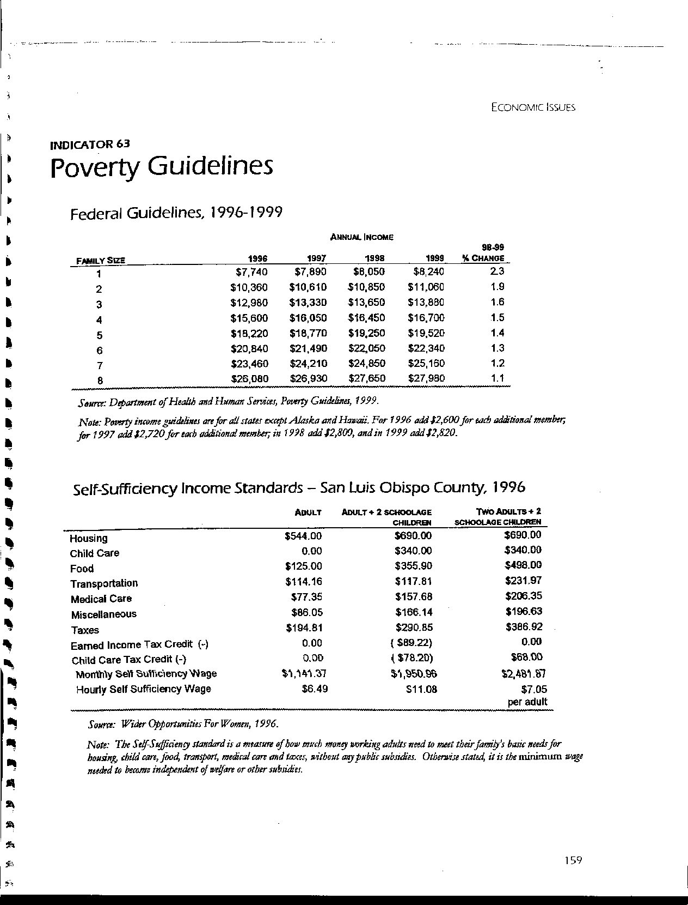
Letter 48

Letter 48
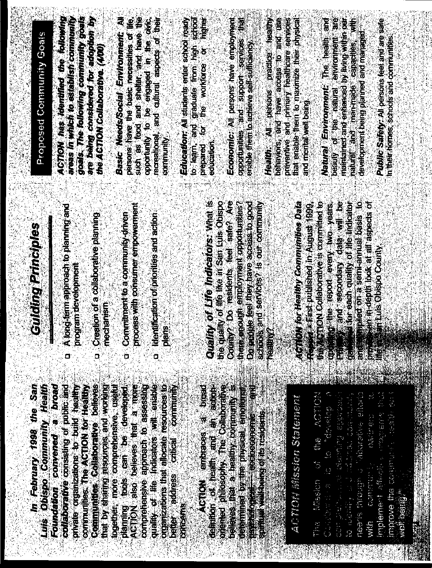
Letter 48
Letter 48

Ms. Carlyn Christianson

ACTION for Healthy Communities

Not dated

48-1 Commenter suggests that Cal Poly, especially because of its higher wage earners and subsidized students, is displacing lower wage earners from area housing.

Response Cal Poly recognizes these issues and has added text to the Residential Communities element to the following effect (p. 129-130): The San Luis Obispo area has the dubious distinction of being one of the least affordable housing markets in the United States. The 1999 Regional Profile published by the San Luis Obispo Council of Governments showed a median selling price in 1999 of $184,300 in the county and $231,500 in the City of San Luis Obispo for single-family homes. The Profile also revealed that 6.5 percent of the housing units in the City of San Luis Obispo are considered over crowded. The 2000 San Luis Obispo County Economic Outlook showed a vacancy rate of only 0.3 percent for rental apartments in the City of San Luis Obispo in September 1999.

Thus, there is a shortage of suitable housing in our community and it seems to be getting worse. Cal Poly faculty and staff hear stories about students engaged in bidding wars for available apartments and students crowded into off-campus homes and apartments. Companies looking to San Luis Obispo as a possible location indicate concerns about the lack of affordable housing in our area. Cal Poly recognizes that housing impacts are a major community concern related to enrollment growth.

While Cal Poly’s student population makes a very real impact on San Luis Obispo County, it is not the only factor contributing to the local housing shortage. Cal Poly’s enrollment in Fall 2000 is about 900 students below in Fall 1990, when it reached 17,758 students. During the 1990’s Cal Poly deliberately cut enrollment when State funding was reduced. Since then enrollment has been slowly building back, but Cal Poly’s growth rate has been slower than that of the City of San Luis Obispo. Cuesta College’s Student Characteristics and Enrollment Trends report for Fall 2000 shows that the community college’s enrollment has increased by about 5 percent annually in recent years. Further, over 40 percent of the new students attending Cuesta’s San Luis Obispo campus come from outside the County, and about 45 percent of all students at the San Luis Obispo campus live in the City of San Luis Obispo. Thus, families and households not associated with Cal Poly represent an increasing share of the local housing market.

To exacerbate the housing situation, during the past decade housing supply has not kept pace with demand, particularly for rental housing. The 1999 Regional Profile published by the San Luis Obispo Council of Governments indicates that multi-family units represented only 5 percent of the new housing authorized for construction in 1997 in San Luis Obispo County (as compared with about 20 percent in Monterey County and 40 percent in Santa Barbara County). Some residential complexes formerly rented to students have been converted for other appropriate purposes, such as housing for senior citizens. Further, the City of San Luis Obispo’s General Plan does not designate significant amounts of land for multi-family housing; and market studies have shown little near-term development potential in the area close to campus.

48-2 Commenter suggests that the lack of housing is a major impediment to attracting employees at all income levels.

Response Comment is noted. Please see response to 48-1 above.

48-3 Commenter suggests that increased pressure to solve the housing deficit will have grave consequences to the natural environment and economy.

Response This comment is noted. Cal Poly’s approach to addressing the housing problem will actually benefit the environment in several ways. Providing additional on-campus and near campus housing will reduce the need for automobile commuting. Further, all on-campus housing will be developed on non-prime soils, protecting agricultural activities on campus.

48-4 Commenter suggests that Cal Poly must play a major role in resolving the housing issue, including committing fiscal and land resources to building more housing.

Response Please see the following new text on p. 136. The Master Plan takes the local housing situation into account and proposes measures that will help alleviate a portion of it. The Guiding Framework of the Master Plan calls for adding student housing to accommodate all new enrollment growth. The campus will be breaking ground in Spring 2001 to build apartment-style housing for 800 students. This facility is scheduled to be ready for occupancy in Fall 2002. The next phase calls for housing from 1150 to 1300 additional students by 2004 or 2005. In sum, Cal Poly expects to add 1950 to 2100 student beds in the next five years, but only about 1250 additional students during that same time period. Over the next two decades Cal Poly will increase the proportion of students who live on campus from about 17 percent today to over 30 percent in the future.

Further, Cal Poly will monitor the local market closely, and, if continuing students are not able to find suitable housing, the campus will develop a strategy to house a larger proportion of the University’s students in the future. Strategies may involve working with off-campus partners to identify suitable housing locations and provide financing. Cal Poly and Cuesta College are also exploring ways to cooperate in assuring appropriate housing for their students. Finally, Cal Poly will participate with non-profit organizations in seeking broader solutions to community housing needs.

48-5 Commenter requests Cal Poly join ACTION in finding solutions to the housing problem.

Response Cal Poly has sponsored two recent studies of the housing market as it affects students, faculty and staff. In 1998, the Division of Student Affairs retained Gordon Chong and Partners and the Sedway Group to analyze the student housing market and explore the potential for new student housing on campus. The findings from this study contributed to the University’s decision to build apartment-style units to house an additional 800 students on campus. The Cal Poly Foundation contracted with Anderson Strickler, LLC, to investigate the need and potential for University-sponsored housing for faculty and staff. Their 2000 Employee Housing Study found that housing cost is a significant factor in faculty recruitment and retention. Their report is guiding the development of faculty and staff housing on two sites west of Highway 1, as identified in the Master Plan.

Cal Poly will review and revise these market studies to inform each phase of Master Plan housing development and enrollment growth. Relevant comparative data includes vacancy rates, rents, land available for housing, financing options, and the nature and importance of amenities. Studies will also address student housing preferences and challenges in locating suitable off-campus housing.

48-6 Commenter appends several pages addressing housing impacts in our community.

Response This information is acknowledged and forwarded to the decision makers for their consideration. See additional sections added to Residential Communities element.

48-7 Commenter appends data on housing need in SLO area.

Response This information is acknowledged and appreciated.

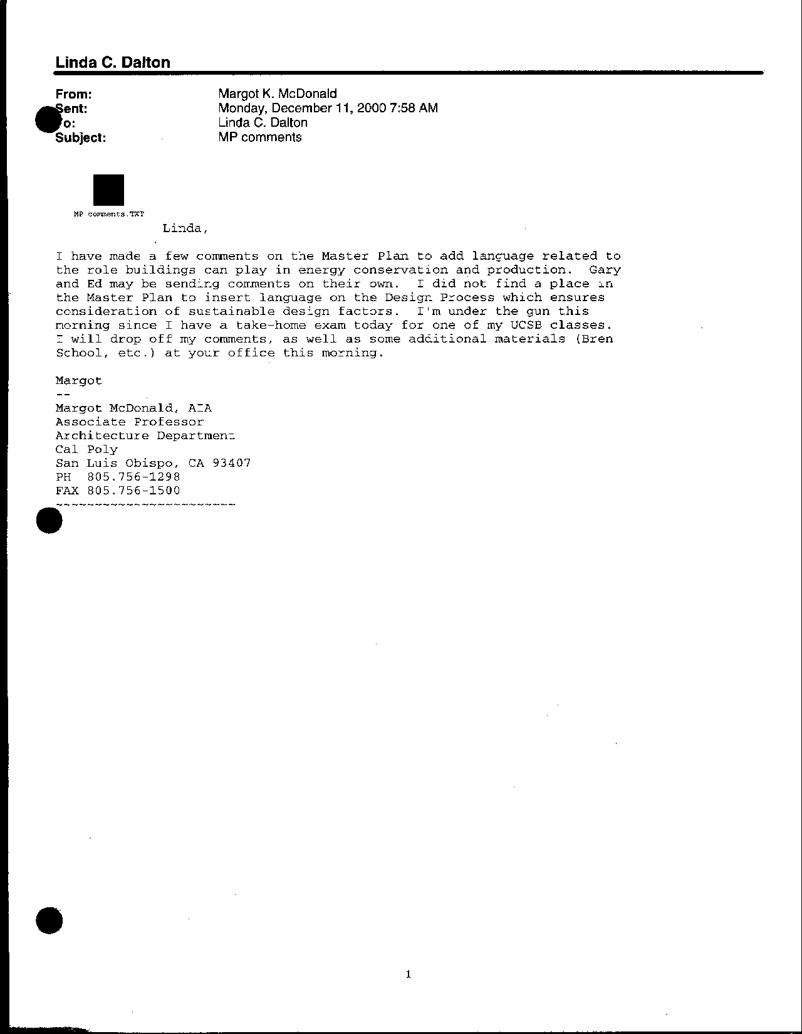
Letter 49
Letter 49

Donna Duerk

Dept. of Architecture

December 8, 2000

49-1 Commenter suggests a number of changes to the text of the Master Plan to strengthen sustainable building practices, specifically on pages viii, 4, 48, 64, 65, and 91 (pages per the October 10, 2000 Plan).

Response These changes have been incorporated into the plan. None of these recommendations raise environmental issues. See text additions on pages viii, 50, 68, 69, and 95 (January 23, 2001 Master Plan).

49-2 Commenter suggests the need to edit the text to strengthen sustainable building practices in additional locations, specifically on pages 1, 3 and 60 (pages per the October 10, 2000 Plan).

Response Wording change is not suitable in this location, but the intent is captured elsewhere in the Master Plan.

49-3 Commenter suggests the need to edit the text to strengthen sustainable building practices in additional locations, specifically on pages 24 and 28 (pages per the October 10, 2000 Plan).

Response It is not appropriate to change wording in this location because the language in this section is from a report of the Deans’ Enrollment Planning Advisory Committee.

49-4 Commenter provides editing suggestions to the Long-Range Enrollment Scenarios chapter to strengthen sustainable building practices.

Response Wording change is not suitable in this location. –However, it is addressed in a detailed text addition to the Public Facilities and Utilities element. See pp. 162-163. This section begins with the statement that “Site selection, site planning and building design should account for solar exposure, prevailing wind direction, and patterns of light and shade to minimize energy requirements and enhance the quality of outdoor space.” Further, an addition to the University Land Uses element states that “Other plan elements that involve development, such as Outdoor Teaching and Learning, Residential Communities, Parking, and Ancillary Activities and Facilities, do not repeat either these aesthetic or sustainability principles. Nevertheless, it is the intention of the Master Plan that they be applied to all campus development” (p. 79).

49-5 Commenter suggests that Cal Poly needs to assess sustainability of existing conditions.

Response This suggestion is being added to the list of implementation studies (Chapter 7).

49-6 Commenter suggests adding a discussion of water as a resource for irrigation, etc.

Response This is covered on the next page under Agriculture Facilities and Resources (p. 49).

49-7 Commenter challenges sewer capacity.

Response The sewer capacity stated is from discussions with Ed Johnson, Utilities Coordinator for Cal Poly.

49-8 Commenter has questions about firmness of student housing sites, other land uses.

Response Board of Trustees will be approving land use designations and tentative future building sites; nevertheless, each project will require detailed site planning.

49-9 Commenter suggests the need for a discussion of levels of environmental stewardship in the Natural Environment element.

Response This is incorporated in the Natural Environment principles (p. 82).

49-10 Commenter calls for adding discussion of sustainable planning and building in campus core.

Response See new integrated discussion at end of Land Use and Public Facilities and Utilities elements, as noted above (response to comment 49-4).

49-11 Commenter recommends that the campus consider integration of energy and resource recovery facility with agricultural facilities.

Response Again, see new integrated discussion at end of Public Facilities and Utilities element. It concludes: “Several opportunities for resource recovery projects with educational and research potential as well as operational value include water supply and waste treatment for animal facilities, enhancement of Brizzolara Creek and the construction of new student residential communities” (p. 163).

49-12 Commenter recommends that the campus consider integration of energy and resource recovery facility with student housing in Brizzolara Creek area.

Response Again, see new integrated discussion at end of Public Facilities and Utilities element (p. 163).

49-13 Commenter suggests adding a discussion of sustainable planning and building practices as they apply to development areas in the Campus Instructional Core.

Response See new integrated discussion at end of Land Use and Public Facilities and Utilities elements, as noted above (response to comment 49-4).

49-14 Commenter suggests including section views of site to show topography.

Response Implementation studies for the Southwest area will address topography.

49-15 Commenter asks that the campus apply environmental responsibility principles to student housing development.

Response See new integrated discussion at end of Land Use and Public Facilities and Utilities elements, as noted above (response to comment 49-4).

49-16 Commenter recommends that the campus consider water recovery and recycling as part of Brizzolara Creek enhancement (repeat comment).

Response Again, see new integrated discussion at end of Public Facilities and Utilities element (p. 163).

49-17 Commenter indicates the need to address water quality/run-off from Sports Complex.

Response Cal Poly has prepared a Turf Management Plan for the Sports Complex (2000), which addresses water quality impacts from the facility and provides for long-term testing of runoff. Please contact the Cal Poly Landscaping Department or Crawford Multari and Clark Associates for more information.

49-18 Commenter suggests additions to infrastructure capacity and distribution section.

Response Wording changes are not suitable in this location - rather later in Public Facilities and Utilities element. See new integrated discussion on pp. 162-163.

49-19 Commenter indicates support for principles in Public Facilities and Utilities element; urges implementation.

Response No response required.

49-20 Commenter seeks addition of ADA considerations to pedestrian circulation design and orientation.

Response See text addition and clarification to Circulation principles as follows: “At the same time, pedestrian routes must be accessible for people with disabilities of all types and under a range of weather conditions” (p. 168).

49-21 Commenter appends material on sustainability.

Response Acknowledged and appreciated.

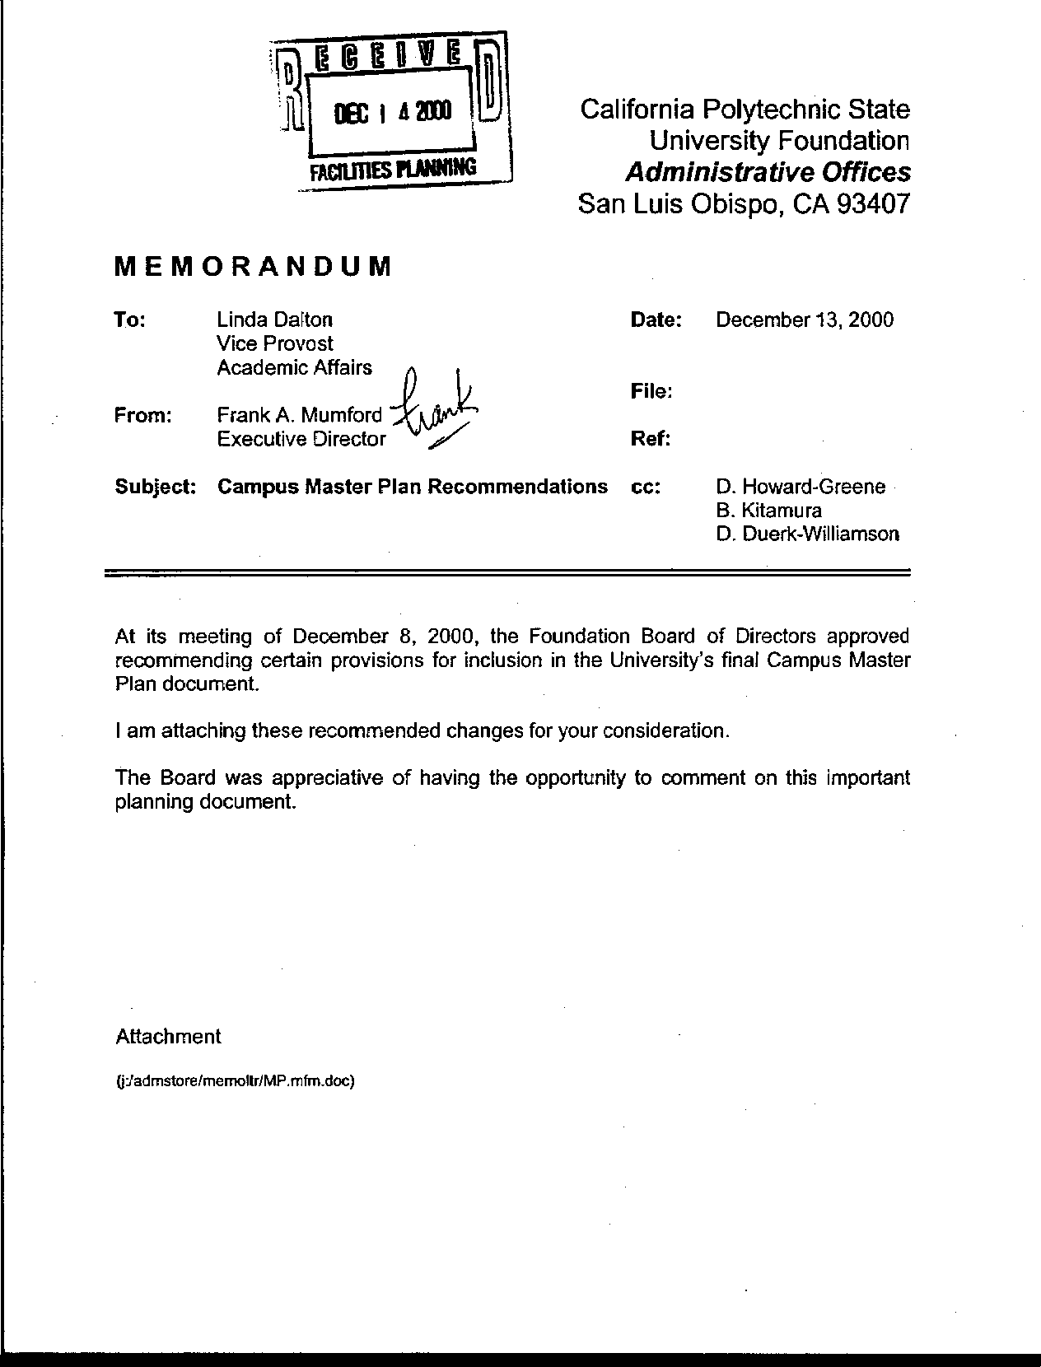
Letter 50
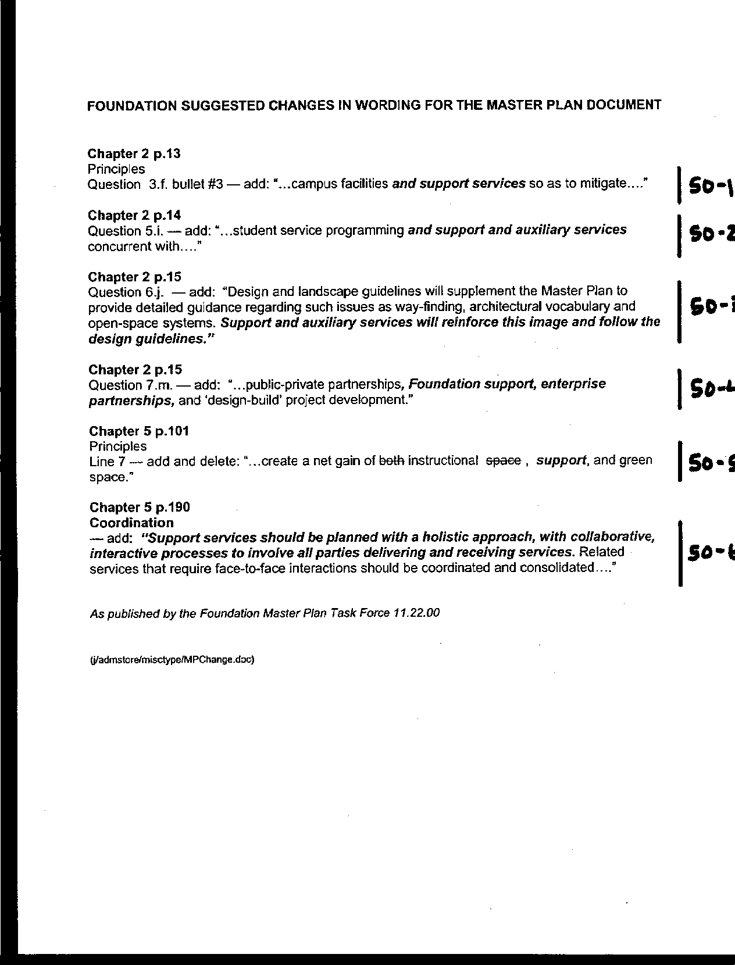
Letter 50
Letter 50

Frank Mumford, Executive Director

Cal Poly Foundation

December 13, 2000

50-1 The Foundation Board of Directors recommended several text amendments to the Master Plan.

Response All of the amendments have been incorporated into the plan. None of these recommendations raise environmental issues. See text additions.

50-2 Add "and support and auxiliary services".

Response See text additions at page 15 and 16.

50-3 Add acknowledgement of design guidelines by support and auxiliary services.

Response See text addition at page 17.

50-4 Add "Foundation support, enterprise partnerships"

Response See text addition at page 17.

50-5 Add "support" space

Response See text addition at page 106.

50-6 Add discussion of planning for support services

Response See text addition at page 200.

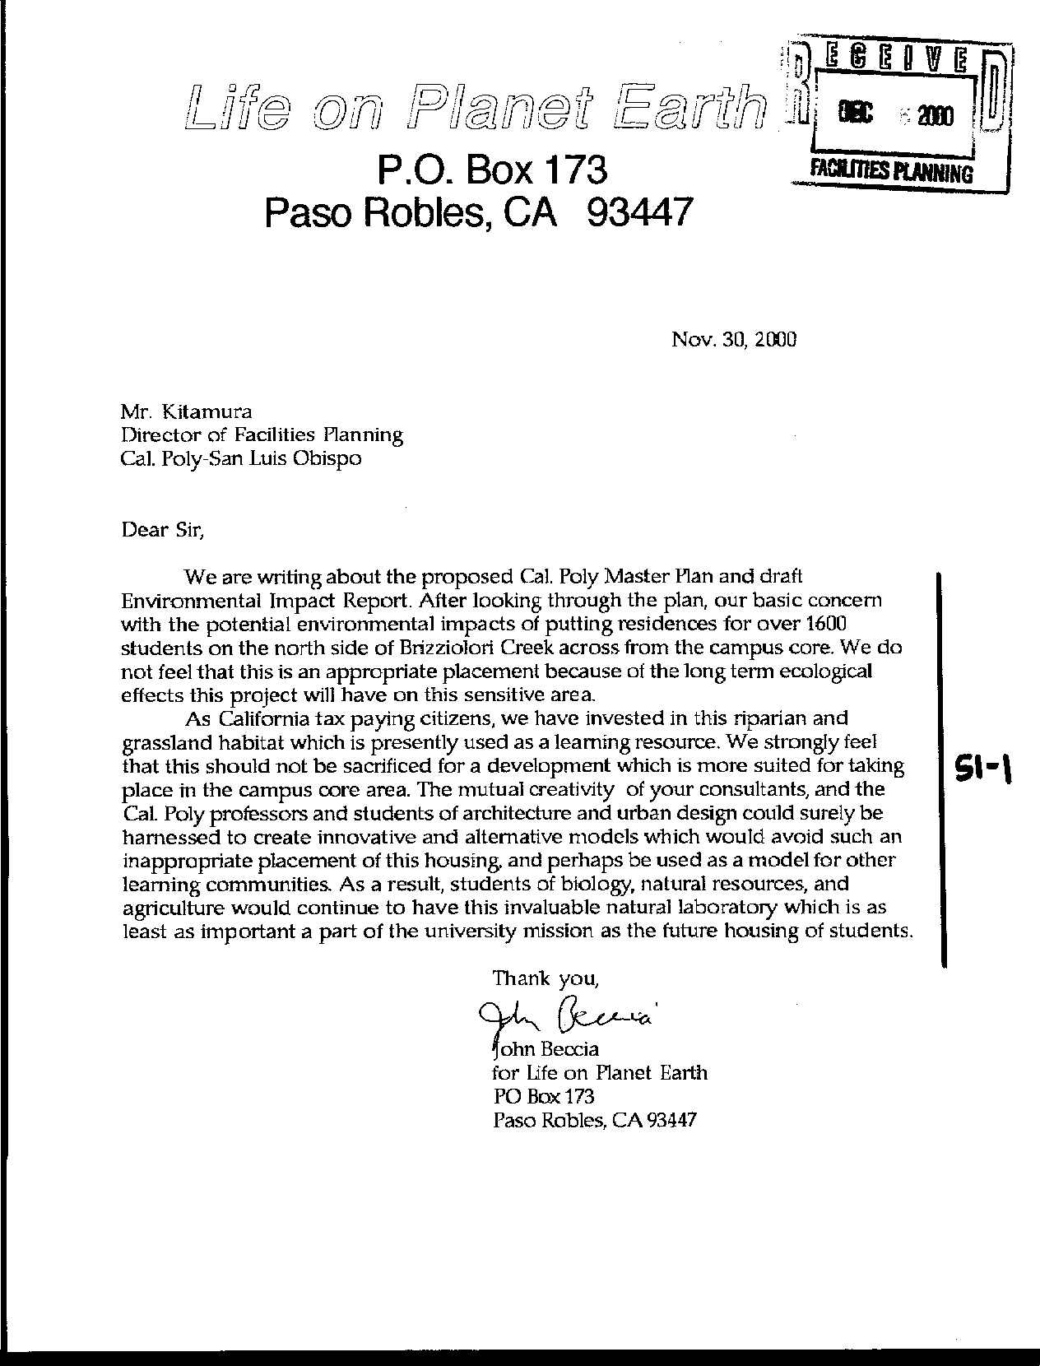
Letter 51

John Beccia

Life on Planet Earth

November 30, 2000

51-1 Commenter’s organization is concerned with the placement of housing (1,600 students) on the north side of Brizzolara Creek and the resulting environmental impacts.

Response Concerns are noted. The Master Plan team made extensive efforts to relocate the H-1 and H-2 housing units at a suitable distance from the creek corridor that resulted in the creation of the Brizzolara Creek Enhancement Project and the re-adsorption of units initially proposed for location along the creek (namely H-3). The additional beds were the result of partial absorption of the H-4 housing unit that could not be relocated in its entirety elsewhere on campus.
Letter 51

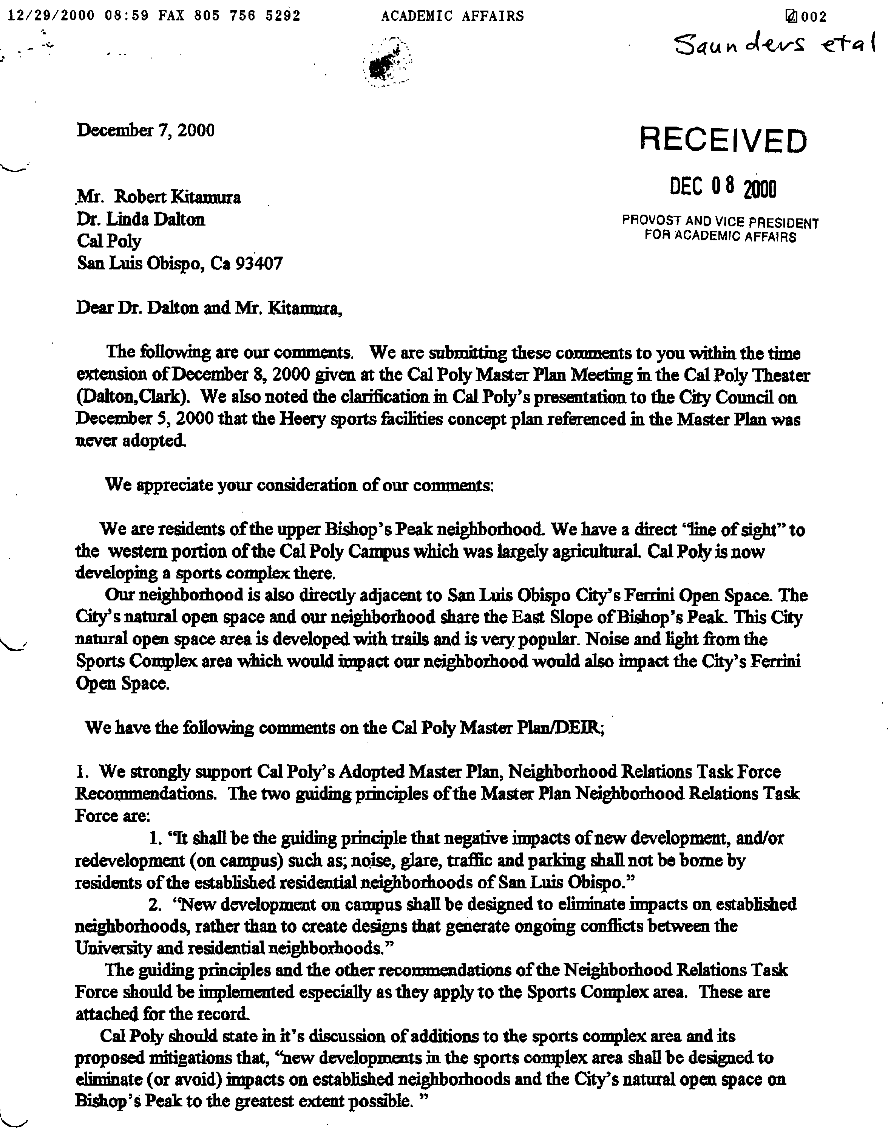
Letter 52

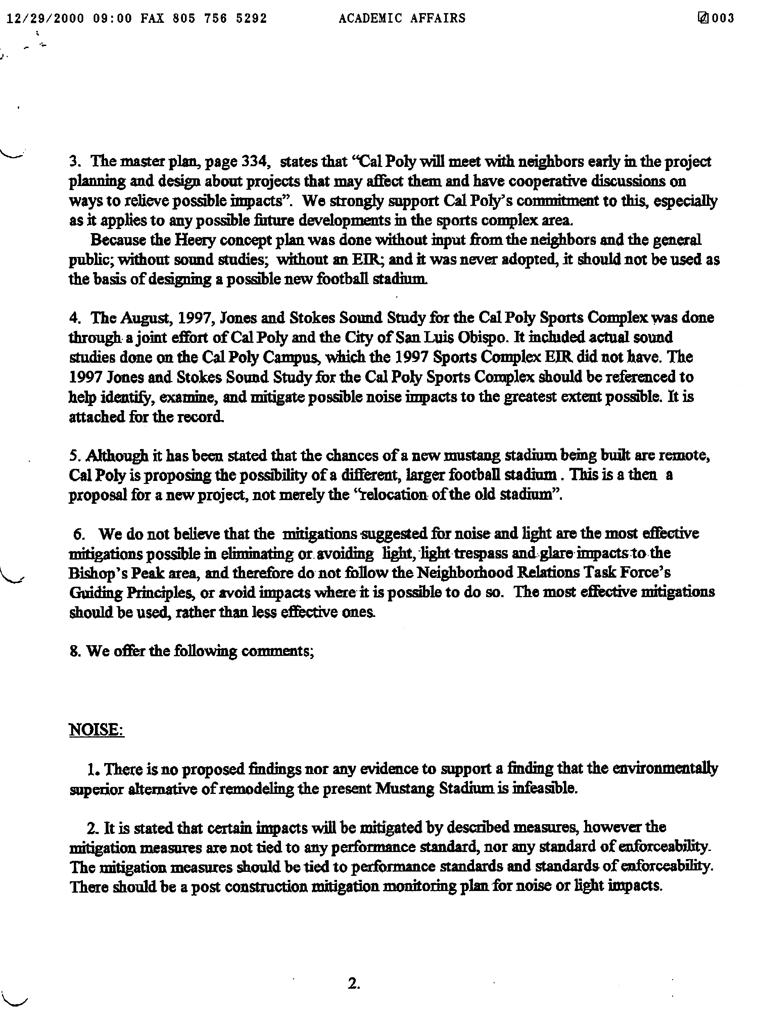
Letter 52

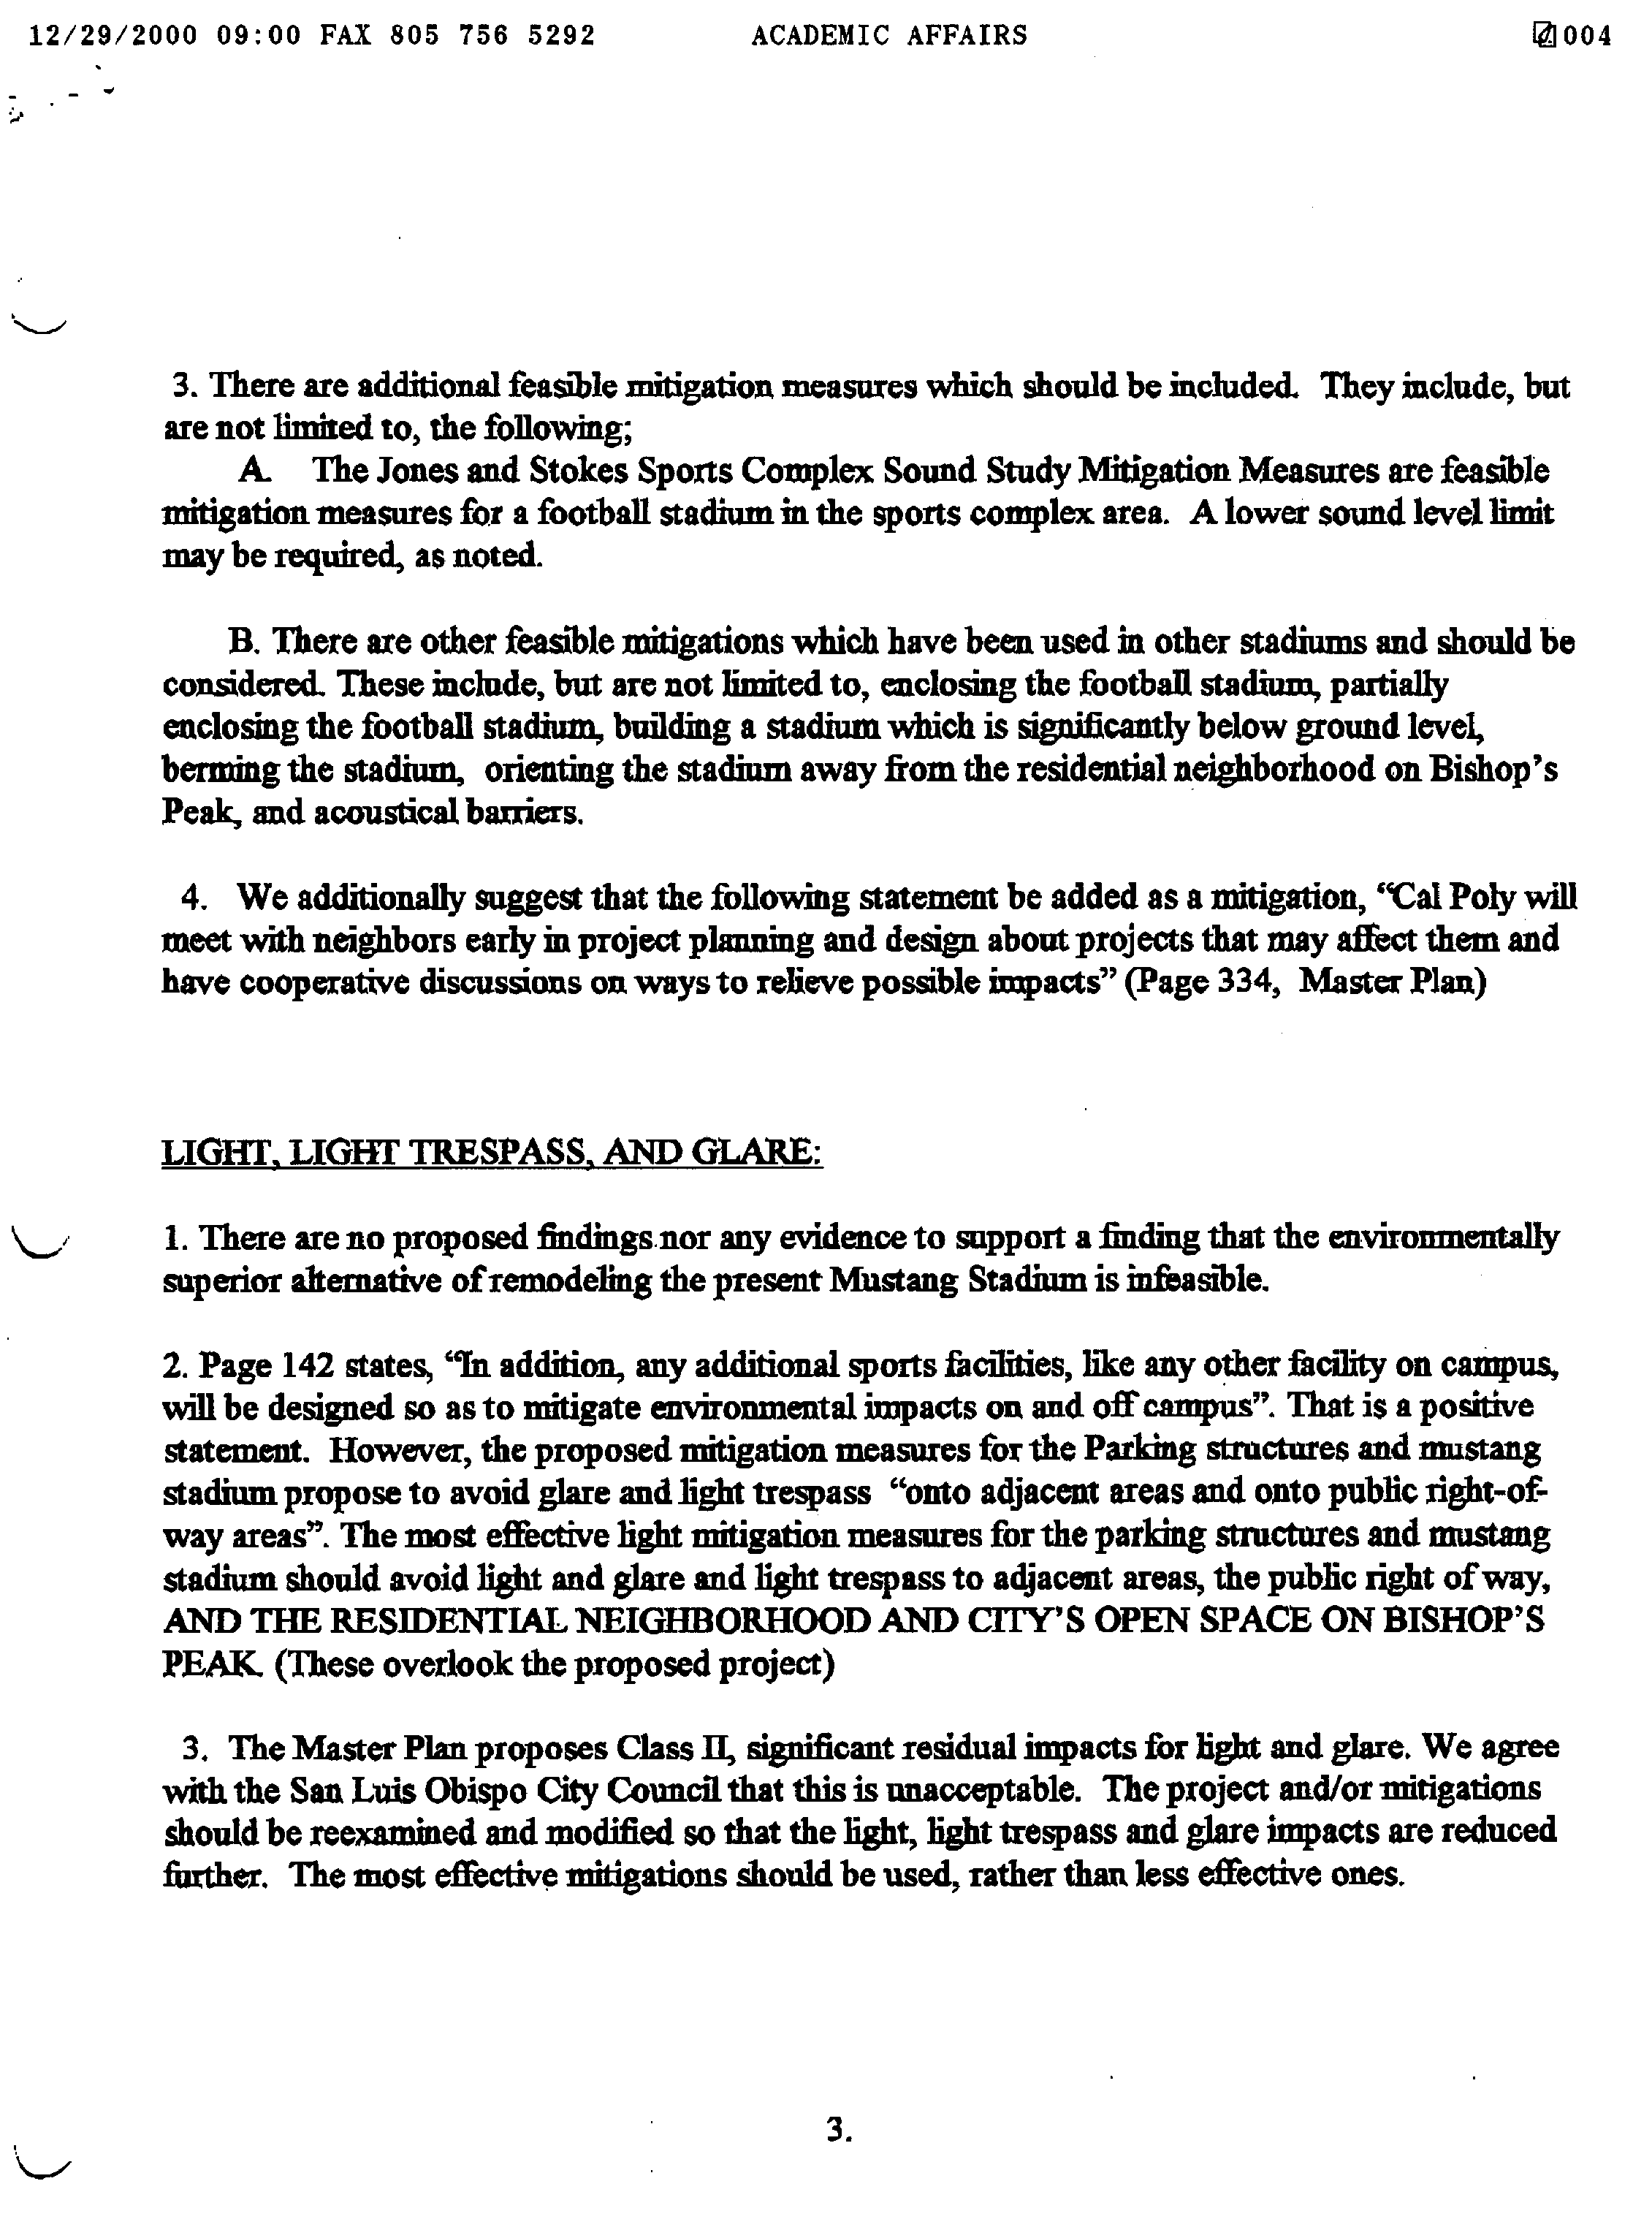
Letter 52

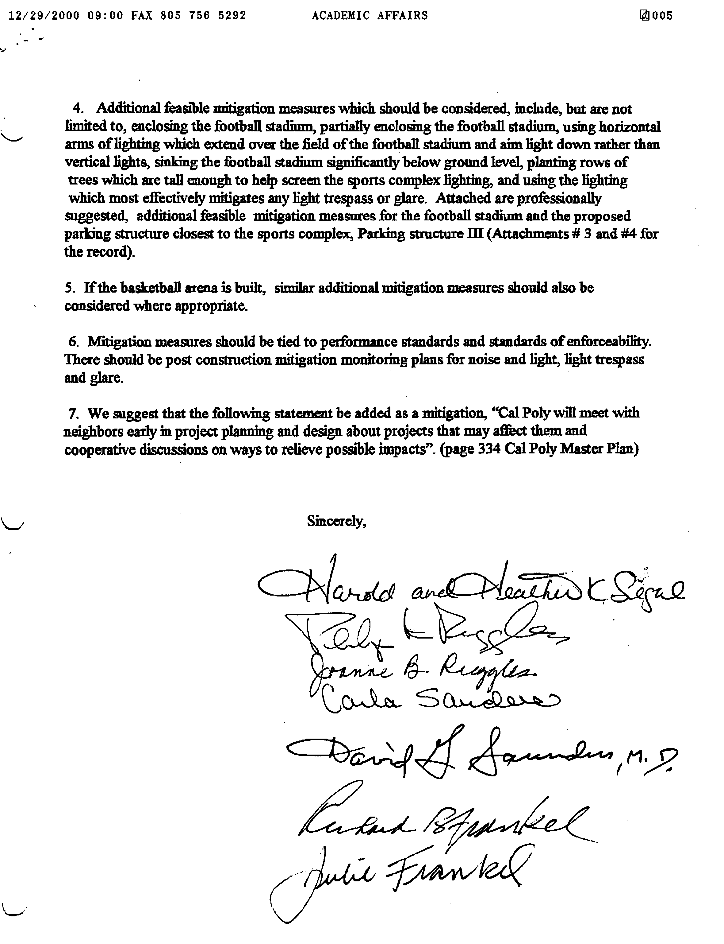
Letter 52
Letter 52
Letter 52
Letter 52
Letter 52
Letter 52
Letter 52
Letter 52
Letter 52
Letter 52
Letter 52
Letter 52
Letter 52
Letter 52
Letter 52
Letter 52

Letter 52
Letter 52

[neighbors]

Bishops Peak Neighborhood Association

December 8, 2000

52-1 Commenter urges implementation of guiding principles from Neighborhood Relations Task Force.

Response The text in the Guiding Framework now reads: “Planning future campus facilities and support services so as to minimize and mitigate environmental impacts on and off campus to the full extent feasible as part of project design” (p. 15).

52-2 Commenter suggests specific language to mitigate impacts in sports complex area.

Response While the recently opened Sports Complex is not a component of the Master Plan update, there are numerous principles that apply to any further development of this type. With respect to any future development in the area around the Sports Complex, text has been added as follows: “Particular consideration will be given to minimizing impacts on established neighborhoods and public open space” (p. 150).

52-3 Asks that Heery plan not be used as a basis for any future football stadium location/design

Response Although the Heery plan offers guidance the provision of future recreational facilities on campus, it does not necessarily guide design; comment is noted for future reference. The Heery plan will not be used for the stadium design. The location in the Heery Plan for Mustang Stadium is consistent with the Master Plan stadium alternative location, should the stadium move.

52-4 Commenter requests reference 1997 Jones and Stokes sound study be made in EIR and plan.

Response The Jones and Stokes study has been cited in the bibliography. A summary of its findings have been incorporated into the discussion of the Mustang Stadium relocation alternative. The Master Plan text has been modified to include references to the Jones and Stokes sound study as well (see pp. 150 and 152).

52-5 Commenter suggests the plan consider the possible future football stadium as new project since it is not just a relocation of same size facility.

Response Comment noted. If Mustang Stadium were to move, it would require additional environmental analysis. Note that the refurbishment of the current Mustang Stadium has been clarified in the Master Plan as the most appropriate current option (see p. 151).

52-6 Commenter suggests the need for more effective mitigation for noise.

Response The Jones and Stokes study has been cited in the bibliography. A summary of its findings have been incorporated into the discussion of the Mustang Stadium relocation in the EIR.

52-7 Commenter requests the plan address feasibility of remodeling Mustang stadium (compare noise impacts.)

Response The refurbishment of the current Mustang Stadium has been added to the Master Plan as an alternative. The Jones and Stokes study provides the following guidance for expected noise levels at the stadium location:

“The results of the sound level projection analysis and the simulation test indicate that crowd sound and public address sound at levels anticipated from the stadia will not measurably increase A-weighted background sound levels in the neighborhoods of concern under cool, calm, weather conditions with clear skies. They also indicate that sounds from these sources will be barely audible depending on location. In addition, the results of the simulation test indicate that loud music (93-94 dBA and 100 feet) can be distinctly audible at locations that have a direct line of sight to the project site and can be barely audible at locations where there is intervening topography or structures. The test results also indicate that public address announcements at a level of 84 dBA at 100 feet can be audible at locations with a direct line of sight to the project site. The predominant winds out of the northeast will tend to increase sound transmission from the project site and could result in distinctly audible crowd and public address sound in the neighborhoods of concern. However, these types of conditions are usually unstable, intermittent, and short term in nature. In addition, temperature inversion conditions and the associated low cloud cover that would tend to increase sound transmission typically occur in July, August, and September and would not typically coincide with use of the stadia.”

52-8 Commenter suggests that noise and light mitigation must be monitored.

Response CEQA requires the development of a mitigation-monitoring plan, a condition of certifying the EIR and its measures. Future environmental work will be more specific to each project and will allow for identification of more concrete applications for mitigation measures.

52-9 Commenter recommends the Jones and Stokes and other studies for alternative noise mitigation.

Response Although the Jones and Stokes study was designed for the Sports Complex, it will be useful for future projects. Specific noise mitigation measures will be developed on a project-by-project basis. The Jones and Stokes study, in conjunction with additional studies, will be used for any modifications to Mustang Stadium, or any similar facility.

52-10 Commenter suggests adding working with neighbors as a component of noise mitigation.

Response See p. 348 where the University includes in its future communication principles that it will consult with neighbors prior to the development of any facility that could have negative impacts in their neighborhood.

52-11 Commenter suggests plan address feasibility of remodeling Mustang stadium).

Response This recommendation has been added to the plan, noting that the refurbishment of the current Mustang Stadium is the most appropriate current option (see p. 151).

52-12 Commenter suggests adding specific language to clarify mitigation of light and glare impacts on residential areas and open space.

Response Additional language includes the following: “As noise and light impacts are significant concerns, the campus will conduct further studies, like the Jones and Stokes Sound Study prepared in 1997 by the City and community for the Sports Complex.” And, further along in the same paragraph: “Particular consideration will be given to minimizing impacts on established neighborhoods and public open space” (p. 150).

52-13 Commenter calls for more effective mitigation for light and glare - Class II finding not acceptable based on proposed mitigation.

Response Additional mitigation has been added to the EIR. The essential change is that the Heery Plan will not necessarily be used for the design of any future facility, and certainly not for the football stadium (which is not proposed for relocation in this Master Plan).

52-14 Commenter offers suggestions for alternative, more effective mitigation of light and glare.

Response Additional mitigation has been added to the EIR. The essential change is that the Heery Plan will not necessarily be used for the design of any future facility, and certainly not for the football stadium (which is not proposed for relocation in this Master Plan).

52-15 Commenter suggests applying similar mitigation measures for light and glare if basketball arena is built.

Response Any sports facility constructed on campus will be subjected to additional environmental scrutiny. The mitigation developed in the Master Plan EIR will be applied to the Field House (basketball arena).

52-16 Commenter suggests noise and light mitigation must be monitored.

Response CEQA requires mitigation to be monitored through the mitigation-monitoring plan, a condition of adopting the EIR and its measures. Future environmental work will be more specific to each project and will allow for identification of more concrete applications for mitigation measures.

52-17 Commenter suggests adding working with neighbors as a component of light and glare mitigation.

Response See p. 348 where the University will consult with neighbors prior to the development of any facility that could have negative impacts in their neighborhood.
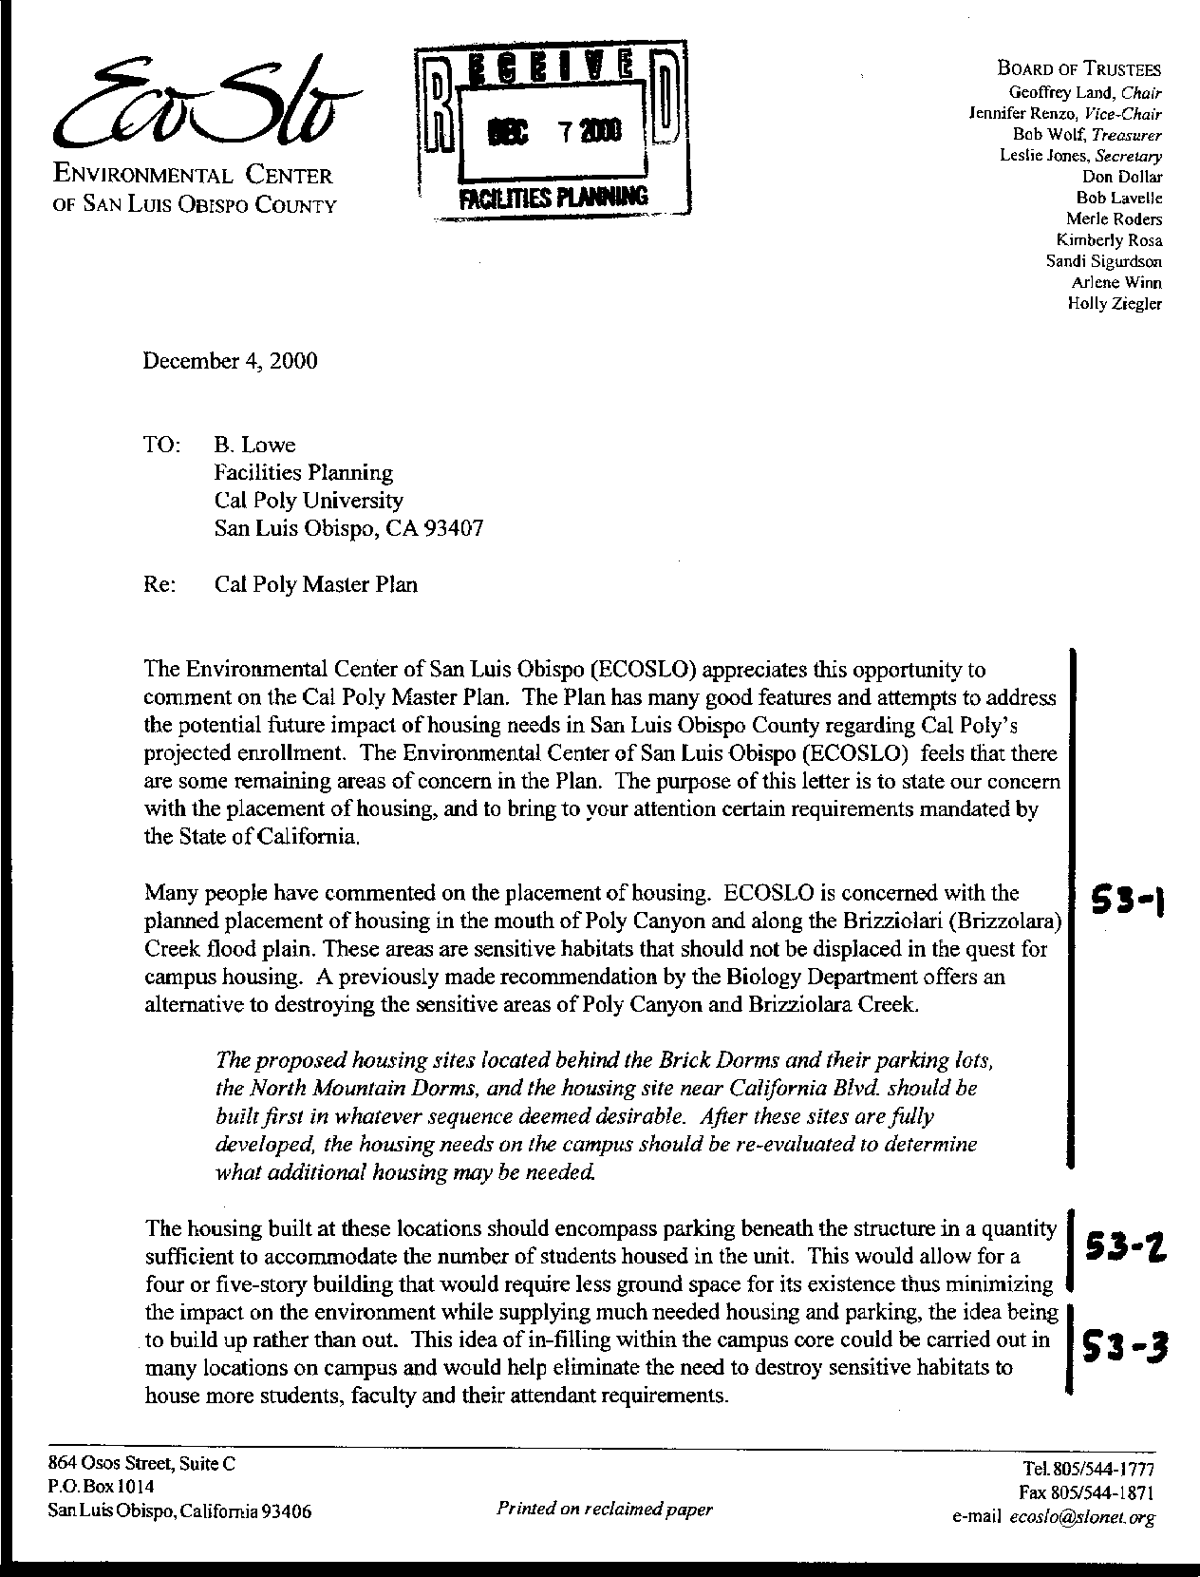
Letter 53
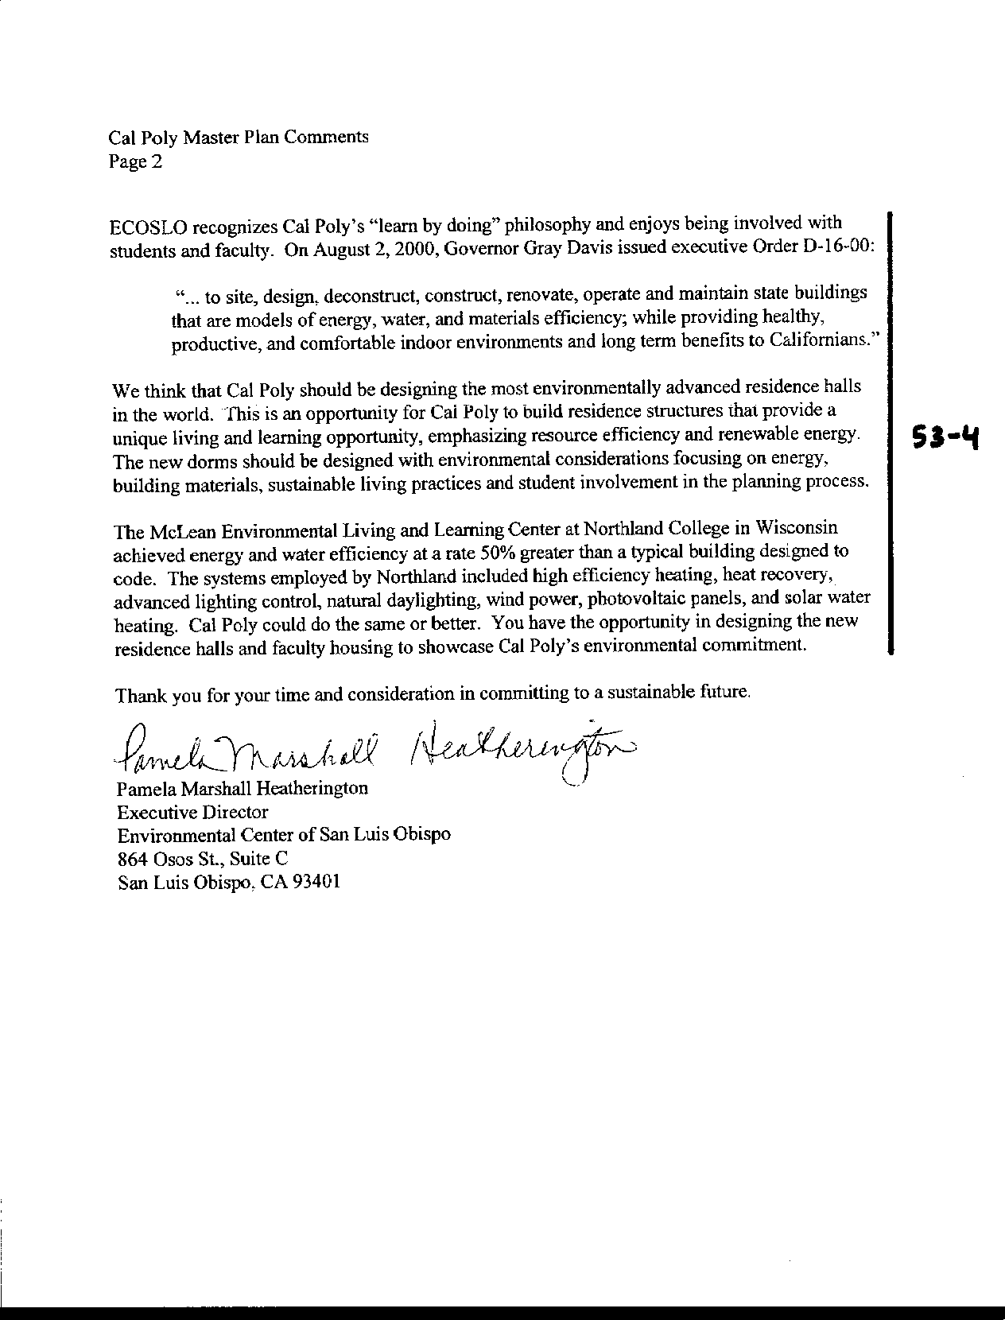
Letter 53
Letter 53

Pamela Heatherington

EcoSlo

December 4, 2000

53-1 The commenter suggests that the housing north of Brizzolara Creek should only be built after housing has been constructed at sites H-4, H-5, H-6 and H-7 (see Figure 5-9) and only if a reevaluation suggests the additional housing would be needed. This would protect sensitive habitats.

Response Concerns are noted. The Master Plan team made extensive efforts to relocate the H-1 and H-2 housing units at a suitable distance from the creek corridor that resulted in the creation of the Brizzolara Creek Enhancement Project and the re-adsorption of units initially proposed for location along the creek (namely H-3). The additional beds were the result of partial absorption of the H-4 housing unit that could not be relocated in its entirety elsewhere on campus.

53-2 The commenter suggests that housing provide parking underneath and be built upwards of four and five stories to reduce the need for land.

Response Several commenters have suggested the University develop housing in a more compact form to save land, especially through the use of taller buildings – “up not out.” Housing on campus was designed to meet several parameters. One was to avoid the development of high-rises. Student housing is effective when it provides an atmosphere of community. This requires air and open recreation space, as well as a connection to everyday living patterns. Taller structures create a disconnection from the student to the student community. In addition, taller structures increase the risk of catastrophe from fire or seismic events. Nevertheless, the proposals are compact, at a density equal to or greater than that elsewhere on campus. Furthermore, a constraints analysis undertaken at the outset of the Master Plan process identified areas appropriate for housing development. The housing proposals are consistent with that analysis. See Constraints and Opportunities analysis. Where feasible, the Master Plan calls for “integration of parking into structures at ground level or below” (page 195).

53-3 The commenter suggests Cal Poly should adhere to principles of building sustainability in all future development, becoming a model for the community. Use infill sites for housing

Response Additional text has been added on pp. 162-163, as follows. Site selection, site planning and building design should account for solar exposure, prevailing wind direction, and patterns of light and shade to minimize energy requirements and enhance the quality of outdoor space. Design guidelines and processes for implementing the Master Plan should encourage energy efficient building design and resource conservation. The campus landscape plan should consider the impact of vegetation and water use on the resource efficiency of facilities and the creation of comfortable and functional outdoor space.

Design for renovation of existing buildings and new construction should consider ways to maximize energy efficiency and take advantage of the mild climate in San Luis Obispo. Alternative, renewable energy sources should be used to the greatest extent possible to offset growth in demand. As costs escalate for traditional energy sources, other options to consider include integrated photovoltaics and solar generation for electricity, passive and low energy cooling strategies for buildings (including materials, solar control, natural ventilation, thermal mass), passive solar space and water heating, and effective use of day lighting. New buildings should be well ventilated using natural ventilation, and existing buildings should be retrofitted where feasible to make them usable and livable during the summer without requiring air conditioning.

Consistent with Cal Poly’s mission, the campus should explore an integrated approach to sustainable, or “green” design for research, education and operational applications in new and renovated buildings and in the campus landscape treatment. In addition to the energy conservation measures noted above, these efforts should address water conservation and reclamation, re-use of materials and products, and life-cycle costing in general. Several opportunities for resource recovery projects with educational and research potential as well as operational value include water supply and waste treatment for animal facilities, enhancement of Brizzolara Creek and the construction of new student residential communities.

53-4 Commenter suggests becoming a model for advanced environmental design.

Response The following text has been added to the University Land Uses element, p. 79. Several of the plan elements contain principles and recommendations to guide future building and landscape design so as to achieve healthy, productive and comfortable indoor and outdoor environments. The Campus Instructional Core element provides the most direction with respect to design principles such as Sense of Place, Compactness, and Visual Continuity. It also includes a section specifying how a green space plan and a landscape plan should be developed as implementation studies. In addition to establishing aesthetic and user-sensitive design, the Master Plan is concerned with energy efficiency and resource conservation. The Public Facilities and Utilities element covers these characteristics of campus development. Other plan elements that involve development, such as Outdoor Teaching and Learning, Residential Communities, Parking, and Ancillary Activities and Facilities, do not repeat either these aesthetic or sustainability principles. Nevertheless, it is the intention of the Master Plan that they be applied to all campus development, including projects undertaken by campus auxiliaries, the Foundation and Associated Students, Inc. As the building and landscape design guidelines are developed, they will take into account the different features of different parts of campus, particularly, the Campus Instructional Core, agricultural facilities in the extended campus, and residential communities.

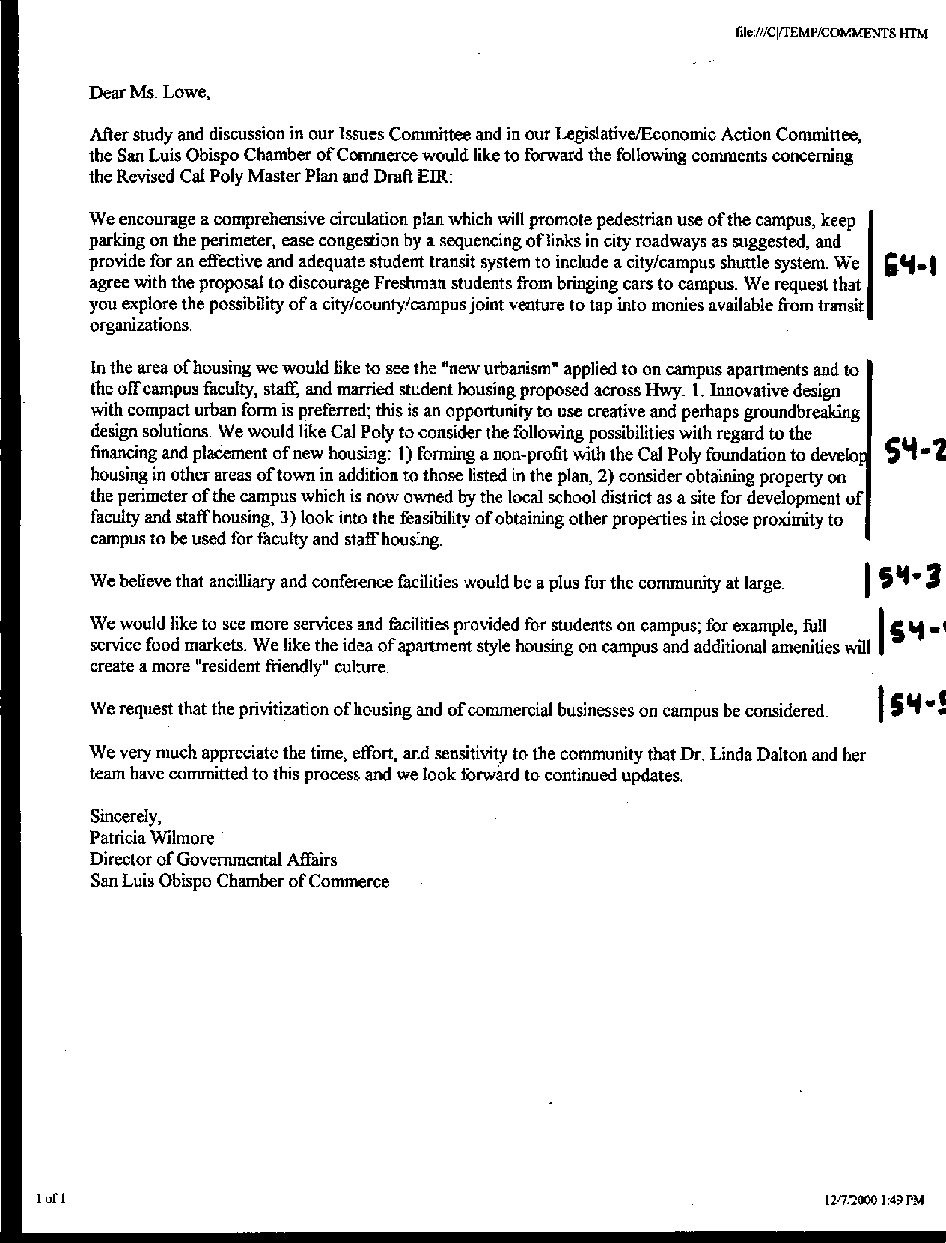
Letter 54
Letter 54

Ms. Patricia Wilmore

San Luis Obispo Chamber of Commerce

December 7, 2000

54-1 Commenter offers support for circulation and parking proposals.

Response No response required; See Circulation, Alternative Transportation and Parking elements.

54-2 Commenter suggests applying "new urbanism" concepts to housing on campus.

Response Several of the plan elements contain principles and recommendations to guide future building and landscape design so as to achieve healthy, productive and comfortable indoor and outdoor environments. The Campus Instructional Core element provides the most direction with respect to design principles such as Sense of Place, Compactness, and Visual Continuity. It also includes a section specifying how a green space plan and a landscape plan should be developed as implementation studies. In addition to establishing aesthetic and user-sensitive design, the Master Plan is concerned with energy efficiency and resource conservation. The Public Facilities and Utilities element covers these characteristics of campus development. Other plan elements that involve development, such as Outdoor Teaching and Learning, Residential Communities, Parking, and Ancillary Activities and Facilities, do not repeat either these aesthetic or sustainability principles. Nevertheless, it is the intention of the Master Plan that they be applied to all campus development, including projects undertaken by campus auxiliaries, the Foundation and Associated Students, Inc. As the building and landscape design guidelines are developed, they will take into account the different features of different parts of campus, particularly, the Campus Instructional Core, agricultural facilities in the extended campus, and residential communities.

54-3 Commenter recommends land and financing options for student, faculty and staff housing.

Response See additional language regarding project financing on page 346: “…to the extent possible, the University should explore a range of alternatives, such as public-private partnerships, Foundation support, enterprise partnerships and collaborative ‘design-build’ project development techniques.”

54-4 Commenter offers support for ancillary and conference facilities.

Response No response required; see pp. 205-206.

54-5 Commenter offers support for services and facilities on campus for student residents.

Response No response required; See also a new section on Commercial Retail Services (pp. 202-203), cited below in response to comment 54-6.

54-6 Commenter requests consideration of "privatization" of housing and commercial services on campus.

Response As planning for an increased range and volume of services occurs, the campus will need to determine which it should offer directly and which might be provided through franchise or “privatization.” The vision of the Master Plan calls for a primary campus activity center near the University Union that is focused on students. Thus, the range of retail businesses and other activities would remain specialized and not constitute a full urban commercial center. Cal Poly understands that there is a delicate balance in determining how much of what services will be sufficient to support the campus community and manage commuting. Effective alternative transportation will allow students, faculty, and staff – as well as members of the broader community – to take advantage of the range of services and facilities both on and off campus without adding to traffic congestion. The Cal Poly Foundation is presently the exclusive provider of certain services – e.g., food service, vending machines and bookstore. Other services compete for campus outlets – e.g., travel service, ATMs. As planning for an increased range and volume of services occurs, the campus will need to determine which it should offer directly and which might be provided through franchise or “privatization.”

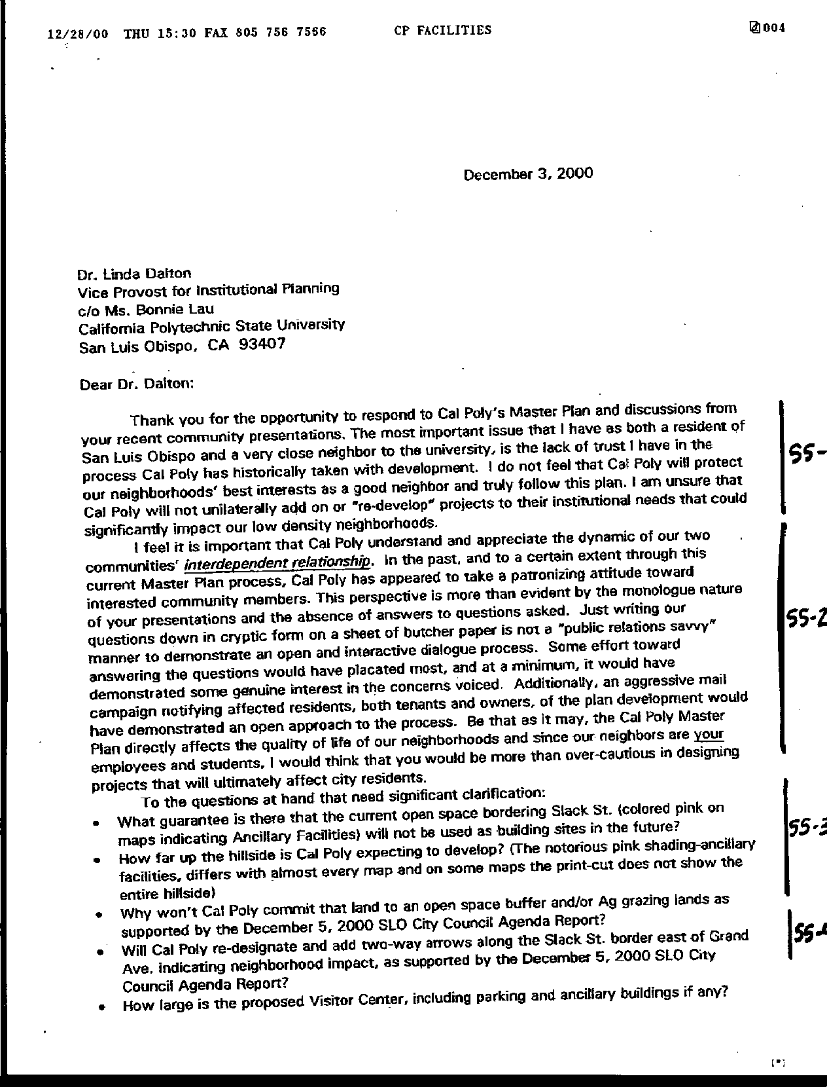
Letter 55
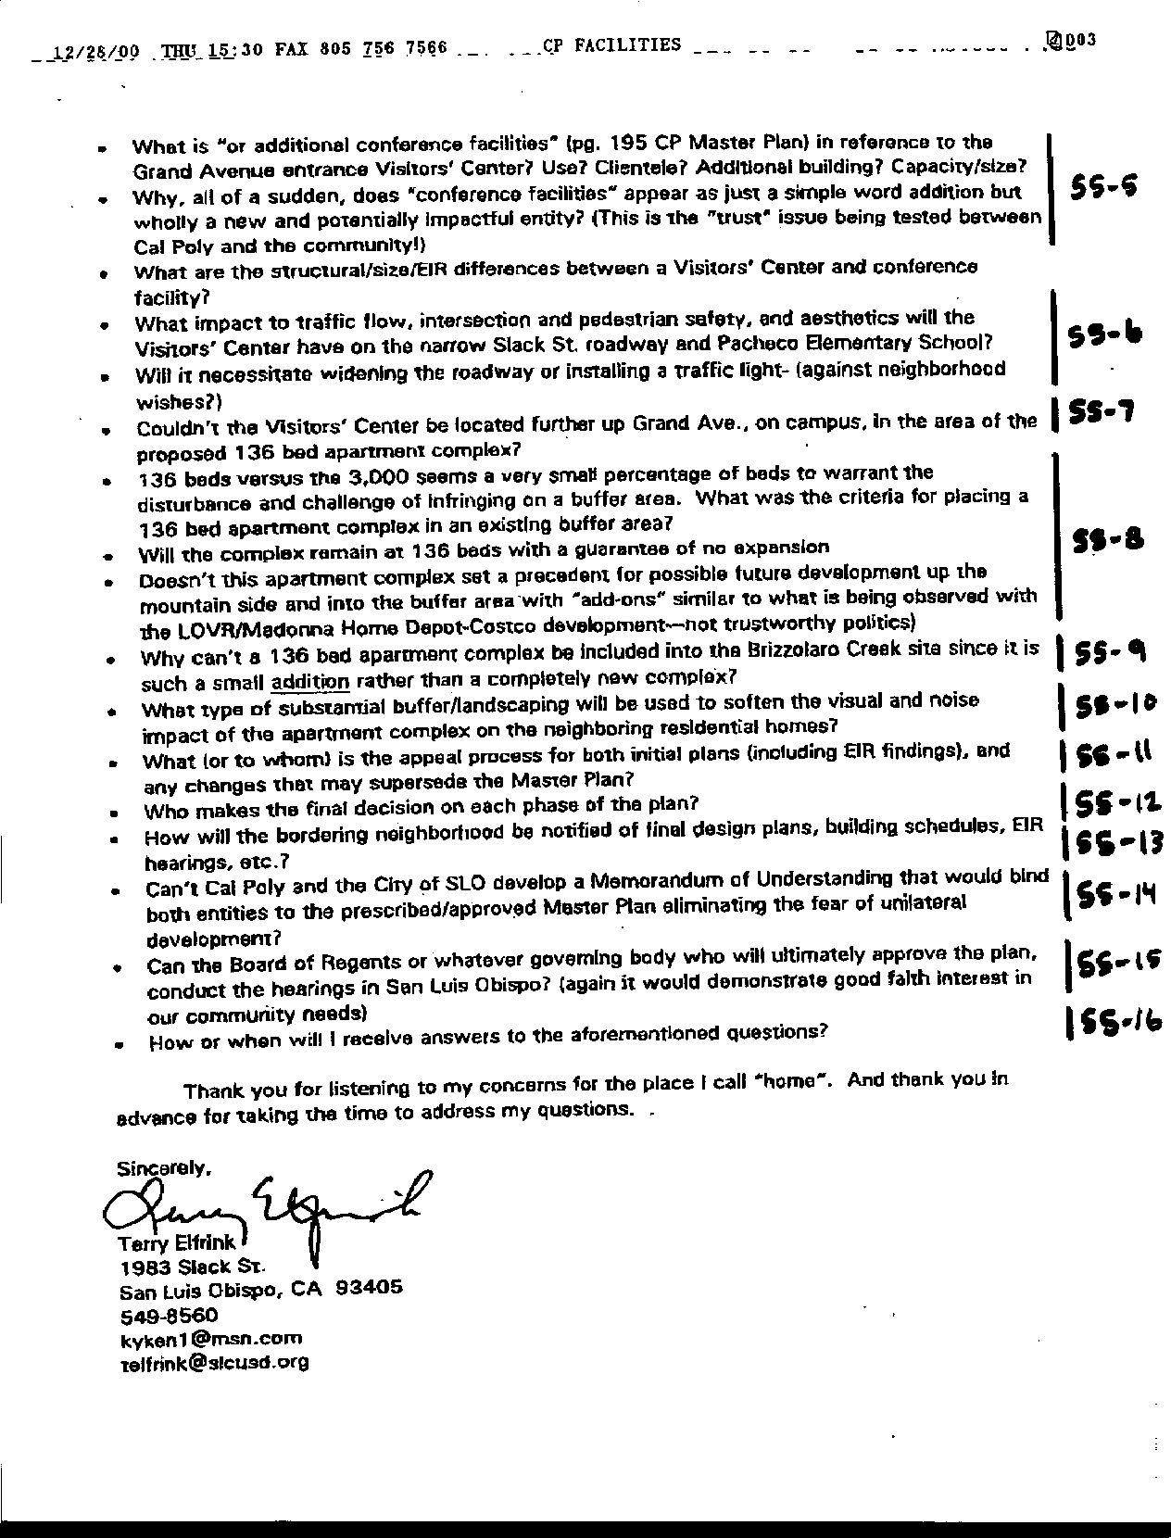
Letter 55
Letter 55
Mr. Terry Elfrink

December 8, 2000

55-1 Commenter notes his distrust of Cal Poly's planning process.

Response Comment noted. See discussion of process in Introduction and Task Forces in Chapter 2.

55-2 Commenter requests more notice and greater consideration of neighbors by Cal Poly.

Response As part of the Communication and Consultation section of Chapter 7, the Master Plan provides for early meetings with neighbors so as to design projects to relieve potential impacts.

55-3 Commenter seeks greater specificity of development potential at Slack and Grand.

Response Exhibit i shows a more limited development area and adds a buffer. The area beyond the ancillary designation will remain “Outdoor Teaching and Learning,” consistent with the grazing activities there.

55-4 Commenter makes request for recognition of potential neighborhood impacts along Slack Street.

Response A double arrow has been moved on Exhibit 4.10 to the east of Grand Avenue to indicate potential neighborhood conflicts.

55-5 Commenter requests that the plan clarify the Visitor Center site and conference facility expectations at Grand and Slack.

Response The building outlines are shown on Exhibit 5.7 and on a graphic at page 207. These are only conceptual, as project designs will be developed later. However, they do identify the relative size and scope of a visitor center. Further, new text on page 206 provides the following clarification of expectations:

“The most commonly mentioned ancillary activities include a visitor center, conference center, and applied research park. This section explores the nature of each briefly; however, each would require further detailed analysis at such time as a specific proposal is made.

“A visitor center would provide a facility to welcome guests to the campus. It could include a station where visitors could obtain parking permits, campus maps, and directions to their destinations. The visitor center could serve as the starting point for campus tours conducted by Poly Reps. It could also include a small exhibit covering Cal Poly’s history and accomplishments.

“No detailed program has been suggested for a conference center, yet the idea has been studied several times and continues to arise. Presently, Cal Poly’s Conference Services use regular campus facilities during times that they are not scheduled for instruction, and house attendees in some of the residence halls during the summer. The Master Plan calls for an expansion of alumni services near the present Alumni House, which may include small conference or retreat facilities. In addition, the area near Grand Avenue and Slack Street has been suggested for potential conference facilities. Cal Poly will continue to use its residence halls during the off season to support conferences.”

55-6 Commenter seeks clarification on traffic impacts of Visitor Center on Grand Avenue.

Response A visitor center would most likely have the effect of reducing the distance existing visitors would have to travel into the campus. Grand Avenue would have only minimal impacts from the proposed project. Access will not be provided off of Slack Street. Future environmental review will also address this topic.

55-7 Commenter requests the plan consider relocating Visitor Center further onto campus.

Response A map change (Exhibit 5.7) shows a different orientation of the Visitor Center and adds a buffer. This is an excellent site for a visitor center, an activity that should have very little effect on the neighborhood.

55-8 Commenter asks for the basis of locating 136 beds at the northeast corn of Slack Street and Grand Avenue - and is that a maximum number that may be built there? Why not elsewhere?

Response The site was selected because it is adjacent to existing student housing, and the tree-lined swale to the south will continue to serve as a buffer. The number of beds represents one estimate of how many units could be built on the site; however, the specific number of students housed will depend on building type and will be determined by more detailed feasibility analysis. Significant changes to this proposal would require a Master Plan amendment from the Board of Trustees. This site was chosen in part to reduce the potential impacts to Brizzolara Creek. Commenter is directed to see Land Use element - Compatibility principle on page 69, proposing buffers between residential neighborhoods and on-campus student residences.

55-9 Commenter asks why the 136-bed complex cannot be moved to the Brizzolara Creek area.

Response The Master Plan team was presented with its greatest challenge when it sought to fulfill the policy of housing all new enrollment on campus. The density assigned to all new housing equals or exceeds that of existing housing on campus. The earlier draft of the plan had considerably more housing near Brizzolara Creek. In order to allow for the enhancement of the creek, the team looked elsewhere to meet the mandate. The area near Slack Street and Grand Avenue is relatively low quality soil, therefore not great for agriculture, is low in biological resources, and has a relatively flat gradient, all of which contribute to it being an excellent site for campus development. However, concern with neighborhood impacts led the team to keep housing to the north of the large swale, behind a natural screen, and to limit the development near Slack Street to non-residential activities. The revised map shows the limits of the area designated for student housing in the Master Plan.

55-10 Commenter requests information on mitigating visual and noise impacts of new student housing.

Response A substantial buffer is currently provided for the complex by the vegetated drainage swale bisecting the site. Additional landscaping to screen light and noise will likely be a part of the project mitigation when proposed.

55-11 Commenter asks about the review and appeal process for the plan and specific developments.

Response The Master Plan will be forwarded to the California State University Board of Trustees for approval and EIR certification at their March 2001 meeting. This will be conducted as a public hearing. Appeal from their decision is to the Superior Court. Subsequent filing to the Board will occur as the development plans are prepared and processed.

55-12 Commenter asks who makes the final decision on each phase of the plan.

Response See response 55-11 above. The Board of Trustees has final decision-making authority over the Master Plan and the individual projects proposed within it.

55-13 Commenter asks how notification will take place for neighbors regarding any development, EIRs, etc. near Grand Avenue and Slack Street.

Response As part of the Communication and Consultation section of Chapter 7, the Master Plan provides for early meetings with neighbors who may be impacted by a campus project. Chapter 7 also addresses future environmental review.

55-14 Commenter requests the City and Cal Poly enter into a Memorandum of Understanding to avoid concerns of unilateral actions.

Response As part of the Communication and Consultation section of Chapter 7, the Master Plan includes provision for consultation with elected officials and local and regional agencies. The University has no provision or current intent to enter into a general Memorandum of Understanding with the City to limit its authority, especially in furtherance of its academic mission.

55-15 Commenter asks if the CSU governing body can meet in SLO.

Response The CSU Board of Trustees will hold their deliberations on the Cal Poly Master Plan as part of a much larger agenda at their March meeting, and, therefore, will not travel to San Luis Obispo for the discussion of the Plan.

55-16 Commenter asks how will he receive answers to his questions.

Response Responses will be included in FEIR as an appendix to Master Plan; individual commenters will receive correspondence noting responses to their concerns.
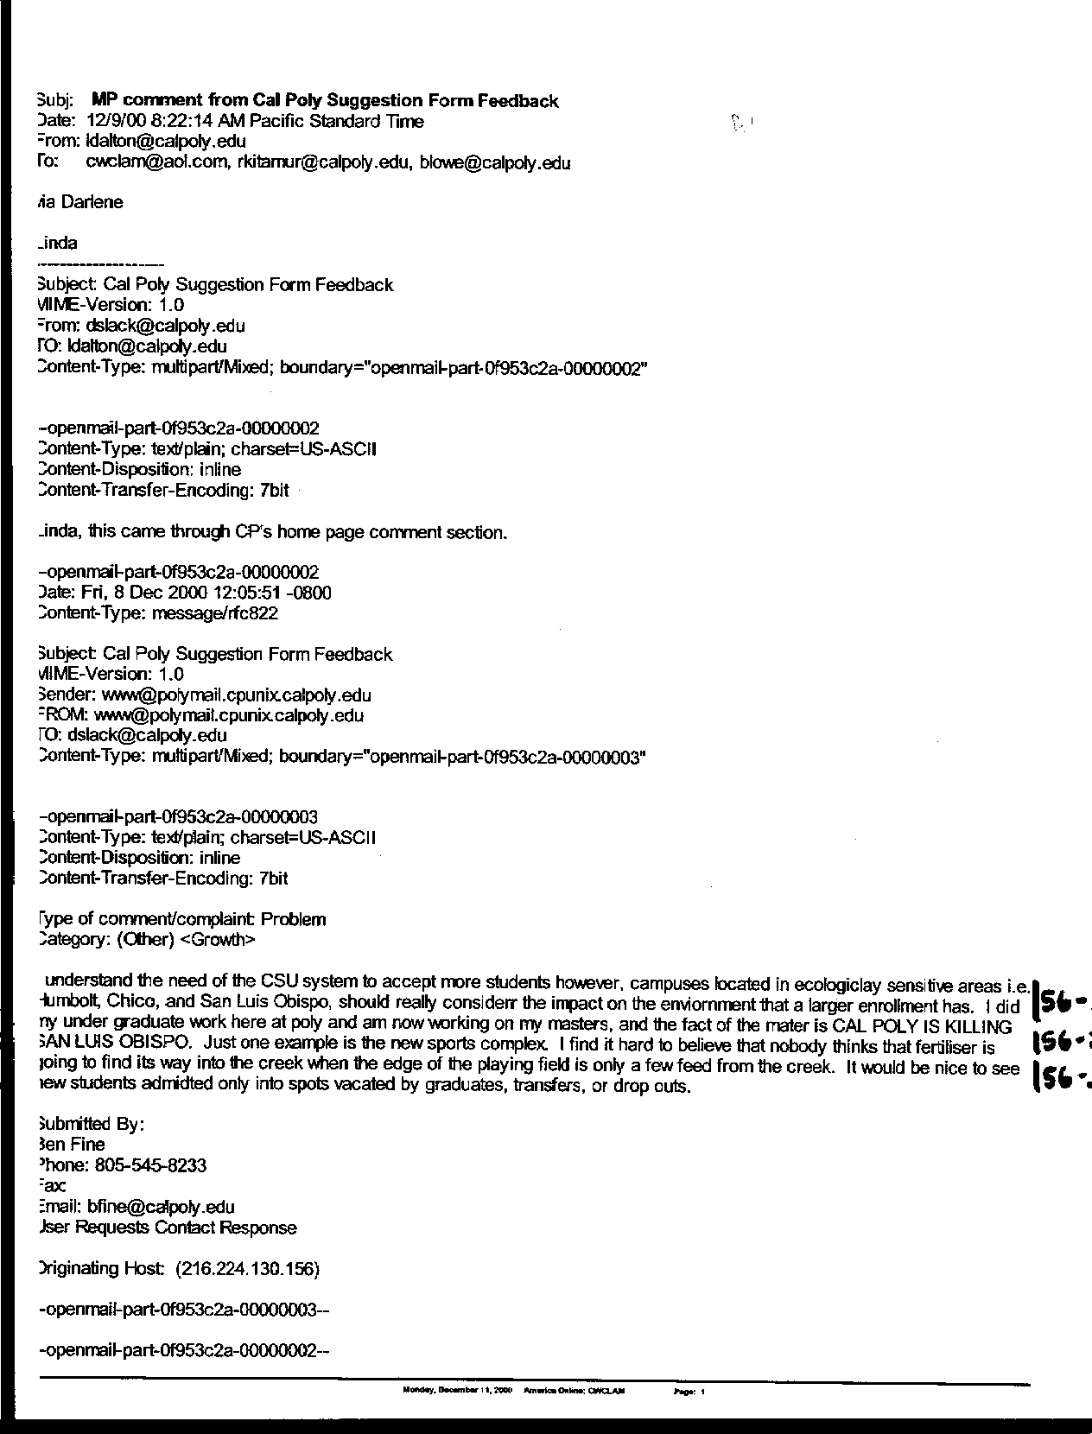
Letter 56
Letter 56

Ben Fine

December 8, 2000

56-1 The commenter notes that Cal Poly is “killing San Luis Obispo.” He is concerned about the environmental impacts of increasing enrollment.

Response This statement is too broad to be addressed here. The commenter is referred to the EIR located in chapter 6 of the Master Plan for a discussion of environmental impacts from the master plan. The comment is noted for the consideration of the decision makers. See DEIR discussion of alternatives

56-2 Commenter notes fertilizer is going to enter Brizzolara Creek from the Sports Complex.

Response The Sports Complex is not part of the Master Plan update. However, for informational purposes, the Sports Complex has been designed with a number of mitigation measures to reduce the introduction of pesticides and fertilizers into Brizzolara Creek. Furthermore, the creek will be monitored to identify changes in water quality.

56-3 Commenter would prefer new students only be admitted into vacated positions.

Response See Chapter 3 for a discussion of different scenarios for meeting enrollment demand.

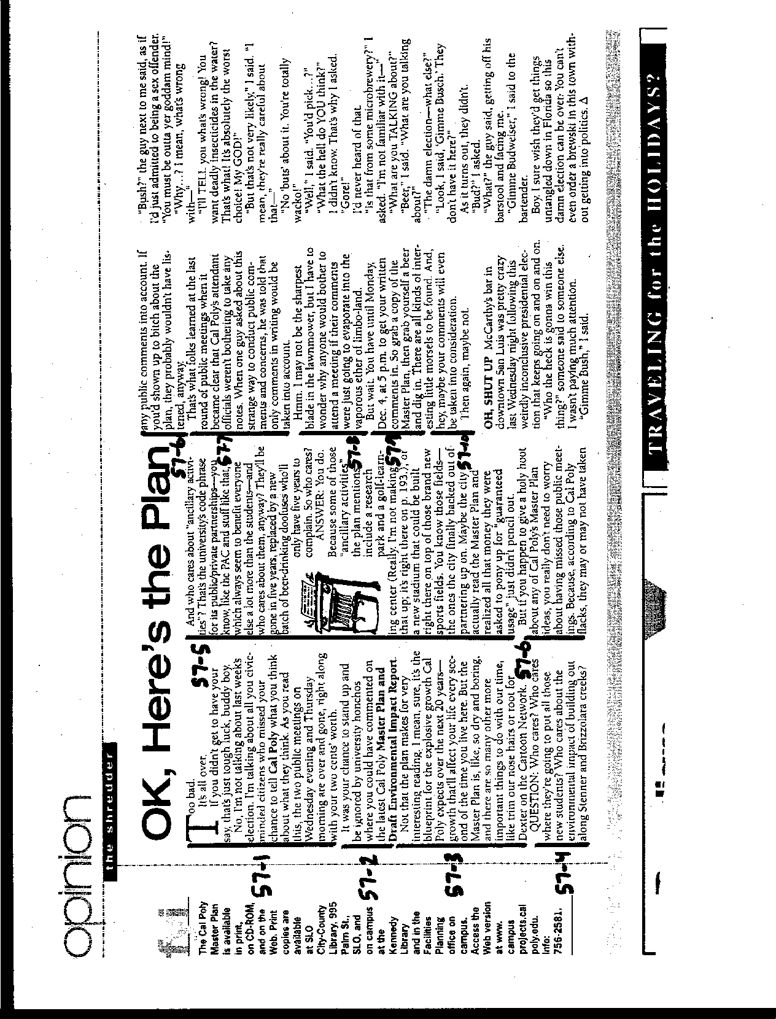
Letter 57
Letter 57

Shredder

New Times

December, 2000

57-1 Commenter notes that it was too late to comment on the Master Plan if the public did not attend the two informational meetings held in December.

Response Commenter corrects this erroneous statement at Comment 57-9 below.

57-2 Commenter suggests the meetings were an opportunity to “stand up and be ignored.”

Response The purpose of the meetings was to provide information and respond to questions from the public about the Cal Poly Master Plan.

57-3 Commenter suggests that the plan is the “blueprint for the explosive growth Cal Poly expects over the next 20 years.”

Response Cal Poly’s enrollment increase of approximately 3,000 students is half what was requested by the CSU Chancellor’s office. Environmental constraints and a lack of housing in the community necessitated Cal Poly’s reducing that increase. See charts in Chapter 3 comparing proposed growth for Cal Poly with San Luis Obispo area, CSU and State of California.

57-4 Commenter questions whether anyone would care about where the new students would be housed or the impacts of developing along Brizzolara and Stenner Creeks.

Response Numerous comments were received from members of the public who showed concern about housing and impacts to riparian habitats. For the record, development is not proposed along Stenner Creek.

57-5 Commenter questions whether anyone cares about the development of ancillary activities, such as a research park and a golf-learning center and the relocation of the football stadium.

Response Numerous comments were received from members of the public who showed concern about these activities. There comments are addressed above.

57-6 Commenter suggests that attending the meetings was of no value to the public because the Cal Poly “flacks” probably weren’t listening.

Response I’m sorry, what did you say?

57-7 Commenter suggests no one was taking notes at the meetings.

Response A Cal Poly representative stood at a two foot by three-foot note pad located on an easel in the front of the room and wrote down every comment made by the public.

57-8 Commenter questioned the value of attending the meeting.

Response Attendance at the meeting was an opportunity to hear and be heard, as is the purpose of public meetings.

57-9 Commenter states that the public had until Monday, December 4th to submit written comments.

Response The comment period was extended until Friday, December 8th at 5:00 pm.

57-10 Commenter suggests that comments made by the public may or may not be taken into consideration.

Response Perhaps the preceding 356 pages of comment and response will suffice.

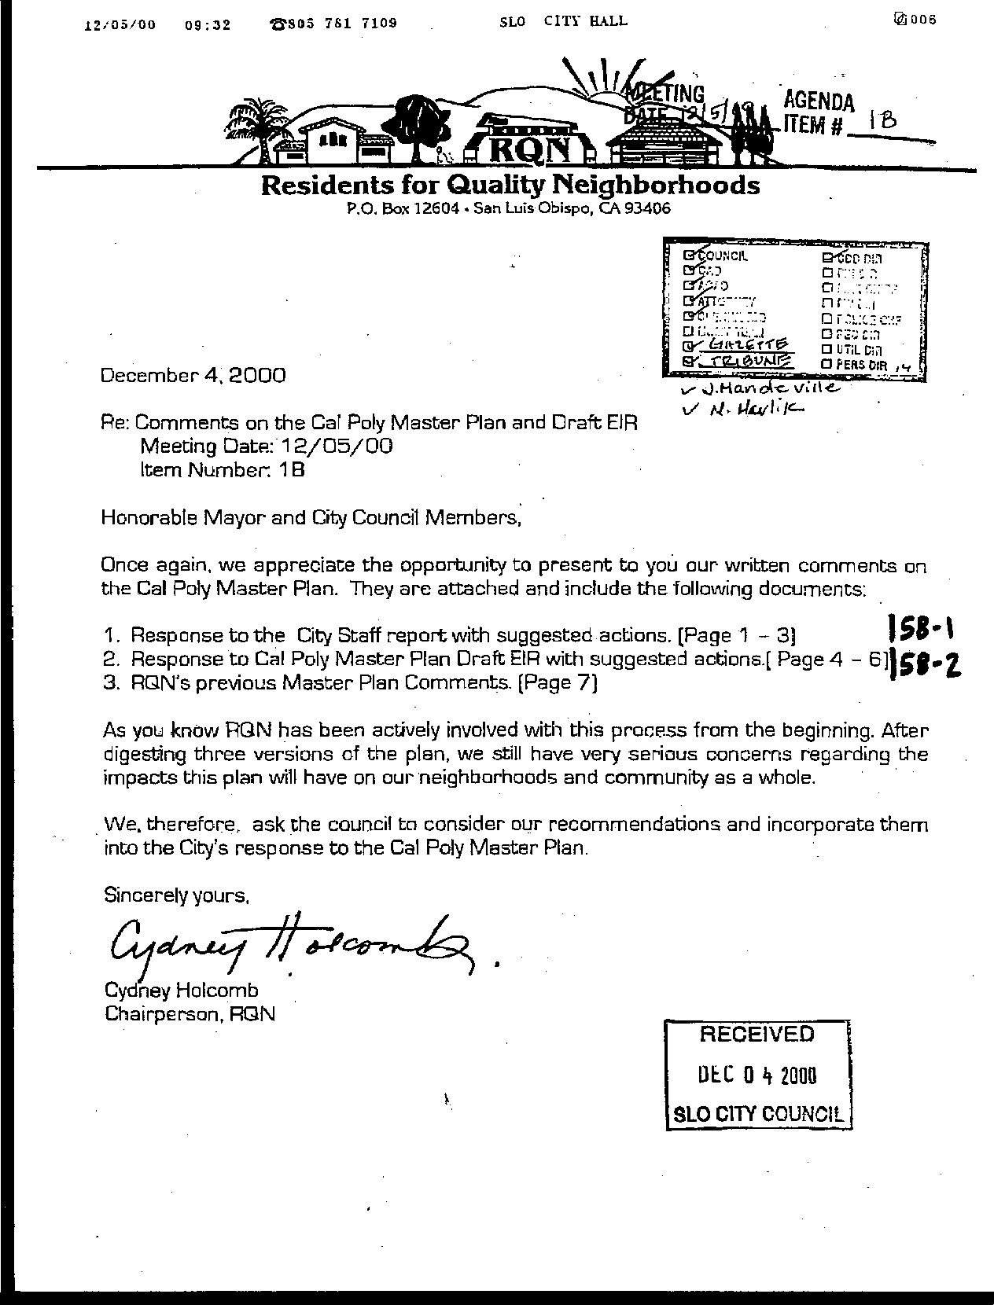
Letter 58
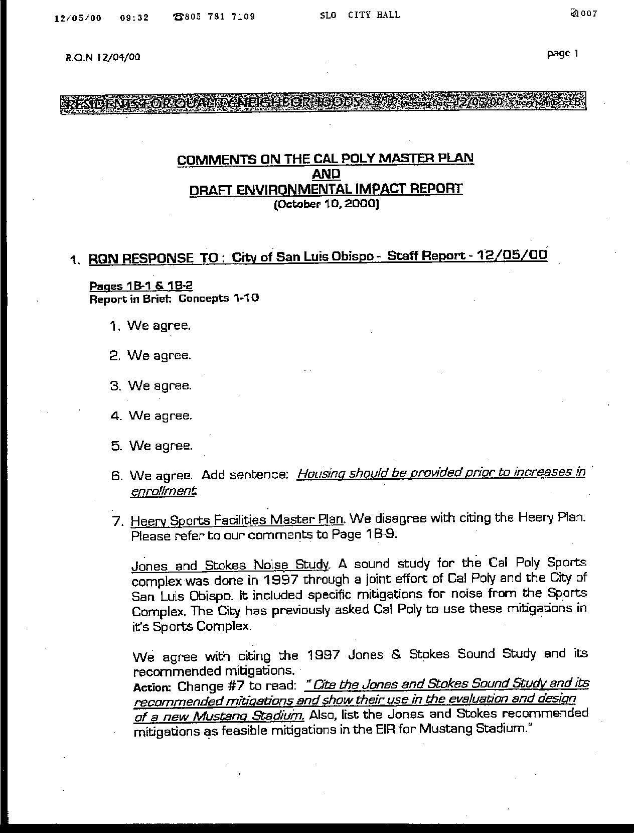
Letter 58
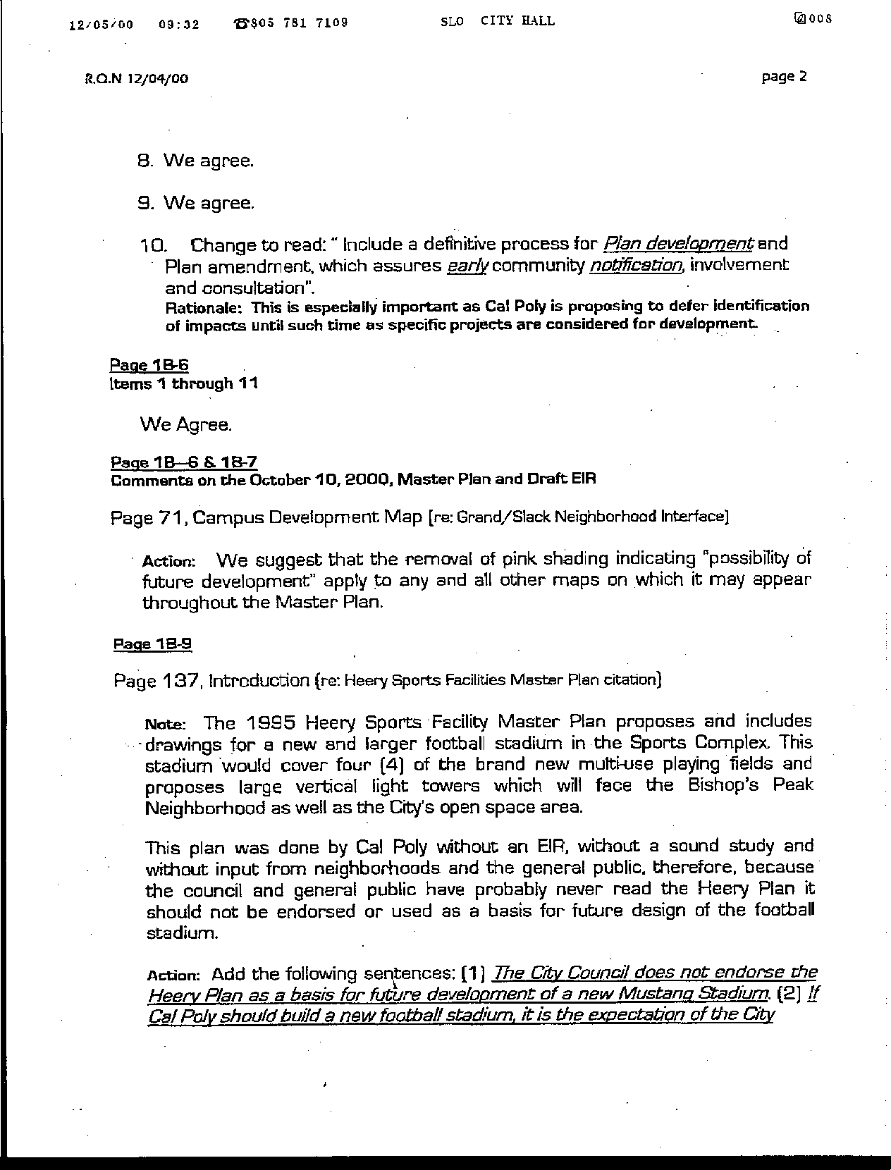
Letter 58
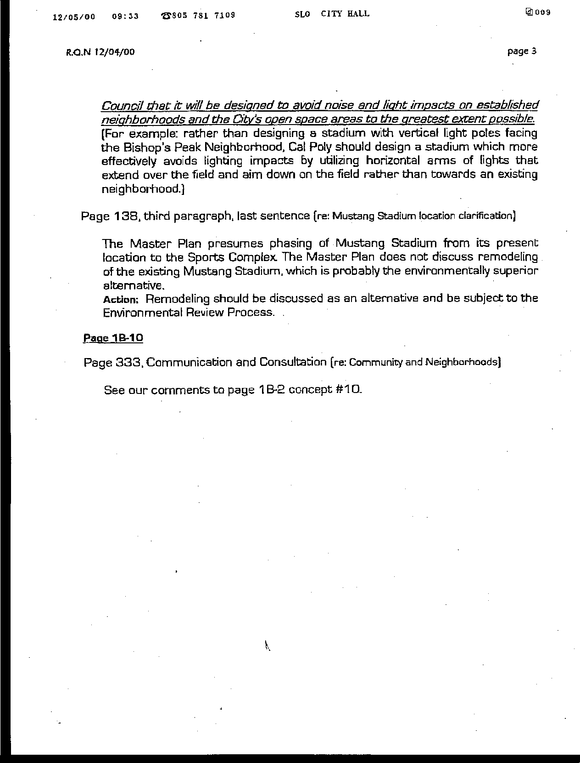
Letter 58
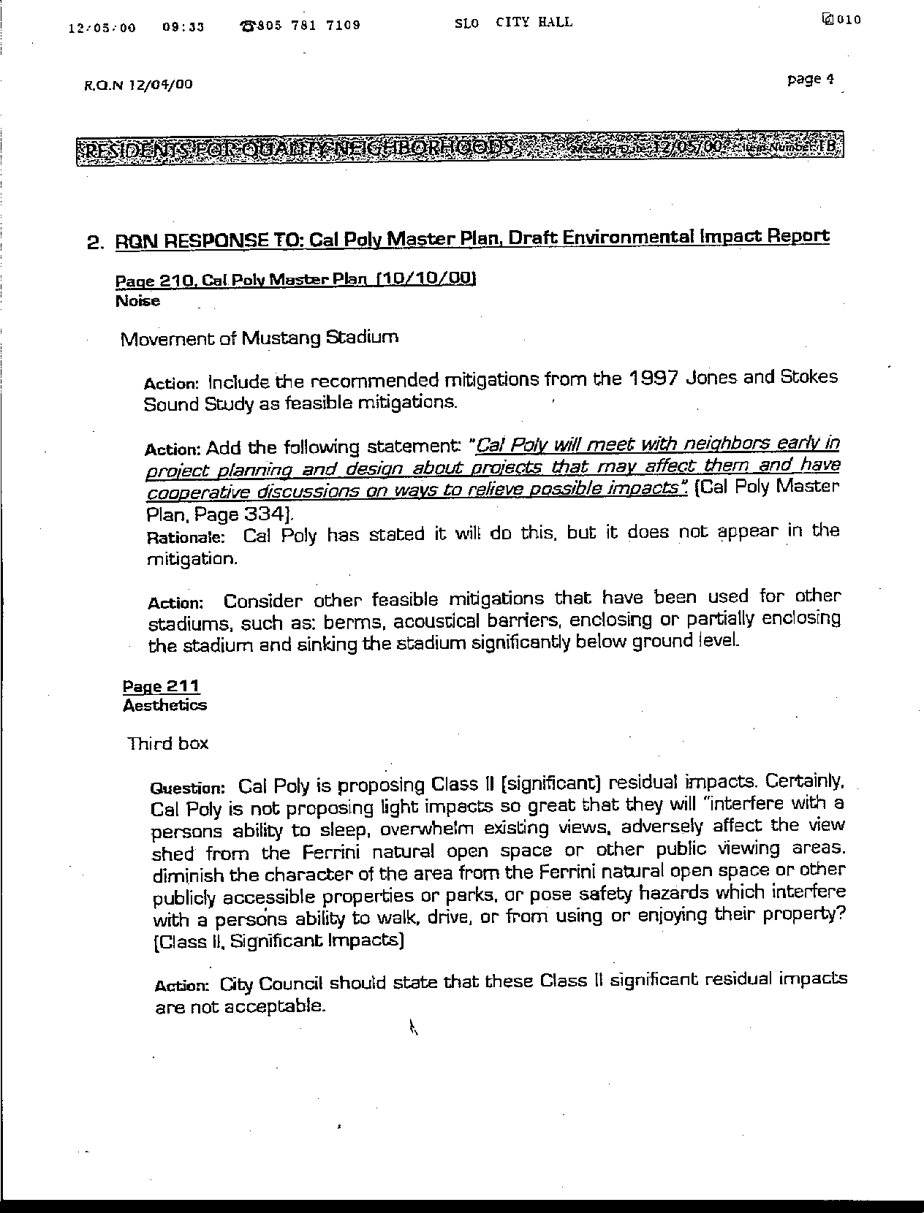
Letter 58
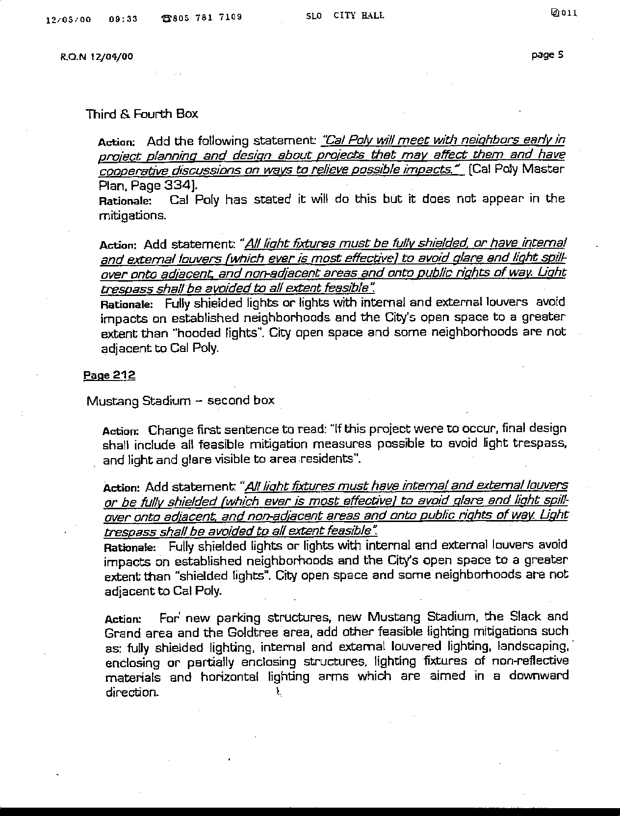
Letter 58
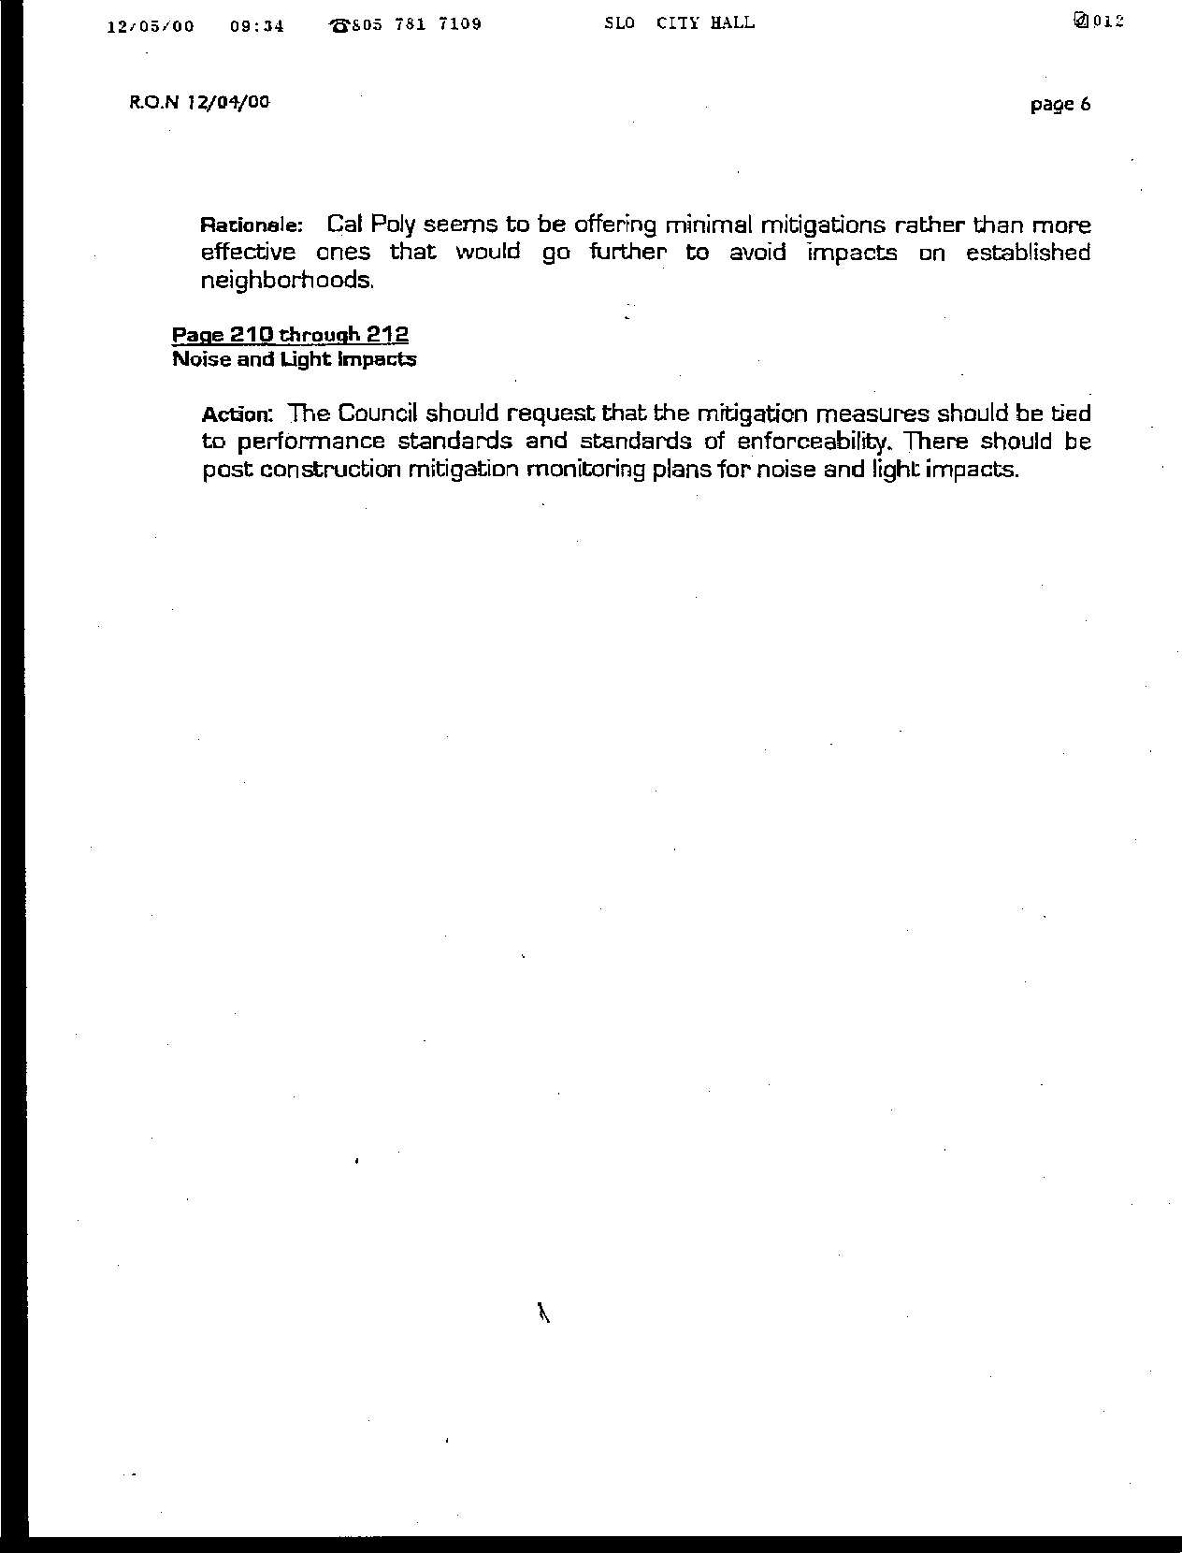
Letter 58
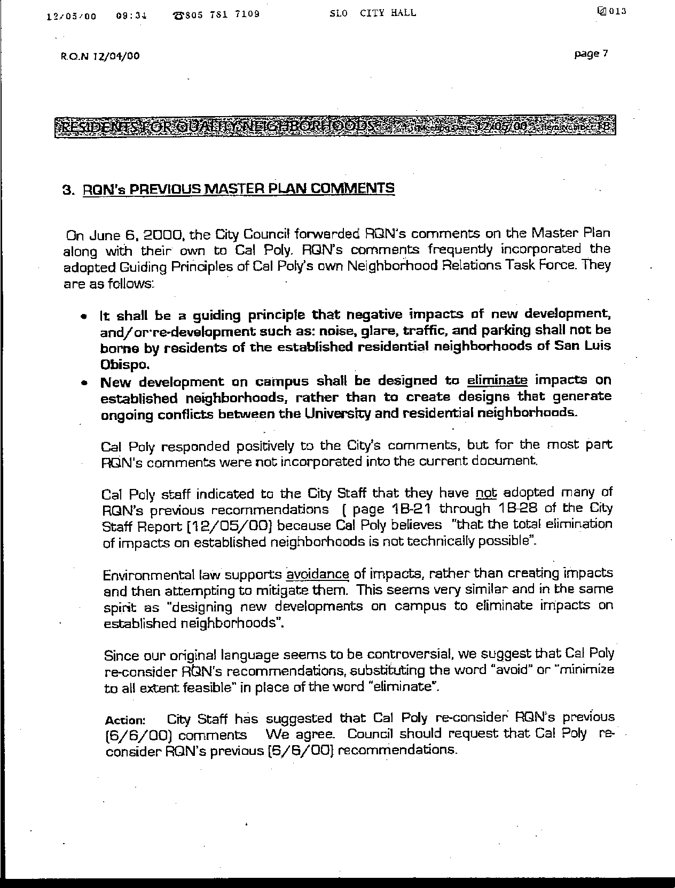
Letter 58
Letter 58
Residents for Quality Neighborhoods (RQN)

December 4, 2000

58-1 Commenter notes that comments have been incorporated in City of SLO correspondence.

Response Please see responses to letter number three, John Mandeville. Please note that the RQN comments are made a part of letter 58 for the convenience of the reader.

58-2 Commenter seeks revised wording from 6/6/00 letter urging avoidance or minimization of impacts (rather than elimination of them).

Response Cal Poly will seek to minimize impacts to neighborhoods, in lieu of “elimination” of impacts. As noted by the City’s comments, project impacts cannot always be eliminated.

58-3 Commenter requests Master Plan add "on and off campus" to provision for mitigation.

Response Chapter 7 of the revised Master Plan identifies a process of interaction with neighbors on campus projects that may have a negative effect in their neighborhood. The text in the Guiding Framework now reads: “Planning future campus facilities and support services so as to minimize and mitigate environmental impacts on and off campus to the full extent feasible as part of project design” (p. 15).

58-4 Commenter requests the Master Plan recognize and address current student housing shortage.

Response See additional sections added to Residential Communities element (p. 136): “The Master Plan takes the local housing situation into account and proposes measures that will help alleviate a portion of it. The Guiding Framework of the Master Plan calls for adding student housing to accommodate all new enrollment growth. The campus will be breaking ground in Spring 2001 to build apartment-style housing for 800 students. This facility is scheduled to be ready for occupancy in Fall 2002. The next phase calls for housing from 1150 to 1300 additional students by 2004 or 2005. In sum, Cal Poly expects to add 1950 to 2100 student beds in the next five years, but only about 1250 additional students during that same time period. Over the next two decades Cal Poly will increase the proportion of students who live on campus from about 17 percent today to over 30 percent in the future.

Further, Cal Poly will monitor the local market closely, and, if continuing students are not able to find suitable housing, the campus will develop a strategy to house a larger proportion of the University’s students in the future. Strategies may involve working with off-campus partners to identify suitable housing locations and provide financing. Cal Poly and Cuesta College are also exploring ways to cooperate in assuring appropriate housing for their students. Finally, Cal Poly will participate with non-profit organizations in seeking broader solutions to community housing needs.”

58-5 Commenter requests Cal Poly to be proactive in implementing agreements with neighbors.

Response The following has been added to Chapter 7: “The Land Use and Project Review Procedures to be established to implement the Master Plan will include the following considerations.
- Establishment of a project development team that represents all affected University interests;
- Identification of responsibility for liaison with elected officials and local and regional agencies, as appropriate to the nature of the project;
- Identification of the appropriate neighborhood areas that may be affected by the project so that meetings may be held early in project planning and design regarding ways to relieve possible impacts;
- Determination of which implementation guidelines and standards are applicable to the project.”

58-6 Commenter requests adding a commitment to mitigation of light and glare.

Response Additional mitigation measures have been added to the EIR to address light and glare. The Master Plan has also been amended at page 150 and 152 to address light and glare. “As noise and light impacts are significant concerns, the campus will conduct further studies, like the Jones and Stokes Sound Study prepared in 1997 by the City and community for the Sports Complex.” And, further along in the same paragraph: “Particular consideration will be given to minimizing impacts on established neighborhoods and public open space” (p. 150).

58-7 Commenter notes traffic impacts and mitigation.

Response No response required.

58-8 Commenter requests adding a commitment to mitigation of noise.

Response The Final EIR includes additional mitigation for noise.

58-9 Commenter suggests adding the Goldtree area to constraints map.

Response A map has been added at page 64 depicting and analyzing the proposed ancillary designation in the Goldtree area.

58-10 Commenter requests recognition of neighborhood impact at Grand Ave. and Slack Street.

Response Exhibit 4.10 has been modified to identify this potential area of conflict. A figure on page 207 depicts the proposed development in this area.

58-11 Commenter requests adding a buffer between campus and residential neighborhoods. They further ask that all impacts to neighborhoods be eliminated.

Response Commenter is directed to see Land Use element - Compatibility principle on page 69, proposing buffers between residential neighborhoods and on-campus student residences. It is not possible to eliminate all impacts to neighborhoods from proposed activities on campus, but Cal Poly is committed to minimizing these impacts.

58-12 Commenter seeks discussion of Goldtree site.

Response See constraints discussion on p. 64 and Ancillary Activities and Facilities element, especially pages 206 and 208.

58-13 Commenter offers support for list of land use issues.

Response No response required.

58-14 Commenter requests adding language to eliminate impacts from light and glare created by proposed development at Slack Street and Grand Avenue

Response It is not possible to eliminate all impacts to neighborhoods from proposed activities on campus, but Cal Poly is committed to minimizing these impacts. See Environmental Consequences analysis. Also, revised map on page 204 shows buffer adjacent to neighborhood.

58-15 Commenter raises concerns about impacts of housing west of Highway 1.

Response See text in Environmental Consequences discussion on pages 142-143. It is acknowledged that this site has aesthetic sensitivity with regard to neighboring residences. Development on the site will provide some buffers and consideration of views. However, it is important to note that any development on site H-9 will have some impact on the views of the residences immediately to the west of the site.

58-16 Commenter offers support for mitigation of impacts of future sports facilities.

Response No response required.

58-17 Commenter requests additional protection in the Master Plan for noise impacts and requests reference to the 1997 Jones and Stokes sound study.

Response The Environmental Consequences discussion has been modified to incorporate reference to the Jones and Stokes study (p. 150 and 152). Note also that language has been added about appropriate facility design and minimizing impacts from light and noise. It will not be possible to “eliminate” all impacts as requested by the commenter.

58-18 Commenter requests additional protection in the Master Plan for noise impacts and requests reference to the 1997 Jones and Stokes sound study.

Response The Environmental Consequences discussion has been modified to incorporate reference to the Jones and Stokes study. Note also that language has been added about appropriate facility design and minimizing impacts from light and noise. It will not be possible to “eliminate” all impacts as requested by the commenter.

58-19 Commenter requests additional protection in the Master Plan for neighborhood impacts.

Response The Environmental Consequences discussion has been modified to incorporate reference to the Jones and Stokes study. Note also that language has been added about appropriate facility design and minimizing impacts from light and noise. It will not be possible to “eliminate” all impacts as requested by the commenter.

58-20 Commenter suggests need to “eliminate” any light and glare impacts of future parking structures.

Response It will not be possible to “eliminate” all impacts as requested by the commenter. However, design of the structures can minimize these impacts. Parking Structure I was designed to minimize impacts of its operations to nearby neighborhoods. Lighting on that facility is muted and has lower impacts than the existing parking on Grand Avenue. Noise is also less that experienced with the surface lots. Air quality impacts from the structure are far below regulatory thresholds.

58-21 Commenter raises concern about impacts of ancillary activities in general.

Response Comment noted. The Master Plan provides protection from neighborhoods in the development of these facilities and the EIR addresses impacts from these facilities.

58-22 Commenter raises concern about commercial component of ancillary activities that might draw non-student clientele.

Response The vision of the Master Plan calls for a primary campus activity center near the University Union that is focused on students. Thus, the range of retail businesses and other activities would remain specialized and not constitute a full urban commercial center. Cal Poly understands that there is a delicate balance in determining how much of what services will be sufficient to support the campus community and manage commuting. Effective alternative transportation will allow students, faculty, and staff – as well as members of the broader community – to take advantage of the range of services and facilities both on and off campus without adding to traffic congestion. The Cal Poly Foundation is presently the exclusive provider of certain services – e.g., food service, vending machines and bookstore. Other services compete for campus outlets – e.g., travel service, ATMs. As planning for an increased range and volume of services occurs, the campus will need to determine which it should offer directly and which might be provided through franchise or “privatization.”

58-23 Commenter raises concern about magnitude of impacts of ancillary activities.

Response The discussion of environmental consequences for ancillary activities has been expanded on pages 207 and 208.

  - Commenter suggests additional language for environmental consequences of ancillary activities.

Response The environmental consequences discussion has been expanded on pages 207 and 208, although not with the same language proposed.

Letter 59
Margot McDonald

December, 2000

59-1 Commenter provided editing suggestions on a number of pages to strengthen consciousness of environmental issues and resource requirements: pp. viii, 2, 4, 100, 101, 102, 123, 153, and 154.

Response Changes made on the corresponding new pages to reflect the intent of the suggestion (pp., viii, 2, 4, 106, and 107).

59-2 Commenter suggested adding additional material to Executive Summary regarding resource requirements.

Response See new integrated discussion at end of Land Use and Public Facilities and Utilities elements (pp. 79 and 162-163).

59-3 Commenter suggested adding to discussion of Electricity capacity and distribution.

Response Changes made later in Public Facilities and Utilities element as a plan component (pp. 162-163).

59-4 Commenter suggested adding to discussion of Natural Gas capacity and distribution.

Response Changes made later in Public Facilities and Utilities element as a plan component (pp. 162-163).

59-5 Commenter suggested clarification to portions of the DEIR: pp. 279 and 331.

Response These pages have been modified per the suggestion.

59-6 Commenter attached Humboldt State University Green Building Checklist

Response Acknowledged for use in Master Plan implementation

SUMMARY NOTES
UNIVERSITY PLANNING AND BUDGET ADVISORY COMMITTEE
Letter 60
Meeting No. 1, 2000-01
Wednesday, October 25, 2000
10:00 A.M.
Administration 301

Members Present: Samuel Aborne, Sema Alptekin, Bob Clover (for Jerry Hanley), Linda Dalton, Bob Detweiler, Myron Hood, Joe Jen, Beth Kaminaka, Steve Kaminaka, Frank Lebens, Bill Pendergast, Rick Ramirez, and Paul Zingg (Chair)

INTRODUCTION

On behalf of Provost Zingg, Vice Provost Linda Dalton welcomed Committee members to the first meeting of the 2000/01 academic year, and introductions were made.

Provost Zingg noted that UPBAC convenes at least once a quarter. Its principal responsibility is the review of matters pertaining to the budget and planning dimensions of the University. Linda Dalton is spearheading the force behind the University Master Plan effort. Its development has been going on for several years, with the beginning of the strategic planning exercises. Frank Lebens and Rick Ramirez are hear to provide us with information with respect to this year’s overall University budget to give you some sense of budget construction elements and some sense as to where we are. In both of these issues, there are many layers of issues that we will be unable to master in one setting. Other meetings that UPBAC has had have focused on education sessions in order to become more familiar and versed on the various responsibilities the Committee has. We are advisory to the President, and a constituency-based body. And one that connects the budget and planning at the University, which is a conscious attempt to underscore the participatory governance commitment of the University and underscore the relationship of budgeting and planning, both short and long-term.

Zingg noted that many of the Committee members will have heard some of the information in other venues of the University due to their involvement in their own respective areas. The value, however, of this group, is this body having the entire University’s constituencies represented with all the various views provided.

1. Master Plan Update

Linda Dalton provided a status report on the Master Plan process. She indicated that the campus has accomplished a process of developing a Plan that addresses enrollment and academic questions, and facility master plan implications for the facilities and properties as a whole. Building from the campus strategic plans and analyses, task forces were developed, and the first drafts of the Master Plan were developed. There is a Master Plan professional team, the President, and various groups on campus that had stakes in the Plan’s development, i.e., the College of Agriculture (agricultural land), ASI, etc.

In May 2000, we distributed the preliminary Plan very widely across the campus and community. This was not to meet a legal requirement, but to get information and responses back from anyone that chose to provide some input. A great deal of input was provided, including the City, County, and other agencies in our vicinity. Over the summer, the team responded to these recommendations, and made a number of changes. Then, the Environmental Impact Report (EIR) was prepared. Now we have the October 2000 Master Plan Report with the EIR. This is a legal step in the process. There are public announcements as part of the Plan, allowing for a specified review timeframe.

The Plan is large, is in CD-ROM format, as well as on the Web. An excerpt from the larger document was distributed to Committee members, and Dalton provided highlights as well as changes from the preliminary draft.

Points highlighted were:

- The executive summary is the same as the preliminary draft, showing colored land use within the campus and close vicinity.
- Changes from preliminary draft: The Plan only refers to Santa Cruz property in the overview portion of the Plan; a later document will be more inclusive of the Swanton Pacific Ranch, but all principals still apply.
- The preliminary draft included four long-range enrollment scenarios that were built from DEPAC recommendations, without building physical capacity. It did not include how some academic disciplines would grow. There is now a new chapter, developed in September, which is included in this new draft.
- Regarding changes that interrelate, i.e., land use reflecting the outdoor lands that relate to instruction, is the Brizzolara Creek enhancement area. The Team looked at the Creek area to provide opportunities for ways to protect the natural environment, but to also create some teaching and learning opportunities (Creek enhancement opportunities). Preliminary plans put student housing in that area, but housing has now been replaced to other areas.
- The instructional core area has been expanded for use and has been modified to add a different structure. One significant piece is the work of the UU planning effort which occurred in Spring 2000 that contributed an ASI perspective as to student services and activities. These are integrated into the document. Diagrams are not intended to be “footprints” but just illustrations as to where a cluster of buildings could occur.
- Regarding circulation and alternative transportation issues, at the Grand Avenue corner, a visitor’s center is envisioned to provide a welcoming activity for visitors. At the NW end of campus, i.e., the Gold Tree area, an applied research park area site as been identified.
- Implementation chapter at the end of the Plan focuses on what still needs to be done after it is approved in principal.

Zingg noted that Dalton mentioned and the report makes clear, that this is very much an effort that attempts to achieve a golden mean between bottom up and top down. Top down is the educational mission and the principal context for any planning, policies, and practices of the institution, which creates a broad umbrella. Several points in the document mention this and the implications of the name of Cal Poly. The bottom up is the fact that this whole effort started with academic strategic planning, the work of the colleges and the UCTE, in looking at their sense of directions and environmental scanning that involved engaging hundreds of on-campus and off-campus folks to provide perspectives to contribute to framing these documents. This is critical to program developing, enrollment implications of program developing, and making critical choices. This is what a master plan is all about, and being able to define and choose the future of the institution and how it defines itself. If a Plan is not in place, someone else will tell us what to do. There will always be some of this, however. But we need to think about what our optimum future is, taking our mission, our membership in the CSU, and the public responsibility roles we play as stewards of our resources (higher education) and an agent for eliciting our constituencies’ trust and confidence.

Discussion occurred on the issue of enrollment growth, the lack of adequate State funding allocations (marginal cost differences), and how the Plan addresses this issue. Dalton indicated that the Academic Senate and DEPAC were very concerned about the operational budget issues, and there is mention in the Plan on the need for capital budget resources and operating resources in order to accommodate growth. The Plan addresses the principles, but not the operational issues. Zingg acknowledged that the first step toward this need, and the commitment of the CSU, is the Workforce Initiative. The commitment from the Chancellor’s Office is to not only making the $10M one-time allocation this year a permanent one, but to triple this amount over the next several years. Growth needs to be contingent upon working these issues out. The solutions are not defined in the Plan, but it is not intended to do this. It was also noted that the State Legislature is unsympathetic and feels the CSU should reallocate from within for the workforce issue. The CSU seems to be recognizing this. Once recognizing differential costs, the next issue is whether we can open the door more fully to have a more differential funding formula adopted. This is part of the long-range strategy to make this case and the extent to which the argument has been recognized within the compact permanent allocation. Regarding the method of new funding, the CSU has never gone to a new funding formula since mode and level was abandoned in early 90’s. We need to get back to something that gets back to relative cost. Zingg reminded Committee members of the “Future of the University” piece that President Baker had done on our distinction as a polytechnic university, and that this distinction is in jeopardy without the resources to continue this distinction.

The $1.78M Workforce Initiative allocation will need to be exclusively addressed to the workforce disciplines noted, with apparently very little flexibility. Discussion occurred on the principle of keeping the restricted workforce funds to those disciplines, vs. flexibility in funding with emphasis of the campus’ outcomes.

Lebens noted the need to get another State bond issue, since the current capital bond runs out. Detweiler acknowledged that he felt it would be unwise not to consider physical growth in the wake of growth/no growth. The State’s economy is good now, so now is the time to seek new funding.

Sam Aborne voiced his disagreement on two of the Master Plan principles: 1) increase in student progress; and 2) unit load. He disagreed with the 15-unit courseload assumption (due to courses becoming 4 units, with full-time status then being at 16 units). He was also concerned about the summer quarter enrollment possibly going to 40% of the AY FTES. He does not believe that our campus could support 40% based on our mission, emphasis on co-ops and internships, etc. Opportunities for co-ops and internships could significantly impact students’ abilities to take courses in the summer.
60-1

In closing, Zingg acknowledged that the above observations are critical to get on the table and brought to the attention of Dr. Dalton and the Master Plan Team during this review phase.

He proposed that we try at the next session to continue any additional comments and observations with respect to the Master Plan. However, in the meantime, Committee members should not hesitate to express individual observations and concerns to Bonnie Lowe, in Facilities Planning.

Due to the lack of time at today’s meeting, most of the next meeting will be spent at looking at the 2000-01 Budget. At that time, the campus may have a better clarification of the $1.78M Workforce Initiative funding. More information may also be available on one-time funds allocated, i.e., excess Lottery funds designed for faculty development and technology, etc.

Frank Lebens and Rick Ramirez distributed the Sources and Uses budget document, and indicated budget information was also available on the Web, but will be discussed at the next meeting.
SUMMARY NOTES
UNIVERSITY PLANNING AND BUDGET ADVISORY COMMITTEE
MEETING NO. 2, 2000-01
Wednesday, December 06, 2000
8:30 A.M.
Administration 409

Present: Preston Allen (for Bob Detweiler), Frank Lebens, Bob Clover (for Jerry Hanley), Joe Jen, Bill Pendergast, Myron Hood, Sema Alptekin, Sam Aborne, Beth Kaminaka, Linda Dalton, Bonnie Long, and Paul Zingg (Chair)

- CONTINUED DISCUSSION OF THE MASTER PLAN

Vice Provost Linda Dalton continued the discussion of the campus draft Master Plan. She indicated that last evening was the last presentation of the Plan at a public setting—the San Luis Obispo City Council, and that she would comment on the County and City presentations and the issues that came up during those presentations.

Dalton indicated that the draft plan and EIR have been out since October 10, and that comments are due by December 8. She described the general reactions as being very constructive. Even though there may have been criticisms, they have been constructive suggestions. The Master Plan team’s outreach efforts have been appreciated. They would like to see this continued into the implementation phase. Specific areas of criticism from outside have been different than the campus’ criticisms. Most of the comments have been related to student housing. The Plan made the commitment to cover housing for new student enrollment, and the Team also agreed to speed up the timeline. Discussions have also started with Cuesta College. People do understand the fiscal obligations we are faced with, however.

Some of the other issues from an off-campus perspective were: concern that we follow through on commitment to alternative transportation, and the lighting adjustments on the sports complex. On campus the largest concern was about the physical development where the student housing sites will be placed (environmental sensitivities). The Team is working with the Landscape Advisory Committee and the Biological Sciences Advisory Committee in this regard, and it feels that the Plan can continue to meet the needs of all. Many comments are continuing to come in, and the Team is making sure that students needs are addressed, i.e., Foundation and food service concerns (an operational issue). When we get to the policy level approval, we will need to review the associated operational issues.

Discussion:
- Sam Aborne noted that it seemed that with the College of Business’ quality improvement (recent Orfalea gift), we haven’t heard much about growth within the College, i.e., facilities to support that College’s growth. Dalton responded that we are not designating disciplinary terms in the Master Plan. We have used vague terms. The Team does have to deal with how much space each particular area needs. Provost Zingg also indicated that the Plan emphasizes the core of the campus being used for instruction. The possible use of Crandall Gym as a desired space due to its architectural style and being in the historical district of campus has been discussed for some time as a likely prospect for supporting programs that now occur in Buildings 2 and 3. The College’s own long-range enrollment calls for it having a 14-15% share of the University’s enrollment. Dean Pendergast indicated that he has been thinking about this, because some of the activities that have been involved in the Orfalea gift have included a need for space—part of this are matching funds for endowed faculty chairs. The Dean also noted his interested in programmatic activity for entrepreneurships that have credit bearing activity. There is also some interest in a Technology Management program. There are a number of future interests that will imply a growth for the College.

- Zingg indicated that the physical growth component of the Plan is approximately $20B over the next 20 years! The Chancellor will need to understand the physical realities of this campus in relation to the amount of agricultural land the campus has. The Chancellor also has as an issue on whether or not new buildings will be used year-round.

- Frank Lebens acknowledged that the Plan has focused on the planning, but we have timing issues as well, since we are already into the implementation phase (student housing and some other instructional facilities plans have already started). Zingg also acknowledged the interest for increased bus service and parking.

- Dean Jen questioned whether the Plan is flexible enough to answer the possible issue of future gifts that may require new buildings. Lebens indicated that we do have the ability to further amend the Master Plan (one major revision a year is allowed). Dalton also pointed out the Plan accounts for enough physical space for the increased enrollment, plus some.
60-2

- Sam Aborne also noted that students are interested in how we service the bottom end of campus, and creating environments for students beyond 5:00 pm. The University Union will need to expand beyond where it is now. Aborne indicated that he is also interested in looking at summer enrollment numbers.
60-3

Dalton noted that the 15,000 FTE physical capacity will not be met for about 3-4 years, since that number does not include non-traditional instruction, i.e. senior project, off-campus instruction (London Study), student teaching, etc.

- 2000-01 BUDGET—SOURCES AND USES

Provost Zingg began by emphasizing that the 2000/01 FY budget it is based on conservative revenue estimates. That is purposeful and appropriate, and is true with this year’s budget.

The campus is looking at a shortfall on enrollment of 1.2%. This still exceeds last year’s enrollment by approximately 300, but falls short of the mandated target. We are closing this gap based on strong registration figures for Winter Quarter (may be as much as halved). This will affect institutional revenues, of course.

Frank Lebens provided an overview of the sources and uses document, and indicated that there are three major demands on our budget at this time (not unlike other campuses): 1) enrollment growth pressures; 2) technology pressure-need to update technologies in classrooms and administratively; and 3) the issue of new initiatives-facility implications and other operating cost pressures. We have tried to accommodate this in the face of the Capital Campaign. There are college priorities, all of which have operating cost implications. We have tried to address some of these priorities in these budget-planning efforts. We have challenges, and we deal with high levels of uncertainty. We have been given warnings by the Chancellor that the impacted campuses having no leeway on enrollments. Zingg acknowledged that the Chancellor has indicated there is no leeway—currently 4 campuses are on impacted status. Utility cost increases are also making an impact on the budget.

Zingg reminded Committee members of the actions taken by the University in the early 90’s to deal with on-going commitments utilizing one-time funding. Over the last three years, the University corrected this problem, which meant we had to tighten our belt to correct the disequilibria (not a deficit but a problem). This is why units and college budgets have not grown even with the press indicating that budgets have grown.

Enrollment growth funds will be targeted for unanticipated increased revenues

The other big unknown this year is what will happen with the utility costs. The multi-media classrooms on the ITS list are funded by Lottery revenues, and implementation of Student Administrative System investment on Degree Audit will also be funded through the Lottery.

Letter 60
University Planning And Budget Advisory Committee

Paul Zingg, Chair

October 25 and December 6, 2000

The two UPBAC meetings were an opportunity for Dr. Linda Dalton to present the findings of the Master Plan effort. Several comments were made by various members of the committee.

60-1 Sam Aborne voiced his disagreement on two of the Master Plan principles: 1) increase in student progress; and 2) unit load. He disagreed with the 15-unit courseload assumption (due to courses becoming 4 units, with full-time status then being at 16 units). He was also concerned about the summer quarter enrollment possibly going to 40% of the AY FTES. He does not believe that our campus could support 40% based on our mission, emphasis on co-ops and internships, etc.

Response Comments are acknowledged. Achieving the Master Plan goals of increased student progress and enhancing summer quarter will be significant challenges for the University. These will require increased resources for teaching and administration, and a change in the culture of the campus, which is one of taking the summer off.

  - Dean Jen questioned whether the Plan is flexible enough to answer the possible issue of future gifts that may require new buildings.

Response Vice President Lebens indicated that Cal Poly does have the ability to further amend the Master Plan (one major revision a year is allowed). According to Vice Provost Dalton, the Plan accounts for enough physical space for the increased enrollment, plus some.

60-3 Sam Aborne also noted that students are interested in how we service the bottom end of campus, and creating environments for students beyond 5:00 pm. The University Union will need to expand beyond where it is now.

Response The Master Plan proposes a number of new facilities on campus that will enhance the community environment for the soon to be 6,000 plus students living on campus. This includes greatly expanded activities and services in the area of the current UU as well as a distribution of conveniences and services throughout campus. An example can be seen in the newly remodeled campus store on Via Carta. Food service will be added to several locations. El Corral will likely expand services to the western portion of the campus instructional core, reducing the need to “climb the hill” in order to acquire needed supplies, especially for the specialty needs of students in agriculture, architecture and engineering.

http://www2.ucsc.edu/taps/students.html#fresh
http://www2.ucsc.edu/taps/students.html#fresh
http://www2.ucsc.edu/taps/students.html#fresh
http://www2.ucsc.edu/taps/students.html#fresh
http://www2.ucsc.edu/taps/students.html#fresh
These last two figures were adjusted to include the anticipated 129 AF/Y from the Sports Complex, which was under construction at the time of this analysis, and the Student Housing Project, which was being permitted.

