School of Mechanical Aerospace and Civil Engineering
University of Manchester

First Year Transfer Report

Application of CFD to Industrial Safety Studies
(with Prediction Accuracy and Error estimations)

Imama Zaidi

Supervised by

Prof. Dominique Laurence

2009

Table of Contents
1 Abstract 7
2 Introduction 8
3 Literature Review: 9
3.1 Numerical Errors: 10
3.1.1 Round off Error: 10
3.1.2 Iterative Convergence Error: 11
3.1.3 Discretisation Error 11
3.2 User errors 12
3.3 Turbulence 12
3.4 Physical Model Uncertainty: 13
3.5 Verification and Validation 14
3.6 Best Practice Guidelines (BPG): 15
3.6.1 Defining the objective: 16
3.6.2 Selection of Equations Describing the Flow Pattern: 16
3.6.3 Computational Domain 16
3.6.4 Computational Grid 16
4 Governing Equations of Fluid Dynamics 20
4.1.1 Mass Conservation in Three Dimensions: 20
4.1.2 Momentum Conservation: 20
5 STAR CCM 22
5.1 Automated Engineering 22
5.2 Numerical Scheme 23
5.2.1 Transient Term: 23
5.2.2 Source Term: 23
5.2.3 Diffusion Term: 23
5.2.4 Convection Term: 24
5.3 Turbulence Modeling 25
5.3.1 Standard Spalart-Allmaras (SSA) Model 25
5.3.2 Standard Low Reynolds Number 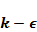model 26
5.3.3 V2f Model 26
5.3.4 Abe Kondo Nagano (AKN) Low Reynolds Number Model 27
5.3.5 SST 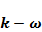 Model 27
5.4 Convergence Criteria. 28
6 The Square Cavity Test Case: 30
6.1 Part I 31
6.1.1 Results: 31
6.2 Part II – turbulent flow cases 35
6.2.1 Results 36
7 Conclusion 68
8 Future Work 69
8.1 Experimental Setup 69
9 Appendix 1 72
10 Appendix 2 74
11 Appendix 3 76
12 References: 89

List of Figures
Figure 5-1: Comparison of results obtained with residual tolerance of 10⁻⁴ for X-momentum for different grids 20
Figure 5-2: Comparison of results obtained after monitoring temperature asymptotic value of 1E-4 at center and near boundaries of the cavity 20
Figure 6-1: Geometry of the problem 20
Figure 6-2: Mesh Types 20
Figure 6-3: Mesh Types for Turbulent Flow 20
Figure 6-4: Temperature Profile inside Cavity at Ra=10³ 20
Figure 6-5: Error in temperature for different mesh numbers 20
Figure 6-6: u-Velocity Profile in side cavity at Ra=10³ 20
Figure 6-7: Error in u-Velocity for different mesh numbers 20
Figure 6-8: v-Velocity Profile in cavity at Ra=10³ 20
Figure 6-9: Error in v-Velocity for different mesh numbers 20
Figure 6-10: Results for Square mesh 20
Figure 6-11: Results for Polyhedral Mesh 20
Figure 6-12: Results for Skewed Mesh 20
Figure 6-13: Comparison of order of accuracy for three meshes. 20
Figure 6-14: Effect of change of design parameters at Ra=10³ 20
Figure 6-15: Richardson Extrapolation for results obtained using Second order Upwind Scheme at Ra=10³ 20
Figure 6-16: Richardson Extrapolation for results obtained using Second order Upwind Scheme at Ra=10⁴ 20
Figure 6-17: Richardson Extrapolation for results obtained using Second order Upwind Scheme at Ra=10⁵ 20
Figure 6-18: Richardson Extrapolation for results obtained using First order Upwind Scheme at Ra=10³ 20
Figure 6-19: Richardson Extrapolation for results obtained using First order Upwind Scheme at Ra=10⁴ 20
Figure 6-20: Richardson Extrapolation for results obtained using Central Differencing Scheme at Ra=10³ 20
Figure 6-21: Richardson Extrapolation for Nu at hot wall using Second Order Upwind Scheme Ra=10³ 20
Figure 6-22: Comparison of Nu number profile obtained from second order approximation and Star CCM for 20*20 grid at Ra=10³ 20
Figure 6-23: Comparison of Nu number profile obtained from second order approximation and Star CCM for 40*40 grid at Ra=10³ 20
Figure 6-24: Comparison of Nu number profile obtained from second order approximation and Star CCM for 20*20 grid at Ra=10⁴ 20
Figure 6-25: Comparison of Nu number profile obtained from second order approximation and Star CCM for 40*40 grid at Ra=10⁴ 20
Figure 6-26: Comparison of Convergence of Nusslet Number with grid spacing obtained from Second order Approximation and From Star CCM 20
Figure 6-27: Variation of Temperature at Center of Cavity for Polyhedral Mesh 20
Figure 6-28: Variation of Temperature at Center of Cavity for Skewed Mesh 20
Figure 6-29: Variation of Temperature at Center of Cavity for Square Mesh 20
Figure 6-30: Variation of Error in Temperature along X axis of grid for Polyhedral Mesh 20
Figure 6-31: Variation of Error in Velocity along X axis of grid for Polyhedral Mesh 20
Figure 6-32: Variation of Error in Temperature along X axis of grid for Skewed Mesh 20
Figure 6-33: Variation of Error in Velocity along X axis of grid for Skewed Mesh 20
Figure 6-34: Variation of Error in Temperature along X axis of grid for Square Mesh 20
Figure 6-35: Variation of Error in Velocity along X axis of grid for Square Mesh 20
Figure 6-36: Effect of grid refinement for square grid while using Second Order Upwind Scheme 20
Figure 6-37: Effect of grid refinement for square grid while using First Order Upwind Scheme 20
Figure 6-38: Effect of grid refinement for square grid while using Implicit Unsteady Solver 20
Figure 6-39: Effect of refinement for square grid using Central Differencing Scheme 20
Figure 6-40: Effect of Different Schemes on Error Convergence for Square Grid 20
Figure 6-41: Effect of grid refinement for polyhedral grid using Second Order Upwind Scheme 20
Figure 6-42: Effect of grid refinement for polyhedral grid while using First Order Upwind Scheme 20
Figure 6-43: Effect of grid refinement for polyhedral grid while using Central Differencing Scheme 20
Figure 6-44: Effect of grid refinement for polyhedral grid while using Implicit Unsteady Solver 20
Figure 6-45: Effect of Different Schemes on Error Convergence for Polyhedral Grid 20
Figure 6-46: Effect of grid refinement for Skewed Mesh while using Second Order Upwind Scheme 20
Figure 6-47: Effect of grid refinement for Skewed Mesh while using First Order Upwind Scheme 20
Figure 6-48: Effect of grid refinement for Skewed Mesh while using Implicit Unsteady Solver 20
Figure 6-49: Effect of grid refinement for Skewed Mesh while using Central Differencing Scheme 20
Figure 6-50: Effect of Different Schemes on Error Convergence for Skewed Mesh 20
Figure 6-51: Effect of grid refinement for Butterfly Mesh while using Second Order Upwind Scheme 20
Figure 6-52: Effect of grid refinement for Butterfly Mesh while using First Order Upwind Scheme 20
Figure 6-53: Effect of grid refinement for Butterfly Mesh while using Implicit Unsteady Solver 20
Figure 6-54: Effect of grid refinement for Butterfly Mesh while using Central Differencing Scheme 20
Figure 6-55: Effect of Different Schemes on Error Convergence for Butterfly Mesh 20
Figure 6-56: Effect of Mesh topology on the solution 20
Figure 6-57: Error Convergence for Second Order Upwind Scheme 20
Figure 6-58: Error Convergence for First Order Upwind Scheme 20
Figure 6-59: Error Convergence for Central Differencing Scheme 20
Figure 6-60: Nu profile along the hot wall using 40x40 Grid 20
Figure 6-61: Nu profile along the hot wall using 80x80 Grid 20
Figure 6-62: Nu profile along the hot wall using 160x160 Grid 20
Figure 6-63: Error in Nu along the hot wall using 40x40 Grid 20
Figure 6-64: Error in Nu along the hot wall using 80x80 Grid 20
Figure 6-65: Error in Nu along the hot wall using 160x160 Grid 20
Figure 6-66: Effect of grid convergence using 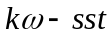 model on the Nu profile along the hot wall 20
Figure 6-67: Effect of grid convergence using v2f model on the Nu profile along the hot wall 20
Figure 6-68: Effect of grid convergence using model on the Error in Nu profile along the hot wall 20
Figure 6-69: Effect of grid convergence using Spalart Allmaras model on the Error in Nu profile along the hot wall 20
Figure 6-70: Effect of grid convergence using v2f model on the Error in Nu profile along the hot wall 20
Figure 6-71: Effect of grid convergence using model on the velocity profile near the wall 20
Figure 6-72: Effect of grid convergence using Spalart Allamaras model on the velocity profile near the wall 20
Figure 6-73: Effect of grid convergence using v2f model on the velocity profile near the wall 20
Figure 6-74: Kinetic Energy at mid height of the Cavity 20
Figure 6-75: Kinetic Energy at mid height of the Cavity near the Cold Wall 20
Figure 6-76: Kinetic Energy at mid height of the Cavity near the Hot Wall 20
Figure 6-77: Effect of first cell spacing for model 20
Figure 6-78: Effect of first cell spacing for v2f model 20
Figure 8-1: Experimental Setup [46] 20
Figure 8-2: A schematic diagram of experimental Setup [46] 20

Abstract
There are certain factors which contribute to enhance the accuracy of CFD results including computational grid, numerical approximation, user experience, post processing and turbulence modeling etc. One can obtain the desired accuracy if expected outputs are known. But in case of design applications sometimes there is no data available for comparison. In that situation reliability of the CFD output becomes a question mark. There are certain Best Practice Guidelines (BPGs) available in the literature to obtain the accurate results. Basic intention of this thesis is to test and verify these BPGs.
A square cavity with differentially heated walls has been taken as the first test case during first year. To study the effect of grid topology, mesh refinement and numerical approximation laminar flow has been taken into account. Four different grid types considered were square, polyhedral, skewed and butterfly type mesh. Richardson Extrapolation has been tested and verified for laminar flow for square grid. Three different numerical schemes i.e. second order upwind scheme, first order upwind scheme and central differencing scheme have been used to approximate the convection term. Effect of error convergence with grid refinement for different numerical schemes and grid types is presented in this report.
For turbulent flow affect of grid refinement on different low Reynolds number have been checked and grid dependence of model and v2f model have been tested.

Introduction
Historical roots of Computational Fluid Dynamics can be traced back to Richardson’s 1910 paper on the computation of stresses in a masonry dam. Then few years later, Horlow and Fromm (1965) presented qualitatively accurate solutions of previously intractable problems without constricting assumptions used by theoreticians. In 1972 after the first book published by Roache, people in the field of science and engineering started to realize the power of computational fluid dynamics and need to keep Computational Fluid Dynamics (CFD) a separate discipline from theoretical fluid dynamics and experimental fluid dynamics. This revolution was aided by the phenomenal progress in computing power, which continues todate.
Effectively, Computational fluid dynamics turned out to be a better alternative of experimental investigation of a system in terms of economy and time. Because even with a small change of geometry and characteristics of fluid one still need to have a new equipment which then would involve large cost in terms of time as well as money. In contrast to experimental techniques, results obtained from CFD codes are meant to accelerate the design process saving both, money and time. In addition, when fully validated, these results should meet environmental regulations ensuring industry compliance.
These days, computational fluid dynamics is widely used in all disciplines not only to get an insight of existing systems but also to foresee and specify the safety margins of systems at the design stage. For instance, involvement of CFD codes at design stage of safety related equipments of nuclear installation need a detailed verification and validation. This has resulted in a number of Best Practice Guidelines (BPG) which have been designed for this purpose. The main objective of the present work is to revisit, reproduce and examine the generality (validity) of these best practice guidelines to estimate the accuracy of a code and the effects of certain parameters on the accuracy of predictions made by a given code.

Literature Review:
Since last three decades CFD is widely being used as a tool to get an insight of the responses of systems, developing public policy and in the preparation of safe procedures in determining legal liability. Due to low cost and efficiency associated to computer simulations, CFD tools are getting a central role in decision making process. In general, some basic steps involved in the solution of a CFD problem are as follows:
- Creating the Geometry: Most of the time geometry of the problem domain is simplified, and this step requires an understanding of geometrical parameters which are important for the calculations and which, do not have any effects on the results and the derived conclusions.
- Defining models to describe the flow domain: Following the creation of the geometry of interest, the next step is to define the models describing the flow i.e. whether flow is laminar, transient or turbulent, (and if turbulent, which models to chose for specific flow behaviors), is flow time-dependant or steady state and so on.
- Grid or mesh generation is also a key step for solving CFD problem. One of the most critical issues of CFD simulations is inevitable loss of accuracy due to grid non-uniformities. For example factors affecting the solution accuracy are cell skewness angle which is angle between two adjacent faces of the cell, cell aspect ratio defined as the ratio of cell dimensions dx, dy and dz. All These factors affect the solution accuracy and convergence of the solution.
- Establish initial and boundary conditions: A finite volume domain is described in terms of inlets, outlets and walls they are termed as boundaries of the domain and physical conditions are required on the boundaries of the flow domain i.e temperature, pressure and mass flow rate etc. In CFD codes simulations generally starts from the initial values of the flow and then converge to the final solution after a number of iterations. Initial values would certainly affect the time taken by the solution to converge to the final value
- Solving and post processing the computational data: This step involves the choice of the model used for describing the flow, and type of numerical schemes to solve the equations use in these models. Finally post processing for the extractions of desired parameters to get from the solution of the problem for example, temperature, Nusselt number, heat released and velocities and so on, can also introduce approximations.
As mentioned above running a simulation requires an extensive knowledge of a number of parameters. An analysist should know the nature of the flow i.e. whether flow is laminar or turbulent, fluid properties, problem geometry, distance of the flow domain from the boundaries, heat transfer model which should be used and dimensionality of the flow and operating conditions. Values obtained from computational fluid dynamics simulations are never true. They always contain inbuilt errors and uncertainties. Some sources of error in computational results are as following:
- User error: they come from the wrong input given by the user that error could come either from wrong model selection or due to wrong definition of boundaries.
- Numerical Errors: They come due to the simplification of mathematical models, discretisation errors depending on the size of mesh, convergence error, computer round off error and error associated with the numerical scheme used to solve the mathematical formulation.
- Available computing power.
- Unavailability of experimental verification of the model being used.
Experimentalists define error as a difference between exact and measured value and uncertainty as an estimate of error in the results from the expected results. In computational problems exact values are not completely known so, meaning of error and uncertainty are inadequate for computer simulations. There are different definitions available in the text to describe the difference of error and uncertainty in CFD one of which is given in AIAA G-0770-1998 as follows:
- Uncertainty: "A potential deficiency in any phase or activity of the modelling process that is due to the lack of knowledge." (AIAA G-077-1998)”
- Error: “A recognizable deficiency in any phase or activity of modelling and simulation that is not due to lack of knowledge. (AIAA G-077-1998)”
One approach for determining level of confidence associated with particular computer simulation code is to run a code number of times with different turbulence models, input parameters, boundary conditions and grids and studying their affect on the results that is also termed as sensitivity analysis. A brief description of different types of errors which affect the accuracy of simulations is given in the subsequent section.

Numerical Errors:
CFD solves systems of non-linear partial differential equations in discretised form on meshes of finite time steps and finite control volumes that covers the region of interest and its boundaries. This give rise to three recognized source of numerical errors:[1,4]
- Round-off Error
- Iterative convergence error
- Discretisation error

Round off Error:
They are the result of computational representation of real numbers by means of a finite number of significant digits, which is termed as machine accuracy. [5,6] Single precision numbers are stored in 32 bits and, for example, have a relative precision of 6-7 decimal places. Double precision numbers use 64 bits of storage and have a relative precision of 14-16 decimal places. Commercial CFD codes are normally available as single and double precision. For example, the code used for present work (Star CCM+) is a double precision code.

Iterative Convergence Error:
Numerical solution of a flow problem requires an iterative process. Solution is said to be convergent if difference between the final solution of a discretised set of equation and current solution after k iteration reduces with the increase in number of iterations. Normally we stop the simulations when a sufficient convergence criterion is approached. This truncation of solution contributes convergence error in the solution. There are two different types of solvers available in Star CCM. One is Coupled solver in which all governing equations are solved together. This means that all variables are updated simultaneously, and there is just one overall iteration loop. For highly non-linear equations in three dimensions, as occur in industrial CFD applications, this requires a large memory overhead. An alternative is to treat each of the governing equations in isolation, assuming all other variables are fixed, and invert the sub-system matrix on this basis. This procedure is often called the inner iteration. The other equations are then all solved in turn, repeating the cycle, or outer iteration, until all the equations are satisfied simultaneously.
Convergence indicator which is commonly used in the commercially available codes is give by the equation[5]
This equation represents the absolute difference of the value of function x at two successive iterations k and k+1. This value gives the qualitative measure of the convergence of the solution with the course of iterations but not the quantitative estimate of error associated with the convergence.

Discretisation Error
This error describes the difference between the solution of original Partial Differential Equation (PDE) and solution of the discretized equation using Finite Volume Method (FVM). In FVM problem geometry is subdivided into a number of small control volumes and governing equations of flow are solved for each control volume separately thus yielding a discrete distribution of mass, energy, temperature and pressure etc. Let describes the exact solution of the PDE and shows the solution of descretized equation then;[3,6 and 7]]
Where represents the discretization error. There are two different methods available in the literature to minimize the discretization error one is to reduce the grid spacing and study the error convergence [8]. A grid independent solution can obtained by using solutions from different grids [9]. Second method involves the calculation of the solution on the same grid using different higher order numerical schemes.

User errors
Results obtained from CFD simulations also depend on the understanding and decision making of the user of the code. Sometimes due to misunderstanding of the phenomenon or little experience of users also contribute a major source of error in CFD simulations. For example for some cases to reduce the computation time symmetry of the problem geometry is used [10] and only half of the physical model is meshed. Sometimes geometry is being simplified, as being done in NUREG-1781[11] in which, instead of the actual vessel, a square geometry is estimated by maintaining volume and linear dimensions same as original. Similarly in order to reduce the computation time instead of modeling the whole geometry a portion of the domain is modeled and simulated to get the desired parameters. In that case cyclic, boundary conditions are applied [12]. Additionally, in order to save the computational time local mesh refinements are used. But all these assumptions require significant knowledge of these parameters effect on the output. That may be achieved by running a number of simulations and estimating the effects of each of these parameters on the output alternatively the user’s previous experience can be used.
Descretization error in the CFD are due to the truncated higher order terms in the real PDEs as discussed in the previous section. However, the use of higher order numerical schemes do not always guarantee the increased accuracy of results. In present study for example, second order upwind failed to give a second order convergence of error when applied for polyhedral cells. This decreased accuracy of results might be due the poor grid quality or other factors such as deferred correction technique used to make the computation more stable [5]. As in case of transient problems sometimes it is recommended to get a rough solution from first order upwind scheme and than refine the solution by using second order upwind scheme. Certainly, this decision making for the selection of descritization scheme and grid topology affects the accuracy.
All examples stated in above paragraphs are factors that contribute to the uncertainty in the input of the code and subsequently in the error in the results of the code. They are all termed as user errors. In short typical user errors are oversimplification of the problem geometry, equations and boundary conditions, inadequate grid generation which is insufficient to resolve necessary flow parameters, use of incorrect boundary conditions, selection of inadequate physical models for example use of steady state model for transient phenomenon, incorrect or inadequate solver parameters (time step, etc.), acceptance of non-converged solutions, and post-processing errors.

Turbulence
Turbulent flows can be characterized as having large Reynold number, irregular and three dimensional. As turbulence increases the exchange rate of momentum between the particles thus increases diffusivity. It is a complex phenomenon. The complexity of turbulence model is because of the nature of the Navier Stokes (N-S) equations. The N-S equations are non linear, three dimensional and time dependant partial differential equation. When we try to make some assumptions or use some correlations to simplify N-S equations it contributes to a major error in CFD results.
For example in case of turbulence modeling, the classic - model is most commonly used as it is a better tradeoff between solution economy and accuracy. The - model is a two equation model with five adjustable constants , , , and . Values of these five constants have been calibrated to match results for decay of isotropic turbulence and properties of thin shear layers such as boundary layers where turbulence production and dissipation are nearly in balance. Accuracy of the simulated flow pattern is affected by the turbulence model therefore for complex flow fields some of physical processes that affect the turbulence parameters are not constant in space. Hence the entire flow field cannot be captured with the modeling framework leading to a contribution to a physical modeling uncertainty [16].
As model gives mean values of velocities and temperatures. The mean turbulent kinetic energy, k, does provide a measure of the average size of the velocity fluctuations but most of the information relating to scale of variation is lost. Hence it requires the use of other turbulence models i.e. Large Eddy Simulation (LES) if only small eddies need to be filtered out or Direct Numerical Simulations (DNS) for both large and small eddies. However, these two approaches are known to require large computational times compared to the Reynolds Averaged Navier Stokes (RANS) approach. Hence, a considerable attention is being given to develop advanced RANS models and hybrid RANS/LES approaches.

Physical Model Uncertainty:
Deliberate simplification of the models is a major cause of uncertainty in the CFD simulations Errors in the modeling of the fluids or solids problem are associated with choice of the governing equations and models for fluid or solid properties. Modeling is required for turbulence quantities, transition, and boundary conditions (bleed, time-varying flow, surface roughness). It involves approximated submodels to be used due to inbuilt complexity of the real phenomenon. There are several reasons why application of submodels brings uncertainty in a CFD result:
- Absence of a sophisticated description of flow in a submodel for the real flow.
- The use of a less accurate model to save the computation time.
- Empirical constants in the submodels to represent the best fit of the experimental data which will themselves then have some uncertainty
For example it is economical to get solution for incompressible fluids as compared to compressible. It has been observed that difference between simulations for compressible and incompressible is small when Mach number is less than 1.0 but when Mach number approaches to unity the difference between two simulations become significant. So it contributes to the physical model uncertainty[1].

Verification and Validation
The importance of computer simulations becomes predominantly critical when they are applied to study the reliability or safety of a high consequence system which cannot be tested physically for example accidents involving large releases of radioactivity.
Hence the credibility of computer simulations becomes a question mark when it takes the central role in decision making process [16]. It brings a growing need of making improvements in the transparency and maturity of the computer codes used, the clarity of the physics included and excluded in the modelling, and the comprehensiveness of the uncertainty assessment performed. For this purpose different benchmarks for validation and verification of computer simulation codes have been designed.
Technically speaking Verification and validation are two different terms defined as follows:
Verification: is to solve equations correctly by the following steps [17]
- Estimating the magnitude of the error in the computational implementation of the mathematical model.
- Comparing the numerical methods used in the code to exact analytical results.
- Testing for computer programming errors.
There are certain steps involved for validation study of a code they involve, defining a list of scenarios for which study has to be carried out, selecting number of test cases from which experimental data has to be taken for comparison, defining the modelling parameters which have to be taken and finally conducting quantitative validation study and then reporting the results i.e. whether that model is validated or not. There are certain methods of presenting the uncertainty associated with experimental values and predicted values. One of which is to present it as a combined uncertainty. The second is to plot a graph between predicted values of models and experimental values and then defining an uncertainty region (if predicted values fall within that region than model is in agreement with experimental results) within the range of combined uncertainty [18].
Validation is to solve a correct equation by
- Estimating the magnitude of the difference between the results of the computational simulation and physical reality.
- Comparing the computed results with experimental results.
Briefly, verification is the assessment of the software correctness and numerical accuracy of the solution to a given computational model. Validation is the assessment of the physical accuracy of a computational model based on comparisons between computational simulations and experimental data. In other words validation is associated to find a relationship of computer simulation with the real world whereas in verification this relationship is not an issue.

Best Practice Guidelines (BPG):
As discussed in earlier sections although CFD is being used extensively in different type of industrial applications but credibility of many CFD simulations is always being discussed. Part of these discussions revolves around the physical difficulties of modeling for instance, turbulence, fire and heat transfer. While on the other hand accuracy of the numerical discretisation in CFD simulations is an issue. Difficulties that still exist in this area are established by the many CFD validation exercises where sufficient information is made available to set up a CFD model to test the accuracy of final solution obtained from these models but the full test results are not available. A major drawback of these exercises is that outputs obtained from them are user dependant even with the use of single model.
The ERCOFTAC special interest group on “Quality and Trust in Industrial CFD” has identified that the use of BPG (Casey and Wintergerste, 2000)[47] would reduce these errors and enhance the credibility of CFD. The ECORA project dealt with this idea and a BPG for nuclear safety applications was created at the beginning of the project (Menter 2002)[18]. The emphasis of the ECORA BPG is on validation, which basically means that small scale simulations are performed and, by comparison with experimental data, the extent to which the model accurately represents reality is assessed. In the BPG, the following potential sources for errors or uncertainties are defined[4,5]:
- Numerical errors; difference between the exact equations and the discretised equations (Spatial and temporal discretisation error, iteration error)
- Model errors; error in the applied models, e.g. turbulence models
- Application uncertainties; lack of information of the application, e.g. boundary condition or details of the geometry
- User errors; inadequate use of the CFD code by the user, e.g. oversimplification of the problem
- Software errors; any inconsistency in the software package, e.g. coding errors.
The range of errors possible in a simulation should be addressed in a logical hierarchical sequence to obtain efficient error quantification. In the case of CFD software, this sequence starts at round off errors and then proceeds to iteration error, discretization error and finally model error [5]. Mostly the BGPs available in the text are structured as follows: [5, 6, 8, 10, 16, and 19]
- Definition of Objective
- Selection of equations describing the flow pattern
- Computational domain
- Boundary Condition and Initial Conditions
- Computational Grid
- Numerical Approximation

Defining the objective:
Numerical error should be monitored for a specific number of variables and they should be decided at the start of the analysis because it would be inefficient to monitor and check the accuracy for all variables [5,8,16 ].

Selection of Equations Describing the Flow Pattern:
It requires information about the time dependant behavior of the fluid i.e whether flow is transient or steady. Than whether flow is laminar or turbulent. In industry flows are mostly turbulent. Turbulence models seem to have a dominant affect on simulation results hence successful modeling of turbulence significantly increases the quality of results. According to BPGs validation exercise the results from at least two turbulence models should be included. In industrial applications and in fire scenarios the turbulence model is Mostly being used owing to its simplicity and robustness [5,20,21]. For the case of nuclear reactors ratio of largest to smallest eddies ranges from 10⁷ to 10⁸ and RANS models averaged over all these length scales to get their mean values of mean quantities. This two equation model has its shortcomings in situations when the time scale of the main flow is of the same order of magnitude as the time scale of the large turbulent eddies [21]. These cases require sophisticated computation of turbulence length scales which require LES or DNS depending upon the choice of solution.
If computational power and data storage is not a problem than for a certain CFD applications there is a possibility to run different simulation with different turbulence models and compare the results with the experimental data available so that a better compromise of computational efforts versus desired accuracy can be made. For example, in case of benchmark testing of different RANS models done by Li Rong [21] found to be appropriate for study of flow pattern away from the boundaries while the other RANS models (k-Omega model, Reynolds stress model and Spalart Allmaras model) are found to predict better the flow pattern near boundary.

Computational Domain
Choice of the computational domain is very important in modelling the problem in CFD as it effects the computation time and accuracy of the results. As discussed in section 2.2 it contributes to the user errors in case of wrong interpretation of the geometry.

Computational Grid
Grid refinement has a substantial effect on the results of CFD codes. The solution of a simulation approaches the exact solution as grid spacing approaches to zero. The authors of the BPG report suggested the need for a systematic mesh refinement i.e. starting with a coarse mesh and halving twice of each cell in x, y and z directions. This in turn results in large computational time as discussed by Dominique Bestion[10] for the case of Upper Plenum Test Facility (UPTF) an initial mesh in this case contained more than 2 million cells than after one step number of cells would become up to several million. It is therefore recommended to refine the mesh according to user experience. In case of tunnel fire [13] results did not show any affect of mesh refinement. While basic simulation strategy adopted in that case was that tunnel was divided into two separate parts one with fire area and other without fire to decrease the total CPU time for the simulation.
When results from several mesh sizes are available, an extrapolated scheme can be used to generate a solution of greater accuracy and estimate the discretization error of the results obtained from the solution. One method of getting extrapolated solution was introduced by Richardson termed as Richardson Extrapolation. Error from a descritized derivative of function “f” can be given as following:
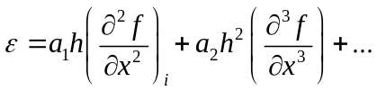
where is the mesh spacing. For an approximated solution 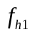 from a grid with mesh spacing 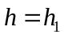a relationship can be established with an exact solution (solution corresponding to the mesh with mesh spacing tending to zero i.e. 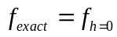) by using the following:
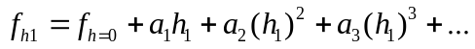 3-1
For a uniform grid coefficient 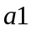, 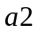, and 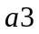 depend on the derivatives of  but are independent of the grid spacing. Hence, if we consider the solution 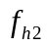 obtained on a finer grid such as 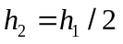 then:
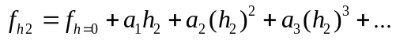 3-2
with the same values of , ...
Eliminating the unknown 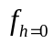 from equation 3.1 and 3.2 :
If one assumes that the first mesh was fine enough, such that 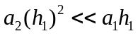 then 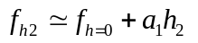 and 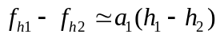 . 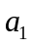 can then be identified and the ”exact” solution can then be ”estimated” by the Richardson extrapolation:
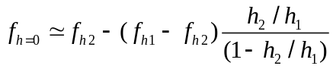

However 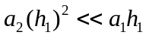 implies that the scheme is known to be first order. If it is second order then 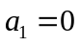 and 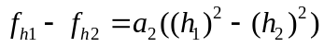, then:
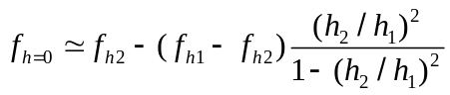
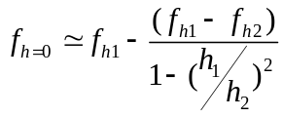
This can be generalised for a scheme of order n:
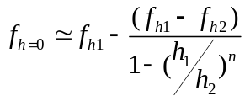 3-3
The method can also be used to estimate the order of the scheme. If we take the solution from three successive grids than:
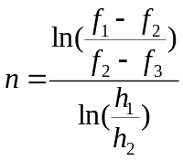 3-4
However the extrapolated solution obtained with the above Richardson method is only applicable in case of monotonic solutions i.e. if << or >> and is not valid for oscillatory solutions. Also the order of convergence depends on the order of numerical scheme used for temporal or spatial discretization. But in case of unstructured meshes n may be larger than the order of the scheme [9]. For example in case of buoyancy driven flow in a square cavity, considered in the present study Vahl Davis [15] reported values of n larger than 3 when using a second order upwind scheme. However in the present work at low Rayleigh number order of convergence is in good agreement with the order of the scheme while using equation 2 but it is not the case for high Rayleigh number (this will be further discussed in section 6.1). One reason for this discrepancy could be attributed to the fact that solution from a coarse grid is included which distort the solution badly. For example, in the present case, the coarser grid has 20 grid points in one direction which is still not sufficient. Second factor which can contribute to the error is incomplete convergence of the numerical simulations and the possibility that the sequence of mesh is not yet in the asymptotic range where Richardson extrapolation is valid.
Relationship defined above is for meshes with same refinement ratio but for the case of unstructured meshes where refinement ratio is not uniform order of convergence must be solved iteratively using following equation[5]
h can be given as
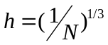
N is the number of vertices.

Governing Equations of Fluid Dynamics
Physics of any fluid is governed by the following three fundamental principles.
- Mass is conserved.
- Rate of change of momentum is equal to the sum of forces on the fluid particle.
- Energy is conserved.
Fluid is regarded as continuum. For fluid flow analysis the properties are described in terms of macroscopic properties for example velocity, temperature, pressure and density. Five basic governing equations of fluid are equations of momentum in x, y and z direction, equation of continuity i.e. mass conservation equation and equation of conservation of energy.

Mass Conservation in Three Dimensions:
Mass balance of a fluid element is written as:
Rate of increase of mass in Fluid element | = | Net rate of flow of mass into fluid element
Or above balance equation in more compact vector notation can be written as following [2]:
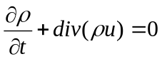 4-5
Equation 1 is unsteady, three dimensional continuity or mass conservation equation. First term of left hand side of equation represents the rate of change of density with time. Second term describes the net flow of mass out of the element across its boundaries and is called convective term.
For an incompressible fluid density is constant so equation of continuity would reduce to the following form[2]:
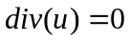 4-6

Momentum Conservation:
Newton second law when applied to moving particles states that net force on the fluid element equals its mass times the acceleration of the element. This is a vector relation so it can be split into three scalar relations to yield three momentum conservation equation in x, y and z direction.[3]

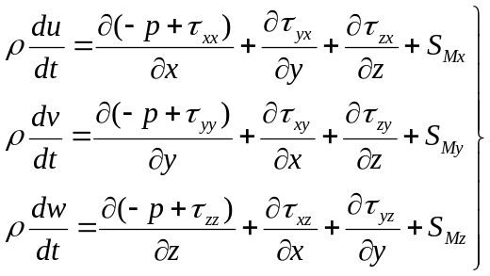 4-7

, and are source terms including contribution due to body forces. For example in case of buoyancy driven flow in the square cavity test case, considered herein, in which Y is the direction of the gravity vector these forces would be as follows:
=0
= - g
=0
In two dimension framework, viscous stresses are as following:

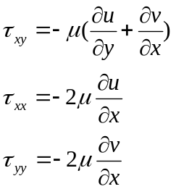
Hence for two dimensional steady state flow equation 3.2 will reduce into the following equations:

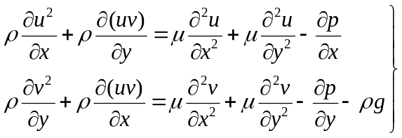 4-8

STAR CCM
Star CCM is a finite volume code which solves discretization equation for each control volume and stores resulting variables at the center of each cell. Each contro volume can have any number of faces, i.e. the mesh can be completely unstructured with any type of polyhedral cells. It is a double precision code by default.
Further features of Star CCM used in this particular study are discussed in the subsequent sections where relevant.

Automated Engineering
A Star-CCM Macro is a java language program which can be compiled and executed in STAR-CCM environment. Unlike other macros Star-CCM macros translate and records what you do in the workspace and convert them into meaningful java code, which can then be edited by the user.
One can also write a macro from scratch, but that would require up-front knowledge about all the objects, attributes and methods used inside the commercial software. It is more effective to use the workspace to record the actions you want to perform than edit the Java file using your any text editor to get the required results. After recording a macro it can be changed accordingly using a text editor to give the required results. For example:
public class run extends StarMacro
{
public void execute() {
Simulation simulation_0 =
getActiveSimulation();
simulation_0.getSimulationIterator().step(1);
}
}
This macro would go to one step and will stop after 1 iteration. But if we change it like following:

public void execute()
{

Simulation simulation_0 =
getActiveSimulation();
simulation_0.getSimulationIterator().run();
}
}
Now this macro would run until the stopping criteria of the simulation is reached. One can also run java macros within macros an example of java macro file used to call other java macros is given in Appendix 1.

Numerical Scheme
The Governing equation for the convection and diffusion of a scalar quantity in Star CCM is given as following[22]:
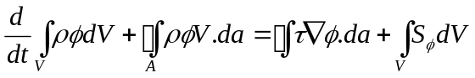 5-9
The terms in above equation along with their approximation in the code is given in the following section:

Transient Term:
First term on LHS of Equation 4.1 is termed as transient term. It represents the time dependant behavior of the scalar. Thus normally it is not used in steady state calculations. At first iteration first order approximation is used to calculate the integral and at subsequent iterations second order approximation is use. Two approximations are given as under[22]:
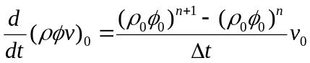 5-10
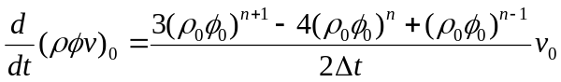 5-11
Equation 4.2 represents the 1st order approximation of the transient term in Star CCM code as it uses two successive iterations to approximate the value of the derivative so it is used at the first iteration to approximate the value of transient term. Equation 4.3 represents the second order approximation of the transient term.

Source Term:
Second term on RHS is source term and is approximated as a product of evaluated at cell centeroid and volume of the cell V 22].
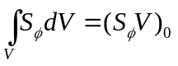 5-12

Diffusion Term:
First term on the RHS is diffusion term and its discrete form of the diffusion term in the transport equation is represented as[22]
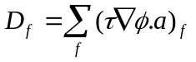 5-13
Where represents the face diffusivity, gradient and vector area respectively.

Convection Term:
Convection term is discretized in the following manner[22]:
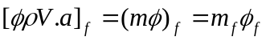 5-14
Where are mass flow rate and scalar values calculated at the cell faces. There are five different numerical schemes available in the code to obtain the value of . these are:
- First order Upwind Differencing Scheme
- Second Order Upwind Differencing Scheme
- Central Differencing Scheme
- Hybrid Second Order Upwind/Central

First Order Upwind Differencing Scheme:
First order upwind scheme is generally not recommended to use because of its associated numerical dissipation effects. For first order upwind scheme convective flux is computed as [22]

for 5-15
for 5-16

Second Order Upwind Scheme:
Advantage of this scheme over first order upwind scheme is that it is second order accurate. This scheme is more accurate for steady state problems but known to be less stable. In those situations it is advisable to use the first order upwind scheme to get an initial solution and then use second order upwind scheme to get improved accuracy. Flux values are computed as under[22]:
for 5-17
for 5-18
Where face values are computed through linear interpolation of cell values from either side of the face as follows:
Where

Central Differencing Scheme:
In Star-CCM central differencing scheme is available for Large Eddy Simulations because of it preserves turbulent kinetic energy when used to discretise velocity. Central Differencing scheme is normally second order accurate. For this scheme convective flux is given as:
5-19
Where “f” is the geometric weighting function related to the mesh stretching. For a uniform mesh f is 0.5.

Turbulence Modeling
In Star CCM a number of turbulence models are available including Reynolds averaged Navier-Stokes (RANS) Models, Large Eddy Simulation (LES) and Detached Eddy simulation (DES). In the present study focus was kept for RANS particularly low Reynolds models. A brief description of low Reynolds turbulence models available in STAR CCM is given in the subsequent sections:

Standard Spalart-Allmaras (SSA) Model
This model solves the single equation to determine the turbulent viscosity. In standard form SSA model [23] is a low Reynolds number model hence it is designed to be applied without wall function so boundary layer should be well resolved by the grid. Standard transport equation [22]:
5-20
Where different terms in the equation can be described as:
=turbulent production term
= Turbulent Dissipation term
= user specified source term in present case source term is buoyancy force

Standard Low Reynolds Number model
Standard Low Reynolds Number Model [24] is same as standard model with all the coefficients. The only difference is that it includes additional damping functions so that it can be applied in regions near the wall. Transport equation for this model is given in the following [22]:
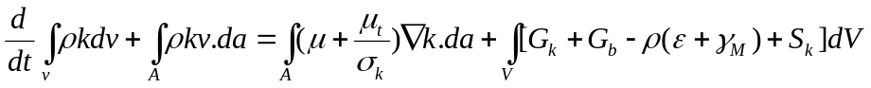 5-21
5-22
and are user defined sources.
Turbulent Production Term
Additional Production Term
Nonlinear Production Term
Buoyancy production Term
Compressibility modification
is damping function given as following
Where
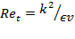

V2f Model
The V2f model [25,26,27] is basically four equation model along with k and it solves two additional equations for f and v². where f is elliptic relaxation factor and v² is velocity scale. Transport equation for this model is given in the following [22]:
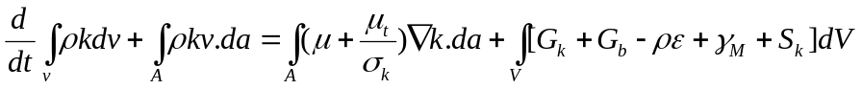 5-23
5-24
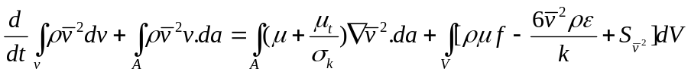 5-25
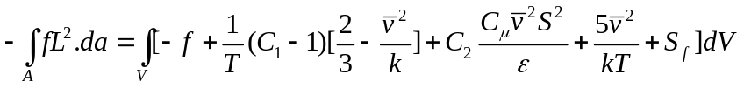 5-26

, , and are user defined sources.
Turbulent production
Buoyancy production
Compressibility modification

Abe Kondo Nagano (AKN) Low Reynolds Number Model
Major difference of Abe Kondo Nagano (AKN) Low Reynolds Number model [28] from standard Low Reynolds number model is that it uses Kolmogrov velocity scale instead of friction velocity to account near wall and low Reynold number effect. Values of constants are different for this model from that low Reynolds model. Basic transport equation for this model is given as following [22].
5-27
5-28

,and are user defined sources.
Turbulent production
Buoyancy production
Compressibility modification
is a damping function
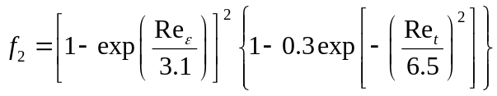

Where
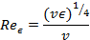

SST Model
-sst model [29] is a two equation model which solves transport equations for turbulent kinetic energy k and specific dissipation rate . Specific dissipation rate is defined as the dissipation rate per unit turbulent kinetic energy. Or we may write it as:
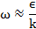
This model can be applied to the boundary layer including viscous dominated region without any further modification. Main transport equation and a description of constants used in the equation is given in the following [22]:
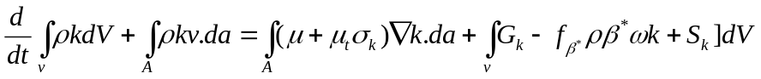 5-29
5-30
=turbulent production term
=Vortex stretching modification
=free shear modification
= Turbulent Dissipation term
= user specified source term in present case source term is buoyancy force
=turbulent viscosity
A detailed description of factors given in turbulence models can be obtained from the Star-CCM user guide [22].

Convergence Criteria.
As a default Star CCM provides a criterion based on residual plots to decide the convergence of simulations. Residual value reduces as solution approaches towards the final solution. However, residual plots alone cannot be trusted as a sole evaluator of convergence. Effectively, for some problems drop of the order of three in the value of the residuals might be acceptable but for others it might not be an adequate limit. As discussed in earlier section there are two types of discretization errors, one is dispersive error that is characteristic of first order upwind scheme. They are inherently stabilizing and produce residual plots that tend to reduce monotonically. Second type of error is diffusive errors which are associated with second order upwind schemes.
For example in the test case of square cavity a residual value of was set as stopping criteria for the simulation. However, after obtaining the results at preliminary stage, it turned out that for the first order upwind scheme this value residual tolerance gave larger errors for the finer meshes as compared to the coarser meshes as shown in figure 4.1.

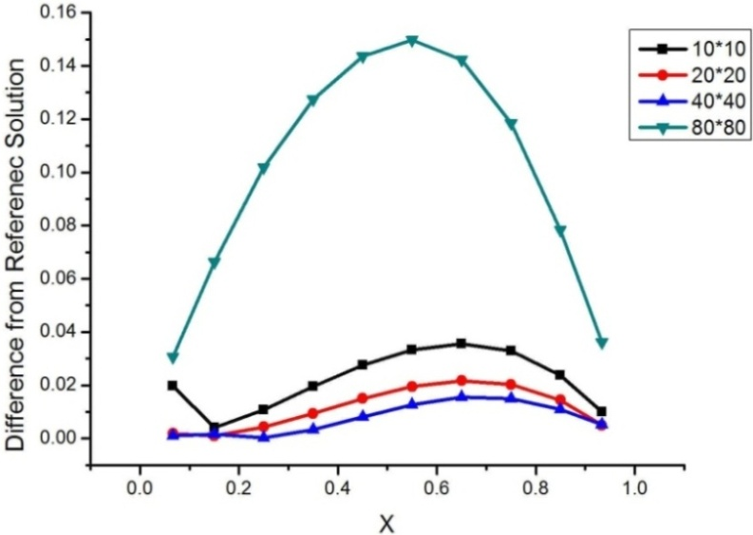
Figure 5-1: Comparison of results obtained with residual tolerance of 10⁻⁴ for X-momentum for different grids
Effectively, this discrepancy of in the predictions calls for monitoring additional values having physical significance in the solution to decide for the convergence of the solution. Star CCM allows a number of physical variables to be monitored for convergence criteria. In the present study, a choice has been made to monitor the maximum value of temperature at midpoint of the cavity and near the boundaries after every iteration and the difference in the value of temperature at that point between two successive iterations have been set as a stopping criteria instead of residuals and results obtained in this way shows that error decreases with decreases mesh spacing.
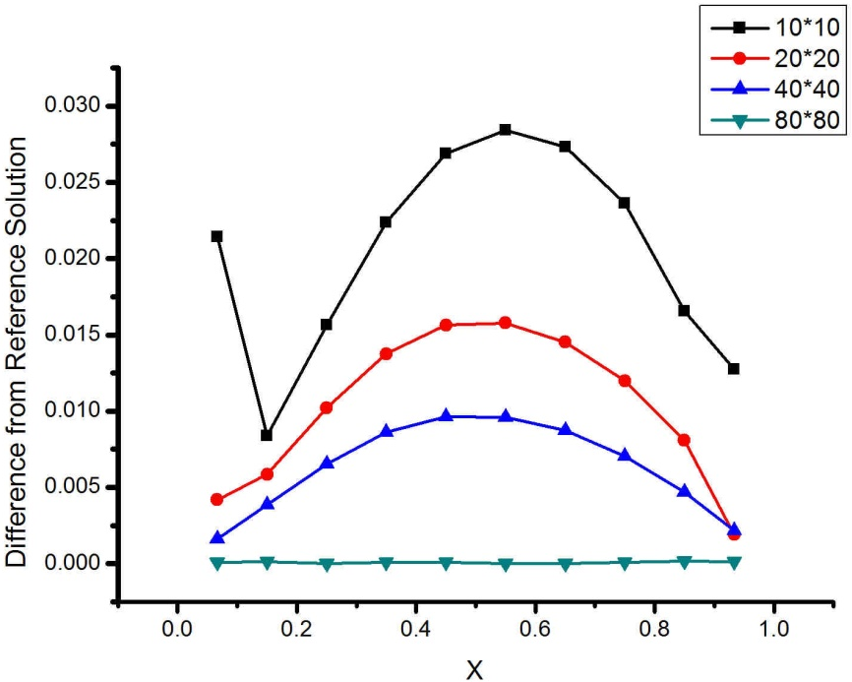.
Figure 5-2: Comparison of results obtained after monitoring temperature asymptotic value of 1E-4 at center and near boundaries of the cavity
One possible reason why residuals are not enough to decide whether a solution is converging or not is that they are averaged on the whole domain which would hinder any local instability hence it is necessary to monitor solution at different points of the domain.

The Square Cavity Test Case:
Natural convection flow in enclosures has many thermal engineering applications such as in double-glazed windows, solar collectors, cooling devices for electronic instruments, gas-filled cavities around nuclear reactor cores and building insulation [15]. Thus, the Buoyancy-driven flow in a square cavity, with vertical differentially heated sides which is a suitable vehicle for testing and validating computer codes used for a wide variety of practical problems such as nuclear reactor insulation, room ventilation, solar energy collectors and crystal growth in liquids[30].
In the following case a square cavity with aspect ratio 1 has been considered. As presented in Figure 5.1 horizontal walls are adiabatic while the vertical walls are at constant temperature difference of 20K. Due to very small temperature difference between two walls one can make use of Boussinesq assumption. A schematic diagram of the two dimensional cavity is given in Figure 3.
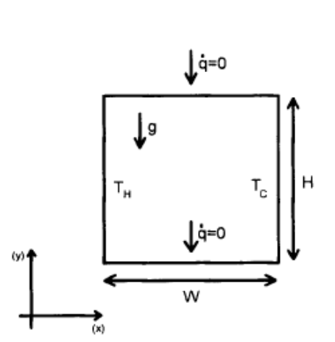
Figure 6-3: Geometry of the problem
In Cartesian coordinates differential form of steady convection and diffusion of a property without any external source is given as follows:
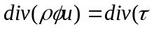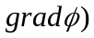 Equation 6-31
In the present study both laminar and turbulent flows have been considered to study the effect of numerical and modeling errors on the solution obtained from Star-CCM. Flow inside the cavity remains laminar up to Ra=10⁶[30,31]. It is also evident from the streamlines obtained at different Rayleigh numbers as given in Appendix 3, that flow remains laminar for Ra = 10³, 10⁴, 10⁵ while 10⁶ can be termed as transition regime from laminar to turbulent.
Present work can be divided into two parts: the first one deals with the numerical errors for laminar flow, while in the second part, effects of different turbulence models have been studied along with grid spacing. Results from these two parts will be discussed in two different sections stating as Part I and Part II respectively.

Part I
This part is dedicated to the numerical errors coming from grid and numerical schemes used to solve the convection equation. Initially three different grids given in figure 5.2 (a),(b) and (c) were used to compare the effect of cell shape on the solution. But skewed grid represented in the figure is rarely used in practical application hence another grid was introduced at later stage given in figure 5.2(d).
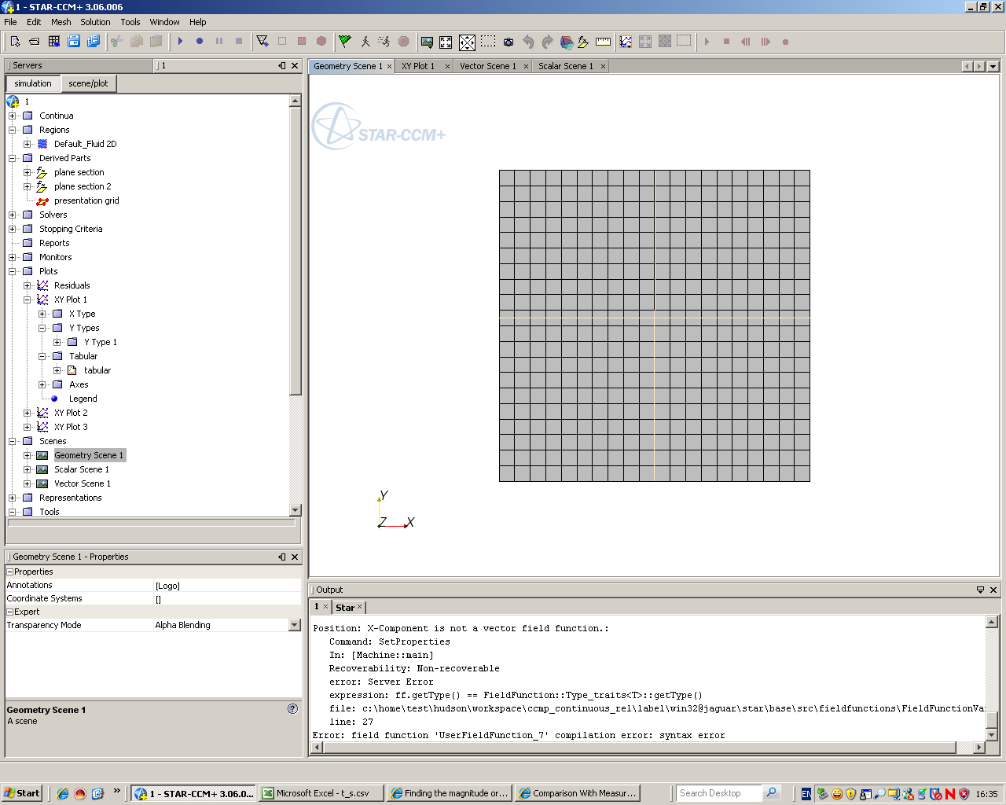 | 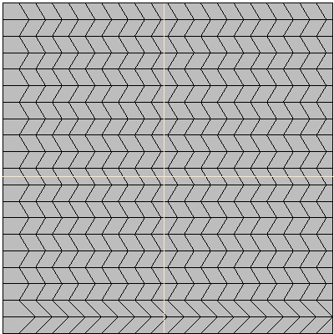 | 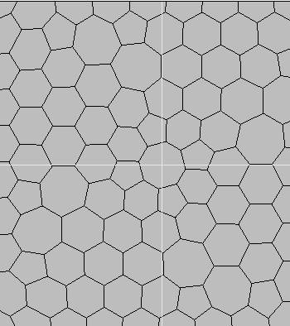
Regular square Grid  (a) | Skewed Grid  (b) | Polyhedral Grid  (c)
 | 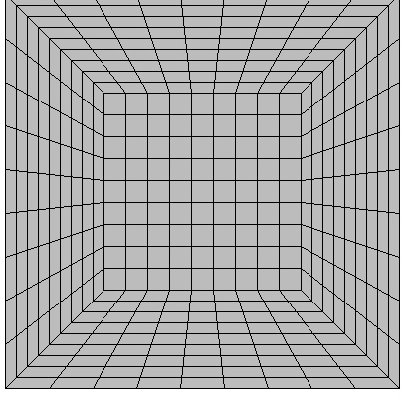
 | Butterfly type Mesh
(d)
Figure 6-4: Mesh Types

Results:
There was no experimental data available in the literature for laminar flow, therefore solution from the most refined grid was used as a reference solution. Flow fields and temperature distributions at mid planes of the cavity have been taken at different Rayleigh number (Ra) ranging from 10³ to 10^{6.} Where Rayleigh number is a dimensionless number associated with buoyancy driven flow. Ra is a product of Grashof number and Prandtl number hence by definition Ra is a ration of buoyancy forces and viscous diffusivities. Formula for Ra is given in the Appendix 2.
Temperature and vertical velocity have been taken at y=0.5 plane and horizontal velocity have been take at x=0.5 plane. In order to change the Rayleigh number from one case to another thermal expansion coefficient has been varied, keeping all other variables constant (details of the values used are given in appendix 1.
That has resulted in the value of velocity of the order of 10⁻⁴ to 10⁻⁸, while using second order upwind scheme,, which is almost of the order of machine truncation error. Hence refinement of grid beyond 80*80 with the same parameters failed to give a converged solution. In that case, the 80*80 grid was taken as a reference grid. Figure 6.4, 6.6 and 6.8 represents the temperature and velocity profiles at Ra=10³. Figure 6.5, figure 6.7 and figure 6.9 shows the difference in the solution obtained from 10*10, 20*20 and 40*40 from reference grid for square, polyhedral and skewed cells along the plane for Ra=10³. Error convergence as a function of grid refinement is shown in figure 6.10 to figure 6.13 for Ra 10³ to Ra=10⁶. Table 6.2 gives the values of the order of convergence for these three different grids. It is clear from the table that order of error convergence is two for the square grid. Here the error is calculated as the average of the difference in reference solution and solution from the grid.
In the second step to get rid of small velocities another approach has been adopted to raise the value of reference velocity and thermal expansion coefficient β. Ra has been changed by changing the density of the fluid as given by the formula in appendix 1. Reference velocity has been increased to 0.15 m/sec. Effect of these two approaches on the error of the solution for 40*40 grid is shown in figure 6.14 a, d and c for three different mesh types. At this time as mentioned earlier another grid have been introduced in the study along with square, polyhedral and skewed which is termed as butterfly like type mesh given in figure 6.2(d).
An exact solution has been obtained using Richardson extrapolation for total mass flow by taking integral of the absolute value of velocity along the mid plane of the cavity and dividing it by 2. Trapezoidal has been used to calculate the value of integral. According to equation 3.4 solutions from three different grids have been used to calculate the order of convergence (n) and extrapolated solution.
In order to decide which three grids should be taken to calculate the order of the scheme figure 6.15 shows the comparison of the extrapolated solution obtained from three different values of n for Ra=10³. Firstly value of n was calculated using 10x10, 20x20 and 40x40 grid (n=1.97), secondly it was calculated using 20x20, 40x40 and 80x80 grid (n=2.27) and finally n was assumed to be 2 and than extrapolated solutions have been compared. As value of n was almost equals to 2 for three approaches used hence figure 6.15 does not show any difference in the value of exact solution obtained from equation 3.3.
Similarly, figure 6.16 shows the same comparison for Ra=10⁴ here 10x10, 20x20 and 40x 40 grid gives value of n equals to 1.71 where 20x20, 40x40 and 80x80 grids gave it to be 1.96. Therefore figure 6.16 shows a difference in the extrapolated solutions obtained from these two different approaches. But when the values of n assume to be 2 it gave the same results as obtained from the 20x20, 40x40 and 80x80. It makes clear that accuracy of the solution obtained from the Richardson extrapolation depends on the value of n. More close the value of n to the order of the numerical scheme more exact the solution will be.
In order to confirm the above finding solution obtained from the 160x160 grid have been plotted on the extrapolated curves to see whether these solutions lie in the extrapolated region or not. Figure 6.17, 6.18 and 6.19 shows the extrapolated curves for the solution obtained using second order upwind scheme from 20x20, 40x40 and 80x80 grid. Solution obtained from the 160x160 grid lies in the extrapolated region for Ra=10³, 10⁴ and 10⁵ similarly figure 6.20 and 6.21 represents the results for first order upwind scheme for Ra=10³ and 10⁴. Here comparison has not been shown for Ra=10⁵ because for that Ra when first order upwind scheme was applied solution was oscillatory hence as explained in section 3.6.4 Richardson extrapolation cannot be applied in that case.
By comparing these approximated exact results with that obtained from 80*80 and 160*160 grid following values of error have been obtained:
Table 6-1: Error for the total mass flow obtained from two different grids
Rayleigh Number | %Error from 80*80 square grid | %Error from 160*160 square grid
10³ | 0.14 | 0.14
10⁴ | 0.4 | 0.08
10⁵ | 2.1 | 0.483
It is obvious from above table that error from 80*80 and 160 grid remains same for Ra=10³ but for higher Ra error from 80*80 square grid is higher as compared to 160*160 grid. As shown in Appendix 2 profiles inside the cavity changes as Rayleigh number changes and gradients near the wall become sharper at higher Ra requiring finer mesh near the wall. Keeping in view the results from table 6-1 160*160 grid has been considered as the reference grid.
When Richardson extrapolation was applied for nusselt number at the hot wall it gave order of convergence almost 0.93 for second order upwind scheme as in figure 6.23. Hence to investigate the order of discretization being used in Star CCM to compute local Nusselt number it has been calculated by using second order and first order approximation given in Ferziger [3] to calculate the derivatives. Equation 6.2 represents the first order approximation of the derivative and equation 6.3 represents the second order approximation of the derivative. Equation 6.4 represents the formula to calculate the Nu number using approximated value of the gradient.
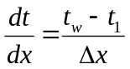 6-32
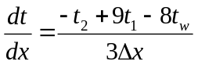 6-33
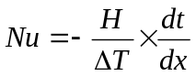 6-34
Values of Nu obtained from the above mentioned relationship were compared from those obtained from the code using 20x20 grid for Ra=10³ given in figure 6.24. It shows that values obtained from the code are not in agreement with those obtained from the equation 6.2, 6.3 and 6.4. Figure 6.25 shows a comparison of these values for 40x40 grid and it shows that with grid refinement difference also decreases. Now to check the effect of Ra on these values figure 6.26 and 6.27 represents the same graphs as figure 6.24 and 6.25 for Ra=10⁴. It shows that difference between the calculated values of Nu and those obtained from the Star CCM remains same independent of Ra.
Figure 6.28 shows the average Nu as a function of grid spacing for values obtained from derivative approximation using equation6.3 and that obtained from Star CCM. It also confirms the fact that as grid is refined the difference between the two values decreases. Average Nu is obtained from the following formula.
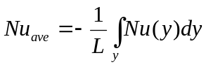 6-35
This test case has been modelled in the code using both steady and implicit unsteady solvers with second order upwind scheme to study the difference of two solvers on the results. Figure 6.29, 6.30 and 6.31 show that both converge to the same value but the unsteady solver takes longer time to converge as compared to the steady sate solver. In case of square grid, unsteady solver shows steps but these steps are not very clear for polyhedral and skewed grids because of the difference of scale along x axis. In figure 6.29 and 6.30 scale along x axis is very large hence these steps are not visible. It also shows that square grid converges much faster.
As discussed in section 4.2 three different schemes have been compared in this study to observe the effect of solver scheme on the solution. In theory all schemes should converge to the same solution as grid spacing approaches to zero with the order of convergence depending upon the order of the scheme. Figure 6.32 to figure 6.37 represents the comparison of the error profile at mid height of the cavity for temperature and velocity profiles for three different types of grid while using different schemes. Error has been calculated as the difference in solution from a grid with the reference solution. Where reference solution is one taken from 160*160 grid.
As mentioned earlier, order of error convergence has been estimated by plotting the error as a function of grid spacing on a log-log graph. Slope of the graph has been taken as the order of convergence. At this stage total mass flow calculated from Richardson extrapolation is taken as the reference solution.
Figure 6.38 represents the error as a function of grid spacing for Second order upwind scheme. For Ra=10³ the order of error convergence is almost two and this is similar to that obtained from Richardson extrapolation. Figure shows that after 80x80 grid there is no further decrease in error for 160x160 grid for Ra=10³. As Ra increases order decreases. Similarly Figure 6.39, 6.40 and 6.41 represents the error as a function of grid spacing for first order upwind, implicit unsteady solver and central difference scheme. To give a brief overview of the effect of the numerical scheme figure 6.42 represents the error convergence for different numerical schemes for Ra=10³. Central differencing scheme, second order upwind scheme and implicit unsteady solvers have been expected to give second order convergence as order of the numerical scheme is two and figure 6.42 is in agreement with that. Error from first order upwind scheme is higher as compared to all other schemes. As discussed in section 4.2.4 that order of accuracy for second order scheme is two hence it is always recommended to be used to get an enhanced accuracy as compared to first order upwind scheme. It also confirms the fact that the higher the order of the numerical scheme, the higher will be the accuracy.
In contrast to square cells mesh, the polyhedral, skewed and butterfly mesh do not exhibits the order of convergence in accordance with the order of the numerical scheme. That might be due to the associated geometrical errors resulting from irregular cell shapes. Figure 6.43 to 6.57 represents the effect of numerical schemes on error reduction with grid spacing for polyhedral, skewed and butterfly mesh.
To explain the effect of cell structure on the predicted results figure 6.58 represents solution as function of grid spacing using same numerical scheme. For square grid solution approaches to the exact value with the grid refinement. But for polyhedral cells solution also approaches to the exact solution with grid refinement but after 6400 cells it oscillates which is also evident from figure 6.43 that for Ra=10³ error increases for 160x160 mesh. Reason for this behaviour could be the geometrical error or non uniform refinement of the mesh. For case of skewed grid refinement does not have any on the accuracy of the results as given in figure 6.49. In case of butterfly type mesh there is a deviation for 80x80 grid. The reason for that wiggle may be the skeweness of the cells at the corner.
It is clear from the graph that accuracy of results cannot be guaranteed with the increased cell density and order of the numerical scheme but it also depends on the shape of the cells of the grid.

Part II – turbulent flow cases
After completing the study of numerical errors next step was to analyse the modelling errors associated with CFD simulations. Turbulence is a dominated phenomenon in modelling a problem in CFD. Because of the simplifications and approximations used in different turbulence models. To observe the effect of different turbulence models along with grid density turbulent flow cases have been considered in the same square cavity given in figure 6.1. In literature there have been a number of papers available containing experimental data for turbulent flow inside differentially heated cavity at .[35]
Three different grids have been used for this geometry with expanding spacing in both x and y direction with 1600, 6400 and 25600 cells. It is clear from the streamlines given in appendix 3 that at Ra=10⁹ gradients near the wall are very sharp requiring fine mesh in that area to estimate those gradients. Table 6.2 gives the number of cells from wall to a distance of 0.12 m in each direction.
Table 6-2: Number of cells from wall to a distance of 0.12 m
Grid | Number of Cells
40 x 40 | 13
80 x 80 | 32
160 x 160 | 63
Figure 6.3 gives the type of grids used in this study to observe the effect of turbulence modelling on the accuracy of results.
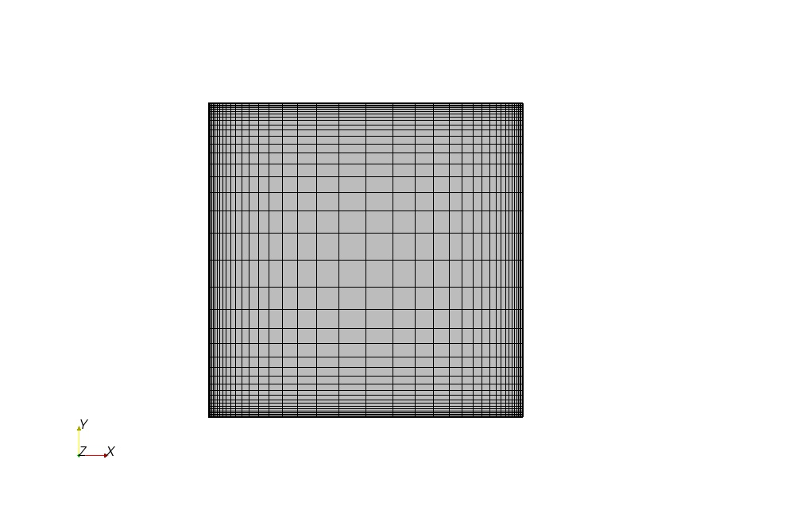 | 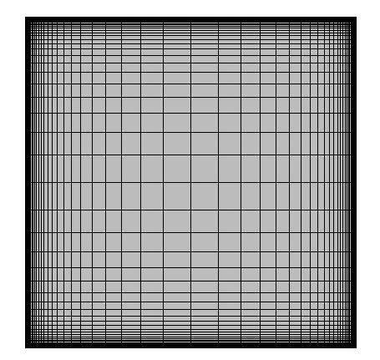 | 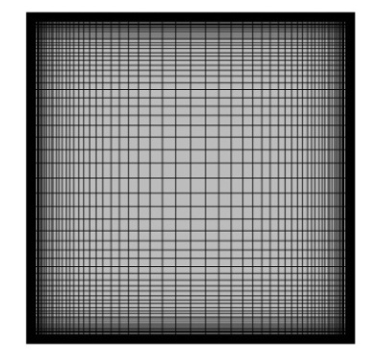
a) 40*40 Grid | b) 80*80 Grid | c) 160*160 Grid
Figure 6-5: Mesh Types for Turbulent Flow

Results
Now reference velocity has been increased to the value of 1m/sec to match the experimental conditions described by Ampofo et all [35]. Hence density is 0.885kg/m³ and β is .0051.
Maximum value of Y⁺ near the hot wall is 3 for 1600 cells 0.75 for 6400 cells and 0.018 for 25600 cells. These low values of Y+ shows that grid near the wall is fine enough to resolve the boundary viscous layer hence low Reynold turbulence models should be used.
As discussed in section 4.3 there are five different low Reynolds models available in the Star CCM they are considered to study the effect of these models on heat transfer and flow fields along with grid refinement near the boundaries.
Figure 6.62 , 6.63 and 6.64 represents the Nu profile on the hot wall obtained from different models and experimental values for three grids. Figure 6.65,6.66 and 6.67 represents the difference of the simulation results and experimental values for different grids to give a comparison of error fluctuation on the same grid due to difference of turbulence model.
Figure 6.68, and 6.69 represents the Nu profile along the hot wall for and v2 f model to show the effect of grid refinement on the results obtained from two model. These graphs shows that for v2f model grid refinement does not have any significant impact on the results but for profile changes as a function of grid spacing. This factor can be observed from figures 6.70, 6.71 and 6.72 where relative error is plotted as a function of height from the bottom to the top along the hot wall. For v2f model error does not show any significant change with grid convergence in contrast to model. Similar behaviour has been observed in case of velocity profile near the wall as in figure 6.73 and 6.75.
Figure 6.76 represents the turbulent energy along the mid plane of the cavity obtained from different turbulence models and experiment. It shows that turbulent kinetic energy obtained from the model is in good agreement with the experimental results as compared to other models.
In order to check further the grid dependence of near the wall results have been compared from two different grids with same number of cells but different width of first cell near the wall for model and v2f model as shown in figure 6.79 and 6.80. It also shows that v2f model is independent of grid refinement near the wall but is very sensitive to that.

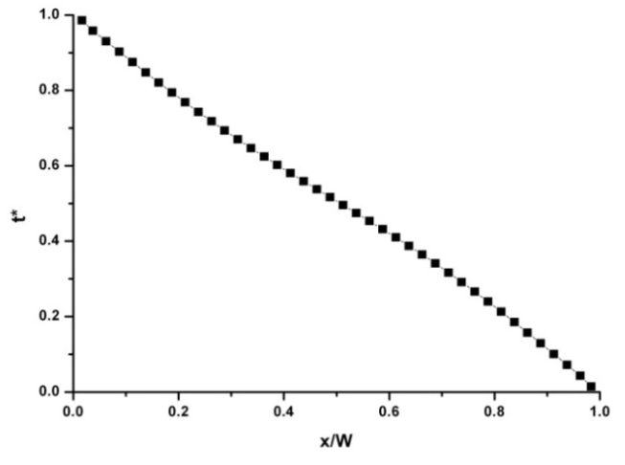
Figure 6-6: Temperature Profile inside Cavity at Ra=10³

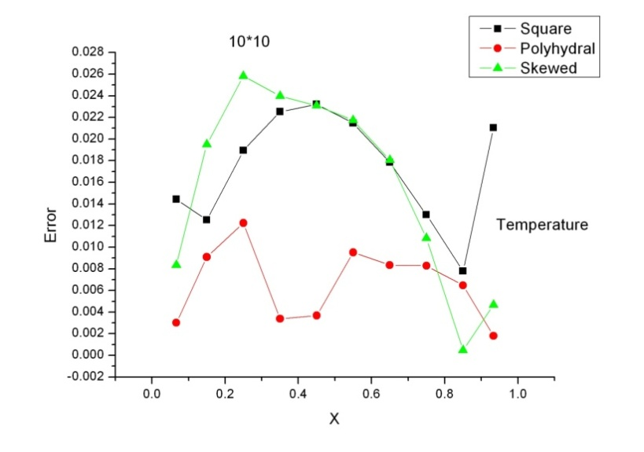 | 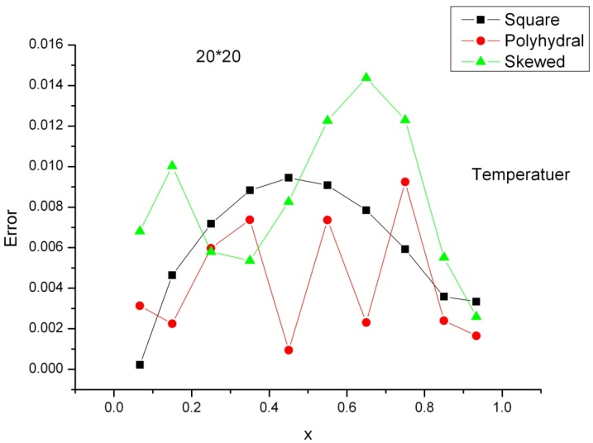
a) 10×10 mesh | b) 20×20 mesh
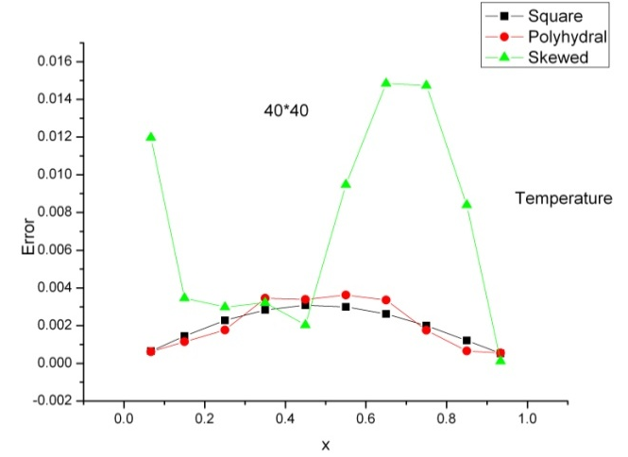
c) 40×40 mesh

Figure 6-7: Error in temperature for different mesh numbers
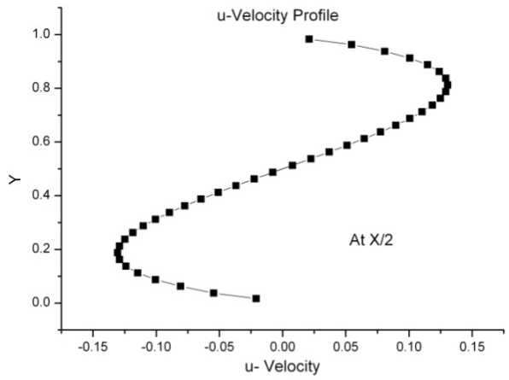
Figure 6-8: u-Velocity Profile in side cavity at Ra=10³
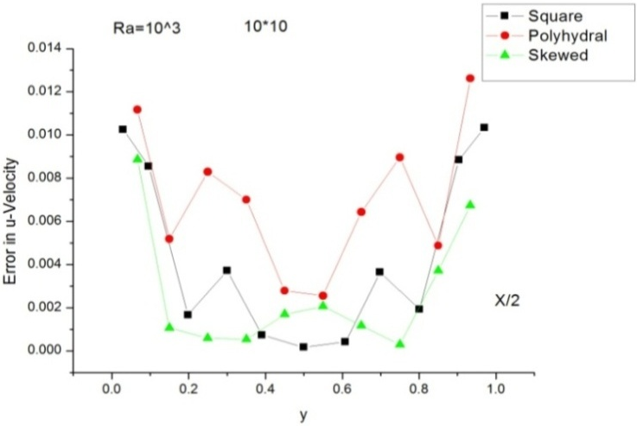 | 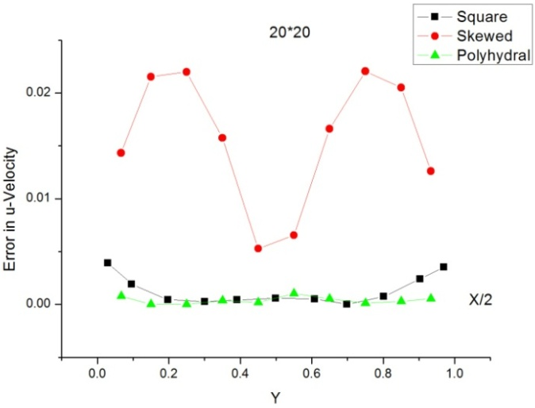
a) 10×10 mesh | b) 20×20 mesh
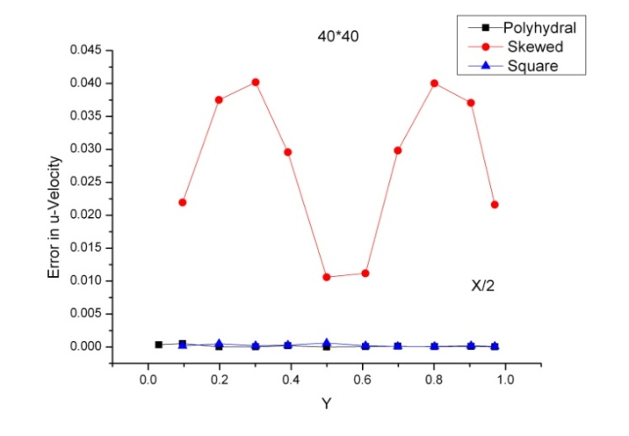
c) 40×40 mesh
Figure 6-9: Error in u-Velocity for different mesh numbers
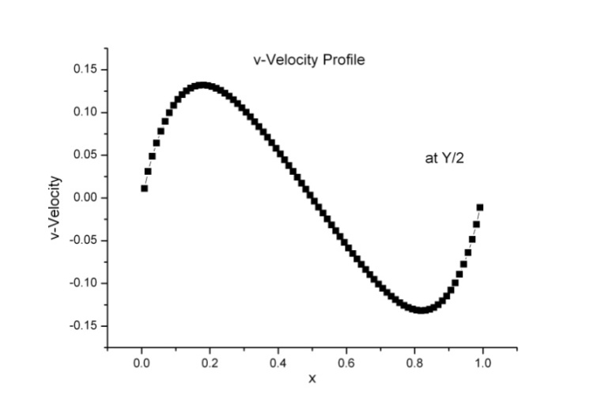
Figure 6-10: v-Velocity Profile in cavity at Ra=10³
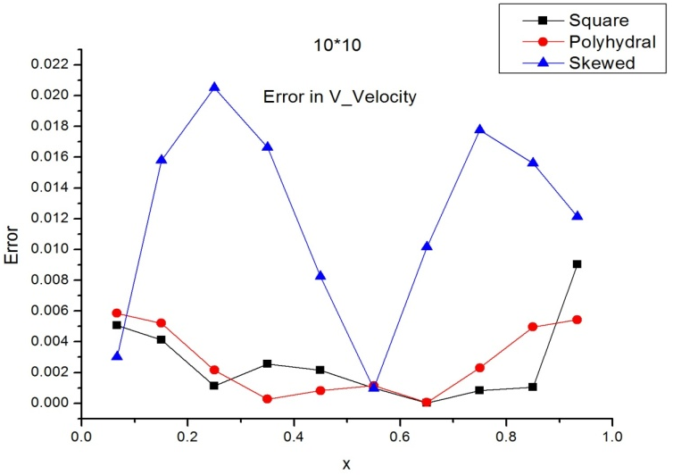 | 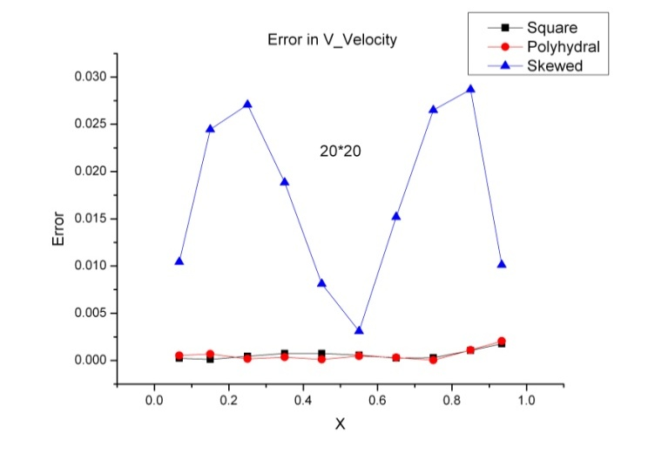
a) 10×10 mesh | b) 20×20 mesh
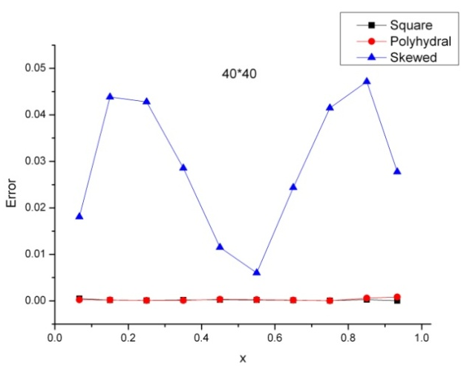
c) 40×40 mesh
Figure 6-11: Error in v-Velocity for different mesh numbers

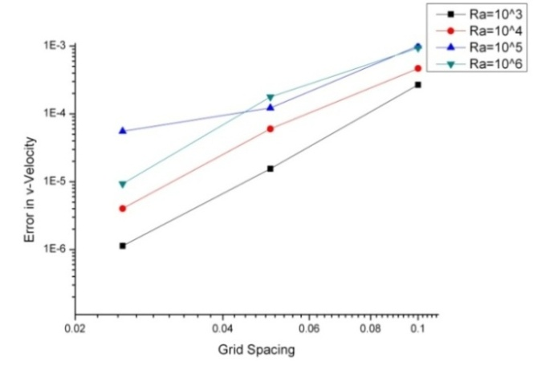 | 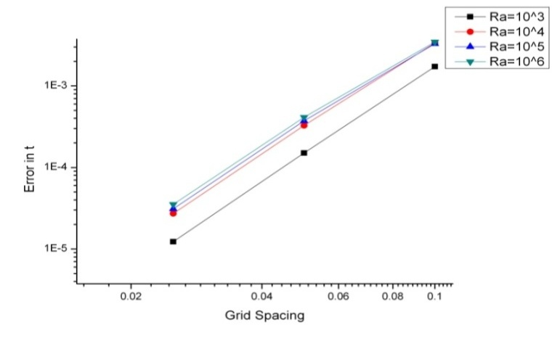
a) Decrease in Error with grid spacing for v-Velocity | b) Decrease in Error with grid spacing for Temperature
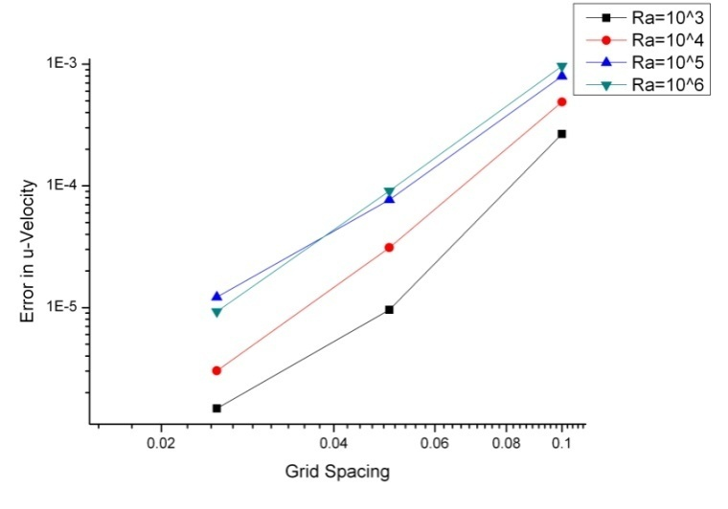
c) Decrease in Error with grid spacing for u-Velocity
Figure 6-12: Results for Square mesh

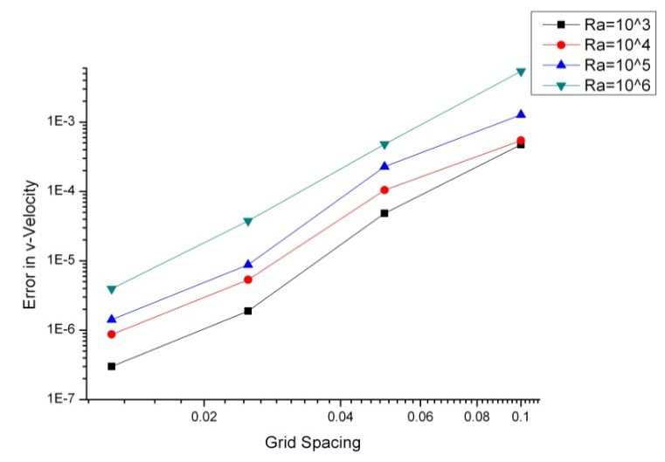 | 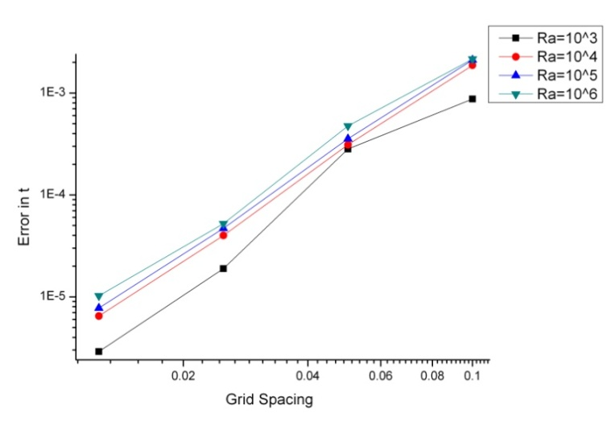
a) Decrease in Error with grid spacing for v-Velocity | b) Decrease in Error with grid spacing for Temperature
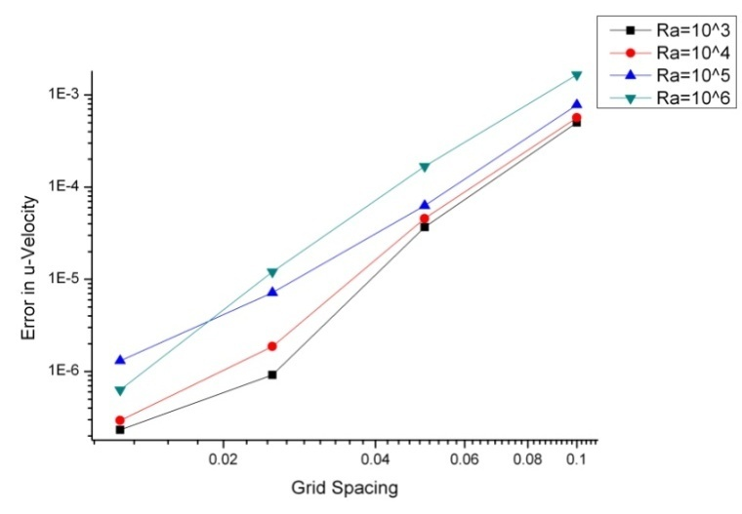
c) Decrease in Error with grid spacing for u-Velocity
Figure 6-13: Results for Polyhedral Mesh
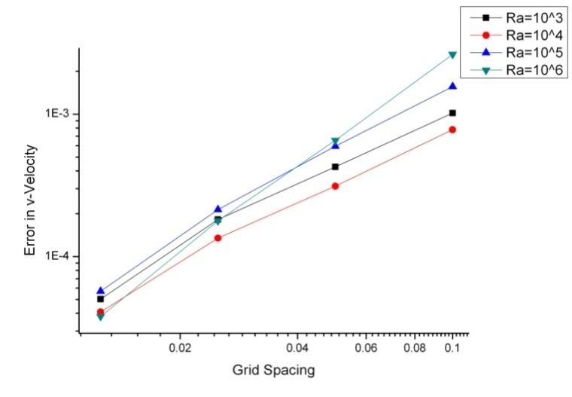 | 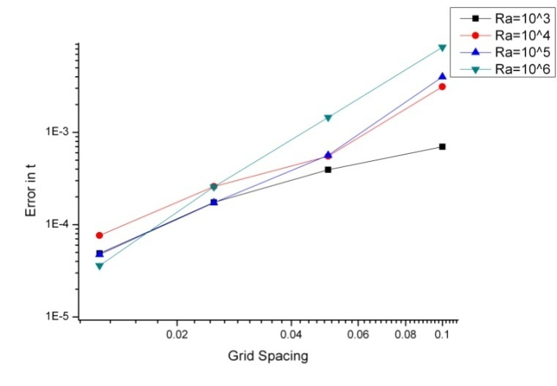
a) Decrease in Error with grid spacing for v-Velocity | b) Decrease in Error with grid spacing for Temperature
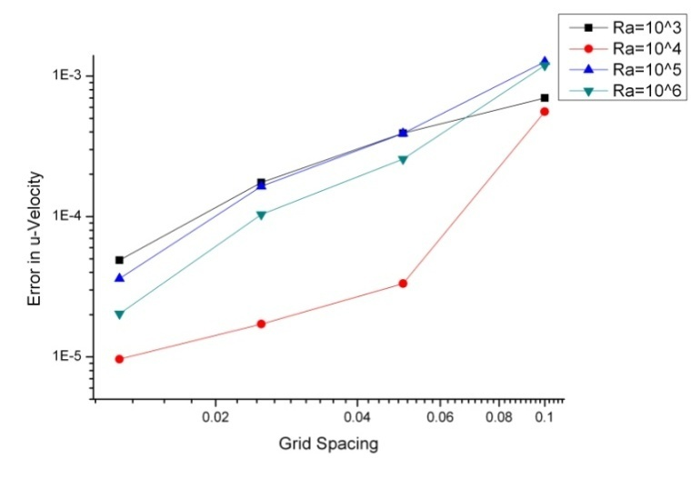
c) Decrease in Error with grid spacing for u-Velocity

Figure 6-14: Results for Skewed Mesh

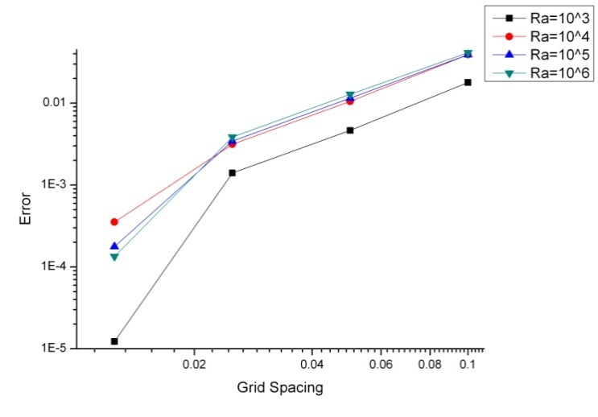 | 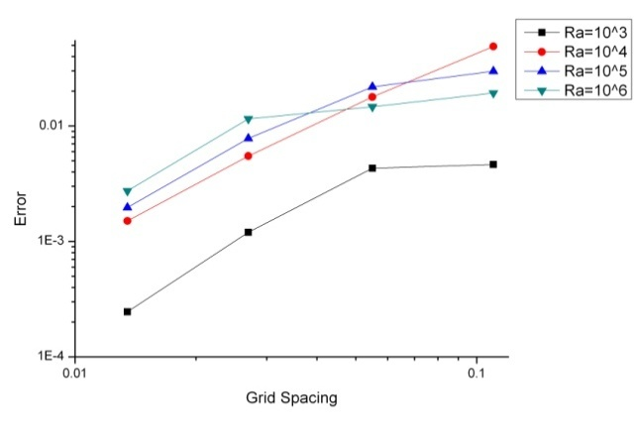
Square Mesh | Polyhedral Mesh
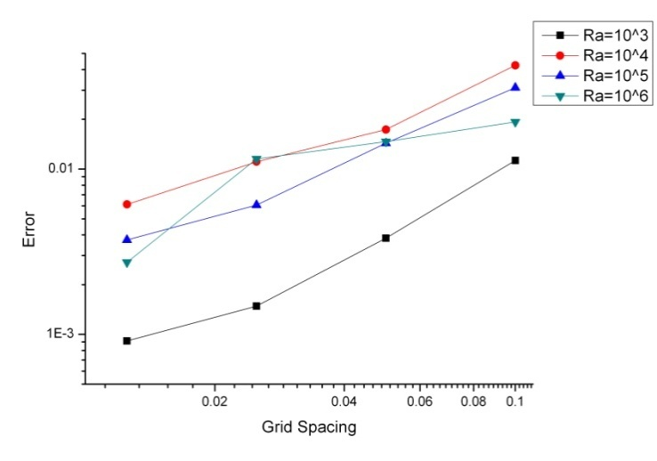
Skewed Mesh
Figure 6-15: Comparison of order of accuracy for three meshes.
Table 6-3: Order of accuracy for different meshes
Sr. No | Rayleigh Number | Order of decrease of error
Square Mesh
1 | 10^3 | 2.523739
2 | 10^4 | 2.363177
3 | 10^5 | 2.147511
4 | 10^6 | 2.064975
Polyhedral mesh
1 | 10^3 | 1.416302
2 | 10^4 | 1.37802
3 | 10^5 | 1.360205
4 | 10^6 | 0.963507
Skewed Mesh
1 | 10^3 | 1.916062
2 | 10^4 | 1.501403
3 | 10^5 | 1.822517
4 | 10^6 | 1.524046

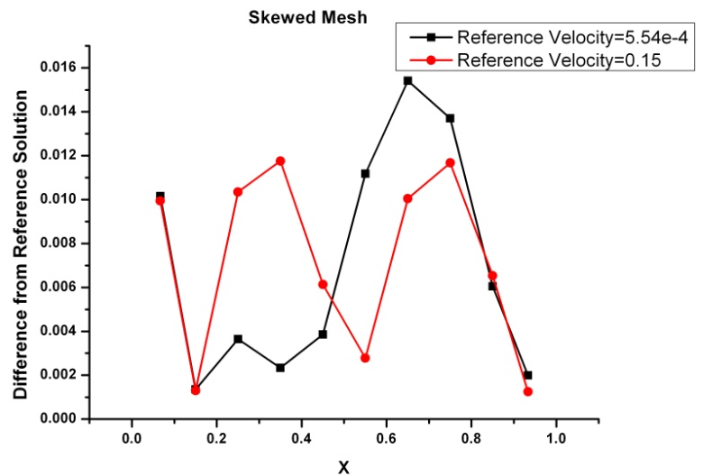 | 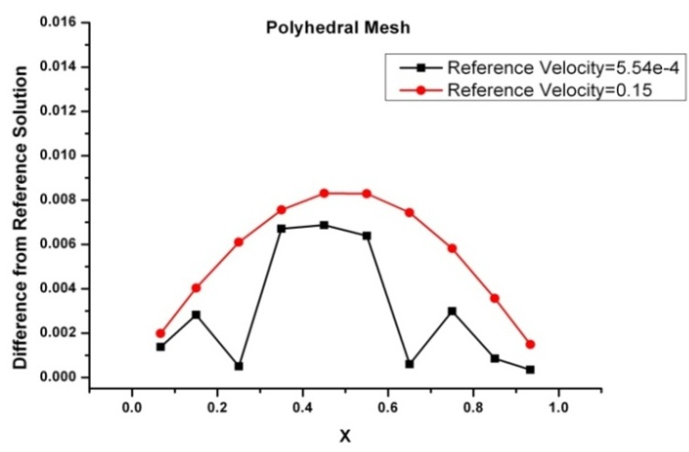
a): Skewed Mesh | b): Polyhedral Mesh
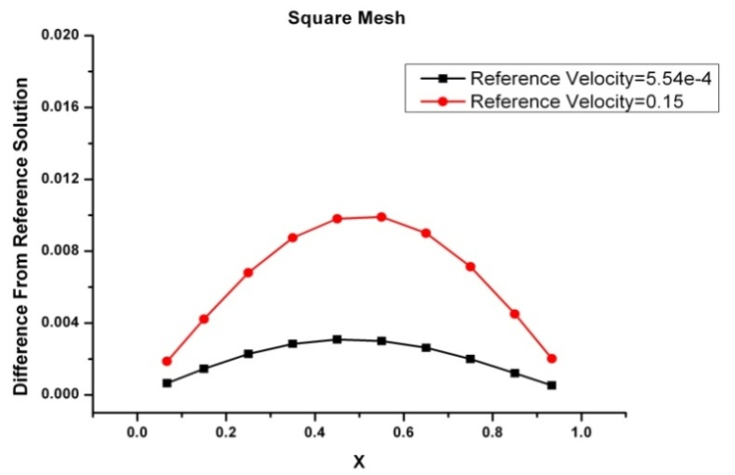
c): Square Mesh
Figure 6-16: Effect of change of design parameters at Ra=10³
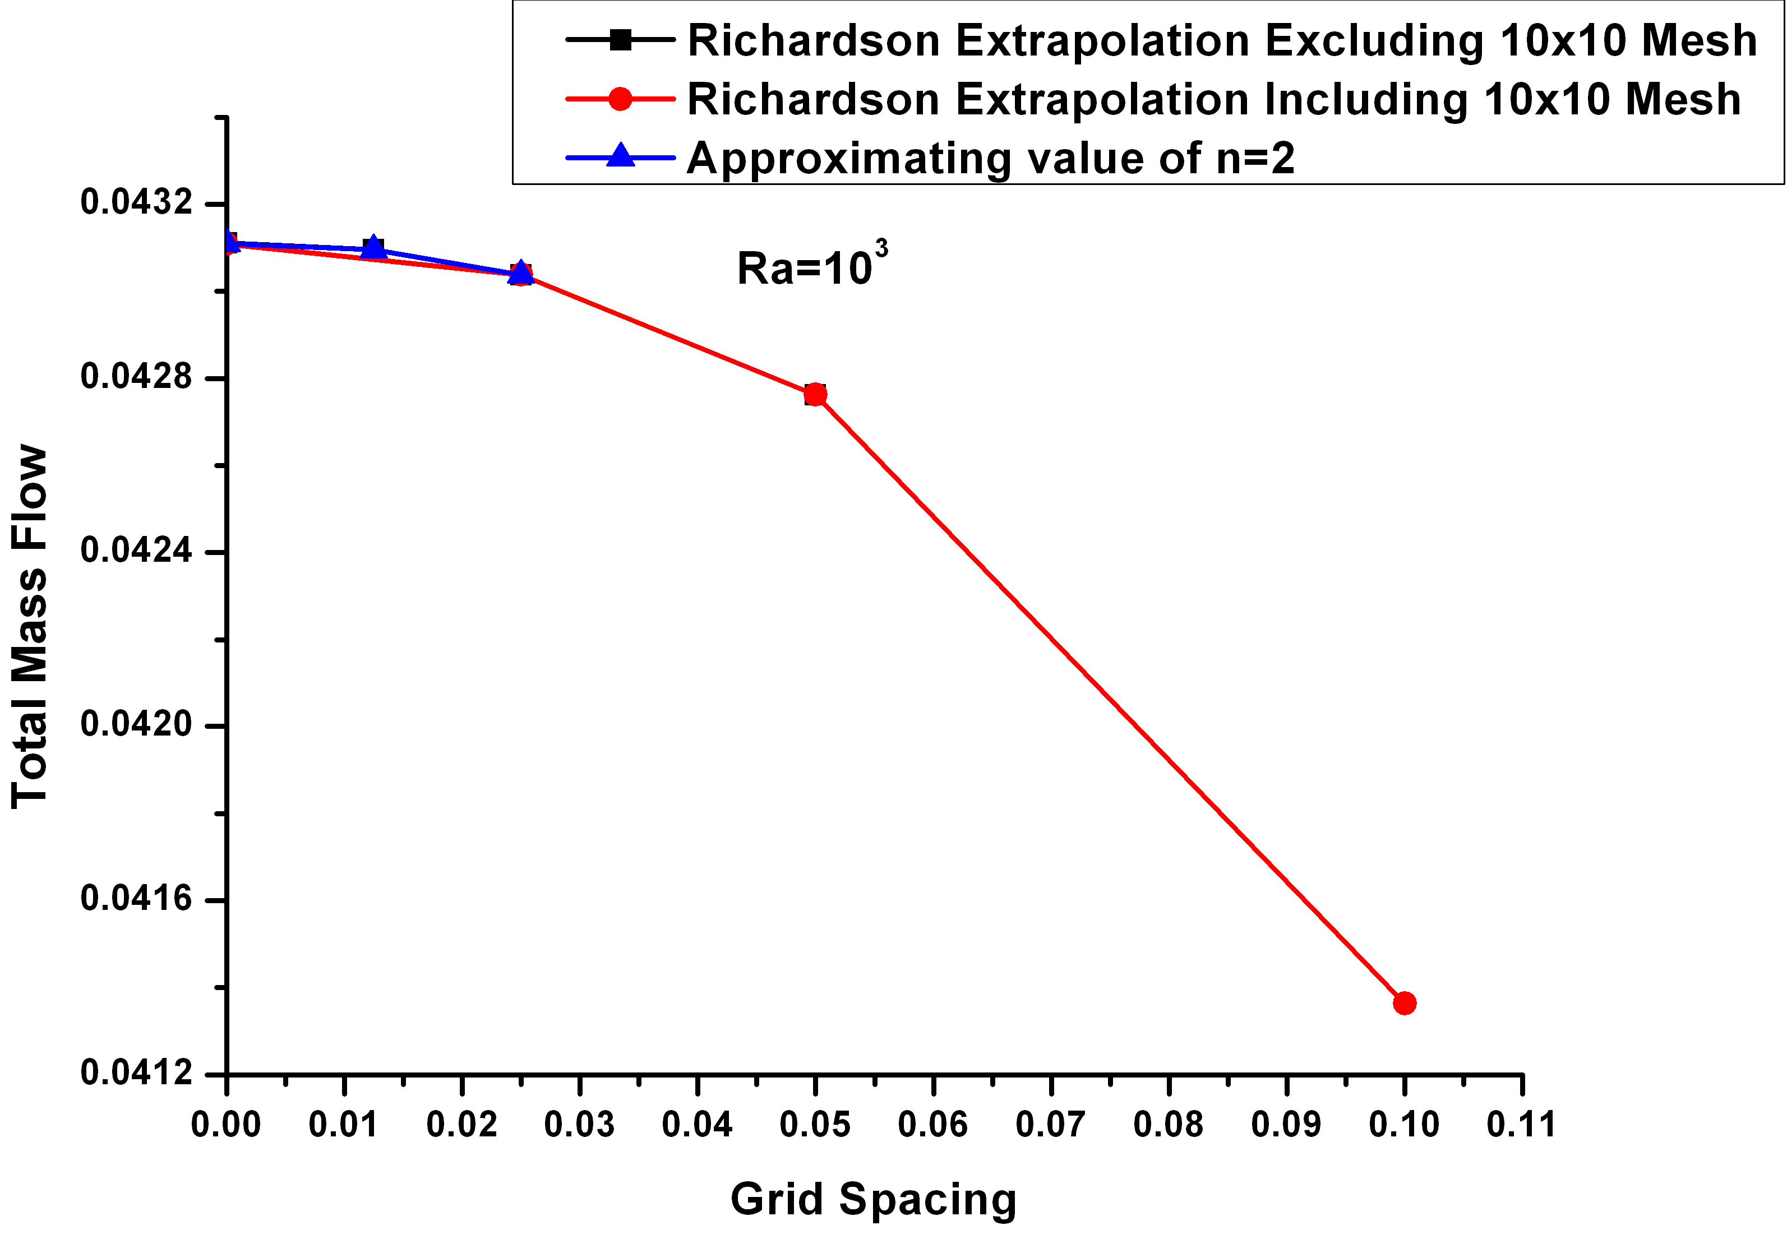
Figure 6-17: Effect of Order of Convergence on Extrapolated Solution at Ra=10³
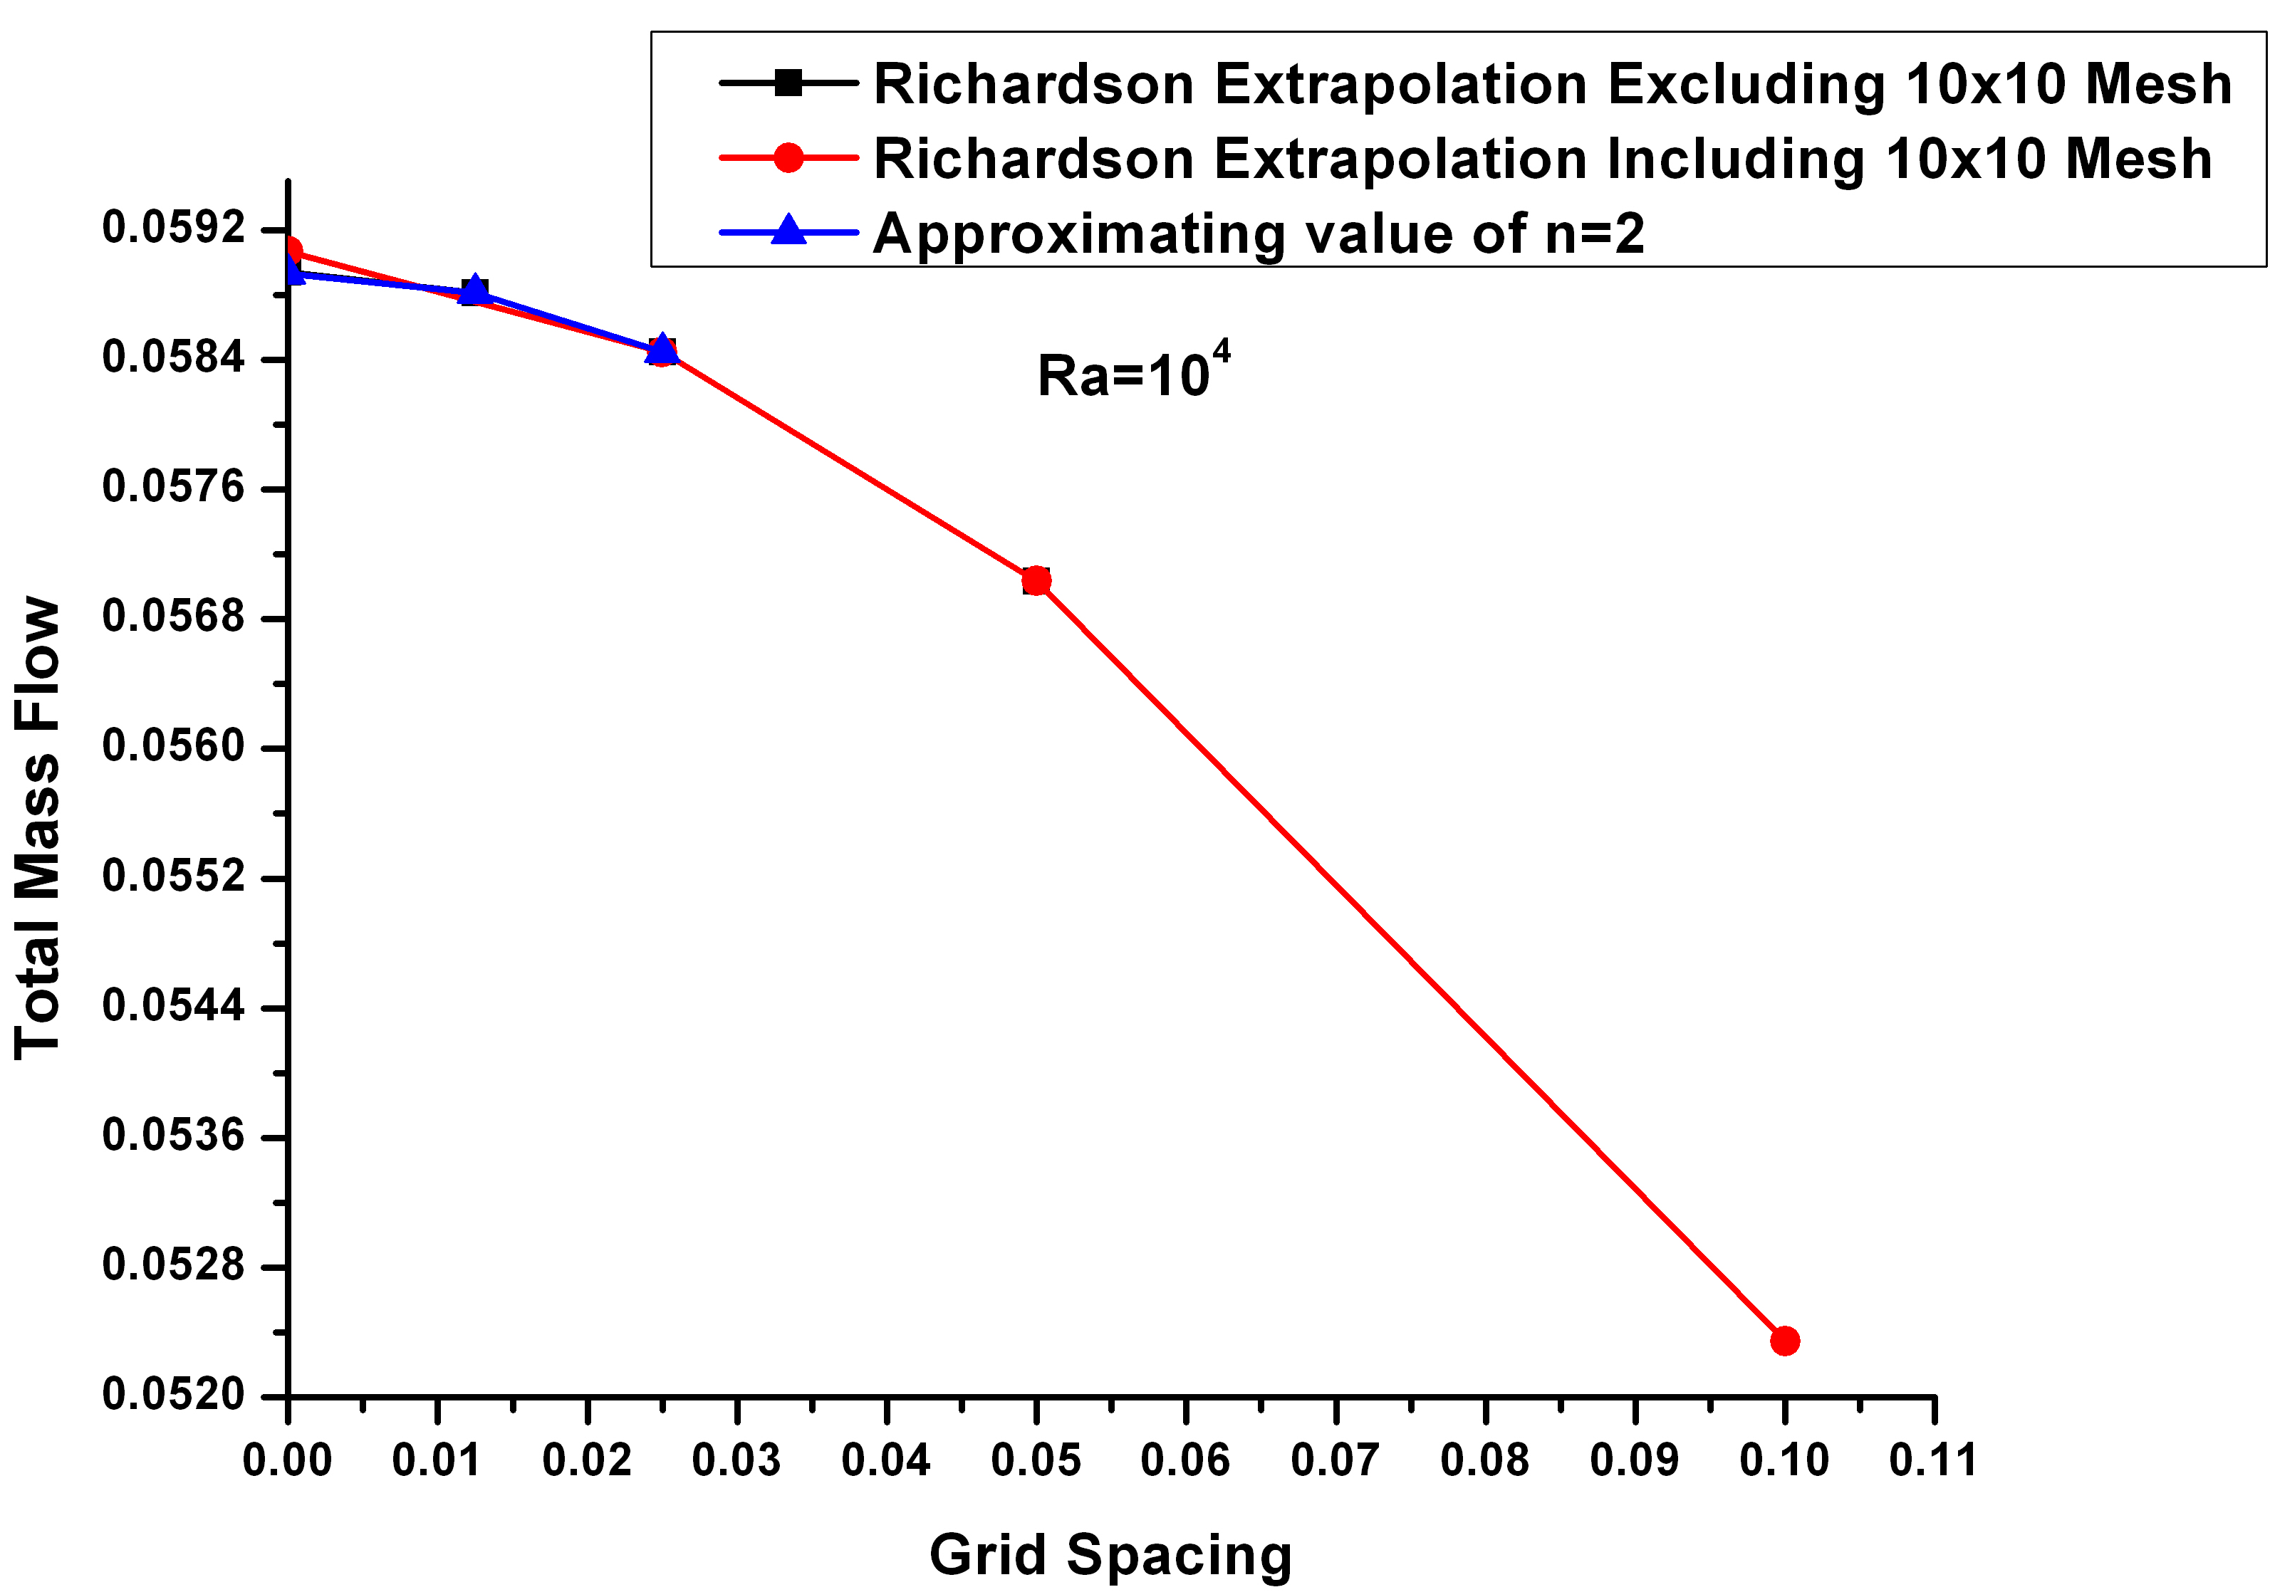
Figure 6-18: Effect of Order of Convergence on Extrapolated Solution at Ra=10⁴
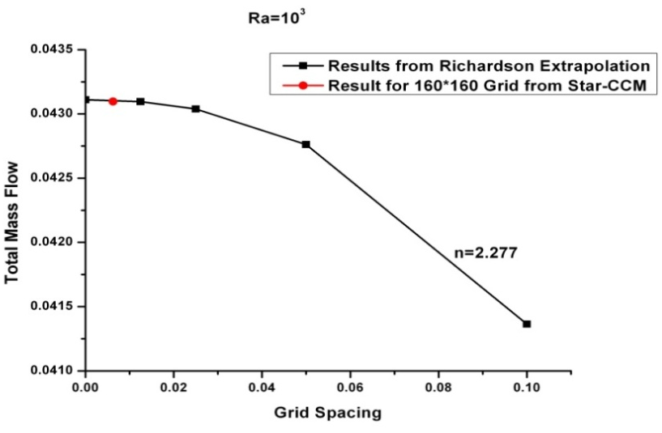
Figure 6-19: Richardson Extrapolation for results obtained using Second order Upwind Scheme at Ra=10³
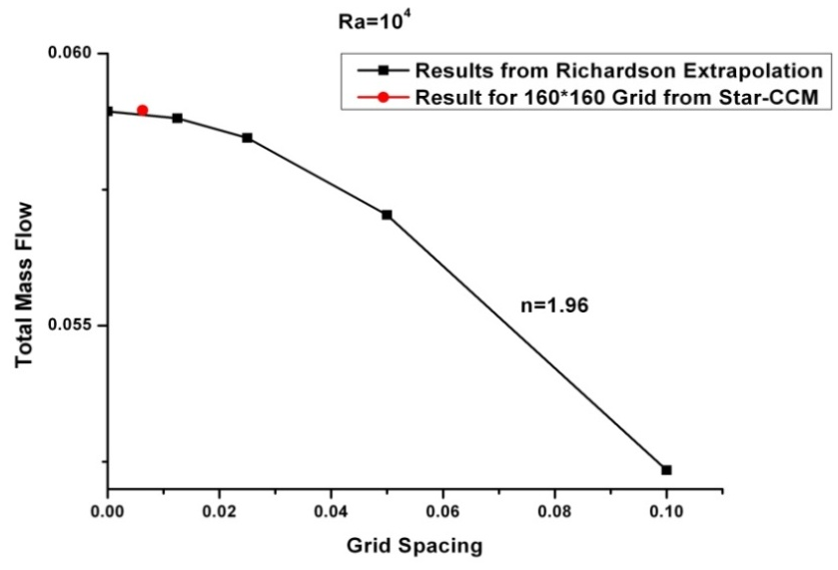

Figure 6-20: Richardson Extrapolation for results obtained using Second order Upwind Scheme at Ra=10⁴

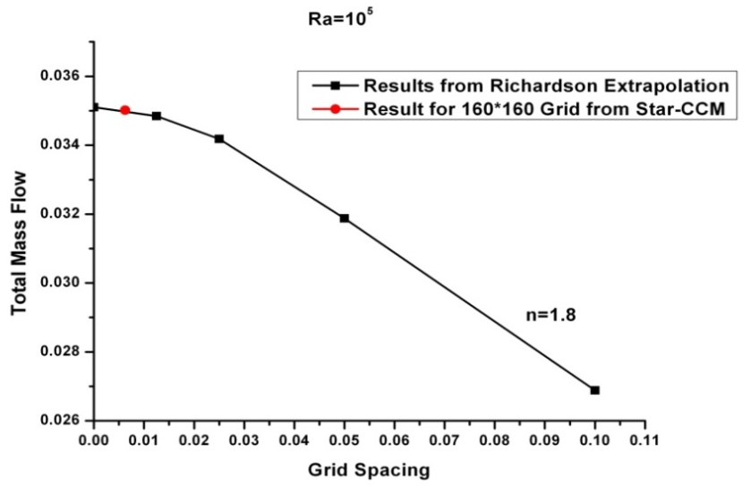
Figure 6-21: Richardson Extrapolation for results obtained using Second order Upwind Scheme at Ra=10⁵

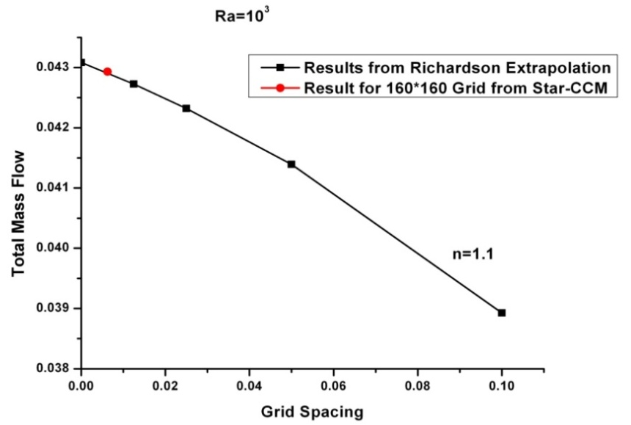
Figure 6-22: Richardson Extrapolation for results obtained using First order Upwind Scheme at Ra=10³
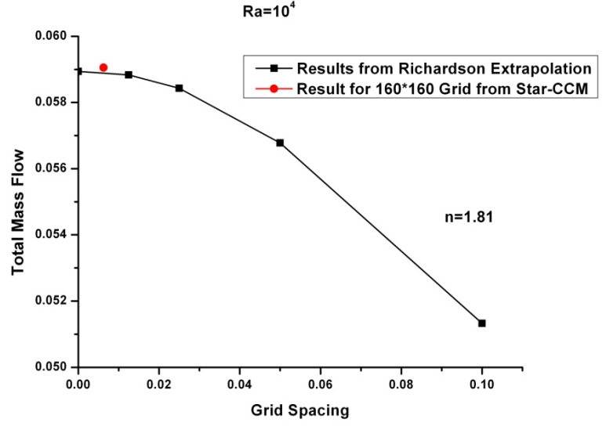
Figure 6-23: Richardson Extrapolation for results obtained using First order Upwind Scheme at Ra=10⁴
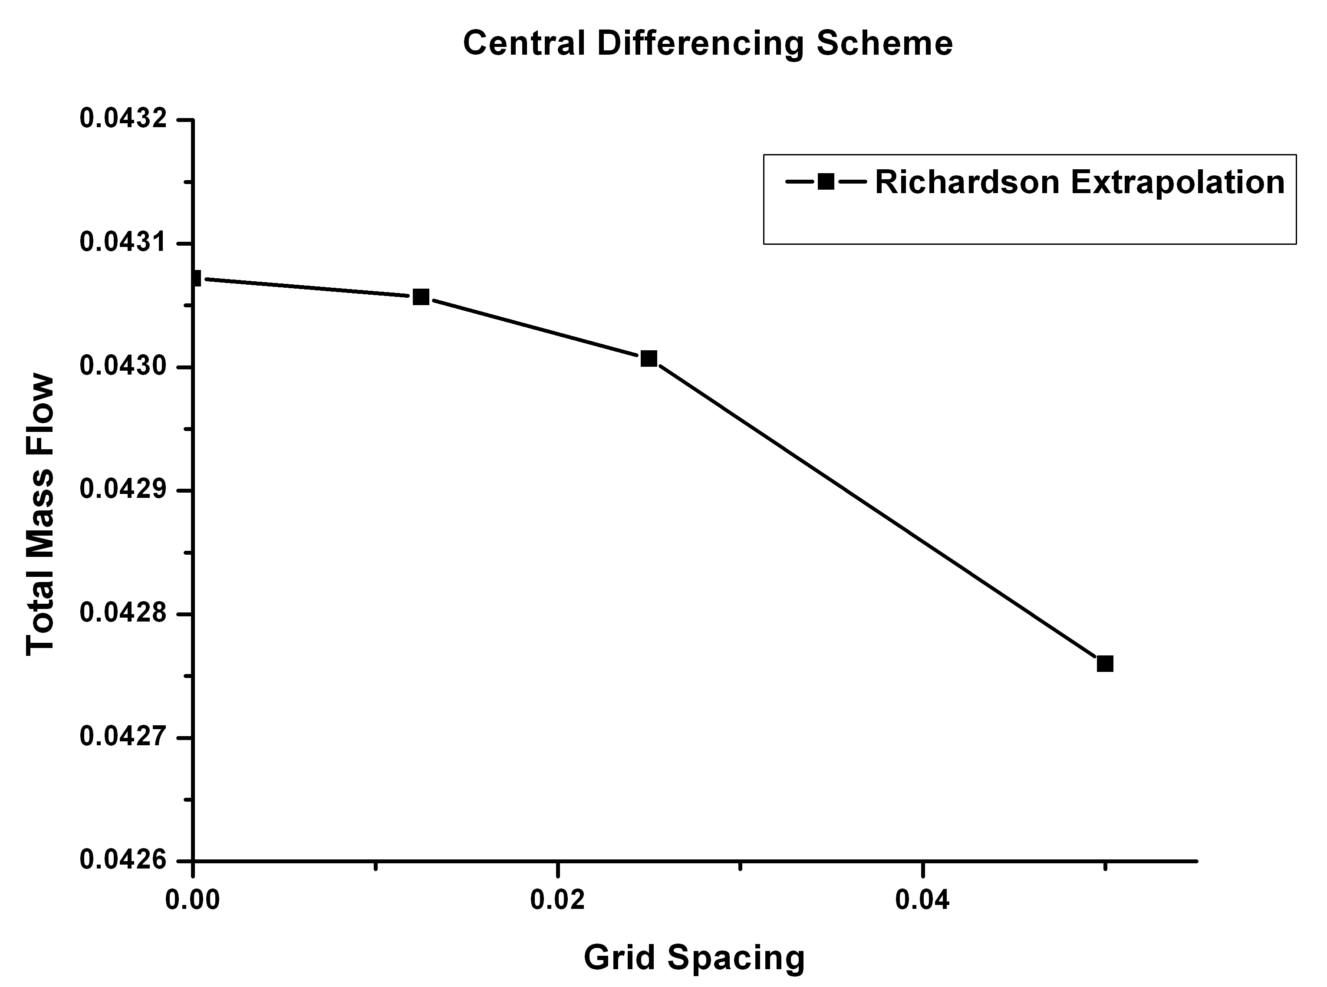
Figure 6-24: Richardson Extrapolation for results obtained using Central Differencing Scheme at Ra=10³
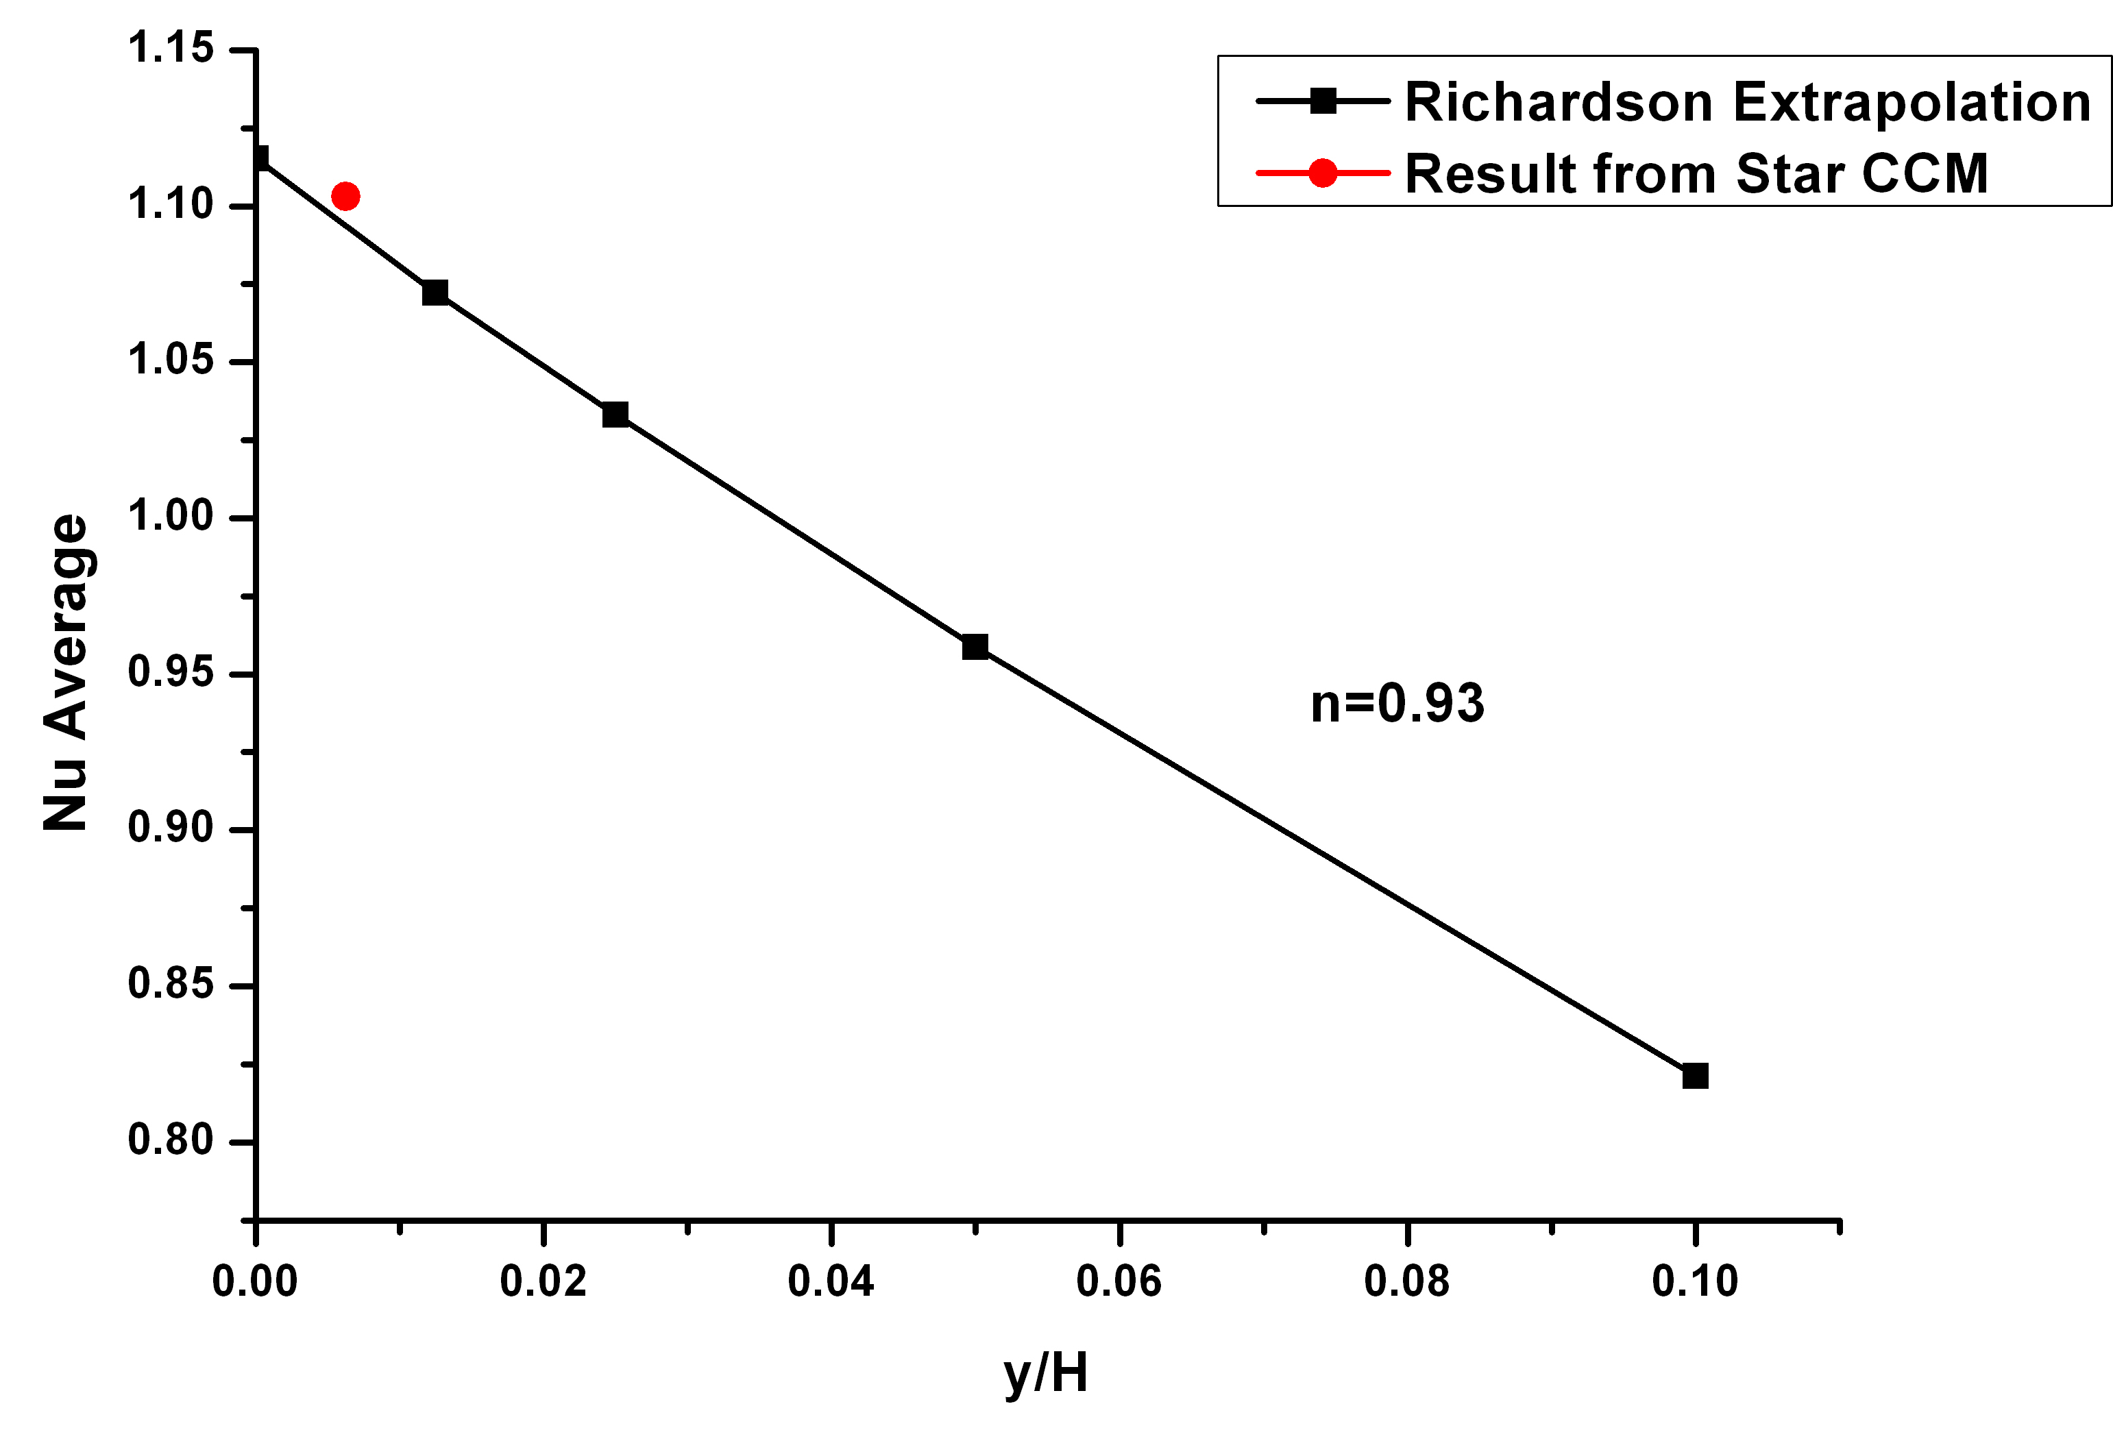
Figure 6-25: Richardson Extrapolation for Nu at hot wall using Second Order Upwind Scheme Ra=10³
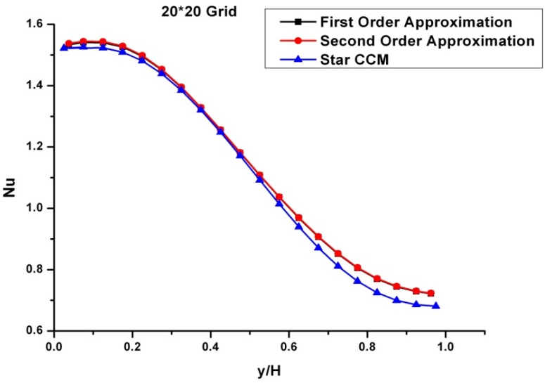
Figure 6-26: Comparison of Nu number profile obtained from second order approximation and Star CCM for 20*20 grid at Ra=10³
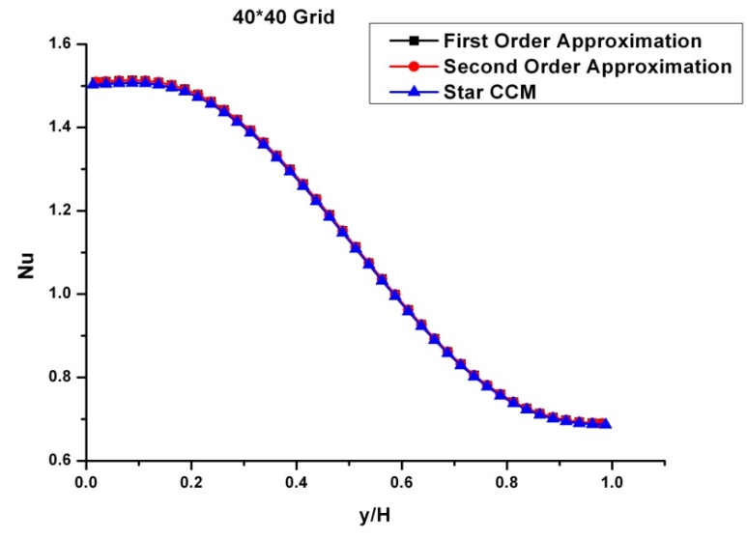
Figure 6-27: Comparison of Nu number profile obtained from second order approximation and Star CCM for 40*40 grid at Ra=10³
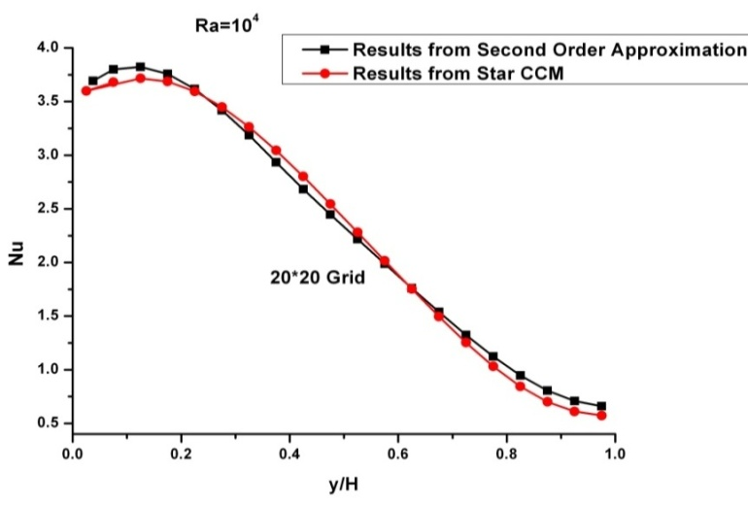
Figure 6-28: Comparison of Nu number profile obtained from second order approximation and Star CCM for 20*20 grid at Ra=10⁴
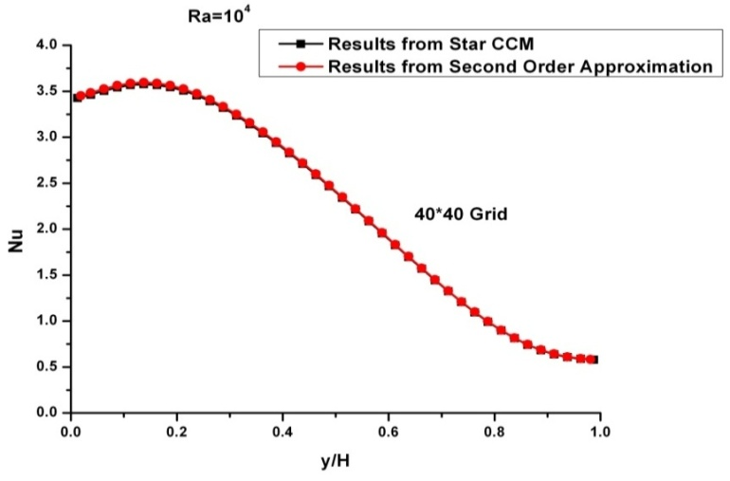
Figure 6-29: Comparison of Nu number profile obtained from second order approximation and Star CCM for 40*40 grid at Ra=10⁴
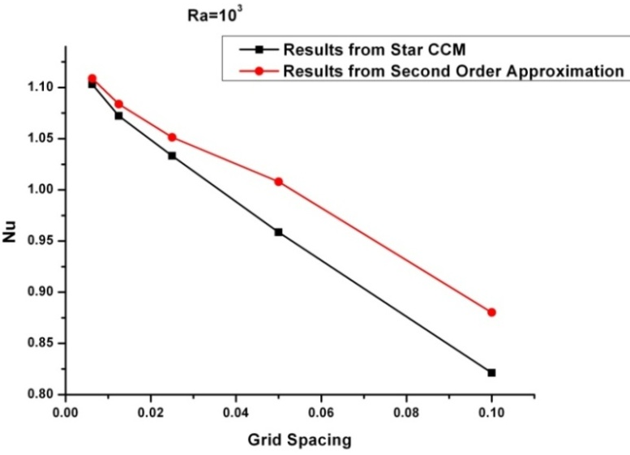
Figure 6-30: Comparison of Convergence of Nusslet Number with grid spacing obtained from Second order Approximation and From Star CCM
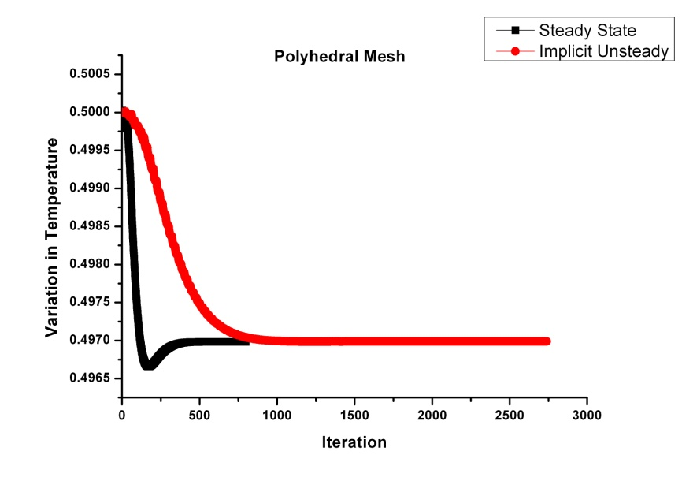
Figure 6-31: Variation of Temperature at Center of Cavity for Polyhedral Mesh
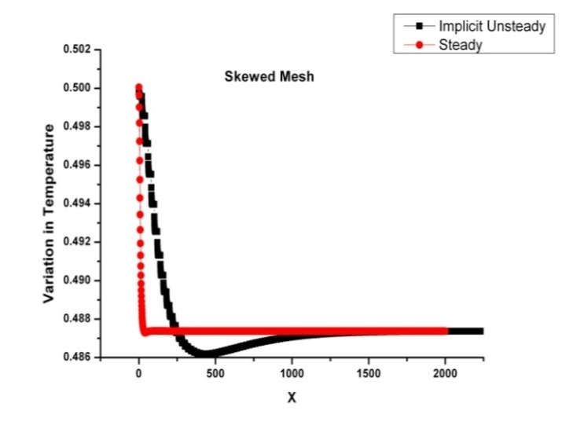
Figure 6-32: Variation of Temperature at Center of Cavity for Skewed Mesh
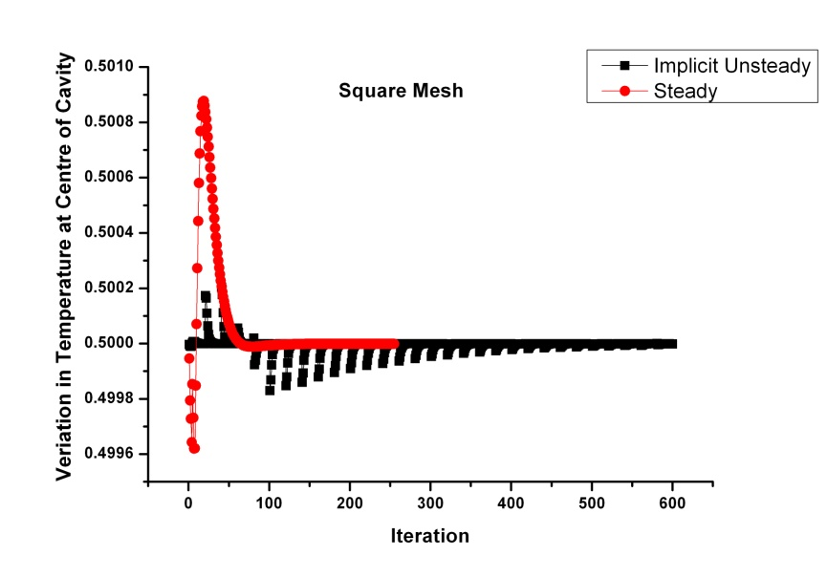
Figure 6-33: Variation of Temperature at Center of Cavity for Square Mesh
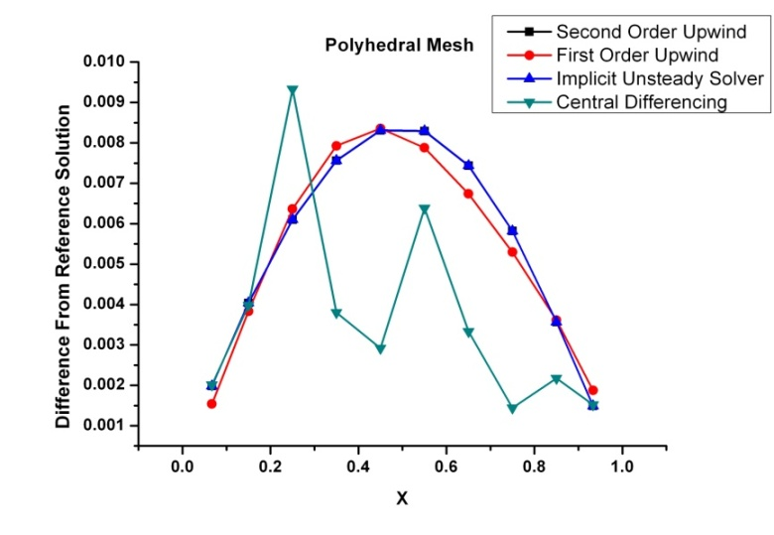
Figure 6-34: Variation of Error in Temperature along X axis of grid for Polyhedral Mesh
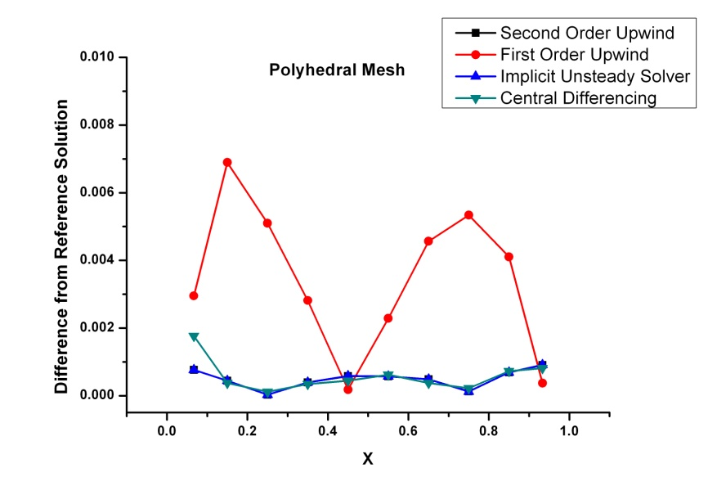
Figure 6-35: Variation of Error in Velocity along X axis of grid for Polyhedral Mesh
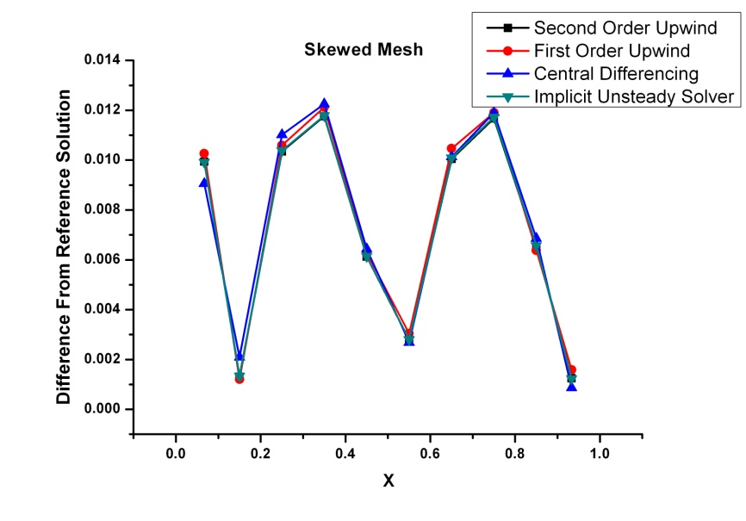
Figure 6-36: Variation of Error in Temperature along X axis of grid for Skewed Mesh
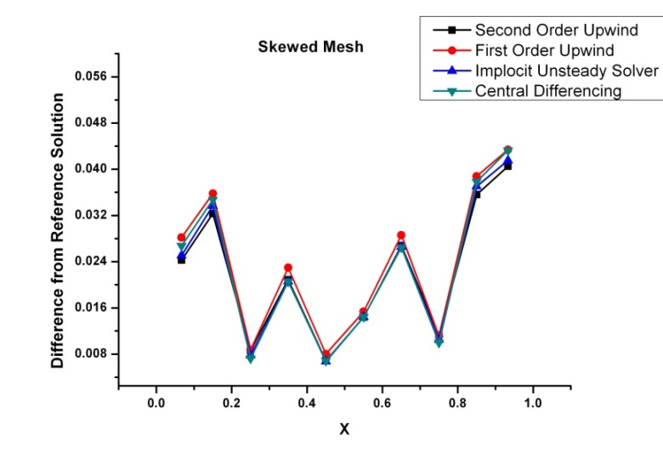
Figure 6-37: Variation of Error in Velocity along X axis of grid for Skewed Mesh
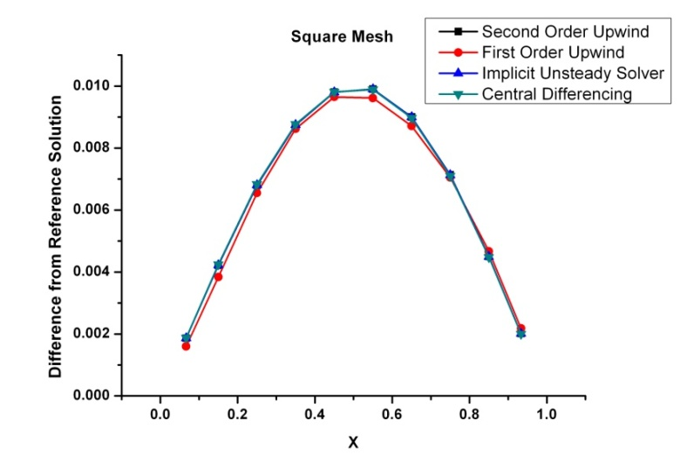
Figure 6-38: Variation of Error in Temperature along X axis of grid for Square Mesh
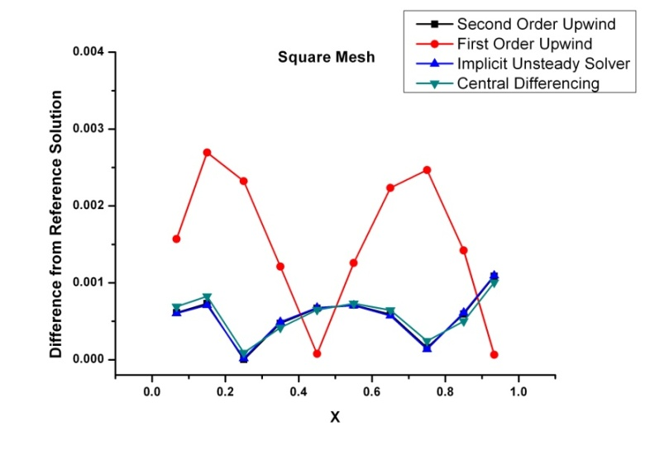
Figure 6-39: Variation of Error in Velocity along X axis of grid for Square Mesh

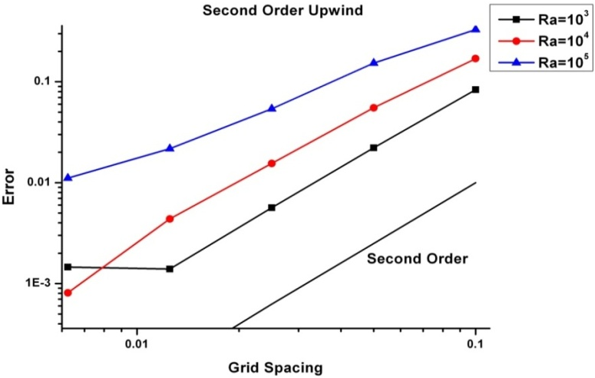
Figure 6-40: Effect of grid refinement for square grid while using Second Order Upwind Scheme
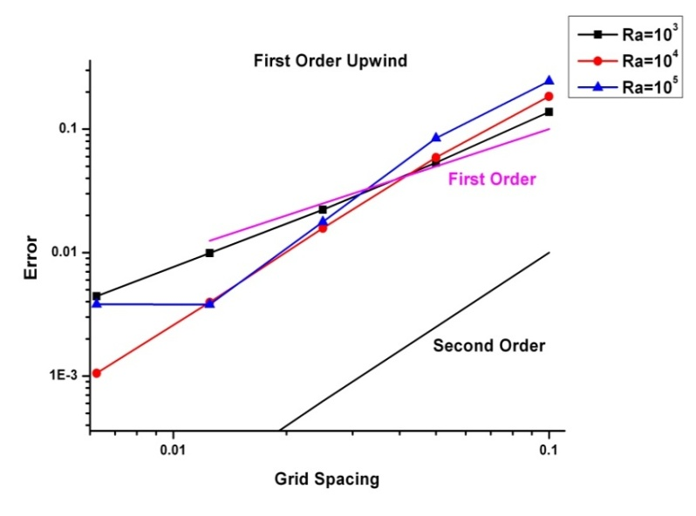
Figure 6-41: Effect of grid refinement for square grid while using First Order Upwind Scheme
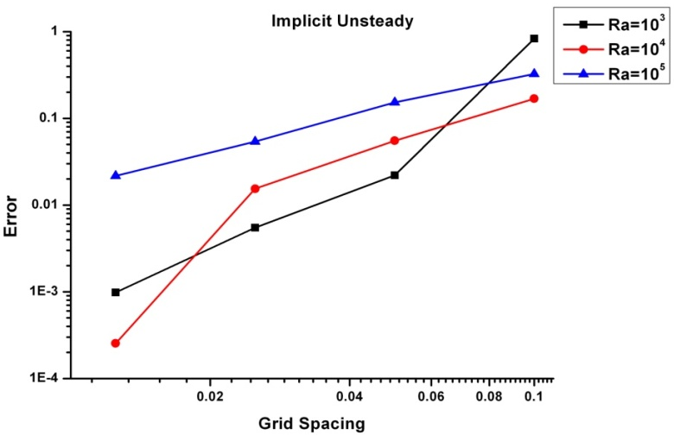
Figure 6-42: Effect of grid refinement for square grid while using Implicit Unsteady Solver
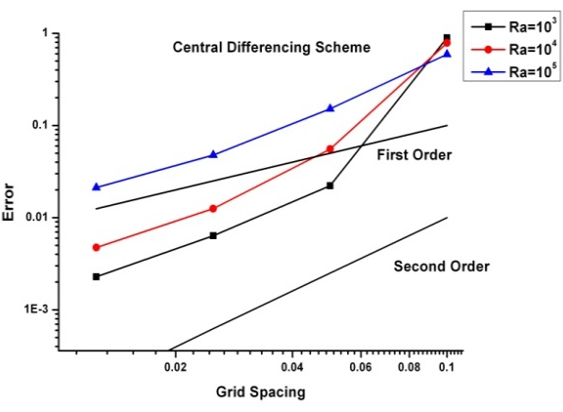
Figure 6-43: Effect of refinement for square grid using Central Differencing Scheme
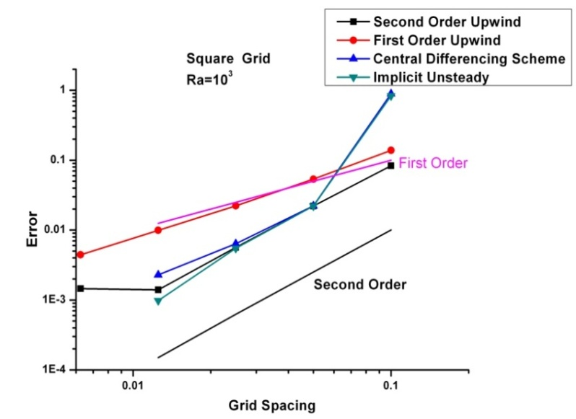
Figure 6-44: Effect of Different Schemes on Error Convergence for Square Grid
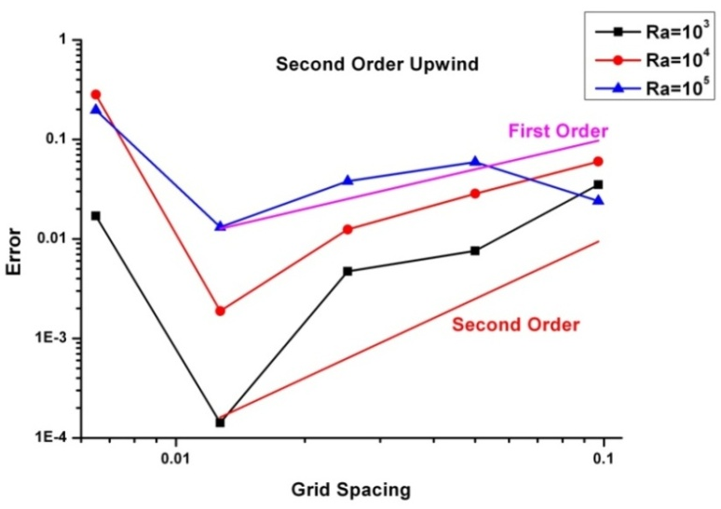
Figure 6-45: Effect of grid refinement for polyhedral grid using Second Order Upwind Scheme
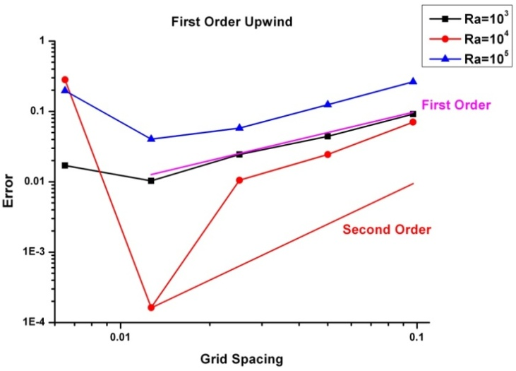
Figure 6-46: Effect of grid refinement for polyhedral grid while using First Order Upwind Scheme
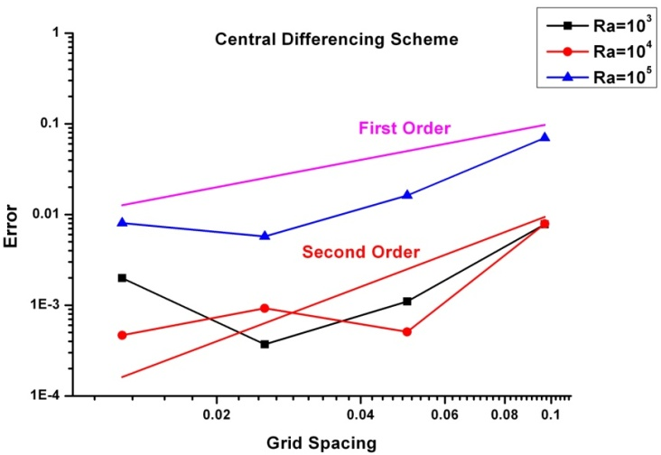
Figure 6-47: Effect of grid refinement for polyhedral grid while using Central Differencing Scheme
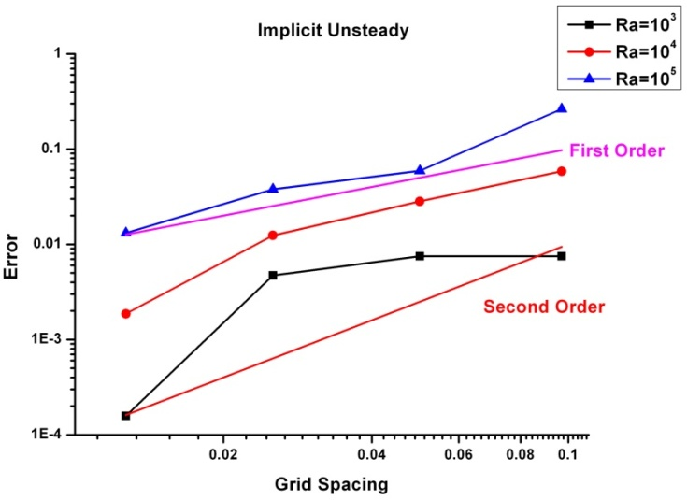
Figure 6-48: Effect of grid refinement for polyhedral grid while using Implicit Unsteady Solver

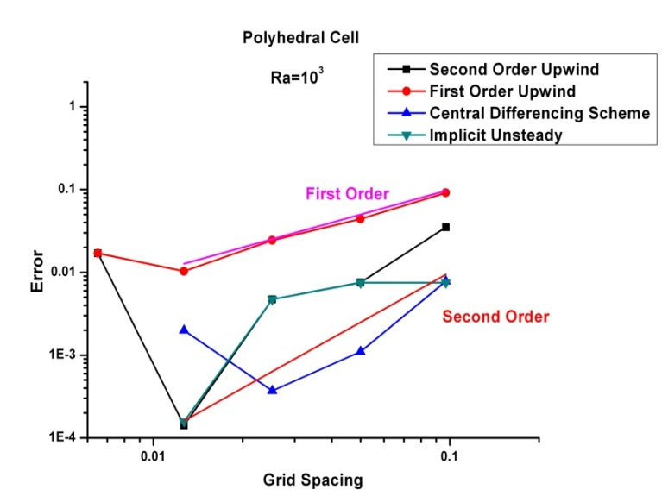
Figure 6-49: Effect of Different Schemes on Error Convergence for Polyhedral Grid
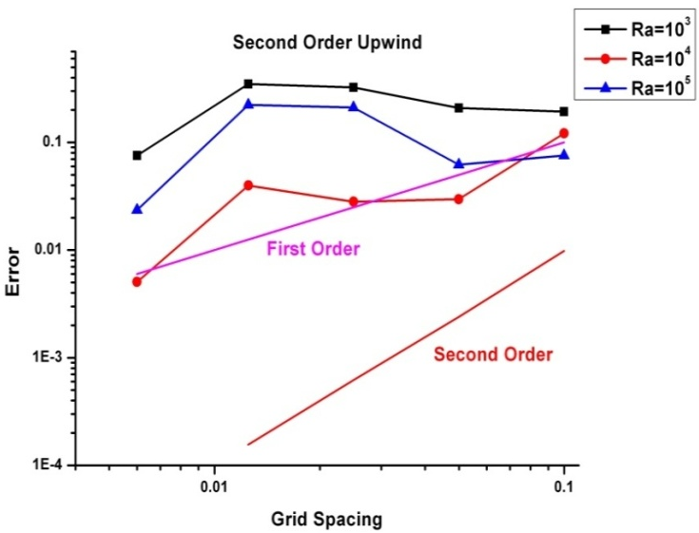
Figure 6-50: Effect of grid refinement for Skewed Mesh while using Second Order Upwind Scheme
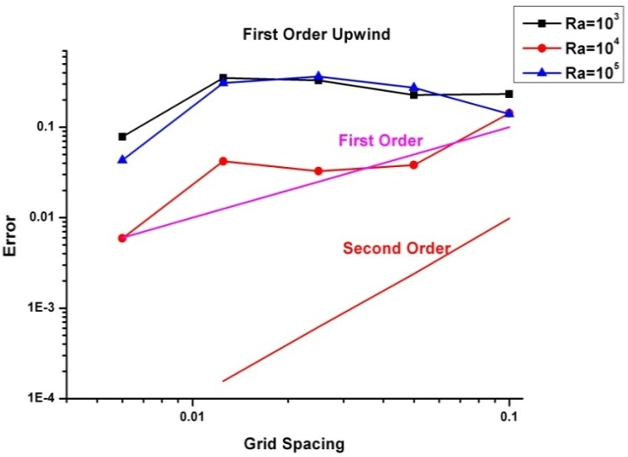
Figure 6-51: Effect of grid refinement for Skewed Mesh while using First Order Upwind Scheme
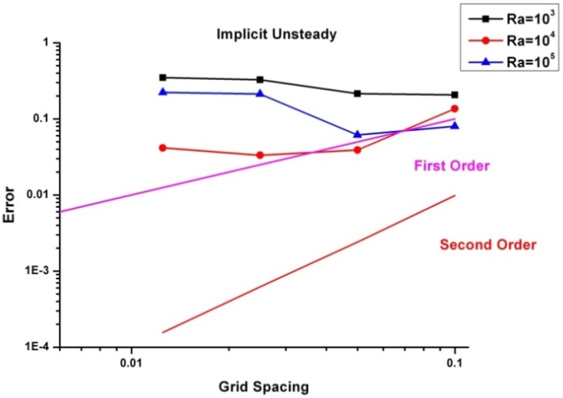
Figure 6-52: Effect of grid refinement for Skewed Mesh while using Implicit Unsteady Solver
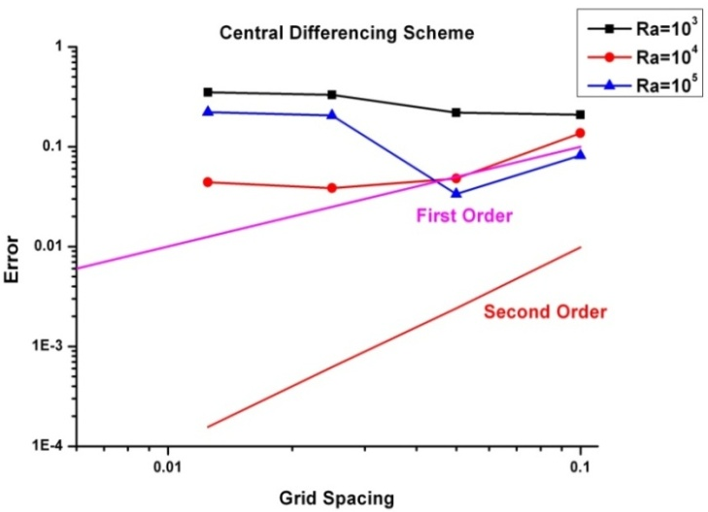
Figure 6-53: Effect of grid refinement for Skewed Mesh while using Central Differencing Scheme
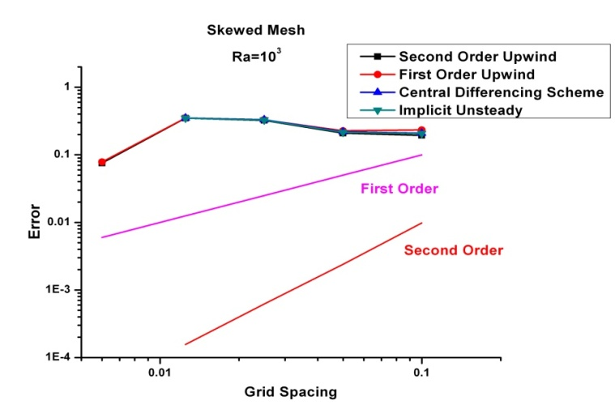
Figure 6-54: Effect of Different Schemes on Error Convergence for Skewed Mesh
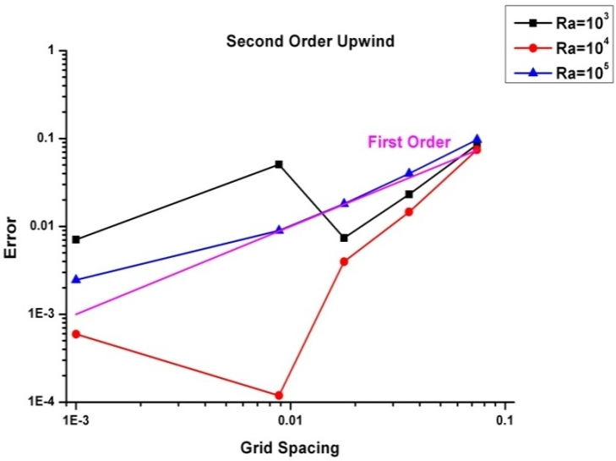
Figure 6-55: Effect of grid refinement for Butterfly Mesh while using Second Order Upwind Scheme
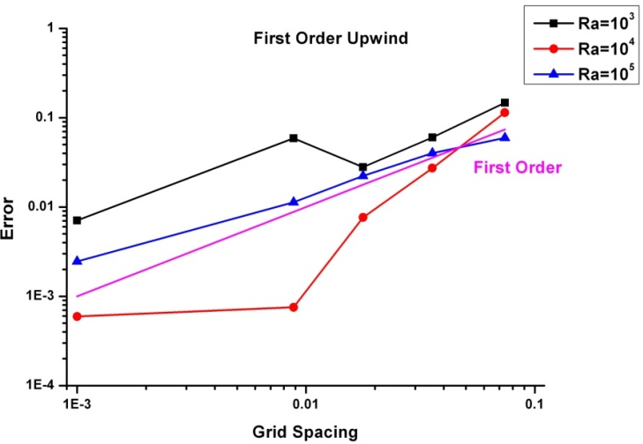
Figure 6-56: Effect of grid refinement for Butterfly Mesh while using First Order Upwind Scheme
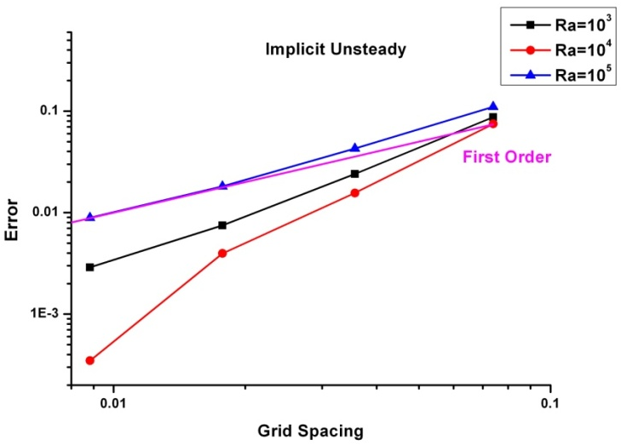
Figure 6-57: Effect of grid refinement for Butterfly Mesh while using Implicit Unsteady Solver
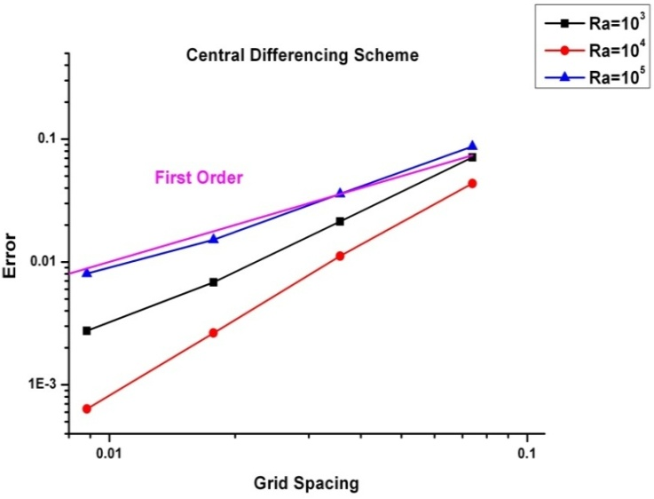
Figure 6-58: Effect of grid refinement for Butterfly Mesh while using Central Differencing Scheme
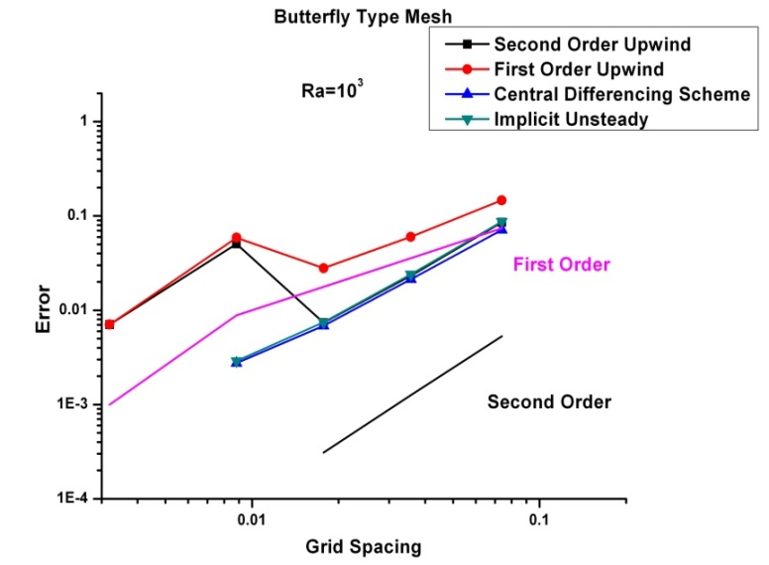
Figure 6-59: Effect of Different Schemes on Error Convergence for Butterfly Mesh
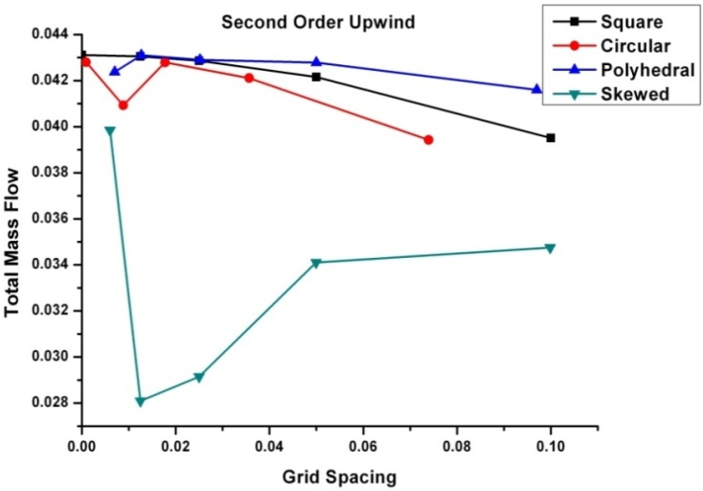
Figure 6-60: Effect of Mesh topology on the solution

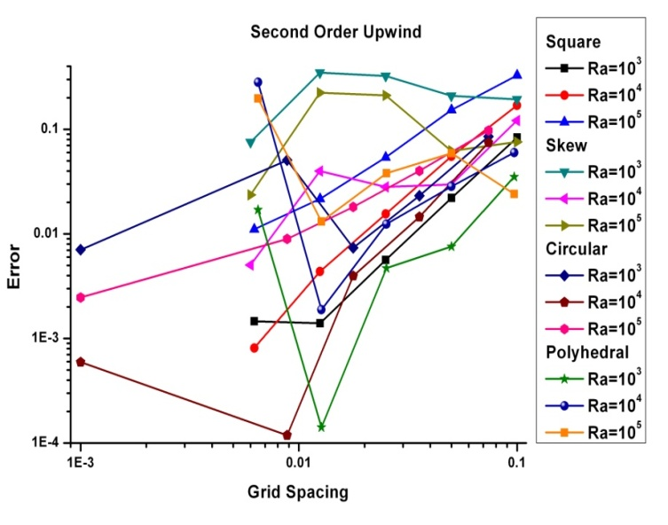
Figure 6-61: Error Convergence for Second Order Upwind Scheme
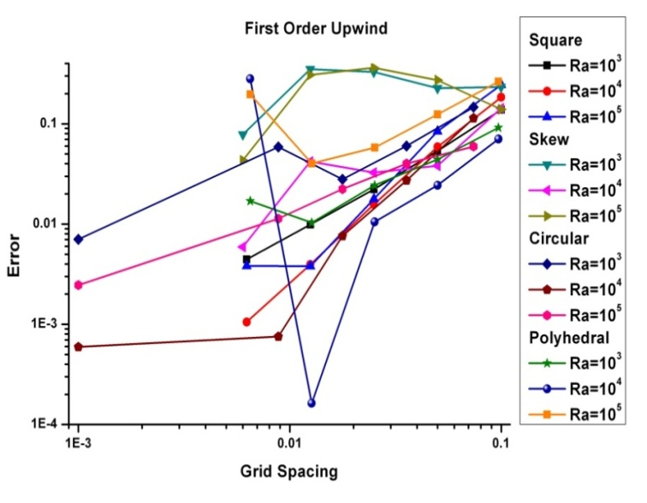
Figure 6-62: Error Convergence for First Order Upwind Scheme
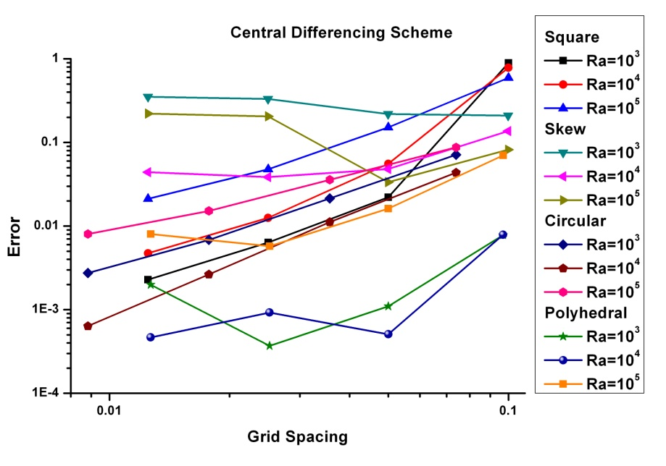
Figure 6-63: Error Convergence for Central Differencing Scheme
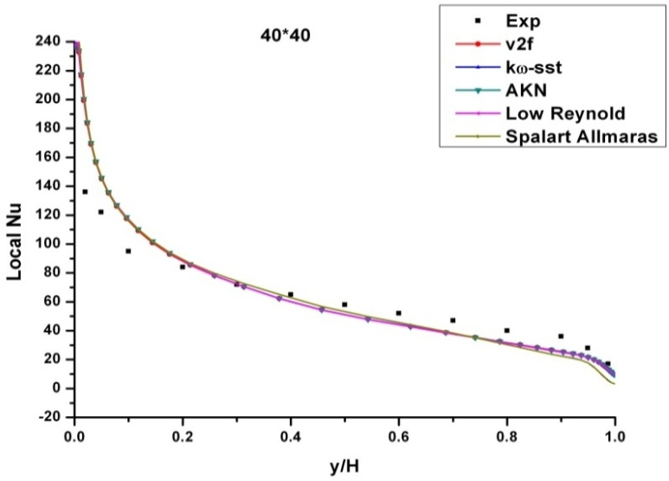
Figure 6-64: Nu profile along the hot wall using 40x40 Grid
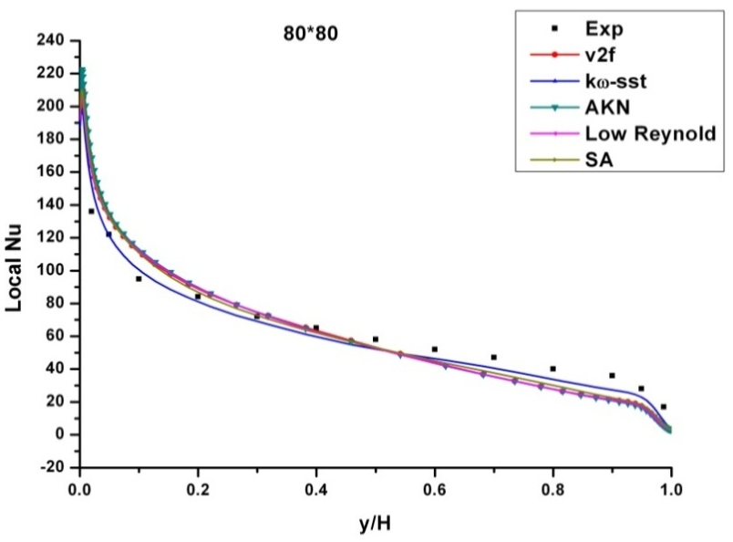
Figure 6-65: Nu profile along the hot wall using 80x80 Grid
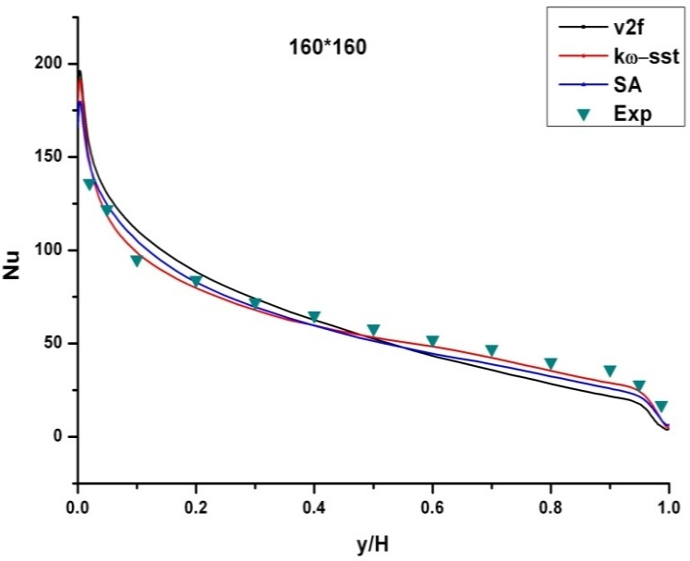
Figure 6-66: Nu profile along the hot wall using 160x160 Grid
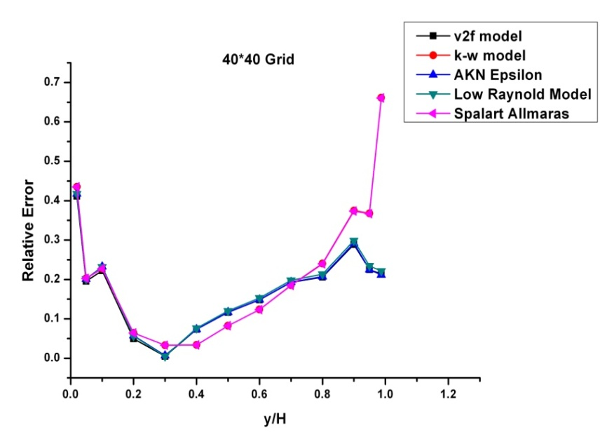
Figure 6-67: Error in Nu along the hot wall using 40x40 Grid
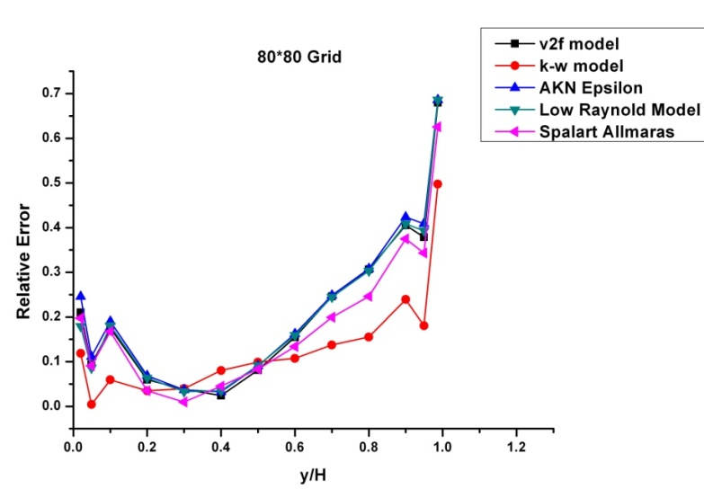
Figure 6-68: Error in Nu along the hot wall using 80x80 Grid
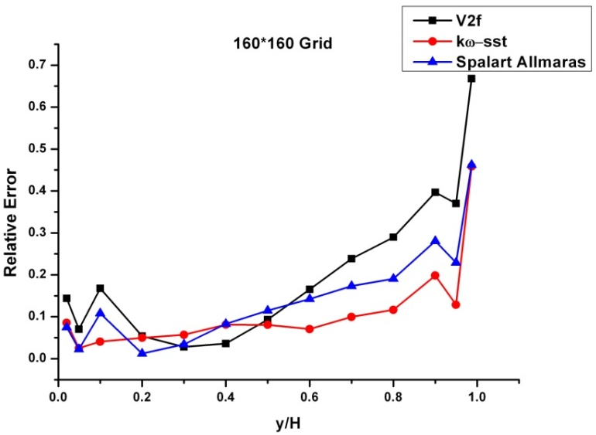
Figure 6-69: Error in Nu along the hot wall using 160x160 Grid
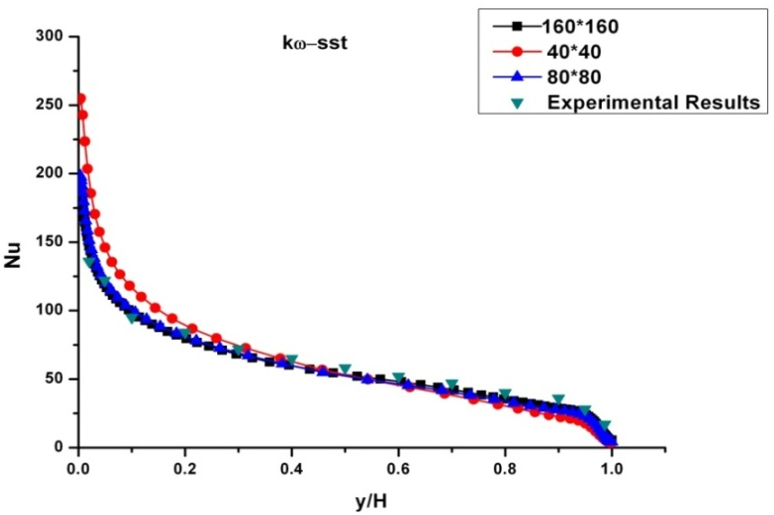
Figure 6-70: Effect of grid convergence using model on the Nu profile along the hot wall
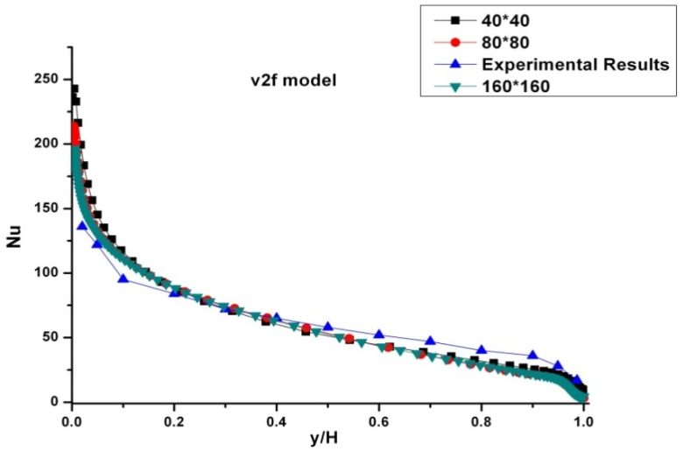
Figure 6-71: Effect of grid convergence using v2f model on the Nu profile along the hot wall
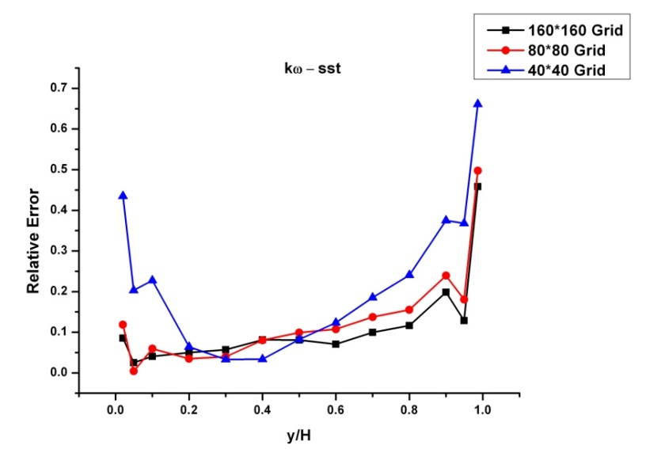
Figure 6-72: Effect of grid convergence using model on the Error in Nu profile along the hot wall
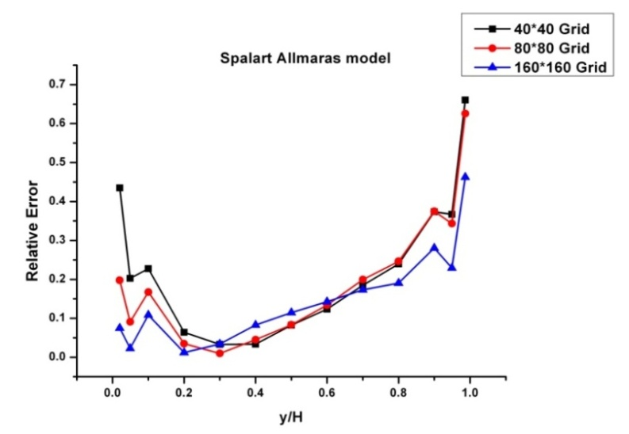
Figure 6-73: Effect of grid convergence using Spalart Allmaras model on the Error in Nu profile along the hot wall
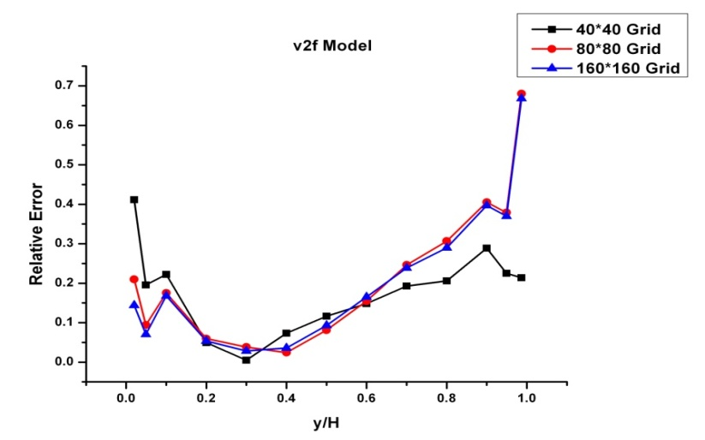
Figure 6-74: Effect of grid convergence using v2f model on the Error in Nu profile along the hot wall
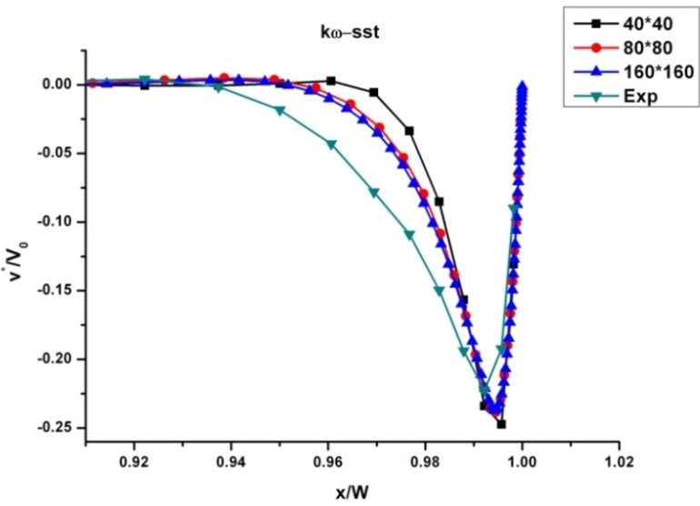
Figure 6-75: Effect of grid convergence using model on the velocity profile near the wall
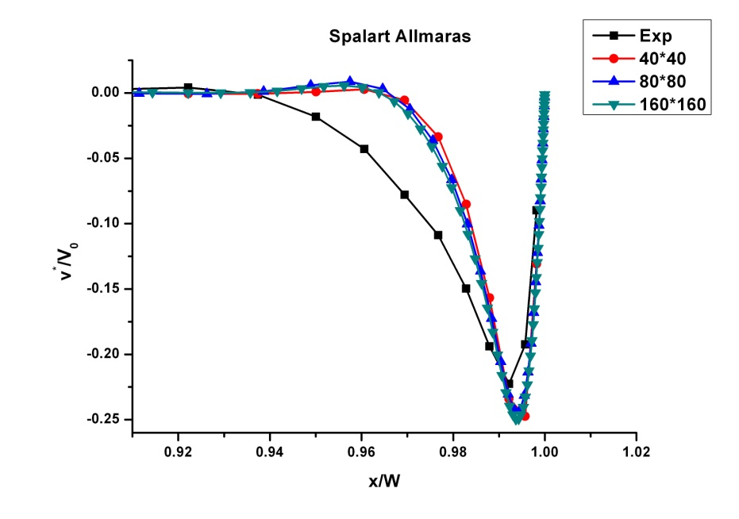
Figure 6-76: Effect of grid convergence using Spalart Allamaras model on the velocity profile near the wall
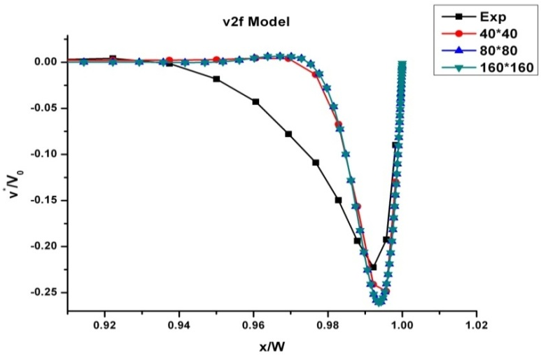
Figure 6-77: Effect of grid convergence using v2f model on the velocity profile near the wall
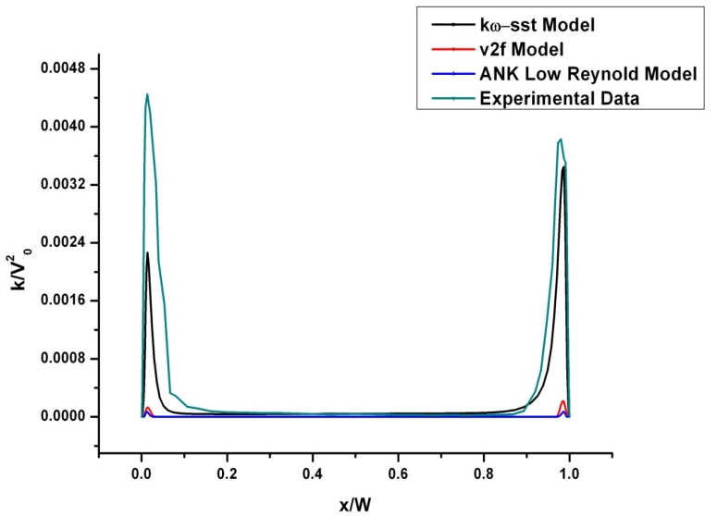
Figure 6-78: Kinetic Energy at mid height of the Cavity
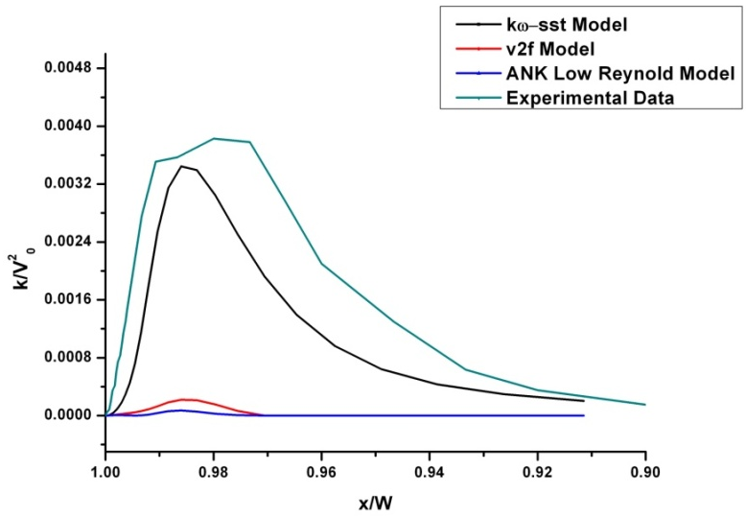
Figure 6-79: Kinetic Energy at mid height of the Cavity near the Cold Wall
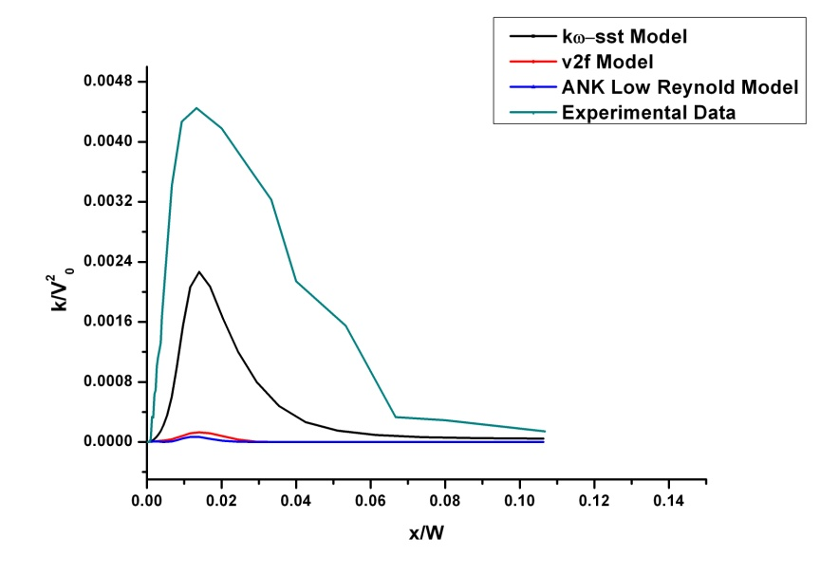
Figure 6-80: Kinetic Energy at mid height of the Cavity near the Hot Wall
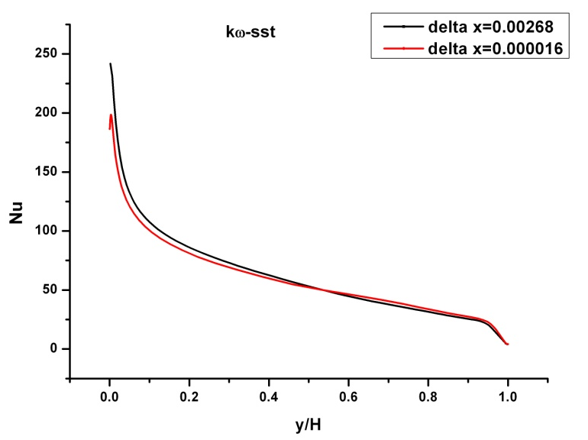
Figure 6-81: Effect of first cell spacing for model
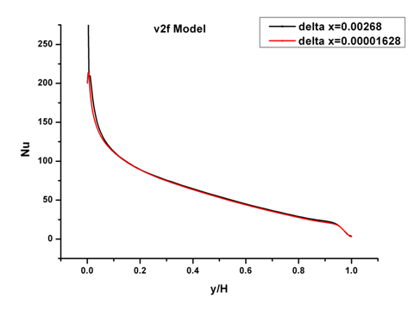
Figure 6-82: Effect of first cell spacing for v2f model

Conclusion
Below are some conclusions drawn from results obtained during this study:
- Keeping the Rayleigh number, value of thermal expansion coefficient (reference velocity) affects the velocity magnitude inside the cavity and error, this is possibly linked to some normalisation and should be investigated further .
- The Richardson extrapolation is in good agreement with the theory for Ra=10³ and Ra=10⁴. As Rayleigh number increases beyond that, gradients near the boundary become sharper, requiring refined grids near the wall. This may explain the contradiction between the results from present work and that expected from Richardson extrapolation
- Accuracy of solution is also affected by the post processing of the results. For instance, Nu is found to be independent of the order of approximation of the gradient [3]. Results obtained from the code are not in agreement with that obtained from gradient approximation from the Ferziger.
- Use of lower order schemes leads to higher error for a regular grid as in the case of square grid. Additionally order of convergence follow the order of the numerical scheme for square cells.
- For meshes other than square cells, cell topology (non orthogonal cell faces) are more important and don’t allow the error to converge with the same order as of numerical scheme with grid refinement. For instance in present case for polyhedral cells error decreases with the order of one even for second order numerical scheme.
- For distorted mesh grid refinement does not mean reduction in error (results for the skewed grid).
- Square grid converges faster as compared to any other grids.
- Star CCM gives higher value of maximum Nu at hot wall as compared to that obtained from experiment. But this over prediction decreases with grid refinement.
- The model gives good approximation for the kinetic energy near the cold wall as compared to that near hot wall.
- Results obtained from the model are in agreement with experimental results as compared to that obtained from any other turbulence model. However, V2f model is less sensitive to grid refinement near the wall as compared to model.

Future Work
Aim of this work is to estimate the prediction accuracy of the results obtained from a CFD code for industrial applications. In the first year numerical errors have been investigated in case of square cavity. For a second test case a fire scenario has been selected to study the effect of grid spacing and turbulence modelling on the prediction of heat release rate, target temperatures, smoke concentration and compartment pressure.
Broadly speaking modelling for fire scenarios can be divided into two major groups depending upon the application of the study. In the first type fire is given as an input termed as design fire. Results obtained from this modelling are used for design applications for existing buildings or buildings under construction. For second type code has to predict the fire growth by itself. They are used for forensic reconstruction. This requires to build a fire scenario depending upon the information available from a real fire incident i.e. eye witnesses, burning signature and unburned materials.
In second year major intention of the work is to study the fire behaviour for design applications i.e. fire will be given as an input and transport of heat and fire products including compartment pressure and target temperatures will be monitored. Considerable amount of work has already been carried out to study the behaviour of fire in a compartment using zone models and field models [41,42,43 and 44]. In September, 2009 NIST has published a report for the validation of FDS [45]. In that report they have provided a list of 22 experiments representing different industrial scenarios ranging from corridors to nuclear power plant control rooms. For each experiment extensive results have been obtained. These results have been used to verify the accuracy of the predictions made by FDS [45].

Experimental Setup
For future work a test case has been selected from this report to continue the present analysis. This experimental setup consists of a compartment of width 7.04m, length 21.7m and height 3.82m [46]. Room had one door of dimensions 2.0 *2.0 m and a mechanical air injection and extraction system. Different setups have been carried out by either keeping the door open or close. Figure 7.1 represents the experimental setup and figure 7.2 gives a schematic representation of experimental setup.
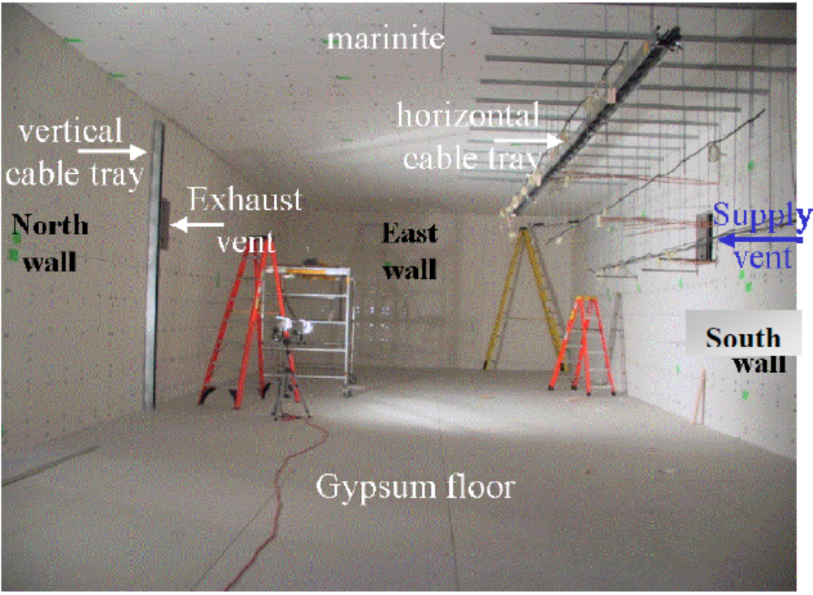
Figure 8-83: Experimental Setup [46]

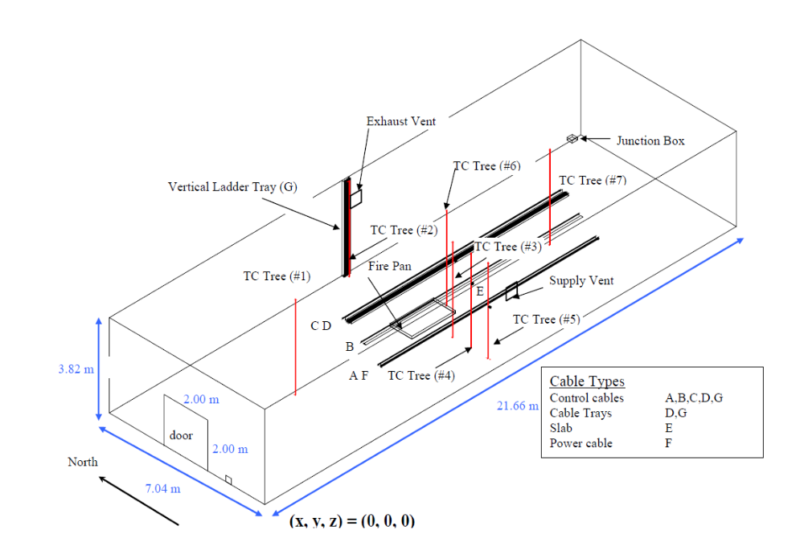
Figure 8-85: A schematic diagram of experimental Setup [46]
The compartment contained three control cables (A, B, C), a horizontal (Target D) and a vertical cable tray (Target G) with control cables, a solid PVC slab “target” (E), and a single power cable (F).One horizontal cable tray 0.3 m wide and 0.1 m deep and 10m long is installed at height of 3.2m above the floor. Another vertical cable tray of same depth and width is installed at the centre of the north wall extending from floor to ceiling. There are two vents available in the room of dimension 0.7m *0.7m [46].
Different experiments have been performed by varying the size and location of fire along with the position of door and vents to change the ventilation conditions inside the room. Size of fire varied from 350 kW to 2.2 MW during the experiments. Following parameters have been measured:
- Compartment pressure
- Surface and core cable temperatures and PVC slab temperature
- Hot gas layer (HGL) temperature, depth, soot density, and concentrations of oxygen, carbon monoxide and carbon dioxide
- Gas temperature vertical profiles
Different mesh spacing will be used to study the effect of different turbulence models on the ceiling jet temperature, heat fluxes at targets and pressure inside the compartment.

Appendix 1
A macro used to specify the Field function in test case of square cavity is written as follows:
public class field_func extends StarMacro
{
public void execute()
{
Simulation simulation_1 = getActiveSimulation();
UserFieldFunction userFieldFunction_0 = simulation_1.getFieldFunctionManager().createFieldFunction();
UserFieldFunction userFieldFunction_1 =
simulation_1.getFieldFunctionManager().createFieldFunction();
UserFieldFunction userFieldFunction_2 =
simulation_1.getFieldFunctionManager().createFieldFunction();
UserFieldFunction userFieldFunction_3 =
simulation_1.getFieldFunctionManager().createFieldFunction();
UserFieldFunction userFieldFunction_4 =
simulation_1.getFieldFunctionManager().createFieldFunction();
userFieldFunction_0.setPresentationName("x/W");
userFieldFunction_1.setPresentationName("y/H");
userFieldFunction_2.setPresentationName("u*");
userFieldFunction_3.setPresentationName("v*");
userFieldFunction_4.setPresentationName("t*");
userFieldFunction_0.setDefinition("$Position_0/1");
userFieldFunction_1.setDefinition("$Position_1/1");
userFieldFunction_2.setDefinition("$Velocity_0/5.5e-4");
userFieldFunction_3.setDefinition("$Velocity_1/5.5e-4");
userFieldFunction_4.setDefinition("$Temperature/20-300/20");
}
}

Following macro calls the convert. Java file to convert a three Dimensional mesh into two dimensional mesh than it physics.java to select the physical models part_plot to creat the planes inside the cavity where to get compare the temperature and velocities obtained at the end of simulation, field_func.java to define the normalized velocity and temperature, stop_criteria.java to define the stopping criteria for simulation and finally plot.java to plot and export the results to the requires destination for further post processing.

public class start extends StarMacro {
public void execute()
{
Simulation simulation_0 = getActiveSimulation();
new StarScript(getActiveSimulation(),
new java.io.File(resolvePath("convert.java")),
getActiveSimulation().getClass().getClassLoader()).play();
new StarScript(getActiveSimulation(),
new java.io.File(resolvePath("physics.java")),
getActiveSimulation().getClass().getClassLoader()).play();
new StarScript(getActiveSimulation(),
new java.io.File(resolvePath("part_plot.java")),
getActiveSimulation().getClass().getClassLoader()).play();
new StarScript(getActiveSimulation(),
new java.io.File(resolvePath("field_func.java")),
getActiveSimulation().getClass().getClassLoader()).play();
new StarScript(getActiveSimulation(),
new java.io.File(resolvePath("stop_Criteria.java")),
getActiveSimulation().getClass().getClassLoader()).play();
new StarScript(getActiveSimulation(),
new java.io.File(resolvePath("plot.java")),
getActiveSimulation().getClass().getClassLoader()).play();
}
}

Appendix 2
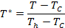
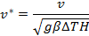
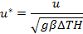
Reference Velocity ==
Rayleigh Number=Ra=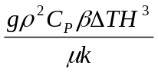
g=[0.0,-9.8] m/s²
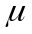=1.913710⁻⁵ Pa-s
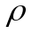=1.20192 Kg/m³

For initial Calculations Rayleigh number has been changed by changing the thermal coefficient and normalized velocity.
Rayleigh Number (Ra)
Ra=10³ | β=1.13710⁻⁹ /K
Ra=10³ | V₀=5.54E-4
Ra=10⁴ | β=1.13710⁻⁸ /K
Ra=10⁴ | V₀=.00176
Ra=10⁵ | β=1.13710⁻⁷ /K
Ra=10⁵ | V₀=.00554
Ra=10⁶ | β=1.13710⁻⁶ /K
Ra=10⁶ | V₀=.0176

For Second part of the study to
V₀=0.15
=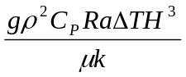
=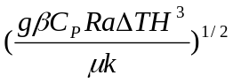
β=1.14710⁻⁴ /K
Rayleigh Number | Density
Ra=10³ | =.00471
Ra=10⁴ | =0.01489
Ra=10⁵ | =.0471
Ra=10⁶ | =.1489

Appendix 3
In the subsequent sections stream lines, isotherms and velocity vectors at different Rayleigh numbers are given.
Ra=10^3
Stream Lines:
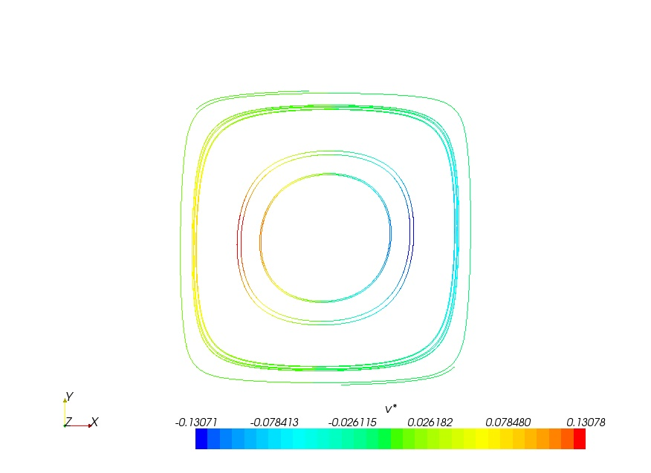 | 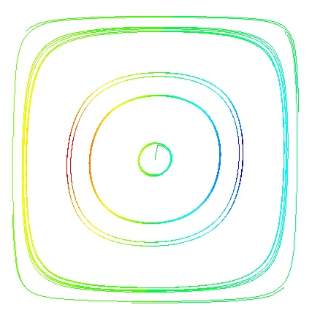
a)Square | b)Polyhedral
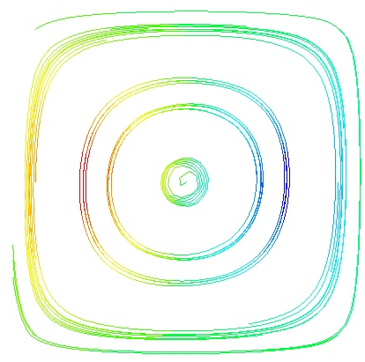 | 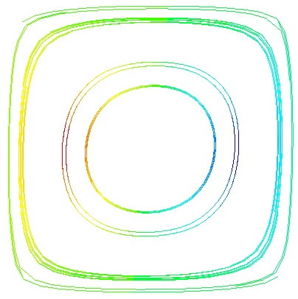
c)Skewed | d) Butterfly Type

Velocity Vectors:
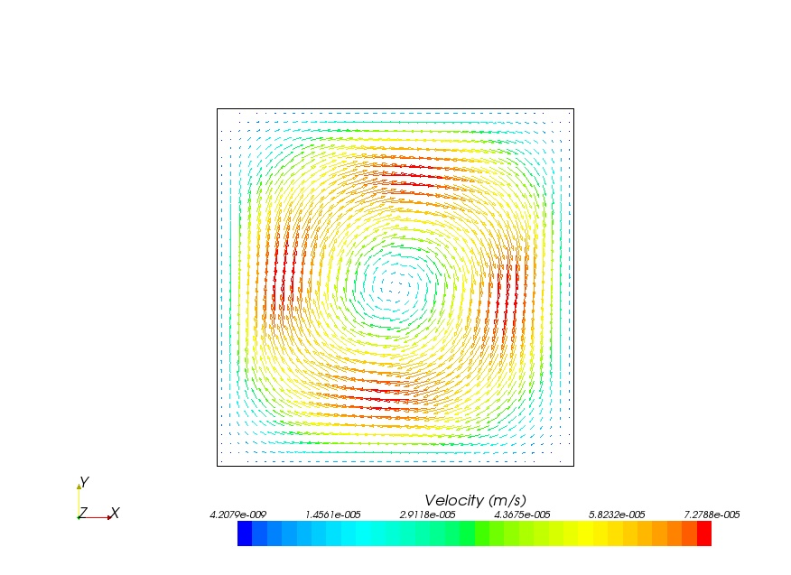 | 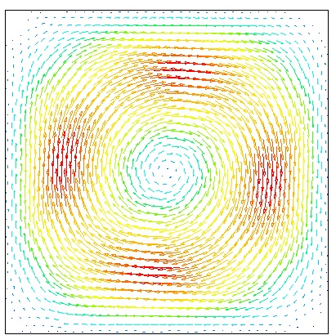
a)Square | b)Polyhedral
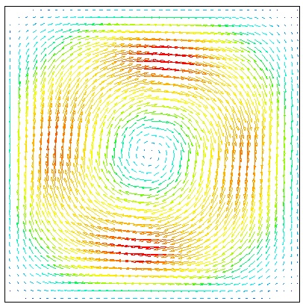 | 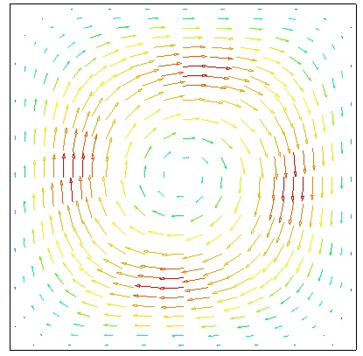
c)Skewed | d) Butterfly Type

Isotherms:
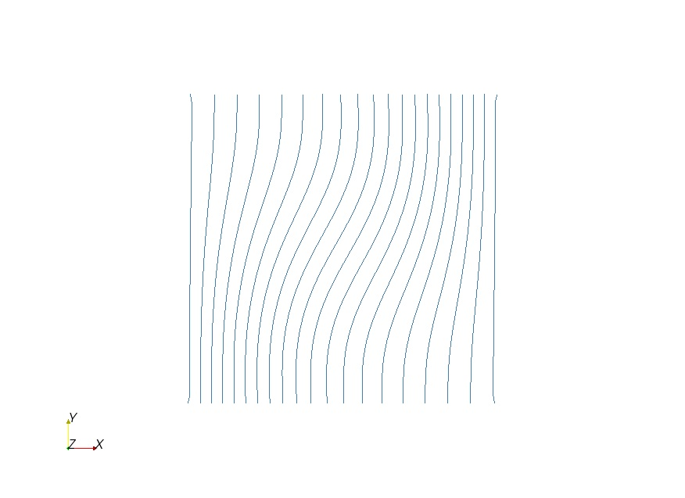 | 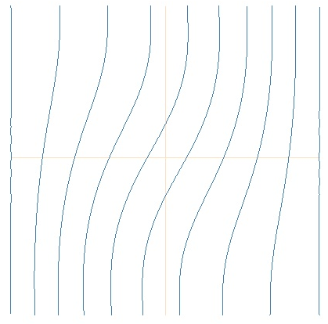
a)Square | b)Polyhedral
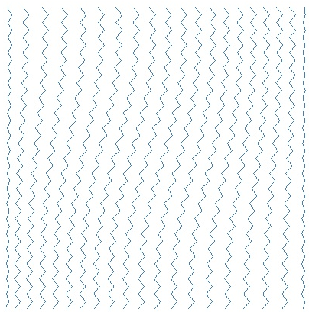 | 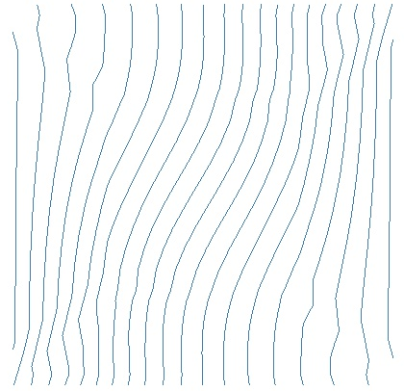
c)Skewed | d)Butterfly Type

Ra=10^4
Stream Lines
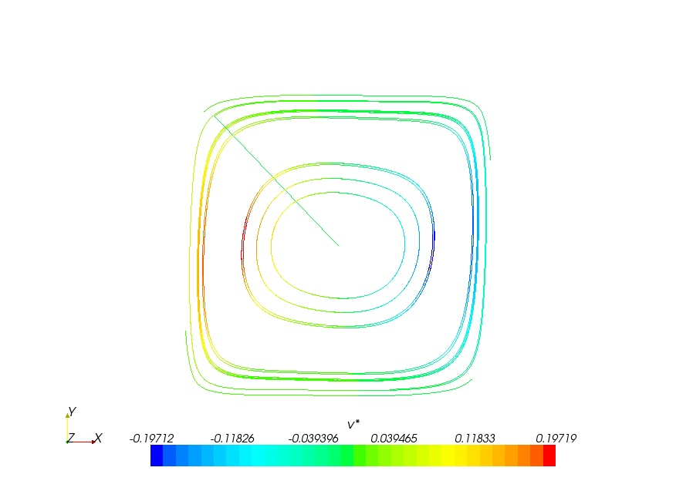 | 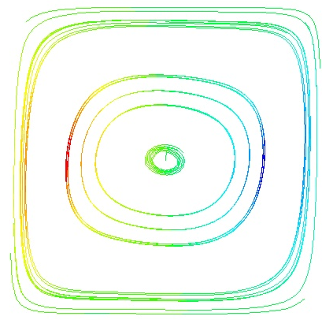
a)Square | b)Polyhedral
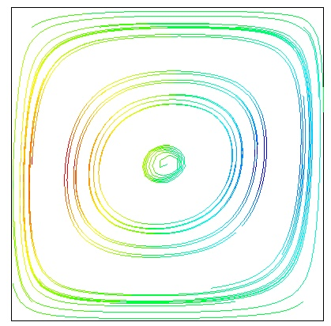 | 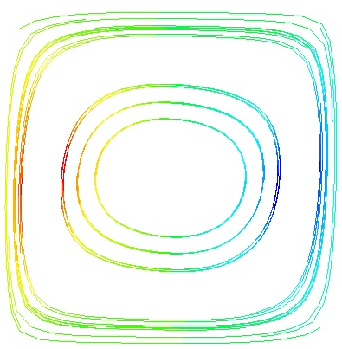
c)Skewed | d)Buterfly Type

Velocity Vector:
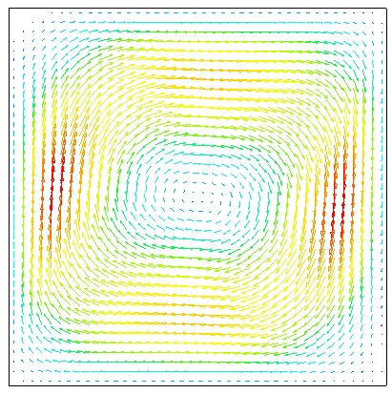 | 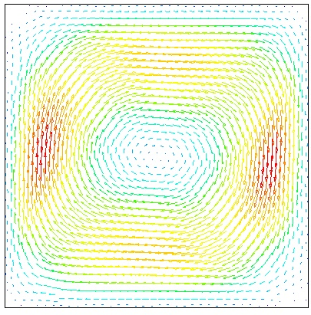
a)Square | b)Polyhedral
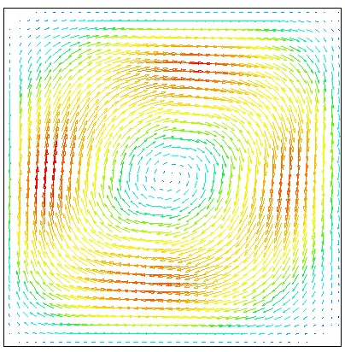 | 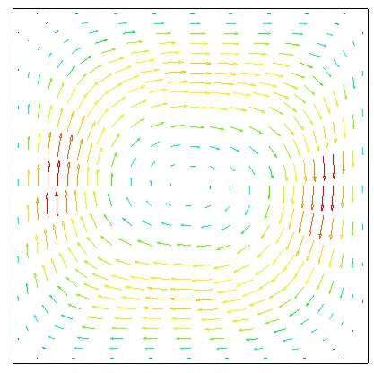
c)Skewed | d)Butterfly Type

Isotherms
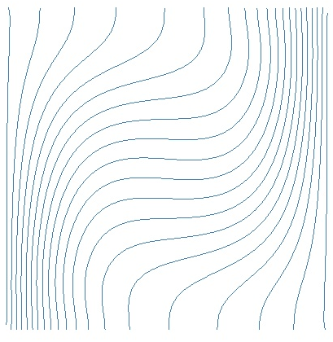 | 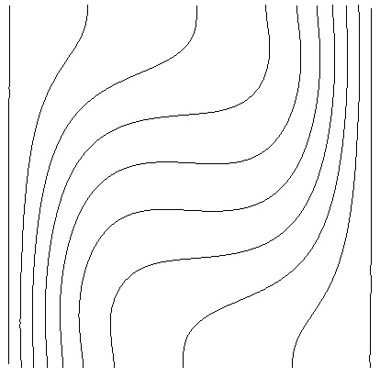
a)Square | b)Polyhedral
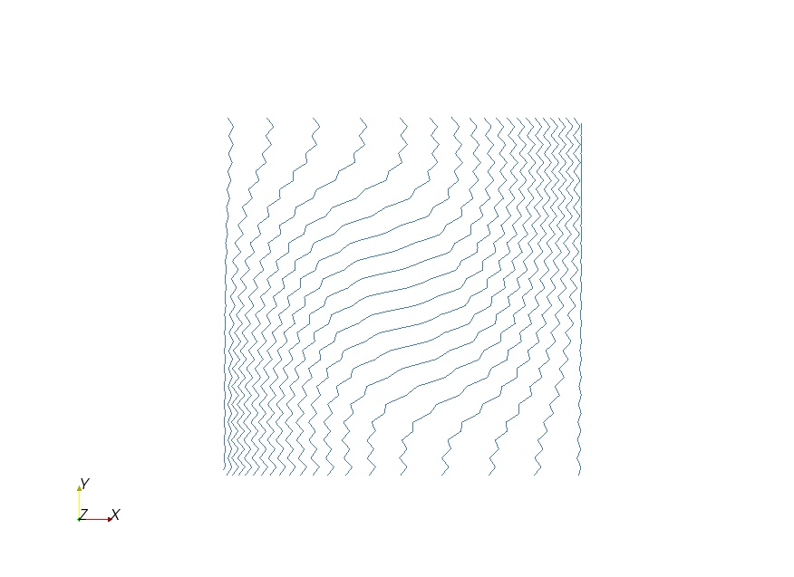 | 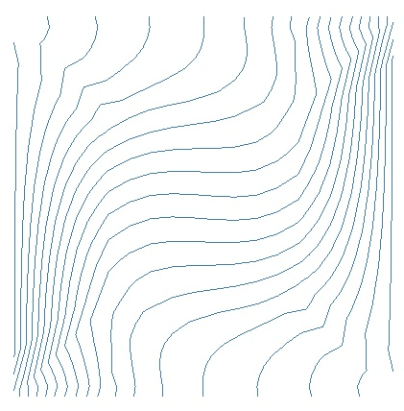
c)Skewed | d)Butterfly Type

Ra=10^5
Stream Lines
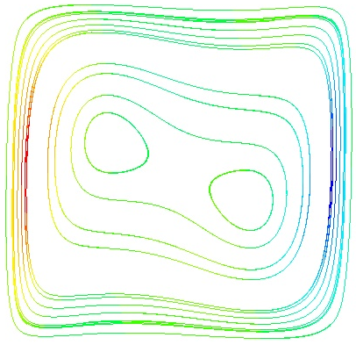 | 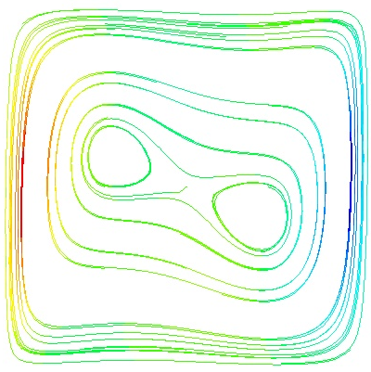
a)Square | b)Polyhedral
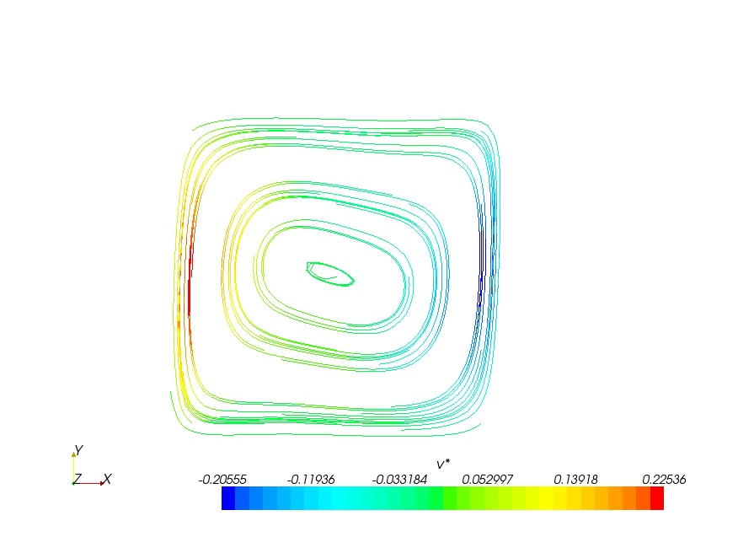 | 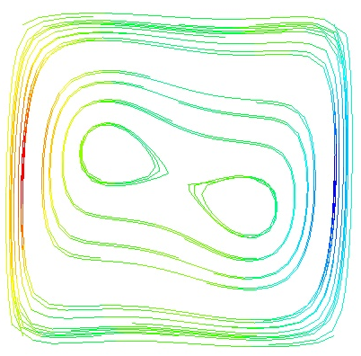
c)Skewed | d)Butterfly type

Velocity Vector:
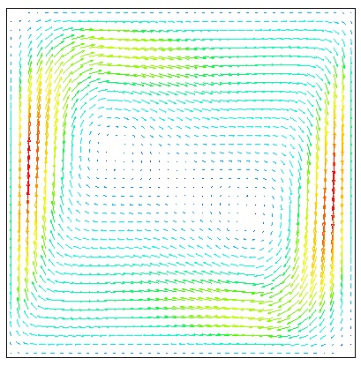 | 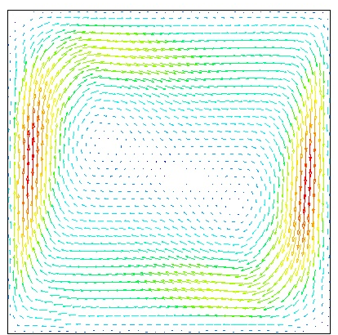
a)Square | b)Polyhedral
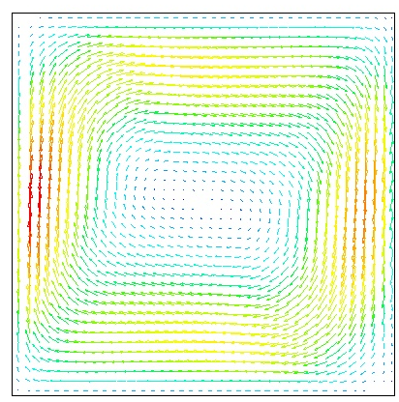 | 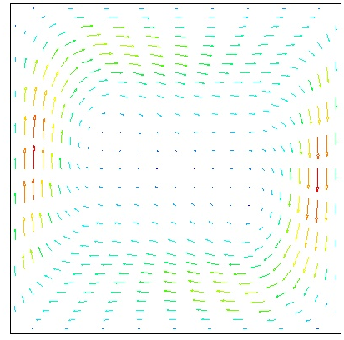
c)Skewed | d)Butterfly Type

Isotherms
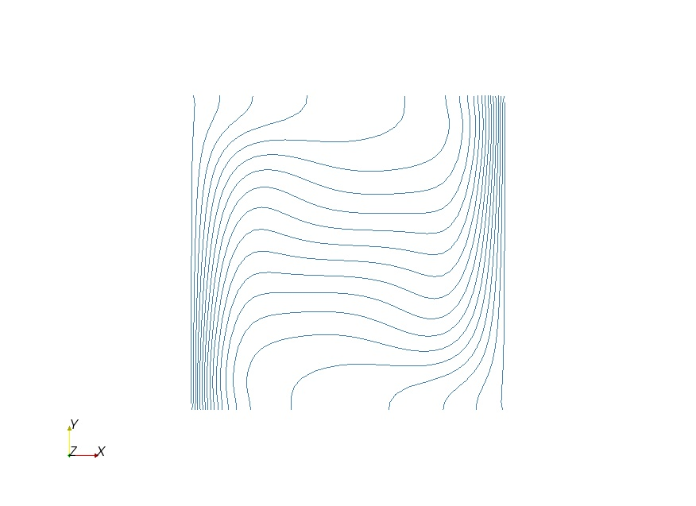 | 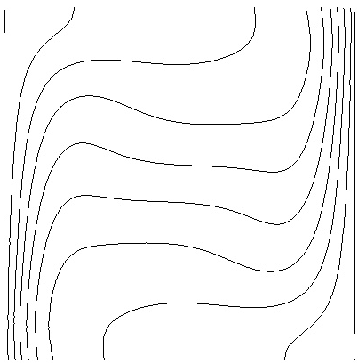
a)Square | b)Polyhedral
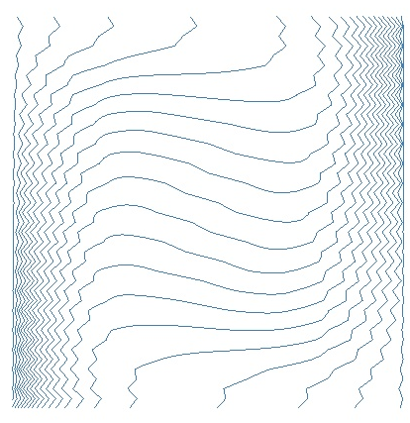 | 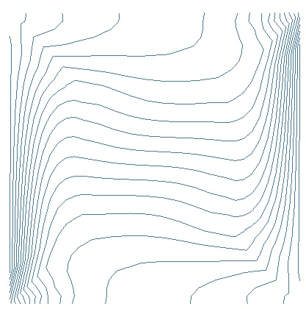
c)Skewed | d)Butterfly Type

Ra=10^6
Stream Lines
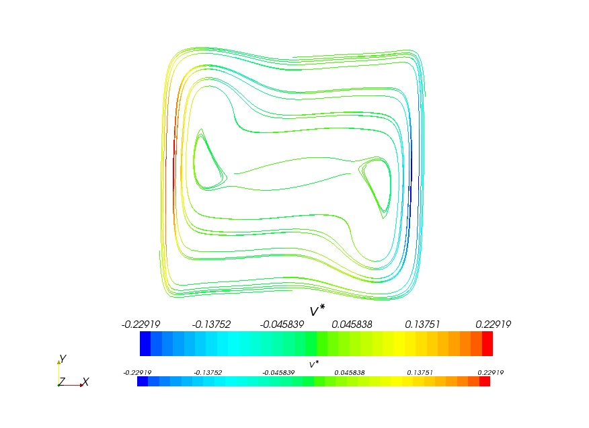 | 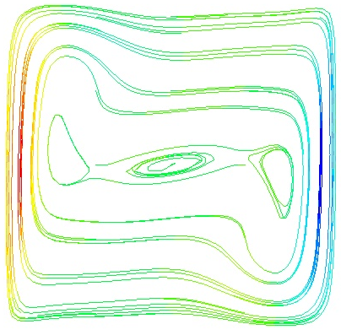
a)Square | b)Polyhedral
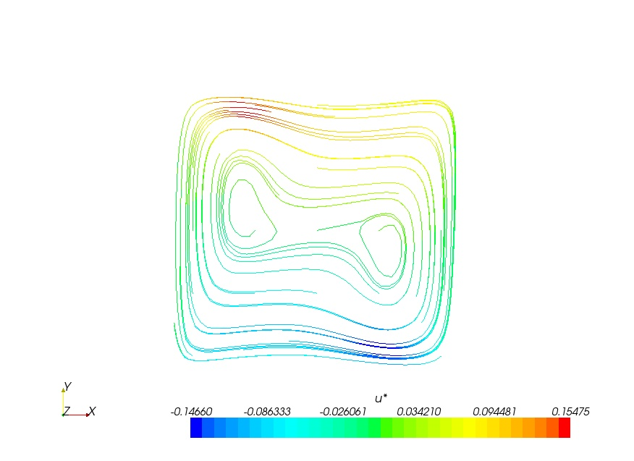 | 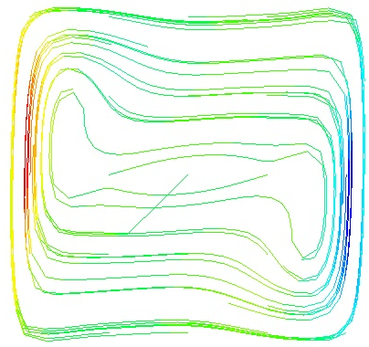
c)Skewed | d)Butterfly Type

Isotherms:
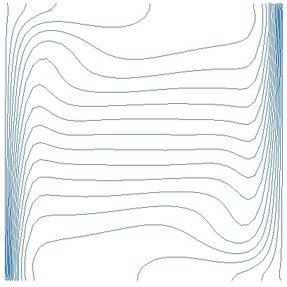 | 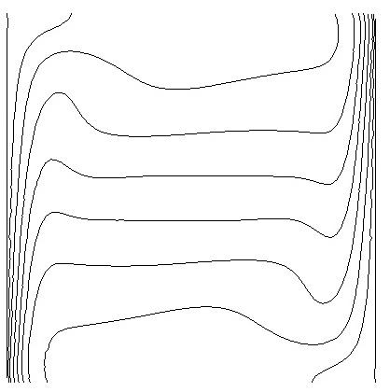
a)Square | b)Polyhedral
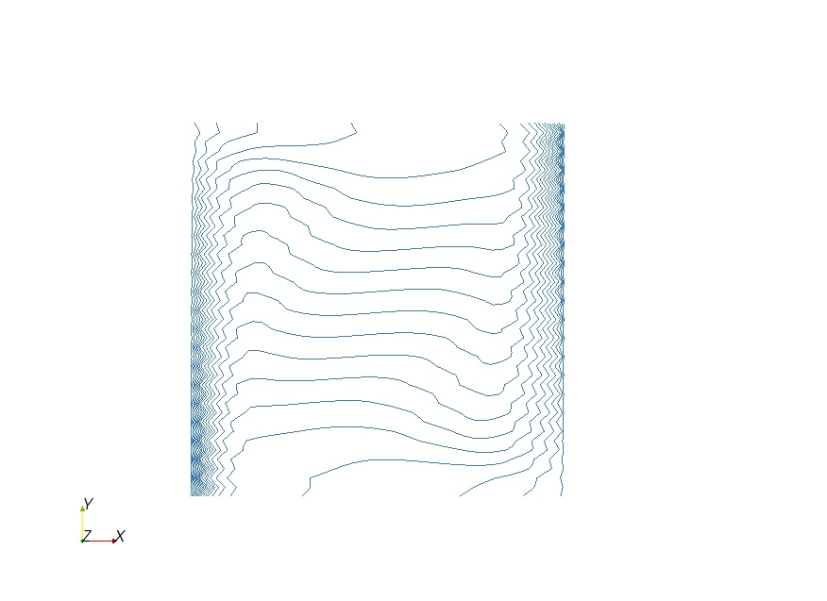 | 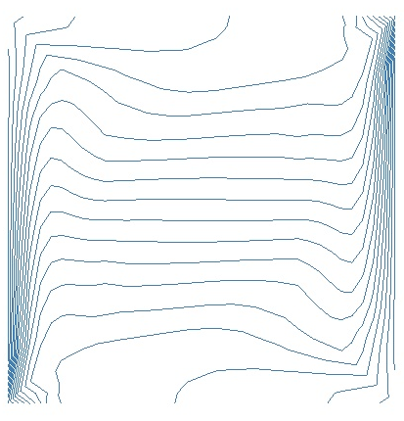
c)Skewed | d)Butterfly Type

Velocity Vector
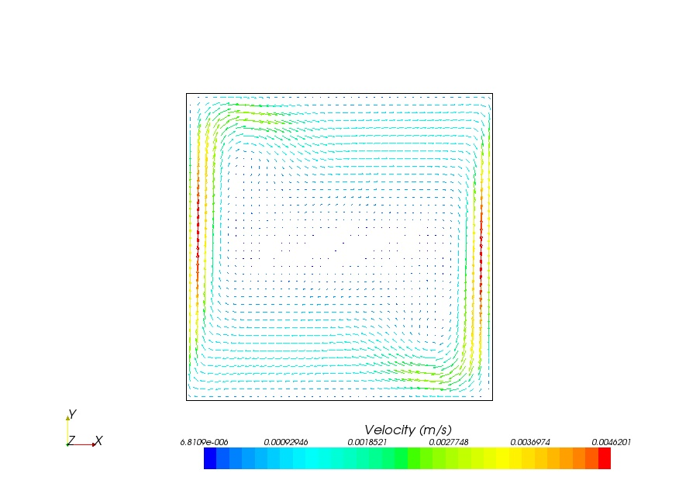 | 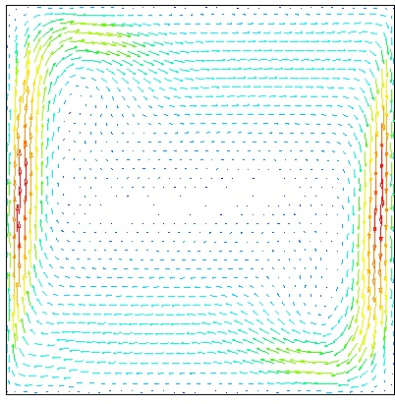
a)Square | b)Polyhedral
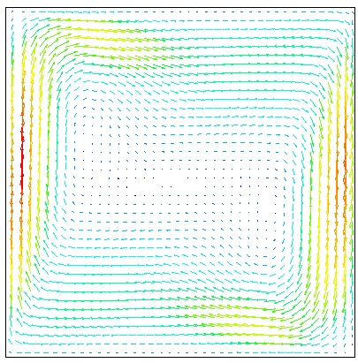 | 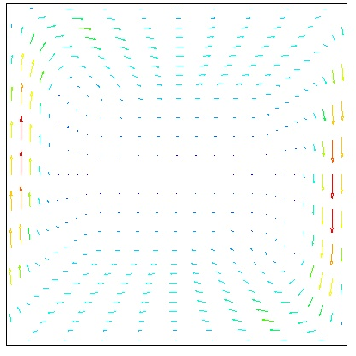
c)Skewed | d)Butterfly Type

Ra=1.58*10⁹
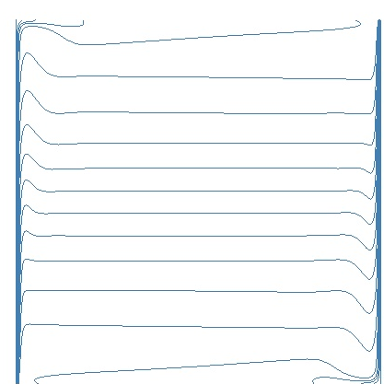 | 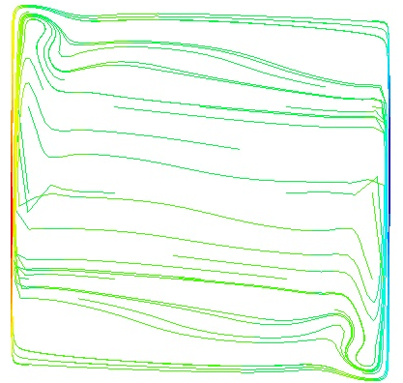
a)Isotherms | b)Streamlines
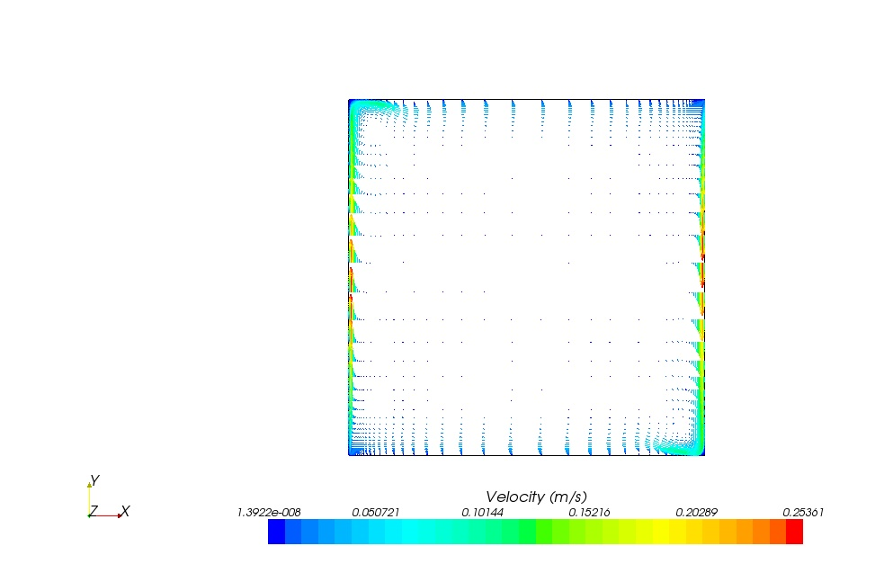
c)Velocity Vector

References:
- H K Versteeg, W Malalasekera “Computational Fluid Dynamics”, Prentice Hall second edition 2007
- Jhon F. Wendth (Ed) “ Computational Fluid Dynamics” A Von Karman Institute Book Springer-Verlag Berlin Heidelberg 1992
- Joel H. Ferziger Milovan Peric “ Computational Methods for Fluid Dynamics, Springer-Verlag Berlin Heidelberg 1996
- Fred Stern, Robert V. Wilson, Hugh W. Coleman*, And Eric G. Paterson “Verification And Validation Of CFD Simulations” Iowa Institute Of Hydraulic Research, 1999
- Mahaffy, J.H., Dietrich, P., Ducros, F., Henriksson, M., Fantoni, P., Morii, T., Muhlbauer, P., Scheuerer, M., Smith, B.L., Watanabe, “Guidelines for the Use of CFD in Nuclear Reactor Safety Applications” OECD Nuclear Energy Agency Report NEA/SEN/SIN/AMA(2005)2.
- Jörg Franke, Antti Hellsten, Heinke Schlünzen, Bertrand Carissimo, “Best Practice Guideline For The Cfd Simulation Of Flows In The Urban Environment”, Cost Action 732, 2007
- A.K. Alekseev and I. M. Navon “Error Estimation of goal oriented functional arising from iterative solution of Euler Equation”
- John Faragher, “Probabilistic Method for the Quantification of Uncertainty and Error in Computational Fluid Dynamics Simulations”, Air Vehicles Division Platforms Sciences Laboratory DSTO-TR-1633
- Peter A. Cavallo, Neeraj Sinha, “An Error Transport Equation with Practical Applications” American Institute of Aeronautics and Astronautics, 2007
- Dominique Bestion “Recommendation on Use of CFD Codes for Nuclear Reactor Safety Analysis” 5th Euratom Framework Programme 1998-2002
- CFD Analysis of 1/7th Scale Steam Generator Inlet Plenum Mixing During a PWR Severe Accident”, NUREG-1781, US Nuclear Regulatory Commission
- A. Keshmiri, M. A. Cotton, Y. Addad and D. Laurence, “Thermal Hydraulic Analysis of Flow in Rib-Roughened Passages with Application to Gas-Cooled Nuclear Reactors”, Turbulence, Heat and Mass Transfer 6.
- P.J. Woodburn, R. E. Britter, “ CFD Simulations of a Tunnel Fire- Part I”, Fire Safety Journal 26(1996)
- E. Leonardi, J. A. Reizes, “Natural Convection in a Compressible Fluid with variable Properties” Numerical Methods in Thermal Problems, 1979
- G. DE Vahl Davis “Natural convection of air in a square cavity:A bench mark numerical solution” International Journal For Numerical Methods In Fluids, Vol. 3, 249-264 (1983)
- Ken Uchida; Shinichiro Kawamura “Error Estimation Of Values Obtained From Practical CFD Analysis” Journal Of Nuclear Science And Technology, Vol. 45, No. 7, P. 625–633 (2008)
- Patrick J. Roache, “Validation and Verification in Computational Science and Engineering” Hermosa 1998
- Mentor et all “Evaluation of computational fluid dynamic methods for reactor safety analysis (ECORA)”
- “Verification and Validation of selected Fire Models for Nuclear Power Plant Application”, NUREG-1824, US-Nuclear Regulatory Commission
- M. Andreani, K. Haller a, M. Heitsch b, B. Hemstr¨omc, I. Karppinen d, J. Maceke, J. Schmid e, H. Paillere f, I. Tothg, “A Benchmark Exercise On The Use Of CFD Codes For Containment Issues Using Best Practice Guidelines: A Computational Challenge, Nuclear Engineering And Design 238 (2008)
- Li Rong, Peter V. Nielsen, “Simulation with different turbulence models in an annex 20 room benchmark test using Ansys CFX 11.0”, DCE Technical Report Number 46, ISSN 1901-726X
- User Guide Star CCM+ Version 3.06.006
- Spalart, P.R., And Allmaras, S.R. 1992. “A One-Equation Turbulence Model For Aerodynamic Flows”, AIAA-92-0439.
- Lien, F.S., Chen, W.L., And Leschziner, M.A. 1996. “Low-Reynolds Number Eddy-Viscosity Modelling Based On Non-Linear
- Durbin, P. A. 1991. “Near-Wall Turbulence Closure Modelling Without Damping Functions”, Theor. Comput. Fluid Dyn. 3, 1-13.
- Lien, L. S., Kalitzin, G., Durbin, P. A. 1998 “RANS Modeling For Compressible And Transitional Flows”, Center For Turbulence Research - Proceedings Of The Summer Program 1998
- Durbin, P. A. 1996, “On The K-E Stagnation Point Anomaly”, Int. J. Heat And Fluid Flow 17, 89-90.
- Abe, K., Kondoh, T., And Nagano, Y. 1994. “A New Turbulence Model For Predicting Fluid Flow And Heat Transfer In Separating And Reattaching Flows --- 1. Flow Field Calculations”, Int. J. Heat Mass Transfer, 37, Pp. 139-151.
- Menter, F.R. 1994. “Two-Equation Eddy-Viscosity Turbulence Modeling For Engineering Applications”, AIAA Journal 32(8) Pp. 1598-1605.
- G. Barakos and e. Mitsoulis “Natural convection flow in a square cavity Revisited: laminar and turbulent models with Wall functions” Department of chemical engineering, university of ottawa, ottawa, ont. Kin 6n5, canada
- G. De Vahl Davis “Laminar Natural Convection in an Enclosed Rectangular Cavity” Int. J. Heat Mass Transfer Vol. II Pp. 1675-1693p. Pergamon Press 1968
- M. Hortmann, M. Peric And G. Scheuerer “Finite Volume Multigrid Prediction Of Solutions Laminar Natural Convection: Bench-Mark Solutions” International Journal For Numerical Methods In Fluids, Vol. 11, 189-207 (1990)
- N. C. Markatos And K. A. Pericleous “Laminar And Turbulent Natural Convection In An Enclosed Cavity” Int J. Heat Mass Transfer Vol. 27. No. 5, Pp. 755~~772. 1984
- T. Saitoh, K. Hirose “High-Accuracy Bench Mark Solutions To Natural Convection In A Square Cavity” Computational Mechanics (1989) 4, 4 I7-427
- F. Ampofo, T.G. Karayiannis, “Experimental Bench Mark Data For Turbulent Natural Convection In Air Filled Square Cavity”, International Journal of Heat and Mass Transfer (2003)
- Hyung Seok Kang, “CFD Analysis for the Experimental Investigation of a Single Channel Post Blowdown” Korea Atomic Energy Research Institute, Korea
- William L. Oberkampf , Timothy G. Trucano “Verification and validation benchmarks Nuclear Engineering and Design 238 (2008) 716–743
- Lars Davidson, “An introduction to turbulence models”, Department of thermo and fluid dynamics, Chelmers University of Technology, Sweden 2003.
- Jurij SODJA, “Turbulence Model in CFD”, University of Ljubljana, Department of Physics 2007
- William L. Oberkampf , Timothy G. Trucano “Verification and validation benchmarks”, Validation and Uncertainty Estimation Department, Sandia National laboratories, USA
- Raunaq Haseeb et all “Simulation of an experimental compartment fire by CFD”, Building and Environment 2007
- Zhuman Fu, “A two-zone fire growth and smoke movement model for multi-compartment buildings”, Fire Safety Journal 2000
- Bart Merci, “Numerical simulations of full-scale enclosure fires in a small compartment with natural roof ventilation”, Fire Safety Journal 2007
- V. Novozhilov, “Computational Fluid Dynamics Modelling of Compartment Fires”, Progress in Energy and Combustion Science
- Kevin McGrattan et all, “Fire Dynamics Simulator (Version 5)”, NIST Special Publication1018-5
- Anthony Hammins et all, “Report of Experimental Results for the International Fire Model Benchmarking and Validation Exercise”, NUREG 6905
- Casey, M., Wintergerste, T. , “Special Interest Group on Quality and Trust in Industrial CFD: Best Practice Guidelines”, ERCOFTAC, Version 1.0, pp.11-19

