PC Passport 
Spreadsheets
Student Workbook



Published date: August 2008
Publication code: CB4122
Published by the Scottish Qualifications Authority
The Optima Building, 58 Robertson Street, Glasgow G2 8DQ
Ironmills Road, Dalkeith, Midlothian EH22 1LE
www.sqa.org.uk

The information in this publication may be reproduced to support the delivery of PC Passport or its component Units. If it is to be used for any other purpose, then written permission must be obtained from the Assessment Materials and Publishing Team at SQA. It must not be reproduced for trade or commercial purposes.

© Scottish Qualifications Authority 2008
Introduction
This student workbook is one of a range of eight titles designed to cover topics for the refreshed PC Passport. Each title in the range covers the required subject material and exercises for candidates studying PC Passport.
This workbook covers all three levels of PC Passport — Beginner, Intermediate and Advanced — with each level clearly identified.
There are a number of exercises associated with each subject and it is recommended that centres download and use the sample exercise files provided.
Each workbook will help prepare candidates for the assessments for the refreshed PC Passport. It is recommended that centres use the most up-to-date Assessment Support Packs appropriate for their type of centre, eg either school, FE or work-based.

Contents
Beginner 1
Spreadsheet Software 1
Excel Overview 1
Creating Workbooks 10
Exercise 1: Using Copy and Cut 16
Exercise 2: Using Copy and Paste 19
Exercise 3: Cell Formatting and Calculations 26
Exercise 4: Using Formulas 27
Exercise 5: Using AutoSum and Other Formatting Options 29
Cell Referencing 31
Exercise 6: Absolute/Relative Cell Referencing 34
Exercise 7: Absolute/Relative Cell Addressing and Statistical Functions 34
Formatting Text 35
Exercise 8: Formatting Cells 37
Exercise 9: Using AutoFormat 39
Previewing and Printing a Workbook 40
Exercise 10: Printing Your Workbook 45
Exercise 11: Working with Print Options 46
Using Functions 48
Intermediate 51
Mathematical Functions 52
Statistical Functions 53
Financial Functions 55
Logical Functions 57
Graphics 62
Charts 72
Exercise 12: Creating Charts 84
Exercise 13: Amending Charts 85
Advanced 87
File Protection 88
Exercise 14: Applying File Protection 95
Creating Spreadsheet Templates 96
Data Validation 98
Using Macros 104
Exercise 15: Creating a Macro 107
PivotTable Reports 108
Exercise 16: Using PivotTables 116
Using Goal Seek 116
Exercise 17: Using Scenarios 118
Sorting Data 119
Exercise 18: Sorting 121
Using Lists 121
Exercise 19: Using Lists 123
Using Filters 125
Exercise 20: Using Filters 129
Using Functions with Lists and Filters 132
Exercise 21: Using Lists, Data Forms and Filters 137
Finally 138

Spreadsheet Software
To enable you to perform calculations on numbers, hold lists of things, perform analyses on data and create charts, you need to use spreadsheet software. Spreadsheet software allows you to do all of these things and is the most widely used software in any office, especially when you need to keep financial information. There are two popular applications: Lotus 123 and Microsoft Excel. You can also get specialist financial and accounting software like SAGE.
Opening and Closing Spreadsheet Software
You can open your spreadsheet software in a number of ways. The most popular method is using the Start menu, which is shown at the bottom left of the Windows screen on the taskbar:
- Click the Start button, choose All Programs (or Programs if you don’t use Windows XP) and then Microsoft Excel or Lotus 123.

Note: If you use Windows XP, and you use Microsoft Excel frequently, you may also find it on the menu shown when you first click the Start button. This is to make it quicker for you to launch the program.
When you have finished using your spreadsheet software, you should close it. You do this by clicking File on the menu bar and then choosing Exit from the menu of options.
Excel Overview
Microsoft Excel is one of the most popular spreadsheet applications, but most have similar features to Excel. Files created in Excel are called workbooks. A workbook may contain one or more worksheets.
Each worksheet in a workbook stores information in a grid of rows and columns of cells. You can enter text, numbers, dates and calculations (formulas) in the cells to present and analyse the information you need.
For example, you could use a workbook to store budget forecasts, employee timesheets, profit and loss accounts, calculation of depreciation, cash flow analysis and monthly expense reports.
Some advantages of using a computer-based workbook are:
- You can format the information in a workbook using a variety of fonts, lines and shading, making the information easier to read.
- Changes can be made to values in a workbook at any time, and all calculations making reference to those values will be updated automatically.
- The information in a workbook can be presented graphically using charts of various types.
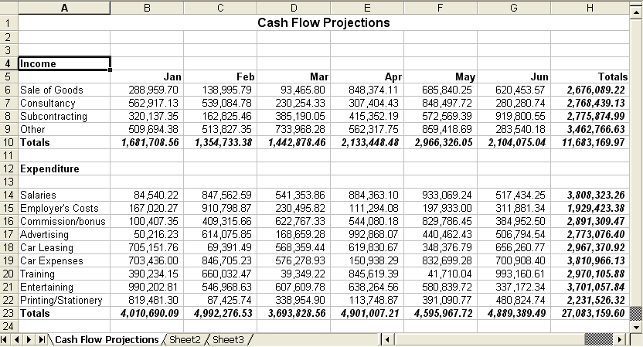
Each cell in the workbook has its own unique cell address (also known as the cell reference). This is made up of its column letter and then its row number, so the cell at the top left of the worksheet in column A on row 1 is cell A1. The cell that reads ‘Expenditure’ in the above illustration is cell A12, while the cell that reads ‘May’ is cell F5, and the active cell pointer is on cell A4.
Note: When working with Excel, you might notice that it sometimes inserts the name of the worksheet the cell address comes from. In that case, in the above example, cell H23 on sheet ‘Cash Flow Projections’ would be referred to as:
‘Cash Flow Projections’!H23
Notice the cell address is made up from text and numbers. When you want to replicate a formula across a number of cells you can use the fill facility.
How to Fill Data within a Row or Column
1 Select the cells you want to copy.
2 Drag the fill handle (the small black square in the lower-right corner of the selection — when you point to the fill handle, the pointer changes to a black cross) across the cells you want to fill, and then release the mouse button.
Spreadsheet Screen Elements
When your spreadsheet application is loaded, the application window will be displayed.
The screen elements described below are for Microsoft Excel, however most spreadsheet applications have similar options. In fact most applications use a menu system, either along the top or the side of the application screen, for you to access various options to enter, manipulate and use the spreadsheet software to create your spreadsheet.
Title Bar
The application window has a title bar displaying Microsoft Excel – Book 1, although Book 1 will change to the name you give the workbook when you save it. The window has standard window elements such as the Minimise button and Maximise buttons that you’ll see on all program windows, and like any other window, you can resize and position the Excel window anywhere on the screen.
Menu Bar
Below the title bar is the menu bar. By clicking a menu name or by pressing [Alt] then the underlined letter, you can display the menu options. For example, [Alt] F will access the File menu. Once the menu is open, to choose an option simply click it or press its underlined letter.
Some commands can be accessed using keyboard shortcuts. When a keyboard shortcut is available, you will see it described to the right of the command name. For example, if you click the Edit menu, you will see the Copy command can also be actioned by pressing [Ctrl] C. This means pressing C while you hold down one of the [Ctrl] keys. Options that appear dimmed are not available for selection at this time. If the command can also be accessed through a toolbar button, eg Cut, the picture that appears on the button is shown to the left of the menu option.
Initially, only some of the options will be shown on each menu, however, you can extend the menu to show all the available options if necessary. As you work with Excel, those options that you use will be added to the shortened list initially displayed.
Toolbars
To begin with, the Standard and Formatting toolbars are displayed — they are the ones you work with most. You can choose to display or hide toolbars using the View, Toolbars command. Alternatively, right-click any toolbar currently displayed to see the shortcut menu and then select a toolbar name to display or hide it.
Worksheet Tabs
Each workbook in Excel is made up of one or more worksheets. Each worksheet (or simply sheet) in the workbook is represented by a tab at the bottom of the window. Each time you create a new workbook, it will have the default number of worksheets for your system. You can rename the sheets from their original Sheet1, Sheet2… format by double-clicking the tabs and typing the new names. This can make it easier for you to know what data is on each sheet.
Scroll Bars
The scroll bars shown along the bottom and right edges of the window allow you to navigate up, down and across your spreadsheet and can be used to see different parts of your workbook if it’s too large to be seen all at once on the screen.
When you click the arrow buttons at the end of a scroll bar, the cells on-screen will scroll in the direction shown on the arrow. If you want to scroll further, you can click and drag the scroll box along the scroll bar to the required position.
How to Open a Workbook
If the workbook you want to work with has already been typed and saved, you have to open it first.
1 Open the file using one of these methods:
- Select the File, Open menu option, ie click the File menu and then the Open option.
- Hold down [Ctrl] and press O.
- Click the Open button on the toolbar.
The Open dialogue box will be displayed.
2 Choose where the workbook is located, eg on the desktop or somewhere on My Computer, by selecting an option from the Look in drop-down list. You can display this list by clicking anywhere on the box or the small arrow at the end of it. This is known as a drop-down arrow as clicking it displays a drop-down list.
Note: The Places bar at the left of the dialogue box can be used to quickly list the contents of the listed folders. Simply click the appropriate button.
3 If necessary, choose the disk where the workbook has been saved by clicking it. The contents of that disk, including any files not stored inside a folder, will be listed in the main window in the dialogue box.
4 Open the folder where the file has been saved by double-clicking its name. For example, if the workbook is in the Projects folder, double-click the Projects folder. The folder name will then appear in the Look in box and its contents listed in the main window.
5 Once the folder you want is open and its name is shown in the Look in drop-down list box, click the workbook name and then the Open button.
How to Save a Workbook
When saving files to your computer, you can choose to save them in a folder on your computer’s local hard disk, floppy disk or memory stick. If you are attached to a network, you can also choose to save them in a folder on the network. You can also choose to store it in a folder that already exists, or create a new folder for it.
1 Choose to save the file using one of these methods:
- Select the File, Save menu option, ie click the File menu and then the Save option.
- Hold down [Ctrl] and press S.
- Click the Save button on the toolbar.
The Save As dialogue box will be displayed.
2 In the File name text box enter a suitable file name. The following rules apply when naming files:
- File names can be a maximum of 255 characters.
- Some characters cannot be used in file names. These include:
\ / * ? : ; " | < >
- Within a single folder each file name must be unique.
Microsoft Excel adds an .xls extension to all workbook file names. It may be the case, however, that you do not see the file extension as its display depends on how your system has been set up.
3 If necessary, choose the file format from the Save as type drop-down list.
4 Specify where the file is to be saved, eg on the desktop or somewhere on My Computer, by selecting an option from the Save in drop-down list. You can display this list by clicking anywhere in the box or on the small arrow at the end of it.
Note: The Places bar at the left of the dialogue box can be used to quickly display the contents of the listed folders. Simply click the appropriate button.
5 If necessary, choose the disk where you want to save the file by clicking it. The contents of that drive, including any files not stored inside a folder, will be listed in the main window in the dialogue box.
6 Open the folder where the file is to be saved by double-clicking its name. For example, to store the file in the Projects folder, double-click the Projects folder. The Project folder name will then appear in the Save in box and its contents listed in the main window.
If you want to create a subfolder inside the one shown in the Save in box, click the New Folder button. A new folder will appear in the file and folders list, ready for you to type a unique name. Type the new folder name then press [Enter].
7 Once the folder you want is open and displayed in the Save in drop-down list box, click the Save button.
Note: When you save a file that has been saved before, Excel assumes that you want to save it on top of the previous version and so doesn’t ask you for a file name or a location. If you want to save another copy of the file, use the File, Save As menu option, which will always ask you for a file name and a location.
Printing a Workbook
To print a copy of your workbook to the default printer, click the Print button on the toolbar. The worksheet can be printed using standard layouts like portrait or landscape (useful for spreadsheets that need to display across the page, rather than down the page). It may be necessary to adjust the page orientation (portrait or landscape) or even adjust the margins, size of font and/or page sizes to get your worksheet to fit onto one page. There are a number or printer properties and page setup properties you can change to allow your spreadsheet to look better, or to minimise paper.
Closing a Workbook
When you have finished working with a workbook, you can close it using the Close option from the File menu.
Inserting, Deleting, Moving and Renaming Worksheets
Each workbook that is created has one or more worksheets. The precise number will depend on each system’s setup, however, you will be presented with three worksheets by default.
You can add and remove worksheets as and when you need to and, as you’ve seen earlier, you can also rename sheets to make them easier to work with. If necessary, you can also change the order in which the sheets appear in the workbook.
How to Insert a Worksheet into a Workbook
1 Right-click a worksheet tab.
2 Choose Insert from this menu.
3 In the Insert box, choose Worksheet and click OK.
The new sheet is inserted to the left of the one you right-clicked.
How to Move a Worksheet
Click the tab of the worksheet that’s to be moved then drag it to its new position in the workbook. As you drag, a small arrow shows you where the worksheet will be placed if you let go of the mouse button.
How to Delete a Worksheet from a Workbook
Right-click the tab of the worksheet you want to delete and choose Delete from the shortcut menu. When you’re asked to confirm the deletion, click OK.
How to Rename a Worksheet
Double-click the worksheet tab and type the new name for the sheet. Press [Enter] when you’ve finished.
Common Spreadsheet File Formats
When you save an Excel workbook it is stored in a particular format, complete with the cell contents, the formatting that has been applied, the graphics that have been included and so on. The file name you supply is given an .xls extension (an abbreviation added to the end of the file name to identify the file type) which identifies it to Excel as an Excel workbook.
Excel can both read and save your workbooks in other formats. This is so that you can exchange data with other programs that can’t read or create Excel’s own format. So if, for example, a client uses a different spreadsheet program that can’t read Excel files, you could save the workbook in another format that they can read. Likewise, if Excel can’t read their spreadsheet program’s file format, they could save their workbook in one of the formats that Excel can read.
Text files | When you save a workbook using one of the text formats, only the text and results of calculations are saved. This means that you lose all formatting, graphics, objects and other contents from the file. Normally you would use the Text (Tab-delimited) (*.txt) file type. When you use this type, the resulting file contains all the text with each row from the worksheet shown on a new line, and with tab characters between the columns.  Files of this type have a .txt extension on their names.  Note: If you’re saving a text file for a Macintosh computer user, use the Text (Macintosh) (*.txt) file type.
Comma Separated Value (CSV) files | This format also saves text and results of calculations, with the rows on separate lines of the CSV file and the columns separated with commas.  Files that use this format can be identified by their .csv file name extension.  Note: If you’re saving a CSV file for a Macintosh computer user, use the CSV (Macintosh) (*.csv) file type.
Symbolic Link (SYLK) files | When you save a workbook using the SYLK format, the text and the formulas (used to perform the calculations) are saved along with limited formatting. If any part of a formula is not supported by the SYLK format, the result of the calculation, rather than the formula used to calculate it, will be saved in the SYLK file.  Files that use this format can be identified by their .slk file name extension.

To open or save a workbook in a format other than the standard Excel Workbook format, use the Files of type drop-down list to choose the particular format you want to work with.
Using Excel Help
Like all Microsoft applications, Excel provides an online facility for getting help when you need it.
The Office Assistant
The Office Assistant is an online help system that you can use when you want to know more about a particular option or how to complete a task. If the Office Assistant is displayed, some of the prompts that are usually shown in dialogue boxes appear in an Office Assistant balloon.
1 Select the Help, Microsoft Excel Help menu option. Alternatively, click the Office Assistant button at the end of the Standard toolbar, or press the function key marked [F1]. An Office Assistant balloon will be displayed.
2 Type your question into this What would you like to do? box. For example, How can I sort information? and then click the Search button. You will then be given a choice of help topics to choose from.
3 Click your chosen topic and help text will be displayed or a list of headings will be shown so you can select more specifically what you would like to do.
4 Click your chosen heading to display the help text.
Creating Workbooks
As you learned earlier, each workbook created in Excel is based on a template that defines its initial appearance and layout. This means that the fonts, sizes and so on give the workbook a consistent look and feel without each user having to spend the time and effort creating the same effects. There are a number of templates for different workbook types including expense statements, invoices and purchase orders, and you can create your own if necessary.
If you choose to create a new workbook using the New button on the toolbar, it will be based on the default Normal template.
If you want to create a workbook based on one of the other templates, you have to use the File, New menu option as this will give you a choice of templates to choose from.
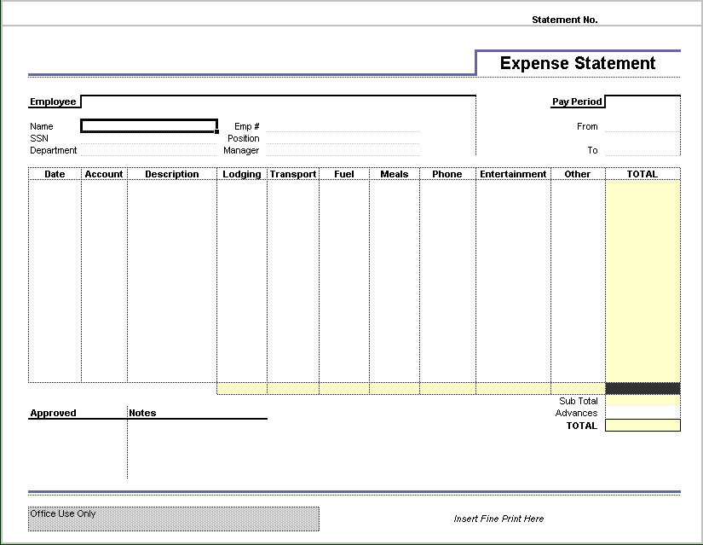
This is an illustration of a workbook based on the Expense Statement template that’s supplied with Excel. As you can see, content and formatting are part of the template. Once the workbook has been created, you simply fill in the blanks with your figures. The Total and Sub Total cells contain calculations (formulas) that will work out the figures based on what you typed into the other cells.
Workbook Templates
Templates allow you to create workbooks that already have the formatting you need as well as standard text such as column or row labels, graphics such as logos, or formulas for calculating the values needed to complete your workbook.
For example, if you had to complete a time sheet every week, it would be quicker to set up the basic sheet as a template (complete with headings and column and row labels, as well as the calculations needed to total your hours) then every week create a workbook based on the template, simply filling in the blanks with the relevant data for that week.
Every workbook you create is based on a template and unless you choose a specific one, it will be based on the Normal template. This template doesn’t add any standard content to your workbook, but applies a basic font and number format to each cell. You will learn how to create a workbook from a template later.
You can create templates yourself by creating what you need as an ordinary workbook and then saving it as a template using the Template (*.xlt) option from the File of type drop-down list in the Save As dialogue box. Templates are recognised by their .xlt extensions.
How to Create a Workbook Using a Template
1 Select the File, New menu option.
2 Click the template you want to use then click OK.
A new workbook will be created based on the template you chose in the dialogue box. This is the workbook that you’ll type your own data into. The template stays the same so that you can use it again later.
Entering Numbers, Text and Symbols in a Cell
Text, numbers, symbols, dates and times can simply be typed into a cell. Just move the active cell pointer to the cell where the data is to appear and then type it.
Note: You can move the active cell pointer to a cell either by clicking it using the mouse or by using the arrow keys on the keyboard to move it from its current location. Pressing [Ctrl] [Home] will move the pointer immediately to cell A1.
- To accept what you have typed, press the [Enter] or [Tab] key.
— If you press [Enter], the cell pointer will move down one row.
— If you press [Tab], it will move right one column.
- If you want to abandon what you have typed, press the [Esc] key.
When entering data you will notice that text entries are lined up at the left of the cell, while numeric entries are lined up at the right. Text entries are referred to as labels and numeric entries, dates and times are referred to as values.
Note: A text entry that's too wide for the cell you've typed it into will spill over into the cell to the right, as long as that cell’s empty. If there's something in the next cell, you will only see as much of your text entry as fits in the cell without spilling.
Editing Data
To make changes to a cell, either double-click it or press [F2] on your keyboard. You can then move around the entry, editing it to suit your needs. Pressing the [Backspace] key will delete data to the left of the cursor that’s shown in the cell when you edit it, and [Delete] will delete data to the right.
Alternatively, you can replace the entire cell contents simply by clicking the cell and typing the new entry.
Using Undo
Your most recent actions can be undone using the Undo drop-down list or the Edit, Undo menu option. If you undo an action or list of actions then discover that you shouldn't have, use the Redo drop-down list or the Edit, Redo command.
Entering Simple Formulas in a Cell
When you want to perform a calculation using numbers stored in a spreadsheet, you enter a formula. One of the main benefits of using a formula that uses cell addresses, rather than doing the calculation yourself and simply typing the answer into a cell, is that formulas are automatically updated when any cell on the sheet is changed or a new entry is made. This means that you can change the values that are used in the calculation without having to work out the result again.
Example Formula
=6+7+2 If you type this formula into a cell, the result (15) will be displayed in the cell. If you wanted to see the formula, you would click the cell then look at the formula bar.
Formulas always start with an = (equals) sign so that Excel can identify them as formulas. What follows the equals sign is the calculation that is to be performed. Although the example above uses numbers, it is usually better to use cell addresses so that the automatic updating of formulas is effective. For example, if you want to add the contents of cells B3 and B4, the formula would read =B3+B4. This means that if the contents of either of these cells is changed, the result of the formula would be updated to match.
If you want to multiply the contents of cell B3 by B4, use the * (asterisk) character. In this case the formula would read =B3*B4. Division uses the / (oblique) character. These characters used in this way are called operators.
Operators
* Multiply
/ Divide
+ Add
- Subtract
% Per cent
^ Exponent (to the power of)
Formula Construction
To enter a formula into a cell, first place the active cell pointer on the cell where the result is to be shown. Next, type = followed by the calculation you want to perform. You can either type the addresses of the cells you want to use or, once you have typed the = sign, you can click the cells, typing the required operator between them.
BODMAS
When you create a formula using more than one of the operators listed above, Excel will perform the various parts in a specific order. This can mean you get unexpected results. For example, what would you expect the result of this formula to be?
=10+5*2
Did you guess 30? If so, you’d find that Excel got a different answer. The answer that Excel would display would be 20. This is because of the order in which the operators are carried out. BODMAS is a way or remembering this order:
Brackets
Order (power of)
Division
Multiplication
Addition
Subtraction
Here’s another example along with an explanation of how Excel would deal with it:
=5+60/5*(1+2)²-1
Brackets | =5+60/5*(3)²-1
Order | =5+60/5*9-1
Division | =5+12*9-1
Multiplication | =5+108-1
Addition | =113-1
Subtraction | =112

The AutoFill Handle and Formulas
The AutoFill handle is the small square at the bottom right corner of the active cell pointer. This handle can be used to fill in series of entries and can also be used to copy cell contents from one cell to other cells beside it. When you copy a cell with a formula, the cell references in the formula are changed to suit the cells they’ve been copied to.
The AutoSum Button
The AutoSum button on the toolbar can be used to quickly add a row or column of values. Simply place the active cell pointer on the cell where the total is to be shown and then click the button. Excel will add the nearest set of values. Press [Enter] to accept the suggested values.

Exercise 1: Using Copy and Cut
1 Make sure that Excel is open.
2 Open the workbook Clothes stored in your main folder.
3 Use the AutoSum button to complete this table.
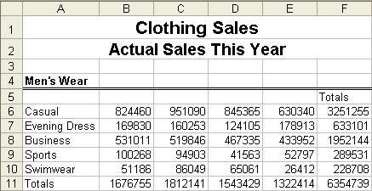
4 Follow these steps to duplicate and move this table, adjusting the values for Ladies’ Wear and Children’s Wear.
- Select the Men’s Wear table (A4:F11).
- Click the Copy button on the Standard toolbar.
- The copy is to be placed beginning at cell A15, so click this cell then click the Paste button on the Standard toolbar.
- Edit cell A15 to read Ladies’ Wear.
- Change some of the values in cells B17:E21, but be careful not to change any of the totals — these values are calculated for you. Notice that they change as you change the values in the rest of the Ladies’ Wear table.
- Make a copy of the Ladies’ Wear table, pasting it at cell A26.
- Edit cell A26 to read Children’s Wear and make some changes to the values in the table.
The Ladies’ and Children’s Wear tables are to be moved onto separate worksheets within the Clothes workbook.
- Select the Ladies’ Wear table (A15:F22) and click the Cut button on the toolbar.
- Paste this table on Sheet 2 at cell A4 then change the column widths as necessary.
Cut and paste the Children’s Wear table at cell A4 on Sheet 3 then change the column widths as necessary.
- Copy and paste the headings in rows 1 and 2 on Sheet 1 for Sheet 2 and Sheet 3.
5 Rename each of the sheets by double-clicking its name, eg Sheet 1 at the bottom of the worksheet and typing Men’s Wear, Ladies’ Wear and Children’s Wear as appropriate.
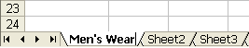
6 Save the changes you’ve made to this workbook.
7 Close the workbook.

Recognising Standard Formula Error Messages
Until you are familiar with formulas, you might find that you make a few mistakes. Most times, reading the message will explain what the problem is and often Excel will suggest a way to fix it, sometimes even fixing it for you.
A less straightforward error is the circular reference. A circular reference is caused when a formula includes the address of its own cell. For example, if the formula =B6*B7 appears in cell B7, you will have created a circular reference. Excel indicates this by displaying a message on the status bar and, depending on how you created the formula, a dialogue box may appear giving further details of your error.
Note: If the Office Assistant is switched on, this message will look different but will contain the same information.
To resolve the problem, edit the formula to remove or correct the problem.
An Error That Isn’t an Error
It’s common for users to think that they’ve made a mistake when the result of a formula they’ve entered looks like this:
 | Jan | Feb | Mar | Apr | Total
North | 700.12 | 35.86 | 367.81 | 467.01 | #####

The problem here isn’t a mistake with the formula; it’s just that the column isn’t wide enough to show the number. To fix it, just make the column wider.
Checking Your Calculations
Although formulas will perform your calculations for you, you should always check that you’re getting the result you expected. As BODMAS shows, you might not get an error message, but that doesn’t mean that your formula is giving you the result you want.
Formula Calculation
Each time you make a change to the data in your spreadsheet, all the formulas dependent on the cell you’ve changed are recalculated so that they can take account of the change. This is called automatic calculation and is the default calculation mode.
Depending on how you work, you may prefer to switch the calculation mode to manual, in which case each time you want to update the formulas affected by the changes you’ve made, you would press the [F9] function key. To switch the calculation mode to manual (or back to automatic), select the Tools, Options menu option and view the Calculation tab. Set the appropriate option in this box then click OK to apply it.

Exercise 2: Using Copy and Paste
1 Open the workbook Dealer Pricing stored in the Cars folder in your PersonalStuff folder.
This workbook contains a number of formulas to calculate values for the first product PLA/001/46. These formulas are to be copied for the other products in the list.
2 Follow these steps to copy the formulas and paste them for the other products.
- Select the formulas in cells C6:H6.
- Make sure the mouse pointer is on the selected range then right-click to display the shortcut menu.
- Click Copy on the shortcut menu.
Because these formulas are to be pasted for more than one product, you have to select all the cells that will be filled with the copied formulas.
- Select the range C7:H13.
- Point to the highlighted range then right-click and choose Paste from the shortcut menu.
- The formulas are repeated on each row and since they all contain relative cell references, they are updated to match so that on each row they calculate the figures for that row.
3 Add your name to the footer on this workbook then print one copy.
4 Save the changes you’ve made and close the workbook.

Selecting Cells, Range of Cells, Rows or Columns
Before you can carry out an operation affecting a number of cells (a range), you must identify the cells to be included in the range by selecting them. If the operation is to affect only one cell, then simply click it to select it. To select one or more ranges of cells you would use different methods, depending on whether they’re together on the worksheet or not.
Selecting a Range of Adjacent Cells
If you want to select a single range of cells that are side by side on the worksheet, click the first of the cells then, holding down the left mouse button, drag the mouse to the last. Alternatively, click the first of the cells and release the mouse button. Then, holding down the [Shift] key, click the last cell. Both these cells and all those in-between will be highlighted as selected.
Selecting Non-adjacent Cells and Ranges
If the cells you want to select don’t appear side by side, you can select them by clicking the first and then, holding down [Ctrl], clicking each of the others.
To select non-adjacent ranges, click and drag the first range and then, holding down [Ctrl], click and drag the others.
Selecting a Single Row or Column
To select a single row or column, click the grey button displaying the row number or column letter.
Selecting a Range of Rows or Columns
To select a number of rows or columns that appear together on the sheet, click and drag over the grey buttons indicating the row numbers or column names.
To select multiple rows or columns that do not appear together in the sheet, click and, if necessary, drag over the first set of rows or columns and then, holding down [Ctrl], click and drag over the others.
Inserting and Deleting Rows or Columns
To insert a new row, select the row it’s to be placed above and then choose the Insert, Rows menu option. Alternatively, hold down the [Ctrl] key and press the + key on the numeric keypad.
To insert a new column, select the column it’s to be placed before and then choose the Insert, Columns menu option. Alternatively, hold down the [Ctrl] key and press the + key on the numeric keypad.
To delete rows or columns, first select them and then choose the Edit, Delete menu option or press [Ctrl] — (on the numeric keypad).
Changing the Column Width
If you need to change the column width to allow for long entries in a cell, you can do so by clicking and dragging the vertical bar between the column heading letters. Alternatively, point to this bar and double-click to make the column wide enough so that the widest entry in that column is fully visible.
Using the AutoFill Handle to Enter Data
Excel’s AutoFill feature can be used to quickly fill a range of cells with a series of values, numbers or dates by use of the AutoFill handle, which is the small square at the bottom right corner of the active cell pointer.
To create a series, type the first entry in the series and then click and drag the AutoFill handle to the right or down over the cells to be filled to complete the series. As you drag, a Screen Tip will be displayed showing the entry that will be filled in the current cell.
So, for example, if a series of months are to be entered into row 4, you would type January into the first cell and then point to the AutoFill handle and drag it to fill in the months you need. You can see the tip that’s displayed to show you what month will be filled in the cell you’re at.
Formatting Cells
The format of a cell containing a number dictates how it is shown in that cell. For example, if you type the number 10 into a cell, it will, by default, be shown as you’ve typed it. If you then format that cell as a percentage, the value in the cell will be shown as 100%; if you format it as a currency it will be shown as £10.00 (unless you also change the number of decimal places).
Note: You can quickly format a cell by typing the value the way you want it displayed. If, for example, you type £10 into a cell, it will be formatted as currency with no decimal places. Any value you type into this cell will now be shown in this format unless you type it in another format.
The Format, Cells menu option and, for some formatting options, the Formatting toolbar can be used to change the way values appear in the selected cells.
Formatting Plain Numbers
Plain numbers can be formatted to increase or decrease the number of decimal places displayed and also to include a comma to separate hundreds and thousands. These options can be adjusted using the Formatting toolbar. First select the cells to be affected by the change, then click the appropriate button.
Formatting Dates
Dates can be formatted in a number of ways to suit the sheet you’re working on. The Format, Cells menu option gives you access to the available formats.
Formatting Currencies
A quick way of formatting a value with your default currency format is to use the Formatting toolbar. You can also use this toolbar to adjust the number of decimal places shown.
Simply select the cell or range you want to format and then click the appropriate buttons.
Alternatively, you can choose from a number of different currency symbols using the Format, Cells command.
Formatting Percentages
When you format a cell as a percentage, the value in the cell is multiplied by 100 and a % symbol is displayed. You can use the Formatting toolbar to do this.
Formatting Text
To allow you to highlight specific parts of your worksheets, the format of letters and numbers within a cell can also be changed, for instance, by changing the font style, colour or size. The Formatting toolbar contains a number of buttons that can be used to make these changes to the selected cells.
In addition to these formatting options, you can change the orientation of the entries in the selected cells. To do this you would use the Format, Cells command, clicking the Alignment tab.
Aligning Cell Contents
When you first enter text into a cell, it is aligned to the left of the cell, whereas numeric values including plain numbers and dates are aligned to the right. This horizontal alignment can be changed using the Formatting toolbar or the Format, Cells command which gives you additional options. Another horizontal alignment option that is available is the Merge and Centre option which lets you treat a number of cells as one and centre the contents within the one new cell.
You can also change the vertical alignment of a cell, ie align the entry to the top, centre or bottom of a cell that is deeper than the entry.
Adding Cell Borders
Using cell borders allows you to highlight ranges of cells within your worksheets. You can add preset borders to the selected range using the Borders drop-down list on the Formatting toolbar or customise the borders using the Format, Cells menu option.
Using the Format, Cells menu option you can set your own choice of borders for the range of cells that is currently selected. In the Border tab, you can choose one of the preset borders or choose a style and colour and then apply it to the required border.
Copying Cell Formatting
You can quickly copy all the formatting attributes that have been applied to one cell and apply them to another cell or a range of cells.
First click the cell that’s been formatted with the attributes you want to copy and then click the Format Painter button on the toolbar.
Next click the cell that’s to be formatted with these attributes. Alternatively, to apply these same attributes to a range of cells, click and drag over the cells.
Note: If you want to apply the attributes to more than one cell or range of cells, double-click the Format Painter. When you’ve finished copying the formatting, click it again to switch it off.
Formatting Other Numbers
The Format Cells box can be used to apply any number format you want to use. On the Number tab (shown under Formatting Currencies box above) you can choose any of the formatting categories and set the specific options for each. Clicking OK will apply your settings to the selected cells.
Using AutoFormat
The AutoFormat feature in Excel can be used to add a collection of formatting attributes to your data in one step. There are a number of different AutoFormats to choose from and even if none of them is exactly what you want, you can adapt it to suit yourself. The Format, AutoFormat menu option gives you the list of AutoFormat to choose from.
Conditional Formatting
When you want to highlight cells that match specific conditions, you can do so by applying formatting attributes via the conditional formatting feature. For example, you might want to emphasise cells that fall outside limits that you’ve specified. By using a different font, style, pattern and/or border, you can draw attention to these cells.
How to Apply Conditional Formatting
1 Select the cells to be formatted.
2 Select the Format, Conditional Formatting menu option.
3 Make the appropriate selections:
- To format value cells based on their contents:
a) Select Cell Value Is from the Condition 1 drop-down list.
b) Next, select a comparison from the Comparison drop-down list. The entries in this list include equal to; not equal to; greater than; less than and between.
c) Enter the values required for the comparison you've chosen into the text box. These values can be numbers or formulas.
- To format cells based on a condition other than their values:
a) Select Formula Is from the Condition 1 drop-down list.
b) Enter the required formula into the text box. This formula will include references to the relevant cells in the first row in the selected range.
The result of the formula must be either True or False.
4 Click the Format button.
Specify the formatting attributes you want to apply to those cells that match the specified condition. When you’re finished, click OK to return to the Conditional Formatting dialogue box.
5 If you want to set other conditions, click the Add button then repeat steps 3 and 4 for up to two others.
6 When you've set all the required conditions, click OK to apply them to the selected cells.

Exercise 3: Cell Formatting and Calculations
1 Create a new blank workbook and create the following table:
Note: Type the £ sign as part of the monthly salaries but not the comma — Excel will format the number this way.
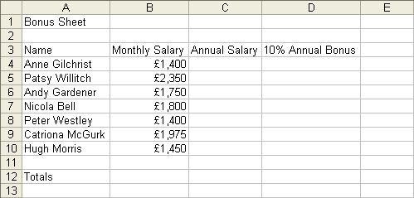
2 In cell C4 enter a formula that will calculate Anne Gilchrist’s annual salary as 12 times her monthly salary.
This formula should read =B4*12
3 In cell D4 calculate Anne’s annual bonus as 10% of her annual salary
This formula should read =C4*10%
4 Copy these formulas and paste them for the other employees.
5 Select cells B12:D12 then use the AutoSum button to give totals for these columns.
6 Andy’s last name has been entered incorrectly. Edit this cell to read Andy Garden.
7 Nicola’s monthly salary is wrong: it should be 1990. Make this edit and notice that the annual salary and bonus are recalculated to reflect this change. The totals on row 12 are also updated.

8 Change the worksheet name to Sales Dept by double-clicking the Sheet 1 tab and typing the new name.
9 Copy all the information from the Sales Dept sheet and paste it on Sheet 2.
10 Rename this sheet Admin Dept.
11 Change the information in columns A and B only as shown below (all cells with formulas will be updated automatically).
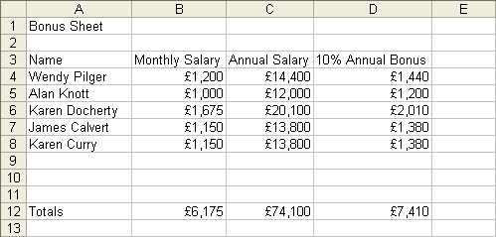
12 Admin department staff receive a 7.5% bonus rather than 10%, so change the column label in cell D3 and then the formula in cell D4 to reflect this.
13 Copy the formula for all other staff in the Admin department.
14 Follow these steps to print one copy of both worksheets:
- Add your name to the footer.
- Select the File, Print menu option.
- Under Print what, click Entire workbook.
- Click OK.
- Save the workbook as Bonus Sheet in the Financial folder in your WorkStuff folder, then close it.

Exercise 4: Using Formulas
1 Open the workbook Salary Rises stored in the Financial folder in your WorkStuff folder.
2 Enter a formula into cell C6 that will calculate the annual salary of Paul Hull by multiplying his monthly salary by 12, then copy the formula for the other employees.
3 Cell B3 contains the percentage rise that the employees are to be given. This percentage is in a separate cell to make it easier to change if necessary. If the percentage was included as part of each formula, you would have to change every formula if the percentage changed. By putting the percentage in its own cell and then including a reference to that cell in the formulas, you would only have to change one cell if the percentage changed.
Follow the instructions below to enter a formula that will calculate the increase for Paul Hull into cell D6 and then copy it for the other employees.
- Position the cell pointer on cell D6 then type =C6*B3
- Copy this formula for the other employees and look at the results.
- The results of these pasted formulas are clearly not correct, so click cell D7 and look at the formula bar.
The formula in this cell reads =C7*B4 since it uses relative cell addressing. However, B4 is an empty cell. The formula should be multiplying Stephen’s annual salary (C7) by the increase percentage (B3), so the original formula needs to include absolute markers to make sure that B3 doesn’t change when the formula is copied.
- Move to C6 and type the formula =C6*$B$3 (you can type the $ symbols, or press the F4 function key when the cursor is next to the B3 address).
When this formula is copied now, C6 will change but B3 won’t.
- Copy this formula for the other employees. This will overwrite the original incorrect formulas.
- Click cell D10 and look at the formula in the formula bar. The reference to cell C6 has been changed to reflect the formula's new row, but the reference to cell B3 remains the same.
4 Enter a formula into cell E6 that will calculate Paul Hull’s New Salary (annual salary + increase) then copy it for the other employees.
5 Calculate the totals on row 11 for each of the columns.
6 Notice the total increase shown in cell D11. The management have budgeted to spend a maximum of £6,200.00 on salary increases and, as you can see, awarding a 5% increase will exceed the budget. As the increase percentage is being taken from cell B3, type other values, such as 3.5% and 4.25%, into cell B3, to find the highest percentage that management could award without exceeding its budget.
7 Save the changes to the workbook and then close it.

Exercise 5: Using AutoSum and Other Formatting Options
1 Open the P&L workbook stored in the Financial folder in your WorkStuff folder.
2 Use the AutoSum button to enter totals in the ranges D5:D7, B8:D8, D11:D32 and B34:D34.
3 Follow the instructions below to replace all occurrences of the word Revenues with the word Sales.
- Move the cell pointer to cell A1 and then choose the Edit, Replace menu option.
- In the Replace dialogue box in the Find What box type Revenues. In the Replace with box, type the word Sales.
- Select the Find Next button. The first cell containing the word Revenues is highlighted.
Notice that this isn’t the only word in the cell, so if you’d ticked Find entire cells only, this occurrence of Revenues would not have been highlighted.
- Click the Replace button. Excel now highlights the next occurrence.
- Click Replace. This occurrence is replaced and the cell pointer stays on this cell, indicating that there are no more occurrences of the word Revenues.
- Notice that, although cell A7 also contains the word revenues, Excel doesn’t move on to this occurrence. This is because it doesn’t have a capital ‘R’.
4 Use Replace to replace all occurrences of the word Wages with Salaries.
5 Use Replace All to replace all occurrences of the word costs with fees. Notice that when you use the Replace All button instead of the Replace button you don’t see the individual occurrences before they’re replaced. You should be careful when using this feature.
6 Save the changes you’ve made and close the workbook.

Copying, Moving and Deleting
How to Use Copy and Paste
The Copy and Paste options available from either the toolbar or the Edit menu can be used to duplicate cell contents in another part of the worksheet or in another open workbook altogether.
1 Select the cell(s) whose contents are to be duplicated elsewhere.
2 Click the Copy button or select the Edit, Copy menu option.
3 Display the sheet where the copied cell(s) is to be put and then position the active cell pointer at the top left of the range where it is to be placed. This can be in the same sheet, the same workbook or in another open workbook altogether.
4 Click the Paste button or select the Edit, Paste menu option.
Note: The AutoFill handle can also be used to copy cell contents to adjacent cells.
How to Use Cut and Paste
The Cut and Paste options available from either the toolbar or the Edit menu can be used to move cell contents to another part of the worksheet or to another open workbook altogether.
1 Select the cell(s) whose contents are to be moved.
2 Click the Cut button or select the Edit, Cut menu option.
3 Display the sheet where the cut cell(s) is to be put and then position the active cell pointer at the top left of the range where it is to be placed. This can be in the same sheet, the same workbook or in another open workbook altogether.
4 Click the Paste button or select the Edit, Paste menu option.
Using Drag-and-drop
Another method of copying or moving cell contents is the drag-and-drop method.
First select the cell or range of cells to be copied or moved, then move the mouse pointer onto one of the edges of the highlighted range, away from the AutoFill handle. When the mouse pointer changes to an arrow, click and drag the selected range to its new position. This will move the range to a new location. If you want to copy the selected cells using this method, hold down the [Ctrl] key as you drag, releasing the mouse button before the [Ctrl] key when you’ve finished.
Deleting Cell Contents
You can remove the contents from a cell or cell range by first selecting the required cell(s) and then pressing [Delete] on your keyboard.
Cell Referencing
One of the real strengths of spreadsheets is their ability to harness the power of formulas. In fact, you might say that formulas were the reason spreadsheets were developed.
The keys to effective use of formulas in Excel are its built-in functions. Functions handle complex calculations automatically for the spreadsheet designer. But in order to use functions or formulas, you must understand and know how Excel handles cell references.
Cell References
A cell reference tells Excel where the data it needs for a calculation is located. There are three ways to make a cell reference in an Excel formula.
Most of the time Excel formulas use relative cell references. Relative cell references are made up of the column letter and the row number. For example, B3 is a relative reference for the cell located in the second column from the left edge of the spreadsheet, on the third row. Columns are lettered from left to right, starting with A. Rows are numbered from the top down, starting with 1
We say that B3 is a relative reference because the cell’s location is ‘relative’ to any cell containing a formula that uses the contents of that cell. A relative reference will update itself when the formula it is in is moved to another cell.
To make this a little clearer, suppose you created a formula in cell G3 to add the values in all the cells in the third row between the third and the sixth columns. The instructions to Excel would look like this in part: (C3+D3+E3+F3).
To place this formula in cell G3, you would select cell G3 by clicking in it. You would tell Excel that the expression in this cell is a formula. Do this by typing an equal sign (=) into the cell or into the Formula bar at the top of the spreadsheet. You would then enter the formula by typing it into the cell or the Formula bar.
On the next row down, suppose you also want to total the cells in columns C through F. Rather than retype the whole formula, just select G3, select Copy from the Edit menu, and then select G4. Open the Edit menu and select Paste.
When you copy the formula from cell G3 to cell G4, Excel automatically adjusts the relative references to correct for being a row lower down. In cell G4, the instructions to Excel will update to (C4+D4+E4+F4) without any further work on your part.
However, sometimes you will want to have the cell references stay the same when the formula is copied. For example, suppose you have a worksheet in which you will total the daily cost of one of the raw materials used to produce materials during a one-month period. It would be faster to set up the worksheet if you didn’t need to enter the unit cost 30 times.
It is much simpler to have constants in only one place and copy the formulas from cell to cell. You can do this and still have everything come out right if you use either absolute or mixed cell references.
An absolute cell reference does not change when a formula is copied from one cell to another. In a mixed cell reference, either the row or the column in the reference is made absolute, and the other part is relative.
Absolute cell references are created by placing dollar signs in front of the column letter and row number. For example, $B$3 is an absolute reference to the cell in the second column of the third row on a given worksheet. This reference will always point to that cell, even if the formula containing the reference is copied or moved to another cell.
However, $B3 is a mixed reference: B is absolute, 3 is relative. It will always point to the same column when the formula it is in is moved or copied to another cell, but the row will update.
Although cell references are designated as relative, absolute or mixed at the time they are created, they can be easily changed to another type at any time.
To cycle between relative, absolute and mixed cell references, place the insertion point within a cell reference in the Formula bar (not in front of the equal sign) and then press the F4 key repeatedly until you get the reference format you require.
To prevent cells with formulas being accidentally changed you could lock the cell contents on the Protection tab of the Format Cells dialogue box.

Exercise 6: Absolute/Relative Cell Referencing
Answer the following questions:
 |  | True or False?
By default, all cell addresses are | Relative
The keyboard shortcut used to change F4 to $F$4 in a formula is | Shift [F4]
$B7 in a formula in C7 copied to cells C8:C10 will become | B8:B10
A$9 in a formula in F9, copied to cells G9:I9 becomes | B$9:D$9

Exercise 7: Absolute/Relative Cell Addressing and Statistical Functions
Enter the following data into a new worksheet, using the following guidelines:
- Cell range C6:C9 — formulas
- Cell range D6:D9 — formulas
- Cell range C11:C15 — functions
- Format all figures appropriately (currency, percentage, integer, etc)
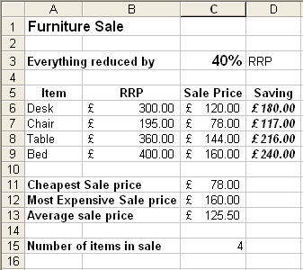
1 Enhance the layout by formatting as required.
2 Use an appropriate function to display today’s date in D2.
3 Rename the worksheet Furniture Sale.
4 Put your name and today’s date in the worksheet footer.
5 Save your worksheet.
6 Take a printout showing formulas, with column and row headings and gridlines displayed (adjust column widths to display complete formula if necessary).
7 Take a printout showing data.

Formatting Text
Formatting allows you to change the appearance of your spreadsheet, perhaps to emphasise particular parts of it, or perhaps to make it look better.
Text Formatting
Text formatting is formatting that affects the text itself, eg bold text, italic text, font, font size (also known as point size) or font colour.
Some of these effects can be added using the toolbars, while all of them can be added using the Format, Cells, Font menu option.
Formatting Toolbar
To apply formatting effects using the toolbar, first select the text you want to apply the effect to and then choose the effect. For bold, italic and underline, simply click the appropriate button to switch it on or off. For the other effects, choose the option you want from the drop-down lists.
Superscript and Subscript
If you want to display text or numbers in smaller than normal text and slightly above or below it (eg in a mathematical expression) you can make use of superscript or subscript. You can turn this off or on from within the Format Font menu option. Notice that it’s a check box under font effects and you will see a preview of what the text would look like applying an effect in the preview pane.
To display a smaller raised number after a letter you would use superscript, eg P³.
Subscript — the opposite of superscript — allows you to place the number lower than normal text, eg P₃.
Remember whenever you turn on a font effect it will remain until you turn it off again. There are other types available like Shadow, Emboss etc.
Alignment
There are four alignment options: left aligns text to the left margin; centre alignment aligns text to both left and right margins, but does not justify the text, so text can be uneven; right alignment justifies text to the right margin; and fully aligned justifies the text so it is even on both sides.
Format, Font Menu Option
To apply formatting effects using the Format, Font menu option, first select the text you want to apply the effect to. Next select the menu option and choose the effects you want to apply. Once you’ve chosen all the effects you want, click OK to apply them to the selected text.
How to Use Formatting Options
To further enhance the appearance of your spreadsheet, you can add borders and shading to parts of it. The Format cells menu option has a number of tabs that will let you choose the number, alignment, border, font and pattern for a single cell or a range of cells.
Adding a Header or Footer
Headers and footers let you add information such as the creation date, page numbers or file name to printed pages of your workbooks. To create a header or footer, select the View, Header and Footer menu option then display the Header/Footer tab. You can select one of the standard headers or footers from the drop-down lists in this tab, or you can use the Custom Header/Custom Footer buttons to create your own. You can also select Headers and Footers from the File, Page Setup option.
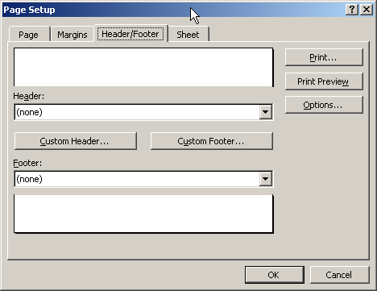

Exercise 8: Formatting Cells
1 Open the workbook Sales Q2 stored in the Sales folder in your WorkStuff folder.
2 Following the instructions below, format all the money values on the sheet to show thousands separated by commas and with two decimal places.
- Select the cell range B4:F13 then choose the Format, Cells menu option.
- Click the Number tab and set the number options as shown below.
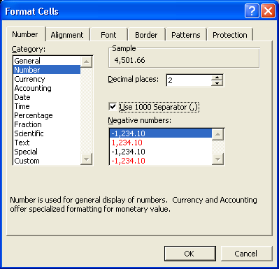
- Click OK.
3 Using Format, Cells, select the Percentage number format so the values in column G are displayed as percentages with two decimal places.
4 Select the headings in B3:E3 and using the Format, Cells, Alignment option, rotate the text to 45 degrees.
5 Click OK to apply this formatting to the selected cells.
6 Using the Format, Cells menu option, centre the heading shown on row 1 as illustrated below:
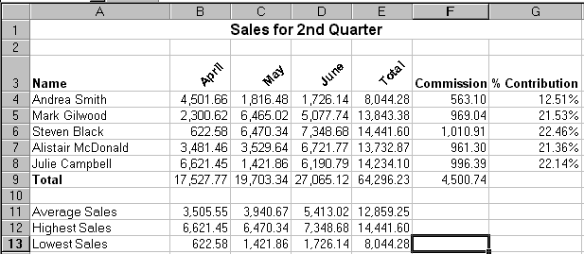
- Select A1:G1.
- Select Format, Cells and click the Alignment tab.
- From the Horizontal drop-down list choose Centre.
- Tick Merge cells and then click OK.
7 Practise using Format, Cells to apply the various formatting options described below.
Cells A4:A8 | Apply a left indent of 1
Cells B9:F9 | Border: thin line top, double line bottom
 | Pattern: light grey background shading
Cells A11:E13 | Border: thick blue line around range
Title | Font: Times New Roman, 20 pt, Bold, Italic

8 Add your name to the footer, then print two copies of this workbook.
9 Save and close the worksheet.

Exercise 9: Using AutoFormat
1 Open the file called Sales Turnover held in the Sales folder in your WorkStuff folder.
2 Follow the instructions below to use AutoFormat to change the appearance of the worksheets.
- Select the range A1:E9.
- Select Format, AutoFormat and choose an AutoFormat layout.
- Click OK and the formatting will be applied to the selected range.
3 Try out one or two of the other AutoFormats until you find one you want to use. Remember you can click the Options button to switch on or off various elements of the AutoFormat.
4 Save and close the workbook.

Previewing and Printing a Workbook
Before printing data from a workbook, you can use Print Preview to check how it’s going to look. When you choose the File, Print Preview menu option you will see the document on the screen exactly as it will appear on paper. If you need to make any last minute changes, you can do so within Print Preview.
To begin, select the File, Print Preview menu option or click the Print Preview button on the toolbar.
If the preview looks okay, click the Print button on the toolbar to display the Print dialogue box and make your selections to print the workbook. You can learn about the Print dialogue box on the next page. You may feel that you need to change the page orientation to landscape (sideways) to enable you to get more of the spreadsheet onto one page. This is done in the printer’s properties settings or if you’re in Print Preview from the Setup button.
If the spreadsheet prints over more than one page, you may want to adjust it to ‘fit on one page’, however it will reduce the size of the font to accommodate it fitting onto one page.
Note: When you return to the workbook after previewing it, a dotted line shows you the right and bottom edges of each printed page.
Inserting Page Breaks
Excel will insert page breaks when you choose to preview or print a worksheet. When the worksheet is too long or too wide to fit on a page, any extra rows and/or columns are moved onto a new page. Page breaks appear as dotted lines on the worksheet.
However, if you decide that the page breaks should be positioned elsewhere, you can insert a manual page break.
To insert a manual page break, move the active cell pointer to the cell where the break is to be inserted (the page break will be inserted above and to the left of the active cell pointer), then select the Insert, Page Break command.
If you need to remove a page break, move the active cell pointer to the cell where the break is and select the Insert, Remove Page Break menu option.
Using Page Break Preview
Use the View, Page Break Preview menu option to see which cells will be printed and where the page breaks are. Cells that will be printed are displayed in white, while cells that are outwith the print range are displayed in grey. You can change the page breaks by dragging them to a new location.
Printing
To print a copy of the current (or active) sheet to the default printer, you simply click the Print button on the toolbar.
If you want to print anything other than all the cells in the current sheet, eg only part of the current sheet, more than one copy, or all the sheets in the workbook, you would use the File, Print menu option.
How to Print in Excel
1 Select the File, Print menu option or press [Ctrl] P.
The Print dialogue box will be displayed
2 If the entire workbook is to be printed, continue and click on OK.
If only part of the worksheet is to be printed, select the required range(s).
If a specific worksheet in the workbook is to be printed in full, ensure that the required worksheet is currently displayed.
Note: If more than one worksheet is to be printed in full, hold down the [Ctrl] key and click each of the required worksheet tabs. The tabs will appear highlighted.
3 Look in the Name box at the top of the dialogue box and ensure that the correct printer has been selected. If not, click the Name drop-down button to display the list of available printers, and select the correct printer.
4 Make the required selections in the other groups in the dialogue box.
- Print range
All: Select the All option to print all pages.
Page(s): Select the Page(s) option and enter values into the From and To text boxes to print a specific set of pages.
- Print what
Selection: Select the Selection option to print the selected range of cells.
Active sheet(s): Select the Active sheet(s) option to print the selected range of sheets.
Entire workbook: Select the Entire workbook option to print the entire workbook.
- Copies
Number of copies: Enter the number of copies required into the Number of copies box.
Collate: Tick the Collate box to print one entire copy of the selection before another copy is printed when you are printing multiple copies.
Note: If you want to see a preview of how the printed selection will look then click the Preview button to display the Print Preview screen.
5 Click OK to start printing.
How to Print Part of a Worksheet
1 Select the cells to be printed.
2 Chose Print from the File menu and click on the Selection option.
3 Click OK.
How to Print Formulas
If you want to print the calculation formulas rather than their results:
1 Select the Tools, Options menu option.
2 Select the View tab.
3 Under the Window options, tick the Formulas box.
4 Click on OK.
When you return to your worksheet, the formulas will be shown in their cells. Now when you print the worksheet, the formulas will be printed.
How to Centre the Worksheet
A worksheet is printed to the left of the page and at the top. It is possible to centre the sheet horizontally, vertically or both.
1 Select Page Setup from the File menu, or click on the Setup button in Print Preview.
2 Click on the Margins tab.
3 In the Centre on page section (at the bottom), check either or both of the Horizontal and Vertical boxes.
4 Click on OK.
How to Print Landscape
The default print setting for your page orientation is portrait. Quite often, a worksheet is wider than it is long and would be better printed in landscape.
1 Select Page Setup from the File menu, or click on the Setup button in Print Preview.
2 Click on the Page tab at the top of the dialogue box.
3 In the Orientation section, check the Landscape option.
4 Click on OK.
How to Print the Worksheet Bigger or Smaller (Scaling)
You may wish to make your worksheet bigger or smaller so that it fits better on a single sheet, especially if parts of your spreadsheet run over onto another page.
1 Select Page Setup from the File menu, or click on the Setup button in Print Preview.
2 Click on the Page tab at the top of the dialogue box.
3 In the Scaling section, use the nudge buttons to change the Adjust to percentage.
4 Click on OK.
How to Repeat Rows at the Top of Printouts
1 From the File menu, select Page Setup.
2 On the Sheet tab, click into the Rows to Repeat at top box.
3 Type in the row numbers you want to repeat (ie 1:1 for the first row or 1:2 for the first two rows) or drag on the required row numbers on the worksheet behind the dialogue box.
4 Click on OK.
The rows should now appear at the top of every page.
How to Print Gridlines
Gridlines are the dotted lines surrounding each cell.
1 If you have Print Preview displayed, click on the Setup button. Otherwise, choose Page Setup from the File menu.
2 Click on the Sheet tab at the top of the box.
3 Click on the Gridlines option to check the box.
4 Click OK.
The gridlines within your data area should now be visible. For instructions on adding your own borders see the section on How to Use Formatting Options.
How to Change Margins by Eye
1 Display the Print Preview.
2 Click on the Margins button at the top of the screen. Dotted lines appear to show the current margin settings.
3 Drag on the dotted margin line until the required change is made.
How to Change Margins by a Specific Figure
1 Display your Page Setup box (either from the File menu or the Print Preview screen).
2 Click on the Margins tab.
3 Type the specific figure you require in the appropriate margin box (or use the nudge buttons).
4 Click on OK.

Exercise 10: Printing Your Workbook
1 Open the workbook Production stored in your main folder.
2 View the document using the Print Preview button shown on the Standard toolbar. You will see that the entire worksheet will be printed on a single landscape page.
3 Close Print Preview.
4 Following the instructions below, insert a page break so that the Production Analysis Across Both Plants information is printed on a separate page.
- Move the active cell pointer to A18.
- Select the Insert, Page Break menu option. The page break is placed above the cell pointer in cell A18.
- Select the View, Page Break Preview menu option so that you can see the breaks more clearly.
- If the Welcome to Page Break Preview dialogue box is displayed, click OK to close it.
- Move the mouse pointer onto the blue page break shown above row 18, then click and drag the page break up one row.
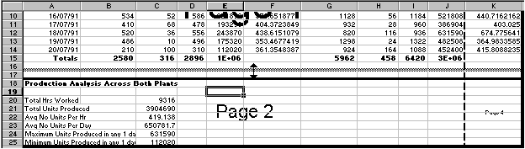
The page break has been moved to row 17.
5 Add your name to the footer of the workbook.
6 Click the Print Preview button on the Standard toolbar to see that rows 1 to 16 are printed on page 1. You can also see your name in the footer area on this page.
7 Click the Next button at the top of the preview window to see page 2, which also contains the footer showing your name.
8 Follow these steps to print one copy of page 2 only.
- Click the Print button at the top of the preview window.
- Make sure the printer you want to use is shown in the Name box at the top of the dialogue box.
- Make sure that Number of copies is 1.
- To print only page 2, enter 2 into the From box and the To box beside Page(s) under Print range.
- Click OK to print your selection.
9 Select the View, Normal menu option to close Page Break Preview and return to the normal view of your workbook.
10 Save the changes you’ve made and close the workbook.

:Exercise 11: Working with Print Options
1 Open the file called Salary Increases held in the Financial folder in your WorkStuff folder.
2 Follow the instructions below to preview your worksheet and use some of Print Preview's features to alter its layout.
- Select the File, Print Preview menu option.
- Click once or twice on the Zoom button shown at the top of the Print Preview screen to increase and reduce the magnification of the displayed page.
- If the margins are not shown, click the Margins button to display them.
- Increase the width of the Increase column by clicking and dragging the column marker shown at the top of the Print Preview window to the right.
- Click the Margins button again to hide the margins.
- Click the Setup button at the top of the preview window.
- Display the Header/Footer settings. At the moment, the header is set to display the name of the workbook centred within the header, and the footer contains a centred page number.
- Click the Custom Header button.
- Click in the Centre section box after &[File] (which is a code for the file name) and press [Enter] once to move the cursor to a new line.
- Click the Worksheet Tab button to add the sheet name to the header.
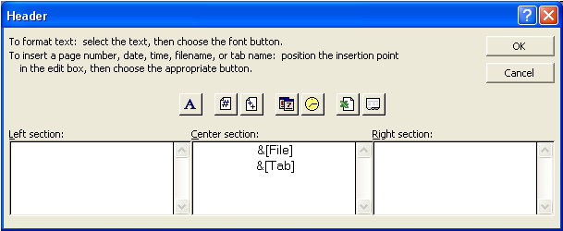
Click the Worksheet Tab button to add the worksheet name to the header.
- Click OK to return to the Header/Footer tab then click the Custom Footer button.
- Click the Date button to add the current date to the Left section box.
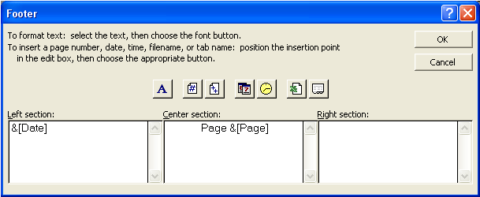
The Date button
- Add your name to the Right section box.
- Click OK and then OK again to return to the preview window.
The information you added to the header and footer is now shown on the preview.
- Check the header and footer are as they should be, zooming in if necessary to read the detail.
3 Follow these steps to print two copies of the workbook:
- Click the Print button in the preview window.
- Enter 2 into the Number of copies box.
- Make sure that the printer you want to use is shown in the Name box under Printer.
- Click OK to start printing.
4 Follow the steps below to display the formulas in the worksheet rather than their results and then print them.
- Select the Tools, Options menu option and display the View settings.
- Under Window options, tick Formulas.
- Click OK to return to your workbook.
- Print one copy of the workbook.
- Select the Tools, Options menu option again and remove the tick from Formulas.
- Click OK to return to the workbook.
- Save and close the file.

Using Functions
Functions are predefined formulas that let you carry out specific calculations. For example, the SUM function allows you to add a range of cells without defining them individually; the AVERAGE function allows you to find the average of a range of values. The AutoSum button that you used earlier inserts a SUM function into your worksheet. There are many functions available in Excel; if necessary, you can find help on functions using the help system.
All functions follow the same format:
=functionname(argument1, argument2, argument3…)
So, for example:
=SUM(B10:B20) | This formula will calculate the total of all the values in the range shown.
=SUM(B10:B20, C10:C20) | This formula will calculate the total of all the values in the ranges shown.
=SUM(B10:B20,10,D19) | This formula will calculate the total of all the values in the range shown plus 10 plus the value in cell D19.
=AVERAGE(B10:B20) | This formula will calculate the average of all the values in the range shown.
=MIN(5,G7,H8) | This will compare the value 5 and the values in cells G7 and H8, and will return the smallest value of the three.
=MAX(5,G7,H8) | This will return the largest value.

Arguments are used to provide the function with data for its calculations. The number and type of arguments needed will vary depending on the function. For example, the ROUND function, which rounds a given value to a specified number of decimal places, has only two arguments (the value to be rounded and the number of decimal places); while the SUM function has as many arguments as necessary, up to the cell size limit. Some functions have no arguments, however you must still include the brackets. An example of this type of function is the TODAY function that returns the current date every time the workbook is opened or printed. This would be typed in a cell as =TODAY()
If you type more than one argument, you must separate them using a comma as shown in the examples above.
Using the SUM Function
As previously mentioned, the SUM function is used to calculate the total value of the contents of a range or ranges of cells. A range of cells is expressed by naming the first cell in the range and the last cell in the range, separating the two references with a : (colon). For example, A1:Z100 includes all the cells in columns A to Z, rows 1 to 100. Therefore, the formula =SUM(A1:Z100) will add together all the values in those cells and show the total in the cell containing the formula.
The formula =SUM(A1:A10,C1:C10) will show the total of all the cell values in the range A1:10 plus those in the range C1:C10.
A SUM function can include values as arguments. In the formula =SUM(A1:A10,10), 10 will be added to the total of the values in the cell range A1:A10.
Using the AVERAGE Function
The AVERAGE function is used to determine the average of a number of values. Like the SUM function, it has an unlimited number of arguments. In this example, =AVERAGE(A1:A10), the result will be the average of the values held in those cells. Like the SUM function, the AVERAGE function can include single cells, cell ranges, and values.
Using the MIN and MAX Function
The MIN and MAX functions find the minimum and maximum values in a set of values. Their syntax is =MIN(arguments) and =MAX(arguments). The arguments may be cell references, constants, or a combination, for which you want to find the smallest or largest value. Both of these functions ignore text, blank cells (not zeros), error values, and logical values.

Spreadsheets Student Workbook — Intermediate

Mathematical Functions
The SUM Function
As previously mentioned, the SUM function is used to calculate the total value of the contents of a range or ranges of cells. A range of cells is expressed by naming the first cell in the range and the last cell in the range, separating the two references with a : (colon). For example, A1:Z100 includes all the cells in columns A to Z, rows 1 to 100. Therefore the formula =SUM(A1:Z100) will add together all the values in those cells and show the total in the cell containing the formula.
The formula =SUM(A1:A10,C1:C10) will show the total of all the cell values in the range A1:10 plus those in the range C1:C10.
A SUM function can include values as arguments. In the formula =SUM(A1:A10,10), 10 will be added to the total of the values in the cell range A1:A10.
The ROUND Function
The ROUND function rounds a given number to a specified number of decimal places and so has only two arguments. For example, the formula =ROUND(13.468,1) returns the result 13.5 by rounding 13.468 to 1 decimal place. The number to be rounded argument can be a number or a cell reference or a calculation, eg =ROUND(15.1254*2,2) returns the result 30.25.
Syntax
=ROUND(number to be rounded, number of digits)
Statistical Functions
The AVERAGE Function
The AVERAGE function is used to determine the average of a number of values. Like the SUM function, it has an unlimited number of arguments. In this example, =AVERAGE(A1:A10), the result will be the average of the values held in those cells. Like the SUM function, the AVERAGE function can include single cells, cell ranges, and values.
The MAX Function
The MAX function returns the highest value from those provided as arguments, and like the SUM and AVERAGE functions, the only limit to the number of arguments is the cell limit.
=MAX(B10:B20) | This formula will return the highest value out of those in the range shown.
=MAX(B10:B20,100) | This formula will return the highest value out of those in the range shown or 100, whichever is highest.
The MIN Function
The MIN function returns the lowest value from those provided as arguments, and like the SUM and AVERAGE functions, the only limit to the number of arguments is the cell limit.
=MIN(B10:B20) | This formula will return the lowest value out of those in the range shown.
=MIN(B10:B20,100) | This formula will return the lowest value out of those in the range shown or 100, whichever is lowest.
The COUNT Function
The COUNT function counts the number of cells that have values in them in the arguments you supply. In the example illustrated below, the COUNT function is used to find how many cells in the range A1:A7 contain values (rather than text entries).
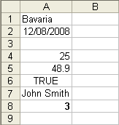
The result of this formula is 3, as cells A2, A4 and A5 all contain values. A1, A3, A6 and A7 contain non-numeric values, blanks or are empty, so they are not counted.
=COUNT(B10:B20) | This formula will return the number of cells containing values out of those in the range shown.

Note: The COUNTA function has the same syntax but returns the number of cells containing any type of entry.
The COUNTIF Function
The COUNTIF function will count the number of cells within a range that meet the given criteria. For example, in the table below we could count the number of cells that say apple, which would equal 3. COUNTIF will return numbers only and works similar to DCOUNT, which is explained later.
Example Table
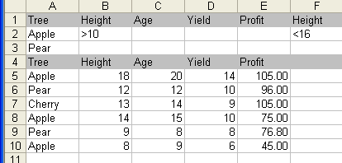

Syntax
COUNTIF(range,criteria)
- Range is the range of cells from which you want to count cells.
- Criteria are in the form of a number, expression or text that defines which cells will be counted. For example, criteria can be expressed as ‘apple’.
Financial Functions
The PMT Function
The PMT function is used to calculate the payments of a loan given the amount of the loan, the interest rate per instalment period (eg monthly, yearly or quarterly) and the number of instalments to be paid.
=PMT(4.25%/12,60,5000) | This formula will return the amount of each monthly instalment on a loan of £5000 at 4.25% per annum over five years (60 months). Notice that the interest rate has been divided by 12 as the rate is an annual one but the payments are made monthly.

The full syntax of the PMT function is:
=PMT(interest rate per instalment period, number of instalments, amount of loan, future value of loan, type)
The future value of loan and type arguments are optional and so don’t have to be supplied unless necessary. Future value of loan allows for an amount to be outstanding at the end of the loan period while type allows you to specify whether payments will be made at the start of each instalment period or at the end. This can make a difference to the amount of interest that you would pay and therefore to the payments.
Date and Time Functions
Date and Time functions allow you to manipulate and display dates and times within your spreadsheet. Excel calculates dates as numbers, so when you specify a date, it is handled like this:
DATE(year, month, day)
Year The year argument can be one to four digits. Microsoft Excel interprets the year argument according to the date system you are using. By default, Excel in Windows uses the 1900 date system; Excel for the Macintosh uses the 1904 date system.
Windows PC 1900 system
- If year is between 0 (zero) and 1899 (inclusive), Excel adds that value to 1900 to calculate the year. For example, DATE(108,1,2) returns January 2, 2008 (1900 + 108).
- If year is between 1900 and 9999 (inclusive), Excel uses that value as the year. For example, DATE(2008,1,2) returns January 2, 2008.
- If year is less than 0 or is 10,000 or greater, Excel returns the #NUM! error value.
Apple Macintosh 1904 System
- If year is between 4 and 1899 (inclusive), Excel adds that value to 1900 to calculate the year. For example, DATE(108,1,2) returns January 2, 2008 (1900 + 108).
- If year is between 1904 and 9999 (inclusive), Excel uses that value as the year. For example, DATE(2008,1,2) returns January 2, 2008.
- If year is less than 4 or is 10,000 or greater, or if year is between 1900 and 1903 (inclusive), Excel returns the #NUM! error value.
Month is a number representing the month of the year. If month is greater than 12, month adds that number of months to the first month in the year specified. For example, DATE(2008,14,2) returns the serial number representing February 2, 2009.
Day is a number representing the day of the month. If day is greater than the number of days in the month specified, day adds that number of days to the first day in the month. For example, DATE(2008,1,35) returns the serial number representing February 4, 2008.
Excel stores dates as sequential serial numbers so they can be used in calculations. By default, January 1, 1900 is serial number 1, and January 1, 2008 is serial number 39448 because it is 39,448 days after January 1, 1900. The DATE function is most useful in formulas where year, month,and day are formulas, not constants.
DATEVALUE converts a date in the form of text to a serial number, eg
=DATEVALUE("23/7/2004")
NOW returns the serial number of the current date and time, eg =NOW()
TIME returns the serial number of a particular time, eg =Time(Hour,Minute,Second)
TODAY returns the current date and needs no arguments, unlike some of the other date and time functions, eg =TODAY()
These are the most common types of date and time functions and are a small selection of the different types of functions you can get for dates and times. Some will require values to be entered, and some will convert the differences between two dates. Access the help files to experiment with these and others you might find.
Logical Functions
The IF Function
The IF function can be used to check whether a specific condition is true or not, returning one result if the condition is true, and another if it's false.
Suppose you want to pay a £50 bonus to all sales staff who have exceeded their £10,000 target. To do this you would check the total sales figures to see who qualifies. If a sales representative’s total sales figure is greater than £10,000, the bonus would be paid. Otherwise, the sales representative doesn’t qualify for the bonus.
An illustration of this example follows.
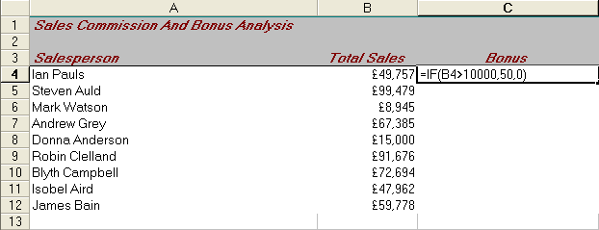
Look at the formula that has been entered into cell C4. The formula is constructed as follows:
=IF(B4>10000, 50, 0)
The results for the example are illustrated below.
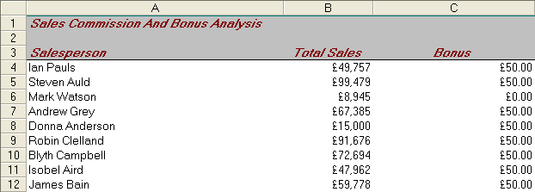
Text Results
Should you want to display text as one or both of the results, you would simply type the text enclosed in " (quotation marks) into the formula like this:
=IF(B4>10000, "Yes", "No")
In this example, the word Yes would be displayed for each sales representative who qualifies for a bonus, and the word No for each sales representative that doesn’t.
You can nest IF statements within each other. For example, say you want to grade student assessments from A to F. If you had the values listed from 40–99, you could say if value >40 and <45, Grade F. Notice the IF statement uses some of the other conditional operators.
Conditional Operators
The previous example uses the > (greater than) operator. The condition within the IF function can incorporate any of the standard operators such as = (equal to), <> (not equal to), <= (less than or equal to), and so on.
The OR Function
The OR function’s syntax is:
=OR(logical1,logical2,...)
This function will return a value of TRUE if one or more arguments (logical1, logical2, and so on) are true. Otherwise, the result will be FALSE. In the example below, the result would be TRUE, as at least one of the arguments is true.
=OR(1+1=2, 2+2=5)
The AND Function
The AND function’s syntax is:
=AND(logical1,logical2,...)
This function will return a value of TRUE if each of the arguments (logical1, logical2, and so on) is true. Otherwise, the result will be FALSE. In the example below, the result would be FALSE, as at least one of the arguments is not true.
=AND(1+1=2, 2+2=5)
The NOT Function
The NOT function’s syntax is:
=NOT(logical)
This function will return a value of TRUE if the argument (logical) is false. Otherwise, the result will be FALSE. In the example below, the result would be TRUE:
=NOT(2+2=5)
Calculating Using Logical Results
The results TRUE and FALSE are stored as 1 and 0 respectively. This means that you can use the results for calculations. You could, for example, calculate the total number of TRUE conditions. You cannot, however, simply add all the TRUE results: you must first multiply them by 1 to return an integer that can be used in the calculation.
Functions that Act on Multiple Values
Functions that act on multiple values typically need three inputs:
Database — is the range of cells that makes up the list or database. A database is a list of related data in which rows of related information are records, and columns of data are fields. The first row of the list contains labels for each column.
Field — indicates which column is used in the function. Field can be given as text with the column label enclosed between double quotation marks, such as “Age” or “Yield”, or as a number that represents the position of the column within the list: 1 for the first column, 2 for the second column, and so on.
Criteria — the range of cells that contains the conditions you specify. You can use any range for the criteria argument, as long as it includes at least one column label and at least one cell below the column label for specifying a condition for the column.
To switch between viewing the results and viewing the formulas that return the results, press [Ctrl]+` (grave accent), or on the Tools menu, point to Formula Auditing, and then click Formula Auditing Mode.
Example Table
Formula | Description (Result)
=DCOUNT(A4:E10,”Age”,A1:F2) | This function looks at the records of apple trees between a height of 10 and 16 feet and counts how many of the Age fields in those records contain numbers. (1)
=DCOUNTA(A4:E10,"Profit",A1:F2) | This function looks at the records of apple trees between a height of 10 and 16 feet and counts how many of the Profit fields in those records are not blank. (1)
=DMAX(A4:E10,"Profit",A1:A3) | The maximum profit of apple and pear trees. (105)
=DMIN(A4:E10,"Profit",A1:B2) | The minimum profit of apple trees over 10 in height. (75)
=DSUM(A4:E10,"Profit",A1:A2) | The total profit from apple trees. (225)
=DSUM(A4:E10,"Profit",A1:F2) | The total profit from apple trees with a height between 10 and 16. (75)
=DPRODUCT(A4:E10,"Yield",A1:B2) | The product of the yields from apple trees with a height greater than 10. (140)
=DAVERAGE(A4:E10,"Yield",A1:B2) | The average yield of apple trees over 10 feet in height. (12)
=DAVERAGE(A4:E10,3,A4:E10) | The average age of all trees in the database. (13)
=DSTDEV(A4:E10,"Yield",A1:A3) | The estimated standard deviation in the yield of apple and pear trees if the data in the database is only a sample of the total orchard population. (2.97)
=DSTDEVP(A4:E10,"Yield",A1:A3) | The true standard deviation in the yield of apple and pear trees if the data in the database is the entire population. (2.65)
=DVAR(A4:E10,"Yield",A1:A3) | The estimated variance in the yield of apple and pear trees if the data in the database is only a sample of the total orchard population. (8.8)
=DVARP(A4:E10,"Yield",A1:A3) | The true variance in the yield of apple and pear trees if the data in the database is the entire orchard population. ( 7.04)
=DGET(A4:E10,"Yield",A1:A3) | Returns the #NUM! error value because more than one record meets the criteria.

Graphics
Inserting Graphics into a Workbook
There are a number of ways you can add graphics to enhance the appearance of your worksheets. The Insert menu contains a number of options that allow you to insert graphics from different sources — some of these are described below.
The Insert, Picture menu gives a selection of picture types for you to choose from. This list includes:
- Microsoft’s Clip Art — a collection of graphics supplied along with the Excel program
- AutoShapes — a variety of ready-made shapes such as arrows, stars and banners
- WordArt — a facility that allows you to add stylised text to your worksheets
- Organisation Chart — a facility that lets you create structured diagrams
Most of the options involve creating a new object, although From File allows you to choose a picture file that already exists on your system.
Note: You can also add charts (or graphs) such as pie charts and bar charts to illustrate your data. You will learn to create these charts in a later part of the course.
Moving and Resizing Graphics
To move a graphic on a worksheet, simply click and drag it to the required location.
To resize an object, first click it once to select it. This will display handles around the object that can be used to change the size and dimensions of the object. These handles look like small blocks around the perimeter of the object.
Note: If you want to retain the original height/width proportions of an object you are resizing, you should use a corner selection handle rather than one of the others. For some object types, you must also hold down the [Shift] key to retain these proportions.
Also, when moving or resizing an object on a worksheet, if you hold down the [Alt] key as you work, the object will snap to borders of cells, allowing you to align the object more precisely.
Graphic File Formats
You can insert many popular graphics file formats into your workbook, either directly or with the use of separate graphics filters. You don’t need a separate graphics filter installed to insert the following graphics file formats:
- The Enhanced Metafile graphics filter (Emfimp32.flt) converts Enhanced Metafiles (.emf) to Windows Metafiles (.wmf). You must have the Enhanced Metafile filter installed to insert an .emf file into a Microsoft Excel workbook as a Microsoft Clip Gallery object or a Microsoft Photo Editor object. However, to insert an .emf file directly into a Microsoft Excel workbook, you don’t need the Windows Metafile filter.
- The Encapsulated PostScript (EPS) graphics filter (Epsimp32.flt) supports the Adobe Systems Encapsulated PostScript Specification versions 3.0 and earlier. The filter supports .eps images from Tagged Image File Format (TIFF) — a high-resolution, tag-based graphics format used for the universal interchange of digital graphics — and Windows Metafile (.wmf) embedded previews.
- The Graphics Interchange Format filter (Gifimp32.flt) supports file format versions GIF87a (including interlacing) and GIF89a (including interlacing and transparency).
- You don’t need the GIF filter to insert animated GIF images into Excel workbooks. When you save a workbook that contains an animated GIF image as a web page, the animation is preserved. You cannot perform certain editing operations — such as cropping or changing the fill, border, or shadow — on an animated GIF image. Make these changes in an animated GIF editing program, and then insert the file again.
- The Joint Photographic Experts Group (JPEG) graphics filter (Jpegim32.flt) supports Version 6.0 of the JPEG File Interchange Format (JFIF). The filter supports cyan-magenta-yellow-black (CMYK) JPEG files. You must have the JPEG filter installed to insert a JPEG file into a Microsoft Excel workbook as a Microsoft Clip Gallery object or a Microsoft Photo Editor object. The JPEG filter is also used to export a single chart to a JPEG file by using Microsoft Visual Basic for Applications. However, to insert a JPEG file directly into a Microsoft Excel workbook, you don’t need the JPEG filter.
- Portable Network Graphics is a graphic file format that is supported by some World Wide Web browsers. PNG supports variable transparency of images (alpha channels) and control of image brightness on different computers (gamma correction). PNG files are compressed bitmaps.
- The Windows Bitmap graphics filter (Bmpimp32.flt) supports Windows and OS/2 bitmaps. You must have the Windows Bitmap filter installed to insert a bitmap file into a Microsoft Excel workbook as a Microsoft Clip Gallery object or a Photo Editor object. However, to insert a bitmap file directly into a Microsoft Excel workbook, you don’t need the Windows Bitmap filter.
- The Windows Metafile graphics filter (Wmfimp32.flt) supports the Windows Metafile format. You must have the Windows Metafile filter installed to insert a Windows Metafile into a Microsoft Excel workbook as a Microsoft Clip Gallery object. However, to insert a Windows Metafile directly into a Microsoft Excel workbook, you don’t need the Windows Metafile filter.
Other graphic types include:
- Corel Draw graphics filter
- Macintosh (PICT) graphics filter.
Use Adequately Sized Images
Readers should be able to view and read your graphics easily. Whether too small or too large, an incorrectly sized image can make your document look messy and may detract from its effectiveness. If an image is too small, readers may struggle to make it out. If the image is too large, it can distract readers from the text as well as increase the file size of the document.
Don’t Include Too Many Images
Including too many images can make your document look cluttered and unorganised, which ultimately detracts from your document’s overall appearance and effectiveness. Try to include only those images that convey key pieces of information or serve a specific purpose.
Copyright, Designs and Patents Act
Whenever you decide to use a logo, image or graphic in your spreadsheet, it is important that you check you are not infringing the copyright of that object. Copyright laws exist to protect the people who created the object and their permission must be sought before you can use any piece of text, reference materials, image, clip art or video clip in your spreadsheet.
The Copyright, Designs and Patents Act gives the creators of literary, dramatic, musical and artistic works the right to control the ways in which their material may be used. The rights cover: broadcast and public performance, copying, adapting, issuing, renting and lending copies to the public. In many cases, the creator will also have the right to be identified as the author and to object to distortions of his work.
Copyright arises when an individual or organisation creates a work, and applies to a work if it is regarded as original, and exhibits a degree of labour, skill or judgement. Interpretation is related to the independent creation rather than the idea behind the creation. For example, your idea for a book would not itself be protected, but the actual content of a book you write would be. In other words, someone else is still entitled to write their own book around the same idea, provided they do not directly copy or adapt yours to do so.
Names, titles, short phrases and colours are not generally considered unique or substantial enough to be covered, but a creation, such as a logo, that combines these elements may be.
Types of Work Covered
1 Literary
Song lyrics, manuscripts, manuals, computer programs, commercial documents, leaflets, newsletters and articles, etc
2 Dramatic
Plays, dance, etc
3 Musical
Recordings and score
4 Artistic
Photography, painting, architecture, technical drawings/diagrams, maps, logos, etc
5 Typographical arrangement of published editions
Magazines, periodicals, etc
6 Sound recordings
May be recordings of works, eg musical and literary
7 Films
Broadcasts and cable programmes
Copyright Notices
It is strongly recommended that you include one on your work. It will:
- announce that copyright exists in the work
- make it clear who is the owner
- deter infringement.
By having a copyright notice you are helping to prevent infringement occurring. For more information on the current Copyright and Patents Act go to: http://www.copyrightservice.co.uk/copyright/uk_law_summary
Because so many images are easily accessible on the internet, you may think you can use any image you see. If you use copyright-protected images within your document, you must also cite the source for each image.
Types of Graphics
When you’re creating art or designs, it’s helpful to know which types of bitmaps or drawn pictures you’re using. Your formatting and editing options will vary, depending on the type of picture you’re working with.
- Bitmap pictures (also called paint-type or raster images) are made from a series of small dots, much like a piece of graph paper with specific squares filled in to form an image. Bitmaps are created with and edited in paint programs, such as Microsoft Paint. All scanned graphics and photographs are bitmaps. When they are resized, they lose definition, and the individual dots that make up the picture become visible. You can change the way colours look in a bitmap picture by adjusting the brightness and contrast, converting colour to black and white or greyscale, or creating transparent areas. To change specific colours in a bitmap, you need to use a photo editing program. Bitmap pictures are often saved with a .bmp, .png, .jpg or .gif extension.
- Drawn pictures (also called vector drawings) are created from lines, curves, rectangles, and other objects. The individual lines can be edited, moved and rearranged. When a drawn picture is resized, the computer redraws the lines and shapes so that they retain their original definition and perspective. Because a drawn picture is made of lines and shapes, you can group and ungroup, reorder, and change the colour of one or all parts of the picture. Drawn pictures are saved in the format of the application that created them. For example, Microsoft Windows Metafiles are saved with a .wmf extension.
Reducing the Picture Size
When you insert a picture with a file size that is greater than a certain threshold, your Microsoft Office program presents you with the option to compress the picture before inserting it. The program automatically selects the type of compression that best suits the type of picture. By compressing the picture’s file size, you will help control the size of the file you are inserting it into. However, the picture might lose some quality.
Finding Clips
The Microsoft Clip Organiser contains drawings, photographs, sounds, videos, and other media files (called clips) that you can insert and use in presentations, publications, and other Microsoft Office documents.
In any Office program, you can find, add, and organise media clips by using the following tools:
- Clip Art Task Pane (Office XP and Office 2003)
- Clip Organiser (not on older versions of Office)
- Office Online (Office XP and Office 2003)
You can search for clips by entering search keywords or phrases in normal, everyday language, for example ‘buildings’ or ‘people at work’. If you find a clip that is close to what you’re looking for, you can find more clips based on a similar artistic style.
If you want to narrow your search, you can specify the clip collections you want to search or ignore, or choose to search only for certain types of media files.
As soon as you start a search, the Clip Art task pane begins listing thumbnail representations of pictures, drawings, photos, sounds, and other media files.
Shapes
Shapes can be resized, rotated, flipped, coloured and combined to make more complex shapes. Many have an adjustment handle (a diamond-shaped handle used to adjust the appearance but not the size of most AutoShapes. — for example you can adjust a rounded rectangle to be more or less rounded) that you can use to change the most prominent feature of a shape, for example you can change the size of the point on an arrow.
AutoShapes (a group of ready-made shapes that includes basic shapes, such as rectangles and circles, plus a variety of lines and connectors, block arrows, flowchart symbols, stars and banners, and callouts) are available on the Drawing toolbar.
To display a toolbar, click Customise on the Tools menu, and then click the Toolbars tab or in older versions go to the View menu and click Toolbars — there will be a long list of different toolbars you can use.
You can add text to shapes. The text you add becomes part of the shape — if you rotate or flip the shape, the text rotates or flips with it.
When you type text directly into an AutoShape or text box, the text is attached to the shape, and you can:
- adjust and position the text within it
- make the text wrap in the shape or place it in the top, bottom or middle of the shape
- change the margins between the text and the edge of the shape
- resize the shape to fit the text precisely.
If the shape is WordArt, you can create shadowed, skewed, rotated and stretched text, as well as text that have been fitted to pre-defined shapes. Text in WordArt does not wrap or need margin settings, because the text is an object.
Depending on the effect you want, you can shadow or emboss text in three different ways:
1 Add a shadow or embossed effect directly to the text. When you use this method, you can’t change such shadow features as offset or colour.
2 Add a shadow or embossed effect to an unfilled object that contains text. With this method, the text takes on the same shadow options as the object, and you can control and change shadow features.
3 Insert WordArt — a drawing object (any graphic you draw or insert which can be changed and enhanced, including AutoShapes, curves, lines and WordArt) that contains special text effects such as shadowing and perspective.
There are three types of connector lines to connect objects — straight, elbow (angled) and curved.
After you choose a connector AutoShape, blue connector sites appear on objects as you move the mouse pointer over them. These points indicate where you can attach a connector line.
When you rearrange objects that are joined with a connector line, the connectors remain attached to the objects and move with the objects. If you move either end of a connector, that end unlocks or detaches from the object. You can then lock it to another connection site on the same object, or you can lock it to another object. Once the connector locks on a connection site, the connector stays connected to the objects, no matter how you move each object.
After you rearrange connected objects, some connectors might need to be rerouted to make the most direct connections and keep connectors from crossing objects.
Changing Drawing Objects or Graphics
There are two ways that you can change the size of a picture — resizing and cropping.
Resizing changes the dimensions of the picture by stretching or shrinking it.
Cropping reduces the size of the picture by removing the vertical or horizontal edges. Cropping is often used to hide or trim a part of a picture, either for emphasis or to remove unwanted portions.
You can also outcrop, which adds a margin around a picture.
You can always restore a resized or a cropped picture to its original size. If you’re certain you won’t want to undo your work, after you crop the picture use the Optimise Pictures feature to delete the cropped parts of the picture from the file completely.
Objects automatically stack in individual layers as you add them. You see the stacking order when objects overlap — the top object covers a portion of objects beneath it.
You can move individual objects or groups (a group can be composed of multiple sets of groups) of objects in a stack. For example, you can move objects up or down within a stack one layer at a time or you can move them to the top or bottom of a stack in one move. You can overlap objects when you draw to create different effects.
When you group objects, you combine them so you can work with them as though they were a single object. You can flip, rotate and resize or scale all objects in a group as a single unit. You can also change the attributes (properties) of all objects in a group at one time. You can ungroup a group of objects at any time and then regroup them later.
Applications for Graphics
You can add graphic objects to embedded charts and chart sheets, and you can also use graphics as data markers.
You can make graphics and buttons ‘hot’ by using them as hyperlinks. When you click the graphic, you go to a specified location in the current document or web page, to a different Microsoft Excel workbook or web page, or to a file that was created in a different program. For example, you can insert a graphic that represents your company’s stock symbol and then use it as a hyperlink to go to a page that contains your company’s current stock prices.
You can assign a macro to run when you click a graphic or button. You can even use graphics on worksheets to create an integrated workbook interface for your automated program. For example, you can create a graphic that represents a calculator and assign a macro to it that finds and displays the current monthly budget for your company.
How to Insert a Picture from a File
1 Click the worksheet where you want to insert the picture.
2 On the Insert menu, under the Picture option, click From File.
3 In the Insert Picture dialogue box, locate the folder that contains the picture you want to insert, and then click the picture file.
4 Click Insert to embed the picture in the worksheet.
How to Insert a Graphic in a Header or Footer
1 On the View menu, click Header and Footer.
2 Click Custom Header or Custom Footer.
3 Click in the Left section, Centre section or Right section box.
4 On the row of buttons in the Header or Footer dialogue box, click Insert Picture and then find the graphic you want to insert.
5 Double-click the graphic to insert it in the header or footer section box.
6 If you want, do one or more of the following:
- To make changes to the graphic, click Format Picture on the row of buttons in the Header or Footer dialogue box.
- To replace a graphic, select &[Picture], click Insert Picture, and then click Replace.
- To start a new line in one of the section boxes, press [Enter].
Note: To delete a graphic, select &[Picture] and then press [Delete].
Charts
Worksheet Data
To create a chart, you must first select the range containing the data that is to be shown on it.
The following pages explain how Excel interprets the data when generating the chart.
Chart Elements
Note: When you rest your mouse pointer on any part of a chart, a tip will be displayed telling you what that part is called.
Chart Title
A title can be shown at any position on the chart. You can increase or decrease the size of the font, and add lines and shading to the title if you need to.
Plot Area
The plot area is the area of the chart on which the data series (column/bars etc) are displayed. You can add lines, referred to as gridlines, to the plot area to help the user read the value of the data series from the value axis. A colour and/or a pattern can be added to the plot area.
X-axis
The X-axis displays the names of the categories being shown on the chart. When creating a chart, Excel will take the category names from the data you’ve selected. It’s always assumed that there are more categories than data series, therefore if you select a range that has more columns than rows, the column headings will be used as the X-axis category labels and the row headings will appear in the legend to describe each data series.
A title can be added to the X-axis to give more information about the category names. Both the axis title and the category labels can be customised by changing the font size and style used.
Y-axis and Z-axis
You’ll find the Y-axis in a different position on the chart depending on whether the chart uses a 2-D or a 3-D style. On a 2-D chart, the Y-axis is the vertical value axis against which the data series are plotted. The scale of this axis will be decided by the values to be plotted and the physical size of the chart. A title can be added to the Y-axis on a 2-D chart to describe what the values represent.
A 3-D chart, however, shows the Y-axis marking the floor of the chart and the Z-axis is the vertical value axis.
Data Series
The appearance of the data series on any chart will depend on the type of chart chosen. For example, on a column chart, the data series are shown as columns; on a line chart, the data series are shown as points joined by lines; and on a pie chart, the data series are shown as segments. These segments can be grouped together or separated (this is often known as an exploded pie chart).
You can change the colour applied to each of the data series and apply labels such as percentages on a pie chart or values on a column chart.
Legend
The legend is the key to the chart, showing the user which data series is which by identifying the colour and/or pattern used for each. You can choose to display or hide the legend, move it to another position on the chart and customise its appearance by changing the font size and style that it uses.
Chart Area
You can apply a colour and/or pattern to the chart area. You can also choose the style of border to be used, for example a simple or a shadowed box.
Chart Types
Excel’s charting facility allows you to produce quality presentation charts quickly and easily. The charts can then be customised using a variety of chart styles and formatting effects to help show your data in an effective and interesting way.
All charts are generated by Excel from worksheet data and can be placed on the worksheet containing data or onto a separate page of their own in the current workbook. If the chart is added to the worksheet containing the data, you have the option of printing the chart with the related worksheet data or independently on a separate page. Simply select the chart before you choose the File, Print Preview or File, Print command if you wish the chart to print independently.
Alternatively, to print the chart and the related values on the same page, ensure the chart is not selected when you choose the File, Print Preview or File, Print command and you will be able to print the worksheet like any other. If you insert the chart as a separate worksheet within the current workbook, it can only be printed as an independent page.
The chart is linked to the data that you use to create it, so if you change any of the data, the chart will be updated to match.
There are 15 basic chart types to choose from. When creating a chart, you should choose the chart type that best illustrates the values you are presenting. For example, pie charts are useful when showing percentages and there is only one data series (for example, comparing the amount of time you spend on the websites you visit most often) or when you want to display the contribution of each value to a total.
Line and area charts are useful when illustrating values that change over time (such as the amount of money you earn by doing chores from month to month). A chart that is added to a worksheet with other data is called an embedded chart.
When you create a chart, the Chart Wizard guides you through the creation process, asking a number of simple questions such as which chart type is to be used and whether or not a legend (key) is required. By answering these questions you can create a chart to match your own requirements.
How to Create Charts
1 Select the range that is to be shown on the chart, ensuring that no blank rows or columns are included in the selection. Include the values and surrounding text labels that have to be shown on the chart.
Note: The values that should be shown on the chart might not appear together on the chart. For example, if you have a table of values but want to create a chart from the column headings and just one row, you would select the headings and then, holding down the [Ctrl] key, select the row of values.
2 Select the Insert, Chart menu option or click the Chart Wizard button shown on the toolbar. The Chart Wizard dialogue box will be displayed.
3 Select the chart type to be used and choose a sub-type from those shown.
Note: If you want help while using the Chart Wizard, click the Yes, provide help option button on the Office Assistant balloon that's displayed.
If you want to see what your data will look like as the chart type you’ve chosen, click and hold down the Press and hold to view sample button shown on the Standard Types property sheet.
4 When you’ve chosen a chart type and sub-type, click the Next button. The second step of the Chart Wizard will be displayed and the Data Range property sheet is shown.
5 To begin with, each row from your data will be shown in the legend unless there are more rows than columns, in which case each column will appear in the legend. If you want to change the way the data has been shown, click the appropriate option button.
6 Click the Next button to move on.
7 Use this dialogue box to add titles to your chart and its axes, specify if and where the legend should be shown and to change other settings.
Tip! Always type a chart title and a label for the X and Y (or Z) axes.
8 When you’ve finished, click Next to move on again.
9 Choose whether you want to place the chart on the same sheet as the values used to create it, or as a new chart sheet, in which case the entire sheet will be taken up by the chart.
10 Click Finish to display the chart.
Changing the Chart Type
You can change the chart type as previously described using the Chart Wizard. Alternatively, use the Chart menu or the shortcut menu and choose Chart Type.
Working with Data Series
When you first create a chart you specify the worksheet data that is to be used. It may be that you want to add or remove a data series at some time.
How to Add a Data Series
To add a data series to a chart, right-click the chart area and choose Source Data from the shortcut menu. Display the Series setting in this dialogue box to see the individual series and the related cells on the chart.
1 To add a new series, click the Add button.
2 Click in the Name box then click the cell in the worksheet that contains the series name for the new data series.
3 Click in the Values box in the dialogue box and delete any text that’s already there.
4 Click and drag over the values to be plotted on the chart.
5 Click OK to update the chart to show this series.
Removing a Data Series
To remove a data series, highlight it in the Source Data dialogue box then click the Remove button. Click OK to update the chart.
Creating Picture Charts
Graphics can be used in Excel to display the data series as pictures. The pictures can be imported using the Edit, Copy and Edit, Paste commands, or they can be inserted using the Insert, Picture menu option.
If the picture has been created and saved using a drawing application, you should insert it using the Insert, Picture menu option. Excel can recognise files in a variety of different formats including .drw, .tif, .wmf and .bmp.
The first step is to create a basic 2-D bar, column, line, radar or XY scatter chart. However, the best type of chart to use is either a bar or column chart. Once the chart has been created, you can insert a different graphic file for each of the data series.
Deleting Pictures from a Chart
Delete a picture from a chart by clicking the picture and then selecting the Edit, Clear, Formats command.
Stacking and Scaling Pictures
When you first add a picture, the data series is represented by a single graphic scaled to match the size of the data series. Using the Format Data Series option, you can specify how many units in the data series are to be assigned to a picture. You could, for example, specify that there should be one picture for every two units. These pictures are then stacked one on top of the other to represent the series. You can scale and stack using the Patterns tab when you format the data series. The Fill Effects button in that dialogue box gives you access to these settings.
What Are Trendlines?
Trendlines are used to graphically display trends in data and to analyse problems of prediction. Such analysis is also called regression analysis. By using regression analysis, you can extend trendlines in a chart beyond the actual data to predict future values.
If you ever need to make projections of trends into the future, trendlines provide a powerful, visual solution for you. Not only are the trends illustrated for your audience to see, but you can also choose from seven types of trends and see the R-squared value for each, which indicates how accurate the trend line is. By selecting each of the seven types of trends, you can choose the one that statistically is a ‘best fit’ with your data.
Chart Types that Support Trendlines
You can add trendlines to data series in:
- unstacked 2-D area
- bar
- column
- line
- stock
- xy (scatter)
- bubble charts.
You cannot add trendlines to data series in 3-D, stacked, radar, pie, surface or doughnut charts. If you change a chart or data series so that it can no longer support the associated trendline (for example, by changing the chart type to a 3-D chart or by changing the view of a PivotChart report or associated PivotTable report) you lose the trendlines.
How to Project Trends Using a Chart
To create a trend line, follow these steps.
1 Select the cells that contain the series you want to project.
2 Click the Chart Wizard button on the standard toolbar, and create a chart as before. A line chart is often a good type to choose when displaying trend lines.
3 With the chart created, choose Add Trendline from the Chart menu.
4 Choose the type of trend line in the Trend/Regression Type group.
5 To see the R-squared value, check Display R-Squared Value On Chart on the Options tab.
6 Choose the number of periods you want to forecast your trend into in the Forward and Backward boxes.
7 Click OK to see the trend line on your chart.
You can repeat steps 3 through 7 to add additional trend lines. The one with the R-squared value closest to 1 is the trend line that is statistically most significant.
Creating Line Data without a Chart
Use AutoFill or one of the statistical functions such as GROWTH() or TREND() to create data for best-fit linear or exponential lines. When you want to add a trendline to a chart in Microsoft Excel, you can choose any of the six different trend/regression types. The type of data you have determines the type of trendline you should use.
Trendline Reliability
A trendline is most reliable when its R-squared value is at or near 1. When you fit a trendline to your data, Excel automatically calculates its R-squared value. If you want, you can display this value on your chart.
Types of Trendlines
- Linear — A linear trendline is a best-fit straight line that is used with simple linear data sets. Your data is linear if the pattern in its data points resembles a line. A linear trendline usually shows that something is increasing or decreasing at a steady rate.
- Logarithmic — A logarithmic trendline is a best-fit curved line that is used when the rate of change in the data increases or decreases quickly and then levels out. A logarithmic trendline can use negative and/or positive values.
- Polynomial — A polynomial trendline is a curved line that is used when data fluctuates. It is useful, for example, for analysing gains and losses over a large data set. The order of the polynomial can be determined by the number of fluctuations in the data or by how many bends (hills and valleys) appear in the curve. An Order 2 polynomial trendline generally has only one hill or valley. Order 3 generally has one or two hills or valleys. Order 4 generally has up to three.
- Power — A power trendline is a curved line that is used with data sets that compare measurements that increase at a specific rate, for example the acceleration of a race car at one-second intervals. You cannot create a power trendline if your data contains zero or negative values.
- Exponential — An exponential trendline is a curved line that is used when data values rise or fall at increasingly higher rates. You cannot create an exponential trendline if your data contains zero or negative values.
- Moving Average — A moving average trendline smoothes out fluctuations in data to show a pattern or trend more clearly. A moving average uses a specific number of data points (set by the Period option), averages them, and uses the average value as a point in the line.
If Period is set to 2, for example, then the average of the first two data points is used as the first point in the moving average trendline. The average of the second and third data points is used as the second point in the trendline, and so on.
Projecting Trends with Data
You might have a range of data and need to make a projection. For instance, in creating a projected profit and loss for next year you want to estimate revenue based on projected sales. In this case, you have to project the trend that your data is displaying using Excel.
You can create a linear series trend that generates a ‘best fit’ straight-line projection, or a growth trend, which extends an exponential projection into the future. The growth trend predicts the growth based on existing data.
How to Create Linear and Growth Trends with the Series Command
Select the cell where you want to start the series. The cell must contain the first value in the series. When you use the Series command, the resulting series replaces the original selected values. If you want to save the original values, copy them to a different row or column and then create the series by selecting the copied values.
1 On the Edit menu, point to Fill, and then click Series.
2 Do one of the following:
- To fill the series down the page, click Columns.
- To fill the series across the page, click Rows.
3 In the Step value box, enter the value that you want to increase the series by.
Series type | Step value result
Linear | The step value is added to the first starting value and then added to each subsequent value.
Growth | The first starting value is multiplied by the step value. The resulting product and each subsequent product is then multiplied by the step value.

4 Under Type, click Linear or Growth.
5 In the Stop value box, enter the value you want to stop the series at.
A simple way to create a trend is as follows.
1 Select the adjacent cells that contain the data on which the trend will be based.
2 Right-click the fill handle, and drag it through the number of cells you want to make projections into.
3 In the resulting shortcut menu, choose Linear Trend or Growth Trend. The existing data is unchanged, and the selected cells are filled with the appropriate type of projected data.
4 Alternatively, if you want to replace the existing data to fit the trend line, choose Series in the shortcut menu. Then, in the Series dialogue box, check Trend, choose Linear or Growth, and click OK.
Caution
Before creating a linear or growth series, copy your existing data to a nearby row or column so you do not lose it when you create the series. The start value will be the first figure in the series and the stop value will be the last figure in the series.
This simple way of creating trends will meet most people’s needs for a quick projection of future values.
Modifying Charts
You can make many changes to the appearance of a chart by clicking it once and then clicking the Chart Wizard button to display the Chart Wizard options again. This allows you to go through the same options as when you were creating the chart. Alternatively, you can make individual changes using the Chart menu or by double-clicking the part of the chart you want to change. Some of these options are described below.
Changing Titles on a Chart
To change the title you gave a chart, you can edit it by clicking it once then clicking it once again. This is not a double click, but two single clicks. You can then make whatever changes you need to in the same way as you change cell entries.
Formatting a Chart
If you want to change the way any part of the chart looks, you can simply point to it and double-click. This will show a dialogue box with formatting options for that part of the chart. So if, for instance, you want to change the colour of the labels on the X-axis, you would point to one of them and double-click. You can then change the colour of the text in the dialogue box that’s displayed.
Changing the Chart Type
You can change the chart type as previously described using the Chart Wizard. Alternatively, use the Chart menu or the shortcut menu and choose Chart Type.
Moving and Deleting Charts
You can move a chart to another position on the worksheet by clicking and dragging it to its new location.
To delete a chart, click it once and then press [Delete] on your keyboard.

: Exercise 12: Creating Charts
1 Open the workbook Forest Devastation stored in your main folder.
In this exercise, you’ll create charts based on some of the information in this workbook.
2 Follow the steps below to create this chart:
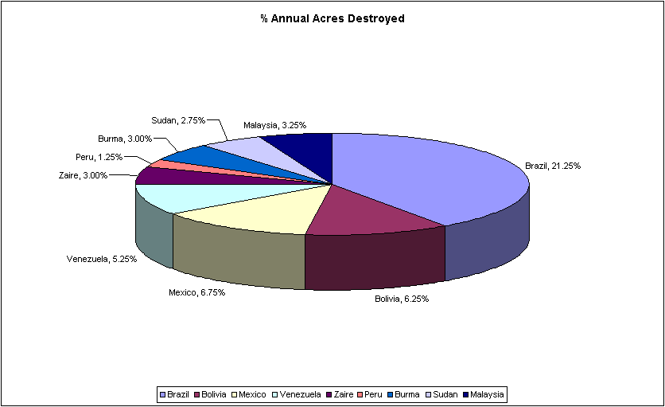
- Select the ranges A9:A18 and C9:C18. Remember you can select separate ranges by selecting the first one, then holding down [Ctrl] while you drag over the next. The first range here will be used for the legend text and the second holds the data to be plotted on the chart.
- Click the Chart Wizard button on the Standard toolbar.
- In the first step box, choose a Pie chart with a 3-D sub-type.
- Click the Next button to move on.
- As the settings for the data series are how you want them in the second step, click Next again.
- Change the chart title to % Annual Acres Destroyed then display the Legend settings.
- Display the legend at the bottom of the chart.
- Display the Data Labels settings and change them to show the Category name and Value.
- Click Next to move on.
- Select to create the chart as a new sheet, then click Finish to create the chart.
A new worksheet called Chart1 is added to the workbook. The chart fills the entire sheet and the Chart toolbar is displayed.
3 Add your name to the chart:
- Click the Text Box tool on the Drawing toolbar (if this toolbar isn’t displayed, select the View, Toolbars menu option and click it to display it).
- Click in a blank part of the chart and type your name.
4 Print the chart only.
5 Save and close the workbook.

:Exercise 13: Amending Charts
1 Open the workbook Forest Devastation with Chart stored in your main folder. This workbook is the same as the completed workbook from the previous exercise.
2 Follow the steps below to make some changes to the chart.
- Make sure the Chart1 worksheet is displayed. First you’ll change the colour used for some of the data series. To do this, you double-click a portion of the pie to display the Format Data Point dialogue box (a data point is one value from a data series).
- First click any part of the pie once to select the data series and then click the portion representing Brazil. Now double-click Brazil.
- Choose a pale green colour for this data point then click OK.
- Change the colours used for Bolivia and Malaysia.
Now you’ll format the data labels surrounding the pie so that they’re shown in bold type.
- Point to any of the data labels and double-click to display the Format Data Labels dialogue box.
- Choose Bold from the Font style list on the Font tab then click OK.
Note: You could have made these bold by clicking any one of them and then clicking the Bold button on the Formatting toolbar or pressing [Ctrl] B on the keyboard.
Finally, to draw attention to the Brazil portion of the pie, you’ll ‘explode’ that part.
- Point to any part of the pie and click once to select the entire data series, then click the Brazil portion to select this data point. The black selection handles should now appear around this portion only.
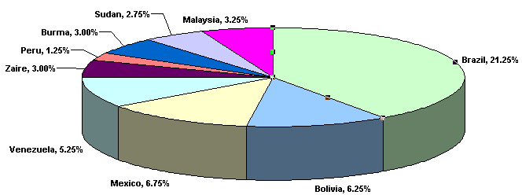
- Now point to the Brazil portion and click and drag it away from the centre of the pie.
Note: If you click and drag while the entire data series is selected, all portions of the pie will be drawn apart from the others.
3 Change the name on the chart to your name, then print one copy of the chart only.
4 Save and close the workbook.

Spreadsheets Student Workbook — Advanced
File Protection
Microsoft Excel provides several layers of security and protection to control who can access and change your Excel data.
- Password protection can restrict access to the workbook, worksheet or part of a worksheet. Passwords can be up to 255 characters long, and you can use letters, numbers, spaces or symbols, but remember if you use uppercase and lowercase letters to type them correctly.
- For additional protection of specific data you can protect certain workbook elements, with or without a password. Use element protection to help prevent anyone from accidentally or deliberately changing, moving or deleting important data.
Securing a Workbook File with a Password
Password security at the workbook file level uses advanced encryption (a standard method of securing the content of a file) to help protect your workbook from unauthorised access. A password can be set on the Security tab of the Options dialogue box (Tools menu, Options command).
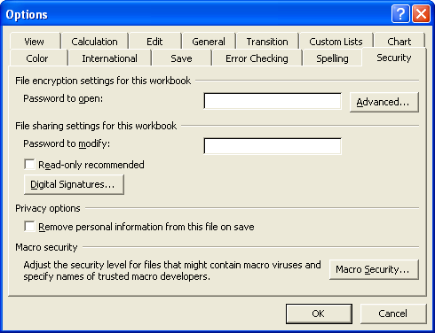
You can specify two separate passwords that users must type to:
- open and view the file
This password is encrypted to help protect your data from unauthorised access.
- modify the file
This password is not encrypted and is only meant to give specific users permission to edit workbook data and save changes to the file.
These passwords apply to the entire workbook file.
Protecting Specific Worksheet or Workbook Elements with a Password
When you share a spreadsheet so that others can collaborate on the data, you can prevent any user from making changes to specific worksheet or workbook elements by protecting parts of the file. You can also specify a password to allow individual users to modify specific elements.
When you protect a worksheet, all cells on the worksheet are locked by default, and users cannot make any changes to a locked cell.
You can, however, specify which elements users will be allowed to change when you protect the worksheet. To protect a worksheet, point to Protection on the Tools menu, and then click Protect Sheet. You can control access to individual worksheet or chart sheet elements by selecting or clearing the following check boxes.
It is important to note that password protection will only work inside the spreadsheet and other methods of protection must be used if transmitting the file to others over the network, like encrypting the data transmission. Encryption allows the data to be sent securely over a network, because without the encryption key the person who intercepts the e-mail cannot access the file.
Worksheet Options
Check box | Action when check box is selected
Select locked cells | Allows user to move the pointer to cells which are locked, ie the Locked check box is selected on the Protection tab of the Format Cells dialogue box. By default, users are allowed to select locked cells.
Select unlocked cells | Allows user to move the pointer to cells which are unlocked, ie the Locked check box is cleared on the Protection tab of the Format Cells dialogue box. By default, users are allowed to select unlocked cells, and they can press the [Tab] key to move between the unlocked cells on a protected worksheet.
Format cells | Allows user to change any of the options in the Format Cells or Conditional Formatting dialogue boxes. If you applied conditional formats before you protected the worksheet, the formatting continues to change when a user enters a value that satisfies a different condition.
Format columns | Allows user to use any of the commands on the Column submenu of the Format menu, including changing column width or hiding columns.
Format rows | Using any of the commands on the Row submenu of the Format menu, including changing row height or hiding rows.
Insert columns | Allows user to insert columns.
Insert rows | Allows user to inserting rows.
Insert hyperlinks | Allows user to insert new hyperlinks.
Delete columns | Allows user to delete columns. Note that if Delete columns is protected and Insert columns is not also protected, a user can insert columns that he or she cannot delete.
Delete rows | Allows user to delete rows. Note that if Delete rows is protected and Insert rows is not also protected, a user can insert rows that he or she cannot delete.
Sort | Allows user to use any of the Sort commands on the Data menu, or the Sort buttons on the Standard toolbar. Users can't sort ranges that contain locked cells on a protected worksheet, regardless of this setting.
Use AutoFilter | Allows user to use the drop-down arrows to change the filter on an AutoFiltered range. Users cannot create or remove AutoFiltered ranges on a protected worksheet, regardless of this setting.
Use PivotTable reports | Allows user to modify PivotTable reports.
Edit objects | Making changes to graphic objects (including maps, embedded charts, shapes, text boxes and controls) that you did not unlock before you protected the worksheet. For example, if a worksheet has a button that runs a macro, you can click the button to run the macro, but you cannot delete the button.  Making any changes, such as formatting, to an embedded chart. The chart continues to be updated when you change its source data.  Adding or editing comments.
Edit scenarios | Viewing scenarios (a set of input values that you can substitute in a worksheet model). Users can change the values in the changing cells, if the cells are not protected, and add new scenarios.

Chart Sheet Options
Check box | Action when check box is selected
Contents | Allows user to make changes to items that are part of the chart, such as data series, axes and legends. The chart continues to reflect changes made to its source data.
Objects | Allows users to make changes to graphic objects (including shapes, text boxes and controls) unless you unlock the objects before you protect the chart sheet.

Before you protect a worksheet, you can unlock the ranges that you want users to be able to change or enter data in. You can:
- unlock cells for all users on the Protection tab of the Format Cells dialogue box (Format menu, Cells command)
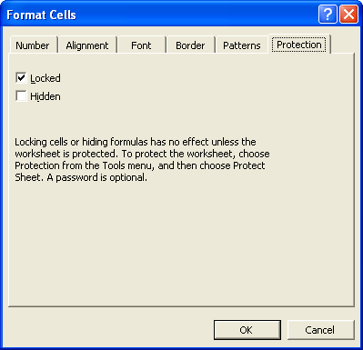
- unlock cells for specific users in the Allow Users to Edit Ranges dialogue box (Tools menu, Protection submenu, Allow Users to Edit Ranges command).
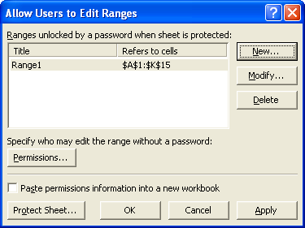
Users you specify in the Permissions for range dialogue box (Permissions button) can automatically edit the range without entering the password. All other users are prompted for the password when they want to edit the range.
Note: It is very important that you remember the password that you set. Without the password, there is no way to unprotect the workbook or worksheet.
Protecting the Workbook Structure
You can lock the structure of a workbook, which prevents users from adding or deleting worksheets or from displaying hidden worksheets. You can also prevent users from changing the size or position of worksheet windows. Workbook structure and window protection applies to the entire workbook.
To protect a workbook, point to Protection on the Tools menu, and then click Protect Workbook.
You can choose which elements you want to protect (workbook structure, windows, or both) by selecting or clearing the check boxes.
To hide an entire workbook so that users cannot see it but can gain access to contents such as macros (a macro is an action or a set of actions you can use to automate tasks — macros are recorded in the Visual Basic for Applications programming language), use the Hide command on the Window menu, and then save the hidden workbook.
1 Switch to the worksheet you want to protect.
2 Unlock any cells you want users to be able to change: select each cell or range, click Cells on the Format menu, click the Protection tab, and then clear the Locked check box.
3 Hide any formulas that you don’t want to be visible: select the cells with the formulas, click Cells on the Format menu, click the Protection tab, and then select the Hidden check box.
4 Unlock any graphic objects you want users to be able to change.
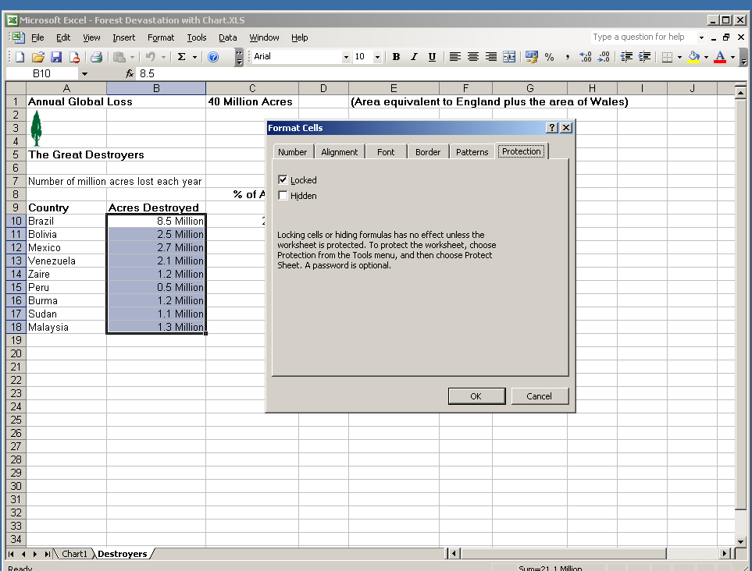
Note the two choices: locked or hidden for the range of cells highlighted
You don’t need to unlock buttons or controls for users to be able to click and use them. You can unlock embedded charts, text boxes, and other objects created with the drawing tools that you want users to be able to modify, and users can add other embedded charts to existing worksheets. To see which elements on a worksheet are graphic objects, click Go To on the Edit menu, click Special, and then click Objects.
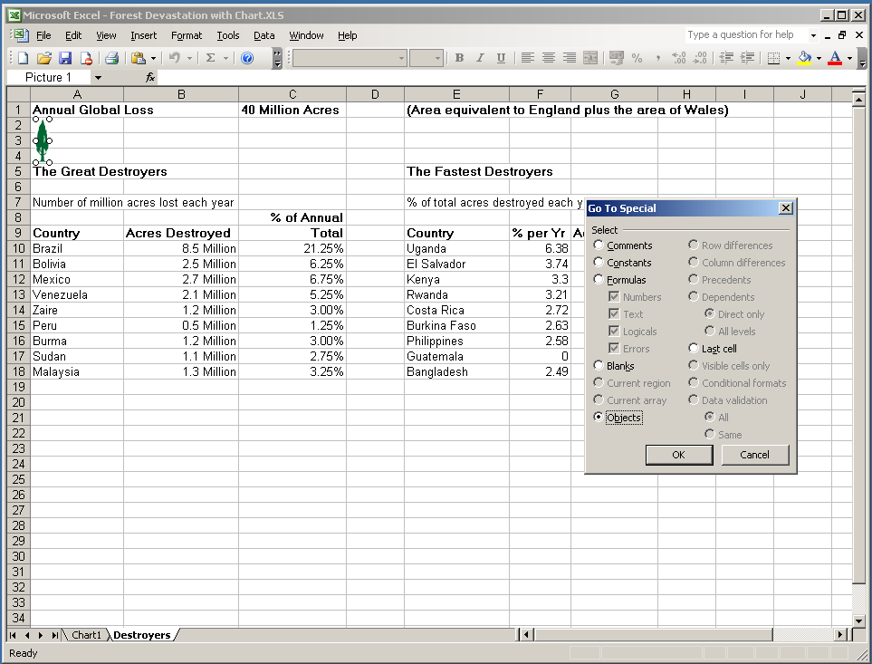
Notice when you select objects it identifies the graphic in the top left corner of the worksheet.
1 Hold down [Ctrl] and click each object that you want to unlock.
2 On the Format menu, click the command for the object you selected: AutoShape, Object, Text Box, Picture, Control or WordArt.
3 Click the Protection tab.
4 Clear the Locked check box and, if present, clear the Lock text check box.
5 On the Tools menu, point to Protection, and then click Protect Sheet.
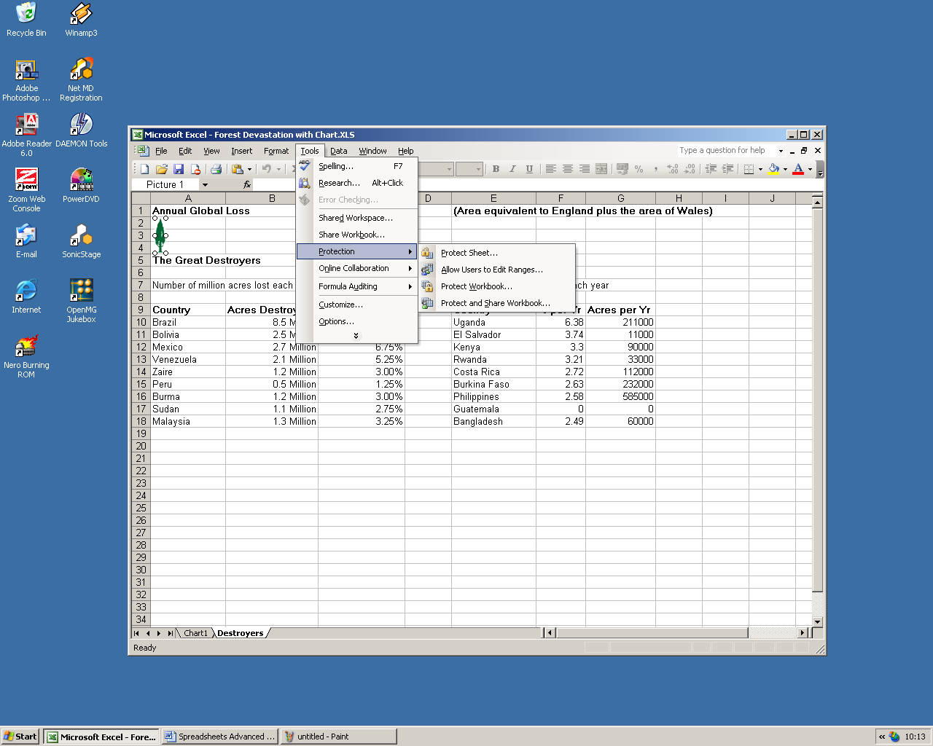
6 Type a password for the sheet.
Note: The password is optional; however, if you don’t supply a password, any user will be able to unprotect the sheet and change the protected elements. Make sure you choose a password you can remember, because if you lose the password, you cannot gain access to the protected elements on the worksheet.
7 In the Allow all users of this worksheet to list, select the elements that you want users to be able to change.
8 Click OK; if prompted, retype the password.

:Exercise 14: Applying File Protection
1 In an Excel worksheet, each cell in a worksheet can be either locked or unlocked. Which feature must be invoked before the effect of these two states becomes apparent?
___________________________________________________________
___________________________________________________________
2 In addition to formatting a cell to be locked/unlocked, hidden status can also be toggled. What effect does this formatting option have?
___________________________________________________________
___________________________________________________________
3 Why might the owner of a worksheet want to invoke either of the above if other users are working on the worksheet?
- Locked status
___________________________________________________________
___________________________________________________________
- Hidden status
___________________________________________________________
___________________________________________________________
4 What steps must be taken to activate the locked and/or hidden formatting options?
___________________________________________________________
___________________________________________________________
5 Why would it be prudent to add password protection to this option?
___________________________________________________________
___________________________________________________________
6 In addition to protecting a worksheet using the above techniques, workbooks can also be protected so that only those with appropriate permissions can open/edit them. How can you restrict access to a workbook by protecting it?
___________________________________________________________
___________________________________________________________
- What options are available when you protect a workbook in this way?
___________________________________________________________
___________________________________________________________

Creating Spreadsheet Templates
To create new workbooks that already have your preferred formatting, you can base the new workbooks on a template. You can create templates for workbooks and worksheets. The default template for workbooks is called Book.xlt. The default template for worksheets is called Sheet.xlt.
A template can include formatting and styles (such as font, font size and indentation) that you name and store as a set. When you apply a style, all of the formatting instructions in that style are applied at one time.
Creating a Default Workbook Template
You can create a default workbook template by clicking New. Workbooks are based on the default template. The default template for workbooks is called Book.xlt. It defines the formatting or content of the new workbooks that open when you start Excel and it is saved in the XLStart folder.
You can create additional custom workbook templates designed for specific tasks and projects.
Creating a Default Worksheet Template
You can create a default sheet template. This template defines the formatting and content of the default worksheets you insert with the Worksheet command (Insert menu). The default template for worksheets is called Sheet.xlt. Excel uses the template to create a blank worksheet when you add a new worksheet to a workbook and it is saved in the XLStart folder.
Storing Default Workbook and Worksheet Templates
If you’ve created a template named Book.xlt or Sheet.xlt and saved it in the XLStart folder, Microsoft Excel uses the template to create new default workbooks (the default start-up workbook is displayed only if you haven’t included other workbooks in the XLStart folder) or to insert new worksheets. The XLStart folder is usually located at:
C:\Program Files\Microsoft Office\Office11\XLStart
You can make a custom template available to others by storing the template on a network location. You make a special area for these ‘workgroup templates’ as they are used specifically for workgroup tasks. For example, you might want all users in your workgroup to use a custom template for a special project. Place the template in a folder in a network location that is accessible to all users in your group.
Settings Saved in a Template
Formatting
- Cell and sheet formats (set by using the commands on the Format menu)
- Page formats and print area settings for each sheet
- Cell styles
- The number and type of sheets in a workbook
- Protected and hidden areas of the workbook (you can hide sheets, rows and columns, and prevent changes to worksheet cells)
Text, Data, Graphics and Formulas
- Text you want to repeat, such as page headers and row and column labels
- Data, graphics, formulas, charts, and other information
- Data validation settings — these include things like restricting data entry to a certain range of dates, limiting choices by using a list, or making sure that only positive whole numbers are entered
Toolbars, Automation and Option Settings
- Custom toolbars, macros and ActiveX controls on forms (ActiveX controls are controls such as a check box or button that offers options to users or runs macros or scripts that automate a task)
- Workbook calculation options and window view options (set with the Options command on the Tools menu)
Data Validation
The first step in applying validation to your cells is to select the cells you want to create the validation for. It should be noted that you can select multiple cells and apply the validation to multiple cells at the one time.
Once you have selected the cells you want to apply validation to, select the Data menu and from the drop-down menu choose the Validation command. This command will open the Data Validation dialogue box. From here you can now choose which type of data your cell should accept.
Data validation is an important area to implement when you are developing an Excel spreadsheet for use by others. The data validation rules play two important roles:
- They prevent the user from accidentally putting the wrong value into your cell.
- They ensure that the entered data is within the range you anticipated.
The other area you should give consideration to using data validation is when you are developing Excel spreadsheets that will be used as templates. Using data validation in your spreadsheets will save you a lot of time and hassle when providing your spreadsheets for use by third parties.
Note: Data validation is not foolproof. It can be circumvented by pasting data into the cell.
Data validation is performed on a single cell or a range of cells. This depends on what you are trying to do with your spreadsheet. However, the process carried out is the same for a single cell or a range of cells.
How to Set Data Validation
You set up data validation by doing the following:
1 Select one or more cells to validate.
2 On the Data menu, click Validation, and then click the Settings tab.
3 To specify the type of validation that you want, do one of the following:
- Allow values from a list or create a drop-down list from a range of cells.
- Allow whole or decimal numbers within limits.
- Allow a date or time within a specified date or time frame.
- Allow text of a specified length.
- Calculate what is allowed based on the contents of another cell or use a formula to calculate what would be allowed.
How to Apply Data Validation to a Cell
Let's start by manually creating a drop-down list.
1 Start Excel and open a new, blank worksheet.
2 In cell A1, type Parts and then select cell B1.
3 On the Data menu, click Validation and then click the Settings tab.
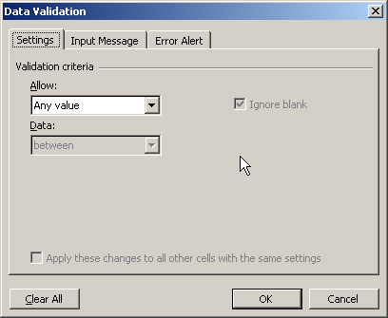
4 From the Allow list, click List.
5 In the Source box, type the following values:
pistons, valves, sunroofs
6 Click the OK button.
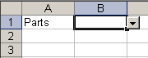
Notice that when you select cell B1, Excel places an arrow next to it to indicate that it contains the list of values you have just entered. The value list is a good way of ensuring people can only pick values from the list you created. However, when you select another cell, the arrow disappears. That, of course, leads to the question: How do you find cells that contain data-validation rules?
How to Find Cells Containing Validation Rules
Click anywhere on the sample worksheet that contains the list you created previously.
1 Press the [F5] key.
2 The Go To dialogue box appears.
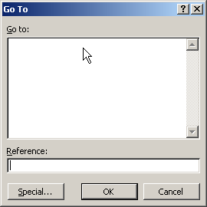
3 Click the Special button and the following dialogue box appears.
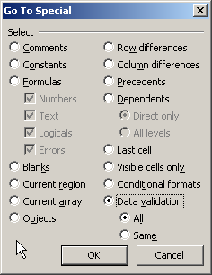
4 Click the Data validation option and All and then click the OK button.
Excel highlights all the cells on the open worksheet that contain data-validation settings.
As a further example let’s choose the Whole number option from the Allow drop-down box. Here we want the user to be able to type in any whole number between zero and 100, therefore we have to select the Between function from the Data drop-down menu and then type in 0 in the minimum text box and 100 in the maximum box. Finish off by pressing the OK button.
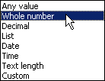
Now enter a value of 22.3 in the cell. You will notice that as soon as you press [Enter] the message below appears. You will not be able to move off this cell until you have entered the correct value.
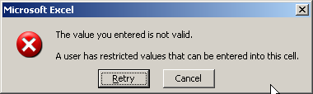
You can restrict your cells to holding just dates or times by choosing the Date or Time option from the Data validation dialogue box. One thing to know though is that you will have to put in a date range. The easiest way to do this is to set the Data drop-down box to ‘Greater Than’ and in the Start Date drop-down box set the value to 1/1/1900. This means that all dates you enter will be valid after 1 January 1900. Remember to finish off by pressing the OK button. Now try and enter an invalid date. You will notice as soon as you try to move off the cell it will generate an error.
How to Provide a Drop-down List of Options
We can use data validation to create a drop-down list of options in a cell. List items can be typed in a row or column on a worksheet, or typed directly into the Data validation dialogue box.
1 Create a List of Items
If the list of options is more than a couple of items it is easier to maintain if you type the list in a worksheet. The list can be entered on the sheet that will contain the drop-down lists, or on a different sheet. In our example, the list will be stored on a sheet named Lists.
In single row or column, type the entries you want to see in the drop-down list. Note: The list must be in a single block of cells, eg you can use A2:A6, but not A2, A4, A6, A8.
- So, starting at A2, type in the following list of fruits: apples, grapes, bananas, oranges, melons and pears.
2 Name the List Range
If you type the items on a worksheet, and name the range, you can refer to the list from any worksheet in the same workbook.
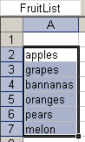
3 Apply the Data Validation
- Select the cells in which you want to apply data validation.
- From the Data menu, choose Validation.
- From the Allow drop-down list, choose List. In the Source box type an = sign and the list name, for example =FruitList. Click the OK button.
4 Using a Delimited List
Instead of referring to a list of items on the worksheet, you can type the list in the Source box, separated by commas. For example: Yes, No, Maybe.
Note: This method of data validation is case sensitive. If a user types YES, an error alert will be displayed.
5 Allow Entries that are not in the List
To allow users to type items that are not in the list, turn off the error alert. This is carried out by removing the tick from the Show error alert after invalid data is entered check box.
6 Protect the List
To protect the list from accidental damage, if you have entered it on a different worksheet you can hide that sheet.
- Select the sheet that contains the list.
- Choose Format | Sheet | Hide.
Using Macros
If you perform a task repeatedly in Microsoft Excel, you can automate the task with a macro. A macro is a series of commands and functions that are stored in a Microsoft Visual Basic module (a collection of declarations, statements and procedures stored together as one named unit). There are two types of modules: standard modules and class modules. The macro can then be run whenever you need to perform the task.
For example, if you often enter long text strings in cells, you can create a macro to format those cells so that the text wraps.
Recording Macros
When you record a macro, Excel stores information about each step you take as you perform a series of commands. You then run the macro to repeat, or ‘play back’ the commands. If you make a mistake when you record the macro, corrections you make are also recorded. Visual Basic stores each macro in a new module attached to a workbook.
1 Set the security level to Medium or Low.
- On the Tools menu, click Options.
- Click the Security tab.
- Under Macro Security, click Macro Security.
- Click the Security Level tab, and then select the security level you want to use.
2 On the Tools menu, point to Macro, and then click Record New Macro.
3 In the Macro name box, enter a name for the macro.
Note: The first character of the macro name must be a letter. Other characters can be letters, numbers or underscore characters. Spaces are not allowed in a macro name; an underscore character works well as a word separator. Do not use a macro name that is also a cell reference or you can get an error message that the macro name is not valid.
4 If you want to run the macro by pressing a keyboard shortcut key (a function key such as [F5] or key combination such as [Ctrl] [A] that you use to carry out a menu command), enter a letter in the Shortcut key box. You can use [Ctrl] + letter (for lowercase letters) or [Ctrl] [Shift] + letter (for uppercase letters), where letter is any letter key on the keyboard. The shortcut key letter you use cannot be a number or special character such as @ or #.
Note: The shortcut key will override any equivalent default Microsoft Excel shortcut keys while the workbook that contains the macro is open.
5 In the Store macro in box, click the location where you want to store the macro.
If you want a macro to be available whenever you use Excel, select Personal Macro Workbook.
6 If you want to include a description of the macro, type it in the Description box.
7 Click OK.
8 If you want the macro to run relative to the position of the active cell, record it using relative cell references. On the Stop Recording toolbar, click Relative Reference so that it is selected. Excel will continue to record macros with relative references until you quit Excel or until you click Relative Reference again so that it is not selected.
9 Carry out the actions you want to record.
10 On the Stop Recording toolbar, click the Stop Recording icon.
Making a Macro Easy to Run
You can run a macro by choosing it from a list in the Macro dialogue box. You can run macros from:
- A keyboard shortcut like a function key or key combination, such as [F5] or [Ctrl] [A], that you use to carry out a menu command. (In contrast, an access key is a key combination such as [ALT] [F] that moves the focus to a menu, command or control.)
- A button or graphic control on a worksheet. Click the button or graphic control so that the sizing handles appear. With the graphic object selected, right-click a sizing handle of the button or graphic object to display the shortcut menu. On the shortcut menu, click Assign Macro.
- An area, or a hotspot on a graphic object. Draw another object to create a hotspot for an existing object. With the graphic object selected, right-click a sizing handle of the button or graphic object to display the shortcut menu. On the shortcut menu, click Assign Macro
- A toolbar button. On the Tools menu, click Customise.
1 Do one of the following:
- If the toolbar that contains the button is not visible, click the Toolbars tab, and then select the check box next to the toolbar name.
- If the button you want to run the macro from is not on a toolbar, click the Commands tab, and then click Macros in the Categories list. In the Commands list, drag the Custom button onto a toolbar.
2 Right-click the toolbar button, and then click Assign Macro on the shortcut menu.
3 Enter the name of the macro in the Macro name box, and then click OK.
Note: If you choose to use a button to control your macro, it can be run from any worksheet that has access to the button.
Managing Your Macros
After you record a macro, you can view the macro code with the Visual Basic Editor to correct errors or change what the macro does. For example, if you wanted the text-wrapping macro to also make the text bold, you could record another macro to make a cell bold and then copy the instructions from that macro to the text-wrapping macro.
The Visual Basic Editor is a program designed to make writing and editing macro code easy for beginners, and provides plenty of online help. You don’t have to learn how to program or use the Visual Basic language to make simple changes to your macros. With the Visual Basic Editor, you can edit macros, copy macros from one module to another, copy macros between different workbooks, and rename the modules that store the macros, or rename the macros.
Macro Security
Excel provides safeguards that help protect against viruses that can be transmitted by macros. If you share macros with others, you can certify them with a digital signature so that other users can verify they are from a trustworthy source. (A digital signature is an electronic, encryption-based, secure stamp of authentication on a macro or document. This signature confirms that the macro or document originated from the signer and has not been altered.) Whenever you open a workbook that contains macros, you can verify their source before you enable them.

Exercise 15: Creating a Macro
Macros can be very useful for automating routines that you perform repeatedly. Try creating the following macros for practice.
Create a macro (in your workbook) that will perform the following tasks in preparation for printing:
- Switch on row and column headings.
- Display gridlines on the worksheet when printed.
- Add your name to the worksheet footer.
- Switch to Formula view.
Assign the macro to a tool on a toolbar (you might want to create a toolbar of your own for this).
Create a second macro that will reverse the one above, eg:
- Switch off row and column headings.
- Hide gridlines on the worksheet when printed.
- Remove your name from the worksheet footer.
- Switch to Data view.
Assign the macro to a tool on a toolbar (you might want to create a toolbar of your own for this).

PivotTable Reports
A PivotTable report is an interactive table that quickly combines and compares large amounts of data. You can rotate its rows and columns to see different summaries of the source data, and you can display the details for areas of interest. Use a PivotTable report when you want to analyse related totals, especially when you have a long list of figures to sum and you want to compare several facts about each figure. Because a PivotTable report is interactive, you can change the view of the data to see more details or calculate different summaries, such as counts or averages.
Let’s say we had data for student scores. You could turn that into a PivotTable, and then view only the Computing scores for each student — or view, say, just Terry’s marks and nobody else's. To get a clearer idea of just what a PivotTable is, examine the one below. You'll be designing this very PivotTable yourself shortly.
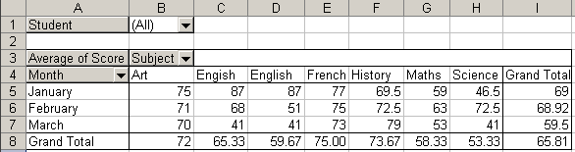
The PivotTable above shows the marks that Elisa got in January, February and March. There were tests for only six subjects.
Notice the black down-pointing arrows in the PivotTable. If the black arrow is clicked, a drop-down box would appear showing a list of students. We could click on a student and view the marks he or she achieved. Or we could select which subjects to view, or choose only one month.
But Excel does most of the work for you, and puts in those drop-down boxes as part of the Wizard. But you'll see how it works.
Before you can construct a PivotTable, you need some data in list form. We're going to construct our PivotTable using only two students: Elisa and Mary. We'll use just three months worth of data, and six subjects.
How to Create a PivotTable in Excel
The PivotTable is constructed using the Wizard. To create your PivotTable do the following:
1 Click inside cell A2 on the spreadsheet you downloaded above.
2 From Excel's menu bar, click on Data.
3 From the menu that drops down, click on PivotTable and PivotChart Report. The Pivot Table Wizard starts up.
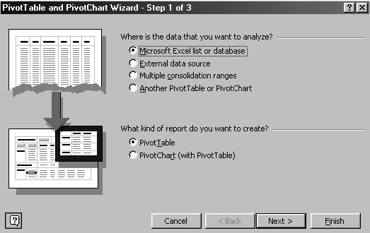
This is step 1 of 3. As we are using data from our spreadsheet there is nothing much for us to do in step 1 because the options we want are selected: Microsoft Excel list or database and PivotTable. As these options are chosen, click the Next button at the bottom.
The Wizard moves on to step 2. It looks like this:
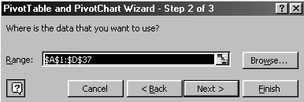
The range of cells that Excel will include in our PivotTable is A1 to D37. (You could change this if you wanted.) Because we clicked in cell A2 to begin with, Excel has taken that as the first row of data. Excel uses the labels from row 1 as headings. Excel will use these to populate the drop-down boxes and data.
4 Click the Next button.
Step 3 of the Wizard appears. Now we have some decisions to make.
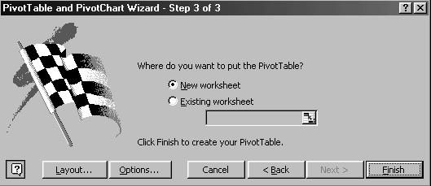
We will accept the default position for the location of the PivotTable: New worksheet.
The button you will use the most is the Layout one. Click the Layout button and you are presented with a quite complicated dialogue box.
You should get something like this:
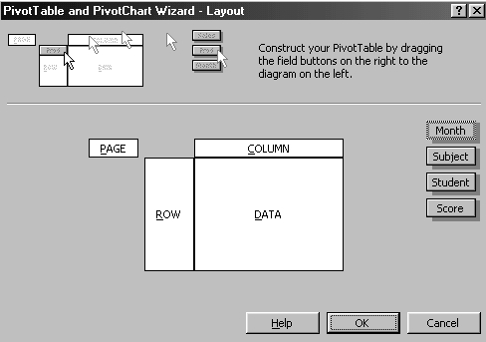
The top section of the dialogue box defines the actions you need to carry out. The Field buttons are those four on the right: Month, Subject, Student and Score. The idea is that you click on a button, hold down your left mouse button and drag to an area on the left. We are going to drag one button to the Column area, one to the Row area, and one to the Data area.
In the Row area we will put Month, in the Column area we will put Subject, and in the Data area we will put Score. We will do something with the Student button after the PivotTable has been constructed.
So carry out the following actions:
- Click on Month.
- Holding down your left mouse button, drag the mouse pointer over to the Row area.
- Let go of the button when it's there.
- A button will appear in the Row area.
When you have the Month button in place, drag the Subject button to the Column area, and the Score button to the Data area.
When you have completed this task the dialogue box should resemble this:
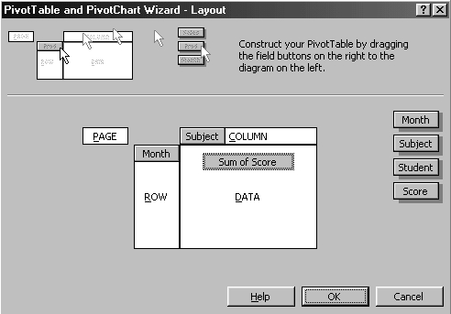
Click OK when your dialogue box is complete.
5 You are taken back to the wizard. Click the Finish button and you have completed the process. At this stage you should have a spreadsheet that is similar to this one:
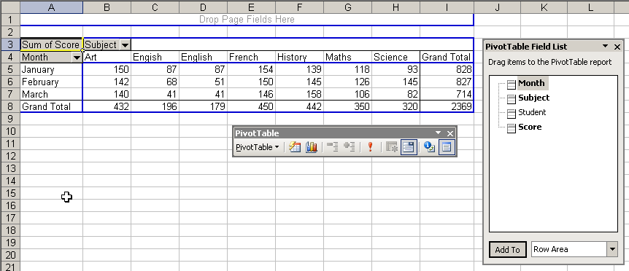
If you don't see the PivotTable toolbar, click on View > Toolbars > PivotTable.
6 Now we are going to put the Student button on the PivotTable, so do the following:
- Locate the Student button in the PivotTable Field List, as in the image below:
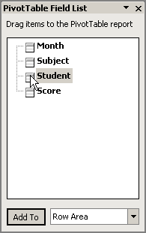
- Holding down your left mouse button on the Student button, drag the Student button to the top of the PivotTable where it says ‘Drag Page Fields Here’.
- Let go of the left mouse button.
- Excel adds the Student field to the PivotTable.
7 We are almost complete. First, take a look at the scores. What our PivotTable is doing is adding all the scores up. That's because of cell A3. Notice that it says ‘Sum of Score’. We really do not want that — an average mark is better for what we require.
To change the scores to averages, do this:
- On the PivotTable toolbar, click on the PivotTable button.

- A menu pops up like the one shown below.
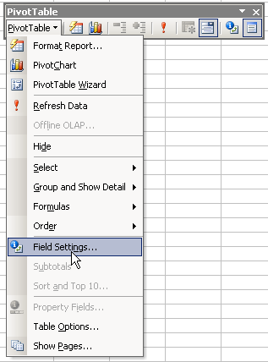
- To change the scores to averages, click on Field Settings.
- The following dialogue box appears:
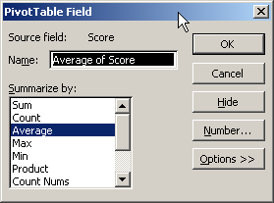
There is a small selection of functions to choose from in the Summarise by list, but Average is present so click on Average and then click OK. The scores will now change on the spreadsheet.
Some of the scores in the spreadsheet will be a bit long so format the numbers to two decimal places in the usual way.
Your PivotTable should now look similar to the one below:
8 We can now take a look at the drop-down boxes. These are identified by the drop-down arrows on the spreadsheet.
Start with the Student box. At the moment, the Student box says All. Click the black down arrow to see the list of students.
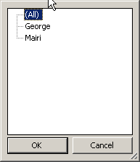
Our two students are listed there. Click on Mairi and then click the OK button. Notice how your spreadsheet has changed. It should now only be showing you Mairi's results. Click the black down arrow in cell B1 again, and click on George. Then click the OK button. Your spreadsheet will change to show only George's results.
If we look at the Subject and click the down arrow in cell B3, you should see the next image.

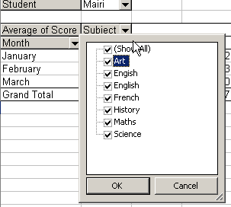
All the Subjects have ticks in them. Click on a tick and it will disappear. Try un-ticking a few of the subjects. Then click the OK button to see what happens.
The Month list in cell A4 shows a similar list with ticks in them. Un-tick a month and see the results when you click OK.

Exercise 16: Using PivotTables
Change the type of PivotTable Report. From the PivotTable toolbar, click the PivotTable button. From the menu that pops up, select Format Report. Click on any of the formats you like then click OK to see what happens. If you don't like what you see, click Edit > Undo AutoFormat to get back to your PivotTable.

Using Goal Seek
Occasionally you may know the result you want to achieve from a formula, but don’t know what the input values have to be to achieve it. On these occasions, you can make use of the goal seek utility.
For example, suppose you want to know how many units must be sold to achieve a profit of £1,000,000. You can use goal seek to find this out. To calculate this, goal seek has to know:
- the cell that contains the formula that calculates the profit
- the profit value you want to achieve
- the cell containing the value to be adjusted by goal seek.
How to Use Goal Seek
1 Select the Tools, Goal Seek menu option.
2 Complete the dialogue box:
- Set cell: Enter the reference of the cell that's to be set to a specific value. This will initially be set to the cell containing the active cell pointer.
- To value: Enter the specific value that's to be shown in the cell identified in the Set cell text box.
- By changing cell: Enter the reference of the cell that's to be changed to achieve the value specified in the To value text box.
3 Click OK.
Excel will perform the necessary calculations and then the Goal Seek Status dialogue box will be displayed showing a solution.
The result of Excel’s calculations will be shown in this dialogue box and in the specified cells on the worksheet.
4 Either accept or abandon the suggested changes.
To accept the result of the goal seek, click OK. The changes will remain in the cells on the worksheet.
Or
To abandon the changes and return to the original cell contents, click Cancel.

Exercise 17: Using Scenarios
What If Scenario
You are considering a number of loan options for a car, and wish to calculate the monthly repayments that would be due for the various options. You can use scenarios to do this — to see what will happen if different loans/interest rates/payback periods are applied. By changing the input values to a function, you can find out what the result will be — the monthly payment in this example. The options are:
 | Amount of Loan | Interest Rate | Payback Period
Option 1 | £22,000 | 7% | 5 years
Option 2 | £25,000 | 8% | 8 years
Option 3 | £30,000 | 10% | 12 years

1 On a new worksheet, input the option 1 data and use the =PMT function to calculate the monthly repayment on this option. (£435.63)
2 Open the Tools menu, choose Scenarios, and set up the three scenarios — one for each option in the table above. They will be listed in the Scenario Manager dialogue box.
3 Show each of the scenarios in turn — you are looking for the one with the lowest monthly repayments, as you are tight for cash on a day-to-day basis.
4 Which option will cost least each month?
You will notice that only one scenario can be displayed at a time — so you have to keep switching between them to compare one with the other.
If you wish to display the results of each scenario side-by-side so you can compare them more easily, you can use a scenario summary.
5 Create a scenario summary for your options (choose Summary from the Scenario Manager dialogue box).

Sorting Data
To change the order in which data is displayed, you can use the Sort Ascending (a–z, 0–9) and Sort Descending (z–a, 9–0) buttons shown on the Standard toolbar. Using these buttons you can simply place the active cell pointer in the column to be used in the sort and then click the Sort Ascending or Sort Descending button.
For example, to sort the data below in ascending order of Invoice No, you would click in the Invoice No column and then click the Sort Ascending button.
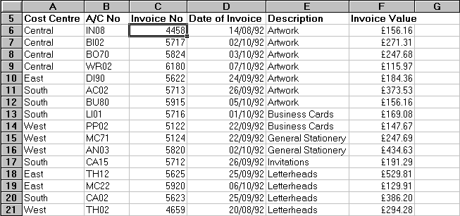
The data would then be shown in ascending order of Invoice No.
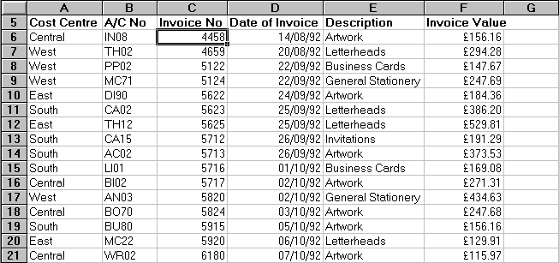
For best results, the range you sort should have column labels, or headers.
1 Click a cell in the range you want to sort.
2 On the Data menu, click Sort.
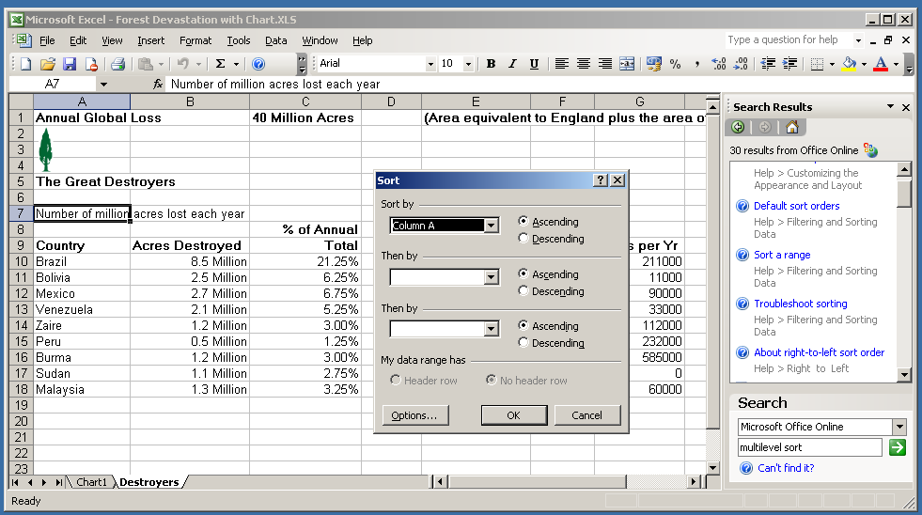
3 In the Sort by and Then by boxes, click the columns you want to sort, starting with the most important.
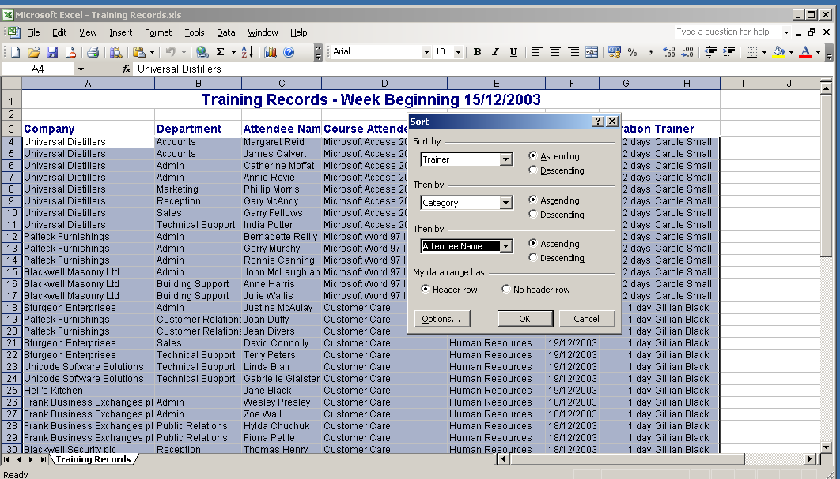
4 Select any other sort options you want, and then click OK.

Exercise 18: Sorting
1 Open the Stock Records workbook stored in the Databases folder in your WorkStuff folder.
2 Follow the instructions below to sort the product list in ascending order of Location.
- Move the cell pointer onto a cell in the Location column.
- Click the Sort Ascending button shown on the Standard toolbar.
3 Now sort the list in order of supplier name by clicking in that column and clicking the Sort Ascending button.
4 Sort the list in descending order of product name.
5 Sort the list in ascending order of cost price.
6 Sort it in descending order of location.
7 Save and close the workbook.

Using Lists
If you keep lists (a series of worksheet rows that contain related data) of information such as customer invoices, product details or simply names and addresses, you can enter these onto a worksheet and then use Excel’s list management facilities to organise and analyse the data. Lists are sometimes referred to as databases.
You can, for example, sort the list to show the data in a specific order, extract some of the information, create a summary report or perform calculations using the data in the list.
Before entering your list into a worksheet, you should plan its content and structure.
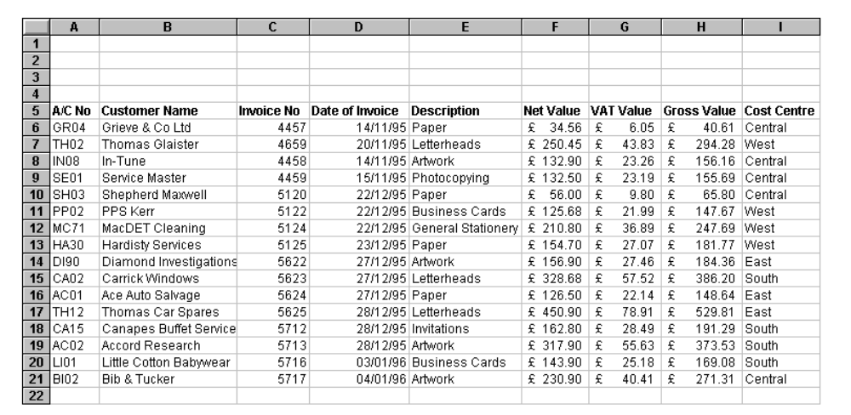
In a separate row at the top of each column, you should enter a column label to identify the field in that column. It’s advisable to format the column labels in a different way to the data in the list so that Excel doesn't include it as part of the data in the list.
Each of the other rows in the list contains all the fields for one invoice. This is referred to as a record.
There are a few rules you should follow when creating a list:
- Always enter column labels on the top row of the list, applying some formatting attributes to differentiate between the column labels and the data in the list.
- The first record must appear on the first row beneath the column labels. Use cell borders to draw lines below labels if required — don’t insert extra rows.
- Avoid putting more than one list on a single worksheet as some of Excel’s list management features, such as filtering, can be used on only one list at a time.
- Leave at least one blank column and row between the list and other data on the same worksheet.
- Don’t put spaces at the beginning of a cell entry — this can cause problems when filtering or sorting the data.
AutoFilter Drop-downs
One of the common things that you do with data in Excel is to filter the data based on different field values. To make this functionality available to you when using lists, AutoFilter drop-downs are automatically added in the header row of a list when the list is created. This enables you to look up specific values by picking the appropriate drop-down list value you wish to see — all records for that value are returned.
Using a Data Form
When working with lists, you can use the Data, Form command to display a form to make data entry user-friendlier. Using this form you can modify, find, add and/or delete records from your list.
Furthermore, you can use the Criteria button to search for particular records in the list. When you click this button, a blank form is displayed. Type an example of the records you're looking for and then click either the Find Prev or Find Next button to find a record based on the example you gave.

Exercise 19: Using Lists
1 Create a new workbook.
2 Enter the column labels and two records as shown below.
Notice that the list starts on row 6 and the column labels have been formatted as bold. Column H should contains formulas to calculate Selling Price 2 by multiplying Selling Price 1 by 120%. Where necessary, increase the column width.
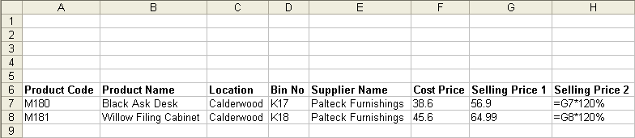
3 Save the workbook as Stock List and store it in the Databases folder in your WorkStuff folder.
4 Make sure the cell pointer is within the list and then choose the Data, Form menu option. This displays a form you can use to work with the existing records in your list and to add new records.
5 Following the instructions below, use the data form to make some changes to the list.
- Change the entry in the Selling Price 1 box to 59.6 and then press [Enter] to apply the change.
The Selling Price 2 entry in the worksheet changes as its formula uses the Selling Price 1 you've just altered and the second record from your list is displayed in the data form.
- Click the Delete button and then click OK to confirm that you want to delete this record.
Now you’ll add a new record to the list using the data form.
- As a blank form is displayed after you deleted the second record, you can create a new record by typing in this blank form. Complete it as shown below.
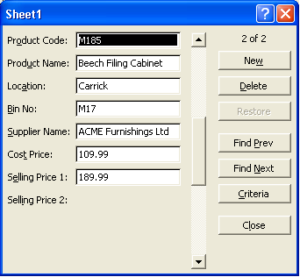
- Press [Enter] to add this record to the list. Notice that the formula is copied from the previous record in the list.
- Click Find Prev in the data form to return to the first record in the list.
- Click Find Next to display the second record.
- Click the Close button to return to the workbook.
6 Save and close the workbook.

Using Filters
Filters are used to display only those records in your list that match specified criteria. For example, you may want to see only those customers whose name is Smith. As only the records relating to Smith will be shown, it will be easier to compare and review the data.
Using Excel’s AutoFilter utility, you can view a subset of the records in your list by selecting or specifying the required criteria
Before you can set a filter, you must switch on AutoFilter. To do this, make sure that the active cell pointer is within the list and then select the Data, Filter, AutoFilter menu option. Filter arrows will then be displayed to the right of the column labels.
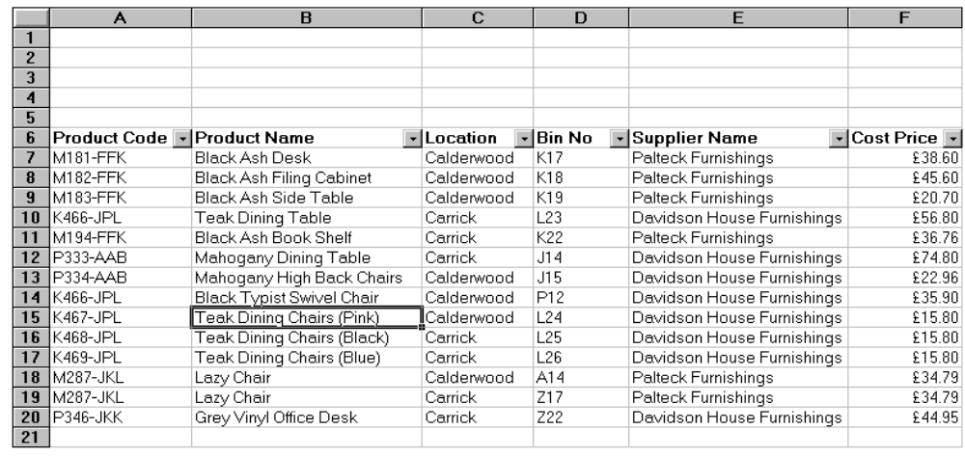
Once you have switched on AutoFilter, you can select or set conditions by choosing from the drop-down list for each field. For example, if you wanted to see only those products that are located at the Carrick warehouse, you would choose Carrick from the Location drop-down list.
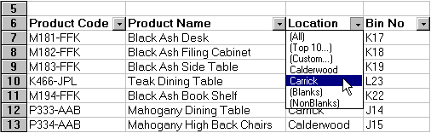
The records that match your choice will be displayed in the list; the others will be hidden.
On screen, the Location drop-down arrow and the selected row numbers are highlighted in blue to indicate that a filter has been set.
You can reduce the list further by setting a condition for another field, eg for those products supplied by Davidson House Furnishings.
The records now shown are for products that are located at the Carrick warehouse and are supplied by Davidson House Furnishings.
Cancelling a Filter
Once a filter has been set for a field, you can cancel it by selecting the (All) option from the field’s drop-down list. If, however, you have set filters on a number of fields and you want to cancel all of them, the quickest way to do so is to choose the Data, Filter, Show All menu option. Using this command means that you don’t have to cancel the filters one at a time.
Setting a Custom Filter
In addition to choosing cell contents from a filter’s drop-down list, you can set a custom filter using wildcard characters (* and ?) and/or operators such as greater than (>) and less than (<).
First display the Custom AutoFilter box by choosing Custom from a field’s filter drop-down list, then specify the criteria for this field. In the example that follows, the custom filter will display all the chairs and tables in this list (you use or rather than and in this box because the name should contain chair or table).
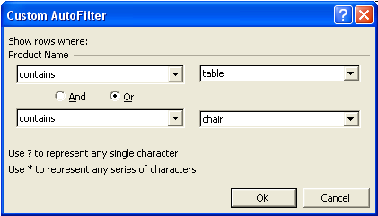
Using Advanced Filters
If you want to apply a filter that uses more than the two criteria allowed by the Custom AutoFilter dialogue box, you will have to use the Advanced Filter options. For example, using the list from the previous exercise, you may want to list all chairs, tables and cabinets.
Another instance where you would have to use these options would be where you want a field to be compared to the result of a calculation. For example, you might want to list the products whose profit (calculated by subtracting Cost Price from Selling Price 2) is greater than £50.
Creating Criteria Ranges
The first step in using the advanced filter options is to create a criteria range. This range of cells contains the name of the field(s) that you want to test and the value(s) to be used for the comparison(s).
The first row in the range must contain the column label of the field(s) to be compared. The second and subsequent rows are used to specify the criteria to be met.
Note: Criteria ranges must span at least two rows.
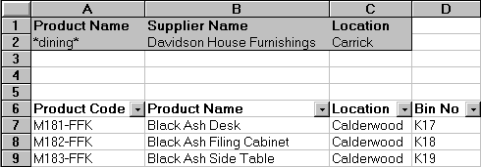
When all the criteria appear in a single row, as they do above, only those records matching all criteria will be listed. If you want to list the records that match at least one of the criteria, they must appear on separate rows.
Note: You can use the wildcard character * to replace any number of characters in your criteria, and ? to replace a single character. In the example above, *dining* means the product name should contain the word dining, perhaps with some characters before it and/or some characters after it.
If you want to test the same field for more than one condition, the field can be repeated in the criteria range. For example, if you wanted to list those products whose Cost Price is more than £20 and less than £50, the criteria range would be:
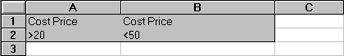
with Cost Price appearing twice on the same row.
Applying Advanced Filters
Once you have created the criteria range, you can apply the filter using the Data, Filter, Advanced Filter command, which will display the Advanced Filter dialogue box.
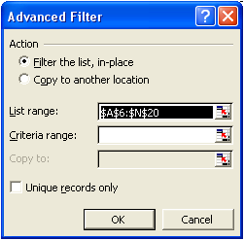
Note: The cell pointer must be within the list before you select this command.
Using the options under Action you can choose to copy the filtered list in another part of the worksheet rather than where the full list is located, and you can prevent duplicated records being included in the filtered list by ticking the Unique records only box.
The List range will be completed by Excel, so you need only specify the Criteria range and, if necessary, the location for the filtered list in the Copy to text box, before clicking OK.
The filtered list will be displayed, with those records not matching the required criteria hidden or, if you chose the Copy to another location option, in the part of the worksheet you specified.
Note: If you use the Copy to another location option, you can choose to show only some of the fields in the filtered list. For example, you may be interested in only the product name, supplier and cost price rather than all the fields in the original list.
You can do this by copying the column labels of those fields you do want in the filtered list to the range where the filtered list is to be shown. You would then select this range as the Copy to range in the Advanced Filter dialogue box.

Exercise 20: Using Filters
1 Open the Stock Records workbook stored in the Databases folder in your WorkStuff folder.
This workbook has the same layout as the one you created in Exercise 19 but has more records.
2 Ensure the cell pointer is in the list and then select the Data, Filter, AutoFilter menu option to display the filter arrows at the right of the column labels.
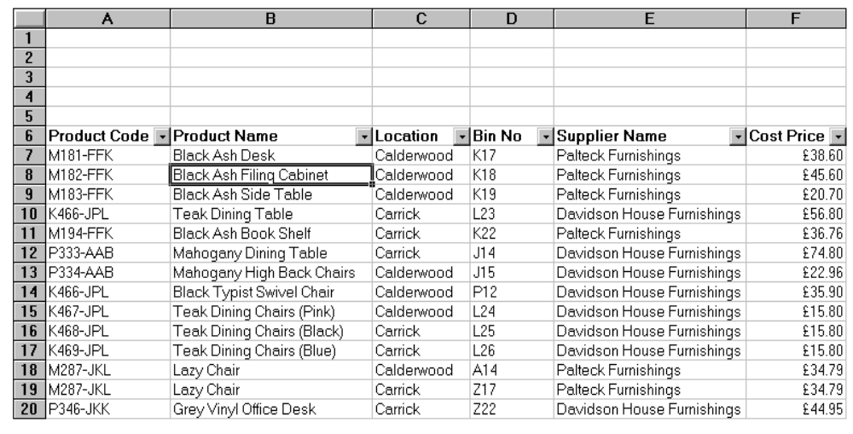
3 Display only those products located at the Calderwood warehouse by selecting Calderwood from the Location field’s drop-down list.
All the other records are hidden, leaving only the Calderwood stock in this list.
4 Reduce the list further by displaying only those products supplied by Palteck Furnishings.
Now the only records displayed are those held at the Calderwood warehouse that have been supplied by Palteck. Notice the blue colour on the filter arrows of those columns that have been filtered and also on the row numbers.
5 Select the Data, Filter, Show All menu option to display all the products again.
6 Display only Lazy Chairs stored in the Carrick warehouse.
7 Select (All) from the Product Name field's drop-down list so that all the products stored in the Carrick warehouse are shown in the list.
8 Experiment with the filters to display different subsets of the records.
9 Display all records using the Data, Filter, Show All menu option.
10 Follow the instructions below to set a custom filter that will display all product codes that start with the letter K.
- From the Product Code drop-down list, select (Custom).
- Select begins with from the criterion drop-down list.
- Type K into the Custom AutoFilter dialogue box as shown below.
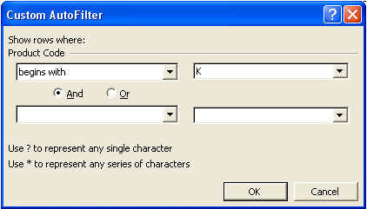
- Click OK to apply the filter.
11 Following the instructions below, modify the filter so that all products with codes beginning with K or M will be shown in the list.
- Select (Custom) from the Product Code drop-down list.
- Ensure that K still appears as the first criterion.
- Click the Or option button, then select the begins with operator from the second criterion drop-down list.
- Enter M into the second criterion text box.
- Click OK to apply the filter.
Product codes starting with either K or M are now shown in the list.
12 Display all records.
13 Use a custom filter to display all products whose Cost Price is greater than £50.
14 Display all the records.
15 Display a list of those products stored at the Carrick warehouse, then use a custom filter to display only those products that have been allocated at least once.
16 Use the Data, Filter, Show All command to display all records.
17 Print the workbook on one landscape page. Remember to add your name to the footer.
18 Save the changes you’ve made and close the workbook.

Using Functions with Lists and Filters
When you use the SUM function with a list, it totals all the values you’ve specified. However, if you apply a filter to the list, the SUM function still totals all the values, regardless of the filter. The SUBTOTAL function is a multi-purpose function that can give you the equivalent of the SUM, AVERAGE, MAX, MIN, COUNT and COUNTA functions, amongst others, but using only the values that are displayed by the filter at that time.
SUBTOTAL Function
The syntax of the SUBTOTAL function is:
=SUBTOTAL(function_number, range)
The function_number argument comes from this list:
Function_number | Function
1 | AVERAGE
2 | COUNT
3 | COUNTA
4 | MAX
5 | MIN
6 | PRODUCT
7 | STDEV
8 | STDEVP
9 | SUM
10 | VAR
11 | VARP

Example
This illustration shows a list where the Cost Price column is to be totalled. However, the total should change to include only the displayed records when the list is filtered.
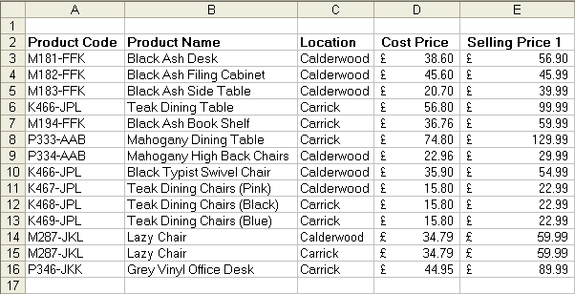
To total the Cost Price column the function would read =SUBTOTAL(9, D3:D16). The function number 9 has been used as this is the SUM function. To find the average cost price the function would be =SUBTOTAL(1, D3:D16) since function number 1 is AVERAGE.
Forecast Function
This function calculates, or predicts, a future value by using existing values. The predicted value is a y-value for a given x-value. The known values are existing x-values and y-values, and the new value is predicted by using linear regression. You can use this function to predict future sales, inventory requirements, or consumer trends.
Syntax
FORECAST(x,known_y's,known_x's)
This returns the correlation coefficient of the array1 and array2 cell ranges. Use the correlation coefficient to determine the relationship between two properties. For example, you can examine the relationship between a height in metres and the speed of impact of an object.
Syntax
CORREL(array1,array2)
Array1 is a cell range of values.
Array2 is a second cell range of values.
Lookup Function
If you wanted to find a specific value in a spreadsheet, you might use a Lookup function, for example to find a phone extension, or a sales amount or product. After you look up the data, you can perform calculations or display results with the values returned. There are several ways to look up values in a list of data and to display the results.
There are different functions to perform different types of lookups. The two most common are VLOOKUP and HLOOKUP but you could also use Index, Match and Offset functions.
VLOOKUP
V (Vertical) LOOKUP looks for values vertically in a list by using an exact match or an approximate match. VLOOKUP searches for a value in the first column of a table array and returns a value in the same row from another column in the table array. Use VLOOKUP instead of HLOOKUP when your comparison values are located in a column to the left of the data that you want to find.
Syntax
VLOOKUP(lookup_value, table_array, col_index_num, range_lookup)
Understanding the parts of the function
Lookup_value The value to search in the first column of the table array which could be a value or a reference. If lookup value is smaller than the smallest value in the first column of table array, VLOOKUP returns the #N/A error value.
Table_array Two or more columns of data. Use a reference to a range or a range name. The values in the first column of table array are the values searched by lookup value. These values can be text, numbers, or logical values. Uppercase and lowercase texts are equivalent.
Col_index_num The column number in the table array from which the matching value must be returned. A col_index_num of 1 returns the value in the first column in table array; a col_index_num of 2 returns the value in the second column in table array, and so on.
If col_index_num is less than 1, VLOOKUP returns the #VALUE! error value. If col_index_num is greater than the number of columns in table array, VLOOKUP returns the #REF! error value.
Range_lookup A logical value that specifies whether you want VLOOKUP to find an exact match or an approximate match. If the logical value is TRUE or omitted, an exact or approximate match is returned. If an exact match is not found, the next largest value that is less than lookup_value is returned.
Note: The values in the first column of table array must be placed in ascending sort order; otherwise, VLOOKUP may not give the correct value. You can put the values in ascending order by choosing the Sort command from the Data menu and selecting Ascending.
If the logical value is FALSE, VLOOKUP will only find an exact match. In this case, the values in the first column of table array do not need to be sorted. If there are two or more values in the first column of table array that match the lookup value, the first value found is used. If an exact match is not found, the error value #N/A is returned.
HLOOKUP
H (Horizontal) LOOKUP looks up values horizontally in a list by using an exact match or an approximate match. HLOOKUP searches for a value in the top row of a table or an array of values, and then returns a value in the same column from a row you specify in the table or array. Use HLOOKUP when your comparison values are located in a row across the top of a table of data, and you want to look down a specified number of rows.
Syntax
HLOOKUP(lookup_value, table_array, row_index_num, range_lookup)
Lookup_value is the value to be found in the first row of the table. Lookup_value can be a value, a reference, or a text string.
Table_array is a table of information in which data is looked up. Use a reference to a range or a range name. The values in the first row of table_array can be text, numbers, or logical values.
Row_index_num is the row number in table_array from which the matching value will be returned. A row_index_num of 1 returns the first row value in table_array, a row_index_num of 2 returns the second row value in table_array, and so on. If row_index_num is less than 1, HLOOKUP returns the #VALUE! error value; if row_index_num is greater than the number of rows on table_array, HLOOKUP returns the #REF! error value.
Range_lookup is a logical value that specifies whether you want HLOOKUP to find an exact match or an approximate match. If TRUE or omitted, an approximate match is returned. In other words, if an exact match is not found, the next largest value that is less than lookup_value is returned. If FALSE, HLOOKUP will find an exact match. If one is not found, the error value #N/A is returned.
Note: Uppercase and lowercase text is equivalent. You can put values in ascending order, left to right, by selecting the values and then clicking Sort on the Data menu. Click Options, click Sort left to right, and then click OK. Under Sort by, click the row in the list, and then click Ascending.
You can also use the Help files on your spreadsheet program to find out more about these other functions.
Lookup and Reference Functions
Function | Description
ADDRESS | Returns a reference as text to a single cell in a worksheet
AREAS | Returns the number of areas in a reference
CHOOSE | Chooses a value from a list of values
COLUMN | Returns the column number of a reference
COLUMNS | Returns the number of columns in a reference
GETPIVOTDATA | Returns data stored in a PivotTable
HLOOKUP | Looks in the top row of an array and returns the value of the indicated cell
HYPERLINK | Creates a shortcut or jump that opens a document stored on a network server, an intranet, or the internet
INDEX | Uses an index to choose a value from a reference or array
INDIRECT | Returns a reference indicated by a text value
LOOKUP | Looks up values in a vector or array
MATCH | Looks up values in a reference or array
OFFSET | Returns a reference offset from a given reference
ROW | Returns the row number of a reference
ROWS | Returns the number of rows in a reference
TRANSPOSE | Returns the transpose of an array
VLOOKUP | Looks in the first column of an array and moves across the row to return the value of a cell

Exercise 21: Using Lists, Data Forms and Filters
1 Enter the following two records into a new worksheet. Name the worksheet Student Results.
2 Use functions to complete column F and G (in column G, if a student’s average mark is >=50 they pass the course, otherwise they fail).
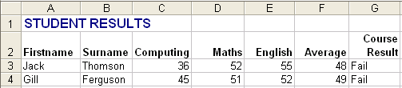
3 Use the data form for the list to complete the other details for students in rows 5–11:
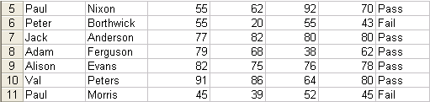
4 Sort the data into ascending order on Surname then Firstname.
5 Starting in row 13 (Lowest Mark in class in cell A13), use appropriate functions to calculate the highest, lowest and average mark for each subject (to 0 decimal places).
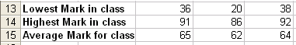
6 Put your name and today’s date into the worksheet footer.
7 Format the worksheet effectively.
8 Save the worksheet and print it out — in data view.
9 Then print the worksheet out in Formula view, with the row and column headings and gridlines displayed. The printout should fit onto one page.
10 Close the workbook.

Filtering
1 Use the Students Result worksheet to practise filtering data lists. Use AutoFilter for this.
- Display all records where the student surname is Ferguson.
- Display all records where the maths mark was >=55.
- Display all records where the student result was Fail.
- Display all records where the computing result was between 50 and 80 (inclusive).

Advanced Filter
1 Use the Advanced Filter option to display those students who:
- passed computing but failed the course
- achieved 65 or more in each subject
- scored between 50 and 70 (inclusive) in computing
- averaged either below 50 or 80 and above.

Finally
The candidate should (after consultation with their tutor) be able to do the assessment for this Unit.
This completes all the learning Outcomes for the PC Passport Spreadsheet subject. Microsoft Excel is one of a range of spreadsheets that could be used to achieve the same results.

