THE ROLE OF INTRAMYOCELLULAR FATTY ACIDS ON THE ETIOLOGY OF THE INSULIN RESISTANCE OF OBESITY

by
Chryssanthi Stylianopoulos

A dissertation submitted to the Johns Hopkins University in conformity with the requirements for the degree of Doctor of Philosophy

Baltimore, Maryland
December 2005

© Chryssanthi Stylianopoulos 2005
All rights reserved
ABSTRACT
The intracellular concentration of fatty acids in insulin-sensitive cells is purported to be a key factor in the development of insulin resistance. It is hypothesized that the intramyocellular lipid (IMCL) concentration is correlated with the degree of insulin resistance (IR), and that a reduction in IMCL will have a more significant effect on IR than a reduction in body adipose tissue stores. This study assessed the effects of weight loss through dietary intervention on the IMCL and IR on a group of obese adults and explored the correlations between IR, IMCL, body mass index (BMI), serum triglycerides (TG), free fatty acids, and total body fat of obese adults with an otherwise similar group of lean individuals.
Baseline tests were performed in lean and obese, including a 2 hour Oral Glucose Tolerance Test (OGTT), body composition measurement by Dual Energy X-Ray Absorptiometry (DEXA), and IMCL determination in the tibialis anterioris (TA) and soleus (SOL) muscles by proton magnetic resonance spectroscopy. The obese underwent insulin sensitivity assessment by the euglycemic-hyperinsulinemic clamp. Furthermore, they were instructed to follow a hypocaloric diet, and were subsequently re-evaluated after a weight loss of 8-10% of total body weight.
Our results indicate that the obese group had significantly higher IMCL levels in the SOL muscle than the lean group. In both groups, there was a significant positive correlation of IR, assessed by Homeostasis Model Assessment Index (HOMA), with IMCL in the SOL muscle but not in the TA. IMCL in the SOL was an important predictor of IR by HOMA, after controlling for age, BMI, and TG. Weight loss resulted in a significant decrease in IR and IMCL in the TA, but not in the SOL muscle. There was no correlation between changes in IMCL in TA myocytes and in IR. Our data documented that reduction in IMCL stores might play an important role in insulin signaling.

Thesis Advisor: Dr. Benjamin Caballero
Thesis Committee: Drs. Christopher Saudek, Benjamin Caballero, Alena Horska, Margarita Treuth, Eliseo Guallar

ACKNOWLEDGEMENTS
I would like to thank my advisor, Dr. Benjamin Caballero, who provided me with the support and guidance for the successful completion of this project.
I would like to thank Dr. Christopher Saudek for financial support through the National Research Service Award Research Training Grant. I would also like to thank the Johns Hopkins University School of Medicine General Clinical Research Center (award M01-RR00052, from the National Center for Research Resources/National Institutes of Health) and the United Stated Department of Agriculture (award 58-1235-2-060) for financial support of this project.
I would like to thank Dr. Alena Horska for assistance on the radiology component of this project. I would also like to thank Terri Brawner and Kathleen Kahl for technical support with the magnetic resonance scanner.
I would like to thank Dr. Lawrence Cheskin and Amy Mitchell for their contribution on the weight management part of this project.
I would like to thank Dr. Todd Brown and Dr. Alice Ryan for their help with the insulin clamp procedure.
I would also like to thank Mary Missouri, Suzanne Dunphy and all the nurses and staff at the General Clinical Research Center for their invaluable collaboration.
Most of all, I would like to thank my family and friends for their continuous love and support throughout this journey.
TABLE OF CONTENTS
1 INTRODUCTION 1
2 LITERATURE REVIEW 4
2.1 Insulin Actions: Overview 4
2.2 Insulin receptor 5
2.3 Insulin Resistance, Insulin Insensitivity and Insulin Unresponsiveness 6
2.4 Insulin and Leptin 7
2.5 Insulin and Adiponectin 9
2.6 From Insulin Resistance to Type 2 Diabetes 10
2.7 Type 2 Diabetes 10
2.8 Diagnosis of Diabetes 11
2.9 Genetic Contributions to Type 2 Diabetes 12
2.10 Obesity-Induced Type 2 Diabetes 14
2.10.1 Receptor Events 14
2.10.2 Post-receptor Events 16
2.11 Adipose Tissue Deposition in Human Skeletal Muscle and Liver 16
2.11.1 Quantification Methods 16
2.11.2 Proton Magnetic Resonance Spectroscopy 17
2.11.3 Mechanism of Muscle Lipid Accumulation 20
2.11.4 Fatty Liver Disease 22
2.11.5 Lipid Accumulation and Insulin Resistance 22
2.11.6 Lipid Accumulation and Exercise 28
2.11.7 Lipid Accumulation and Adiponectin 29
3 HYPOTHESES AND OBJECTIVES 31
3.1 Hypotheses 31
3.2 Objectives 31
4 MATERIALS AND METHODS 33
4.1 Study Design 33
4.2 Sample Size 34
4.3 Subjects 35
4.4 Baseline Measurements 36
4.4.1 Initial Screening 36
4.4.2 Proton Nuclear Magnetic Resonance Spectroscopy 38
4.4.3 Euglycemic-Hyperinsulinemic Clamp Procedure 41
4.5 Dietary Intervention 42
4.6 Follow-up measurements 44
4.7 Laboratory Procedures 45
4.8 Insulin Sensitivity Assessments 46
4.9 Proton Magnetic Resonance Spectroscopy Data Processing 48
4.10 Statistical Analysis 50
5 RESULTS 52
5.1 Subject Characteristics 52
5.2 Baseline Comparisons 52
5.2.1 Anthropometric Data and Fasting Blood Tests 52
5.2.2 Intracellular Lipid Accumulation 55
5.2.3 Euglycemic-Hyperinsulinemic Clamp 62
5.2.4 Correlations 64
5.2.5 Insulin Resistance Predictors 68
5.3 Follow up 69
5.3.1 Anthropometric Data and Fasting Blood Tests 70
5.3.2 Intracellular Lipid Accumulation 72
5.3.3 Losses to Follow up 76
5.3.4 Correlations 78
6 DISCUSSION 80
6.1 Intracellular Lipid Concentration is Higher in Obese Compared to Lean 80
6.2 Intracellular Lipid Levels are Positively Correlated with Insulin Resistance and Glucose Intolerance 80
6.3 Weight Loss Reduces Intracellular Lipid 82
6.4 Other Factors Affecting Intramyocellular Lipid Concentration 84
6.4.1 Muscle Fiber Type 84
6.4.2 Physical Activity 86
6.4.3 Adiponectin 87
6.5 Proton Magnetic Resonance Spectroscopy 88
6.6 Measures of Insulin Resistance 89
6.7 Suggestions for Future Research 90
6.8 Summary and Conclusions 92
7 REFERENCES 94
8 CURRICULUM VITAE 117
LIST OF TABLES
1 Study methodology..………………………………………………………………….. 45
2 Spectral parameters………………………………………………………………….... 49
3 Baseline anthropometric characteristics of lean and obese……………………………. 53
4 Baseline plasma lipid levels of lean and obese………………………………………… 54
5 Baseline plasma hormones levels, insulin sensitivity and glucose metabolism indices
of lean and obese……………………………………………………………………... 55
6 Baseline IMCL, EMCL, and IHL by proton magnetic resonance spectroscopy of
lean and obese………………………………………………………………………... 56
7 Baseline euglycemic-hyperinsulinemic clamp data of obese subjects………………….. 63
8 Anthropometric characteristics of obese subjects before and after weight loss………... 70
9 Plasma lipid levels of obese subjects before and after weight loss…………………….. 71
10 Plasma hormones levels, insulin sensitivity and glucose metabolism of obese subjects
before and after weight loss…………………………………………………………... 72
11 IMCL, EMCL, and IHL by proton magnetic resonance spectroscopy of obese
subjects before and after weight loss...……………...………………………………… 73
12 Anthropometric characteristics of obese subjects that completed the weight loss
compared to those who dropped out…………………………………………………. 76
13 Plasma metabolite concentrations of obese subjects that completed the weight loss
compared to those who dropped out…………………………………………………. 77
14 IMCL, EMCL, and IHL by proton magnetic resonance spectroscopy of obese subjects
that completed the weight loss compared to those who dropped out………………… 78
LIST OF FIGURES
1 Mobilization of GLUT4 from intracellular stores to cell surface……………………….. 6
2 Types of insulin resistance……………………………………………………………... 7
3 Proton spectrum of human soleus muscle……………………………………………. 18
4 Proton spectrum of human liver………………………………………………………20
5 Mechanism of insulin resistance due to increased FFA concentration………………... 21
6 Diagram of study design……………………………………………………………… 33
7 Sagittal magnetic resonance images of the calf muscle…….…………………………... 39
8 Axial magnetic resonance image of the calf of a 34-year-old male volunteer………….. 40
9 Axial, coronal, and sagittal magnetic resonance images of the liver…………………… 41
10 Axial magnetic resonance image and TA proton spectra of the right calf muscle of
a 30-year-old female lean subject……………………………………………………... 57
11 Axial magnetic resonance image and SOL proton spectra of the right calf muscle of
a 43-year-old male lean subject………………………………………………………... 58
12 Axial magnetic resonance image and TA proton spectra of the right calf muscle of
a 39-year-old female obese subject……………………………………………………. 59
13 Axial magnetic resonance image and SOL proton spectra of the right calf muscle of
a 46-year-old male obese subject………………………………………………….........60
14 Magnetic resonance images and corresponding proton spectrum of the liver of a
26-year-old female lean subject……………………………………………………….. 61
15 Magnetic resonance liver images and corresponding proton spectrum of the liver of a
35-year-old female obese subject…………………………………………………….... 61
16 Plasma glucose levels and infusion rate during the baseline euglycemic-hyperinsulinemic
clamp of obese subjects………………………………………………………………. 63
17 Correlation of HOMA versus IMCL in the SOL muscle for lean and obese….………. 65
18 Correlation of HOMA versus IMCL in the TA muscle for lean and obese...….………. 65
19 Correlation of lnAUCG versus IMCL in the SOL muscle for lean and obese………… 66
20 Correlation of lnAUCG versus IMCL in the TA muscle for lean and obese…..……… 67
21 Correlation of 2-hour post-OGTT PG versus IMCL in the SOL muscle for lean
and obese………………………………………...………………………..…..……… 67
22 Correlation of 2-hour post-OGTT PG versus IMCL in the TA muscle for lean
and obese……………………………….……..…………………………..…..……… 68
23 Axial magnetic resonance images and SOL proton spectra of the right calf muscle
of a 42-year-old female obese subject before and after weight loss…………………… 74
24 Axial magnetic resonance images and TA proton spectra of the right calf muscle
of a 39-year-old female obese subject before and after weight loss…………………… 75

INTRODUCTION
In the past decade, obesity has been on the rise in the United States and has reached epidemic proportions. Recent results from the National Health and Nutrition Examination Survey (NHANES) in 1999-2002 indicate that 65 percent of U.S. adults are either overweight or obese, defined as having a body mass index (BMI=kg/m²) of 25 or more (CDC, 2005). The prevalence of overweight (defined as BMI 25.0 – 29.9 kg/m²) among U.S. adults age 20 – 74 years, according to the Center for Disease Control (CDC, 2005) has increased from 56 percent in 1988-1994 to 64 percent of the population in 1999-2002 (based on NHANES data). In the same age group, obesity (defined as BMI greater than or equal to 30.0 kg/m²) has increased from approximately 23 percent in 1988-1994 to 30 percent in 1999-2002 (CDC, 2005). In the state of Maryland, obesity in adults 20 – 74 years increased from 12.0% in 1990 to 19.4% in 2002, an astonishing 61.7% rise (CDC, 2005).
Obesity is a serious public health problem associated with high rates of morbidity and mortality (Khan et al, 1999; James et al, 2001; Popkin & Doak, 1998). It is an important risk factor for 4 out of 8 leading causes of death in the U.S.: coronary heart disease (CHD), cancer, stroke and diabetes. The costs of obesity and chronic diseases are enormous. The Centers for Disease Control and Prevention estimated that in 2002 obesity among U.S. adults cost approximately $100 billion in medical expenditures (CDC, 2005).
Obesity is the single most important risk factor for the development of type 2 diabetes mellitus. As a result, the high rates of obesity are increasing the prevalence of type 2 diabetes (Seidell, 2000). Diabetes is the 6th leading cause of death in the United States in the year 2000, contributing to over 200,000 deaths annually (CDC, 2005). It is estimated that 18.2 million Americans have diabetes, among which 13 million are diagnosed, and an estimated 5.2 million remain undiagnosed (CDC, 2005). The costs of diabetes amount to $132 billion a year and the average health care cost of a diabetic person is almost four times higher than that of a non-diabetic person (CDC, 2005).
More than 80% of people who suffer from type 2 diabetes are obese and the majority of these individuals are insulin resistant. Although the association between excess adiposity and insulin resistance is most likely causal, a thorough biochemical explanation of the role of free fatty acids and intracellular lipid in the pathogenesis of insulin resistance and type 2 diabetes has not been elucidated.
The deposition of triglycerides (TG), for the breakdown into fatty acids (FAs) and the production of energy, has been thought to occur only in adipose tissue, but recently FAs in the skeletal muscle have been established to be important energy sources (Sinha et al, 2002; Krssak et al, 1999). The overaccumulation of various lipids in the skeletal muscle has been linked with an increase in insulin resistance in obese and lean adults, as well as in nondiabetic offspring of type 2 diabetic subjects (Jacob et al, 1999; Krssak et al, 1999; Boden et al, 2001; Ashley et al, 2002; Kelley et al, 2002; Sinha et al, 2002).
Previous studies that evaluated increased skeletal fat concentration were cross-sectional. This prospective intervention study was developed to investigate the role of intramyocellular lipid (IMCL) accumulation in skeletal muscle in the development of the insulin resistance of obesity. It is hypothesized that insulin resistance in obesity is primarily dependent on IMCL concentration and that a reduction in IMCL will have more significant effects on insulin sensitivity than a reduction in body adipose tissue stores.
Following this introductory chapter, a literature review on the etiology of the insulin resistance associated with obesity is presented in Chapter 2. This review focuses on insulin action and insulin resistance, as well as skeletal muscle and liver fatty acid accumulation. Chapter 3 provides a description of the hypotheses and objectives of this study. Chapter 4 contains the research design and methodology used in this study. Chapter 5 outlines the results obtained, including a description of the study groups and analytical test outcomes. Chapter 6 contains the discussion of the main findings, including the strengths and limitations of the study and suggestions for future research.

LITERATURE REVIEW

Insulin Actions: Overview
Insulin plays a vital role in human metabolism. It mainly regulates carbohydrate, lipid, and amino acid metabolism. When a meal is ingested, glucose is liberated from hydrolysis of dietary carbohydrate in the small intestine and then it is absorbed into the blood. Increased glucose concentrations stimulate the production and secretion of insulin by the β cells of the pancreas. Insulin promotes the transfer of glucose into the target cells (i.e. skeletal muscle, liver and adipose tissue) for utilization as energy and for storage in the form of glycogen, in the liver, primarily.
Glucose enters the target tissues by facilitated diffusion through a family of transporters known as glucose transporters. There are five different isoforms of glucose transporters that have been isolated and characterized, commonly known as GLUT1 – GLUT5. GLUT4 is mainly present in skeletal and cardiac muscle and brown adipose tissue. It differs significantly from the other isoforms as it can be stimulated by insulin. The other types of glucose transporters do not require insulin’s action for glucose transport. GLUT1 and GLUT3 are responsible for glucose transport in most body tissues and are found in the brain, kidney, placenta, red blood cells and fetal tissue. GLUT2 exists mainly in the liver and pancreas and GLUT5 is responsible for glucose and fructose transport in the small intestine.
Insulin also stimulates the liver to form glycogen. When glucose is plentiful, insulin activates the enzyme hexokinase to phosphorylate glucose and aid in retaining glucose within the cell. Furthermore, insulin activates phosphofructokinase and glycogen synthase, among other enzymes, which are directly involved in glycogen synthesis.
Consequently, insulin action results in a decrease of glucose concentration in the blood; when glucose concentration decreases, insulin secretion is also terminated. When insulin is absent, glycogen synthesis stops and glycogen breakdown is activated. Glucagon, another hormone secreted by the pancreas, is then activated and stimulates the breakdown of glycogen, counteracting the action of insulin.
When the liver is saturated with glycogen to a level higher than approximately 5% of its mass, glycogen synthesis is inhibited. Insulin then promotes the synthesis of fatty acids in the liver, when there is additional glucose uptake. These fatty acids are exported from the liver as lipoproteins and are shuttled through the blood to other tissues for the synthesis of triglycerides.
Insulin also suppresses the breakdown of fat in adipose tissue and prevents triglyceride hydrolysis and the subsequent release of fatty acids. Insulin promotes glucose transport in adipose tissue for the synthesis of glycerol and triglycerides in adipose tissue. Therefore, insulin stimulates the accumulation of triglycerides in adipose tissue and promotes the use of carbohydrates for energy instead of fatty acids.
Insulin participates in amino acid transport in the cells and storage of proteins. Insulin also promotes protein synthesis in the ribosomes. As a result, in the presence of insulin, blood amino acid concentration is decreased and protein breakdown is inhibited. When insulin is absent, protein catabolism is induced. Consequently, insulin is vital for growth.

Insulin receptor
Insulin initiates its action by binding to a specific receptor in the plasma membrane of a given tissue. The insulin receptor is a tetramer, composed of two α and two β polypeptide chains. The β subunits are trans-membrane proteins that have a tyrosine-specific protein kinase activity. Insulin binds to the α subunits and activates this kinase, which is called insulin receptor kinase and phosphorylates the β subunits (Haring, 1991). The phosphorylated receptor transfers the message inside the cell by phosphorylating tyrosine residues on the insulin receptor substrate-1 (IRS-1). Consequently, a cascade of signaling events is initiated within the cell, eventuating in translocation of glucose transport proteins (GLUT4) to the cell surface and increased glucose uptake into the cells (Figure 1).

Figure 1: Mobilization of GLUT4 from intracellular stores to cell surface
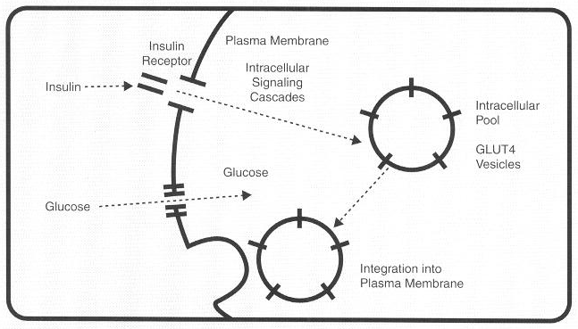
Source: Pietropaolo & Le Roith, 2001

Insulin Resistance, Insulin Insensitivity and Insulin Unresponsiveness
Kahn (1978) defines insulin resistance as a state when normal insulin concentrations result in “a less than normal biological response.” Kahn postulates that insulin resistance consists of insulin insensitivity and insulin unresponsiveness. Insulin insensitivity is a state when greater than normal insulin concentrations are needed to elicit a normal biological response and the dose-response curve of insulin is shifted to the right. This effect is consistent with an insulin receptor defect (Molnar, 1990). Insulin unresponsiveness is a state when the maximal insulin response is decreased, but the dose-response curve of insulin remains the same. This effect is consistent with a post-receptor defect, which would not permit a maximal biological response, even at high insulin levels (Molnar, 1990). Furthermore, a combination of insulin insensitivity and unresponsiveness can exist, which is the existence of receptor and post-receptor defects (Figure 2).

Figure 2: Types of insulin resistance


Adapted from Kahn, 1978.

Insulin and Leptin
Leptin is a hormone synthesized by adipose tissue that regulates body weight, food intake, energy expenditure and endocrine functions (Steppan & Lazar, 2002; Koopmans et al, 1998). Leptin and its function in animal and human physiology have been studied extensively. Increasing leptin levels lead to fatty acid oxidation and reduction in adipose tissue mass, whereas leptin deficiency is associated with an increase in fat deposition (Friedman & Halaas, 1998). The leptin receptor (db or Ob-R), which has been isolated from mice, is essential for signal transduction and for leptin’s weight-reducing effects (Friedman & Halaas, 1998).
Leptin concentration can be increased in obese individuals, suggesting a resistance to its effect (Haffner et al, 1997), but there are significant differences in leptin levels at each degree of adiposity, suggesting that environmental and genetic factors may regulate leptin concentrations. However, 5-10% of obese individuals have low leptin levels, an indication of a decreased rate of leptin production (Friedman & Halaas, 1998). Therefore, the pathogenesis of some forms of obesity is more likely to be a result of differences in leptin secretion and/or sensitivity (Friedman & Halaas, 1998).
In animal models, leptin levels have been associated with insulin action. Leptin-deficient ob/ob mice and leptin receptor-deficient db/db mice are characterized by extreme insulin resistance, which in the ob/ob mice is reversible by leptin infusion (Steppan & Lazar, 2002). Leptin administration has been shown to enhance insulin sensitivity and glucose disposal rate in ob/ob mice (Steppan & Lazar, 2002). A constant insulin infusion in rats resulted in a progressive increase in leptin levels and in a parallel decrease in food consumption (Koopmans el al, 1998).
Conflicting results have been published on the effect of insulin on leptin in human subjects. Several studies have failed to find a correlation between insulin concentrations and circulating leptin levels (Caprio et al, 1996; Schwartz et al, 1997). Increasing evidence suggests that insulin-mediated glucose uptake, rather than insulin itself, regulates circulating leptin concentration (Fruehwald-Schultes et al, 2002; Wellhoener et al, 2000). Numerous studies have found an association between leptin concentration and plasma insulin response (Abbasi et al, 2000; Albala et al, 2000; Schmitz et al, 1997). It has been postulated that leptin resistance may be a result of insulin resistance from a study in lean, normoglycemic men (Haffner et al, 1997). Fruehwald-Schultes et al (2002) showed that experimentally-induced insulin resistance in normal-weight men diminished the stimulatory effect of insulin on leptin.

Insulin and Adiponectin
Adiponectin is a hormone that is synthesized in the adipose tissue (Scherer et al, 1995; Hu et al, 1996; Maeda et al, 1996; Nakano et al, 1996). Adiponectin is an abundant plasma protein, ranging in concentration from 5 – 30 µg/ml, which is approximately three times higher than that of the majority of hormones (Gil-Campos et al, 2004). Its physiological role has not been fully clarified. Several studies suggest that it may modulate insulin action, and that it has anti-inflammatory and anti-atherogenic properties (Gil-Campos et al, 2004). It has been postulated that adiponectin increases insulin sensitivity by increasing muscle glucose uptake and fatty acid oxidation (Gil-Campos et al, 2004).
In animal models, adiponectin has been associated with insulin sensitivity and lipid oxidation in the muscle. In normal and db/db mice, adiponectin administration resulted in lowering serum glucose levels (Berg et al, 2001). Furthermore, adiponectin administration improved obesity-induced insulin resistance in ob/ob mice (Yamauchi et al, 2001).
It has been shown that transcription of the adiponectin gene is decreased in diabetic and obese individuals (Statnick et al, 2000). It has also been demonstrated that weight loss results in increased adiponectin concentrations in obese and diabetic individuals (Hotta et al, 2000; Yang et al, 2001). This increase in adiponectin levels has been correlated with improvement in insulin resistance after weight loss (Vendrell et al, 2004). High adiponectin values have been shown to predict increased insulin sensitivity, independent of body fat mass in both men and women (Tschritter et al, 2003).

From Insulin Resistance to Type 2 Diabetes
At the initial steps of insulin resistance, enhanced insulin secretion (2-3 fold) can compensate for this situation for several years (Groop, 2000). However, after a certain point, this is no longer possible and hyperglycemia occurs. Once chronic hyperglycemia has developed, it can result in further increases in insulin resistance and subsequent deterioration of the pancreatic β cells (So et al, 2000). In most cases, type 2 diabetes begins years before it is diagnosed. In 50% of the cases, patients have already developed macrovascular disease by the time of diagnosis (Groop, 2000).

Type 2 Diabetes
Diabetes mellitus is a group of metabolic disorders, characterized by high levels of blood glucose and resulting from defects in insulin secretion, insulin action or both (CDC, 2005). The two principal forms of diabetes mellitus are Type 1 and Type 2. Type 1 diabetes is caused by autoimmune pancreatic β cell exhaustion and loss of insulin secretion (Fagot-Campagna et al, 1999; Ludwig & Ebbeling, 2001). Until recently, type 1 diabetes in children was the only type of diabetes prevalent among this age group (ADA, 2000). Type 2 diabetes, which is characterized by insulin resistance, obesity, a sedentary lifestyle, and occasionally by decreased insulin secretion was considered an adult disease. Because obesity and physical inactivity are increasing in children, the prevalence of pediatric type 2 diabetes has increased dramatically over the past 20 years (Rosenbloom et al, 1999; Fagot-Campagna et al, 1999). More than 85% of adult and pediatric cases of diabetes mellitus are type 2 (So et al, 2000).
Maturity-Onset Diabetes of the Young (MODY) is a subtype of type 2 diabetes, which accounts for 2-5% of the cases of type 2 diabetes (So et al, 2000). It is an autosomal dominant trait and it primarily affects insulin secretion. MODY can be caused by mutations in the glucokinase genes. Defective glucokinase activity leads to reduced rate of glycolysis in the pancreas, reduced glycogen synthesis and increased gluconeogenesis in the liver. It is a disease thus far diagnosed mostly in France (50% of cases) and in the United Kingdom (17% of the cases).

Diagnosis of Diabetes
According to the 1997 Report of the Expert Committee on the Diagnosis and Classification of Diabetes Mellitus, there are three ways to diagnose diabetes:
- Symptoms of diabetes (polyuria, polydipsia, and unexplained weight loss) plus casual plasma glucose concentration >200 mg/dL (11.1 mmol/L). Casual is defined as a value taken at any time of day without regard to time since last meal.
- Fasting plasma glucose (FPG) >126 mg/dL (7.0 mmol/L). Fasting is defined as no caloric intake for at least 8 hours.
- 2-hour postload glucose >200 mg/dL (11.1 mmol/L) during an oral glucose tolerance test (OGTT). The test should be performed as described by the World Health Organization (WHO), using a glucose load containing the equivalent of 75 g anhydrous glucose dissolved in water.
In the presence of hyperglycemia, testing should be performed to confirm diagnosis on a subsequent day. In the absence of hyperglycemia, repeat testing should be performed on a different day (Expert committee on the diagnosis and classification of diabetes mellitus, 1997).
The same report defines impaired fasting glucose (IFG) as FPG from 110 – 126 mg/dL (6.1 – 7.0 mmol/L) and impaired glucose tolerance (IGT) as 2-hour postload glucose from 140 – 200 mg/dL (7.75 – 11.1 mmol/L) during an OGTT (Diabetes Care, 1997). Normal fasting glucose (NFG) is defined as < 110 mg/dL (6.1 mmol/L) and normal glucose tolerance as 2-hour postload glucose <140 mg/dL (7.75 mmol/L) during an OGTT (Diabetes Care, 1997).

Genetic Contributions to Type 2 Diabetes
Type 2 diabetes is a complex heterogeneous disorder caused by interactions of various genetic and environmental factors (Gloyn & McCarthy, 2001; Ong & Dunger, 2000; So et al, 2000). Only a small percentage of cases of type 2 diabetes (2-5%) is caused by a defect of a single gene (MODY). Several susceptibility genes have been discovered to contribute to the pathogenesis of type 2 diabetes (Gloyn & McCarthy, 2001).
Many twin studies have evaluated the genetic component of type 2 diabetes, resulting in additional evidence of a genetic predisposition for the disease (Medici et al, 1999; Poulsen et al, 1999; Kaprio et al, 1992). A study performed on 606 Danish twins, calculated a 26% hereditability for type 2 diabetes and a 61% value for glucose intolerance (Poulsen et al, 1999). Another study of 13,888 Finish twins revealed similar concordance rates for monozygotic twins (Kaprio et al, 1992). A prospective study of 44 non-diabetic British monozygotic twins, who had siblings with type 2 diabetes, had more astonishing results. The concordance rate of these twins increased with age, reaching 96% after 15 years follow up (Medici et al, 1999).
Numerous epidemiological studies have shown an increased prevalence of insulin resistance and type 2 diabetes in various ethnic groups, among which are American Indians, African American and Hispanic (Saad et al, 1991, Haffner et al, 1991). The Pima Indians, who have the highest recorded prevalence of type 2 diabetes, have been studied extensively (Dabelea et al, 1999; Dabelea & Pettitt, 2001; Saad et al, 1991; Story et al, 1999). The high prevalence of diabetes among this ethnic group has been related to the increase in frequency of exposure to diabetes in utero as well as low birth weight (Dabelea et al; 1998; Dabelea et al, 2000; Lindsay et al, 2000). African-Americans have been shown to have significantly lower insulin secretion and sensitivity than whites (Arslanian & Suprasongsin, 1996; Cruz et al, 2002). Hispanics have been shown to have a higher insulin secretion and hyperinsulinemia could be a possible reason for the high prevalence of diabetes type 2 among this ethnic group (Haffner, 1987; Haffner et al, 1991; Haffner et al, 1992).
The increased prevalence of diabetes type 2 among several ethnic groups has triggered several researchers to explore the “thrifty genotype hypothesis.” According to this hypothesis, the high frequency of type 2 diabetes in societies that suffered from malnutrition, suggests that there is a predisposition to this disease due to an evolutionary advantage (Ong & Dunger, 2000). This advantage enables the fetuses with the “thrifty genotype” to store energy more efficiently in an unfavorable intrauterine environment and survive prolonged food shortages (Kawaga et al, 2002; So et al, 2000). However, in affluent societies, these fetuses are at a greater risk of developing diabetes later in life (Kawaga et al, 2002). The opposing theory suggests that poor maternal nutrition would result in poor fetal growth, resulting in defective development of the pancreatic β cells and insulin sensitive tissues (So et al, 2000). This “thrifty phenotype” hypothesis postulates that low rates of growth program fetal metabolism and result in an increased risk for type 2 diabetes (Forsen et al, 2000; Hales & Barker, 1992; Ong & Dunger, 2000). Those two hypotheses explain the high prevalence of type 2 diabetes among individuals who had a low birth-weight and have a later affluent life, with food abundance, physical inactivity, and psychosocial stress (So et al, 2000; Lindsay et al, 2000; Dabelea et al, 1999).

Obesity-Induced Type 2 Diabetes
Obesity-induced insulin resistance in adults has been linked with endothelial dysfunction (Tounian et al, 2001). It has been suggested that impairment of nitric oxide (NO) synthesis results from the decreased levels of apolipoprotein A-I and HDL in the obese state (Tounian et al, 2001). Decreased endothelial NO synthesis causes the tightening of the lumen of the capillaries and prevents vascular relaxation. Endothelial dysfunction could thus prevent effective insulin transport to the peripheral tissues and cause insulin resistance. Several studies support the existence of endothelial dysfunction in insulin resistance (Verma & McNeill, 2001; Weyer et al, 2002). However, it still remains a controversy whether endothelial dysfunction is a cause or consequence of obesity and insulin resistance (Baumgartner-Parzer & Waldhausl, 2001; Tack et al, 1998; Avogaro et al, 1997; Utriainen et al, 1996).
Most factors in obesity that influence the response to insulin and result in insulin resistance can be receptor or post-receptor events (Caballero, 1992).

Receptor Events
In 1963, Randle et al proposed a relationship between glucose and free fatty acid metabolism, the glucose – fatty acid cycle. According to Randle, FFAs compete with glucose as a substrate for energy. As a result, increased FFAs cause a rise in fatty acid oxidation and a decrease in glucose uptake by insulin, leading to insulin resistance (Randle et al, 1963). Substrate competition caused by dietary factors has been shown to impair insulin response during elevated fat metabolism (Vouillamoz et al, 1987; Boden et al, 1991). However, this event has been observed at high and low plasma insulin levels (Vaag et al, 1994).
In obesity, there is a decrease in the binding of insulin to its receptors due to a decrease in the number of available receptors in muscle, liver and adipose tissues (Kahn, 1980). Excess adiposity results in a down-regulation of insulin receptors, that is proportional to basal insulin concentration and body adiposity, and is caused by the increase of plasma insulin for a prolonged period of time (Kahn, 1980). A decreased number of insulin receptors is not likely to affect insulin sensitivity exceedingly, because saturation of the receptors and maximal insulin action is achieved at a 10% utilization of the receptors (Caballero, 1992).
Rare mutations in the insulin receptor result in severe insulin resistance (leprechaunism or type A syndrome of insulin resistance). These mutations are less than 1% of all cases of type 2 diabetes (Zierath & Wllberg-Herniksson, 2002). Impaired signal transduction through the insulin receptor pathway is more likely to have a profound effect on glucose metabolism.
The human insulin receptor (HIR) exists in two subtypes: HIR-A and HIR-B, which differ by a 12-amino acid sequence insertion in the α-subunit of the HIR-B type (Mosthaf et al, 1991). These two types of receptors differ in the affinity for insulin and HIR-B has the lowest insulin-binding activity of the two isoforms. These differences in the two isoforms are acquired, rather than derived from defects in the primary structure of the receptor (Cama et al, 1990). In experiments it has been shown that in skeletal muscle of non-diabetic individuals, predominantly mRNA encoding for the HIR-A is found, while in type 2 diabetic individuals similar amounts of each isoform are expressed and therefore an increased level of HIR-B is found (Kellerer et al, 1993). However, it has been shown that the expression of the isoforms does not account for skeletal muscle insulin resistance in type 2 diabetes and obesity (Anderson et al, 1993; Haring et al, 1994). Insulin receptor activity can be inhibited by hyperglycemia, through the isoforms of protein kinase C, which are able to form stable complexes with the insulin receptor and modulate its tyrosine kinase activity through serine phosphorylation of the receptor β subunit (Haring et al, 1994).

Post-receptor Events
Various post-receptor defects have been linked to obesity and the mechanisms involve defects in the signaling cascade following the binding of insulin to its receptor, resulting in a reduction of glucose transporters (Caballero, 1992; Molnar, 1990). These defects have been linked to abnormalities in the skeletal muscle and include increased concentration of intramyocellular lipids (IMCL) and altered composition of muscle fiber types (Ashley et al, 2002).

Adipose Tissue Deposition in Human Skeletal Muscle and Liver

Quantification Methods
Muscle fat deposition can be measured by Computed Axial Tomography (CAT scan). However, there are safety issues resulting from ionizing radiation of this method (Sinha et al, 2002). Furthermore, muscle fat deposition can be measured through muscle biopsy, but the major problem of this method is its invasive nature and variable results, with a coefficient of variation ranging from 20 – 26% (Wendling et al, 1996). In addition to the problems associated with these two techniques, they also lack the accuracy and sensitivity to discern between intramyocellular and extramyocellular lipids (EMCL) (Sinha et al, 2002).
Proton nuclear magnetic resonance (MRS) is a non-invasive method, which has the capacity to quantitatively determine IMCL and EMCL, as well as intrahepatic lipid accumulation (IHL) in vivo and has been validated in animal and human models against histological and biochemical analyses (Schick et al, 1993; Rico-Sanz et al, 1998; Rico-Sanz et al, 1999; Boesch et al 1997; Szczepaniak et al, 1999).

Proton Magnetic Resonance Spectroscopy
Over the last few years, the use of magnetic resonance has been applied to the measurement of metabolic products and intermediates (Szczepaniak et al, 1999). ³¹P magnetic resonance spectroscopy is used to study energy metabolism, ¹³C magnetic resonance spectroscopy is used to study carbohydrate metabolism. Proton MRS has been used to study brain disorders and defects in lipid metabolism and recently it has been used to measure intracellular triglyceride levels in body tissues (Szczepaniak et al, 1999).
MRS is mainly performed in the soleus (SOL) and tibialis anterioris (TA) calf muscles, because of their muscle fiber content (Perseghin et al, 1999). The human muscle fiber types are slow-twitch oxidative fibers (fibers type I), fast-twitch oxidative fibers (fibers type IIa) and fast-twitch glycolytic fibers (fibers type IIb). Fibers type I are the insulin sensitive fibers, whereas fibers type IIa have moderate insulin sensitivity and fibers type IIb have the least (Perseghin et al, 1999). The SOL is a feathered muscle with oblique and crossing fiber and orientation and is prevalently composed of insulin-sensitive oxidative fibers type I (Machann et al, 2004). The TA is a spindle-shaped muscle with parallel fiber orientation and has a higher percentage of less insulin sensitive glycolytic fibers type IIb (Machann et al, 2004). Thus, both of these muscles are very useful in observing an association between insulin resistance and IMCL (Perseghin et al, 1999; Ashley et al, 2001).
MRS distinguishes between IMCL and EMCL because of the frequency shift caused by the difference in magnetic susceptibility between the adipocyte pool and the intramuscular fatty acid compartment, as well as the difference in geometric arrangement of muscle tissue (Boesch et al, 1997, Schick et al, 1993). The resonances of the methyl and methylene proton of the triglyceride (TG) acyl chains appear between 1.0 and 1.6 parts per million (ppm; Szczepaniak et al, 1999). In healthy human muscle, it has been shown that four peaks appear in a proton spectrum, as can be seen in Figure 3 (Szczepaniak et al, 1999). The peak at 1.6ppm represents the methylene (-CH₂) resonance of EMCL, while the peak at 1.2ppm represents the methyl (-CH₃) resonance of EMCL (Rico-Sanz et al, 1998). Furthermore, the peak at 1.4ppm corresponds to the methylene (-CH₂) resonance of IMCL, while the peak at 1.0ppm corresponds to the methyl (-CH₃) resonance of IMCL (Szczepaniak et al, 1999).

Figure 3: Proton spectrum of human soleus muscle
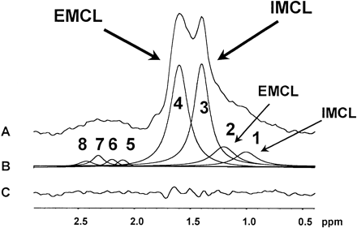
A: raw spectrum; B: deconvolution with fitted peaks for signals identified by prior knowledge; C: difference spectrum after subtracting fitted curves from B from raw data in A. EMCL, extramyocellular; IMCL, intramyocellular. IMCL CH₃ (1) and CH₂ (3) at 1.0 and 1.4 parts per million (ppm); EMCL CH₃ (2) and CH₂ (4) at 1.2 and 1.6 ppm; IMCL+EMCL α-CH₂ (5, 6) and polyolefinic/monolefinic (7, 8) CH₂ overlap and were approximated by four peaks. Source: Szczepaniak et al, 1999

The MRS determination of IMCL has several potential sources of error. The signal of cellular phospholipids, cholesterol esters and lactate is possible to contaminate the total methylene signal at approximately 1.3 ppm. However, under normal conditions, the concentration of these moieties is low and these compounds do not interfere significantly with the TG methylene peaks (Szczepaniak et al, 1999). Furthermore, in MRS TG determination, a source of error can occur if the composition of TGs in the diet is much different than expected (Szczepaniak et al, 1999). The predominance of a limited number of fatty acids (18:0, 18:1 and 16:0) in the diet can minimize such errors.
In the human calf muscle, the coefficient of variation (CV) of MRS for IMCL determination of SOL has been shown to be 11.8% for lean individuals and 7.9% for obese individuals and the EMCL of SOL was 22.6 and 52.5% respectively (Szczepaniak et al, 1999). Another study by Rico-Sanz et al (1998) measured the CV of IMCL of the SOL muscle to be 13.6% and that of EMCL to be 13.2%. Brechtel et al (1999) quantified the CV of IMCL of the SOL muscle to be within 2 – 15% and that of the TA to be 2 – 12%, while the CV of EMCL of the SOL muscle was 8 – 17% and that of the TA was 12 – 45%. The strong dependence of EMCL on the voxel positioning and the high CV obtained from its measurement limit its physiological relevance (Machann et al, 2004).
MRS is a useful tool for noninvasive determination of abnormalities in lipid metabolism and can accurately distinguish between IMCL and EMCL in animal and human models (Perseghin et al, 1999; Szczepaniak et al, 1999; Sinha et al; 2002). It can be used successfully to study alterations in IMCL and the association of muscular lipid accumulation with the development of insulin resistance in obesity.
MRS has also been used in studies of liver diseases and has been shown to correlate well with histological and biochemical analyses (Tarasow et al, 2002; Szczepaniak et al, 1999). In liver proton spectra, a single peak at 0.8 – 1.6ppm indicates the presence of abnormal liver fat (Figure 4). A separation of methyl and methylene IHL is not possible. Thomas et al (2005) reported that the CV for IHL determination with subject repositioning was 6 – 7%.

Figure 4: Proton spectrum of human liver
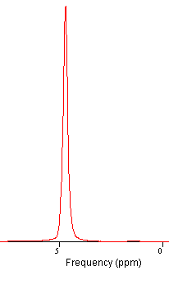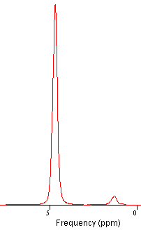
water
water
Presence of
abnormal IHL
Absence of
abnormal IHL
The left spectrum is a liver spectrum of a subject with presence of abnormal intrahepatic lipid (IHL) at 0.8 – 1.6ppm. The right spectrum is a liver spectrum of a subject with absence of abnormal IHL at 0.8 – 1.6ppm. The water peak is shown at 4.7 – 4.8 ppm at both spectra.

Mechanism of Muscle Lipid Accumulation
As a result of lipid accumulation in the muscle, glucose metabolism is compromised due to impaired insulin-stimulated glucose transport and subsequent defect in glycogen synthesis (Perseghin et al, 1999). Defective glucose transport is thought to cause an interruption in the insulin-signaling cascade (Krssak et al, 1999). The exact molecular mechanism of defective glucose transport is not yet elucidated. However, it has been postulated that increased IMCL, due to dietary excess, inhibits the docking and fusion process of the GLUT4 transporters to the plasma membrane and the subsequent glucose transport in the muscle cell (Jacob et al, 1999). The proposed mechanism (Figure 5) postulates that IMCL levels activate protein kinase C (PKC) in the muscle cell, which in turn phosphorylates the IRS-1 molecule at the serine residue instead of the tyrosine residue. As result, IRS-1 is deactivated and there is a disruption of the cascade that leads to GLUT4 translocation to the surface and therefore, glucose cannot be transported in the cell.

Figure 5: Mechanism of insulin resistance due to increased FFA concentration
Normal glucose transport
Insulin
Insulin
Receptor
Tyrosine Kinase
Phosphorylation
GLUT4
Glucose
IRS-1
Insulin
Insulin
Receptor
IRS-1
FFA → FAcyl-CoA
PKC
Serine Kinase
Phosphorylation
GLUT4
Glucose
Defective glucose transport

IRS-1: Insulin Receptor Substrate 1; FFA: Free Fatty Acids; FAcyl-CoA: Fatty Acyl Coenzyme A; PKC: Protein Kinase C.

Fatty Liver Disease
Fatty liver disease can be classified as alcoholic and nonalcoholic. Alcoholic fatty liver disease (AFLD) is the inflammation of the liver caused by alcohol abuse. The pathophysiology of alcoholic fatty liver is linked to nutrient malabsorption and reduced consumption because of an increase in empty calories from alcohol and reduced appetite (NIH, 2005). The liver inflammation progresses to fatty liver and the final stage is irreversible liver damage (cirrhosis).
Nonalcoholic fatty liver disease (NAFLD) includes a range of changes from fatty liver (steatosis) to steatohepatitis (NASH) and cirrhosis (Mendler, 2005). The similarity among all stages of NAFLD is lipid accumulation in the liver cells (hepatocytes). In NASH, the fat accumulation is associated with different levels of hepatitis (inflammation) and fibrosis (scarring) of the liver. Although the histology of NAFLD is similar to AFLD, it does not occur due to high alcohol consumption. Several conditions are associated with NAFLD, the two most important being obesity and type 2 diabetes (Choudhury and Sanyal, 2004). Although the prevalence of NAFLD is 3% in the U.S. population, among obese individuals it is as high as 20 – 40% (Youssef and McCullough, 2002). The high rates of NAFLD among obese individuals may be explained by the action of the liver cells (hepatocytes) as a reservoir of toxic compounds which are susceptible to reactive oxygen species, resulting in lipid peroxidation and eventually leading to cell death (Youssef and McCullough, 2002).

Lipid Accumulation and Insulin Resistance
The deposition of triglycerides (TG), for the breakdown into fatty acids (FAs) and the production of energy, has been thought to take place only in adipose tissue, but recently FAs in the skeletal muscle have been established to be important energy sources (Sinha et al, 2002; Krssak et al, 1999). The overaccumulation of various lipids in the skeletal muscle has been linked with an increase in insulin resistance in obese and lean adults, as well as in nondiabetic offspring of type 2 diabetic subjects (Jacob et al, 1999; Krssak et al, 1999; Perseghin et al 1999; Boden et al, 2001; Ashley et al, 2002; Sinha et al, 2002; Virkamaki et al, 2001).
Perseghin et al (1999) studied 14 young lean offspring of type 2 diabetic parents and 14 healthy subjects matched for anthropometric and lifestyle factors (mean age = 30 years). Insulin sensitivity was evaluated by the euglycemic-hyperinsulinemic clamp and IMCL of the SOL and TA was determined by proton MRS. This study results indicated an increase IMCL of the SOL but not the TA muscle in the offspring of diabetic parents. Furthermore, IMCL in the SOL muscle and FFA were the main predictors of insulin sensitivity.
A group of 41 boys with a mean age of 9.1 years and no history of diabetes, and a group of 23 mothers of this cohort with a mean age 39 years were studied (Ashley et al, 2002). Insulin sensitivity was assessed by fasting glucose and insulin values and IMCL of the SOL muscle was determined by proton MRS. Significant associations were found between the boy’s IMCL and insulin sensitivity, as well as maternal log fasting plasma insulin (FPI) and IMCL values. In a subset of 23 boys, maternal IMCL explained 39% of the variance in their IMCL.
In a study performed by Jacob et al (1999), 13 lean insulin resistant (mean age = 31.8 years) were compared to 13 lean insulin sensitive subjects (mean age = 29.4 years), both relatives of type 2 diabetics which were matched for sex, age, BMI, percent body fat, physical fitness and waist-to-hip ratio. Insulin sensitivity was determined by the euglycemic-hyperinsulinemic clamp and IMCL was determined by proton MRS of the SOL and the TA muscles. This study showed that IMCL in both muscles was statistically significantly higher in the insulin-resistant compared to the insulin-sensitive individuals, whereas EMCL content in both muscles was not significantly different in the two groups. These results demonstrated that high levels of IMCL can be an early response in the development of insulin resistance.
Virkamaki et al (2001) studied a group of 20 healthy men (mean age = 42 years) with no family history of diabetes (mean BMI=26 kg/m²). Insulin sensitivity was assessed by the euglycemic-hyperinsulinemic clamp and IMCL was determined by proton MRS of the vastus lateralis muscle. The subjects were then separated in two groups, one with high IMCL and one with low IMCL levels. Both groups had similar characteristics, with respect to age, BMI, and maximal oxygen consumption. In that study, IMCL accumulation was associated with whole-body insulin resistance and with defective insulin signaling in skeletal muscle independent of body weight and physical fitness (Virkamaki et al, 2001).
Furthermore, Krssak et al (1999) investigated the association between IMCL levels and insulin sensitivity in a group of 23 normal weight non-diabetic subjects (mean age = 29 years, mean BMI = 24.1 kg/m²). In this study group, IMCL of SOL muscle was quantified using proton MRS and insulin sensitivity was assessed by the insulin clamp. It was demonstrated that IMCL and insulin sensitivity were inversely correlated. In the same study, it was shown that IMCL-associated insulin resistance was unrelated to BMI, age and fasting plasma concentrations of triglycerides, non-esterified fatty acids, glucose or insulin (Krssak et al, 1999). The authors concluded that IMCL levels quantified by proton MRS are good indicators of whole body insulin sensitivity in non-diabetic lean adults.
Sinha et al (2002) explored the relationships between IMCL and EMCL to in vivo insulin sensitivity, independent of total body fat and central obesity in a group of 14 obese (mean BMI = 35 kg/m², mean age = 13 years) and 8 lean adolescents (mean BMI = 21kg/m², mean age = 14 years). Both study groups underwent IMCL and EMCL determination of the SOL muscle by proton MRS and insulin sensitivity assessment by the euglycemic-hyperinsulinemic clamp. Both IMCL and EMCL of SOL were significantly higher in the obese adolescents compared to the lean controls. In the same study, a strong inverse correlation was found between IMCL and insulin sensitivity, which became stronger after adjusting for TBF and abdominal subcutaneous fat mass (Sinha et al, 2002).
However, a study by the same group failed to uncover a correlation between insulin sensitivity and IMCL in the SOL muscle in a group of 30 healthy Asian Indian males with a mean age of 40.6 years and a mean BMI of 23.2 kg/m² (Sinha et al, 2005). Proton MRS was used to evaluate IMCL in the SOL muscle and HOMA was used as an index of insulin resistance. IMCL levels of this group did not show a significant correlation with HOMA values.
Several studies have investigated the effect of acute changes in plasma FFA and changes in IMCL and insulin resistance (Boden et al, 2001; Brechtel & Dahl et al, 2001; Backman et al, 2001). These studies were performed in young healthy lean volunteers. IMCL was quantified by proton MRS and insulin resistance was assessed by the euglycemic-hyperinsulinemic clamp, before and after lipid and heparin infusions. Acute changes in plasma FFA were accompanied by corresponding changes in IMCL (Boden et al, 2001; Brechtel & Dahl et al, 2001; Backman et al, 2001) and insulin resistance (Boden et al, 2001; Backman et al, 2001).
The majority of studies that have been used to evaluate skeletal fat accumulation were cross-sectional. Few longitudinal studies investigated the depletion of IMCL levels in the skeletal muscle with weight loss (Petersen et al, 2005; Greco et al, 2002; Tamura et al 2005).
Greco et al (2002) tested the effects of selective IMCL depletion on the obesity-associated insulin resistance. This group measured whole-body insulin sensitivity by the euglycemic-hyperinsulinemic clamp technique, and IMCL by quantitative histochemistry on quadriceps muscle biopsies on a group of 20 morbidly obese patients, and 7 non-obese control patients. A group of 8 obese individuals underwent biliopancreatic diversion (BPD) and lost 24% of their total body weight, while a group of 9 obese subjects were administered a hypocaloric diet and lost 10% of the their total body weight in a period of 6 months. Insulin resistance was reversed in the obese group who underwent BPD and IMCL levels were decreased. Furthermore, Glut4 expression was restored, and circulating leptin concentrations were normalized in the same group. The hypocaloric diet group showed small changes in insulin sensitivity and IMCL compared to the obese BPD group. This research group concluded that IMCL was selectively depleted as a result of lipid deprivation and a normal metabolic state was subsequently induced.
A short-term weight loss study to examine the effect of moderate weight reduction on IMCL and insulin resistance in type 2 diabetic patients was recently published (Petersen et al, 2005). This study included a group of 8 obese sedentary diabetic patients (5 men and 3 women), with a mean age of 47 years and mean BMI of 30.1 kg/m², and a control group of lean sedentary individuals (5 men and 5 women), with a mean age of 30 years and a mean BMI of 25.2 kg/m². The endpoint of the intervention was normoglycemia (3 – 12 weeks) and the obese subjects were analyzed at baseline and two weeks after weight stabilization on a hypocaloric low-fat diet. The control group was only examined at baseline. Insulin sensitivity was assessed by the euglycemic-hyperinsulinemic clamp technique, while IMCL of the SOL muscle and IHL were measured by proton MRS. The diabetic group was significantly insulin resistant compared to the insulin sensitive lean controls at baseline. After a mean weight loss of 8 kg (9.3% of total body weight), the diabetic group demonstrated a significant improvement in hepatic insulin resistance, but not in peripheral glucose metabolism or IMCL.
Another short-term diet and exercise study examined the effects of IMCL, IHL, and peripheral insulin sensitivity (Tamura et al, 2005). In this study, two groups of type 2 diabetics were studied at baseline and after a two-week diet and a diet plus exercise intervention. The diet group had a mean age of 55.0 years and a mean BMI of 27.4 kg/m² compared to that of 46.3 years and 27.1 kg/m² of the diet and exercise group. Insulin sensitivity was assessed by the euglycemic-hyperinsulinemic clamp technique, while IMCL in the TA muscle and IHL were measured by proton MRS. In both groups a significant decrease in IHL was found, which was independent of fasting FFA levels. However, IMCL was reduced by 19% and glucose infusion rate was increased by 57% only in the diet and exercise group.
A longer intervention trial of diet and exercise was performed by He et al (2004) to examine the effect on IMCL and lipid droplet size in a group of sedentary obese individuals. IMCL and lipid droplet size were quantified by percutaneous biopsy in the vastus lateralis muscle of 21 obese individuals (mean age ≈ 40 years, mean BMI = 33.3 kg/m²). Insulin sensitivity was assessed by the euglycemic-hyperinsulinemic clamp technique. The intervention resulted in a 10% weight loss and a 46% increase in insulin sensitivity. Even though, IMCL levels were not significantly different after weight loss, the size of lipid droplets was significantly decreased and this reduction was associated with an increase in insulin sensitivity.

Lipid Accumulation and Exercise
Several studies have examined the role of physical activity and aerobic fitness on IMCL. Trained endurance athletes have been shown to possess elevated IMCL levels, even though they are very insulin sensitive (van Loon et al, 2004). This paradox was investigated in a group of 8 highly trained endurance athletes, 8 type 2 diabetic patients, and eight overweight, sedentary men after an overnight fast (van Loon et al, 2004). IMCL in the vastus lateralis was determined by muscle biopsy obtained from this population. IMCL levels were considerably higher in the athlete group compared to the overweight or type 2 diabetic individuals. Furthermore, a group of 9 lean trained subjects was examined before and after a submaximal treadmill run to exhaustion to determine the role of lipid utilization during exercise (Krssak et al, 2000). IMCL of the SOL muscle was quantified by proton MRS. After the exercise, IMCL levels increased to 83% of the baseline value.
One the contrary, a study on trained males (age range 24 – 38 years) showed that IMCL and EMCL of SOL, TA and gastrocnemius muscles (quantified by proton MRS) were not affected by exercise intensity (Rico-Sanz et al, 1998). The role of exercise duration and workload on IMCL was investigated by Brechtel & Niess et al (2001). A group of 12 male runners was studied before and after exercise to determine the effects of prolonged exercise of moderate intensity on skeletal muscle lipids. IMCL and EMCL of the TA and SOL muscles were quantified by proton MRS. Prolonged and moderate intensity exercise decreased IMCL in both muscles, whereas high intensity exercise did not affect IMCL in either muscle.
In a substudy of the Tubingen Family Study for Type 2 Diabetes, 105 healthy lean previously untrained individuals (mean age = 19 years, mean BMI = 24.6 kg/m²) were examined to determine the role of aerobic fitness and IMCL (Thamer et al, 2003). IMCL in the TA and SOL muscles was determined by proton MRS, aerobic capacity by bicycle ergometry, and insulin sensitivity by the euglycemic-hyperinsulinemic clamp. Only IMCL in the TA was significantly associated with measures of aerobic fitness, after adjusting for adiposity. In this study, no correlation was found between insulin sensitivity with IMCL in neither of the muscles studied.

Lipid Accumulation and Adiponectin
The possible role of adiponectin in insulin resistance and IMCL accumulation still remains unclear (Weiss et al, 2003; Perseghin et al, 2003). A study of 15 patients with type 1 diabetes, 7 patients with type 2 diabetes, 15 non diabetic insulin resistant offspring of type 2 diabetics, and 15 healthy controls investigated the role of reduced plasma adiponectin and increased IMCL in the pathogenesis of type 2 diabetes (Perseghin et al, 2003). Insulin sensitivity was assessed by the euglycemic-hyperinsulinemic clamp and IMCL of the SOL and TA muscles was quantified by proton MRS. In type 1, type 2 diabetics and offspring of type 2 diabetics, IMCL concentration was positively associated with insulin resistance. However, adiponectin levels were shown to be increased in type 1 diabetics in contrast to the decreased levels found in type 2 diabetics and their offspring.
Another study by Weiss et al (2003) examined the effects of adolescent obesity on plasma adiponectin, insulin sensitivity, IMCL, plasma TG and FFAs. Eight non obese (mean TBF = 18%) and 14 obese adolescents (mean TBF = 41%) were studied. Insulin sensitivity was assessed by the euglycemic-hyperinsulinemic clamp and IMCL of the SOL muscle was quantified by proton MRS. Adiponectin concentration was higher in the non obese adolescents and was positively associated with insulin sensitivity in both obese and non obese individuals. IMCL and plasma TG were negatively associated with adiponectin levels, and explained 62% of the change in adiponectin levels between the two groups. Further investigation is required to establish the link between excess adiposity, IMCL and insulin resistance.

HYPOTHESES AND OBJECTIVES

Hypotheses
- Insulin resistance in obesity is primarily dependent on IMCL concentration. There is better correlation between insulin resistance and IMCL than with BMI, serum TG levels or TBF.
- A reduction in IMCL will have more significant effects on insulin sensitivity than a reduction in body adipose tissue stores.

Objectives
The general aims of this study were to assess the correlations between insulin resistance, IMCL, BMI, serum TG and TBF of an obese group with an otherwise similar group of lean individuals, and to quantify the effects of weight loss through dietary intervention on the IMCL and insulin sensitivity of a group of healthy obese adults.
The specific objectives were:
- To quantify IMCL in lean and obese individuals and correlate with TBF and insulin sensitivity.
- To determine which variables are more useful in predicting insulin sensitivity among the outcome variables: BMI, TBF, IHL, waist-to-hip ratio (WHR), serum TG content, leptin, adiponectin, and IMCL.
- To establish whether the association of IMCL with insulin resistance is independent of other factors known to affect insulin action, like BMI, body composition and body fat distribution.
- To assess the impact of weight loss in obese individuals on IMCL, TBF and insulin sensitivity.
- To determine correlations between IMCL and leptin, adiponectin, insulin, glucose, serum TG levels, TBF, IHL, WHR, and BMI before and after the dietary intervention.

MATERIALS AND METHODS

Study Design
A prospective intervention trial was conducted to assess the effects of weight loss through dietary intervention on IMCL and insulin sensitivity in a group of healthy obese adults. Body composition, plasma metabolite levels, IMCL, IHL, and insulin resistance indices were compared at baseline and follow up. The desired endpoint for weight loss was 8 – 10% reduction of initial weight.
Furthermore, cross-sectional comparisons were performed at baseline between the obese group and an otherwise similar group of lean individuals to assess the correlation of insulin resistance in obesity with IMCL concentration. Anthropometric data, blood metabolites, IMCL, IHL, and insulin resistance indices of the obese were compared with those of the lean group. Baseline correlations were obtained for insulin resistance indices and measures of adiposity (including IMCL, BMI, TG, and WHR). A flow diagram of the study design is shown in Figure 6.
All participants from both obese and lean groups underwent the initial screening, and the intracellular lipid measurement by proton MRS. Only the obese subjects underwent the euglycemic-hyperinsulinemic insulin clamp procedure, the weight loss intervention and the follow up measurements (Figure 6).
Figure 6: Diagram of study design
MRS: Proton Magnetic Resonance Spectroscopy; Clamp: Euglycemic-Hyperinsulinemic clamp.

Sample Size
A total of 10 obese subjects were needed to detect a ±0.2% difference in IMCL after an 8 – 10% weight loss and a standard deviation of 0.22% with power of 0.80 and a significance level α of 0.05 (Sinha et al, 2002). The following sample size formula for paired data was used:
where is the percentile of the normal distribution used as the critical value in a two-tailed test of size α (1.96 for an 0.05 level test), is the th percentile of the normal distribution (0.84 for the 80th percentile), σ is the standard deviation and Δ is the expected difference between the two measurements. For baseline comparisons, a reference group of 19 lean individuals matched for gender and ethnicity was also used.
The sample size was verified using Stata version 8.1 (College Station, TX, 2004) for paired analysis with a baseline measurement and one follow up measurement, and a correlation of baseline and post-treatment measurement of 0.5.
The proposed sample size is sufficient to detect a significant difference in insulin resistance with a weight loss of 8 – 10 %. Similar studies that evaluated the change in insulin resistance after a 10% weight loss were able to detect a 32 – 42% improvement (Colman et al, 1995; Ikeda et al, 1996). Several studies have shown that even moderate weight loss (5-10% of body weight) results in great improvement in insulin sensitivity (up to 60%) and other risk factors for cardiovascular disease (Goldstein, 1992; Vidal, 2002; de Leiva, 1998; Van Gaal et al, 1997; Ross et al, 2000).

Subjects
All subjects recruited in this study were adults 20 – 65 years old. Obese participants had a BMI of 30.0 – 40.0 kg/m², while lean subjects had a BMI of 18.0 – 25.0 kg/m² and no history of obesity. Participants had to meet certain criteria to be eligible for inclusion in this study. All subjects should have had a normal electrocardiogram (ECG) or ECG approved by a physician investigator. Women of childbearing age should have agreed to use an acceptable form of birth control, and should have been non-pregnant or lactating. Subjects should have had no history or presence of any uncontrolled disease, or have taken drugs that could interfere with their metabolic status and their ability to complete the study. All subjects should have had normal fasting blood glucose (< 126 mg/dl), liver enzymes and thyroid hormone levels. Furthermore, all subjects had to sign an informed consent for their participation and agree to follow the research protocol.

Baseline Measurements

Initial Screening
All participants for this study (lean and obese) were pre-screened by telephone and their eligibility was established. All eligible participants were then asked to fast 8-10 hours prior to the screening visit. At the morning of the visit, they were provided with the informed consent forms.
Their vital signs were obtained (pulse and blood pressure) using an Omron HEM 907 blood pressure monitor (Omron Healthcare Inc, Bannockburn, Illinois). Height was measured to the nearest 0.1cm with a Harpenden 602VR stadiometer (Holtain Limited, Crymych, United Kingdom) and weight was measured with a ScaleTronix 6002 digital scale (Scale-Tronix, White Plains, New York) to the nearest 100g. Their BMI was calculated as weight (kilograms) divided by height squared (meters²).
A fasting blood draw was obtained for the following tests: complete blood count, thyroid and liver functions [Thyroid-Stimulating Hormone (TSH), Alanine Transaminase (ALT) Aspartate Aminotransferase (AST)], albumin, lipid profile [free fatty acids (FFA), serum triglycerides (TG), total cholesterol (TCho), High Density Lipoprotein (HDL), Low-Density Lipoprotein (LDL)], glycated hemoglobin (HbA1c), glucose, insulin, leptin and adiponectin. After the fasting blood draw, an Oral Glucose Tolerance Test (OGTT) was performed. Subjects ingested 75g of glucose solution (Glucotrol®). Repeat blood samples were taken at 30, 60, 90 and 120 minutes after the glucose ingestion. Between blood draws, an electrocardiogram (ECG) was performed using a GE Mac 5000 ECG system (GE Healthcare, Waukesha, Wisconsin).
Body composition was determined by Dual-energy X-ray Absorptiometry (DEXA) using a Hologic QDR 4500W total body scanner (Hologic Inc, Bedford, Massachusetts). DEXA has been used extensively for the determination of body composition (Rosenfalck et al, 2002; Munoz et al, 2002; Weyers et al, 2002; Martini et al, 2001; Lukaski, 1993; Slosman et al, 1992). DEXA allowed the direct measurement of the lean body mass, fat body mass and bone mineral body mass (Slosman et al, 1992). DEXA is accurate and precise enough to detect even small to moderate weight loss (Weyers et al, 2002). It is relatively inexpensive, widely available and exposure to radiation is low. Therefore, it has been deemed safe for clinical investigations in most populations (Wang et al, 1999).
The DEXA scanner performed serial transverse scans from head to toe at 1.2-cm intervals providing a pixel size of 1.9 mm × 1.2 cm (Panotopoulos et al, 2001). For each pixel, the equipment calculated weight, bone mass and percent of fat and integrated the measurements for the whole body and different regions as arms, trunk, and legs. Lean mass was indirectly calculated and the head was assumed to contain 17% fat. The precision of a whole body scan, performed by the Hologic QDR 4500W scanner has been reported in previous studies: 0.5% for lean body mass and 4% for body fat (Berruti et al, 2002).
Anthropometric measurements of waist and hip circumference were performed by a study dietician. Waist circumference was measured at the mid-point between the iliac crest and the lower costal margin in the mid-axillary line. Hip circumference was measured at the level of the greatest posterior protuberance of the buttocks. Both measurements were done to the nearest 0.1 cm using Gullick II tape. The waist circumference was divided by the hip circumference in order to calculate the waist-to-hip ratio (WHR) as a measure of central obesity. In previous studies, central obesity has been shown to correlate with higher insulin secretion and increased insulin resistance (Mayer-Davis et al, 2001; Furler et al, 2001).
The dietician also provided the subjects with food record forms. Subjects were asked to document detailed food intake on study forms for two weekdays and one weekend day. The subjects were asked to answer various questionnaires in order to determine their health status, eating and physical activity patterns, as well as weight and diet history. Screening for eating disorder symptoms (Eating Attitudes Test) and depression (Beck Inventory Scale) was performed. After the OGTT was completed, the subjects were given breakfast and were discharged.

Proton Nuclear Magnetic Resonance Spectroscopy
Subjects (lean and obese) were scheduled at the Kennedy Krieger F.M. Kirby Research Center for IMCL and IHL measurements. This procedure was performed in a Phillips Intera 1.5 Tesla magnetic resonance imaging (MRI) scanner (Philips Medical Systems N.A, Bothell, Washington), using a combination of whole body and knee coils by a trained radiology technician. Subjects were placed with their feet first in the MRI scanner in the supine position. The right calf of each subject was placed flat on a padded circular knee coil where the larger diameter of the calf muscle was positioned in the middle of the coil.
Initially, an initial crude scan, known as scout, was performed and sagittal T₁ images were taken, using the body coil and a repetition time (TR) of 500 ms, echo time (TE) of 15ms, and field-of-view (FOV) of 350mm. Slice thickness was 0.5 mm gap and a total of 18 slices were obtained. Water markers were used to visualize the position of the knee coil on the sagittal images (Figure 7). The distance between an anatomical landmark on the knee and the center of axial slice 11 was recorded and that image with the distance marked was saved to ensure reproducible positioning for the subsequent measurement (Figure 7). Then, axial T₁ images were taken, using the knee coil and a TR of 500 ms, a TE of 15ms, and a FOV of 150mm. Slice thickness was 0.5 mm and a total of 21 axial slices were obtained.

Figure 7: Sagittal magnetic resonance images of calf muscle
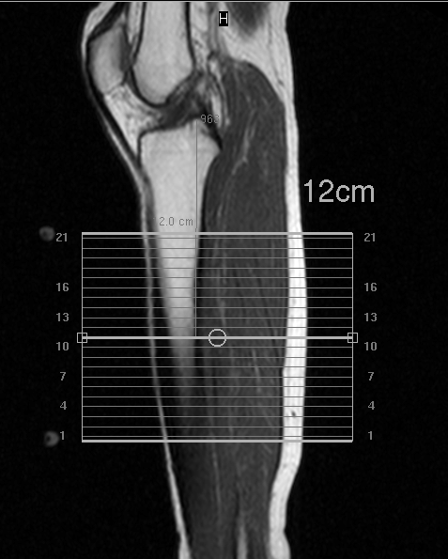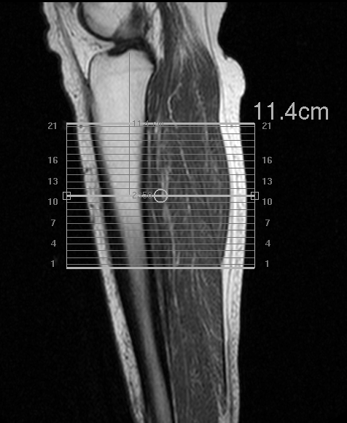
In both images the right calf is shown: on the right of a 31 year old obese male, while on the left of a 42 year old lean female. The distance between an anatomical landmark on the knee and the center of axial slice 11 is clearly marked on each image. The water markers used to visualize the position of the knee coil are visible on the left image.

The axial images were used to choose the position of the volume of interest, known as voxel, on the TA and SOL muscles of the calf (Figure 8). Voxel positions were determined in order to avoid vascular structures and gross adipose tissue deposits and to make sure that the muscle fibers were consistently oriented along the magnetic field. Single voxel magnetic resonance spectroscopy (MRS) was performed on both muscles, using the Point-Resolved Spectroscopy (PRESS) sequence, a voxel of 15 x 15 x 15 mm³, 128 acquisitions, TR=3s, TE=30ms, and water suppression. The same voxel was subsequently used to obtain 8 acquisitions, using TR=10s, TE=25ms, and no water suppression. The images of the voxel position of both muscles were saved to ensure reproducible positioning for the subsequent measurement.

Figure 8: Axial magnetic resonance image of the calf of a 34-year-old male volunteer
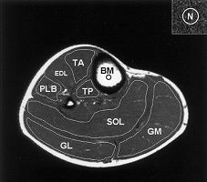
Regions of interest for evaluation of the muscular lipid content are drawn in tibialis anterioris (TA), tibialis posterioris (TP), soleus (SOL), gastrocnemius medialis (GM) and lateralis (GL), and peroneus longus and brevis (PLB). BM stands for tibial bone marrow. Source: Machann et al, 2003

When the muscle MRS was completed, the subjects were switched to head first in the MRI scanner in the supine position. Initially, a scout was performed and axial T₂-weighted spin-echo images were obtained from the torso, using the body coil and a TR of 5.9 ms and a TE of 3.1 ms. Then, a T₂ W scan was performed in the axial, sagittal and coronal planes in order to achieve proper positioning of the voxel in the liver. For this scan, the body coil was used and a TE of 90 ms and a TR of 3593ms. The images had a slice and gap thickness of 11mm. The position of the voxel was chosen to avoid major vascular structures in the liver. Single voxel MRS was performed the liver, using the PRESS sequence, a voxel of 60 x 50 x 60 mm³ (A-P=60mm, F-H=50mm, and R-L=60mm), 8 acquisitions, TR=10ms, TE=30ms, and no water suppression (Figure 9).
Figure 9: Axial, coronal, and sagittal magnetic resonance images of the liver
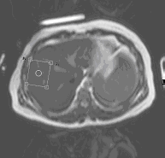 | 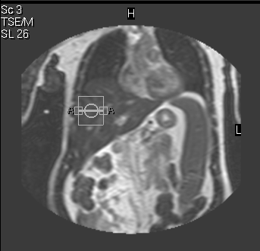 | 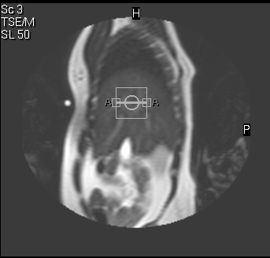
The axial image is shown on the left, the coronal is on the center, and the sagittal is on the right.

Euglycemic-Hyperinsulinemic Clamp Procedure
Obese subjects were admitted to the Johns Hopkins General Clinical Research Center (GCRC) the evening prior to the euglycemic-hyperinsulinemic clamp procedure. The clamp was performed the following morning after an overnight fast. The clamp is considered the gold standard for the measurement of insulin sensitivity (Radziuk, 2000). It is performed by infusing insulin in order to raise the plasma insulin concentration and maintain it at high levels, while keeping the plasma glucose concentration at basal levels by variable glucose infusion (DeFronzo et al, 1979). Under these steady state conditions, the glucose infusion rate is the same as the rate of glucose uptake from the body tissues, thus providing a means of calculating the sensitivity of the body tissues to exogenous insulin (DeFronzo et al, 1979).
Two flexible catheters were inserted in the subject: a 2’’ 18G flexible catheter was placed in a vein of the forearm for infusion of insulin and glucose, and a 1.5’’ 20G catheter was placed in a dorsal vein of the ipsilateral hand for blood sampling. Both lines were kept patent with a slow saline infusion until the start of the insulin infusion. The hand was then placed in a warming box at 50⁰C for the duration of the procedure. The warming box was used for “arterialization” of the hand line.
After obtaining baseline blood samples and determining the baseline glucose value, the insulin clamp procedure started. The insulin infusion was manually changed, while the glucose infusion was calculated by the CLAMP software, developed by Dr. Dariush Elahi. At time zero, the insulin infusion started at a high rate and was manually decreased every two minutes for the first ten minutes, remaining constant thereafter at a rate of 40 mU/m² of surface area per minute. Four minutes after the start of the insulin infusion, a variable-rate infusion of 20% dextrose started and was adjusted every 5 minutes based on the plasma glucose level. During the insulin clamp, circulating insulin levels where acutely elevated and blood glucose concentration was maintained within 10% of baseline levels (baseline glucose value ± 5%). Blood samples for insulin analysis were obtained at baseline and at 30, 60, 90, 100, 110, and 120 minutes after the start of the insulin infusion. Blood samples for glucose analysis were obtained at baseline and every five minutes thereafter.
The glucose disposal rate, a measure of insulin sensitivity, was calculated by the average of the glucose infusion rates during the last 30 minutes of the infusion. Upon completion of sampling at 120 minutes, the insulin infusion was discontinued, and the glucose infusion continued over a 10-20 minute period, while blood glucose was still being monitored. During this period, subjects were offered sweetened fruit juice. After the subjects were given lunch and their blood glucose value was at normal post-prandial levels, they were discharged.

Dietary Intervention
After the obese subjects have completed the initial screening and the baseline tests (IMCL and IHL determination by proton MRS and insulin sensitivity measurement by the clamp), they were referred to the Johns Hopkins Nutrition & Health Research Center. An experienced research associate assessed the participants and designed the weight loss program for each one at an energy intake designed to achieve a 1-2 lbs weight loss per week. The Mifflin-St Jeor prediction equation was used to estimate each participant’s resting metabolic rate (RMR), based on height, weight, age and gender (Mifflin et al, 1990). This equation was derived from a sample of 251 men and 247 women, aged 19 – 78 years. This study population included 264 normal weight and 234 obese individuals, and RMR calculations were compared to measured values from indirect calorimetry, and the predictive value of this equation was very high compared to other RMR prediction equation, like the Harris-Benedict, the Cunningham and the Owen equations (Harris and Benedict, 1919; Cunningham, 1980; Owen et al, 1986; Owen et al, 1987).
First, the Ideal Body Weight (IBW) was calculated, based on the individual’s gender:
Men: IBW = 106 lbs for the first 5 feet of height + 6 lbs for each additional inch
Women: IBW = 119 lbs for the first 5 feet of height + 3 lbs for each additional inch
The Adjusted Body Weight (ABW) was then calculated:
ABW = (CBW – IBW) x 0.25 + IBW, where CBW is the Current Body Weight in kg and IBW is in kg.
RMR (in kilocalories / day) was calculated, using the following equation:
Men: RMR = (10 x ABW in kg) + (6.25 x Height in cm) – (5 x Age) + 5
Women: RMR = (10 x ABW in kg) + (6.25 x Height in cm) – (5 x Age) − 161
After the calculation of each participant’s RMR, each individual’s physical activity level (PAL) was assessed, based on self-reported physical activity. For example, a value of 1.3 was assigned to sedentary individuals, while values of 1.4, 1.5, 1.6 or 1.7 were assigned respectively to individuals who averaged 15, 30, 45 or 60 minutes of exercise daily. This factor was multiplied by the calculated RMR to provide the calorie consumption necessary to achieve weight maintenance. The resulting number was multiplied by 0.75 to provide a 25% daily caloric deficit. A personalized sample menu was created for each participant, in which meals were prepared from self-selected whole foods and commercially available Medifast® supplements. The macronutrient diet composition was approximately 50-60% carbohydrate, 25-30% fat and 15-20% protein.
Weekly or biweekly personal meetings were scheduled with the research associate throughout the weight loss phase of the study. During those meetings, participants were weighed and their progress was evaluated. Nutritional counseling and food supplements were provided. Furthermore, physical activity was assessed and the caloric consumption was modified if necessary to adjust for any changes in physical activity and lifestyle factors. Periodically, food records were obtained to assess adherence to the diet regimen.

Follow-up measurements
When the participants reached their weight goal, they repeated the initial screening and baseline tests: anthropometric measurements, blood pressure, pulse, ECG, fasting blood draw, OGTT, body composition measurement by DEXA, measurement of IMCL and IHL by MRS, insulin sensitivity measurement by the clamp. An outline of the study methodology is shown in Table 1.
Table 1: Study methodology
Obese | Lean
- Screening  - Fasting blood tests  - OGTT  - ECG  - DEXA  - Anthropometric measurements  - Questionnaires  - Baseline Measurements  - MRS  - Clamp  - Weight Loss  - Weekly or biweekly nutritional counseling & weighing  - Follow-up  - Fasting blood tests  - OGTT  - ECG  - DEXA  - Anthropometric measurements  - MRS  - Clamp | - Screening  - Fasting blood tests  - OGTT  - ECG  - DEXA  - Anthropometric measurements  - Questionnaires  - Baseline Measurements  - MRS
OGTT = Oral Glucose Tolerance Test, ECG = Electrocardiogram, MRS = Proton Nuclear Magnetic Resonance Spectroscopy, Clamp = Euglycemic-Hyperinsulinemic Clamp, and DEXA = Dual-Energy X-ray Absorptiometry.

Laboratory Procedures
Complete blood count was determined by optic and flow cytometry automated cell count, using a SYSMEX XE (Sysmex, Kobe, Japan). TSH and insulin were determined by Enzyme Immunoassay (EIA), using a TOSOH 1800 (Tosoh Corporation, Tokyo, Japan). Albumin was determined by the Bromo Cresol Green dye binding method, AST, ALT, TG, HDL, LDL, TCho, were determined by enzymatic methods and glucose (OGTT testing) was determined by the hexokinase method. All these tests were performed using the Roche Modular (Roche Diagnostics, Basel, Switzerland). FFA and leptin testing was performed at the Nichols Institute. FFA were quantified using an enzymatic-spectrophotometric method and leptin and was quantified by Radioimmunoassay (RIA). HbA1c was quantified by High-Performance Liquid Chromatography by Bio-Rad Variant II (Bio-Rad, Hercules, California). Adiponectin testing was performed by Enzyme-Linked Immunosorbent Assay (ELISA), using a Linco Research Kit (Linco Research Inc., St. Charles, Missouri).

Insulin Sensitivity Assessments
Homeostasis model assessment (HOMA) was proposed about 15 years ago and has been used systematically as an inexpensive and simple technique of estimating insulin sensitivity from a mathematical modeling of fasting plasma glucose (FPG) and fasting plasma insulin (FPI) levels:
HOMA values increase with a decrease in insulin sensitivity. Bonora et al (2000) recently validated the HOMA technique, and determined the intra-individual CV values for HOMA scores to be 9.4% for nondiabetic and 7.8% for diabetic individuals. Furthermore, the inter-individual CV values were 13.8% and 11.2% in five consecutive day measurements in a nondiabetic and in a diabetic individual respectively. The HOMA index has been used in various clinical and epidemiological studies (Haffner et al, 2000; Hanley et al, 2002; Rocha et al; 2005; Haugen et al, 2005; Sinha et al, 2005; Emoto et al, 1999; Haffner et al, 1996; Katsuki et al, 2001; Shoji et al, 2001; Unwin et al, 2002). In particular the log transformed value of HOMA was shown to have high correlation (r = – 0.801) with insulin sensitivity values from the clamp (Bonora et al, 2000).
Furthermore, two additional indices of insulin sensitivity were calculated from the 2-hour OGTT: Area under the Curve (AUC) for Insulin (AUCI) and for Glucose (AUCG). The AUCI measures insulin response after a glucose challenge and the AUCG measures post-prandial glucose disposal (Kim et al, 2004; Ciampelli et al, 2005; Mori et al, 2005; Tschritter et al, 2003). Those two indices were calculated using the trapezoid rule. According to this rule, the areas of the trapezoids formed in the graph of glucose or insulin values versus time are calculated using the following formula for the trapezoid area:
Consequently, the AUC for both insulin and glucose are calculated as the sum of the individual trapezoids over the 120 minutes of the OGTT.
During the clamp, glucose was determined by the glucose oxidase method, using a Beckman Glucose Analyzer 2 (Beckman Coulter, Fullerton, California). Insulin was determined by Enzyme Immunoassay (EIA), using a TOSOH 1800 (Tosoh Corporation, Tokyo, Japan).
The following values were calculated from the clamp (DeFronzo et al, 1979):
Corrected glucose infusion (in mg/kg/min) = Total glucose infusion during the last 30 minutes of the clamp – space correction
Space correction = (PG_{120min} – PG_{90min}) / 0.063 (where PG_{90min} and PG_{120min} are the plasma glucose values at 90 and 120 minutes of the clamp respectively)
Glucose utilization M (in µmol x kg⁻¹ x min⁻¹) = Corrected glucose infusion x 180 g/mol (glucose molecular weight) x 1000 µg/mg
Glucose utilization M_{L} (in µmol x kg_{LBM} ⁻¹ x min⁻¹) = Glucose utilization (in µmol x kg⁻¹ x min⁻¹) x kg of body weight / kg LBM
Insulin Sensitivity MI (in µmol x kg⁻¹ x min⁻¹/pmol/l) = [Glucose utilization (in µmol x kg⁻¹ x min⁻¹)]/[average insulin during the last 30 minutes of clamp (in µU/ml) x 6.945 (pmol/L)/(µU/ml)]
Insulin Sensitivity M_{L}I (in µmol x kg_{LBM} ⁻¹ x min⁻¹/pmol/l) = Insulin Sensitivity (in µmol x kg⁻¹ x min⁻¹/pmol/l) x kg of body weight / kg LBM

Proton Magnetic Resonance Spectroscopy Data Processing
Spectral data were processed using the Magnetic Resonance User Interface software (jMRUI, version 2.2) developed by A. van den Boogaart (Katholieke Universiteit Leuven, Leuven, Belgium). After Fourier transformation and manual phasing of the spectra, the water peak was identified and nominated 4.75 parts per million (ppm).
For the water-suppressed signal, the signal amplitude was obtained in absolute units for each resonance by using AMARES, a non-linear least squares quantification algorithm (Vanhamme et al, 1997; Naressi et al, 2001). Prior knowledge was used to achieve reproducibility in data processing (Schick et al, 1993; Rico-Sanz et al, 1998; Rico-Sanz et al, 1999). The line widths of IMCL and EMCL– (CH₂)_{n} resonances as well as for the IMCL and EMCL–CH₃ resonances were constrained to be the same with a –CH₃ : (–CH₂–)_{n} factor ratio of 1.2:1 (e.g. line width IMCL– CH₃ = line width EMCL–CH₃, line width IMCL– (CH₂)_{n} = line width EMCL– (CH₂)_{n} and line width IMCL/EMCL– (CH₂)_{n}: line width IMCL/EMCL– (CH₃)=1.2 (Rico-Sanz et al, 1998). Soft constraints were used for the IMCL, EMCL, total creatine (Cr), trimethyl amines (TMA) and water resonances (IMCL-CH₃: 0.8 – 1.0, EMCL-CH₃: 1.0 – 1.2, IMCL-CH₂: 1.2 – 1.4, EMCL-CH₂: 1.4 – 1.6, Cr: 3.0 – 3.1, TMA: 3.2 – 3.3, water: 4.7 – 4.8, all in ppm). The resonances were fitted assuming a Gaussian line shape for IMCL and EMCL, and a Lorenzian line shape for all other resonances. The zero-order was estimated by AMARES and the first order phase correction manually estimated and fixed.
For the unsuppressed water signal, the water peak was identified and nominated 4.75 ppm. The Cadzow enhancement procedure was used to filter all resonances, except the water at 4.75ppm. Then, the water resonance was fitted to a Lorenzian line shape, using the Hankel Lanczos Squares Singular Values Decomposition (HLSVD) algorithm. For IMCL and EMCL quantification, the –CH₂ peaks were used, and were expressed as a ratio to the unsuppressed water resonance.
The values obtained from the spectra were corrected for longitudinal T₁ and transverse T₂ relaxation effects, using values from the literature (Table 2 ; Schick et al, 1993). The signal equation for a repeated spin echo sequence as a function of TR and TE is:
S = k ( 1 – e ^{– TR/T1} ) e ^{– TE/T2}
where S is the amplitude of the signal after being Fourier transformed (S), k is a proportionality constant and is the density of spins in the sample (Hornak, 2005).

Table 2: Spectral parameters
 | TR | TE | T₁ | T₂
IMCL | 3000 | 30 | 280 | 85
EMCL | 3000 | 30 | 270 | 75
Water | 10,000 | 25 | 1100 | 50
All values are in milliseconds (ms). TR: Repetition time; TE: Echo time. T₁ and T₂ values are obtained from Schick et al (1993).

The T₁ and T₂ correction values of the signal amplitude are the following:
S_{IMCL} = 0.702603 * kρ
S_{EMCL} = 0.670310028 * kρ
S_{water} = 0.606462312 * kρ
The obtained signal amplitude for each peak (IMCL, EMCL, and water) was divided by the corresponding factors, to correct for T₁ and T₂ relaxation effects.
In the liver spectra, presence of a peak at 0.8 – 1.6 ppm, indicated the presence of abnormal liver fat and patient was then diagnosed with fatty liver.

Statistical Analysis
Data analysis focused on the mean differences in each anthropometric and metabolic variable in the lean and the obese group, using unpaired T-test. Spearman Rank correlation coefficients were calculated to assess the cross-sectional associations between variables. Multiple linear regression was performed to establish the variables that were more accurate at predicting insulin resistance (IR). Several models were tested including the following:
IR = β₀ + β₁ * age + β₂ * IMCL
IR = β₀ + β₁ * ΒΜΙ + β₂ * IMCL
IR = β₀ + β₁ * leptin + β₂ * IMCL
IR = β₀ + β₁ * WHR + β₂ * IMCL
IR = β₀ + β₁ * serum TG + β₂ * IMCL
IR = β₀ + β₁ * TBF + β₂ * IMCL
Furthermore, mean differences were examined in anthropometric and metabolic variables in the obese group at baseline and after weight loss, using paired non-parametric analysis. The differences between baseline and post-treatment measurements (Δ) of each variable were examined for associations, using Spearman Rank correlation coefficients.
All data is presented as mean ± standard error of the mean (SE). Differences were regarded as statistically significant if p < 0.05. Possible outliers and inconsistent values were examined. Graphs were also used to determine associations between variables in exploratory data analysis and linear regression. All data analysis was performed using Stata (Version 8.1, Stata Corporation, College Station, TX).

RESULTS

Subject Characteristics
A total of 22 obese subjects and 19 lean controls were initially recruited for this study and completed the baseline measurements. All subjects were in good health on admission and throughout the course of the study. Only two obese subjects had slightly low hemoglobin levels and were instructed to take an iron supplement during the weight loss phase. Thirteen of the obese subjects had moderately elevated total cholesterol levels.
There were no significant medical problems during the study, except for two incidents. During one of the baseline clamps, there was infiltration of the infusion catheter in the forearm of the participant, which caused mild swelling of the tissue. The participant was kept for a period of two hours for observation, while glucose was monitored carefully. The participant was discharged without any complications. Another obese individual lost consciousness at the screening visit after the first blood draw for approximately one minute. Upon regaining consciousness, the individual felt mildly disoriented and nauseated. She admitted to having prior vasovagal episodes with blood draws and minor surgery. Her blood pressure and pulse were monitored hourly for more than three hours. Upon refusal to obtain further treatment and after stabilization of her vital signs, she was discharged. As a result, this individual was not enrolled in the study, but no further complications were reported.

Baseline Comparisons

Anthropometric Data and Fasting Blood Tests
The baseline characteristics of the two groups are presented in Table 3. The mean age of the obese groups was 40.91 ± 2.07 years (mean ± SE) with a mean BMI of 35.05 ± 0.57 kg/m². The mean age of the lean group was 31.89 ± 1.59 years with a mean BMI of 21.26 ± 0.39 kg/m². The mean age of the obese group was statistically significantly higher than the lean group (p=0.001).

Table 3: Baseline anthropometric characteristics of lean and obese
Lean Obese p value Lean vs. Obese
n 19 22
Age (years) 31.89 ± 1.59 40.91 ± 2.07 0.001
Body weight (kg) 61.32 ± 2.60 100.39 ± 2.51 < 0.0001
BMI (kg/m²) 21.26 ± 0.39 35.05 ± 0.57 < 0.0001
TBF (%) 23.39 ± 1.44 39.37 ± 1.41 < 0.0001
LBM (kg) 43.16 ± 2.18 56.08 ± 2.12 0.0001
WHR 0.83 ± 0.013 0.93 ± 0.016 < 0.0001
Data are means ± SE. The two sample t-test was used. NS: No statistical significance, p> 0.1; BMI: Body Mass Index; TBF: Total Body Fat by Dual-Energy X-Ray Absorptiometry; LBM: Lean Body Mass; WHR: Waist-to-Hip Ratio.

Both groups differed significantly in the majority of plasma metabolite levels, as can be expected in these two populations (Tables 4 & 5). Almost all blood lipid metabolites, including total cholesterol (TCho), low-density lipoprotein (LDL), serum triglycerides (TG), and free fatty acids (FFA) were statistically significantly higher in the obese group compared to the control group (Table 4). High-density lipoprotein (HDL) was not different in the two groups.
Table 4: Baseline plasma lipid levels of lean and obese
Lean Obese p value Lean vs. Obese
n 19 22
TCho (mg/dl) 162.89 ± 6.41 206.32 ± 6.56 < 0.0001
HDL (mg/dl) 65.63 ± 3.39 65.55 ± 3.29 NS
LDL (mg/dl) 83.21 ± 4.29 117.71 ± 5.25 < 0.0001
TG (mg/dl) 69.74 ± 7.70 115.91 ± 18.02 < 0.0001
FFA (mg/dl) 0.38 ± 0.29 0.59 ± 0.048 < 0.0001
Data are means ± SE. The two sample t-test was used, except for IGT data, where the χ² test was used. NS: No statistical significance, p> 0.1; TCho: Total Cholesterol; HDL: High-Density Lipoprotein; LDL: Low-Density Lipoprotein; TG: Serum Triglyceride; FFA: Free Fatty Acids.

Almost all indices of insulin resistance and glucose tolerance, including FPI, HOMA, log transformed value of AUCI (lnAUCI), log transformed value of AUCG (lnAUCG), were significantly higher in the obese group compared to the control group (Table 5). In the obese group, 7 subjects had IGT (31.8%), as defined by the Expert Committee on the diagnosis and classification of diabetes mellitus (1997). However, only 1 subject from the lean group had IGT (5.3%). Both 2-hour post-OGTT plasma insulin and glucose values were significantly higher in the obese compared to the control group. Adiponectin levels, which have been linked to insulin sensitivity, were statistically significantly lower in the obese group, as has been previously observed in other studies (Fu et al, 2005; Bullo et al, 2005; Fasshauer et al, 2004). Furthermore, leptin values were statistically significantly higher in the obese than the control group. However, fasting plasma glucose (FPG) and glycated hemoglobin (HbA1c), which are markers of glucose tolerance and mean glycemia for the previous 3 months respectively, were not different between the two groups.
Table 5: Baseline plasma hormone levels, insulin sensitivity and glucose metabolism indices of lean and obese
Lean Obese p value Lean vs. Obese
n 19 22
FPG (mg/dl) 85.11 ± 1.40 87.32 ± 1.48 NS
FPI (µU/ml) 4.77 ± 0.56 9.52 ± 1.22 0.001
HbA1c (%) 5.22 ± 0.071 5.34 ± 0.095 NS
HOMA 1.01 ± 0.13 1.89 ± 0.17 0.0002
lnAUCI 8.35 ± 0.082 8.75 ± 0.11 0.005
lnAUCG 9.44 ± 0.036 9.61 ± 0.041 0.003
2-hour PG 95.89 ± 4.52 121.91 ± 4.61 0.006
2-hour PI 42.92 ± 4.61 69.39 ± 10.18 0.02
IGT 1/19 7/22 0.03
Leptin (ng/ml) 7.68 ± 0.93 25.13 ± 2.54 < 0.0001
Adiponectin (µg/ml) 23.96 ± 1.64 18.35 ± 1.30 0.03
Data are means ± SE, except for IGT data, which is reported as subjects with IGT/total subjects. The two sample t-test was used, except for IGT data, where the χ² test was used. NS: No statistical significance, p> 0.1; FPG: Fasting Plasma Glucose; FPI: Fasting Plasma Insulin; HOMA: Homeostasis Model Assessment Index; lnAUCI: log transformed Area under the Curve of Insulin in a 2 hour Oral Glucose Tolerance Test (OGTT); lnAUCG: log transformed Area under the Curve of Glucose in a 2 hour OGTT; IGT: Impaired Glucose Tolerance defined as 2 hour post-OGTT glucose 140 – 200 mg/dl; 2-hour PG: 2 hour post-OGTT plasma glucose; 2-hour PI: 2 hour post-OGTT plasma insulin; HbA1c: Glycated Hemoglobin.

Intracellular Lipid Accumulation
The obese had 36.6% higher IMCL levels in the SOL and 28.8% higher IMCL levels in the TA than the lean (Table 6). The difference in IMCL levels in the SOL muscle was highly statistically significant (p=0.001), while the difference in IMCL in the TA muscle was marginally statistically significant (p=0.06). EMCL of the SOL and TA muscles were not different in the two groups (Table 6). These results are consistent with other studies conducted on obese compared to lean individuals (Sinha et al, 2002; He et al, 2004).
Repeat measurements of eight subjects (3 lean and 5 obese) were taken, after voxel repositioning during the same visit, to determine the CV for the MRS procedure. The combined CV for IMCL in the TA and SOL muscles was 6.2% and for the EMCL in the TA and SOL muscles was 18.6%. These values are consistent with those obtained from other investigators (Rico-Sanz et al, 1998; Brechtel et al 1999; Torriani et al, 2005; Szczepaniak et al, 1999).
From the 20 obese subjects with liver data, 16 had abnormal IHL, or 80% of that group (Table 6). However from the 19 lean individuals, only one had abnormal IHL (5.3%). The obese group had a significantly higher proportion of people with abnormal IHL compared to the lean group (p< 0.0001). Selected muscle and liver magnetic resonance images and corresponding spectra are shown for control and lean participants in Figures 10 – 15.

Table 6: Baseline IMCL, EMCL, and IHL by proton magnetic resonance spectroscopy of lean and obese
Lean Obese p value Lean vs. Obese
n 19 22
IMCL-TA 0.408 ± 0.049 0.567 ± 0.068 0.06
EMCL-TA 0.747 ± 0.18 1.27 ± 0.28 NS
IMCL-SOL 1.74 ± 0.10 2.73 ± 0.25 0.001
EMCL-SOL 1.73 ± 0.19 2.46 ± 0.238 0.02
IHL 1/19 16/20 < 0.0001
Data are means ± SE, except IHL data, which is reported as presence or absence of abnormal IHL (subjects with presence of abnormal IHL/total subjects with IHL data). The two sample t-test was used. NS: No statistical significance, p> 0.1; IMCL-TA: Intramyocellular lipid in the tibialis anterioris muscle; EMCL-TA: Extramyocellular lipid in the tibialis anterioris muscle; IMCL-SOL: Intramyocellular lipid in the soleus muscle; EMCL-SOL: Extramyocellular lipid in the soleus muscle; IHL: Intrahepatic Lipid. IMCL and EMCL data are presented in arbitrary units as a ratio of the corresponding peaks over the unsuppressed water peak x 100, corrected for T₁ and T₂ relaxation effects.
Figure 10: Axial magnetic resonance image and TA proton spectra of the right calf muscle of a 30-year-old female lean subject
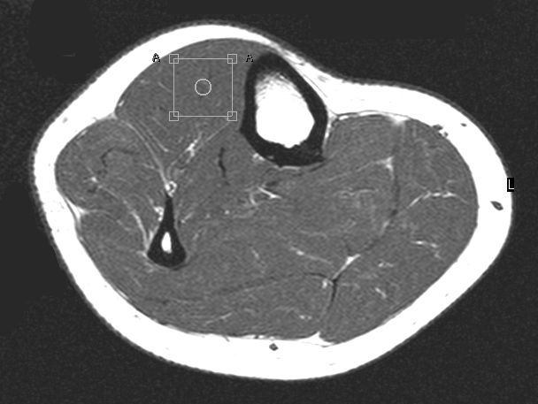
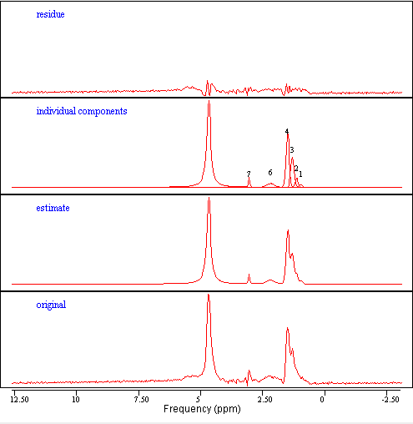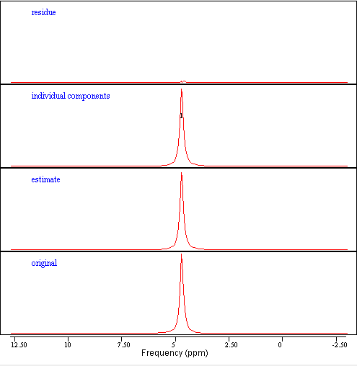
5
In both processed spectra, the bottom line labeled ‘original’ represents the original data, the second from the bottom line labeled ‘estimate’ represents the estimated spectrum, the third from the bottom line labeled ‘individual components’ represents the individual peaks, and the top line labeled ‘residue’ represents the residual spectrum obtained by subtracting the original spectrum from the estimate. The left set of spectra show the tibialis anterioris (TA) suppressed water spectra. In the line labeled ‘individual components,’ peaks 1, 2, 3, and 4 represent the intramyocellular methyl, extramyocellular methyl, intramyocellular methylene, and extramyocellular peaks respectively. Peak 5 is identified as water, peak 6 as a mixture of allylic methylene compounds and peak 7 as the total creatine. The right set of spectra show the corresponding TA unsuppressed water spectra. In the line labeled ‘individual components,’ a single water peak is observed at 4.7 – 4.8 ppm.
Figure 11: Axial magnetic resonance image and SOL proton spectra of the right calf muscle of a 43-year-old male lean subject

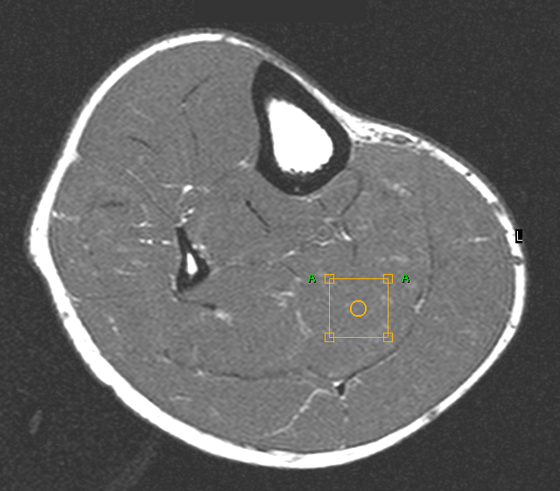
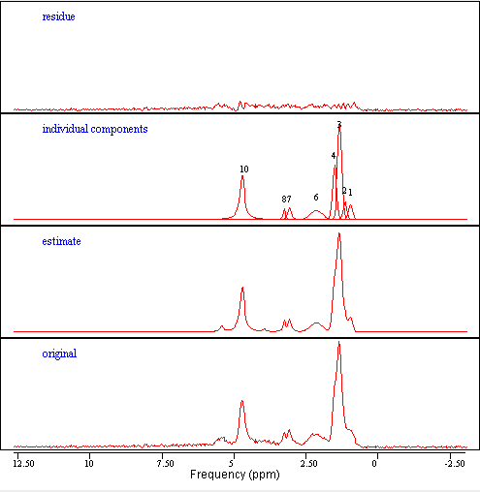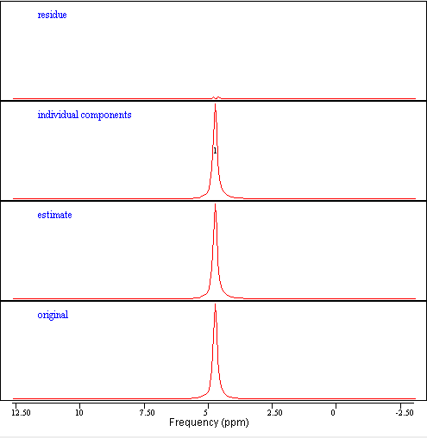
In both processed spectra, the bottom line labeled ‘original’ represents the original data, the second from the bottom line labeled ‘estimate’ represents the estimated spectrum, the third from the bottom line labeled ‘individual components’ represents the individual peaks, and the top line labeled ‘residue’ represents the residual spectrum obtained by subtracting the original spectrum from the estimate. The left set of spectra show the soleus (SOL) suppressed water spectra. In the line labeled ‘individual components,’ peaks 1, 2, 3, and 4 represent the intramyocellular methyl, extramyocellular methyl, intramyocellular methylene, and extramyocellular peaks respectively. Peak 10 is identified as the water peak, peak 6 as a mixture of allylic methylene compounds, peak 7 as the total creatine, and peak 8 as the trimethyl amines. The right set of spectra show the corresponding SOL unsuppressed water spectra. In the line labeled ‘individual components,’ a single water peak is observed at 4.7 – 4.8 ppm.
Figure 12: Axial magnetic resonance image and TA proton spectra of the right calf muscle of a 39-year-old female obese subject
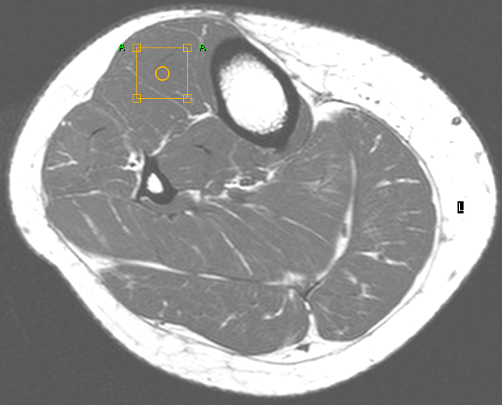

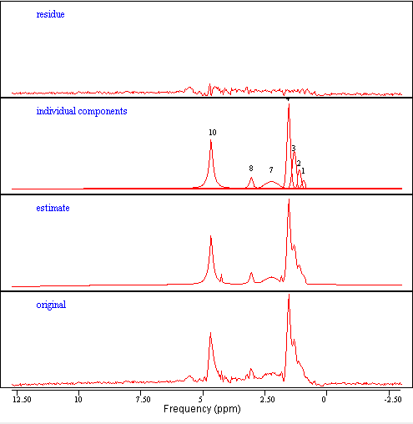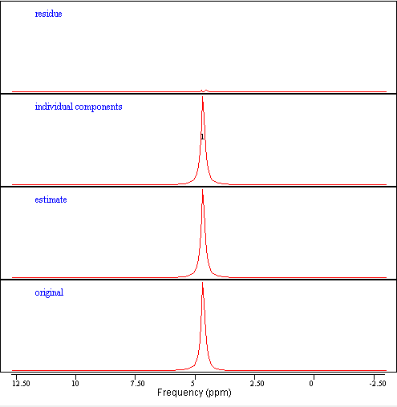
4
In both processed spectra, the bottom line labeled ‘original’ represents the original data, the second from the bottom line labeled ‘estimate’ represents the estimated spectrum, the third from the bottom line labeled ‘individual components’ represents the individual peaks, and the top line labeled ‘residue’ represents the residual spectrum obtained by subtracting the original spectrum from the estimate. The left set of spectra show the tibialis anterioris (TA) suppressed water spectra. In the line labeled ‘individual components,’ peaks 1, 2, 3, and 4 represent the intramyocellular methyl, extramyocellular methyl, intramyocellular methylene, and extramyocellular peaks respectively. Peak 10 is identified as the water peak, peak 7 as a mixture of allylic methylene compounds and peak 8 as the total creatine. The right set of spectra show the corresponding TA unsuppressed water spectra. In the line labeled ‘individual components,’ a single water peak is observed at 4.7 – 4.8 ppm.

Figure 13: Axial magnetic resonance image and SOL proton spectra of the right calf muscle of a 46-year-old male obese subject
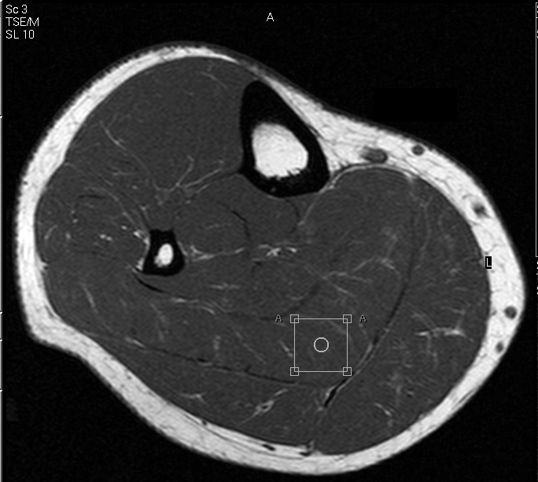
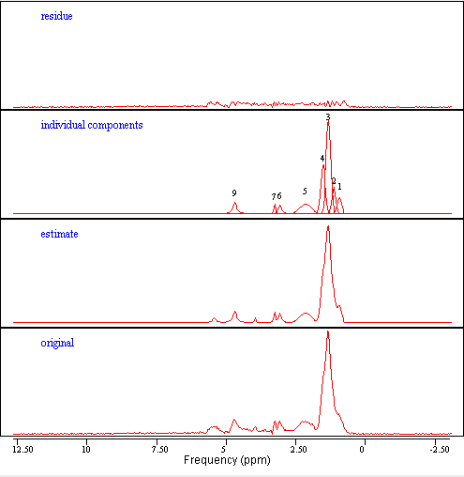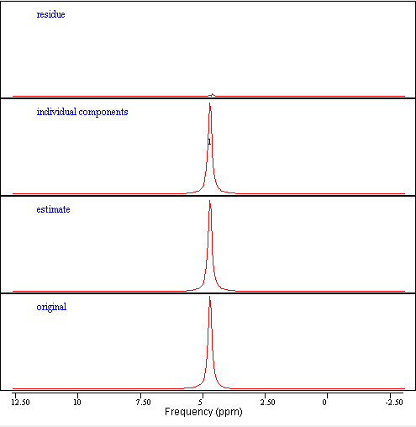
In both processed spectra, the bottom line labeled ‘original’ represents the original data, the second from the bottom line labeled ‘estimate’ represents the estimated spectrum, the third from the bottom line labeled ‘individual components’ represents the individual peaks, and the top line labeled ‘residue’ represents the residual spectrum obtained by subtracting the original spectrum from the estimate. The left set of spectra show the soleus (SOL) suppressed water spectra. In the line labeled ‘individual components,’ peaks 1, 2, 3, and 4 represent the intramyocellular methyl, extramyocellular methyl, intramyocellular methylene, and extramyocellular peaks respectively. Peak 9 is identified as the water peak, peak 5 as a mixture of allylic methylene compounds, peak 6 as the total creatine, and peak 7 as the trimethyl amines. The right set of spectra show the corresponding SOL unsuppressed water spectra. In the line labeled ‘individual components,’ a single water peak is observed at 4.7 – 4.8 ppm.
Figure 14: Magnetic resonance images and corresponding proton spectrum of the liver of a 26-year-old female lean subject
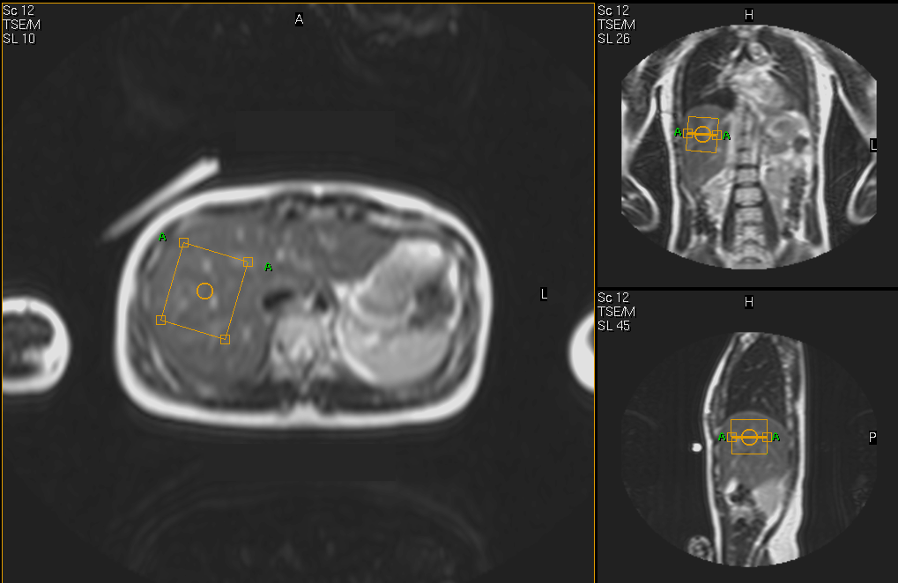
On the liver spectrum, the water peak is shown at 4.7 – 4.8 parts per million (ppm), while no liver fat is observed at 0.8 – 1.6 ppm.

Figure 15: Magnetic resonance images and corresponding proton spectrum of the liver of a 35-year-old female obese subject
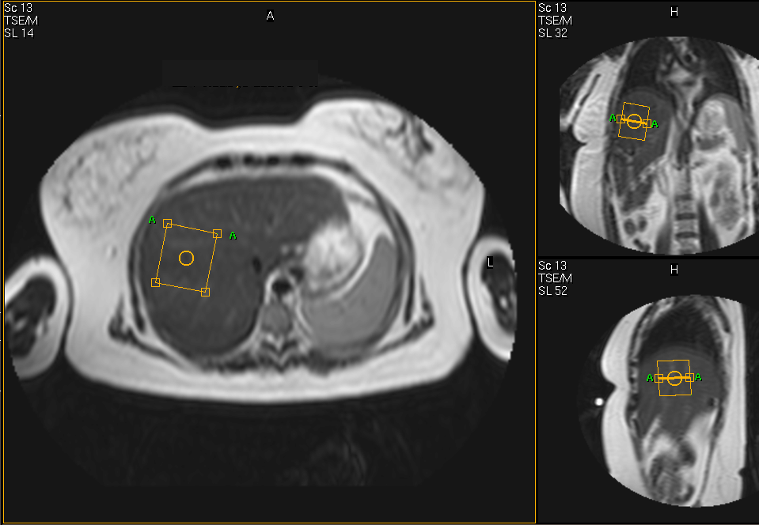
On the liver spectrum, the water peak is shown at 4.7 – 4.8 parts per million (ppm) and the liver fat peak at 0.8 – 1.6 ppm.

Euglycemic-Hyperinsulinemic Clamp
The clamp procedure was implemented and carried out at the inpatient unit of the General Clinical Research Center (GCRC) in the obese participants only. This procedure, although conceptually simple, had many technical complications. The greatest challenge was to maintain a blood sampling line open for the two hours period of the clamp. Another difficulty was to maintain a constant flow of both insulin and glucose through the intravenous catheters and connectors (3-way stopcocks). Furthermore, another complex issue was the adjustment of the glucose infusion rate in such a way that a steady blood glucose level was maintained for at least the last 30 minutes of the clamp. As a result, several of the clamp procedures cannot be used in this data analysis because of problems with insulin and glucose catheters or the blood sampling line. Two individuals were not able to undergo the procedure due to access problems of the blood sampling line. From the remaining baseline clamps, data from 15 of them were used.
The mean glucose utilization of the obese group in reference to total body mass was 18.14 ± 1.85 µmol x kg⁻¹ x min⁻¹ and in reference to LBM was 31.65 ± 3.39 µmol x kg_{LBM} ⁻¹ x min⁻¹ (Table 7). The mean insulin sensitivity in reference to total body mass was 0.0442 ± 0.0059 µmol x kg⁻¹ x min⁻¹/pmol/l and in reference to LBM was 0.0767 ± 0.010 µmol x kg_{LBM} ⁻¹ x min⁻¹/pmol/l (Table 7). The mean glucose infusion rate and blood glucose concentration during the 2-hour clamp for 15 obese individuals is shown in Figure 16. The last 30 minutes of the clamp were used for measuring glucose utilization and insulin sensitivity.
Table 7: Baseline euglycemic-hyperinsulinemic clamp data of obese subjects
Clamp data
n 15
M (µmol x kg⁻¹ x min⁻¹) 18.14 ± 1.85
M_{L} (µmol x kg_{LBM} ⁻¹ x min⁻¹) 31.65 ± 3.39
MI (µmol x kg⁻¹ x min⁻¹/pmol/l) 0.0442 ± 0.0059
M_{L}I (µmol x kg_{LBM} ⁻¹ x min⁻¹/pmol/l) 0.0767 ± 0.010
Data are means ± SE. M is glucose utilization divided by kg of body total mass, while M_{L} is divided by lean body mass; MI is insulin sensitivity divided by kg of total body mass, while M_{L}I is divided by lean body mass.

Figure 15: Plasma glucose levels and infusion rate during the baseline euglycemic-hyperinsulinemic clamp of obese subjects
Upper graph is plasma glucose in mg/dl and lower graph is glucose infusion rate mg/kg/min. Values are expressed as mean ± SE. Number of subjects is 15.
0
10
20
30
40
50
60
70
80
90
100
0
10
20
30
40
50
60
70
80
90
100
110
120
Time (min)
Glucose (mg/dl)
0
2
4
6
8
10
Glucose Infusion
(mg/kg/min)

The values obtained for glucose utilization (M, M_{L}) and insulin sensitivity (MI, M_{L}I) from the clamp were correlated with corresponding indices from the glucose tolerance test, including FPG, FPI, HOMA, lnAUCI, and lnAUCG, using the Spearman Rank correlation coefficient r. This type of correlation coefficient was used in this dataset because it is fairly insensitive to outliers and non-normal observations. There was a strong negative correlation of HOMA with insulin sensitivity indices from the clamp (MI: r=–0.74, p=0.002; M_{L}I: r=– 0.70, p=0.003). The HOMA index was therefore chosen to make comparisons of insulin sensitivity between the obese and lean groups.
The clamp is a sensitive method for evaluating insulin sensitivity in vivo and has been widely used in small clinical studies. HOMA is a good estimate of basal insulin resistance and has been used in large epidemiological studies, because it depicts fasting glucose and insulin conditions. However, no definite conclusions can be drawn about insulin secretion, distribution, and degradation.

Correlations
The Spearman Rank correlation coefficient r, was calculated for both the lean and the obese groups to determine linear associations between measures of insulin sensitivity, blood metabolites, anthropometric variables, and intracellular lipids.
Moderate, but statistically significant correlations were found between HOMA and IMCL in the SOL muscle (Figure 17; r=0.55, p=0.0002), BMI (r=0.67, p< 0.0001), TBF (r=0.56, p=0.0001), and leptin (r=0.55, p=0.0002). Weak and marginally statistically significant correlation was found between HOMA and IMCL in the TA muscle (Figure 18; r=0.28, p=0.07).
Figure 17: Correlation of HOMA versus IMCL in the SOL muscle for lean and obese

Lean are represented by squares and obese are represented by triangles. Spearman Rank correlation coefficient, r=0.55, p=0.0002; SOL: Soleus; HOMA: Homeostasis Model Assessment Index; IMCL: Intramyocellular lipid by proton magnetic resonance spectroscopy. IMCL data are presented in arbitrary units as a ratio of the corresponding peaks over the unsuppressed water peak x 100, corrected for T₁ and T₂ relaxation effects.

Figure 18: Correlation of HOMA versus IMCL in the TA muscle for lean and obese
Lean are represented by squares and obese are represented by triangles. Spearman Rank correlation coefficient, r=0.28, p=0.07; TA: tibialis anterioris; HOMA: Homeostasis Model Assessment Index; IMCL: Intramyocellular lipid by proton magnetic resonance spectroscopy. IMCL data are presented in arbitrary units as a ratio of the corresponding peaks over the unsuppressed water peak x 100, corrected for T₁ and T₂ relaxation effects.
Adiponectin was negatively correlated with BMI (r=– 0.47, p=0.002), lnAUCG (r=– 0.45, p=0.003), and WHR (r=– 0.40, p=0.002). There was a moderate positive correlation between adiponectin and HDL (r=0.43, p=0.005).
Moderate but statistically significant correlations were found between lnAUCG and FFA (r=0.60, p< 0.0001), serum TG (r=0.43, p=0.005), WHR (r=0.45, p=0.008), and IMCL in the SOL muscle (Figure 19; r=0.41, p=0.008). A positive correlation was also found between lnAUCG and IMCL in the TA muscle (Figure 20; r=0.50, p=0.0009). This association was even stronger for the obese group (r=0.66, p=0.0009). The 2-hour plasma glucose (PG) value during the OGTT was positively correlated with FFA (r=0.58, p=0.0001), IMCL in the SOL muscle (Figure 21; r=0.51, p=0.0006), and IMCL in the TA muscle (Figure 22; r=0.50, p=0.0008). The correlation of 2-hour PG with IMCL in the TA muscle was even stronger in the obese group (r=0.65, p=0.001).

Figure 19: Correlation of lnAUCG versus IMCL in the SOL muscle for lean and obese

Lean are represented by squares and obese are represented by triangles. Spearman Rank correlation coefficient, r=0.41, p=0.008; SOL: soleus lnAUCG: log transformed values of Area under the Curve for Glucose in a 2 hour Oral Glucose Tolerance Test; IMCL: Intramyocellular lipid by proton magnetic resonance spectroscopy. IMCL data are presented in arbitrary units as a ratio of the corresponding peaks over the unsuppressed water peak x 100, corrected for T₁ and T₂ relaxation effects.
Figure 20: Correlation of lnAUCG versus IMCL in the TA muscle for lean and obese

Lean are represented by squares and obese are represented by triangles. Spearman Rank correlation coefficient, r=0.50, p=0.0009; TA: tibialis anterioris; lnAUCG: log transformed values of Area under the Curve for Glucose in a 2 hour Oral Glucose Tolerance Test; IMCL: Intramyocellular lipid by proton magnetic resonance spectroscopy. IMCL data are presented in arbitrary units as a ratio of the corresponding peaks over the unsuppressed water peak x 100, corrected for T₁ and T₂ relaxation effects.

Figure 21: Correlation of 2-hour post-OGTT PG versus IMCL in the SOL muscle for lean and obese
Lean are represented by squares and obese are represented by triangles. Spearman Rank correlation coefficient, r=0.50, p=0.0008; SOL: soleus; OGTT: Oral Glucose Tolerance Test; PG: Plasma glucose levels; IMCL: Intramyocellular lipid by proton magnetic resonance spectroscopy. IMCL data are presented in arbitrary units as a ratio of the corresponding peaks over the unsuppressed water peak x 100, corrected for T₁ and T₂ relaxation effects.
Figure 22: Correlation of 2-hour post-OGTT PG versus IMCL in the TA muscle for lean and obese
Lean are represented by squares and obese are represented by triangles. Spearman Rank correlation coefficient, r=0.51, p=0.0006; TA: tibialis anterioris; OGTT: Oral Glucose Tolerance Test; PG: Plasma glucose levels; IMCL: Intramyocellular lipid by proton magnetic resonance spectroscopy. IMCL data are presented in arbitrary units as a ratio of the corresponding peaks over the unsuppressed water peak x 100, corrected for T₁ and T₂ relaxation effects.

Strong positive associations were found between BMI and WHR (r=0.72, p< 0.0001), TBF (r=0.81, p< 0.0001), and leptin (r=0.79, p< 0.0001).

Insulin Resistance Predictors
Multiple linear regression was performed to evaluate which variables perform better in predicting insulin resistance. HOMA was used as an index of insulin resistance and as the dependent variable in the regression analysis. In the model, age was included since it has been shown to affect insulin sensitivity (Machann et al, 2005; Ryan, 2000). BMI was also included in the model, as a measure of total body adiposity. WHR was examined as a measure of central obesity and fasting blood metabolites were also considered in this model. The initial analysis was performed separately for the two study groups. However, since no difference was found between groups, both groups were joined for the final analysis.
The most important predictors of insulin resistance were age, IMCL of the SOL muscle, TG, and BMI. They accounted for 58% of variability in insulin resistance by the HOMA index. IMCL in the SOL muscle accounted for 27% of the variability in insulin resistance by the HOMA index, after adjusting for age, BMI, and TG. The best model for predicting insulin resistance was:
HOMA = β₀ + β₁ x age + β₂ x BMI + β₃ x TG + β₄ x IMCL_{SOL}
This model was checked for violation of basic assumptions of multiple linear regression, including normal distribution, constant variance, and independence of residuals, as well as the presence of influential data points. When highly influential points were removed, the predictive ability of this model increased and the variables accounted for 76% of variability in insulin resistance by the HOMA index.

Follow up
A total of 10 obese subjects completed the intervention part and the follow up testing. The drop out rate (54.5%) for the weight loss part of the study is similar to that of other intervention studies (14 – 52%) and it is expected because of the inherent difficulties associated with weight loss and weight maintenance (Blue and Black, 2005). From the obese group, one subject was recruited by the marines, two subjects were removed from the study for non-compliance to the diet regimen, and nine subjects dropped out of the study either at the beginning or during the weight loss phase.

Anthropometric Data and Fasting Blood Tests
The 10 obese participants who completed the weight loss intervention achieved a statistically significant weight loss of 10% of baseline body weight (p=0.005) in an average time of 4.60 months. This group was sedentary to moderately active, with a mean PAL of 1.42, ranging from 1.3 to 1.6.
The anthropometric and body composition comparisons before and after weight loss are shown on Table 8. There was a significant decrease in BMI of the obese participants (p=0.005), and it almost reached the overweight range. TBF and LBM decreased significantly by 7.1% and 5.3% respectively. There was trend for a decrease in WHR in this group, but it did not reach statistical significance.

Table 8: Anthropometric characteristics of obese subjects before and after weight loss
Before weight loss After weight loss p value Before vs.
After weight loss
n 10 10
Age (years) 43.20 ± 2.02
Body weight (kg) 96.58 ± 3.90 86.81 ± 3.91 0.005
BMI (kg/m²) 34.14 ± 0.92 30.65 ± 0.91 0.005
TBF (%) 37.92 ± 2.46 35.24 ± 2.71 0.006
LBM (kg) 55.11 ± 3.68 52.18 ± 3.65 0.005
WHR 0.91 ± 0.030 0.89 ± 0.023 NS
Data are means ± SE. The Wilcoxon matched-pairs signed-ranks test was used. NS: No statistical significance, p> 0.1; BMI: Body Mass Index; TBF: Total Body Fat, by Dual Energy X-Ray Absortiometry; LBM: Lean Body Mass; WHR: Waist-to-Hip Ratio.

Plasma lipid levels of obese subjects before and after weight loss are shown in Table 9. TCho and LDL were significantly reduced with weight loss by 18.3% and 22.3% respectively. FFA, TG, and HDL were also reduced with weight loss, but their change did not reach statistical significance.

Table 9: Plasma lipid levels of obese subjects before and after weight loss
Before weight loss After weight loss p value Before vs.
After weight loss
n 10 10
TCho (mg/dl) 226.20 ± 7.42 184.90 ± 6.38 0.005
HDL (mg/dl) 72.00 ± 5.62 67.20 ± 4.73 NS
LDL (mg/dl) 129.90 ± 7.28 100.90 ± 3.83 0.007
TG (mg/dl) 122.60 ± 30.90 83.30 ± 8.89 NS
FFA (mg/dl) 0.55 ± 0.044 0.51 ± 0.070 NS
Data are means ± SE. The Wilcoxon matched-pairs signed-ranks test was used. NS: No statistical significance, p> 0.1; TCho: Total Cholesterol; HDL: High-Density Lipoprotein; LDL: Low-Density Lipoprotein; TG: Serum Triglyceride; FFA: Free Fatty Acids; FFA levels were calculated for 9 subjects.

The majority of indices of insulin sensitivity were significantly improved with weight loss, including HOMA, lnAUCI, lnAUCG, and FPI (Table 10). HOMA decreased significantly, showing a 36.5% improvement in insulin sensitivity (p=0.005). All subjects had normal glucose tolerance (NGT) after weight loss. Adiponectin levels increased significantly by 35.8% (p=0.005), further indicating an improvement in insulin sensitivity in this group. FPG and HbA1c were not significantly changed, as expected since those values were not different from the lean controls at baseline. Leptin levels decreased dramatically after the intervention by 50.6% (p=0.05).
Table 10: Plasma hormone levels, insulin sensitivity and glucose metabolism indices of obese subjects before and after weight loss
Before weight loss After weight loss p value Before vs.
After weight loss
n 10 10
FPG (mg/dl) 87.40 ± 2.12 85.60 ± 3.30 NS
FPI (µU/ml) 8.36 ± 0.97 6.68 ± 1.39 0.09
HbA1c (%) 5.25 ± 0.12 5.33 ± 0.11 NS
HOMA 1.70 ± 0.16 1.08 ± 0.15 0.005
lnAUCI 8.56 ± 0.19 8.23 ± 0.19 0.005
lnAUCG 9.61 ± 0.066 9.49 ± 0.045 0.03
IGT 3/10 0/10 0.08
2-hour PG 118.4 ± 11.05 95.3 ± 6.02 0.047
2-hour PI 58.35 ± 12.21 39.01 ± 12.01 0.02
Leptin (ng/ml) 26.90 ± 4.45 13.29 ± 2.93 0.005
Adiponectin (µg/ml) 20.07 ± 3.52 27.25 ± 4.05 0.005
Data are means ± SE, except for IGT data, which is reported as subjects with IGT/total subjects. The Wilcoxon matched-pairs signed-ranks test was used. NS: No statistical significance, p> 0.1; FPG: Fasting Plasma Glucose; FPI: Fasting Plasma Insulin; HOMA: Homeostasis Model Assessment Index; lnAUCI: log transformed Area under the Curve of Insulin in a 2 hour Oral Glucose Tolerance Test (OGTT); lnAUCG: log transformed Area under the Curve of Glucose in a 2 hour OGTT; IGT: Impaired Glucose Tolerance defined as 2 hour post-OGTT glucose 140 – 200 mg/dl; 2-hour PG: 2 hour post-OGTT plasma glucose; 2-hour PI: 2 hour post-OGTT plasma insulin; HbA1c: Glycated Hemoglobin.

Intracellular Lipid Accumulation
After weight loss, there was a significant change in body water which can be attributed to loss of LBM. Since the water peak was used as a reference for the IMCL and EMCL quantification, a correction was made to account for that difference. The tissue water content of human skeletal muscle is 0.81 kg/kg LBM (Szczepaniak et al, 1999). As a result, loss of tissue water was calculated as: Tissue water lost = LBM lost x 0.81 kg water/kg LBM.
This value was calculated for each participant and was added to the absolute water value obtained from proton MRS. This adjusted water value was used as a reference for the post-treatment IMCL and EMCL quantification. The MRS results are shown in Table 11.

Table 11: IMCL, EMCL, and IHL by proton magnetic resonance spectroscopy of obese subjects before and after weight loss
Before weight loss After weight loss p value Before vs.
After weight loss
n 10 10
IMCL-TA 0.597 ± 0.10 0.468 ± 0.089 0.046
EMCL-TA 0.945 ± 0.19 1.01 ± 0.18 NS
IMCL-SOL 2.28 ± 0.17 2.45 ± 0.27 NS
EMCL-SOL 2.23 ± 0.34 2.35 ± 0.45 NS
IHL 8/10 3/10 0.03
Data are means ± SE, except IHL data, which is reported as presence or absence of abnormal IHL (subjects with presence of abnormal IHL/total subjects with IHL data). The Wilcoxon matched-pairs signed-ranks test was used. NS: No statistical significance, p> 0.1; IMCL-TA: Intramyocellular lipid in the tibialis anterioris muscle; EMCL-TA: Extramyocellular lipid in the tibialis anterioris muscle; IMCL-SOL: Intramyocellular lipid in the soleus muscle; EMCL-SOL: Extramyocellular lipid in the soleus muscle; IHL: Intrahepatic Lipid. IMCL and EMCL data are presented in arbitrary units as a ratio of the corresponding peaks over the unsuppressed water peak x 100, corrected for T₁ and T₂ relaxation effects.

After weight loss there was a significant decrease of 22% in IMCL of the TA muscle (p=0.046). This decrease in IMCL was not correlated with the decease in insulin resistance by HOMA or the improvement in glucose tolerance by lnAUCG, even after adjusting for percent of total weight or TBF lost. Magnetic resonance images and spectra of the TA and SOL muscle before and after weight loss are shown in Figures 23 and 24. Furthermore, the proportion of subjects with presence of abnormal IHL was also significantly decreased in this group (p=0.03). Before weight loss, 80% of this obese had abnormal IHL, but only 30% had abnormal IHL after weight loss. There was no significant change in IMCL of the SOL muscle or EMCL of the SOL or TA muscle.

Figure 23: Axial magnetic resonance images and SOL proton spectra of the right calf muscle of a 42-year-old female obese subject before and after weight loss
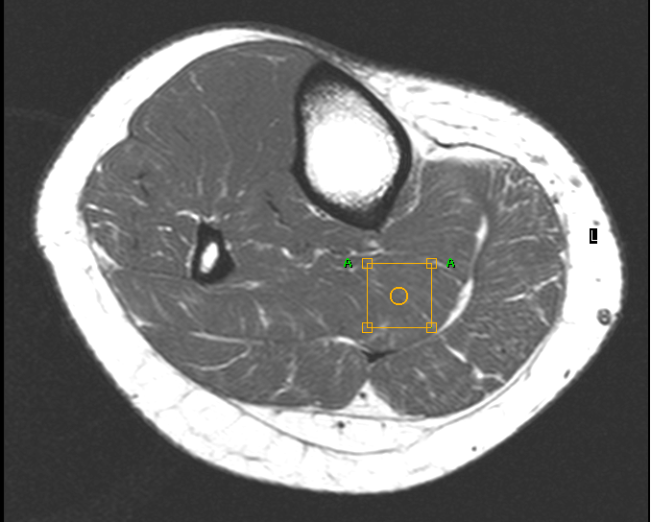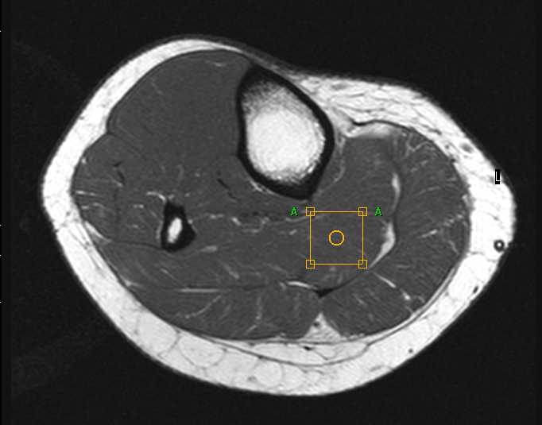
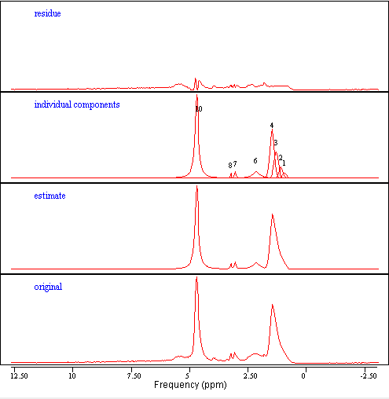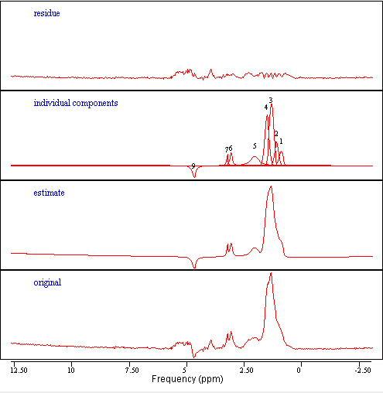
In both processed water suppressed spectra, the bottom line labeled ‘original’ represents the original data, the second from the bottom line labeled ‘estimate’ represents the estimated spectrum, the third from the bottom line labeled ‘individual components’ represents the individual peaks, and the top line labeled ‘residue’ represents the residual spectrum obtained by subtracting the original spectrum from the estimate. The left set of spectra and image show the soleus (SOL) muscle before weight loss. In the line labeled ‘individual components,’ peaks 1, 2, 3, and 4 represent the intramyocellular methyl (IMCL-CH₃), extramyocellular methyl (EMCL-CH₃), intramyocellular methylene (IMCL-CH₂), and extramyocellular (EMCL-CH₂) peaks respectively. Peak 10 is identified as the water peak, peak 6 as a mixture of allylic methylene compounds, peak 7 as the total creatine (TCr), and peak 8 the trimethyl amines (TMA). The right set of spectra and image show the SOL muscle after weight loss. In the line labeled ‘individual components,’ peaks 1, 2, 3, and 4 represent the IMCL-CH₃, EMCL-CH₃, IMCL-CH₂, and EMCL-CH₂ peaks respectively. Peak 9 is identified as the water peak, peak 5 as a mixture of allylic methylene compounds, peak 6 as the TCr, and peak 7 as the TMA.
Figure 24: Axial magnetic resonance images and TA proton spectra of the right calf muscle of a 39-year-old female obese subject before and after weight loss
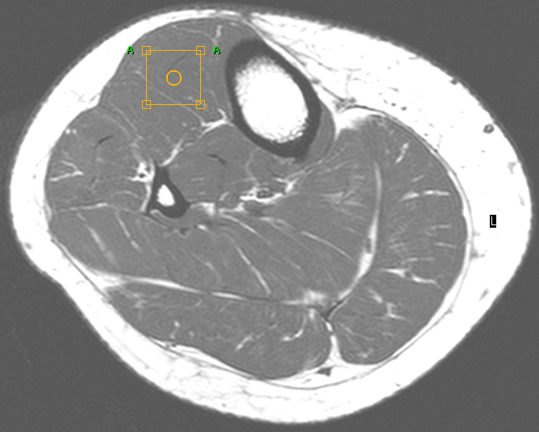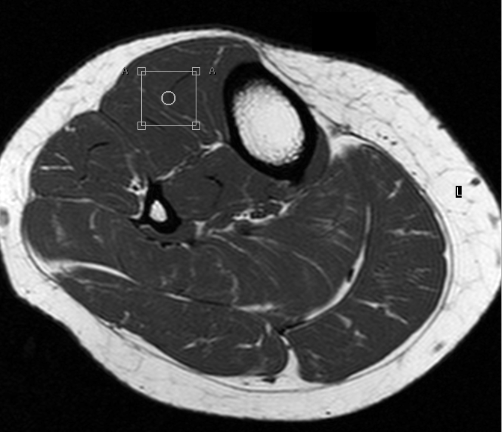

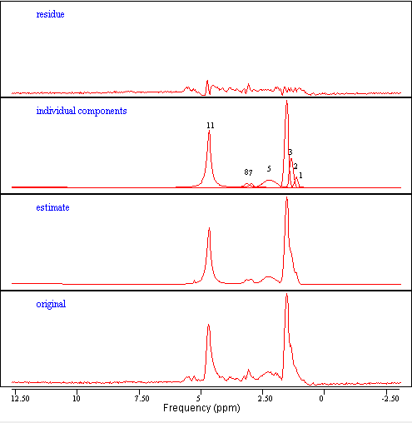
4
4
In both processed spectra, the bottom line labeled ‘original’ represents the original data, the second from the bottom line labeled ‘estimate’ represents the estimated spectrum, the third from the bottom line labeled ‘individual components’ represents the individual peaks, and the top line labeled ‘residue’ represents the residual spectrum obtained by subtracting the original spectrum from the estimate. The left set of spectra and image show the tibialis anterioris (TA) muscle before weight loss. In the line labeled ‘individual components,’ peaks 1, 2, 3, and 4 represent the intramyocellular methyl (IMCL-CH₃), extramyocellular methyl (EMCL-CH₃), intramyocellular methylene (IMCL-CH₂), and extramyocellular (EMCL-CH₂) peaks respectively. Peak 10 is identified as the water peak, peak 6 as a mixture of allylic methylene compounds, peak 7 as the total creatine (TCr), and peak 8 as the trimethyl amines (TMA). The right set of spectra and image show the TA muscle after weight loss. In the line labeled ‘individual components,’ peaks 1, 2, 3, and 4 represent the IMCL-CH₃, EMCL-CH₃, IMCL-CH₂, and EMCL-CH₂ peaks respectively. Peak 9 is identified as the water peak, peak 5 as a mixture of allylic methylene compounds, peak 6 as the TCr, and peak 7 as the TMA.

Losses to Follow up
We observed a loss to follow up of 54.5% in the obese group. Participants excluded from the follow up analyses were compared to those who completed the weight loss program to determine if there were significant differences between groups. Overall, the two groups appeared to be very similar in baseline anthropometric characteristics, plasma metabolites, and intracellular lipid levels. The group that dropped out had a slightly but not statistically significantly higher BMI compared to the group that completed the weight loss (Table 12).

Table 12: Anthropometric characteristics of obese subjects that completed the weight loss compared to those who dropped out
Completed Drop outs p value Completed
weight loss vs. Drop outs
n 10 12
Age (years) 43.20 ± 2.02 39.00 ± 3.40 NS
Body weight (kg) 96.58 ± 3.90 104.10 ± 3.43 NS
BMI (kg/m²) 34.14 ± 0.92 36.02 ± 0.77 0.06
TBF (%) 37.92 ± 2.46 40.58 ± 1.58 NS
LBM (kg) 55.11 ± 3.68 56.88 ± 2.51 NS
WHR 0.91 ± 0.030 0.95 ± 0.016 NS
Data are means ± SE. The two sample Wilcoxon rank sum test was used. NS: No statistical significance, p> 0.1; BMI: Body Mass Index; TBF: Total Body Fat by Dual Energy X-Ray Absorptiometry; LBM: Lean Body Mass; WHR: Waist-to-Hip Ratio.

Furthermore, the total cholesterol of the group that dropped out of the study was statistically significantly lower than the corresponding values of the group that completed the weight loss (Table 13). The lnAUCI was also slightly higher in the drop out group, but that difference was only marginally significant (p=0.06).
Table 13: Plasma metabolite concentrations of obese subjects that completed the weight loss compared to those who dropped out
Completed Drop outs p value Completed
weight loss vs. Drop outs
n 10 12
TCho (mg/dl) 226.20 ± 7.42 189.75 ± 7.64 0.006
TG (mg/dl) 122.60 ± 30.90 110.33 ± 21.90 NS
FFA (mg/dl) 0.55 ± 0.044 0.64 ± 0.081 NS
FPG (mg/dl) 87.40 ± 2.12 87.25 ± 2.14 NS
FPI (µU/ml) 8.36 ± 0.97 10.48 ± 2.09 NS
HOMA 1.70 ± 0.16 2.05 ± 0.28 NS
lnAUCI 8.56 ± 0.19 8.91 ± 0.14 0.06
lnAUCG 9.61 ± 0.066 9.61 ± 0.055 NS
HbA1c (%) 5.25 ± 0.12 5.41 ± 0.14 NS
Leptin (ng/ml) 26.90 ± 4.45 24.33 ± 3.35 NS
Adiponectin (µg/ml) 20.07 ± 3.52 16.92 ± 1.69 NS
Data are means ± SE. The two sample Wilcoxon rank sum test was used. NS: No statistical significance, p> 0.1; TCho: Total Cholesterol; TG: Serum Triglyceride; FFA: Free Fatty Acids; FPG: Fasting Plasma Glucose; FPI: Fasting Plasma Insulin; HOMA: Homeostasis Model Assessment Index; lnAUCI: log transformed Area under the Curve of Insulin in a 2 hour Oral Glucose Tolerance Test (OGTT); lnAUCG: log transformed Area under the Curve of Glucose in a 2 hour OGTT; HbA1c: Glycated Hemoglobin.

No differences were observed in the intracellular lipid accumulation levels of the muscle and liver between the group that completed the weight loss program compared to the one who did not (Table 14). In general, the two groups are comparable and no systematic bias can be observed due to attrition.

Table 14: IMCL, EMCL, and IHL by proton magnetic resonance spectroscopy of obese subjects that completed the weight loss compared to those who dropped out
Completed Drop outs p value Completed
weight loss vs. Drop outs
n 10 12
IMCL-TA 0.597 ± 0.10 0.542 ± 0.096 NS
EMCL-TA 0.945 ± 0.19 1.53 ± 0.49 NS
IMCL-SOL 2.28 ± 0.17 3.10 ± 0.41 NS
EMCL-SOL 2.23 ± 0.34 2.64 ± 0.34 NS
IHL 8/10 8/10 NS
Data are means ± SE, except IHL data, which is reported as presence or absence of IHL (subjects with presence of IHL/total subjects with IHL data). The two sample Wilcoxon rank sum test was used. NS: No statistical significance, p> 0.1; IMCL-TA: Intramyocellular lipid in the tibialis anterioris muscle; EMCL-TA: Extramyocellular lipid in the tibialis anterioris muscle; IMCL-SOL: Intramyocellular lipid in the soleus muscle; EMCL-SOL: Extramyocellular lipid in the soleus muscle; IHL: Intrahepatic Lipid.

Correlations
The differences between baseline and post-treatment measurements (Δ) of each variable were examined for associations, using the Spearman Rank correlation coefficient r, to determine linear associations between measures of insulin sensitivity, blood metabolites, anthropometric variables, and intracellular lipids. No correlations were found between measures of insulin resistance and IMCL in the TA or the SOL muscles. There was a moderate negative and marginally statistically significant correlation of ΔIMCL in the SOL muscle with ΔTBF (r=– 0.56, p=0.09). Furthermore, there was a moderate positive correlation between Δleptin and ΔIMCL in the SOL (r=0.66, p=0.04), Δleptin and ΔHDL (r=0.69, p=0.03). There was a strong negative correlation between ΔIMCL in the TA muscle and ΔLDL (r=–0.70, p=0.02), ΔFPG and ΔFFA (r=–0.77, p=0.02). A moderate negative correlation was found between Δadiponectin and ΔlnAUCG, (r=–0.68, p=0.03), and ΔTG and ΔFPG (r=–0.62, p=0.06). A strong positive correlation was found between ΔBMI and ΔHDL (r=0.75, p=0.01), ΔBMI and Δleptin (r=0.72, p=0.02).

DISCUSSION

Intracellular Lipid Concentration is Higher in Obese Compared to Lean
The obese group in the present study exhibited higher IMCL levels in both SOL and TA muscles than the lean group. The IMCL levels in the TA muscle were marginally significant, but there was an obvious trend of increased IMCL levels in the TA muscle of obese compared to lean. These results are consistent with other studies in obese and lean, as well as insulin resistant and insulin sensitive individuals (Sinha et al, 2002; Jacob et al, 1999; Perseghin et al, 1999). Sinha et al (2002) found that IMCL of the SOL muscle was significantly higher in obese adolescents compared to lean controls. Jacob et al (1999) concluded that IMCL levels in both the TA and SOL muscles were statistically significantly higher in insulin-resistant compared to insulin-sensitive individuals. Perseghin et al (1999) found that there were higher IMCL levels in the SOL but not the TA muscle in the offspring of diabetic parents compared to healthy controls. These results are similar to the results of this study, which showed higher IMCL levels in the obese compared to lean subjects.
The obese group had a significantly higher proportion of subjects with fatty liver compared to the lean group. This result is consistent with a study by Petersen et al (2005). The prevalence of fatty liver in the obese group (80%) is similar to that observed in obese populations (Youssef and McCullough, 2002).

Intracellular Lipid Levels are Positively Correlated with Insulin Resistance and Glucose Intolerance
In both study groups, there was a significant positive correlation between insulin resistance by HOMA and IMCL in the SOL, but not in the TA muscle. This result agrees with previous studies (Ashley et al, 2002; Virkamaki et al, 2001; Krssak et al, 1999; Sinha et al, 2002).
Ashley et al (2002) found a significant association between IMCL in the SOL muscle in his group of healthy lean adolescent boys. In a study by Virkamaki et al (2001), IMCL accumulation in the vastus lateralis muscle was associated with whole-body insulin resistance and with defective insulin signaling in skeletal muscle independent of body weight and physical fitness in healthy lean men. Krssak et al (1999) found a negative correlation between insulin sensitivity and IMCL in the SOL muscle in a group of healthy adults. Sinha et al (2002) found a strong inverse correlation between IMCL and insulin sensitivity, which became stronger after adjusting for percent TBF and abdominal subcutaneous fat mass in a group of lean and obese adolescents. However, a study of the same group in Asian Indian males failed to uncover a correlation between insulin sensitivity and IMCL in the SOL muscle (Sinha et al, 2005).
All study subjects had normal fasting glucose values (NFG), therefore their ability to maintain basal insulin secretion and hepatic glucose output has not been compromised. However, 5.3% of the lean group and 31.8% of the obese group had impaired glucose tolerance (IGT), which is considered a risk factor for the development of diabetes (Unwin et al, 2002). During an OGTT, the body responds to the carbohydrate load by suppressing hepatic glucose output and stimulating liver and muscle glucose uptake (Unwin et al, 2002). Therefore, IGT is mainly associated with skeletal muscle insulin resistance and is more prevalent than impaired fasting glucose (IFG) in most populations (Unwin et al, 2002).
In both study groups, there was a significant positive correlation between glucose intolerance (lnAUCG and 2-hour post-OGTT plasma glucose) and IMCL in the SOL and TA muscles. The correlation between glucose intolerance and IMCL in the TA muscle was stronger for the obese group. Glucose intolerance was also significantly positively correlated with FFA, TG, and WHR. A study in healthy elderly and young volunteers also found a correlation between IMCL in the SOL muscle and measures of glucose tolerance (Cree et al, 2004). A study in women with previous gestational diabetes found a significant positive correlation of glucose intolerance with IMCL in the TA muscle, but not the SOL (Kautzky-Willer et al, 2003)
From the outcome variables studied, it was shown that IMCL in the SOL muscle, serum TG, and BMI are the main predictors of insulin resistance. Perseghin et al (1999) also found that IMCL in the SOL muscle was an important predictor of insulin sensitivity in a group of lean offspring of type 2 diabetic parents and healthy subjects. On the contrary, he found FFA not TG to be another important predictor of insulin sensitivity in the populations studied. Krssak et al (1999), however, did not find any associations between BMI, age, TG, FFA and insulin sensitivity in a group of healthy lean adults.

Weight Loss Reduces Intracellular Lipid
In this study there was a 22% decrease in IMCL levels in the TA muscle with a mean 10% weight loss. This decrease in IMCL was significant, but it was not correlated with the mean 36.5% improvement in insulin resistance by HOMA, even after adjusting for TBF or percent of total body weight lost. No change in the IMCL levels of the SOL muscle was found before and after weight loss in this group. These results are consistent with animal and human studies (Korach-Andre et al, 2005; Greco et al, 2002; Garg et al, 2000; Petersen et al, 2005; Tamura et al; 2005).
A study in Zucher lean and fat rats, investigated the IMCL content in glycolytic (SOL) and oxidative (TA) muscles and its relationship to insulin resistance (Korach-Andre et al, 2005). In repeated measurements over 3 months of IMCL in these rats, IMCL in both SOL and TA were significantly higher in the fat compared to the lean rats. For the fat rats, IMCL in the TA muscle increased with age, whereas in the lean rats IMCL in the TA muscle decreased with age. In contrast, IMCL levels in the SOL muscle were not significantly changed in either rat throughout the study. Impairment in whole-body insulin sensitivity in fat rats was concomitant with IMCL concentration in the TA muscle. The results are consistent with the findings of our study and support the hypothesis that glycolytic muscles (TA) play a major role during the onset of insulin resistance.
In a 6-month intervention study, IMCL of the quadriceps muscle, which has higher percentage of glycolytic fibers, was reduced and insulin resistance was reversed in a group of morbidly obese patients who underwent weight loss (24% of total body weight) through biliopancreatic diversion (BPD), but small changes in IMCL and insulin sensitivity were observed in a second group who followed a hypocaloric diet and lost 10% of their total body weight (Greco et al, 2002; Garg et al, 2000).
In a 3-12 week study (end-point to achievement of normoglycemia) of a group of obese sedentary diabetic patients who lost 9.3% of total body weight, a significant improvement was observed in hepatic insulin resistance, but not in peripheral glucose metabolism or IMCL of the SOL muscle (Petersen et al, 2005).
In a two-week intervention study involving two groups of type 2 diabetics who were studied at baseline and after a two-week diet and a diet plus exercise program, a significant decrease in IHL was found, which was independent of fasting FFA levels (Tamura et al, 2005). However, IMCL of the TA muscle was reduced by 19% and glucose infusion rate was increased by 57% in the diet and exercise group.
Contrary to the results of our study, a 4-month intervention trial of diet and exercise in a group of sedentary obese adults that resulted in a 10% weight loss and a 46% increase in insulin sensitivity did not uncover a significant decrease in IMCL levels of the TA muscle (He et al, 2004). Furthermore, this study found a significant decrease in the size of lipid droplets and an association of this reduction with an increase in insulin sensitivity.
It can be hypothesized that the decrease if IMCL levels in the TA muscle with weight loss results in improvement of skeletal insulin resistance in the obese group by an increase in GLUT4 expression and enhanced glucose transport in the muscle cell. Since IMCL in the SOL muscle was not decreased, it can be hypothesized that the weight reduction was not adequate to induce a decrease in the lipid concentration in that muscle or can be attributed to the different muscle fiber composition of that muscle.
The lack of correlation between IMCL in the TA and SOL muscles and indices of insulin resistance and glucose tolerance can be partly attributed to insufficient weight loss. Furthermore, several factors including the difference in the time to achieve target weight loss and in relative changes of body composition among the obese subjects could be responsible for the lack of correlation between IMCL and insulin resistance after weight loss.

Other Factors Affecting Intramyocellular Lipid Concentration

Muscle Fiber Type
Given the greater content of IMCL and increased insulin sensitivity in oxidative muscles, like SOL, it is possible that fiber-type variability is responsible for the different relationships seen in the examined muscles types (Jacob et al, 1999; Perseghin et al, 1999; Essen et al, 1975; Rico-Sanz et al, 1999; Malenfant et al, 2001; James et al, 1985; Lillioja et al, 1987). The SOL muscle, which mainly consists of type I muscle fibers has a higher oxidative potential than TA, which mainly consists of type II muscle fibers. In addition to differences in oxidative capacity, muscle I fibers typically have increased capillary density, increased lipid storage capacity, increased insulin binding, increased insulin-stimulated glucose uptake, and increased glucose transport protein content relative to type II fibers (Hickey et al, 1995). Therefore, the statistically significant positive correlation of IMCL in the SOL muscle that was found with insulin resistance can be explained.
Animal studies have investigated the effects of muscle fiber on glucose and insulin metabolism (Halseth et al, 2001; Rizk et al, 1998; James et al, 1985). Halseth et al (2001) examined glucose uptake in different rat muscle types and demonstrated that muscle glucose uptake was much lower in muscle comprised of type II fibers (like the TA) than in the SOL muscle under both basal and insulin-stimulated conditions, and concluded that glucose delivery and transport are the primary factors for this limitation. Furthermore, it has been shown that the oxidative muscles in rats exhibit greater basal uptake than the glycolytic muscles (Rizk et al, 1998). A study by James et al (1985) examined the effect of insulin on glucose metabolism in different types of skeletal muscle in rats. This study concluded that insulin-induced increases in total peripheral glucose disposal occur predominantly in muscles containing a high proportion of oxidative fibers.
Human studies have demonstrated that GLUT-4 expression is muscle fiber type dependent (Gaster et al, 2000). The association among muscle insulin resistance, obesity, GLUT4 immunoreactivity, and muscle fiber type has been investigated (Gaster et al, 2001). GLUT4 expression in oxidative fibers was shown to be lower in obese individuals and even lower in type 2 diabetics compared to lean controls (Gaster et al, 2001). It can be hypothesized that the reduced GLUT4 contribution from oxidative fibers in obese and type 2 diabetics may result in a decrease in skeletal muscle glucose uptake.
A study by Lillioja et al (1987) compared insulin sensitivity with muscle fiber type in human skeletal muscle in healthy men. This study found a significant association between muscle fiber type and insulin action. It has been postulated that even though the proportion of type I muscle fibers is genetically determined and fixed, interchange may occur between IIa and IIb fiber types (Lillioja et al, 1987). In another study by Kriketos et al (1997), it was demonstrated that the composition of muscle fiber type is different between infants and adults (Kriketos et al, 1997). Increased levels of type IIb glycolytic fibers was shown to be correlated with obesity in adults (Kriketos et al, 1997).
Furthermore, glucose intolerant individuals have been shown to have elevated percentage of insulin insensitive type IIb (glycolytic) muscle fibers compared to normoglycemic controls (Toft et al, 1998). It has been indicated that chronic hyperglycemia is more likely to result in insulin resistance in glycolytic muscles, since they are affected to a greater extent by hyperglycemia and hyperinsulinemia than the oxidative muscles (Rizk et al, 1998).
Since the SOL muscle (mainly oxidative) has an increased capacity for lipid storage and oxidation, simultaneous depletion and repletion of IMCL in SOL muscle could explain the lack of IMCL reduction after weight loss in this muscle. On the contrary, the TA muscle (mainly glycolytic) has a reduced capacity for lipid storage and oxidation. Therefore, weight loss resulted in depletion of IMCL in this muscle, with possible reduction in fatty acid uptake.

Physical Activity
In this study group, physical activity was self-reported; thus, it can only be estimated. The study group consisted of sedentary to moderately active individuals. Only one study subject was very active for part of the intervention. This individual was the only one who showed increased IMCL in the TA muscle after weight loss. Trained endurance athletes have been shown to possess elevated IMCL levels, even though they are very insulin sensitive (van Loon et al, 2004). In a study of highly trained endurance athletes, an increase of 83% of baseline IMCL levels in the SOL muscle was observed after a submaximal treadmill run to exhaustion (Krssak et al, 2000). In a study of healthy lean previously untrained individuals, IMCL in the TA was significantly associated with measures of aerobic fitness, after adjusting for adiposity (Thamer et al, 2003). Rico-Sanz et al (1998) and Brechtel & Niess et al (2001) have shown that in trained males IMCL levels in the calf muscle were increased with prolonged and moderate intensity exercise.

Adiponectin
At baseline, adiponectin values were shown to be significantly lower in the obese compared to the lean group. There results agree with the study of Perseghin et al (2003), which showed that adiponectin levels were decreased in type 2 diabetics and their offspring. Weiss et al (2003) also found that adiponectin concentration was higher in non obese compared to obese adolescents.
In this study, adiponectin was moderately negatively associated with lnAUCG, which is an index of glucose tolerance, yet it was not associated with insulin resistance by HOMA. However, Perseghin et al (2003) demonstrated that in type 1, type 2 diabetics and offspring of type 2 diabetics, IMCL concentration was positively associated with insulin resistance. Weiss et al (2003) found that adiponectin was positively associated with insulin sensitivity in both obese and non-obese individuals.

Proton Magnetic Resonance Spectroscopy
In this study, proton nuclear magnetic resonance spectroscopy (MRS) was used for the quantification of IMCL accumulation in vivo. MRS is a non-invasive method that has been recently utilized to assess the composition and structure of living tissue. The sensitivity of the fatty acid proton chemical shift enables the separation of difference types of protons, based on the geometrical arrangement of the lipid compartments (Machann et al, 2004).
EMCL is enclosed in septa along the muscle fiber bundles or fasciae, whereas IMCL is located in droplets within the cytoplasm (Machann et al, 2004). This frequency shift of the EMCL, caused by the different geometrical arrangement, results in the separation of these two types of fatty acids. The IMCL and EMCL are well separated in the TA muscle because it contains parallel muscle fibers; the IMCL-EMCL separation in the SOL muscle is less pronounced, because of its crossing fiber orientation. MRS can accurately distinguish between IMCL and EMCL in animal and human models (Perseghin et al, 1999; Szczepaniak et al, 1999; Sinha et al; 2002). It can be used successfully to study alterations in IMCL and the association of muscular lipid accumulation with the development of insulin resistance in obesity.
The method used for MRS and spectroscopy data processing was validated in this study. The CV for IMCL of TA and SOL muscles was 6.2% and for the EMCL was 18.6%, which are consistent with values obtained from other investigators (Rico-Sanz et al, 1998; Brechtel et al 1999; Torriani et al, 2005; Szczepaniak et al, 1999). Since EMCL strongly depends on voxel positioning, its physiological relevance is limited and it was not used as an outcome variable in data analysis (Machann et al, 2004).
IMCL and EMCL quantification requires the use of an internal standard. Water and creatine are the only standards used for this purpose throughout the literature. Since weight loss reduces all body compartments, including body fat, muscle mass, and bone mineral density, both water and creatine were reduced. The creatine peak was examined and it was not possible to determine and quantify the degree of reduction in the obese. Previous literature provided information on the water content of the human skeletal muscle (Szczepaniak et al, 1999). Since lean tissue mass was accurately quantified by DEXA, lean tissue water loss could be estimated. This estimation was used to account for changes in muscle water content due to weight loss, and therefore provide a more accurate measurement of post weight loss IMCL. Nevertheless, this correction could be a possible source of measurement error and should be further explored with future studies. Additional internal validation is required to establish the accuracy of this correction and possibly uncover an internal standard which is not altered by changes in body composition.

Measures of Insulin Resistance
The clamp has been widely used since the 1970s and it is considered the gold standard for measurement of insulin sensitivity in vivo. The clamp can be modified to include a stable glucose tracer in order to evaluate endogenous glucose production, indirect calorimetry to evaluate substrate oxidation, stable free fatty acid (FFA) tracer to evaluate lipolysis, and tracer amino acids to evaluate protein turnover. It can also be used with other techniques like Positron Emission Tomography (PET) scanning to estimate regional glucose uptake and nuclear magnetic resonance to estimate glycogen storage. The clamp values are fairly reproducible, with an intra-subject CV ranging from 5 – 17%. However, the clamp requires the use of special equipment and personnel training, and it is not suitable for large epidemiological studies. Furthermore, the true steady state assumed in the insulin sensitivity calculations is never achieved.
In this study, the HOMA index was used as a measure of insulin resistance. In this study, HOMA had a strong negative correlation with the insulin sensitivity values obtained from the euglycemic-hyperinsulinemic clamp. HOMA has been used systematically to estimate basal glucose output in the skeletal muscle, but cannot describe insulin secretion, distribution, and degradation (Katsuki et al, 2001; Emoto et al, 1999; Shoji et al, 2001; Haffner et al, 1996; Unwin et al, 2002). HOMA is mainly used in large epidemiological studies.
It would have been very useful to use the clamp data to compare improvement in glucose utilization and insulin sensitivity before and after weight loss in the obese. However, such a comparison was not possible due to the limited number of clamp data obtained. The clamp technique is labor intensive and several complications made the data obtained unusable.

Suggestions for Future Research
Proton MRS can be a useful tool for evaluating and monitoring the effects of interventions for diabetic and prediabetic states. Water and creatine are used as internal standards to quantify IMCL and EMCL using proton MRS. However, the reduction of body weight results in changes in body composition and loss of lean muscle and tissue water, as well as reduction in muscle lipids. The limited and short-term longitudinal studies evaluating the effects of weight loss in IMCL do not provide adequate information for resolving this issue. Therefore, the use of water as an internal standard for the quantification of IMCL and EMCL should be re-examined and alternative internal standards should be considered that remain unaltered with weight loss or other changes in body composition. Absolute IMCL quantification should also be explored to eliminate the need of an internal standard.
The dietary intervention in this study consisted of a balanced hypocaloric diet with a consistent macronutrient composition (50-60% carbohydrate, 25-30% fat and 15-20% protein). Future studies should examine the effect of dietary macronutrient and fatty acid composition on IMCL levels. High protein, low carbohydrate (f.e. Atkins or South Beach Diet), low-fat, high carbohydrate (f.e. Pritikin diet), and vegetarian diets are possible candidates for exploring the effect of macronutrient composition on IMCL and insulin resistance.
In this study, physical activity was self-reported and there was no structured exercise intervention associated with the weight loss program. Overall, this group was sedentary and no significant effect can be observed on the outcome variables. Since there is some evidence that physical activity influences IMCL, the role of exercise as part of weight loss should be further examined. Specifically, the role of different types of exercise (endurance or aerobic conditioning and strength or anaerobic training) and their effect on IMCL should be evaluated.
In this study the HOMA index was used as a measure of insulin resistance. The complications associated with the clamp procedure resulted in few usable clamp data. As a result, the clamp could not be used for comparison of insulin sensitivity before and after weight loss. Future metabolic studies should include the use of the clamp, which is a more sensitive measure of glucose metabolism. Furthermore, the use of tracer glucose and FFA should also be considered to evaluate endogenous glucose production and lipolysis in relation to IMCL concentration.
The role of muscle fiber composition and insulin resistance should be investigated further. Muscle fiber orientation and GLUT4 expression should be quantified to determine the fiber type on glucose and insulin metabolism. Furthermore, the influence of different types of exercise on muscle fiber should also be explored.
This study estimated central obesity by the WHR. More accurate methods for the quantification of visceral fat, including Computerized Assisted Tomography and Magnetic Resonance Imaging should be employed instead of WHR. Central obesity should be further investigated as a confounder in the relationship between obesity and insulin resistance.
An improvement in insulin resistance was observed in all obese participants who lost weight. However, the amount of weight loss for the study group might not have been sufficient to result in a reduction in IMCL in SOL muscle or a correlation between insulin resistance and IMCL. A prospective study with a greater target weight loss is needed to examine the effects of weight loss on IMCL and re-investigate the correlation between IMCL and insulin resistance.
Adiponectin is one of several pro-inflammatory cytokines, which are proteins secreted by adipocytes and can induce insulin resistance in peripheral tissues. Several cytokines have been shown to disrupt the insulin signaling cascade. The role of cytokines in the impairment of insulin signaling and their relationship with free fatty acid concentration in the skeletal muscle should be closely examined.

Summary and Conclusions
The obese group had significantly higher IMCL levels in both SOL and TA muscles than the lean group. In both groups, there was a significant positive correlation of insulin resistance with IMCL in the SOL muscle but not in the TA. Both IMCL in the TA and SOL were significantly positively correlated with glucose intolerance. IMCL in the SOL was an important predictor of insulin resistance by HOMA, after controlling for age, BMI, and TG.
Weight loss in the obese group resulted in a significant decrease in insulin resistance and IMCL in the TA, but not in the SOL muscle. There was no significant correlation between changes in IMCL in TA myocytes and insulin resistance in the obese group after weight loss.
This study provided with information on the regulatory role of free fatty acid inside the muscle cell in regards to insulin resistance. When humans gain excess adipose tissue, there is an increase in lipid concentration in a variety of tissues, especially in the skeletal muscle. Impairment in insulin sensitivity could result from the excess fatty acid concentration in the muscle cells. Weight loss is known to improve insulin sensitivity by reducing total body adiposity. Our data documented that concurrent reduction in IMCL stores might have an important role in improving insulin signaling. Future research will explore if specific interventions with different diet composition and various types of physical activity have a more significant effect on IMCL reduction and improvement in insulin resistance.

REFERENCES

Abbasi F, Carantoni M, McLaughlin T, Reaven GM. Plasma insulin concentration is more tightly linked to plasma leptin concentration than is the body mass index. Metabolism 2000;49:544-7.
Albala C, Perez F, Santos JL, et al. Relationship between leptin and insulin blood levels in obese and lean Chilean women. Rev Med Chil 2000;128:154-61.
American Diabetes Association (ADA). Type 2 diabetes in children and adolescents. Diabetes Care 2000;23:381-9.
American Obesity Association. AOA Fact Sheets: Obesity - A Global Epidemic. Internet: http://www.obesity.org/subs/fastfacts/obesity_global_epidemic.shtml (accessed 09/14 2005).
Anderson CM, Henry RR, Knudson PE, Olefsky JM, Webster NJ. Relative expression of insulin receptor isoforms does not differ in lean, obese, and noninsulin-dependent diabetes mellitus subjects. J Clin Endocrinol Metab 1993;76:1380-2.
Arslanian S, Suprasongsin C. Differences in the in vivo insulin secretion and sensitivity of healthy black versus white adolescents. J Pediatr 1996;129:440-3.
Ashley MA, Buckley AJ, Criss AL, et al. Familial, anthropometric, and metabolic associations of intramyocellular lipid levels in prepubertal males. Pediatr Res 2002;51:81-6.
Avogaro A, Piarulli F, Valerio A, et al. Forearm nitric oxide balance, vascular relaxation, and glucose metabolism in NIDDM patients. Diabetes 1997;46:1040-6.
Bachmann OP, Dahl DB, Brechtel K, et al. Effects of intravenous and dietary lipid challenge on intramyocellular lipid content and the relation with insulin sensitivity in humans. Diabetes 2001;50:2579-84.
Baumgartner-Parzer SM, Waldhausl WK. The endothelium as a metabolic and endocrine organ: its relation with insulin resistance. Exp Clin Endocrinol Diabetes 2001;109 Suppl 2:S166-79.
Berg AH, Combs TP, Du X, Brownlee M, Scherer PE. The adipocyte-secreted protein Acrp30 enhances hepatic insulin action. Nat Med 2001;7:947-53.
Berruti A, Dogliotti L, Terrone C, et al. Changes in bone mineral density, lean body mass and fat content as measured by dual energy x-ray absorptiometry in patients with prostate cancer without apparent bone metastases given androgen deprivation therapy. J Urol 2002;167:2361,7; discussion 2367.
Boden G, Jadali F, White J, et al. Effects of fat on insulin-stimulated carbohydrate metabolism in normal men. J Clin Invest 1991;88:960-6.
Boden G, Lebed B, Schatz M, Homko C, Lemieux S. Effects of acute changes of plasma free fatty acids on intramyocellular fat content and insulin resistance in healthy subjects. Diabetes 2001;50:1612-7.
Bonora E, Targher G, Alberiche M, et al. Homeostasis model assessment closely mirrors the glucose clamp technique in the assessment of insulin sensitivity: studies in subjects with various degrees of glucose tolerance and insulin sensitivity. Diabetes Care 2000;23:57-63.
Brechtel K, Dahl DB, Machann J, et al. Fast elevation of the intramyocellular lipid content in the presence of circulating free fatty acids and hyperinsulinemia: a dynamic 1H-MRS study. Magn Reson Med 2001;45:179-83.
Brechtel K, Machann J, Jacob S, et al. In-vivo 1H-MR spectroscopy: the determination of the intra- and extramyocellular lipid content depending on the insulin effect in the direct offspring of type-2 diabetics. Rofo 1999;171:113-20.
Brechtel K, Niess AM, Machann J, et al. Utilisation of intramyocellular lipids (IMCLs) during exercise as assessed by proton magnetic resonance spectroscopy (1H-MRS). Horm Metab Res 2001;33:63-6.
Bullo M, Salas-Salvado J, Garcia-Lorda P. Adiponectin expression and adipose tissue lipolytic activity in lean and obese women. Obes Surg 2005;15:382-6.
Caballero B. Insulin resistance in obesity. Arch Latinoam Nutr 1992;42:131S-6S.
Cama A, Patterson AP, Kadowaki T, et al. The amino acid sequence of the insulin receptor is normal in an insulin-resistant Pima Indian. J Clin Endocrinol Metab 1990;70:1155-61.
Caprio S, Tamborlane WV, Silver D, et al. Hyperleptinemia: an early sign of juvenile obesity. Relations to body fat depots and insulin concentrations. Am J Physiol 1996;271:E626-30.
Centers for Disease Control and Prevention (CDC). Overweight and Obesity. Version current 04/29/2005. Internet: http://www.cdc.gov/nccdphp/dnpa/obesity/ (accessed 09/14 2005).
Centers for Disease Control and Prevention (CDC). National Diabetes Fact Sheets. Version current 06/09/2005. Internet: http://www.cdc.gov/diabetes/pubs/factsheet.htm (accessed 09/14 2005).
Ciampelli M, Leoni F, Cucinelli F, et al. Assessment of insulin sensitivity from measurements in the fasting state and during an oral glucose tolerance test in polycystic ovary syndrome and menopausal patients. J Clin Endocrinol Metab 2005;90:1398-406.
Colman E, Katzel LI, Rogus E, Coon P, Muller D, Goldberg AP. Weight loss reduces abdominal fat and improves insulin action in middle-aged and older men with impaired glucose tolerance. Metabolism 1995;44:1502-8.
Cree MG, Newcomer BR, Katsanos CS, et al. Intramuscular and liver triglycerides are increased in the elderly. J Clin Endocrinol Metab 2004;89:3864-71.
Cruz ML, Huang TT, Johnson MS, Gower BA, Goran MI. Insulin sensitivity and blood pressure in black and white children. Hypertension 2002;40:18-22.
Cunningham JJ. A reanalysis of the factors influencing basal metabolic rate in normal adults. Am J Clin Nutr 1980;33:2372-4.
Dabelea D, Hanson RL, Bennett PH, Roumain J, Knowler WC, Pettitt DJ. Increasing prevalence of Type II diabetes in American Indian children. Diabetologia 1998;41:904-10.
Dabelea D, Hanson RL, Lindsay RS, et al. Intrauterine exposure to diabetes conveys risks for type 2 diabetes and obesity: a study of discordant sibships. Diabetes 2000;49:2208-11.
Dabelea D, Pettitt DJ. Intrauterine diabetic environment confers risks for type 2 diabetes mellitus and obesity in the offspring, in addition to genetic susceptibility. J Pediatr Endocrinol Metab 2001;14:1085-91.
Dabelea D, Pettitt DJ, Hanson RL, Imperatore G, Bennett PH, Knowler WC. Birth weight, type 2 diabetes, and insulin resistance in Pima Indian children and young adults. Diabetes Care 1999;22:944-50.
DeFronzo RA, Tobin JD, Andres R. Glucose clamp technique: a method for quantifying insulin secretion and resistance. Am J Physiol 1979;237:E214-23.
Emoto M, Nishizawa Y, Maekawa K, et al. Homeostasis model assessment as a clinical index of insulin resistance in type 2 diabetic patients treated with sulfonylureas. Diabetes Care 1999;22:818-22.
Essen B, Jansson E, Henriksson J, Taylor AW, Saltin B. Metabolic characteristics of fibre types in human skeletal muscle. Acta Physiol Scand 1975;95:153-65.
Expert Committee on the diagnosis and classification of diabetes mellittus. Report of the Expert Committee on the Diagnosis and Classification of Diabetes Mellitus. Diabetes Care 1997;20:1183-97.
Fagot-Campagna A, Burrows NR, Williamson DF. The public health epidemiology of type 2 diabetes in children and adolescents: a case study of American Indian adolescents in the Southwestern United States. Clin Chim Acta 1999;286:81-95.
Fasshauer M, Paschke R, Stumvoll M. Adiponectin, obesity, and cardiovascular disease. Biochimie 2004;86:779-84.
Forsen T, Eriksson J, Tuomilehto J, Reunanen A, Osmond C, Barker D. The fetal and childhood growth of persons who develop type 2 diabetes. Ann Intern Med 2000;133:176-82.
Friedman JM, Halaas JL. Leptin and the regulation of body weight in mammals. Nature 1998;395:763-70.
Fruehwald-Schultes B, Oltmanns KM, Kern W, Born J, Fehm HL, Peters A. The effect of experimentally induced insulin resistance on the leptin response to hyperinsulinaemia. Int J Obes Relat Metab Disord 2002;26:510-6.
Fu Y, Luo N, Klein RL, Garvey WT. Adiponectin promotes adipocyte differentiation, insulin sensitivity, and lipid accumulation. J Lipid Res 2005;46:1369-79.
Furler SM, Poynten AM, Kriketos AD, et al. Independent influences of central fat and skeletal muscle lipids on insulin sensitivity. Obes Res 2001;9:535-43.
Garg A, Stray-Gundersen J, Parsons D, Bertocci LA. Skeletal muscle morphology and exercise response in congenital generalized lipodystrophy. Diabetes Care 2000;23:1545-50.
Gaster M, Poulsen P, Handberg A, Schroder HD, Beck-Nielsen H. Direct evidence of fiber type-dependent GLUT-4 expression in human skeletal muscle. Am J Physiol Endocrinol Metab 2000;278:E910-6.
Gaster M, Staehr P, Beck-Nielsen H, Schroder HD, Handberg A. GLUT4 is reduced in slow muscle fibers of type 2 diabetic patients: is insulin resistance in type 2 diabetes a slow, type 1 fiber disease? Diabetes 2001;50:1324-9.
Gil-Campos M, Canete RR, Gil A. Adiponectin, the missing link in insulin resistance and obesity. Clin Nutr 2004;23:963-74.
Gloyn AL, McCarthy MI. The genetics of type 2 diabetes. Best Pract Res Clin Endocrinol Metab 2001;15:293-308.
Goldstein DJ. Beneficial health effects of modest weight loss. Int J Obes Relat Metab Disord 1992;16:397-415.
Greco AV, Mingrone G, Giancaterini A, et al. Insulin resistance in morbid obesity: reversal with intramyocellular fat depletion. Diabetes 2002;51:144-51.
Groop L. Pathogenesis of type 2 diabetes: the relative contribution of insulin resistance and impaired insulin secretion. Int J Clin Pract Suppl 2000;(113):3-13.
Haffner SM. Hyperinsulinemia as a possible etiology for the high prevalence of non insulin dependent diabetes in Mexican Americans. Diabete Metab 1987;13:337-44.
Haffner SM, Hazuda HP, Mitchell BD, Patterson JK, Stern MP. Increased incidence of type II diabetes mellitus in Mexican Americans. Diabetes Care 1991;14:102-8.
Haffner SM, Kennedy E, Gonzalez C, Stern MP, Miettinen H. A prospective analysis of the HOMA model. The Mexico City Diabetes Study. Diabetes Care 1996;19:1138-41.
Haffner SM, Miettinen H, Mykkanen L, Karhapaa P, Rainwater DL, Laakso M. Leptin concentrations and insulin sensitivity in normoglycemic men. Int J Obes Relat Metab Disord 1997;21:393-9.
Haffner SM, Mykkanen L, Festa A, Burke JP, Stern MP. Insulin-resistant prediabetic subjects have more atherogenic risk factors than insulin-sensitive prediabetic subjects: implications for preventing coronary heart disease during the prediabetic state. Circulation 2000;101:975-80.
Haffner SM, Stern MP, Watanabe RM, Bergman RN. Relationship of insulin clearance and secretion to insulin sensitivity in non-diabetic Mexican Americans. Eur J Clin Invest 1992;22:147-53.
Hales CN, Barker DJ. Type 2 (non-insulin-dependent) diabetes mellitus: the thrifty phenotype hypothesis. Diabetologia 1992;35:595-601.
Halseth AE, Bracy DP, Wasserman DH. Functional limitations to glucose uptake in muscles comprised of different fiber types. Am J Physiol Endocrinol Metab 2001;280:E994-9.
Hanley AJ, Williams K, Stern MP, Haffner SM. Homeostasis model assessment of insulin resistance in relation to the incidence of cardiovascular disease: the San Antonio Heart Study. Diabetes Care 2002;25:1177-84.
Haring HU. The insulin receptor: signalling mechanism and contribution to the pathogenesis of insulin resistance. Diabetologia 1991;34:848-61.
Haring HU, Kellerer M, Mosthaf L. Modulation of insulin signalling in non-insulin-dependent diabetes mellitus: significance of altered receptor isoform patterns and mechanisms of glucose-induced receptor modulation. Horm Res 1994;41 Suppl 2:87,91; discussion 92.
Harris JA, Benedict FG. A Biometric Study of Basal Metabolism in Man. Washinton, D.C: Publication No. 279.: Carnegie Institute of Washington, 1919.
Haugen F, Ranheim T, Harsem NK, Lips E, Staff AC, Drevon CA. Increased plasma levels of adipokines in preeclampsia: relationship to placenta and adipose tissue gene expression. Am J Physiol Endocrinol Metab 2005 (in press)
He J, Goodpaster BH, Kelley DE. Effects of weight loss and physical activity on muscle lipid content and droplet size. Obes Res 2004;12:761-9.
Hickey MS, Carey JO, Azevedo JL, et al. Skeletal muscle fiber composition is related to adiposity and in vitro glucose transport rate in humans. Am J Physiol 1995;268:E453-7.
Hornak JP. The Basics of MRI. Internet: http://www.cis.rit.edu/htbooks/mri/ (accessed September 22, 2005).
Hotta K, Funahashi T, Arita Y, et al. Plasma concentrations of a novel, adipose-specific protein, adiponectin, in type 2 diabetic patients. Arterioscler Thromb Vasc Biol 2000;20:1595-9.
Hu E, Liang P, Spiegelman BM. AdipoQ is a novel adipose-specific gene dysregulated in obesity. J Biol Chem 1996;271:10697-703.
Ikeda T, Gomi T, Hirawa N, Sakurai J, Yoshikawa N. Improvement of insulin sensitivity contributes to blood pressure reduction after weight loss in hypertensive subjects with obesity. Hypertension 1996;27:1180-6.
Jacob S, Machann J, Rett K, et al. Association of increased intramyocellular lipid content with insulin resistance in lean nondiabetic offspring of type 2 diabetic subjects. Diabetes 1999;48:1113-9.
James DE, Jenkins AB, Kraegen EW. Heterogeneity of insulin action in individual muscles in vivo: euglycemic clamp studies in rats. Am J Physiol 1985;248:E567-74.
James PT, Leach R, Kalamara E, Shayeghi M. The worldwide obesity epidemic. Obes Res 2001;9 Suppl 4:228S-33S.
Kagawa Y, Yanagisawa Y, Hasegawa K, et al. Single nucleotide polymorphisms of thrifty genes for energy metabolism: evolutionary origins and prospects for intervention to prevent obesity-related diseases. Biochem Biophys Res Commun 2002;295:207-22.
Kahn CR. Role of insulin receptors in insulin-resistant states. Metabolism 1980;29:455-66.
Kahn CR. Insulin resistance, insulin insensitivity, and insulin unresponsiveness: a necessary distinction. Metabolism 1978;27:1893-902.
Kaprio J, Tuomilehto J, Koskenvuo M, et al. Concordance for type 1 (insulin-dependent) and type 2 (non-insulin-dependent) diabetes mellitus in a population-based cohort of twins in Finland. Diabetologia 1992;35:1060-7.
Katsuki A, Sumida Y, Gabazza EC, et al. Homeostasis model assessment is a reliable indicator of insulin resistance during follow-up of patients with type 2 diabetes. Diabetes Care 2001;24:362-5.
Kautzky-Willer A, Krssak M, Winzer C, et al. Increased intramyocellular lipid concentration identifies impaired glucose metabolism in women with previous gestational diabetes. Diabetes 2003;52:244-51.
Kellerer M, Sesti G, Seffer E, et al. Altered pattern of insulin receptor isotypes in skeletal muscle membranes of type 2 (non-insulin-dependent) diabetic subjects. Diabetologia 1993;36:628-32.
Kelley DE, Goodpaster BH, Storlien L. Muscle triglyceride and insulin resistance. Annu Rev Nutr 2002;22:325-46.
Khan LK, Bowman BA. Obesity: a major global public health problem. Annu Rev Nutr 1999;19:xiii-vii.
Kim SH, Abbasi F, Reaven GM. Impact of degree of obesity on surrogate estimates of insulin resistance. Diabetes Care 2004;27:1998-2002.
Koopmans SJ, Frolich M, Gribnau EH, Westendorp RG, DeFronzo RA. Effect of hyperinsulinemia on plasma leptin concentrations and food intake in rats. Am J Physiol 1998;274:E998-E1001.
Korach-Andre M, Gounarides J, Deacon R, et al. Age and muscle-type modulated role of intramyocellular lipids in the progression of insulin resistance in nondiabetic Zucker rats. Metabolism 2005;54:522-8.
Kriketos AD, Baur LA, O'Connor J, et al. Muscle fibre type composition in infant and adult populations and relationships with obesity. Int J Obes Relat Metab Disord 1997;21:796-801.
Krssak M, Falk Petersen K, Dresner A, et al. Intramyocellular lipid concentrations are correlated with insulin sensitivity in humans: a 1H NMR spectroscopy study. Diabetologia 1999;42:113-6.
Krssak M, Petersen KF, Bergeron R, et al. Intramuscular glycogen and intramyocellular lipid utilization during prolonged exercise and recovery in man: a 13C and 1H nuclear magnetic resonance spectroscopy study. J Clin Endocrinol Metab 2000;85:748-54.
Lindsay RS, Dabelea D, Roumain J, Hanson RL, Bennett PH, Knowler WC. Type 2 diabetes and low birth weight: the role of paternal inheritance in the association of low birth weight and diabetes. Diabetes 2000;49:445-9.
Ludwig DS, Ebbeling CB. Type 2 diabetes mellitus in children: primary care and public health considerations. JAMA 2001;286:1427-30.
Lukaski HC. Soft tissue composition and bone mineral status: evaluation by dual-energy X-ray absorptiometry. J Nutr 1993;123:438-43.
Machann J, Bachmann OP, Brechtel K, et al. Lipid content in the musculature of the lower leg assessed by fat selective MRI: intra- and interindividual differences and correlation with anthropometric and metabolic data. J Magn Reson Imaging 2003;17:350-7.
Machann J, Haring H, Schick F, Stumvoll M. Intramyocellular lipids and insulin resistance. Diabetes Obes Metab 2004;6:239-48.
Machann J, Thamer C, Schnoedt B, et al. Age and gender related effects on adipose tissue compartments of subjects with increased risk for type 2 diabetes: a whole body MRI/MRS study. MAGMA 2005;18:128-37.
Maeda K, Okubo K, Shimomura I, Funahashi T, Matsuzawa Y, Matsubara K. cDNA cloning and expression of a novel adipose specific collagen-like factor, apM1 (AdiPose Most abundant Gene transcript 1). Biochem Biophys Res Commun 1996;221:286-9.
Malenfant P, Joanisse DR, Theriault R, Goodpaster BH, Kelley DE, Simoneau JA. Fat content in individual muscle fibers of lean and obese subjects. Int J Obes Relat Metab Disord 2001;25:1316-21.
Martini G, Valenti R, Giovani S, Campagna S, Franci B, Nuti R. Leptin and body composition in healthy postmenopausal women. Panminerva Med 2001;43:149-54.
Mayer-Davis EJ, Levin S, Bergman RN, et al. Insulin secretion, obesity, and potential behavioral influences: results from the Insulin Resistance Atherosclerosis Study (IRAS). Diabetes Metab Res Rev 2001;17:137-45.
Medici F, Hawa M, Ianari A, Pyke DA, Leslie RD. Concordance rate for type II diabetes mellitus in monozygotic twins: actuarial analysis. Diabetologia 1999;42:146-50.
Mendler M. Fatty Liver: Nonalcoholic Fatty Liver Disease (NAFLD) and Nonalcoholic Steatohepatitis (NASH). Internet: http://www.medicinenet.com/fatty_liver/article.htm (accessed September 26, 2005).
Mifflin MD, St Jeor ST, Hill LA, Scott BJ, Daugherty SA, Koh YO. A new predictive equation for resting energy expenditure in healthy individuals. Am J Clin Nutr 1990;51:241-7.
Molnar D. Insulin secretion and carbohydrate tolerance in childhood obesity. Klin Padiatr 1990;202:131-5.
Mosthaf L, Vogt B, Haring HU, Ullrich A. Altered expression of insulin receptor types A and B in the skeletal muscle of non-insulin-dependent diabetes mellitus patients. Proc Natl Acad Sci U S A 1991;88:4728-30.
Munoz J, Derstine A, Gower BA. Fat distribution and insulin sensitivity in postmenopausal women: influence of hormone replacement. Obes Res 2002;10:424-31.
Nakano Y, Tobe T, Choi-Miura NH, Mazda T, Tomita M. Isolation and characterization of GBP28, a novel gelatin-binding protein purified from human plasma. J Biochem (Tokyo) 1996;120:803-12.
Naressi A, Couturier C, Devos JM, et al. Java-based graphical user interface for the MRUI quantitation package. MAGMA 2001;12:141-52.
National Institutes of Health (NIH). Alcoholic liver disease. Internet: http://www.nlm.nih.gov/medlineplus/ency/article/000281.htm (accessed September 26, 2005).
Ong KK, Dunger DB. Thrifty genotypes and phenotypes in the pathogenesis of type 2 diabetes mellitus. J Pediatr Endocrinol Metab 2000;13 Suppl 6:1419-24.
Owen OE, Holup JL, D'Alessio DA, et al. A reappraisal of the caloric requirements of men. Am J Clin Nutr 1987;46:875-85.
Owen OE, Kavle E, Owen RS, et al. A reappraisal of caloric requirements in healthy women. Am J Clin Nutr 1986;44:1-19.
Perseghin G, Lattuada G, Danna M, et al. Insulin resistance, intramyocellular lipid content, and plasma adiponectin in patients with type 1 diabetes. Am J Physiol Endocrinol Metab 2003;285:E1174-81.
Perseghin G, Scifo P, De Cobelli F, et al. Intramyocellular triglyceride content is a determinant of in vivo insulin resistance in humans: a 1H-13C nuclear magnetic resonance spectroscopy assessment in offspring of type 2 diabetic parents. Diabetes 1999;48:1600-6.
Petersen KF, Dufour S, Befroy D, Lehrke M, Hendler RE, Shulman GI. Reversal of nonalcoholic hepatic steatosis, hepatic insulin resistance, and hyperglycemia by moderate weight reduction in patients with type 2 diabetes. Diabetes 2005;54:603-8.
Pietropaolo M, Le Roith D. Pathogenesis of diabetes: our current understanding. Clin Cornerstone 2001;4:1-16.
Popkin BM, Doak CM. The obesity epidemic is a worldwide phenomenon. Nutr Rev 1998;56:106-14.
Poulsen P, Kyvik KO, Vaag A, Beck-Nielsen H. Heritability of type II (non-insulin-dependent) diabetes mellitus and abnormal glucose tolerance--a population-based twin study. Diabetologia 1999;42:139-45.
Radziuk J. Insulin sensitivity and its measurement: structural commonalities among the methods. J Clin Endocrinol Metab 2000;85:4426-33.
Randle PJ, Garland PB, Hales CN, Newsholme EA. The glucose fatty-acid cycle. Its role in insulin sensitivity and the metabolic disturbances of diabetes mellitus. Lancet 1963;1:785-9.
Rico-Sanz J, Hajnal JV, Thomas EL, Mierisova S, Ala-Korpela M, Bell JD. Intracellular and extracellular skeletal muscle triglyceride metabolism during alternating intensity exercise in humans. J Physiol 1998;510 ( Pt 2):615-22.
Rico-Sanz J, Thomas EL, Jenkinson G, Mierisova S, Iles R, Bell JD. Diversity in levels of intracellular total creatine and triglycerides in human skeletal muscles observed by (1)H-MRS. J Appl Physiol 1999;87:2068-72.
Rizk NM, Meier DA, Pastorek DJ, Krakower GR, Kissebah AH. Glucose utilization in muscle fiber types: use of the partial pancreatectomized rat model to distinguish effects of glucose and insulin on insulin resistance. Mol Genet Metab 1998;65:44-50.
Rocha R, Cotrim HP, Carvalho FM, Siqueira AC, Braga H, Freitas LA. Body mass index and waist circumference in non-alcoholic fatty liver disease. J Hum Nutr Diet 2005;18:365-70.
Rosenbloom AL, Joe JR, Young RS, Winter WE. Emerging epidemic of type 2 diabetes in youth. Diabetes Care 1999;22:345-54.
Rosenfalck AM, Almdal T, Hilsted J, Madsbad S. Body composition in adults with Type 1 diabetes at onset and during the first year of insulin therapy. Diabet Med 2002;19:417-23.
Ryan AS. Insulin resistance with aging: effects of diet and exercise. Sports Med 2000;30:327-46.
Saad MF, Lillioja S, Nyomba BL, et al. Racial differences in the relation between blood pressure and insulin resistance. N Engl J Med 1991;324:733-9.
Scherer PE, Williams S, Fogliano M, Baldini G, Lodish HF. A novel serum protein similar to C1q, produced exclusively in adipocytes. J Biol Chem 1995;270:26746-9.
Schmitz O, Fisker S, Orskov L, Hove KY, Nyholm B, Moller N. Effects of hyperinsulinaemia and hypoglycaemia on circulating leptin levels in healthy lean males. Diabetes Metab 1997;23:80-3.
Schwartz MW, Prigeon RL, Kahn SE, et al. Evidence that plasma leptin and insulin levels are associated with body adiposity via different mechanisms. Diabetes Care 1997;20:1476-81.
Seidell JC. Obesity, insulin resistance and diabetes--a worldwide epidemic. Br J Nutr 2000;83 Suppl 1:S5-8.
Shoji T, Emoto M, Nishizawa Y. HOMA index to assess insulin resistance in renal failure patients. Nephron 2001;89:348-9.
Sinha R, Dufour S, Petersen KF, et al. Assessment of skeletal muscle triglyceride content by (1)H nuclear magnetic resonance spectroscopy in lean and obese adolescents: relationships to insulin sensitivity, total body fat, and central adiposity. Diabetes 2002;51:1022-7.
Sinha S, Rathi M, Misra A, et al. Subclinical inflammation and soleus muscle intramyocellular lipids in healthy Asian Indian males. Clin Endocrinol (Oxf) 2005;63:350-5.
Slosman DO, Casez JP, Pichard C, et al. Assessment of whole-body composition with dual-energy x-ray absorptiometry. Radiology 1992;185:593-8.
So WY, Ng MC, Lee SC, Sanke T, Lee HK, Chan JC. Genetics of type 2 diabetes mellitus. Hong Kong Med J 2000;6:69-76.
Stata Corporation. Stata Statistical Software. 2004; v. 8.1.
Statnick MA, Beavers LS, Conner LJ, et al. Decreased expression of apM1 in omental and subcutaneous adipose tissue of humans with type 2 diabetes. Int J Exp Diabetes Res 2000;1:81-8.
Steppan CM, Lazar MA. Resistin and obesity-associated insulin resistance. Trends Endocrinol Metab 2002;13:18-23.
Story M, Evans M, Fabsitz RR, Clay TE, Holy Rock B, Broussard B. The epidemic of obesity in American Indian communities and the need for childhood obesity-prevention programs. Am J Clin Nutr 1999;69:747S-54S.
Szczepaniak LS, Babcock EE, Schick F, et al. Measurement of intracellular triglyceride stores by H spectroscopy: validation in vivo. Am J Physiol 1999;276:E977-89.
Tack CJ, Ong MK, Lutterman JA, Smits P. Insulin-induced vasodilatation and endothelial function in obesity/insulin resistance. Effects of troglitazone. Diabetologia 1998;41:569-76.
Tamura Y, Tanaka Y, Sato F, et al. Effects of diet and exercise on muscle and liver intracellular lipid contents and insulin sensitivity in type 2 diabetic patients. J Clin Endocrinol Metab 2005;90:3191-6.
Tarasow E, Siergiejczyk L, Panasiuk A, et al. MR proton spectroscopy in liver examinations of healthy individuals in vivo. Med Sci Monit 2002;8:MT36-40.
Thamer C, Machann J, Bachmann O, et al. Intramyocellular lipids: anthropometric determinants and relationships with maximal aerobic capacity and insulin sensitivity. J Clin Endocrinol Metab 2003;88:1785-91.
Toft I, Bonaa KH, Lindal S, Jenssen T. Insulin kinetics, insulin action, and muscle morphology in lean or slightly overweight persons with impaired glucose tolerance. Metabolism 1998;47:848-54.
Torriani M, Thomas BJ, Halpern EF, Jensen ME, Rosenthal DI, Palmer WE. Intramyocellular lipid quantification: repeatability with 1H MR spectroscopy. Radiology 2005;236:609-14.
Tounian P, Aggoun Y, Dubern B, et al. Presence of increased stiffness of the common carotid artery and endothelial dysfunction in severely obese children: a prospective study. Lancet 2001;358:1400-4.
Tschritter O, Fritsche A, Thamer C, et al. Plasma adiponectin concentrations predict insulin sensitivity of both glucose and lipid metabolism. Diabetes 2003;52:239-43.
Unwin N, Shaw J, Zimmet P, Alberti KG. Impaired glucose tolerance and impaired fasting glycaemia: the current status on definition and intervention. Diabet Med 2002;19:708-23.
Utriainen T, Makimattila S, Virkamaki A, Bergholm R, Yki-Jarvinen H. Dissociation between insulin sensitivity of glucose uptake and endothelial function in normal subjects. Diabetologia 1996;39:1477-82.
Vaag AA, Handberg A, Skott P, Richter EA, Beck-Nielsen H. Glucose-fatty acid cycle operates in humans at the levels of both whole body and skeletal muscle during low and high physiological plasma insulin concentrations. Eur J Endocrinol 1994;130:70-9.
Van Gaal LF, Wauters MA, De Leeuw IH. The beneficial effects of modest weight loss on cardiovascular risk factors. Int J Obes Relat Metab Disord 1997;21 Suppl 1:S5-9.
van Loon LJ, Koopman R, Manders R, van der Weegen W, van Kranenburg GP, Keizer HA. Intramyocellular lipid content in type 2 diabetes patients compared with overweight sedentary men and highly trained endurance athletes. Am J Physiol Endocrinol Metab 2004;287:E558-65.
Vendrell J, Broch M, Vilarrasa N, et al. Resistin, adiponectin, ghrelin, leptin, and proinflammatory cytokines: relationships in obesity. Obes Res 2004;12:962-71.
Verma S, McNeill JH. Alterations in the vascular actions of insulin in the pathogenesis of insulin resistance and hypertension. Adv Exp Med Biol 2001;498:133-42.
Vidal J. Updated review on the benefits of weight loss. Int J Obes Relat Metab Disord 2002;26 Suppl 4:S25-8.
Virkamaki A, Korsheninnikova E, Seppala-Lindroos A, et al. Intramyocellular lipid is associated with resistance to in vivo insulin actions on glucose uptake, antilipolysis, and early insulin signaling pathways in human skeletal muscle. Diabetes 2001;50:2337-43.
Vouillamoz D, Temler E, Jequier E, Felber JP. Importance of substrate competition in the mechanism of insulin resistance in man. Metabolism 1987;36:715-20.
Wang W, Wang Z, Faith MS, Kotler D, Shih R, Heymsfield SB. Regional skeletal muscle measurement: evaluation of new dual-energy X-ray absorptiometry model. J Appl Physiol 1999;87:1163-71.
Weiss R, Dufour S, Groszmann A, et al. Low adiponectin levels in adolescent obesity: a marker of increased intramyocellular lipid accumulation. J Clin Endocrinol Metab 2003;88:2014-8.
Wellhoener P, Fruehwald-Schultes B, Kern W, et al. Glucose metabolism rather than insulin is a main determinant of leptin secretion in humans. J Clin Endocrinol Metab 2000;85:1267-71.
Wendling PS, Peters SJ, Heigenhauser GJ, Spriet LL. Variability of triacylglycerol content in human skeletal muscle biopsy samples. J Appl Physiol 1996;81:1150-5.
Weyer C, Yudkin JS, Stehouwer CD, Schalkwijk CG, Pratley RE, Tataranni PA. Humoral markers of inflammation and endothelial dysfunction in relation to adiposity and in vivo insulin action in Pima Indians. Atherosclerosis 2002;161:233-42.
Weyers AM, Mazzetti SA, Love DM, Gomez AL, Kraemer WJ, Volek JS. Comparison of methods for assessing body composition changes during weight loss. Med Sci Sports Exerc 2002;34:497-502.
World Health Organization (WHO). Global Strategy on Diet, Physical Activity and Health: Obesity and Overweight. Internet: http://www.who.int/hpr/NPH/docs/gs_obesity.pdf (accessed 09/14 2005).
World Health Organization (WHO). Obesity: preventing and managing the global epidemic. Report of a WHO consultation. World Health Organ Tech Rep Ser 2000;894:i,xii, 1-253.
Yamauchi T, Kamon J, Waki H, et al. The fat-derived hormone adiponectin reverses insulin resistance associated with both lipoatrophy and obesity. Nat Med 2001;7:941-6.
Yang WS, Lee WJ, Funahashi T, et al. Weight reduction increases plasma levels of an adipose-derived anti-inflammatory protein, adiponectin. J Clin Endocrinol Metab 2001;86:3815-9.
Youssef WI, McCullough AJ. Steatohepatitis in obese individuals. Best Pract Res Clin Gastroenterol 2002;16:733-47.
Zierath JR, Wallberg-Henriksson H. From receptor to effector: insulin signal transduction in skeletal muscle from type II diabetic patients. Ann N Y Acad Sci 2002;967:120-34.

CURRICULUM VITAE
CHRYSSANTHI L. STYLIANOPOULOS

Johns Hopkins Bloomberg School of Public Health
615 N. Wolfe Street, W2041
Baltimore, MD 21205
Email: cstylian@jhsph.edu
Phone: 410-502-3332

EDUCATION

9/01–12/05 JOHNS HOPKINS BLOOMBERG SCHOOL OF PUBLIC HEALTH, Baltimore, MD.
PhD, Human Nutrition

9/02–7/04 JOHNS HOPKINS BLOOMBERG SCHOOL OF PUBLIC HEALTH, Baltimore, MD.
MHS, Biostatistics

8/97–7/99: I. T. E. S. M., Monterrey, Mexico.
MS, Biotechnology

9/92–8/96: THE UNIVERSITY OF MEMPHIS, Memphis, TN.
BS Summa Cum Laude, in Chemistry with minor in Biology and Mathematics

PROFESSIONAL EXPERIENCE

7/02–12/05 JOHNS HOPKINS BLOOMBERG SCHOOL OF PUBLIC HEALTH, Baltimore, MD
Research Assistant in Human Nutrition
- Study of the role of intramyocellular fatty acids on the etiology of the insulin resistance of obesity
- Study of dietary fat intake and uncoupling protein expression in lean and obese mice

4/02–10/04 JOHNS HOPKINS BLOOMBERG SCHOOL OF PUBLIC HEALTH, Baltimore, MD
Teaching Assistant in Principles of Human Nutrition
Development of course exercises and exams, grading and assisting students with questions

10/00–7/01 REXALL SUNDOWN, Boca Raton, FL
Analytical Chemist II – Quality Control Department
Method validation in microbiology, proximate analysis and chemical testing of nutritional supplements and food products

9/98–7/99 I. T. E. S. M., Monterrey, Mexico
Research Assistant in Biotechnology and Food Science
Study of the effects of the fortification and enrichment of tortillas on the cerebral and physiological growth of rats

10/9–-9/98 I. T. E. S. M., Monterrey, Mexico
Research Assistant in Cellular Biology
- Study of the gelatinization of potato using video-enhanced microscopy and image analysis
- Study of the air contamination in the US-Mexico border area

10/96–2/97 WOODSON - TENENT LABORATORIES, Memphis, TN
Micro-Analyst – Antibiotics / Analytical Microbiology Department
Coordinate laboratory testing of livestock feed samples.

1/96–12/96 THE UNIVERSITY OF MEMPHIS, Memphis, TN
Research Assistant in Computational Chemistry
Study of vanadium peroxide structures using computer modeling and computational chemistry calculations to discover possible insulin mimics

9/92–5/96 THE UNIVERSITY OF MEMPHIS, Memphis, TN
Tutor in Science and Mathematics. Specialized in disabled students

LANGUAGES

Greek, English, Spanish – Fluency in speaking, excellent reading and writing skills.
HONORS AND AWARDS
05/05: Elsa Orent Keiles Fellowship – JHSPH, Baltimore, MD.
05/05: Harry D. Kruse Fellowship – JHSPH, Baltimore, MD.
10/02 – 9/05: National Research Service Award Research Training Grant – NIH, Bethesda, MD.
8/98 – 7/99: Research Fellowship – GIMSA, Monterrey, Mexico.
6/93: Honors Certificate – THE UNIVERSITY OF MEMPHIS, Memphis, TN.
9/92 – 8/96: Early Scholars’ Scholarship – THE UNIVERSITY OF MEMPHIS, Memphis, TN.

PROFESSIONAL SOCIETIES

7/02–present American Society for Nutrition
7/02–present North American Association for the Study of Obesity
3/05–present American College of Sports Medicine
9/92 – 8/96: Alpha Epsilon Delta Honor Society

PUBLICATIONS

- Stylianopoulos CL (2005) Carbohydrates: Chemistry and Classification (Including Dietary Fiber). In: Caballero B, Allen L and Prentice A (eds) Encyclopedia of Human Nutrition, 2nd edition. London: Elsevier Ltd.

- Stylianopoulos CL (2005) Carbohydrates: Regulation of Carbohydrate Metabolism. In: Caballero B, Allen L and Prentice A (eds) Encyclopedia of Human Nutrition, 2nd edition. London: Elsevier Ltd.

- Stylianopoulos CL (2005) Carbohydrates: Requirements and Dietary Importance. In: Caballero B, Allen L and Prentice A (eds) Encyclopedia of Human Nutrition, 2nd edition. London: Elsevier Ltd.

- Stylianopoulos C, Serna Saldívar SO, MacKinney GA. Effects of Fortification and Enrichment of Maize Tortillas on Growth and Brain Development of Rats Throughout Two Generations. Cereal Chemistry 2002; 79(1): 85 – 91.

- Cundari TR, Sisterhen LL, Stylianopoulos C. Molecular Modeling of Vanadium Peroxides. Inorganic Chemistry 1997; 36(18): 4029 – 4034 and 36(25): 5972.

