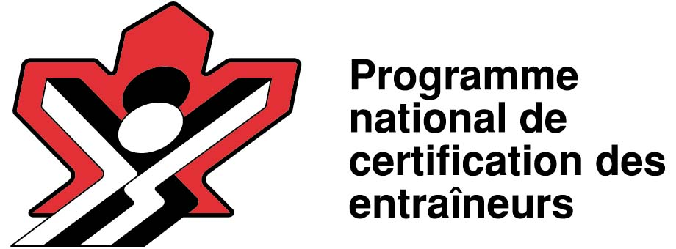

CB - S’entraîner à la compétition
PNCE- Compétition Développement
Stratégies et tactiques

Coffre à outils


www.basketball.ca

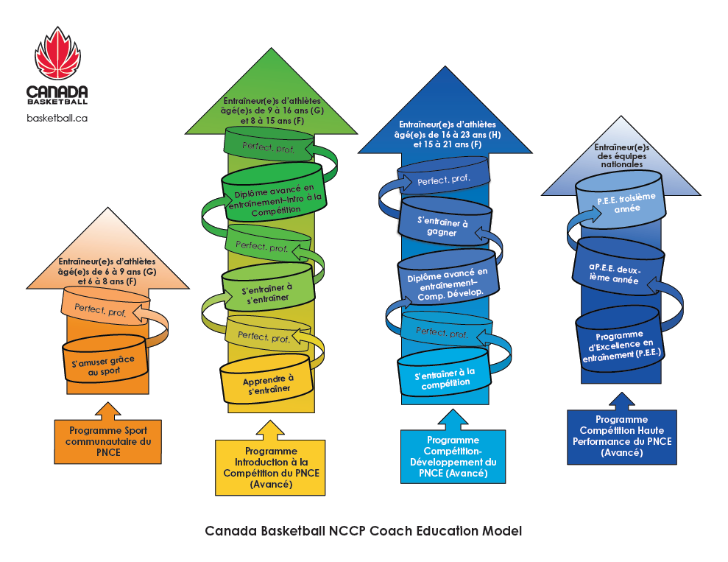
Contents
Introduction 5
Stratégie 5
Étapes de l’enseignement 22
APPROCHE CONCEPTUELLE POUR L’ENSEIGNEMENT DU JEU OFFENSIF – PRINCIPES TECHNIQUES EN ATTAQUE 32
Aspects à prendre en considération 32
• ATTAQUER LE PANIER 36
Attaquer à 1 contre 1 lorsqu’on est en possession du ballon (dribbler) 38
1 contre 1 et lecture du jeu du/de la défenseur(e) 41
ESPACE 44
Durant les premières secondes de possession du ballon 46
PÉNÉTRATION 47
ÉDUCATIFS D’ESPACEMENT ET DE PÉNÉTRATION 53
ÉDUCATIFS POUR PASSER LE BALLON ET COUPER 58
COMBINAISONS D’ÉDUCATIFS DE DRIBBLE, DE PASSE ET DE TIR 61
JOUER AVEC LES COÉQUIPIERS OU COÉQUIPIÈRES 64
SAISIR LES REBONDS 67
UTILISER UNE APPROCHE CONCEPTUELLE EN ATTAQUE, EN TENANT COMPTE DES CINQ PREMIERS PRINCIPES OFFENSIFS 69
JEU À L’INTÉRIEUR 75
DÉVELOPPER LES HABILETÉS DE JEU À L’INTÉRIEUR 81
FAIRE ÉCRAN 91
Options 101
PROGRESSIONS PÉDAGOGIQUES POUR ENSEIGNER LA MANŒUVRE D’ECRAN SUR LA BALLE SUIVIE D’UN PIVOT 104
• 115
• ISOLER CERTAIN(E)S JOUEURS/JOUEUSES 115
STRATÉGIES 117
LORS DE LA TRANSITION – PREMIÈRES SECONDES DE POSSESSION 117
ÉDUCATIFS DE TRANSITION, SUR TERRAIN COMPLET 118
ÉDUCATIFS DE PROGRESSIONS DU BALLON TOUT TERRAIN – SITUATIONS DE PARTIES 120
APPROCHE CONCEPTUELLE POUR ENSEIGNER LES ACTIONS OFFENSIVES (MILIEU OU FIN DU DÉCOMPTE AVANT LE LANCER) 123
CONTRE-ATTAQUE 140
Contre-attaque 146
ATTAQUE D’UNE DÉFENSIVE DE ZONE 147
SITUATIONS PARTICULIÈRES 160
ENTRE-DEUX 160
LANCERS FRANCS 161
REMISES EN JEU 161
PRINCIPES DÉFENSIFS 163
• ASPECTS PARTICULIERS DU JEU DÉFENSIF 168
EXERCICES POUR DÉVELOPPER UNE MENTALITÉ DÉFENSIVE 179
TRANSITION DÉFENSIVE 185
PRESSION DÉFENSIVE 191
CONCEPTS DE PRESSION DÉFENSIVE 195
DÉFENSIVE DE ZONE 198

Introduction
Le basketball consiste toujours à mettre le ballon dans le panier. Cependant, depuis qu’on a mis en place une limite de temps pour lancer, la vitesse à laquelle les joueurs ou joueuses se sont mis(e)s à exécuter les différentes techniques et à exploiter les concepts du jeu a changé drastiquement. On peut faire une comparaison avec la croissance de l’Internet. Au début, la plupart des personnes ne disposaient que d’une connexion par le biais d’une ligne téléphonique. Cela leur permettait de naviguer sur la toile et convenait à leur besoins à l’époque; mais lorsque les systèmes sans fil à haute vitesse sont entrés sur le marché, le nombre de personnes qui ont continué à utiliser les connexions téléphoniques a chuté considérablement. De nos jours, il est encore possible de se brancher à Internet grâce à une ligne téléphonique, mais la quantité d’informations que l’on peut gérer de cette façon au cours d’une période de temps fixe est plutôt restreinte. C’est un peu la même chose au basketball. Les entraîneur(e)s peuvent tenter de ralentir le jeu et de contrôler chaque action, mais l’horloge impose des limites à ce type d’approche. L’implication est claire : on doit de plus en plus laisser les joueurs ou joueuses prendre des décisions en situation de match. Ceci mène inévitablement au développement d’un joueur ou d’une joueuse « globale », c.-à-d. d’un(e) athlète qui maîtrise l’ensemble des techniques du jeu, et qui peut également évoluer à plusieurs postes. Cette nouvelle réalité nous force à réévaluer la façon d’enseigner le basketball à chaque étape du développement des joueurs/joueuses.

Stratégie
Les stratégies et les tactiques peuvent fonctionner à court terme, pour une ou deux parties. Mais la plupart des équipes adverses pourront s’y ajuster rapidement. À l’inverse, si vous adoptez une approche qui vise à améliorer les habiletés individuelles de vos joueurs/joueuses, ils/elles « appendront », et n’oublieront jamais. La plupart d’entre nous se souviennent sans doute d’un(e) entraîneur(e) qui nous a enseigné une chose qui a eu un impact majeur sur notre façon de jouer. Ce n’était pas un jeu ou une combinaison tactique; c’était plutôt une chose qui nous a permis d’améliorer notre performance sur le plan individuel. Lorsque l’on bâtit la confiance des joueurs/joueuses, on leur permet d’aller au-delà de leurs erreurs et de s’améliorer.

L’amélioration est d’abord et avant tout une question individuelle, elle ne résulte pas des tactiques ou des stratégies.
Ettore Messina

Certain(e)s d’entre vous se demanderont sans doute pourquoi une telle citation est incluse au tout début d’un document dont les thèmes centraux sont les tactiques et les stratégies. La raison est simple : en tant qu’entraîneur(e) nous devenons trop souvent obnubilés par cet aspect du jeu, et nous oublions du même coup l’importance d’enseigner les concepts fondamentaux et les techniques de base. Les tactiques et les stratégies ont bien sûr leur importance, mais les entraîneur(e)s doivent faire preuve de discernement et éviter de les utiliser à outrance. Les entraîneur(e)s doivent également toujours garder en tête le profil des joueurs ou joueuses avec qui ils/elles interviennent, et se demander si les stratégies utilisées sont vraiment adaptées à leur stade de développement.

Le présent document a été rédigé à l’intention des entraîneur(e)s du stade « S’entraîner à la Compétition » du modèle de Développement à long terme des athlètes (DLTA). Nous nous attarderons tout d’abord à la « pyramide de l’entraînement » de ce stade particulier, ainsi qu’aux différents concepts techniques et aux stratégies que l’on devrait aborder avec ces athlètes.

En 2010, Canada Basketball a embauché Renato Pasquali au poste de Directeur Technique. Plusieurs des idées et des notions qui sont présentées et décrites dans le présent document témoignent de sa vaste expérience dans le sport du basketball. Tel qu’on l’a mentionné plus tôt, le jeu a beaucoup évolué au fil des ans, et il faut tenir compte de cette réalité quand on l’enseigne afin de demeurer à jour avec ce qui se fait ailleurs dans le monde. Les informations contenues dans ce manuel sont à la fine pointe des connaissances actuelles. Il ne s’agit pas de ce que l’on faisait il y a 20 ans; c’est plutôt ce que l’on doit chercher à faire maintenant si on aspire à devenir une puissance mondiale en basketball. Grâce à ce manuel, nous souhaitons partager des principes d’enseignement et des pratiques éprouvées avec l’ensemble de la collectivité des entraîneur(e)s.

Canada Basketball désire remercier Kelly Woloshyn et Kathy Brook pour leurs conseils au moment de rédiger et d’éditer ce manuel, ainsi que Mike McNeill, Dave Constantine, André Desjardins et Daniel Grimard qui ont contribué à la rédaction technique. Et bien sûr, il faut souligner l’immense contribution de Renato qui a offert son temps et partagé ses connaissances sans réserve; une telle implication de sa part témoigne du grand intérêt qu’il porte au développement des athlètes et au perfectionnement des entraîneur(e)s de notre pays.

Mike Mackay
Responsable du développement et de la formation des entraîneur(e)s
Canada Basketball

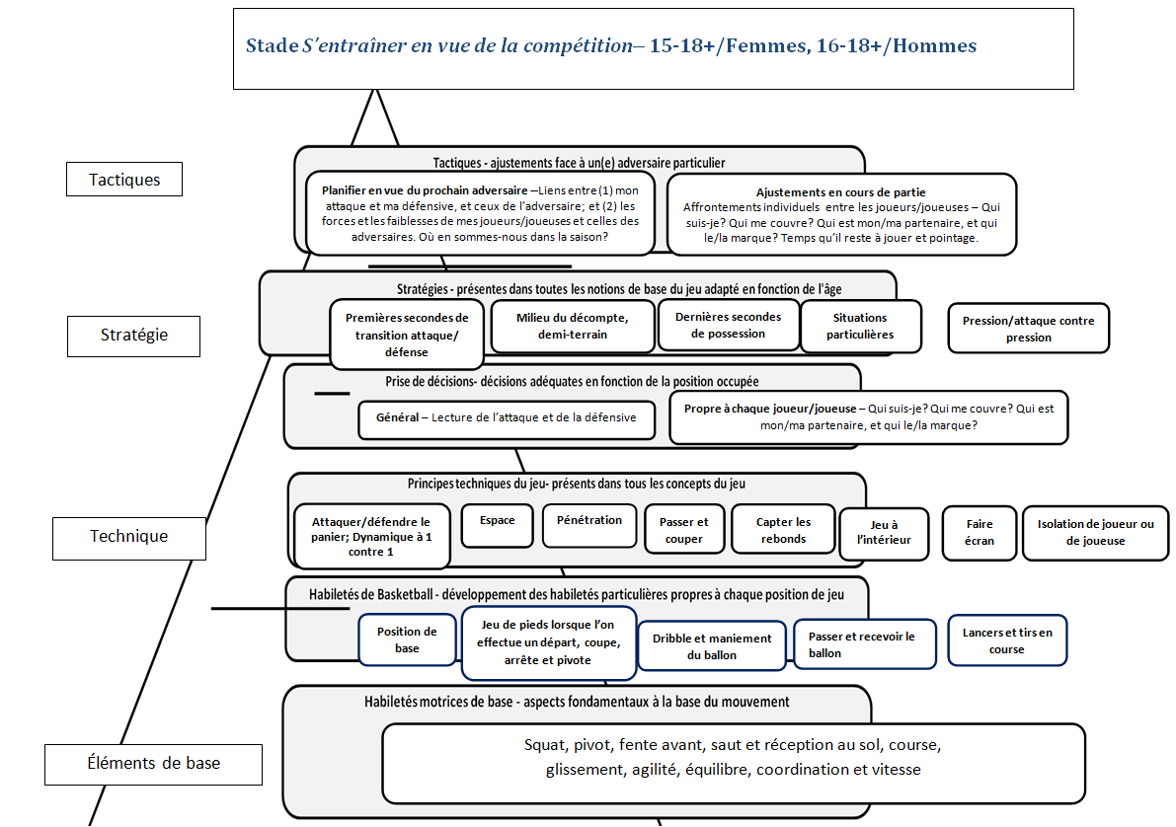

Canada Basketball’s LTAD Overview
LTAD Stages | Learn to train | Train to train | Training to Compete
Age | 10-11 years old | 11-15 girls | 15-19 girls
 |  | 12 - 16 boys | 16- 20 boys
Aim | To learn the basic basketball skills while still emphasizing fundamental movement skills in a fun all inclusive environment. | To introduce the basic technical and strategic parts of "global" basketball with a more structured approach to training. | To introduced athletes to all aspects of the game, and begin to refine all technical aspect and most strategic components.
Fundamental Movements Skills (FMS)
FMS is the foundation around which all movement is based. All players must master the ABC’s – Agility, Balance, Coordination and Speed. The ABS’s need to be taught. The greatest limitation in skill development is often problems with a fundamental movement skill. We want to make players athletes’ first and basketball players second. FMS also help the players develop the neuromuscular memory to help prevent injuries. Players need to develop the proper technique for squatting, lunging, twisting, bending, pushing and pulling.

FMS | Since this is still an entry stage for many children it is imperative that the instructor ensure that each child still has these fundamental movement skills. 20% of time is used on movement skills. After the skills have been acquired coaches can use more basketball specific methods to consolidate and refine the FMS. | 25% of the time in instruction should be used to warm up using the fundamental movement and basketball skills. Error detection and corrections still needs to be done at this stage since the players are going through their growth spurt. | 20 % of instructional time is spent here. Work is done on refining the skills and in warming up. It can become more individualized.
Fundamental Basketball Skills (FBS)
The FBS are the basic building blocks of the game. These include; a balanced stance, the ability to start, stop and pivot (footwork), shot form (which includes lay ups), dribble form, passing form and the ability to play one on one. We need to develop ‘global player’. Players who have a sound foundation in the FBS rather than being restricted in the skills they learn based on positional play.

FBS | Introduced the basic skills. Initiation and acquisition of the main fundamental skills of basketball: Starts, stops and pivots, shot form (lay ups), pass form, dribble form and dynamic 1 on 1  Bilateral development global approach, everyone learns all skills and positions. 20% of teaching time is basketball fundamentals.  GLOBAL PLAYER | Players should be taking the basic skills of basketball (Starts, stops and pivots, shot form (lay ups), pass form, dribble form and dynamic 1 on 1) through consolidation and refinement. They will also be introduced to more complex variations of the skill. Note that some players may still be introduced to the sport at this stage. Players may be at different stages of their own personal skill development of the main fundamental skills of basketball.  Bilateral development global approach, everyone learns all skills and positions  GLOBAL PLAYER | The players should be able to perform the basic skills in a competitive environment. Begin to develop a more individualized skill package. Players may take certain skills to the creative stage.  Players are introduced to positional play, but are not restricted in their global skill developed because of a position. The position they play should not be a reason to restrict the use of the basic skills of the game. For example: a player playing the post position should not be told to never dribble the ball.  Apply their Global Player skills into positional play.
Start /stop /pivot | This begins with a balance. Players learn how to start in a balanced stance. They then progress to moving, stopping and pivoting, all done while on balance. Begin without the ball progressing to movement with the ball. Use both feet to start and stop. | Balance becomes an issue through this stage as players are progressing through puberty. Care must be taken to constantly working with players on proper form. They should be able to execute the proper starts stops and pivots without travelling; from a stationary start and while moving and catching the ball. Use both feet. | Once the player as completed puberty they can begin to work on some more specialized starts stops and pivots that are more position related. Proper form must be maintained.
Shot (layup) form | The players are working on the correct form. Stationary shot form is taught using phase 1, 2 and 3.Players should learn the basic right and left hand layup. It is important that form is a higher priority than range on the shot.  By the end of this stage players should have acquired the proper form for catching and shooting (layups) off the pass and for shooting (lay ups) off the dribble. | In this stage the player will have less time in to perform the skill. The emphasis is on using correct form to maintain the one second advantage. The player work on consolidating and refining the skill of shooting the ball against defence.  The players will also acquire and consolidate the outside- in-power layup that is used close to the basket when contact can occur. | Once the player as completed puberty they can begin to work on some more specialized shooting (layups) that are based on:  - the position the player will play  - individual characteristics of the player  Proper form must be maintained. Positional play should not be a reason to limit players from shooting the ball.
Dribble form | Players are introduced to and acquire the ability to dribble with the eyes up with both hands. They should be able to perform changes of speed and changes of direction. The speed at which they dribble should never be faster than their vision or balance. | At this stage the defensive pressure is increased. For this reason players should be able to dribble with the eyes up, with both hands, while being closely guarded. Players need consolidate and refine when to:  - go fast and when to go slow  - change direction  - stop and start a dribble  - fake | At this stage position specialized dribbling becomes a priority. Positional play does not include restricting a player from dribbling. All positions need to be able to dribble the ball.
Pass form | Players are introduced to and acquire the skill to pass the ball to a teammate. Both the receiver and passer are learning how to:  - Show target hands  - Shorten the pass.  - Pass to the right and left  - Use the proper pivot foot  - Use the universal release  - Pass from both a stationary position  - Pass from the dribble | As defensive pressure increase players must learn to consolidate and refine the ability to:  - Pass against pressure.  - Pass on time and on target  - Know how to pass to a cutter  - Know to pass to a sealed player  - Move or seal to create passing lanes | At this stage position specialized passing becomes a priority. Positional play does not include restricting a player from passing. All positions need to be able to pass the ball.
Dynamic 1 on 1 | Players are introduced to playing 1 on 1. It is recommended that the players learn to play from dynamic starts and not always from a stationary position. The offensive player should always have a release pass available. This helps the players learn not to force contested shots. | Players at this stage learn to anticipate the defence and make use of a cross over, curl or shot. This is the foundation of team play. They are learning to play 1 on 1 within the context of all five players on the team. | At this stage position specialized 1 on 1 becomes a priority. Positional play does not include restricting a player from playing 1 on 1. All positions need to be able to play 1 on 1.
Technical Principles of play
The concepts of play that are applied in the base games (1on1, 2on2, 3on3). The players must learn the concepts from both the offensive and defensive point of view. Players are introduced to the following ideas :
- One second advantage.
Offensively we want to create an advantage where the offensive player can take a high percentage shot. The defence is working to prevent this advantage and to force the defence to turn the ball over or take low percentage shots.
- Flow
The offence does not want to freeze the ball. Each action that occurs must be linked to the previous action. Teams flow through their early clock, mid-clock and late clock offence. They do not take time to set up each section individually. This continuous flow means that no time is wasted on the shot clock. Defence is attempting to disrupt the flow of the offence. If it can force multiple disruptions in flow it will force the offence into poor shot selections. Even though younger player do not use a clock it is imperative that they are taught the concept of flow in their play as it creates a seamless progression in their growth as players.
- Conceptual play
Players are taught to play the game using the technical concepts of play rather than strategies first. The concepts allow the players to work together to create one second advantages that give them an opportunity to score
- Global Player
Every player needs a solid foundation in the basic basketball skills and concepts of the game. When taught positional play at a younger age the player is often restricted in learning some of the basic skills and concepts. This solid foundation allows the player to take their future positional play to higher levels when it is appropriate to play a position.

Technical (when) | 30% of time is spent on individual skills. When should I dribble with my left hand/right hand? 20% of time is spent on multi-player skills. When should I cut to get the ball?  Progression of Concepts:  - Attacking the open basket  - Spacing  - Penetration  - Pass and cut  The defence is learning the three basic rules:  - Protect the basket  - Pressure the ball  - 1 and ½  Teaching is done in transition or from dynamic starts. | 30% of instructional time is on introduction, acquisition of new skills and refinement of old. Some should become creative. A major emphasis is on learning to "read" on defense and offense.  Concepts:  - Attacking the open basket  - Spacing  - Penetration  - Pass and cut  - Sealing  - Screening at the end (ball screens is the last to be added)  The defence is still consolidating the three basic rules:  - Protect the basket  - Pressure the ball  - 1 and ½  Additional rules are loaded:  - Denying position on the floor  - Rebounding  Teaching is done in transition or from dynamic starts. | 40 % of the time is spent on the acquisition and consolidation of specialized skills, refinement and creative of the basic technical skills.  Concepts:  - Attacking the open basket  - Spacing  - Penetration  - Pass and cut  - Sealing  - Screening  The defence is applying the three basic rules:  - Protect the basket  - Pressure the ball  - 1 and ½  More positional specific defence rules must be applied.  Teaching is done in transition or from dynamic starts.
Attacking/defending  the basket | Players learn to drive the ball when they see an open basket. If a defender is between the basket and the player with the ball a pass should be made. On defence the players learn the first rule which is to protect the basket. | Players look for opportunities to attack the basket when playing. This can be with the dribble or by passing to a cutter. Defence is making use of the three rules; protect the basket, ball pressure and one and a half. | Players must learn to attack the basket when playing at the various positions. Perimeter players must learn to attack poor close outs by the defence. Interior players learn to attack poor positioning by sealing inside.
Space | Use of the grid to help players to learn play in space. Never two players in the same grid space. This is especially effective when playing the base games of 1 on 1, 2 on 2, 3 on 3 and 4 on 4. | Players learn to use the three point line and key for spacing principles. In general, we do not want catches in the space between the three point line and the key. | Players must now learn to play in space within positional play.
Penetration | This is a continuation of attacking the basket. The player without the ball must move to create a passing lane for the player driving the ball. After passing, the passer must move to make new space. The defence is introduced to the one and a half rule. | Players must be introduced to movement as a perimeter and interior player. Details such as: when the movement should occur, pausing for one second on the catch, replaying against your defender; need to be consolidated. Towards the end of this stage players should know how to make secondary cuts on the pivot. | Penetration principles from the various positions need to be taken to the refinement stage.
Passing & Cutting | After passing the players learn to cut to the basket, open and the exit to vacant space. Other players learn to fill the vacant space when the passer looks at them and is ready. Backdoor cuts are added at the end of this stage. | Players should consolidate and refine the passing and cutting principles introduced in the L2T stage. Players are introduced to:  - Being on time and on target  - Skip pass | Players learn the specific passes and cutting action for their positions.
Rebounding | The skill is introduced and acquired at this stage. | The skill is consolidated and refined. Physical contact increases at this stage. Players are taught to properly move their feet to get their body in position. | The skill is applied to positional play.
Posting & sealing | Should not be taught or emphasized at this stage | ALL players learn how to use their body to seal a defender or how to escape from a seal on defence. Coaches must be alert to the differences in physical maturation. Players learn how to pass the ball to a person in the post position: pass high, bounce pass, triangle pass, lob and how to move in relation to the ball in the post.  Players learn simple ways to score from the interior. The emphasis is still on playing one on one within five. They must also learn when and how to pass out of the post. | At this stage post play becomes more positional and strategic. All players must still be able to defend and score inside.
Screening | Should not be taught or emphasized at this stage | Screening is introduced at the end of this stage. Off ball screens are introduced before on ball screens. A coach should not feel pressured to rush to introduce screening. Moving too quickly to this concept often limits the development of the previous concepts.  It is recommended that screens are used to create a one second advantage to allow the players to play free. The players use one screen as a way to read the defence rather than multiple screens in a complex strategic pattern.  Switching screens defensively at this stage is recommended when a coach is concerned with the amount of time required to properly teach how to defend the numerous number of possible screens. | Screening is a major emphasis of this stage. Players must be taught how to properly set, read and defend a variety of screens. A concern is that coaches often put players in positions that they player will never play at the next stage of development. For this reason teaching should progresses from a global approach to a more positional specific.
Isolations | Should not be taught or emphasized at this stage | Should not be taught or emphasized at this stage | Isolations occur in positional play. It is important to understand that the player isolated is playing 1 on 1 within all five players, rather than 1 on 1 by him/herself.
Decision Making
Players need to be able to think for themselves on the floor. In training the coach must provide the players with problems and allowed them to come up with the solution. Too often coaches TELL the players the solutions without allowing the players the valuable experience of learning. There is no depth of understanding developed. With this in mind coaches need to go through the three phases of teaching:
Phase A - introduce the skill on air (1 on 0, 2 on 0 etc.)
Phase B - the coach guides the decision making of the players by providing reads
Phases C – the players use the skill in break down drills with live defence
Phase D – the players use the skill in game like situations (2 on 2, 3 on 3, 4 on 4 and 5 on 5)

General – reading the offence/defence | Technical basketball (decision making) is taught through 2-1, 3-2, and 4-3. The offence is learning to SEE and FIND the open player. For example: In a 2-1 situation the player must decide if he/she has an open basket. If the answer is yes attack with the dribble. If the answer is no pass the ball to the player who is open to attack. This gives the offence success with their basic skills. The defence is required to apply their three rules: protect the basket, ball pressure and one and a half.  By starting playing straight 3 on 3 the offensive players do not have the skills to get to the point where they can use their decision making ability. We need to allow the offence a chance to grow first.  The majority of the decisions made by the players involve when to use specific skills. For example; when the player with the ball sees and open basket, should he/she shoot or dribble the ball. | In technical teaching the offense is given a one second advantage. The object is for the player to USE theone second advantage. For example a 2 on 2 drill starts with the defender of the ball standing beside the offensive player. If the offensive player effective uses his/her advantage he/she forces the help defender to defend. The offensive player must now see and then find the open player. Defence is constantly applying the three defensive rules.  The player’s decision making now begins to include more decisions involving other players. | In technical teaching the offense see, find, use and CREATE a one second advantage. Now the offensive player must make use of screens, fakes or dribble move to break down their initial defender. Once the advantage has been created the player must use the advantage. If the defence helps see and find the open player and pass your one second advantage on to the next player.  At this stage player’s decisions also need to include game situations such as: match ups, time and score.
Player specific – Who am I? Who is guarding me? Who is my teammate? Who is guarding my teammate? | This is done in very generic terms at this stage. The coach should ensure that match ups reflect the player’s abilities to provide meaningful competition and not be seen as a way to exploit poor match ups to win games. | Players need to begin to understand the strength and weaknesses of their teammates and opponents. Play to your teams strength and to your opponents weaknesses. | In a all competitive situations players need to recognize this situation. It becomes more positional at this stage.
Strategy
What is your team going to do? This is where the coach develops a plan for how the team will play in transition, on offence and defence. The chosen strategy should not restrict player growth and development. It should provide opportunities for ALLPLAYERS to make use of their skills and concepts of play.

Strategy (long term organizational plan of the players into a method of play) | Players participate equally in controlled games designed to enhance skill development. Players learn a basic awareness of offense and defense. 10% of the time is spent on basic offense / defense.  3 on 3 progressing through 4 on 4 with limited 5 on 5 at the very end. This allows for more touches on the ball. The basket is more open and provides opportunities for the players to use their basic concepts  Teach through use of the grid. | To use the basic skills for all positions in a competitive environment. Players learn basic team maneuvers that involve multi-player and multi-positional play. 30% of instructional time is spent here. Basic offenses and defenses should be consolidated and refined before introducing more complex strategies such as zones and presses. | 40 % Of the time is spent here. Acquisition and consolidation of specialized strategies, refinement and creative of the basic strategies. Players are exposed to an expanding array of team maneuvers and an increased knowledge of positional movement.  Early clock – players time  Mid clock – coaches time  Late clock – players time
Early clock transition offence/defence | There should be no team strategy at this stage. The players learn to advance the ball or defend the advancing ball, using their concepts of play. A shot clock is not used at this stage. | There should be limited team strategy at this stage. ALL players advance the ball or defend the advancing ball, using the concepts of play. ALL players need to learn the skills and decision making required to play in transition, both from and offensive and defensive prospective.  A shot clock is used at this stage. | Teams progress towards a more positional approach to playing in transition. This should not restrict players but enhance their skills and decision making. The coaches’ needs to ensure that there is flow from early clock into midi-clock.  Appropriate pressure releases need to be built in;  outlet denied, wing push denied etc.
Mid clock ½ court offence/defence | There should be no team strategies at this stage. The players should play through their concepts of play. Looking to find open player. No shot clock is used at this stage. | There are limited team strategies. The players should flow into their half court offence from transition. They are looking to make use of one second advantages that appear.  Set plays are used as means to create a one second advantage. Once they advantage is taken the players play free using their concepts of play. Players are not running elaborate patterns and playing keep away. | The offence needs to flow from transition into the mid-clock offence. The set should enhance or build upon the strengths of the players. The needs to be a sense of urgency in each action that occurs (reading the defence). As one action is ending the next action has already begun. The set is to create a one second advantage.  There needs to be opportunities for each position to have opportunities to create a one second advantages. The coach should know how these advantages can occur within the offence and what defences may do to stop them The coach will develop depth to the offence by progressively teaching counters, reads or pressure releases. This is preferred over continually adding new sets.
Late clock | This does not apply at this stage. | Even though late clock situations do occur at this stage, the coach is not encouraged to run special plays or sets at this time. Players should attempt to maintain good spacing and timing throughout the entire shot clock. This will lead to one second advantage that allows the players to play free. | Any set offence must take into account the time on the shot clock. Players must be given pressure releases to allow the offence to continue to flow without disruptions. When late clock situation occur the coach must have accounted for the concepts that will be used to prevent contested or forced shots from occurring.
Special situations | Players are given a simple method to inbound the ball and to line up for foul shots and jump balls. | Players are introduced to foul line situation, jump ball and inbound splays. These should not be too elaborate and take up too much time in training. | Coaches begin to build a bigger repertoire of special situations. More time can be devoted in training to time and score situations.
Pressure/pressbreaks | This does not apply at this stage. | ALL players need to be involved in learning how to handle the ball move and pass vs. player to play pressure. Trapping and double teaming is allowed as long as the remaining layers are matching up in rotation.  The use of zone presses is discouraged at this stage in that it promotes positional play. | Players are introduced to zone pressure and pressbreraks. Players are progressively given more positional roles.
Zone | This does not apply at this stage. | Zones are not recommended at this stage since zones put players in positions. Also it can monopolize teaching and prevent coaches from spending time on skills and concepts of play. | Coaches can use zones as part of their strategy of play. Coaches should be careful that playing zone does not hurt the continued development of the players.
Tactics
These are adjustments for a specific opponent or game.

Tactical (short term adjustments to the plan, usually competition specific) | Any short term adjustments are made to enhance the learning of the skills and concepts of the game and to allow the players to cooperate in a competitive environment.  This can mean changing the makeup of teams or adding modified rules to provide more meaningful competition rather than stacking teams so one team can win.  Coaches should not use tactical adjustments to trick young players so the coaches’ team can score an easy basket. | Simple reminders about the strengths and weaknesses of an opponent. Elaborate scouting reports or having half your team walk through the opponent’s sets is not recommended at this stage. Preparation for an opponent is done through working on the concepts on offence and defence that will be used for the next competition.  Only 15% of the time should be spent here.  Players are encouraged in drills to understanding an opponent’s main strengths / weaknesses. | 20% of the time is spent on competition specific tactics. It is still best to prepare for the opponent by practicing the required concepts and skills need for the best competition. Some team and player specific preparation can occur, but not at the detriment of continued development. For example: when coaches spend the majority of time in training sessions, leading up to the competition, on have players learn the opponents sets and defences. This limits player development.
Planning for your next opponent - Relationship between my offence/defence and my opponents’ offence/defence  Relationship between my player’s strength/weakness and opponent player’s strength/weaknesses  Where am I in my season? | This does not apply at this stage. | In planning for the next opponent the coach is aware of where his/her team will be able to see, find use and create one second advantages. In training the coach ensures that his/her team is working on the skills and concepts required to introduce, acquire, consolidate and refine these skills and concepts. This is done using a global approach. All players get to work on the skills and concepts.  The coach uses the rules of defence to help the players prepare for how the opponent likes to score. | The coach uses the same approach as in the T2T stage, but more positional approach is used. The coach can make use of video, hand outs meetings to prepare the team for the opponent.
Other Points to Consider
Periodization | Single periodization. Maximum of two sport specific session per week. | In the early part one of this stage single periodization with a general prep and specific preparatory stage. Double periodization can occur in the later part of this stage. | This phase can be a single, double and in elite situations triple periodization.
Length of Program | 12- 20 weeks | 20 - 35 weeks | 35 - 45 weeks
Training to Competition | For every minute of game time three minutes will be spent on skill development. This will enhance the experience of playing the game. 75% of the time devoted to training 25% spent in games (not competition). | For every game there needs to be one hour minimum of training. Games for learning vs. games for competition. The ratio of 75% training and 25 % competition is still applicable. | Competition becomes more important and training takes on a more competitive nature. 40% of training is devoted to technical and tactical skills and fitness. 60% is devoted to competition and competition specific training.
Physical  , | Continue with fundamental movement skills (Agility, balance, coordination and speed)  Own body weight exercises for strength  Basic flexibility  Neuromuscular training (prehabilitation– twisting, bending, squatting, lunging, pushing, pulling) | Fine tune the fundamental movement skills.  Strength training continued medicine ball, Swiss ball and body weight for strength. Core strength is key.  Flexibility training  Continue neuromuscular training  Note: During PHV coaches must be aware of limitations. | Develop the aerobic and anaerobic systems in sport specific context.  Individualized conditioning  Neuromuscular training (prehabilitation)  Strength and power training.  Develop proper technique first.
Recovery | Introduce recovery  - Post activity snack/Hydration  - Cool down  - Basketball vacations | Recovery continued  - Use of down time  - Sleep  - Nutrition/ hydration pre/ post game  - Being alert to overuse or growth pain | Expanded recovery techniques becoming more player specific.
Mental / Emotional | The main focus is on building confidence through the skills of the game. Players can be introduced to the following topics:  - Focus and concentration  - Self debrief  - Imagery  - Simple goal setting  - Centered breathing | Focus on building confidence through the skills of the game and developing good training routines.  - Self-confidence  - Focus and concentration  - Anxiety  - Debrief  - Imagery  - Goal setting  - Centered breathing  - Developing routines | Build confidence and introduce the athlete to the mental skills required for competition.  - Anxiety management  - Distraction plans
Social / Life lessons | Multi sport involvement  Lead themselves  Self-directed play  Nutritional advice  Develop good play habits  Relationships  - Do what is right  - Do your best  - Treat others the way you want to be treated  Dealing with adversity  Delayed gratification | Multi-sport involvement  General and specific training  Self-directed practice  Introduction to planning and periodization  Training and performance diary/log (time management)  Nutrition /hydration  Basic leadership skills  - Lead yourself  - Give energy  - Know how to follow  - Lead others  Fitting sport into life  Relationships  - Constructive / destructive behavior  Lifestyle choices (high risk behaviors) | Some player may choose sport specific training, others will still be multi-sport. It should not be multi-sport in a season.  Integrated sport into lifestyle  Dealing with being an athlete  Self-directed practice/play  Injury prevention and recovery  Nutrition / hydration  Leadership  Relationships  Lifestyle choices (high risk behaviors)  Planning for the future

Enseigner de façon progressive
Les séances d’entraînement devraient être mises en place de façon progressive. Dans le cas contraire, le développement des joueurs ou joueuses pourrait en souffrir. Il n’est pas nécessaire d’enseigner tout ou tout à la fois, mais il faut s’assurer de respecter une démarche pédagogique progressive et par étapes. De telles progressions doivent tenir compte des étapes par lesquelles les joueurs ou joueuses doivent passer lors de leur développement technique. Cela leur permet non seulement de bien maîtriser les différentes habiletés, mais également de bien comprendre les aspects décisionnels en lien avec chacune. Au terme de l’apprentissage, l’athlète est capable d’utiliser un élément technique particulier en situation de compétition sans devoir porter attention à l’exécution proprement dite. On voit trop souvent des entraîneur(e)s utiliser des progressions trop rapides qui font en sorte que, durant les matches, les joueurs ou joueuses utilisent des techniques qu’ils ou elles ne maîtrisent pas encore suffisamment – une telle approche conduit inévitablement à de mauvais résultats…

Étapes de l’enseignement

- Étape A - Initiation et Acquisition - Au cours de cette phase, les joueurs ou joueuses ont besoin de voir de bonnes démonstrations de la technique enseignée. Ils ou elles doivent également comprendre à quoi elle sert dans une perspective du jeu plus globale. Quand on présente une technique pour la première fois, il faut laisser suffisamment de temps pour que les joueurs ou joueuses puissent expérimenter et se fassent une idée par eux-mêmes ou par elles-mêmes. L’exécution se fait de façon individuelle, sans opposant(e). Au fur et à mesure que le joueur ou la joueuse progresse, l’entraîneur(e) peut ajouter des éléments additionnels à caractère technique. Le dernier élément à incorporer est la vitesse.

- Étape B - Acquisition et Consolidation - Au cours de cette phase, l’entraîneur(e) dirige l’attaque en agissant comme défenseur(e) et en maintenant le jeu sous contrôle. Ceci permet de développer les habiletés de prise de décision des joueurs ou joueuses. L’entraîneur(e) peut ici en profiter pour faire certaines choses de façon exagérée, ce qui permettra aux athlètes de prendre plus facilement les décisions qui s’imposent. Si on utilise des joueurs ou joueuses en défense à ce stade, les indices fournis peuvent être incorrects ou encore trop subtils pour cette étape de l’apprentissage. Par exemple, si l’entraîneur(e) couvre un joueur ou une joueuse qui tente de couper pour se démarquer, il ou elle conteste son action, lui indiquant ainsi clairement que la meilleure option est de couper par derrière.

- Étape C - Consolidation et Raffinement - Le joueur ou la joueuse doit être en mesure d’utiliser la technique contre une défensive active, habituellement dans une situation de un(e) contre un(e). Il est souvent avantageux de permettre à l’athlète d’effectuer plusieurs répétitions avant d’inverser les rôles en attaque et en défense.

- Étape D - Raffinement et Consolidation – À cette étape de l’apprentissage, le joueur ou la joueuse doit être en mesure de démontrer sa maîtrise de l’habileté technique en situation de jeu. L’entraîneur(e) sait que l’athlète y est parvenu lorsqu’il ou elle peut exécuter la technique sans avoir à y penser. Par exemple, un joueur ou une joueuse marque en exécutant un tir en foulée à l’aide de la main gauche; l’athlète n’avait pas remarqué qu’il ou elle avait eu recours à cette technique avant que l’entraîneur(e) le lui fasse remarquer…

Note : Les étapes C et D ne peuvent être mises en place tant que les étapes A et B ne sont pas achevées.

PLAN D’ENTRAÎNEMENT JOURNALIER
Afin de pouvoir enseigner efficacement les différentes habiletés et notions du jeu, l’entraîneur(e) doit suivre un plan qui s’inscrit dans une perspective à long terme. Les joueurs ou joueuses ne pourront y arriver s’il y a trois matches et une seule séance d’entraînement au cours d’une semaine… Le rapport entraînement : compétition doit plutôt être inversé… Le fait de mettre en place des séances d’entraînement efficaces est la clé du succès lorsqu’on cherche à permettre aux joueurs ou joueuses de développer leur plein potentiel.

PREMIÈRE PARTIE : ÉCHAUFFEMENT (5 % du temps)

Échauffement sous forme de jeux ou d’habiletés motrices de base
Mouvements préparatoires et prévention des blessures

DEUXIÈME PARTIE : TECHNIQUES INDIVIDUELLES DE BASE (30 % du temps)

Lancers, passes et dribble
Dribbles pour attaquer et utilisation de pieds pivots
Confrontations dynamiques de type « 1 contre 1 »
Éducatifs regroupant plusieurs habiletés - dribble, passe, lancer
Habiletés et techniques en défense

TROISIÈME PARTIE : ÉLÉMENTS DU JEU EN ATTAQUE ET EN DÉFENSE (30 % du temps)

1 contre 1 Prise de décisions
2 contre 2 Situation de jeu sur demi-terrain - attaque/défense
3 contre 3 Jeu en situation d’avantage - c.-à-d. on donne un certain avantage aux joueurs ou aux joueuses en attaque (p. ex. brève opportunité à 3 contre 2 avant que le ou la troisième défenseur(e) n’entre en jeu)
2 contre 1 Éducatifs de transition
3 contre 2 Éducatifs de transition tout terrain – attaque/défense
3 contre 3 Situations d’avantage

QUATRIÈME PARTIE : JEU SUR DEMI TERRAIN OU SUR TOUT TERRAIN (30 % du temps)

4 contre 4 Éléments particuliers - attaque/défense
5 contre 5 Systèmes de jeu - attaque/défense
5 contre 5 Partie simulée

CINQUIÈME PARTIE : (5 % du temps)
Retour au calme et récupération

ÉCHAUFFEMENT
Sometimes we want to load a warm up so that you can progress from increasing body temperature, to fundamental movement skills and then into basketball skills and concepts without changing the basic format of the activity. By keeping the drill or activity the same you waste little time in setting up for a new activity.

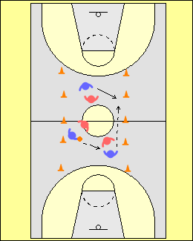 | Élévation de la température corporelle  Le but premier de l’échauffement est d’élever la température corporelle et, pour ce faire, on doit effectuer des activités aérobies d’intensité faible à modérée. L’utilisation de jeux peu structurés est une façon amusante de débuter une séance : les joueurs ou joueuses augmentent alors leur niveau d’activation tout en s’échauffant.  La passe à dix  On utilise des cônes pour délimiter la surface de jeu. Deux équipes formées d’un nombre égal de joueurs ou joueuses doivent effectuer 10 passes consécutives sans échapper le ballon, sortir de l’aire de jeu, ou transporter le ballon lorsqu’ils ou elles l’ont en mains. L’autre équipe prend possession lorsque l’une de ces règles est enfreinte.

Surcharge sur le plan mental

Pour encourager chaque joueur ou joueuse à s’exprimer et à s’affirmer, celui ou celle qui reçoit la passe doit crier à haute voix et avec leadership le nombre de passes qui ont maintenant été effectuées avec succès. Chaque participant(e) doit compter individuellement : de cette façon les joueurs ou joueuses qui ont tendance à s’imposer naturellement au sein du groupe ne contrôlent pas l’activité, et ceux et celles qui sont plus réservé(e)s ont l’occasion de s’exprimer.

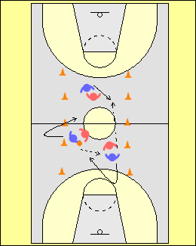 | Passe suivie d’un déplacement  Après, on peut ajouter le concept d’un déplacement suite à la passe.  Les joueurs ou joueuses doivent toucher le sol au-delà des cônes avant de pouvoir revenir au jeu.
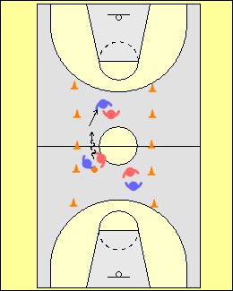 | Dribble suivi d’une passe  Dans cette version de l’activité, le joueur ou la joueuse dispose d’un délai d’une seconde pour effectuer une passe ou amorcer un dribble après être entré(e) en possession du ballon.  Ceci force les joueurs ou joueuses à garder la tête haute en dribblant, à dribbler jusqu’à ce qu’ils ou elles puissent faire une passe, et à faire des passes rapides et précises à partir d’un mouvement de dribble.  Pour encourager des passes fréquentes, on peut limiter à 5 secondes la période permise pour le dribble.
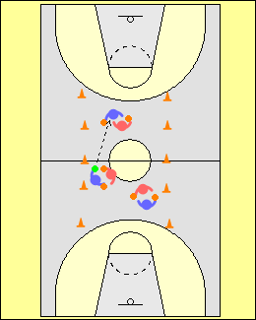 | Tout le monde dribble  Dans cette version de l’activité, chaque joueur ou joueuse a un ballon et dribble. Un ballon additionnel est mis en jeu et on cherche toujours à effectuer 10 passes consécutives.  Au début, on recommande d’utiliser un ballon qui sera facile à attraper et à passer à une seule main.
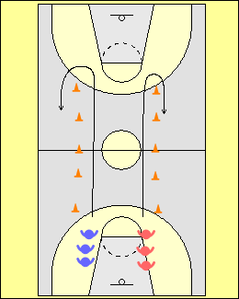 | Mouvements dynamiques  On passe ensuite à la partie de l’échauffement dans laquelle on effectue des mouvements dynamiques qui sollicitent les habiletés motrices de base, c.-à-d. les habiletés fondamentales du mouvement humain.  Les joueurs ou joueuses forment deux lignes derrière les cônes. Ils ou elles peuvent effectuer différents types de mouvements, p. ex. :  - Course vers l’avant  - Course dans laquelle on exagère l’élévation des genoux  - Course dans laquelle on ramène les talons aux fesses  - Carioca  - Mouvements de galop  - Déplacements latéraux (pas chassés)  - Course à reculons  - Déplacement dans lequel on entre et sort le genou suite à une rotation de la hanche
Une fois que les athlètes maîtrisent bien les mouvements, on peut ajouter des exigences additionnelles, p. ex. les effectuer tout en dribblant un ballon.
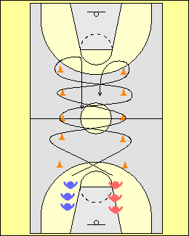 | Déplacements en zigzag  Les joueurs ou joueuses s’exercent à couper brusquement autour des cônes. Ils ou elles doivent également communiquer et avertir l’autre athlète au moment d’effectuer un croisement au centre.  Dans une version plus avancée de cet exercice, les joueurs ou joueuses doivent revenir par le centre après avoir complété le parcours. Il y a alors beaucoup de personnes qui sont en mouvement et qui doivent communiquer entre elles !
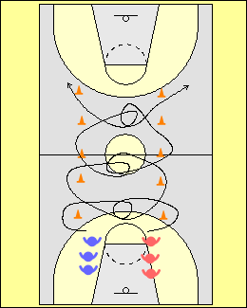 | Tourner autour du ou de la partenaire  Les joueurs ou joueuses se dirigent tout d’abord vers l’extérieur; ils ou elles contournent un cône, reviennent vers le centre et lorsqu’ils ou elles se croisent, font un tour complet autour du ou de la partenaire, avant de poursuivre.  Cet exercice oblige les athlètes à effectuer des mouvements rapides et bien coordonnés.
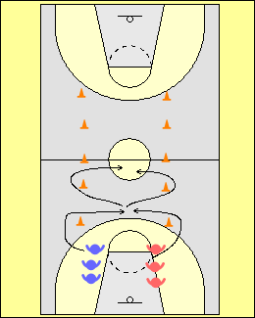 | Sauts synchronisés  Les joueurs ou joueuses travaillent deux par deux. Ils ou elles contournent un cône, reviennent vers le centre et lorsqu’ils sont près l’un(e) de l’autre, effectuent un saut synchronisé. Ils ou elles peuvent :  - Faire contact avec l’épaule.  - Tendre le bras le plus haut possible et taper dans la main de l’autre.  - Lancer leur ballon en l’air, et essayer de frapper celui du ou de la partenaire, qui tente de faire de même.  Cet exercice oblige les joueurs ou les joueuses à effectuer des sauts contrôlés et à faire des réceptions stables au sol.
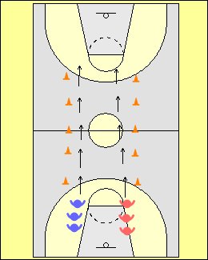 | Mouvements préparatoires  Dans cette activité, les joueurs ou joueuses effectuent des mouvements de type « yoga dynamique » qui contribuent au renforcement des muscles stabilisateurs du tronc et à l’amélioration de la flexibilité, p. ex. :  - Marcher en position de fente avant  - Marcher en position accroupie  - Marcher en position de fente latérale  - Ramper comme un vers  - Marcher de reculons en position « de l’avion »  (voir section précédente)  - Avancer en faisant des bonds  Les joueurs ou joueuses qui attendent en ligne devraient également effectuer les exercices suivants pour renforcer le tronc :  - Croisement des hanches  - Pont avant  - Pont latéral  - Pont arrière
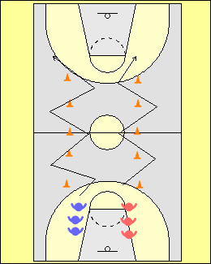 | Agilité et jeu de pieds  Les joueurs ou joueuses effectuent des exercices qui visent à développer l’agilité et l’efficacité du jeu de pieds, afin de se préparer en vue d’autres exercices qui seront faits plus tard durant la séance :  - Sauts latéraux – sauter d’une jambe à l’autre en effectuant des mouvements de zigzag; cet exercice est important si on prévoit travailler les finitions créatives de tir en foulée ou des mouvements originaux lors de l’exécution de tirs en foulée  - Pas chassés ou croisés  - Déplacements selon une trajectoire en « 8 »  - Bonds sur un pied  - Déplacements effectués à l’aide de mouvements contra-latéraux de type « ski de fond »
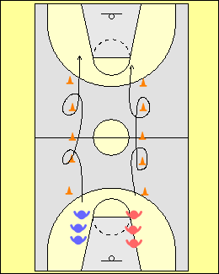 | Deux pas en avant, un pas en arrière  Cette activité est particulièrement importante lorsque l’on travaille la manœuvre du « dribble en retrait avec croisement ».
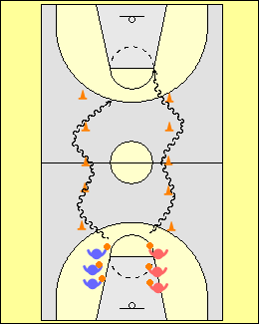 | Habiletés de basketball  Sans changer les formations utilisées, on passe ensuite à une progression dans laquelle on intègre le dribble et le tir en foulée. Les joueurs ou joueuses s’exercent à effectuer différentes manœuvres de dribble lorsqu’ils ou elles atteignent un cône, puis terminent le parcours en effectuant un tir en foulée. Pour le retour, ils ou elles peuvent effectuer un dribble en course rapide.  L’entraîneur(e) ou un(e) assistant(e) devraient se placer devant le panier :  - et faire un signal de la main afin que les joueurs ou joueuses s’habituent à garder la tête haute;  - pour réduire le meilleur angle d’approche au panier avant un tir en foulée.
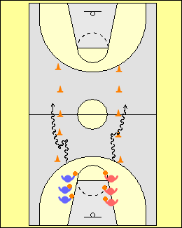 | Dribble en retrait avec croisement  Cette manœuvre de dribble est très importante, et chaque joueur ou joueuse devrait la maîtriser.  Les joueurs ou joueuses progressent vers l’avant et dépassent deux cônes, reculent ensuite en dribblant jusqu’au cône précédent, puis enchaînent immédiatement avec un dribble croisé.
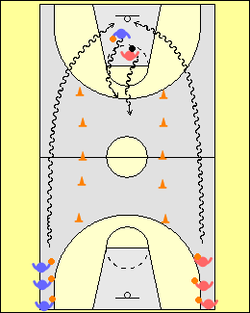 | Tirs en foulée « à la russe »  À noter que l’on a encore une fois conservé la même disposition de cônes pour cet exercice, afin de limiter les pertes de temps : on s’assure ainsi de maximiser le temps consacré à l’apprentissage des habiletés.  Deux joueurs ou joueuses dribblent dans le couloir extérieur, et font un tir en foulée. Ils ou elles reviennent ensuite par le centre, et l’un(e) est alors l’attaquant(e) tandis que l’autre est en défense.  Ceci oblige le ou la défenseur(e) à dribbler avec contrôle en position basse et à reculons.
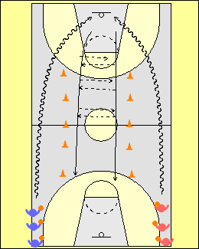 | Dans cette variante de l’exercice précédent, après avoir lancé les joueurs ou les joueuses s’échangent les deux ballons en se faisant des passes dans le couloir central.
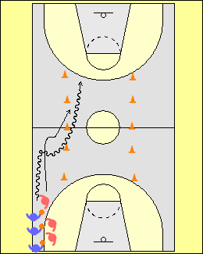 | Dribble en retrait avec croisement - défensive dirigée  On cherche ensuite à intégrer les principales notions que l’entraîneur(e) souhaite aborder lors de la séance : la manœuvre de dribble de type en retrait avec croisement dans laquelle on cherche à éviter de franchir le milieu du terrain près de la ligne de côté.  Les joueurs ou joueuses travaillent en groupes de deux avec un ballon. Le ou la défenseur(e) joue de façon semi active, et tente d’obliger l’attaquant(e) vers la ligne du centre le long de la ligne de côté.  L’attaquant(e) utilise alors le dribble en retrait avec croisement afin de se diriger vers le milieu du terrain. L’éducatif se termine par une confrontation de type 1 contre 1 dans le couloir central.
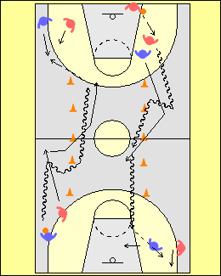 | 2 contre 2  La progression finale des exercices précédents consiste à jouer à 2 contre 2 sur l’ensemble du terrain.  Les joueurs ou joueuses peuvent alors constater de quelle façon les différentes activités d’échauffement ou de développement moteur s’intègrent dans le jeu. La séance prend alors tout son sens.  Trop souvent, on voit des entraîneur(e)s qui mettent en place des éducatifs qui ne s’agencent pas bien les uns aux autres : on perd alors toute perspective de progression logique pour les athlètes.

APPROCHE CONCEPTUELLE POUR L’ENSEIGNEMENT DU JEU OFFENSIF – PRINCIPES TECHNIQUES EN ATTAQUE

Cette section propose une procédure et des principes en lien avec l’enseignement du jeu en attaque. Ces notions constituent les éléments de base du jeu tel qu’il est pratiqué aux niveaux supérieurs. Le fait de négliger ou de ne pas tenir compte de ces notions pour passer tout de suite à des tactiques ou à des stratégies avancées pourrait avoir des répercussions négatives sur le développement à long terme des joueurs ou joueuses. Si certaines tactiques peuvent fonctionner pendant un match, les concepts fondamentaux demeurent quant à eux valables pendant toute la carrière du joueur ou de la joueuse. Il est illusoire de penser que l’on puisse enseigner les principes d’attaque lors d’une seule séance d’entraînement…il faut plutôt adopter une approche planifiée et à long terme. Le développement athlétique se réalise au fil d’innombrables répétitions que l’entraîneur(e) observe, analyse et corrige au besoin.

Aspects à prendre en considération

Apprendre à jouer tout en ayant du plaisir

De nos jours, les joueurs/joueuses ont un vécu et une expérience de vie qui sont souvent très différents de ce que la plupart des entraîneur(e)s ont connu dans leur jeunesse. Ils ou elles possèdent en effet des téléphones cellulaires, des ordinateurs, etc., et la plupart sont aussi constamment en contact avec les autres via les médias sociaux. Si les séances d’entraînement ne sont pas « accrocheuses » et qu’ils ou elles ne s’amusent pas, il n’est pas rare que les participant(e)s ne reviennent pas… Le jeu et le plaisir représentent donc des aspects cruciaux dont l’entraîneur(e) doit tenir compte afin de s’assurer d’une implication à long terme de la part des joueurs/joueuses.

Enseigner comment jouer – avoir du plaisir et développer des habiletés grâce au jeu

Il faut savoir utiliser de façon judicieuse les jeux à caractère compétitif qui représentent un défi pour les joueurs/joueuses, et les obligent à penser et à être actif(ve)s dès le début d’une séance d’entraînement. De tels jeux peuvent n’avoir aucun rapport direct avec le basketball (p. ex. jeu de poursuite), mais de par leur nature, ils peuvent obliger les participant(e)s à apprendre à devenir plus compétitif(ve) ou encore à développer des stratégies pour gagner. De tels jeux contribuent également à créer une dynamique positive dans le groupe, laquelle persiste souvent durant toute la séance.

Faire une analyse du niveau des joueurs/joueuses et avoir des attentes réalistes sur le plan technique

L’entraîneur(e) doit avoir des attentes réalistes pour son équipe, et connaître le niveau d’habileté de ses athlètes. Si le niveau technique est relativement bas au départ, il n’est pas logique de pousser les joueurs/joueuses à exécuter des manœuvres très complexes. Par exemple, si les joueurs/joueuses ne peuvent pas dribbler ou passer efficacement, ou encore effectuer des tirs en foulée avec les deux mains, il est complètement inutile de leur présenter des tactiques ou des stratégies complexes telles les écrans. Un(e) entraîneur(e) réaliste choisit un programme technique qui convient au niveau de l’équipe. Trop souvent on voit des entraîneur(e)s qui établissent leur système de jeu sur la base de :

- ce qu’ils ou elles ont fait lorsqu’ils ou elles jouaient
- modèles provenant d’entraîneur(e)s de haut niveau reconnu(e)s (livres; sites Internet; DVD; etc.)
- ce qu’ils ou elles voient à la télévision en regardant des matches de haut niveau (NCAA; NBA; etc.)

Les entraîneur(e)s doivent plutôt bien comprendre le stade de développement auquel se trouvent leurs athlètes. Le système de jeu doit être établi sur la base de concepts simples qui peuvent être adaptés au niveau des joueurs/joueuses, tant sur le plan individuel que collectif. Les techniques de base et les concepts fondamentaux du jeu demeureront valables pendant toute la carrière du joueur ou de la joueuse. Certaines tactiques ne seront quant à elles valables que pour un seul match… On doit donc se demander ce qui est le plus important…

Par exemple, si l’entraîneur(e) enseigne aux défenseur(e)s de jouer en retrait dans une défensive de zone, parce que les attaquant(e)s adverses ne sont pas habiles au lancer, il ou elle préconise une approche qui ne fonctionne qu’à court terme, et ne prépare pas vraiment ses joueurs ou joueuses dans une perspective à long terme pour les situations où ils ou elles devront affronter des adversaires plus habiles… situation qui pourrait d’ailleurs très bien se présenter dès le prochain match…

Enseigner les aspects fondamentaux et utiliser une approche globale

Avec les jeunes joueurs/joueuses, on doit tout d’abord mettre l’accent sur les concepts généraux les plus importants. Faire trop d’analyses ou se concentrer sur trop de détails à la fois peut nuire au développement des athlètes.

Le principe des « explications courtes et simples » est toujours efficace, et on doit toujours le garder en tête. Les jeunes joueurs/joueuses ont de plus besoin de bons modèles et de bonnes démonstrations pour bien assimiler les différentes techniques et pouvoir les travailler correctement de façon individuelle. Ils ou elles doivent également savoir pourquoi on leur demande d’exécuter une technique de telle ou telle façon. Toutes ces petites suggestions ont leur importance, et contribuent à faciliter les apprentissages.

Dans le cas présent, la première chose sur laquelle on doit se concentrer est le jeu de pieds. À chaque fois qu’un joueur ou une joueuse apprend une nouvelle habileté, il ou elle doit d’abord et avant tout porter attention aux mouvements de ses pieds lors de l’exécution.

Inclure la prise de décisions, mais sans trop d’analyses

Les jeunes joueurs ou joueuses doivent pouvoir prendre des décisions et déterminer quand il est pertinent d’utiliser une technique particulière ou de mettre un concept en application. Ceci doit se faire dans un contexte d’entraînement positif, et ils/elles doivent répéter les exercices un très grand nombre de fois afin de reconnaître les bons indices (lecture correcte du jeu) et ensuite prendre les bonnes décisions. Au début, l’entraîneur(e) doit agir comme « guide » et les aider à prendre les bonnes décisions. Il est préférable que ce soit l’entraîneur(e) qui joue ce rôle et non d’autres athlètes, car ceux-ci ou celles-ci n’ont probablement pas encore suffisamment d’expérience pour fournir les bons indices à leur(e)s coéquipier(ère)s, ou encore le faire au bon moment. Il ne faut pas créer des situations dans lesquelles les athlètes doivent faire de longues analyses, car cela peut être mélangeant ou frustrant pour eux/elles.

Les éducatifs et les exercices doivent refléter des situations de jeu réelles

Les jeunes joueurs ou joueuses apprennent à jouer… en jouant. Pour développer une bonne compréhension des concepts et pouvoir appliquer les bonnes techniques au bon moment, ils ou elles doivent les mettre en pratique en situation de jeu. Celles-ci doivent, en retour, être relativement faciles à comprendre et à exécuter. L’enseignement doit donc porter sur les aspects suivants :

- Comprendre pourquoi on exécute la technique
- Comprendre ce qu’il faut faire, et comment on le fait
- Comprendre quand on utilise la technique

La meilleure façon d’y arriver est de se référer à certains principes de base du jeu. Au fil des semaines, l’entraîneur(e) pourra surcharger les exercices (les rendre plus exigeants) et raffiner la façon selon laquelle les principes du jeu sont mis en pratique afin que les joueurs/joueuses puissent poursuivre leur développement. Par exemple, au lieu de demander à de jeunes joueur/joueuses de mettre en pratique « un jeu déjà préparé », l’entraîneur(e) devrait plutôt leur donner des directives simples telles :

- Si un(e) partenaire est libre, passe le ballon
- Nombre de dribbles en attaque limité à deux dans le demi terrain
- Après avoir reçu le ballon, pense « lancer », ensuite « passe », ensuite « attaquer »
- Attrape le ballon à un endroit qui te permet d’être une menace offensive

70% terrain complet et 30 % demi terrain

À ce stade de leur développement, les joueurs/joueuses doivent apprendre à jouer correctement lors des transitions de l’attaque à la défensive, et de la défensive à l’attaque. La plupart des occasions de marquer se produiront en effet lors de situations de surnombre créées lors d’une transition. C’est pourquoi :

Les attaquant(e)s doivent apprendre à maintenir et à exploiter l’avantage d’une seconde qui se crée lors d’une transition; et

Les défenseur(e)s doivent apprendre à empêcher que ce type d’avantage ne se produise lors d’une transition, et effectuer un repli défensif.

Demander à de jeunes joueurs/joueuses d’exécuter des jeux complexes qui comptent beaucoup de passes et d’enchaînements d’actions sur demi-terrain est une perte de temps, et s’avère inévitablement frustrant tant pour les athlètes que les entraîneur(e)s. À ce niveau, les matches sont très ouverts et il n’y a souvent qu’une ou deux passes avant un lancer.

Méthode d’enseignement progressif (l’entraîneur(e) dirige le jeu défensif)

L’entraîneur(e) doit enseigner le jeu et les techniques de façon progressive, en respectant certaines étapes. La première est l’acquisition, qui a pour but de développer la forme globale du geste alors que les répétitions se font de façon individuelle et sans opposition. Lors de la seconde étape, l’entraîneur(e) dirige la prise de décision et contrôle la qualité d’exécution en agissant comme défenseur(e). À la troisième étape, le joueur ou la joueuse met la technique ou le concept en application contre un(e) défenseur(e) actif(ve). Finalement, à la dernière étape du processus, il ou elle doit prendre des décisions et exécuter la technique en situation de match simulé. L’utilisation d’une telle approche permet un enseignement progressif et systématique, ce qui favorise à la fois le développement technique et la compréhension des concepts clés du jeu.

Éducatifs qui ont pour but de développer le sens de la compétition

En créant des éducatifs qui, dès le départ, obligent les joueurs/joueuses à réfléchir, anticiper, reconnaître certains indices et prendre des décisions rapides, l’entraîneur(e) fait en sorte que les athlètes acquièrent une compréhension plus approfondie des concepts clés du jeu, et apprennent à les mettre en pratique correctement et au bon moment. Ceci constitue également une bonne façon d’injecter un élément de plaisir et de compétition dans la séance. Par exemple, au lieu de débuter un exercice à 3 contre 3 de façon « statique », l’entraîneur(e) peut créer une situation dans laquelle un(e) joueur/joueuse doit tout d’abord empêcher le ballon de quitter le terrain.

Maniement du ballon, seul(e) ou avec partenaire

Chaque joueur/joueuse doit apprendre à bien manier et contrôler le ballon. Chez les jeunes, l’une des habiletés les plus importantes consiste à être capable de dribbler et de manier le ballon avec chaque main tout en en gardant les yeux relevés, même lorsqu’il y a de la pression autour. On peut y arriver en obligeant les athlètes à se servir de leur main non dominante lors de chaque exercice, et en les effectuant de chaque côté du terrain. Par exemple, si on amorce un éducatif sur le côté gauche du terrain, l’attaquant(e) en possession du ballon est forcé(e) de se servir de sa main gauche. En prenant pour acquis qu’il ou elle soit droitier(ère), le fait d’utiliser la main gauche produira éventuellement une amélioration du niveau d’habileté de la main droite dans la même situation. Par contre, on n’observe pas ce même phénomène lorsque seule la main dominante est utilisée.

CONCEPTS OFFENSIFS

ATTAQUER LE PANIER

Attaquer le panier ou remettre le ballon à un(e) joueur/joueuse à découvert près du panier sont deux des façons les plus efficaces de marquer. Cette notion est importante, car elle permet :

- D’effectuer des tirs en foulée - ce type de tir est celui qui présente les probabilités de réussite les plus élevées.
- D’inciter l’adversaire à commettre des fautes qui peuvent être sanctionnées par des lancers francs, et parfois réduire l’efficacité défensive de l’autre équipe.
- De créer des situations à 2 contre 1 dans lesquelles il y a soit un accès libre au panier, ou encore un(e) partenaire à découvert.

Il y a un certain nombre de facteurs qui restreignent les chances de marquer lorsque l’on attaque le panier, entre autres :

- Un joueur ou une joueuse qui tente de mettre en place un jeu préparé plutôt que d’être à l’affût d’occasions d’attaquer. Certain(e)s attaquant(e)s négligent souvent de jeter un coup d’œil en direction du panier afin de vérifier si l’accès est libre, car ils ou elles se concentrent exclusivement à la prochaine passe ou au prochain changement de direction qui est prévu dans le patron de jeu. Ceci se produit lorsque les entraîneur(e)s ne respectent pas les Étapes B et C des progressions techniques, et passent de l’Étape A à l’Étape D. Les éducatifs qui sont élaborés pour les étapes B et C permettent aux joueurs/joueuses d’apprendre à lire le jeu défensif, et sont par conséquent très importants.

- Ne pas avoir le niveau d’habileté requis pour attaquer le panier. Plusieurs attaquant(e)s droitier(ère)s hésitent souvent à attaquer le panier du côté gauche même lorsqu’il y a une ouverture, car ils ou elles ne maîtrisent pas suffisamment le dribble de la main gauche. Par ailleurs, plusieurs occasions de passer à des attaquant(e)s qui coupent au panier et qui sont complètement à découvert sont perdues car le passeur ou la passeuse n’est pas suffisamment rapide ou précis(e) lorsqu’il y a de la pression en défense.

Les joueurs ou joueuses en périphérie doivent apprendre à attaquer les mauvaises récupérations défensives. Les joueurs(e)s d’intérieur doivent pour leur part apprendre à attaquer un mauvais positionnement défensif en prenant avantage sur leur défenseur(e).

Lors des premières secondes de possession du ballon

Lors d’une transition de la défense à l’attaque, le meilleur moyen de créer une situation dans laquelle on peut attaquer un panier à découvert est de faire avancer rapidement le ballon vers la zone offensive; en effet, l’équipe adverse est alors en phase de repli et les adversaires sont souvent hors position.

Milieu du décompte des 24 secondes

Même si un système de jeu est utilisé par l’équipe, l’entraîneur(e) doit aider les joueurs/joueuses à reconnaître les situations de marquer ou d’attaquer le panier qui se présentent. Une telle approche devrait avoir priorité sur l’application rigide de patrons de jeu pré établis. À titre d’exemple, l’attaquant(e) peut couper derrière son/sa défenseur(e) qui conteste de façon évidente et répétée.

Vers la fin du décompte des 24 secondes

Pour avoir de bonnes chances d’attaquer le panier vers la fin du décompte des 24 secondes, il faut que l’espace entre les attaquant(e)s soit adéquat, ainsi qu’un bon synchronisme. Dans les dernières secondes de la période allouée pour lancer, si plusieurs attaquant(e)s et défenseur(e)s se retrouvent sous le panier, il y a très peu de chance qu’une attaque directe puisse réussir.

Attaquer à 1 contre 1 lorsqu’on est en possession du ballon (dribbler)
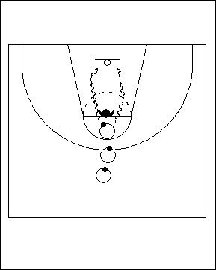 | Protéger le ballon  Les joueurs/joueuses forment une file à la ligne de trois points et font face au panier; chacun(e) a un ballon en mains sauf le premier ou la première. L’attaquant(e) peut choisir de passer par la gauche ou la droite, mais doit débuter par un pas croisé. Celui ou celle qui est en tête de file devient défenseur(e) actif(ve) dès que l’attaquant(e) se trouve dans sa vision périphérique. Cet éducatif est excellent pour enseigner aux attaquant(e)s différents aspects clés qui permettent de créer et de maintenir un avantage d’une seconde sur l’adversaire :
- Faire un premier pas explosif
- Passer très près du/de la défenseur(e) lors du dribble : l’épaule frôle sa hanche
- Couper rapidement devant le/la défenseur(e) pour s’assurer qu’il/elle soit derrière
- Décider si la meilleure option est un tir en foulée avec extension (si le panier est libre) ou encore un tir en puissance de près précédé d’un pied extérieur / pied intérieur (si le/la défenseur(e) est rapproché(e), ou encore si il ou elle s’apprête à bloquer le lancer).

On peut amorcer cet éducatif de différents endroits sur le terrain.
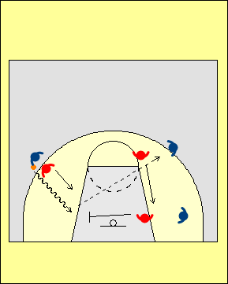 | Étape D –Situation de match simulé  Cet éducatif représente une excellente façon d’amorcer des situations de matches simulés qui se déroulent à 2 contre 2, 3 contre 3, 4 contre 4 ou même à 5 contre 5. L’attaquant(e) en possession du ballon doit prendre la bonne décision et choisir entre : (1) lancer, ou (2) passer et chercher à donner un avantage de jeu d’une seconde à un(e) partenaire qui est à découvert  Les joueurs/joueuses sans ballon doivent:  - Conserver un bon espacement, afin d’éviter qu’un(e) seul(e)défenseur(e) puissent marquer deux attaquant(e)s  - Chercher à se rendre disponible pour recevoir une passe si un(e) défenseur(e) décide d’apporter de l’aide à un(e) coéquipier(ère)  - Fournir de l’aide en défense et reprendre rapidement position (défenseur(e)s seulement)  - Gérer correctement les transitions – les joueurs/joueuses doivent avoir beaucoup d’occasion d’apprendre comment gérer efficacement les transitions
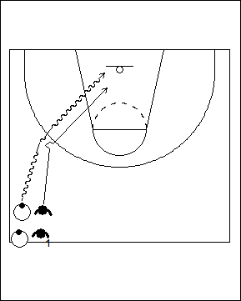 | Varier la vitesse et le rythme du jeu  Cet éducatif est excellent pour enseigner aux joueurs/joueuses à exploiter les variations de rythme afin de créer un avantage d’une seconde en jeu. Pour l’attaquant(e) en possession du ballon, il permet également de favoriser la prise de décision car celui-ci ou celle-ci doit choisir entre effectuer:  - un tir en foulée avec extension  - un tir de près en puissance avec manoeuvre pied extérieur / pied intérieur  - un tir en suspension
On forme deux file de joueurs/joueuses au centre du terrain, sur un des côtés; ceux et celles qui sont à l’extérieur ont un ballon et sont les attaquant(e)s; les autres jouent le rôle de défenseur(e)s, et sont retourné(e)s, de sorte qu’ils ou elles font face à l’autre panier. Les joueurs/joueuses en défense alignent leurs épaules avec celles des attaquant(e)s.

L’attaquant(e) amorce l’exercice en effectuant un dribble lent en direction du panier. Le/la défenseur(e) se déplace à la même vitesse mais à reculons, tout en maintenant le contact de l’épaule. Lorsque l’attaquant(e) pense qu’il ou elle peut avoir l’avantage, il/elle accélère soudainement et attaque le panier; le/la défenseur(e) doit alors se retourner rapidement et tenter de l’en empêcher.

Erreurs fréquentes :
- L’attaquant ne varie pas vraiment le rythme, et conserve la même vitesse tout au long de l’exercice.
- La variation de rythme se produit trop tôt.
- L’attaquant(e) attaque en suivant une trajectoire en arc, ce qui permet au/à la défenseur(e) de reprendre position. L’attaquant(e) doit chercher à garder le/la défenseur(e) derrière.

Au dernier moment, il faut faire une lecture de la défensive; il est parfois efficace de s’arrêter brusquement et de laisser le/la défenseur(e) poursuivre sa course, hors de contrôle.

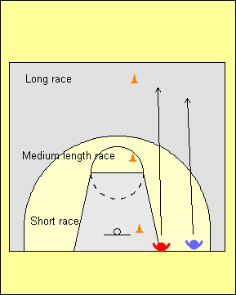 | Une notion importante dont les joueurs/joueuses doivent se souvenir est que, lors d’une course effectuée sur courte distance, celui ou celle qui part en premier gagne toujours – peu importe la vitesse de l’autre. Lors d’une course sur une distance moyenne, les probabilités de gagner diminuent : elles sont à peu près égales pour chacun(e). Cependant, plus la course est longue, plus la vitesse devient le facteur clé : l’avantage d’être parti(e) en premier devient alors beaucoup moins déterminant.  Les attaquant(e)s doivent donc réaliser qu’en variant le rythme de leurs déplacements de façon planifiée, ils ou elles se trouvent en fait à créer des situations de courses sur courtes distances qui sont assez faciles à remporter. En effet, c’est celui ou celle qui a le ballon qui décide quand la course débute…
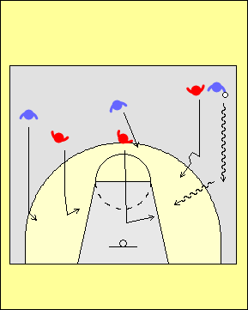 | Étape D  Cet éducatif illustre une autre façon d’amorcer des situations de jeu simulé, dans le cas présent, une pénétration de l’aile lors d’une transition.  Lors de cet exercice, les attaquant(e)s doivent chercher à créer et à maintenir un avantage d’une seconde, tandis que les défenseur(e)s doivent aider et reprendre ensuite position face à l’attaquant(e) qu’ils ou elles marquent.
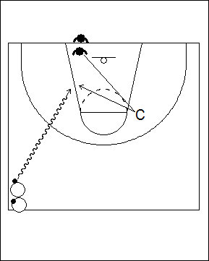 | Lecture de la défensive  Les joueurs ou joueuses forment deux files : les défenseur(e)s se placent à la ligne de fond près du panier, et les attaquant(e)s près de la ligne de côté, au centre du terrain. L’attaquant(e) dribble et fait une attaque au panier. Le ou la défenseur(e) doit se déplacer rapidement et venir taper dans la main de l’entraîneur(e) avant d’aller empêcher l’autre de marquer. L’entraîneur doit ajuster la distance que chaque joueur/joueuse doit couvrir en tenant compte de l’habileté de chacun(e). Par exemple, si le/la défenseur(e) a le temps de se replacer et d’attendre l’attaquant(e), il faut rallonger sa course, et vice versa si l’attaquant(e) a toujours un accès libre au panier.
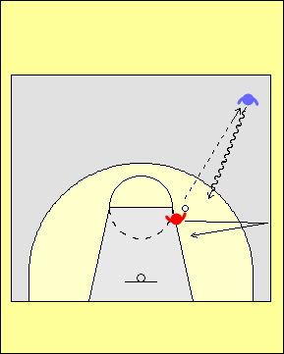 | Varier les angles  On peut répéter l’exercice précédent à partir de différents endroits, ce qui oblige le/la défenseur(e) et l’attaquant(e) de faire une lecture différente du jeu.  Dans cet exemple, le/la défenseur(e) amorce le jeu en effectuant une passe à celui ou celle qui attaquera, puis doit ensuite aller toucher la ligne de côté avant de reprendre position. Il faut surveiller les joueurs/joueuses « qui trichent » en faisant une passe molle et haute, ou encore qui font quelques pas avant de passer…

1 contre 1 et lecture du jeu du/de la défenseur(e)
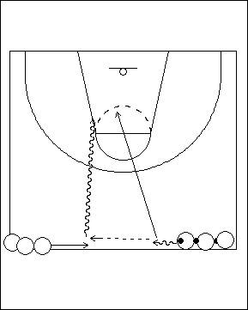 | 1 contre 1 : évaluer la distance  On forme deux files de joueurs/joueuses qui se font face au milieu du terrain. Dans une file, les athlètes ont chacun(e) un ballon, dans l’autre non. Le premier ou la première ayant un ballon fait deux pas en dribblant vers le centre; en même temps, celui ou celle qui n’a pas de ballon coupe vers le centre en faisant un appel de balle. Il/elle reçoit alors une passe vive, tourne immédiatement et attaque le panier. Le passeur ou la passeuse devient alors le/la défenseur(e). L’attaquant(e) dispose d’un avantage d’une seconde et doit se débrouiller pour le conserver et créer une occasion de marquer. Une fois que les joueurs/joueuses sont familier(ère)s avec l’exercice, on peut l’effectuer sur tout le terrain : le réceptionneur ou la réceptionneuse choisit alors quel panier il ou elle attaquera.
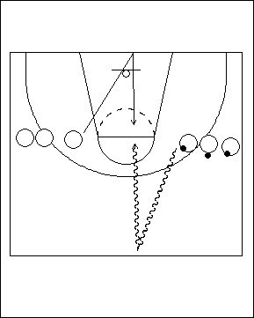 | Feintes avec le corps  Cet éducatif est excellent pour enseigner comment attaquer un(e) défenseur(e) isolé(e) qui protège le panier. On forme deux files dans le prolongement de la ligne de lancer franc. Dans une file, les athlètes ont chacun(e) un ballon, dans l’autre non. Celui ou celle qui a le ballon amorce l’exercice en effectuant un dribble rapide jusqu’au centre du terrain; au même moment, l’autre (qui agira comme défenseur(e)), court en direction du panier et va toucher la ligne de fond. Les deux s’affrontent ensuite dans un duel à 1 contre 1. Il faut encourager le/la défenseur(e) à ne pas attendre l’attaquant(e) dans la clé.
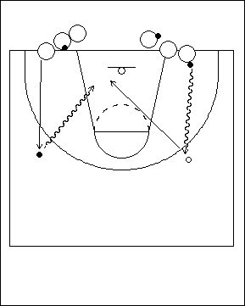 | Tir en suspension ou tir en foulée  On forme deux files près de la ligne de fond. Le premier joueur ou la première joueuse d’une file a un ballon, l’autre non et on alterne comme sur le diagramme. On place un ballon au sol au point d’attaque, devant celui ou celle qui n’a pas de ballon. L’attaquant(e) avec ballon dribble vers l’extérieur jusqu’au point d’attaque et dépose le ballon au sol. Au même instant, le/la partenaire sans ballon sprinte et va saisir le ballon situé devant lui/elle, pour devenir l’attaquant(e), l’autre jouant le rôle du/de la défenseur(e). L’attaquant(e) doit déceler le signal que fera le joueur ou la joueuse en défense : une main sur la poitrine signifie un tir en suspension; une main levée signifie un tir en puissance précédé d’une feinte extérieur-intérieur. S’il n’y a pas de défenseur(e), l’attaquant(e) doit effectuer un tir en foulée rapide.
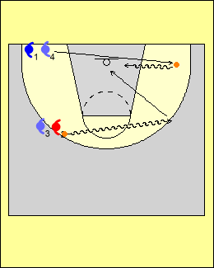 | On peut amorcer cet exercice à partir de divers endroits s sur le terrain, ce qui oblige les joueurs/joueuses à faire une lecture différente du jeu. | 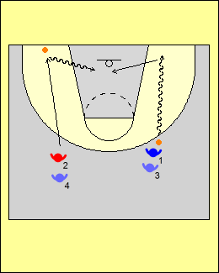

Éducatifs en attaque – Étapes A, B, C, et D
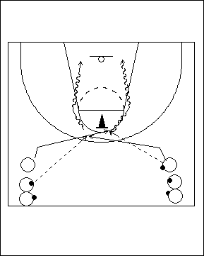 |  | Croiser la ligne  Les joueurs ou les joueuses forment deux files à l’extérieur de la ligne de trois points. Chacun(e) a un ballon, sauf le premier ou la première de l’une des files. L’athlète sans ballon fait quelques pas en diagonale vers la ligne de fond puis change rapidement de direction et coupe vers le haut de la clé; à l’aide des mains, il ou elle indique au partenaire en possession du ballon que c’est le moment de faire la passe. La passe doit arriver au moment où le joueur arrive au haut de la clé. Celui ou celle qui reçoit le ballon prétend qu’un(e) défenseur(e) vient le couvrir, et amorce alors rapidement un mouvement de dribble croisé dans la direction où il ou elle était au départ.
L’action se termine par un tir en suspension ou par un tir en puissance avec manœuvre pied extérieur /pied intérieur. Le joueur ou la joueuse qui a fait la passe amorce ensuite la même manœuvre et reçoit à son tour le ballon au moment de passer au haut de la clé. Celui ou celle qui s’apprête à recevoir la passe doit s’assurer de ne pas couper avant qu’un contact visuel n’ait été fait avec son partenaire en possession du ballon.
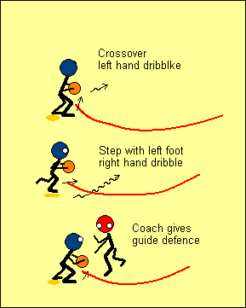 |  | La prochaine habileté consiste à anticiper l’action d’un(e) défenseur(e) derrière soi. Le joueur ou la joueuse attrape le ballon alors qu’il ou elle se tient sur le pied extérieur, puis se retourne et revient vers le panier. Il ou elle doit attaquer la bouteille, et s’assurer de ne pas dribbler le ballon à l’extérieur de celle-ci. Lors de l’exécution, le ballon doit constamment être en mouvement afin de pouvoir tirer avantage d’une position défensive désavantageuse et créer alors immédiatement un avantage d’une seconde.
Étape A – Effectuer le geste sans opposition
Le joueur ou la joueuse s’exerce à attraper le ballon. A) feinte avec déplacement du ballon en croisé – en appui sur les deux pieds et face au panier, il ou elle ramène rapidement le ballon vers le bas à l’aide d’une main et enchaîne immédiatement avec un mouvement en croisé devant le corps pour le transférer à l’autre main; l’action se poursuit avec un dribble pour attaquer le panier. B) crochet – le ballon est attrapé du côté du pied extérieur; le joueur ou la joueuse croise ensuite le pied extérieur au moment d’amorcer un dribble vers le panier.

Points clés : yeux relevés; appel de balle à l’aide d’une main pour donner une cible à celui ou celle qui fait la passe; utilisation adéquate du jeu de pieds.

Étape B – Jeu défensif dirigé par l’entraîneur(e)
L’entraîneur(e) dirige le jeu de l’attaquant(e) en fournissant certains indices défensifs qui l’obligent à lire la situation et à choisir la bonne action à effectuer dans les circonstances. Cette approche aide aussi l’attaquant(e) à attaquer le panier au lieu de déborder vers les côtés. Le joueur ou la joueuse qui fait la passe doit s’assurer que celle-ci soit rapide, précise, et bien synchronisée.

Étape C – Exécution contre un(e) défenseur(e) actif(ve)
L’exercice est répété, cette fois avec un(e) défenseur(e) qui tente de s’interposer. Pour l’attaquant(e), la clé du succès est l’anticipation des actions du ou de la défenseur(e), car cela lui permettra de créer une situation dans laquelle il ou elle disposera d’un avantage d’une seconde. Il est préférable de prévoir un certain nombre de répétitions consécutives pour chaque attaquant(e), ce qui lui permet de découvrir les différentes options de jeu qui peuvent se présenter.

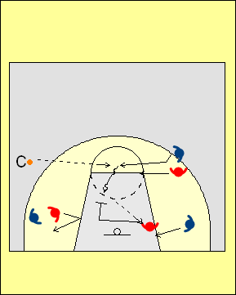 | Étape D – Exécution en situation de jeu  On peut utiliser ce type de mouvement pour amorcer une situation de jeu à 2 contre 2 ou à 3 contre 3.  Une fois que l’attaquant(e) a réussi à créer une situation dans laquelle il ou elle dispose d’un avantage d’une seconde, il ou elle doit maintenant faire une lecture correcte et rapide des options qui s’offrent contre le ou la deuxième défenseur(e) et se poser les questions suivantes : est-ce que je devrais lancer au panier, ou faire une passe afin de transférer l’avantage d’une seconde à un(e) coéquipier(ère) libre?
Autres façons de créer une surcharge pour l’éducatif:

C’est une bonne idée de faire en sorte qu’un(e) entraîneur(e) soit disponible pour une passe. Si l’attaquant(e) n’est pas en bonne position pour effectuer un lancer ou une passe, il ou elle peut alors faire une passe à l’entraîneur(e).

Note: On peut utiliser le même éducatif et une progression similaire pour enseigner des changements de direction brusques vers l’aile à partir d’un coin.

ESPACE

Une distance adéquate entre les joueurs/joueuses fait en sorte qu’il est très difficile pour un(e) défenseur(e) de marquer deux attaquant(e)s simultanément.
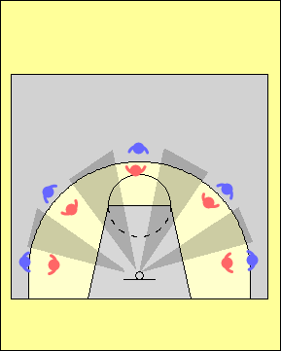 | Lorsque des joueurs/joueuses tentent de s’infiltrer à partir de la ligne de trois points, il est assez facile pour un(e) défenseur(e) de marquer plus d’un(e) attaquant(e)s à la fois, car l’espace à leur disposition pour manœuvrer est alors plutôt restreint. | 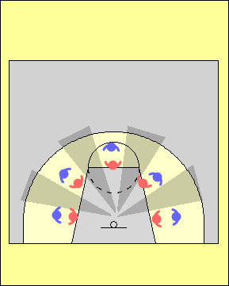
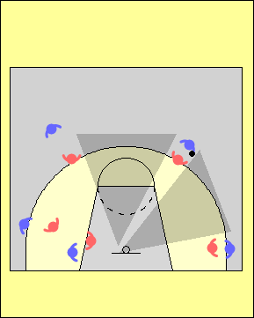 | Les différentes positions que les joueurs/joueuses peuvent occuper sur le terrain créent en retour des ouvertures ou des espaces plus ou moins grands que les attaquant(e)s peuvent exploiter : plus il y a d’espace, plus l’équipe en attaque a d’options et plus il est difficile aux adversaires d’apporter de l’aide en défensive. | 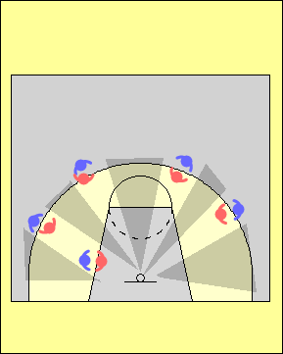

- Les attaquant(e)s sont placé(e)s de façon à pouvoir recevoir une passe précise d’un(e) partenaire.

- Les attaquant(e)s sont placé(e)s de façon à avoir une bonne vue d’ensemble du jeu : il devient alors plus facile pour eux ou pour elles d’anticiper ce qui se produira et de prendre de bonnes décisions.

- L’espacement entre les attaquant(e)s ne doit pas être statique, mais doit fluctuer constamment. Si on fait exception des entre-deux, des remises en jeu ou des lancers francs, les joueurs/joueuses sont rarement à l’arrêt : ils ou elles doivent plutôt constamment réagir à la position du ballon, ainsi qu’aux actions des adversaires et des partenaires.

- Il est important de conserver un bon espacement entre les attaquant(e)s tout au long de la période allouée pour effectuer un lancer.

PVAD – Une bonne position sur le terrain permet une bonne vision du jeu; en retour, cela permet de mieux anticiper et de prendre de meilleures décisions. Par exemple, les joueurs/joueuses doivent apprendre à se servir de la ligne de trois points et de la clé pour conserver un bon espacement. En règle générale, ils ou elles ne devraient pas chercher à attraper le ballon dans l’espace compris entre la ligne de trois points et la clé tandis qu’un(e) autre joueur/joueuse s’éloigne du panier.

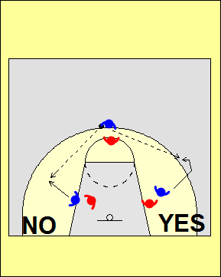 | Lorsqu’une passe est faite à un(e) joueur/joueuse avant qu’il ou elle ne soit rendu(e) à la ligne de trois points, cet(te) attaquant(e) n’est pas bien placé(e) pour avoir une bonne vue du panier. Par conséquent, cela limite la possibilité d’anticiper la meilleure option à venir, et résulte souvent en des opportunités manquées : en effet, il est difficile de prendre rapidement des décisions efficaces tant qu’on ne se trouve pas face au panier.  D’autre part, lorsqu’un(e) joueur/joueuse attrape le ballon trop près du panier, il devient plus facile pour le/la défenseur(e) de surveiller deux attaquant(e)s à la fois. La zone autour du panier peut alors devenir congestionnée rapidement si le/la défenseur(e) qui marque le porteur ou la porteuse du ballon peut aider à protéger le panier…

Durant les premières secondes de possession du ballon

Lorsque l’équipe prend possession du ballon, les joueurs/joueuses doivent chercher à étendre l’espace, à la fois dans le sens horizontal et dans le sens vertical; ils ou elles doivent occuper les allées et les corridors lors de leurs déplacements en course, tout en conservant une bonne distance avec leur(e)s partenaires. Une erreur commune est de se retrouver trop loin vers l’avant, à une distance à laquelle il est alors très difficile de recevoir une passe.

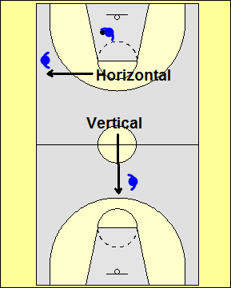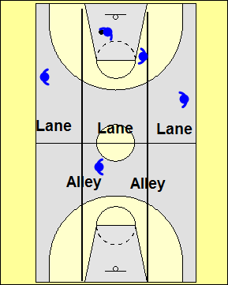

Vers le milieu de la période des 24 secondes

Les joueurs/joueuses doivent passer de la phase de transition à une autre dans laquelle ils ou elles cherchent à se placer au meilleur endroit possible. Pour ce faire, les entraîneur(e)s peuvent utiliser des jeux préparés à l’avance, en autant qu’on ne perde pas de temps lors de l’exécution. Une fois que le mouvement s’amorce, un bon synchronisme et un espacement adéquat doivent être préservés tout au long de la période de possession qui précède le lancer. Quand l’attaque ne fonctionne pas, c’est souvent en raison d’une perturbation dans le rythme d’exécution.

Vers la fin de la période des 24 secondes

Lors des dernières secondes du décompte, les entraîneur(e)s tentent souvent de mettre en place une formation offensive particulière, afin de créer des situations dans lesquelles on isole certain(e)s joueurs/joueuses. Un exemple commun est de faire avancer les quatre joueurs/joueuses qui n’ont pas le ballon vers la ligne de fond, afin de donner plus d’espace à celui ou celle qui est en possession pour attaquer à partir du haut.

PÉNÉTRATION

Une pénétration est la suite d’une attaque au panier. Quand l’attaquant(e) en possession du ballon dribble en direction du panier et que des adversaires décident d’apporter de l’aide défensive, ses partenaires doivent se déplacer afin de créer des corridors de passe. Une fois la passe faite, le joueur ou la joueuse doit à son tour se déplacer afin de créer un nouvel espace ou une ouverture.

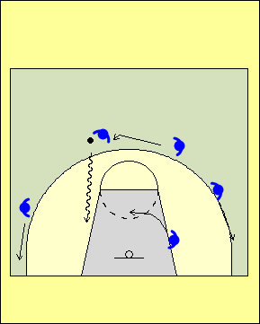 | Pénétration à partir du haut  Ceci se produit quand on attaque avec le ballon de la ligne de trois points jusqu’à la ligne de lancer franc ou plus bas, de préférence dans la clé. Les autres joueurs/joueuses doivent se déplacer pour maintenir un bon espacement. Ils/elles doivent alors s’assurer :  - De se placer à un endroit d’où celui ou celle qui attaque puisse les voir.  - Qu’un(e) défenseur(e) ne soit pas en mesure de marquer deux attaquant(e)s. Entre autres, ils/elles doivent éviter d’aller se cacher derrière le dos d’un(e) défenseur(e), créant ainsi un alignement de type ballon- défenseur(e)- attaquant(e)  - De faire tout d’abord une lecture de la position et des intentions du porteur ou de la porteuse du ballon, avant de se préoccuper de celles du ou de la défenseur(e) : ils/elles doivent donc s’assurer qu’il y a effectivement pénétration, et ensuite faire la lecture des intentions défensives.
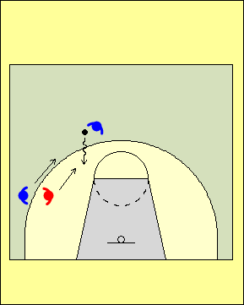 | Bouger trop tôt  Dans la situation de gauche, l’attaquant(e) sans ballon bouge avant que le dribbleur ou la dribbleuse n’ait traversé la ligne de lancer franc. Ceci permet au/à la défenseur(e) de surveiller deux joueurs/joueuses à la fois.  Dans la situation de droite, l’ailier/ère attend que le dribbleur ou la dribbleuse ait traversé la ligne de lancer franc avant de se déplacer. |  | 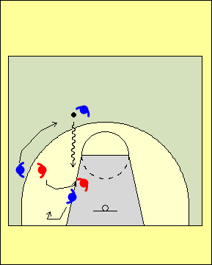
L’attaquant(e) a réalisé que l’adversaire qui le/la couvre cherche à apporter de l’aide, et par conséquent il/elle fait une rotation derrière la pénétration. Le joueur ou la joueuse d’intérieur glisse alors au coin rapproché; le/la défenseur(e) aura énormément de difficulté à reprendre sa position à cet endroit.

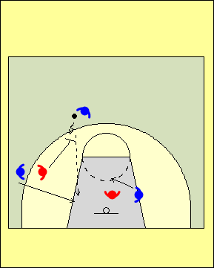 | Dans la situation de gauche, le/la défenseur(e) s’est déplacé pour offrir de l’aide, ce qui a pour effet de laisser la voie libre au panier. L’ailier(ère) doit donc en profiter pour couper au panier. L’attaquant(e) à l’intérieur se déplace devant le panier au moment où l’adversaire qui le/la couvre bouge pour tenter de contrer l’ailier(ère) qui coupe derrière le/la défenseur(e).  Dans la situation de droite, le/la défenseur(e) qui marque l’ailier(ère) s’est déplacé(e) en direction du porteur ou de la porteuse du ballon, mais il y a un(e) autre attaquant(e) sur le même côté que le ballon. L’ailier(ère) doit alors en profiter pour s’esquiver dans l’espace libre près de la ligne de fond, tandis que son/sa partenaire se déplace en cercle devant le panier. |  | 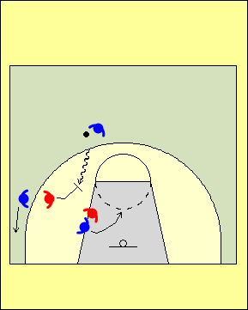
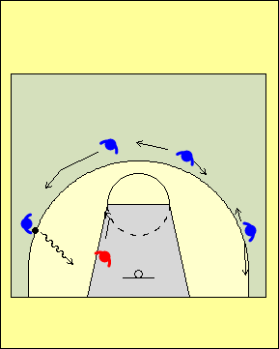 | Pénétration par le côté  Quand l’attaquant(e) s’avance à partir du côté et se dirige vers la ligne de fond, les autres joueurs/joueuses se déplacent et cherchent à occuper des espaces libres; ce faisant, il/elles doivent s’assurer que le porteur ou la porteuse du ballon pourra les voir facilement. Dans une telle situation, les joueurs/joueuses qui se trouvent en périphérie peuvent se déplacer dans une direction ou dans l’autre, en tenant compte tout d’abord du mouvement du ballon, puis ensuite de celui du/de la défenseur(e).
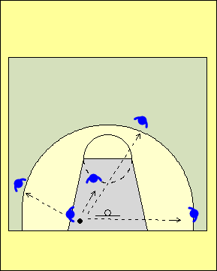 | Plus la pénétration se fait en profondeur, plus les réceptionneurs ou réceptionneuses potentiel(le)s doivent également jouer en profondeur afin d’ouvrir les corridors de passe.  Si la pénétration ne se fait pas trop profondément dans la clé, les réceptionneurs ou réceptionneuses potentiel(le)s peuvent demeurer en position plus haute, en autant que le porteur ou la porteuse du ballon puisse bien les voir. | 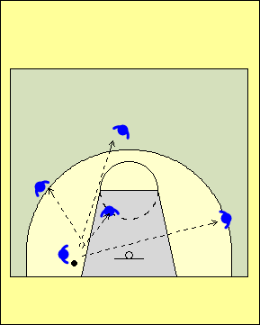
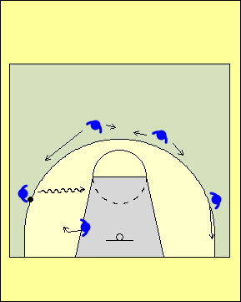 | Quand la pénétration se fait au centre en provenance de l’aile, les joueurs/joueuses doivent encore une fois se déplacer vers des espaces libres.  Dans ce cas, ils/elles doivent tout d’abord tenir compte du mouvement du ballon, puis ensuite de celui du/de la défenseur(e).
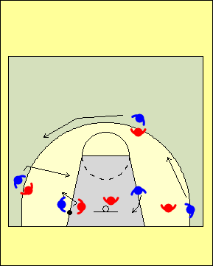 | Coupes secondaires  À chaque fois que l’attaquant(e) qui pénètre s’arrête et pivote, les autres joueurs/joueuses doivent effectuer des mouvements d’attaque secondaires. En effet, les défenseur(e)s se retrouvent alors souvent en position de vulnérabilité car ils/elles ont tendance à regarder le ballon.
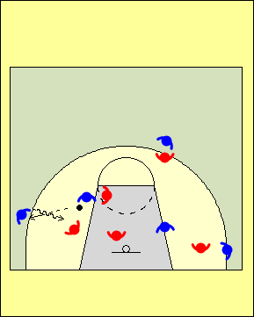 | Attendre une seconde après la première pénétration  En règle générale, on doit éviter de faire une seconde pénétration immédiatement après que l’attaquant(e) qui a fait la première ait ressorti le ballon de la clé en faisant une passe. Celui ou celle qui a reçu le ballon doit prendre le temps de s’arrêter et de jeter un regard en direction du panier. Si le joueur ou la joueuse en possession du ballon attaque tout de suite le panier après la passe, il/elle risque fort de dribbler parmi une défensive compacte et de commettre une faute offensive. Il faut plutôt attendre que les défenseur(e)s aient récupéré sur leur adversaire et que le passeur ou la passeuse ait quitté la clé. Pour leur part, les joueurs/joueuses qui se trouvent en périphérie ne devraient pas se précipiter pour occuper immédiatement les espaces libérés autour d’eux/elles, car ceci pourrait faire en sorte qu’une ouverture double se réduise en ouverture simple.
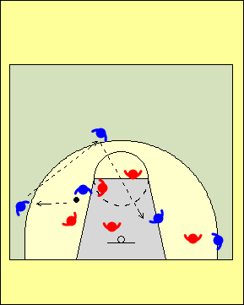 | Pénétration, passe, passe  Il est souhaitable d’essayer de passer le ballon tout de suite après la pénétration, car très souvent la défensive s’est resserrée et plusieurs adversaires se retrouvent dans la clé.  C’est une situation très favorable aux attaquant(e)s, car plusieurs seront à découverts tandis que les défenseur(e)s tentent de récupérer sur leurs joueurs/joueuses.

Les joueurs/joueuses doivent apprendre à reconnaître les situations dans lesquelles il y a des ouvertures simples, ou encore une ouverture double, ou même triple. Celles-ci peuvent se produire quand les attaquant(e)s se positionnent lors de la mise en place du système d’attaque, ou encore suite à différents mouvements des joueurs/joueuses, p. ex. lorsqu’ils ou elles coupent au panier.

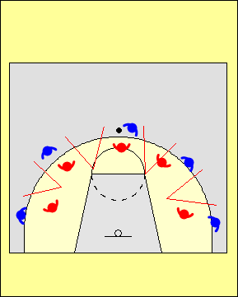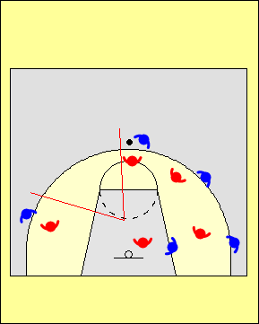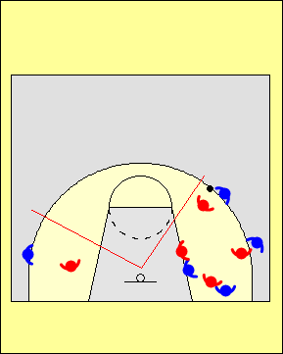
Ouvertures simples
Ouverture double

Ouverture triple

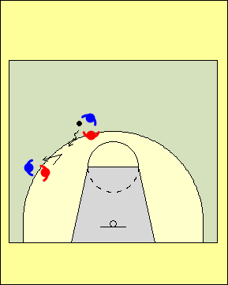 | Si l’ailier(ère) se trouve trop près d’un(e) partenaire qui pénètre à partir du haut, une seule ouverture se trouve à être créée, permettant ainsi au/à la défenseur(e) qui joue à l’aile de surveiller deux attaquant(e)s simultanément. Par contre, en se déplaçant plus bas à l’aile, une double ouverture est créée, ce qui oblige le/ la défenseur(e) posté(e) à l’aile à ne couvrir qu’un(e) seul(e)attaquant(e). | 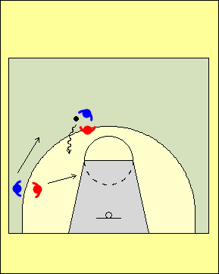
Durant les premières secondes de possession du ballon
Durant les premières secondes de possession, une pénétration du haut se produit souvent à la suite d’un dribble de dégagement efficace d’un(e) joueur/joueuse qui s’est emparé(e) d’un rebond, ou encore quand celui ou celle qui reçoit une passe de dégagement réussit à se démarquer du/de la défenseur(e) qui tente de ralentir la montée de balle lors de la transition. Une pénétration sur le côté se produit quant à elle quand le ballon est envoyé à l’aile très tôt lors de la phase de transition.

Vers le milieu de la période allouée pour tirer
Il faut enseigner aux joueurs/joueuses à attaquer les mauvaises récupérations défensives lorsque celles-ci ont lieu dans le demi-terrain offensif. Les autres attaquant(e)s doivent être à l’affût de cette lecture faite par le porteur ou la porteuse du ballon.

Durant les dernières secondes de possession
Il est possible que l’on doive ajuster l’espacement entre les attaquant(e)s durant les dernières secondes de possession, de façon à créer une ouverture double ou triple. De tels ajustements ont habituellement plus de chance de porter fruit s’ils se mettent en place « naturellement » grâce aux mouvements des joueurs/joueuses, plutôt que lorsqu’on donne un signal pour les amorcer.

ÉDUCATIFS D’ESPACEMENT ET DE PÉNÉTRATION

Ces éducatifs sont conçus pour aider les joueurs/joueuses à :

- Dribbler correctement lors d’une pénétration
- Effectuer les bons types de déplacements lorsqu’ils/elles n’ont pas le ballon suite à une pénétration Passer correctement suite à une pénétration
- Effectuer un lancer suite à une pénétration
- Effectuer les bons types de déplacements après une passe
- Prendre de bonnes décisions après une réception de passe qui fait suite à une pénétration

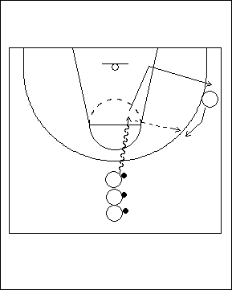 | Pénétration à 2 contre 0  Les joueurs/joueuses placé(e)s au haut ont un ballon. Ceux et celles qui sont à l’aile doivent attendre que la pénétration ait eu lieu. Un déplacement trop hâtif est à éviter, car cela permettrait au/à la défenseur(e) de fournir de l’aide contre le porteur ou la porteuse de balle, tout en continuant à marquer l’attaquant(e) en périphérie.  L’attaquant(e) qui pénètre dribble avec sa main extérieure; il/elle doit attaquer la clé et tenter d’effectuer une passe à l’aide de la main intérieure. L’ailier(ère) remonte derrière la pénétration pendant que le/la partenaire fait la pénétration et attend une passe qui lui permettra de lancer. Après la passe, l’attaquant(e) poursuit sa course et va occuper l’espace laissé vacant du côté où la passe a été effectuée.
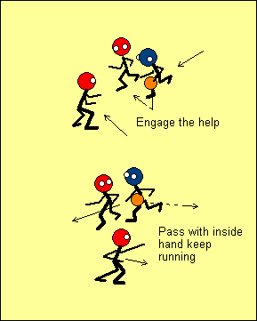 | Il s’agit d’une passe qui est facile à faire avec la main intérieure. Le dribbleur ou la dribbleuse n’a pas à faire de mouvement inhabituel à l’aide du poignet, ce que seul(e)s les joueurs/joueuses les plus fort(e)s réussissent généralement à faire. Dans le cas présent, il n’est pas recommandé de faire un arrêt en un temps avant la passe, car cela ralentirait l’action.  De plus, il faudrait alors plus de temps au passeur ou à la passeuse pour quitter la clé. Plus les attaquant(e)s restent longtemps dans la clé, plus leurs partenaires doivent patienter avant d’amorcer une nouvelle pénétration.
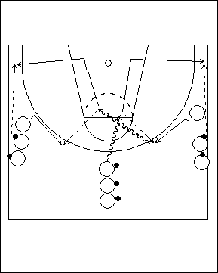 | Pénétrations successives et lancers  Les joueurs/joueuses forment trois files. Chacun(e) a un ballon en main, sauf le premier ou la première des files sur les côtés. Le premier ou la première de la file du milieu fait une pénétration au centre, mais légèrement sur l’un des côtés. L’ailier(ère) remonte l’aile derrière la pénétration pour recevoir une passe. Après la passe, l’attaquant(e) poursuit sa course puis coupe ensuite vers la ligne de côté et se dirige dans le coin; là, il/elle reçoit une passe en provenance du/de la deuxième joueur/joueuse de la file.
Lors de cet éducatif, il est impératif que celui ou celle qui reçoit la passe après la pénétration affiche clairement son intention de lancer pendant une seconde avant de pénétrer à son tour et d’attaquer la clé. L’ailier(ère)n de la file la plus éloignée remonte l’aile derrière la pénétration. Le passeur ou la passeuse poursuit son déplacement, et coupe du côté où il/elle a fait la passe. L’attaquant(e) qui a reçu la passe après la pénétration attend une seconde avant de pénétrer à son tour en dribblant et d’effectuer un tir en suspension.
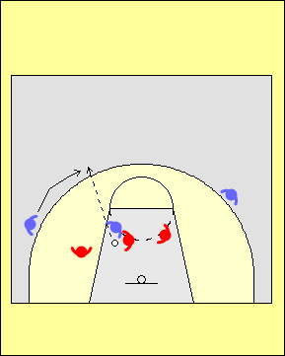 | Dans cet éducatif, il est important d’insister sur le fait que celui ou celle qui reçoit la passe après la première pénétration doit attendre une seconde avant de pénétrer à son tour.  Si ce joueur ou cette joueuse pénètre tout de suite après la réception de passe, il/elle se trouve à attaquer directement dans une formation défensive qui est compacte. De plus, le/la partenaire d’attaque pourrait encore se trouver dans la clé : il faut lui laisser le temps de quitter cet espace. En faisant une feinte de lancer, l’attaquant(e) pourra voir des partenaires qui sont à découvert et à qui il/elle pourrait passer; il/elle pourra également attaquer un(e) défenseur(e) qui est en récupération défensive plutôt que de rester au même endroit en attendant la pénétration.
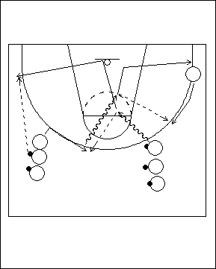 | Pénétration au centre  Les joueurs/joueuses forment trois files : une entre la clé et la ligne de côté, une autre près de la ligne de fond sur le même côté, et une troisième de l’autre côté près de la ligne de trois points. Chacun(e) a un ballon sauf le premier ou la première des files de côté.  Le premier ou la première attaquant(e) avec ballon se dirige en dribblant vers la clé. Le premier ou la première de la file extérieure du côté ou la pénétration se fait remonte l’aile derrière la pénétration pour recevoir une passe. Après avoir pénétré jusqu’à la ligne de lancer franc, l’attaquant(e) se retourne et passe au premier ou à la première de l’autre file qui a coupé vers
le centre, poursuit ensuite son déplacement en direction du panier, et coupe vers le coin; le/la deuxième de la file située près de la ligne de trois points lui fait alors une passe en vue d’un lancer. Celui ou celle qui a reçu la passe au haut de la ligne de trois points face au panier attend une seconde avant de pénétrer à son tour, et de remettre le ballon à l’attaquant(e) du côté opposé qui remonte l’aile derrière la pénétration; celui-ci ou celle-ci exécute alors un lancer.
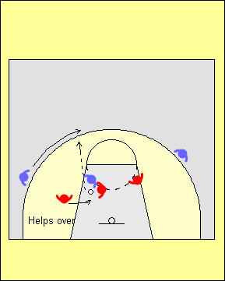 | Se déplacer en s’éloignant plutôt que se déplacer derrière  Le but de cet éducatif est de s’assurer que l’attaquant(e) fasse une bonne lecture du jeu. Si l’adversaire se déplace vers celui ou celle qui pénètre pour offrir une aide défensive hâtive, l’attaquant(e) doit s’éloigner de l’endroit où se fait la pénétration. Par contre, si le/la défenseur(e) offre une aide tardive (lorsque l’attaquant(e) s’est engagée profondément dans la clé), l’attaquant(e) | 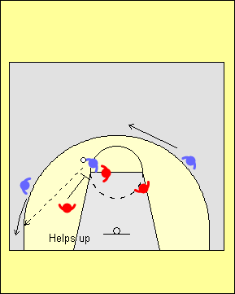
doit remonter l’aile derrière la pénétration. L’objectif est d’augmenter la distance que le/la défenseur(e) devra couvrir pour reprendre contact avec l’attaquant(e) qu’il ou elle couvrait au départ.
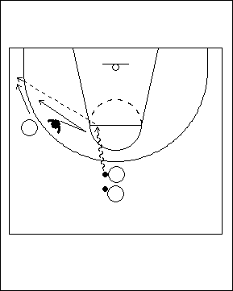 | 1 contre 1 Pénétration et passe à l’extérieur  Dans cet éducatif, l’attaquant(e) cherche à identifier l’adversaire qui se déplace pour offrir une aide défensive, afin que l’ailier(ère) s’en éloigne.  Le/la défenseur(e) se place dans un couloir de passe, et l’attaquant(e) avec le ballon attaque la clé au centre. L’aide du/de la défenseur(e) consiste à se déplacer pour mettre le bras et le pied dans le couloir de passe. Le/la défenseur(e) devrait récupérer sur son attaquant(e) en gardant la main levée dans le couloir de passe. À l’étape B, l’entraîneur(e) fournit les indices pour la lecture du jeu.  Il s’agit ici d’un éducatif adapté à l’étape C (défensive active).  L’art d’entraîner consiste précisément à bien reconnaître à quelle étape du développement des habiletés les joueurs ou joueuses se trouvent lorsqu’on cherche à leur enseigner une technique ou un concept de jeu.
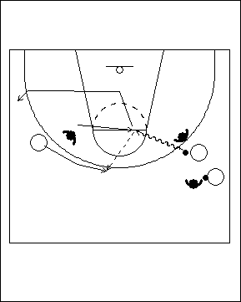 | 2 Avantage à 2 contre 2  Il s’agit ici d’un éducatif adapté à l’étape D, dans lequel on travaille à faire une pénétration et une passe à l’extérieur en situation de match simulé.  Au départ, le/la défenseur(e) qui marque l’ailier(ère) a le dos tourné aux autres attaquant(e)s, ce qui leur donne à l’attaquant (e) un léger avantage d’une seconde.  Le joueur ou la joueuse doit faire une bonne lecture de l’aide défensive.
Les joueurs/joueuses amorcent ensuite une situation à 2 contre 2. Dans cette situation simulée, on ne doit pas tenter un lancer de trois points tant que le ballon ne s’est pas tout d’abord retrouvé dans la clé suite à une pénétration ou à une passe. Pour un(e) attaquant(e), ces situations de tirs de trois points sont les plus faciles à réussir, car la passe provient de l’intérieur de la clé : il ou elle se trouve en effet fort probablement déjà face au panier, et n’a qu’un pas à faire pour lancer.
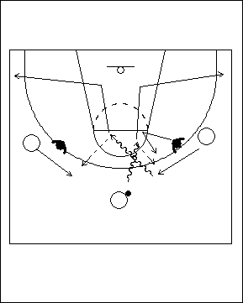 | Situation d’avantage à 3 contre 2, espacement des attaquant(e)s  Dans cet éducatif, il y a trois attaquant(e)s et deux défenseur(e)s. L’attaquant(e) non marqué(e) est au centre avec le ballon et amorce le jeu en pénétrant dans la clé afin de simuler une situation à 2 contre 1. Si un(e) défenseur(e) vient en aide, l’attaquant(e) doit passer au/à la partenaire qui est maintenant à découvert; ce joueur devrait disposer d’un avantage d’une seconde au moment de faire la passe. Pendant ce temps, celui ou celle qui reçoit la passe doit se rappeler des options qui s’offrent : lancer (premier choix), passer (second choix) ou pénétrer après un délai d’une seconde (troisième choix).
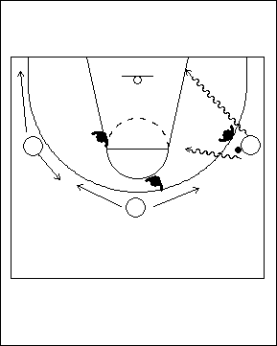 | Situation d’avantage à 3 contre 3, espacement des attaquant(e)s  Dans cet éducatif, on joue à 3 contre 3 et les attaquant(e)s amorcent la séquence en situation d’avantage. En effet, le/la défenseur(e) qui marque l’attaquant(e) en possession du ballon lui tourne le dos au départ. Les autres attaquant(e)s doivent faire une bonne lecture de la pénétration avant de se déplacer. On peut surcharger cet éducatif en y ajoutant une transition; on peut permettre aux joueurs/joueuses d’évoluer à 3 contre 3 dans l’autre direction.
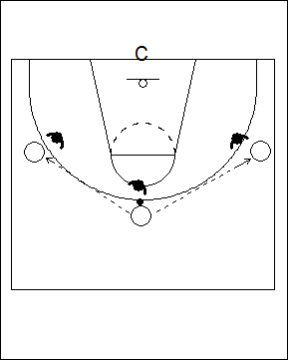 | 3 contre 3 après un signal de l’entraîneur(e)  Dans cet éducatif, trois attaquant(e)s se passent le ballon le long de la ligne de trois points. Les défenseur(e)s sont placé(e) dans le couloir de passe mais ne touchent pas au ballon. L’entraîneur(e) est sous le panier et fait face aux attaquant(e)s. Quand l’entraîneur(e) lève le bras, l’attaquant(e) en possession du ballon doit faire une pénétration; les joueurs/joueuses évoluent ensuite à 3 contre 3 tout en respectant les règles du jeu.  Un aspect important sur lequel insister ici est qu’à ce stade de leur développement, les joueurs/joueuses n’occupent pas encore de postes spécialisés; ils ou elles doivent donc apprendre à exécuter toutes les techniques, et ce à partir de n’importe où sur le terrain.

Passer, couper, et prendre la place d’un(e) partenaire
Il est important de souligner qu’un déplacement de joueur/joueuse effectué au bon moment met énormément de pression sur l’équipe en défense. On doit donc enseigner aux joueurs/joueuses le bon rythme des déplacements (synchronisme et espacement), ainsi que comment et quand couper. Les principaux aspects à considérer sont :

- Les signaux qui indiquent quand couper :
  - Un contact visuel avec le porteur ou la porteuse du ballon est très important
  - Le porteur ou la porteuse du ballon doit toujours être prêt(e) et en mesure de faire une passe
- Variations de vitesse – lent et ensuite rapide; l’attaquant(e) a un avantage énorme puisqu’il/elle sait quand il/elle va couper.
- Avant de couper, le joueur ou la joueuse doit chercher à « élargir » son espace de jeu. Si le/la défenseur(e) se trouve au bas, il faut l’amener encore plus bas et ensuite couper vers le haut. Si le/la défenseur(e) se trouve au haut, il faut l’amener encore plus haut et ensuite couper par derrière.

- La ligne de trois points doit servir de point de repère. Si un(e) défenseur(e) s’oppose à l’attaquant(e) une fois qu’il ou elle est rendu(e) à cet endroit, il/elle doit couper au panier. Ce n’est pas une bonne idée pour un(e) joueur ou une joueuse que de chercher à recevoir une passe au-delà de la ligne de trois points, alors qu’il/elle se trouve en dehors de sa zone d’efficacité.
- Lorsqu’il/elle coupe, l’attaquant(e) devrait terminer son action au panier. Une fois rendu(e) au panier, il ou elle devrait se retourner afin d’apercevoir le ballon et le prochain espace libre (la sortie doit se faire vers l’espace libre).
- Après avoir coupé, les joueurs/joueuses ne devraient pas retourner à leur point de départ.

Lorsqu’un(e) joueur ou une joueuse coupe, on doit lui faire une passe uniquement une fois qu’il/elle est rendu(e) dans la clé, ou encore à la ligne de trois points. Une passe faite plus tôt limite les possibilités d’anticiper le jeu défensif.

Lors des premières secondes de possession du ballon

À ce stade du jeu, les joueurs/joueuses coupent pour occuper les corridors de passe et pour se libérer afin de recevoir une passe de dégagement. Les joueurs/joueuses qui courent en direction de la zone adverse doivent toujours être en mesure de couper pour revenir vers le ballon s’il y a beaucoup de pression défensive. Lorsqu’on se dirige en zone d’attaque, les trois premiers pas sont décisifs pour devancer un(e) défenseur(e).

Au milieu de la période de possession du ballon

Ces mouvements ont lieu lorsque l’attaque se déroule sur demi-terrain. Les attaquant(e)s doivent également apprendre à avoir une réponse (une autre option) lorsqu’il devient évident que les passes ne peuvent être faites. On doit également s’exercer à avoir un bon synchronisme et à faire de bons espacements.

Lors des dernières secondes de possession du ballon

Si les joueurs/joueuses ont réussi à maintenir un bon espacement tout au long de la période de possession, des coupes vers le ballon et le panier peuvent encore s’avérer efficaces même à ce stade avancé du décompte. Souvent, les défenseur(e)s hésitent, car ils ou elles ne veulent pas commettre de faute, et cela peut donner de bonnes occasions.

ÉDUCATIFS POUR PASSER LE BALLON ET COUPER
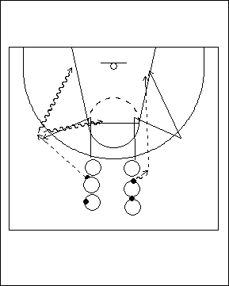 | Pivot/ esquive– Sans opposition  Cet éducatif permet de travailler le jeu de pieds afin de pouvoir attraper une passe en provenance d’angles variés. Les athlètes forment deux files à l’extérieur de la ligne de trois points. Chacun(e) a un ballon, sauf le premier ou la première de chaque file.  L’athlète au début de chaque file fait un départ rapide et coupe vers le ‘T’ (jonction de la clé et de la ligne de lancers francs) pour effectuer un arrêt en un temps. Le joueur ou la joueuse effectue un pivot afin de se placer en position pour bien voir le passeur ou la passeuse, puis donne une cible avec ses mains avant de recevoir la passe. Il est important que la passe soit faite alors que le joueur ou la joueuse se trouve à l’extérieur de la ligne de trois points, et qu’il/elle fasse un arrêt en un temps à deux pieds face au panier au moment de la recevoir.
L’attaquant(e) peut effectuer un tir en suspension ou encore un tir de près en puissance avec manœuvre de pied extérieur- pied intérieur. Il/elle s’exerce également à couper par derrière. Les joueurs/joueuses doivent toujours chercher à maximiser l’efficacité d’un lancer. Par exemple, s’il y a un marquage défensif au moment d’arriver à la ligne des trois points, tant le joueur ou la joueuse qui fait la passe que celui ou celle qui est en train de couper doivent s’en rendre compte, et réaliser que la manœuvre consistera plutôt à couper par derrière. La passe est alors dirigée par derrière dans la clé, ou en forme de lob dirigé vers le coin du panneau, du côté où le ou la partenaire coupe.

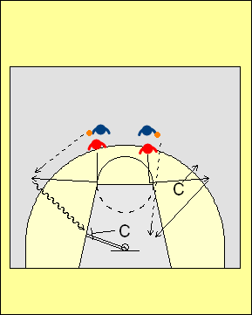 | Étape B – Pivot/esquive– L’entraîneur(e) dirige le jeu  L’entraîneur(e) peut donner quatre options au joueur ou à la joueuse au moment où celui-ci ou celle-ci attrape le ballon :  - Jouer vers le côté haut – croiser et attaquer la ligne de fond  - Jouer vers le côté bas – croiser et attaquer le centre  - Ralentir au moment de recevoir le ballon – effectuer un lancer  - Empêcher que la passe se fasse – couper par derrière  L’entraîneur(e) peut également donner des signaux au joueur ou à la joueuse après que celui-ci ou celle-ci ait attrapé le ballon. Si l’entraîneur(e) indique une passe de la poitrine lors du mouvement vers le panier, le joueur ou la joueuse doit faire un arrêt en un temps et lancer; si l’entraîneur(e) montre uniquement un bras, l’attaquant(e) doit effectuer un tir en puissance avec avec mouvement de pied extérieur – pied intérieur. Si l’entraîneur(e) ne se place pas dans la zone d’action, le joueur ou la joueuse effectue un tir en foulée régulier.

Étape C – Pivot/esquive – Défenseur(e) actif(ve)
Il faut ensuite faire travailler les attaquant(e)s contre une défensive active. Dans le cas présent, il est préférable de laisser le joueur ou la joueuse effectuer 3 ou 4 répétitions successives dans son rôle offensif, car cela lui permet d’utiliser des mouvements différents et d’apprendre de chaque situation de jeu. Si les options de lancer ne sont pas bonnes, l’attaquant(e) devrait effectuer une passe de retour à l’entraîneur(e) plutôt que de gaspiller un lancer.

Étape D – Pivot/esquive – Exécution en situation de jeu
On doit commencer par des situations de jeu à 2 contre 2, 3 contre 3 ou 4 contre 4. Une fois que le jeu est lancé, les athlètes doivent apprendre à évoluer à 1 contre 1 au sein de l’équipe.
Est-il préférable de tirer, ou de transférer l’avantage d’une seconde à quelqu’un d’autre?

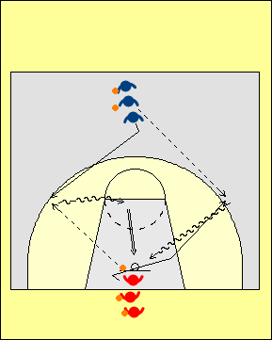 | Entrée à l’aile et esquive en alternance – Étape A sans opposition  On forme deux files, chaque joueur ou joueuse ayant un ballon sauf le premier ou la première de la file du haut. Au départ, cet(te) athlète peut choisir d’aller vers la gauche ou vers la droite pour effectuer une esquive au point d’attaque. La passe doit être parfaitement synchronisée. Au moment de recevoir le ballon, l’athlète effectue un arrêt en un temps sur les deux pieds, de sorte que la reprise du mouvement se fait à l’aide d’un pas croisé dans l’une ou l’autre direction.  Le joueur ou la joueuse prétend qu’un(e) défenseur(e) lui fait face et visualise une action défensive. Il ou elle se dirige ensuite soit vers le centre pour exécuter un tir en suspension, ou encore vers la ligne de fond pour faire un tir en puissance avec mouvement pied extérieur- pied intérieur.
Après avoir effectué la passe, le joueur ou la joueuse qui se trouve au bas coupe au point d’attaque pour recevoir une passe en provenance de celui ou celle qui se trouve maintenant en tête de la file du haut. La réception est suivie d’un croisement dans l’une ou l’autre direction. Les joueurs ou les joueuses alternent.

Étape B – Jeu dirigé
L’entraîneur(e) peut fournir des indices aux attaquant(e)s au moment où ceux-ci ou celles-ci attrappent le ballon.

COMBINAISONS D’ÉDUCATIFS DE DRIBBLE, DE PASSE ET DE TIR
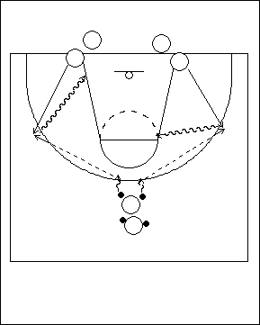 | Exercice avec deux ballons : pénétration de l’aile après une passe  Les joueurs/joueuses forment trois files. Ceux et celles situé(e)s en haut à la ligne de trois points doivent avoir chacun deux ballons. Les joueurs/joueuses placé(e)s le long de la ligne de fond doivent décider qui amorcera le jeu, car les files alterneront. Le passeur ou la passeuse doit déceler qui est libre en premier. Le rythme de la passe est crucial : la passe doit arriver au moment même où le/la partenaire coupe au point d’attaque. L’ailier(ère) doit ensuite attaquer le panier à partir de la ligne de fond ou au centre. Pour rendre l’exercice plus exigeant (Étape B), ajouter un(e) défenseur(e) semi actif(ve) pour marquer le passeur ou la passeuse, ainsi que l’ailier(ère).
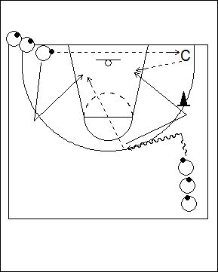 | Passe derrière le/la défenseur(e)  Les joueurs/joueuses forment deux lignes, et chacun(e) a un ballon. Celui ou celle placé(e) dans le coin amorce le jeu en faisant une passe au dessus de la tête à l’entraîneur(e) (C) qui se trouve dans le coin opposé. Les athlètes plus jeunes devront peut-être chercher à raccourcir la longueur de la passe en s’avançant un peu en dribblant, et simuler une pénétration à partir de la ligne de fond.  Le joueur ou la joueuse du haut ramène le ballon vers le centre en dribblant. Celui ou celle qui est dans le coin opposé court tout d’abord jusqu’à la ligne de trois points, puis coupe rapidement vers
le panier; il ou elle doit synchroniser sa manœuvre et arriver au point d’attaque au même moment que son/partenaire est prêt(e) à faire la passe à l’aile. Le passeur ou la passeuse exécute une passe rebond dans la clé, ou encore une passe en lob dirigée vers le coin. Il est important que cette passe soit dirigée du côté du terrain où se trouve celui/celle à qui elle est destinée, sinon le risque d’interception sera élevé. Après avoir exécuté sa passe, le joueur ou la joueuse se retourne, coupe vers l’aile et coupe à nouveau en direction du panier pour recevoir une passe de l’entraîneur(e).

Il devrait y avoir un cône ou un(e) assistant(e) pour indiquer l’endroit à partir duquel couper au panier.

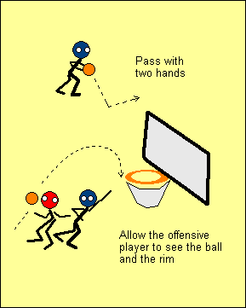 | Cette passe arrière devrait être faite à deux mains, et précédée d’une feinte de passe à l’aile pour mettre le/la défenseur(e) hors position.  Si le joueur ou la joueuse fait une passe en lob, il/elle devrait la diriger vers le coin. Ceci permettra au réceptionneur ou à la réceptionneuse de voir à la fois le panier et le ballon et d’anticiper sa prochaine manœuvre.  Tout comme dans les autres éducatifs, l’entraîneur(e) peut suivre les différentes étapes de progression :
Étape A – Seul(e), sans opposition
Étape B–Avec défensive dirigée
Étape C–Avec défenseur(e) actif/ve. Dans cet exercice, celui ou celle qui fait la passe ne devrait pas couper derriere le défenseur au panier. L’attaquant(e) peut soit attraper le ballon à l’aile et amorcer un duel à 1 contre 1, ou encore couper par derrière vers le panier.
Étape D – On peut amorcer une situation de jeu simulé avec le dribble en direction du centre; les passeurs/passeuses ainsi que les réceptionneurs/réceptionneuses doivent alors faire une bonne lecture de l’aile en défensive apportée par les opposant(e)s.
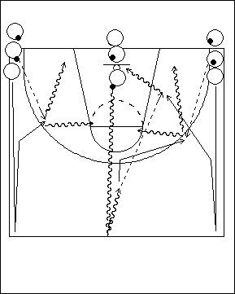 | Passes d’entrée de zone avec trois files  On forme trois files le long de la ligne de fond. Chacun(e) a un ballon en mains, sauf le premier ou la première de la file située à chaque coin. L’attaquant(e) de la file du centre amorce l’exercice en effectuant un dribble rapide jusqu’au centre du terrain; ceux/celles placé(e)s sur les côtés sprintent jusqu’au centre et reviennent en courant dans le couloir extérieur. Le joueur ou la joueuse qui est au centre passe au/à la partenaire devant lui, qui effectue ensuite un tir en foulée comme si il ou elle se trouvait en transition. L’ailier(ère) qui n’a pas reçu la passe en recevra une du prochain joueur ou de la prochaine joueuse placé(e) au coin.
Rendu(e) à la ligne de trois points, celui ou celle qui a fait la passe fait un changement de direction et coupe pour recevoir une passe en provenance de l’autre coin et dirigée au point d’attaque. La passe ne devrait pas être dirigée entre la clé et la ligne de trois points, car le réceptionneur ou la réceptionneuse a besoin d’espace pour la recevoir correctement; le joueur ou la joueuse fait ensuite une attaque à partir du centre ou de la ligne de fond.
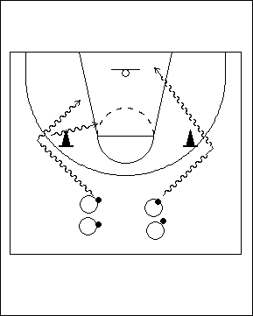 | Observer ce que font les coéquipier(ère)s – éducatif de lancer  On forme deux files au-delà de la ligne de trois points et chaque joueur/joueuse a un ballon en mains. On place aussi deux cônes aux points d’attaque. Les deux premier(ère)s partent en direction du cône en dribblant et une fois rendu(e)s font un changement de direction. Celui ou celle qui arrive en premier à son cône décide d’attaquer par le centre, ou encore à partir de la ligne de fond. L’autre joueur/joueuse doit observer, et exécuter l’option que l’autre n’a pas retenue. Ceci oblige chaque joueur/joueuse à dribbler en regardant le jeu, et à être conscient(e) de la position du ou des partenaires de jeu.
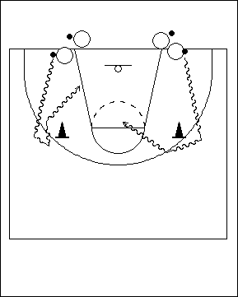 | Ligne de fond  Cet éducatif est essentiellement le même que le précédent, sauf que les joueurs/joueuses dribblent à partir de la ligne de fond. Celui ou celle qui arrive en premier à son cône a le choix de le contourner et de faire un tir en suspension, ou encore de faire un pas croisé et de revenir attaquer le panier en exécutant un tir en puissance de près précédé d’une manœuvre pied extérieur- pied intérieur.
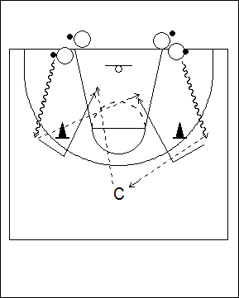 | Passe à l’entraîneur(e)  L’entraîneur(e) (C) se place au haut de la ligne de trois points. Les joueurs/joueuses partent en même temps et dribblent à partir de la ligne de fond. L’entraîneur(e) fait un signe de la main à l’un(e) des deux, qui doit alors lui passer le ballon, avant de couper au panier. L’autre attaquant(e) passe alors le ballon à celui ou celle qui a coupé, puis coupe à son tour pour recevoir une passe de l’entraîneur(e) avant d’attaquer le panier. Cet éducatif oblige les joueurs/joueuses à garder la tête haute.

JOUER AVEC LES COÉQUIPIERS OU COÉQUIPIÈRES
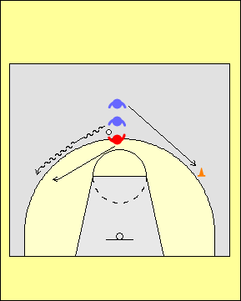 | Jeu à trois: passe à celui/celle qui coupe – marquage défensif du passeur ou de la passeuse  Trois joueurs/joueuses forment une file au haut de la ligne de trois points. Le premier ou la première joue en défensive, le/la deuxième est l’attaquant(e) qui fera la passe, et le/la troisième devra couper. Celui ou celle qui a le ballon dribble jusqu’à un point
d’attaque tandis que le/la défenseur(e) met de la pression. L’attaquant(e) qui coupe court tout d’abord jusqu’à un cône situé sur le côté opposé, puis fait un contact visuel avec le passeur ou la passeuse. Lorsque le passeur ou la passeuse est prêt(e), l’autre attaquant(e) coupe vers la balle.

Dans cet éducatif, l’élément clé est de s’assurer que la passe soit faite à l’extérieur de la ligne de trois points, ou encore dans la clé. En effet, si la passe se fait entre la ligne de trois points et la clé, l’espacement entre les joueurs/joueuses n’est pas optimal. Il est important de souligner que si le joueur ou la joueuse doit ensuite faire un déplacement à partir de la ligne de trois points, il ou elle se doit couper de par derrière (c’est ici une situation dans laquelle il est essentiel que le pied pivot du passeur ou de la passeuse soit le pied éloigné du/de la défenseur(e). Si l’attaquant(e) utilise plutôt le pied le plus rapproché du/de la défenseur(e), il ou elle sera confronté(e) à beaucoup de pression, et risque fort d’effectuer une passe imprécise. Le joueur ou la joueuse doit donc utiliser le pied le plus éloigné du/de la défenseur(e), et garder le ballon devant le pied pivot.
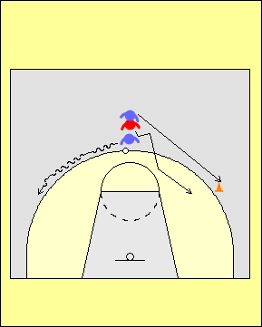 | Jeu à trois: passe à un(e) attaquant(e)– marquage défensif de celui/celle qui coupe  Cet éducatif est le même que le précédent, sauf que c’est le premier ou la première de la file qui a le ballon, et le/la deuxième qui joue en défense sur le joueur ou la joueuse sans ballon.  L’attaquant(e) dribble le ballon d’un côté, tandis que celui ou celle qui coupera se déplace de l’autre. Le/la défenseur(e) doit se placer en bonne position d’aide en défensive.
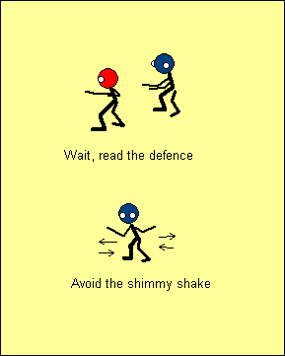 | Erreurs fréquentes  Souvent, l’attaquant(e) sans ballon n’attend pas assez longtemps et ne peut donc faire une lecture du jeu défensif, ou encore s’assurer que le passeur ou la passeuse peut l’observer. Dans plusieurs cas, il est préférable de ne pas couper, mais plutôt de varier la vitesse de déplacement et faire un changement de direction.  Une autre erreur commune de la part de l’attaquant(e) sans ballon est de faire plusieurs feintes successives au moment de couper. Ceci complique grandement la tâche de celui ou celle qui fait la passe, car il/elle a alors une chance sur deux de se tromper de côté au moment de la décocher.
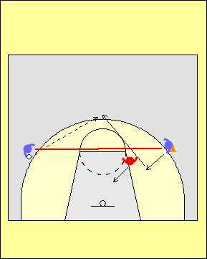 | Il est très important que l’attaquant(e) qui coupe apprenne à bien lire la défensive, car le but de cette manœuvre est d’élargir l’espace de jeu que cèdent les adversaires. Si le/la défenseur(e) se trouve au bas de la ligne imaginaire qui relie l’attaquant(e) en possession du ballon et celui/celle qui s’apprête à couper, il faut tenter de le/la forcer à se déplacer encore plus bas; en effet, lors d’une brève course, celui ou celle qui coupe peut faire un changement abrupte de vitesse et de direction et se retrouver seul(e) et à découvert au haut de la clé. Dans ce jeu, l’élément clé est d’attraper le ballon à la ligne de trois points, d’anticiper le jeu défensif, et d’attaquer à gauche, à droite ou encore avec un lancer.
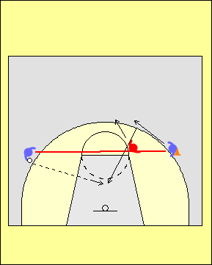 | Si le/la défenseur(e) se trouve en haut de la ligne imaginaire qui relie l’attaquant(e) en possession du ballon et celui/celle qui s’apprête à couper, il faut le/la forcer à se déplacer encore plus haut. L’attaquant(e) sans ballon peut se servir de la ligne de trois points comme d’un point de repère au moment de couper par derrière en direction du panier lorsque la passe est faite dans la clé. Le point crucial à souligner ici est que l’attaquant(e) en possession du ballon doit faire les bons choix au moment de passer; si aucun(e) défenseur(e) ne se trouve trop près, il ou elle devrait effectuer une passe de la poitrine.
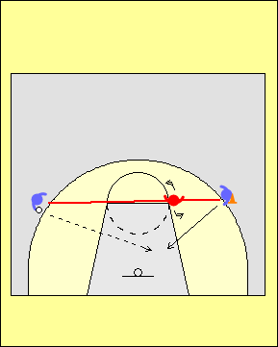 | Si le/la défenseur(e) se trouve entre l’attaquant(e) en possession du ballon et celui/celle qui s’apprête à couper, on doit chercher à le/la mettre en situation vulnérable. Dans l’exemple fournit à gauche, le/la défenseur(e) n’est pas en mesure d’observer en même temps le porteur ou la porteuse du ballon et celui/celle qui s’apprête à couper. Si le/la défenseur(e) tourne la tête, l’attaquant(e) peut couper selon une trajectoire avantageuse. De plus, le fait de feinter une réception de passe à l’aide des mains et des yeux incitera souvent le/la défenseur(e) à se retourner.
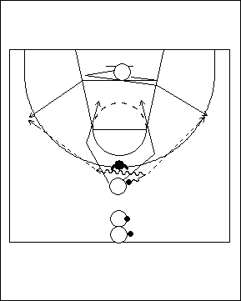 | 2 contre 1, sortie double  Dans cet éducatif, on cherche à effectuer une passe à l’aile, et à enchaîner avec une manœuvre de « passe et va ». Les joueurs/joueuses forment une file au haut de la ligne de trois points; chacun(e) a un ballon, sauf le premier ou la première qui est retourné(e) et qui agira comme défenseur(e). Un(e) second(e) attaquant(e) est posté(e) sous le panier, et il/elle a le choix de se déplacer vers l’un ou l’autre des points d’attaque sur la ligne de trois points. Le porteur ou la porteuse du ballon peut raccourcir la passe en dribblant un peu sur le côté. La passe doit parvenir au réceptionneur ou à la réceptionneuse au moment précis où il/elle arrive au point d’attaque; en effet, il n’est pas très efficace de remettre le ballon à un joueur ou une joueuse qui s’éloigne du panier à l’intérieur de la ligne de trois points (à moins qu’il ou elle ne se trouve dans la clé).
Lorsqu’un(e) attaquant(e) attrape le ballon entre la ligne de trois points et la clé, il ou elle ne peut anticiper les actions défensives et créer une situation dans laquelle l’attaque bénéficie d’un avantage d’une seconde; par conséquent, cet attaquant(e) n’est pas très efficace si il/elle n’est pas en mesure de bien voir ses partenaires; de plus, il n’y a pas assez d’espace pour couper par derrière.

Dès que l’attaquant(e) à l’aile reçoit le ballon, le passeur ou la passeuse exécute la manœuvre de « passe et va » soit devant ou derrière le/la défenseur(e), selon sa réaction au moment de la passe.

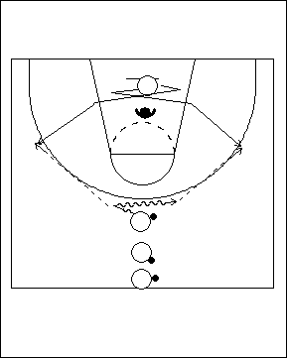 | Synchronisme de la passe (précise et au bon moment)  Dans cet éducatif, le/la défenseur(e) se concentre sur l’attaquant(e) qui coupe. Le passeur ou la passeuse doit faire en sorte que la passe arrive exactement au bon endroit et au bon moment. Il peut s’agir d’une passe derrière dans la clé derrière le/la défenseur(e), ou d’une passe au point d’attaque sur la ligne de trois points.
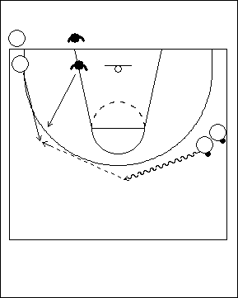 | Raccourcir la passe  Dans cet éducatif, on cherche à effectuer une passe derrière le/la défenseur(e) ou encore une passe à l’aile après un dribble. L’ailier(ère) qui amorce le jeu doit chercher à raccourcir la distance de la passe en s’avançant en dribblant jusqu’au centre, ou même un peu au-delà. Il est important de souligner que si la passe est décochée plus tôt, c.-à-d. avant que le porteur ou la porteuse ne soit rendu(e) au centre, le risque d’interception est élevé.

SAISIR LES REBONDS

Il faut enseigner aux joueurs/joueuses quand et comment se servir de leur corps afin de s’assurer d’être en bonne position pour saisir un rebond offensif.

Par la même occasion, les joueurs/joueuses doivent apprendre à conserver un bon équilibre défensif lorsqu’un lancer est décoché. De plus, les défenseur(e)s ne peuvent pas tous ou toutes tenter de récupérer un rebond; certain(e)s doivent agir comme « sécurité » et assurer la protection du panier.

On doit mettre l’accent sur la saisie des rebonds lors de chaque éducatif ou activité. Une telle approche permettra de développer une attitude compétitive chez les joueurs/joueuses lors des situations de rebonds.

Durant les premières secondes de possession
Il est souvent plus facile de s’emparer d’un rebond offensif après un lancer effectué durant les premières secondes de possession, car la défensive n’est pas encore complètement en place. L’entraîneur(e) devrait décider quels lancers sont acceptables à ce moment, et qui devrait tenter de récupérer le rebond.

Vers le milieu de la période de possession
Lors de cette phase de l’attaque, les joueurs/joueuses, devraient avoir une meilleure compréhension des lancers qui seront effectués, et quand ils le seront. L’entraîneur(e) devrait alors pouvoir mieux contrôler qui devrait être position pour récupérer un rebond. Tout ceci doit être bien intégré au système de jeu offensif.

Durant les dernières secondes de possession
Il est souvent possible de récupérer des rebonds offensifs à ce moment car les attaquant(e)s peuvent être forcé(e)s de précipiter leurs lancers. Les joueurs/joueuses qui agissent comme « sécurité » ont donc un rôle important lors de ces phases du jeu.

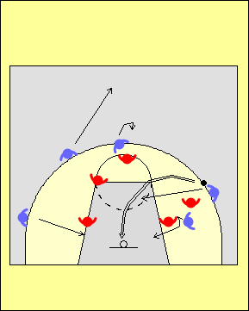 | Lors de tous les exercices qui simulent des situations de jeu, on peut utiliser le principe suivant : les joueurs/joueuses qui se trouvent au bas de la ligne de lancer franc doivent chercher à récupérer les rebonds offensifs. Ceux et celles qui se trouvent au haut sont alors responsables de protéger le panier. Cette tactique permet de s’exercer à récupérer les rebonds lors de pratiquement tous les exercices. Une autre approche consiste à désigner des postes ou des individus qui seront responsables de récupérer les rebonds. Cette approche présente toutefois des limites importantes car certain(e)s joueurs/joueuses ont alors des occasions très limitées de s’exercer à récupérer les rebonds offensifs ou défensifs.  La récupération des rebonds fait partie intégrale du jeu, et on doit donc constamment mettre l’accent sur cet aspect.

Note : Le fait que cette section soit plutôt courte ne signifie aucunement que les rebonds représentent un aspect secondaire. Au contraire, on doit plutôt constamment insister sur cette facette du jeu. Nous aborderons d’autres notions en lien avec les rebonds plus loin dans ce document lorsque nous discuterons du jeu le long de la clé.

UTILISER UNE APPROCHE CONCEPTUELLE EN ATTAQUE, EN TENANT COMPTE DES CINQ PREMIERS PRINCIPES OFFENSIFS

Principes:

1 – Passer le ballon si des partenaires sont à découvert
2 – Effectuer une pénétration chaque fois qu’il n’y a pas suffisamment d’espace pour lancer, ou qu’aucun(e) partenaire n’est libre
3- Couper uniquement si le/la partenaire en possession du ballon regarde, et peut bien voir la manoeuvre
4- Remplacer la position libre en périphérie
5- Attraper le ballon à un endroit où il est possible de faire un jeu efficace (c.-à-d. à la ligne de trois points, et non à l’intérieur de celle-ci ou encore à un point trop éloigné).

Les options de jeu après une réception de passe sont un lancer, une passe, ou une attaque à 1 contre 1.

3 contre 3 sur demi-terrain

Ces éducatifs sont conçus pour appliquer les principes offensifs précédents sur demi-terrain. Il faut souligner qu’on ne doit pas s’attendre à ce que cela puisse se réaliser lors d’une seule séance d’entraînement… Il faut plutôt adopter une approche planifiée et à long terme.

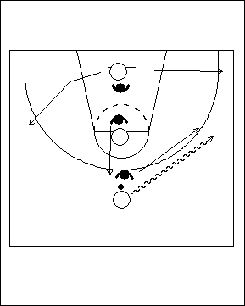 | Attaque à partir du haut - un(e) garde  Les trois attaquant(e)s sont aligné(e)s au centre, entre le panier et le haut de la ligne de trois points. Celui ou celle qui se trouve sous le panier peut sortir vers la gauche ou la droite. L’attaquant(e) en possession du ballon se déplace en dribblant vers l’un des côtés, et celui/celle qui se trouve au milieu doit trouver une position (ou espace) libre en périphérie. L’exercice se poursuit ensuite à 3 contre 3 en respectant les règles du jeu.
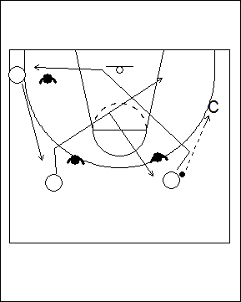 | Couper et remplacer – deux gardes  L’entraîneur(e) se place à l’aile. Trois autres attaquant(e)s prennent position en périphérie, chacun(e) étant marqué(e) par un(e) défenseur(e). Après la passe de l’entraîneur(e), les joueurs/joueuses tentent de couper au panier. Tout en respectant les principes énoncés précédemment, les autres attaquant(e)s doivent remplacer le poste vacant lorsqu’un(e) partenaire coupe; si la voie n’est pas libre à la ligne des trois points, le joueur ou la joueuse doit couper par derrière. Après la réception de passe, l’attaquant(e) ne doit pas immobiliser le ballon, mais plutôt penser : lancer, passe, ou attaque du panier, dans cet ordre. Dans cet exercice, l’entraîneur(e) devrait également toujours constituer une option de passe.
Note : On se fait souvent poser la question suivante : « Qu’est-ce que je devrais enseigner à mes joueurs/joueuses si la défensive adverse ralentit le jeu car elle réalise que mon équipe est plutôt faible au tir ? » La réponse est bien simple… il faut passer le temps qu’il faut à leur enseigner à bien lancer. Si l’entraîneur(e) tente de résoudre ce type de problème en mettant en place une tactique ou une stratégie, ça ne fonctionnera en général que pendant une courte période de temps. À long terme, le problème persistera et la seule solution est que les joueurs ou joueuses apprennent à bien lancer.
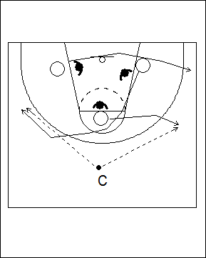 | Changer de position  Les joueurs/joueuses amorcent l’éducatif en formation de triangle. L’entraîneur(e) assigne un numéro à chaque attaquant(e) (1, 2 et 3). Ce numéro sert à indiquer l’ordre dans lequel les joueurs/joueuses se déplaceront lorsque le signal sera donné. Les joueurs/joueuses ne peuvent retourner sur le côté d’où ils ou elles sont parti(e)s. L’entraîneur(e) effectue une passe à un(e) joueur ou une joueuse qui est à découvert, et on joue ensuite à 3 contre 3. Cet éducatif oblige les joueurs/joueuses à (1) se démarquer vers les espaces libres, (2) tenir compte des mouvements que font leurs coéquipiers/ères, (3) évoluer à différentes positions, et (4) se familiariser avec le rythme de l’attaque.

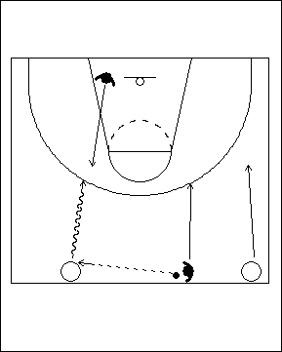 | À partir du côté  Un(e) défenseur(e) est posté(e) sous le panier et un(e) autre près du centre du terrain, à l’extérieur du couloir central. Les deux attaquant(e)s sont également au centre, mais dans les corridors extérieurs. Les trois joueurs/joueuses placé(e)s au centre sont aligné(e)s. Dans cet éducatif, les deux attaquant(e)s disposent d’un avantage d’une seconde. Celui ou celle qui est en possession du ballon doit garder la tête haute et décider si il ou elle est en mesure de passer à son/sa partenaire qui se déplace à l’aile. Dans le cas contraire, il/elle peut ralentir le jeu, et mener une attaque à 2 contre 2. Pour leur part, les défenseur(e)s tentent de ralentir la circulation du ballon et de récupérer en défensive.
Note: L’entraîneur(e) doit tenir compte des forces et faiblesses des joueurs/joueuses impliqué(e)s. Dans tous les éducatifs où il y a un avantage d’une seconde, il peut être nécessaire de placer les athlètes à des endroits différents de ceux qui sont proposés sur les diagrammes afin de s’assurer qu’il y ait bel et bien avantage. Par exemple, si les joueurs/joueuses ne peuvent effectuer de longues passes, on doit chercher à les raccourcir; si les défenseur(e)s arrivent toujours en premier et que les attaquant(e)s n’ont pas le temps d’exécuter leur manoeuvre, il faut leur faire parcourir une plus grande distance. De plus, on doit placer les joueurs/joueuses dans des situations de jeu dans lesquelles ils/elles doivent utiliser leur main non dominante pour amorcer l’action.
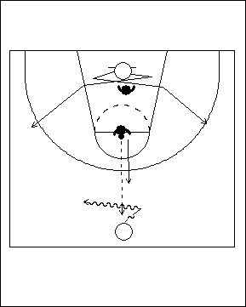 |  | À partir du centre  Un(e) attaquant(e) se place sous le panier et est marqué(e) par un(e) défenseur(e). Le/la deuxième défenseur(e) a le ballon, et se trouve à la ligne de lancer franc, tandis que le/la deuxième attaquant(e) est près du centre du terrain. Le jeu s’amorce quand le/la défenseur(e) en possession du ballon remet le ballon à l’attaquant(e) placé(e) au centre et on se trouve alors en situation de 2 contre 2. L’attaquant(e) sous le panier doit chercher à couper à l’aile, soit à gauche ou à droite, et à se démarquer de la couverture défensive.Il faut se rappeler des points suivants :  - Faire toutes les passes à l’extérieur de la ligne de trois points ou dans la clé.  - On doit anticiper le jeu défensif : il est toujours préférable d’avoir l’initiative plutôt que de réagir.  - On ne doit pas arrêter la circulation du ballon.  - Option 1- lancer  - Option 2 – passer  - Option 3 – foncer au panier
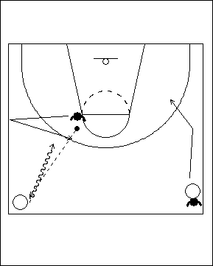 |  | Synchronisme de la passe  Dans cet éducatif, les joueurs/joueuses évoluent à 2 contre 2, et les défenseur(e)s arrivent d’angles différents. L’un(e) des défenseur(e)s est posté(e) au « T » avec le ballon. L’autre est derrière l’attaquant(e) qui se trouve au centre, près de la ligne de côté, et lui fait dos afin de lui donner un avantage d’une seconde. L’autre attaquant(e) est également près de la ligne centrale, mais sur le côté opposé. Le/la défenseur(e) en possession du ballon fait une passe à l’attaquant(e) qui est à découvert, puis doit aller toucher la ligne de côté avant de tenter de contrer le porteur ou la porteuse du ballon. Ceci crée une brève situation à 2 contre 0, et il est donc important que les attaquant(e)s préservent et exploitent leur avantage pendant que les défenseur(e) tentent de reprendre leur poste.
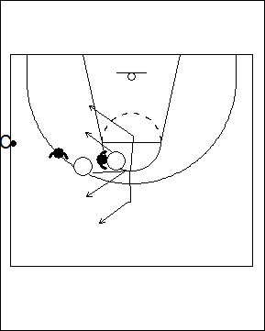 |  | 2 contre 2 après remise en jeu  Une autre façon d’amorcer les situations à 2 contre 2 est de demander à un(e) autre joueur ou joueuse ou à un(e) assistant(e) de remettre le ballon en jeu à partir de la ligne de côté. Un principe simple à mettre en application lors d’une remise en jeu est que l’attaquant(e) le/la plus éloigné(e) du ballon fait face au ballon, alors que celui/celle qui en est le/la plus rapproché(e) tourne le dos au ballon, et fait face à son/sa partenaire. L’attaquant(e) le/la plus éloigné(e) coupe en premier; son/sa partenaire qui a le dos tourné au ballon réagit à ce déplacement, et coupe dans l’autre direction. Une fois le ballon remis en jeu, les joueurs/joueuses évoluent à 2 contre 2 en appliquant les principes énoncés auparavant.

4 contre 4

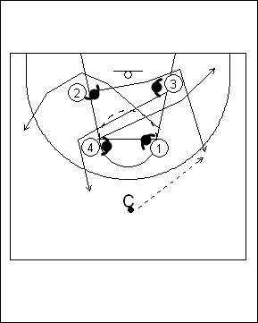 | Échanges entre joueurs (trouver le bon endroit)  Afin de s’exercer à exploiter l’avantage d’une seconde, les joueurs/joueuses peuvent se placer en formation de boîte pour amorcer le 4 contre 4. Ici encore, ils/elles doivent se déplacer avec synchronisme et trouver un espace libre, mais ils/elles ne peuvent sortir sur le même côté qu’ils/elles commencent. Cette formation peut également s’amorcer en enlignant les joueur/joueuses. | 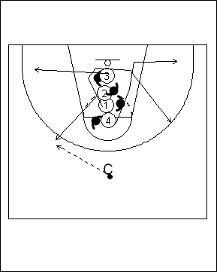
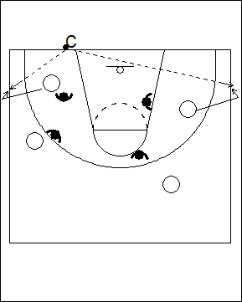 | 4 contre 4, empêcher le ballon de sortir  Une autre façon d’amorcer les situations de jeu à 4 contre 4 ou à 5 contre 5 est de demander aux joueurs/joueuses de se déplacer aléatoirement sur le terrain. On a au préalable formé des équipes et on leur a désigné une couleur. Lorsque l’entraîneur(e) désigne une de ces couleurs, l’équipe en question doit empêcher le ballon de quitter le terrain. L’un(e) des joueurs/joueuses doit se charger de cette tâche tandis que les autres doivent communiquer et se placer en position pour recevoir le ballon. L’équipe en possession du ballon attaque ensuite le panier le plus éloigné (l’entraîneur(e) peut toutefois désigner le panier où se fera l’attaque).
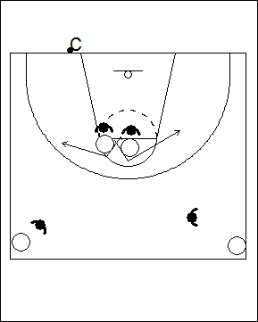 | 4 contre 4, ballon à l’extérieur - ligne de fond  L’entraîneur(e) a le ballon en main à l’extérieur du terrain. Les deux équipes se déplacent aléatoirement sur le terrain. L’entraîneur(e) désigne une couleur d’équipe, puis dépose le ballon. L’équipe désignée doit alors remettre le ballon en jeu rapidement, puis attaquer le panier correspondant à la couleur indiquée.  4 contre 4, ballon à l’extérieur - la ligne de côté  On peut répéter le même exercice que précédemment, mais faire la remise en jeu à partir de la ligne de côté. | 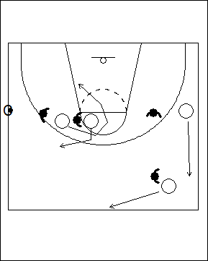

5 contre 5
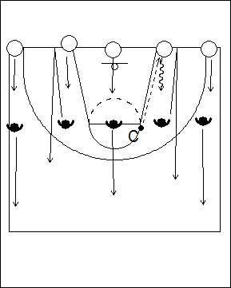 | 5 contre 5, avantage  Les attaquant(e)s se placent le long de la ligne de fond et les défenseur(e)s leur font face à la hauteur de la ligne de lancer franc. L’entraîneur(e) qui est placé(e) dans la file de défenseur(e)s passe le ballon à l’un(e) des attaquant(e)s. Le/la défenseur(e) qui fait face à celui/celle qui a reçu la passe doit aller toucher la ligne de fond avant de revenir au jeu.
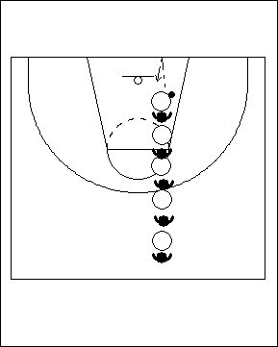 | 5 contre 5 en file  Les joueurs/joueuses forment une file devant le panneau; les attaquant(e)s et les défenseur(e)s alternent dans la file. On lance le ballon sur le panneau et les joueurs/joueuses le garde en jeu en le tapant chacun(e) leur tour sur le panneau; après avoir tapé le ballon, le joueur ou la joueuse va se placer en queue de file. Au signal de l’entraîneur(e), celui ou celle qui se trouve devant le panier s’empare du ballon, et son équipe se trouve alors en attaque.  Il s’agit ici simplement d’une autre façon d’amorcer l’attaque.
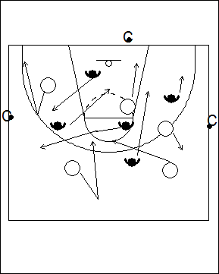 | contre 5 lorsque le ballon est remis en jeu  Les joueurs/joueuses de chaque équipe se déplacent de façon aléatoire sur un demi-terrain. L’entraîneur(e) remet le ballon à une équipe en le passant ou en le faisant rouler au sol; cette équipe est alors en attaque. Si l’équipe en défense s’empare du ballon, elle peut à son tour attaquer.  On peut également amorcer cet éducatif avec un lancer, et l’équipe qui s’empare du rebond passe à l’attaque.  On peut aussi le faire à l’aide d’un puissant rebond du ballon au sol.
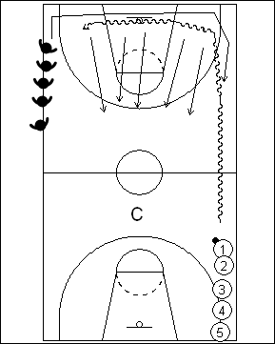 | 5 contre 5 précédé d’une course  Les cinq attaquant(e)s et les cinq défenseur(e)s forment une file à chaque extrémité du terrain, de chaque côté. Le premier ou la première attaquant(e) a le ballon. Au premier signal de l’entraîneur(e), les joueurs/joueuses amorcent une course lente le long des lignes de côté. Au deuxième signal, l’équipe en possession du ballon amorce une attaque en direction du panier éloigné, et les défenseur(e)s doivent aller marquer leur attaquant(e) respectif(ve) et empêcher l’équipe adverse de marquer.  Il s’agit d’une façon créative et amusante d’amorcer une situation à 5 contre 5.
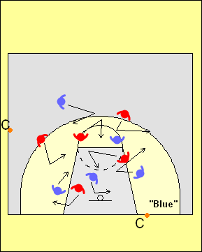 | Remise en jeu de la ligne de côté ou de la ligne de fond  Les joueurs/joueuses de chaque équipe se déplacent de façon aléatoire sur un demi-terrain. Un(e) entraîneur(e) se place derrière la ligne de fond, et un(e) autre le long d’une ligne de côté; chacun(e) a un ballon en mains. L’un(e) des entraîneur(e) nomme une équipe, et dépose son ballon au sol. Un(e) joueur/joueuse de cette équipe doit alors le récupérer, et le remettre en jeu derrière cette ligne; l’équipe attaque ensuite le panier.

JEU À L’INTÉRIEUR

Chaque joueur/joueuse doit apprendre à se servir de son corps pour prendre position sur un(e) défenseur(e). Un(e) attaquant(e) qui se trouve « à l’intérieur » doit se débrouiller pour devenir une cible potentielle et recevoir une passe en provenance d’un(e) partenaire qui se trouve en périphérie. Les attaquant(e)s doivent apprendre à effectuer une passe au joueur ou à la joueuse qui se trouve à l’intérieur – passe haute, à rebond, en triangle, et en lob. Ils ou elles doivent également se placer à un endroit qui empêchera le/la défenseur(e) de surveiller en même temps l’attaquant(e) qui est en possession du ballon « à l’intérieur » et son/sa partenaire en périphérie. L’attaquant(e) à l’intérieur doit toujours se déplacer en fonction de la position du ballon.

Faire une passe à l’intérieur

Il est difficile de créer un avantage d’une seconde à chaque fois que l’on effectue une passe, particulièrement lorsque la qualité du jeu défensif s’améliore, que ce soit sur le plan individuel ou collectif. Lorsque l’on affronte une équipe dont la défensive est très étanche et contre laquelle il est difficile de faire des passes à des partenaires qui tentent de couper derrière les défenseur(e)s, les joueurs/joueuses doivent apprendre à prendre position sur le/la défenseur(e) pour se libérer et pouvoir attraper une passe. Ces manœuvres auront lieu en périphérie, et lorsque les attaquant(e)s commenceront à prendre le dessus sur les défenseur(e)s à l’intérieur.

Les joueurs/joueuses doivent apprendre à exécuter des passes de côté et des passes circulaires contre les défenseur(e)s, et aussi à regarder les options qui s’offrent à eux/elles avant de passer à un(e) partenaire qui a pris position sur un(e) défenseur(e).

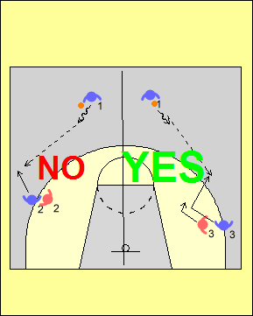 | Passer à un(e) attaquant(e) qui a pris position sur son/sa défenseur(e) en périphérie  Il est important d’insister sur le fait que la passe au point d’attaque doit être faite à l’endroit où l’angle est optimal pour l’exécuter. Si le/la partenaire attrape le ballon trop loin de la ligne des trois points et le long de la ligne de côté, ses options pour attaquer la défensive seront alors très limitées. L’attaquant(e) doit chercher à inciter l’adversaire qui le/la marque à se rapprocher du panier avant de prendre position sur lui ou sur elle.  Lorsque le joueur ou la joueuse coupera pour aller capter la passe, il/elle aura alors suffisamment d’espace.
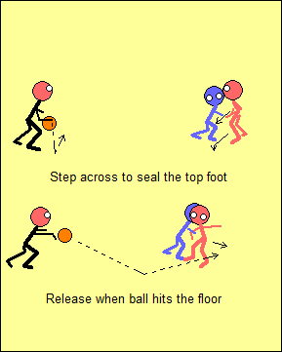 | L’attaquant(e) enjambe le pied avant du/de la défenseur(e), et s’interpose à l’aide de son avant-bras et de son épaule. Il ou elle établit également un contact visuel avec le passeur ou la passeuse. Dans une telle situation, il est plus facile d’attraper une passe rebond; le réceptionneur ou la réceptionneuse amorce son déplacement vers le ballon lorsque celui-ci touche le sol.  Note: Lorsque l’attaquant(e) prend position sur le/la défenseur(e), il/elle doit attendre que la passe ait été faite avant de se déplacer; ceci est différent de la situation dans laquelle l’attaquant(e) coupe, auquel cas c’est lui ou elle qui bouge en premier et la passe suit.  Il est plus difficile pour le passeur ou la passeuse de savoir exactement quand décocher la passe si celle-ci est faite dans les airs; la difficulté provient du fait que la passe doit être dirigée vers un point situé à l’extérieur du corps du ou de la réceptionnaire, et non directement vers son corps.
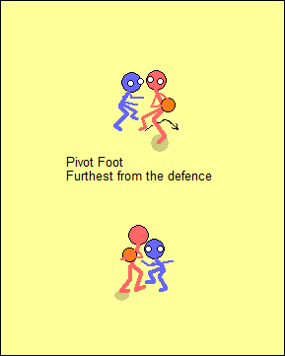 |  | Dans cette situation, l’attaquant(e) est également le passeur ou la passeuse. Après la réception du ballon, le joueur ou la joueuse utilise le pied pivot le plus éloigné du/de la défenseur(e) (pivot renversé). Il ou elle cherche alors à effectuer une passe de qualité à un(e) partenaire qui pourra ensuite créer une situation dans laquelle l’attaque aura un avantage d’une seconde; en effet, ce joueur ou cette joueuse ne devrait pas se trouver dans une situation statique à 1 contre 1. Il est important de souligner que si l’attaquant(e) fait une feinte de lancer ou d’attaquer, il/elle risque fort de ne pas remarquer le ou la partenaire qui s’est libéré(e) pour recevoir une passe.
Pour évoluer efficacement à 1 contre 1 tout en jouant en équipe, les cinq joueurs/joueuses doivent anticiper quand il leur sera possible de créer un avantage d’une seconde, et également quand ils/elles doivent effectuer des passes de qualité, c.-à-d. des passes qui pourront créer un avantage d’une seconde pour un(e) partenaire.

Les joueurs ou joueuses doivent tenir le ballon correctement, ce qui leurs permettra de passer à un(e) partenaire qui se trouve à l’intérieur et qui a pris avantage sur un(e) défenseur(e), ou encore qui coupe au panier.

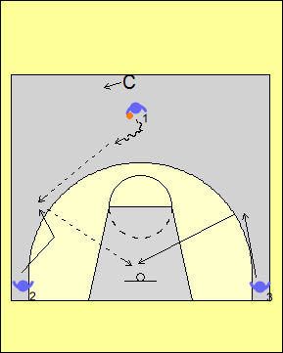 | Effectuer la passe à l’attaquant(e) qui coupe à l’intérieur  Cet éducatif est le même que lorsqu’une passe est faite à l’ailier(ère) qui se trouve en périphérie. L’attaquant(e) en possession du ballon doit faire un balayage visuel et déceler le ou la partenaire qui est libre (l’entraîneur(e) qui est placé(e) derrière indique de quel côté se fera le jeu). Le joueur ou la joueuse désigné(e) comme étant à découvert prend position à l’intérieur sur un joueur imaginaire et reçoit la passe au point d’attaque. Lorsqu’il ou elle voit que la passe a été faite, l’ailier(ère) situé(e) dans le coin opposé remonte afin de conserver un bon espacement. Une fois que le joueur ou la joueuse en possession du ballon a effectué un pivot renversé et a établi un contact visuel, l’ailier(ère) coupe au panier pour recevoir la passe. Une fois que les joueurs/joueuses maîtrisent ces concepts, ils/elles peuvent passer à la prochaine étape.
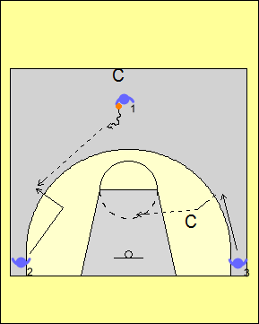 | Défensive dirigée par l’entraîneur(e)  Dans cet exercice, l’entraîneur(e) indique à l’attaquant(e) quelle manœuvre effectuer lorsqu’il/elle coupe. Si le/la défenseur(e) se trouve au bas, il faut l’inciter à se déplacer encore plus bas, et vice versa si il/elle se trouve plus haut, le but étant de créer plus d’espace de jeu. |  | 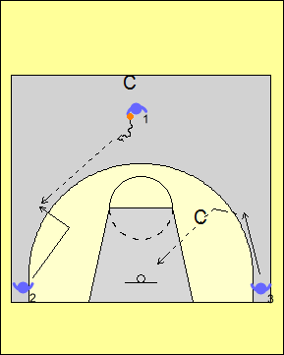
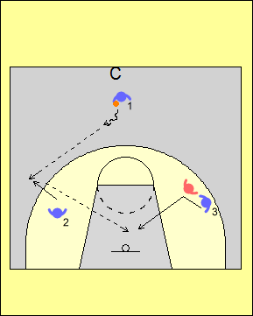 | Défensive dirigée  Dans cet éducatif, l’attaque dispose d’un avantage d’une seconde. Dans l’exemple de gauche, le/la défenseur(e) se trouve plus haut que l’attaquant(e) qui coupe; dans celui de droite, il/elle se trouve plus bas. On cherche à travailler le synchronisme de la « coupe à la balle » et la qualité de la passe; celui ou celle qui coupe doit également s’assurer que le/la défenseur(e) demeure derrière. |  | 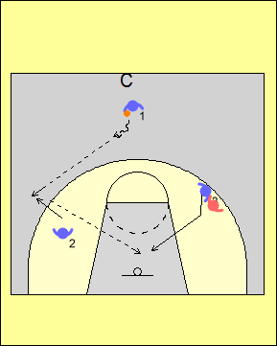
L’entraîneur(e) doit tenir compte du niveau des joueurs/joueuses afin de donner un avantage adéquat aux attaquant(e)s; les défenseur(e)s doivent éventuellement jouer de façon active tandis que les joueurs ou les joueuses en attaque disposent d’un léger avantage.
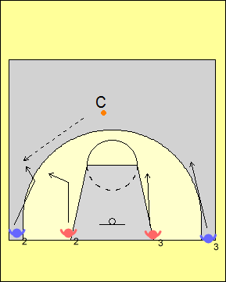 | 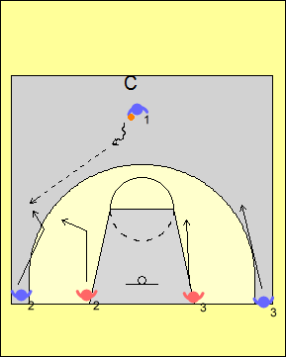 |  | 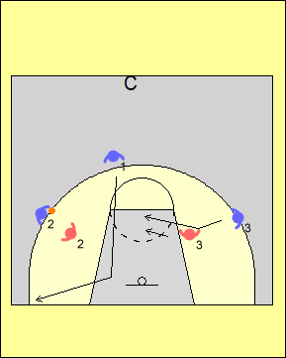
2 contre 2

Dans le diagramme de gauche ci-dessus, les joueurs/joueuses évoluent à 2 contre 2. Deux défenseur(e)s couvrent les ailier(ère)s mais les attaquant(e)s disposent d’un avantage d’une seconde car les défenseur(e)s se trouvent à une certaine distance lorsque le jeu s’amorce. L’entraîneur(e) décide à quel(le) ailier(ère) il ou elle fera la passe. Dans le diagramme du centre, c’est l’attaquant(e) en possession du ballon qui fait la passe à l’un des ailier(ère)s qui coupe, et les joueurs/joueuses évoluent ensuite à 2 contre 2. Pour jouer à 3 contre 3, on peut ajouter un(e) défenseur(e) contre l’attaquant(e) en possession du ballon.
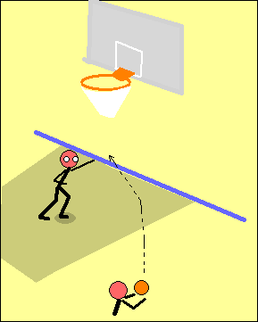  Étape 1 –sans opposant(e) | 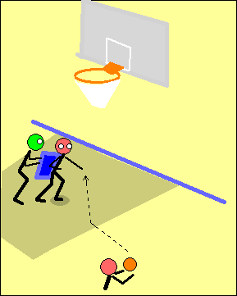  Étape 2- L’entraî-  neur(e) dirige | 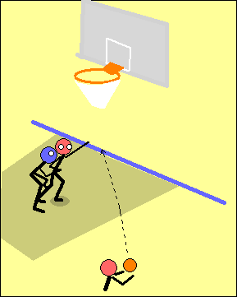  Étape 3 – Jeudéfensifdirigé

Passer à un(e) partenaire qui a pris position sur un(e) défenseur(e)

Dans cet éducatif, les joueurs/joueuses s’exercent à effectuer une passe à un(e) partenaire qui a pris position sur un(e) défenseur(e) dans la clé; une progression en trois étapes est proposée. À l’étape 1, l’attaquant(e) dans la clé doit présenter une cible au passeur ou à la passeuse, tout en gardant sa position contre un(e) défenseur(e) imaginaire. Après la réception, le joueur ou la joueuse pivote à l’aide du pied qui se trouve le plus éloigné du/de la défenseur(e). Compte tenu de la cible présentée, la passe peut être faite dans les airs ou à rebond.

À l’étape 2, l’entraîneur(e) joue le rôle du/de la défenseur(e). L’attaquant(e) doit maintenir sa position contre le/la défenseur(e), s’esquiver au bon moment pour recevoir la passe et finalement pivoter à l’aide du bon pied, c.-à-d. celui qui se trouve le plus éloigné du/de la défenseur(e).

À l’étape 3, l’attaquant(e) évolue contre un(e) défenseur(e) qui est dirigé(e). L’intention première doit être de marquer, mais le joueur ou la joueuse cherche aussi à garder sa position sur le/la défenseur(e) dans la clé puis à s’esquiver pour attraper la passe. On peut ajouter un élément de surcharge en plaçant un(e) défenseur(e) devant celui ou celle qui doit exécuter la passe.

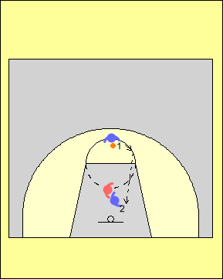 | Il est important de travailler ce type de passes à partir de différents endroits autour de la clé, toujours en mettant l’accent sur une bonne prise de position sur le/la défenseur(e) et sur la qualité de la passe. Le/la défenseur(e) doit se débattre pour reprendre sa position tandis que l’attaquant(e) doit pour sa part maintenir sa position sur le/la défenseur(e).  On peut rendre l’exercice plus exigeant en ajoutant un(e) autre attaquant(e) en périphérie près de la ligne de trois points, et lui demander d’effectuer une passe relais.  Qui se trouve dans le meilleur angle pour effectuer une passe ? | 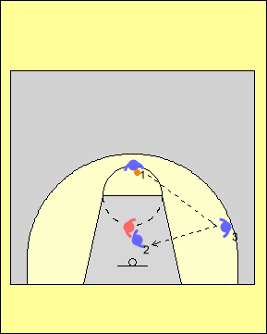

DÉVELOPPER LES HABILETÉS DE JEU À L’INTÉRIEUR

Les informations qui suivent sont tirées de notes prises à l’occasion d’une conférence donnée par
Ettore Messina, un entraîneur de basketball bien connu sur la scène internationale.
Plus on reçoit d’informations, plus il devient difficile de les mettre en pratique.

« Davantage » ne signifie pas nécessairement « Mieux ». L’art d’entraîner consiste à recueillir les bonnes informations et à les utiliser au bon moment. Il est donc important d’être sélectif(ve). De nos jours, cela s’avère encore plus difficile car nous sommes bombardé(e)s d’informations. On ne peut tout enseigner aux joueurs/joueuses. Il faut donc savoir ce qu’on doit absolument leur enseigner maintenant. Qu’est-ce qui devrait suivre? Qu’est-ce qu’on devrait garder pour la fin?

Un(e) bon(ne) enseignant(e) sait par où commencer et vers quel est objectif terminal progresser. Quel est cet objectif? En tant qu’entraîneur(e), vous devez aider les joueurs/joueuses à évoluer, et à devenir autonomes.

Il faut tout d’abord définir le système – c’est la structure avec laquelle je suis à l’aise. Le point de départ doit être une méthode d’enseignement organisée, et il faut débuter avec les éléments de base. L’entraîneur(e) doit identifier les étapes du cheminement. Celles-ci ne doivent pas être trop faciles car elles ne représenteront alors aucun défi pour les athlètes, mais elles ne doivent pas non plus s’avérer trop difficiles et causer de la frustration. Un niveau de difficulté approprié doit aider l’athlète à apprendre à gérer sa frustration.

Il faut que les joueurs/joueuses apprennent de leurs erreurs. Êtes-vous disposé(e) à accepter les erreurs? En tant qu’entraîneur(e), vous devez déterminer le niveau d’erreurs que vous êtes prêt(e) à accepter. Plus les choses seront complexes, plus il y aura d’erreurs. L’entraîneur(e) doit réfléchir à ces choses avant d’amorcer le travail avec les athlètes.

Il faut bien se préparer si on veut que les athlètes soient bien préparé(e)s.

Quand on enseigne, on doit s’attendre à ce que les autres interprètent ce que l’on dit de bien des façons. Il faut donc garder les choses simples : les joueurs/joueuses doivent faire une bonne lecture du jeu, et réagir correctement. En soi, cela constitue un processus à long terme. Il faut limiter les options : au début des apprentissages, il est en effet difficile de bien lire le jeu et de faire les bons choix lorsque les situations sont complexes et qu’il y a beaucoup de joueurs/joueuses dont il faut tenir compte. L’athlète doit tout d’abord être bien conscient(e) de ce qu’il ou elle fait avant d’être en mesure de « lire » le jeu des adversaires. Au fur et à mesure que le joueur ou la joueuse progresse, on doit lui laisser plus de latitude. Ceci exige une auto discipline de la part de l’athlète, ainsi qu’une intensité adéquate de sa part une fois que la lecture du jeu a été faite, mais telles sont les exigences à un haut niveau de jeu. Le joueur ou la joueuse doit également être prêt(e) à se sacrifier et il n’y a pas de place pour l’égoïsme. Le basketball est un jeu relativement simple quand on limite les options, et il faut donner aux joueurs/joueuses l’occasion d’interpréter les situations de jeu, et de «lire et réagir ».

Il faut aussi savoir que les joueurs/joueuses et l’entraîneur(e) ne voient pas toujours les choses du même œil.

Les joueurs/joueuses peuvent s’améliorer sur les plans :
- Mental – confiance en soi; situations de jeu simple; jouer lorsqu’il y a de la pression
- Physique – jouer plus rapidement; avec plus de puissance et un meilleur équilibre
- Technique – manœuvres offensives; qualité d’exécution des lancers; meilleurs déplacements (où et quand les faire)

Il y a également un lien entre chacun de ces aspects. Par exemple, l’exécution d’une manœuvre de joueur/joueuse d’intérieur peut s’avérer correcte sans opposition, mais les choses peuvent se compliquer considérablement lorsque l’athlète se retrouve confronté(e) à un(e) défenseur(e) : il ou elle doit en effet apprendre à « absorber » un contact physique et à mettre l’accent sur les bons éléments physiques et techniques que la situation exige. Ainsi, lorsque la condition physique est meilleure, la confiance de l’athlète s’accroît et cela peut l’inciter à tenter quelque chose de nouveau. Il ne s’agit donc pas uniquement de faire un grand nombre de répétitions – l’entraîneur(e) doit plutôt agir tel un grand chef cuisinier.

Le joueur ou la joueuse de grande taille

Les joueurs/joueuses doivent comprendre comment ils/elle peuvent s’améliorer, et en même temps connaître l’importance de contribuer au succès de l’équipe. Dans les jeunes catégories, les athlètes de petite taille qui sont souvent les plus rapides peuvent dominer le jeu. Il faut par contre plus de temps pour qu’un jeune joueur ou une jeune joueuse de grande taille puisse se développer. Éventuellement, et avec une bonne dose de patience, ce seront toutefois eux/elles qui seront dominant(e)s. Plusieur(e)s entraîneur(e)s hésitent à insérer un(e) jeune athlète de grande taille dans l’alignement par crainte que cela n’affecte la performance de l’équipe. Pour cette raison, on doit donc chercher à aider ce type de joueur ou de joueuse à développer un certain nombre d’habiletés critiques. Une fois ces habiletés maîtrisées, la confiance que cet(te) athlète affichera enverra un signal clair à ses coéquipier(ère)s qui, en retour, auront confiance en son niveau d’habileté.

Est-ce que le jeune joueur ou la jeune joueuse peut :
- Marquer lors d’une transition?
- Garder l’équilibre lorsqu’il ou elle récupère un rebond offensif?
- Réussir ses lancers francs?
- Se débrouiller lorsqu’il y a des contacts?
- Se placer au bon endroit en défensive?

Si l’athlète peut tirer son épingle du jeu dans chacune des situations précédentes, il/elle peut jouer et contribuer de façon positive aux succès de l’équipe.

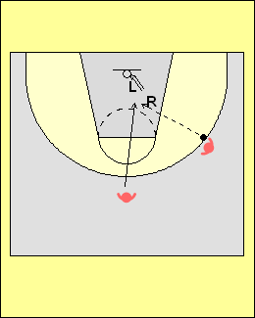 | Marquer lors d’une transition  Le joueur ou la joueuse doit effectuer un arrêt en deux temps afin de ne pas marcher avec le ballon. On suggère que l’athlète apprenne à exécuter une manœuvre de pied extérieur - pied intérieur. Dans ce cas, le jeu de pieds se fait de l’extérieur vers l’intérieur. Ceci permet au joueur ou à la joueuse de conserver le contrôle de ses mouvements tout en continuant à progresser vers le panier, à interrompre l’action du ou de la défenseur(e), et à protéger le ballon.
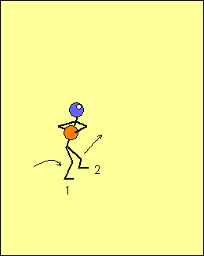 | Sur le côté droit du terrain, le joueur ou la joueuse atterrira habituellement sur le pied droit en premier, suivi du gauche, alors que du côté gauche ce sera l’inverse, soit pied gauche en premier, suivi du droit. En prenant contact avec le pied extérieur en premier, le joueur ou la joueuse peut effectuer une poussée à l’aide de ce pied et poursuivre son action vers le panier. Le joueur ou la joueuse ne doit pas penser à son jeu de pieds lors d’une telle manoeuvre, car il/elle risquerait d’être sanctionné(e) pour avoir marché avec le ballon. Ceci s’avère particulièrement difficile lorsqu’il y a beaucoup de circulation au moment d’attraper le ballon. Lors des exercices, l’entraîneur(e) devrait effectuer différents types de passes (régulière; mauvaise passe haute ou basse; etc.)
Avec la pratique, le joueur ou la joueuse s’habituera à effectuer cette manœuvre de pied extérieur – pied intérieur de façon automatique. À noter qu’il est beaucoup plus facile d’attraper une passe rebond, car le joueur ou la joueuse n’a pas besoin de s’étirer. La coordination entre les bras et les jambes est ici cruciale. Les yeux doivent être fixés sur le ballon au moment de l’attraper, mais le regard doit ensuite être rapidement dirigé vers la cible.
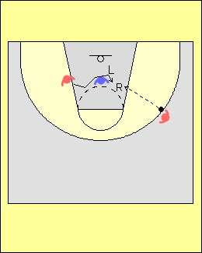 | Arrêt en deux temps inversé suivi d’une manoeuvre après avoir coupé  Lorsque l’attaquant(e) coupe au travers de la clé, il/elle risque de se faire détourner par son défenseur(e). À la fin de la manœuvre, les joueurs/joueuses doivent utiliser la même séquence de pas que lorsqu’ils/elles coupent devant un(e) défenseur(e) pour l’emboîter, soit pied extérieur – pied intérieur; plusieurs ont par contre tendance à continuer leur course plus loin, jusqu’au bloc.  Il est crucial de planter solidement le pied extérieur en premier, car cela permet d’appliquer une pression et de repousser le/la défenseur(e); cet aspect est crucial pour que le joueur ou la joueuse puisse conserver son équilibre et absorber un contact physique.
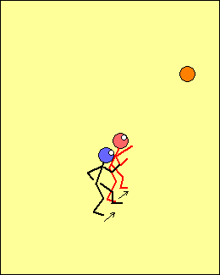 | S’emparer du ballon lors des rebonds offensifs  On utilise le même jeu de pieds lorsqu’on cherche à s’emparer d’un rebond offensif. Le joueur ou la joueuse se déplace vers l’avant, plante son pied extérieur devant le/la défenseur(e) qui tente de s’interposer, puis coupe ensuite devant l’adversaire à l’aide de la jambe intérieure. Beaucoup de joueur/joueuses ont tendance à planter le pied intérieur en premier, de sorte que le deuxième pas doit être fait avec le pied extérieur. Si un contact physique se produisait lors de cette action, le joueur ou la joueuse se trouverait hors d’équilibre et pourrait alors facilement être éloigné(e) du panier.
Dans toutes les situations précédentes, une fois que le joueur ou la joueuse se retrouve en possession du ballon, il/elle doit chercher à abaisser l’épaule intérieure et à incliner le corps en direction du panier. Il est important de protéger le ballon et de rester en position compacte pour pouvoir effectuer des feintes ou une action explosive en direction du panier.

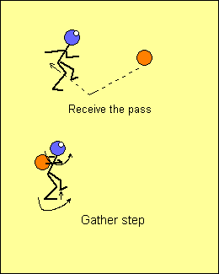  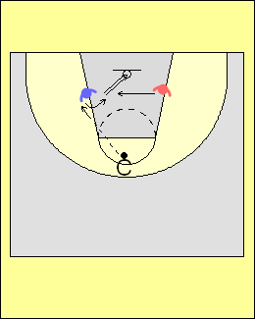 | Marquer après avoir effectué une pénétration  Deux joueur/joueuses se placent de chaque côté de la clé devant le panier; leurs pieds ne doivent pas être parallèles à la ligne de fond car il faudrait alors effectuer un pivot de 180 degrés pour marquer. Ils/elles sont plutôt légèrement retourné(e)s vers l’intérieur, avec le talon le plus rapproché du panier bien ancré, en position d’attente. L’entraîneur(e) fait une passe à l’un(e) des joueur/joueuses, sur le côté extérieur. Il/elle doit attraper le ballon, pivoter, et tenter d’effectuer un lancer pendant que l’autre essaie de l’en empêcher. On utilise ce type d’exercice pour simuler des situations de match, et donner confiance à un joueur ou une joueuse de grande taille.  Les points clés dont il faut tenir compte sont les suivants :  - Effectuer un saut vertical.  - Ne pas dribbler.  - Ne pas craindre un contact physique.  - Après avoir attrapé la passe, on effectue un pas préparatoire en ramenant le pied extérieur vers le panier. Le joueur ou la joueuse utilise le point de contact entre son talon intérieur et le sol pour transférer son énergie dans le plan vertical (il s’agit du même jeu de pieds que celui qu’utilisent les joueurs/joueuses de Volleyball et les sauteurs et sauteuses en hauteur).  - Transférer rapidement le ballon vers l’épaule intérieure; elle deviendra l’épaule extérieure une fois le pivot complété. Ce mouvement permet de protéger le ballon, tout en augmentant la vitesse du pivot.  - Abaisser l’épaule intérieure.  - Ne pas décocher le lancer au même moment que le contact se fait. Le contact doit se faire en premier, ensuite le lancer.
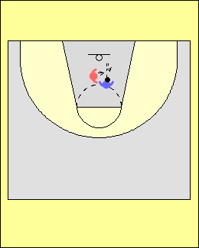 | Comment amortir un contact physique lors d’une situation de rebond offensif  Dans cet éducatif, l’attaquant(e) projette le ballon vers le panneau arrière du panier et attrape le rebond. Dès que ses deux pieds reprennent contact avec le sol, un(e) défenseur(e) fait contact avec sa poitrine et exerce une pression afin de lui faire perdre l’équilibre. Il est très important que l’attaquant(e) atterrisse correctement sur les deux pieds lorsque le/la défenseur(e) s’amène pour tenter de le/la forcer à s’éloigner du panier. Les joueurs/joueuses qui ne possèdent pas un bon niveau de force dans les muscles du tronc auront souvent tendance à se retrouver hors d’équilibre au moment de reprendre contact avec le sol. Le but de cet exercice est d’obliger l’attaquant(e) à regagner l’équilibre avant de tenter de marquer.
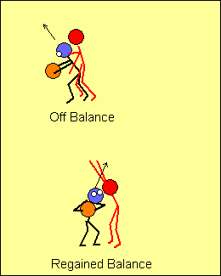 | Au moment de reprendre contact avec le sol, le corps de l’attaquant(e) aura souvent tendance à être incliné dans la direction opposée au panier. Pour regagner l’équilibre, il ne faut pas jouer du coude ou tenter de repousser le/la défenseur(e), mais plutôt utiliser le pas préparatoire et le pivot pour ramener le corps face au panier.  On n’insistera jamais assez sur le fait que l’on doit enseigner l’équilibre avant la vitesse d’exécution. C’est seulement une fois que le joueur ou la joueuse est en mesure de bien conserver son équilibre qu’il ou elle devrait chercher à effectuer la manœuvre plus rapidement.
Enseignement
Quand on enseigne, on a souvent tendance à aller trop rapidement. Il faut plutôt respecter trois étapes importantes :
- Expliquer - à faible vitesse
- Laisser répéter - le joueur ou la joueuse effectue un grand nombre de répétitions, jusqu’à ce qu’il ou elle puisse exécuter la technique sans avoir à y penser
- Donner des objectifs de performance à l’athlète, p. ex. :
- 10 répétitions en 30 secondes
- 10 répétitions consécutives sans erreur
- Exécution correcte avec défensive dirigée

Autrement dit:
- Vitesse réduite – apprentissage
- Vitesse normale – répétitions
- Vitesse accrue – pour surcharger et ajouter un élément de stress
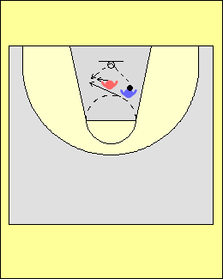 | Surcharger l’éducatif  Dans cet éducatif, l’attaquant(e) projette le ballon vers le panneau arrière du panier selon une trajectoire en angle, et court pour rattraper le rebond. Après la réception au sol (à deux pieds), le/la défenseur(e) se rapproche et tente de le/la repousser. L’attaquant(e) doit regagner l’équilibre et se rediriger vers le panier. Il ou elle peut effectuer une courte feinte pour reprendre l’équilibre, mais dans ce cas, le centre de gravité ne doit pas être relevé. Si l’adversaire saute au moment de la feinte, il ou elle peut provoquer une faute en créant un contact.
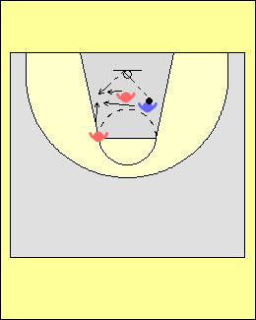 | Ajouter un(e) autre défenseur(e)  Dans cette version de l’éducatif, un(e) deuxième défenseur(e) entre en jeu pour contrer l’attaquant(e), mais seulement une fois que le premier contact a eu lieu suite au rebond.
Lancers francs

Il est très important d’enseigner aux jeunes joueurs/joueuses de grande taille à être réguliers(ères) lors des situations de lancers francs. On suggère de travailler cet aspect avant de développer un répertoire d’actions de manœuvres de type « 1 contre 1 dos au panier ». En effet, en raison du poste qu’il ou elle occupe, le joueur ou la joueuse devrait avoir beaucoup d’occasions d’effectuer des lancers francs suite à des fautes défensives.

Lorsqu’on apprend la technique de lancer franc, il n’y a aucune contrainte de temps ou de pression défensive. Le joueur ou la joueuse doit s’assurer de bien placer ses pieds, et ensuite suivre une bonne routine. Si le taux de réussite est de un sur deux au début, la contribution de l’athlète est acceptable.
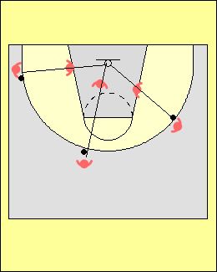 | Alignement  Lorsqu’ils ou elles évoluent à l’intérieur, les joueur/joueuses doivent réaliser qu’ils ou elles ne doivent pas simplement se placer à un endroit particulier, mais plutôt chercher à s’aligner entre le panier et l’attaquant(e) en possession du ballon.
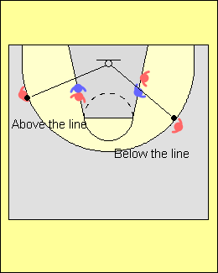 | Si le joueur ou la joueuse se trouve en haut ou en bas de la ligne, le/la défenseur(e) se trouve en bonne position pour neutraliser l’attaquant(e) dans la clé.
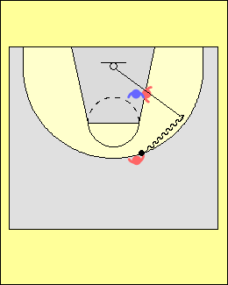 | Apprendre à jouer dans la clé  Au début, lorsqu’un joueur ou une joueuse apprend à jouer dans la clé, la chose la plus simple à faire est de demander à un(e) attaquant(e) de dribbler le long de la ligne de trois points jusqu’à l’endroit qui permet de créer l’alignement. Pendant ce temps, l’attaquant(e) dans la clé ne se déplace pas, et ne cherche pas à prendre position sur le/la défenseur(e). Procéder ainsi aide le joueur ou la joueuse qui est en possession du ballon en périphérie à comprendre le principe de l’alignement.
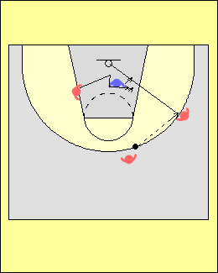 | L’autre concept important dont il faut tenir compte est de s’assurer que le ballon soit remis à l’aile pendant que l’attaquant(e) coupe dans la clé et prend position sur le/la défenseur(e). Si le ballon et le joueur ou la joueuse se déplacent au même moment, il devient alors plus difficile d’avoir un bon alignement.
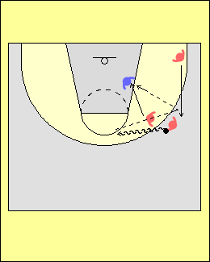 | Jeu plus avancé dans la clé  Si on ajoute des déplacements ou des actions de jeu avant qu’un(e) attaquant(e) prenne position sur un(e) défenseur(e), cela rendra un bon alignement difficile. Dans cet éducatif, l’attaquant(e) qui doit aller dans la clé, fait tout d’abord un écran face au/à la partenaire en possession du ballon, qui se dirige ensuite en dribblant vers le centre; il/elle pivote ensuite dans la clé en attendant une passe de l’ailier(ère) qui est remonté(e), et qui entretemps a reçu le ballon. On doit chercher à bien familiariser les jeunes joueur/joueuses avec cette manœuvre en la répétant souvent.
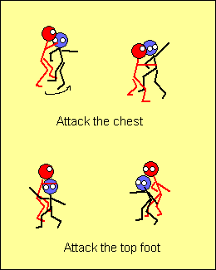 | Comment prendre position sur un(e) défenseur(e)  Lorsqu’ils/elles exécutent un arrêt simultané après avoir coupé à l’intérieur pour prendre position, les joueurs/joueuses peuvent avoir tendance à « attaquer » la poitrine de l’adversaire, ce qui est une erreur. Quand cela se produit, le/la défenseur(e) peut en effet facilement se déplacer en cercle autour de l’attaquant(e) et prendre une position avantageuse pour le/la contrer. L’attaquant(e) doit plutôt chercher à s’interposer en enjambant le pied avant du ou de la défenseur(e). Les joueurs/joueuses doivent également apprendre à se défaire des bras d’un(e) adversaire en se servant des leurs, p. ex. en exerçant une pression qui forcera le/la défenseur(e) à faire une flexion de l’avant-bras. Ces mouvements ne doivent toutefois pas être trop excessifs…
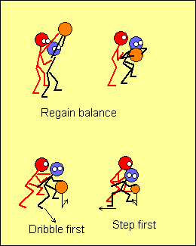 | Réception du ballon lors d’un bloc  Le plus important lorsqu’on reçoit une passe à l’intérieur est de recouvrer l’équilibre après avoir attrapé le ballon. Souvent, le/la défenseur(e) donnera une petite poussée dans le dos à ce moment, ce qui pourra faire décoller les talons du sol et faire pencher le corps vers l’avant et dans la direction opposée au panier. Si le joueur ou la joueuse effectue un dribble, il ou elle doit tout d’abord s’assurer de faire un pas avant d’effectuer un dribble avec le ballon; sinon, le/la défenseur(e) pourra facilement l’éloigner du panier. En faisant tout d’abord un pas, l’attaquant(e) peut se regrouper avant sa prochaine action.
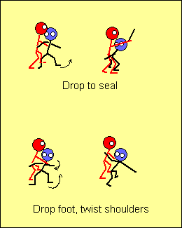 | Progressions – enseignement des actions de jeu dans la clé  La première action à enseigner au joueur ou à la joueuse d’intérieur est d’attaquer immédiatement après la réception de passe, alors que le/la défenseur(e) se trouve encore emboîté(e) du côté haut.  Les droitier(ère)s devraient commencer avec le bloc sur le côté gauche. Après avoir attrapé le ballon, le joueur ou la joueuse exécute un pivot en se servant du pied le plus éloigné du/de la défenseur(e). Lorsque le joueur ou la joueuse dépose le pied au sol pour prendre position sur le/la défenseur(e), il ou elle a souvent tendance à fléchir le tronc ce qui n’offre alors aucune cible à l’attaquant(e) qui se trouve en périphérie. Quand le pied entre en contact avec le sol, l’épaule du même côté doit plutôt être retournée vers l’arrière dans la direction opposée, et vers le ballon : ceci permet à l’attaquant(e) d’offrir une bonne cible au/à la partenaire tout en réduisant la distance de la passe.  Il est important de ne pas enseigner les prochaines manoeuvres tant et aussi longtemps que les joueurs/joueuses ne maîtrisent pas les techniques précédentes.
Action de jeu numéro 2
Faire un pas tout en dribblant, et lancer

Action de jeu numéro 3
Faire un pas tout en dribblant au centre et effectuer un crochet en suspension.

Action de jeu numéro 4
Faire un pas tout en dribblant au centre, se retourner rapidement de l’autre côté et effectuer un tir en foulée.

Dans la clé, il faut amorce le dribble à l’aide des deux mains afin de protéger le ballon; il ne s’agit pas du même type de dribble que celui que l’on utilise en périphérie.

FAIRE ÉCRAN

On utilise les écrans pour créer un avantage d’une seconde. L’écran peut en effet causer une certaine confusion chez les défenseur(e)s; une lecture correcte du jeu permettra alors aux attaquant(e)s de bénéficier d’un tel avantage. On doit enseigner aux joueurs/joueuses à la fois comment effectuer différents types d’écrans, et comment en faire une bonne lecture.

Aspects fondamentaux du jeu avec écrans

- Il doit y avoir une communication verbale et visuelle entre les joueurs/joueuses. Ils/elles doivent se servir de signaux manuels et de mots clés. C’est l’entraîneur(e) qui doit décider qui sera responsable de faire ce genre de communication en situation de jeu : un joueur ou une joueuse en particulier, deux joueurs/joueuses, trois, etc.

- Lorsqu’on enseigne le jeu avec écran, il doit y avoir un(e) premier(ère) et un(e) deuxième attaquant(e) qui coupent – habituellement, il y en a un(e) qui se dirige vers l’extérieur (en direction du ballon) tandis que l’autre va vers l’intérieur (au panier). Le terme que l’on utilise dans un tel cas est « un(e) dehors, un(e) dedans ».

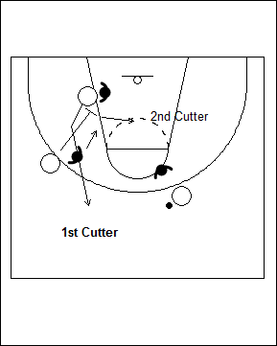

  - Les actions des attaquant(e)s sont dictées par ce que font les défenseur(e)s; il faut donc que les attaquant(e)s fassent une bonne lecture de la défensive.

  - Après avoir fait un écran, il faut établir à nouveau un bon espacement entre les attaquant(e)s sur le terrain.

  - Il devrait toujours y avoir des actions effectuées vers le panier.

Principes à respecter - lorsque l’on coupe il faut :
- Couper pour se retrouver à découvert, et non pour être marqué(e); l’action doit être intense et il faut garder l’œil sur le ballon.
- Couper devant le panier, se placer en position ouverte pour bien voir le ballon, et ensuite ressortir jusqu’à la ligne des trois points.
- Passer entre les adversaires qui s’interposent – p. ex., exécuter un écran supplémentaire non prévu en coupant vers le panier en passant entre les bras d’un(e) adversaire qui vient apporter de l’aide en défensive. Cela compliquera grandement les choses pour le/la défenseur(e), qui aura alors beaucoup de difficulté à reprendre sa place et à s’interposer efficacement contre le ou la deuxième attaquant(e) qui coupe.
- Varier le rythme, ou s’arrêter brusquement et repartir si le/la défenseur(e) pourchasse ou suit de près.
- Faire un ou deux pas dans la mauvaise direction avant de couper. Élargir l’espace en s’éloignant d’abord de l’écran, avant de revenir et ensuite couper en utilisant l’écran.

    - Écran vers le bas – longer la ligne de trois points
    - Autres types d’écrans – couper en V ou arrêt/départ

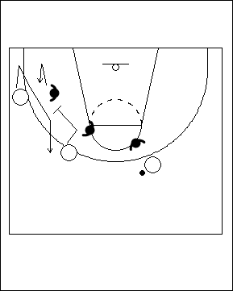

- Les joueur/joueuses qui coupent en deuxième doivent être rapides; un(e) attaquant(e) ne reste pas à découvert très longtemps, et par conséquent ceux/celles qui coupent doivent obliger les défenseur(e)s à prendre des décisions très rapidement.
- En passant tout d’abord le bras qui se trouve vers l’intérieur, on peut couper très près des écrans. Les joueur/joueuses devraient chercher à agripper celui ou celle qui fait écran lorsque cela est possible, car cela empêchera le/la défenseur(e) d’emprunter le trajet intérieur au dessus de l’écran.
- Les attaquant(e)s devraient attendre que l’écran soit mis en place. Voici quelques exemples de ce qui peut être fait lorsqu’un(e) partenaire exécute un écran :
    - Attendre et observer
    - Premier principe – attendre
    - Second principe – attendre
    - Troisième principe – attendre
    - Pour « prendre l’écran », il est préférable d’être en retard que trop tôt
    - Sprinter pour mettre l’écran en place, marcher pour l’exploiter

Principes à respecter lors de l’exécution d’un écran

    - Emplacement – les joueurs/joueuses devraient savoir où effectuer les différents types d’écran sur le terrain; ils/elles doivent donc toujours chercher à avoir un « positionnement efficace » lors d’un écran.

    - Il faut couper avant de faire un écran – Dans le diagramme ci-dessous, le joueur ou la joueuse d’intérieur prépare l’écran arrière en coupant tout d’abord dans la clé. Ceci permet un bon angle de mise en place de l’écran.

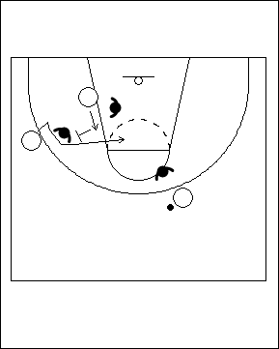

    - Il faut sprinter pour faire un écran – Cette méthode oblige le/la défenseur(e) à se concentrer sur celui ou celle qui fait écran et l’empêche d’aller en aide. Quand les joueurs/joueuses sprintent pour faire l’écran, il leur est plus facile de se faufiler au panier (lorsque celui ou celle qui fait écran coupe en premier). Ceci se produit lorsque le panier est laissé sans protection par l’équipe en défense une fois que l’écran est en place.

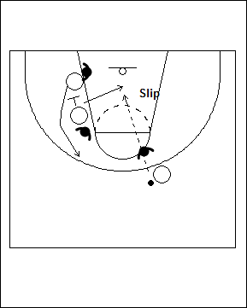

    - Angle de l’écran– La direction dans laquelle pointe le dos de celui ou celle qui fait écran détermine en retour celle dans laquelle le ou la partenaire doit couper.

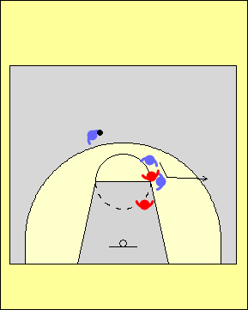

    - On ne doit pas commettre de faute lors d’un écran – L’écran doit se faire de façon statique après avoir fait un arrêt en un temps, large et bas. Lors d’écrans « à l’aveugle », l’attaquant(e) doit s’assurer de laisser un pas au/à la défenseur(e).

    - Lecture du jeu lorsqu’on coupe – Celui ou celle qui coupe en premier doit faire une lecture du ou de la défenseur(e) qui le/la couvre, tandis que celui ou celle qui coupe en deuxième doit faire une lecture du ou de la partenaire qui a coupé en premier.

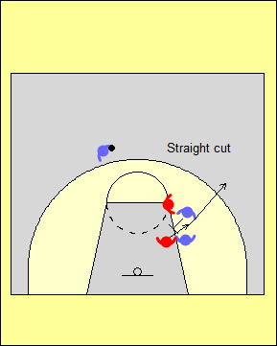 | Couper en ligne droite  Lorsque l’adversaire qui marque celui ou celle qui coupe suit derrière et que l’adversaire de celui ou celle qui fait l’écran est en position d’aide par rapport au ballon, il faut ressortir en ligne droite.  Contourner  On effectue cette manoeuvre quand l’adversaire qui marque celui ou celle qui coupe suit derrière et que le/la défenseur(e) de celui ou celle qui fait l’écran n’est pas en position d’aide par rapport au ballon. | 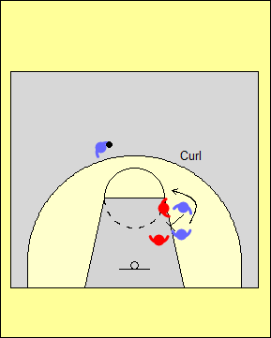
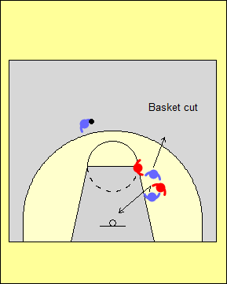 | Couper vers le panier  Si le/la défenseur(e) « triche » et se déplace vers le haut de l’écran, celui ou celle qui coupe doit se diriger vers le panier. Celui ou celle qui fait écran peut ensuite couper à son tour vers l’extérieur.  S’esquiver  Si le/la défenseur(e) qui joue contre celui ou celle qui coupe décide de prendre un raccourci, cet(te) attaquant(e) doit alors chercher à s’esquiver. Celui ou celle qui fait écran peut alors se repositionner, changer l’angle de son écran et en faire un nouveau pendant que le ou la défenseur(e) reprend sa place. | 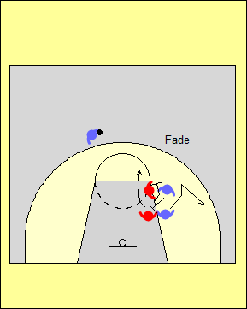

Si le joueur ou la joueuse dispose de suffisamment de temps et d’espace, il/elle doit faire l’écran dans un autre angle lorsque le ou la défenseur(e) « triche ». Attention à ne pas commettre une faute !

Types d’écrans

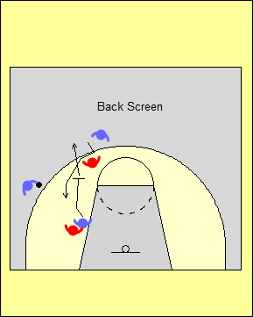 | Écran vers le haut (écran « à la UCLA »)  Un(e) attaquant(e) se déplace de la ligne de fond vers le haut pour faire un écran contre un(e) adversaire qui marque un(e) partenaire placé(e) au haut de la clé.  Écran vers le bas  On effectue ce type d’écran pour le joueur ou la joueuse qui sort de l’intérieur, ou encore pour un(e) ailier(ère). On le fait pour un(e) attaquant(e) qui est situé plus bas (c.-à-d. plus près du panier). | 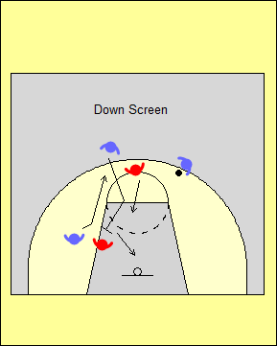
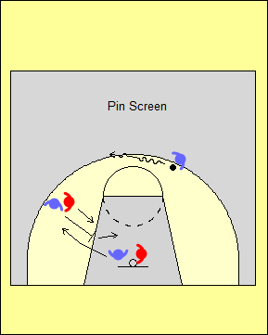 | Écran pour coincer  Le joueur ou la joueuse qui se trouve en périphérie et près de la ligne de côté effectue ce type d’écran pour son/sa partenaire situé(e) plus près du panier.  Écran vers le haut en périphérie  Le joueur ou la joueuse qui se trouve près de la ligne de côté effectue ce type pour son/sa partenaire situé(e) plus près du centre du terrain d’écran en plaçant son dos en direction du coin. | 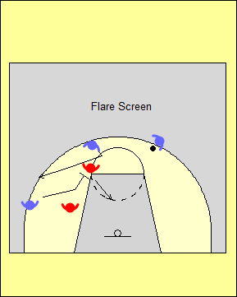
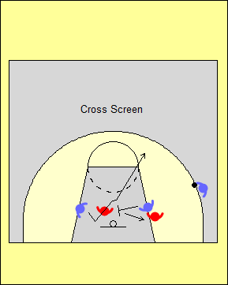 | Écran au travers de la clé  Le joueur ou la joueuse qui se trouve sur un côté de la clé se déplace au travers de celle-ci pour effectuer un écran de l’autre côté; ce type d’écran peut se faire vers le haut ou le bas.  Écran dans le dos  Un(e) joueur/joueuse qui se trouve plus près du centre du terrain effectue ce type d’écran pour son/sa partenaire situé(e) plus près de la ligne de côté en plaçant son dos en direction du panier. | 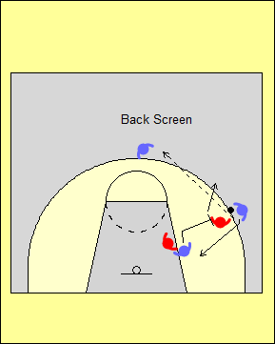
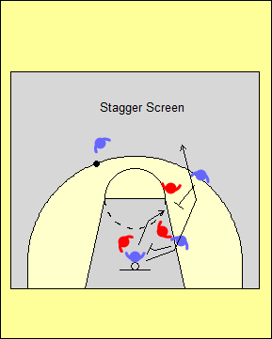 | Écran décalé  Le diagramme de gauche montre une situation dans laquelle il y a plusieurs écrans.  On fait tout d’abord un « écran pour coincer » dirigé vers le bas, puis ensuite un « écran vers le bas » pour le joueur ou la joueuse située près du panier.

Écrans sur la balle

Pourquoi une équipe adopte-t-elle un style offensif dans lequel on fait des écrans sur la balle?

- Le ballon se trouve habituellement dans les mains d’un(e) attaquant(e) qui manie bien le ballon et prend de bonnes décisions
- L’équipe se trouve en meilleure posture pour déterminer qui effectuera les lancers.
- L’équipe peut établir son rythme de jeu et l’imposer à l’équipe adverse.
- Les défenseur(e)s adverses peuvent changer les joueurs ou joueuses qu’ils ou elles couvrent, créant ainsi des désavantages de taille ou d’habiletés pour les attaquant(e)s.
- L’équipe peut commencer son attaque sans avoir à faire une passe d’entrée à l’aile.
- L’équipe peut occuper beaucoup d’espace sur le terrain, ce qui donne davantage d’occasions pour effectuer des pénétrations et saisir des rebonds.
- L’équipe peut éloigner du panier un(e) défenseur(e) habile à bloquer les lancers.
- L’équipe peut cibler le/la meilleur(e) défenseur(e) adverse lors de situations d’écran pour l’attaquant(e) en possession du ballon.
- L’équipe peut exploiter le/la pire défenseur(e) adverse lors de situations d’écran pour l’attaquant(e) en possession du ballon.
- L’équipe peut provoquer une faute défensive tôt dans le match chez un(e) adversaire de grande taille, p. ex. si il ou elle effectue une mauvaise manœuvre d’aide lors de l’écran.
- L’équipe peut inciter un(e) défenseur(e) à marquer deux attaquant(e)s sur le côté faible.

Jeu offensif avec écran sur la balle – Questions

Où l’écran doit-il être fait?
Rép. Au milieu; au « T »; à l’aile et au coin.

Comment le ballon arrive-t-il à l’endroit où se fait l’écran?
Rép. Par le dribble, ou encore une passe et une remise de main à main.

Q. Qu’entend-on par « l’angle »?
Rép. C’est l’angle que crée celui ou celle qui se positionne pour faire l’écran sur le/la défenseur(e) pour permettre à l’attaquant(e) d’utiliser l’écran adéquatement.

Q. Où les autres joueurs/joueuses devraient-ils/elles se placer ?
Rép. Espacé(e)s; au haut et au bas; deux au haut de la clé; dans un coin inoccupé (pour « écran et ressort à l’extérieur »); un(e) attaquant(e) dans un coin (pour « écran et roule » et lors d’une situation où il y a un(e) joueur/joueuse qui remonte l’aile le long de la ligne de trois points).

Concepts que l’on doit enseigner:

L’attaquant(e) en possession du ballon devrait:

- Inclure les manœuvres d’hésitation de dribble; le dribble croisé, les manœuvres intérieur-extérieur, et le dribble à reculons. Les joueurs/joueuses devraient être capables de se faufiler entre les défenseur(e)s si l’adversaire de celui ou celle qui fait l’écran n’aide pas de façon adéquate.
- Savoir attendre pour l’écran, à moins que la défensive ne rejette l’écran.
- Rejeter l’écran lorsque le/la défenseur(e) qui le/la couvre se prépare hâtivement à passer au-dessus de l’écran.
- Attaquer dans la clé; penser « panier » en premier, et « passe » en second.
- Exécuter au moins deux dribbles en utilisant l’écran, et effectuer une passe directe (passe rapide faite à partir de la hanche, à la hauteur d’une poche de pantalon).
- Atttaquer au-delà et au-dessus du pied avant du/de la défenseur(e) qui délaisse son joueur ou sa joueuse pour aider.
- Percevoir les intentions du/de la défenseur(e) qui lui fait face, et observer les autres.
- Effectuer une passe suite à un arrêt en un temps, et faire une passe dans les airs.

Celui ou celle qui fait écran devrait:
- Glisser au panier lorsque son/sa défenseur(e) le/la délaisse hâtivement pour aider, ou lorsque les deux défenseur(e)s forment une trappe.
- Sprinter pour aller faire écran – l’objectif est d’arriver à l’endroit où se fait l’écran sans son/sa défenseur(e).
- Déplacer l’écran vers le bas si le/la défenseur(e) réussit à passer sous l’écran - tourner
  - Ouvrir à la balle lorsque l’adversaire qui le/la marque quitte hâtivement pour aider lors d’un écran qui se déplace vers le milieu.
  - Ouvrir à la balle lorsque le/la défenseur(e) joue bas lors d’un écran vers le bas
- Ressortir vers l’extérieur ou rouler au panier correctement.

Les équipes devraient:
- Décoller de la ligne de fond et remonter vers le haut lorsqu’il n’y a qu’un(e) joueur/joueuse sur un côté.
- Inverser rapidement le sens de la circulation du ballon vers le côté faible lorsque les deux défenseur(e)s forment une trappe.
- Tenter de repérer le joueur ou la joueuse qui est libre lorsqu’une situation à 2 contre 1 se présente sur un côté.
- Ouvrir un corridor de passe pour l’attaquant(e) qui fait une pénétration.

Types d’écrans pour l’attaquant(e) en possession du ballon
- À l’aile
- Au haut de la clé
- Au centre
- Remise de main à main suite à un dribble

Remises de main à main suite à un dribble

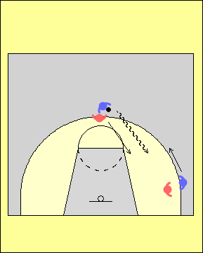 | Remises de main à main suite à un dribble  La remise de main à main suite à un dribble est une façon très efficace de garder le ballon en mouvement quand un joueur ou une joueuse d’intérieur ne peut exécuter une passe à un(e) partenaire en périphérie.  Dans cet éducatif, le joueur ou la joueuse d’intérieur qui se trouve au haut de la clé dribble vers la jambe intérieure du/de la défenseur(e).  Il est important de noter que si l’attaquant(e) est en mesure de se diriger vers le panier et a une chance de marquer, la remise de main à main après avoir dribblé n’est pas la meilleure option… Dans ce cas, il est plutôt préférable de tenir compte des principes de pénétration au panier, et de s’asssurer que les ailiers(ères) fassent une bonne lecture de l’aide défensive.  Le joueur ou la joueuse en périphérie doit chercher à allonger l’arc, afin de se retrouver à la même hauteur que celui ou celle qui joue le long de la clé.
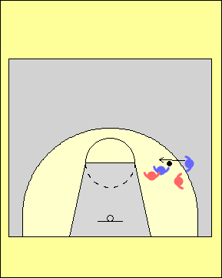 |  | Pivot renversé  Une possibilité qui s’offre à l’attaquant(e) qui se trouve à l’intérieur est d’effectuer un arrêt en un temps et ensuite un pivot renversé; ceci permet alors à l’ailier(ère) de couper vers le bas, en direction du panier, après la remise de main à main. L’arrêt permet par la même occasion de prendre position sur le/la défenseur(e) et de rouler plus facilement après la remise.  Le passeur ou la passeuse devrait tenir le ballon en mettant une main par-dessus et l’autre par-dessous. Ceci permet au réceptionneur ou à la réceptionneuse de placer ses mains sur le côté du ballon au moment de le saisir. Une autre option pour celui ou celle qui dribble consiste à tendre le ballon vers le côté extérieur pour que l’ailier(ère) s’en empare.
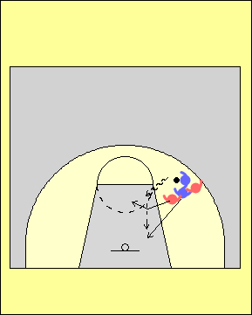 |  | Options  Remise de main à main et pivot  Après la remise de main à main, l’ailier(ère) dribble vers le panier tandis que l’attaquant(e) qui avait le ballon auparavant roule au panier. Si le/la défenseur(e) qui couvre ce joueur ou cette joueuse se déplace pour offrir de l’aide contre l’ailier(ère), il ou elle peut alors en profiter pour repasser le ballon à son/sa partenaire.
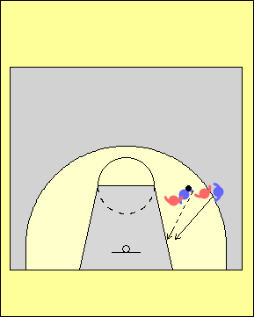 |  | Couper derrière le/la défenseur(e)  Si le/la défenseur(e) qui couvre l’ailier(ère) tente de l’empêcher de couper et de recevoir le ballon, celui-ci ou celle-ci peut couper par derrière et passer dans son dos. L’attaquant(e) en possession du ballon peut alors lui faire une passe rebond ou une passe rapide par dessus l’épaule.
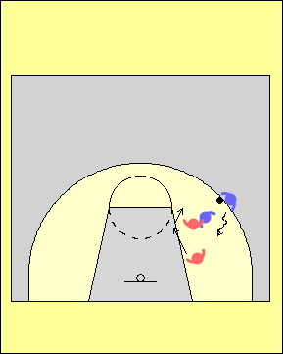 |  | Le ou la défenseur(e) se retrouve derrière  Lorsque le ou la défenseur(e) qui couvre l’ailier(ère) contourne l’écran par-dessous, l’ailier(ère) peut s’arrêter derrière son/sa partenaire. Il/elle peut ensuite effectuer un lancer, ou encore tenter une pénétration dans l’une ou l’autre direction, compte tenu du côté sur lequel le/la défenseur(e) récupère.
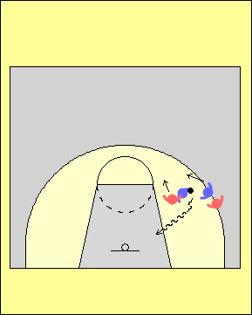 |  | Feinte de remise de main à main  L’attaquant(e) qui se trouve à l’intérieur de la clé peut feinter d’exécuter un pivot renversé et laisser croire qu’il/elle fera également une manœuvre de pivot. Il ou elle conserve cependant le ballon et fonce vers le panier. Cette méthode est efficace lorsque l’équipe tente de réaliser une permutation de la couverture défensive.
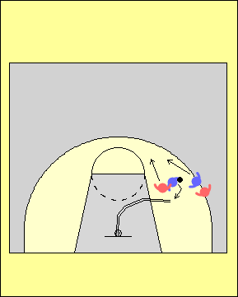 |  | Feinte de remise de main à main suivie d’un lancer  L’attaquant(e) qui se trouve à l’intérieur de la clé feint de remettre le ballon de main à main à un(e) partenaire, puis effectue un pivot et lance au panier.
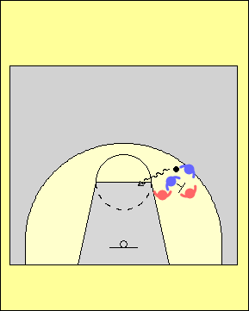 |  | Écran après la remise de main à main  Immédiatement après la remise de main à main, l’attaquant(e) qui avait le ballon doit se déplacer rapidement pour aller faire un écran pour l’ailier(ère). Cet écran rend difficile toute tentative du ou de la défenseur(e) de contrer l’attaque du ballon.

Permutations

Lorsqu’il y a des permutations défensives, cela crée souvent des situations avantageuses pour l’attaquant(e) avec le ballon. Par exemple, après le dribble : (1) le joueur ou la joueuse en périphérie peut attaquer le défenseur du joueur ou de la joueuse d’intérieur, ou (2) le joueur ou la joueuse d’intérieur peut chercher à prendre avantage d’un(e) défenseur(e) de petite taille.

Quelles solutions peut-on envisager pour diminuer l’efficacité des différentes tactiques défensives utilisées contre les écrans?

Tactique: Aide agressive du/de la défenseur(e) pour ralentir ou détourner l’attaquant
Solution: Les joueurs/joueuses devraient glisser au panier ou inverser rapidement le sens de la circulation du ballon au haut ou vers le coin. De plus, contre une défensive très coriace, on peut inverser rapidement le sens dans lequel le ballon circule pour le remettre à l’attaquant(e) qui a pivoté et roulé : en effet, le/la défenseur(e) qui marque celui ou celle qui fait l’écran se trouve alors hors position et ne sera probablement pas capable de récuperer.

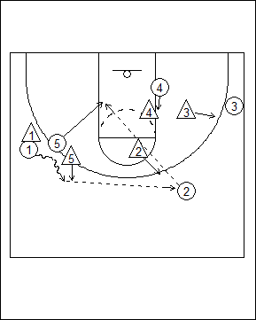

Tactique : Le/la défenseur(e) de l’ailier(ère) passe sous l’écran
Solution: Le joueur ou la joueuse peut effectuer un nouvel écran en utilisant tout d’abord le premier dans une direction, puis en revenant faire un autre écran; celui ou celle qui fait l’écran doit être dans une position plus basse que le ballon.

Tactique : Trappe
Solution: Le joueur ou la joueuse peut sprinter vers le centre, donner un corridor de passe d’un côté ou de l’autre de l’attaquant(e) en possession du ballon, puis attaquer à 4 contre 3. Pour réussir, on doit tenter de faire passer le ballon le plus rapidement possible sur le côté faible.

Tactique : Permutation défensive
Solution: Les joueurs/joueuses peuvent faire une petite passe, ou tenter d’attirer l’adversaire de grande taille à l’extérieur avant d’attaquer.

Tactique : Aide basse du/de la défenseur(e)
Solution: Les joueurs/joueuses peuvent attaquer l’adversaire de grande taille à l’aide d’un « pas Euro » (lorsque l’on change de direction après avoir dribblé), en faisant une action de feinte de dribble de l’intérieur vers l’extérieur, ou encore à l’aide d’un dribble de croisement. Celui ou celle qui faisait l’écran en fait ensuite un nouveau en se retournant et en plaçant le dos en direction de la ligne de fond.

PROGRESSIONS PÉDAGOGIQUES POUR ENSEIGNER LA MANŒUVRE D’ECRAN SUR LA BALLE SUIVIE D’UN PIVOT

L’écran sur la balle suivi d’un pivot pour ouvrir vers le ballon est l’action offensive la plus utilisée dans le basketball moderne, et on estime qu’elle est exécutée de 35 à 45 fois au cours d’une partie. Aux plus hauts niveaux de jeu, il est possible que cette manœuvre soit tentée du début à la fin de la prise de possession du ballon, et ce même si l’exécution n’est pas toujours très efficace. Si les arrières sont habiles à lire le jeu, ou encore si l’attaquant(e) qui fait l’écran est suffisamment rapide pour rouler en direction du panier, cet écran peut aussi être employé contre une défensive de zone.

Lors de la préparation du plan de match en défensive, il est également très important de réfléchir à la façon dont l’équipe se défendra contre les écrans sur la balle suivis de pivots que feront les adversaires. Les concepts offensifs fondamentaux que l’on cherche à créer lors d’un écran sur la balle suivi d’un pivot sont les suivants :

- Situations à 5 contre 4 dans lesquelles on remet le ballon à l’attaquant(e) à découvert avant que le ou la cinquième défenseur(e) puisse reprendre sa position.
- Création d’un avantage d’une seconde pour les attaquant(e)s.
- Exploitation d’une situation de jeu favorable lorsqu’elle se présente.
- Le fait d’exécuter plusieurs actions d’écrans sur la balle suivis de pivots au cours d’une même possession peut permettre aux joueurs/joueuses de trouver de meilleures options de jeu et d’appliquer d’autres tactiques si ils/elles réalisent que cette manœuvre n’est pas efficace contre la défensive adverse.

Le fait d’exécuter plusieurs actions d’écrans suivis de pivots au cours d’une même possession peut permettre aux joueurs/joueuses de trouver de meilleures options de jeu et d’appliquer d’autres tactiques si ils/elles réalisent que cette manœuvre n’est pas efficace contre la défensive adverse.

Ceci ne se produit pas très souvent en raison des lacunes que l’on observe sur le plan des techniques individuelles de base chez plusieurs joueurs ou joueuses. Il est donc important que les joueurs/joueuses maîtrisent les techniques et les concepts de base avant qu’on leur apprenne à utiliser une manœuvre aussi complexe que l’écran sur la balle suivi d’un pivot. On ne doit pas inclure l’enseignement de cette action dans les programmes destinés aux jeunes simplement parce qu’elle est utilisée fréquemment à un haut niveau de jeu; les jeunes doivent d’abord et avant tout bien maîtriser les aspects fondamentaux du jeu.

Pour exécuter correctement l’écran sur la balle suivi d’un pivot, et pouvoir se défendre efficacement contre cette manœuvre, une équipe peut devoir y consacrer jusqu’à 50 pourcent de son temps d’entraînement. Est-ce vraiment ce que l’on doit chercher à faire avec de jeunes joueurs ou joueuses qui ont de la difficulté à dribbler tout en gardant les yeux relevés?

Lorsque les joueurs/joueuses sont rendu(e)s au stade « S’entraîner à s’entraîner » du modèle de développement à long terme des athlètes, on peut commencer à leur enseigner l’écran sur la balle suivi d’un pivot.

Les pages qui suivent présentent des conseils techniques sur la façon de commencer à intégrer l’écran sur la balle suivi d’un pivot dans le système offensif d’une équipe. À noter que l’écran sur la balle suivi d’un pivot doit être considérer pour ce qu’il est vraiment : l’un des concepts offensifs que l’on cherche à enseigner, et non pas une solution miracle ou indispensable…

Dans les diagrammes 1 à 4, les attaquant(e)s en possession du ballon apprennent à utiliser l’écran. Il est essentiel que les arrières aient auparavant amené le ballon au bas de l’écran. Lorsqu’on est à l’étape A de l’apprentissage, on utilise une chaise pour simuler l’écran. À l’étape B, l’entraîneur(e) peut diriger la défensive. À l’étape C, on utilise une défensive active. On passe ensuite à des situations de jeu simulé avec avantage, p. ex. les 2 contre 1, 3 contre 2, 4 contre 3 (Étape D).
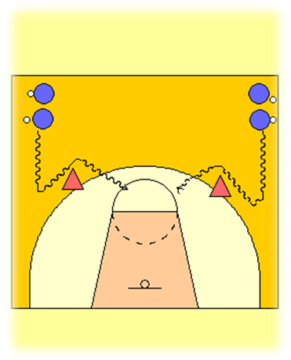
Diag. 1
Diag. 2

Au diagramme 1, si le/la défenseur(e) qui joue contre l’attaquant(e) en possession du ballon frappe l’écran, il faut alors effectuer un tir en suspension, que ce soit pour deux ou trois points.

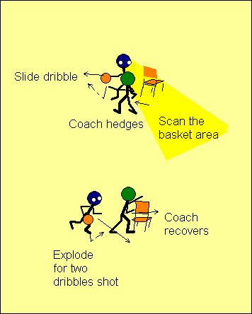 | Lorsque l’entraîneur(e) décide de passer à l’étape de la « défensive dirigée », les joueurs/joueuses doivent porter une attention particulière aux aspects suivants :  - Ils/elles doivent constamment observer la zone du panier. Ceci permet à l’attaquant(e) en possession du ballon de voir tous ses partenaires, ainsi que les défenseur(e)s qui les couvrent.  - Lorsque l’entraîneur(e) aide de façon agressive, l’attaquant(e) en possession du ballon, doit dribbler en glissant de côté et en s’éloignant afin de protéger le ballon. Il/elle peut ainsi changer de direction rapidement au besoin.  - Lorsque l’entraîneur(e) reprend sa place, l’attaquant(e) doit réagir immédiatement avec deux dribbles explosifs suivi d’un lancer. L’attaquant(e) ne doit pas s’engager dans un duel physique avec le/la défenseur(e) qui marque le/la partenaire qui fait écran.

Au diagramme 2, si le/la défenseur(e) réussit à passer sous l’écran, l’attaquant(e) en possession du ballon doit changer de main pour dribbler, effectuer deux dribbles en direction de la ligne de fond, et terminer avec un tir en suspension. L’entraîneur(e) doit s’assurer de diriger le jeu défensif lorsque les joueurs/joueuses ont compris le principe de l’éducatif.

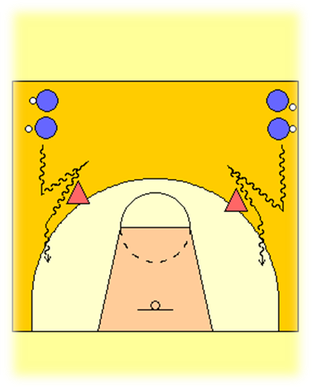
Diag. 2

Au diagramme 3, contre un(e) adversaire qui joue de façon agressive pour apporter de l’aide en défensive mais qui ne joue pas près de l’écran, l’attaquant(e) en possession du ballon doit chercher à passer entre les deux défenseur(e)s. L’attaquant(e) ne doit jamais faire plus de deux dribbles après avoir dépassé l’écran : il/elle doit plutôt lancer ou effectuer une passe afin de conserver l’avantage du jeu. Le dribble doit de plus être fait en croisé, bas et en puissance.

Au diagramme 4, l’attaquant(e) en possession du ballon doit doit reculer afin d’éviter un(e) défenseur(e) qui joue de façon agressive, et passer le ballon à l’autre arrière (passe en triangle); celui-ci ou celle-ci doit donc être prêt(e) à recevoir la passe et à lancer. La passe doit être précise et bien synchronisée. Lors de cet exercice, on doit chercher à améliorer le jeu de pieds du passeur ou de la passeuse, ainsi que du/de la réceptionnaire.

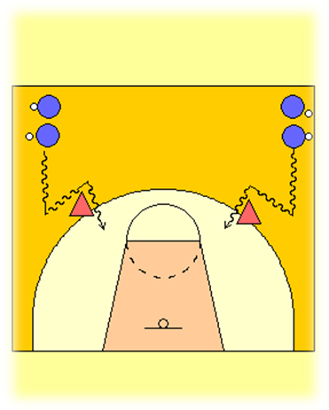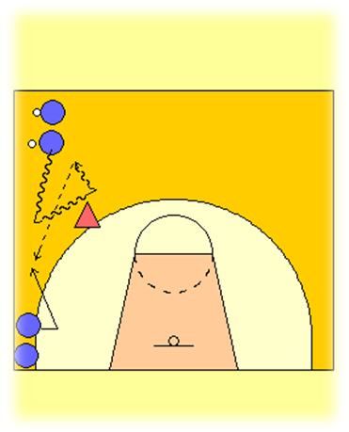
Diag.3
Diag.4

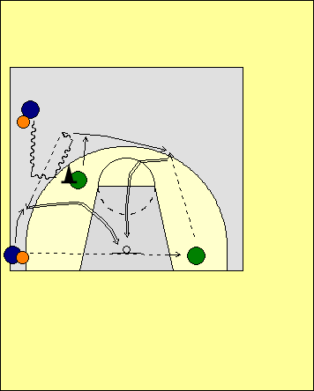  Diag.5 | Afin d’optimiser les actions lors de cet éducatif, le joueur ou la joueuse qui se trouve dans le coin peut faire une passe à l’entraîneur(e) qui se trouve près de la ligne de fond, de l’autre côté du terrain. Le joueur ou la joueuse place(e) au haut utilise l’écran et décèle le déplacement de l’autre entraîneur(e) qui vient en aide. L’attaquant(e) dans le coin doit bien synchroniser son action au moment de couper afin de se rendre disponible pour la passe en triangle. L’ailier(ère) effectue le lancer. Après la passe, le joueur ou la joueuse du haut coupe pour recevoir une passe de retour de l’entraîneur(e), et lance à son tour.  Note: Le passeur ou la passeuse doit pivoter avec le pied le plus éloigné du/de la défenseur(e). Il s’agit d’un pivot vers l’arrière afin de créer de l’espace pour pouvoir passer. Le ballon ne doit pas être ramené derrière le pied pivot.
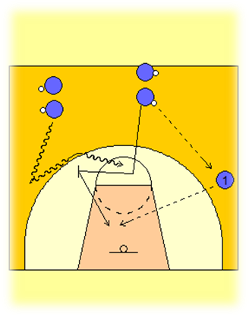  Diag.6 | Au diagramme 6, on fait l’exercice avec l’attaquant(e) en possession du ballon et celui/celle qui fait l’écran. Le joueur ou la joueuse qui exécute l’écran passe le ballon à l’entraîneur(e), puis fait une feinte de couper au panier avant de faire un écran pour l’attaquant(e) en possession du ballon. Celui-ci ou celle-ci doit alors passer tout près (épaule à épaule) avant d’effectuer un tir en suspension. Le joueur ou la joueuse qui fait l’écran pivote et roule ensuite vers le panier et reçoit une passe de l’entraîneur(e); le jeu de pieds pour cet athlète doit se faire de l’extérieur vers l’intérieur, ce qui l’aidera à conserver son équilibre. Si un pivot doit être effectué, c’est le pied le plus éloigné du/de la défenseur(e) qui doit être utilisé. Dans cette situation, le joueur ou la joueuse qui roule peut voir simultanément le ballon et le panier. L’arrière et le joueur ou la joueuse qui fait l’écran effectuent tous deux un lancer.

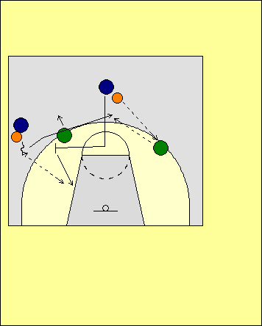  Diag.7 | Faufilade de l’écran vers le panier  L’entraîneur(e) dirige le joueur ou la joueuse qui fait l’écran. Au moment de faire écran, l’attaquant(e) jette un coup d’œil par-dessus son épaule intérieure (le menton doit être placé au-dessus de la clavicule). Si le/la défenseur(e) « triche » pour aider plus tôt que prévu, l’attaquant(e) doit se faufiler et couper au panier. Si au contraire l’attaquant(e) peut bien voir le/la défenseur(e), il faut poursuivre avec l’écran. L’entraîneur(e) dirige le jeu tout en variant ses actions défensives. Si la passe est dirigée vers le joueur ou la joueuse qui coupe au panier, l’attaquant(e) en possession du ballon coupe vers le haut pour effectuer un lancer suite à une passe reçue de l’autre entraîneur(e).
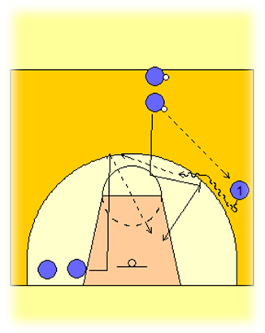  Diag.8 | Au diagramme 8, on travaille la passe en triangle entre les deux joueurs/joueuses qui se trouvent à l’intérieur (passe du haut vers le bas), et on met l’accent sur le synchronisme entre le joueur ou la joueuse qui fait l’écran et l’autre qui se trouve à l’intérieur. Tandis que le premier ou la première pivote en direction du panier, l’autre joueur ou joueuse se déplace en courant à l’extérieur de la clé et remonte vers le haut.
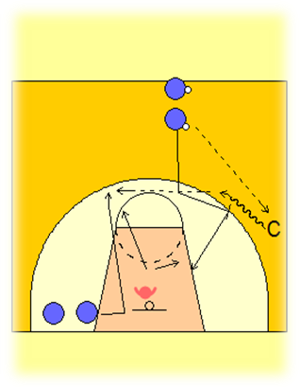  Diag.9 | Cet éducatif (diagramme 9) est le même que le précédent, mais on a ajouté la défensive dirigée (étapes B et C). Le ou la défenseur(e) choisit le joueur ou la joueuse qu’il ou elle ira couvrir : soit celui ou celle qui court à l’extérieur et remonte vers le haut, ou encore l’attaquant(e) qui se dirige vers la clé. Il est crucial que chaque attaquant(e) puisse exécuter efficacement un lancer de l’extérieur; dans le cas contraire, l’équipe en défense ne cherchera pas à marquer le joueur ou la joueuse qui fait l’écran sur la balle et l’avantage d’une seconde sera alors perdu.  L’attaquant(e) qui coupe doit effectuer sa manœuvre au bon moment. À l’étape de progression suivante, l’entraîneur(e) dirige la défensive. Le joueur ou la joueuse qui reçoit le ballon doit choisir entre passer ou lancer, selon l’action défensive de l’entraîneur(e). Les attaquant(e)s doivent chercher à créer une situation à 2 contre 1.
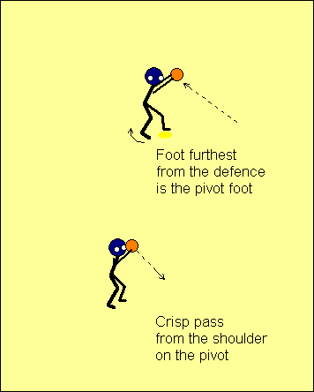 | On doit s’assurer que les passes soient faites de façon réaliste :  - Aucune passe poitrine  - Aucune passe molle  Le joueur ou la joueuse qui joue au haut de la clé doit utiliser le pied qui est le plus éloigné du/de la défenseur(e) pour pivoter. La passe devrait être attrapée haute, et après le pivot, le joueur ou la joueuse doit effectuer une passe rapide et ferme à partir de l’épaule qui se trouve au-dessus du pied pivot.
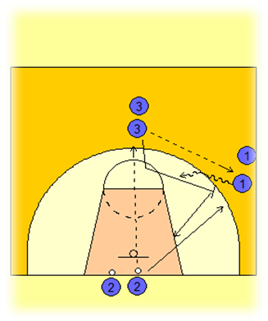  Diag. 10 | Dans cet éducatif (diagramme 10), les joueurs/joueuses évoluent dans une situation de 2 contre 1, et s’exercent à placer un écran sur le/la défenseur(e) qui marque l’attaquant(e) en possession du ballon. Le joueur ou la joueuse placé(e) sous le panier fait une passe à l’ailier(ère) et court pour marquer celui ou celle qui a reçu le ballon. L’attaquant(e) du haut place ensuite un écran : il/elle s’approche du ou de la défenseur(e) à partir du côté où ce dernier ou cette dernière ne peut voir l’écran, puis place ses pieds de façon à former un « T » avec ceux de l’adversaire. Ensuite, l’attaquant(e) du haut et l’ailier(ère) utilisent l’écran sur la balle suivi d’un pivot contre le/la défenseur(e), qui doit alors décider qui il/elle marquera.
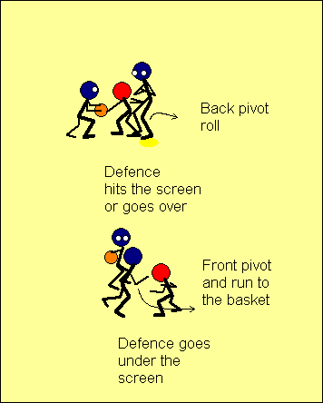 | Les joueurs/joueuses et les entraîneur(e)s se demandent souvent de quel côté le pivot en direction du panier devrait s’effectuer après avoir posé l’écran. En fait, il n’y a pas de réponse unique à cette question, et c’est plutôt la réaction du/de la défenseur(e) qui détermine le meilleur choix.  Si le/la défenseur(e) passe au-dessus de l’écran ou réussit à faire contact, il sera alors très difficile d’effectuer un pivot vers l’avant et le joueur ou la joueuse devra alors tenter de se défaire du contact de son adversaire. Il faut alors faire un pivot renversé et rouler, et utiliser la poussée du/de la défenseur(e) pour accroître son avantage.
Si au contraire le/la défenseur(e) passe au-dessous de l’écran, le joueur ou la joueuse doit effectuer un pivot vers l’avant et couper au panier. Au besoin, ceci permet également de faire un nouvel écran dans la direction où le ballon est venu.

Le joueur ou la joueuse qui fait l’écran doit garder son équilibre afin de pouvoir contrôler la direction de ses déplacements, qu’il s’agisse de rouler, sprinter, ou ressortir vers l’extérieur après l’écran. Il faut se rappeller que pour être en équilibre, les bras doivent demeurer au-dessus des jambes.
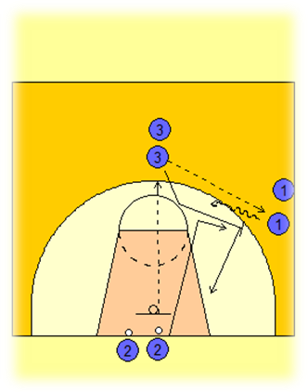  Diag. 11 | Le diagramme 11 est similaire au diagramme 10, à la différence que le joueur ou la joueuse débute son action défensive en marquant l’attaquant(e) qui exécute l’écran sur la balle. Les deux attaquant(e)s doivent faire une bonne lecture du jeu à partir des actions du/de la défenseur(e).
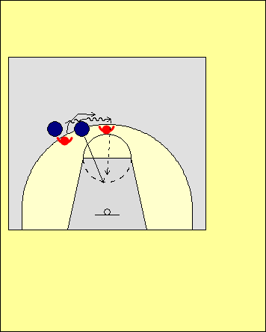 | Voir à la fois le ballon et le panier  Dans ce diagramme, le/la défenseur(e) n’a pas réussi à obliger l’attaquant(e) en possession du ballon à se déplacer vers la ligne de côté. Puisque le joueur ou la joueuse qui a fait l’écran a pivoté directement vers le panier, il/elle se retrouve dans une position où il n’est pas possible de voir simultanément le ballon et le panier.  De plus, il y a très peu d’espace pour une passe. Si un(e) troisième défenseur(e) entrait en jeu, celui ou celle qui a roulé pourrait se faire surprendre et échapper le ballon, marcher avec le ballon, ou encore faire une faute offensive.
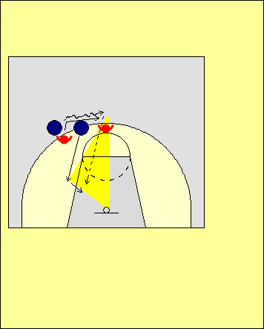 | La situation est la même dans cet éducatif, sauf que le joueur ou la joueuse qui fait l’écran roule pour s’espacer correctement. Cette manœuvre lui permet de se retrouver dans une position où il lui est possible de voir simultanément le ballon et le panier. Plus important encore, il est également possible de voir le/la troisième défenseur(e). Il est alors possible pour cet(te) attaquant(e) d’anticiper les actions défensives, ce qui est un aspect important du jeu en attaque.  À titre d’exemple, l’attaquant(e) qui fait l’écran peut planifier une passe ou un lancer avant même que le ballon lui parvienne.
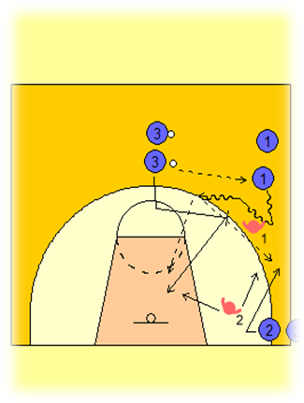  Diag. 12 | Les joueurs/joueuses évoluent à 3 contre 2. On place un(e) défenseur(e) sur l’arrière qui exécute l’écran et un(e) autre sur l’attaquant(e) en périphérie qui se trouve dans le coin.  Pour amorcer l’éducatif, le joueur ou la joueuse situé(e) au haut fait une passe à l’aile (on doit laisser cette passe se réaliser). Après avoir fait la passe, l’attaquant(e) place un écran pour l’ailier(ère) et roule ensuite vers le panier. Les deux défenseur(e)s doivent décider qui ils/elles couvriront, et les trois attaquant(e)s doivent remettre le ballon à celui ou celle qui est à découvert. L’attaquant(e) en possession du ballon ne peut faire que deux dribbles au-delà de l’écran. Les joueurs/joueuses doivent utiliser la passe en triangle pour rejoindre celui ou celle qui n’est pas couvert(e).
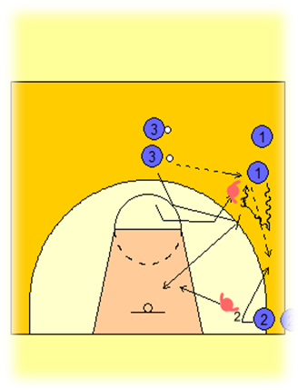  Diag. 13 | Dans cette situation, un(e) défenseur(e) marque le joueur ou la joueuse qui fait l’écran, et l’autre marque l’attaquant(e) dans le coin. On travaille encore la passe en triangle.  Les défenseur(e)s doivent varier leurs actions, ce qui oblige les attaquant(e)s à trouver celui ou celle qui est à découvert. On limite à nouveau le nombre de dribble à deux une fois que l’écran a été utilisé.
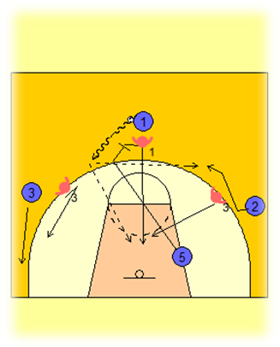  Diag. 14 | Dans cet éducatif, les joueurs/joueuses évoluent à 4 contre 3 et on applique les même règles qu’aux diagrammes N et O; la seule exception est l’ajout d’un(e) attaquant(e) en périphérie. Les joueurs/joueuses s’exercent à bien effectuer la passé en triangle et à conserver un bon espacement entre eux/elles. Personne n’est chargé(e) de surveiller le joueur ou la joueuse à l’intérieur qui fait l’écran. Les défenseur(e)s doivent se débrouiller pour marquer celui ou celle qui fait l’écran sur la balle, fournir de l’aide contre le porteur ou la porteuse du ballon, puis reprendre ensuite leur position.
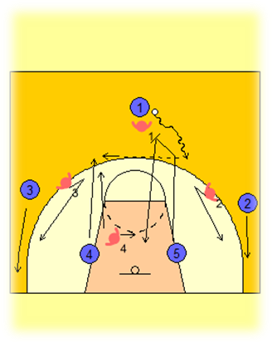  Diag. 15 | Cet éducatif est semblable aux précédents mais les joueurs/joueuses évoluent à 5 contre 4. On met l’accent sur le synchronisme entre les deux attaquant(e)s placé(e)s à l’intérieur, et sur l’espacement entre ceux et celles qui sont à la périphérie. Il n’y a qu’un(e) seul(e) défenseur(e) pour marquer les attaquant(e)s placé(e)s à l’intérieur.  L’entraîneur(e) utilise cette formation de départ pour créer différentes situations de jeu que l’on peut rencontrer lors d’un match.
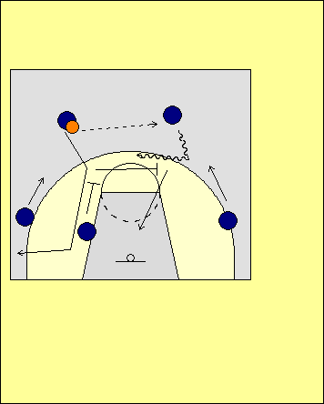 | Intégrer l’écran sur la balle suivi d’un pivot dans le système d’attaque  L’écran sur la balle suivi d’un pivot constitue une bonne option pour amorcer une attaque, et cette approche peut être intégrée au système offensif. Au moment où les deux arrières s’échangent le ballon, l’attaquant(e) à l’intérieur de la clé fait un écran vers le haut, et ensuite fait l’écran sur la balle. Cette manœuvre fait en sorte qu’il est difficile pour le/la défenseur(e) qui couvre le joueur ou la joueuse d’intérieur d’arriver à temps pour défendre l’écran sur la balle. Il est important de donner une certaine latitude aux joueurs/joueuses : plus ils/elles maîtriseront les techniques et les concepts, plus ils/elles seront efficaces. Escamoter les éléments de base pour passer rapidement à l’application de systèmes de jeu équivaut à courir au désastre plus tard dans le développement des athlètes.
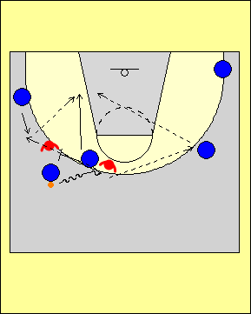 | Contre des défenseur(e) qui permutent  Contre des défensives qui permutent les joueurs ou joueuses lors d’un écran sur la balle, la première chose que l’on doit enseigner aux attaquant(e)s est de faire usage de la passe en triangle. Si cela se fait correctement, le/la défenseur(e) qui a changé d’adversaire se retrouvera hors position et on pourra alimenter l’attaquant(e) à l’intérieur de la clé.
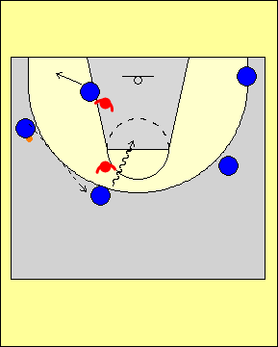 | Si aucune ouverture ne s’offre à l’attaquant(e) à l’intérieur en possession du ballon, il ou elle devrait ressortir le ballon à l’arrière. L’attaquant(e) à l’intérieur de la clé glisse alors vers le coin pour élargir l’espace. L’arrière crée un avantage d’une seconde suite au dribble.  Note: On doit éviter de faire trop d’analyses lors au début des apprentissages.

L’exercice précédent permettra aux entraîneur(e)s d’enseigner les principes à respecter lorsqu’on intègre l’écran sur la balle suivi d’un pivot dans le système offensif. Les entraîneur(e)s doivent cependant insister sur le fait que ces options doivent être envisagées par l’ensemble des joueurs/joueuses de l’équipe, et qu’il ne s’agit pas d’un « jeu à deux » pour les attaquant(e)s, tant en attaque qu’en défense. On ne cherche pas à isoler les deux meilleur(e)s joueurs/joueuses, mais plutôt à créer des situations dans lesquelles on bénéficiera d’un avantage d’une seconde : les attaquant(e)s jouent en effet à 2 contre 2 à l’intérieur des cinq membres du système offensif. Il va sans dire que les actions d’écrans suivis de pivots seront plus efficaces si elles sont exécutées correctement en situation de jeu, et il faut donc s’exercer quotidiennement à les mettre en place dans des situations d’attaque variées, et à partir de différents endroits sur le terrain.

Lors des premières secondes de possession du ballon
Lors des premières secondes de possession du ballon, on utilise fréquemment les écrans pour libérer un attaquant(e) habile au lancer, ou encore pour faire des pénétrations. Les écrans s’avèrent alors efficaces car le système défensif adverse n’est souvent pas encore complètement mis en place.

Vers le milieu du décompte
L’entraîneur(e) doit décider du type d’écrans qui seront placés à ce stade de l’attaque. Lorsque les occasions se présentent, on ne devrait pas hésiter à attaquer le panier. Les écrans constituent un moyen de créer des avantages d’une seconde.

Lors des dernières secondes de possession du ballon
Un écran ou un écran sur la balle bien fait peut s’avérer très efficace lors des dernières secondes de possession du ballon, à condition que les attaquant(e)s fassent une lecture correcte des options de jeu qui s’offrent à eux/elles. On devrait éviter de tenter de faire des écrans sur la balle lors des dernières secondes de possession si l’équipe adverse possède une défensive coriace; en effet, plusieurs équipes décideront alors d’effectuer une trappe contre l’attaquant(e) en possession du ballon, et puisque le temps disponible se trouve alors très limité, il est souvent difficile d’exploiter les opportunités qui se présentent même s’il y a des joueurs/joueuses à découvert.

ISOLER CERTAIN(E)S JOUEURS/JOUEUSES

On cherche à isoler un joueur ou une joueuse quand l’attaquant(e) dispose d’un avantage marqué sur le/la défenseur(e) qui le/la couvre (p. ex., grandeur ou vitesse). À ce stade du développement des athlètes, on suggère cependant d’avoir recours à cette approche avec modération. Celui ou celle qui est « isolé(e) » joue à 1 contre 1 avec les cinq joueurs/joueuses sur le terrain. Si l’aide est présente, on doit passer le ballon et ainsi l’avantage d’une seconde au joueur ou à la joueuse qui est à découvert. Si le ballon arrête de circuler, cela permet aux défenseur(e) de bien se positionner en aide; le synchronisme des mouvements offensifs est donc très important. La seule exception est lorsque l’attaquant(e) « isolé(e) » se trouve en possession du ballon dans la clé; il/elle peut alors chercher à ralentir le jeu et tout en faisant une lecture du jeu défensif.
Autres aspects à considérer

Exploiter l’avantage d’une seconde
Il est toujours préférable d’anticiper une action que d’y réagir. Lorsqu’il/elle se prépare à recevoir la passe, l’attaquant(e) sans ballon doit jeter un coup d’œil à son/sa défenseur(e) en plaçant le menton sur l’épaule; ceci lui permettra de savoir ce que fait l’adversaire avant même d’avoir le ballon en mains. Ce faisant, l’attaquant(e) se donne également un avantage d’une seconde, et le/la défenseur(e) se retrouve dans une situation ou il doit récupérer.

Enseigner le 2 contre 1
Une fois que l’attaquant(e) a réussi à se démarquer et à créer un avantage d’une seconde, il/elle doit ensuite faire une lecture du/de la prochain(e) défenseur(e). Il en résulte une situation d’attaque à 2 contre 1. L’attaquant(e) doit ici décider si la meilleure option est de lancer, ou de refiler l’avantage d’une seconde à un(e) partenaire. Ceci se fait sur demi-terrain ainsi que lors de stuations tout-terrain. L’attaquant(e) en possession du ballon ne devrait pas lancer si un(e) défenseur(e) le/la marque de près, mais plutôt remettre le ballon à un(e) partenaire à découvert; ce dernier ou cette dernière doit, en retour, se déplacer pour se rendre disponible et ainsi obliger le/la défenseur(e) à récupérer sur une longue distance.

1 contre 1 avec cinq joueurs/joueuses
Traditionnellement, le style de basketball préconisé dans la NBA est le «1 contre 1 » et on cherche à isoler un joueur. L’attaquant(e) tente de déjouer son défenseur, et ignore fréquemment ses coéquipiers. Ceci débouche souvent sur des situations de lancers forcés, et par conséquent il s’agit d’une tactique à éviter. Toutes les situations à 1 contre 1 devraient plutôt être envisagées dans le contexte des cinq joueurs/joueuses qui évoluent sur le terrain, car chacun(e) doit apprendre à jouer en équipe. Lorsqu’un(e) attaquant(e) qui a réussi à créer un avantage d’une seconde passe le ballon à un coéquipier ou une coéquipière qui est à découvert, il/elle lui transmet alors cet avantage. À l’inverse, si l’attaquant(e) effectue un lancer forcé tandis qu’un(e) partenaire se trouve libre, cela peut être interprété comme un manque de confiance envers celui-ci ou celle-ci. La passe constitue un moyen privilégié de bâtir les liens solides avec les autres membres de l’équipe; un(e) attaquant(e) qui exécute une passe précise à un(e) partenaire devient du même coup un meilleur joueur ou une meilleure joueuse.

Il faut garder le ballon en mouvement
Quand un(e) attaquant(e) garde le ballon en mains pendant quatre secondes ou encore qu’il ou elle dribble constamment sur place, la passe qu’il ou elle exécute ensuite est rarement bonne. Une passe qui est imprécise, p. ex. trop basse ou trop haute, ou encore molle ou trop dure, oblige le réceptionneur ou la réceptionneuse à se déplacer d’une position qui est avantageuse pour marquer; cela oblige également l’attaque à créer une nouvelle situation où il y a un avantage d’une seconde, car l’équipe en défence a alors pu se regrouper. Une équipe qui garde le ballon en mouvement après avoir créé un avantage d’une seconde réussit la plupart du temps à le conserver, et déstabilise du même coup l’équipe en défense.

Remettre le ballon dans la clé à l’aide d’une passe ou d’un dribble
Dès le début, on doit chercher à faire comprendre aux joueurs/joueuses l’importance d’amener le ballon dans la clé grâce à des manœuvres de pénétration, tout en préservant un bon espacement sur le terrain. Ceci est particulièrement important lorsqu’il n’y a pas de partenaires à découvert à qui faire une passe, et que l’un(e) des attaquant(e)s décide de couper dans la clé ou de prendre position à l’intérieur.

STRATÉGIES

LORS DE LA TRANSITION – PREMIÈRES SECONDES DE POSSESSION

Éducatifs de passe et de tir lors de la transition
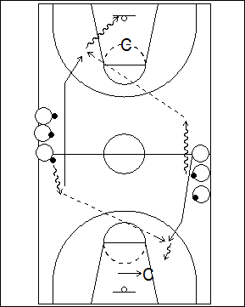 | Deux files, éducatif de lancers tout terrain  Les joueurs/joueuses forment deux files sur les lignes de côté, près du centre du terrain. Chacun(e) a un ballon en mains sauf le premier ou la première de l’une des files. Celui/celle qui n’a pas de ballon fait un sprint vers le panier. Le premier ou la première de l’autre file fait alors deux dribbles dans la même direction, et passe au joueur ou à la joueuse qui court vers le panier; celui-ci ou celle-ci attrape le ballon et marque ensuite un panier. Celui/celle qui a effectué la passe fait alors un arrêt en un temps, change de direction et sprinte à son tour vers l’autre panier; le joueur ou la joueuse qui est en tête de l’autre file exécute alors à son tour deux dribbles puis fait la passe. L’action se poursuit ainsi, en alternant le panier où se fait le lancer.
À l’étape B, un(e) entraîneur(e) se place à chaque extrémité du terrain, dans la clé. Le joueur ou la joueuse qui se dirige au panier doit tenir compte de la position de l’entraîneur(e). Si l’entraîneur(e) place sa poitrine face à l’attaquant(e), ce dernier ou cette dernière doit effectuer un tir en suspension. Si l’entraîneur(e) ne montre pas sa poitrine, il ou elle continue jusqu’au panier pour un tir en foulée.

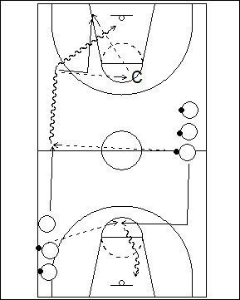 | Passes et tirs en foulée sur tout terrain  La première file se trouve au centre du terrain près de la ligne de côté, et chaque joueur/joueuse a un ballon en mains. La seconde file est de l’autre côté, à la hauteur de la ligne de lancer franc; chaque joueur/joueuse a un ballon en mains, sauf le premier ou la première, qui amorce l’exercice en courant le long de la ligne de côté. Rendu(e) au centre, il/elle reçoit une passe du premier ou de la première de l’autre file, puis doit ensuite dribbler en gardant la tête relevée afin de voir le signal de l’entraîneur(e) qui se trouve au haut de la clé. Si l’entraîneur(e) lève les mains et donne une cible le joueur ou la joueuse doit passer, puis couper au panier pour une passe de retour, sinon, il/elle continue et effectue un tir en foulée.
Le joueur ou la joueuse qui a fait la première passe court le long de la ligne de côté puis coupe vers le centre pour recevoir une passe au haut de la clé. Après la réception, il/elle effectue une manœuvre de dribble en croisé ou une manœuvre pour contourner un/une défenseur(e) imaginaire et attaque ensuite le panier.
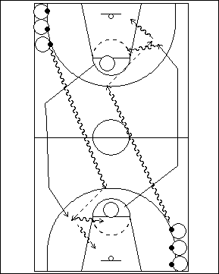 | Courir dans le couloir extérieur  On forme deux files, aux coins des extrémités opposées du terrain. Chaque joueur/joueuse a un ballon en mains. Un(e) joueur/joueuse sans ballon est également placé(e) à chaque ligne de lancer franc. Le joueur ou la joueuse dans le coin amorce l’exercice en dribblant en direction du panier éloigné vers le ‘T’ mais en restant sur le même côté. Pendant ce temps, celui ou celle qui est à la ligne de lancer franc sprinte en diagonale jusqu’à la ligne de côté la plus près, et se dirige ensuite vers la ligne de fond dans le couloir extérieur. Le joueur ou la joueuse avec le ballon fait ensuite une passe à celui ou celle qui court lorsque ce dernier ou cette dernière arrive au point d’attaque. On exécute la même manœuvre de l’autre côté. Le joueur ou la joueuse qui dribblait se place ensuite à la ligne de lancer franc.

ÉDUCATIFS DE TRANSITION, SUR TERRAIN COMPLET
Principes à respecter :
1. Les joueurs/joueuses devraient toujours effectuer une passe à un(e) partenaire qui est à découvert.
2. Si aucun partenaire ne se trouve devant soi, il faut continuer à faire progresser le ballon vers le panier.
3. Les joueurs/joueuses sans ballon doivent toujours courir rapidement.
4. Il doit y avoir trois corridors, peu importe où se trouve le ballon.
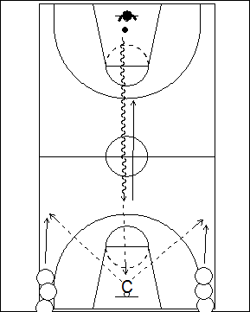 | 1 contre 0 / 2 contre 1 – Séparer le terrain en 2  Le/la défenseur(e) a le ballon et se place sous le panier à une extrémité du terrain; l’entraîneur(e) se tient sous l’autre panier. Il y a une file d’attaquant(e)s sur le même côté que l’entraîneur(e), dans chaque coin. Le joueur ou la joueuse en possession du ballon s’avance en dribblant rapidement vers l’entraîneur(e), tout en changeant de mains à chaque dribble. Lorsque l’entraîneur(e) lève les mains et donne une cible, il/elle lui fait une passe, et devient défenseur(e). Au même moment les deux attaquant(e)s sprintent, et l’entraîneur(e) effectue une passe à l’un(e) des deux. L’attaque se poursuit à 2 contre 1.
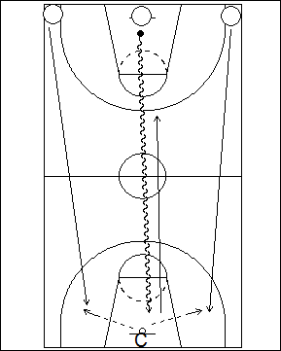 | 1 contre 2 / 2 contre 1 – être plus rapide grâce à des passes  Trois joueur/joueuses sont aligné(e)s à la ligne de fond, et celui/celle du milieu a un ballon. Il/elle amorce une attaque au panier opposé en vue de marquer. Les joueur/joueuses sur les côtés sont des défenseur(e)s et tentent d’empêcher celui ou celle qui est au centre de marquer. Après le lancer, l’entraîneur(e) s’empare du retour et remet le ballon à l’un(e) de ces deux joueurs/joueuses, qui se retournent et attaquent à leur tour, cette fois à 2 contre 1. Pour surcharger l’exercice et favoriser une attaque rapide, on peut empêcher le dribble avant d’avoir franchi la ligne centrale, et ne permettre qu’une passe en zone offensive.
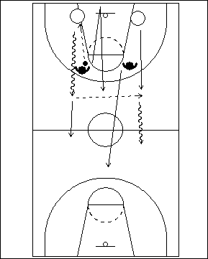 | 2 contre 2 – conserver l’avantage  On place les deux attaquant(e)s à la ligne de fond, et les deux défenseur(e)s dans le prolongement de la ligne de lancer franc. L’un(e) des défenseur(e)s a le ballon, et il/elle amorce l’action en faisant une passe à l’un(e) des attaquant(e)s, qui débutent alors leur attaque vers le panier opposé. Le joueur ou la joueuse qui a fait la passe doit sprinter jusqu’à la ligne de fond avant de pouvoir reprendre son rôle défensif. L’autre défenseur(e) doit protéger le panier et tenter de ralentir l’attaque jusqu’au retour de son/sa partenaire.

ÉDUCATIFS DE PROGRESSIONS DU BALLON TOUT TERRAIN – SITUATIONS DE PARTIES

Les éducatifs qui suivent se déroulent sur tout le terrain et ils permettent aux attaquant(e)s de chercher à exploiter l’avantage d’une seconde. Pour y arriver, ils/elles doivent apprendre (1) à maîtriser le dribble lors de déplacements à haute vitesse et à attaquer le panier lorsqu’il n’y a pas de défenseur(e)s, et (2) à dribbler sous contrôle afin d’exécuter une passe précise.

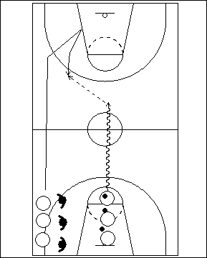 | Monter le ballon vers la zone offensive tout en le contrôlant  On forme une file de passeurs/passeuses à la ligne de lancer franc et près d’une ligne de côté, une file d’attaquant(e)s qui sont tous/toutes marqué(e)s par un(e) défenseur(e). L’action débute lorsque le joueur ou la joueuse en possession du ballon commence à dribbler en direction du panier opposé. Cet(te) attaquant(e) ne peut toutefois pas marquer : il/elle doit dribbler sous contrôle et décider si une passe peut être faite à son/sa partenaire qui sprinte à l’aile et tente de se démarquer. Le/la défenseur(e) tente de se mettre en position pour bien protéger le panier.  Si l’attaquant(e) en possession du ballon ne peut passer à l’ailier(ère), ce dernier ou cette dernière doit entrer profondément en zone offensive, puis revenir vers la ligne de trois points pour se démarquer, tout en s’assurant que l’angle de sa course au retour ne soit pas la même que lorsqu’il/elle a coupé vers le panier. Une fois le ballon remis au/à la partenaire, le passeur ou la passeuse n’est plus dans le jeu.
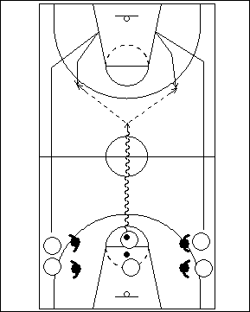 | Voir les deux côtés du terrain  Cet éducatif est identique au précédent, mais cette fois il y a un(e) attaquant(e) de chaque côté. Le passeur ou la passeuse doit donc faire un balayage visuel sur la gauche et sur la droite. Celui ou celle qui fait la passe arrête de jouer après avoir remis le ballon à un(e) partenaire.
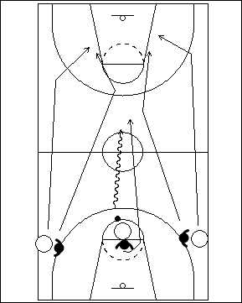 | 3 contre 3  Cet éducatif est identique au précédent, mais se déroule à 3 contre 3. Le/la troisième défenseur(e) se place dos à l’attaquant(e) du milieu. Dès que celui-ci ou celle-ci se met à dribbler, l’action s’amorce; il y a alors un léger avantage d’une seconde pour les attaquant(e)s. Le joueur ou la joueuse du milieu peut marquer.
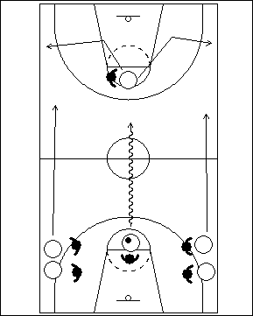 | Exploiter l’avantage  Dans cet éducatif, on ajoute un(e) quatrième attaquant(e) et un(e) quatrième défenseur(e). Les joueurs/joueuses commencent à la ligne de lancer franc à une extrémité, et le jeu se dirige vers le panier opposé. Les attaquant(e)s peuvent couper vers les espaces libres.
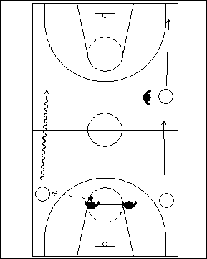 | 3 contre 3 – attaque dans le corridor extérieur  Dans cet éducatif, l’attaquant(e) en possession du ballon a un léger avantage d’une seconde sur un côté du terrain; il y a deux autres attaquant(e)s placés de l’autre côté. Les défenseur(e)s sont placé(e)s sur le côté intérieur des attaquant(es). L’action s’amorce lorsque le/la défenseur(e) fait une passe à l’attaquant(e) sur le côté. Les joueurs/joueuses en attaque doivent chercher à maintenir un bon espacement.
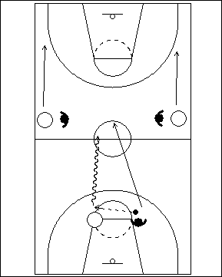 | 3 contre 3, attaque par le centre avec avantage  Dans cet éducatif, l’attaquant(e) qui évolue au centre possède un léger avantage, et il y a deux partenaires marqué(e)s sur chaque aile.
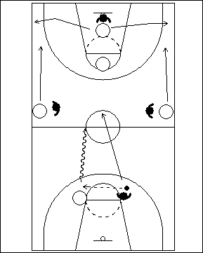 | 5 contre 4, attaque par le centre avec avantage  Dans cet éducatif, on ajoute deux autres attaquant(e)s à l’autre bout du terrain et un(e) quatrième défenseur(e).  L’attaquant(e) en possession du ballon doit contrôler le jeu, et déceler les partenaires qui sont à découvert.

APPROCHE CONCEPTUELLE POUR ENSEIGNER LES ACTIONS OFFENSIVES (MILIEU OU FIN DU DÉCOMPTE AVANT LE LANCER)

Avant de passer à l’enseignement des concepts offensifs décrits dans cette section. L’entraîneur(e) doit s’assurer que ses joueurs/joueuses ont une bonne connaissance et une maîtrise suffisante des notions et des techniques qui ont été abordées précédemment, soit :

- Couper et remplacer (un contact visuel doit être fait lorsque le joueur ou la joueuse coupe).
- Exploiter l’avantage d’une seconde (faire une bonne lecture de la défensive).
- Attaquer à 2 contre 1 (demi-terrain et tout terrain)
- Jouer à 1 contre 1 avec cinq joueurs/joueuses (jouer avec tou(te)s les partenaires)
- Garder le ballon en mouvement (agir vaut mieux que réagir).

Ces notions devraient également avoir été enseignées à l’aide des différentes étapes de la méthode progressive.

Révision rapide

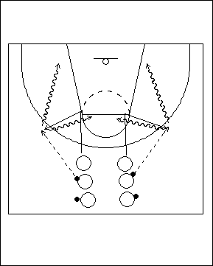 | 1 contre 0, départ en dribblant– Étape A  Les joueurs/joueuses forment deux files dans les corridors intérieurs à la ligne de trois points. Chacun(e) a une ballon en mains, sauf le premier ou la première de chaque file. Le joueur ou la joueuse sans ballon court vers le ‘T’, fait un arrêt en un temps, pivote et coupe ensuite au point d’attaque. Le/la partenaire qui a le ballon lui fait alors une passe juste à l’extérieur de la ligne de trois points, à un endroit où l’attaquant(e) pourra constituer une menace. À l’aide d’un pas croisé, le joueur ou la joueuse attaque vers le centre en faisant un tir en suspension, ou attaque vers la ligne de fond avec un tir en puissance avec une manœuvre de pied extérieur-pied intérieur.  Dans cet éducatif, on doit mettre l’emphase sur un jeu de pieds correct, une passe précise, et une bonne finition au panier.
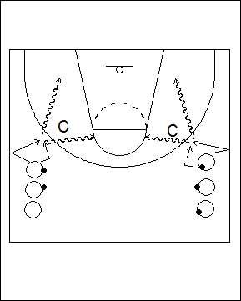 | Lecture du jeu défensive de l’entraîneur(e) – Étape B  Pour surcharger l’éducatif, l’entraîneur(e) se place de façon à simuler un(e) défenseur(e) qui marquerait l’ailier(ère) au moment de la réception de passe. Le joueur ou la joueuse doit décider si la meilleure option est de lancer, d’attaquer au panier en passant à gauche ou à droite, ou encore de couper derrière le/la défenseur(e).
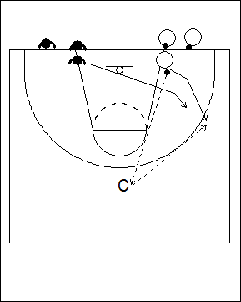 | 1 contre 1 avec défensive active – Étape C  Ici, les joueurs/joueuses évoluent dans un duel de type « 1 contre 1 ». Deux groupes sont formés près de la ligne de fond, et les attaquant(e)s ont un ballon en mains. L’attaquant(e) en tête de file passe à l’entraîneur(e) (qui est placé(e) au centre, un peu à l’extérieur de la ligne de trois points), puis coupe ensuite vers l’extérieur au point d’attaque. Le/la défenseur(e) entre en jeu dès que l’attaquant(e) s’est mis en mouvement.
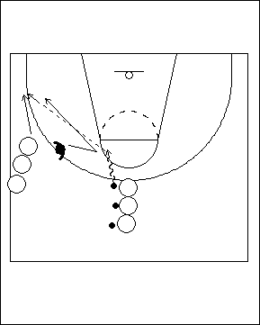 | 1 contre 1 situation de match – Étape D  Les attaquant(e)s forment deux files, une sur le côté et une autre (avec ballons) au centre, à l’extérieur de la ligne de trois points. On place un(e) défenseur(e) contre dans le couloir de passe pour marquer l’ailier(ère). L’attaquant(e) en possession du ballon attaque la clé. Le/la défenseur(e) se dirige tout d’abord vers le ballon, puis reprend son poste pour couvrir l’ailier(ère), qui tente de se déplacer vers un endroit à découvert. Après la passe, l’ailier(ère) et le/la défenseur(e) jouent 1 contre 1.
Couper/passer par derrière – Étape A

On forme deux files, une dans un coin et l’autre sur le côté opposé près du centre. Chaque joueur ou joueuse a un ballon. L’attaquant(e) du coin amorce l’action en faisant une passe à l’entraîneur(e), puis se déplace à l’aile, à l’extérieur de la ligne de trois points. Le joueur ou la joueuse de l’autre côté dribble jusqu’au haut de la clé, puis passe à l’ailier(ère) qui coupe vers le panier. Après la passe, le joueur ou la joueuse coupe vers l’autre point d’attaque et coupe ensuite vers le panier pour recevoir une passe de l’entraîneur(e). La première passe doit être attrapée dans la clé.

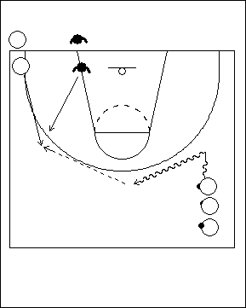 | Couper/passer par derrière - Étape B  Pour compliquer la prise de décision, et pour obliger les joueurs/joueuses à être précis(e)s lorsqu’ils coupent et passent, on ajoute un(e) défenseur(e) semi-actif(ve).
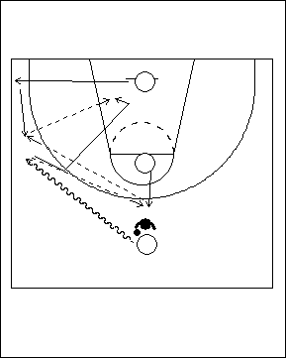 | 3 contre 1, passe en triangle – Étape C  Lorsqu’on enseigne cette notion, on recommande que les joueurs/joueuses se familiarisent tout d’abord avec l’éducatif à 3 contre 0 (Étape A). De plus, à l’Étape B, l’entraîneur(e) devrait diriger la défensive afin d’aider les athlètes à prendre les bonnes décisions et à faire une exécution correcte.  À l’Étape C, on ajoute une défensive active et on met l’accent sur les actions qui visent à prendre position contre le/la défenseur(e) à l’intérieur de la clé, et on utilise la passe en triangle pour rejoindre efficacement l’attaquant(e) qui se trouve à l’intérieur.  Le joueur ou la joueuse situé(e) au haut est en possession du ballon, et dribble jusqu’au point d’attaque. L’attaquant(e) placé(e) sous le panier coupe vers le coin, du même côté, tandis que celui ou celle qui se trouve à la ligne de lancer franc remonte vers le haut. Le/la défenseur(e) marque l’attaquant(e) en possession du ballon, qui est rendu(e) à l’aile. Ce dernier ou cette dernière passe dans le coin ou au haut, puis coupe ensuite au panier, du côté du panier où se trouve le ballon. Après la passe, le/la défenseur(e) se déplace rapidement vers l’attaquant(e) en possession du ballon.
Voici certains exemples de ce qui peut se produire lors de cet éducatif.
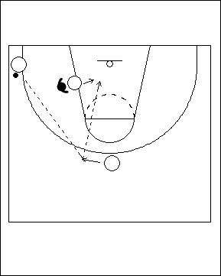 | Exemple A  Dans cet exemple, la passe a été dirigée dans le coin. Le/la défenseur(e) s’est déplacé(e) côté ballon et empêche la passe de parvenir à l’attaquant(e) à l’intérieur. Le joueur ou la joueuse qui se trouve au haut doit chercher à raccourcir le trajet du ballon, et doit laisser savoir à ses partenaires qu’il faut faire une passe en triangle. L’attaquant(e) qui est dans la clé doit maintenir le contact avec le/la défenseur(e), et l’empêcher de se déplacer lorsque la passe est faite. Après avoir reçu le ballon, l’attaquant(e) du haut effectue une passe à son/sa partenaire qui est à l’intérieur.
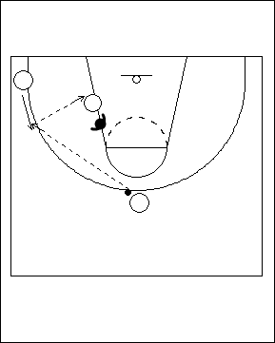 | Exemple B  Dans cet exemple, la passe a été dirigée dans le haut. Le/la défenseur(e) s’est placé(e) en position de contestation, de sorte que le joueur ou la joueuse qui est dans le coin doit se déplacer un peu vers le haut afin de raccourcir le trajet du ballon; ce déplacement facilite l’exécution d’une passe en triangle efficace.
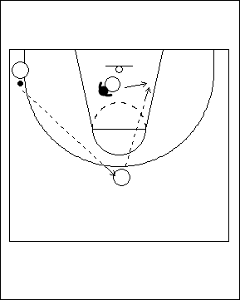 | Exemple C  Dans cet exemple, le joueur ou la joueuse qui coupe se dirige au panier, ce qui se produit souvent. Puisque le règlement ne lui permet de demeurer dans cette position que pendant trois secondes, il n’y a habituellement pas assez de temps pour exécuter une passe en triangle. De plus, si l’attaquant(e) en possession du ballon décide de faire une passe dans l’espace que s’est créé le joueurou la joueuse d’intérieur dans la clé, cela éloignera son/sa partenaire du panier, souvent directement vers un(e) autre défenseur(e).
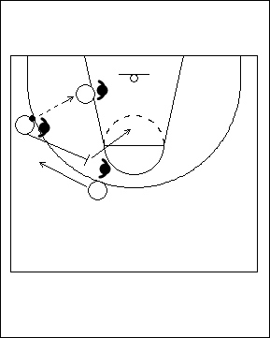 | Ballon à l’intérieur  Il ne faut pas prendre pour acquis qu’un lancer sera effectué chaque fois que le ballon est remis à l’attaquant(e) à l’intérieur. Par conséquent, les joueurs/joueuses qui se trouvent en périphérie doivent apprendre à bien s’espacer et à ne pas se trouver à un endroit où un(e) défenseur(e) peut marquer en même temps le joueur ou la joueuse d’intérieur et celui ou celle en périphérie. L’autre aspect important dont on doit se rappeler est qu’il ne faut pas qu’un(e) attaquant(e) se retrouve dans le coin à l’aile du même côté où se trouve déjà son/sa partenaire qui joue à l’intérieur, car cela l’empêchera de bien voir le déroulement de l’action. Puisque l’attaquant(e) dans la clé n’est pas en mesure d’observer tous les joueurs/joueuses à la fois, il/elle doit se retourner la tête et ceci peut créer des situations où un(e) deuxième défenseur(e) peut venir placer une trappe.  Dans cet exemple, les deux joueurs/joueuses en périphérie font un écran l’un(e) pour l’autre. Il s’agit ici d’un concept avancé qui ne devrait être utilisé que lorsque les joueurs/joueuses apprennent le système d’attaque.
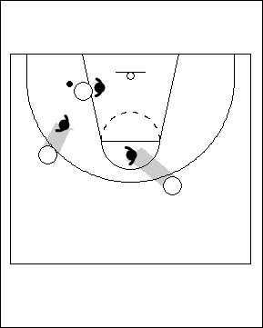 | À ce niveau de jeu, les attaquant(e)s devraient toujours chercher à s’aligner avec l’épaule du/de la défenseur(e) qui les marque. Ce principe simple leur permet de se placer légèrement en dehors du champ de vision de l’adversaire. Si le/la défenseur(e) tourne la tête, le joueur ou la joueuse peut alors en profiter pour couper vers un espace libre.
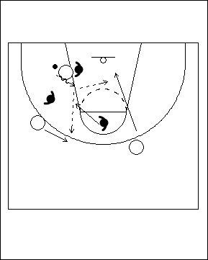 | Lorsque l’attaquant(e) qui joue à l’intérieur dribble, ses partenaires devraient couper de façon énergique dans le dos des défenseur(e)s; en effet, dans ce genre de situation les défenseur(e)s ont souvent tendance à tourner la tête en direction du ballon.
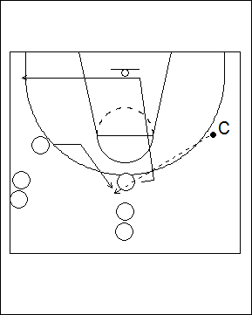 | 2 contre 2 – Couper et remplacer  Le principe de cet éducatif est le même qu’à l’Étape A, mais il n’y a pas de défenseur(e)s. L’attaquant(e) du haut passe à l’entraîneur(e), puis coupe dans la clé (sur le côté du ballon) afin d’ouvrir le jeu, puis se dirige ensuite dans le coin opposé tout en continuant à regarder le ballon. L’ailier(ère) prend ensuite la place de celui/celle qui a coupé, et reçoit le ballon de l’entraîneur(e).
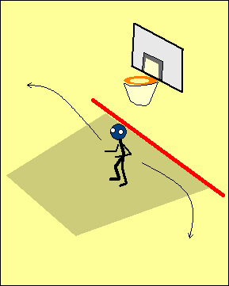 | Lorsque le joueur ou la joueuse arrive au panier, il/elle doit se retourner afin de voir ce que font ses partenaires. L’attaquant(e) doit également garder les yeux sur le ballon lorsqu’il ou elle quitte la clé pour se diriger vers un espace libre.
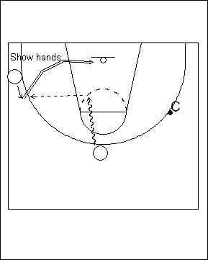 | Lorsque le joueur ou la joueuse au haut reçoit le ballon, il/elle doit anticiper ce que fera la défensive – donc, faire un arrêt en un temps et se placer face au panier. Il ou elle peut ensuite attaquer le panier à l’aide d’une manœuvre de pas croisés. Par contre, si un(e) partenaire indique une cible à l’aide de ses mains, il faudrait lui effectuer une passe.  À l’Étape B, on peut surcharger cet éducatif avec une défensive dirigée.  À l’Étape C, les joueurs/joueuses évoluent à 2 contre 2 contre une défensive active. L’entraîneur(e) demeure alors toujours disponible pour recevoir une passe pendant que les attaquant(e)s s’exercent à couper.
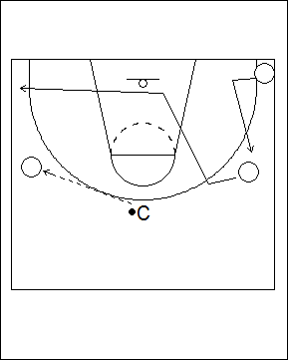 | 3 contre 3 – Couper et remplacer  À l’Étape A, il n’y a pas de défenseur(e)s dans cet éducatif. L’entraîneur(e) est placé(e) en haut, au centre, et trois attaquant(e)s sont disposé(e)s le long de la ligne de trois points. Le principe est simple : l’attaquant(e) doit couper lorsque le joueur ou la joueuse en possession du ballon (l’entraîneur(e) dans le cas présent) établit un contact visuel. Après avoir coupé, le joueur ou la joueuse se retourne rendu(e) au panier, puis va occuper l’espace libre.  Si un(e) attaquant(e) du haut coupe vers le panier, le/la partenaire du même côté doit prendre sa place. Si une passe est faite à l’un(e) des joueurs/joueuses, les autres peuvent encore couper, mais seulement après que l’attaquant(e) en possession du ballon ait établi un contact visuel.  À l’Étape D, les joueurs/joueuses évoluent à 3 contre 3 et les défenseur(e)s se placent dans les corridors de passe.
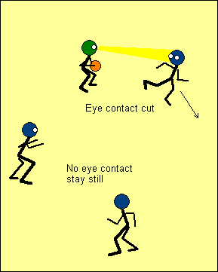 | L’un des concepts les plus importants que les joueurs/joueuses doivent mettre en pratique est de toujours maintenir un contact visuel avec l’attaquant(e) en possession du ballon lorsqu’ils ou elles coupent. Dans le cas contraire, on risque des pertes de balles, on peut se retrouver avec trop de joueurs/joueuses en même temps dans la clé, et un mauvais synchronisme lors des « coupes » au panier.  Dans bien des cas, la meilleure chose à faire est tout simplement de ne pas couper…
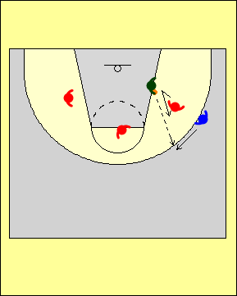 | 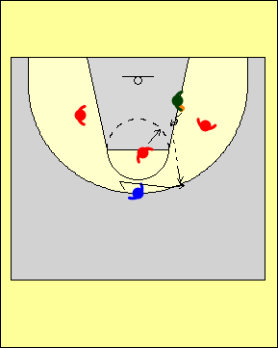 | 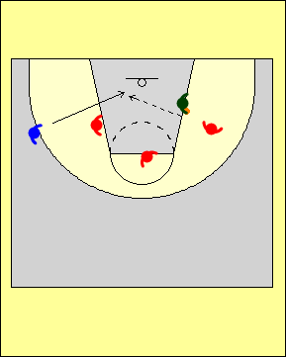
Jouer à 1 contre 1 trois fois – Passe à l’attaquant(e) dans la clé

Dans cet écucatif, l’entraîneur(e) a le ballon, dans la clé. L’attaquant(e) joue à 1 contre 1 contre son/sa défenseur(e). L’entraîneur(e) doit tenter d’empêcher le/la défenseur(e) de venir aider, tout en observant ce que fait l’attaquant(e). L’entraîneur(e) fait une passe, et l’attaquant(e) affronte alors le/la défenseur(e) dans un duel à 1 contre 1.

Dans le second éducatif, l’attaquant(e) se déplace à la deuxième position vers le haut et affronte le/la défenseur(e). Si l’entraîneur(e) dribble, le/la défenseur(e) va en aide et « attaque » ce dribble.

Dans le troisième exemple, l’attaquant(e) se déplace à la troisième position d’où il/elle peut voir le/la défenseur(e), se retourne, puis coupe vers le panier. Puisqu’il/elle attaque trois fois de suite et doit lire le jeu défensif, il est très peu probable que l’attaquant(e) répète la même manœuvre à chaque tentative.

Les attaquant(e)s devraient toujours chercher à s’aligner avec l’épaule du/de la défenseur(e) qui les marque.
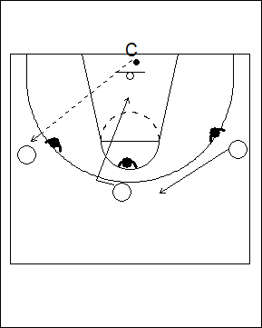 | 3 contre 3 – Couper et remplacer  Dans cet éducatif, les joueurs/joueuses évoluent à 3 contre 3. L’entraîneur(e) se place sous le panier avec le ballon tandis que les défenseur(e)s sont actif(ve)s. L’action s’amorce quand l’entraîneur(e) effectue la passe. Si l’entraîneur(e) établit un contact visuel avec un joueur ou une joueuse, celui-ci ou celle-ci doit couper, et l’un des partenaires doit prendre sa place tandis que l’autre attend.
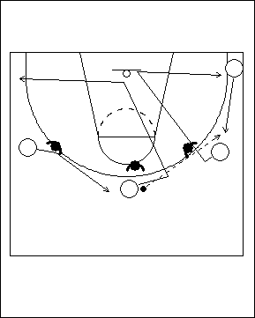 | 4 contre 3 – Couper et remplacer  Cet éducatif est très important pour enseigner aux joueurs/joueuses l’ordre dans lequel ils/elles doivent considérer leurs options : lancer; passe; dribble; attaque. Les défenseur(e)s commencent par se placer dans les corridors de passe. L’attaquant(e) amorce le jeu en coupant par derrière lorsque le passeur ou la passeuse lui jette un coup d’œil. Le joueur ou la joueuse suivant(e) prend alors la place de celui ou celle qui a coupé. On doit insister sur le fait qu’il ne s’agit pas d’une situation dans laquelle on devrait tenter un lancer de trois points, puisqu’aucune pénétration de la clé n’a encore été faite.  Le joueur ou la joueuse qui reçoit la passe doit envisager les différentes options qui s’offrent à lui/elle, tout en cherchant à apercevoir un(e) partenaire à découvert.
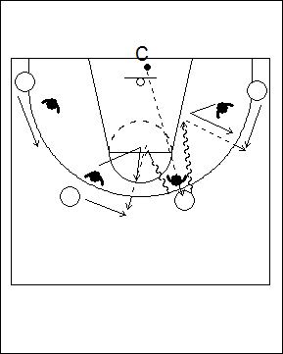 | 4 contre 4 - Avantage  Dans cet éducatif, les joueurs/joueuses évoluent à 4 contre 4. L’entraîneur(e) se place sous le panier et fait une passe à l’une des attaquant(e)s en périphérie. Les défenseur(e)s jouent dans les corridors de passe. Les attaquant(e)s peuvent amorcer des pénétrations dès qu’ils/elles sont en possession du ballon.
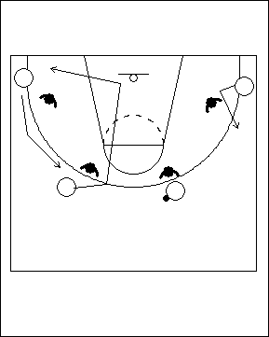 | 4 contre 4 – Couper et remplacer (deux dribbles)  Dans cet éducatif, les joueurs/joueuses évoluent à 4 contre 4; les attaquant(e)s doivent couper et prendre la place laissée vacante par celui/celle qui a coupé.  L’action s’amorce lorsque le passeur ou la passeuse jette un coup d’oeil à l’un(e) des attaquant(e)s, qui doit alors couper par derrière. Les joueurs/joueuses en attaque peuvent faire un maximum de deux dribbles.

Fluidité de l’attaque
Dans un système offensif bien rodé, chaque action est liée à une autre et tout s’enchaîne avec fluidité. Dans le cas des équipes qui « se cherchent » en attaque, on voit souvent des séquences où l’action s’arrête, puis reprend.

Rythme offensif
L’attaque doit se dérouler selon un rythme inverse de celui qu’utilise l’équipe en défense. Si la defensive cherche à ralentir le jeu, l’attaque doit l’accélérer; au contraire, si la defensive cherche à mettre beaucoup de pression le rythme de l’attaque doit ralentir.

De plus, les attaquant(e)s doivent maintenir un bon synchronisme et un bon espacement tout au long de la période allouée pour lancer.
EntraîneurPasquali

SYSTÈME EN ATTAQUE
On ne peut trop insister sur le fait que les entraîneur(e)s ne devraient jamais escamoter le travail portant sur les techniques et les notions vues précédemment. Trop souvent, ils ou elles veulent passer à l’étape où « on exécute des jeux » avant que les athlètes aient les fondements qui leur permettent de jouer correctement…

Les notions qui ont été abordées dans les sections précédentes constituent les éléments fondamentaux du basketball. Si les joueurs ou joueuses ne disposent pas tout d’abord et avant tout de bases solides sur le plan technique, tout système que l’entraîneur(e) cherchera à implanter aura des lacunes.
Quand on vient juste de déménager dans une nouvelle ville, le retour à la maison peut souvent s’avérer pénible. Il faut porter attention à chaque panneau indiquant le nom des rues, afin de trouver ceux qui correspondent au trajet que l’on doit emprunter. Au fil du temps, alors que l’on se familiarise avec le trajet, on peut se relaxer au volant et remarquer ce qu’il y a autour. On se dit alors : « Je n’avais jamais remarqué cela auparavant … ». Puis, un beau jour, on prend la voiture jusqu’à la maison et on ne se rappelle même pas par quelle route on est passé(e). Lorsque cela se produit, c’est que le trajet est imprégné dans le subconscient.

C’est un peu la même chose pour les joueurs/joueuses lorsqu’ils/elles doivent apprendre un système d’attaque : chaque fois que l’entraîneur(e) ajoute un « nouveau jeu », c’est un peu comme si ils/elles devaient conduire pour la première fois dans une nouvelle ville. Le joueur ou la joueuse doit se concentrer sur la marche à suivre et n’est pas en mesure de bien voir ce qui se passé autour. Lorsqu’on enseigne à l’aide de principes, il faut du temps aux joueurs/joueuses pour « apprendre le trajet »; mais lorsqu’ils/elles l’ont bien intégré ils/elles peuvent se concentrer sur autre chose durant le jeu, p. ex. lire la défensive adverse.
EntraîneurPasquali

Le système d’attaque employé devrait:
- Permettre aux joueurs/joueuses d’évoluer à plusieurs positions.
- Être employé uniquement pour amorcer l’attaque. Le patron de jeu n’est pas aussi important que la notion selon laquelle on cherche à créer un avantage d’une seconde.
- Se mettre en place avec fluidité à partir de la transition.
- Enseigner aux joueurs/joueuses à faire une bonne lecture du jeu.
- Chercher à créer des lancers de qualité à partir des avantages d’une seconde et en tenant compte du niveau d’habileté des joueurs/joueuses.

Quatre + un(e) - (quatre joueurs/joueuses en périphérie, et un(e) à l’intérieur)
Le joueur ou la joueuse peut évoluer à l’intérieur durant toute une possession, ou différent(e)s joueurs/joueuses peuvent entrer et sortir de l’espace intérieur lors d’une même possession, mais ce ne devrait pas toujours être le ou la même attaquant(e) qui joue à l’intérieur.

Le jeu à l’intérieur est pour tout le monde
Chaque joueur ou joueuse doit avoir l’occasion de jouer à l’intérieur et de manœuvrer pour prendre position contre un(e) défenseur(e) dans la clé.

Écrans de dos
C’est le premier type d’écran que l’on doit enseigner, car il convient à tous les concepts offensifs. La première option est toujours de faire en sorte que le ballon se retrouve dans la clé; la seconde est de tenter un lancer de trois points.

Pénétrations à l’aide du dribble
Tout comme c’est le cas avec l’écran dans le dos, la pénétration grâce au dribble est efficace pour amener le ballon dans la clé, pour ressortir le ballon, ainsi que pour faire des tentatives de lancers de trois points.

Écran suivi d’un pivot
Ce devrait être le dernier type de manœuvre que l’on enseigne aux joueurs/joueuses.

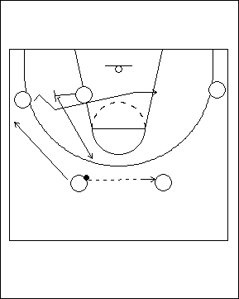 | Manoeuvre de base  Le système de base dans lequel les joueurs/joueuses évoluent est le suivant : un(e) attaquant(e) à l’intérieur sur le côté où se trouve le ballon, et quatre joueurs/joueuses réparti(e)s en périphérie, soit deux arrières et deux ailier(ère)s ou avants.  Lorsque les arrières s’échangent le ballon, l’attaquant(e) à l’intérieur doit placer un écran pour l’ailier(ère); il ou elle ouvre à la balle et remonte au haut et prend la place de l’arrière qui a fait la passe, car celui-ci ou celle-ci s’est déplacé(e) à l’aile pour remplacer le joueur ou la joueuse qui a coupé au travers de la clé.
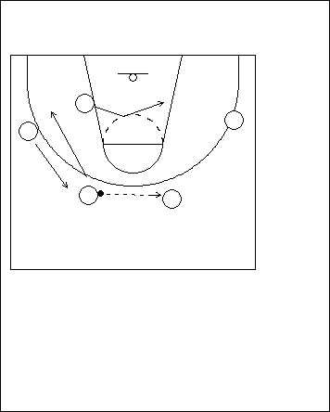 | L’attaquant(e) à l’intérieur demeure à son poste  L’attaquant(e) à l’intérieur a l’option de suivre le ballon si il/elle détient un avantage par rapport à son/sa défenseur(e).  Dans ce cas, l’ailier(ère) et l’arrière permutent.
Offensive flow
In any good offenisve system, each action connects; as one is finishing the next is occuring.On a bad team the action stops, then starts.
Offensive Tempo
The offence must reflex the opposite tempo of the defence. If the defence wants to slow down we need to play faster on offence. If the defence is trying to press, we need to slow down.
Coach Pasquali

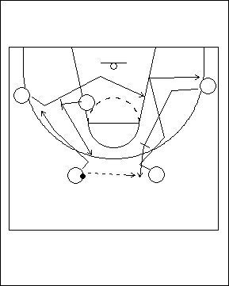 | Écran dans le dos sur le côté faible  Si la défensive conteste l’arrière du côté faible, l’ailier(ère) qui se trouve sur le même côté peut remonter et placer un écran pour cet(te) arrière. L’ailier(ère) devrait amorcer son action en coupant légèrement vers le panier, car cela lui donnera un meilleur angle pour placer son écran. Lorsque les arrières s’échangent le ballon, l’attaquant(e) à l’intérieur place un écran dans le dos, et l’arrière se déplace vers l’aile.
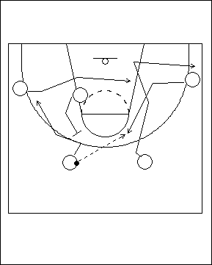 | Couper par derrière sur le côté faible, et faire un écran dans le dos sur le côté fort  Pour amorcer l’action, l’arrière qui est sur le côté faible coupe au panier par derrière et va prendre la place de l’ailier(ère), tandis que celui-ci ou celle-ci coupe et se rend à l’endroit où était l’arrière. Ceci permet alors aux arrières de s’échanger le ballon. Au lieu de placer un écran dans le dos du/de la défenseur(e) pour l’ailier(ère), l’attaquant(e) à l’intérieur le fait plutôt pour l’arrière situé(e) du même côté.  L’ailier(ère) sur le côté du ballon coupe de façon énergique vers le panier et termine sa course sur le côté opposé, puis se positionne à l’intérieur; ceci crée une ouverture qui permet à l’attaquant(e) à l’intérieur de venir placer un écran pour l’arrière.
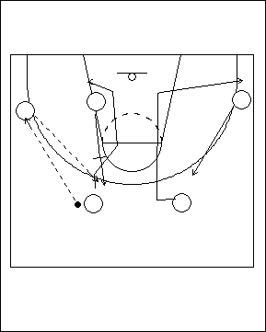 | Passe à l’aile  Si le ballon est remis à l’ailier(ère), l’attaquant(e) à l’intérieur vient placer un écran pour l’arrière situé sur le côté du ballon. Pendant ce temps, les joueurs/joueuses sur le côté faible permutent.
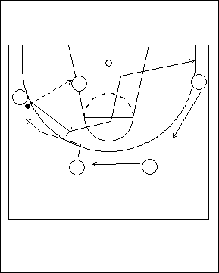 | Ballon à l’intérieur, et vers le bas  Lorsque le ballon est remis à l’attaquant(e) à l’intérieur, les joueurs/joueuses situé(e)s en périphérie doivent se déplacer pour maintenir un bon espacement. L’ailier(ère) qui fait la passe peut placer un écran pour l’arrière qui est sur le côté du ballon. Après l’écran, ce joueur ou cette joueuse coupe et va à l’aile sur le côté opposé, tandis que les autres joueurs/joueuses se déplacent d’une position sur le côté où se trouve le ballon. Il est important d’insister pour que personne ne vienne se placer dans le coin où se trouve le ballon tant qu’il est encore à l’intérieur, car l’attaquant(e) en possession aurait alors de la difficulté à voir simultanément tou(te)s les joueurs/joueuses sur le terrain.
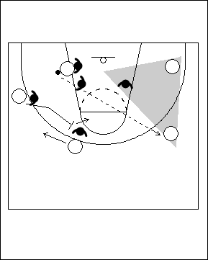 | Si l’équipe adverse joue à deux défenseur(e)s contre l’attaquant(e) à l’intérieur, les joueurs/joueuses doivent chercher à passer le ballon en vue de créer une situation à 2 contre 1.
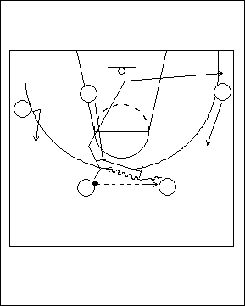 | Écran sur la balle suivi d’un pivot  Il est important d’insister sur le fait que lorsque les joueurs/joueuses font un écran sur la balle, il doit tout d’abord y avoir une action avec un autre écran qui précède.  Les arrières s’échangent le ballon tandis que l’attaquant(e) à l’intérieur se déplace pour faire un écran vers le haut, puis place ensuite son écran sur la balle. Cette manœuvre fait en sorte qu’il est difficile pour le/la défenseur(e) qui couvre le joueur ou la joueuse à l’intérieur d’arriver à temps pour défendre l’écran sur la balle.

Concepts dont on doit se rappeler :

- Après avoir effectué quelques passes, il faut laisser les joueurs/joueuses libres de couper, faire des pénétrations, s’espacer, etc.; cela permettra à leur talent de s’exprimer.

- Dans tout système d’attaque, on doit conserver une certaine souplesse pour ce qui est de l’exécution.

- L’entraîneur(e) peut modifier les options offensives après un temps-mort.

4 contre 4 – Décortiquer le système d’attaque

Les éducatifs ci-dessous se déroulent à 4 contre 4 et ont pour but de travailler différents aspects du système offensif.

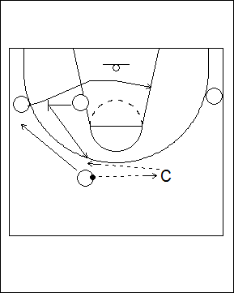 | Passe d’un(e) arrière à l’autre  Dans cet éducatif, l’entraîneur(e) joue le rôle du/de la deuxième arrière. Le joueur ou la joueuse d’intérieur monte pour faire un écran à l’arrière, et les autres s’exercent à faire une bonne lecture de l’action par laquelle l’ailièr(e) coupe à l’intérieur suite à l’écran.  Ici, l’arrière travaille quatre aspects du jeu : (1) utiliser l’écran pour se déplacer à l’aile, (2) se déplacer pour recevoir la passe, (3) prendre la place d’un(e) partenaire, et (4) faire une pénétration.
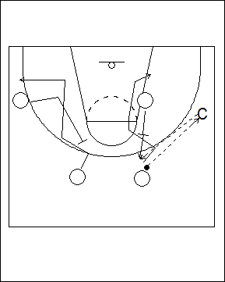 | Dans cet éducatif, on travaille à faire l’écran vers le haut pour l’arrière lorsque celui-ci ou celle-ci exécute une passe à l’aile (à l’entraîneur(e) dans cet exemple).
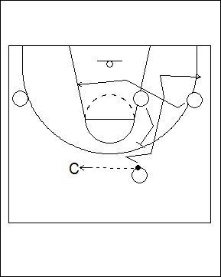 | Dans cet éducatif, l’ailier(ère) s’exerce à couper par derrière, puis l’attaquant(e) à l’intérieur enchaîne en plaçant un écran dans le dos du/de la défenseur(e) pour l’arrière.

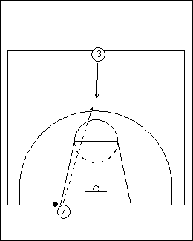 | Contre-attaque/montée rapide du ballon  Questions à se poser:  - Cherche-t-on à effectuer un lancer rapide, ou à passer le centre du terrain?  - Qui est le plus en mesure de manier le ballon quand la pression est forte?  - Qui sont les meilleur(e)s passeurs/passeuses?  - Qui peut marquer à la fin de la contre-atttaque?  - Qui est bon(ne) pour remettre le ballon en jeu, et qui peut se démarquer efficacement au centre du terrain?  .
Il est important de faire évoluer les joueurs/joueuses à des positions où ils/elles auront le plus de chances de connaître du succès. Ils/elles doivent jouer avec confiance.

Il est essentiel de savoir si on doit utiliser une contre-attaque rapide ou contrôlée vers la zone adverse; dans chaque cas, il faut cependant toujours chercher à créer trois corridors de passe (latéralement; vers le centre; vers l’arrière) et avoir une solution de rechange en cas de forte pression défensive. Des exemples de contre-attaques sont proposés ci-après :

CONTRE-ATTAQUE
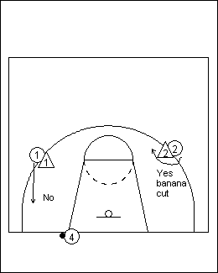 | Remise en jeu  L’attaquant(e) qui fait la remise en jeu doit se placer de façon à avoir une vue d’ensemble du terrain. Il ou elle doit de plus pouvoir faire de longues passes, et devrait éviter de se placer directement sous le panier afin d’avoir plus d’espace.  Une passe doit toujours être faire à un(e) partenaire qui se trouve au-delà du prolongement de la ligne de lancer franc. Au besoin, les attaquant(e)s peuvent couper en suivant une trajectoire « en forme de banane », prendre position contre le ou la défenseur(e) vers le haut et ainsi recevoir une longue passe, ou encore faire une feinte vers l’extérieur et couper au centre. | 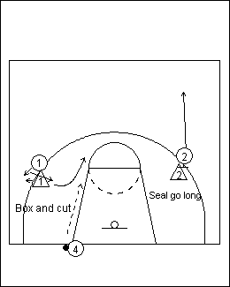

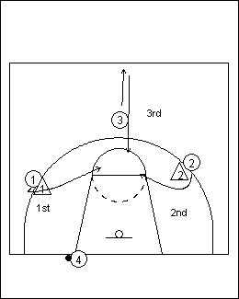 | Ordre des actions lors de la remise en jeu  Pour créer le plus d.espace possible, les joueurs/joueuses devraient se placer loin de la ligne de fond. Celui ou celle qui fait la remise en jeu doit tout d’abord jeter un coup d’œil à l’arrière qui est de son côté, ensuite vers l’arrière qui est sur le côté éloigné et, en dernier lieu, à un(e) partenaire qui coupe et revient brusquement dans sa direction à partir du centre.  Lorsque la pression défensive est intense, comme première option on devrait envisager une passe au joueur ou à la joueuse 3; en effet, les opportunités sont souvent meilleures lorsque le ballon se trouve au centre du terrain.

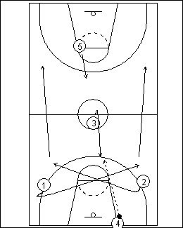 | Contre-attaque rapide  Ici, on cherche à monter le ballon en ligne droite rapidement, et en passant « par-dessus » la pression défensive. Quand la passe est faite au joueur ou à la joueuse 3 au centre, l’attaquant(e) 5 revient vers la balle pour recevoir une passe dans la zone offensive. Les attaquant(e)s 1 et 2 coupent par derrière et se croisent au centre, puis se dirigent rapidement vers la zone offensive le long des lignes de côté. Le joueur ou la joueuse 4 suit, en retrait.  Ensuite, le joueur ou la joueuse 3 doit faire une bonne lecture de la défensive et « attaquer la pression ». Les options sont alors les suivantes : (1) passer au centre à l’attaquant(e) 5, (2) passer vers la ligne de côté aux attaquant(e)s 1 ou 2, ou (3) dribbler au centre.

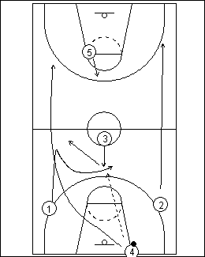 | Contre-attaque contrôlée  Lors de cette contre-attaque, le joueur ou la joueuse 4 passe à 3 qui revient au centre; pendant ce temps, l’attaquant(e) 1 fait un départ brusque et coupe au centre pour une remise de mains à mains. Après la remise, le joueur ou la joueuse 3 doit chercher à écarter la défensive en courant vers le côté et en demeurant dans le couloir.

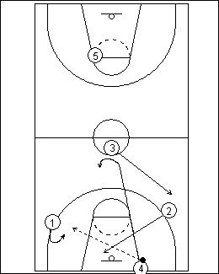 | Contre-attaque contrôlée  Dans cet exemple, le joueur ou la joueuse 4 remet le ballon à son/sa partenaire 1, puis sprinte jusqu’au centre du terrain et revient vers le ballon en faisant un tracé en crochet. Le joueur ou la joueuse 2 coupe derrière le ballon pour le renversement, tandis que l’attaquant(e) 3 coupe vers le côté opposé où le ballon a été passé (ils/elles préparent un renversement).  Par la suite, le joueur ou la joueuse 1 monte rapidement le ballon le long de la ligne de côté, le joueur ou la joueuse 4 se place au milieu au centre du terrain, et le joueur ou la joueuse 2 reste en retrait sous le panier pour recevoir une passe de renversement au besoin. L’entrée de zone peut se faire pour les joueurs/joueuses 1 ou 2. Pour leur part, l’attaquant(e) 3 va du côté opposé et 4 sprinte vers le centre.

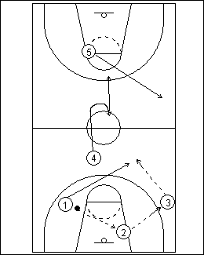 | Contre-attaque contrôlée  Dans ce système, le joueur ou la joueuse 1 remet le ballon vers l’arrière à 2, qui fait une lecture rapide du jeu et remet ensuite à 3, qui passe à son tour à 1 qui a coupé par le centre.  Le joueur ou la joueuse 2 doit faire une lecture du jeu et ses options sont les suivantes : (1) passer au centre à l’attaquant(e) 4, (2) défier son/sa défenseur(e) en dribblant ou (3) chercher à faire un « passe et va » vers le centre à l’attaquant(e) 1.  Pour sa part, le joueur ou la joueuse 3 peut passer (1) à son/sa partenaire 5 sur le côté si il/elle est disponible, (2) au centre à l’attaquant(e) 4, ou (3) en retrait au joueur ou à la joueuse 2 (qui doit alors monter le ballon rapidement en dribblant tout en s’éloignant de l’action).

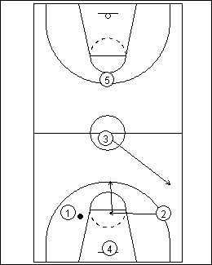 | Contre-attaque de type 1-2-1-1  Si l’adversaire ne surveille pas le joueur ou la joueuse 3 qui coupe, et conteste l’attaquant(e) 4 au centre et l’attaquant(e) 2 qui est en position pour un renversement, 3 doit alors conserver le ballon.  Le joueur ou la joueuse 4 remet le ballon en jeu et s’avance pour le renversement, tandis que l’attaquant(e) 3 se tient au centre. Pour surcharger encore davantage la zone où il y a beaucoup de défenseur(e)s, 3 coupe du côté opposé au ballon après avoir fait une lecture du/de la défenseur(e) qui couvre son/sa partenaire 2.  À ce stade, l’attaquant(e) 1 réalise que la défensive conteste son/sa partenaire 4, et que 3 est marqué(e). L’attaquant(e) 2 doit alors couper rapidement vers la ligne de lancer franc, tandis que 1 doit lire le jeu et réaliser que le/la défenseur(e) continue toujours à couvrir 2. Dans une contre-attaque contrôlée, il faut que la passe soit faite vers l’arrière au joueur ou à la joueuse 4, qui remettra à son tour le ballon à l’attaquant(e) 3. Lors d’une contre-attaque rapide, on doit faire la passe au joueur ou à la joueuse 2 qui est au centre.

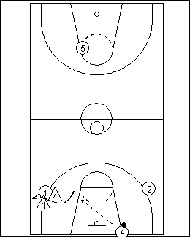 | Un(e) arrière contre deux arrières  Si une équipe ne possède qu’un(e) seul(e) arrière qui est habile à manier le ballon, celui-ci ou celle-ci doit travailler fort pour l’avoir. Lors d’une couverture défensive à deux, cet(te) arrière doit feinter, et tenter de passer entre les deux défenseur(e)s.  Lorsqu’il y a deux arrières efficaces, chacun(e) est un(e) réceptionnaire potentiel(le) pour la passe. L’un(e) peut alors couper et libérer de l’espace pour l’autre.

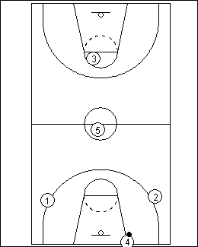 | Faire évoluer les joueurs/joueuses là où ils/elles pourront être efficaces  Si l’attaquant(e) 5 est un passeur ou une passeuse efficace, il/elle peut s’avérer être la solution à une forte pression que la défensive exerce au centre, car ses partenaires auront alors de bonnes chances de marquer. De plus, il est peu probable que le/la défenseur(e) qui marque ce joueur ou cette joueuse tente de s’interposer contre la passe.  Le ballon doit être remis en jeu par le meilleur passeur ou la meilleure passeuse de l’équipe; cet(te) attaquant(e) doit prendre de bonnes décisions et pouvoir lancer loin.

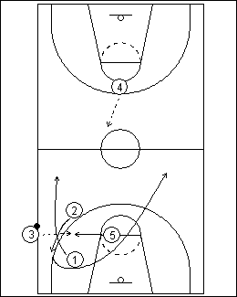 | Sortie de balle le long de la ligne de côté, dans sa propre zone  Ici, le concept est le même que lorsque les deux arrières cherchent à couper pour se libérer. Le joueur ou la joueuse 5 représente la solution à la pression défensive.  Lorsque la passe est faite au joueur ou à la joueuse 5, l’attaquant(e) 4 coupe rapidement au centre tandis que l’arrière coupe par derrière. Cette manœuvre peut s’effectuer à vitesse contrôlée, ou encore rapidement.

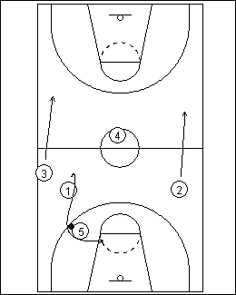 | Contre attauqe contrôlée  Le joueur ou la joueuse 1 feint d’amorcer une course vers la zone offensive, puis revient pour une remise de mains à mains.  Lors d’une contre-attaque rapide, il faut être à l’affût de toute passe en ligne droite qui pourrait être faite en direction de la zone adverse.

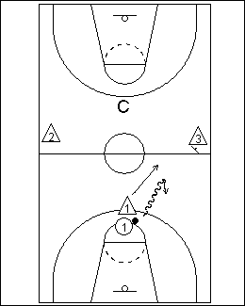 | 1 contre 3 – éducatif pour les arrières  Le joueur ou la joueuse 1 attaque le ou la défenseur(e) qui met de la pression. Il/elle peut alors utiliser un dribble de recul pour éviter la trappe et attaquer de l’autre côté.  Lors de ce type d’action, il ne faut pas interrompre le dribble.

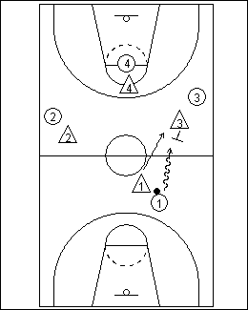 | 4 contre 4  L’entraîneur(e) indique l’un des trois types de trappes défensives et de rotations afin que les arrières puissent s’exercer à faire une bonne lecture de chaque situation : (1) faire une rotation et laisser à découvert l’arrière qui est de l’autre côté); (2) aucune rotation (ce qui laisse l’ailier(ère) du même côté à découvert); et (3) faire une rotation et laisser une ouverture au centre.  De plus, on doit rappeler à l’arrière que, dans une situation de trappe où il ne semble y avoir aucune ouverture, il/elle peut lancer le ballon sur la jambe de l’un(e) des défenseur(e)s.

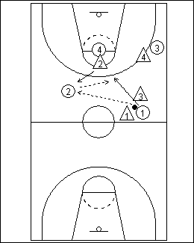 | 4 contre 4 - Passe-et-va pour à la sortie d’une trappe défensive  On doit rappeler aux joueurs/joueuses qu’il faut couper de façon énergique pour un « passe-et-va » lorsque l’on réussit la passe pour se sortir d’une trappe défensive. Si l’attaquant(e) coupe sans hésiter, ceci permet de passer entre les deux défenseur(e)s et de créer instantanément une situation à 5 contre 3.  Pour surcharger l’éducatif, on peut ajouter un(e) cinquième défenseur(e) et jouer à 5 contre 5, ou encore varier le type de pression exercée par les défenseur(e)s.

Contre-attaque
Questions à se poser:

- Cherche-t-on à effectuer un lancer rapide, ou à se render au centre du terrain?
- Qui est le plus en mesure de transporter le ballon quand la pression est forte?
- Qui sont les meilleur(e)s passeurs/passeuses?
- Qui peut conclure la manoeuvre et marquer?
- Qui est bon(ne) pour remettre le ballon en jeu, et qui peut se démarquer efficacement au centre du terrain?

Il est important de faire évoluer les joueurs ou joueuses aux positions qui leur permettront de connaître du succès. En tant qu’entraîneur(e), il ne faut pas que l’on montre des signes de nervosité lorsqu’il y a de la pression; il faut plutôt adopter une attitude du type « pas de problème, nous sommes prêt(e)s ! ».

ATTAQUE D’UNE DÉFENSIVE DE ZONE

Cette section présente une approche conceptuelle pour enseigner l’attaque d’une défensive de zone.
Objectifs
1. Améliorer l’habileté des attaquant(e)s à faire une bonne lecture du jeu défensif.
2. Améliorer l’habileté des attaquant(e)s à prendre de bonnes décisions.
3. Accroître et améliorer le répertoire technique en vue d’attaquer efficacement une défensive de zone

Points clés :
- Au début, on doit enseigner les concepts en faisant évoluer les joueurs/joueuses à 4 contre 4; cela leur permettra d’avoir plus d’espace et de manipuler le ballon plus souvent, ce qui confèrera du même coup un avantage à l’attaque.
- L’action doit s’amorcer de façon dynamique.
- On doit enseigner un seul concept à la fois.
- On doit utiliser une approche axée sur le jeu lors des éducatifs.
- Il faut prioriser les concepts et non les stratégies.

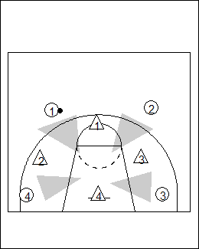 | Concept 1 – Espacement des joueurs/joueuses  Dans la situation illustrée à gauche, les joueurs/joueuses cherchent à s’infiltrer dans les ouvertures. Les attaquant(e)s doivent déterminer si l’équipe adverse présente un front défensif pair ou impair. Les joueurs/joueuses en périphérie se placent dans les ouvertures, et cela contribue à créer une certaine confusion chez les défenseur(e), à savoir qui marquera chaque attaquant(e).  De plus, l’attaquant(e) qui joue à l’intérieur tente de prendre position contre un(e) défenseur(e) afin de créer une ouverture; il/elle peut également ressortir à l’extérieur pour contribuer à maintenir la circulation du ballon et à créer des ouvertures encore plus larges.

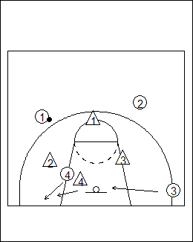 | Attaque d’un front défensif impair avec un(e) attaquant(e) placée en bas à l’intérieur  Le joueur ou la joueuse 4 tente de prendre position contre le/la défenseur(e) placé(e) au bas de la défensive de zone afin de créer une ouverture et de coincer un(e) adversaire. Si cet(te) attaquant(e) est couvert(e), il/elle peut ressortir vers le coin rapproché et ainsi attirer le/la défenseur(e). Ceci rapprochera probablement deux défenseur(e)s et provoquera une ouverture qu’un(e) autre attaquant(e) pourra chercher à exploiter.

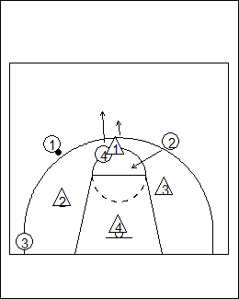 | Attaque d’un front défensif impair avec un(e) attaquant(e) placé(e) au haut de la clé.  Ce concept est identique au précédent, sauf qu’en prenant position, l’attaquant(e) à l’intérieur coince l’un(e) des défenseur(e)s, créant ainsi une ouverture encore plus large pour les attaquant(e)s qui se trouvent en périphérie.  Le joueur ou la joueuse 4 peut également ressortir pour attirer un(e) défenseur(e) ou encore pour aider à inverser le sens dans lequel circule le ballon.

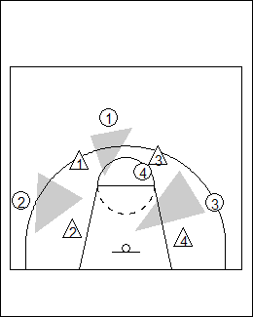 | Attaque d’un front défensif pair  Les attaquant(e)s en périphérie se placent dans les ouvertures. Le joueur ou la joueuse 4 (celui ou celle qui est à l’intérieur, vers le haut), tente de prendre position contre un(e) défenseur(e) qui évolue au haut, pour le/la coincer.  L’attaquant(e) qui joue haut à l’intérieur ne devrait pas amorcer son jeu au milieu du terrain, car cela empêcherait alors l’arrière d’avoir un accès direct au panier.

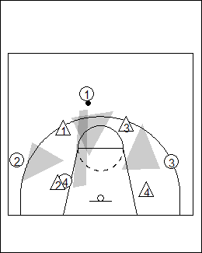 | Attaque d’un front défensif pair – l’attaquant(e) placé(e) bas à l’intérieur coince un(e) défenseur(e)  L’attaquant(e) 4 prend position contre le/la défenseur(e) 2 qui évolue au bas de la défensive de zone et le/la coince à l’extérieur, ce qui lui permet de recevoir une passe.  Le joueur ou la joueuse 4 peut également se diriger vers le coin rapproché pour élargir l’ouverture ou repousser encore plus les adversaires.

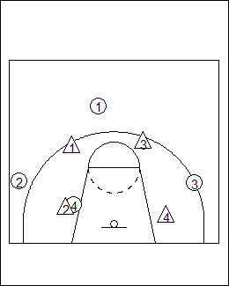 | Concept 1 – Approche par jeux  Dans cette situation, on joue à 4 contre 4 et les attaquant(e)s affrontent un front défensif pair ou impair. On multiplie les points marqués par le nombre de fois qu’on inverse le sens dans lequel le ballon circule. Par exemple si cela se produit 4 fois avant de marquer, les attaquant(e)s obtiennent alors 8 points. On peut inverser le sens de la circulation du ballon en faisant des passes, des passes au-dessus de la tête ou en utilisant le joueur ou la joueuse d’intérieur. Les attaquant(e)s ne sont pas autorisé(e)s à dribbler ou couper, ce qui les oblige à faire beaucoup de feintes de passe; pour sa part, l’attaquant(e) à l’intérieur s’exerce à prendre position contre les défenseur(e)s et à ressortir de la clé. Toutes ces actions ont pour but de semer la confusion parmi les défenseur(e)s.  Les joueurs/joueuses devraient chercher à se rendre disponibles pour recevoir des passes en entrant et en ressortant des ouvertures, ou encore en exploitant les espaces à découvert créés par les actions de l’attaquant(e) à l’intérieur qui prend position contre un(e) défenseur(e).  Les attaquant(e)s doivent de plus toujours être prêt(e)s à lancer lorsqu’une bonne occasion se présente.

Concept 2 –Pénétration
Il est important de pouvoir effectuer des pénétrations afin d’affaisser ou de modifier la forme que les adversaires donnent au système défensif de zone. Il existe trois types de dribbles de pénétration :

1. Dribble pour immobiliser l’adversaire – on l’utilise pour obliger un(e) défenseur(e) à demeurer dans un secteur précis
2. Dribble vers le côté - on l’utilise pour éloigner un(e) défenseur(e) du secteur qu’il/elle protège
3. Dribble d’attaque – on l’utilise pour attaquer le panier

On peut également utiliser la passe pour pénétrer. Pour attaquer efficacement une défensive de zone, l’équipe doit utiliser une combinaison de passes en périphérie et de passes de pénétration.

Enfin, les joueurs/joueuses peuvent également pénétrer en coupant, entre autres en coupant « à la verticale » pour attaquer le panier. Les attaquant(e)s doivent toujours attaquer lorsque la voie au panier est libre : si le joueur ou la joueuse réalise qu’il y a un couloir libre, il/elle doit attaquer.

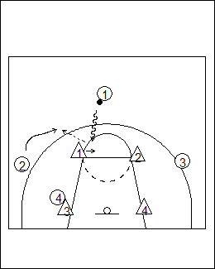 | Dribble pour immobiliser l’adversaire  Les joueurs/joueuses en périphérie devraient pénétrer vers le pied intérieur du/de la prochain(e) défenseur(e) afin de l’immobiliser et de créer une occasion de lancer pour le/la partenaire proche.  Dans l’exemple de gauche, l’attaquant(e) à l’intérieur (4) tente de prendre position contre le/la défenseur(e) qui le/la marque (3), ce qui permet à son/sa partenaire qui est en périphérie (2) de glisser ou de faire une rotation afin de pouvoir effectuer un lancer sans être gêné(e). Si l’attaquant(e) 2 fait une rotation par derrière, cela obligera le/la prochain(e) défenseur(e) (2, qui se trouve en haut à droite) à faire un long déplacement lors d’une éventuelle récupération.

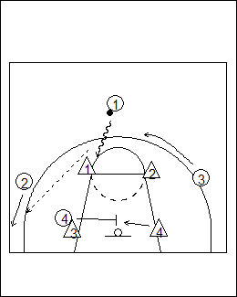 | Déplacements des joueurs ou des joueuses en périphérie  Utiliser un dribble qui immobilise l’adversaire s’avère souvent efficace pour isoler un(e) défenseur(e) à l’intérieur du système défensif de zone.  Dans cette situation, le/la défenseur(e) 1 est vulnérable si l’attaquant(e) 2 glisse et l’attaquant(e) 4 prend position contre le/la prochain(e) défenseur(e) 3, puis le libère ensuite pour aller prendre position contre le ou la prochain(e) adversaire 4.  Cette séquence est efficace lorsqu’on cherche à utiliser le joueur ou la joueuse d’intérieur pour déstabiliser la défensive de zone.

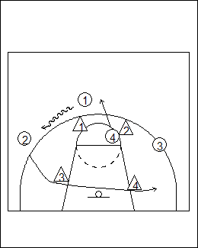 | Poussée avec dribble et joueur/joueuse tiré(e)  Lorsqu’un(e) attaquant(e) qui est en périphérie dribble vers son/sa partenaire le/la plus proche, on parle d’une « poussée avec dribble ». Le but est d’attirer l’un(e) des défenseur(e)s hors position et ainsi déstabiliser la défensive de zone. Le joueur ou la joueuse vers qui fait le dribble peut traverser la formation défensive en courant, ou encore couper en arc de cercle pour aller prendre la place que le dribbleur ou la dribbleuse occupait au départ. Ici, le terme « tiré(e) » est utilisé pour désigner la situation dans laquelle le ou la défenseur(e) suit l’attaquant(e) qui s’éloigne en dribblant.  Dans cet exemple, le joueur ou la joueuse 1 dribble jusqu’à son/sa partenaire 2, et attire le/la défenseur(e) 1 hors position. Le joueur ou la joueuse 4 sort ensuite vers le haut pour prendre la place laissée vacante par 1, tandis que l’attaquant(e) 2 traverse la défensive en courant pour créer une situation de surnombre.  Il est important que les attaquant(e)s fassent une lecture correcte du jeu défensif. Si le/la défenseur(e) reste avec l’attaquant(e) qui dribble, le joueur ou la joueuse qui est « tirée » (attaquant(e) 4 dans cet exemple) devrait se retrouver à découvert. Si le/la défenseur(e) passe la responsabilité du dribbleur ou de la dribbleuse (déf. 3 dans cet exemple), il faut tenter de remettre le ballon à l’attaquant(e) vers qui la « poussée » a été effectuée (2 dans cet exemple) lors d’un renversement de passe.

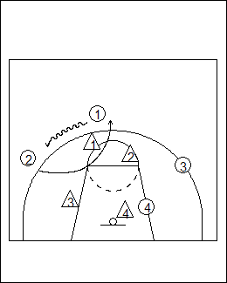 | Dans cet exemple, le joueur ou la joueuse 1 dribble jusqu’à l’endroit qu’occupe le joueur ou la joueuse 2, qui coupe ensuite en arc de cercle pour prendre la place laissée vacante par son/sa partenaire.  Pendant ce temps, le joueur ou la joueuse 4 coince un(e) défenseur(e) à l’intérieur de la défensive de zone.

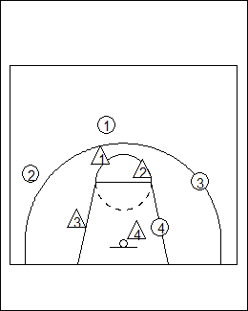 | Concept 2 – Approche par jeux  Ce scénario est le même qu’auparavant, mais dans le cas présent les joueurs/joueuses évoluent à 4 contre 4 et on ajoute le dribble, de sorte que les attaquant(e)s peuvent utiliser les manœuvres précédentes (dribble pour « immobiliser l’adversaire » ou « pousser – tirer »).  On peut également ajouter des pénétrations et des rotations pour surcharger l’éducatif.

Concept 3 – Couper
Les joueurs/joueuses peuvent couper pour créer de la confusion dans le système défensif de zone ou encore un surnombre sur un côté.

Il faut toutefois que les attaquant(e)s aient remarqué quel(le) défenseur(e) marque chaque attaquant(e) dans la défensive de zone – au haut, sur la passe d’entrée à l’aile, à l’intérieur, lors d’une passe de renversement faite au-dessus de la défensive, etc.

Ces informations sont importantes, car elles déterminent de quelle façon les joueurs/joueuses devraient couper.

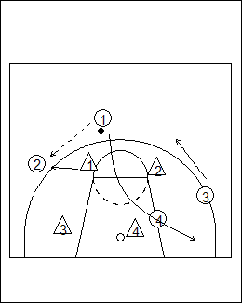 | Si le/la défenseur(e) en haut marque l’ailier(ère), il faut inverser le sens dans lequel circule le ballon.  Le joueur ou la joueuse placé(e) en haut passe, et coupe ensuite du côté opposé au ballon.

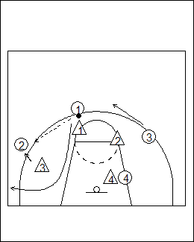 | Si le/la défenseur(e) qui joue en bas marque l’ailier(ère) en possession du ballon, l’attaquant(e) placé(e) en haut doit chercher à couper au coin, du côté du ballon.  Ces manœuvres par lesquelles les attaquant(e)s coupent fonctionnent bien si on applique les principes de pénétration.

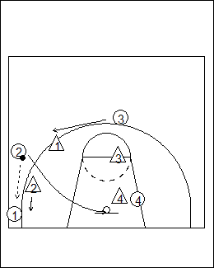 | Passe au coin  Si le/la défenseur(e) suit le ballon et se déplace vers le coin, la meilleure option est de couper après avoir fait une passe au/à la partenaire qui se trouve dans le coin.

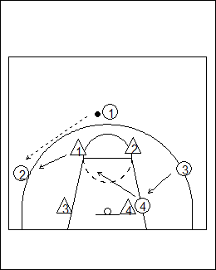 | Prendre la place qu’un(e) partenaire vient tout juste de laisser vacante  Un autre principe à respecter lorsqu’on coupe est de le faire derrière le/la défenseur(e) et vers un endroit qu’un(e) adversaire a laissé à découvert. Au même moment, un(e) deuxième attaquant(e) doit alors prendre la place que le/la partenaire qui a coupé vient tout juste de laisser vacante. De tels déplacements causent souvent de la confusion parmi les défenseur(e).  Dans cet exemple, le joueur ou la joueuse 4 coupe vers le haut de la clé lorsque le/la défenseur(e) 1 se déplace vers le ballon. Ceci permet alors au joueur ou à la joueuse 3 de couper par derrière et de prendre la place laissée vacante par l’attaquant(e) 4; il/elle peut alors recevoir une passe en diagonale si le/la défenseur(e) 4 se déplace pour suivre l’attaquant(e) 4.

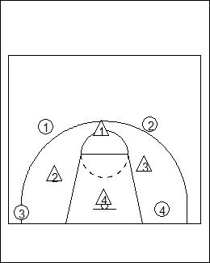 | Concept 3 – Approche par jeux  Dans cet exemple, on utilise les mêmes règles que précédemment, mais les attaquant(e)s peuvent couper.  On cherche à faire une lecture de la défensive afin de savoir qui marque l’attaquant(e) qui recevra la première passe.  En plus de couper, les attaquant(e)s utilisent les manœuvre de dribble où l’on « pousse », « tire » et « immobilise ».

Concept 4 – Faire des écrans
Avec les écrans, on cherche à faire des trous dans la défensive de zone; il sera alors difficile pour les défenseur(e)s d’aider et de récupérer, et également d’efefctuer des permutations.

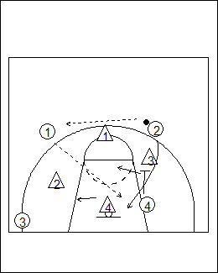 | Écran dans le dos du/de la défenseur(e) (un)  Dans cette situation, le joueur ou la joueuse 4 fait un écran dans le dos du le/la défenseur(e) 3 afin de permettre à l’attaquant(e) 2 de couper au panier.

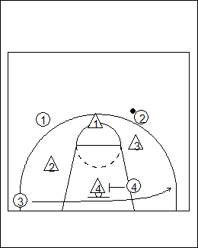 | Écran dans le dos du/de la défenseur(e) (deux)  Ici, le joueur ou la joueuse 4 fait un écran pour coincer le/la défenseur(e), permettant ainsi à son/sa partenaire 3 de se déplacer en courant le long de la ligne de fond.

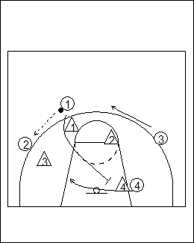 | Écran dans le dos du/de la défenseur(e) (trois)  Après avoir fait une passe au joueur ou à la joueuse 2, l’attaquant(e) 1 coupe au travers de la clé, et fait un écran vers le bas pour le joueur ou la joueuse 4.

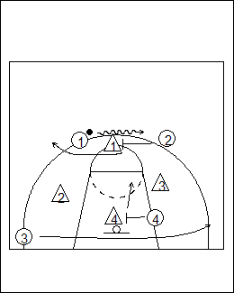 | Écran dans le dos du/de la défenseur(e) (quatre)  Le joueur ou la joueuse 2 fait un écran pour coincer le/la défenseur(e) de l’attaquant(e) 1, et au même moment le joueur ou la joueuse 4 fait un écran pour l’attaquant(e) 3 qui se déplace le long de la ligne de fond.

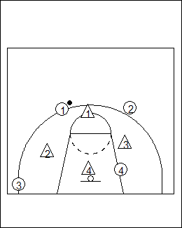 | Concept 4 – Approche par jeux  On utilise les mêmes principes que ceux décrits précédemment, mais on ajoute les écrans. Dans cet éducatif, on fait en sorte que les joueurs/joueuses s’exercent à faire un écran :  - en périphérie pour permettre à l’attaquant(e) qui est à l’intérieur de couper  - à l’intérieur pour permettre à l’attaquant(e) qui est en périphérie de couper  - sur la balle - fait par l’attaquant(e) en périphérie (qui court jusqu’à l’endroit où l’écran est placé)  - sur la balle - fait par le joueur ou la joueuse d’intérieur (qui roule au panier).

Principes de base
Cet éducatif sert à établir les principes de base : l’attaquant(e) reste deux secondes à l’intérieur, puis sort pendant deux secondes tandis que les joueurs/joueuses en périphérie pénètrent, font des rotations, et exécutent des passes.

Attaque d’une défensive de zone – autres points à considérer
- L’entraîneur(e) devrait contrôler qui joue en défensive contre ses joueurs/joueuses. Chaque attaquant(e) doit prendre place devant le/la défenseur(e) de son choix.
- On doit tenir compte des aspects suivants : la forme de la défensive de zone; la façon dont les défenseur(e)s se déplacent; le secteur attribué à chaque défenseur(e); le type de front défensif (pair ou impair); l’espace qu’il y a entre les défenseur(e)s; les endroits où il y a des ouvertures et des avantages, ainsi que les opportunités de prendre position contre un(e) défenseur(e).
- Les feintes de passe et les feintes de lancer.
- Utiliser les actions par lesquelles les attaquant(e)s coupent à partir du haut ou du bas pour créer des occasions de rebond du côté faible.

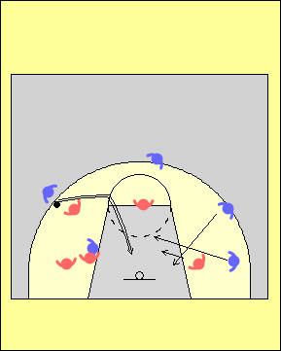

- Faire des écrans ou prendre position contre le/la défenseur(e) – écran au centre : on prend position, puis on libère.
- Pénétration avec dribble – pour immobiliser le/la défenseur(e), l’obliger à se déplacer, ou encore le ou la « tirer »; faire en sorte qu’un(e) défenseur(e) marque l’attaquant(e) en possession du ballon.
- Créer un surnombre offensif – du côté opposé au ballon, en sortant un joueur(se) ou une joueuse d’intérieur ou en positionnant deux attaquant(e)s côte à côte à l’intérieur
- Mouvements des joueurs/joueuses – occuper l’endroit laissé vacant par un(e) partenaire.
- Attaquer derrière – couper en provenance du côté opposé au ballon dans le dos des défenseur(e)s, sortir au coin rapproché
- Passes pour pénétrer et passes de renversement – il faut être en position pour faire la passe suivante – la passe au-dessus de la tête (écran vers le haut en périphérie du côté opposé)

Approche simple pour attaquer une défensive de zone

Lorsque les entraîneur(e)s voient une défensive de zone pour la première fois, ils/elles font souvent l’erreur d’assigner des postes permanents aux joueurs/joueuses. Cette section décrit une approche simple pour attaquer une défensive de zone dans laquelle les attaquant(e)s évoluent à plusieurs positions. Tel que mentionné précédemment, il est très important que les joueurs/joueuses apprennent et maîtrisent les concepts et les techniques de base du système d’attaque, et pas uniquement « le système ».

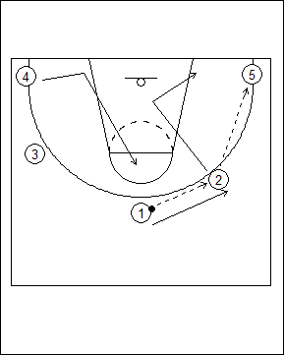 | L’attaque s’amorce avec cinq joueurs/joueuses en périphérie. On déplace le ballon vers l’extérieur jusque dans un coin. L’ailier(ère) coupe ensuite vers le panier, du côté du ballon et sort au coin rapproché. L’attaquant(e) dans le coin opposé coupe vers le haut de la clé, et celui/celle qui est au haut glisse pour prendre la place de l’ailier(ère). On a alors créé un surnombre offensif contre la défensive de zone.
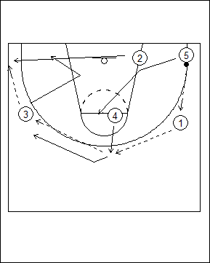 | On inverse le sens dans lequel circule le ballon. Le joueur ou la joueuse placé(e) au coin rapproché suit le ballon, puis coupe au coin opposé au moment où le ballon change de direction. L’attaquant(e) à la ligne de lancer franc ressort en périphérie, inverse le sens de la circulation du ballon et devient le/la joueur (se) au haut de la clé.  Une fois que le ballon a été remis au joueur ou à la joueuse qui est dans le coin, la même séquence de mouvement se répète de l’autre côté.

SITUATIONS PARTICULIÈRES
L’entraîneur(e) doit préparer son équipe en vue de différentes situations qui surviennent au cours d’un match, entre autres :

- Entre-deux
- Lancers francs
- Remises en jeu
  - En zone d’attaque, à partir de la ligne de côté
  - En zone d’attaque, à partir de la ligne de fond
  - En zone défensive, à partir de la ligne de côté
  - En zone défensive, à partir de la ligne de fond (on peut courir)
  - En zone défensive, à partir de la ligne de fond (on ne peut pas courir)
  - Au milieu du terrain (seulement vers la zone d’attaque)
  - Au milieu du terrain (on peut aller dans l’une ou l’autre direction)

ENTRE-DEUX
Même s’il n’y a qu’une seule situation d’entre-deux, l’entraîneur(e) devrait néanmoins s’assurer que son équipe soit bien préparée car l’entre-deux peut donner le ton à un match. On doit faire une distinction entre un saut à caractère offensif et un autre à caractère offensif. S’il y a de fortes chances que ce soit l’autre équipe qui s’empare du ballon, on devrait adopter une formation défensive.

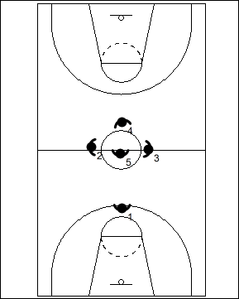 | Entre-deux à caractère offensif  Dans ce cas, on place un(e) joueur/joueuse additionnel(le) autour du cercle central, du côté offensif. Il est alors fort probable que l’un(e) des adversaires soit désigné(e) comme « gardien(ne) » afin d’empêcher un tir en foulée facile.  Entre-deux à caractère défensif  Dans ce cas, le/la joueur/joueuse additionnel(le) se place sur le côté défensif du cercle central.  Il faut que les joueurs/joueuses soient vigilant(e)s et prêt(e)s à affronter des jeux spéciaux préparés à l’avance, p. ex. un écran fait pour celui/celle qui saute. | 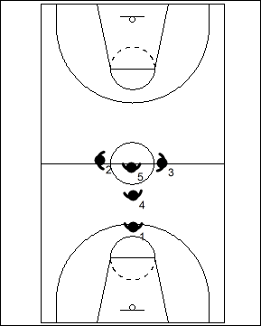

LANCERS FRANCS

Plusieurs matches sont remportés ou perdus à la ligne de lancer franc. L’entraîneur(e) doit prévoir des situations d’attaque dans lesquelles le joueur ou la joueuse rate un lancer franc, ou encore le fait intentionnellement, p. ex. vers la fin d’un match. Sur le plan défensif, l’équipe doit s’exercer à bloquer les attaquant(e)s vers l’extérieur afin de contrer des stratégies par lesquelles l’équipe adverse cherche à marquer un panier à la fin d’un match, ou encore obtenir une possession de plus.

Les situations de lancer franc offrent également d’excellentes occasions de communiquer. Plusieurs équipes tiennent alors un petit caucus, ou les entraîneur(e)s en profitent pour rappeler certain(e)s joueurs/joueuses au banc pour leur donner des instructions particulières.

REMISES EN JEU

L’entraîneur(e) doit s’assurer que son équipe soit bien préparée en vue de chaque situation de remise en jeu possible, tant à l’attaque qu’en défense. Il y a deux écoles de pensée pour ce qui est des remises en jeu :

      - Pouvoir exécuter plusieurs jeux afin de créer de l’incertitude chez l’équipe adverse

      - Avoir un jeu de base avec différentes options que les joueurs/joueuses choisissent en fonction de leur lecture du jeu défensif.

L’entraîneur(e) doit choisir la meilleure option pour son équipe en tenant compte (1) du temps qui est nécessaire pour apprendre plusieurs jeux différents, et (2) de la facilité relative qu’auront les défenseur(e)s à identifier le patron général du jeu de base utilisé. L’entraîneur(e) doit donc se poser les questions suivantes :

- Le jeu retenu sera-t-il efficace à la fois contre une défensive de zone et une défensive de type « homme à homme » ?
- Le jeu sera-t-il efficace partout sur le terrain ?
- Le jeu repose-t-il sur l’exécution que fait un(e) joueur/joueuse en particulier? Qu’adviendra-t-il si celui-ci ou celle-ci est blessé(e) ou expulsé(e)?
- Quelle est la meilleure façon de communiquer les options ou les indices lors de l’exécution (signaux, voix)?
- Y a-t-il un jeu qui peut être utilisé dans la zone offensive pour marquer dans les deux dernières minutes du match?
  - Le jeu permet-il de marquer rapidement après la remise en jeu, ou se contente-t-on simplement de remettre le ballon en jeu?
  - Cherche-t-on à permuter les joueurs/joueuses lors des écrans lors d’une remise en jeu faite par l’autre équipe?
  - Est-ce qu’une permutation des défenseur(e)s aura lieu en prévision de l’écran?
  - Peut-on se défendre efficacement contre un double écran?
  - Lors d’une remise en jeu faite par l’autre équipe, peut-on protéger le panier, arrêter le/la meilleur(e) attaquant(e) adverse, obtenir un compte de cinq secondes, ou réussir à commettre rapidement une faute sur un(e) adversaire qui n’est pas habile à la ligne de lancer franc?

PRINCIPES DÉFENSIFS

1 – Protéger le panier

Ce principe doit être inculqué dès les tout débuts. Dans le jeu de base à 1 contre 1, les joueurs/joueuses doivent apprendre à se placer entre l’attaquant(e) en possession du ballon et le panier. Quand on commence à jouer à 2 contre 2, le/la défenseur(e) qui marque l’attaquant(e) sans ballon doit encore une fois se placer de façon à protéger le panier, tout en s’assurant d’être plus près du panier que son adversaire. Les principes défensifs sont les mêmes sur terrain complet ou sur demi-terrain. L’important est de trouver la bonne position défensive en plaçant correctement les pieds.

2 –Mettre de la pression sur l’attaquant(e) en possession du ballon

Dès que l’attaquant(e) en possession du ballon franchit sa propre ligne de lancer franc, la défensive doit s’activer et commencer à exercer de la pression : ce joueur ou cette joueuse ne doit pas être en mesure de repérer facilement ses partenaires sur le terrain, et on doit l’obliger à changer sa main de dribble et à changer de direction le plus souvent possible. De plus, on ne doit pas lui laisser la possibilité de choisir de quel côté dribbler (côté fort ou côté faible).

Une fois que l’attaquant(e) a traversé le centre du terrain, le/la défenseur(e) qui le ou la marque doit tout faire pour le/la garder du même côté, et éviter que le ballon ne traverse le terrain en largeur. Ceci permettra aux quatre autres défenseur(e)s d’identifier le « côté ballon » et le « côté aide ». Il est important de contester la première passe car celle-ci correspond au début de l’attaque.

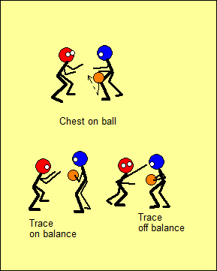 | Le/la défenseur(e) doit chercher à placer sa poitrine entre le ballon et le panier.  Lorsque le ou la défenseur(e) tend un bras vers l’adversaire pour mettre de la pression, il faut que ce soit le bras qui se trouve du côté du ballon; si le joueur ou la joueuse s’étire avec le bras opposé, il ou elle risque de se retrouver hors d’équilibre.

3–Jouer à « un(e) et demi(e) » contre l’attaquant(e) en possession du ballon

Un principe important pour que le jeu d’équipe soit efficace en défense est que chaque joueur/joueuse doit bien s’occuper de son/sa vis-à-vis en attaque, et être prêt(e) à fournir de l’aide en défense lors d’une éventuelle pénétration ou rotation de la part d’un(e) adversaire.

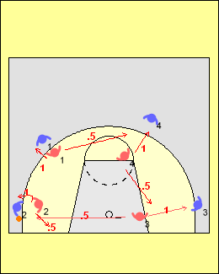 | À tout moment au cours d’une situation défensive, les joueurs/joueuses doivent donc savoir (1) qui est l’adversaire qu’ils/elles marquent directement, c’est ce qu’on entend par « un(e) », et (2) à qui ils/elles peuvent apporter de l’aide, c’est ce qu’on entend par « demi(e) ».  Seul(e) le joueur ou la joueuse qui marque l’attaquant(e) en possession du ballon n’a pas de « demi responsabilité défensive ». Il ou elle doit par contre savoir qui est le ou la partenaire qui peut fournir de l’aide.

4–Toujours demeurer dans le couloir de passe

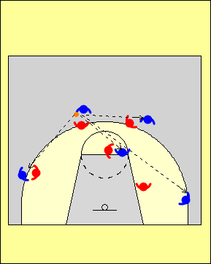 | Lorsque l’équipe est en défense, chaque joueur/joueuse doit s’assurer de toujours être dans le couloir de passe et prêt(e) à contester le ballon, ou encore apporter de l’aide défensive en cas de pénétration.  Une défensive collective n’est efficace que si les cinq joueurs/joueuses occupent une bonne position. La défensive doit également ressembler à un mur.

5 – Forcer l’attaquant(e) à se déplacer avant qu’il ou elle n’attrape le ballon

Il ne faut jamais permettre à l’adversaire que l’on surveille d’attraper le ballon près de la ligne de trois points. Il faut plutôt l’obliger à se déplacer et à travailler fort si il ou elle souhaite recevoir une passe.

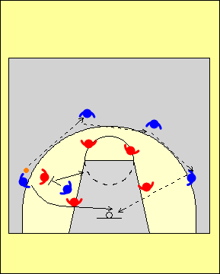 | Un entraîneur de l’ex Yougoslavie a déjà dit que la meilleure attaque consiste à faire circuler le ballon par les trois joueurs/joueuses qui se trouvent du côté fort du terrain puis d’inverser rapidement le sens de la circulation vers le côté où il n’y en a que deux et, à ce moment précis, de faire couper le/la troisième attaquant(e) du côté fort vers le côté faible.  Dans un tel scénario, si la circulation du ballon est inversée rapidement, il est effectivement très difficile pour l’équipe en défense de contrer l’écran dans le dos.
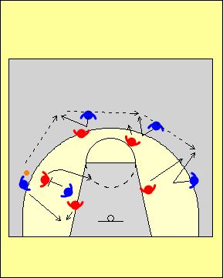 | Cependant, si la defensive oblige les attaquant(e)s en périphérie à se déplacer pour attraper le ballon, le sens de la circulation ne peut pas être inversé aussi rapidement. En effet, les défenseur(e)s qui jouent contre l’écran ont alors le temps d’aider leurs partenaires et de récupérer.

6. Le ballon ne doit jamais se retrouver dans la zone de jeu située à environ 2 ou 3 m de la ligne de fond, le long de la clé (anglais : low post)

Il est important de ne jamais laisser le ballon se retrouver à l’intérieur, au bas de la clé. Le/la défenseur(e) qui se trouve à cet endroit doit contester la passe, ou encore s’assurer qu’aucun(e) attaquant(e) n’occupe cette position.
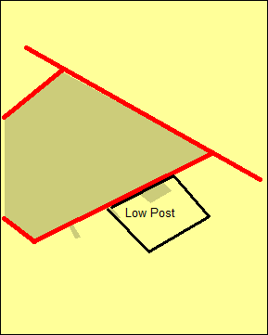 | Le terme anglais « low post » est la zone de jeu située à environ 2 ou 3 m de la ligne de fond, le long de la clé, et il s’agit d’une surface d’environ un mètre carré (voir diagramme de gauche). La défensive doit éviter à tout prix que le ballon ne s’y retrouve.  À l’entraînement, on peut utiliser du ruban gommé pour identifier clairement cette zone, car cela aidera les joueurs/joueuses à la remarquer plus facilement.
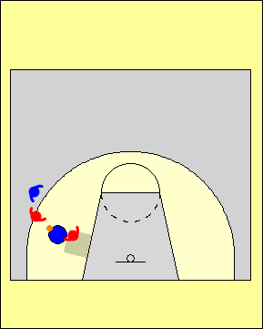 | Si l’attaquant(e) reçoit le ballon devant cette zone, le/la défenseur(e) qui marque l’ailier(ère) peut assez facilement s’occuper de deux  joueurs/joueuses.  Si l’attaquant(e) reçoit le ballon au haut de cette zone, deux joueurs/joueuses qui se trouvent en périphérie peuvent venir fournir de l’aide en défense tout en continuant de surveiller leur(e) attaquant(e) désigné(e). | 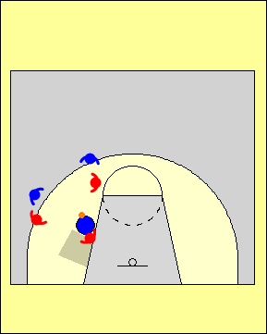
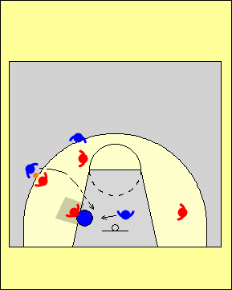 | Quand l’attaquant(e) qui joue à l’intérieur se trouve dans la clé, il est très facile pour un(e) joueur/joueuse qui se trouve sur le côté faible de fournir une aide en défence contre une passe lobée.  Quand l’attaquant(e) qui joue à l’intérieur se trouve au bas de cette zone, un(e) joueur/joueuse qui se trouve sur le côté faible peut fournir de l’aide lors d’un dribble. Le/la défenseur(e) direct(e) se charge alors de bloquer le centre ainsi que la vue de l’attaquant(e) à l’intérieur. | 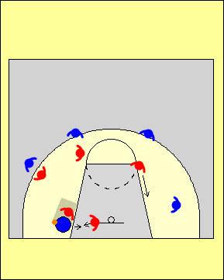
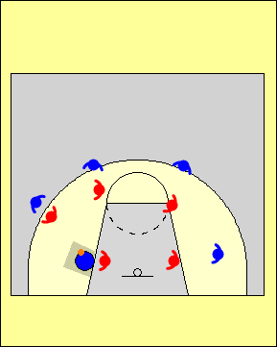 | Quand l’attaquant(e) qui joue à l’intérieur reçoit le ballon au bas de la clé, il devient très difficile pour le/la défenseur(e) qui le/la couvre de recevoir toute forme d’aide défensive : en effet, le/la défenseur(e) qui apporterait de l’aide serait forcé(e) de faire une rotation et se retrouverait alors en « mode réaction ». Dans une telle situation à l’entraînement, on ne doit pas permettre que des partenaires défensifs se déplacent pour aider, afin que le/la défenseur(e) réalise l’importance d’empêcher l’attaquant(e) d’entrer en possession du ballon au bas de la clé. Si le/la défenseur(e) sait qu’il ou elle pourra compter sur l’aide de ses coéquipier(ère)s dans une telle situation, il/elle ne jouera probablement pas avec le même niveau d’intensité pour empêcher que le ballon ne se retrouve à cet endroit critique.
7. Contester toute passe près du ballon

Ce concept découle des principes défensifs deux et trois; on doit absolument chercher à l’appliquer lorsqu’il y a un(e) adversaire dans un coin; si le/la défenseur(e) conteste par le haut et joue « trois-quarts », il faut absolument éviter qu’une passe en triangle puisse être faite à l’attaquant(e) qui joue à l’intérieur.

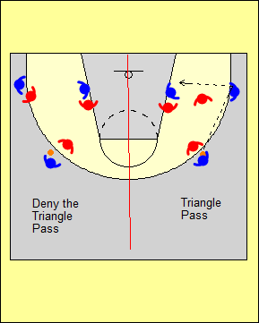

8. Ralentir les tentatives d’inverser le sens dans lequel le ballon circule

Ce concept découle des principes défensifs trois et six. Toute forme d’attaque pourra fonctionner assez bien si la défensive laisse les adversaires inverser la circulation du ballon à leur guise, en particulier si l’attaquant(e) qui joue à l’intérieur à la hauteur de la ligne de lancer francs est impliqué(e). Il est donc important de chercher à briser le rythme de l’attaque en contestant énergiquement les passes qui sont faites pour inverser le sens dans lequel le ballon circule. La défensive doit également tenter de contester la passe lorsque l’équipe adverse fait un écran par derrière ou encore qu’un(e) attaquant(e) coupe en provenance du côté faible.

9. Il faut une défensive individuelle (type « homme à homme ») si on veut éviter les rotations défensives

Idéalement, la défensive individuelle - ou de type « un(e) à un(e) » - s’amorce avec un marquage individuel serré de l’attaquant(e) en possession du ballon; en effet, toute rotation a tendance à diminuer l’efficacité de l’équipe en défensive car on crée alors une « situation d’urgence ». On voit souvent des entraîneur(e)s qui consacrent beaucoup de temps à la gestion de ce type de situations d’urgence lors des entraînements, alors qu’il serait plus efficace de chercher à améliorer les habiletés qui permettent aux joueurs/joueuses d’éviter qu’elles ne se produisent… L’apprentissage correct des techniques défensives sera utile aux joueurs/joueuses tout au long de leur carrière, tandis que les rotations ne fonctionnent souvent que pour un seul match…

ASPECTS PARTICULIERS DU JEU DÉFENSIF

Défensive individuelle ou de type « un(e) à un(e) »

Les joueurs/joueuses doivent être en équilibre et réagir. Il faut se rappeler le principe de base qui consiste à mettre une main sur le ballon et à placer l’autre dans un couloir de passe probable.

Le joueur ou la joueuse doit continuellement bouger les pieds et toujours placer sa poitrine devant le ballon; de plus, il/elle ne doit jamais croiser les mains ou les pieds. L’efficacité de la défensive de type « un(e) à un(e) » dépend de la pression qui est mise sur l’attaquant(e) en possession du ballon.

Défensive contre l’écran sur la balle

Lorsque les joueurs/joueuses sont jeunes, on suggère d’enseigner les permutations comme moyen de se défendre contre les écrans sur la balle. En effet, les joueurs/joueuses n’ont pas encore les habiletés ou les connaissances qui leur permettent de tirer avantage d’un déséquilibre attaquant(e)/défenseur(e). Lorsque les joueurs/joueuses sont rendu(e)s au stade d’apprendre à faire des écrans sur la balle, la défensive doit chercher à mettre en place des trappes aggressives, et empêcher celui ou celle qui fait l’écran de voir le ballon et le panier pendant qu’il ou elle pivote vers la clé.

Lors de la trappe, le joueur ou la joueuse de grande taille conserve une main basse en direction du ballon afin d’éviter que l’attaquant(e) ne se faufile, et lève les deux bras au moment de reprendre sa position. Les arrières doivent tenter d’obliger l’attaquant(e) en possession du ballon à utiliser l’écran, et anticiper le moment où il sera placé tout en se débattant du mieux qu’ils/elles le peuvent pour passer au dessus de l’écran. Lors d’une manœuvre d’écran sur la balle suivi d’un pivot, les cinq joueurs/joueuses doivent s’impliquer en défensive.

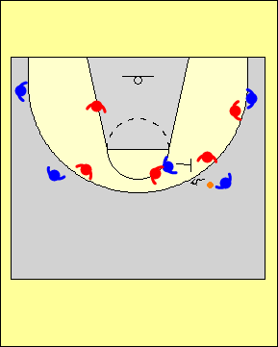 | Le/la défenseur(e) qui marque l’attaquant(e) en possession du ballon doit l’obliger à utiliser l’écran et informer rapidement et clairement ses partenaires qu’une telle manœuvre est en train de se dérouler.  Les défenseur(e)s qui se trouvent à une distance d’une passe de l’écran doivent faire en sorte que les attaquant(e)s ne puissent effectuer une passe en triangle. Le/la défenseur(e) du côté faible est pour sa part responsable de s’occuper de l’adversaire qui fait l’écran si jamais celui-ci ou celle-ci décidait de glisser au panier.
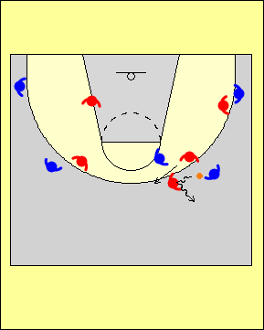 | Lorsque l’attaquant(e) en possession du ballon utilise l’écran, le/la défenseur(e) qui couvre celui ou celle qui l’a placé va en aide en gardant les mains basses afin de mettre de la pression sur le porteur ou la porteuse, et repousser le ballon vers la ligne de côté. Au moment de reprendre sa place, le/la défenseur(e) garde une main élevée pour tenter de faire dévier la passe. | 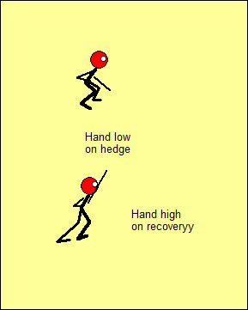
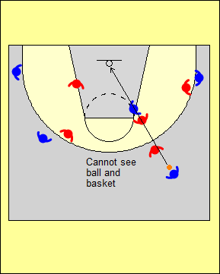 | Le/la défenseur(e) qui surveille l’attaquant(e) en possession du ballon passe au haut de l’écran mais au bas du ou de la partenaire qui il ou elle a apporté de l’aide.  Si la manœuvre est effectuée correctement, l’attaquant(e) qui a fait l’écran n’est pas en mesure de voir le ballon et le panier en même temps. Ceci permet à un(e) autre défenseur(e) de venir en aide si nécessaire. | 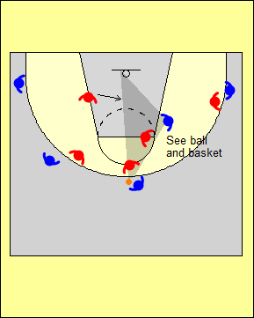
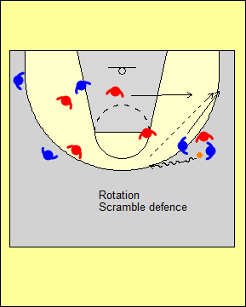 | Lorsqu’une équipe en attaque utilise l’écran sur la balle suivi d’un pivot du joueur ou de la joueuse en périphérie, il est souvent difficile de fournir de l’aide en défensive car les joueurs/joueuses font souvent de longues rotations qui les placent dans une sitiatuation précaire. Dans cet exemple, les joueurs/joueuses font la même chose que lors de l’écran suivi d’un pivot vers le panier. La seule différence est que le/la défenseur(e) reprend sa position en se déplaçant dans le couloir de passe, ce qui oblige l’attaquant(e) à couper par derrière. Ceci permet à celui/celle qui aide de demeurer dans la clé. |  | 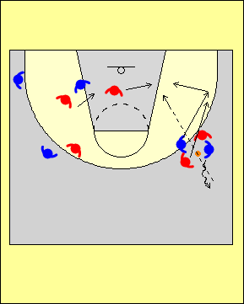
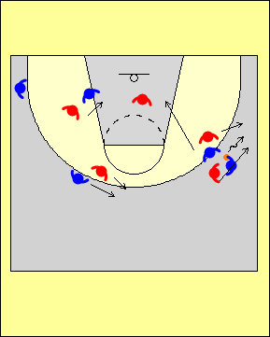 | Lorsqu’une équipe fait un écran sur la balle en vue d’attaquer vers la ligne de fond, ou que la défensive cherche à empêcher l’attaquant(e) en possession du ballon d’utiliser l’écran, la défensive doit jouer la trappe.  Les défenseur(e)s qui se trouvent à une distance d’une passe de l’attaquant(e) en possession du ballon contestent pour limiter les options offensives, tandis que le joueur ou la joueuse du côté faible peut fournir de l’aide en défense contre l’adversaire qui pivote et roule au panier.

Défensive contre l’écran sur la balle – Aspects fondamentaux

- Le jeu défensif contre un écran inclut à la fois la couverture (deux joueurs/joueuses impliqué(e)s à l’endroit où l’écran est fait) et l’aide (trois défenseur(e)s éloigné(e)s du ballon).

- Les défenseur(e)s qui jouent contre le joueur ou la joueuse en possession du ballon doivent :
  - Demeurer avec l’attaquant(e) en possession du ballon
  - L’obliger à utiliser l’écran (à moins que la couverture ne dicte une autre option).

- Les défenseur(e)s qui marquent l’attaquant(e) qui fait l’écran doivent :
  - Appeler la couverture
  - Arriver au même moment que l’adversaire

- Les défenseur(e)s qui jouent éloigné(e)s du ballon doivent :
  - Former un triangle derrière le ballon
  - Se rapprocher du centre de la clé lorsque le ballon s’éloigne d’eux/elles (les joueurs/joueuses doivent être prêt(e)s à entrer en contact avec l’attaquant(e) qui roule)
  - Travailler fort quand le ballon est remis à leur adversaire direct(e)

Façons de se défendre lors du placement d’un écran :

- Aide agressive pour détourner (par-dessus; par-dessous)
- Aide légère suivie d’un retour rapide à son joueur ou à sa joueuse
- Faire une permutation
- Le/la défenseur(e) qui marque l’attaquant(e) qui fait l’écran le/la repousse vers le haut (l’autre défenseur(e) passe alors en dessous des deux)
- Passer sous le joueur ou la joueuse qui fait l’écran
- Jouer la trappe (deux défenseur(e)s exécutent la trappe, tandis que les autres défenseur(e)s font une rotation par derrière)
- Empêcher l’écran en obligeant l’attaquant(e) à dribbler dans la direction opposée

Points clés de la défensive contre l’écran suivi d’un pivot vers le ballon (les réponses déterminent la manoeuvre utilisée)

Où l’écran est-il fait ?
- Sur le côté
- Au centre ou vers le haut
- En angle

Qui est impliqué(e) - L’écran est-il fait :
- Pour un(e) attaquant(e) efficace ou inefficace au tir?
- Par un(e) attaquant(e) efficace ou inefficace au tir?
- Par un(e) attaquant(e) qui préfère ressortir ou pivoter au panier?

Quelle est la formation utilisée?
- Position du joueur ou de la joueuse qui évolue à la position de 4
- Position des lanceurs/lanceuses

Quel type de communication est utilisé?
- On doit communiquer tôt, suffisamment fort, et sans arrêt
- Le/la défenseur(e) qui marque l’adversaire qui fait l’écran devrait diriger la communication car il/elle voit continuellement l’action de près

Quel type de couverture les joueurs/joueuses utilisent-ils/elles?
- Aide agressive, permutation, trappe etc.

La couverture défensive contre l’écran suivi d’un pivot vers le ballon est inefficace lorsque :
- Les joueurs/joueuses ne communiquent pas.
- L’arrière n’oblige pas l’attaquant(e) en possession du ballon à utiliser l’écran
- L’avant ou le/la centre n’arrivent pas au même moment que l’adversaire qui fait l’écran
- Il y a des écarts trop marqués entre les défenseur(e)s
- Les joueurs/joueuses jouent mollement
- Celui ou celle qui joue au centre n’adopte pas une posture défensive adéquate
- Les autres défenseur(e)s aident de façon agressive

Défensive contre un écran vers le bas

Pour être prêt(e) à fournir de l’aide lorsque l’attaquant(e) contournera l’écran et aussi pour l’empêcher de couper devant soi, le/la défenseur(e) qui joue contre l’attaquant(e) qui fait l’écran doit chercher à placer ses pieds plus haut que ceux de son adversaire – tout en demeurant dans le couloir de passe, prêt(e) à contester la passe à l’intérieur. L’arrière doit pour sa part suivre l’attaquant(e) et faire une bonne lecture de l’écran : si l’écran est placé près de la ligne de fond il/elle doit contourner l’écran par le haut; si au contraire l’écran est placé plus haut, le/la défenseur(e) doit poursuivre l’attaquant(e) pour qui l’écran a été placé. Il est important que le/la défenseur(e) qui marque le passeur ou la passeuse fasse un pas en direction de la passe afin d’apporter de l’aide contre la manœuvre de contournement.

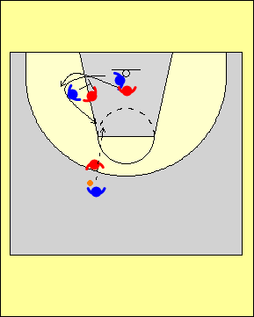 | Si le/la défenseur(e) qui joue contre l’attaquant(e) qui fait l’écran demeure derrière ou se place trop bas, l’adversaire pour qui l’écran a été fait peut alors facilement contourner l’écran.  Si l’adversaire ne contourne pas mais choisit plutôt de couper à l’aile, il devient alors trop facile pour celui ou celle qui a fait l’écran de de prendre position sur son/sa défenseur(e) à l’intérieur. | 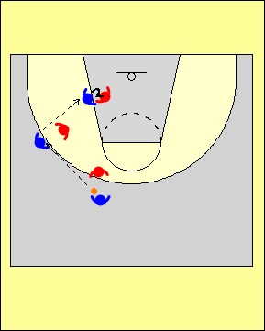
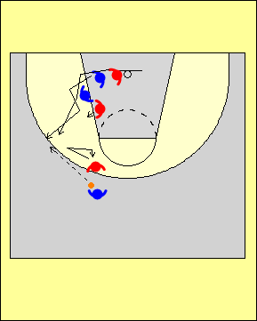 | Le joueur ou la joueuse qui défend contre l’écran doit se placer de façon à ce que ses deux pieds soient plus hauts que ceux de l’adversaire qui fait l’écran; ceci permet à son/sa partenaire d’être en bonne position pour réagir si l’attaquant(e) décide de contourner.  Après la réception, le/la défenseur(e) qui marquait le passeur ou la passeuse doit se placer rapidement en position d’aide afin de dissuader toute tentative de pénétration par le milieu de la part de l’ailier(ère). Ce joueur cette joueuse doit ensuite reprendre immédiatement son rôle défensif dans le couloir de passe.
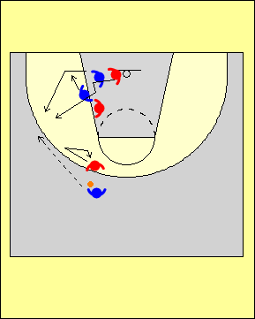 | Écran qui bouge  Celui ou celle qui fait l’écran fait souvent un léger déplacement vers le bas après que l’autre attaquant(e) ait utilisé son écran. Lorsque l’attaquant(e) coupe, le joueur ou la joueuse qui le/la surveille doit se mettre à sa poursuite et ensuite bifurquer pour passer directement entre son/sa partenaire et l’adversaire qui a fait l’écran.  Le joueur ou la joueuse qui couvre l’adversaire qui a fait l’écran ne doit pas se placer à côté, car cela crérait alors un double écran sur le/la partenaire.

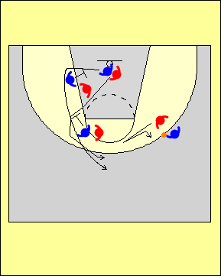 | Défensive contre un écran double décalé  Tout comme dans le cas de l’écran fait vers le bas, les défenseur(e)s qui évoluent contre l’adversaire qui a fait l’écran dans le couloir de passe devraient appliquer les principes vus précédemment.  L’arrière doit passer au dessus du premier écran et pour ce qui est du second, passer directement entre son/sa partenaire et l’adversaire qui a fait l’écran.

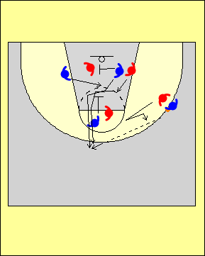 | Faire un écran pour celui/celle qui vient de faire un écran  On doit obliger l’attaquant(e) qui joue à l’intérieur à passer au-dessus du premier écran; ceci a pour effet de raccourci le trajet du joueur ou de la joueuse qui retourne à sa position après avoir apporté de l’aide en défensive.  On doit néanmoins se mettre à la poursuite de l’adversaire qui a fait le second écran; pour sa part, le/la défenseur(e) qui surveille le passeur ou la passeuse doit se placer rapidement en position d’aide pour ses partenaires lors de l’attaque rapide.

Attaquant(e) qui coupe du côté faible

Les défenseur(e)s doivent empêcher leur(e) adversaire immédiat(e) de couper directement devant eux/elles. On peut arrêter l’attaquant(e) à l’aide de l’avant-bras lorsqu’il ou elle arrive dans la clé, et obliger ainsi un déplacement vers la la ligne de fond ou le haut de la clé (il faut toutefois contester jusqu'à ce que l’adversaire se rende à la ligne de trois points). Selon que le/la défenseur(e) ait pu maintenir ou non une bonne position d’équilibre, il/elle devra choisir entre (1) voir le ballon ou (2) voir l’attaquant(e) qui coupe au moment où celui-ci ou celle-ci arrivera au point critique de son action vers le ballon.

Par derrière

Dès que l’attaquant(e) fait un pas en direction du panier, le/la défenseur(e) doit glisser vers l’arrière. Au deuxième pas, il/elle doit tourner la tête et jeter immédiatement un regard en direction du ballon. Si l’adversaire choisit de revenir vers la ligne de trois points, le/la défenseur(e) doit tourner à nouveau la tête vers l’attaquant(e).

Contre une pénétration

À chaque fois qu’un(e) arrière qui est en périphérie tente une pénétration, les défenseur(e)s doivent (1) feinter puis revenir marquer leur adversaire avec le ou la défenseur(e) qui se trouve le/la plus près du ballon (ceci se fait en tendant le bras pour tenter de toucher au ballon), et (2) fournir de l’aide en collaboration avec le/la partenaire de grande taille qui arrive du côté faible (on ne doit jamais permettre qu’une passe soit effectuée à l’attaquant(e) qui est dans le champ de vision de l’adversaire qui fait la pénétration).

Le ou la défenseur(e) de grande taille ne doit venir en aide que lorsque l’adversaire qui a pénétré se trouve dans la clé; il/elle doit aussi déterminer si l’attaquant(e) cherche à passer ou encore à lancer.

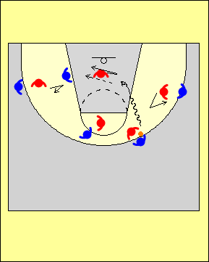 | L’ailier(ère) qui se trouve sur le côté de la pénétration doit s’interposer brièvement, puis reprendre sa position; pour sa part, le/la défenseur(e) qui se trouve dans la clé doit y demeurer pour protéger le devant du panier et obliger l’attaquant(e) en possession du ballon à faire un tir en suspension ou à commettre une faute offensive lors de sa pénétration.  Il est important de mentionner que si le ou la défenseur(e) qui vient aider arrive du côté où se trouve le ballon, personne ne pourra en retour lui offrir de l’aide en défensive; un lancer de trois points facile pourrait alors être tenté, ou les défenseur(e)s pourraient se retrouver complètement au dépourvu suite à la pénétration.
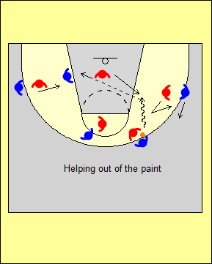 | Dans cet exemple, le/la défenseur(e) qui se trouve dans la clé fournit de l’aide vers le haut et l’extérieur.  Il s’agit d’une situation à éviter, car cela crée une situation de passe facile dans laquelle aucun(e) défenseur(e) ne peut apporter de l’aide.

Défensive contre le joueur ou la joueuse d’intérieur au bas de la clé
On ne doit jamais laisser le ballon se rendre dans la zone située à 2 ou 3 m de la ligne de fond, le long de la clé. Le/la défenseur(e) devrait se placer devant son joueur ou sa joueuse si cet(te) attaquant(e) se trouve près de la clé, ou en position « trois-quarts » si il ou elle est près de la ligne de fond. Le joueur ou la joueuse doit demeurer derrière si l’adversaire attrape le ballon à l’extérieur de la clé, ce qui permet à un(e) partenaire de venir en aide.

= Endroit où l’attaquant(e) à l’intérieur peut attraper le ballon
= Endroit où l’attaquant(e) à l’intérieur ne doit pas pouvoir attraper le ballon

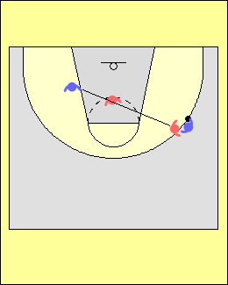 | Jouer éloigné(e) du ballon lorsqu’on est en défense  Les jeunes joueurs/joueuses de grande taille ont souvent de la difficulté à se placer au meilleur endroit en défense.  Il est important qu’ils/elles exploitent leur force lors du jeu (leur taille) et qu’ils/elles démontrent aux défenseur(e)s qui sont en périphérie qu’ils/elles sont capables d’apporter une aide efficace.  De plus, le/la défenseur(e) qui apporte de l’aide ne devrait pas chercher à s’aligner avec son/sa partenaire, car cela permet alors à l’attaquant(e) d’avoir la voie libre vers le panier.
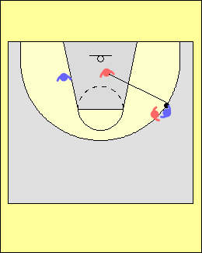 | Lorsque l’attaquant(e) en périphérie tente d’amener le ballon vers la ligne de fond, le/la défenseur(e) qui joue à l’intérieur doit se placer dans la trajectoire que l’ailier(ère) pourrait emprunter lors d’une pénétration au panier.  Ceci tend à dissuader la pénétration, et facilite une rotation pour venir en aide lorsque l’adversaire se déplace vers le haut de la ligne.
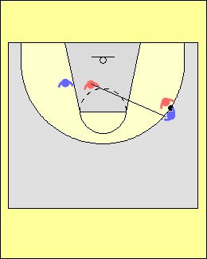 | Lorsque l’attaquant(e) en périphérie tente d’amener le ballon vers le milieu du terrain, le/la défenseur(e) qui joue à l’intérieur doit se placer dans la trajectoire que l’ailier(ère) pourrait emprunter lors d’une pénétration au panier.
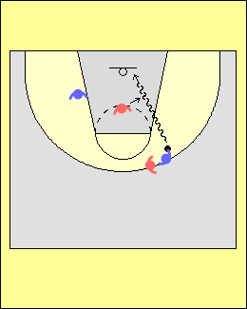 | Contester l’épaule du bras lanceur  Pour demeurer dans la partie, les jeunes joueurs/joueuses de grande taille doivent éviter de prendre des fautes inutiles. On doit leur apprendre à affronter l’épaule du bras lanceur de l’attaquant(e).  Lorsqu’un(e) adversaire qui se trouve en périphérie attaque au panier, le/la défenseur(e) s’interpose souvent face à l’épaule la plus près du panier; dans l’exemple du diagramme ci-contre, il s’agirait de l’épaule gauche. Le problème, c’est que l’attaquant(e) est droitier(ère)…
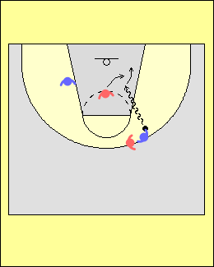 | Dans cet exemple, le joueur ou la joueuse se déplace un peu plus loin pour bloquer la voie de l’attaquant(e) et se place devant son épaule droite, ce qui complique les choses pour cet(te) adversaire lors du lancer.  À ce stade du développement des joueurs/joueuses, on ne cherche pas nécessairement à leur enseigner à bloquer le lancer ou à provoquer des fautes offensives mais plutôt à leur donner confiance; on doit donc surtout insister sur l’importance d’être au bon endroit.

EXERCICES POUR DÉVELOPPER UNE MENTALITÉ DÉFENSIVE

Contre l’attaquant(e) à l’intérieur

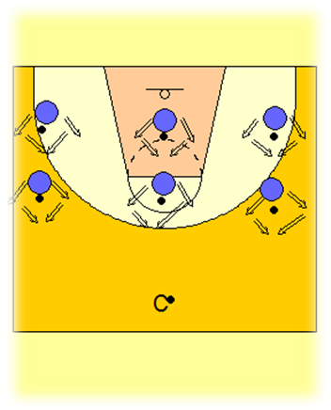
Chaque joueur ou joueuse place un ballon au sol devant lui/elle. Chacun(e) doit se déplacer autour du ballon pendant dix secondes en imaginant qu’il s’agit de l’attaquant(e) à l’intérieur.

Jeu du miroir
Les joueurs/joueuses font face à l’entraîneur(e), qui indique dans quelle direction ils/elles doivent se déplacer.

L’entraîneur(e) peut modifier l’exercice en criant « rebond » (les joueurs/joueuses doivent alors bloquer leur joueur/joueuse et sauter), ou « pénétration » (les joueurs/joueuses doivent alors simuler qu’ils/elles s’interposent devant la pénétration de l’attaquant(e) pour provoquer une faute offensive).

Récupérer le ballon cinq fois
Deux entraîneur(e)s se placent de chaque côté de la ligne de lancer franc. À tour de rôle, l’un(e) fait rebondir le ballon au sol en direction de la ligne de fond. Le joueur ou la joueuse doit faire des déplacements défensifs et aller récupérer le ballon avant qu’il ne rebondisse deux fois.
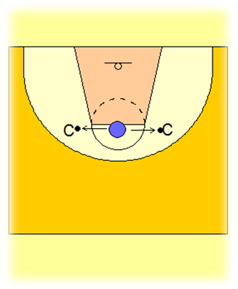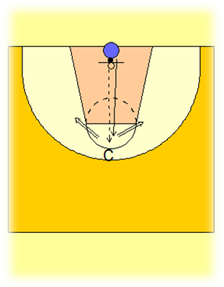

Récupération défensive et déplacements défensifs
Le joueur ou la joueuse fait une passe à l’entraîneur(e) et court pour faire une récupération défensive. L’entraîneur(e) fait une feinte de lancer, puis feint ensuite une pénétration au panier vers la droite et vers la gauche. Le joueur ou la joueuse doit revenir vers l’arrière et reprendre sa place. L’entraîneur(e) lance ensuite le ballon sur le panneau, et le joueur ou la joueuse doit bloquer et aller au rebond.

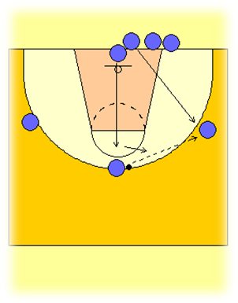
Contester le ballon et glisser
Le joueur ou la joueuse qui est sous le panier court vers celui ou celle qui a le ballon pour faire une récupération défensive. Après la passe, il/elle se déplace dans le couloir de passe, puis le/la suivant(e) fait la même chose.

Ici, la rotation est importante; lorsque l’attaquant(e) va derrière la file sous le panier, le/la défenseur(e) prend sa place.

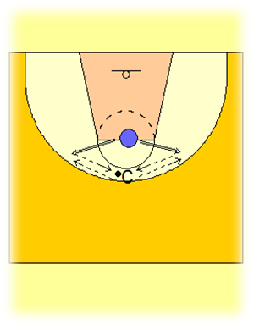
Cinq déplacements défensifs
L’entraîneur(e) se tient devant le joueur ou la joueuse, et fait rouler un ballon au sol.

Le joueur ou la joueuse doit faire un déplacement défensif pour le récupérer et le remettre ensuite à l’entraîneur(e) en faisant une passe. On répète cinq fois.

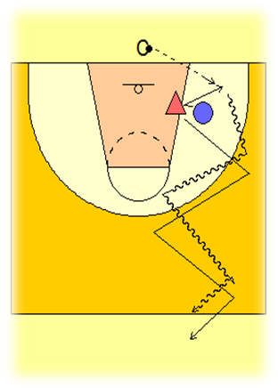
Cinq secondes pour se rendre au centre du terrain

Dans cet exercice, l’entraîneur(e) remet le ballon en jeu à partir de la ligne de fond et l’attaquant(e) tente de se démarquer et de recevoir la passe. Le/la défenseur(e) tente pour sa part de l’obliger à recevoir la passe avant la ligne de lancer franc, et faire en sorte qu’il faille plus de cinq secondes à l’attaquant(e) pour se rendre au centre du terrain; pour y arriver, le/la défenseur(e) doit obliger l’autre joueur/joueuse à changer de direction le plus souvent possible.

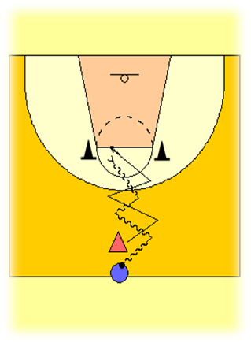
« Défendre le but »

L’attaquant(e) dispose de cinq secondes pour passer entre les pylônes tandis que le/la défenseur(e) tente de l’en empêcher.

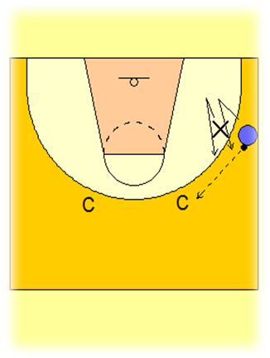
Contester pendant trois secondes
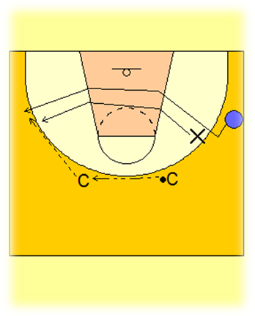
L’attaquant(e) passe le ballon à l’entraîneur(e) et tente ensuite de se démarquer en moins de trois secondes. Le/la défenseur(e) doit contester pendant ce temps, jusqu’à ce que l’entraîneur(e) remette le ballon à l’autre entraîneur(e). L’attaquant(e) coupe alors de l’autre côté; le/la défenseur(e) doit se déplacer et contester encore une fois pendant trois secondes. Si l’attaquant(e) réussit à s’emparer du ballon avant la fin des trois secondes, les joueurs/joueuses s’affrontent dans un duel à 1 contre 1; on ne permet cependant que deux dribbles avant qu’un lancer ne soit effectué.

Défensive contre un adversaire qui coupe à la balle en provenance du côté faible

Le joueur ou la joueuse placé(e) au milieu fait une passe à l’entraîneur(e). Les trois joueurs/joueuses courrent ensuite jusqu’à la hauteur de la ligne de lancer franc. L’entraîneur(e) passe ensuite le ballon au joueur ou à la joueuse à sa droite, tandis que celui ou celle qui est au centre devient un(e) défenseur(e) et doit chercher à empêcher l’autre joueur/joueuse de couper avec succès. Entre autres, le/la défenseur(e) doit éviter qu’une passe soit faite dans la clé.
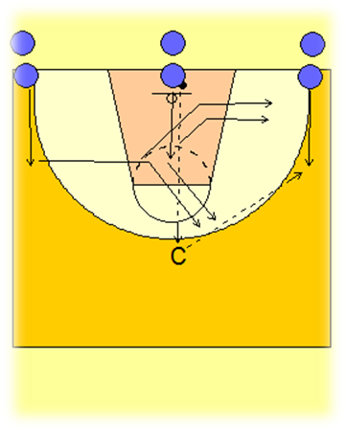

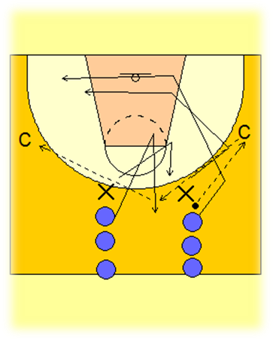

Formation 2 contre 2, jeu défensif contre l’attaquant(e) qui coupe
Deux entraîneur(e)s agissent comme passeurs ou passeuses. Le/la défenseur(e) doit empêcher l’attaquant(e) d’attraper le ballon dans la clé, et doit tenter de se déplacer rapidement vers le ballon à chaque fois qu’une passe est faite.

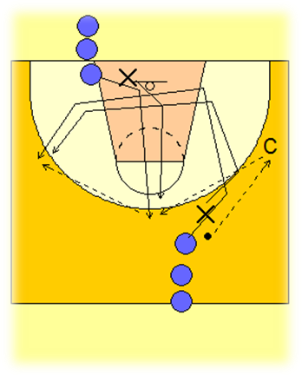

Formation 2 contre 2, contester le renversement de passe

L’arrière passe le ballon à l’entraîneur(e), puis coupe ensuite pour aller prendre position à l’intérieur au bas de la clé. Le joueur ou la joueuse de grande taille part de la ligne de fond, court jusqu’au haut de la clé et reçoit la passe de l’entraîneur(e), puis inverse le sens dans lequel circule le ballon. Après la passe, les attaquant(e)s ont différentes options : écran sur le ballon, prendre position à l’intérieur côté ballon, ou couper derrière le/la défenseur(e).

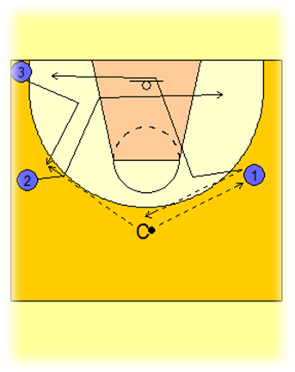
Éducatif « Pentha » à 3 contre 3

Trois joueurs/joueuses doivent défendre les actions par lesquelles les adversaires coupent vers le ballon en provenance du côté faible et aussi empêcher qu’un(e) attaquant(e) ne coupe par derrière. Chaque défenseur(e) doit prendre place rapidement dans le corridor de passe lorsqu’une passe est faite, et demeurer entre le ballon et son joueur ou sa joueuse durant les mouvements. On peut aussi en profiter pour bien communiquer afin de clarifier si on joue le ballon, si on conteste ou si on fournit de l’aide.

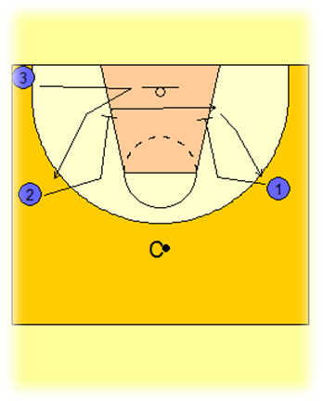
Éducatif « Pentha » à 3 contre 3 - surcharge

Le joueur ou la joueuse 2 fait un écran pour son/sa partenaire 3, et va se positionner à l’intérieur. Le jeu se déplace ensuite de l’autre côté et l’attaquant (e) 2 tente d’exploiter l’écran vers le bas que lui fait l’attaquant(e) 1.

Les défenseur(e)s doivent pour leur part tenter de neutraliser cette manœuvre. Ils/elles devraient de plus signaler les écrans ainsi que leur choix de couverture de ces écrans.

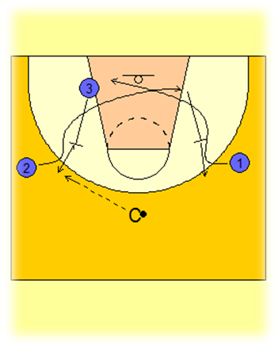
Éducatif « Pentha » à 3 contre 3 – nouvelle surcharge

Cet éducatif est le même que le précédent, et on travaille en plus la défense contre l’écran dans le dos du/de la défenseur(e).

TRANSITION DÉFENSIVE

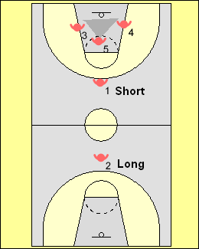 | Transition défensive  Après un lancer, la stratégie la plus commune lors d’une transition défensive est de mettre deux joueurs/joueuses en position de « sécurité » : un(e) se place au haut de la ligne de trois points et l’autre dans sa zone, au-delà du cercle central. Les autres joueurs/joueuses forment un triangle défensif autour du panier pour le rebond.  Voici une stratégie que plusieurs entraîneur(e)s emploient de nos jours lors de la transition défensive. Lorsque le lancer est effectué :  - Le joueur ou la joueuse 1 se déplace pour occuper la position de « sécurité rapprochée » au haut de la ligne de trois points (certain(e)s entraîneur(e)s préfèrent que ce joueur ou cette joueuse prenne plutôt position à la ligne de lancer franc; d’autres, qui adoptent une approche plus conservatrice, limitent le déplacement à la ligne d’attaque du terrain de volleyball).  - Le joueur ou la joueuse 2 se déplace pour occuper la position de « sécurité éloignée » au cercle central;  - Les joueurs ou les joueuses 3, 4 et 5 forment le triangle défensif pour le rebond.
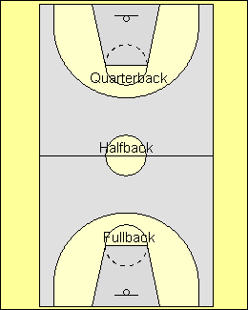 | Une autre approche consiste à placer un joueur ou une joueuse dans chacun des trois cercles (A, B, C) et à donner à chacun(e) un rôle précis, tandis que les autres joueurs/joueuses se replient rapidement dans leur zone.  Selon la stratégie qu’emploie l’équipe adverse, on peut assigner des positions variables à ces joueurs/joueuses. Par exemple, si l’autre équipe favorise la course et que c’est toujours le/la même attaquant(e) qui monte le ballon, les défenseur(e)s peuvent se placer dans les cercles A et B; par contre, si l’adversaire utilise surtout la contre-attaque, ils/elles devraient se placer dans les cercles B et C.
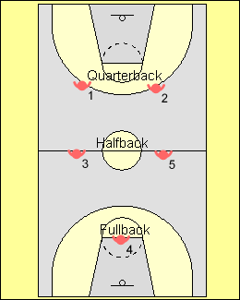 | Cette stratégie permet à l’entraîneur(e) d’indiquer aux joueurs/joueuses quand ils/elles devraient se retourner et faire face au ballon lors du repli.  Par exemple, lors d’une montée rapide de l’adversaire, l’entraîneur(e) peut indiquer aux joueurs/joueuses qui sont en « première ligne défensive » de se retourner vers le ballon une fois rendu(e)s au cercle A; la seconde ligne peut se retourner au centre (B) et la dernière uniquement au cercle C.  Évidemment, on fait ce genre d’ajustements lorsque la situation l’exige.
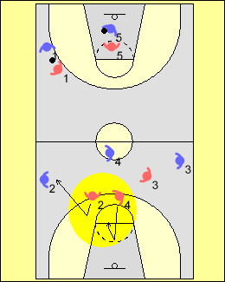 | Retour à son joueur ou à sa joueuse  Il s’agit d’un élément clé de cette stratégie défensive. Dans l’exemple à gauche, le joueur ou la joueuse 4 a fait un repli en sprintant pour protéger le panier, ce qui permet au joueur ou à la joueuse 2 de se déplacer vers l’extérieur pour empêcher une longue passe de l’adversaire vers la zone d’attaque. La plupart des lancers de trois points effectués tôt sont rendus possibles parce que trop de défenseur(e)s protègent le panier et ne retournent pas marquer leur adversaire.  Si le joueur ou la joueuse 2 se déplace trop tôt, l’autre équipe aura une bonne chance de marquer car la voie vers le panier sera alors libre.
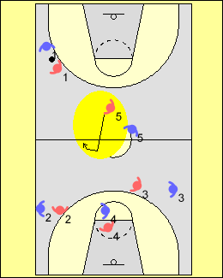 | Suivre l’adversaire comme son ombre  Contre une équipe qui aligne un(e) attaquant(e) dominant(e) qui peut monter rapidement le ballon, on peut utiliser un(e) couvreur ou une couvreuse.  Dans cet exemple, le/la défenseur(e) 5 sprinte jusqu’au cercle central, en aide contre l’arrière adverse qui monte le ballon et qui est couvert(e) de près par 1 qui le ou la suit « comme son ombre ». Cette manœuvre s’avère souvent efficace car l’attaquant(e) qui est marqué(e) de près ne peut dribbler ou manier le ballon à sa guise.
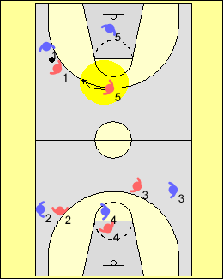 | Aide en défense au milieu de la zone adverse  Dans cet exemple, le/la défenseur(e) qui joue en retrait dans la zone adverse se retourne et cherche à fournir de l’aide près de la ligne de lancer franc, car l’adversaire qu’il ou elle marque se trouve derrière le ballon.  Cette stratégie est efficace lorsque l’équipe adverse utilise un joueur ou une joueuse qui n’est pas très habile à manier le ballon pour faire les remises en jeu.
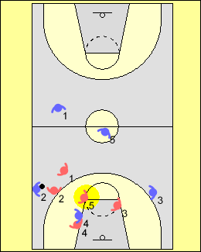 | Couverture de près à l’intérieur  Dans cet exemple, le/la défenseur(e) en retrait sprinte jusqu’au cercle C afin d’aider à stopper la progression du ballon, et va se placer à l’intérieur pour (1) neutraliser un(e) attaquant(e) qui est dangereux(se) à cet endroit ou (2) boucher le couloir afin d’empêcher une pénétration.
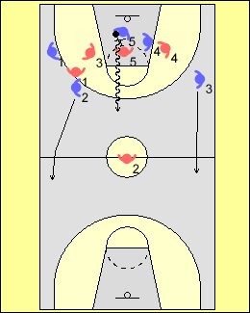 | Neutraliser une sortie par le centre à l’aide du dribble  Une équipe peut décider d’appliquer une pression de type « tout terrain ». Par contre, cette stratégie défensive n’est pas très efficace contre un(e) attaquant(e) qui s’est emparé du rebond et qui fait une sortie par le centre à l’aide du dribble.  Plusieurs équipes déploient donc un joueur ou une joueuse pour mettre beaucoup de pression sur celui ou celle qui s’est emparé(e) du rebond (il s’agit en général du/de la défenseur(e) qui se trouve le/la plus près…), afin d’éviter le dribble ou encore une passe rapide vers le côté.
Après s’être emparée du rebond, si l’équipe réussit à sortir le ballon rapidement de sa zone elle peut créer une situation d’avantage, car lors d’un long rebond qui fait suite à un lancer de la ligne de trois points il est souvent plus difficile de prendre position contre l’attaquant(e) qui a attrapé le ballon.

Les éducatifs suivants ont pour but d’enseigner aux joueurs/joueuses différentes notions défensives en lien avec le jeu défensif lors d’une transition. Les joueurs/joueuses devraient s’exercer à toutes les positions.
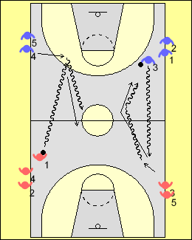 | Empêcher la progression du ballon  L’un des aspects les plus importants de la transition défensive est d’empêcher la progression du ballon, ou du moins la ralentir; ceci est par contre difficile à faire sur tout le terrain. Le/la défenseur(e) qui se trouve en première ligne doit chercher à faire en sorte que le ballon se retrouve à un endroit particulier du terrain, habituellement une ligne de côté. Le fait d’exercer une pression sur l’attaquant(e) dès qu’il ou elle entre en possession du ballon peut également l’empêcher de facilement faire une longue passe vers la zone offensive - en particulier une longue passe en diagonale qui obligerait les défenseur(e)s à faire une rotation.
Les joueurs/joueuses forment quatre files près des marques le long des lignes de côté. L’attaquant(e) en possession du ballon dribble de façon énergique jusqu’à l’endroit désigné par l’entraîneur(e) et dépose le ballon au sol. Ce joueur ou cette joueuse devient alors « le/la défenseur(e) de sécurité rapproché(e) » et son rôle est d’obliger l’attaquant(e) en possession du ballon à se diriger vers la ligne de côté. Le joueur ou la la joueuse de l’autre côté ramasse le ballon et devient l’attaquant(e); les deux s’affrontent alors dans un duel 1 contre 1 jusqu’au panier éloigné. On peut accorder des points lorsque le ballon traverse le centre le long de la ligne de côté.

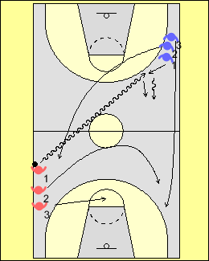 | Dans cet éducatif, un(e) membre de l’équipe en défensive dribble le ballon en diagonale vers l’autre zone, puis le dépose au sol. Dès que le dribble s’amorce, les attaquant(e)s font une transition en zone offensive. L’entraîneur(e) siffle pour indiquer quand déposer le ballon.
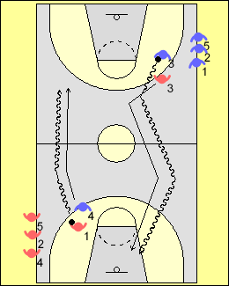 | Jeu défensif à 1 contre 1 sur tout le terrain lors d’une transition  Dans cet éducatif, les joueurs/joueuses forment une file le long de la ligne de côté, et doivent évoluer à 1 contre 1 dans une zone restreinte.
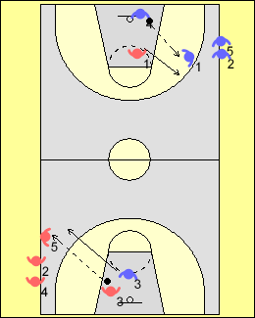 | Lorsque le/la défenseur(e) s’empare du ballon suite à un revirement, ou après un lancer réussi ou raté, il/elle remet le ballon au joueur ou à la joueuse suivant(e) dans la file. L’attaquant(e) doit alors passer rapidement en mode défensif.  On peut surcharger l’éducatif en permettant un dribble lors de la transition offensive, ce qui met davantage de pression sur le/la défenseur(e).
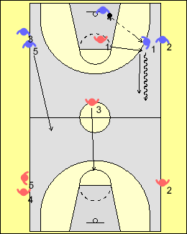 | 2 contre 2 – transition défensive ininterrompue  Dans cet éducatif, lorsque le/la défenseur(e) s’empare du ballon, il/elle le remet à la prochaine paire d’attaquant(e)s. Les deux attaquant(e)s deviennent ensuite les défenseur(e)s de sécurité « rapproché(e)s » et « éloigné(e)s ». Ceux et celles qui jouaient en défensive deviennent les prochain(e)s remplaçant(e)s. | 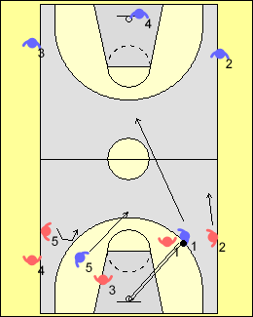
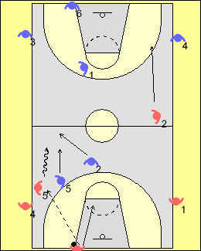 | 3 contre 3 – transition défensive ininterrompue, surcharge  Le/la troisième joueur ou joueuse est à l’extérieur de la ligne de fond et s’apprête à remettre le ballon en jeu; ceci permet aux défenseur(e)s de s’exercer à marquer de près et à suivre leur(e) adversaire. Celui ou celle qui surveille l’attaquant(e) qui remet le ballon en jeu peut s’arrêter et venir en aide, puisqu’il/elle se trouve en retrait.
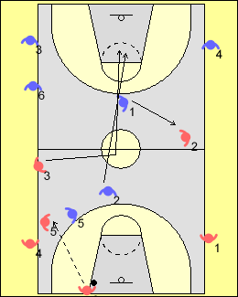 | Retour à son joueur ou à sa joueuse  Dans cet éducatif, on ajoute un(e) troisième attaquant(e) qui doit passer par le cercle central afin de simuler un(e) premier(ère) attaquant(e) de grande taille. Le/la défenseur(e) qui occupe le poste de « sécurité – éloigné(e) » ne peut quitter le panier tant que l’autre joueur/joueuse n’est pas venu(e) prendre sa place.  À noter que tous ces éducatifs se déroulent de façon continue.  L’entraîneur(e) peut s’occuper du pointage entre les deux équipes.
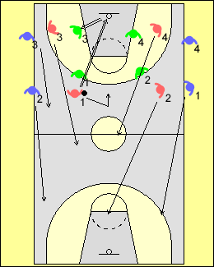 | Transition défensive à 4 contre 4  Pour cet éducatif, on a besoin de douze joueurs/joueuses; les nombreux déplacements et contacts permettront d’améliorer leur condition physique.  Lorsque l’équipe en attaque perd le ballon, les joueurs/joueuses doivent rapidement retrouver leur(e)s vis-à-vis qui se trouvent à l’extérieur. |  | 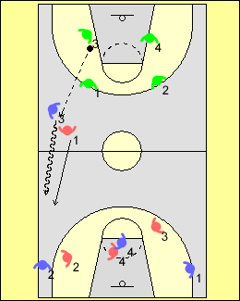
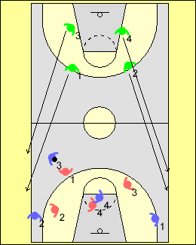 | Lors d’un changement de possession, les défenseur(e)s doivent traverser le terrain en sprintant et aller se placer aux endroits désignés à l’extérieur du terrain; ils ou elles auront tendance à « tricher » si on ne désigne pas des endroits bien précis sur le plancher…  On peut tenir le pointage en tenant compte du nombre de fois qu’équipe réussi à faire la séquence : marquer-arrêter-marquer.

PRESSION DÉFENSIVE
Défensive tout terrain lors des remises en jeu

On peut emprunter certains termes du baseball pour aider les joueurs/joueuses à comprendre les différentes façons de jouer en défense lorsque le ballon est remis en jeu. Cela s’avère particulièrement utile lorsque l’on joue à 3 contre 3 sur tout le terrain. Ces concepts aident les joueurs/joueuses à devenir des attaquant(e)s plus efficaces et à appliquer de la pression, car ils/elles se familiarisent avec les forces et les faiblesses de chaque méthode.

Lorsque l’enseignement progressera et que l’on utilisera des situations spécifiques en lien avec le pointage ou encore le temps de jeu restant, les joueurs/joueuses pourront alors facilement simuler un ensemble de situations auxquelles on peut être confronté(e) à la fin d’un match. Ces concepts constituent les éléments de base de toutes les actions dans lesquelles on cherche à mettre de la pression, que ce soit à 1 contre 1 ou encore dans un système de zone. Il est important de souligner que ces mêmes concepts défensifs peuvent également servir lors de situations de remise en jeu en zone offensive.

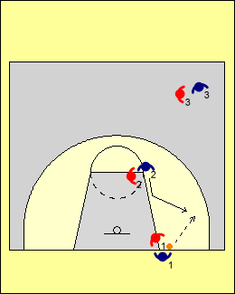 | Receveur(e)  L’attaquant(e) qui remet le ballon en jeu représente le marbre. Le ou la défenseur(e) qui se trouve à proximité du marbre est le/la receveur(e); il s’agit du joueur ou de la joueuse 1 en rouge dans le diagramme de gauche. La pression doit être exercée sur l’attaquant(e) qui remet le ballon en jeu, et avec un léger angle qui l’incitera à diriger la passe vers le coin.  Les autres défenseur(e)s empêchent leur(e) adversaire de couper au centre ou de s’échapper pour une longue passe.
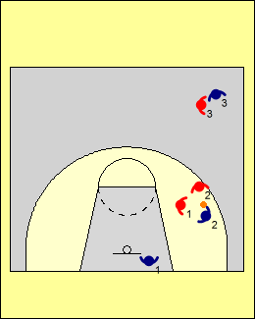 | Si le/la receveur(e) peut rejoindre le réceptionneur ou la réceptionneuse de la passe en faisant une ou deux enjambées, les défenseur(e)s devraient chercher à placer une trappe. Son/sa partenaire (2) doit empêcher l’attaquant(e) en possession du ballon de progresser vers la zone offensive le long de la ligne de côté, et on laisse l’option de passer le ballon à celui/celle qui a fait la remise en jeu.  La méthode « receveur(e) » est efficace contre les équipes qui ont un(e) attaquant(e) très habile à manier le ballon et qui peut dominer le jeu. Elle fonctionne également bien lorsque celui ou celle qui remet le ballon en jeu n’est pas particulièrement habile avec le ballon.
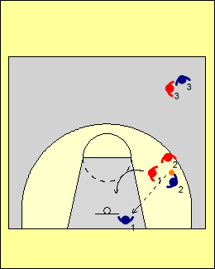 | Lors de la passe de retour, le/la défenseur(e) qui surveille l’attaquant(e) en possession du ballon doit couper afin d’éviter une montée en dribble rapide par le centre. Il est important d’empêcher que l’attaquant(e) sur qui on a placé la couverture double plus tôt ne reçoive à nouveau le ballon.  Du point de vue de l’attaque, la meilleure façon de déjouer cette défensive est de faire une longue passe par-dessus le/la défenseur(e) lors de la remise en jeu, ou encore s’assurer que l’attaquant(e) qui fait la remise soit habile à manier le ballon et efficace contre la pression.
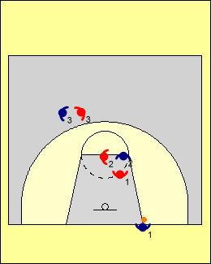 | L’arrêt-court  Avec « l’arrêt-court », le/la défenseur(e) qui marque celui ou celle qui fait la remise en jeu fait une couverture de face contre l’attaquant(e) adverse qui est le/la plus habile avec le ballon.  Les autres défenseur(e)s empêchent que le ballon soit remis vers le centre, ou encore qu’une longue passe soit faite.
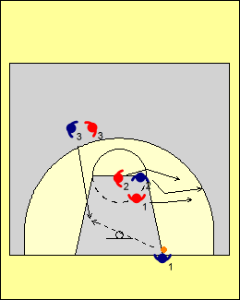 | On cherche faire en sorte que ce soit un(e) autre joueur/joueuse qui attrape le ballon et le monte en zone offensive.  La meilleure façon de déjouer cette défensive est de faire une longue passe par-dessus le/la défenseur(e) lors de la remise en jeu, ou encore que l’attaquant(e) responsable de la remise exécute une passe rapide puis sprinte vers la zone offensive pour recevoir une passe de retour avant que le/la défenseur(e) n’ait pu reprendre sa place pour couvrir.
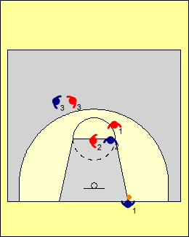 | Le champ gauche ou droit  Avec le « champ droit », le/la défenseur(e) qui surveille l’attaquant(e) qui remet le ballon en jeu joue derrière l’adversaire qui est très habile à manier le ballon.  Les autres défenseur(e)s tentent d’empêcher les attaquant(e)s de couper vers le centre ou encore de couper pour une longue passe.
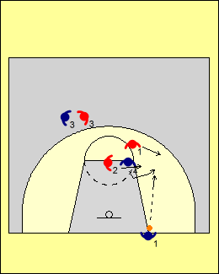 | On donne l’option à l’adversaire de couper vers le coin pour aller attraper le ballon. Si l’attaquant(e) en possession du ballon tente ensuite une montée rapide avec le dribble, le/la défenseur(e) est bien placé(e) pour ralentir l’action.  Cette approche est efficace pour ralentir un(e) adversaire qui veut monter rapidement après la remise en jeu. Tant que celui ou celle qui a fait la remise en jeu demeure derrière le ballon, le/la défenseur(e) peut rester près du ballon et ralentir sa progression vers la zone offensive.  Pour déjouer cette défensive, celui ou celle qui a fait la remise en jeu doit couper rapidement vers le centre vers un espace libre après sa passe.
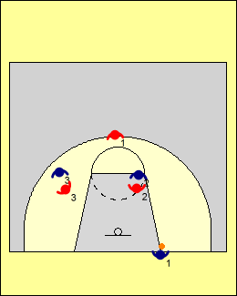 | Le champ centre  Avec le « champ centre », le/la défenseur(e) qui surveille l’attaquant(e) qui remet le ballon en jeu joue derrière les adversaires qui sont les cibles de choix pour la passe.  Les autres défenseur(e)s contestent en fixant le nombril de l’attaquant (e) qui se trouve devant eux/elles et en tentant d’empêcher leur adversaire de couper vers le ballon.
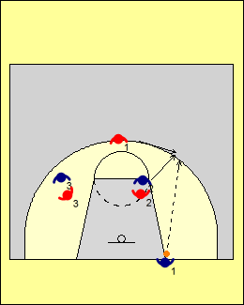 | Si l’attaquant(e) qui remet le ballon en jeu tente de faire une longue passe, le/la défenseur(e) au poste de « champ centre » pourra l’intercepter.  Cette approche fonctionne bien quand on tente d’obliger l’autre équipe à prendre plus de cinq secondes pour faire la remise en jeu, ou encore que celui ou celle qui la fait ne peut faire de longues passes.  Du point de vue de l’attaque, la meilleure façon de déjouer cette défensive est d’utiliser une formation dans laquelle plus d’un(e) joueur/joueuse peut recevoir la longue passe.

CONCEPTS DE PRESSION DÉFENSIVE

Ces notions sont valables pour un système défensif individuel ou de zone.

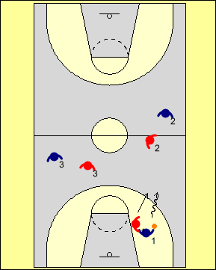 | Obliger l’attaquant(e) en possession du ballon à se diriger vers la ligne de côté  Dans la plupart des situations où l’on exerce de la pression, on cherche à faire en sorte que le ballon se retrouve dans un secteur bien précis du terrain; de préférence, on tente d’obliger l’attaquant(e) en possession du ballon à dribbler vers la ligne de côté.  Dans certains cas, on tente aussi de l’obliger à dribbler avec la main non dominante et à traverser le centre du terrain en demeurant près de la ligne de côté.
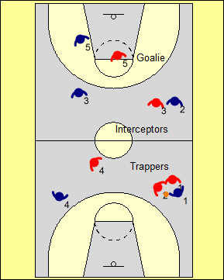 | Placer la trappe, intercepter et « garder le but »  Chaque fois qu’il y a une trappe défensive, les joueurs/joueuses doivent remplir les rôles suivants :  - Deux défenseur(e)s font une trappe contre l’attaquant(e) en possession du ballon et appliquent beaucoup de pression - mais sans toutefois commettre de faute; les revirements proviennent la plupart du temps d’une passe qui a été déviée.  - Deux joueurs/joueuses se placent dans les corridors de passe où se trouvent les réceptionnaires les plus probables et cherchent à intercepter le ballon; ils/elles surveillent habituellement « un(e) joueur/joueuse et demi(e) ».  - Un(e) joueur ou une joueuse qui protège le panier – c’est le/la gardien(ne) de but. Dans certaines situations extrêmes, l’entraîneur(e) peut opter pour trois « intercepteurs ou interceptrices » et aucun(e) « gardien(ne) ».
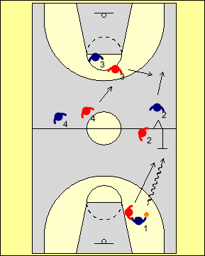 | Trappes sur le côté fort  Lorsque l’une ou l’autre des situations suivantes se produit, c’est un bon moment pour placer une trappe :  - l’attaquant(e) en possession du ballon dribble hors-contrôle,  - l’attaquant(e) qui dribble vient tout juste de traverser le centre du terrain,  - le/la défenseur(e) peut placer une trappe en faisant deux pas  Après coup, les autres défenseur(e)s tentent de faire une rotation.
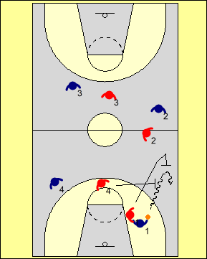 | Trappes dans l’angle mort  Une trappe placée dans l’angle mort s’avère souvent efficace contre un(e) attaquant(e) qui n’est pas habile à manier le ballon.  Le joueur ou la joueuse qui surveille l’attaquant(e) qui dribble le/la repousse vers la ligne de côté, puis tente ensuite de s’interposer devant. Le/la défenseur(e) qui se trouve le/la plus près se dirige alors rapidement vers l’adversaire pour placer la trappe et communique avec son/sa partenaire à l’aide d’un mot clé (ex. : « feu ». On doit alors anticiper une manœuvre de pivot sur soi ou de pivot arrière de la part de l’attaquant(e).
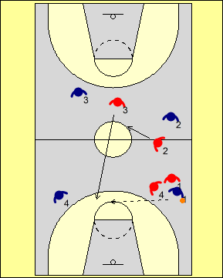 | Aller rapidement dans l’ouverture  Lorsqu’un(e) joueur ou une joueuse bouge pour venir placer une trappe, le/la prochain(e) défenseur(e) qui se trouve de son côté doit faire une rotation vers le haut et se déplacer rapidement pour boucher l’ouverture qui s’offre alors à l’attaquant(e) suivant(e).  Un(e) défenseur(e) qui se trouve du même côté que le ballon doit faire une feinte en direction de l’adversaire en possession du ballon, et tenter de le/la ralentir. Il est plutôt rare de placer une trappe dans l’angle-mort lorsqu’on utilise une défensive de type « 1 à 1 » sur demi terrain.  Dans certains cas, l’entraîneur(e) peut permettre que les attaquant(e)s fassent des passes vers l’arrière, afin de ralentir le jeu et écouler le temps. Une telle approche est également efficace lorsque l’attaquant(e) qui se trouve en retrait n’est pas très habile avec le ballon.
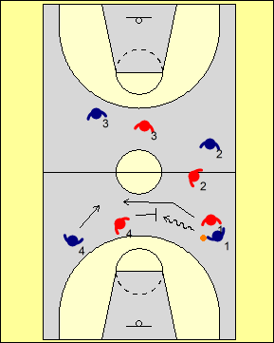 | Ballon au centre  Lorsque le ballon parvient au centre, il est important de ne pas laisser le dribbleur ou la dribbleuse passer entre deux défenseur(e)s.  Les défenseur(e)s peuvent alors faire une permutation rapide pour ralentir la progression du ballon, ou faire semblant de reprendre leur position initiale afin d’inciter l’attaquant(e) à faire une passe à l’aile.
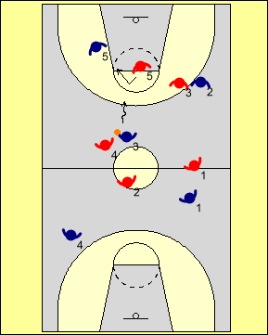 | Faire une feinte et se replier  Lorsque le/la dernier(ère) défenseur(e) (c.-à-d. le/la « gardien(ne) de but ») se retrouve seul(e) à protéger le panier, il/elle doit faire une feinte en direction de l’adversaire en possession du ballon puis ensuite se replier en direction de l’attaquant(e) qui se trouve le plus près du panier, en espérant que cette manœuvre pourra contribuer à ralentir le jeu offensif ou encore causer une mauvaise passe.  La feinte vers l’attaquant(e) suivie d’un repli peut également être utilisée par un(e) défenseur(e) qui se trouve sur le côté fort pour simuler une trappe.
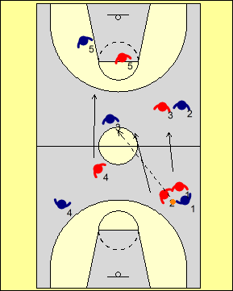 | Sortir rapidement de la trappe  Si l’attaquant(e) réussit à passer le ballon au-delà de la trappe, tou(te)s les défenseur(e)s doivent se remettre très rapidement en position, et faire face au ballon.

DÉFENSIVE DE ZONE
Cette section présente une approche conceptuelle pour enseigner la défensive de zone.

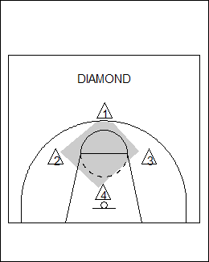 | Concept de zone  La formation défensive peut être en losange (front défensif à un(e) joueur/joueuse) ou en carré front défensif à deux joueurs/joueuses).

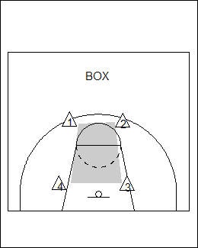 | Formation en carré avec front défensif à deux joueurs/joueuses

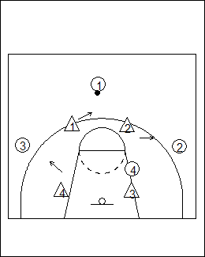 | 1. Désigner un(e) joueurs/joueuse qui s’occupera du ballon  Un(e) défenseur(e) doit être responsable de s’occuper du ballon, ce qui permet aux autres de bien jouer leur rôle respectif dans le système.  Ceci ne signifie pas que ce(te) défenseur(e) doive quitter sa position pour aller marquer l’attaquant(e) en possession du ballon; cependant, cela permet à chacun de savoir quoi faire lorsque la prochaine passe sera faite.

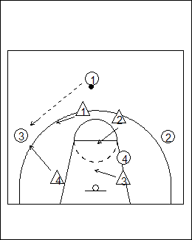 | 2. Se déplacer pendant que le ballon est dans les airs  Lors d’une passe, la défensive se déplace lorsque le ballon voyage dans les airs; on devrait également crier « ballon » pour que les partenaires puissent synchroniser leurs déplacements.  C’est le même concept qui s’applique lors d’une défensive individuelle (type 1 à 1).

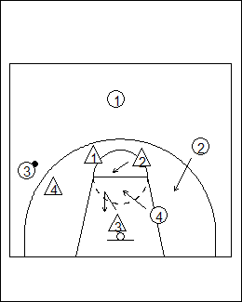 | 3. Changer de responsabilité lorsqu’un(e) adversaire coupe vers le ballon  Les attaquant(e)s coupent pour désorganiser la défensive de zone; par conséquent, un(e) défenseur(e) doit jouer devant l’adversaire qui coupe jusqu’à un certain point, puis laisser ensuite un(e) partenaire s’en occuper.  Dans cet exemple, l’attaquant(e) 4 coupe. Le/la défenseur(e) 3 s’oppose, mais seulement au début de l’action; il/elle laisse ensuite le/la défenseur(e) 2 prendre la relève.  Le/la défenseur(e) 3 doit alors reprendre sa position rapidement afin d’éviter que l’attaquant(e) 2 ne coupe par derrière pour venir occuper l’espace laissé vacant par l’attaquant(e) 4.

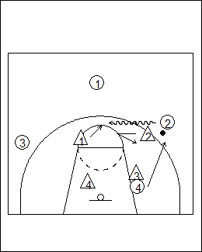 | 4. Changer de responsabilité lors du dribble  Ce concept est semblable au changement de responsabilité lorsqu’un(e) adversaire coupe vers le ballon. Si le/la défenseur(e) demeure trop longtemps avec l’attaquant(e) qui dribble, la défensive de zone peut se faire « tirer », et devient alors vulnérable.  Dans cette situation, après s’être déplacé(e) légèrement vers la gauche, le/la défenseur(e) 2 doit refiler l’attaquant(e) 2 au/à la défenseur(e) 1, puis se replier en direction de l’attaquant(e) 4 qui remonte pour prendre la place laissé vacante.

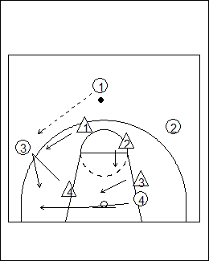 | 5. Changer de responsabilité lorsque les attaquant(e)s coupent et dribblent simultanément  Contre des équipes qui jouent beaucoup le long des lignes, on doit changer les responsabilités des défenseur(e)s.  Dans cette situation, le/la défenseur(e) 4 se déplace en direction de l’attaquant(e) 3 et reçoit ensuite de l’aide du/de la défenseur(e) 1 ce qui leur permet de bien couvrir l’attaquant(e) 4 (qui coupe).

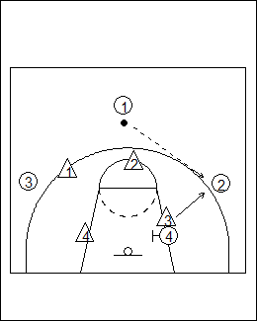 | 6. Se placer en haut des écrans  Dans une défensive de zone, les défenseur(e)s ne peuvent pas se permettre d’être coincé(e)s ou obstrué(e)s. Lors d’un écran, ils/elles doivent donc chercher à se placer au haut de l’écran, afin de pouvoir se déplacer dans chaque direction.  Ici, le/la défenseur(e) 3 s’est mis(e) au haut de l’écran fait par l’attaquant(e) 4, afin de pouvoir marquer l’attaquant(e) 2 après la passe.

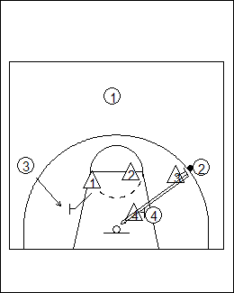 | 7. Bloquer au rebond  La principale faiblesse de la défensive de zone est la couverture des attaquant(e)s lors des rebonds.  Tou(te)s les joueurs/joueuses doivent s’impliquer, en particulier les arrières qui se trouvent au haut de la clé.  Si l’équipe place un(e) défenseur(e) en retrait, les arrières doivent s’impliquer et bloquer au rebond.




